Masaryk University Brno
Faculty of Education
Department of English Language and Literature



The Development of an E-learning Course According to the ADDIE Method

Diploma Thesis

Brno 2012

Author: Libuše Spáčilová Supervisor: PhDr. Tamara Váňová

Declaration
I declare that I worked on this thesis independently, using only the sources listed in the bibliography.
I agree with this diploma thesis being deposited in the library of the Faculty of Education at the Masaryk University in Brno and making it accessible for academic purposes.

………………………………………….
Libuše Spáčilová

Acknowledgements

I would like to express sincere gratitude to my supervisor PhDr. Tamara Váňová for her expert advice, inspiration and valuable comments as well as her support during my work. My grateful thanks also belong to my willing student.

Rožnov pod Radhoštěm, 22 March 2012. Libuše Spáčilová

…. ………………………..
Annotation

The Diploma thesis The Development of an E-learning Course According to the ADDIE Method, based on the bachelor’s thesis Online Language Learning – Idioms, employs the ADDIE model, following the five phases, i.e. analysis, design, development, implementation, and evaluation, in order to design an ideal online course with the support of blended learning.
The outcome of the thesis is an improved online course “English figurative language” designed in the Moodle software to suit the learner’s individual needs, containing a number of study materials, diverse activities and tasks, concerning English figurative language, idioms in particular.
The thesis is divided into two parts – the first being theoretical and the second practical. The theoretical part explores the ADDIE method and its utilisation in e-learning. Furthermore, it considers the potential of both blended and online learning. Finally, a chapter on English figurative language is presented. The practical part provides a detailed description of the course, including the gradual development of the original course. Afterwards, it discusses the learning process of the participant involved in the trial course through a mixture of blended and online learning, affecting the resulting course content by the trial.

Key words:
ADDIE model, e-learning, online learning, blended learning, a learning management system, Moodle, online courses, instructional design, instructional systems design, figurative language, English idioms, the learner’s individual needs

Anotace

Diplomová práce The Development of an E-learning Course According to the ADDIE Method, založená na bakalářské práci Online Language Learning – Idioms, využívá ADDIE modelu, držící se jeho pěti fází, tzn. analýzy, designu, vývoje, realizace a hodnocení, za účelem navržení ideálního online kurzu za podpory smíšeného učení.
Výsledkem diplomové práce je online kurz “English figurative language” projektovaný v Moodle softwaru a vylepšený tak, aby vyhovoval individuálním potřebám žáka, zahrnující řadu studijních materiálů, rozmanitých aktivit a úkolů, které se týkají anglického metaforického jazyka, idiomů především.
Práce je rozdělená do dvou částí – první teoretické a druhé praktické. Teoretická část zkoumá ADDIE metodu a její využití v e-learningu. Mimoto zvažuje potenciál jak smíšeného učení, tak elektronického vzdělávání. Nakonec předkládá kapitolu o anglickém metaforickém jazyce. Praktická část poskytuje detailní popis kurzu včetně postupného vývoje původního kurzu. Poté projednává učební proces žáka zapojeného do zkušebního kurzu skrze spojení smíšeného učení a elektronického vzdělávání, který ovlivňuje následný obsah kurzu.

Klíčová slova:
ADDIE model, e-learning, elektronické vzdělávání, smíšené učení, řídící výukový systém, Moodle, internetové kurzy, výukový design, systémový výukový design, metaforický jazyk, anglické idiomy, individuální potřeby žáka
Table of contents

Introduction 7

Theoretical Part 9

1 E-learning 9
1.1 Introduction to e-learning 9
1.1.1 Technology-based learning versus classroom-based learning 10
1.2 Past expectations versus reality 10
1.3 Future trends 11
1.3.1 E-learning in tertiary education 12
1.4 Pros and cons 12
2 Virtual Learning Environments 14
2.1 Pros and cons 14
3 Moodle 17
4 Blended learning 19
4.1 Introduction to blended learning 19
4.2 Definition 19
4.3 Implementation 20
4.4 History of blended learning 21
5 Instructional Design 23
5.1 Instructional System Design models 27
5.2 History of Instructional Design 29
6 ADDIE 32
6.1 Introduction to ADDIE 32
6.2 ADDIE phases 33
6.3 ADDIE and the learners’s motivation 42
6.4 ADDIE for teaching purposes 43
6.5 Weaknesses of the ADDIE model 44
6.6 History of ADDIE 44
7 Figurative language 47
7.1 Introduction to figurative language 47
7.2 Figures of speech 49
7.3 Idioms 53
7.3.1 Classification of idioms 56
7.3.2 Idiom dictionaries 58
7.3.3 Why to learn idioms? 58

Practical Part 60

8 Introduction 60
9 The course preparation 61
10 The application of the ADDIE model 63
10.1 Phase 1: Analysis 63
10.1.1 A general student’s profile 65
10.2 Phase 2: Design 66
10.3 Phase 3: Development 68
10.3.1 Action plan 71
10.4 Phase 4: Implementation 72
10.5 Phase 5: Evaluation 73
11 The course description 75
11.1 The settings of the course 82
12 Adjustments to the former course 84
13 Trial course 87
13.1 Introduction 87
13.2 Programme of the trial course 88
14. Conclusion 99
14.1 The course outcomes 99
14.1.1 The ADDIE model: pros and cons 100
14.2 Ideas on improvements 101
14.3 Final evaluation 102

Resume 104

Bibliography 105

Appendices 111

Introduction

As I have always been interested in information and communication technology, I started to explore the potentials of online learning immediately after I entered Masaryk University. Although I met with e-learning at the very beginning of my studies through a number of online Moodle courses, which provided support for some compulsory subjects at university, my real experience with IT was provided by the Department of Technical Education and Information Science in the form of the optional subject Introduction to Information Technology. Following the requirements of this course, I created a PowerPoint presentation, a sort of study material for distant learning, dealing with English idioms with which I have been concerned since then. Having enjoyed this task, I consequently chose idiomatic language as the topic of my next project - the design of an online Moodle course. Later, I was advised to devote my bachelor’s thesis to the same area, specifically online language learning and English idiomatic language, which finally led me to the idea of developing my original Moodle course based on English idioms.
This diploma project was initiated by the supervisor of my bachelor’s thesis PhDr. Tamara Váňová, who suggested polishing the online course English idioms, representing the practical part of the bachelor’s thesis Online Language Learning – Idioms. This incentive, provoking further considerations on e-learning, resulted in the creation of an advanced course on English figurative language. As opposed to the original course English idioms, the field of English idiomatic language has been extended by adding new figures of speech, i.e. metaphors, similes and proverbs. The new course has been redesigned in the Moodle software, but this time according to the rules of the ADDIE model, following its five phases, i.e. analysis, design, development, implementation, and evaluation, thus exploring the ADDIE method and its possible utilisation in online language learning. Even though I was unaware of the existence of the ADDIE model until recently, I decided to use it after a consultation with my supervisor since it seemed to offer a suitable and useful tool for efficient online course design. In addition, blended learning was employed during the trial course to achieve smoother contact with the course participant, providing extra feedback from face-to-face lessons, and the potential of blended and online learning was considered.
The main objective of this thesis was to develop a valuable online Moodle course dealing with English figurative language, idioms in particular, derived from the original course English idioms. The course content should offer relevant study materials and a variety of appropriate activities to learners interested in this area.
Another goal of the project was to demonstrate the applicability of the ADDIE model to online language learning.
Since the ADDIE model appears to be worth a detailed examination, this subject matter will be closely dealt with in the theoretical part of this thesis.

Theoretical Part

1 E-learning

1.1 Introduction to e-learning

First of all, the definition of e-learning should be provided. Online learning (also known as e-learning, technology-assisted learning or Internet-based learning) can be described as learning involving network technologies, e.g. the Internet or various business networks, for online delivering, supporting and assessing instruction and supplying electronic resources of knowledge, i.e. learning materials in a digital format that are available on the Internet, a local Intranet, a CD-ROM or other digital storage media. Online learning is mediated via online materials and resources, electronic libraries, learning courses, discussions, chats, e-mail, conferencing as well as knowledge sharing applications. What is important to mention is the fact that online learning does not have to happen strictly online but includes also off-line types of learning and is often a supplement to traditional face-to-face learning. (Shank & Sitze, 2004, p. 2). The basis of e-learning is an e-learning course, simulating traditional learning activities in the classroom.
To discuss the main differences between traditional learning and e-learning, the latter places an emphasis on the use of unconventional teaching/learning methods, the learner’s autonomy, time independence and constant access to study materials. As opposed to traditional learning, all the learning activities take place without the presence of a teacher.
From a different perspective, online learning is basically a type of distant learning (even though not necessarily), which is quite an old approach to learning, existing in various forms, using different media, e.g. print, TV, satellite, Internet etc. that has been introduced to meet the demands of changing society, satisfying the need for training people at a distance. It was the medium of Internet in particular that has enabled distant learning to overcome great distances almost in a second and started the era of online learning.
Once online learning meets the needs of learners and organizations, it becomes a powerful and meaningful tool. However, technology used wrongly can also become an obstacle to these needs. To illustrate this idea with an example, a student who is not comfortable with computers is not likely to be the right candidate for e-learning.
Nowadays, online learning is becoming an integral part of educational systems in developed countries such as the United States or the United Kingdom and its potential is growing. Besides educational institutions (universities, high schools, primary schools etc.), e-learning is also utilized in the private sector.
As regards its utilization in the Czech Republic, e-learning is becoming widely spread in the Czech tertiary as well as lower educational system. It offers a number of benefits to all levels of education and is applied not only at schools but also in private institutions and various companies. Thus, it is likely to expand in the future, supporting not only traditional learning but also extra-curriculum activities and school projects. Further, it could be used for education of gifted and handicapped children or preparation of formal educational programs (i.e. “ŠVP”).

1.1.1 Technology-based learning versus classroom-based learning

According to Shank & Sitze (2004), it is impossible to state whether technology-based learning is better than traditional face-to-face learning. There is always good and bad technology-based as well as classroom-based learning. “A better question is which instructional method works best in which circumstances, and which technologies best support them.” (p. 14). As a matter of fact, a blend of classroom and online learning usually works best, which leads to the phenomenon of blended learning (see chap. 2.0).

1.2 Past expectations versus reality

To consider the potentials of e-learning properly, it is necessary to examine this phenomenon from rather different perspectives. Despite the fact that e-learning has been used for a relatively long time and its application is increasing year by year, it is probably not being adopted as rapidly and widely as it was initially expected, considering the assumptions made in the period of the so-called dot-com era. Comparing classroom and online learning, traditional education seems to predominate unequivocally and opinions on the efficiency of both classroom and online teaching differ. Even though e-learning was supposed to improve the quality as well as efficiency of teaching at universities, some studies suggest that it is found more time-consuming than traditional face-to-face lessons and even more expensive than classroom courses.
According to Carliner & Shank, “e-learning didn’t replace classroom learning and does not seem poised to do so now” (p. 22).
Nevertheless, it cannot be argued that e-learning has been a great success, particularly in tertiary education, in which students must appreciate possibilities provided by a number of universities nowadays, e.g. various online courses, e-degrees etc.
Further, blended learning has become an alternative between purely online and classroom courses offered to students.

1.3 Future trends

Even though the period of the Internet boom is over and the Internet industry is growing nowadays, there have been more and more developments introduced on the market. Consequently, it is becoming an integral part of present education.
Whilst there was a preference for the traditionally obtained degrees in the past, online degrees have been given almost equal status and are possible to expand in the future.
Naturally, it is impossible to state what innovations will be introduced in the future and what new opportunities will be brought by the future advanced technology. Nonetheless, mobile learning, simulations or adaptive learning environments are very likely to be put in practice. The main trend, however, seems to be the expansion of distant education to all fields with the use of a Virtual Learning Environment, e.g. Moodle software. Its incorporation into all types of schools is probably the principal objective of future e-learning.
Carliner & Shank make the following predictions:
E-learning will continue to diffuse into higher education in the form of blended learning and supplemental online resources and assignments. The number of students served online will continue to grow and resources will steadily improve in quality, until the barriers and obstacles become less formidable. Over time e-learning is fast becoming integral to the culture of higher education, and e-learning work a more natural extension of faculty job descriptions. (p. 64)

1.3.1 E-learning in tertiary education

Although the earlier exaggerated expectations of e-learning were not fulfilled, noticeable growth in the last few years, caused by the digital age, has enabled students to obtain university diplomas entirely online or through a blend of classroom and distance coursework (see chap. 1.4). It is also suggested that it has become a preferred style of learning for many students throughout the world. Thus, online learning in higher education seems to have considerably developed (see Graph 1), gradually forming a necessary part of traditional educational system.

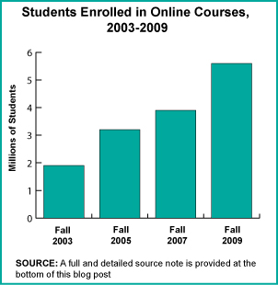
Graph 1: Increasing number of students enrolling in online courses in the U.S.

1.4 Pros and cons

There are many advantages in incorporating e-learning into traditional learning and replacing traditional lessons by online courses that can either support face-to-face lessons or substitute them completely.
The main benefits of e-learning comprise high flexibility (people can learn at any time without being bound by timetables), availability (most of the students nowadays have access to a computer and the Internet), accessibility (possibility to use various operating systems), easy upgrade, consistency (the same quality of training is ensured to everyone), lower costs (even though not necessarily), fast delivery and dynamism (it is constantly in progress).
Nevertheless, e-learning has also several drawbacks. Firstly, the distance between learners, their peers and the teacher can significantly affect learners’ social and communication skills provided the participants communicate purely via the Internet (or other media), not getting the chance to meet socially. Secondly, considerable freedom given to students can cause a lack of interest since they are not so time-limited and personally supervised by the teacher. Despite the fact that e-learning is generally supposed to save costs compared to traditional learning, its entry costs can be rather high as the course can be expensive to design, develop, deliver and maintain. This particularly concerns tailor-made instructions designed for special audience with specific needs. Further, using e-learning in certain subject, e.g. mathematics, might entail difficult communication. Lastly, people involved in e-learning sometimes tend to infringe copyright by so-called “borrowing” from the Web. Therefore, trainers/teachers should be fully aware of copyright laws to avoid potential problems. (Rothwell, Butler & Maldonado, 2006).

2 Virtual Learning Environments

Any computer program that facilitates computerized learning/e-learning can be considered Virtual Learning Environment (abbrev. VLE). It is based on the Web, using a content management system. Although it was originally developed for distance education, it can be equally incorporated into a physical environment of traditional learning. Nowadays, VLEs are usually utilized as a support to face-to-face lessons, known as blended learning.
VLEs provide a wide range of effective tools for developing a course web site. To mention some of the useful features, these include various tools for sharing and uploading materials, communication tools such as forums and chats and feedback tools such as quizzes, assignments, tests etc. Furthermore, new features are being incorporated, e.g. wikis, blogs, 3D virtual learning spaces etc. that have been added recently.
Terms similar to VLE include Learning Management System (LMS), Content Management System (CMS), Learning Content Management System, Managed Learning Environment, Learning Platform, Learning Support System, Online Learning Centre or OpenCourseWare. (Wikipedia, the free encyclopedia, n.d.).
As the Moodle software, representing one of the Course Management Systems (sometimes referred to as Learning Management System), will be discussed in the chapter below, the term CMS should be also explained. A Course Management System (or LMS) is a web application, i.e. it is accessed by using an Internet browser. Thus, online courses are accessible anywhere in the world, providing there is an Internet connection. (Cole & Foster, 2007).
Concerning recent history, in the last few years “CMS systems have matured rapidly and are now considered critical software for many colleges and universities. The CMS market is now a multimillion dollar market and is growing quickly”. (Cole & Foster, 2007, p. 2).

2.1 Pros and cons

To name some of the advantages of using VLEs, flexibility can be seen as number one because online courses can be reached at any time, depending on the student. Higher efficiency is another one, which enables to move a part of the lesson content online. Consequently, there is more space for discussing problematic issues in the classroom. Further, accessibility represents another benefit of using VLEs as students like to access study materials whenever they need, which is only possible with the support of an online course. It also supports communication and interaction. Moreover, many students nowadays find online communication simply more convenient than face-to-face interaction. Next, VLEs facilitate to integrate traditional and distance learning or learning within several campuses. Lastly, there are economical issues such as saving time of teaching staff etc.
As far as educational issues are concerned, VLEs can serve as a good support to traditional lessons, providing a range of additional materials and resources, certainly making the lessons more exciting by employing the course web site regularly into the classes. Students attending such classes can recap the topics discussed in the lessons. Further, they can more easily follow their teacher in the classroom without taking detailed notes since they are consequently put on their online course. This concept, mixing face-to-face lessons with online learning, is usually perceived as so-called blended learning (see chap. 4). Next, students can feel confident about what to expect in the following sessions since there is usually a syllabus placed on the course, containing necessary information regarding the subject outline as well as subject requirements, including the appropriate deadlines. In addition, students can elicit information concerning their performance through the grades section and the feedback they get regularly from the teacher. Thus, the course participants have a transparent overview of their results.
Although using a VLE has many benefits, there are also some drawbacks. As there are various demands placed by VLEs, inexperienced teachers in particular can find it very time-consuming at first before they learn how to manage it efficiently. Any VLE also requires a level of obligation put on the side of the teacher. Therefore some teachers tend to avoid starting to use a VLE in their classes. From the students’ perspective, there are sometimes problems with initial enrolment in online courses. Likewise, technological difficulties such as troubles with Internet browsers may occur. Next, a problem can be caused by the fact that the content of each class is subsequently uploaded to the course web site. As a result, students may not pay sufficient attention during lectures because they rely on the materials to be found on the online course. Another minus is represented by an absence of the teacher during the course work, particularly quizzes, as students are more likely to cheat during online tests.
To sum up this chapter, using a VLE poses a challenge for today’s students, enabling to establish contact and develop relationships among the course participants, including the teacher. Since most students nowadays are familiar with the Internet, Facebook and other social networks, it seems natural to them to manage an online course in any VLE. In addition, VLEs have proved effective, improving group performance by using various online activities, incorporating technology into traditional learning. Despite the fact that students have to face a new experience with educational technology, it appears to be particularly convenient for freshmen at universities as they are given extra support in the new environment. (Ismail, 2010).

3 Moodle

Moodle is a global development project designed to support social structure of education. (About Moodle, n.d.). The purpose of this software is to design and develop online courses (Internet-based) and web sites. This open source Course Management System (also referred to as Learning Management System) is used by a number of universities, secondary and primary schools, businesses and even individual trainers to incorporate technology into their courses.
In March 2012, there were approximately 66,000 active Moodle sites that were registered from 218 countries around the world. (Moodle,org., n.d.). This software, offering high flexibility, is provided for free on the Web so that anyone can download it, respecting certain conditions.
To provide the definition of the word Moodle, the word is an acronym and its letters stands for Modular Object-Oriented Dynamic Learning Environment. This CMS/LMS can be used at any type of school or corporation.
Searching the history of Moodle, it was created by a computer scientist and educator Martin Dougiamas from Australia, who supported a CMS at a university in Perth, focusing on educational process. His determined effort has remained to develop the best CMS available. (Cole & Foster, 2007).
As regards administration, Czech Moodle software was first implemented by David Mudrák from Charles University in Prague (the Department of Information Technology and Education at the Faculty of Education).
Besides Moodle, there are also other CMSs used in the Czech Republic, such as iTutor, Adobe Connect, EDEN, Microsoft Class Server etc.
To analyse the content of a Moodle course, there are three basic categories: course information (e.g. syllabus), interaction (e.g. forum) and course activities, including various types of exercises, readings, quizzes etc.
Concerning advantages, there are a number of benefits in using a Moodle environment. First, Moodle is regarded as the most widely spread CMS/LMS in the world, offering high flexibility. Consequently, it has been translated into many languages, including Czech. As this software belongs to so called open sources, it is provided for free, eliminating costs. It is constantly developing, which is ensured by Moodle Headquarters and a community of developers, educators as well as students. Commercial support is ensured by Moodle Partners.
What is a big drawback of the Moodle software is, from the point of view of programming, its unclear structure. However, this issue is likely to be solved in the future.

4 Blended learning

4.1 Introduction to blended learning

Recently, there has been a lot of research conducted into how to combine traditional face-to-face lessons and online learning effectively in what is known as blended learning or so-called hybrid courses. Such hybrid courses combine the best of both learning environments, using several different delivery methods, moving the most of the content to an online course, thus enabling to save time for debates, questions and problem solving in the lesson. Further, students are given more opportunities to express their opinions in online discussions, which they are often prevented from because of lack of time. (Cole & Foster, 2007).

4.2 Definition

As its name suggests the term “blended learning” can be defined as a blend of online learning and traditional learning. It is a logical and natural evolution of learning, representing a smart solution to the development of learning focused on individual needs, providing a great opportunity to integrate the advances of modern technology as well as the innovations of online learning with the interaction and participation used in traditional learning, which can be supported by personal one-to-one contact with a teacher (Thorne, 2003).
Another definition, provided by Bersin, explains the term in the following way:
Blended learning is the combination of different training “media” (technologies, activities, and types of events) to create an optimum training program for a specific audience. The term “blended” means that traditional instructor-led training is being supplemented with other electronic formats. Blended learning programs use many different forms of e-learning, perhaps complemented with instructor-led training and other live formats. (p. 15)

Blended learning seems to have a great potential. According to Thorne, “the potential of blended learning is almost limitless and represents a naturally evolving process from traditional forms of learning to a personalized and focused development path” (p. 5). Thus, blended learning can be seen as a means to meet individual needs. Due to blended learning, it is possible to combine different learning environments, e.g. online learning and face-to-face lessons, including the strategies for personal development. Consequently, ideal lessons can be designed in order to suit the needs of each individual.
The power of blended learning rests primarily in merging different training media into an efficient mix creating an effective training program tailored to one’s needs.

4.3 Implementation

Since most of organizations nowadays have to contend with limited resources, it is vital to pay attention to economic issues of blended learning programs. Nevertheless, these programs should be effective not only with regard to its costs but also performance improvement.
Further, learning styles theories, relevant also to blended learning, should be considered before starting to design a training program.
To design a blended/hybrid course, first the course objectives must be analysed and divided into smaller bits, i.e. learning objects. Subsequently, delivery methods need to be determined. Afterwards, the instruction is put into logical sequence.
As regards blended learning design, there are numerous techniques, strategies and activities that can be blended together to create a single course. These can be divided into five categories, i.e. instructor-led training (abbrev. ILT), independent study, distance learning, synchronous learning and asynchronous learning. To discuss what belongs to each of the categories, ILT includes face-to-face lessons, presentations, field trips, lab exercises, observations, personal factors (e.g. learning preferences) etc. Next category, independent study, covers reading assignments, audio/video materials, action projects, case studies etc. Distance learning (without the Internet support) uses television broadcasts, phone and video conferences. Whilst synchronous learning includes web cats, virtual lessons, online collaboration, chatting etc., asynchronous learning deals with web-based training, simulations, knowledge builders, performance support (e.g. job aids), threaded discussion etc. To distinguish between synchronous and asynchronous learning activities, synchronous learning takes place in a real/same time, however, not necessarily in the same place (physical versus virtual learning). On the other hand, asynchronous learning is not time-dependant and takes place in different time in the same or different place. (“Blended Learning”, 2003).
Thus, traditional learning may be merged with online learning, bringing complex and balanced opportunities to learners, satisfying a range of learner preferences that can be achieved through blended learning. (“Blended Learning”, 2003).
To illustrate what traditional delivery methods can be mixed with online delivery methods, see fig. 4.
Blended learning provides a number of challenges that has to be managed, such as design, instructional complexity, roles and responsibilities, coherent learning environment, costs efficiency etc. in order to meet its expectations.
Concerning the benefits of blended learning, the main advantage lies in its flexibility to combine different media to create the most suitable learning environment and to match the media with the learning objects. Further, blended learning seems to provide an efficient way to increasing learners’ confidence, promoting learners’ autonomy. Moreover, it enables to design a training program according to individual needs.

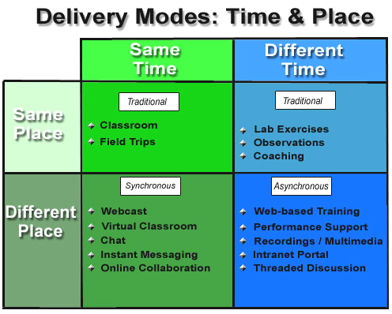
Figure 4: Different delivery methods to combine

4.4 History of blended learning

As far as the history of technology-based learning is concerned, blended learning seems to represent its latest logical step. Although it is not regarded as a completely fresh concept, there is no doubt that its tools, available today, are new, offering broader possibilities to educators as well as learners.
Starting from the very beginning, there was Instructor-Led Training (abbrev. ILT), emphasizing the role of the teacher who has a complete power over his/her lesson. Furthermore, ILT has a cultural effect based on interaction and mutual proximity. However, it is not possible to apply this model in the case that hundreds or even thousands of learners have to be taught. Here, the technology-based learning needs to be implemented. Bersin says that “technology is intended to solve these problems: extend the instructor model in space and time”. Thus, it is possible to “reach more learners in a shorter period of time-and as a bonus they can learn at their own pace and speed” (Bersin, p. 3).
The first technology-based training was enabled by mainframe and mini-computers in the 1960s and 1970s. Between 1980s and 1990s, distance learning started its era due to the extension of satellite-based live video in 1970s. The expansion of CD-ROM dates back to the early 1980s when the first personal computers appeared. In the 1990s, the web-based training arrived, bringing new opportunities, which leads us to the present when educators have a broad range of options for blended learning e.g. web-based courseware, simulations, EPSS systems and books for self-study and webcasting, live video, conference calls, or instructor-led training. The key point to discuss is primarily to decide which, when and how to mix them together.
To learn from the history of technology-based training, Bersin (2004) suggests that it is crucial to develop appropriate content, not omitting its maintenance, arrangement as well as distribution in any program.
Finally, Bersin claims, “Today’s blended learning approaches build on years of experience but apply new technologies and delivery options that will continue to change. (p. 13)

5 Instructional Design

Instructional Design (abbrev. ID, also known as instructional systems design, abbrev. ISD) is a systematic approach dealing with planning and developing effective instructional materials focused on individual learning, used for producing educational and training programs usually in the form of online courses, providing a framework for learning. This approach is based on both theoretical and practical research in the fields of cognitive psychology, educational psychology and problem solving. It is particularly beneficial to distance students and students studying online courses because of its efforts to present content effectively and reinforce interaction. The ID process is similar to lesson planning but more elaborate, using the knowledge of various learning theories to develop instructional strategies that meet the learners’ needs and achieve the desired learning outcomes. It requires ongoing evaluation as well as feedback. It can begin at any phase of the design process, arranging materials and procedures to support learning. It is goal oriented, determined by individual learner’s characteristics and based primarily on evaluation, which seems to be the principal element of the whole process. The ID process, structured into a series of suggested steps, is complex, creative, active and interactive. (Branch, 2009). “The purpose of instructional design is to maximize the value of instruction for the learner - especially the learner's time” with the main goal “to ensure instructional quality, effectiveness, efficiency and enjoyment”. (“ADDIE”, 2003). Generally, ID should assist users to overcome deficiencies at work or in their knowledge.
The role of instructional designers is to focus on the instruction, particularly its design, feel, organization and functionality. Their work can be compared to the work of architects who design specific features and blueprints as well. However, instructional designers do so for the purpose of a course/training program development. To briefly discuss what the job of an instructional designer involves, it is analyzing learning needs and developing instruction, studying instructional theories, tools and resources to create methods that would facilitate learning, using pedagogical teaching methods and the latest technology to develop effective learning products such as online learning courses, tutorials, training manuals, workshops, seminars etc., planning and implementing the most effective training strategies, integrating feedback, assessment and evaluation of the course into the training program and evaluating its effectiveness. (Culley, n.d.). Quite frequently, instructional designers are not only involved in the course design but also in its development. Consequently, they become the course developers, focusing on the implementation of a plan/system. Their main aim is to develop appropriate instructional strategies that are tailored to the learners’ needs as well as the learning objectives. Often, instructional designers work in course development teams, whose members should be well coordinated to attain the best instructional results.
As for the course development process, this typically includes the following: training/learning needs assessment, task analysis, instructional design, graphic layout design, production of training/learning materials and course evaluation. (“ID Roles and Responsibilities”, n.d.).
There is a range of instructional design models, providing more than 100 variants. The focus of most ID models is to describe the intended instructional outcomes and prescribe a suitable approach how to achieve them. Using such models enables to accelerate the ID process, assist in communication between team members and cover all the ID phases, providing a useful tool for both design teams as well as individuals when planning an instructional process. Besides, it enables to evaluate instruction that already exists. The model used for instructional design and probably the most widespread among the others is the ADDIE model (see chap. 4), providing a systematic ID process for developing a training program.
What is important to realize is the difference, between instructional design and instructional system design (ISD). While ID models are not so broad in its nature, focusing primarily on analysis and design, ISD models have a wide scope, usually dividing the process into five phases, i.e. analysis, design, development (production), implementation (delivery) and evaluation. ISD models are usually based on the ADDIE model (see chap. 4), following its five basic steps. Even though ADDIE represents a logical, systematic process, these steps can be skipped, reordered, supplemented or carried out simultaneously according to individual needs. However, potential danger in the form of ineffective training may arise from the disruption of the systematic procedure of an ISD model. Besides the ADDIE model, there are also other ones used, such as the Dick & Carey and Kemp ISD models (see the following chapter). The deliberate attempt of such models is to save time and reduce costs by identifying problems while they are still easy to solve through receiving continuous feedback during the development of instructional materials.
Before dealing with instructional design in more detail, the word instruction should be first explained. Koohang & Harman (2007) defines it as the following: “Instruction is the intentional facilitation of education toward particular learning goals”. (p. 225). As for the instructional design, it is the science clarifying how to achieve such instruction.
The conceptual ID model is based on three educational theories, i.e. behaviorism, cognitivism and constructivism as well as a number of instructional theories. Nevertheless, the educational theories, which are discussed later in this chapter, are foundational. (Koohang & Harman, 2007).
Since there are different types of learners, this resulted in developing multiple learning theories. Although it is solely the matter of each designer which theories and taxonomies as well as instructional design methods will be employed, it is always necessary to consider some learning theories, frameworks, interpretative pedagogies (e.g. critical pedagogy, feminist pedagogy, postmodern discourse and phenomenological theories) and taxonomies (e.g. Bloom’s taxonomy) for learning object development when working on instructional design. (Koohang & Harman, 2007).
The three basic theories, from which instructional design has been derived, are regarded to be active learning theories. The first one, behaviorism, based on B. F. Skinner’s work, presupposes that all behavior is learned and can be changed by rewards and punishments. Further, it assumes that behavior is influenced by external environment. The second, constructivism, relies on existing knowledge that is linked to the problem and the context in which it must be solved. The main point of constructivism is that students discover the new knowledge themselves, being actively involved in knowledge development. Thus, the focus of constructivism is put on the learner who constructs his/her own understanding. Consequently, the learner’s autonomy as well as initiative is encouraged and collaboration supported. The learning theories that laid foundations to constructivism were those of J. Piaget, J. Bruner, L. Vygotsky and John Dewey. Whilst behaviorism deals with external environment, cognitivism, incorporating views of gestald psychology (e.g. B. Bode), focuses on internal factors and meanings rather than behaviors, utilizing the interaction between the learners’ knowledge, the environment and the problem the learner is considering. The premise of cognitivism is that learners construct new knowledge, which is based on previous knowledge, in order to make sense of their experience and that they are active in searching for meaning. The concept essential to cognitivism is that of critical thinking. (Koohang & Harman, 2007).
Developing learning objects seems crucial to instructional design. Basically all theories can be used for determining learning objects provided they are basis for instructional design, consequently becoming an efficient tool for the instruction development.
Considering the taxonomy of learning and instruction, Bloom’s taxonomy, representing the original work from 1956, laid foundations to all later taxonomies. Although Bloom suggested three areas of taxonomies, i.e. cognitive, psychomotor and affective, the cognitive domain should be given prominence during the learning objectives development. As for Bloom’s six domains, knowledge, comprehension, application, analysis, synthesis and evaluation, these provide a useful tool for building learning objectives. (Koohang & Harman, 2007). Another important taxonomy for instructional design was provided by Krathwohl and his affective domain taxonomy (1964), comprising five elements, i.e. receiving, responding, valuing, organization and characterization by value/set of values. Finally, Gagne’s taxonomy of learning (1972) comprising the five categories, verbal information, intellectual skill, cognitive strategy, attitude and motor skill should be taken into account with respect to ID.
Instructional design is supposed to help learners in learning. Its main function is to stimulate and support individual learning. According to Koohang & Harman, “the goal and purpose of instructional design is to change the knowledge, skills or attitudes of students”. (p. 282). This systematic approach is built on the knowledge of human learning. Therefore, learning objectives plan forms a necessary part of the process. Koohang & Harman (2007) claim that besides being carefully planned, “learning objectives must be written for long term and short term learning, be applicable to an individual learning style and developmental level, and be based on applicable learning theory, frameworks and taxonomies”. (p. 18). Further, learning objects aid controlled learning and serve as the source of positive reinforcement given to students through task completion.
When developing the instruction, several principles should be followed to promote the learning process. These include engagement, activation, demonstration, application and integration. To explain individual principles, first learners should be engaged in solving real-world problems. Second, existing knowledge is necessary to be activated to lay a foundation for new knowledge. Further, new knowledge must be demonstrated to the learner. Subsequently, the learner applies the new knowledge, which is finally integrated into the learner’s world. (Culley, n.d.).
To outline the process of ID development, it consists of several successive steps with more or less fixed sequence. First, the need for instruction must be examined. If the need is real, the instruction goals can be established. In this phase, the individual learner’s abilities must be considered together with the learning needs of the whole group. Further, learning conditions must be analyzed, including the sociocultural factors, reasons for learning as well as the context in which the learning is set. Afterwards, seeking of the appropriate learning objects can begin. In the next step, lesson plans are being created and suitable learning activities designed in order to meet the learning objectives. Finally, the incorporation of both formative and summative evaluation should be considered. Lesson planning involves selecting events, media and materials. At this point, the main task of instructional designers is to choose appropriate learning objects that would be related to the learners’ individual needs.
Moreover, an important factor to consider in the ID process is usability, i.e. how well users learn to use a product and how easily they can achieve the set learning goals, which is related to their satisfaction with the learning process. Consequently, usability (the term user-friendliness can be use instead) should be dealt with in the planning stage of the ID process as considering this factor in advance saves time, money and resources. (“ID Roles and Responsibilities”, n.d.).
To list some of the main benefits of ID, besides the support of distance learning achieved by delivery strategy and effective presentation of content, it ensures quality of courses as well as consistency between courses designed by different designers. Further, it provides structure to the learning process, starting with the learner and his experience. Next, it uses technology appropriately and finally, ID enables to create a transparent process, which can be easily monitored. Consequently, it helps reduce design costs.
To provide connection between instructional design and online learning, ID seems to play the key role in the growth of online learning that has become successful in higher education in particular, enabling to design high-quality learning courses thanks to the incorporation of modern technology.
As for the future views, these seem promising, supposing that learning objectives may gradually replace the teacher in the classroom or even the classroom itself, making modern education dependant on design and quality of the learning objectives selected. However, this did not happen with computer assisted instruction, the promises of which showed quite exorbitant when expecting that classroom interactions would be replaced with computerized lessons allowing students to stay at home and perhaps never even meet a real teacher. In any case, the same learning objective will become in time a very accessible and economic tool used by educators providing that lesson plans are designed systematically and will be related to the learning objectives. (Koohang & Harman, 2007).

5.1 Instructional System Design models

Instructional designers can choose from a number of ID models. It is vital to consider selecting an appropriate model according to the purpose. In other words, a model suitable for a language course does not necessarily have to fit soft skill courses (e.g. people management) etc. It is the effectiveness of the model that should be the key factor when choosing the right variant of an ID model.
The ADDIE model probably represents the supreme model among all the ISD models. As it is dealt with in detail in the next chapters, other instructional design models should be briefly discussed for comparison, particularly the Dick and Carey model and Kemp’s model.
Even though the Dick and Carey model (see fig. 5), created in 1978, provides a systematic approach, it has been criticised for being too rigid for an optimal design process. This model starts similarly like the others with identifying instructional goals and entry behaviour, further conducting instructional analysis that is subsequently revised, writing performance objectives, developing criterion-referenced tests, creating instructional strategy and developing and selecting instructional material, which is followed by developing and conducting informative and summative evaluation. (“ADDIE Model”, 2004).
In the Kemp’s model (see fig. 6), developed later, there are nine key elements defined and a systematic implementation/evaluation model incorporated. The nine elements include problem identification and goal specification in the first step, learner examination in the second, subject content identification and task components analysis in the third step. Next, instructional objectives for the learner are stated, content is sequenced for logical learning, instructional strategies are designed and instructional message and delivery planned. In the following step, evaluation instruments are determined, incorporating both formative and summative evaluation. Lastly, resources for supporting instruction and learning activities are selected. (“ADDIE Model”, n.d.).
To mention some of the other useful ID models, these include the Smith and Ragan model, the OAR model, Wiggins theory of backward design, Rapid prototypingetc.
ISD models are often criticised due to its unclarity, providing clear instructions for what to do, but omitting to say how to do it. Nevertheless, ISD models can be also combined with other instructional design and learning models, ensuring dynamics. Consequently, other elements can be added to an ISD model according to the individual needs.

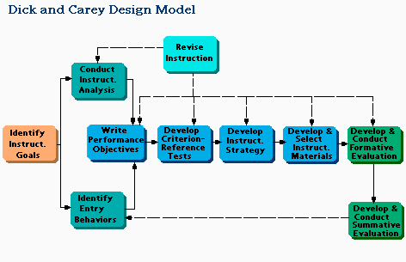
Figure 5: Dick and Carey Model
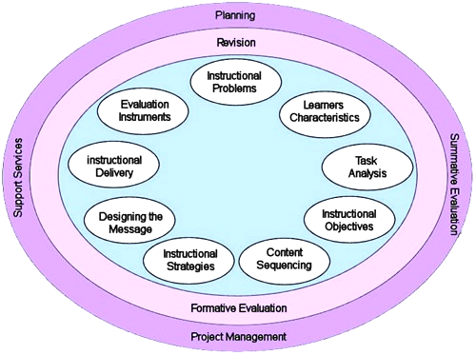
Figure 6: Kemp’s Model

5.2 History of Instructional Design

As a formal discipline, Instructional design (also instructional systems design) has a long history. The first contributions to ID, dealing with cognitive basis of learning and memory, can be considered those of Aristotle, Socrates and Plato. These were further advanced by St. Thomas Aquinas, the 13th century philosopher, who based his theory of teaching on free will. Some four hundred years later, John Lock developed Aristotle’s philosophy of human’s initial mental blankness by claims that nearly all reason and knowledge must be gained through experience, thus stressing the importance of experience. Finally, at the turn of the 20th century, John Dewey came with the theory of active learning, promoting that learning occurs best when appears together with doing. The 20th century also gave rise to behaviourism, represented by Thorndike and his original stimulus-response (S-R) model of behavioural psychology, on which instructional design was based together with constructivism and cognitivism. Thorndike’s theory was further advanced by Hull, who introduced a motivational model of behaviour emphasizing learner's wants, attention, and activities. The Second World War became the most important period for instructional design when ID was used by the U.S. army for the purpose of efficient military training. In the following fifty years, instructional design has become the standard for developing high-quality training/learning programs in military, corporate as well as educational settings. (Leigh, n.d.).
In terms of modern history, the instructional design (also ISD) is rooted in the period between 1940s and 1960s, connecting several theories such as Skinner’s behaviourism and programmed instruction, Bloom’s taxonomy, Mager’s learning objectives, Glaser’s testing and Gagne’s instructional design. Although general systems theory was developed by Ludwig von Bertalanffy in the 1940s, a set of general instructional learning theories appeared later when others could make connection between systems and the learning/training process to create the ISD process as we know it today. (“ADDIE Model”, n.d.). In 1954, a behaviourist B.F. Skinner canonized the basic principles of S-R, feedback and reinforcement, incorporating reinforcement into programmed instruction. B. Bloom introduced his taxonomy of intellectual behaviours in 1956, providing instructional designers with a way to match subject matter and instructional methods, enabling to effectively impart instructional content to learners. In 1962, R. Glaser contributed to ID by his theory known as Individually Prescribed Instruction, an approach using the learners’ results from placement tests for planning learner-specific instruction. R. Mager’s theory on the construction of performance objectives introduced in the same period seems to represent the key element of ISD. In the 1960s, Gagne discussed different levels of learning, distinguishing psychomotor skills, intellectual skills, verbal information, cognitive strategies and attitudes, companioning Bloom’s six cognitive learning domains. Later Gagne developed his theory, introducing nine instructional events that has become the basis for the design of instruction and the selection of media. In the 1970s, Roger Kaufman came with a theory of needs assessment, introducing a problem-solving framework for strategic planning, targeting not only the learner but also the school system and the whole society. Since then, this approach has been used as the basis for planning, evaluation and improvement in educational as well as other settings. Between the 1970s and early 1980s, a variety of ISD models appeared, e.g. Gagné and Briggs, Branson, Dick and Carey, Atkins etc., which is probably related to the establishment of formal education and training departments. In the 1990s, due to the spread of new media such as the Internet and hypermedia, researchers focused on technological innovations, including the performance improvement. Moreover, new approaches to learning and instruction were adopted. (Leigh, n.d.).

6 ADDIE

6.1 Introduction to ADDIE

The abbreviation ADDIE is an acronym standing for Analysis, Design, Development, Implementation and Evaluation. It is an Instructional Systems Design (ISD) model that has been influenced by instructional theories such as behaviourism, constructivism, social learning and cognitivism, emphasizing interdependence of entities joined in learning environment by incorporating successful teaching and learning theories. Nevertheless, the ADDIE model does not directly follow specific learning theories, providing a project management tool facilitating instructional design. ADDIE can be also understood as an umbrella term, referring to other models with the same structure and providing a systematic method to instructional design.
The concept of ADDIE can be defined as a systematic product development process aimed at performance-based learning, representing the traditional “waterfall” type of development model with sequential phases. This model provides an entire instructional design method with carefully planned built-in activities, transparent checkpoints as well as cyclic feedback, assuming that trainers/teachers have a lot of time to develop an excellent training program. Nevertheless, when necessary, quality and timeliness must be balanced. This model is also regarded as a starting point for developing learning objectives. The philosophy behind this concept assumes that intentional learning should comply with the following criteria: authenticity, innovation, inspiration and focus at students. It is assumed that intentional learning is complex, comprising eight basic elements involved in the learning environment, i.e. a student, peer, teacher, content, media, time, context and conditions. (Branch, 2009).
Since ADDIE is not regarded as a product but a process providing guidelines for complex situations, it can become an efficient tool for creating various educational products as well as other learning materials. Validation of the products and procedures incorporated in the development process contributes to the credibility of ADDIE model. ADDIE supports guided learning, which refers to the construction of knowledge in the shared learning environment, following an Input-Process-Output paradigm (abbrev. IPO). The first input phase of IPO is based on identification, accepting information and knowledge. The second phase, process, tries to stimulate creative thinking by seeking appropriate methods, actions and procedures and the last output phase provides the results of the process by presenting knowledge that is being translated into action.. According to Branch (2009), “ADDIE is context sensitive, proactive, interactive and is a vehicle for communicating ideas to all stakeholders.” (p. 4).
To mention some of the main advantages of the ADDIE model, these include cost efficiency, time saving, consistency, effective learning promotion as well as training.
Concerning the disadvantages of this model (for more details see chap. 6.5), it might be perceived as rather unreal because of the claims that it does not copy the real way instructional designers do their work. Nonetheless, it has been used quite successfully for a number of years. Also the opinion that ADDIE cannot lead to the best instructional solutions seems pointless if the model is understood and performed properly. (“ADDIE Model”, n.d.).
ADDIE is currently used by many corporations dealing with individual training. Further, “it is commonly used to accomplish educational objectives, particularly as e-learning options are adopted and distance learning via the Internet becomes more popular worldwide.” (Branch, 2009, p. 5)

6.2 ADDIE phases

Each of the five phases of ADDIE (see fig. 7) represents an important step, serving different purpose, providing a complete training development process that could be illustrated with the two most significant questions. The initial question to be asked before starting the whole process is “What do learners need to learn?” leading to the measurable outcome at the end of the process “Did they learn what they needed?” Although each phase of the ADDIE process should be performed carefully, special attention should be paid particularly to the first two, i.e. analysis and design.
As for the individual ADDIE stages, the first Analysis phase is a pre-planning phase, concerned with the instructional problem clarification, identification of the audience and its needs and identification of potential constraints, seeking information for composing a detailed project management plan. Simply, the questions who, what, where, when, why and by whom are answered. It is the most important stage, in which learning objectives are established. In the second Design phase, the performance objectives are determined, instructional strategies devised, appropriate testing methods generated and calculations made. Shortly, the blueprint or course structure is created. The first two phases can be performed simultaneously. In the third Development stage, the content is created according to the decisions taken in the design phase, and learning resources validated. In other words, what was designed in the previous phase is applied and the training product is created. In the Implementation stage, the training is delivered, including the instructors/teachers’ training. Its aim is to prepare the teacher and engage the student by preparing the learning space. It is necessary to choose media, develop guidance for the teacher as well as the student and conduct a trial test. The purpose of the trial version is to test the prototype developed in the previous steps with targeted audience. In the last Evaluation phase, the criteria and evaluation tools are selected and the quality of instructional products and processes is assessed before and after implementation. However, Branch (2009) suggests there is not a precise set of procedures for the ADDIE model or no single correct sequence of such procedures. “The procedures associated with each phase of ADDIE will vary depending on the designer’s perspective, the backgrounds of the design team members, and the peculiarities of the context in which the ADDIE paradigm is being applied.” (p. 18).
To provide a detailed description of each ADDIE phase, individual stages will be discussed in the following paragraph. The very first step of the whole process is the identification of the problem, posing the challenge for learning or training in order to establish the instructional or learning goal, which represents the purpose of the course. In other words, what do you want the learner to achieve after the lesson? Second, the learning goal is split into objectives, i.e. smaller learning steps. The question to ask here is whether the course objectives are based on accreditation agency, curriculum, program or school requirements. After determining the learning objectives, it is essential to analyze the learner as well as the setting and learning conditions. This means to identify the learner’s existing knowledge, skills and characteristics, including the learning style and consider the factors such as the learner’s background, the learner’s expectations about the course, the number of students for the course, prerequisites, compulsory versus elective courses, the fact whether the course replaces or supplements an existing one, potential information gaps, what will be needed for teaching (e.g. a pre-test at the beginning of the course, a review etc.), who will approve/pay for the instruction and what will be expected. Next, it is advisable to examine existing learning constraints (e.g. the age of the learner, different levels in case of advanced and remedial students, learners’ disabilities, time zone differences, technology issues such as software incompatibilities, plug-ins, etc.), delivery options (e.g. Web, CD/DVD, Director, Book etc.), and determine the learning environment i.e. face-to-face, online or combination of both (so called hybrid courses). Online pedagogical considerations should be also made (i.e. auditory, visual, verbal, tactile etc.) and the timeline (including management, storyboarding, design, training etc.) for finishing the project established. Also the involvement of other participants, such as instructors and student assistants, should be determined in this step. Further, the course content should be identified and resource assessment made. This involves asking relevant questions, such as what materials will be needed (books, textbooks or workbooks) and what content will need to be created (syllabus, assignments, study guides, presentations, illustrations, audio/video materials, exercises, quizzes, resources etc.). If necessary, material is reserved in the library. What is especially important to avoid future problems is to ensure that copyrights of all the materials will not be infringed. It is helpful to explore possible existing contents, which might save time as well as money and enable to focus on improvements. Technical analysis is also an integral part of this stage, determining the tools needed in the future course, including software and hardware, and establishing server capabilities and systems needed (e.g. Moodle). Next, structural analysis is necessary, considering the future course format (e.g. a single learning experience, a few longer sessions or more frequent shorter ones, purely online learning or blended learning etc.), appropriate course duration and time distribution (time needed for introduction, skill development, test preparation, determining due dates for various tasks, quizzes, group work etc.). Further, instructional strategies should be considered. This includes decision making regarding the structure of the learning events and the choice of appropriate strategies (e.g. the organization of activities, interaction, lectures, exercises and assignments, summary, feedback from students etc.). As the evaluation issues should be considered throughout the whole instructional design process, formative evaluation should be determined in this stage. Consequently, the form of eliciting feedback from students should be defined. The questions to be answered here are what to ask and at what points. Finally, the differences between classroom and online learning should be considered (e.g. online teaching concepts, computer literacy etc.). The analysis process is finished with the outcome in the form of a concept map based on preparatory research. The main aim of this phase is to understand a problem (as the instruction always represents the response to a problem) and to design a proper means to deliver an instructional solution to achieve the desired learning behaviour. (“ADDIE Instructional design”, n.d.). The first phase should not be underestimated as a number of problems can be prevented from by performing this step carefully.
The second Design phase represents a systematic procedure for planning instructional systems that involves planning, developing, managing and evaluating an instructional process. Its main aim is to create a blueprint of the course. In this phase, analysis of the subject matter should be continued and performance objectives defined by considering a number of factors, such as learning domains, instructional strategy, delivery methods as well as evaluation instruments. However, the first subject to be determined in this step is the sequence in which the learning objectives will be reached. Subsequently, instruction is divided into individual units, either chronologically by week/topic (so called “week instruction”) or socially. For each unit separately, it is necessary to state the goal, specific learning objectives, content, instructional and assessment strategies, due dates and identify the software tools (e.g. tests, chat rooms, discussion areas etc.). Thereafter individual units are entitled, providing the names for the learning modules. Further, types of activities and exercises, tests, content and its organization, lesson planning and media selection are dealt with and materials collected. It is important to ensure all the materials needed for each of the units. As for the actual course content, it is not created in this phase, being the subject of the next development phase together with the development of learning materials. To search for the sites and resources available via the Internet/in the library, it is essential in this phase to draw from other’s experience, to find relevant material to support and supplement the instruction, to find resources to support the learner and reduce costs. Subject to consider in this search includes availability of online resources, such as libraries, websites and discussion forums, availability of courses or materials in other media, possible contributions of experts in the form of the course instructors or “guests”, availability of resources at learner locations, such as libraries, books, videos, testing centers etc. Subsequently, the resources should be linked to specific objectives. The types of resources can be divided into several categories. These are resources from existing courses used as a part of the new course, resources used as guides or those used to supplement the course (e.g. books, articles etc.). Other supporting materials can be used in the form of references, however, these are not the part of the course. (“ADDIE Instructional design”, n.d.). To increase learning effectiveness, it is necessary to determine the instructional strategy. Subjects to be discussed here include pedagogical issues, availability of media, interaction, meeting the objectives as well as their measurement. Another important step of this phase is lesson planning. First, it is desirable to design a lesson template, in which a number of factors should be considered such as learning objectives, lesson content, visuals, practical exercises, anticipatory problems, evaluation, lesson closure etc. After generating a lesson template, it is necessary to plan each lesson/sequence of lessons and decide on subjects relevant to lesson planning, such as which skills, knowledge and attitudes need to be developed, consider teaching techniques, delivery methods, media choice, appropriate resources, suitable activities, the course structure, sequence as well as presentation, assessment strategies etc. Different learning styles should be also taken into account when planning lessons properly. Therefore, carefully designed lesson plans should involve activities suitable for basic types of learners, i.e. visual, auditory and kinaesthetic. Since well-planned use of media contributes to the effectiveness of instruction, various considerations should be made before selecting media to be incorporated into the course. The issues to be considered include technical issues, compatibility with the instruction requirements, costs etc. Media should primarily support the learning objectives. Inappropriate media choice could bring obstacles to the course instruction. Next, testing strategy should be determined. To mention some of the useful strategies for designing tests, positive presentation is important as well as the sense of improvement provoked in students. What designers should keep in mind is the fact that tests provide reinforcement, feedback and give encouragement to learners. Regarding the test questions, clarity is essential. Further, sufficient opportunity for learners to provide feedback should be ensured, which is crucial to the continuous process of improvement. Thus, future deficiencies can be eliminated on the basis of feedback received from the course participants. There are a number of evaluation programs to choose from. The subject to consider here regards test questions. It is desirable to use multiple choice questions as well as some open questions or area, in which other subjects that have not been touched can be expressed. Finally, the course interface together with the course layout is designed. An appealing interface can provide an efficient tool for students’ engagement in the course. Similarly, if the course interface is not appealing enough, it can cause the opposite effect. The interface design involves several elements, i.e. the orientation in the course (e.g. through tabs, colour schemes etc.), navigation (e.g. menus, buttons etc.) and a theme (the course environment). Although the layout is the part of the interface, it should be considered separately, providing a friendly course environment. Up to this point, all the issues have been dealt with only theoretically, however, the detailed considerations of the first two stages of the ADDIE model, i.e. Analysis and Design, provide great flexibility for the course modification and correction prior to the actual course development, thus saving time, money as well as effort. (“ADDIE Instructional design”, n.d.). At the end of the design step, a prototype/template is created with the application of graphic design. Simply, what the course will look like after completing the whole process is decided in this phase. The prototype should contain all the course components such as main menu, learning modules, lessons, pre-tests, quizzes, discussions forums and other items. The whole course should be logically organized, following the order of the objectives. Even though the course template is not required, it facilitates the following development phase.
Generating course materials is the subject of the next phase – Development, in which relevant instructional materials are developed and suitable media chosen together with effective teaching methods. The main purpose of the development phase is to produce the course content, perform evaluation and revise the project. The blueprint created in the previous phase is now reviewed. After developing the remaining course content, the course begins to be built. What is important in this step is to remain focused on the learning objectives, following what was identified in the previous two phases. The materials/media collected in the development stage include audio, video, images/graphics, databases, games, simulations, online books and text materials that are prepared, developed or referred to (e.g. in a list of references). A range of media content should support the learning objectives. Moreover, all the materials should be incorporated into the course in a logical way. If e-learning is involved, technologies and all multimedia elements are incorporated. Different learning styles should be considered and all the possible options examined before developing the course. Also the form of instructions should be carefully considered. Since too much information tends to confuse the students, it should be short, concise and explicit. The purpose of the instructions is to move the students through the learning exercises, and to prompt them what to do. (“Instructional Design”, n.d.). In addition, it is helpful to create a “welcome page” for the course, in which the course is introduced (the teacher may be introduced as well), providing instructions on getting started with the course. At the end of the development stage, the course should be reviewed to reduce deficiencies. However, it is advisable to test a prototype before it is fully developed to avoid potential problems and adjust the course in advance. The issues to be addressed in this step are the following: the user interface (particularly its comprehensibility, consistency and professional design), content (Is everything in place?), course links (Do they work?), instructions (their clarity), assignments (Are the objectives supported?), evaluation strategies (Are the objectives measured?), interaction as well as feedback opportunities (sufficiency). (“Instructional Design”, n.d.).The whole project is subsequently analyzed and revised on the basis of feedback received. The primary goal of this step is to ensure that students’ interest will be attracted and maintained during the whole course. The success of the development phase depends on the information carefully collected in the analysis phase (the identification of needs) and decision making in the design phase. Performing the first two ADDIE phases properly, a number of difficulties that usually start to occur in the development stage should be prevented and the following phase should proceed smoothly. The outcome of the development stage should be represented by a detailed action plan listing procedures for the following implementation phase. The plan should also contain responsibilities assigned (if there are more team members), time schedules and all the important deadlines. Since the two phases Design and Development are the most time-consuming, it should be taken into consideration from the beginning of the process and reflected in the project schedule.
In the Implementation stage, the plan outlined in the previous ADDIE phases is implemented. The main goal of the implementation stage is to deliver the instruction. This phase involves promotion (if necessary), distribution (usually using a Learning Management System, e.g. Moodle), reporting, maintenance and the development of a training procedure for both, the facilitators as well as the students. Regardless of the targeted audience for the course, the course can be promoted through a number of ways, such as submitting to search engines, online advertisements, e-mail promotion, joining an educational portal or traditional methods, representing the most expensive means. Naturally, the need for promotion depends on the fact whether it is necessary to find students on the Internet or whether the targeted group for the course is ensured, e.g. company employees, university students etc. (“ADDIE Instructional design”, n.d.). Reporting is necessary in this stage as it provides the instructor with necessary feedback, enabling to adjust teaching and accommodate the learners. A LMS usually offers efficient reporting tools, thus saving time to the instructor. As for the course maintenance, all the technology needs support. Consequently, it should be ensured that the Internet access is reliable, servers perform properly and all the links function. It is advisable to make several backups throughout the instructional process so that the course can be restored in case of a failure. Another important subject of the implementation phase is training. Whilst the facilitators should be trained on the course curriculum, learning objectives, delivery methods and testing strategy, the students should be prepared for using new tools, i.e. software or hardware, learner registration as well as other necessary preparations. Next, putting the learning tools into the right place is required. These are the crucial factors in the implementation stage. Basically any well-designed product might fail if instructors and students are left unprepared and the position of the learning tools is not ensured. Other subjects to be dealt with in this phase include the course schedule, enrolment, the selection of trainers/teachers or issues such as to ensure Internet-ready computers for all sites, check external links in learning modules to be still accessible etc. Nevertheless, the main purpose of the implementation phase is to launch the course. Before running a trial course, it is necessary to check all the dates (e.g. start and end dates, due dates etc.), topics, tasks, tests as well as discussion areas (e.g. forums). Next, settings of the course should be checked together with the settings for assignments and quizzes. As for the trial course, the first days should allow the students to become familiar with the course. This involves reading initial instructions and the “welcome page” if it has been created, introducing the students among themselves, which contributes to the sense of group, giving feedback to the introductions and eliciting feedback from the students (e.g. through a short survey), making sure that the students understand what they are supposed to do, answer all the questions from students promptly and do not forget about announcement regarding initial work in the course. In the following two weeks (provided the course follows the “week instruction”), the teacher should support discussions and ask the students opinions about the first experience in the course in order to make them aware they are being cared about as well as to be able to identify any potential difficulties. The identification of problematic areas that can be subsequently fixed is necessary in this step through systematic collection of data. Therefore, formative feedback should be incorporated into every learning module/unit. Open-ended questions seem to provide the right option for receiving the best results (i.e. questions such as “What do you like most/least about this unit?”, “How would you improve it?” etc.). It is advisable to undergo this process with one-to-one trial before trying with a larger group. The final course is subsequently adapted according to the needs and deficiencies discovered during running the trial course (especially through feedback) with the participation of the members of the target audience. The implementation phase also includes evaluation of the course design.
Since the ADDIE model emphasizes careful planning, review and revision that form the basis for a good training program, evaluation represents a crucial element in the whole process, determining the quality of the instructional design and effectiveness of the final output. Despite coming last, evaluation is employed during the whole process, starting in the analysis stage. The purpose of the final Evaluation phase is to assess teaching and learning activities as well as learning outcomes of the students, representing the key factor for assessing effectiveness of the course design. Moreover, due to evaluation, it is possible to receive necessary information to improve the future course. The questions to put in this stage include the following: “Did the students achieve the learning objectives set for the course?”, “Did the teaching strategies and learning tasks help the students to move towards the learning outcomes?”, “Were the learning objectives specific enough?” and finally “How the course could be improved?”. If the students did not meet the expectations in the form of stated learning objectives, there is probably a problem concerning the course activities or course delivery that can lie in several areas, e.g. unclear instructions, immeasurable objectives, inaccurate evaluation strategies, unsupportive learning activities, unclear guidelines and/or assignments, inappropriate teaching methods etc. As regards different subjects to be evaluated, these could be divided into three categories, i.e. the reaction of learners, learning results and learning behaviour. To elicit learner reaction, students must be asked to assess the learning/training after they finish the course through post-learning surveys. To evaluate learning results, i.e. knowledge, skills and attitudes, pre-test and post-test must be incorporated into the course, discovering whether the learning objectives were met. Evaluating learning behaviour seems most difficult. It can be performed through later measurements from three to six months after finishing the course in the form of observations and behavioural surveys or interviews. Thus, it can be seen whether the instruction had lasting effect on the learners and whether their learning behaviour changed as a result of the instruction. (“ADDIE Instructional design”, n.d.). The Evaluation phase includes two parts: formative and summative evaluation. While formative evaluation occurs in each stage of the ADDIE procedure, having influence on the effectiveness of each step, summative evaluation employs tests designed for individual items providing feedback opportunities from particular users and assess learning outcomes of the students. The main aim of formative evaluation is to collect information particularly in the early stages of the ID procedure in order to uncover deficiencies, identify errors and find suitable solutions to remove obstacles, which contributes to the success of the project. The individual stages of formative evaluation include evaluation goal specification, preparation (determining personnel as well as measurement instruments), data collection (eliciting feedback) with subsequent analysis, revision (modifying the course to increase effectiveness based on the collected data) and recycling (retesting the course, removing deficiencies and moving to summative evaluation). Summative evaluation follows the implementation phase, determining its effectiveness and meeting instructional objectives. It allows measuring knowledge transfer, learning outcomes, cost factors and attitude of learners. (“ADDIE”, n.d.). Its main goal is to assess the effectiveness of the project, i.e. whether the course was favoured by the students, how much they learned as well as other potential outcomes such as reflections received from the teacher etc. Therefore, data from all the possible resources, i.e. students as well as teachers, should be collected for final evaluation. Such information can be gathered through various methods, e.g. short surveys asking students for their opinion, pre-tests and post-tests measuring whether the learning objectives were achieved, interviews etc. However, it is not possible to measure all the results easily, e.g. changes in learners’ behaviour. In case the information is insufficient, the formative evaluations should be re-reviewed and students asked for more feedback.
Although there are several influential factors, e-learning evaluation depends primarily on its aim. The question is whether to evaluate the learner (his skills and knowledge) or the online course. Each requires different evaluating strategies. If the object of the evaluation is the learner, it is necessary to build in a sufficient number of performance opportunities with the main objective to found out what the learner is able to do after the course. In the case of the course evaluation, it is important to set clear goals, e.g.: to reduce costs, eliminate help desk calls etc. and measure how well the course meets these targets. (Shank & Sitze, 2004).
As it has been already suggested in the chapter above, omitting any of the five basic steps of the ADDIE model can cause ripple effects, disrupting the whole process as each ADDIE step is built on the previous one. Therefore better planning and proper executing a project should be preferred in order to reduce potential risks in the form of errors, increasing project costs.
Lastly, it should be mentioned that in the classroom model of ADDIE, the relevance of given instructions should be considered rather than problem analysis performed as it is beneficial to students’ motivation. (Carr-Chellman, 2010).

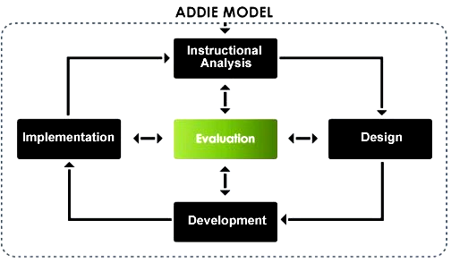
Figure 7: The five phases of the ADDIE model.

6.3 ADDIE and learners’s motivation

In addition, there are several significant subjects to be dealt with in any instructional design process, including the ADDIE model. Since active participation and motivation represent essential factors in a learning process, it should be carefully considered during an instructional design process. According to Gagne’s nine events of instruction, first learners’ attention should be gained through various media. Second, learners should be informed of learning objectives usually through the statement “After the lesson you will be able to…”. Third, new lesson should be related to previous experience and stimuli presented with distinctive features. Next, instruction should proceed from simple to complex. Further, performance should be provoked, involving learners in questioning, discussions and demonstrations to support comprehension and keep attention. Next, feedback should be provided by the teacher and learners’ performance evaluated through quizzes or other techniques. Finally, retention and learning transfer should be ensured by creating opportunities for learners to apply the learning outcomes in a real world experience. (“ADDIE Based Five-Step Method”, n.d.). As motivation has a positive impact on learners’ performance, various motivational techniques should be used during the ADDIE process to increase it, e.g. getting attention through learners’ interest, personalizing the learning process, relating the instruction to learners’ needs and objectives, building confidence in learners through the feeling of success, making learners satisfied through a system of rewards, building a sense of “fair play”, reinforcing learning through helpful feedback provided by the instructor etc.

6.4 ADDIE for teaching purposes

From the teacher’s perspective, instructional design is a disciplined approach to designing learning situations in a classroom, helping to focus the teacher’s efforts toward specific learning goals that are then supported by appropriate objectives, tests, technology as well as activities. Its main goal is to help students achieve the desired learning outcomes. (Carr-Chellman, 2010).
Similarly, ADDIE, representing one of the ISD models, offers an efficient tool for planning, implementing and evaluating the teacher’s instructions. In his book, Carr-Chellman (2010) defines ID as “the process by which instruction is created for classroom use through a systematic process of setting goals, creating learning objectives, analyzing student characteristics, writing tests, selecting materials, developing activities, selecting media, implementing and revising the lesson.” (p. 3).

6.5 Weaknesses of the ADDIE model

The ADDIE model provides undoubtedly a great tool for instructional designers as well as teachers/instructors, offering many advantages to an instructional systems design process. Nevertheless, there are also some drawbacks in the use of this approach. The ADDIE process is sometimes claimed to require too comprehensive analysis, which is unreal and might lead to the failure of the whole project. Further, it has been criticised for using storyboards, providing ineffective tools for developing, communicating and assessing design alternatives. The strictly set processes, i.e. the five ADDIE phases, are sometimes seen as to prevent creativity of the whole instructional design (it is said to be too systematic and linear). Next, it has been criticized for being too constraining and too time-consuming to implement. It is also suggested that there is no accommodation for dealing with faults/interesting ideas during the process. Moreover, it is claimed that learning programs meet only those criteria that are measured (e.g. schedule or costs) and fail to focus on the identification of behavioural changes. Lastly, the post-tests incorporated into the course offer little relevant information to help to improve the instruction. (“Weaknesses of the ADDIE Model”, 2007). Due to the weaknesses of the ADDIE model, other variants of ISD models have been developed such as once mentioned Dick & Carey model or Kemp model. However, all the criticism of the ADDIE model appears pointless if the model is properly understood and its process accurately performed.

6.6 History of ADDIE

Even though the instructional systems design concept comes from the early 1950s, the ADDIE model first appeared in 1975 when it was created by the Centre for Educational Technology at Florida State University for the U.S. Armed Forces. Originally, it contained five phases. These phases, which have been maintained until today, are Analysis, Design, Development, Implementation, Evaluation and Control (see fig. 8). Despite being systematic, the ADDIE process provides sufficient flexibility as it can be used for individualized as well as traditional instruction. Nevertheless, it is specifically oriented towards objectives and criterion-referenced tests. In 1981, Dr. Russell Watson proposed slight changes to the original ADDIE model at International Congress for Individualized Instruction, altering the steps within each of the five phases to suit an organization’s needs (see fig. 9). Nowadays, the steps have been adjusted to reflect the needs of today’s organization. (“ADDIE Model”, n.d.).
Initially, the model was referred to as SAT (System Approach to Training) or ISD (Instructional System Design). Although the first version of the ADDIE model was strictly linear, by 1984 the model was developed by U.S. Army into a more dynamic structure and all its phases interrelated. Additionally, the last step Evaluation and Control was renamed to Evaluation. Hence, the model becomes ADDIE. As for the acronym ADDIE, this seems to be first used in 1995 by Schlegel in his work A Handbook of Instructional and Training Program Design. Another important step came in 1997, when Merriënboer suggested that ADDIE can be used in combination with other ID models, creating a “plug and play” model. (“ADDIE Model”, n.d.).
To sum up this chapter, Instructional System Design has developed through a number of years into a complex process. Although it was originally created as a tool for designing, implementing and evaluating corporate and military training (invented by U.S. military), it has become a standard for worker training in various settings. What is especially relevant to this thesis is the fact that recently, eminent efforts have been made to find ways to apply ISD to public education. (Carr-Chellman, 2010).

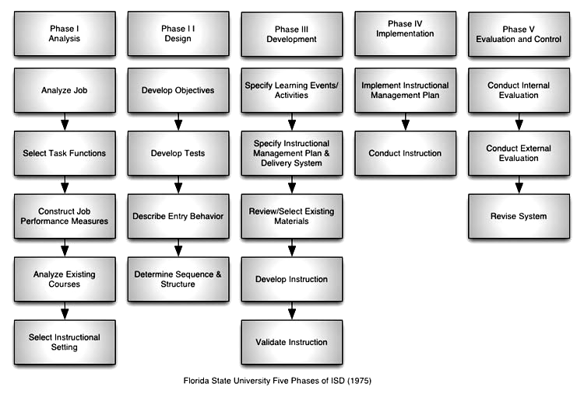 Figure 8: Original five steps of the ADDIE model
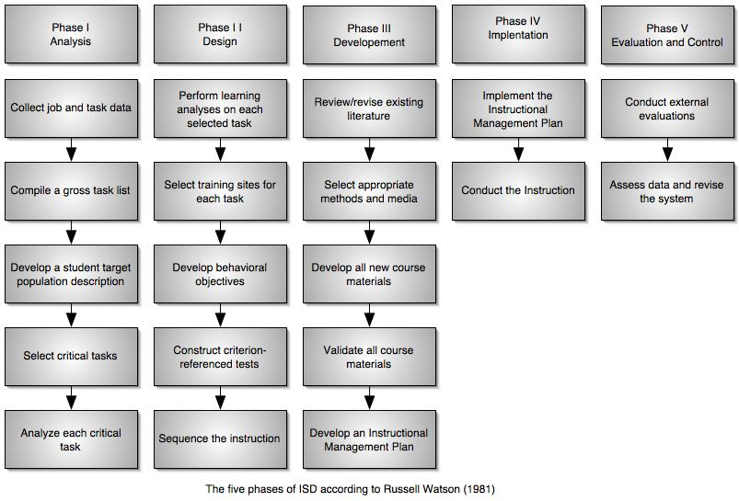 Figure 9: The revised ADDIE model according to Watson

7 Figurative language

7.1 Introduction to figurative language

According to Cambridge Dictionary, the word figurative is defined as “(of words and phrases) used not with their basic meaning but with a more imaginative meaning”. (“English dictionary & thesaurus”, 2011). What is important to distinguish is the difference between literal and non-literal (sometimes also referred to as figurative or metaphorical) language. Since the word metaphorical can be easily confused with a particular type of figurative language called “metaphor”, it is better to use the term figurative, providing an umbrella term for various non-literal uses of language. (Montgomery et al., 2007, p. 118). Whilst the term literal is used to describe the language in which words or phrases correspond to their primary/denotative meanings (in other words, they state fact as they are), figurative language (or non-literal language) uses words and phrases whose literal meaning does not make any sense or simply cannot be true, implying a non-literal meaning that deviate from the usual meaning, involving exaggerations and alterations, with the purpose “to suggest illuminating comparisons and resemblances”. (Vogel, 2007, p. 27). In other words, “figurative language is language that means one thing literally but is taken to mean something different”, which is an omnipresent aspect of language. (Carroll, 2008, p. 141). Thus, supplementary layers of meaning are ascribed to words and phrases that are taken out of its common context. Since the noun figure refers to an image/picture, figurative language can be also interpreted as the language creating mental images, enabling to express different meanings vividly and more quickly than words.
In their work, Brinton & Brinton (2010) claim that “figurative uses of language routinely violate or break selectional restrictions”. With these uses, “as opposed to true anomaly, however, we can supply some interpretation, allowing certain semantic features to override others in context”. (p. 176). To illustrate literal, figurative and anomalous uses of language with examples, the three following sentences are provided.
- A man attacked me.
- Envy attacked me.
- The stone attacked me.
Whilst the first sentence is an example of a ‘normal’ or literal use, the other two violate the selectional restriction of the verb “to attack” since it normally requires an animate subject. Whereas the second sentence permits interpretation, the last one does not. (Brinton & Brinton, 2010).
Dobrovol’skij & Piirainen (2005) further suggest that to decode the uses of figurative language, purely linguistic knowledge is not sufficient. Therefore, extralinguistic knowledge, including culture-based knowledge must be applied. Such cultural knowledge may include the knowledge of folk beliefs, customs, art, literature etc.
The figurative expressions that are employed by figurative language are rhetorical devices that are termed figures of speech. Figurative language involves various types of figures of speech such as metaphors, personification, similes as well as many others, including indirect speech acts. The most common types, i.e. metaphors and similes will be dealt with in the following chapter. As for the idioms, these are usually considered to be another type of figure of speech. However, this issue is arguable as idioms seem to form a specific group of figurative language. They will be focused on in a separate chapter since they form the core of the online course “English idioms”, representing the practical part of this thesis. Proverbs, being of peripheral importance to this thesis, will be touched together with similes and metaphors. Additionally, instances of some others figures of speech will be provided.
Generally, the use of non-literal or figurative language and figures of speech is usually associated with literature, particularly poetry. However, it is common also in prose and non-fiction. Besides literature, it is frequently used in everyday speech, writing, pop music, TV as well as other media. Incorporating figures of speech into writing and conversation helps authors to illustrate the meaning that needs to be conveyed and also to express their own view of the world in a remarkable way, which makes the readers/listeners understand as well as interested. Thus, using figurative language can be seen as a way to highlight communicative purpose of the discourse, providing a powerful tool for communication, enabling to communicate a wider range of meanings than would be possible if limited merely to literal language. (Carroll, 2008, p. 150).
To name some of the difficulties that concern the use of figurative language, it is usually difficult for small children as they cannot interpret words with more than one meaning. Also people with various disabilities might have problems with the identification of figurative expressions since they give preference to the literal use of language. Finally, people learning English as a second language (abbrev. ESL) and sometimes even native speakers themselves (such as the groups mentioned above) struggle to understand figurative language due to their limited vocabulary and different cultural background (the figurative expressions they know from their native language usually differ). Nonetheless, learning figurative language should pose a challenge to all learners.

7.2 Figures of speech

According to scholars of classical rhetoric, figures of speech can be divided into two main categories – schemes and tropes. While schemes are those figures of speech that change the usual pattern of words (e.g. cataphora, ellipsis, pleonasm etc.), tropes alter their general meaning (e.g. allusion, irony, oxymoron etc.). (“Wikipedia, the free encyclopedia”, n.d.).
However, not all the figures of speech can be regarded as figurative. For instance, the hyperbole “Thousand thanks!” cannot be considered figurative as there is no image component involved in its meaning structure (the concept of hyperbole will be explained later in this chapter). Similarly, some other figures of speech such as alliteration, litotes or oxymoron, which somehow deviate from what is generally considered “normal”, “neutral” or “standard” in the language cannot be labelled as a figurative expression. Such expressions are indirect but not figurative. (Dobrovol’skij & Piirainen, 2005).
Probably the most frequently used figure of speech, typically illustrating figurative language, is metaphor. The word metaphor comes from the Greek word “metaphora” with the meaning “to transfer”. Brinton & Brinton (2010) provides the following definition of metaphor: “metaphor refers to expressions which transfer a word from one conceptual domain to another”, thus violating selectional restrictions. (p. 178). In other words, this figure of speech is based on implicit comparison/similarity between two unlike things. According to Carroll (2008), “metaphors are primarily used to convey ideas and feelings that are difficult to express”. (p. 150). Thus, metaphor enables to express emotions, attitudes and various situations that would be otherwise too difficult to be communicated. Dugan (2011) also stresses that “metaphor is important to understanding because it enables image-schematic thought”. (“On Idioms and Metaphor”). Moreover, metaphors seem to play an important role in the formation and existence of idioms. (Dugan, 2003, p. 1). In order to interpret a metaphor, the element of similarity between a non-literal word/phrase and the implied meaning must be searched for and transferred into a new context. To provide an example, the statement “to have a baby was the summit of her ambition” illustrates a metaphor, transferring the word “summit” from one semantic field (mountains) into another (aspirations in one’s life). Thus the top of the mountain is compared to the highest point of human ambitions, suggesting similarity between the “highest point” and “summit”. (Montgomery et al., 2007, p. 118).
Metaphor often uses body parts to refer to the parts of other entities such as “a neck of the bottle”. Further, it commonly transfers terms from the physical domain to the mental domain e.g. “to wrestle with an idea”. Typically, it also uses the names of animals to refer to human beings, lowering their esteem such as a rat, pig, snake etc. (e.g. the sentence “He is a pig.” referring to someone’s inappropriate table manners). The interpretation of a metaphor can be rather difficult as it is based on selected features of a word. Moreover, these features are often peripheral instead of the core ones, transferring them to the other domain. For example, in the sentence “That vending machine ate my money.” the feature of eating is transferred onto the inanimate entity of the vending machine, attributing human qualities to it. This process can be also referred to as personification. (Brinton & Brinton, 2010).
There are different types of metaphors, e.g. absolute, animistic, complex, conceptual, concrete, extended, mixed etc. With an absolute metaphor, there seems to be no similarity between the image and the idea (e.g. “The TV is the autobahn of a living room”.). An Animistic metaphor uses animate (i.e. living) things to describe inanimate concepts (e.g. “the leg of a chair”). While a complex metaphor involves a single metaphor that is supported by another secondary element (e.g. “The puck danced into the net.”), a conceptual metaphor presents an idea that can be understood relatively in terms to another subject (e.g. “Time is money”). A concrete metaphor involves a concrete term to refer to an abstract concept (e.g. “the burden of youth”). An extended metaphor compares one subject that is primary to other secondary subjects, involving expressions form the same semantic field (e.g. “All the world is a stage, and all the men and women merely players”.). A mixed metaphor, on the other hand, employs two or more metaphors whose expressions come from different semantic fields (e.g. “wake up and smell the music”, combining the expressions “wake up and smell the coffee”, implying the meaning “to be more alert” and “hear the music”). Interpretation of such metaphors is difficult, leaving a lot of space to one’s imagination, and depending much on the context.
From the point of view of life and duration, metaphors can be divided into live metaphors, degraded (fading) metaphors and dead metaphors. A live metaphor is a fresh expression that have been newly created, using one’s imagination (e.g. “My little brothers are a band of drummers.”, implying the meaning of being noisy). A degraded/fading metaphor is the one which have already become trite, however, it still conveys some of its initial freshness (e.g. “to sift the evidence”). (Dugan, 2003, p. 1). Finally, a dead metaphor involves concepts such as “to grasp” (with the meaning of understand) that has been used so frequently that the original meaning of movement has been replaced by the new one, thus the metaphor “has died”. In other words, dead metaphors are those metaphorical words and phrases that stop to be regarded as metaphors. Interestingly enough, the term “dead metaphor” itself is an example of this type of metaphor.
Another typical figure of speech is that of a simile, sometimes regarded as a subdivision of metaphor. It is also based on comparison/similarity between two unlike things (people, animals, things or places) that are introduced by a conjunction or particle “as” or “like”. Nevertheless, this time the comparison is explicit. For instance, “Her hair was as white as snow.” or “He eats like a pig.” are typical examples of similes. Although all the components the simile consists of convey a literal meaning, similes are fixed and conventionalised expressions, representing integral part of figurative language. However, there are similes the meaning of which cannot be understood literally at all (e.g. “life is like a box of chocolates”, implying the meaning of unpredictability). Despite the fact that similes were traditionally considered to belong to the class of idioms, they are discussed separately in this thesis since contemporary views classify similes as a specific group, representing a proper category of figures of speech. (Dobrovol’skij & Piirainen, 2005).
To compare a simile and metaphor, metaphors are generally more difficult to identify, being based on implicit relations between entities, whereas similes express the relationships explicitly. Therefore, metaphors can be understood as implicit devices as opposed to similes, functioning explicitly. To demonstrate the previous point, the following examples are provided. (Beard et al., 2002, p. 38, ).
- “The camel is the ship of the desert.”
- “The camel is like a ship in the desert.”
While the first sentence illustrates the example of a metaphor, the second one instances a simile, both comparing the camel to a ship that must store the water for the survival of its passengers. The image of the desert parallels the sea and its vastness. (Beard et al., 2002, p. 38).
Furthermore, metaphors can be in a traditional view also regarded as “elliptical similes” providing reduced forms of similes (e.g. “Achilles is a lion.” representing a short version of the simile “Achilles is like a lion.”). However, this approach seems wrong as metaphors imply meaning much stronger than similes and should not be classified as similes. (Dobrovol’skij & Piirainen, 2005).
Other common figures of speech include hyperbole, personification, metonymy, synecdoche, understatement, clichés, taboo expressions etc. To provide their definitions, hyperbole is a statement that is being exaggerated for the purpose of emphasis or highlighting, often creating humorous effect (e.g. “I died laughing.”). Personification, as already discussed before, is basically a subtype of metaphor in which human qualities are attributed to non-human or inanimate entities (e.g. “The sun smiled.”). Metonymy involves a semantic shift, using words of single characteristics that replace other words/phrases, referring to more complex subjects (e.g. the sentence “The White House announced its decision.” with the meaning that the U.S. administration announced the decision). To distinguish metonymy from metaphor, the former typically involves one conceptual domain, rather than two distinct ones (being the case of metaphor). (“On Idioms and Metaphor”, 2011). Similarly, synecdoche represents a figure of speech in which the part is used to refer to the whole or vice versa (e.g. “ABCs” standing for the alphabet). In understatement, the statement/expression presents the facts as being less than they really are (e.g. to say “There was a little rain.” when all the houses are flooded). Clichés are phrases that have become stereotyped because of their overuse, losing their originality and effect (e.g. “Haste makes waste.”). Taboo expressions are the words that people tend to avoid to be polite as they are considered offensive or embarrassing (e.g. “adult video”, which stands for pornography).
Even though proverbs are usually not classified as figures of speech, they employ a number of them such as alliteration, ellipsis, personification, hyperbole etc. To define a proverb, Dobrovol’skij & Piirainen (2005) provide the following definition: “proverbs are general statements that are believed to express a universal truth”. (p.51). They are fixed multi-word expressions of metaphorical character that are popular among people, being based on human experience (sometimes also known as “folk wisdom”), referring to shared cultural knowledge, providing rules of social behaviour and human co-existence in a particular culture. Dobrovol’skij & Piirainen (2005) further suggest that a proverb can be regarded as a cultural model the typical feature of which is that it “always recommends a certain way of behaviour”. (p.27). According to Dugan (2011), “the proverbs are stable word groups specific to a certain language, enjoying a long existence and a wide circulation”. (“On Idioms and Metaphor”)
As for the classification, proverbs can be subdivided into maxims and aphorisms. A maxim is “a proverbial saying” or “a general truth, fundamental principle, or rule of conduct”, expressing a piece of advice for living in a memorable way (e.g. “a watched pot never boils”). (“maxim”, 2011). An aphorism is “a concise statement of a principle” or “a terse formulation of a truth or sentiment” the form of which is short and memorable (e.g. a well-known phrase “less is more”). (“aphorism”, 2011). To avoid confusion, distinction between proverbs and sayings should be provided. While saying can be simply a quotation from someone famous (e.g. the famous quote by Julius Ceasar “The dice is cast.”) but also a traditional piece of wisdom passed orally from generation to generation (e.g. “Practice makes perfect.”), a proverb is usually longer, containing some moral (e.g. “A bird in the hand is worth two in the bush”). Since proverbs can be borrowed from one language to another, they might occur across different languages. For example, the English proverb “When the cat's away, the mice will play.” has its counterparts in other languages as well (e.g. in Czech version “Když kocour není doma, myši mají pré.”). As regards significant sources, many proverbs and sayings come from well-known authors such as Shakespeare and other literary sources (e.g. Jesus and his sayings in the Bible such as “The borrower is servant to the lender.”). Many proverbs have also originated from famous stories, songs, films, commercials etc. Another important source is provided by old thinkers such as Confucius, Plato, or Socrates as well as other significant personalities such as scientists, philosophers, historical figures etc.

7.3 Idioms

Another use of figurative language can be illustrated by idioms. Even though this linguistic phenomenon is usually classified as a figure of speech, its classification has remained the subject of debate. Basically, there are no strict boundaries between idioms and other restricted collocations and proverbs. An idiom is a multi-word expression comprising a group of words the meaning of which is more or less fixed and cannot be understood from the meaning of its constituents, i.e. individual words it contains. For example, the phrase “to kick the bucket” implies the meaning of death, however, this meaning could not be deduced from the meaning of individual words as the denotative meaning of the word kick is “to hit someone or something with the foot, or to move the feet and legs suddenly and violently” and of the word bucket “a container with an open top and a handle, often used for carrying liquids”. (“English dictionary & thesaurus”, 2011).
Dugan (2003) defines idioms as following: “An idiom is a long-lived group of words characteristic of a language, comprising grammatical collocations and phrases, most of them being based on degraded metaphors”. (p. 1). Besides metaphors, idioms have been influenced by other semantic processes, such as folk-etymology and metonymy. (Dugan, 2003, p. 2). Further, Dugan (2011) suggests that “an idiom is not just an expression that has a meaning that is somehow special in relation to the meanings of its constituting parts, but it arises from our more general knowledge of the world”. (“On Idioms and Metaphor”)
Since idioms, together with proverbs and colloquialisms, form the most difficult part of language to translate, it is usually very demanding to translate such expressions into other languages because not all the idioms have direct equivalents in those languages. Consequently, the figurative meaning of such expressions can be often changed during the translation or lost completely. Thus, idioms provide a real challenge to translators, who must seek after parallel expressions in a particular language, reflecting its cultural differences (e.g. an English idiom “the icing on the cake”, can be figuratively translated into Czech as "třešnička na dortu".)
To distinguish idioms from other figures of speech, idioms are set expressions (combinations of words) that can be seen as indivisible units the constituents of which either cannot be varied at all or can be varied but only to a certain limit. They are conventional phrases that are fixed in order, lexical form and have a limited range of variants. Moreover, idioms, as well as many other figurative expressions, are usually culture-dependant, rooted in national beliefs, customs, traditions, history or even geography, resulting from a shared human experience. Consequently, idioms can become case-specific and therefore their literal definitions often do not make sense. (“10 Idioms in Translation”, 2009).
Supporting the argument mentioned above, Dobrovol’skij & Piirainen (2005) claim that “the most important linguistic feature of the conventional figurative units”, i.e. idiomatic expressions, “is that they record and preserve relevant knowledge as part of their content plane, including reflection of the perspective culture”. (p. 1).
According to Palmer (1981), idioms are special kinds of collocation of words with certain restrictions, which vary from idiom to idiom. Some idioms are more restricted (frozen) than the others. (p.79). Thus, grammatical structure and vocabulary of idiomatic expressions can occasionally vary (e.g. an idiom in the active voice can be used in the passive, a word/ more words in the idiomatic phrase can be altered etc.). (McCarthy & O’Dell, 2002, p. 6).
As for the language employed by idioms, this is often unusual, containing archaic words, words of foreign origin or even the whole phrases that have been derived from a foreign language (e.g. the French expression “faux pas”, referring to a situation causing embarrassment because of its social incorrectness). Further, the grammatical structure of some idiomatic expressions can be rather uncommon, changing the word class of some words (e.g. prepositions used as nouns in the phrase “the ins and outs”), using unusual verb forms (e.g. the use of the verb to be in the phrase “be that as it may”) or other grammatically untypical features. Moreover, many idioms employ repetition and rhythm (e.g. the emphatic repetition of the same word in the phrase “live and let live”). (Oxford Idioms Dictionary, 2006).
Regarding the origin of idioms, most of the idioms start to be used as a phrase, conveying a literal (denotative) meaning which is later shifted to an idiomatic (figurative) meaning. This can be illustrated with an example such as “to take one’s hat off”, a phrase used in the past to show respect when meeting someone or entering his house. Now, this phrase implies the meaning “to show respect or express admiration for what someone has done”. (Oxford Idioms Dictionary, 2006). Many idioms are rooted in history, related to the way of life at those times, e.g. the idioms connected with farming such as “till the cows come home” (implying the meaning of a very long time), or milling such as “to put someone through the mill” (meaning to experience/make someone experience something difficult). Further, many idiomatic expressions have come from literature. Rich sources for idioms have been provided by fables and fairy tails, e.g. Hans Christian Andersen’s “the ugly duckling” (meaning someone/something that is at first underestimated but later becomes successful), ancient myths, e.g. “Pandora’s box” (referring to something that will become a source of many problems and suffering), biblical stories, e.g. “to fall by the wayside” (meaning not to be able to keep discipline or starts to behave dishonestly) as well as by famous writers, e.g. Shakespeare and his expressions such as “to gild the lily” (meaning to spoil something already perfect by trying to improve it). Moreover, the idiomatic language has been influenced by various famous quotations from well-known authors and historical figures, for example, the saying “hope springs eternal” (implying the meaning that people never abandon hope), coming from a poem by Alexander Pope or Oliver Cromwell’s famous expression “warts and all”, (referring to the concept that includes all the faults, not only the good points), which was first used when Cromwell asked a painter to create a real portrait of him, displaying him as he really was. (Oxford Idioms Dictionary, 2006).

7.3.1 Classification of idioms

In his work, Palmer (1981) suggests that idioms have different degrees of idiomacity. (p. 79). Hence, idiomatic expressions can be divided into four basic categories, transparent, semi-transparent, opaque and semi-opaque. Transparent idioms are those the constituents of which (individual words they contain) indicate the meaning of the whole phrase (e.g. “to give someone a hand”, meaning to help someone). This is possible due to the literal (denotative) meaning of individual words they convey. Thus, the meaning of the whole idiomatic phrase can be easily guessed from the literal meaning of its components. Moreover, transparent idioms (sometimes even semi-transparent idioms) often imply the same meaning in different languages (e.g. the phrase “the black sheep of the family”, referring to a family member who is not approved by other members because of his bad behaviour, has the same meaning in English, Italian, Czech as well as some other languages). Consequently, these idioms are the easiest to be translated. By contrast, opaque idioms are the most challenging for translators as their meaning cannot be deduced from the meaning of their constituents at all (e.g. “to pull someone’s leg”, meaning to make fun of someone). As a result, these idioms have to be learned simply as vocabulary by non-native speakers since they cannot be comprehended by means of translation. In the middle, there are semi-transparent and semi-opaque idioms. While semi-transparent idioms often contain metaphors so their meaning can be understood on the basis of metaphoric shift (e.g. “to skate on thin ice”, meaning to appear in a dangerous situation), semi-opaque idioms are those expressions the meaning of which might be inferred from the metaphor it contains but only to a certain degree (e.g. “to burn one’s boats”, referring to an action that prevents someone from returning to a previous state).
Another classification of idioms provided by Oxford Dictionary of English Idioms (1993) groups idiomatic expressions into the four following categories, pure idioms, figurative idioms, restricted collocations and open collocations. Pure idioms refer to the frozen expressions that resulted from the process of idiomatization into fixed multi-word phrases (e.g. “to kick the bucket”). Figurative idioms are the expressions standing on the border of idioms that are usually fixed (e.g. “to burn one’s boats”). Restricted collocations are semi-idioms, involving one component with a literal meaning and one with a figurative meaning (e.g. “a cardinal error”). And finally, open collocations refer to free syntactic structures, using all their constituents in a literal (denotative) meaning. (Dumitrascu, A.M., 2007).
Further, McCarthy & O’Dell (2002) distinguish several types of idioms according to their structure. Individual types can be various phrases (e.g. prepositional phrases such as “in the bag”, implying the meaning to be certain to achieve something), compounds (e.g. “a rule of thumb”, referring to a useful rule), binomial expressions, containing two lexical words plus the coordinator and (e.g. “rough and ready”, meaning crude and unsophisticated), trinomial expressions, containing three words and the coordinator (e.g. “cool, calm and collected”, meaning relaxed and in control) or whole clauses and sentences (e.g. “to cut a long story short” with the meaning to tell the main points, omitting details). McCarthy & O’Dell also suggest similes to be another type of idioms, involving the structures introduced by the word as/like (e.g. “as black as coal”). (p. 6). However, the author of this thesis considers similes to be a specific kind of a figure of speech, thus classifying simile into a separate category.
Nevertheless, there are many other ways idioms/idiomatic expressions can be categorized. One of them is a thematic division, classifying idioms into groups based on similar characteristics. For example, the idioms connected with the human body can be classified as body parts idioms, the idioms concerning sport can be put into another class of sport idioms etc. According to the thematic categorization of idioms, they can be divided into animal idioms, body parts idioms, clothes idioms, colour idioms, food idioms, health idioms, law idioms, money idioms as well as many other groups such as music, nature, numbers, names, politics, profession, religion, sport, technology & science, time, transport, weather etc. according to the topic they share.
Furthermore, idioms can be simply arranged alphabetically on the basis of keywords they contain, which is the case of most of the dictionaries (e.g. Oxford Idioms Dictionary) or classified into categories according to the regional variation (i.e. the country they are spoken in) e.g. British, American, Australian, Canadian idioms etc.
7.3.2 Idiom dictionaries

When searching for the meaning of idioms, it is advisable to consult a dictionary. There are special kinds of dictionaries focusing on English idioms such as Cambridge International Dictionary of Idioms or Oxford Idioms Dictionary explaining meaning of idioms/idiomatic expressions. A good idioms dictionary should provide relevant information on each of the idiomatic entries. Such information may include notes on grammatical structure, lexical structure (e.g. a word that can be left out, interchangeable words etc.), an example of use, register (e.g. formal, informal, old-fashioned etc.) or regional variations (e.g. British, American, Australian etc.). (McCarthy & O’Dell, 2002, p. 8). Thus learners of English, non-native speakers in particular, can get necessary information and comprehend the meaning of an idiom properly.
To consult the meanings of different idioms, the author of this thesis used the printed version of the second edition of Oxford idioms dictionary for learners of English (2006) for the practical part of this thesis (the online course “English idioms”).

7.3.3 Why to learn idioms?

Idioms together with other figurative expressions belong to the most difficult vocabulary in any language as they do not reflect their literal meanings. (Rasinski, 2008, p. 5). Since English is rich in idioms/idiomatic expressions, which form an integral part of the language, learners of English (especially ESL learners whose understanding is limited, depending on their level of English) should pay attention to this issue to be able to decode various uses of figurative language (figures of speech) not only for literary purposes (e.g. reading different pieces of literature) but also for natural everyday communication. Nevertheless, as it has already been discussed, the use of figurative language is a typical feature of writing, literature in particular. Consequently, if a reader is unaware of the existence of different figurative expressions, he/she is likely to struggle with a discourse containing such expressions, lacking sufficient understanding of non-literal use of language. Therefore, ESL learners should be encouraged to study English figurative language to improve their reading comprehension skills as well as writing skills because once they learn to understand figurative language and use it appropriately, they can employ this knowledge in their writing (particularly in creative writing), improving their level of English. Moreover, learners of English can make use of figurative expressions (e.g. idioms) in speaking, trying to illustrate their message by various figures of speech, demonstrating their advanced level of English.
To summarize this chapter, learning figurative language provides learners with a number of benefits. First, misunderstanding caused by the non-literal use of language can be avoided. Next, incorporating figurative language into one’s vocabulary leads to better reading comprehension, creative writing and natural communication, supporting diversity not only in writing but also in speech. Finally, using figurative language enhances English language knowledge in general.

Practical Part

8 Introduction

Since this diploma thesis is based on the bachelor’s thesis “Online Language Learning – Idioms”, its main goal was to enhance the original course “English idioms”, which represented the practical part of the thesis. Thus, the experience from the previous project could be applied to improve the future online course, this time entitled “English figurative language”.
As its name suggests, the topic of the original online course “English idioms” has been extended and new figures of speech have been added. Even though the main focus of the new online course has remained the same, i.e. idioms and idiomatic expressions, the additional figures of speech, discussing metaphors, similes and proverbs, have been incorporated into the new online course to provide the learner with a wider scope of non-literal/figurative use of language.
The new course has been redesigned according to the ADDIE model, representing one of the approaches to instructional design, following its five stages, i.e. analysis, design, development, implementation and evaluation, with the aim to prove the applicability of this model to online language learning. The fact whether the ADDIE method has fulfilled the expectations of the author will be discussed later in the conclusion.
When running a trial course, the author involved one participant only to test the efficiency of the new course, using different teaching strategies, mixing different learning environments, i.e. online learning and face-to-face learning, which is referred to as blended learning. The purpose of blended learning here was to support online learning and elicit more information on the course deficiencies through the face-to-face discussions with the course participant, focusing on meeting his individual needs.

9 The course preparation

Before the actual development of the original online course “English idioms”, the author of this thesis studied the relevant theory of instructional design, particularly the application of the ADDIE model to ensure that the new online course “English figurative language” could be designed in accordance with the ADDIE model, meeting all the necessary requirements of e-learning (e.g. interaction, collaboration, flexibility etc.) and language learning through different teaching strategies applied in the online course (e.g. skills teaching, translation method etc.). Furthermore, the new course was intended to be designed in order to be able to suit individual needs that would be identified through the process of blended learning, involving observations, discussions, completing questionnaires, eliciting feedback etc.
Studying the theory of the ADDIE method, the author could start to develop the original course “English idioms”. Following the ADDIE model properly, all its five phases had to be covered to generate an optimal online course, designed in the Moodle e-learning software.
As for the individual stages, in the first phase (analysis), it was necessary to ask questions regarding the intended audience. Further, it was essential to define main goals, consider delivery options, pedagogical issues such as suitable teaching methods, clear instructions and logical sequence, and the project timeline.
Stage two (design) involved monitoring instructional, visual and technical strategies, focusing on cognitive behavioural outcome. At this stage, graphic design of the course is normally decided. However, the general design of the original course was adopted, which enabled to reduce this step to minimum, saving time for the next phases.
In the third phase (development), the structure of the original course was rebuilt, the content was assembled and then uploaded into the course. At the end of this stage, all the procedures were verified to reduce deficiencies.
The purpose of the fourth phase (implementation) is to consider strategies for the training of the future course facilitators and preparation of the learners. Nevertheless, the former was not necessary since the designer was at the same time the facilitator of the course. Next, it was necessary to ensure that everything functioned properly. At this point, the teaching process could begin, following the programme of the online course.
The last stage, focused on evaluation, involved both formative and summative evaluation. Whilst formative assessment was present in each phase of the ADDIE model, summative assessment was to be derived from the feedback of the participant involved in the trial course.
Each of the ADDIE phases will be further discussed in the chapters below.

10 The application of the ADDIE model

10.1 Phase 1: Analysis

The first step of the ADDIE model focused on analysing learners’ needs. Nevertheless, the course requirements for the future course participants had to be determined first. Subsequently, a general student’s profile was compiled (see chap. 10.1.1) to define the target audience for the future online course “English figurative language”. Further, it was vital to set the main goals for the whole project together with the course objectives. The principal aim of this thesis was to prove applicability of instructional design, i.e. the ADDIE model, to online language learning. Moreover, the author wanted to explore the possibilities of blended learning with the focus on meeting individual needs. The primary objectives of the online course were to introduce English figurative language, learn some useful figurative expressions and enhance students’ knowledge of English in general.
To analyse learning needs in detail, the author decided to address the issue of multiple intelligences to differentiate different types of learners. For this purpose, the author prepared a questionnaire on multiple intelligences (see the “Multiple Intelligences Test” in Appendix 1) for the future course participants to discover what kind of intelligence they are strongest in (e.g. linguistic, musical, visual etc.). The aim of the questionnaire was to identify a specific learning style and subsequently adjust the teaching strategies used in the future course to meet individual learners’ needs.
Next, it was necessary to consider the learning environment, pedagogical issues, modes of delivery, clarity of instruction as well as the timeline for the project. To meet learners’ individual needs efficiently, the author chose blended learning, mixing traditional face-to-face learning with online learning. Subsequently, potential learning constraints had to be considered (e.g. learners’ disabilities) to avoid future difficulties. As for the delivery options, the author decided to utilize web-based methods (e.g. the Internet and various learning portals), network-based media (e-mail as a communicative tool) and a mobile phone (another communicative tool independent of the Internet). Further, a numerous teaching strategies had to be contemplated prior to the course design and suitable methods selected in order to be able to provide a tailor-made language course that would be flexible to meet individual needs of the future course participants. Afterwards, future instruction was considered to provide clear and relevant information on English figurative language. Finally, the project schedule was determined (see fig. 10) and individual stages of the ADDIE process spread over a period of ten months, covering all the five phases of the ADDIE model, including the initial period intended for the theoretical study of instructional design methods and the final evaluation of the project together with the conclusion. Moreover, the course duration was determined together with the number of students involved in the future trial course. The author decided to use a qualitative approach and chose one student to test the future online course. The implementation of the trial was eventually planned for a two-month period.
Regarding the course content, it was necessary to identify resources, materials as well as activities suitable for the future course and ensure their copyrights would not be violated. Subsequently, the sequence of the course content had to be considered to be presented in a logical order.
Further, technical analysis had to be performed and different tools needed for the future online course determined (e.g. the Moodle software).
In addition, the evaluation element, which should be present in each ADDIE phase, was incorporated and suitable tools for feedback considered by the author.
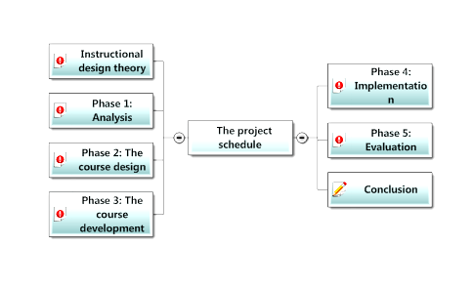

Figure 10: The project schedule.
10.1.1 A general student’s profile

To define the target audience for the future course, the following questions had to be answered:

- Who is the learner?
- How old is he/she?
- What is his/her level?
- What is his/her learning style?
- What are his/her personal characteristics?
- What other characteristics does he/she have?
- What are the course requirements?
- What technical requirements are there?
- What is expected from the learner?
- What are his/her expectations?
- What other considerations are there?

Consequently, a general student’s profile, provided below, was written to illustrate the ideal target audience of the future online course.

- Learner: male/female ESL student
- Age: teenage/adult learner (not suitable for young learners)
- Level: B1-B2 according to the CEFR
- Learning style: visual type (linguistic intelligence developed)
- Personal characteristics: autonomy, responsibility, reliability, sense of duty etc.
- Other characteristics: positive attitude to information technology and e-learning
- Course requirements: computer literacy, communicative competence
- Technical requirements: computer and Internet access
- Course expectations: interest in English language
- Learner’s expectations: to become familiar with English figurative language
to learn some figurative expressions
to improve my knowledge of English
- Considerations: learner’s previous experience with English figurative language
10.2 Phase 2: Design

The second stage of the ADDIE model dealt with the design of the future online course in particular, which should be properly considered to provide an attractive course to the future users to support their motivation. Nevertheless, as the graphic design together with the interface design of the course “English figurative language” was largely adopted from the former course “English Idioms”, the second design phase could be shortened, saving time for the following phases. The principal aim of this stage was to create a blueprint of the future course.
Besides the visual aspect, the author followed the analysis phase, monitoring instructional and technical strategies. First, it was necessary to consider the course structure and arrange instruction into a logical sequence, dividing the content into units. The author decided to use so called “week instruction” (units divided according to weeks), generating a ten-week course. Subsequently, individual units were entitled, providing names for individual learning modules. Further, the learning objectives, content, resources, appropriate activities and exercises as well as assessment strategies (e.g. tests), including due dates, had to be determined for each of the units and materials collected. Considering the media selection, the author chose the Web and the Internet, nowadays representing probably the most powerful media, which were suitable for the online course and supported instruction. However, the course content was not created in this stage, being the main task of the following development phase.
To choose appropriate instructional strategies, the author contemplated various pedagogical issues, availability of media and the course objectives that should be realistic and measurable in order to be met before planning the lessons. Having considered a number of issues such as lesson content, visual aids, suitable activities and practical tasks, teaching methods, evaluation strategies etc., the author planned a sequence of lessons to be incorporated into the future course. Moreover, different learning styles were taken into consideration to respond to individual learning needs. Afterwards, a lesson template for the future course was designed to provide general instructions on how to plan the lessons carefully (see fig. 11).
As regards technical issues, the Moodle software used in the course “English idioms” was naturally utilized for this project, enabling to follow and elaborate what was set in the former course, which finally enabled to reduce time spent on the course design.
To incorporate formative evaluation into the design phase, feedback tools had to be defined, providing sufficient opportunity for feedback to be elicited from the future course participants.
Compared to the original course “English idioms”, several adjustments have been made to the new course design, e.g. in the interface, the use of visuals etc. All the modifications will be discussed later in detail (see chap. 12).
At the end of this phase, a prototype of the future course was created, applying graphic design. Thus, the project could progress further, focusing on the following development phase.

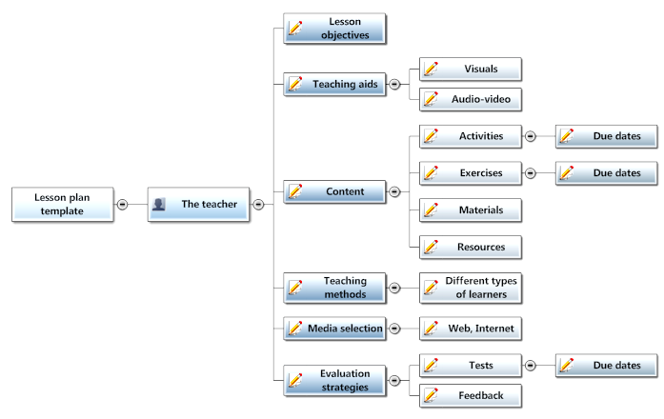 Figure 11: The lesson template.

10.3 Phase 3: Development

Having created the former course “English Idioms”, the author had already gained some experience with the development of an online course in the Moodle software, which facilitated the whole process. The main goal of this stage was not only to develop a quality course based on instructional design but also to reduce deficiencies identified in the former course. Consequently, the author of the thesis (and the online course) considered the structure of the future course properly, choosing the course content carefully to be able to offer a useful and efficient online course on English figurative language.
When redeveloping the original course “English idioms”, set in the Moodle environment, the author of the course considered a range of choices that were at her disposal in the Moodle software such as numerous blocks, activities and resources as well as other Moodle tools that can be determined by the course designer or subsequently by the instructor who is in charge of managing the course. The number of the blocks together with other Moodle modules available in a Moodle course depends on the administrator, who can add extra blocks for specific purposes. The list of blocks is available on the official Moodle website together with other modules and plugins. The author of the course utilized this service, asking the “Feedback” module to be supplemented into the category of Moodle activities. The author considered this module necessary for eliciting feedback from the course participant efficiently as the previous module “Quiz” used for this purpose in the former course did not prove successful.
Another Moodle tool important for this course was the language menu, offering a range of languages, i.e. Czech, English, French, German, Russian, Slovak and Welsh in the case of Faculty of Education at Masaryk University. Nevertheless, Moodle has been already translated into more than 70 languages. Language options provide a great tool for teaching language courses in particular since the whole course, i.e. labels, instructions as well as the content, can be created in a particular language (English in this case), forcing students to use the language given by an instructor. (Cole & Foster, 2007).
After assembling the course content, it was uploaded into the online course through the two basic Moodle categories, i.e. resources and activities. To provide a detailed description of the resource category, there is the icon “Add a resource” on which it has to be clicked on for a drop-down menu to appear (see fig. 12). This offers several options for adding materials to the course, which include “Book”, “Insert a label”, “Compose a text/web page”, “Link to a file or web site”, “Display a directory” and “Add an IMS Content Package”. To discuss the options used by the author, the tool “Insert a label”, through which a label can be added directly to the course page, was applied. To create content in Moodle environment, the author used “Compose a text/web page tools”. For content created in different programs than Moodle, it was necessary to select “Link to a file or web site”. As regards the “Book” module, this seemed to be the most creative tool for the course, which allowed to compose a “book” consisting of particular chapters and subchapters.
To support the learning process, the course had to be filled with various activities and exercises, which was enabled by the “Add an activity” menu (see fig. 13). The activities found in this menu may include “Assignments”, which can be of several types, “Chat”, “Choice”, “Database”, “Forum”, “Glossary”, “Journal”, “Quiz” etc. Nevertheless, there is a range of activities provided by Moodle software such as “Dialogue”, “Drill”, “Lesson”, “Workshop” and several others. Moreover, as it has been suggested above, extra activities beneficial to the course can be asked for and consequently added to the activity menu by the administrator of a Moodle server.
To describe the functions of the activities used by the author, students’ works can be collected through the tool “Assignments” and evaluated by the teacher as well as commented on by their peers. Another module “Choice” enables simple voting within the course. The “Feedback”, incorporated additionally, provides a great tool for eliciting feedback from the participants of the course, analysing the data received. The “Forum” module, representing one of the most powerful communicative Moodle tools, is a discussion board processed in threads. Its biggest advantage probably rests in the unlimited time given to students, which encourages them to think thoroughly. Similarly, the “Journal” activity provides students with space for writing as well as the subsequent feedback from the teacher. As opposed to the “Forum”, which is a communicative activity shared by all the course participants, the “Journal” serves as the internal kind of communication between a particular student and the teacher as its entries are invisible to the other participants. Thus, the communication with shy students can be supported. The “Glossary” module performs functions similar to a dictionary. The “Quiz” module is an efficient tool for testing students and providing them with feedback, containing different types of questions such as essay, multiple choice, matching, short answer, true/false etc., probably representing the key activity for students’ engagement with the course.
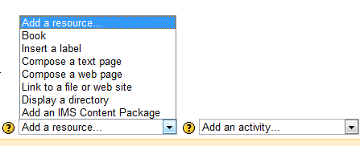
Figure 12: The menu for uploading resources in the Moodle course.

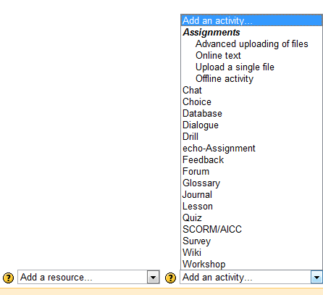
Figure 13: The menu for uploading activities in the Moodle course.

Finally, the visual and audio-visual material was uploaded into the course, containing short videos, pictures and various illustrations to enrich the course content and motivate learners’ interest through the use of attractive materials.
At the end of the development phase, the previous steps of the ADDIE model, i.e. analysis, design and development, had to be verified to avoid future difficulties. This involved considering the course objectives that should be measurable, checking the course content (its placement and logical sequence), functionality of the course links, clarity of instructions, evaluation strategies as well as sufficient opportunities for feedback. The course was subsequently backed up to avoid inconvenience in case of a failure. Moreover, the question of the learning styles was again considered together with other learner’s needs. Finally, the action plan was written as the output of this phase, listing the procedures for the following stage. At this point, the implementation phase could begin.

10.3.1 Action plan

The action plan for the implementation stage included the following procedures:
- to develop a training procedure (in this case it is not necessary to train the teacher, who is the author of the course, but the student)
- to create guidelines for the student(s)
- to set the course schedule
- to check all the dates in the course (e.g. due dates etc.)
- to perform a backup
- to ensure the technology is maintained (Internet, server, course links etc.)
- to enrol the student(s)
- to launch the trial course
- to introduce the course (welcome, instructions, initial work)
- to follow the course program
- to collect data systematically through feedback to identify problems
- to fix the deficiencies discovered throughout the process
- to adapt the course according to the needs identified during the trial course
- to evaluate the course

10.4 Phase 4: Implementation

As it has been outlined in the chapter above, the principal aim of the implementation phase was to launch the course and to identify problematic areas in the trial version that could be subsequently fixed in order to limit the deficiencies of the final course.
In this case, the author decided to involve only one student in the trial course to be able to apply blended learning and identify individual needs that could be eventually met.
To open the trial course “English figurative language”, several issues had to be arranged. First of all, the student who agreed to participate in the trial course had to be prepared for the course. This involved delivering oral as well as written instructions on the new course and the Moodle software in which it had been created. All the written information was delivered via email, which served as a provisional communicative tool between the tutor and student until the course was launched. (Later, during the trial, the author used the “Forum” module for this purpose.) Subsequently, the student was provided with the guidelines concerning the course enrolment. In case of difficulties, the author and the tutor of the course was ready to provide demonstration of how to enrol on the course face-to-face. Moreover, the demonstration video was created for future students to illustrate the enrolment instructions. Normally, the training of the course facilitator/s would have to be performed as well, however, this procedure was omitted due to the fact that the function of the tutor was performed by the author herself. Consequently, the preparation of such training was left for later. Further, the schedule of the course was decided and all the dates of different activities and assignments in the course verified according to the schedule. The backup of the course was performed to ensure that all the instructional design would not be lost in case something went wrong. The last step before launching the course involved an overall check of the course, i.e. its settings, design and content. Also the technology, i.e. a PC, the Internet access and server together with all the course links had to be verified to function properly.
At this stage, when the course was finally prepared for its launch, the future course participant in the role of the student was asked to check the technical support of his computer to ensure all the technical requirements were met and invited to enrol on the course. Thus, the testing of the trail version began.
The programme of the trial course together with the whole teaching process and the learning experience of the participant will be described further in the text (see chap 13.2). The data necessary for eliciting the information from the student were systematically collected through the “Feedback” module, discussed in the previous chapter.
The deficiencies identified during the trial course were subsequently fixed and the course was adjusted to suit the individual needs of the participant. Nevertheless, there were only subtle adjustments made to maintain the flexibility of the course, which is supposed to serve more students in the future.
After the trial, the course, including its design, was to be evaluated in accordance with the ADDIE model. Here, the last evaluation phase was to be performed.

10.5 Phase 5: Evaluation

Since the last stage of the ADDIE model represents a key factor of the whole process, the author paid increased attention to this issue, incorporating this element into the each phase of the ADDIE method, i.e. analysis, design, development, implementation and subsequently evaluation. The evaluation, present in each phase, stressed particularly in the early stages, enabled to verify each of the previous steps of the ADDIE process. This type of evaluation is usually referred to as formative evaluation. Its principal aim was to collect data that were subsequently analysed and revised. Consequently, the course was modified to increase its effectiveness. For this purpose, the module “Feedback”, discussed in the previous chapters, was introduced and newly incorporated into the course to elicit feedback efficiently. To mention some of the benefits of the “Feedback“ module, in case there are more course participants in the future, this module will enable to analyse the answers of all the course participants, providing analytical data that are graphically processed to compare individual answers. Even though this module could not be fully utilized in the trial version, which involved only one student, it will definitely become a useful tool for the future course. In addition, the formative feedback was supported by the face-to-face discussions with the course participant involved in the trial through blended learning.
Concerning summative evaluation, as the term suggests this type of assessment involves final, summarizing evaluation of the whole ADDIE process. Therefore, such assessment could not be performed until the trial course was completed, based on the feedback of the course participant involved in the trial course in the role of the student. In other words, the course had to be first implemented and the trial version finished before the whole process of the instructional design could be finally assessed. Subsequently, the course effectiveness as well as meeting the instructional aims could be evaluated. The main goal of the summative evaluation was to assess the effectiveness of the ADDIE model and consider its applicability on online language learning.
Besides the course evaluation, it was necessary to evaluate the learner, i.e. the participant of the trial course, to discover whether the learning objectives set for the course were achieved. To evaluate the student, a sufficient number of performance possibilities had to be built and different tools incorporated into the course to measure the knowledge transfer, the learning outcomes as well as the attitudes of the course participant. These tools included the pre-test presented at the beginning of the course and post-test to be performed at the very end of the course. A number of quizzes were incorporated to measure the learning results. Further, the course participant was asked to express his opinions in the forum incorporated in the final unit of the course. Having completed the trial course, the course participant was interviewed on his experience with the trial course face-to-face to elicit overall feedback on the course deficiencies. Subsequently, several adjustments have been made to improve the future course (for more details see chap. 12).
To evaluate the learning behaviour of the course participant involved in the trial was not possible in the end as this evaluation is very difficult and time-consuming and a lack of time caused by personal reasons of the course participant at the end of the trial prevented the author/tutor from performing such evaluation afterwards.
Evaluating teaching strategies and learning activities was a part of the learner’s evaluation process. To elicit the feedback of the course participant on these issues, the author used the strategies and tools described above.
To sum up the last phase, considering all the outputs of the evaluation stage, the ADDIE model appeared to fulfil the author’s expectations, being efficiently applied to online language learning, i.e. the online course “English figurative language”. The learning objectives seemed to be met and teaching methods and learning tasks proved helpful to the course participant, enabling to achieve the learning outcomes at the end of the course. As a result, instructional design, the ADDIE method in particular, was evaluated as an efficient tool, providing a number of benefits to language course design. The particular results and concrete numbers will be provided later in the text (see chap. 13.2).

11 The course description

As far as a detailed description of the online course “English figurative language” is concerned, it was designed in the Moodle software, as already discussed, based on the original course “English idioms”. Thus, the graphic design together with the course structure resembles the former course (see fig. 14), excluding several adjustments made to enhance the interface design.
To introduce the course page, there is a title of the course placed at the top of the page with a navigation bar beneath with the “Switch role” menu on the right, allowing the teacher to switch his role to the role of the student to see what the course would look like to students. As for the course layout, it is further divided into three columns. Whilst the side columns offer a range of different Moodle blocks, the broadest middle column contains the course content.
Starting from the left, there is a block “Calendar”, placed in the upper left corner, reminding forgetful learners about oncoming events, which can be of four types, i.e. global events, group events, course events and user events. Below, there is the “People” block, revealing profiles of the course participants, including the total number of the course members. The “Activities” block beneath lists all the activities incorporated into the course, in this case “Assignments”, “Books”, “Choices”, “Feedback”, “Forums”, “Glossaries”, “Journals”, “Quizzes” and “Resources”. The following block “Administration” contains icons used for managing the course as well as obtaining information (see fig. 15). The icon “Turn editing on” represents the main teacher’s tool for creating and modifying the course content, opening further course options. Another icon “Settings” enables to set the course name, format, the number of topics, the course start date, enrolments, groups enabling to create workgroups, availability, as well as the language, due to which the course participants are forced to use the language intended for the course. The “Assign roles” icon defines different roles of the participants, i.e. teacher, non-editing teacher, student and guest, including their numbers in the relevant course. While the one with the teacher’s role can do almost anything, a guest has the least privileges in the course. Extra roles are performed by the course creator and administrator. The icons “Backup”, “Restore”, “Import”, “Reset” and “Delete” ensure basic computer operations. There are also tools for gathering and obtaining information such as “Reports”, providing detailed data on students’ activities in the course or “Questions”, forming a question bank for course quizzes. The “Files” icon enables to enter the data storage where all the course materials can be saved. The last three icons are also available to students. These are “Grades”, “Unenrol me from the course”, and “Profile”. The icon “Grades” presents information on students’ performance in a tabular form, allowing students to see only their own results. In case of unenrolment, students can use the icon “Unenrol me from the course”, not allowing to return to the course. The “Profile” section provides not only personal information about the course participants such as country, city/town, phone number and email address but also enrolled courses, last access and the participant’s role in the course. Moreover, there are several bookmarks, enabling for example to edit the profile, to see all the forum posts or to see activity reports of the particular student/teacher. The last on the left is the “My courses” block, listing other courses in which the participant is involved either as a teacher or a student.
As regards the right-side blocks, there is the “Course Summary” block, placed in the upper right corner, stating the main goal of the course together with recommended literature. The other blocks below provide information on various course activities. These include “Latest News”, “Upcoming Events”, “Online users” and “Recent Activity”. As their name suggest, the block “Latest News” reports on the course latest news, “Upcoming Events” provides a tool for monitoring calendar events, the block “Online users” enables the teacher/student to see which participants are currently online, providing the opportunity to communicate in a real time. Consequently, shy students or those who are unwilling to express their opinions and discuss sensitive issues in the classroom are given the chance to do so in the form of online interaction with the teacher/other students, avoiding face-to-face confrontation. In this sense, creating a safe learning environment can be seen as one of the goals of Moodle courses and online learning in general. Finally, the block “Recent Activity” informs the participant about the recent activities since the last login.
Moreover, additional blocks can be supplemented to the course according to the needs of the future course participants. The complete list of blocks provided by Moodle software can be found on the official Moodle web site.
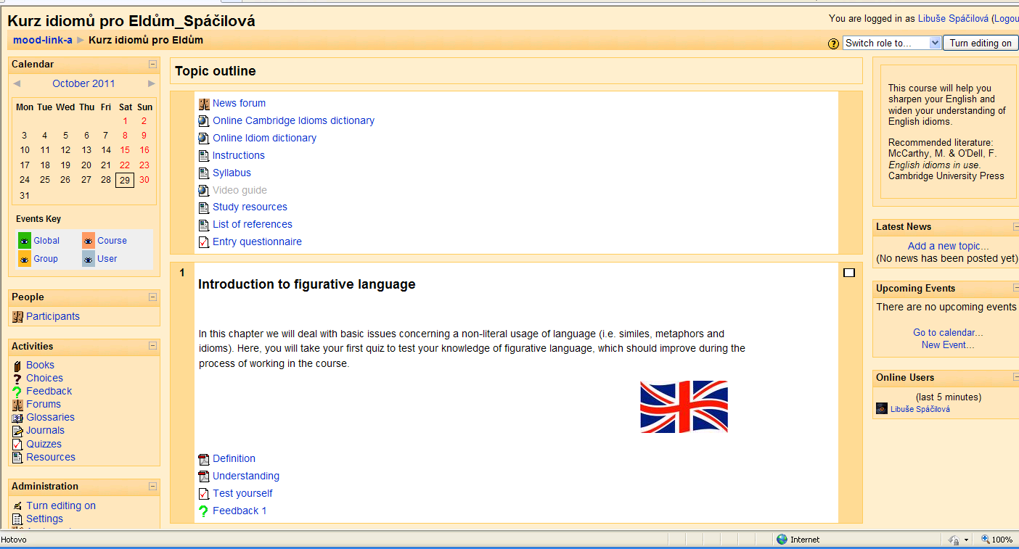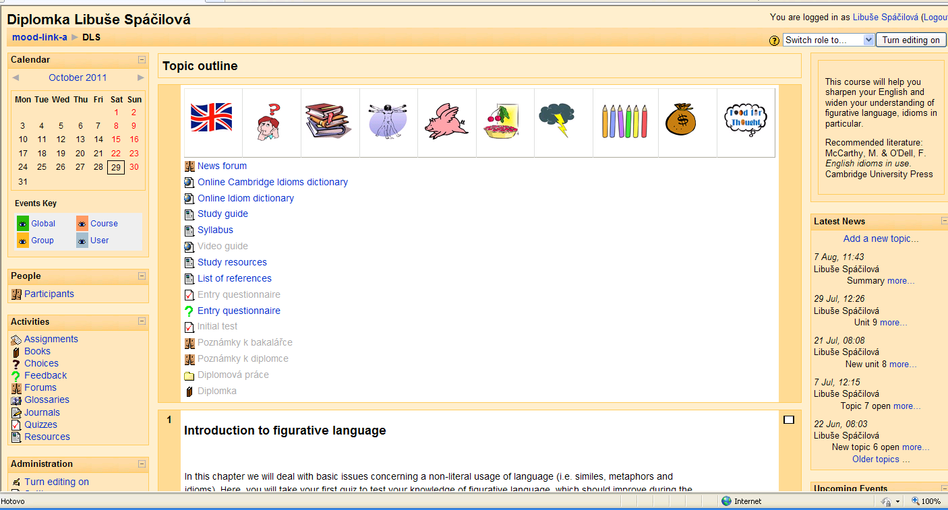
Figure 14: The original course “English idioms” compared to the new advanced course
“English figurative language”.

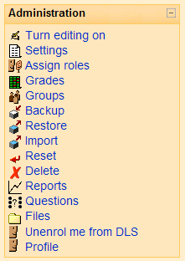
Figure 15: The Moodle block “Administration”.

Regarding the course content, it is placed in the broadest central column, offering enough space for various materials and activities. The format of the new course adopts a chronological order of the former course “English idioms”, arranged by topic, presented in individual sections. As for the division, there are eleven sections in the course, including the course outline providing ten chapters on English figurative language.
The first section entitled “Topic outline” contains ten visual icons, each of them representing a particular unit, for easier orientation in the course. Clicking on the icon, the user can reach the relevant topic that will appear beneath the course outline, hiding all the other sections. Below, there is the “News forum”, in which the news concerning mainly the course schedule is presented. Further, there are several resources in the form of links to web sites or text pages composed directly in the Moodle environment. The first two link the course participants to different online dictionaries, i.e. “Cambridge Dictionaries Online” and “Online Idiom Dictionary”. The remaining resources provide basic information on the course, i.e. “Study guide”, “Syllabus”, “Study resources” and “List of references”. To build enough opportunities for feedback and evaluation, the first section contains the quiz “Initial test” to test students’ initial knowledge of English figurative language and the feedback “Entry questionnaire”, initially designed in the quiz module, to elicit feedback from the course participants to be compared with the “Final questionnaire” at the end of the course. In addition, there is the book module entitled “Diploma thesis” incorporated into this section for internal purposes, hidden to the course participants in the role of the students.
The first unit “Introduction to figurative language” provides a brief introductory chapter to the course subject matter. The materials and activities included in this chapter contain a label, explaining the topic, a study guide in the form of the book module “Figurative Language”, the quiz “Test yourself”, presenting a matching exercise on different figures of speech, a text page “Why to learn figurative language?”, stating the main reasons why to study English figurative language, the forum “Your reasons”, enabling the course participants to express their own reasons for learning figurative language, and the feedback module simply entitled “Feedback 1”, incorporated for the evaluation of the first chapter/lesson. The book module in this section contains chapters on different figures of speech, i.e. idioms, similes, metaphors and proverbs together with a short video on figurative language.
Unit two “Divisions of idioms” deals with the categorization of idioms and similes, incorporating the glossary tool “Your Glossary” into the course, introduced by a short label encouraging students to build their own dictionary of idioms and idiomatic expressions throughout the whole course. Even though the first intention was to introduce two different dictionaries, one for idioms and the other for similes and metaphors, the author resolved to retain one glossary module only, in which all the expressions would be written. Further, there is a file “Video Guide: Glossary”, comprising instructional video on the glossary module, offering several video formats to ensure the course participants will be able to watch at least one in their browsers. Another label placed below provides brief explanation on possible divisions of idioms. The resources “Different groups of idioms”, “Index of idioms” and “A list of similes” provide links to the relevant web sites. The label above instructs the learners on the task for the forum “My favourite expressions”. The feedback module, for the second chapter entitled “Feedback 2”, is incorporated at the end of each chapter to provide opportunity to express students’ opinions on the particular unit.
The third unit entitled “Body parts” presents English idioms connected with human body. Since this chapter the book module is incorporated into each unit, excluding the final one. The study materials in the book format are divided into two chapters on English idioms, the first part providing a list of idioms relevant to an appropriate topic (e.g. “Body parts idioms”) and the second one presenting the idioms in sentences to illustrate their use (e.g. “Body parts idioms in use”). The book for this unit “English idioms – Body parts” is introduced by a label, instructing the students to study the materials in this module regularly and prompting them to take an appropriate test afterwards. The label beneath provides instructions on the first resource with integrated videos on idioms “Watch the videos” placed below, explaining the follow-up activity in the forum entitled “Forum for Topic 3”, comprising four subsections, i.e. “Arm idioms”, “Head idioms”, “Foot idioms” and “Eye idioms”, encouraging students to contribute to each of the sections. The subsequent quiz “Body idioms test” examines learners’ newly acquired knowledge on particular area of English idioms. A feedback opportunity in the form of “Feedback 3” is naturally incorporated. Moreover, there is a supplementary exercise “Quiz on body idioms” under the label “Additional activity to unit 3”, providing a link to an appropriate online test. For the purpose of the course additional activities, the author utilized a learning web site “English Club”, comprising a lot of interesting material on English idioms, including the online tests.
The following unit four “Animals” is based on animal idioms. The label placed at the top prompts students to search the Internet for extra information on the subject. The book, this time entitled “English idioms – Animals”, provides relevant study materials. The label above the video section “Watch the videos” instructs learners on the video activities to be performed in the “Forum for Topic 4”, comprising all the idioms from the videos, i.e. “Pig idioms”, “Dog idioms”, Bird idioms” and “Monkey idioms”. In addition, there is a resource “Animated idioms” above the forum module, providing a link to the relevant web site of animated videos. Consequently, a follow-up activity “Animated idioms” is incorporated into the forum. Further, there is the “Animal idioms test” and “Feedback 4” placed below the forum. Similarly to the previous unit, the additional activity in the form of an online test “Quiz on animal idioms” is provided at the end of the unit.
Chapter five “Food” discusses English idioms associated with meals and drinks. Beneath the introductory label, there is the book module “English idioms – Food”, presenting a number of food idioms. The label below provides instructions on the activities based on the following videos in the resource “Watch the videos”. The next label encourages students to browse an online dictionary, the link of which is provided, to complete the task “Some more pie idioms” in the forum “Food idioms”. The forum also comprises sections for the video activities “Fruit idioms”, “Egg idioms”, “Pie idioms” and “Tea idioms”. Further, there is the quiz “Food idioms test” followed by the “Feedback 5”. The additional activity “Quiz on food idioms” at the end provides a link to an appropriate online test.
Unit six “Weather”, focusing on weather idiomatic expressions, contains study materials in the book module “English idioms – Weather”. Below, there is the resource “Watch the video”, this time presenting only one video for which the instructions are provided in the following label. The follow-up activities in this unit are divided into two modules. The first task is set in a new journal module of the same title “Journal” to test its utilization for this course and the second one in the forum “Weather idioms” providing space for the activity called “Story writing”. To evaluate the learners as well as the course, the quiz “Weather idioms test” and the feedback “Feedback 6” are incorporated at the end. The additional activity to unit six “Quiz on weather idioms” offers a supplementary online test on particular idioms.
The seventh unit entitled “Colours” is vividly introduced by a label with a quote containing the word “colours”. Subsequently, the book “English idioms – Colours” provides students with appropriate materials on colour idioms. The label below guides learners through the following activities that are based on the videos from the resource “Watch the videos”. The space for these activities is provided in the forum “Colour idioms”, consisting of two sections “Green idioms” and “Silver idioms”, prompting students to complete the tasks. The evaluation tools in the form of the quiz “Colour idioms test” and the feedback module entitled “Feedback 7” are typically incorporated after the forum activities. A supplementary exercise to chapter seven “Quiz on colour idioms” is included at the very end of the unit.
Unit eight “Miscellaneous” represents the last chapter on English idioms, involving a mixture of idioms from different areas (e.g. money idioms, sport idioms etc.) that did not fit the previous topics. The study materials on theses idioms are also presented in the book format entitled “English idioms – Miscellaneous”. Below, there is a new activity “Do you know this idiom?” incorporated into the course in the Moodle module “Choice”, prompting students to choose the right answer. The following label instructs learners on the tasks for the videos placed in the resource “Watch the videos”. The next label provides guidelines for the following game based on the resource “Paint by idioms” placed beneath, linking students to a particular web site. The follow-up activity is to be completed in the forum “Forum for Topic 8” in the section “Painted idioms”. The forum also includes sections “Sport idioms” and “Money idioms” for the video tasks mentioned above. The course evaluation, becoming an integral part of each course unit, is again incorporated towards the end of the chapter, taking the traditional form of the quiz module “Miscellaneous test” and feedback module “Feedback 8”. The additional online activity “Quiz on sport idioms” is placed at the end of the unit.
Chapter nine entitled “Similes, metaphors, proverbs” discusses the figures of speech from the title. First, there is a label with a notice, drawing students’ attention to the following formats of study materials used in this unit. To consider different options, the author designed the study materials for this unit in two different formats, presenting the same content in Word documents (“Similes” and “Metaphors”) as well as pages in the book module “Similes and metaphors”. Further, there is the quiz “Test: similes and metaphors” to evaluate the students. A relevant translation activity is to be performed in the forum “CZ versus EN” placed below. To assess the course and elicit feedback on the different formats of the study materials, “Feedback 9” is incorporated underneath. Next, this unit has been supplemented with three worksheets created as Word documents, including “Worksheet: similes”, “Worksheet: improving similes” and “Worksheet: metaphors”. Consequently, the worksheets are to be completed and uploaded into the spaces provided by the assignment modules under the same titles (e.g. the completed worksheet “Similes” to be uploaded into the assignment “Worksheet: similes”.). Moreover, there is a quiz “Proverbs”, containing a matching exercise for students to compare English and Czech proverbs.
The last chapter “Summary” offers a review on the whole course as well as the last opportunity for feedback. The students are first instructed to take the “Final test” in the label above. Further, another online game is presented through the resource “Idioms game”, providing a link to an appropriate learning web site. In addition, there is the resource “Powerpoint presentation on English idioms”, created by the author in the past, introducing a short presentation, supported by a number of pictures, animations as well as videos to enrich the course content. The last evaluation tools, incorporated at the end of the course, include the feedback module “Final feedback”, the quiz “Final questionnaire” and the forum “Your comments”.
As for the visuals, the topic of each unit is illustrated by a picture retrieved from “Google Images”, ensuring the copyright will not be infringed. Moreover, illustrations are used also in the book modules to support the study materials. Finally, a number of videos relevant to the course topics are incorporated into the appropriate units to supplement the course with audio-visual material, utilizing the BBC website as the main source.

11.1 The settings of the course

Regarding the course settings, this is performed via the “Settings” icon in the “Administration” section (see the chapter above), setting the course full name “English figurative language” as well as its short name “EFL”, the topics format, the eleven units/topics, the course start date, the availability to students, not allowing guests in, setting an enrolment key, and the English language, forcing the course participants to use English only.
Besides the settings of the course itself, individual course modules offer several options as well. First of all, the icon “Turn editing on” in the upper-right corner has to be clicked on (or chosen in the block “Administration”). Consequently, a number of options appear. To start with the first one, each Moodle module can be made invisible to students either by choosing “Hide” in Common module settings or by clicking on the “eye icon”. Despite hiding the item, the course participants in the role of the teacher can see the whole content. Next, all the Moodle tools, i.e. blocks, activities and resources, can be shifted to another position in the course, replacing the previous item, through the arrow signs. Each of the course items can be also deleted by clicking on the “cross icon”. While all the modules creating the course content can be updated through the “writing hand icon”, activity modules are equipped with an extra option for setting workgroups that can be set either through Common module settings or the “figure icon”. Additionally, Moodle blocks contain the “Assign roles icon” (discussed in chap. 3.2). Regarding the window options, resources such as files and web sites linked to the course can be displayed in two ways, either in the same window or a new one. Finally, individual content units can be highlighted by clicking on the “light bulb icon” placed in the right bar at each section, together with the “eye icon” and “arrow icons”. Moreover, there is “a white square icon”, enabling to show only one unit in case the teacher wants the students to focus on a particular unit without being disturbed by the surrounding content.
In addition, the Moodle server also provides a system of help, marked with a yellow circle with a question mark. Thus, it is possible to get advice in the form of a new window with the help that is asked for by clicking on this icon.

12 Adjustments to the former course

The main difference between the new online course and the original course “English idioms”, as the title suggests, lies in the course content. While the former course was devoted purely to English idioms, the new course “English figurative language” has been extended, covering a broader area of figurative language, i.e. similes, metaphors and proverbs. However, the focus on English idioms and idiomatic expressions has been maintained. Thus, learners can obtain more complex information on the subject, including the practical exercises to illustrate different figures of speech. The structure of the original course has been retained, following the thematic division of idioms and involving additional chapter on different figures of speech.
Concerning the Moodle blocks, the new course has adopted all the blocks used in the former course. However, the block “Recent Activity”, providing information on the activities performed since the last login of the participant, has been added into the right column to ensure nothing will be overlooked.
To improve the navigation in the course, the ten pictures illustrating individual units have been borrowed and placed at the top of the first section “Topic outline”. These visual icons enable to reach appropriate topics by clicking on the item, hiding the other sections. The resources linking users to the online dictionaries have been verified to fit the current websites available on the Internet. The resource “Instructions” has been renamed to “Study guide” and modified to suit the new course. Similarly, the other resources, i.e. “Syllabus”, “Study resources” and “List of references” have been adjusted. The “Entry questionnaire”, originally created as a Word document, has been redesigned in the new feedback module and its content revised, deleting irrelevant questions, to provide a systematic evaluation. Moreover, the quiz “Initial test” has been added to define the initial level of students’ knowledge of English figurative language to be compared with the “Final test” at the end of the course.
As for the introductory chapter, the title “Introduction to figurative language” has been maintained (together with the titles of the following units) despite its different content. The newly generated study materials on figurative language, including the video, have been placed in the book module. The quiz “Test yourself” has been filled with an appropriate content, offering a practical exercise on the theory. Further, the resource “Why to learn figurative language?” has been added to make students contemplate on the purpose of figurative language. Consequently, the forum “Your reasons” has been incorporated to express students’ ideas. The original “Journal” feedback activity has been replaced by the feedback module “Feedback 1”.
Unit two has undergone slight changes, introducing a new resource “A list of similes” to cover broader area of figurative language, renaming the original forum “My sentences” to “My favourite expressions” and incorporating the feedback module “Feedback 2”. The former evaluation tool in the form of the quiz “Evaluation of the topic” has been superseded by the new feedback module throughout the whole course.
The third chapter has been supplemented with an instruction label, prompting learners to study the materials in the book module and taking an appropriate test afterwards. As opposed to the former course, all the study materials dealing with English idioms have been revised, modified and supplemented with new idioms as well as example sentences. Consequently, the quizzes have been revised to include the new idioms, employing the four types of test questions, i.e. matching, multiple choice, short answer and true/false questions. Furthermore, three more videos have been added to the resource “Watch the videos” in each chapter, excluding unit six, and more activities included in the forums. Finally, starting from unit three, additional activities have been incorporated at the end of each chapter, linking the participants to extra online quizzes relevant to the appropriate topics.
The content of the fourth unit has been revised and supplemented with additional materials as discussed above. Besides, the resource “Animated idioms” has been verified to ensure the link functions properly. The following chapters have been likewise revised and supplemented with new materials and activities to enhance the original course (e.g. the activity “Do you know this idiom?” replacing the former activity in the choice module that proved inefficient). Further, the tests incorporated since unit five have been supplemented with additional questions regarding the previous chapters for revision. The external link to the resource “Paint by idioms” incorporated in unit eight has been also verified to avoid future problems.
Unit nine, added to the current course, has provided a new chapter on different figures of speech, i.e. similes, metaphors and proverbs, offering two different formats of the study materials to choose from. Nevertheless, since the author considered the book module as the most suitable format of the study materials, all the other materials are presented in the book module. In addition, new activities in the form of worksheets on similes and metaphors to be completed and uploaded to appropriate assignments have been employed. Besides, a supplementary quiz comparing English and Czech proverbs, first designed as the Word document, has been incorporated.
The final chapter has been again revised, the “Final test” together with the “Final questionnaire” modified and the “Final feedback” incorporated to provide space for final evaluation of the course. Moreover, the last unit has been supplemented with a new resource “Idioms game”, linking students to appropriate online activities.
Regarding the course settings, after the experience with the former course, all the external resources have been reset to open in a new window to prevent from causing difficulties when returning to the course. The settings of the individual quizzes, changed during the trial course, will be discussed in the following chapter.
To avoid violating copyrights, some of the pictures used in the original course “English idioms” have been replaced by alternative ones retrieved from the Internet.
To sum up this chapter, the main goal of the new course was to reduce deficiencies of the former course “English idioms” and create and advanced course to cover a broader area of English figurative language, which has been hopefully achieved by the author.

13 Trial course

13.1 Introduction

When testing the advanced course “English figurative language”, the author decided to use qualitative approach, involving one student in the trial course to test its efficiency. The future course participant was carefully chosen to fit the “General student’s profile” generated in the analysis phase. (To learn more about the course participant see the “Profile of a learner” in Appendix 2). As the pilot course entailed also blended learning to help to identify individual learner’s needs efficiently, the student and the teacher (the author of this thesis) agreed to meet once a week to supplement the online course with face-to-face lessons, supporting human interaction. However, the face-to-face sessions were eventually incorporated approximately every second week due to the lack of time on the side of the student.
Prior to launching the trial, the future course participant had to be prepared for the course, the Moodle environment in particular, and the Moodle account of the new participant created. Nevertheless, since the participant had already had some experience with e-learning and Moodle software, there was no problem with the student’s comprehension of the instructions on the Moodle course delivered vie e-mail. Similarly, the course enrolment was performed without any difficulties, following written guidelines. Furthermore, the course participant was asked to ensure the course technical requirements could be met to avoid future problems.
Even though the pilot course was intended as a ten-week online course, it took approximately four months to finish its programme also due to blended learning, which required personal presence of the course participant. Partly presupposing such a course of events, the author decided to open the pilot course a month sooner than originally planned, i.e. the first of May 2011, to ensure there would be enough time to complete it. Nevertheless, the future course is intended to be purely online course also suitable for distant learning.

13.2 Programme of the trial course

During the first face-to-face session, the teacher introduced the course “English figurative language”, explaining the resources in the “Topic outline”. Afterwards, the student was supposed to take the “Initial test” and “Entry questionnaire”, set as homework. Surprisingly, the student achieved a very high score in the test (27 points out of 30). Subsequently, it was discovered that the student cheated during the test, browsing the Internet to find the right answers. Having explained that such behaviour is inappropriate, preventing from proper evaluation of the course as well as the student, the teacher asked the participant to take the test once more during the face-to-face lesson in a month’s time. This time the student scored 22 points, which confirmed that something had been wrong with the student’s first attempt. Thus, the teacher realized that one of the main disadvantages of online tests is the absence of a teacher. The first feedback “Entry questionnaire”, initially designed in the quiz format, proved that the student was a suitable candidate for the course, having a positive attitude to e-learning. In this stage, the first deficiency concerning the feedback module was detected. The problem with the anonymous responses in the module was removed immediately by changing the module settings to record users’ names. Thus, the teacher would be able to monitor responses from individual participants recorded under their names. The feedback module, incorporated in each course unit, provided necessary information for future evaluation. However, it could not be fully utilized as there was only one participant involved in the trial course. Since this module offers an analysis of the students’ response that can be processed in a chart in the Excel format, it will become extremely beneficial when comparing results of more participants in the future.
The answers from the first feedback showed that the trial course participant had already had some experience with online learning. However, she was not persuaded that it could substitute traditional learning completely. Further, the student expressed her interest in English idioms with the main purpose to improve her knowledge of English and enhance her communicate competence, applying figurative language. Consequently, the students’ expectations could be detected. Curiously enough, the student claimed that she did not know any figurative expressions, which did not correspond to the result of the “Initial test”, taking the student’s second attempt into account. Hence, the author considered modification of this test in the future, incorporating more challenging questions (e.g. open-ended questions) and figurative expressions that are dissimilar to their Czech equivalents.
As a result of the evaluation of the student’s initial work in the course, the teacher was forced to hide all the units apart from the one that was being dealt with at the moment since the participant attempted to take the “Final test” in the “Summary” at the same time as taking the “Initial test”. Having interviewed the student, the teacher realized it had been caused by the student’s curiosity, taking necessary steps.
The second face-to-face lesson, held in two weeks, was devoted to the introduction of English figurative language, explaining different figures of speech. However, the main purpose of this lesson was to discuss appropriateness of the study materials used for the introduction. After the oral feedback of the student, the teacher modified the study materials, changing the original formal definitions to simple explanations that would be comprehensible to learners of intermediate level of English, providing more examples on individual figures of speech. Subsequently, the quiz “Test yourself” was adjusted to the new content, providing a practical matching exercise on the figures of speech discussed in the course, which replaced the previous theoretically-based questions. To prevent from the disruption of the course work and avoid wasting a lot of time, this chapter was skipped, to be completed additionally at the end of the trial course. Consequently, the student was instructed to start working on unit two discussing possible divisions of idioms.
Moreover, the teacher introduced the Moodle block “Calendar”, instructing the student to follow and gradually check the deadlines for appropriate activities, which was notified in another block “Upcoming Events”.
Having reviewed the student’s work, the teacher clarified how to gradually build “Your Glossary” during the next face-to-face lesson. Unfortunately, the student did not follow the teacher’s instructions throughout the whole course, omitting to provide English definitions of the idioms, providing only their Czech translations despite the teacher’s examples illustrating the proper dictionary entries. Although this issue was discussed several times during the course and the student saw the instructional video on the glossary module providing clear guidelines, she failed to follow the set examples. Later, the student explained that it was mainly caused by the lack of time and unforeseen events that occurred during the process (the student got pregnant and for health reasons could not devote sufficient time to the online course).
According to the answers included in “Feedback 2”, all the presuppositions for the successful building of the glossary tool had been met as the student claimed that she liked “Your Glossary”, preferring an online dictionary to a traditional one, and the instructional video in the “swf” format worked in her browser. Nevertheless, this module became a source of problems even in the former course “English idioms”, perhaps for its demands on time.
All the tasks from unit two, including “Feedback 2”, were performed online, without the presence of a teacher. The student had no problems with the forum module, responding to the teacher’s comments. However, the forum model that normally serves as a tool for social interaction and is usually favoured by students could not really perform its function in the trial course as there was only one participant.
The following week, the student was supposed to work online on chapter three “Body parts”. Since the result of the appropriate “Body idioms tests” was not satisfactory (5 out of 12), the teacher decided to discuss the test in the next face-to-face session. Afterwards, it was discovered that the student misunderstood the purpose of the book module, which provided the main source of study materials for the course and studied the idioms from the resource “Watch the videos” only, assuming that the test was based on the idioms from the videos. Having explained that the course participants are supposed to learn figurative expressions primarily from the book “English idioms”, the knowledge of which is tested in the appropriate quizzes, the teacher advised the participant to take the test once more. The student’s second attempt was successful since she achieved 9 points. Consequently, the author supplemented the third unit with a label clarifying the book module.
Regarding the four activities in the “Forum for Topic 3” based on the videos, the student managed to complete all the tasks, being able to correct her grammatical mistakes by herself, in a reaction to the teacher’s remarks. Nevertheless, the teacher had to provide the right meaning of one of the idioms that was not understood correctly, which was subsequently discussed face-to-face to ensure its meaning was clear to the student. Further, the student was encouraged to think of more figurative translation of the idioms into Czech, being forced to use Czech figurative language as well, realizing the differences between the two languages.
The feedback elicited from “Feedback 3”, focused on audio-video material, confirmed that the idiom videos were useful to the student, facilitating the learning process by providing visual support, which is helpful to the visual types of learners in particular (being the case of the course participant). Moreover, the student found the videos enjoyable, which certainly contributed to the learner’s motivation. As for the additional activity “Quiz on body idioms”, the student later admitted that she did not pay much attention to it, failing to take the appropriate online test according to the course schedule.
During the next face-to-face meeting that had to be postponed for two weeks, the teacher decided to examine the student’s knowledge on unit three, asking checking questions. Afterwards, it was discovered that the student omitted the additional activity, assuming it was not important. Consequently, the teacher explained that all the activities should be completed in order to evaluate the course at the end of the project efficiently as well as to achieve the learning objectives. The student promised to take the online quiz immediately and spend some time on additional activities in each unit. It should be noted that despite her delay, the student was quite responsible, keeping her promise till the end of the trial course.
Chapter four “Animals” was entirely performed via the Internet, utilizing all the e-learning tools. The four translation tasks incorporated into the forum “Forum for Topic 4” were all completed in time. However, the teacher had to explain meanings of some of the idioms that were not clear, prompting the student to correct herself in the following forum contributions. This approach proved successful in most of the cases throughout the whole course. The supplementary activity “Animated idioms”, also included in the forum, had to be first clarified, providing concrete instructions on the task. Subsequently, the student was able to finish it without any problem.
Since the course participant had complained that she could not see the wrong answers in the tests immediately, the quiz settings underwent slight modification, starting from unit four. Thus, the adaptive mode in all the subsequent quizzes was activated, allowing multiple responses to a question within the same attempt in the test. Nevertheless, the penalties subtracted from the learners’ scores for each wrong answer were applied.
Subsequently, the quiz “Animal idioms test”, first employing the revision questions from the previous quiz, revealed that the student had not studied the idioms in this section in detail, scoring 8 points out of 12. Event though the test score was not very high, the student did not attempt to take the test again. Having considered this issue, the teacher discussed the possibility of unlimited attempts set for the tests with the course participant in the future. Similarly, there were no time limits set for finishing the tests. The questions concerning former topics were incorporated into the quizzes from unit four to the end of the course.
Regarding the evaluation from “Feedback 4”, the student’s answers elicited in this stage confirmed that learners usually like interesting additional activities referring to the resource “Animated idioms”. When asking about the student’s time spent on this course, the participant claimed she had spent approximately two hours on the online course per week. However, after consulting the “Activity reports” recording the student’s work in the course, the time stated did not fully correspond, recording approximately one and a half hours of the student’s time weekly. At the same time, the participant declared that she would like to devote more time to the study of English figurative language. According to her response, the participant was not sure if she missed any kinds of learning activities in the course or not at this point.
Even though the additional task “Quiz on animal idioms” was not completed in time, the student finally managed to finish it.
The following week the teacher again checked the comprehension of the idioms involved in the additional activity for unit four during the face-to-face session. Subsequently, the student, having no idea about some of the idioms, making pointless excuses, promised to complete it, which she finally did with a two-week delay. The best motivation for the student seemed to be to avoid humiliation of being criticised by the teacher in the future as such problems did not occur since then with one exception. Furthermore, the student was encouraged to start working on unit five “Food”, which was also supposed to be completed entirely online without the presence of the teacher.
Having checked the student’s contributions in the forum “Food idioms”, the teacher prompted the participant to correct the minor grammatical mistakes by herself. However, what was the main question discussed in this forum was the usage of Czech figurative language that should be applied during the translation activities. Despite her first clumsy attempts, the student managed to provide perfect translation in the end, employing her imagination and the knowledge of figurative language in her mother tongue. Thus, the differences between Czech and English could be demonstrated and a lesson on multicultural education was provided.
As regards the evaluation tools incorporated in unit five, the student achieved a good result in the “Food idioms test”, scoring 12 points out of 15, which means that the learning objectives stated for this lesson were more or less met. The feedback elicited from the participant in “Feedback 5” revealed that the student was persuaded she was making progress in English idiomatic language. Further, it was said that the forum and video activities were favoured by the student whilst the glossary activity was not. Despite the fact that the participant claimed she liked “Your Glossary”, in the second feedback she expressed her dislike of this module.
The supplementary task “Quiz on food idioms” was this time finished on schedule. Consequently, the student was praised for her punctuality to increase her motivation.
The next week, the teacher last examined the student’s knowledge of the “additional” idioms face-to-face. Being satisfied with the results, the teacher stopped reminding the student about additional activities, assuming it would not be necessary any more. As usual, the student was instructed on the following chapter six “Weather” to be performed online at home.
The main purpose of the sixth unit “Weather” was to test the applicability of the journal tool, first used in this unit. Although it is actually pointless with one course participant, the “Journal” should prove effective in case there are more participants in the future course. This module can react to learners’ needs, ensuring the students who do not want their entries to be public that the content will be available only to the teacher, which prevents the other participants from following private communication between the student and the teacher.
The forum “Weather idioms” brought an innovative activity “Story writing”. Nonetheless, the student failed to contribute to this forum, which became the core of the discussion in the following face-to-face meeting. The student later confessed that she intentionally omitted the activity, assuming it would be too time-consuming. As a result, the teacher emphasized the fact the students are supposed to write really short stories, highlighting the word “short” in the instructions for the future course participants.
As for the evaluation of the sixth unit, the student scored 9 points out of 10 in the quiz “Weather idioms test”, achieving a very good result, meeting the learning aims. The answers from “Feedback 6” confirmed that the journal module could be favoured by the future participants of the course since the student involved in the trial showed a positive reaction to this activity. Concerning the video material used in this section, the participant expressed her dislike about the new teacher from the video, founding him rather boring compared to the teacher engaged in the BBC videos, who had been regarded funny. The student’s claim that she needed to see the videos only once in order to be able to fulfil the tasks in the course proved true (except for the case of unit three), which indicated that the audio-video material used in this course was appropriate to the student’s level of English.
The additional activity “Quiz on weather idioms” was finished according to the course schedule.
The following face-to-face session with the course participant had to be postponed for personal reasons (holidays). The teacher and the student met personally in a month’s time again to discuss a number of issues such as the teacher from the new video in chapter six, the “Story writing” activity in the forum or the future course programme. At this point, the trail participant revealed that she was pregnant, which influenced the following course schedule. Thus, it had to be adjusted to the student’s individual needs.
Unit seven “Colours”, completed distantly online, included another kind of writing activity incorporated into the forum “Colour idioms”. However, the instructions for the task “Green idioms” written in the teacher’s attempt not to discourage the student were modified, prompting the participant to use several idioms from the video in a piece of writing. As a result, the student did not expect the activity to be too time-consuming and finished it in time. The teacher praised the student, considering this motivational element necessary in this case. Since there were minor grammatical mistakes, the teacher drew the student’s attention to them, suggesting self-correction. The participant corrected her mistakes immediately. The second forum activity “Silver idioms” provided a new matching exercise on the idioms from the appropriate video. The student completed the task without difficulties. Even though the question of additional activities had been discussed several times before and the teacher regarded this issue to be already pointless, the participant did not complete the appropriate activity “Quiz on colour idioms” on schedule. Nevertheless, it was finished together with the next chapter, after the teacher’s notice.
The quiz “Colour idioms test” ensured the teacher that the former personal discussion with the course participant brought results since the student scored 9 out of 10 points at the second attempt, improving her first attempt, during which she achieved mere 6 points. Thus, the face-to-face discussions between the teacher and the student proved to be meaningful, bringing effective outcomes, helping to meet the learning objectives. The feedback elicited from unit seven through “Feedback 7” provided the author with important answers. First, the student expressed her delight in the new matching activity, confirming the author’s theory about the sufficient variety of activities necessary for the course success. Next, the participant stated she appreciated older topics to be tested in the course quizzes simultaneously for revision (performed from unit four). At the same time, she confessed she did not return to the tests from previous units, taking an appropriate test only in the time given. Finally, the participant drew the teacher’s attention to the quiz settings preventing the course participants in the role of the student from seeing the right answers as well as the feedback after taking the test. The quiz settings were immediately altered, allowing the participants to see necessary data when reviewing a quiz attempt, which reduced deficiencies in the future course.
The face-to-face lesson realized in the next two weeks was initiated by the teacher to prepare the student for the following chapter eight “Miscellaneous” introducing a mixture of new idioms and idiomatic expressions. Afterwards, the student was supposed to study this chapter at home, finishing the unit in a week’s time.
The new activity “Do you know this idiom?” designed in the “Choice” module was first used in unit eight to test its applicability. Since the “Choice” tool enables to analyse the answers of the course participants that can be processed in different formats, all the possibilities offered by this module could not be utilized. Nevertheless, the tool proved convenient for the future course. The activities in the forum “Forum for Topic 8” provided the student with new types of exercises to enrich the course content. The forum activity “Sport idioms”, introducing multiple choice tasks, was easily completed by the student. However, the teacher had to clarify the meaning of one of the idioms. Another forum activity “Money idioms” comprising a “correct the mistake” exercise on different figurative expressions, was corrected properly. The last forum activity “Painted idioms”, encouraging the participant to provide new idioms learned in the online game together with the Czech translation was also managed without difficulties. The teacher’s only comment concerned a fine mistake in grammar.
Assessing the student’s performance through the quiz “Miscellaneous test”, the participant scored 11 out of 15 points, achieving a mediocre result. Although the student seemed satisfied, not retaking the test, she did not feel very comfortable with her score, regretting she did not have enough time for the second attempt. The student’s discontent emerged during the following face-to-face lesson. The evaluation tool “Feedback 8”, enabling the participant to express her opinions on the course, revealed that the student enjoyed working in the course, finding the online game as well as the new forum activities beneficial. Despite the possibility to comment on the course, the participant did not provide any ideas on improvements.
All the exercises in unit eight were completed on schedule, including the supplementary activity “Quiz on sport idioms”.
Having completed chapter eight, the teacher and the student met in a fortnight again to discuss the upcoming unit nine “Similes, metaphors, proverbs”, dealing with different figures of speech. During this session the student complained about the lack of time due to which she could not devote more time to the online course, which was also reflected in the student’s last result (“Miscellaneous test”). The student also admitted that she might be pressed for time in the future due to her health problems.
Chapter nine was partly experimental, offering two different formats of the study materials to the course participant, i.e. the traditional book module and the Word documents. The author also considered transforming the materials into RTF format (abbrev. for Rich Text Format) in case the Word documents cause problems. However, this option was abandoned during the trial. Even though the forum in the ninth unit “CZ versus EN”, prompting the student to think about differences between the two languages was finished on schedule, the participant failed to react to the teacher’s request to translate the figures of speech into Czech. Moreover, the participant ignored all the three assignments on similes and metaphors into which the completed worksheets presented in this unit should have been uploaded.
The student’s score in the quiz “Test: similes and metaphors” was excellent, achieving the total 10 points (out of 10) in mere two and a half minutes needed for completing the test. According to the result, the quiz was obviously very easy for the student. Similarly, the quiz “Proverbs” seemed also simple for the student, who scored again 10 points out of 10. Although this test on proverbs could appear too easy, it was actually quite challenging as the student had to provide her own answers in the space provided. Subsequently, the teacher appreciated the student’s effort, evaluating the student with the highest result. Surprisingly enough, the feedback for unit nine “Feedback 9” revealed that the student preferred the study materials designed in Microsoft Word to the book despite the author’s persuasion of the highest suitability of the book module for the course. Further, the participant agreed that the similes and metaphors were relevant to this course and therefore should form an integral part of the new course “English figurative language”. The student also claimed in the feedback that she liked the worksheets incorporated into this unit as well as the quiz “Proverbs”. Nevertheless, the student did not comment on individual worksheets, failing to complete them.
The last unit ten “Summary” was finished immediately after the unit nine without any face-to-face preparation due to the time constraints of the course participant. Since this chapter served mainly as the evaluation of the student as well as the whole course, providing enough opportunities for feedback, no more study materials had been incorporated into this unit except for the PowerPoint presentation and the online game on English idioms.
The result of the “Final test” showed the student’s progress. Compared to the “Initial test” at the beginning of the course, the participant scored 27 points out of 30, improving by 5 points. Although the betterment in the score might appear rather low, the student claimed she had significantly improved her knowledge of English figurative language during the subsequent face-to-face discussion. The evaluation tool “Final feedback” confirmed that the participant enjoyed working in the pilot course, feeling the time spent on the course was worth, founding the course “English figurative language” suitable for learning idiomatic language. The student also expressed her delight in the presentation on English idioms as well as the online game in the last chapter. When asked to list the things she liked about the course, the participant claimed she liked the videos the most. Interestingly, the student did not provide anything she did not like in the course in spite of the fact she had expressed her dislike about the glossary module in “Feedback 5”. The participant also omitted to discuss ideas on possible improvements of the course. Moreover, the participant ignored the forum “Your comments”, incorporated for the purpose of expressing students’ thoughts and impressions at the end of the course.
The quiz “Final questionnaire” provided additional data for final evaluation. Since the participant stated she liked the Moodle software and would definitely recommend it in her school (local secondary school), Moodle proved successful, offering efficient e-learning environment. The student also admitted that the Moodle contributed to her positive attitude to e-learning. Further, the participant was persuaded that she had spent between 30 to 40 hours on the course altogether but in fact it had been approximately 25 hours online (this figure was retrieved from the Moodle tool “Activity reports”, listing all the logins of the course participants) plus the ten face-to-face lessons, the length of which varied according to the current needs. The student also confirmed that the course fully met her expectations, improving her knowledge of English and the understanding of English figurative language. Next, the questionnaire showed the course was found useful by the trial participant, who seemed to be really satisfied with e-learning that had proved efficient. Consequently, the student claimed she preferred an online course for learning idiomatic language to other possibilities (e.g. textbooks, dictionaries etc.), expressing her wish to spend more time on e-learning in the future. Moreover, the student believed e-learning was highly suitable for distant learning, having the potential to substitute traditional face-to-face learning completely. (As opposed to the “Entry questionnaire”, in which the student stated e-learning could partially substitute traditional lessons but not entirely.) Finally, the participant confirmed the intermediate level of English as the most appropriate to this course, recommending the course to all students who want to learn English idiomatic expressions to enrich their vocabulary and improve their comprehension of English figurative language.
The last lesson, during which the student and the teacher met face-to-face at the end of August, was devoted to the course evaluation and the student’s achievements in the trial course. The student regretted lacking time towards the end of the course due to her health problems, omitting several tasks. Nevertheless, being a responsible person, she promised to finish the first unit “Introduction to figurative language” that had been skipped at the beginning in the future.
Keeping her promise, the student really completed unit one in a three-month time, meanwhile, giving birth to her first child. The score of the quiz “Test yourself” (9 out of 9) suggests that the participant studied the unit properly, being able to distinguish basic figures of speech. In the forum “Your reasons”, the participant stated her reasons for studying English idiomatic language, saying she wanted to understand native speakers and incorporate figurative expressions into her own speech to enrich her English.
The feedback elicited from “Feedback 1” confirmed the appropriateness of the study materials used in the introductory chapter. The student not only approved of the theory provided in this unit, founding it relevant and the subsequent test appropriate, but also appreciated the video on different figures of speech incorporated in the book module. Thus, the first unit, considered useful by the course participant, served its purpose.
Eventually, the student contributed to the last forum “Your comments” in the “Summary”, revealing her surprise about the similarity of some of the Czech and English idiomatic expression, which helped her to remember them more easily.
Summarizing the student’s last feedback, the participant added she founded the course interesting as well as appealing. At the very end, the student also expressed her thanks to the teacher for her help.

14. Conclusion

14.1 The course outcomes

To sum up the output of the trial course“English figurative language”, the student seemed to achieve the expected learning outcomes, being satisfied with her progress. According to the test results, the student obviously improved her performance, enhancing her knowledge of English idiomatic language. The new course has also met the student’s expectations, providing relevant materials on English idioms as well as other figures of speech, i.e. metaphors, similes and proverbs.
As opposed to the former course “English idioms”, the new course has brought a wider perspective on English figurative language, discussing different figures of speech from the practical point of view, offering a variety of activities and practical tasks. Thus, learners can achieve a better understanding of English metaphorical language. In addition, students can realize the differences between English and their mother tongue through a series of translation activities that were appreciated by the trial course participant as well.
The main goal of the implementation phase has been met since all the deficiencies detected during the trial course have been fixed (for more details see chap. 13.2) and the course adapted according to the needs of the trial course participant. Nonetheless, only subtle modifications have been made to retain the flexibility for the future course participants. Hence, the new course provides an efficient online course on English figurative language, offering an improved version of the former course “English idioms”, taking students’ individual needs into account.
Having developed and subsequently tested the online course “English figurative language”, the author has confirmed the suitability of the ADDIE model for the course design. However, not all the steps suggested by the ADDIE process in individual phases were relevant to the language course. Therefore, each phase of the ADDIE method should be first revised and modified to fit the specific needs, depending on the project. Nevertheless, the ADDIE model provides a great tool for course designers in general, facilitating the whole process.
As far as blended learning is concerned, the blend of face-to-face lessons and online learning proved convenient for the trial course, enabling the teacher to provide double instructions when necessary as well as extra oral support. In addition, extra feedback could be elicited from the participant of the trial course, which was essential for the last evaluation phase.
Finally, the trial version of the course “English figurative language” enabled the author to verify the applied methodology as well as other pedagogical issues, e.g. motivation in the learning process, appropriate level etc.

14.1.1 The ADDIE model: pros and cons

The ADDIE model provides instructional designers with a number of benefits, offering useful and effective guidelines for the whole instructional design process. First, it is focused on detailed analysis in the initial stage as well as proper evaluation incorporated into each of the five phases, i.e. analysis, design, development, implementation and evaluation, eliminating future deficiencies. As a result, a high quality course can be developed, considering numerous factors essential for a successful course such as the course requirements, pedagogical issues as well as learners’ needs. Similarly, the formative evaluation employed during the whole process enables instructional designers to verify individual ADDIE phases and guarantee the removal of defects identified throughout the process, which saves time in the future. Thus, it contributes to its high cost efficiency. Although the ADDIE method provides consistent instruction, suggesting a set of procedures the sequence of which is more or less fixed, it is relatively flexible, allowing modification depending on the context. Consequently, designers can adjust the model to suit their purpose.
As for the disadvantages of the ADDIE method, the first one can be seen in the unreal way instructional designers perform the ID process since the model assumes that all the requirements are known before the content development of the future course. However, this is not always the case, which brings shortcomings to the future course that must be additionally adapted to meet the necessary requirements. Even though it could be considered an advantage, next drawback lies in its consistency, which might become potential danger to designers who try to observe the instructions of the ADDIE model too strictly as such instruction can be very time-consuming to develop. Nevertheless, despite the fact that the ADDIE method has been sometimes criticized for its linearity and inflexibility, it is entirely the matter of an instructional designer which procedures will be followed and which will be omitted.
In summary, the ADDIE model provides a beneficial tool to instructional designers, reaching high efficiency when adjusted to project-specific needs.
14.2 Ideas on improvements

Despite the fact most of the deficiencies were removed during the trial course, some space has been left for the improvement of the new course “English figurative language”.
First, the content of some quizzes as well as its settings should be reconsidered since certain tests, i.e. “Initial test” and “Test: similes and metaphors” in particular, were completed in a short time by the participant of the trial course. Yet, the results achieved in these quizzes were excellent, which suggests that their contents were too easy for the student of intermediate level of English, representing the target group for this course. As a result, the tests mentioned above should be rebuilt to include more difficult questions to challenge the future participants. However, the challenge should be balanced not to discourage the students. Having analysed all the quizzes incorporated into the course, the author decided to modify their settings and establish a time limit in each of the tests to avoid cheating (being the case of the “Initial test”). Thus, the future course participants will not have sufficient time to search for the right answers and the results should be objective.
Second, the author considered the Moodle tool “Lesson”, being available in the “Add an activity” menu, to be utilized in the future to provide online lectures on English figurative language. Thus, questions could be incorporated into the study materials to actively involve students in learning. Nevertheless, this improvement is not necessary to the current course.
Further, the journal module, used in unit six, could be incorporated in the other chapters as well to provide additional space for private communication between the teacher and the student. Consequently, the students would be offered two options for communication within the course to choose from, i.e. the forum and the journal in each unit.
Next, it would be advisable to replace the video material included in unit six by one of the BBC videos to substitute the teacher who was unpopular with the trial course participant.
Also the “PowerPoint presentation on English idioms”, incorporated into the final chapter, should be reviewed, all the defects removed and its content modified to suit the new course “English figurative language” perfectly.
The worksheets used in chapter nine could be redesigned in the quiz module to support interaction. Thus, the assignments following these activities, asking students to upload appropriate completed worksheets, would be deleted, serving no further purpose.
Although the external resources such as the websites, online quizzes and games used in the course “English figurative language” provide certain disadvantages as their permanence cannot be guaranteed, they enrich the course content with additional interesting materials. However, these links should be regularly checked by the teacher to ensure their availability.
Similarly to the former course “English idioms”, the glossary tool “Your glossary” was not fully utilized by the trial course participant in the new course “English figurative language” despite the teacher’s repeated notifications on insufficient work performed in this module. Even though the instructions on this tool were clear, illustrated by the instrumental video, the student often failed to contribute to the module during the trial, which was, according to the student, mainly caused by the lack of time. To increase students’ motivation in the future, the author decided to introduce an assessment strategy for this activity, granting points to each glossary entry.
As regards the file “Video Guide: Glossary”, this will be preserved, offering different formats of instrumental video on the glossary module to select according to users’ needs. Moreover, additional video guides could be created to illustrate different course activities in the future.
Lastly, the pedagogical point of view of the new course should be reconsidered as well. For example, to avoid disruption of the course programme, it will be vital to open the units successively one by one, highlighting the particular chapter that is being dealt with at the moment. The future topics should remain hidden not to distract students’ attention. The future teacher should also prompt students to plan their time efficiently and work regularly on the online course. To motivate the future course participants, extra motivational strategies could be applied and a number of issues considered, e.g. relevant topics, sense of autonomy (promoted by offering options), appropriate level of learning material, teacher’s support etc. Consequently, the future students would be more motivated to achieve excellent learning outcomes.

14.3 Final evaluation

Having designed the online course “English figurative language” in accordance with the ADDIE model, following all its five phases that were carefully performed (except for the second design phase reduced due to the firm graphic foundations of the former course “English idioms”), including the implementation of the trial course, the author has gathered enough experience to evaluate the effectiveness of instructional design, the ADDIE method in particular.
Regarding a complete evaluation of the project, the main goal of this thesis has been accomplished since a high quality online course “English figurative language” has been created, which has proved the applicability of the ADDIE model on online language learning. Having covered the whole ADDIE process, the author has confirmed her conviction about its practicality and efficiency. The author has also come to the conclusion that basically any instructional design process provides useful guidelines for effective course design. In addition, the ADDIE method offers a suitable tool for a high quality course design, created in Virtual Learning Environment, the Moodle software in particular.
Nevertheless, the author, being the designer of the former course “English idioms”, realized that instructional design provides only general rules for a design process that are usually applied intuitively by designers. Hence, the main purpose of the instructional design seems to be to guide designers/developers of the online courses not to omit important parts of the process.
Furthermore, extra support of the trial course was achieved through a blend of different learning environments, i.e. traditional and online learning. Thus, blended learning also proved effective, contributing to the course efficiency, facilitating to meet the learner’s individual needs.
Finally, the combination of different modes of delivery proved successful too, manifesting the possibility to use a Moodle course in traditional face-to-face lessons.
To summarize, the author has considered the whole project of the diploma thesis beneficial, revealing the potential of instructional design, utilizable for language learning.
Resume

This diploma thesis deals with the instructional design according to the ADDIE method representing a suitable tool for the authors of e-learning courses. The main goal of the thesis is to provide a suitable language course based on the former course “English idioms”, which focuses on English figurative language. It consists of two parts, the first theoretical and the second practical. The theoretical part is concerned with the issues of e-learning, blended learning and instructional design with the focus on the ADDIE model and its five phases. Finally, a chapter on English figurative language is provided, discussing different figures of speech, i.e. metaphors, similes, idioms and proverbs in particular, being relevant to the content of the online course “English figurative language”. The practical part is devoted to the online course, i.e. its description, development and implementation, discussing the programme of the trial course involving both blended and online learning. The outcomes of the course as well as the applicability of the ADDIE model on online language learning are discussed in the conclusion.

Resumé

Tato diplomová práce se zabývá výukovým designem podle ADDIE metody, která představuje příhodnou pomůcku pro autory e-learningových kurzů. Hlavní cílem této práce je poskytnutí vhodného jazykového kurzu založeného na předchozím kurzu “English idioms”, který se zaměřuje na anglický metaforický jazyk. Práce se skládá ze dvou částí, první teoretické a druhé praktické. Teoretická část se zabývá otázkami týkajících se elektronického vzdělávání, smíšeného učení a výukového designu se zaměřením na ADDIE model a jeho pět etap. Závěrečná kapitola o anglickém metaforickém jazyce projednává různé druhy přenesených významů slov, tzn. zejména metafory, přirovnání, idiomy a přísloví, které jsou relevantní pro obsah online kurzu “English figurative language”. Praktická část věnována online kurzu, tzn. jeho popisu, vývoji a realizaci, projednává program testovacího kurzu zahrnujíc jak smíšené učení tak elektronické vzdělávání. Výsledky tohoto kurzu, stejně jako použitelnost ADDIE modelu pro jazykovou výuku online, jsou prodiskutovány v závěru.
Bibliography

About Moodle. (n.d.). Moodle. Retrieved September 9, 2011, from http://docs.moodle.org/en/
About_Moodle
ADDIE. (2003). Cognitive Design Solutions. Retrieved September 4, 2011 from http://
www.cognitivedesignsolutions.com/Instruction/ADDIE.htm
ADDIE. (n.d.). College of Education. Retrieved August 15, 2011, from http://ed.isu.edu/
addie/index.html
ADDIE Based Five-Step Method. (n.d.). Retrieved September 4, 2011 from http://fog.ccsf.
cc.ca.us/~mmalacho/OnLine/ ADDIE.html
ADDIE Model. (n.d.). Performance, Learning, Leadership, & Knowledge. Retrieved August
25, 2011, from http://www.nwlink.com/~donclark/history_isd/addie.html
ADDIE Model. (n.d.). Wikipedia, the free encyclopedia. Retrieved August 9, 2011, from
http://en.wikipedia.org/wiki/ADDIE_Model
ADDIE Instructional design.(n.d.). E-Learning Resources at GrayHarriman.com. Retrieved
August 31, 2011, from http://www.grayharriman.com/ADDIE.htm
ADDIE Instructional Design Model. (n.d.). Creative Outsource Training Solutions by
Intulogy. Retrieved August 15, 2011, from http://www.intulogy.com/addie/
aphorism. (2011). In Dictionary and Thesaurus - Merriam-Webster Online. Retrieved
September 18, 2011, from http://www.merriam-webster.com/dictionary/aphorism
Beard, P., Liftig, R., Maloney, J., Miller, J. K., Trenouth, P., & Williams, M. (2002). The Best
Test Preparation for the Advanced Placement Examination in English literature &
Composition. Retrieved September 16, 2011, from http://books.google.com/books
?id=QDSjdNxHaN8C&pg=PA38&dq=english+figurative+language&hl=cs&ei=jkRW
TtORK _T04QTdm9ilDA&sa=X&oi=book_result&ct=result&resnum=6&ved=0CE0 Q6AEw BQ#v=onepage&q=english%20figurative%20language&f=false
Bersin, |J. (2004). The Blended Learning Book: best practices, proven methodologies, and
lessons learned. Retrieved from September 4, 2011 http://books.google.com/books
?id=8efvdPMExssC&printsec=frontcover&hl=cs#v=onepage&q&f=false
Blended Learning. (2003). Cognitive Design Solutions. Retrieved September 4, 2011 from
http://www.cognitivedesignsolutions.com/Instruction/BlendedLearning.htm
Blended Learning. (n.d.). E-Learning Resources at GrayHarriman.com. Retrieved
September 4, 2011, from http://www.grayharriman.com/blended_learning.htm
Branch, M., R. (2009). Instructional Design: The ADDIE Approach. Retrieved from
http://books.google.com/books?id=mHSwJPE099EC&pg=PA17&dq=ADDIE&hl=
cs&ei=OV8VTsCEConJswbw7NzADw&sa=X&oi=book_result&ct=result&resnum=
5&ved=0CDwQ6AEwBA#v=onepage&q&f=false
Brinton, J. L., & Brinton, M. D. (2010). The Linguistic Structure of Modern English.
Retrieved September 16, 2011 from http://books.google.com/books?id=Q3uY9Ie0j
WgC&pg=PA176&dq=english+figurative+language&hl=cs&ei=jkRWTtORK_T04Q
Tdm9ilDA&sa=X&oi=book_result&ct=result&resnum=5&ved=0CEcQ6AEwBA#v=onepage&q=english%20figurative%20language&f=false
Carabaneanu, L., Trandafir, R., & Mierlus-Mazilu, I. (n.d.). Trends in E-learning. Retrieved
September 9, 2011, from http://codewitz.utcb.ro/mmt22006.pdf
Carliner, S., & Shank, P. (2008). The e-learning handbook: past promises, present challenges.
San Francisco: Pfeiffer.
Carr-Chellman, A. (2010). Instructional Design for Teachers: Improving Classroom Practice.
Retrieved from http://books.google.com/books?id=A7oTWI_1WWgC&printsec
=frontcover&hl=cs#v=onepage&q&f=false
Carroll, D.W. (2008). Psychology of Language. Retrieved October 10, 2011, from http://
books.google.com/books?id=qaatrAHKPRAC&pg=PA141&dq=english+figurative+
language&hl=cs&ei=EZWTq2KM4PpOcfZjIsM&sa=X&oi=book_result&ct=result&r
esnum=7&ved=0CEkQ6AEwBjgK#v=onepage&q=english%20figurative%20
language&f=false
Categories of English Idioms. (n.d.). UsingEnglish.com. Retrieved September 16, 2011, from
http://www.usingenglish.com/reference/idioms/cat/
Cole, J., & Foster, H. (2007). Using Moodle, second edition. California: O'Reilly Media, Inc.
Cowie, A.P., Mackin, R., & McCaig, I. R. (1993). Oxford Dictionary of English Idioms.
London: Oxford University Press.
Culley, A. (n.d.). Instructional Design Australia. Retrieved September 9, 2011 from
http://instructionaldesign.com.au/
Dobrovol’skij, D., & Piirainen, E. (2005). Figurative language: cross-cultural and cross-
linguistic perspectives. Retrieved September 16, 2011, from http://books.google.com/
books?id=CFO5rVMg4pkC&printsec=frontcover&dq=english+figurative+language&
hl =cs&ei=jkRWTtORK_T04QTdm9ilDA&sa=X&oi=book_result&ct=result&
resnum=7&ved=0CFQQ6AEwBg#v=onepage&q=english%20figurative%20language
&f=false
Dot-com bubble. (n.d.). Wikipedia, the free encyclopedia. Retrieved July 8, 2011, from
http://en.wikipedia.org/wiki/Dot-com_bubble
Dugan, O. (2003). Idioms between Motivation and Translation. Retrieved October 10, 2011,
from http://www.uab.ro/reviste_recunoscute/philologica/philologica_2003_tom2/49.
dugan_oana.pdf
Dugan, O. (2011). On Idioms and Metaphor. Retrieved October 10, 2011, from http://
oanadugan.blogspot.com/2011/06/on-idioms-and-metaphor.html
Dumitrascu, A. M. (2007). Patterns of Idiomacity in English, Italian and Romanian. Journal
of Language and Linguistic Studies, Vol. 3, No. 1. Retrieved September 16, 2011, from
http://www.jlls.org/Issues/Volume%203/No.1/amdumitrascu.pdf
Electronic performance support systems. (n.d.). Wikipedia, the free encyclopedia. Retrieved
July 21, 2011, from http://en.wikipedia.org/wiki/Electronic_performance_support_
system
English dictionary & thesaurus. (2011). Cambridge Dictionaries Online. Retrieved September
9, 2011, from http://dictionary.cambridge.org/
Figurative Language. (2011). Retrieved September 16, 2011, from http://figurativelanguage.
org/
Figurative Language. (n.d.). YourDictionary. Retrieved September 16, 2011, from http://
www.yourdictionary.com/dictionary-articles/Figurative-Language.html
Figure of speech. (n.d.). Wikipedia, the free encyclopedia. Retrieved September 16, 2011,
from http://en.wikipedia.org/wiki/Figures_of_speech
Figures of speech. (n.d.). EnglishClub.com. Retrieved September 16, 2011, from http:// www.
englishclub.com/vocabulary/figures.htm
Hanley, M. (2009, June 10). Discovering Instructional Design 11: The Kemp Model. [Web
log comment]. Retrieved from http://michaelhanley.ie/elearningcurve/discovering-
instructional-design-11-the-kemp-model/2009/06/10/
Idiom. (n.d.). Wikipedia, the free encyclopedia. Retrieved September 16, 2011, from http://
en.wikipedia.org/wiki/Idiom
ID Roles and Responsibilities. (n.d.). Instructional Design for Online Training. Retrieved
September 4, 2011, from http://instructionaldesign.gordoncomputer.com/
IDRoles.html#ID
Instructional Design Taxonomies. (n.d.). Retrieved September 9, 2011, from http:// www.
gdrc.org/info-design/instruct/blooms-taxonomy.html
Instructional Technology. (n.d.). Wikibooks. Retrieved September 9, 2011, from http://en.
wikibooks.org/wiki/Instructional_Technology/Instructional_Design/ADDIE
Instructional Design Using the Addie Model. (n.d.). Retrieved August 26, 2011, from
http://raleighway.com/addie/index.htm
Ismail, I. (Eds.). (2010). Proceedings of the 5th International Conference on e-Learning:
Universiti Sains Malaysia, Penang, Malaysia, 12-13 July 2010. Retrieved from
http://books.google.com/books?id=8wRIjaxTQjkC&pg=PA164&dq=Moodle&hl=cs&
ei=_mwVTqORH4X4sgbM1bHCDw&sa=X&oi=book_result&ct=result&resnum=
3&ved =0CDEQ6AEwAjgK#v=onepage&q=Moodle&f=false
Koohang, A., & Harman, K. (2007). Learning objects and instructional design. Retrieved
From http://books.google.com/books?id=DOZFrbLt1CUC&pg=PA62&dq =behaviorism+and+instructional+design&hl=cs&ei=r2QVTqHiKsvCswbP1rnDDw&sa=X&oi=book_result&ct=result&resnum=5&ved=0CD0Q6AEwBA#v=onepage&q=behaviorism% 20and%20instructional%20design&f=false
Leigh, D. (n.d.). A Brief History of Instructional Design. Retrieved September 9, 2011, from
http://www.pignc-ispi.com/articles/education/brief%20history.htm
Literal and figurative language. (n.d.). Wiktionary. Retrieved September 16, 2011, from http://
en.wiktionary.org/wiki/Wiktionary:Literal_and_figurative_language#Hyperboles
López-Couso, J., & Seoane, E. (2008). Theoretical and Empirical Issues in
Grammaticalization. Retrieved September 16, 2011, from http://books.google.cz/
books?id=wHhU47BfBtgC&pg=PT306&lpg=PT306&dq=the+process+of+idiomatizat
ion&source=bl&ots=trSjDNScEO&sig=6DVhv3uV76DleMHkWW5vBLO6SSw&hl=
cs&ei=4JeITreAMaag0QXe95DmDw&sa=X&oi=book_result&ct=result&resnum=9
&ved=0CEMQ6AEwCA#v=onepage&q=the%20process%20of%20idiomatization&f
=false
maxim. (2011). In Dictionary and Thesaurus - Merriam-Webster Online. Retrieved
September 18, 2011, from http://www.merriam-webster.com/dictionary/maxim
McCarthy, M., & O’Dell, F. (2002). English idioms in use. Cambridge: Cambridge University
Press.
Montgomery, M., Durant, A., Fabb, N., Furniss, T., & Mills, S. (2007). Ways of Reading:
Advanced reading skills for students of English literature. Retrieved September 16,
2011, from http://books.google.com/books?id=BhrYfYdHuN8C&pg=PA117&dq=
english+figurative+language&hl=cs&ei=EZWTq2KM4PpOcfZjIsM&sa=X&oi=book
_result&ct= result& resnum =5&ved=0CD4Q6AEwBDgK#v=onepage&q=english%
20figurative% 20language&f=false
Multiple Intelligences – Questionnaire. (n.d.). Scribd. Retrieved October 19, 2011, from
http://www.scribd.com/doc/4663415/Multiple-Intelligences-Questionnaire-Resource
Oliva, J. (2009). Využití Moodle ve vzdělávání. Retrieved September 9, 2011, from http://is.
muni.cz/th/136421/pedf_b/bp_oliva.pdf
OnlineLearning Market Size Blog (2011). [Graph illustration Students Enrolled in Online
Courses June, 28, 2011]. e-Education - Students Enrolled in Online Courses.
Retrieved from http://www.marketsize.com/blog/index.php/2011/06/28/e-education
students-enrolled-in-online-courses/
Oxford idioms dictionary for learners of English (2nd ed.). (2006). Oxford: Oxford University
Press.
Palmer, F.R. (1981). Semantics.-2nd ed.. Cambridge: Cambridge University Press.
Petersel, M. (2010, August 16). Many Ways to Learn: Instructional Design is Not Dying.
[Web log comment]. Retrieved from http://mwtl.blogspot.com/2010/08/instructional-
design-is-not-dying.html
Proverb. (n.d.). Wikipedia, the free encyclopedia. Retrieved September 16, 2011, from
http://en.wikipedia.org/wiki/Proverb
Rasinski, T. (2008). Idioms and Other English Expressions. Retrieved September 16, 2011,
From http://books.google.com/books?id=un1jWi2S-BsC&printsec=frontcover&hl=
cs&source=gbs_ge_summary_r&cad=0#v=onepage&q&f=false
Rothwell, J. W., Butler, M., & Maldonado, C. (2006). The Handbook of Training
Technologies: An Introductory Guide to Facilitating Learning with Technology-From
Planning Through Evaluation. Retrieved from http://books.google.com/books?id
=dY5hqh5R7K4C&pg=PA5&dq=ADDIE+model&hl=cs&ei=ImIVToWlH8PVsgbWn
3GDw& sa= X&oi=book_result&ct=result&resnum=5&ved=0CD8Q6AEwBA#v=
onepage&q= ADDI E%20model&f=false
Shank, P., & Sitze, A. (2004). Making sense of Online learning: a guide for beginners and the
truly skeptical. San Francisco: Pfeiffer.
Siemens, G. (2002). Instructional Design in Elearning. Retrieved September 9, 2011, from
http://www.elearnspace.org/Articles/InstructionalDesign.htm
Speech act. (n.d.). Wikipedia, the free encyclopedia. Retrieved October 10, 2011, from
http://en.wikipedia.org/wiki/Speech_act
Storyboard. (n.d.). Wikipedia, the free encyclopedia. Retrieved August 9, 2011, from http://
en.wikipedia.org/wiki/Storyboard
Systems Approach to Training. (n.d.). ATC - World Class Clinician Training for UAE.
Retrieved September 9, 2011 from http://atc-uae.com/sat.php
Thorne, K. (2003). Blended Learning: how to integrate online & traditional learning.
Retrieved from http://books.google.com/books?id=xkBMgdG9up8C&printsec=
frontcover &dq=blended+learning&hl=cs&ei=OXEVTpqfCoTFtAbIxaDEDw&sa=
X&oi=book_result&ct=result&resnum=1&ved=0CDQQ6AEwAA#v=onepage&q&f=
false
Time-Place. (2003). Cognitive Design Solutions. Retrieved September 9, 2011 from http://
www.cognitivedesignsolutions.com/ELearning/Time-Place.htm
Top 20 Figures of Speech. (n.d.). About.com. Retrieved September 9, 2011, from http://
grammar.about.com/od/rhetoricstyle/a/20figures.htm
Understanding by Design. (n.d.). Wikipedia, the free encyclopedia. Retrieved August 9, 2011,
from http://en.wikipedia.org/wiki/Understanding_by_Design#Backward_design
Virtual learning environment. (n.d.). Wikipedia, the free encyclopedia. Retrieved July 8, 2011,
from http://en.wikipedia.org/wiki/Virtual_learning_environment
Vogel, R. (2007). Basics of Lexicology. Brno: Masarykova univerzita v Brně.
Weaknesses of the ADDIE Model. (2007). Instructional Design. Retrieved September 4, 2011
from http://www.instructionaldesign.org/models/addie_weaknesses.html
10 Idioms in Translation. (2009). Altalang.com. Retrieved October 9, 2011, from http://www.
altalang.com/beyond-words/2009/01/22/10-idioms-in-translation/

APPENDICES

List of Appendices

Appendix A: Multiple Intelligences Test: How are you smart?
Appendix B: Profile of a learner.
Appendix C: Samples of the online course “English figurative language”.
APPENDIX A

Multiple Intelligences Test:
How are you smart?

Class___________ Name_____________________

- Tick the statements that are true for you and add the totals to find out what kinds of intelligence you are strongest in (weakest).

1. Linguistic
- I like playing with words.
- I enjoy reading books, magazines, newspapers etc
- I’m good at writing.
- I like to talk about things I've read or heard.
- I like to do crosswords, play Scrabble or other word puzzles.
- Sometimes I use complicated words.
- I prefer school subjects such as English, history and social studies.
- I’m good in arguments or debates.
- I like to talk through problems, explain solutions and ask questions.
- I don’t remember the things from the radio or audio cassettes (only hearing them).
Total: ______________

2. Logical-Mathematical
- I enjoy working with numbers.
- I’m interested in science.
- I can do calculations.
- I like to plan vacations, trips etc.
- I enjoy tasks and puzzles that need logical thinking.
- I usually try to find some logic in things people say and do.
- My favourite subjects are math and science.
- I can find specific examples of a general idea.
- I solve problems systematically, step-by-step.
- I tend to put things into categories.
Total: _______________

3. Visual-Spatial

- I like art.
- I like taking pictures with a camera.
- I tend to draw when I’m taking notes or thinking through something.
- It is easy for me to read maps and navigate
- I enjoy visual games such as puzzles and mazes.
- I’m good at taking things apart and putting them back together.
- I like art lessons and prefer geometry to algebra.
- I often illustrate my ideas with a diagram or drawing.
- I can imagine how things look from a different perspective.
- I prefer books and magazines with pictures.
Total: _______________

4. Bodily-kinaesthetic

- I like sports.
- I like to do things by myself.
- I enjoy various physical activities.
- I often thing during a physical activity such as walking or running.
- I enjoy doing exciting things.
- I don’t like sitting at the table all the time.
- I like PE and handicrafts lessons at school.
- I often use hands and gestures to express myself.
- I’m very active.
- I prefer trying how things work to reading a manual.
Total: _______________

5. Musical

- I can play a musical instrument.
- I can sing very well.
- I can remember a tune after hearing it several times.
- I often listen to music at home.
- I often tap in time to music.
- I can recognise different musical instruments.
- I often have music in my head.
- I can’t imagine life without music.
- I often whistle or sing a tune.
- I like a musical background when I’m working.
Total: _______________

6. Interpersonal

- I enjoy working with other people as part of a group.
- I like to teach other people.
- People tend to come to me for advice.
- I prefer team sports—such as basketball, soccer, football—to individual sports such as swimming and running.
- I like games involving other people (e.g. Monopoly).
- I love parties.
- I have several very close friends.
- I communicate well with people.
- I like leading other people.
- I usually talk about my problems with others.

Total: _______________

7. Intrapersonal

- I keep a personal diary.
- I often spend ‘quiet time’ alone.
- I have set my own goals. I know where I’m going.
- I decide by myself.
- I have a private hobby which I don’t share with anyone else.
- I like to go fishing by myself. I’m happy with my own company.
- I prefer isolated places to places with lots of people.
- I have a realistic idea of my own strengths and weaknesses.
- I like to learn more about myself.
- I’d like to work for myself. (I prefer ‘doing my own thing.’)

Total: _______________

8. Naturalist

- I like pets.
- I like nature.
- I can recognize many different types of trees, flowers and plants.
- I’m interested in how the human body works.
- I can ‘read’ weather signs.
- I can imagine being a farmer or a fisherman.
- I like gardening.
- I’m interested in the main global environmental issues.
- I’m interested in astronomy, the origins of the universe and the evolution of life.
- I’m interested in social issues, psychology and human motivations.
Total: _______________

Compare the totals from all eight intelligences to see your strengths and weaknesses. The higher your score, the more you favour that particular intelligence.

My strongest intelligence(s) is/are ______________________________
My weakest intelligence(s) is/are _______________________________
APPENDIX B
Profile of a learner

Learner: female ESL student
Name: Monika P.
Age: 31 (adult learner)
Occupation: teacher of Czech and history
Level: intermediate (B2 according to the CEFR)
Learner’s type: visual; (linguistic intelligence developed)
Motivation: instrumental – FCE exam, integrative – travelling, communication
skills
Personal characteristics: autonomy, responsibility, reliability, sense of duty
Other characteristics: positive attitude to IT and e-learning (not the first experience with
E-learning)
Course expectations: met (interest in English language)
Learner’s expectations: to become familiar with English figurative language
to learn some figurative expressions
to improve my knowledge of English
Technical requirements: fulfilled (PC and Internet access at home)
Considerations: the student has never studied English figurative language
separately; however, has known some figurative expressions
learned during a long-term process of studying English
Learning history:
Monika has been learning English for 19 years. She began at primary school at the age of eleven. She also studied English at grammar school, where she took her leaving “maturita” exam. She continued studying English at university (Pedagogical faculty in Olomouc) but as this was not the core of her study programme, she soon left her afford because of lack of time, reaching intermediate level. After a several-year gap in learning, when she was on maternity leave, she decided to improve her knowledge of English not only for good job prospects but also for personal reasons (communication in E.). Being a responsible and ambitious person, she is determined to pass FCE exam to receive the certificate, which is her main aim at the moment. She has been taking private English lessons once a week.
Problems & achievements:
Monika is a good speaker (fluent) and is able to participate in discussions without and difficulties. The weakest point of her English seems to be her listening skill. Despite her level, she often misunderstands various listening tasks and sometimes struggles with vocabulary (pronunciation). Her reading and writing are above average.
Frequent mistakes:
Monika occasionally forgets about the third person singular in the simple present and is unsure about the right usage of tenses (grammatical mistakes). Sometimes, she mispronounces certain words and it’s particularly hard to make her stick to the right pronunciation (vocabulary). Insufficient understanding occurs during listening activities.
Reasons:
The use of English tenses can be confusing for Czech people, especially when taken out of the context. As for the wrong pronunciation, it’s obvious that it takes more time to learn once wrongly learned words properly. The problems connected with listening are probably caused by a lack of practise.
Suggestions for improvement:
The student’s grammar can be easily improved through practice. The same attitude can be applied to listening because, as it is said, “practice makes perfect”. The exposure of the language would be also beneficial for improving pronunciation. Thus, Monika will be exposed to various videos in the trial course to enhance her listening skill as well as pronunciation.

APPENDIX C

Samples of the online course “English figurative language”

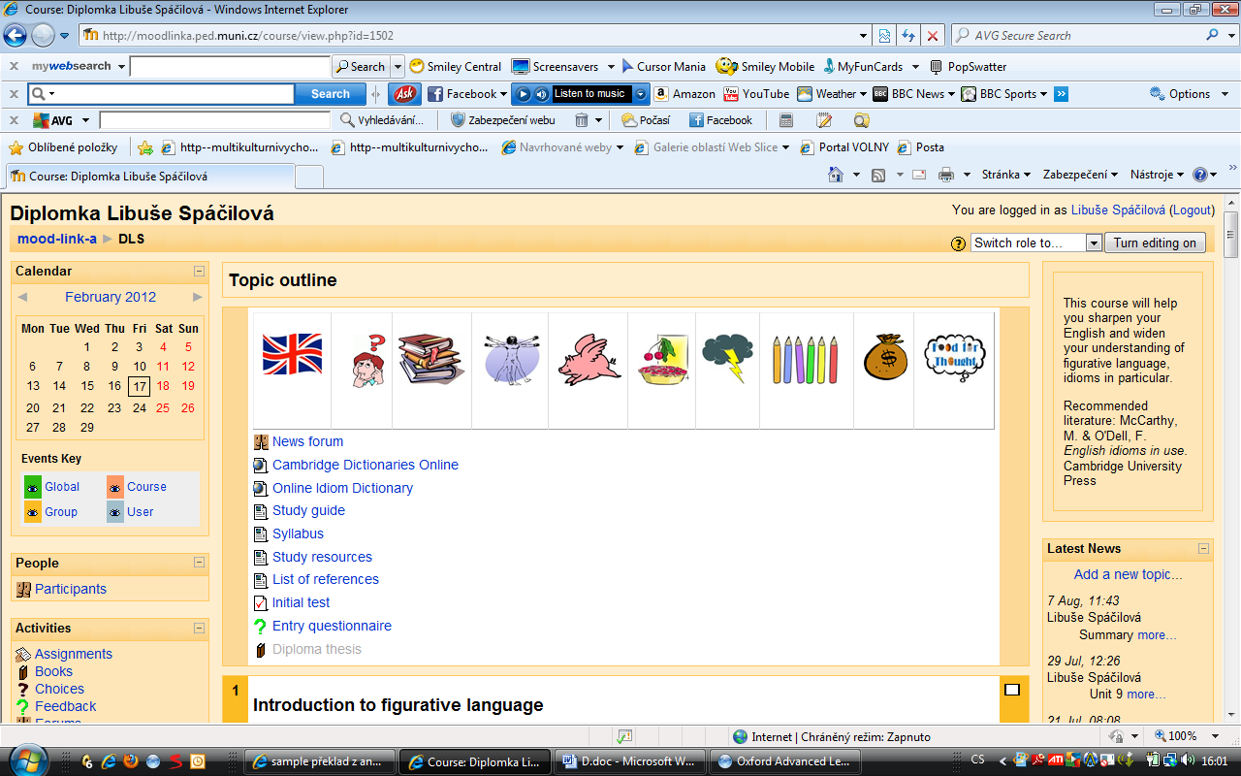
Sample 1: The course outline

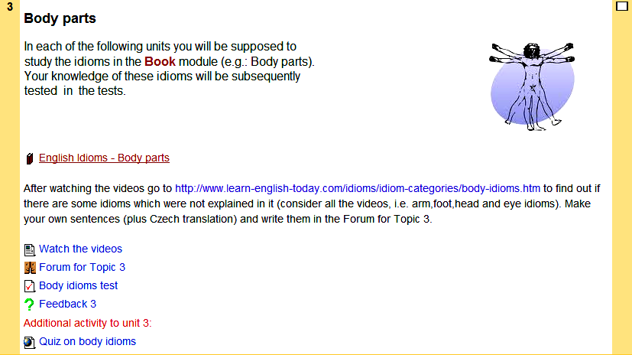
Sample 2: The structure of the unit

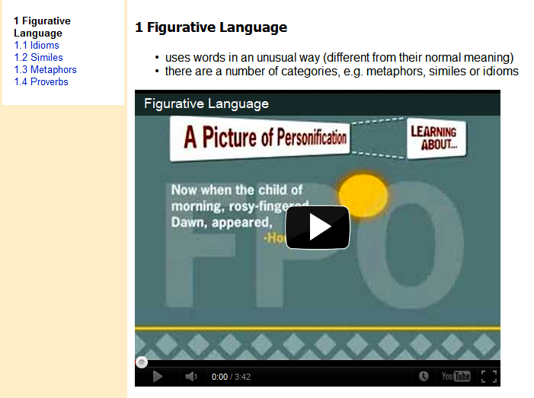
Sample 3: The Book module

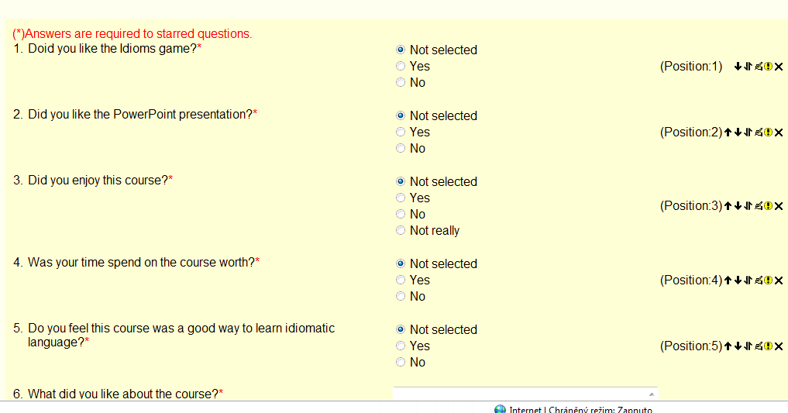
Sample 4: The course feedback

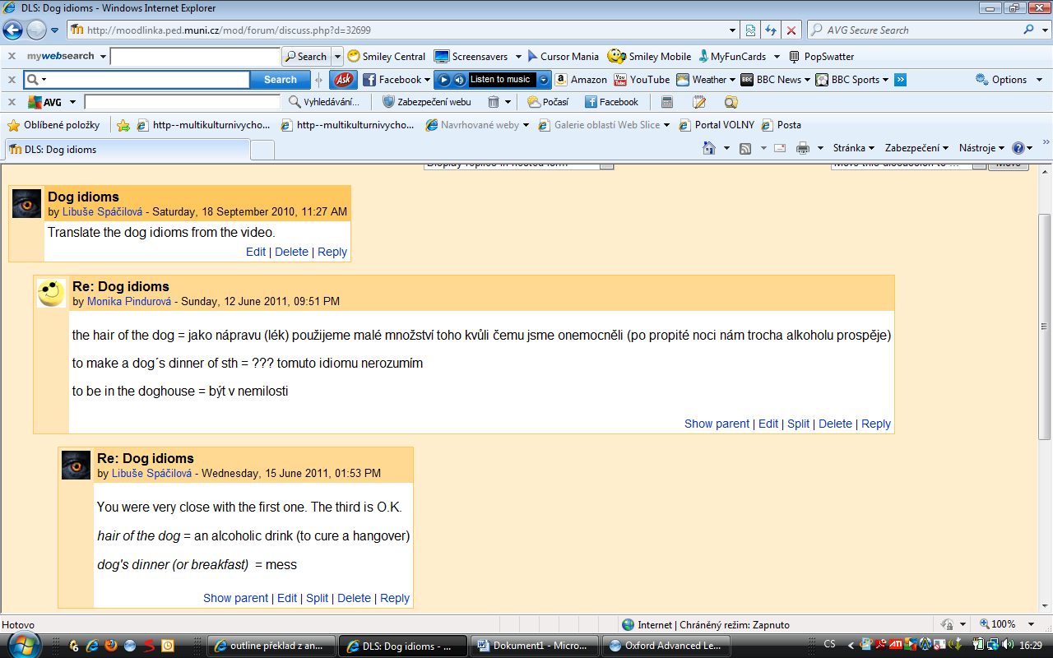
Sample 5: The course forum

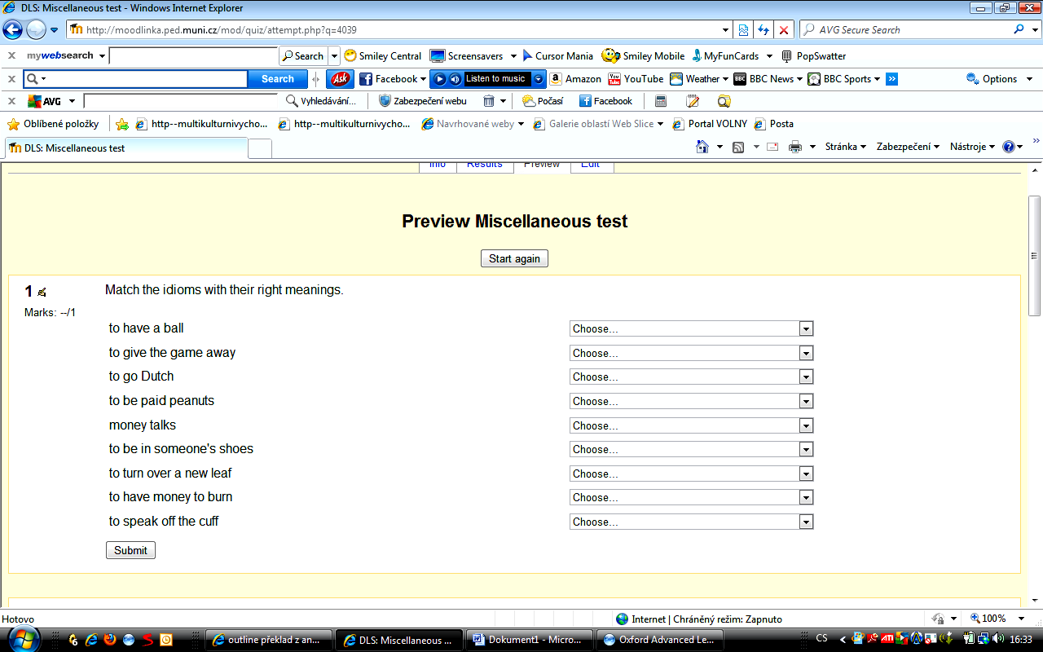
Sample 6: The course test

The dot-com era was the bubble covering the period between 1995-2000 during which stock markets expected their value to grow in the recent Internet sector and related fields.
Blended l earning is a mixture of different learning environments.
Virtual Learning Environment is a computer program facilitating e-learning (sometimes referred to as Learning Management System).
See the official web site http://www.moodle.org on which Moodle is available.
Electronic Performance Support System (EPSS) is any computer software program or component, improving user performance.
Smith/Ragan model comprises three phase, i.e. Analysis, Strategy and Evaluation, focusing on the second one.
OAR model is an ID model designed for distance higher education courses delivered through a LMS.
In backward design, the process is inversed. First, the teacher identifies classroom outcomes and then plans the curriculum and select activities and materials that help determine student ability and foster student learning.
Rapid prototyping involves learners and subject matter experts who interact with prototypes and instructional designers in a review/revision cycle, focusing on developing a prototype.
Storyboards are visual organizers, usually a series of illustrations in sequence for the purpose of previsualizing a video, a web site, application or interactive media.
Denotative meaning is the primary (dictionary) meaning of a word.
Indirect speech act is an utterance the meaning of which differs from the content that is intended to be communicated.
ESL is the abbreviation for the learners of English as a second language.
Cataphora is a figure of speech referring forwards to what will be mentioned later in the text.
Ellipsis is a figure of speech that involves omission of words.
Pleonasm is a figure of speech using redundant words.
Allusion is a figure of speech referring indirectly to other works of literature/art.
Irony is a figure of speech using words in a non-literal way to express other than denotative meaning.
Oxymoron is a figure of speech using two contradictory terms the notions of which are incompatible.
Alliteration is the repetition of the initial consonant sound in the subsequent words (e.g. “Big Brother”).
Litotes is a figure of speech involving understatement, in which a situation is expressed by the negative (e.g. “not bad” said about something excellent).
Folk-etymology is the process of change from simple to complex naming unit, which usually occurs when a word is borrowed from a foreign language and incorrectly interpreted as compound. (Vogel, 2007, p. 16).
Idiomacity refers to the degree of semantic transparency (comprehensibility) of multi-word expressions.
Idiomatization is the process in which the syntactic construction of an expression is converted into an idiom due to its loss of compositionality.
CEFR is the abbreviation for the Common European Framework of Reference for Languages: Learning, Teaching, Assessment, established by the Council of Europe.
A Moodle block is a feature that is situated on the right or left side of the course’s home page.
The official Moodle website is available at http://moodle.org/.
“IMS Content Package is an international standard for simple learning content that is created by authoring software”. (Moodle, 2007, Retrieved from http://moodle.org/mod/forum/discuss.php?d=86101)
A Moodle block is a feature that is situated on the right or left side of the course’s home page.
“Online Idiom Dictionary“available at http://en.18dao.net/Idiom_Dictionary lists idioms by alphabet as well as category.
The learning web site “English Club” is available at http://www.englishclub.com/.
Animated idioms can be watched on official British Council web site available at http://www.englishonline. org.cn/en/vocabulary-grammar/animated-idioms.
The learning web site “Funbrain”, available at http://www.funbrain.com/, provides a number of online games suitable for ESL.
The web site “Vocabulary games and Resources”, available at http://www.vocabulary.co.il/ provides a variety of English vocabulary building games.
The pictures used in the course were retrieved from http://www.google.com/imghp?hl=en&tab=wi.
The BBC website available at http://www.bbc.co.uk/worldservice/learningenglish/language/theteacher/index. shtml has been used as the main source for the video materials in the course.

