Journal of Exercise Medicine online

February 2016
Volume 1 Number 1



JEMonline
Editor-in-Chief
Tommy Boone, PhD, MBA
Review Board
Todd Astorino, PhD
Julien Baker, PhD
Steve Brock, PhD
Lance Dalleck, PhD
Eric Goulet, PhD
Robert Gotshall, PhD
Alexander Hutchison, PhD
M. Knight-Maloney, PhD
Len Kravitz, PhD
James Laskin, PhD
Yit Aun Lim, PhD
Lonnie Lowery, PhD
Derek Marks, PhD
Cristine Mermier, PhD
Robert Robergs, PhD
Chantal Vella, PhD
Dale Wagner, PhD
Frank Wyatt, PhD
Ben Zhou, PhD

Official Research Journal of the American Society of Exercise Physiologists

ISSN 1097-9751

Official Research Journal of the American Society of Exercise Physiologists

ISSN 2378-4083

Task-Oriented Ankle and Foot Training for Improving Gait, Balance, and Strength in Individuals with Multiple Sclerosis: A Pilot Study

Cizelle Rodriques MS¹, Kurt Jackson PhD², Joaquin Barrios PhD², Lloyd Laubach PhD¹, Kimberly Edginton-Bigelow PhD³

¹Department of Health and Sport Science, University of Dayton, Dayton, Ohio, USA, ²Department of Physical Therapy, University of Dayton, Dayton, Ohio, USA, ³Department of Mechanical and Aerospace Engineering, University of Dayton, Dayton, Ohio, USA

ABSTRACT

Rodrigues C, Jackson K, Barrios J, Laubach L, Edginton-Bigelow K. Task-Oriented Ankle and Foot Training for Improving Gait, Balance, and Strength in Individuals with Multiple Sclerosis: A Pilot Study. JEMonline 2016;1(1):1-13. The purpose of this pilot study was to investigate the effects and feasibility of a task-oriented ankle and foot exercise program on gait, balance, and strength in 6 adults with mild to moderate disability from multiple sclerosis (MS). The subjects participated in an 8-wk task-specific home-based ankle and foot exercise program. Outcome measures included stance phase ankle joint torque and power, limits of stability, isometric and isokinetic ankle strength, gait speed, and the 12-item Multiple Sclerosis Walking Scale (MSWS-12). Five subjects completed the 8-wk intervention. Following training, there were significant increases in ankle power during early (38.1%) and late (11.8%) stance, limits of stability (6.1%), and isokinetic dorsiflexion (26.4%), and plantar flexion (15.0%) strength. There were no differences in isometric strength, gait speed, or the MSWS-12. The findings indicate that a task-oriented home-based ankle and foot exercise program appears to be safe and feasible and may improve select measures of gait, balance, and muscle performance in individuals with MS who have mild to moderate disability. Further research may be warranted.

Key Words: Ankle, Exercise, Task-oriented, Multiple sclerosis

INTRODUCTION

Multiple sclerosis (MS) is a chronic, progressive disease of the central nervous system characterized by inflammation and demyelination of axons within the brain and spinal cord (12). Individuals with MS often experience problems with gait, balance, and functional activities due to the combined effects of muscle weakness, sensory loss, spasticity, and fatigue (21). Gait and balance disturbances are common and can affect over 80% of people with MS (25). Impairments in gait can have a significant impact on activities of daily living and social participation, and are perceived by patients to be one of the most important factors influencing quality of life (6,27). People with MS also exhibit impaired postural control and balance across various environmental and behavior conditions including stance under altered sensory conditions, limits of stability and reactive postural responses to an unexpected loss of balance (3).

Weakness in the muscles of the legs is a common impairment seen in people with MS (15,23,24), and is considered an important factor in the development of both gait and balance deficits (2,28). In studies of healthy adults, the power generated by the ankle plantar flexors during gait has been shown to be an essential contributor to forward propulsion (9) and distal lower extremity muscles play an important role in basic balance reactions such as ankle strategies (22). Although evidence suggests that resistance training is well tolerated and can improve muscle strength in MS, there is less convincing evidence that it can improve specific components of gait, balance, and functional capacity (16). To date, most strength training studies for individuals with MS have employed more traditional machine based resistance exercises that focus on isolated muscles that involve slower muscle contractions performed in less than optimal functional positions (18). Additionally, most exercise training studies for MS subjects have been multi-modal in nature with some combination of strength, flexibility, and endurance training that makes it more difficult to identify which specific exercises may have been most beneficial (18). Identifying the most effective exercises is important for people with MS because fatigue may limit tolerance to the number and type of exercises that can be performed in a given session (8). Also, due to the chronic nature of MS, finding effective exercises that can be performed safely in the home or community setting on a long-term basis is also an important consideration.

Therefore, the primary purpose of this pilot study was to measure the effects of a simple task-oriented home based ankle and foot exercise program on gait, balance, and strength in adults with MS. Additionally, we hoped to assess the feasibility of the exercise program and use the findings to assist in the planning of future trials.

METHODS

Participants
Six subjects were recruited using a database of individuals with MS who had participated in prior unrelated research at the University of Dayton and through informational fliers distributed to local health care providers. The inclusion criteria included: (a) diagnosis of relapsing-remitting or secondary progressive MS; (b) stable on current medications for at least 4 wks; (c) able to ambulate a minimum of 10 m without an assistive device or physical assistance of another person; and (d) currently not participating in any regular strength or balance training program. Subjects were excluded from the study if they had any other neurological condition, had cardiovascular, orthopedic, and/or metabolic conditions that would make the exercise training unsafe, or had an exacerbation of their MS in the last 60 d. All subjects gave informed consent that was approved by the Institutional Review Boards at the University of Dayton. Characteristics of the 5 subjects who completed the study are presented in Table 1.

Table 1. Participant Characteristics.
Characteristic | Participant 1 | Participant 2 | Participant 3 | Participant 4 | Participant 5
Age | 51 | 60 | 50 | 60 | 58
Gender | M | F | F | F | F
Height (m) | 1.85 | 1.61 | 1.70 | 1.73 | 1.58
Weight (kg) | 113 | 62 | 60 | 120 | 72
BMI | 33.0 | 24.0 | 21.6 | 41.5 | 29.3
Duration of MS (yrs) | 9 | 9 | 23 | 12 | 19
EDSS score | 2.0 | 1.5 | 3.0 | 3.5 | 3.5

Study Design
After a preliminary phone interview, the subjects attended an initial screening and test familiarization session. A pre-intervention testing session was then conducted, which was immediately followed by the 8-wk exercise intervention. A final post-intervention test was performed within 1 wk of completing of the exercise program (Figure 1).

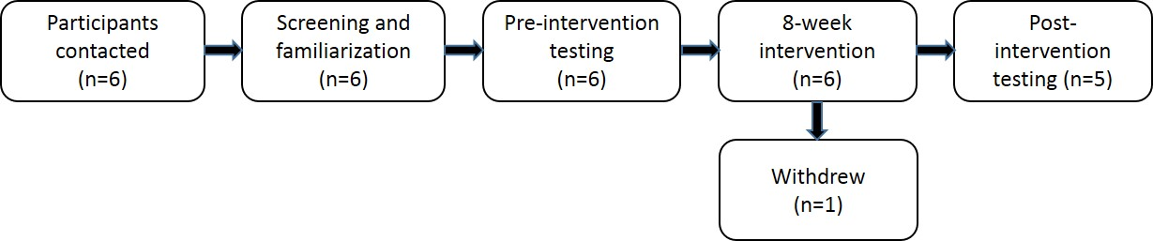
Figure 1. Study Design Flow Diagram.

Overview of Outcome Measures
During the screening and familiarization session, demographic information, height, weight, resting blood pressure, and heart rate were recorded. Additionally, a neurologic exam was conducted by an experienced clinician. Each subject’s disability level was documented using the Kurtzke Expanded Disability Status Scale (EDSS) (17). The EDSS scores ranged from 1.5 to 3.5 for the 5 subjects completing the study. The outcome measures represent different domains of the International Classification of Functioning Disability and Health (ICF), which includes: (a) Body Structure and Function (muscle performance, stance phase ankle joint torques and power, and limits of stability); (b) Activity (gait speed); and (c) Disability (12-item Multiple Sclerosis Walking Scale). During each of the testing sessions, all of the outcome measures were performed in the same order at approximately the same time of day (±1 hr).

Gait Measures
Peak ankle joint torques and powers during early and late stance were measured using a Vicon motion analysis system (Vicon, Oxford Metrics, UK) at 150 Hz and a floor-mounted force plate (Bertec Corp., Worthington, OH, USA) at 1500 Hz. Retro-reflective spherical markers were placed on the subjects’ most involved leg in the following locations: (a) iliac crest; (b) greater trochanter; (c) medial and lateral femoral condyles; (d) medial and lateral tibial plateaus; (e) calcaneus; (f) medial and lateral malleoli; and (g) first and fifth metatarsal heads. The foot markers were taped to the shoe of each subject in the locations listed. In addition, rigid clusters of four tracking markers were fastened with Velcro® straps on the distal posterior shank and the distal posterolateral thigh. Initially, subjects underwent a static standing reference trial and a hip motion trial. Anatomical markers that were not needed during the dynamic trials were then removed. Baseline data were collected as the subjects walked at a self-selected pace along a 23 m walkway. For all subsequent testing sessions at least 4 usable trials were collected that were within ±10% of their self-selected speed that was determined during the familiarization session, as well as 4 usable trials that were collected at a “free” self-selected speed. Ankle joint torques and powers during early and late stance were determined using an inverse dynamics approach using a combination of Visual 3D (C-Motion, Germantown, MD, USA) for post processing and a custom LabVIEW (National Instruments Corp, Austin, TX.) program. Gait speed was determined by tracking the velocity of a marker placed at the S2 spinous process.

Self-perceived walking ability was assessed using the 12-Item Multiple Sclerosis Walking Scale (MSWS-12). The MSWS-12 is a reliable and valid questionnaire that measures the perceived impact of MS on walking ability (13). The scores of the 12 individual items are summed and standardized to a scale with a range of 0-100 with a higher score representing greater perceived limitations in walking ability.

Balance Measures
Dynamic balance was assessed by measuring anterior/posterior (A/P) limits of stability (LOS) using a Bertec force plate (Bertec Corp., Columbus, OH, USA). Subjects were asked to lean forward and backward as far as possible at the ankle without lifting their foot from the plate. Total A/P LOS (mm) was calculated and averaged over 3 trials. A/P LOS was chosen as an outcome measure because it requires effective use of the dorsiflexors and plantar flexors, which was a primary focus of the exercise program.

Strength Measures
Dorsiflexor (DF) and plantar flexor (PF) strength of the more involved leg was tested with a computerized dynamometer (Biodex System 3, Shirley, NY, USA). Each subject was securely strapped to the dynamometer using the manufacturer endorsed testing positions. Maximal isometric and isokinetic (90°/sec) DF and PF torques were determined using a testing protocol described by Webber and Porter (29) that was shown to be reliable (ICC = 0.85 - 0.97) in older adults. During the isometric tests, the subjects were given 3 submaximal practice trials before completing 3 maximal efforts. During the isokinetic tests, the subjects performed 3 to 5 submaximal practice trials followed by 5 maximal efforts. The average peak torque of the maximal efforts was used for data analysis. The subjects were given a 2-min rest between each individual test.

Intervention
In addition to the instructions during the exercise program, the subjects were given an instruction booklet with photos of each exercise. Additionally, the subjects were contacted by phone weekly to facilitate exercise progression and to answer any questions. They were also given a log book to track exercise adherence and progression and were provided with the following pieces of equipment; 8” plastic step stool (Rubbermaid®, USA), plastic wedge (RhinoGear Tirehugger® wheel chock), four 24” elastic bands of different resistance levels (yellow, red, green, and blue), and an 8” x 24” board and an adjustable (1-5 lb) ankle weight. See Table 2 and Figure 2 for a detailed description and illustration of the exercise program.

Table 2. Description of Exercises.
Exercise | Dosage* | Description and Progression | Rationale
Marching | 1-3 min | Increase speed and time (max of 3 min) as tolerated with use of hand hold support as needed | Warm-up activity to increase circulation and motor activity.
Heel Raise | 2 sets  10-15 reps | Level 1: Stride stance position with weight shifted toward back foot. ↑ speed as tolerated.  Level 2: Front foot on 8 inch step with weight shifted toward back foot. ↑ speed as tolerated.  Level 3: Front foot on 8 inch step with weight shifted toward back foot with adjustable ankle weight (1-5 lbs) around back foot. ↑ speed as tolerated. | Increase power during push-off phase of gait.
Toe  Raise | 2 sets  10-15 reps | Toe raises in stride stance using board and resistance bands. Subjects progressed through the following levels of resistance bands with ↑ speed as tolerated: yellow→ red→ green→ blue. | Improve ankle control during loading response.
Gastroc Stretch | 2 x 30 sec | Using a plastic wedge, increase stretch as tolerated. | Increase dorsiflexion ROM to allow tibial progression during stance and increase anterior limits of stability.
*All exercises performed 2 x wk for 8 wks with 48 hrs between exercise bouts.
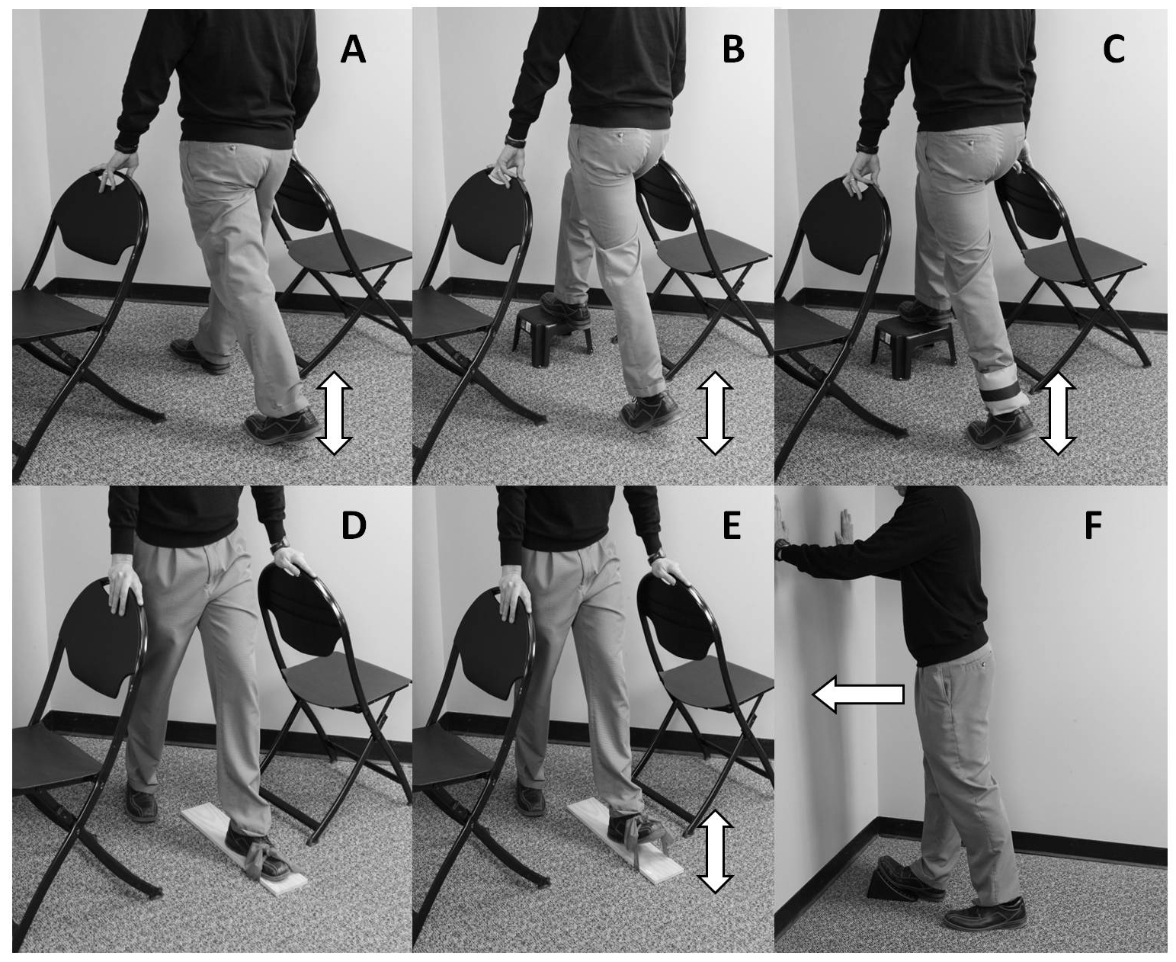

Figure 2. A, Level 1 heel raise; B, Level 2 heel raise with front foot on 8” step; C, Level 3 heel raise with step and ankle weight; D, start position for toe raises; E, end position for toe raise; F, wedge stretch for gastrocnemius.

The 8-wk home-based exercise program focused on ankle and foot strength, power, and flexibility. It was designed to be task-oriented by mimicking the position of the lower extremity during the loading response and push-off phases of gait. The exercises were performed twice weekly on both lower extremities with at least 48 hrs between exercise bouts. The subjects were instructed to perform all exercises in a corner of a room with chairs on either side for balance, but were encouraged to minimize use of upper extremity support. The exercises included a brief warm-up of marching in place, which was followed by progressively challenging heel and toe raises that were performed in a stride stance position and concluded with a gastrocnemius stretch (Table 2 and Figure 2). Because of differences in ability levels, the initial difficulty of the exercise program was individualized by the physical therapist so that each subject could perform the exercises safely and be challenged appropriately at the start of the program. The difficulty level of the heel and toe raise exercises was adjusted so that only 8 to 15 repetitions could be completed. When a subject could complete 15 repetitions on two consecutive sessions the difficulty level was increased as described in Table 2 and illustrated in Figure 2. Additionally, the subjects were encouraged to increase the speed of ankle joint movement as tolerated to simulate what they experienced during gait.

Statistical Analyses
Descriptive statistics were calculated for each of the outcome measures of interest. Due to the small sample, the Wilcoxon Signed Rank Test was used to test for differences between the pre- and post-intervention values. Given the exploratory nature of the study, a liberal apriori alpha level of 0.10 was selected. However, a sample size estimate was calculated for one of the primary outcome measures (ankle power during late stance) assuming an alpha of 0.05 and a power of 0.80 to assist in the design of future trials. Since all walking trials (free and controlled speed) were within the predetermined acceptable window of variability as described in the methods, only data from the free speed trials were used in the analysis.

RESULTS

Five of the 6 subjects completed the exercise intervention and all outcome testing sessions. One subject withdrew from the study after experiencing a non-study related fall and foot injury shortly after initiating the exercise intervention portion of the study.

Gait
There were non-significant increases in peak dorsiflexion torque during early stance (13.3%. P = .225) and plantar flexion torque during late stance (2.8%, P = .225). There was a significant increase in peak ankle power during early stance (38.1%, P = 0.08) and ankle power during late stance (12%, P = 0.08) (Figure 3). There were non-significant increases in free gait speed (3.5%, P = 0.225) and in the MSWS-12 (2.2%, P = 0.892).
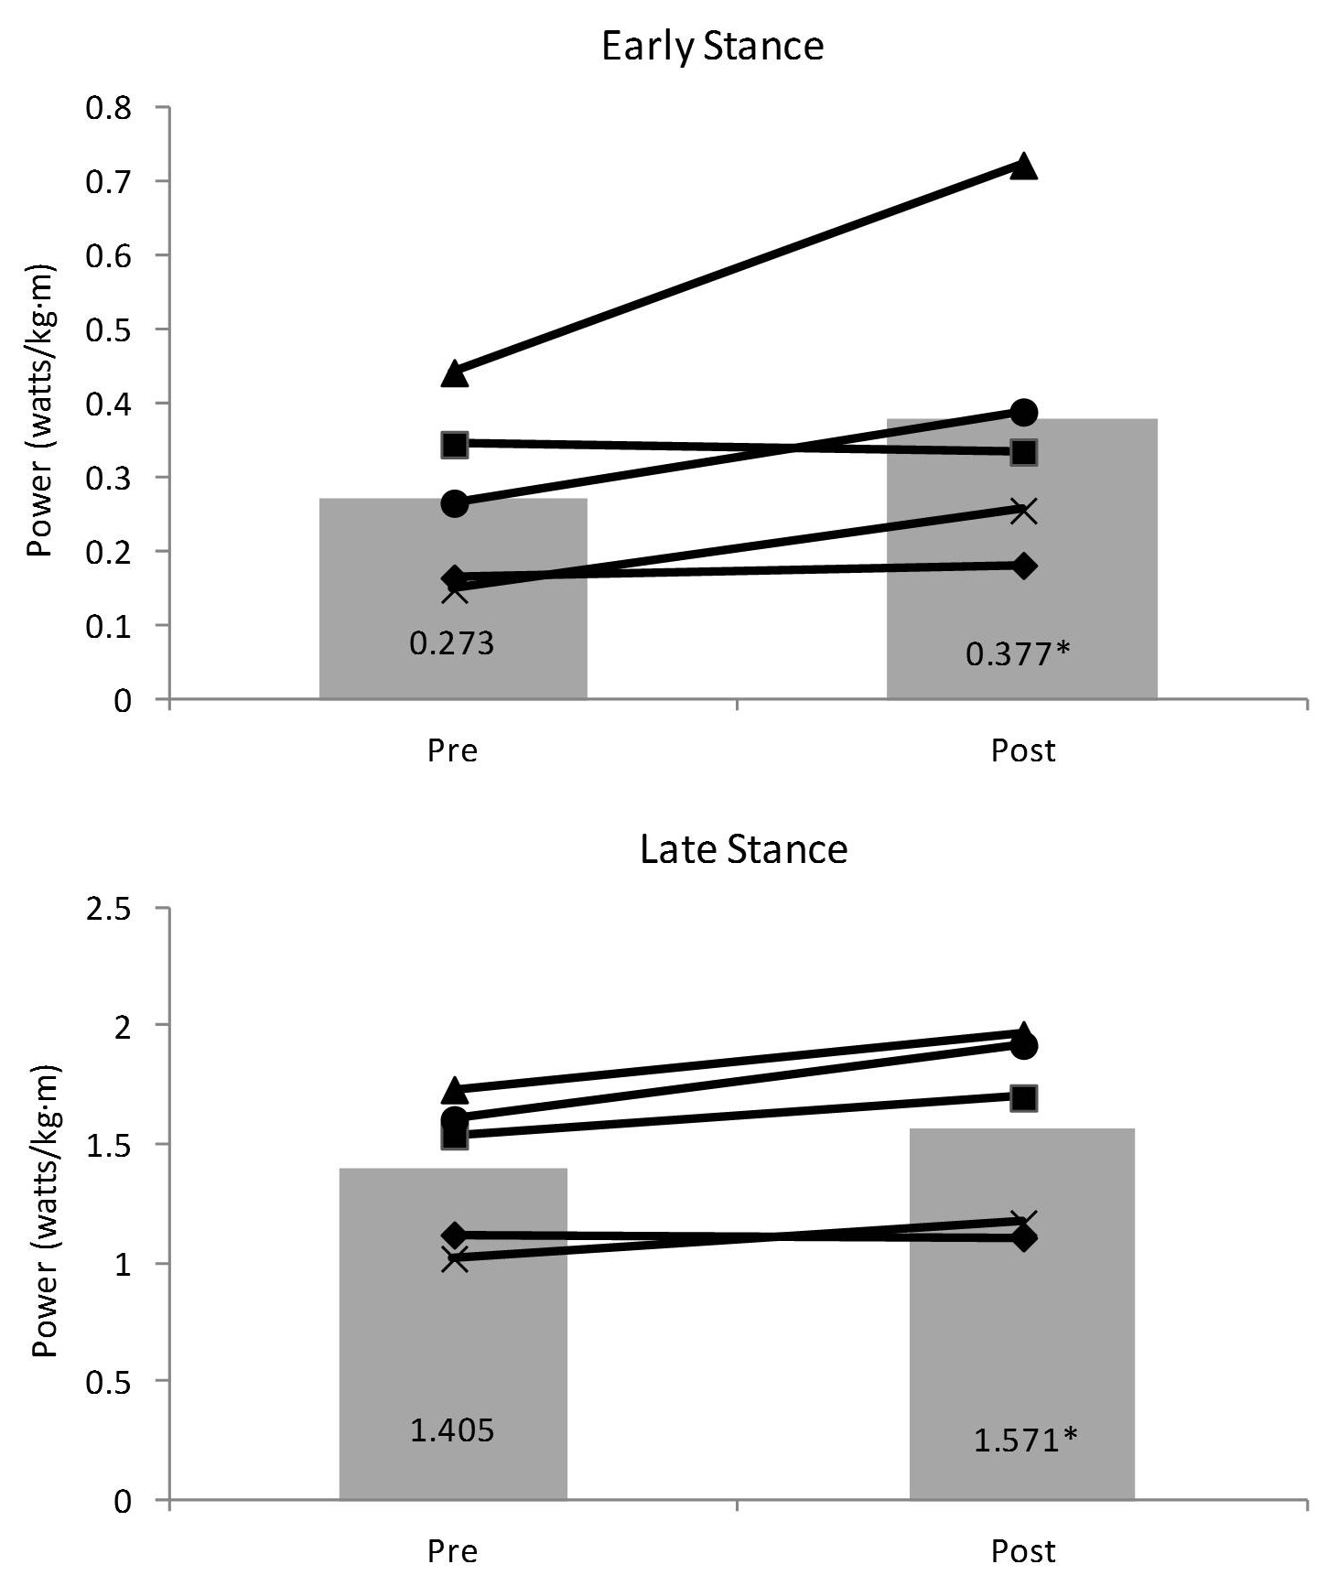

Figure 3. Normalized Mean (bars) and Individual (lines) Peak Ankle Power during Early and Late Stance for Most Affected Leg. Subject 1 = , 2 = ▲, 3 = X, 4 = , 5 = . *P<0.10 for Wilcoxon Signed Rank Test

Balance
There was a significant increase in anterior/posterior limits of stability (6%, P = 0.08) (Figure 4).
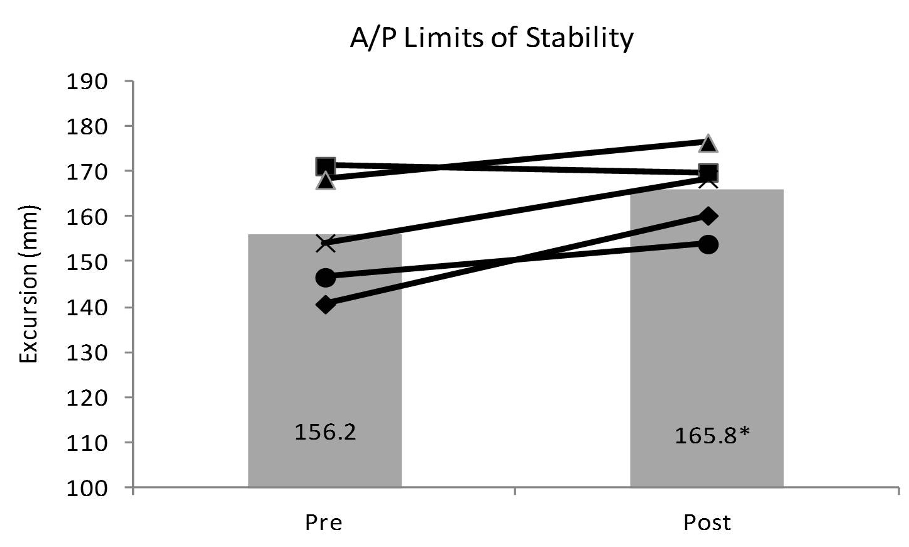

Figure 4. Mean (bars) and Individual (lines) Anterior/Posterior (A/P) Limits of Stability Values.
Subject 1 = , 2 = ▲, 3 = X, 4 = , 5 = . *P<0.10 for Wilcoxon Signed Rank Test
Strength
There were non-significant increases in isometric dorsiflexion (4.5%. P = 0.138) and plantar flexion strength (11.2%, P = 0.225). There were significant increases in isokinetic dorsiflexion (26.3%, P = 0.08) and plantar flexion strength (15.0%, P = 0.08) (Figure 5).

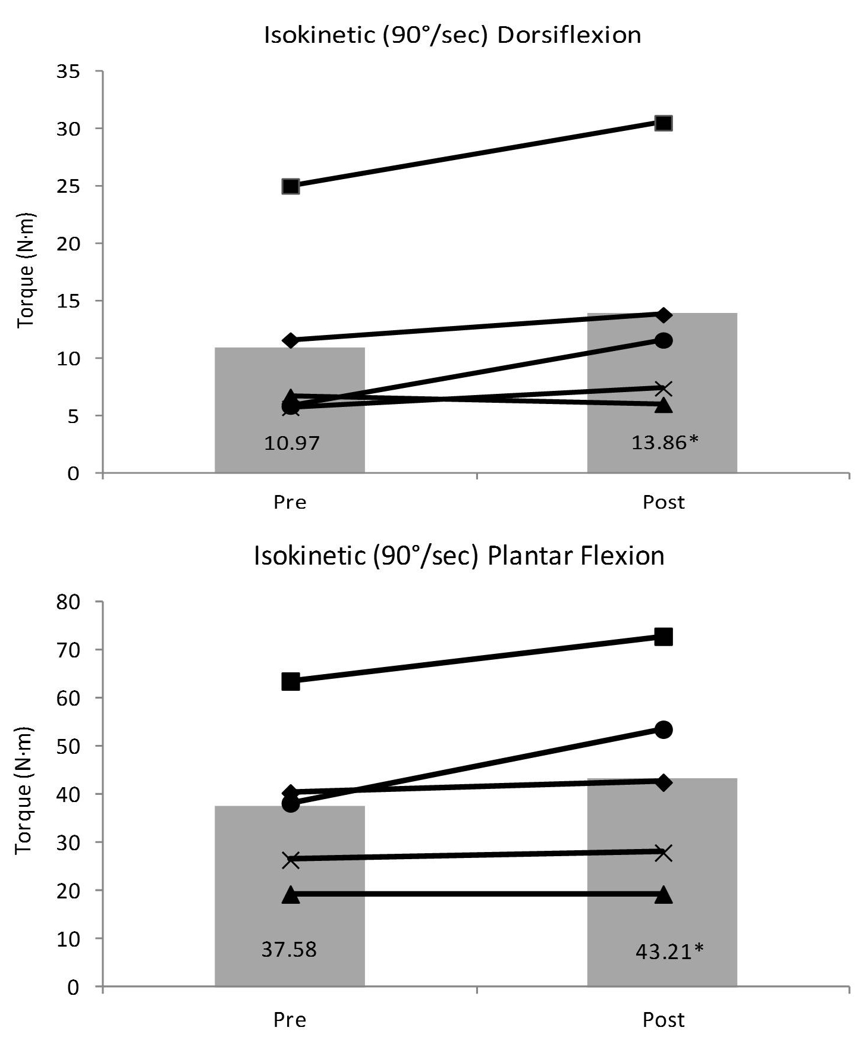

Figure 5. Mean (bars) and Individual (lines) Isokinetic Dorsiflexion and Plantar Flexion Strength for Most Affected Leg. Subject 1 = , 2 = ▲, 3 = X, 4 = , 5 = . *P<0.10 for Wilcoxon Signed Rank Test.

Sample Size Estimate
A sample size estimate for ankle power during late stance was calculated using G*Power (7) assuming an alpha level of 0.05 and power of 0.80. It was estimated that 22 subjects would be required with an effect size of 0.64.

Feasibility
No adverse events were reported and the exercise program was well tolerated with a self-reported compliance rate of 100%. The subjects reported the exercises took ~10 to 15 min to complete and induced only minor local muscle fatigue and soreness. All of the equipment used for training was purchased at a large retail store for less than $50 per subject.

DISCUSSION

The primary purpose of this pilot study was to examine the effects of a task-oriented foot and ankle exercise program on gait, balance, and strength in individuals with MS. Another important objective was to assess the feasibility of the program to gain a better understanding of the appropriateness and relevance of the outcome measures that were selected. Following the intervention there were improvements in select measures of gait, balance, and strength, especially those that may require more rapid and forceful contraction of the ankle dorsiflexors and plantar flexors.

Gait
Following the intervention there were significant increases in both power absorbed during early stance (loading response) and power generated during late stance (push-off). Both of these changes may indicate more normal gait kinetics and could contribute to an improvement in lower extremity control and gait efficiency. Huisinga et al. (14) have previously shown that ankle power during early and late stance are significantly lower for individuals with MS than age-matched controls and that disability level (as measured by the EDDS) is significantly correlated with ankle power during early (r_{s} = -0.41) and late (r_{s} = -0.57) stance. This information may support the rationale for performing exercises aimed at improving ankle power such as those used in this study. This is the first study we are aware of to measure changes in kinetic gait variables (torque and power) in response to an exercise intervention in persons with MS. However, Gutierrez et al. (10) previously demonstrated improvements in a number of temporal and kinematic gait variables following a more traditional resistance lower extremity training program including a decrease in stance and double support time with corresponding increases in swing time and stride length. While these studies provide preliminary evidence that resistance training may influence both kinetic and kinematic aspects of gait, the potential clinical and functional relevance of these findings requires further evaluation.

Gait speed has been shown to be an important indicator of normal mobility (26), and it was another gait variable measured in the present study. Despite the improvements that were seen in ankle power, there were no changes in walking speed following the intervention. This finding was not entirely unexpected since actual walking activities were not part of the intervention. Increases in ankle power and muscle performance may provide a foundation for improvements in gait speed, but unless activities that include faster walking (e.g., treadmill intervals) are practiced, changes in gait speed may not occur. Similarly, Gutierrez et al. (10) found no changes in walking speed despite improvements in kinematic gait variables and Hayes et al. (11) failed to demonstrate improvements in gait speed following high intensity resistance training. Although speed did not change, other important aspects of gait such as energy cost and fatigue may have improved but were not assessed in this study.

Balance
Balance problems and falls are one of the most commonly reported symptoms of MS (19) and, therefore, both were considered as an important area of interest for this study. Prior research has demonstrated important relationships between balance performance and strength and range of motion of the foot and ankle in older adults (1,20). While this same relationship has not been confirmed in MS, the common presentation of greater distal muscle weakness would make the foot and ankle susceptible to the impairment of ankle strategies required for normal postural control.

Following the intervention there was a significant improvement in A/P limits of stability, which indicate that the subjects could volitionally lean further forward and backward without altering their base of support. This finding may indicate an improvement in use of an effective ankle strategy. The improvement in plantar flexor and dorsiflexor strength and flexibility, which was a focus of the exercise intervention, may play a role in increasing LOS. While these findings are encouraging and may be of interest for future investigations, improvements in force plate measures of postural control may not necessarily translate into a reduction in fall risk or an improvement in function.

Strength
Following the exercise intervention there was a significant increase in isokinetic strength for both the dorsiflexors and plantar flexors. This finding was somewhat expected and supports the concepts of specificity of training because the exercise program required more rapid joint movements and muscle contractions. Interestingly, this is the only study we are aware of that has determined isokinetic ankle strength in persons with MS. While improving ankle muscle performance was a goal of the exercise intervention, changes in strength as measured by a dynamometer were viewed as a secondary outcome measure for several reasons. First, improvements in the gait and balance measures were considered to be of greater importance than any isolated improvements in isometric or isokinetic torque production. Secondly, we used a dynamometer to assess strength in the subjects while in the seated position. This is very different from the standing position from which the exercises were performed and, thus could reduce the likelihood of carryover to the test position.

While most resistance training studies for individuals with MS have shown significant improvements in strength (4), the majority have used traditional machine based exercises in a supervised or semi-supervised setting. Unfortunately, this type of training may not be practical for many individuals with MS. Most comparable to our study, DeBolt and McCubbin (5) administered a home-based exercise program that was functional in nature and focused on the subjects’ lower extremity strength and power. Following training, they found significant improvements in knee extensor power but no changes in postural control or mobility (Timed Up and Go). These results are similar to our findings and demonstrate that while strength and power of the lower extremities can be safely improved in the home setting, practice of specific gait and balance activities is likely required to maximize improvements in function.

Limitations of this Study
As an unblinded pilot study, only 5 subjects completed the exercise intervention. A liberal a priori alpha level of P<0.10 was used to protect against a type II error, and there was no correction applied for multiple comparisons. All of the subjects were highly motivated and had only mild to moderate disability, which is not necessarily representative of the general MS population. There was also no follow up to assess the long-term effects of the exercise program. Thus, the clinical meaningfulness of the results should be interpreted cautiously.

CONCLUSIONS

The primary purpose of this pilot study was to evaluate the effects and feasibility of an 8-wk task-oriented home exercise program for the ankle and foot in persons with MS. Following training, the subjects demonstrated improvements in ankle power, limits of stability, and isokinetic ankle strength. The training program was completed without injury or increases in MS symptoms and compliance was high. However, there were no changes in gait speed or self-perceived walking ability. This finding suggests that the select improvements in ankle power, postural control, and muscle performance may not have been sufficient to impact function or disability in the short term. Yet, despite the limitations in this study, the findings address a simple and novel home-based exercise program that may be of interest to the clinician and/or researcher.

ACKNOWLEDGMENTS
We thank the individuals with MS who participated in this study.

Address for correspondence: Kurt Jackson PT, PhD, Department of Physical Therapy, University of Dayton, Dayton, OH, 45469 Email: Kjackson1@udayton.edu

REFERENCES

- Bassey EJ, Bendall MJ, Pearson M. Muscle strength in the triceps surae and objectively measured customary walking activity in men and women over 65 years of age. Clin Sci (Lond). 1988;74(1):85-89.

- Broekmans T, Gijbels D, Eijnde BO, et al. The relationship between upper leg muscle strength and walking capacity in persons with multiple sclerosis. Mult Scler. 2013;19 (1):112-119.

- Cameron MH, Lord S. Postural control in multiple sclerosis: Implications for fall prevention. Curr Neurol Neurosci Rep. 2010;10(5):407-412.

- Cruickshank TM, Reyes AR, Ziman MR. A systematic review and meta-analysis of strength training in individuals with multiple sclerosis or parkinson disease. Medicine (Baltimore). 2015;94(4):e411.

- DeBolt LS, McCubbin JA. The effects of home-based resistance exercise on balance, power, and mobility in adults with multiple sclerosis. Arch Phys Med Rehabil. 2004; 85(2):290-297.

- Delgado-Mendilivar JM, Cadenas-Diaz JC, Fernandez-Torrico JM, Navarro-Mascarell G, Izquierdo G. A study of the quality of life in cases of multiple sclerosis. Rev Neurol. 2005;41(5):257-262.

- Faul F, Erdfelder E, Lang A, Buchner A. G*Power 3: A flexible statistical power analysis program for the social, behavioral, and biomedical sciences. Behav Res Methods. 2007;39(2):175-191.

- Freal JE, Kraft GH, Coryell JK. Symptomatic fatigue in multiple sclerosis. Arch Phys Med Rehabil. 1984;65(3):135-138.

- Gottschall JS, Kram R. Energy cost and muscular activity required for propulsion during walking. J Appl Physiol (1985). 2003;94(5):1766-1772.

- Gutierrez GM, Chow JW, Tillman MD, McCoy SC, Castellano V, White LJ. Resistance training improves gait kinematics in persons with multiple sclerosis. Arch Phys Med Rehabil. 2005;86(9):1824-1829.

- Hayes HA, Gappmaier E, LaStayo PC. Effects of high-intensity resistance training on strength, mobility, balance, and fatigue in individuals with multiple sclerosis: A randomized controlled trial. J Neurol Phys Ther. 2011;35(1):2-10.

- Hemmer B, Nessler S, Zhou D, Kieseier B, Hartung H. Immunopathogenesis and immunotherapy of multiple sclerosis. Nat Clin Pract Neurol. 2006;2(4):201-211.

- Hobart JC, Riazi A, Lamping DL, Fitzpatrick R, Thompson AJ. Measuring the impact of MS on walking ability: The 12-item MS walking scale (MSWS-12). Neurology. 2003; 60(1):31-36.

- Huisinga JM, Schmid KK, Filipi ML, Stergiou N. Gait mechanics are different between healthy controls and patients with multiple sclerosis. J Appl Biomech. 2013;29(3): 303-311.

- Kent-Braun J, Ng AV, Castro M, et al. Strength, skeletal muscle composition, and enzyme activity in multiple sclerosis. J Appl Physiol. (1985). 1997;83(6):1998-2004.

- Kjølhede T, Vissing K, Dalgas U. Multiple sclerosis and progressive resistance training: A systematic review. Mult Scler. 2012;18(9):1215-1228.

- Kurtzke JF. Rating neurologic impairment in multiple sclerosis: An expanded disability status scale (EDSS). Neurology. 1983;33(11):1444-1452.

- Latimer-Cheung A, Martin Ginis K,A., Hicks AL, et al. Development of evidence-informed physical activity guidelines for adults with multiple sclerosis. Arch Phys Med Rehabil. 2013;94(9):1829-1836.e7.

- Matsuda PN, Shumway-Cook A, Bamer AM, Johnson SL, Amtmann D, Kraft GH. Falls in multiple sclerosis. PM R. 2011;3(7):624-632.

- Menz HB, Morris ME, Lord SR. Foot and ankle characteristics associated with impaired balance and functional ability in older people. J Gerontol A Biol Sci Med Sci. 2005;60A(12):1546-1552.

- Motl RW, Goldman MD, Benedict RHB. Walking impairment in patients with multiple sclerosis: Exercise training as a treatment option. Neuropsychiatr Dis Treat. 2010; 6:767-774.

- Nasher L, Woollacott M. The organization of rapid postural adjustments of standing humans: An experimental – conceptual model. In: Talbot RE HD, ed. Posture and Movement. New York: Raven; 1972:243-257.

- Ng A, Miller R, Gelinas D, Kent‐Braun J. Functional relationships of central and peripheral muscle alterations in multiple sclerosis. Muscle Nerve. 2004;29(6):843-852.

- Pollock M, Calder C, Allpress S. Peripheral nerve abnormality in multiple sclerosis. Ann Neurol. 1977;2(1):41-48.

- Scheinberg L, Holland N, Larocca N, Laitin P, Bennett A, Hall H. Multiple sclerosis; Earning a living. N Y State J Med. 1980;80(9):1395-1400.

- Studenski S, Perera S, Patel K, et al. Gait speed and survival in older adults. JAMA. 2011;305(1):50-58.

- Sutliff MH. Contribution of impaired mobility to patient burden in multiple sclerosis. Curr Med Res Opin. 2010;26(1):109-119.

- Thoumie P, Lamotte D, Cantalloube S, Faucher M, Amarenco G. Motor determinants of gait in 100 ambulatory patients with multiple sclerosis. Mult Scler. 2005;11(4):485-491.

- Webber SC, Porter MM. Reliability of ankle isometric, isotonic, and isokinetic strength and power testing in older women. Phys Ther. 2010;90(8):1165-1175.

Disclaimer
The opinions expressed in JEMonline are those of the authors and are not attributable to JEMonline, the editorial staff or the ASEP organization.

