Literature Review

Change and Transition
Advisory Material
For Managers


Introduction

The intention of this literature review (WP1) is to translate a selection of theories and models of change management into an operational framework that comply with the ATM C&T context and consequently can be applied in the change and transition advisory material for managers. What follows is thus designed to provide a common tool box for the following work packages of this project.

The content is organised into four parts including 17 theories and models. This structure reflects the four elementary phases of change management that also describes the four essential objects of change managers:

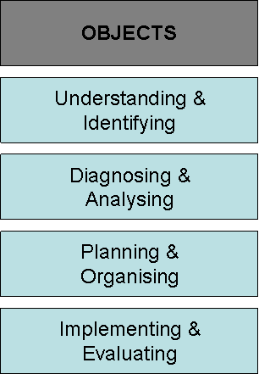

To enhance the usability of this document, the presentation of each theory and model follows a distinctive and uniform order including specifications, characteristics, and references.

Aspects of overlapping must be taken carefully into consideration as most of the presented theories and models are originally developed and designed to be applied to more than just one of the four phases. The utility of each theory and model is outlined within a tableau in the appendix of this document.

All theories and models are simplifications of the real world, and the utility of any particular model needs to be judged in terms of whether or not it provides a helpful conceptual framework for managing the change process in the specific context of this project.

None is guaranteed to accommodate all circumstances and provide a reliable basis for understanding why things are the way they are, or identify actions that can be taken to produce a desired outcome. Depending on circumstances and purpose, some theories and models may have greater utility than others.

The three characteristics of plausible identification and selection of theories or models to apply in a specific context are that they:
- Are relevant to the particular issues under consideration.
- Help change managers recognise cause and effect relationships.
- Focus on elements that change managers can influence.

Previous to making a final decision of which model to use as guidance in a specific change management process, it is useful to reflect on two points:
- How do the available model relate to your personal experience? For example, to what extent do the models considered accommodate or ignore elements and causal relationships that your experience has led you to believe are important? It might be unwise to slavishly apply a model that ignores aspects of organisational functioning that your own experience tells you are significant.
- Do any of the available models include elements or relationships that you have never previously considered but which, on reflection, might help you make better sense of your own experience? You need to be alert to the danger of rejecting alternative models too hastily. You may find that a model that is quite different from your own personal favourite model can provide useful new insights.

Change management is not a one-off activity: it is on-going and often begins with a review of the total system. The use of theories and models to investigate specific aspects of organisational behaviour and functioning elaborates and helps to build a richer picture of the organisation as a whole, and because this big picture exists it is possible to align efforts to improve particular aspects of organisational performance.

Finally, it is worthwhile to note that the extensive empirical research of change management processes in numerous industries suggests that the human factors of determination, knowledge, unambiguous values and managerial courage to eliminate misassumptions and misunderstandings are crucial elements of successful change in any organisation.

SØREN LYBECKER & NIELS MØLLER

DEPARTMENT OF MANUFACTURING ENGINEERING AND MANAGEMENT
TECHNICAL UNIVERSITY OF DENMARK
OCTOBER 2007
Table of Contents

PART ONE
Understanding & Identifying

1. Types of Organisational Change (page 5)
2. Change versus Transition (page 7)
3. Developmental, Transitional and Transformational Change (page 9)
4. A Congruence Model of Organisations (page 12)
5. Four Frames in eight Stages (page 15)
6. The Hourglass Model (page 18)
7. Socio-Technical Systems Theory (page 21)

PART TWO
Diagnosing & Analysing

8. SWOT Analysis (page 25)
9. PESTLE Analysis (page 27)
10. Weisbord’s Six-Box Model (page 29)
11. Total Quality Management (page 31)
12. The Five Steps of an Appreciative Inquiry (page 33)

PART THREE
Planning & Organising

13. The Dynamics of Organisational Culture (page 37)
14. Fernandez and Rainey’s eight Factors of Successful Change (page 40)
15. Five Basic Communication Strategies (page 44)

PART FOUR
Implementing & Evaluating

16. The Psychological Contract (page 48)
17. Individual and Collective Learning (page 51)

APPENDIX
Summary & Overview

Summary
Overview

Part One

Understanding
& Identifying
1. Types of Organisational Change

Re-orientation

Adaptation

Re-creation
Proactive

Reactive
Incremental Radical

Tuning

Specifications

The extent to which change involves incremental adjustment or radical change and the extent to which the organisation’s response to change is proactive or reactive provides a useful typology of organisational change.

Nadler, Shaw and Walton (1995) identify four types of change:

- Tuning is change that occurs when there is no immediate requirement to change. It involves seeking a better way of achieving the strategic vision. For example, improving policies, methods, procedures; introducing new technologies; redesigning processes or developing people with required competencies. Most organisations engage in a form of fine tuning much of the time. This approach to change tends to be initiated internally in order to make minor adjustments to maintain alignment between the internal elements of organisation and the external environment.
- Adaptation is an incremental and adaptive response to a pressing external demand for change. Essentially, it involves, within broad terms, doing more of the same but doing it better in order to remain competitive. This kind of change is not about doing things in fundamentally different ways or doing fundamentally different things.

While tuning and adaptation can involve minor or major changes, they are types of change that occur within the same frame, they are bounded by the existing paradigm. Re-orientation and re-creation, on the other hand, are types of change that target the playing field and the rules of the game rather than the way a particular game is played. They involve transforming the organisation and breaking the frame to do things differently or to do different things.

- Re-orientation involves a re-definition of the enterprise. It is initiated in anticipation of future opportunities or problems. The aim is to ensure that the organisation will be aligned and effective in the future. It may be necessary to modify the frame, because the need for change has been anticipated, this could involve a gradual process of continuous frame-bending. In those cases where the need for change is not obvious to all and may not be seen as pressing by many, change agents may need to work hard in order to create a sense of urgency and gain widespread acceptance of the need to prepare for change.
- Re-creation is a reactive change that involves transforming the organisation through the fast and simultaneous change of all its basic elements. Nadler and Tushman (1995) state that it inevitably involves organisational frame-breaking and the destruction of some elements of the system. It can be a very disorienting process.

The most common type of change is either fine-tuning or adaptation but it is not unusual for a single organisation to be involved in more than one type of change at the same time.

Characteristics

Origin
Nadler, Shaw & Walton (1995)
Approach
Core concepts
Implications
Different types of change can affect the focus for change efforts, the sequence of steps in the change process and the locus for change. While tuning or adaptation can involve minor or major changes, they are bounded by the existing paradigm. Re-orientation and re-creation, on the other hand, are types of change that target the playing field and the rules of the game rather than the way a particular game is played
Applications
Primary: Understanding & Identifying;
Secondary: Diagnosing & Analysing.
Requirements
Basic understanding of organisations and organisational processes
Benefits
The extent to which change involves incremental adjustments or radical change and the extent to which the organisation’s response to change is proactive or reactive provides a useful typology of organisational change

References

Nadler, Shaw & Walton: Discontinuous Change (Jossey-Bass, 1995)
2. Change versus Transition

Change  External  Situational  Event-based  Defined by outcome  Can occur quickly | Transition  Internal  Psychological  Experience-based  Defined by process  Always takes time

Specifications

The concepts change and transition are often used interchangeably, but it is important to be aware that there is a difference between them. Change happens when something starts or stops, or when something that used to happen in one way starts happening in another. Organisational change is structural, economic, technological, or demographic, and it can be planned and managed on a more or less rational model. Transition, on the other hand, is a psychological process that extends over a long period of time and cannot be planned or managed by the same rational formulae that work with change (Bridges, 1991).

Sometimes change is deliberate, a product of conscious reasoning and actions. This type of change is called planned change. In contrast, change sometimes unfolds in an apparently spontaneous and unplanned way. This type of change is known as emergent change.

Change can be emergent rather than planned in two ways:
- Managers make a number of decisions apparently unrelated to the change that emerges. The change is therefore not planned. However, these decisions may be based on unspoken, and sometimes unconscious, assumptions about the organisation, its environment and the future (Mintzberg, 1989) and are, therefore, not as unrelated, as they first seem. Such implicit assumptions dictate the direction of the seemingly disparate and unrelated decisions, thereby shaping the change process by ‘drift’ rather than by design.
- External factors (such as the economy, competitors’ behaviour, and political climate) or internal features (such as the relative power of different interest groups, distribution of knowledge, and uncertainty) influence the change in directions outside the control of managers. Even the most carefully planned and executed change programme will have some emergent impacts.

This highlights two important aspects of managing change.
- The need to identify, explore and if necessary challenge the assumptions that underlie managerial decisions.
- Understanding that organisational change is a process that can be facilitated by perceptive and insightful planning and analysis and well crafted, sensitive implementation phases, while acknowledging that it can never be fully isolated from the effects of serendipity, uncertainty and chance (Dawson, 1996).

An important (arguably the central) message of recent high-quality management of change literature is that organisation-level change is not fixed or linear in nature but contains an important emergent element.

Another distinction is between episodic and continuous change. Episodic change, according to Weick and Quinn (1999), is ‘infrequent, discontinuous and intentional’. Sometimes termed ‘radical’ or ‘second order’ change, episodic change often involves replacement of one strategy or programme with another. Continuous change, in contrast, is ongoing, evolving and cumulative. Also referred to as first order or incremental change, continuous change is characterised by people constantly adapting and editing ideas they acquire from different sources. At a collective level these continuous adjustments made simultaneously across units can create substantial change. The distinction between episodic and continuous change helps clarify thinking about an organisation’s future development and evolution in relation to its long-term goals. Few organisations are in a position to decide unilaterally that they will adopt an exclusively continuous change approach. They can, however, capitalise upon many of the principles of continuous change by engendering the flexibility to accommodate and experiment with everyday contingencies, breakdowns, exceptions, opportunities and unintended consequences that punctuate organisational life (Orlikowski, 1996).

Characteristics

Origin
Bridges (1991)
Approach
Core concepts
Implications
Change happens when something starts or stops, or when something that used to happen in one way starts happening in another. Transition is a psychological process that extends over a long period of time and cannot be planned or managed by the same rational formulae that work with change
Applications
Primary: Understanding & Identifying;
Secondary: Diagnosing & Analysing.
Requirements
Basic understanding of organisations and organisational processes
Benefits
The concepts change and transition are often used interchangeably, but it is important to be aware that there is a difference between them

References

Bridges: Managing Transitions – Making the Most Out of Change (HarperCollins, 1991)
Dawson: Analysing Organisations (Macmillan, 1996).
Kaarstad & Heimdal: Organisational and Individual Change and Transition in ATM – A Literature Review (Eurocontrol, 200x)
Mintzberg: Mintzberg on Management – Inside Our Strange World of Organisations (Free Press, 1989)
Orlikowski: Improving Organisational Transformation over Time – A Situated Change Perspective (Information Systems Research 7 (1), 1996).
Weick & Quinn: Organisational Change and Development (Annual Review of Psychology, 1999)
3. Developmental, Transitional and Transformational Change

Specifications

Change can also be understood in relation to its extent and scope. Ackerman (1997) has distinguished between three types of change: developmental, transitional and transformational.

Developmental change may be either planned or emergent; it is first order, or incremental. It is change that enhances or corrects existing aspects of an organisation, often focusing on the improvement of a skill or process.

Transitional change seeks to achieve a known desired state that is different from the existing one. It is episodic, planned and second order, or radical. The model of transitional change is the basis of much of the organisational change literature (Kanter, 1983; Beckhard and Harris, 1987; Nadler and Tushman, 1989). It has its foundations in the work of Lewin (1951) who conceptualised change as a three-stage process involving:
  - Unfreezing the existing organisational equilibrium
  - Moving to a new position
  - Refreezing in a new equilibrium position.

Schein (1987) further explored these three stages. He suggested that unfreezing involves:
- Disconfirmation of expectations
- Creation of guilt or anxiety
- Provision of psychological safety that converts anxiety into motivation to change

Moving to a new position is achieved through cognitive restructuring, often through:
- Identifying with a new role model or mentor
- Scanning the environment for new relevant information

Refreezing occurs when the new point of view is integrated into:
- The total personality and concept of self
- Significant relationships.

Transformational change is radical or second order in nature. It requires a shift in assumptions made by the organisation and its members. Transformation can result in an organisation that differs significantly in terms of structure, processes, culture and strategy. It may, therefore, result in the creation of an organisation that operates in developmental mode – one that continuously learns, adapts and improves.

Characteristics

Origin
Ackerman (1997)
Approach
Core concepts
Implications
Change can be defined in relation to its extent and scope. Ackerman distinguish between three types of change: developmental, transitional and transformational. Developmental change enhances or corrects existing aspects of an organisation. Transitional change seeks to achieve a known desired state that is different from the existing one. Transformational change results in an organisation that differs significantly in terms of structure, processes, culture and strategy
Applications
Primary: Understanding & Identifying;
Secondary: Diagnosing & Analysing.
Requirements
Basic understanding of organisations and organisational processes
Benefits
The three types of change provides a useful backcloth for comparing the advantages and disadvantages of different strategies

References

Ackerman: Development, Transition or Transformation – The Questions of Change in Organisations (Jossey-Bass, 1997)
Beckhard and Harris: Organisational Transitions – Managing Complex Change (Addison-Wesley, 1987)
Kaarstad & Heimdal: Organisational and Individual Change and Transition in ATM – A Literature Review (Eurocontrol, 200x)
Kanter: The Change Masters (Simon & Schuster, 1983)
Lewin: Field Theory in Social Science (Harper Row, 1951)
Nadler & Tushman: Organisational Frame-Bending (Academy of Management Executive 3, 1989)
Schein: Process Consultation – Volume II (Addison-Wesley, 1987)
4. A Congruence Model of Organisations

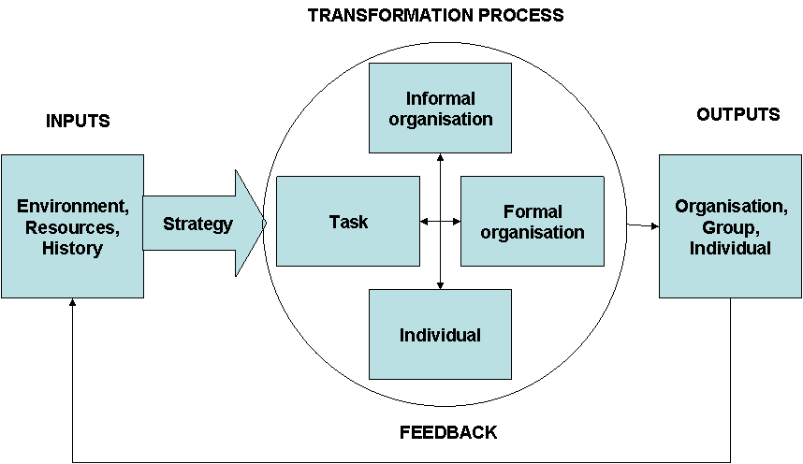

Specifications

This model proposed by Nadler and Tushman (1982) highlights the effect of congruency of the component parts of the organisation on organisation effectiveness. In addition, it elaborates the relationship between the organisation and its wider environment and focuses more explicit attention on the role of strategy.

The model identifies four classes of input:
- Environment. This includes any larger system that the focal organisation is a part of and the cultures within which the organisation operates. It is this environment that provides the opportunities and constraints that the organisation has to contend with.
- Resources. Such as physical plant, technologies and labour.
- History. This is important because past strategic decisions and the development of core values and patterns of leadership can affect current patterns of organisational behaviour.
- Strategy. This involves determining how the organisation’s resources can be used to the best advantage in relation to opportunities, constraints and demands of the environment. Nadler and Tushman argue that strategy (and associated goals and plans) defines the task (purpose) of the organisation and is the most important input to the organisation’s behavioural system. They suggest that effectiveness can be assessed in terms of how well the organisation’s performance meets the goals of strategy.

Nadler and Tushman define the major components of the transformation process as:
- Task. This can be viewed in terms of complexity, predictability, interdependence and skill demands.
- Individuals. This includes capabilities, intelligence, skills and abilities, experience, training, needs, attitudes and expectations.
- Formal organisational arrangements. This includes all the mechanisms used by the organisation to direct, structure or control behaviour.
- Informal organisation. Such as informal group structures, the quality of inter-group relations and political processes.

Nadler and Tushman argue that any useful model of organisations must go beyond merely providing a simple description of the components of the organisation and consider the dynamic relationships that exist between the various components. They define congruence as the degree to which needs, demands, goals, objectives and structures of any one component of the organisation are consistent with the needs, demands, goals, objectives and structures of any other component. Their general hypothesis is that the greater the total degree of congruence between the various components the more effective will be the organisation’s behaviour.

The six fits between the components of the transformation process (the internal organisation) are:
- Individual – Formal organisation. For example, to what extent are individual needs met by the formal organisational arrangements?
- Individual – Task. For example, to what extent do individuals have the skills necessary to meet task demands and to what extent do the tasks satisfy individual needs?
- Individual – Informal organisation. For example, to what extent does the informal organisation satisfy the needs of individuals or make best use of their talents?
- Task – Formal organisation. For example, to what extent are the formal organisational arrangements adequate to meet the demands of the task?
- Task – Informal organisation. For example, to what extent does the informal organisation facilitate task performance?
- Formal organisation – Informal organisation. For example, to what extent are the goals, rewards and structures of the informal organisation consistent with those of formal organisation?

Characteristics

Origin
Nadler & Tushman (1982)
Approach
Recognising and diagnosing the need for change
Implications
This model highlights the effect of the congruency of the component parts of the organisation on organisational effectiveness. In addition, it elaborates the relationship between the organisation and its wider environment and focuses more explicit attention on the role of strategy
Applications
Primary: Understanding & Identifying;
Secondary: Diagnosing & Analysing.
Requirements
Basic understanding of organisations and organisational processes
Benefits
The model goes beyond merely providing a simple description of the components of the organisation and considers the dynamic relationships that exist between the various components

References

Hayes: The Theory and Practice of Change Management (Palgrave MacMillan, 2007)
Nadler & Tushman: A Congruence Model for Organisational Assessment (Wiley, 1980)
Nadler & Tushman: Managing Organizations (Little, Brown, 1982)

5. Four Frames in Eight Stages

 | Structural Frame | Human Resource Frame | Political Frame | Symbolic Frame
1. Creating a sense of urgency |  | Involve people throughout organisation; social input | Network with key players; use power base | Tell a compelling story
2. Pulling together a guiding team with the needed skills, credibility, connections, and authority to move things along | Develop coordination strategy | Team building for guiding team | Stack team with credible, influential members | Put commanding officer on team
3. Creating an uplifting vision and strategy | Implementation plan |  | Map political terrain; develop agenda | Craft a hopeful vision of future rooted in organisation history
4. Communicating the vision and strategy through a combination of words, deeds, and symbols | Create structures to support change process | Meetings to communicate direction, get feedback | Create arenas; build alliances; defuse opposition | Visible leadership involvement; kick-off ceremonies
5. Removing obstacles, or empowering people to move ahead | Remove or alter structures, procedures that support the old ways | Provide training, resources and support
6. Producing visible signs or progress through short -term victories | Plan for short term victories |  | Invest resources, power to ensure early wins | Celebrate and communicate early signs of progress
7. Sticking with the process and refusing to quit when things get tough | Keep people on plan |  |  | Revival meetings
8. Nurturing and shaping a new culture to support the emerging innovative ways | Align structure to new culture | Create a “culture” team; broad involvement in developing culture |  | Mourn the past; celebrate heroes of the revolution; share stories of the journey

Specifications

Kotter and Cohen (2002) have summarised successful and unsuccessful change efforts in organisations around the world. The basic message is that too many change initiatives fail because they rely on too much “data generating, analysis, report writing and presentations” instead of a more creative approach aimed at grabbing the “feelings and motivate useful action”. In other words, change processes fail when they rely almost entirely on reason and structure and neglect human, political, and symbolic elements.

The eight stages presents a model of a change process moving through time, though not necessarily unfolding a linear sequence. In the real world, stages overlap, and change agents sometimes need to cycle back to earlier phases.

Bolman and Deal (2003) present four frames that are rooted in both managerial practice and social science research. The structural frame focuses on the architecture of organisation - the design of units and subunits, rules and roles, goals and policies - that shape and channel decisions and activities. The human resource frame emphasises an understanding of people, with their strengths and foibles, reason and emotion, desires and fears. The political frame sees organisations as competitive arenas characterised by scarce resources, competing interests and struggles for power and advantage. Finally, the symbolic frame focuses on issues of meaning and faith. It puts ritual, ceremony, story, play, and culture at the heart of organisational life.
Each of the frames is both powerful and coherent. Collectively, they make it possible to reframe, viewing the same problem from multiple perspectives.

Combining Kotter and Cohen’s eight stages with the four frames generates the table presented above. The table lists each of Kotter and Cohen’s stages and illustrates possible actions that change agents might take. Not every frame is essential to each stage, but all are critical to success. Consider, for example, Kotter and Cohen’s fifth step: removing obstacles, or empowering people to move ahead. Structurally, this is a matter of identifying rules, roles, procedures, and patterns blocking progress and then working to realign them. Meanwhile, the human resource frame counsels training and providing support and resources to enable people to master new behaviours.

The four frames in eight stages illustrate and give ideas of how to handle a change process. Every change is unique. The table can be used to generate ideas and stimulate thinking.

Characteristics

Origin
Kotter & Cohen (2002); Bolman & Deal (2003)
Approach
Process models of change
Implications
The model illustrates possible actions that change agents might take. Not every frame is essential to each stage, but all stages are critical to success
Applications
Primary: Understanding & Identifying;
Secondary: Diagnosing & Analysing; Planning & Organising.
Requirements
Basic understanding of organisations and organisational processes
Benefits
The model combines the four frames model with the eight stages in successful change. It can be used to generate ideas and stimulate thinking of how to handle a change process

References

Bolman & Deal: Reframing Organisations. Artistry, Choice and Leadership (Jossey-Bass, 2003)
Kotter: Leading Change – Why Transformation Efforts Fail (Harvard Business Review 73 (2), 1995)
Kotter: Leading Change (Harvard Business School Press, 1996)
Kotter & Cohen: The Heart of Change – Real Life Stories of How People Change Their Organisations (Harvard Business School Press, 2002)
6. The Hourglass Model

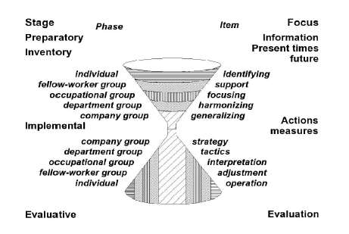

Specifications

The Hourglass Model is an approach that considers the individual participation in development and change. The model is designed in order to increase participation and empowerment among employees in order to minimize some of the communication and interaction problems that often serve as the greatest barriers to successful change initiatives.

It is based on four theoretical approaches:
- Argyris’ action science theory; valid information, free and informed choice, and internal commitment constitute a frame for communicating about and initiating change processes
- Kolb’s experimental learning theory is used to form a point of view for acquiring knowledge and developing proficiency
- Likert’s linking-pin model serve to guide the formation of corporate groups
- Festinger’s cognitive dissonance theory is used to uncover mental conflicts, promote motivation and trigger spontaneous changes.

The Hourglass model stresses that organizational development is a process that takes time, and has to be adapted to the human capacity to grow and mature.

A crucial aspect with this model is that organizational development starts and stops with the ambition to involve all individuals affected by change activities. One reason to focus on the individual is that every organization is built up around individuals.

The Hourglass Model describes a change process in four stages:

1. Preparatory stage:
- Define problem (research team, management and trade union)
- Establish a project team
- Develop a budget
- Develop a time schedule
- Specify authority and responsibility in different phases
- Discuss research methods to be applied
- Decide type of data to be collected
- Decide how results should be reported
- Decide upon ethical rules
- Get adequate assistance from managers, employees and researchers
- Make employees feel ownership to the project
- Inform the whole staff (also the management) about the project

2. Inventory stage
This stage is performed through a bottom-up process. All people affected by the change are invited to participate. The aim is to investigate how the staff perceives the present and what goals they have for the future of the organization. The research team formulates questions regarding topics investigated by the project team. This stage consists of five phases:
- Individual phase
- Fellow-worker group phase
- Occupational group phase
- Department phase
- Company phase
All phases use a polarizing technique to facilitate communication and interaction among participants in later phases of the Hourglass process, and to initiate changes on an individual level as early as possible in the development of the project.

3. Implemental stage
In this stage a strategic core plan for actions is worked out. This plan specifies – with regard to the interests of both the employer and the employees – what problems must be solved and in what order they should be addressed. The strategic plan is carried out in a top-down manner. The employees will see what types of changes will be feasible as compared to the problems and development noted in the individual phase in the inventory stage. The bottom part of the Hourglass model will now be filled, and the evaluative stage is reached.

4. Evaluative stage
In this stage, the Hourglass is turned over, and the results obtained are evaluated. This is, according to Johansson, a critical point in an action research and organizational development project; because both the employer and the employees often feel that they have reached their goals when change activities are initiated. Therefore, it is important that the employer and the employees are committed to evaluate the outcome as well as the development process. In principle, the evaluative stage starts a new Hourglass cycle by investigating what has been achieved from the individual as well as from the company point of view.

Even if there are no sharp boundaries between the stages and they overlap, it should be emphasized that the stages focus upon different matters: problem analysis, description of present conditions and expectations concerning the future, analysis of action items, realization of actions, and evaluation of outcomes.

The figure below illustrates that the room for influence is large in the individual phase of the inventory stage and shrinks successively towards the company phase. The opposite is true in the implemental stage, where the company group has the core influence on planning and implementation in the implemental stage.
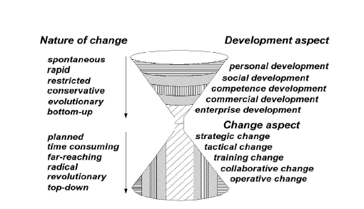

Characteristics

Origin
Johansson (2004)
Approach
Process models of change
Implications
The Hourglass Model describes a change process in four stages: preparatory; inventory; implemental; and evaluative. A crucial aspect with this model is that organisational development starts and stops with the ambition to involve all individuals affected by change activities
Applications
Primary: Understanding & Identifying;
Secondary: Diagnosing & Analysing; Planning & Organising; Implementing & Evaluating.
Requirements
Basic understanding of organisations and organisational processes
Benefits
First, the model incorporates the individual. (After all, individuals play an important role in forming and shaping organisational change processes.) Second, it includes an evaluation stage. (This makes the organisation better capable of learning from various change initiatives.)

References

Frevel, Geissler-Gruber, Johansson & Strina: Applied Participation and Empowerment at Work – Methods, tools, Case Studies (Studentlitteratur, 2004)
7. Socio-Technical Systems Theory

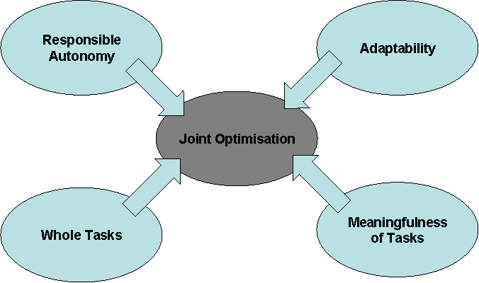

Specifications

Socio-technical theory is founded on two main principles. One is that the interaction of social and technical factors creates the conditions for successful (or unsuccessful) organisational performance.
This interaction is comprised partly of linear cause and effect relationships and partly from non-linear, complex, even unpredictable relationships. Both types of interaction occur when social and technical elements are put to work. The corollary of this, and the second of the two main principles, is that optimisation of each aspect alone tends to increase not only the quantity of unpredictable relationships, but those relationships that are injurious to the system’s performance. Therefore, Socio-technical theory is about joint optimisation. Socio-technical theory proposes a number of different ways of achieving joint optimisation. They are usually based on designing different kinds of organisation, ones in which the relationships between social and technical elements lead to the emergence of productivity and wellbeing.

Some of the central principles of socio-technical theory were elaborated in a seminal paper by Trist and Bamforth (1951). The study was based on the paradoxical observation that despite improved technology, productivity was falling, and that despite better pay and amenities, absenteeism was increasing. The cause of the problem was hypothesized to be the adoption of a new form of production technology which had created the need for a bureaucratic from of organization.

The analysis that followed introduced the terms socio and technical and elaborated on many of the core principles that socio-technical theory subsequently became:
- Responsible autonomy. Socio-technical theory pays particular attention to internal supervision and leadership at the level of the group and refers to it as responsible autonomy. The key to responsible autonomy seems to be to design an organization possessing the characteristics of small groups. In practice (Rice, 1958) this requires groups to be responsible for their own internal regulation and supervision, with the primary task of relating the group to the wider system falling explicitly to a group leader. This principle, therefore, describes a strategy for removing more traditional command hierarchies.
- Adaptability. Carvajal (1983) states that the rate at which uncertainty overwhelms an organisation is related more to its internal structure than to the amount of environmental uncertainty. Sitter, Hertog and Dankbaar (1997) offer two solutions for organisations confronted with an environment of increased (and increasing) complexity. The first option is to restore the fit with the external complexity by an increasing internal complexity. The second option is to deal with the external complexity by reducing the internal control and coordination needs. This option might be called the strategy of simple organisations and complex jobs. The point is that the agility and internal regulation of the group allows problems to be solved locally without propagation through a larger social space, thus increasing tempo.
- Whole tasks. A whole task has the advantage of placing responsibility for the task squarely on the shoulders of a single, small, face-to-face group which experiences the entire cycle of operations within the compass of its membership (Trist and Bamforth, 1951). The socio-technical embodiment of this principle is the notion of minimal critical specification. This principle states that while it may be necessary to be quite precise about what has to be done, it is rarely necessary to be precise about how it is done (Cherns, 1976). In other words, the focus shifts from being a scriptwriter for tasks to instead being a designer of behaviours. In some cases this can make the task of the manager significantly less arduous (Rice, 1958).
- Meaningfulness of tasks. The notion of whole tasks, combined with adaptability and responsible autonomy, has additional advantages for those at work in the organisation. For each participant the task has total significance and dynamic closure (Trist and Bamforth, 1951) as well as the requirement to deploy a multiplicity of skills and to have the responsible autonomy in order to select when and how to do so. This is clearly hinting at a relaxation of the myriad control mechanisms found in the more classically designed organisations. In other words, in classic organisations the wholeness of a task is often diminished by multiple group integration and spatiotemporal disintegration (Trist and Bamforth, 1951). The group based form of organisation design proposed by socio-technical theory combined with new technological possibilities provide a response to this often forgotten issue, one that contributes significantly to joint optimisation.

Characteristics

Origin
Trish & Bamforth (1951)
Approach
Interventions
Implications
Socio-technical theory is about joint optimisation based on four core principles: responsible autonomy; adaptability; whole tasks; and meaningfulness of tasks.
Applications
Primary; Understanding & Identifying
Secondary: Planning & Organising
Requirements
Basic understanding of organisations and organisational processes
Benefits
Socio-technical theory proposes a number of different ways of designing or re-designing organisations

References

Carvajal: Systemic Net Fields – the Systems’ Paradigm Crises (Human Relations 36 (3), 1983)
Cherns: The Principles of Socio-technical Design (Human Relations 29 (8), 1976)
Rice: Productivity and Social Organisation – The Ahmedabad Experiment (Tavistock, 1958)
Sitter, Hertog & Dankbaar: From Complex Organizations with Simple Jobs to Simple Organizations with Complex Jobs (Human Relations 50 (5), 1997)
Trist & Bamforth: Some Social and Psychological Consequences of the Long Wall Method of Coal Getting (Human Relations 4, 1951)
Walker, Stanton, Young, Jenkins & Salmon: Review of the Knowledge Base – Socio-technical Systems in NEC Design (Human Factors Integration Defence Technology Centre, 2007)
Walker, Stanton, Young, Jenkins & Salmon: Socio-technical Theory and NEC System Design (HCII, 2007)

Part Two

Diagnosing
& Analysing
8. SWOT Analysis

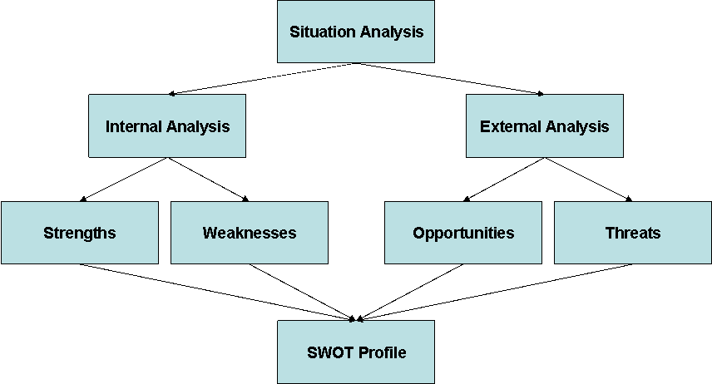

Specifications

SWOT analysis is a simple framework for generating strategic alternatives from a situation analysis. SWOT stands for strengths, weaknesses, opportunities and threats. SWOT analysis focuses on issues that have potentially most impact, and it is a useful tool when a very limited amount of time is available to address a complex strategic situation.

The internal and external situation analysis can produce a large amount of information, much of which may not be highly relevant. The SWOT analysis can serve as an interpretative filter to reduce the information to a manageable quantity of key issues. The SWOT analysis classifies the internal aspects of the organisation as strengths or weaknesses and the external situational factors as opportunities and threats. Strengths can serve as a foundation for building a competitive advantage, and weaknesses may hinder it. By understanding these four aspects of its situation, an organisation can better leverage its strengths, correct its weaknesses, determinate opportunities and deter potentially devastating threats.

The internal analysis is a comprehensive evaluation of the internal environment’s potential strengths and weaknesses. An evaluation of areas across the organisation my include factors such as:
- Culture
- Image
- Structure
- Knowledge
- Resources
- Efficiency
- Capacity

Within an organisation, opportunities that may arise are often the result of a change in the external environment. Such changes can sometimes be seen as threats. Changes in the external environment may be related to:
- Customers
- Competitors
- Market trends
- Suppliers
- Partners
- Social changes
- New technology
- Economic environment
- Political and regulatory environment

With the SWOT analysis completed and strengths, weaknesses, opportunities and threats identified, managers can begin the planning process and determine strategies for achieving the organisation’s missions and goals. The resulting strategies should enable the organisation to attain its goals by taking advantage of opportunities, countering threats, building strengths and correcting organisational weaknesses.

Characteristics

Origin
Humphrey (196x)
Approach
Recognising and diagnosing the need for change
Implications
SWOT analysis is an assessment of internal resources and competences in relation to conditions in an organisation’s external environment. It can serve as an interpretative filter to reduce the information to a manageable quantity of key issues
Applications
Primary: Diagnosing & Analysing
Secondary: Planning & Organising
Requirements
Basic understanding of organisations and organisational processes
Benefits
The SWOT framework focuses on issues that have potentially most impact. It is a useful tool when a very limited amount of time is available to address a complex strategic situation

References

Ashleigh, George, Jones & Meyer: Contemporary Management (McGraw-Hill, 2007)
Bloisi, Cook & Hunsaker: Management & Organisational Behaviour (McGraw-Hill, 2007)
Hayes: The Theory and Practice of Change Management (Palgrave MacMillan, 2007)
9. PESTLE Analysis

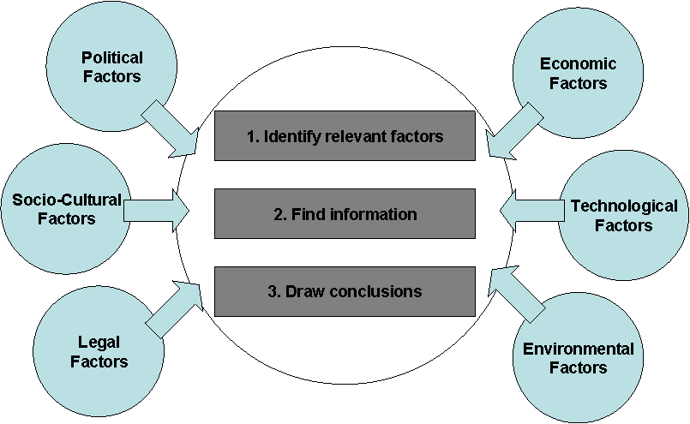

Specifications

PESTLE analysis can be used by managers to examine the organisation’s environment and search for evidence of change that might signal a threat or opportunity. The mnemonic refers to political, economic, socio-cultural, technological, legal and environmental factors:

- Political factors include political trends; consumer protection and employment; fiscal policies; and so forth.
- Economic factors include issues such as exchange rates, cost of borrowing, change in levels of disposable income, cost of raw materials, and the trade cycle.
- Socio-cultural factors include demographic trends. They also include shifting attitudes towards education, training, work and leisure which can have knock-on effects on the availability of trained labour, consumption patterns and so on. Cultural factors can also affect business ethics and the way business is done in different parts of the world.
- Technological factors include issues such as levels of investment competitors are making in research and development and the outcome of this investment; the availability of new technologies, products, business processes, means of distribution and so forth; the rate of obsolescence and the need to reinvest in plant and people.
- Legal factors include international legislation; regulatory bodies and processes; and industry specific regulations.
- Environmental factors include the wider ecological system of which the organisation is a part and consideration of how the organisation interacts with it.

Using the PESTLE analysis is a three stage process:
- Firstly, you brainstorm the relevant factors that apply to your problem;
- Secondly, you identify the information that applies to these factors;
- Thirdly, you draw conclusions from this information.

Characteristics

Origin
Unknown
Approach
Recognising and diagnosing the need for change
Implications
PESTLE analysis is a useful tool for understanding the big picture of the environment in which you are operating, and the opportunities and threats that lie within it. By understanding your environment, you can take advantage of the opportunities and minimize the threats
Applications
Primary: Diagnosing & Analysing
Secondary: Planning & Organising
Requirements
Basic understanding of organisations and organisational processes
Benefits
Using the tool is a three stage process: Firstly, you brainstorm the relevant factors that apply to your problem. Secondly, you identify the information that applies to these factors. Thirdly, you draw conclusions from this information

References

Hayes: The Theory and Practice of Change Management (Palgrave MacMillan, 2007)

10. Weisbord’s Six-Box Model

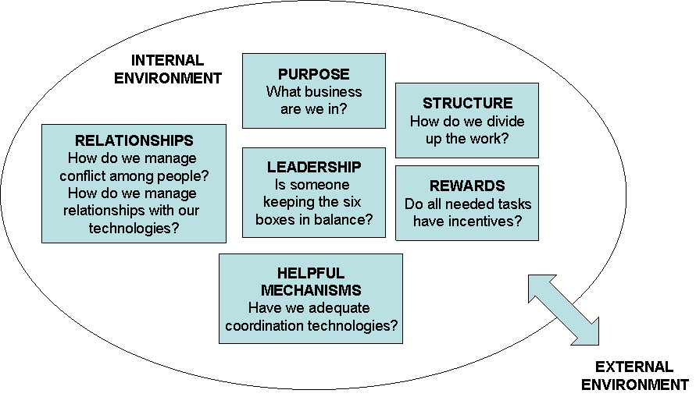

Specifications

Weisbord presents his systematic model as a practice theory that synthesises knowledge and experience for change agents. It provides a conceptual map of six elements that can be used to apply any theories to the assessment of these elements in a way that can reveal new connections and relationships between elements. It is an open-system model that recognises the importance of organisation-environment relationships but focuses most attention on what needs to be done internally to ensure that the organisation becomes a high-performance organisation able to adapt to external changes.

Weisbord argues that the effectiveness of an organisation’s functioning depends on what goes on in and between the six boxes. There are two aspects of each box that deserve attention: the formal and the informal. Weisbord argues that the formal aspects of an organisation (for example, stated goals or the structure as represented by an organisation chart) may bear little relation to what actually happens in practice. Attention needs to be given to the frequency with which people take certain actions in relation to how important these actions are for organisational performance. This leads to a consideration of why people do what they do, and what needs to be changed to promote more effective behaviour.

Leadership is seen to have a role to play in coordinating what goes on in the other five boxes. Weisbord suggests that a useful starting point for any diagnostic exercise is to:
- Focus on one major output (of a unit or the total organisation)
- Explore the extent to which the producers and the consumers of the output are satisfied with it
- Trace the reasons for any dissatisfaction to what is happening in or between the six boxes that represent the unit or organisation under consideration.

Characteristics

Origin
Weisbord (1978)
Approach
Recognising and diagnosing the need for change
Implications
Weisbord’s six-box model synthesises knowledge and experience for change agents. The model provides a conceptual map of six elements that can be used to apply any theories to the assessment of these elements in a way that can reveal new connections and relationships between elements
Applications
Primary: Diagnosing & Analysing
Secondary: Understanding & Identifying; Planning & Organising; Implementing & Evaluating
Requirements
Basic understanding of organisations and organisational processes
Benefits
It is an open-system model that recognises the importance of organisation-environment relationships but focuses most attention on what needs to be done internally to ensure that the organisation becomes a high-performance organisation able to adapt to external changes

References

Weisbord: Organizational Diagnosis (Addison-Wesley, 1978)

11. Total Quality Management

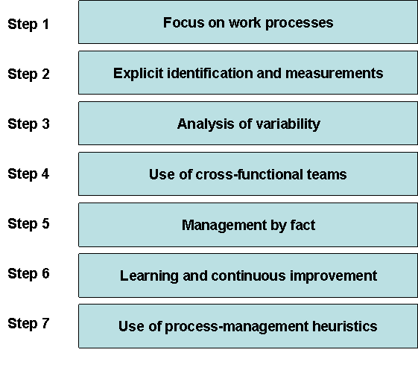
Specifications

Total Quality Management (TQM) focuses on improving the quality of an organisation’s products and services and stresses that all of an organisation’s value-chain activities should be directed toward this goal. Conceived as an organisation-wide management programme, TQM requires the co-operation of managers in every function of an organisation. The four general theses underpinning TQM are as follows:
- Organisational success relies on every department meeting the needs of those it serves (customers) and many of these customers will be internal to the organisation.
- Quality is an effect caused by the processes of production in which the causal systems are complex but understandable.
- Most human beings engaged in work are intrinsically motivated to try hard and to do well.
- Simple statistical methods linked with careful collection and analysis of data on work processes can yield powerful insights into the causes of problems within those work processes.

What actions should managers take to implement a successful TQM programme? The following steps are necessary to make a TQM control system work:

  - Focus on work processes: it is not sufficient to provide clear direction about hoped-for outcomes; management must train and coach employees to assess, analyse, and improve work processes and nurture supplier relationships
  - Explicit identification and measurement of customer (both internal and external) requirements
  - Analysis of variability: uncontrolled variance in processes or outcomes is the primary cause of quality problems and must be analysed and controlled by those who perform an organisation’s front-line work
  - Use of cross-functional teams to identify and solve quality problems
  - Management by fact: TQM calls for the use of systematically collected data at every point in a problem-solving cycle, from determining high-priority problems, analysing their causes, to selecting and testing solutions
  - Learning and continuous improvement: the long-term health of an enterprise depends on treating quality improvement as a never-ending quest
  - Use of process-management heuristics to enhance team effectiveness, for example, flow charts, brainstorming, cause-and-effect diagrams, benchmarking and Pareto diagrams.

The focus of TQM is on processes of work rather than on the workers themselves; thus the means of understanding the processes are important. Then, through a process of data collection, analysis, hypothesis formation, and hypothesis testing, changes to processes can be devised, and the aim is that these changes are introduced steadily and forever to improve quality.

Characteristics

Origin
Feigenbaum (1951)
Approach
Interventions
Implications
TQM is an organisation-wide, long-term change effort designed to orient all of an organisation’s activities around the concept of quality. The focus of TQM is on processes of work rather than on the workers themselves
Applications
Primary: Diagnosing & Analysing
Secondary: Planning & Organising; Implementing & Evaluating
Requirements
Full attention and involvement from all members of the organisation
Benefits
Through a process of data collection, analysis, hypothesis formation and hypothesis testing, changes to processes can be devised

References

Almaraz: Quality Management and the Process of Change (Journal of Organisational Change Management (7), 1994)
Anderson, Rungtusanatham & Schroeder: A Theory of Quality Management Underlying the Deming Management Method (Academy of Management Review (19), 1994)
Ashleigh, George, Jones & Meyer: Contemporary Management – European Edition (McGraw-Hill, 2007)
Bowen & Dean: Management Theory and Total Quality: Improving Research and Practice through Theory Development (Academy of Management Review (19), 1994)
Hackman & Wageman: Total Quality Management – Empirical, Conceptual and Practical Issues (Administrative Science Quarterly 40 (2), 1995)
Kaarstad & Heimdal: Organisational and Individual Change and Transition in ATM – A Literature Review (Eurocontrol, 200x)
12. The Five Steps of an Appreciative Inquiry

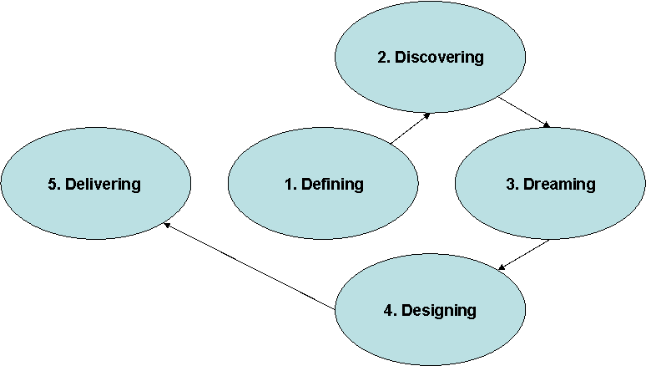

Specifications

The essence of appreciative inquiry is the generation of a shared image of a better future through a collective process of inquiry into the best of what is. It is the imagined future that provides the powerful pull effect that guides the development of the group or the organisation.
The critical part of the intervention is the inquiry. The mere act of asking questions begins the process of change. Based on the assumptions that the things we choose to focus on and the questions we ask determine what we find, it follows that the more positive the questions the more positive the data, and the more positive the data the more positive are the beliefs that people are likely to develop about what contributes to peak experiences. The more positive are these beliefs, the more positive is the vision of the organisation at its best, and the more positive is this image, the more energy it generates for change.

Bushe (1999) describes the process of appreciative inquiry as consisting of three parts:
- Discovering the best of… This involves discovering the best examples within the experience of organisational members
- Understanding what creates the best of… This involves seeking insights into the forces that lead to superior performance and what it is about the people, the organisation and the context that creates peak experiences at work
- Amplifying the people or processes that exemplify the best of… This involves reinforcing and amplifying those elements of the situation that contribute to superior performance.

Understanding and amplifying the best of what is involves five steps:
- Defining the focus of the inquiry. The scope of appreciative inquiries can be extended to include more focused inquiries into issues such as retention, team-building, leadership, customer service, conflict management, cross-gender relationships and culture change. Defining the precise field of inquiry is often undertaken by some kind of steering group, possibly one that represents the different categories of organisational members who might be involved in the inquiry. The inquiry needs to be defined in a way that focuses attention on the positive rather than negative aspects of people’s experience. For example, if an organisation has an issue with high labour turnover, rather than focusing attention on why people leave the inquiry might focus attention on why people choose to stay.
- Discovering the best of what is. Whatever the format of inquiry, interviewers need to be good listeners, able to attend to what others are saying and understand their thoughts and feelings from their perspective. They also need to be good at getting others to tell their stories of excellence and achievement. Key to this is the questions they ask. Cooperrider, Kaplan, Trosten-Bloom & Whitney (2002) have produced an encyclopaedia of positive questions that some practitioners might find helpful.
- Dreaming about what might be. To inspire a vision of a more positive future is the essence of the dreaming phases. Organisational members are encouraged to envision what the future might be like if the best of what is or has been became the new norm. However, imagination is like many of our faculties, from memory to muscles; if they are not used, they wither. It is possible, therefore, that some organisational members may need to be helped and encouraged in order to use their imagination to envision a more positive future. Elliott (1999) suggests some warm-up exercises that might help people gain the confidence to envision new possibilities.
- Designing provocative propositions that will achieve the dream. In order to facilitate the achievement of the vision it has to be translated into a set of statement of intent. These are provocative propositions that will stretch organisational members and show them the way to an achievable preferred future. Designing the provocative propositions typically generates considerable energy and involvement and it is through the dialogue associated with testing, redrafting and refining them that the possibilities for amplifying the best of the present and past are realised.
- Delivering the dream. Guided by the design principles in the provocative propositions the group or organisation is propelled to fulfil its destiny. Sometimes those leading the inquiry help organisational members write implementation strategies and action plans and develop score cards or other procedures for monitoring progress. However, amplifying the best of what is and moving the organisation towards a more positive future does not necessarily require those leading the appreciative inquiry to get involved with the details of implementation.

Characteristics

Origin
Bushe (1999)
Approach
Interventions
Implications
The essence of appreciative inquiry is the shared image of the better future that provides the powerful pull effect that guides the development of the group or the organisation
Applications
Primary: Diagnosing & Analysing
Secondary: Planning & Organising
Requirements
Basic understanding of intervention theory and methodology for intervening in organisations
Benefits
The critical part of intervention is the inquiry. The mere act of asking questions begins the process of change. Appreciative inquiry is a process that involves exploring the best of what is and amplifying this best practice. Whereas action research promotes learning through attending to dysfunctional aspects of organisational functioning, appreciative inquiry seeks to accentuate the positive rather than eliminate the negative

References

Bushe: Appreciative Inquiry with Teams (Organization Development Journal 16 (3), 1998)
Bushe: Advances in Appreciative Inquiry as an Organizational Development Intervention (Organization Development Journal 17 (2), 1999)
Cooperrider, Kaplan, Trosten-Bloom & Whitney: Encyclopedia of Positive Questions (Lakeshore Communications, 2002)
Cooperrider, Stavros & Whitney: Appreciative Inquiry Handbook (Berrett-Koehler, 2003)
Elliott: Locating the Energy for Change – An Introduction to Appreciative Inquiry (International Institute for Sustainable Development, 1999)
Hayes: The Theory and Practice of Change Management (Palgrave MacMillan, 2007)
Trosten-Bloom & Whitney: The Power of Appreciative Inquiry – A Practical Guide to Positive Change (Berrett-Koehler, 2003)

Part Three

Planning &
Organising

13. The Dynamics of Organisational Culture

Specifications

This model of the dynamics of organisational culture describes four processes underlying both cultural change and stability. In developing this model Hatch (1993) followed a suggestion of Herskovits (1948) to think in a circular way about processes in order to explain both stability and change. Hatch then applied this approach to Schein’s model (1985) of culture as assumptions, values and artifacts. Unlike Schein’s theory, Hatch’s model does not focus on the elements of culture, but on the processes linking these elements.

The top half of the cultural dynamics model describes the manifestation and realisation processes by which artifacts are created, the bottom half describes what happens once artifacts are made part of the organisation's cultural inventory and become available for symbolisation and interpretation.

In the domain of the top half of the model, assumptions and values shape activity such that artifacts of these influences are created and maintained within the culture. In the domain of the lower half of the model, organisational members choose some (but not all) of the artifacts available to them and use the selected artifacts to symbolise their meanings in communication with others.

The idea of cultural focus offers a means to better understand management’s role in cultural dynamics. If cultures change more readily in areas of focus, then managers who are aware of and can intensify attention within this focus have an important part to play in culture change.

The processes described by the cultural dynamics model are ongoing. Active attempts by managers to change organisations would therefore also be described as a part of these processes. Attempts to intentionally introduce change usually begin in the domain of realisation and symbolisation when management introduces a new idea through language or other artifacts which then may be symbolised and interpreted by those who will either carry the change forward or deny it any influence.

If the symbols made are in alignment with existing organisational assumptions and values, change should be relatively easy but not very deep. However, change in line with existing assumptions and values may not be what management wants. Some change may involve introducing "foreign" ideas into the system. Cultural processes of acculturation, accommodation and reinterpretation then come into play, and change initiators must recognise that their sense of control over the process will be diminished as others confront the new artifacts, construct symbols with them and make their own interpretations of the meaning of the change and intent of the change agent.

This is how the cultural dynamics model places the manager within the organisational culture. It suggests that control of the power of leadership lies in the sensitivity of managers to their own symbolic meaning. According to Hatch, leaders have tremendous influence within organisations, but their ability to effectively mobilise this influence depends upon their knowledge of, and relationship with, the culture.

Meanwhile, regardless of acts of leadership and change interventions, the dynamic processes of culture produce continuous stability and change. This is because the processes of culture are in constant motion. Furthermore, what appears to be stability and what change is an interpretation given to events after the fact and this propensity to interpret and label likewise needs to be part of the theory of cultural dynamics. This means that not only do we need to incorporate leaders and other agents of change into our theories of culture, but ourselves as students and observers of culture as well.

Characteristics

Origin
Hatch (1993)
Approach
Interventions
Implications
This framework reformulates Schein’s (1985) model of organisational culture by making a place for symbols alongside assumptions, values and artifacts; by articulating the arrows linking assumptions, values and artifacts; and by defining these links as processes having both forward and backward temporal modes of operation
Applications
Primary: Planning & Organising;
Secondary: Understanding & Identifying; Diagnosing & Analysing; Implementing & Evaluating.
Requirements
Basic understanding of organisations and organisational processes
Benefits
Because it represents culture as a wheel, the cultural dynamics model can be entered at any point.

References

Hatch: The Dynamics of Organizational Culture (Academy of Management Review 18 (4), 1993)
Herskovits: Man and His Work – The Science of Cultural Anthropology (Knopf, 1948)
Schein: Organizational Culture and Leadership (Jossey-Bass, 1985)
14. Fernandez & Rainey’s Eight Factors of Successful Change

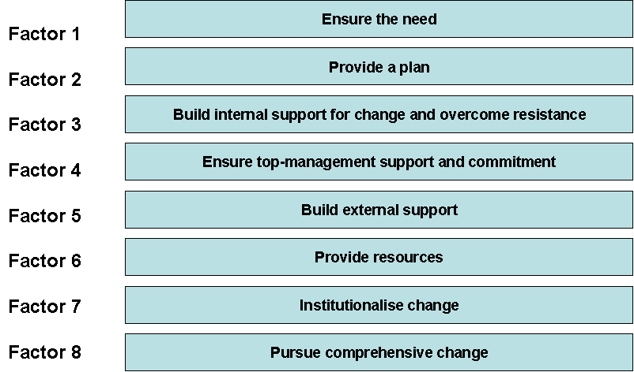

Specifications

The eight factors offered by Fernandez and Rainey can serve as a compass for practitioners seeking to find their way amid the sustained, persistent, and challenging pressures for change they confront daily.

Factor 1: Ensure the need
Managers must verify and persuasively communicate the need for change. Research indicates that the implementation of planned change generally requires that leaders verify the need for change and persuade other members of the organisation and important external stakeholders that it is necessary. The process of convincing individuals of the need for change often begins with crafting a compelling vision for it. A vision presents a picture or image of the future that is easy to communicate and that organisational members find appealing; it provides overall direction for the change process and serves as the foundation from which to develop specific strategies for arriving at a future end state. Research by Kets de Vries and Balazs (1999) on private organizations indicates that it is easier to convince individuals of the need for change when leaders craft a vision that offers the hope of relief from stress or discomfort. Nadler and Nadler (1998) even suggest implanting dissatisfaction with the current state of affairs in order to get members of the organisation to embrace change.

Factor 2: Provide a plan
Managers must develop a course of action or strategy for implementing change. Convincing the members of an organisation of the need for change is obviously not enough to bring about actual change. Research emphasises that the new idea or vision must be transformed into a course of action or strategy with goals and a plan for achieving it. This strategy serves as a road map for the organization, offering direction on how to arrive at the preferred end state, identifying obstacles, and proposing measures for overcoming those obstacles. As Kotter (1995) explains, the basic elements of the vision should be organised into a strategy for achieving that vision so that the transformation does not disintegrate into a set of unrelated and confusing directives and activities.

Factor 3: Build internal support for change and overcome resistance
Managers must build internal support for change and reduce resistance to it through widespread participation in the change process and other means. According to Kets de Vries and Balazs (1999) individuals in organisations resist change for a variety of reasons. For example, some ideas for change is simply ill conceived, unjustified, or pose harmful consequences for members of the organisation. Even assuming a well-justified and well-planned change initiative, however, leaders must build internal support and overcome resistance. How can they do so? Several researchers have observed that a crisis, shock, or strong external challenge to the organization can help reduce resistance to change. Van de Ven (1993) explains that because individuals are highly adaptable to gradually emerging conditions, a shock or stimulus of significant magnitude is typically required for them to accept change as inevitable. In a similar vein, Kotter (1995) warns managers against the risk of playing it too safe and he notes that when the urgency rate is not pumped up enough, the transformation process cannot succeed. Kotter even observed that in a few of the most successful cases of organisational change, the leadership manufactured crises.

Factor 4: Ensure top-management support and commitment
An individual or group within the organisation should champion the cause for change. Top-management support and commitment to change play an especially crucial role in success.
Kanter (1983) stress the importance of having a single change agent or “idea champion” lead the transformation. An idea champion is a highly respected individual who maintains momentum and commitment to change, often taking personal risks in the process.
Bardach (1977) and O’Toole (1989) have offered evidence of how a skilful and strategically placed leader can successfully coordinate the behaviour of disparate actors and overcome obstacles by leveraging close personal ties and pursuing informal avenues of influence.
Kotter (1995) have stressed the need to have a guiding coalition to support the change. A guiding coalition is a group of individuals who lend legitimacy to the effort and marshal the resources and emotional support required to induce organizational members to change. Kotter asserts that one or two managers often launch organizational renewal efforts, but whenever some minimum mass is not achieved early in the effort, nothing much worthwhile happens.

Factor 5: Build external support
Managers must develop support from political overseers and key external stakeholders.
Organisational change in the public sector also depends on the degree of support from political overseers and other key external stakeholders. The impact of these actors on the outcome of change efforts stems in part from their ability to impose statutory changes and control the flow of vital resources to public organizations. Political overseers can influence the outcome of planned change by creating and conveying a vision that explains the need for change, as well as by selecting political appointees who are sympathetic to the change and have the knowledge and skills required for managing the transformation.

Factor 6: Provide resources
Successful change usually requires sufficient resources to support the process. A fairly consistent finding in the literature is that change is not cheap or without trade-off. According to Burke (2002) and Nadler and Nadler (1998) planned organisational change involves a redeployment or redirection of scarce organisational resources toward a host of new activities, including developing a plan or strategy for implementing the change, communicating the need for change, training employees, developing new processes and practices, restructuring and reorganising the organisation, and testing and experimenting with innovations. Failure to provide adequate resources in support of a planned change leads to feeble implementation efforts, higher levels of interpersonal stress, and even neglect of core organizational activities and functions.

Factor 7: Institutionalise change
Managers and employees must effectively institutionalise and embed changes. To make change enduring, members of the organisation must incorporate the new policies or innovations into their daily routines. Virtually all organisational changes involve changes in the behaviour of organisational members. According to Lewin (1947) and Kotter (1995) employees must learn these behaviours in the short term, and leaders must institutionalise them over the long haul so that new patterns of behaviour displace old ones. Doing so, however, is not easy. Armenakis, Harris and Feild (1999) have developed a model for reinforcing and institutionalising change. According to the model, leaders can modify formal structures, procedures, and human resource management practices; employ rites and ceremonies; diffuse the innovation through trial runs and pilot projects; collect data to track the progress of and commitment to change; and engage employees in active participation tactics that foster learning by doing. Judson (1991), too, strongly emphasises the need to collect data and monitor the implementation process to keep managers aware of the extent to which organisational members have adopted the change. Evaluation and monitoring efforts should continue even after the change is fully adopted to ensure that organizational members do not lapse into old patterns of behaviour.

Factor 8: Pursue comprehensive change
Managers must develop an integrative, comprehensive approach to change that achieves subsystem congruence. Many researchers stress that in order for fundamental change in behaviour to occur, leaders must make systemic changes to the subsystems of their organisation. These must be aligned with the desired end state. Changing only one or two subsystems will not generate sufficient force to bring about organizational transformation. Hannan, Polos and Carroll (2003) have warned, however, that implementing multiple changes without understanding the structure and nature of the interconnections among subsystems can result in additional costs and a longer implementation period than anticipated. Amis, Slack and Hinings (2004) go even further, arguing that the actual sequence of change matters; they found that beginning the transformation process by changing “high-impact” decision-making elements of the organisation first helps to build momentum for the broader array of changes that follow. Likewise, Robertson, Roberts and Porras (1993) conclude from their study of business firms that practitioners should begin any change effort with systematic changes in the work setting and insure that the various work setting changes are congruent with each other, sending consistent signals to organisation members about the new behaviours desired.

Characteristics

Origin
Fernandez & Rainey (2006)
Approach
Process models of change
Implications
Fernandez and Rainey’s model is an eclectic review of the organisational change literature as it pertains to the public sector. The eight factors can be used as a compass for practitioners seeking to find their way through the change process
Applications
Primary: Planning & Organising
Secondary: Implementing & Evaluating
Requirements
Basic understanding of organisations and organisational processes
Benefits
Researchers and practitioners can use the model to analyse the interactive effect of the eight factors in a contingency approach to implementing organisational change seriously

References

Amis, Slack & Hinings: The Pace, Sequence, and Linearity of Radical Change (Academy of Management Journal 47 (1), 2004)
Armenakis, Harris & Field: Paradigms in Organizational Change – Change Agent and Change Target Perspectives (Marcel Dekker, 1999)
Bardach: The Implementation Game (MIT Press, 1977)
Burke: Organization Change – Theory and Practice (Sage Publications, 2002)
Fernandez & Rainey: Managing Successful Organizational Change in the Public Sector (Public Administration Review (March/April), 2006)
Hannan, Polos and Carroll: The Fog of Change – Opacity and Asperity in Organizations (Administrative Science Quarterly 48 (3), 2003)
Judson: Changing Behavior in Organizations – Minimizing Resistance to Change (Blackwell, 1991)
Kanter: The Change Masters (Simon & Schuster, 1983)
Kets de Vries & Balazs: Transforming the Mind-Set of the Organization (Administration & Society 30 (6), 1999)
Kotter: Leading Change – Why Transformation Efforts Fail (Harvard Business Review 73 (2), 1995)
Lewin: Group Decision and Social Change (Holt, Rinehart, and Winston, 1947)
Nadler & Nadler: Champions of Change – How CEOs and Their Companies Are Mastering the Skills of Radical Change (Jossey-Bass, 1998)
O’Toole: Alternative Mechanisms for Multi-organizational Implementation – The Case of Wastewater Management (Administration & Society 21 (3), 1989)
Robertson, Roberts and Porras: Dynamics of Planned Organizational Change – Assessing Empirical Support for a Theoretical Model (Academy of Management Journal 36 (3), 1993)
Van de Ven: Managing the Process of Organizational Innovation (Oxford University Press, 1993)

15. Five Basic Communication Strategies

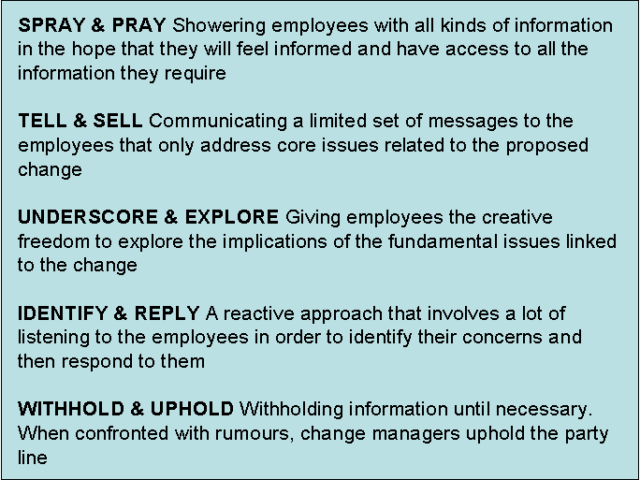

Specifications

Communication plays a vital role in the change process. It is an essential prerequisite for recognising the need for change, and it enables change managers to create a shared sense of direction, establish priorities, reduce disorder and uncertainty and facilitate learning. However, change managers often give insufficient attention to the role of communication. Clampitt, DeKoch and Cashman (2000) suggest that communication strategies emerge from existing practices with little hard thinking about communication objectives or processes and little (if any) attention to reviewing the consequences of their approach to communicating with others. On the basis of their experience in several organisations and a review of literature they identified five basic strategies. Sometimes the communication strategy in any particular setting closely resembles on of these, but sometimes it is a hybrid and includes a blend of elements from more than one. The five basic strategies are:
- Spray and pray. Clampitt, DeKoch and Cashman use this term to describe communication strategy that involves showering employees with all kinds of information in the hope that they will feel informed and have access to all the information they require. It is based on the assumption that more communication equals better communication, which in turn contributes to improved decision making. It is also based on an implicit assumption that all organisational members are able to differentiate between what is significant and what is insignificant. In practice, some employees may attend only to the information that is related to their own personal agendas, while others may be overwhelmed by the amount of information they are confronted with.
- Tell and sell. This approach involves change managers communicating a more limited set of messages that they believe address core issues related to the proposed change. They first of all tell employees about these key issues and then sell them the wisdom of their approach to managing them. Clampitt, DeKoch and Cashman observe that change managers who adopt this kind of strategy often spend a great deal of time planning sophisticated presentations but devote little time and energy to fostering meaningful dialogue and providing organisational members with the opportunity to discuss their concerns. They also assume that they possess much of the information they need and they tend to place little value on input from others.
- Underscore and explore. Like the tell-and-sell approach this strategy involves focusing attention on a limited set of fundamental issues linked to the change, but unlike the tell-and-sell approach change managers give others the creative freedom they need to explore the implications of these issues. Those who adopt this approach are concerned not only with developing a few core messages but also with listening attentively for potential misunderstandings and unrecognised obstacles.
- Identify and reply. This strategy is different from the first three in that the primary focus is the concerns of organisational members. It is a reactive approach that involves a lot of listening in order to identify and then respond to these concerns. It is essentially directed towards helping employees make sense out of the often confusing organisational environment, but it is also attentive to their concerns because it is assumed that organisational members are in the best position to know what the critical issues are. However, this may not always be the case. Clampitt, DeKoch and Cashman suggest that often they may not know enough to even ask the right questions.
- Withhold and uphold. This strategy involves withholding information until necessary. When confronted by rumours, change managers uphold the party line. There may well be special circumstances where commercial or other considerations require information to be shared on a need-to-know basis but there are also change managers whose implicit values are secrecy and control whatever the circumstances. Some of those who adopt this strategy assume that information is power and they are reluctant to share it with anyone. Others assume that most organisational members are not sophisticated enough to grasp the big picture.

Hargie and Tourish (2000) recommend the regular auditing of communications. This requires change managers to have a clear idea about their communication objectives in order to assess the extent to which they are being achieved. Some of the questions they might need to ask are:
  - Who is communicating with whom?
  - What issues are they talking about?
  - Which issues receive most attention and arouse most anxiety?
  - Do people receive all the information they require?
  - Do people understand and use the information they receive?
  - Do people trust and have confidence in the information they receive?
  - From what sources do people prefer to get their information?
  - Which channels are most effective?

Characteristics

Origin
Clampitt, DeKoch & Cashman (2000)
Approach
Communicating change
Implications
Communication plays a vital role in the change process. It is an essential prerequisite for recognising the need for change, and it enables change managers to create a shared sense of direction, establish priorities, reduce disorder and uncertainty and facilitate learning. On the basis of experience in numerous organisations and a review of the literature Clampitt, DeKoch and Cashman identified five basic strategies
Applications
Primary: Planning & Organising
Secondary: Implementing & Evaluating
Requirements
A clear idea about the communication objectives
Benefits
The five basic strategies provide a useful backcloth for comparing the advantages and disadvantages of various communication strategies

References

Clampitt, DeKoch & Cashman: A Strategy for Communicating about Uncertainty (The Academy of Management Executive 14 (40), 2000)
Hargie & Tourish: A Handbook of Communication Audits for Organisations (Routledge, 2000)
Hayes: The Theory and Practice of Change Management (Palgrave MacMillan, 2007)
Morrison & Milliken: Organizational Silence – A Barrier to Change and Development in a Pluralistic World (Academy of Management Review 25 (4), 2000)

Part Four

Implementing
& Evaluating
16. The Psychological Contract

Inputs | Content | Outputs
Employee characteristics | Fairness | Employee behaviour
Organisation characteristics | Trust | Performance
HR practices | Delivery
A useful model of the psychological contract is offered by Professor David Guest of Kings College London (see table above). In outline, the model suggests that the extent to which employers adopt people management practices will influence the state of the psychological contract. The contract is based on employees' sense of fairness and trust and their belief that the employer is honouring the deal between them. Where the psychological contract is positive, increased employee commitment and satisfaction will have a positive impact on business performance.

Research evidence shows that, where employees believe that management have broken promises or failed to deliver on commitments, this has a negative effect on job satisfaction and commitment and on the psychological contract as a whole. This is particularly the case where managers themselves are responsible for breaches. For example, where employees do not receive promised training, or performance reviews are badly handled. Managers cannot always ensure that commitments are fulfilled. For example, where employment prospects deteriorate or organisations are affected by mergers or restructuring – but they may still take some blame in the eyes of employees.
Managers need to remember that employment relationships may deteriorate despite management’s best efforts: nevertheless it is managers’ job to take responsibility for maintaining them. Preventing breach in the first place is better than trying to repair the damage afterwards. But where breach cannot be avoided it may be better to spend time negotiating or renegotiating the deal, rather than focusing too much on delivery.

Changes currently affecting the workplace include:
- The nature of jobs: more employees are on part time and temporary contracts, more jobs are being outsourced, tight job definitions are out, and functional flexibility is in.
- Organisations have downsized and optimised: leanness means doing more with less, so individual employees have to carry more weight.
- Markets, technology and products are constantly changing: customers are becoming ever more demanding, quality and service standards are constantly going up.
- Technology and finance are less important as sources of competitive advantage: human capital is becoming more critical to business performance in the knowledge-based economy.
- Traditional organisational structures are becoming more fluid: teams are often the basic building block; new methods of managing are required.
The effect of these changes is that employees are increasingly recognised as the key business drivers. The ability of the business to add value rests on its front-line employees, or human capital. Organisations that wish to succeed have to get the most out of this resource. In order to do this, employers have to know what employees expect from their work. The psychological contract offers a framework for monitoring employee attitudes and priorities on those dimensions that can be shown to influence performance.

Strategic implications of the psychological contract
Basically the psychological contract offers a metaphor, or representation, of what goes on in the workplace, that highlights important but often neglected features. It offers a framework for addressing soft issues about managing performance; it focuses on people, rather than technology; and it draws attention to some important shifts in the relationship between people and organisations.
Most organisations could benefit from thinking about the psychological contract. The first priority is to build the people dimension into thinking about organisational strategy. If people are bottom-line business drivers, their capabilities and needs should be fully integrated into business process and planning. The purpose of business strategy becomes how to get the best return from employees' energies, knowledge and creativity.
Employees' contribution can no longer be extracted by shame, guilt and fear: it has to be offered. Issues about motivation and commitment are critical. Yet many of the levers which managers have relied on to motivate employees are increasingly unreliable.
The psychological contract may have implications for organisational strategy in a number of areas, for example:
- Process fairness: People want to know that their interests will be taken into account when important decisions are taken; they would like to be treated with respect; they are more likely to be satisfied with their job if they are consulted about change. Managers cannot guarantee that employees will accept that outcomes on eg pay and promotion are fair, but they can put in place procedures that will make acceptance of the results more likely.
- Communications: Although collective bargaining is still widely practised in the public sector, in large areas of the private sector trade unions now have no visible presence. It is no longer possible for managers in these areas to rely on 'joint regulation' in order to communicate with employees or secure their co-operation. An effective two-way dialogue between employer and employees is a necessary means of giving expression to employee 'voice'.
- Management style: In many organisations, managers can no longer control the business 'top down' - they have to adopt a more 'bottom up' style. Crucial feedback about business performance flows in from customers and suppliers and front-line employees will often be best able to interpret it. Managers have to draw on the strategic knowledge in employees' heads.
- Managing expectations: Employers need to make clear to new recruits what they can expect from the job. Managers may have a tendency to emphasise positive messages and play down more negative ones. But employees can usually distinguish rhetoric from reality and management failure to do so will undermine employees' trust. Managing expectations, particularly when bad news is anticipated, will increase the chances of establishing a realistic psychological contract.
- Measuring employee attitudes: Employers should monitor employee attitudes on a regular basis as a means of identifying where action may be needed to improve performance. Some employers use indicators of employee satisfaction with management as part of the process for determining the pay of line managers. Other employers, particularly in the service sector, recognise strong links between employee and customer satisfaction. But employers should only undertake surveys of employee attitudes if they are ready to act on the results.

Managing change is a major challenge for organisations. Human resource professionals have a key role to play in contributing to top-level decisions about the direction and pace of change and in supporting line managers across the organisation in implementing them. The psychological contract can help human resource managers to make the business case for incorporating effective people management policies and practices into the change management process at an early stage, and to successfully manage their implementation.

Characteristics

Origin
Argyris (1964)
Approach
Core concepts
Implications
The psychological contract can be defined as the perceptions of both parties to the employment relationship of their obligations implied in the relationship. It is an unwritten set of expectations between every member of an organisation
Applications
Primary: Implementing & Evaluating
Secondary: Understanding & Identifying
Requirements
Basic understanding of psychology and organisational behaviour
Benefits
An awareness of psychological contracts should remind managers of the reciprocal relationship between individuals and the organisation, and the need to keep those contracts fair, equitable and up to date

References
Argyris: Integrating the Individual and the Organization (Wiley, 1964)
Briner & Conway: Understanding Psychological Contracts at Work – a Critical Evaluation of Theory and Research (Oxford University Press, 2005)
Conway & Guest: Pressure at Work and the Psychological Contract (CIPD, 2002)
Cullinane & Dundon: The Psychological Contract – a Critical Review (International Journal of Management Reviews 8 (2), 2006)
Lester & Kickul: Psychological contracts in the 21st century – What Employees Value Most and How Well Organizations Are Responding to Those Expectations (Human Resource Planning 24 (1), 2001)
Miller: The People Make the Process – Commitment to Employees, Decision Making and Performance (Journal of Management (March), 2001)
Paine & Organ: The Cultural Matrix of Organizational Citizenship Behavior – Some Preliminary Conceptual and Empirical Observations (Human Resource Management Review 10 (1), 2000)
Rousseau: The Idiosyncratic Deal – Flexibility versus Fairness? (Organizational Dynamics 29 (4), 2001)
17. Individual and Collective Learning in Organisations

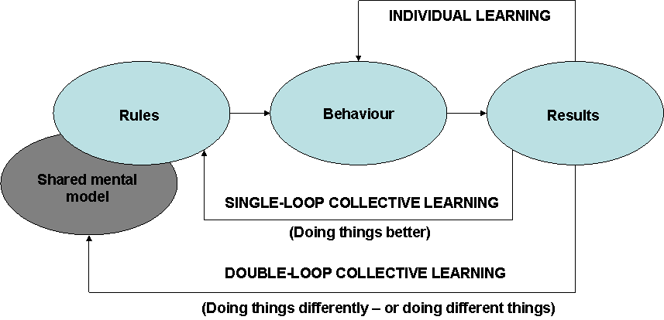

Specifications

Organisational learning involves enhancing the collective ability to act more effectively. The quality of organisational learning is important because it affects both strategy formulation and strategy implementation. The collective nature of learning is especially important in complex and turbulent environments, because in such circumstances senior managers may not be the best placed individuals to identify opportunities and threats. Organisational members, at all levels, who are involved in boundary-spanning activities, may have data that could provide a valuable input to strategy formulation. Furthermore, the quality of response to any threats or opportunities that are identified may require individuals and groups located in different functions to collaborate and learn from each other in order to design and produce high-quality products and services in ever-shorter time frames.

Swieringa and Wierdsma (1992) conceptualise organisations as a set of explicit and implicit rules that prescribe the way members behave. These rules are based on insights which represent what is known and understood. They relate to everything that happens in the organisation. For example, there are rules about the structure of the organisation that prescribe how activities will be grouped and responsibilities allocated, and there are rules about how resources are produced and used and about how people are managed and rewarded. These rules reflect the mental models through which organisational members examine and make sense of their experience. The shared mental model represents the basic assumptions that underpin the organisation’s culture. Schein (1990) defines culture as the pattern of basic assumptions, invented, discovered or developed by a group, as it learns to cope with its problems of external adaptation and internal integration, that have worked well enough in the past to be considered valid and, therefore, are taught to new members as the correct way to perceive, think, and feel in relation to these problems.

So long as the rules lead to behaviours that produce desired results, there will be no need to change the rules. The only requirement will be for individual learning. Organisational learning occurs when a group recognises something that offers a more effective way of functioning. Argyris and Schon (1978) distinguish between two different kinds of organisational learning:
- Single-loop learning entails the detection and correction of errors leading to a modification of the rules within the boundaries of current thinking. It involves organisational members collectively refining their mental models about how the world operates in order to do things better. It does not offer any fundamental challenge to current thinking. The effect of single-loop learning is to promote an incremental approach to strategy formulation and change management.
- Double-loop learning is a more cognitive process; it occurs when the assumptions and principles that constitute the governing variables or shared mental model are examined and challenged. This kind of learning challenges accepted ways of thinking and can produce new understanding of situations and events which, in turn, can lead to the development of new rules that require organisational members to change their behaviour and do things differently, or even do different things.

When there is a good fit between the organisation and its environment and when this leads to the achievement of desired levels of performance, there is a high chance that the prevailing shared mental model will be reinforced. The only collective learning in these circumstances will be single-loop learning associated with the detection and correction of errors. This kind of learning is often associated with continuous improvement.
Double-loop collective learning is most likely to occur when desired performance levels are not achieved and when feedback signals a need to re-examine the relevance of the shared mental model. Leroy and Ramanantsoa (1997) refer to incongruous events that violate conceptual frameworks as triggers for this kind of learning, and Fiol and Lyles (1983) assert that some type of crisis is necessary to trigger double-loop learning. Triggers are often associated with discontinuities such as the appointment of a new leader, or dramatically altered market conditions.

The approach to organisational learning presented here focuses on the development of shared mental models that provide a basis for effective action. These shared mental models furnish organisations with a conceptual framework for perceiving and interpreting new information and for determining how stored information can be related to any given situation. They persist over time, despite changes in organisational membership. This implies that organisations have collective memories that are not wholly dependent on the knowledge stored in the minds of current members. It is assumed that knowledge can also be stored in files, procedural manuals, routines, traditions and conventions and that this collective memory enables past experience to be applied to current problems.

Characteristics

Origin
Swieringa & Wierdsma (1992)
Approach
Organisational learning and effectiveness
Implications
Organisational learning involves the acquisition of knowledge, the recognition of its potential and its application to improve organisational performance. The collective nature of learning is especially important in complex and turbulent environments, because in such circumstances senior managers may not be the best-placed individuals to identify opportunities and threats
Applications
Primary: Implementing & Evaluating
Secondary: Understanding & Identifying
Requirements
Basic understanding of organisations and organisational processes
Benefits
The model conceptualise organisations as a set of explicit and implicit rules that prescribe the way members behave. These rules are based on insights which represent what is known and understood. They relate to everything that happens in the organisation

References

Argyris & Schon: Organizational Learning (Addison-Wesley, 1978)
Fiol & Lyles: Organizational Learning (Academy of Management Review 10 (4), 1983)
Hayes: The Theory and Practice of Change Management (Palgrave MacMillan, 2007)
Leroy & Ramanantsoa: The Cognitive and Behavioural Dimensions of Organizational Learning in a Merger Situation – An Empirical Study (Journal of Management Studies 34 (6), 1997)
Schein: Organizational Culture (American Psychologist 45 (2), 1990)
Schein: Three Cultures of Management – The Key to Organizational Learning (Sloan Management Review (Fall), 1996)
Swieringa & Wierdsma: Becoming a Learning Organisation (Addison-Wesley, 1992)

Appendix

Summary
& Overview

Summary

Part One
Understanding & Identifying

Different types of change can affect the focus for change efforts, the sequence of steps in the change process and the locus for change. While tuning or adaptation can involve minor or major changes, they are bounded by the existing paradigm. Re-orientation and re-creation, on the other hand, are types of change that target the playing field and the rules of the game rather than the way a particular game is played. [1. Different Types of Change]

The concepts change and transition are often used interchangeably, but it is important to be aware that there is a difference between them. Change happens when something starts or stops, or when something that used to happen in one way starts happening in another. Transition is a psychological process that extends over a long period of time and cannot be planned or managed by the same rational formulae that work with change. [2. Change versus Transition]

Change can be defined in relation to its extent and scope. Developmental change enhances or corrects existing aspects of an organisation. Transitional change seeks to achieve a known desired state that is different from the existing one. Transformational change results in an organisation that differs significantly in terms of structure, processes, culture and strategy. The three types of change provide a useful backcloth for comparing the advantages and disadvantages of different strategies. [3. Developmental, Transitional and Transformational Change]

A congruence model of organisation goes beyond merely providing a simple description of the components of the organisation and considers the dynamic relationships that exist between the various components. It highlights the effect of the congruency of the component parts of the organisation on organisational effectiveness. In addition, it elaborates the relationship between the organisation and its wider environment and focuses more explicit attention on the role of strategy. [4. A Congruence Model of Organisation]

The combination of the four frames model with the eight stages in successful change can be used to generate ideas and stimulate thinking of how to handle a change process. The model illustrates possible actions that change agents might take. Not every frame is essential to each stage, but all stages are critical to success. [5. Four Frames in eight Stages]

The hourglass model describes a change process in four stages: preparatory; inventory; implemental; and evaluative. A crucial aspect with this model is that organisational development starts and stops with the ambition to involve all individuals affected by change activities. [6. The Hourglass Model]

Socio-technical theory is about joint optimisation based on four core principles: responsible autonomy; adaptability; whole tasks; and meaningfulness of tasks. Socio-technical theory proposes a number of different ways of designing or re-designing organisations. [7. Socio-Technical Systems Theory]

Part Two
Diagnosing & Analysing

SWOT analysis is an assessment of internal resources and competences in relation to conditions in an organisation’s external environment. It can serve as an interpretative filter to reduce the information to a manageable quantity of key issues. The SWOT framework focuses on issues that have potentially most impact. It is a useful tool when a very limited amount of time is available to address a complex strategic situation. [8. SWOT Analysis]

PESTLE analysis is a useful tool for understanding the big picture of the environment in which you are operating, and the opportunities and threats that lie within it. By understanding your environment, you can take advantage of the opportunities and minimize the threats. [9. PESTLE Analysis]

Weisbord’s six-box model synthesises knowledge and experience for change agents. The model provides a conceptual map of six elements that can be used to apply any theories to the assessment of these elements in a way that can reveal new connections and relationships between elements. It is an open-system model that recognises the importance of organisation-environment relationships but focuses most attention on what needs to be done internally to ensure that the organisation becomes a high-performance organisation able to adapt to external changes. [10. Weisbord’s Six-Box Model]

Total Quality Management (TQM) is an organisation-wide, long-term change effort designed to orient all of an organisation’s activities around the concept of quality. The focus of TQM is on processes of work rather than on the workers themselves. Through a process of data collection, analysis, hypothesis formation and hypothesis testing, changes to processes can be devised. [11. Total Quality Management]

The critical part of intervention is the inquiry. The mere act of asking questions begins the process of change. Appreciative inquiry is a process that involves exploring the best of what is and amplifying this best practice. Whereas action research promotes learning through attending to dysfunctional aspects of organisational functioning, appreciative inquiry seeks to accentuate the positive rather than eliminate the negative. [12. The five Steps of an Appreciative Inquiry]

Part Three
Planning & Organising

Hatch’s model of the dynamics of organisational culture is making a place for symbols alongside assumptions, values and artifacts; by articulating the arrows linking assumptions, values and artifacts; and by defining these links as processes having both forward and backward temporal modes of operation. Because it represents culture as a wheel, the cultural dynamics model can be entered at any point. [13. The Dynamics of Organisational Culture]

Fernandez and Rainey’s model is an eclectic review of the organisational change literature as it pertains to the public sector. The eight factors can be used as a compass for practitioners seeking to find their way through the change process. The model can be used to analyse the interactive effect of the eight factors in a contingency approach to implementing organisational change seriously. [14. Fernandez and Rainey’s eight Factors of Successful Change]

Communication plays a vital role in the change process. It is an essential prerequisite for recognising the need for change, and it enables change managers to create a shared sense of direction, establish priorities, reduce disorder and uncertainty and facilitate learning. On the basis of experience in numerous organisations and a review of the literature Clampitt, DeKoch and Cashman identified five basic strategies. The five basic strategies provide a useful backcloth for comparing the advantages and disadvantages of various communication strategies. [15. Five Basic Communication Strategies]

Part Four
Implementing & Evaluating

The psychological contract can be defined as the perceptions of both parties to the employment relationship of their obligations implied in the relationship. It is an unwritten set of expectations between every member of an organisation. An awareness of psychological contracts should remind managers of the reciprocal relationship between individuals and the organisation, and the need to keep those contracts fair, equitable and up to date. [16. The Psychological Contract]

Organisational learning involves the acquisition of knowledge, the recognition of its potential and its application to improve organisational performance. The collective nature of learning is especially important in complex and turbulent environments, because in such circumstances senior managers may not be the best-placed individuals to identify opportunities and threats. The model conceptualise organisations as a set of explicit and implicit rules that prescribe the way members behave. These rules are based on insights which represent what is known and understood. They relate to everything that happens in the organisation. [17. Individual and Collective Learning]

Overview

Model | Understanding  & Identifying | Diagnosing & Analysing | Planning & Organising | Implementing & Evaluating | Page
1. Types of Organisational Change | Primary | Secondary |  |  | 5
2. Change versus Transition | Primary | Secondary |  |  | 7
3. Developmental, Transitional and Transformational Change | Primary | Secondary |  |  | 9
4. A Congruence Model of Organisation | Primary | Secondary |  |  | 12
5. Four Frames in eight Stages | Primary | Secondary | Secondary |  | 15
6. The Hourglass Model | Primary | Secondary | Secondary | Secondary | 18
7. Socio-Technical Systems Theory | Primary |  | Secondary |  | 21
8. SWOT Analysis |  | Primary | Secondary |  | 25
9. PESTLE Analysis |  | Primary | Secondary |  | 27
10. Weisbord’s Six-Box Model | Secondary | Primary | Secondary | Secondary | 29
11. Total Quality Management |  | Primary | Secondary | Secondary | 31
12. The Five Steps of an Appreciative Inquiry |  | Primary | Secondary |  | 33
13. The Dynamics of Organisational Culture | Secondary | Secondary | Primary | Secondary | 37
14. Fernandez and Rainey’s eight Factors of Successful Change |  |  | Primary | Secondary | 40
15. Five Basic Communication Strategies |  |  | Primary | Secondary | 44
16. The Psychological Contract | Secondary |  |  | Primary | 48
17. Individual and Collective Learning | Secondary |  |  | Primary | 51

Authors: Søren Lybecker and Niels Møller  Title: Change and Transition. Advisory material for managers  Department: DTU Management | October 2007
 | ISBN 978-87-90855-23-9

