THE ROLE OF EXERCISE AND EXERCISE TESTING IN THE MANAGEMENT OF CHILDREN WITH CYSTIC FIBROSIS
Submitted by
HIRAN SELVADURAI MB BS, FRACP
A thesis in fulfilment of the requirements for the degree of Doctor of Philosophy
Department of Paediatrics and Child Health Faculty of Medicine
The University of Sydney
Sydney. NSW. 2006
Australia

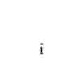

The University of Sydney
Copyright in relation to this Thesis
Under the Copyright Act 1968 (several provision of which are referred to below), this material must be used only under the normal conditions of scholarly fair dealing for the purposes of research, criticism or review. In particular no results or conclusions should be extracted from it, nor should it be copied or closely parahrased in whole or in part without the written consent of the author. Proper written acknowledgement should be made for any assistance obtained from this material.
Under Section 35 (2) of the Copyright Act 1968 'the author of a literary, dramatic, musical or artistic work is the owner of any copyright subsisting in the work'. By virtue of Section 32 (1) copyright 'subsists in an original literary, dramatic, musical or artistic work that is unpublished¹ land of which the author was an Australian citizen, an Australian protected person or a person resident in Australia.
The Act, by Section 36(1) provides: 'Subject to this Act, the copyright in a literary, dramatic, musical or artistic work is infringed by a person who, not being the owner of the copyright and without the licence of the owner of the copyright, does in Australia, or authorises the doing in Australia of, any act comprised in the copyright¹.
Section 31 (1) (a) (i) provides that copyright includes the exclusive right to 'reproduce the work in a material form'. Thus, copyright is infringed by a person who, not being the owner of the copyright, reproduces or authorises the reproduction of a work, or of more than a reasonable part of the work, in a material form, unless the reproduction is a 'fair dealing* with the work 'for the purpose of research or study' as further defined in Sections 40 and 41 of the Act.
Section 51 (2) provides that "Where a manuscript, or a copy, of material of other similar literary work that has not been published is kept in a library of a university or other similar institution or in an archives, the copyright in the material or other work Is not infringed by the making of a copy of the material or other work by or on behalf of the officer in charge of the library or archives if the copy is supplied to a person who satisfies an authorized officer of the library or archives that he requires the copy for the purpose of research or study'.
Thesis¹ includes * treatise', ' dissertation¹ and other similar productions.
This thesis is dedicated to my wife Niloufer and our sons, Yoshua and Daniel.
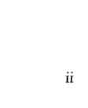
The role of exercise and exercise testing in the management of children with Cystic
Fibrosis
TABLE OF CONTENTS
Abstract viii
List of Abbreviations x
Statement of Authorship xi
Publications and Conference Presentations xii
Grants xv
Acknowledgements xvi
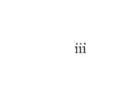
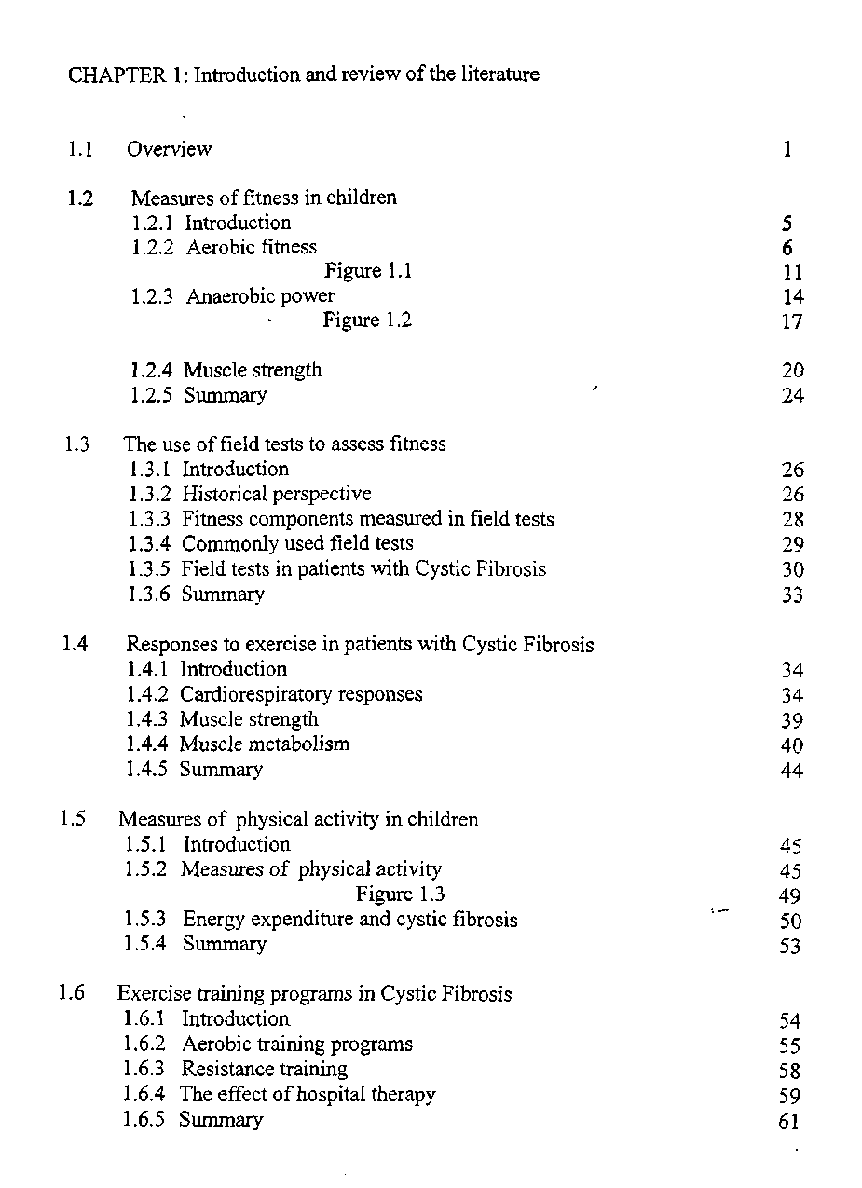
iv
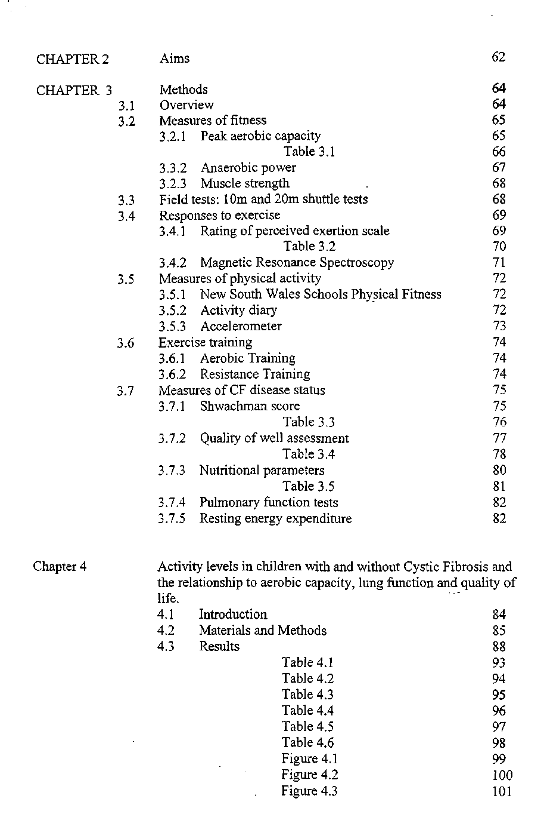
v
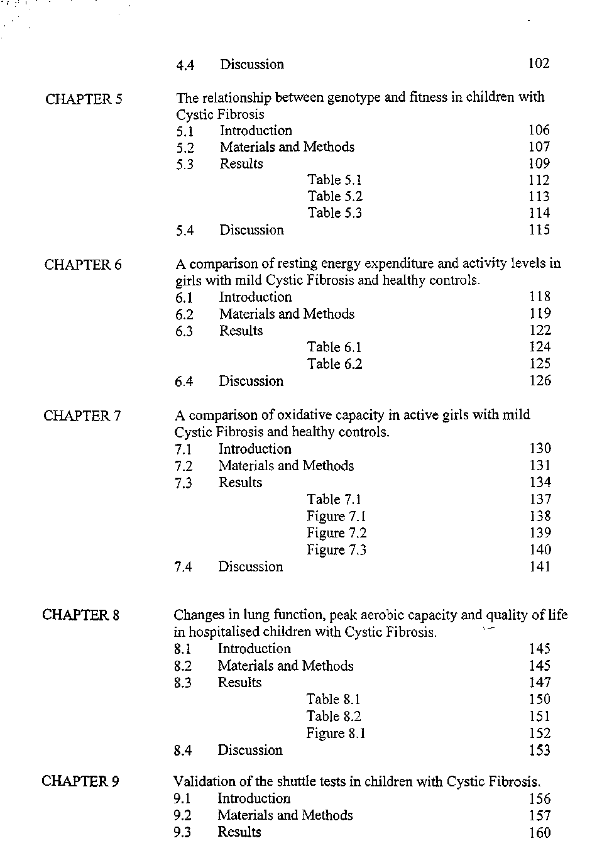
vi
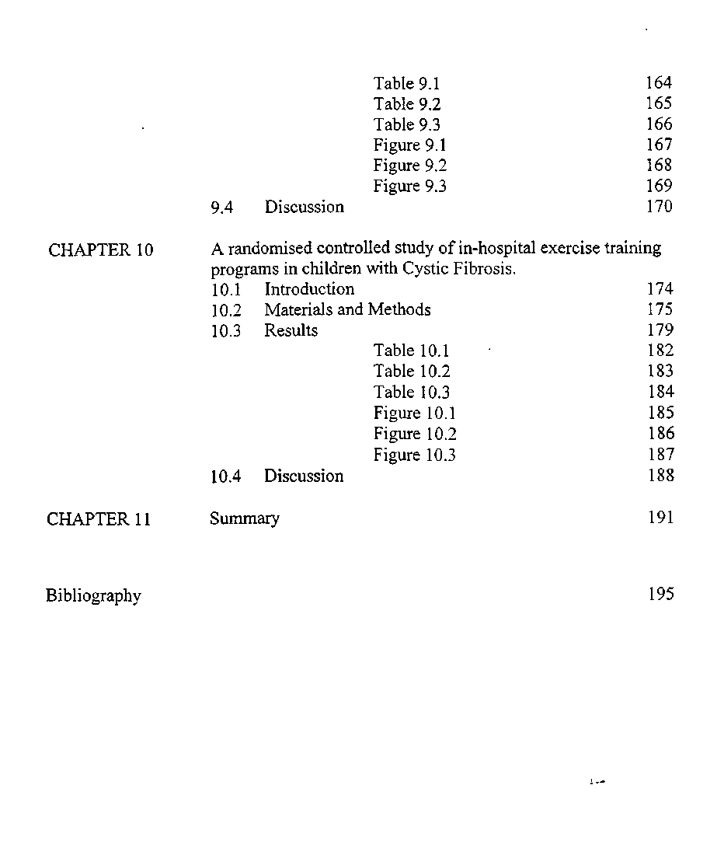
vii
Abstract
The overall aim of this thesis was to address deficiencies in the understanding of the role of exercise and exercise testing in the management of children with Cystic Fibrosis (CF), as well as how the disease influences on the ability of children to exercise. In the pursuit of these aims, seven studies were performed.
To compare aerobic fitness, lung function and physical activity levels in children with CF and healthy controls, participants completed an activity questionnaire and an activity diary as well as wearing activity accelerometers that detected movement for seven days. To assess the relationship between genotype and fitness, the genotype was categorised according to previously described CFTR mutation classes and correlated with aerobic fitness and anaerobic power. To compare resting energy expenditure in girls with CF and healthy controls, an indirect calorimeter with a metabolic cart was used. Leg strength in female athletes with CF was also compared with that in healthy matched controls. In addition, muscle metabolism in female athletes with CF was compared with healthy matched controls using a 31-phophorous magnetic resonance spectroscope. In another study, changes in lung function were compared with measures of fitness on admission to hospital and on discharge. The ten- meter and twenty- meter shuttle tests were assessed for repeatability and criterion validity using the treadmill test as the gold standard. Finally, the effectiveness of aerobic training and resistance training programs in hospitalised children with CF were assessed in a randomised controlled study.
viii
Children with mild CF were more active than healthy children, and those with moderate to severe CF had activity levels that were similar to control children. Activity levels in children with CF correlated well with aerobic capacity and quality of life but not with lung function. The detrimental effects of pancreatic insufficiency on activity levels and the cardiorespiratory status of girls were most apparent after the onset of puberty. In patients with one copy of the delta F508 gene, there was a statistically significant relationship between the class of the second CFTR mutation and aerobic capacity, anaerobic power and body mass index. Female athletes with mild CF had a significantly lower peak aerobic capacity, anaerobic power and leg strength than healthy matched controls. However, their resting energy expenditure and daily activity levels were significantly higher than healthy controls. Female athletes with mild CF demonstrated deficient anaerobic metabolism, as well as inefficient and deficient oxidative metabolism compared to healthy controls. When comparing changes in lung function and exercise tests in children with moderate to severe CF disease, exercise testing demonstrated the greatest magnitude of change after hospitalisation. The ten-meter and twenty-meter shuttle tests were found to be reproducible, valid assessments of maximal function limited aerobic capacity. Aerobic training produced the greatest improvement in quality of life, whereas resistance training improved weight gain and lung function."
In conclusion, the studies reported in this thesis demonstrate that exercise testing is an important adjunct to conventional clinical and lung function measures currently used to assess disease severity and response to therapy in children with CF. While there is some impact of CF disease on exercise ability, exercise training was also shown to improve outcome in children admitted to hospital for intravenous therapy.
ix

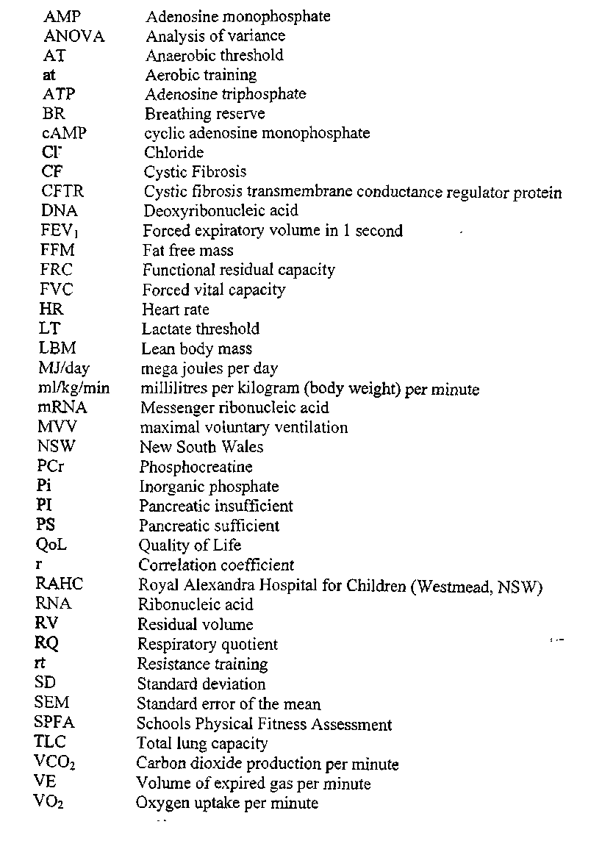
List of Abbreviations
X

STATEMENT OF AUTHORSHIP
Except where reference is made in the text, this thesis contains no material published elsewhere or extracted in whole or in part from any thesis by which the author has qualified for or has been awarded another degree or diploma. No other person's work has been used without due acknowledgment in the main text of the thesis. This thesis has not been submitted for the award of any other degree or diploma in any other institution.
Date 1 November 2000 Candidate's Signature: }fylj*dutifr-\
XI
PUBLICATIONS AND CONFERENCE PRESENTATIONS
Papers
The validation of the shuttle tests in children with cystic fibrosis. Selvadurai HC, Blimkie CJ, Mellis CM, Cooper PC, Van Asperen PP. In press.
A randomised controlled study of in hospital exercise training programs in children with Cystic Fibrosis. Selvadurai HC, Blimkie CJ, Mellis CM, Cooper PC, Van Asperen PP. In press.
Activity levels, aerobic capacity, lung function and quality of life in children with Cystic Fibrosis. Selvadurai HC, Blimkie CJ, Mellis CM, Cooper PC, Van Asperen PP. submitted October 2000.
The relationship between genotype and fitness in children with Cystic Fibrosis. Selvadurai HC, Blimkie CJ, Mellis CM, Cooper PC, Van Asperen PP. In press.
A comparison of resting energy expenditure and activity levels in girls with mild Cystic Fibrosis and healthy controls. Selvadurai HC, Allen JA, Blimkie CJ, Mellis CM, Cooper PC, Van Asperen PP. Submitted November 2000.
A comparison of oxidative capacity in active girls with mild Cystic Fibrosis and healthy controls. Selvadurai HC, Blimkie CJ, Mellis CM, Cooper PC, Van Asperen PP. Submitted November 2000.
xii
Abstracts
A comparison of fitness vs static lung function measurement as indicators of disease severity in CF. Selvadurai HC, Blimkie CJ, Mellis CM, Cooper PC, Van Asperen PP. Pediatr Pulmonol 1998; suppl 17: 451.
The validation of the shuttle tests in children with cystic fibrosis. Selvadurai HC, Blimkie CJ, Mellis CM, Cooper PC, Van Asperen PP. Pediatr Pulmonol 1999; suppl 18: 221-222.
A randomised controlled study of in hospital exercise training programs in children with Cystic Fibrosis. Selvadurai HC, Blimkie CJ, Mellis CM, Cooper PC, Van Asperen PP. Pediatr Pulmonl 1999; suppl 19 : 180.
The effect of exercise training programs during acute pulmonary exacerbation in children with Cystic Fibrosis. Selvadurai HC, Blimkie CJ, Mellis CM, Cooper PC, Van AsperJ»PP. J Paed Child Health 1999; 38: 212.
PRESENTATIONS
Validation of the shuttle test in Paediatric Cystic Fibrosis. Presented at the Congress of International Pediatric Pulmonology, Monaco, 1998.
xiii
A comparison of fitness vs static lung function measurement as indicators of disease severity in CF. Presented at the North American CF Conference, Montreal, Canada 1998.
Exercise testing in children with Cystic Fibrosis. Presented at Thoracic Society meeting (NSW branch of TSANZ), Sydney, Australia 1998.
A randomised controlled study of in hospital exercise training programs in children with Cystic Fibrosis. The Royal Australasian College of Physicians Annual Scientific Meeting, Perth, Australia 1999.
Activity levels and the effect of conditioning programs in children with Cystic Fibrosis. Australian Cystic Fibrosis Conference, Sydney, Australia 1999.
A randomised controlled study of in hospital exercise training programs in children with Cystic Fibrosis. North American Cystic Fibrosis Conference, Seattle, USA 1999.
xiv
LIST OF GRANTS AND SCHOLARSHIPS
The following grants and scholarships were awarded to enable the research for this thesis to be completed.
Research Grants
The Australia Cystic Fibrosis Foundation 1997
The Royal Alexandra Hospital for Children Research Fund 1998
Scholarships
Departmental Fellowship, RAHC 1997-1999
The University of Sydney Travelling Grant 1999
North American Cystic Fibrosis Foundation Travelling Grant 1998, 1999
Prizes
Best oral presentation, 1998. Congress of International Paediatric Pulmonolgy, Monaco.
Best oral presentation, 1998. Thoracic Society of Australia and New Zealand (NSW branch), Sydney, Australia.
Poster Award, 1997. North American Cystic Fibrosis Conference, Montreal, Canada.
xv
ACKNOWLEDGEMENTS
I am greatly indebted to my supervisors A/ Professor Peter van Asperen, Dr Peter Cooper and Dr Karen McKay who have encouraged and inspired me through out my research candidature. This research could not have been completed without A/ Professor Peter van Asperen. He believed in me even before I did. His clear thinking simplified even the most complex of problems. He has been the perfect teacher, role model and friend. I am very grateful to Dr Peter Cooper who inspired me to pursue a career in paediatric respiratory medicine and exercise physiology. Even from the early days of my clinical training, he has been a comforter when things did not go to plan and a one man cheer squad when things did. Dr Karen McKay has been a pillar of efficiency and strength. She is genuinely one of the nicest people one could ever meet. Together, this wonderful trinity has guided me through the challenges of my candidature and I will always be grateful to them.
I wish to express my gratitude to Professor Craig Mellis and A/ Professor Henry Kilham who have been the "gold standard" in paediatric respiratory medicine. I will always treasure the honour and privilege of working with them. I wish to thank Professor Mellis for his support and constructive advice from the conception to completion of this research and A/ Professor Kilham for his wit which helped keep me sane.
I am indebted to Professor Cameron Blimkie at the Children's Hospital Institute for Sports Medicine. His expertise in exercise physiology was invaluable to my candidature.
xvi
I am immensely grateful to the children who were the subjects of the studies in this thesis. Their enthusiasm inspired me. Their courage strengthened me. Tfcwir friendship humbled me. To them, and to their parents and families I extend my heartfelt thanks. I am grateful to Dr Garry Sholler and Dr Richard Hawker at the Adolph Basser Cardiac Institute for permission to use the exercise testing equipment. I would also like to thank Nick Meyer, Paul Bernhardt and Grace Agbulof for their technical support and ready availability. I am indebted to Illaria Verrochio, Anne Marie Davis and Brendan Kennedy from the pulmonary function testing laboratory for their expertise and friendship. I would like to thank Alison Chivers, Liz Kassis and Carry Mansfield from the Department of Physiotherapy for their enthusiastic support of the research.
Finally, I would like to thank my wife, Niloufer and our sons, Yoshua and Daniel. Niloufer [BA (Hons I), LLB (Hons I)] is perfection personified and from her, I have learned the meaning of love. She selflessly sacrificed her career ambitions so that I could pursue my dreams. Every moment of every day, I am amazed by her goodness. Life was nothing before her and is everything with her. Yoshua and Daniel have been my inspiration. They have showed me the meaning of absolute purity and have blessed our lives with boundless joy. We pray that they will be blessed abundantly every day of their lives. I would like to thank my parents [Dr.] Indran and Vino Selvadurai who have loved me unconditionally. I am grateful to my parents in-law [Professor] Mark and [Dr.] Noreen Cooray for their loving support and for frequently stepping in the shoes of an absent father.
xvii
CHAPTER 1 Introduction and review of the literature
1.1 Overview
Cystic Fibrosis (CF) is an inherited autosomal recessive disorder that in white Caucasian
populations, affects 1 in 2500 newborns [Wilcken et al, 1983; Forstner and Durie, 1991]. The disease is characterised by chronic suppurative lung disease, bronchiectasis and premature death from respiratory failure. According to the North American consensus guidelines [Rosenstein and Cutting, 1998], the diagnosis of CF is suggested by the presence of characteristic clinical features such as chronic sinopulmonary disease, gastrointestinal and nutritional abnoramalities, and male urogenital abnormalities, together with an abnormally elevated sweat chloride concentration. Identification of two CF gene mutations, and, or, demonstration of an abnormal nasal epithelial ion transport arew alternative diagnostic criteria.
The Cystic Fibrosis Transmembrane Regulator (CFTR) gene is located on chromosome 7 and encodes for a protein product, the CFTR protein. This CFTR protein has been demonstrated to be the cyclic AMP dependent chloride channel in apical membranes of epithelial cells [Riordan et al, 1989; Rommens et al, 1989; Kerem et al, 1989]. Ramjeesingh and colleagues [1999] have demonstrated that CFTR is not the only chloride channel present on epithelial cells. There are more than 900 known gene defects associated with CF. The most common defect is known as delta F 50? and up to 95% of patients have at least one copy of this allele [Cystic Fibrosis Genetic Analysis Consortium, 1990; Forstner and Durie, 1991]. The dysfunctional CFTR results 'to abnormal chloride and sodium transport channel in the apical membrane of epithelial
1
cells [Smith et al, 1992]. Tsui [1992] and Welsh and Smith [1993] proposed molecular mechanisms by which genetic mutations disrupt the function of cystic fibrosis transmembrane regulators (CFTR). By categorising these mechanisms into four different classes, it is not only possible to better understand the pathophysiology of the disease process, but new therapies targetted at altering CFTR functioning are being developed according to the class of the mutation [Denning et al, 1992b]. Tsui [1995] subsequently refined the classification to incorporate five different classes of mutations. For class I mutations, there is a premature termination of the CFTR mRNA translation caused by either base substitutions that create stop codons or by mutations that shift the reading frame and result in defects in protein production. Examples of class I mutations are G542X and W1282X. The most common mutation, delta F508, and the N1303K mutation belong to class II mutations and result in defects in protein processing. In class II mutations, the CFTR protein is degraded in the endoplasmic reticulum and fails to reach its intended site of action at the plasma membrane. Class III mutations, of which G551D is an example, are regulatory mutations in which protein reaches the surface of the cell but fails to respond normally to activation signals. Class IV mutations also result in protein reaching the plasma membrane but it has altered channel properties which result in defects in protein conduction. The mutations R117H and R347P are examples of class IV mutations. Class V mutations result in reduced level of ribonucleic acid (RNA) for CFTR.
Generalised exocrine gland dysfunction results in abnormalities of several organ systems. Abnormal mucus m the lungs contributes to the development of chronic obstruction, infection and inflammation. Exocrine pancreatic insufficiency occurs in
2
approximately 85% of patients with CF and despite enzyme replacement therapy, malabsorption of fat and micronutrients occur [Forstner and Durie, 1991]. Pancreatic function is closely Mated to the specific mutation the patient carries and mutations associated with exocrine pancreatic sufficiency are dominant to those associated with pancreatic insufficiency [Kristidis et al, 1992]. The mutations associated with pancreatic sufficiency are predominantly those that have readily detectable channel actMty (eg. R117H and A455E) whereas the mutations with little activity (eg. delta F508, G551D) or those that result in quantitative reduction in CFTR (eg. W1282X) are associated with pancreatic insufficiency [Sheppard et al, 1993]. Biliary cirrhosis and infertility may also occur in patients with CF.
In Australia, Cystic Fibrosis is usually diagnosed on the routine newborn screen collected on day 3 of life. This blood sample is assayed for immunoreactive trypsinogen (IRT), a pancreatic enzyme. The top 2% of the day's values are retested in triplicate for IRT. Since January 1993, half of this group (the top 1%) are screened for the delta F508 gene using the blood collected on the initial newborn screen. Delta F08 is the most common gene found in CF in Australia with up to 95% of patients having at least one copy of this gene. The diagnosis of CF is confirmed with a sweat test using pilocarpine iontophoresis [Gibson and Cooke, 1959]. A chloride concentration of greater than 60mmol /l is diagnostic of CF. The exocrine pancreatic function of patients with CF can be assessed by measuring faecal chymotrypsin concentration [Brown et al, 1988]. It can also be assessed by.pancreatic stimulation tests [Hadorn et al, 1968, Kopleman et al, 1988]. Pancreatic stimulation tests may aid in the diagnosis of patients with borderline sweat test results [Gaskin et al, 1982a].
3
Life expectancy among patients with CF has dramatically improved in the past twenty years and the mean survival is around 34 years [Fitzsimmons, 1993; Curtis et al, 1997]. However, there remains a significant gender difference in survival rates. TMg is most evident in females with CF under the age of 20 years, who are 60% more likely to die than males of the same age [Rosenfeld et al, 1997]. Rosenfeld et al, [1997] demonstrated that while nutritional status, pulmonary function and airway microbiology were independent predictors of survival, none of these parameters could account for the gender difference in survival rates.
Exercise is an integral part of the growth and development of children. Assessment of the exercise tolerance of patients with CF provides important information about the disease severity [Cropp et al, 1982] and the psychological well being of the patient [Orenstein et al, 1989], Furthermore, as maximal aerobic capacity is an independent predictor of survival in CF [Nixon et al, 1992], exercise testing has benefits in terms of estimating prognosis. Despite the role of exercise in the daily lives of children, exercise testing in children is based on protocols developed for adults and for the most part, has not been validated in children [Cooper, 1995]. As exercise testing in the laboratory setting can be threatening to young children, the development of valid field tests, llirich measure maximal function limited aerobic capacity have the potential to assist in the assessment and management of children with CF,
This thesis will focus on measures of aerobic fitness, muscle strength, quality of life and activity levels in children with Cystic Fibrosis as well as the impact of conditioning programs on these measures.
4
1.2 Measures of fitness in children 1.2.1 Introduction
The parameter most commonly assessed when gauging a child's fitness is aemfale fitness. Other measures of fitness, which are less frequently used in children, include anaerobic performance and muscle strength. Aerobic fitness, anaerobic performance and muscle strength each measure different aspects of fitness, but currently there is no consensus as to which is the best assessment of fitness.
Aerobic fitness is defined as the ability to accomplish endurance performance that mainly depends on aerobic metabolism [Leger, 1996]. Aerobic metabolism in turn relies predominantly on the oxidative pathway to produce energy for muscle function. Anaerobic tasks, in contrast, are high intensity activities that predominantly depend on the non-oxidative pathway. Muscle strength is the maximal tension a muscle group exerts against a resistance [Gaul, 1996]. Typically, long distance running is a predominantly aerobic sport and weight lifting and sprinting are examples of anaerobic tasks. Despite the seemingly exclusive definitions of aerobic and anaerobic tasks, at the cellular level, both metabolic processes occur concurrently regardless of the activity. Thus, at the commencement of long distance running, the anaerobic pathway provides the necessary energy until oxygen transport to the muscle mitochondria is established. The anaerobic pathway is utilised again when the muscle stores are depleted, oxygen demand is greater than supply and lactate accumulates. Muscle strength promotes efficient movement and stability of joints, which reduces the risk of musculoskeletal injury.
5
1.2.2 Aerobic Fitness
Aerobic fitness is a measure of cardiovascular health and has been demonstrated to be a prognostic factor in predicting the survival of patients with CF [Nixon et al_{y} 1992]. Aerobic fitness has three principal components; maximal aerobic power or maximal oxygen uptake, mechanical efficiency of aerobic energy processes and the aerobic endurance.
Maximal aerobic power
The highest exercise intensity that can be maintained during aerobic muscle metabolism is defined as the maximal aerobic power [Leger, 1996]. Oxygen consumption in most adults exercising at progressively increasing intensity will increase steadily up to a maximum level, and then will plateau, despite further increases in workload. Maximal aerobic power corresponds to the plateau in oxygen consumption, (known as the V02 max) during maximal exercise. Maximal oxygen consumption has an inverse relationship with fatigue during submaximal tasks [Leger, 1996]. Vaccaro and Mahon [1987], Armstrong et al> [1991], Mahon and Vaccaro [1991] and Freedson and Goodman [1993] haw all reported that oxygen consumption does not always plateau when children exercise maximally. Massicotte et al, [1985] recommended that this problem could be overcome by recording the highest oxygen consumption attained which is referred to as the V02 peak. Despite the lack of a defined plateau in oxygen consumption, Vaccaro and Mahon [1987] demonstrated that the reproducibility and reliability of exercise testing in children was similar to that in adults. Furthermore, Shuleva et al [1990] demonstrated that reliable exercise tests can be obtained in children as young as 3 years of age.
6
Oxygen consumption is usually expressed in absolute terms (liters per l&inute) and thus adults with a larger body mass attain higher absolute oxygen consumption values than children. This measurement is useful when comparing changes in aerobic power over short time intervals in a given individual but is less valuable over long time intervals when individuals may experience weight changes. Absolute oxygen consumption cannot be used to assess weight bearing exercise tests such as running on a treadmill [Buskirk and Longstreet Taylor, 1957]. In addition,,as the absolute oxygen consumption does not take into account differences in the load (that is, the body mass during weight bearing exercise) between individuals, interindividual comparisons are not possible [Kuipers et al> 1985]. Maximal oxygen consumption is therefore usually normalized for body weight (ml/kg/min) particularly in children [Krahenbuhl and Williams, 1992]. Maximal oxygen uptake relative to lean body mass has been shown to be the best method to assess both intra and inter individual differences in the status of the aerobic system during weight bearing exercise testing [Buskirk and Longstreet Taylor, 1957]. Lean body mass can be measured using skinfold thicknesses and the formulae provided by Durnin and Rahaman [1967].
There has been a recommendation that oxygen uptake be expressed in terms of biological age to account for pubertal development [Mirwald and Bailey, 1986]. Vanden Eynde et al, [1988] suggested that the biological age could be derived from the height velocity as plotted on a height - age curve. By expressing the maximal oxygen uptake in terms of the biological age, variations between countries due to differences in the age of onset of puberty are minimised [Molnar et al, 1973].
7
Rogers et al [1995] examined the relationship between oxygen consumption and both body surface area (BSA), and body mass in children and adults. Analyses revealed that there was a stronger linear relationship between oxygen consumption and body surface area than oxygen consumption and body mass in both children and adults. Logarithmic transformation of the data demonstrated that a scaling factor of body mass and body surface area to the 0.75 power provided the most appropriate method of comparing oxygen consumption in children with that in adults. ,
The two "Gold standard" ergometers used for assessing maximal oxygen consumption are the cycle ergometer and the treadmill ergometer [Bar-Or, 1983]. Rowland [1993] demonstrated that maximal oxygen consumption obtained with treadmill testing was 7% to 19% greater than that with cycle testing. Thus, specific norms are required for each ergometer. The use of cycle ergometers in children is difficult. The cycle ergometer often has to be modified for body size during growth. The length of the pedal shaft and the distance between the seat and the handlebars are frequently inappropriate for children. Moreover, the specifications recommend a 13 cm crank length for 6 year old children and a 15 cm one for children 8 to 10 years of age [Klimt and Voight, 1971; Bar-Or, 1983]. These specifications often rule out the use of cycle ergometers in the assessment of children, as modifications to the crank length are not possible in the less sophisticated cycle ergometers. In addition, cycle ergometer testing is more likely to cause local muscle fatigue than treadmill feting. The latter test is a more natural movement and modifications are not required to the ergometer when testing different body sizes. The cycle ergometer test requires the child to keep an appropriate pace (revolutions per minute) which the examiner needs to measure. This is
8
not necessary in the treadmill test as the treadmill determines the incremental speed according to the preset protocol. While maximal oxygen consumption can be predicted from heart rate and submaximal power on the cycle ergometer using the Astrand and Ryhming nomogram [Astrand and Rytiming,1954], the nomogram underestimates oxygen consumption in children by 12% to 25% [Buono et al, 1989, Woynarowska, 1980]. Correlation between predicted maximum oxygen consumption and measured oxygen consumption vary substantially between studies.. Woynarowska [19 80] demonstrated a correlation coefficient of 0.52 whereas Buono et al, [19B9] found that it was 0.89.
Numerous protocols for measurement of maximal oxygen consumption using the treadmill have been described in the literature [Bar-Or, 1983; Docherty and Gaul, 1990; Freedson and Goodman, 1993]. The Bruce and Balke protocols [Docherty and Gaul, 1990] were originally developed for adults, but, the Balke protocol is too long and involves too high a grade for fit children. A survey of paediatric exercise laboratories revealed that 50% used the Bruce or, modified Bruce protocol [Rowland, 1993]. Although the Bruce protocol is reliable [Cumming et al, 1978], the intensity of the increments between the stages are potentially too large for young children [Rowland, 1993]. Large increments between stages may lead to short bursts of anaerobic metabolism, which is clearly undesirable when assessing aerobic fitness. The modified Bruce protocol has smaller increments and is presently the protocol of choice when testing using the treadmill to assess aerobic fitness in children [Docherty and Gaul, 1990].
9
Falgairette [1989] reviewed the published results of exercise tests on 7000 children in studies on maximal oxygen uptake and concluded that there were great differences in maximal oxygen uptake between children of different ages. Further, the maximal oxygen consumption in boys who participated in competitive sport increased with age whereas it stayed constant in boys not involved in sport. Moreover, there was a decrease in maximal oxygen consumption in girls with age but, it stayed constant if they participated in sport. Kemper [1986] and Jones [1991] have concluded similar results with their respective studies. The range of the normal values for maximal oxygen uptake in children are plotted in Figure 1.1.
While maximal oxygen consumption has been used to predict survival [Nixon et al, 1992], there are no published age, gender or disease severity related normal predicted values for patients with CF. Orenstein and Nixon [1991] compared the exercise tolerance of males and females with CF and demonstrated that males had significantly greater peak oxygen consumption than females. Orenstein and Nixon [1991] demonstrated that minute ventilation was also significantly greater in males with CF than females with CF which is similar to findings in healthy subjects [Aitken et al, 1986], When minute ventilation was expressed in terms of ventilation per unit work load, however, there was no statistical difference between the genders.
10
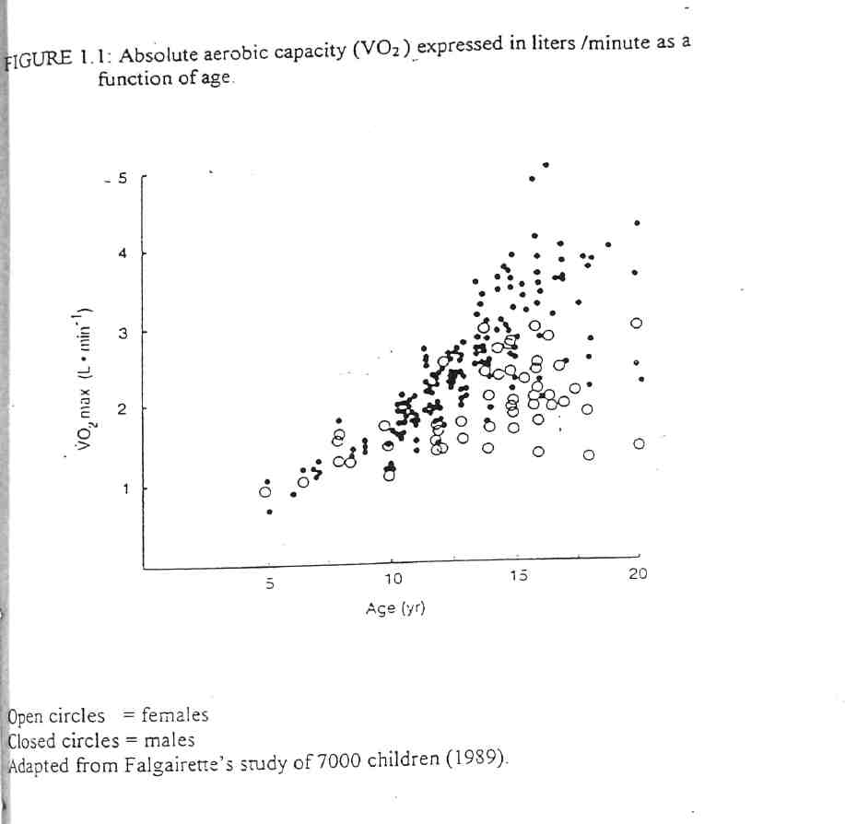

TIGHT BINDING

Mechanical Efficiency
The child who consumes the least oxygen to undertake a given submaximal task is the most mechanically efficient Paniels and Daniels, 1992]. Children consume more energy than adults in weight bearing exercises [Astrand, 1952; MacDougall et al, 1983]. The oxygen consumption for a specific speed is greater in children than adults. Krahenbuhl et al, [1992] demonstrated that aerobic performance in children increases with age and growth. However, oxygen consumption during, submaximal tasks when expressed per unit body weight, is relatively static during growth [Bar-Or, 1983]. The improvement in aerobic performance has therefore been attributed to improved muscle efficiency.
Aerobic reserve is a measure of muscle efficiency [Bar-Or, 1983] and is defined as the percent of maximal oxygen co&sumption required to undertake a given submaximal task. While the concept of aerobic reserve is useful to account for the greater aerobic performance in children as they grow, Leger [1986], Rowland [1993], and Unnithan and Eston [1990] have demonstrated differing values for the aerobic reserve for a given age and task. There are no studies of muscle efficiency in subjects withCF.
Aerobic Endurance
Aerobic endurance is the third component of aerobic fitness [Leger, 1996]. Aerobic endurance is the length of time a subject can participate in a task of static intensity before the oxygen demand of aerobic metabolism is no longer met. Anaerobic endurance is measured by the anaerobic threshold, which is the level of oxygen uptake during
12
exercise above which aerobic energy production is supplemented by anaerobic mechanisms. It is reflected by an increase in arterial blood lactate and the lactate/pyruvate ratio [Wasserman and Mcllroy, 1964].
Beaver et al, [1986] plotted the V- slope, which is the graphical relationship between alveolar carbon dioxide (VCO2) and alveolar oxygen (VO2). The point of deviation from the linear association of the V slope was defined as the aerobic threshold. In healthy subjects, the aerobic threshold is closely related to the anaerobic threshold as measured by blood lactate. However, Belman et al, [1992] demonstrated that the Beaver method of measuring the anaerobic threshold using the gas exchange method was not reliable in patients with chronic obstructive pulmonary disease.
Conconi et al [1982] described a simple test to measure anaerobic threshold. The threshold occurs at the deflection point from the linear relationship between work load and heart rate. This method of assessing the anaerobic threshold has become one of the most frequently used exercise tests in sports medicine. Nikolaizik et al, [1998] have however, demonstrated that the Conconi test overestimated the anaerobic threshold in adult subjects with mild CF related lung disease raising the possibility that exercise training programs based solely on the Conconi method may result in overexertion of patients with CF. The Conconi test has not been evaluated in children.
Changes in.aerobic endurance during growth have not been extensively documented. However, Berthoin [1994] demonstrated that the endurance time at any given submaximal exercise intensity was stable during growth.
13
1.2.3 Anaerobic power
Power is defined as the amount of work performed in unit time where as work is the product offeree and velocity [Bar-Or, 1987]. Anaerobic power implies that the energy to perform the task is obtained through a biochemical pathway that does not require oxygen. In reality, some part of the energy for even the most intense supramaximal activity is obtained through the aerobic pathway [Bar- Or, 1987; Vandewalle et al, 1987].
The contribution of energy through the aerobic pathway during predominantly anaerobic activity is greater in children than in adults [Hebestreit et al, 1993], and thus, anaerobic power is lower in children than in adults even when normalized for body mass or lean body mass [Bar-Or, 1983; Blimkie et al 1988; Kurowski, 1997;]. Anaerobic power does however, increase with the onset of puberty, [Paterson et al, 1986; Blimkie et al, 1988] and reaches peak adult levels in the second or third decade of life [Di Prampero and Cerretelli, 1969]. Blimkie et al [1988] and Mercier et al, [1992] demonstrated that peak power and mean anaerobic power increase throughout adolescence even when expressed in terms of muscle mass. Moreover, Blimkie et al, [1988] and Docherty and Gaul [1990] demonstrated gender differences in anaerobic performance. These differences were however, no longer present when power per lean mass was calculated.
The mechanism for the changes in anaerobic performance noted with maturation has not been delineated. Eriksson et al [1974] suggested that the rate of anaerobic glycolysis is limited in prepubescent children by low concentrations of the muscle
14
enzyme phosphofructokinase. This hypothesis is supported by the finding of low lactate concentrations in the blood [Duche et al, 1992] and muscle [Eriksson et al, 1973], and less acidosis in blood after maximal exercise in prepubescent children [Kindermann et al, 1975]. Animal research has demonstrated that anaerobic performance is related to serum testosterone [Dux et al, 1982], but, salivary testosterone level has been shown to correlate with maximal blood lactate. [Fellman et al, 1988]. Furthermore, changes in testosterone activity cannot explain the puberty related increase in anaerobic performance among females.
Daily activity frequently requires repeated bouts of anaerobic exercise rather than performance of sustained aerobic efforts. Therefore, an understanding of anaerobic performance may be of greater practical importance in the daily life of a patient with CF than the more classic concept of aerobic endurance. Despite extensive research on anaerobic exercise in healthy children, it remains unclear whether children with CF have a limited anaerobic capacity. Boas et al, [1996] reported a strong correlation between anaerobic capacity and body mass index in adolescent boys with CF. In addition, Shah et al, [1998] demonstrated that adult patients with CF and moderate lung disease had a significantly lower anaerobic performance than healthy controls. Lean body mass and arm muscle area correlated significantly with anaerobic performance in both the healthy controls and the subjects with CF. Lands et al [1993] used an isokinetic cycle ergometer to demonstrate that adult patients with CF had a significantly lower peak power than the healthy controls. Moreover, adult females with CF had a significantly lower peak power than their male counterparts, but, the difference was not statistically significant when
15
expressed per unit of lean body mass. There is clearly a need to investigate anaerobic power in children with CF.
Anaerobic tests
Anaerobic tests measure either the peak power a group of muscles can generate, or, the endurance of the muscles to sustain a high power output. As each type of anaerobic test measures different muscle groups and function, -they each have their own range of normal predicted values. The gold standard for assessing anaerobic performance in children is the Wingate test. It was developed by Ayalon et al, [1974] and has subsequently been validated in several studies. Its test- retest reliability ranges from 0.92 to 0.97 [Bar- Or, 1987] and it has a low coefficient of variation within subjects between six and twelve years of age [Naughton et al, 1992], Inbar et al [1985] published norms for males for peak power using the Wingate test. They are presented in figure 1.2.
The Wingate test requires the use of a fixed braking constant force cycle ergometer. The test is preceded by a warm up phase of moderate intensity cycling which is followed by three to four sprints each of two to three second duration. The test is then commenced with the child being instructed to pedal as fast as possible for a thirty second period. The parameters of assessment are the peak power output reached (Watts) and the mean power during the 30 second test. The fatigue index, which is the percent drop in power from peak level to the lowest level can also be calculated. The fatigue index correlates with the preponderance of fast twitch muscle fibers [Bar-Or et al, 1980] and thus,
16
FIGURE 1.2: Peak power of legs in males using the Wingate Anaerobic test.
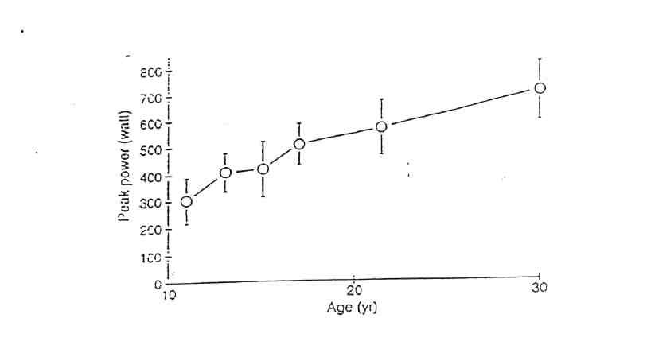
Values represented are the mean values with error bars representing +/ SD. Based on Inbar (1985).

obviates the need for muscle biopsy to obtain such information. The Wingate test is well tolerated by children and the test remains the anaerobic test of choice. The cost of equipment and the possibility of post test nausea in young adults however, need to be considered before using the test in subjects with CF.
The Force Velocity Cycling test measures peak power during a maximal five to eight second burst of cycling [Sargeant et al, 1981]. This test.was developed for adults and subsequently adapted for children. A constant force, isokinetic cycle is required for the test. Although there is a high correlation between peak power obtained by it and that obtained by the Wingate test [Van Praagh et al, 1990], the limitation of this test is that there are no available data about its reproducibility.
Based on force -velocity principles, there is an optimal velocity at which the peak power is obtained [Wilkie, 1960], the optimal velocity in children being 110 revolutions per minute [Sargeant, 1981; Dotan and Bar-Or, 1983]. An isokinetic cycle ergometer which maintains a constant pedal velocity was developed by Sargeant et al, [1981]. Both peak power and muscle endurance can be measured by the isokinetic cycle ergometer although the utility of the test is limited by the cost of the ergometer.
Peak power can also be assessed using the Margaria step running test [Margaria, et al, 1966] which requires the subject to run up stairs at maximal speed. Mechanical peak power is calculated from the time it takes the subject to make two strides. As subjects differ in their style of sprinting up stairs, and as a given subject may vary from
18
one attempt to another in running style, it is difficult to make either inter- or intra-tofividual comparisons using the results of this test.
Sargent [1921] also introduced a vertical jump test to assess peak power. The test is a simple field test which can be easily learned by children. It is highly reproducible between jumps [Glencross, 1966] and compares well with the results obtained using the best assessment of anaerobic performance, the Wingate test [Bar-Or, 1983].
Isokinetic monoarticular anaerobic tests using isokinetic dynamometers can also be used to measure peak power as well as muscle endurance. Dynamometers calculate the peak power from the force generated and angular velocity. Several protocols have been developed using these instruments for assessing a wide range of muscle power. Bar-Or [1983] developed the McMaster Muscle Endurance Test (McMET) which measures peak power and muscle endurance of the knee flexors and extensors. Again, the results obtained using this test have been shown to correlate well with those obtained using the Wingate test [Bar-Or, 1983] but, the utility of the test is limited by the cost of the dynamometers. The isokinetic dynamometer, precisely matches the force applied by the subject and prohibits acceleration (hence the term isokinetic). This enables strength to be measured through a full range of motion at a constant velocity. The advantage of this method of testing is that short bursts of force, that are not maintained for the full range of motion of that muscle group, are not recorded and hence, cannot give a falsely high reading.
19
1.2.4 Muscle strength
Strength is defined as the maximum force a muscle group can exert against resistance [Gaul 1996]. Muscle strength is necessary to stabilise joints and enable individuals to participate in activities of daily living without undue fatigue [Haskell et al, 1985]. The development of muscular strength helps muscles to endure long periods of submaximal force and delays the onset of fatigue. Muscle endurance is defined as the ability of a muscle group to generate force over an extended period of time* [Gaul, 1996].
In the laboratory setting, muscle strength can be measured by isokinetic testing, isotonic testing and isometric testing. In muscle strength assessments using isokinetic testing, the maximal force through a complete range of motion is measured while the speed of movement is kept constant. Isokinetic testing is by far the most widely used strength testing protocol In isotonic strength testing, the maximal muscle action occurs within a small portion of total range of motion. During isometric testing, force development occurs at a preset joint angle against an immovable resistance.
Isokinetic Testing
The term "isokinetic" refers to a constant force velocity, and isokinetic muscle action does not occur during normal movement. However, isokinetic testing enables measurement of maximum force at each point of the full range of motion of that'muscle group. The measurement of isokinetic muscle strength requires the use of specially designed dynamometers which alter the resistance according to the force applied to ensure a constant limb velocity. Isokinetic muscle action is recorded as the peak torque. This is the highest torque output by a muscle group as th&ilimb moves through a range of
20
motion [Burnie and Brodie, 1986]. Peak torque has been demonstrated to be an accurate and reproducible measure of strength in children [Molnar et al, 1979]. Children typically demonstrate greater peak torque with limb extensors than with limb flexors [Burnie and Brodie, 1986], but the muscle strength of the dominant and non dominant limbs in children is not significantly different [Sunnegardh et al, 1988].
There are several commercially available 'dynamometers such as Cybex, Kin Com and Biodex. However, almost all isokinetic research in children has been performed using the Cybex II or Kin Com versions. There are no available data comparing the two dynamometers.
When the strength of a group of muscles is measured during rotational motion, it is described as the torque. The use and interpretation of isokinetically derived torque is subject to error as a result of mechanical imperfections in the equipment used [Taylor et al, 1991]. At high velocities, the momentum of the accelerating limb is absorbed by the dynamometer which decelerates the limb in order to maintain constant velocity through the range of motion. This can result in impact artifact and may be incorporated in the torque reading [Sapega et al, 1982]. This artifact has however been shown to be less common when testing children, and this is thought to be due to a smaller limb mass and total torque values [Winter et al, 1981]. Further, gravity has an influence on the measurement of torque and some dynamometers have inbuilt correction devices to account for the effect of gravity. Despite these limitations, there have been some studies on the liability and applicability of isokinetic strength testing of children. Molnar et al, [1979] demonstrated a small variability between test-retest assessments and between
21
different examiners. These differences were not statistically significant and were confirmed by Sunnegardh et al, [1988] in later studies.
Isotonic Testing
The most widely used isotonic protocol is termed the one repetition maximum (1RM) and requires the subject to bench press or leg press a supramaximal load twice. The National Strength and Conditioning Association (NSCA) has recommended that prepubescent children should not undertake isotonic testing using the one repetition maximum protocol as used by Blimkie et al, [ 1989] as the risk of injury is high.
Watkins and Docherty [1996] have described the 10 repetition maximum protocol, which requires the subject to bench press 40% of body weight with 10 repetitions. This protocol has been shown to be well tolerated by 10 to 12 year old children but nonetheless, isotonic testing is an uncommon test in children because of significant concerns about the rick of injury.
Isometric Testing
Isometric testing involves measuring the force applied against an immovable measuring device. Isometric testing can be performed using an isokinetic dynamometer by fixing the dynamometer's measuring arm at a chosen angle. The force generated by a specific muscle group is dependent on the joint angle and body position [Clarke, 1966]. Although normal predicted values for force generated at various joint angles have been published for adults, the data is poor for children [Ramsay et al> 1990]. The optimal joint angle for isometric testing depends on the muscle group being tested. Often more than
22
one angle is necessary to construct an isometric profile. The duration of the isometric test protocol typically ranges from 2 seconds to 5 seconds [Andersen and Henckel, 1987] and includes a minimum of two trials with the average of the trials taken as the result of the test. Although simple to perform, isometric testing has no reproducibility or, reliability data in children and as such has limited use in the assessment of children with CF.
23
1.2.5 Summary • Aerobic fitness
- Has been shown to predict survival in patients with CF.
- Aerobic fitness has three principle components
Maximal aerobic power - this is the highest exercise inte&sity that can be maintained during aerobic muscle metabolism and is best measured in¹ children using either the cycle ergometer or treadmill ergometer.
Mechanical Efficiency - this relates inversely to the amount of oxygen consumed during a given task and is best measured by the aerobic reserve.
Aerobic endurance - this is the length of time a subject can participate in a task before the oxygen demand is no longer met and is measured by the anaerobic threshold.
• Anaerobic performance
- Is an important component of daily activity
- Is measured by peak power or endurance.
- The Wingate test is the current "gold standard" of measurement
• Muscle strength
- Is the maximum force a muscle group can exert against resistance
- May be assessed by isokinetic, isotonic or isometric testing.
24
• Isokinetic testing is the most commonly used method utilising dynamometers to measure peak torque.
- An ideal fitness test should really incorporate all three measures of fitness but this is not possible as muscle function assessed with each test is very different.
- Aerobic fitness is most commonly assessed iri CF patients but there is a need to measure anaerobic performance and muscle strength as current data is very limited.
. 1.3 The use of field tests to assess fitness
1.3.1 Introduction
Exercise tolerance reduces as the severity of the lung disease in CF progresses [Cropp et al, 1982]. Exercise tolerance has been demonstrated by Nixon et al, [1992] to be an independent predictor of survival. Furthermore, at the Cystic Fibrosis Consensus Conference in 1994, exercise tolerance was described as an important outcome measure in interventional trials [Ramsey and Boat, 1994].
While the treadmill and cycle ergometer remain the "gold standard' for exercise testing, these tests do not replicate children's daily activity [Cooper, 1995]. Furthermore, the equipment necessary for testing is expensive and not readily available. As these tests are performed in the laboratory setting, young children in particular can find the testing threatening and hence not perform to their maximal ability. Field tests are measures of fitness, which are undertaken without the need for highly specialised and expensive equipment. The aim of field tests is to replicate the "gold standard" tests such as the treadmill or cycle ergometer as closely as possible in a non threatening environment.
1.3.2 Historical perspective
Historically, the focus of field tests was initially on motor fitness where the efficiency of muscle function was assessed. The Kraus- Weber Minimal Fitness Test [Kraus and Hirschland, 1953] was one of the earliest field fitness assessments developed and was used to compare the fitness of European and American children. The principle assessment was of muscle strength and included sit ups, push ups and an endurance run.
26
The Canadian Association for Health, Physical Education and Recreation (CAHPER) introduced a similar battery of tests to Canadian schools in 1966 and in addition added tests of aerobic fitness. Australian schools adopted the CAHPER tests of fitness in 1967 with the addition of static and explosive assessments of strength.
In 1975, the American Alliance for Health, Physical Education, Recreation and Dance revised the fitness test to incorporate health related assessments in addition to the measures of physical performance. The health related assessments included anthropometric (growth and nutrition) details, which had not previously been documented in any of the fitness tests [Franks et al, 1988].
The Manitoba Physical Fitness Performance Test Manual and Fitness Objectives was published in 1980 and included measures of aerobic fitness, as well as assessments of strength, flexibility and anthropometric details. The revised version contained normal standards of fitness based on the Manitoba Schools Physical Fitness Survey [1989].
The New South Wales Schools Physical Fitness assessment was completed on 7000 school children [Booth et al, 1998]. This assessment was unique in that it incorporated measures of aerobic fitness, muscle strength, muscle endurance as well as information on activity levels. The assessment of activity level was obtained by asking the children to document the number of hours of organised as well as miscellaneous sport played per week.
27
1.3.3 Fitness components measured in field tests
Several components of fitness can be measured in field tests. The type of field test administered can be tailored so that the fitness parameter deemed to be of greatest clinical importance is measured. The components which can be assessed in these tests include muscle strength, power, endurance and body composition.
The maximum force a muscle group can generate in one contraction is the "strength" of that muscle group [Sale, 1991]. The maximum weight a subject can lift is a commonly used field test of strength but to more precisely quantitate strength requires expensive equipment and hence, strength is not often assessed in field tests. Power refers to explosive strength or, the ability of muscles to contract forcefully and quickly. [Sale, 1991]. Power can be evaluated in field assessments by throwing medicine balls, standing broad jumps or vertical jumps. Muscle endurance is the ability of a designated muscle group to perform repeated contractions. Field tests such as push ups, sit ups, and flexed arm hang (where the subjects hangs off a bar for as long as possible) all assess muscle endurance.
The range of motion about a specific joint is referred to as flexibility [Hubley, 1991]. Typically, field tests measure only a part of the range of motion. Quantitating flexibility usually requires the use of equipment such as a goniometer.
28
Body composition, in the field test setting consists of assessing lean body mass [Ross and Marfell- Jones, 1991]. This is accomplished with the use of calipers to measure skinfold thickness as described by Durnin and Rahaman [1967].
1.3.4 Commonly used field tests
The step test is a quick, simple and portable field test. The subjects are required to step up and down a step of 15cm height at a rate of 30 steps per minute for„three minutes. Being externally paced, it has the additional benefit of not being dependent on patient motivation. However, while the test is reproducible [Balfour-Lynn et al, 1998], criterion validity has yet to be assessed against an accepted gold standard of exercise assessment (eg. treadmill or cycle ergometer). In addition, the step test does not measure a maximal functional capacity and the workload will vary according to the step height, and the weight and height of the subject. The test is therefore not suited to longer term clinical intervention trials [Orenstein, 1998].
The shuttle test is another inexpensive and portable field test which assesses maximal function limited cardiorespiratory fitness. The two shuttle tests commonly in use are the 10m shuttle walk which was developed by Singh et al, [1992] and the 20m shuttle run which was developed by Leger et al [1988]. These tests are effective measures of aerobic fitness as they estimate maximal oxygen uptake. The shuttle tests overcome the limitations of the 2- minute and 6- minute walk tests by being externally paced maximal tests, and therefore not dependent on patient motivation. Unlike the 2 and 6 minute walk tests and the step te$% the shuttle tests are standardized incremental, maximal tests. The
29
shuttle tests are also superior to the step test in that they provide a quantitative assessment of maximal functional capacity. As the outcome measures (such as maximal oxygen uptake, oxygen pulse) are recorded in terms of total or lean body mass, the shuttle tests are potentially an ideal assessment in long term clinical trials. Moreover, the validity of the 20m shuttle run has been assessed in healthy children [van Mechelin et al, 1986; Leger et al, 1988; Liu et al, 1992; McVeigh et al, 1995] athletes [Ramsbottom et al, 1988], and a sedentary adult population [Paliczka et al 1987]. However, despite use in the assessment of exercise tolerance, neither of the shuttle tests have been validated in children with cystic fibrosis.
1.3.5 Field tests in patients with Cystic Fibrosis
A cardiorespiratory assessment of fitness is the most commonly used field test in CF. This is because aerobic fitness is a useful measure of disease severity [Cropp et al, 1982] and has important prognostic implications [Nixon et al, 1992]. Furthermore, as aerobic fitness is a measure of the overall impact of the disease on the subject [Nixon et al, 1992], interventional clinical trials can use cardiorespiratory assessments of fitness as important outcome measures [Ramsey and Boat, 1994]. While there are several assessments of aerobic fitness in the field setting, only two tests have been validated in patients with CF. The tests are the six minute walk test [Nixon et al, 1996; Gulmans et al, 1996] and the Great Ormond Street 3 minute Step test [Balfour- Lynn et al, 1998]. Both these tests have limitations when assessing fitness in children with CF.
30
Gulmans et al, [1996] assessed the validity of the six rninute walk test in children with CF by measuring the total distance walked in six minutes. Encouragement was offered after every 16m walked. Validity was assessed by correlating the distance walked with a maximal cycle ergometer exercise test in children with CF. Reproducibility was assessed by comparing the distance walked on two separate six minute walk tests. There was a significant correlation between the distance walked in the six minute walk test, and the maximal oxygen uptake and the peak work capacity during the cycle ergometer test. Further, the six minute walk test was demonstrated to be reproducible with no significant differences between the. distances walked when the test was repeated. The correlations between the distance walked and the maximal oxygen uptake suggest sufficient variability that the six minute walk test must be interpreted with care when considering individual patients [Cerny, 1996]. Inadequate or, unsafe exercise prescriptions may result if the exercise capacity is under, or overestimated. As the test is essentially self paced, the patient's attitude and motivation are a major factor in determining the distance walked [Guyatt et al, 1984; Swinburn et al, 1985]. For this reason, CF centers that utilise the six rninute walk test, use the fall in oxygen saturation (pulse oximetry) and peak heart rates as the critical outcome measures rather than the distance walked [Balfour-Lynn et al, 1998]. Thus, the six minute walk test has limited application in clinical interventional trials in patients with CF.
Balfour-Lynn et al, [1998] validated the reproducibility of the step test in children with CF. Exercise tolerance from both the step test and the six minute walk test were compared by measuring the peak heart rate, minimum oxygen saturation (pulse oximetry)
31
and the modified Borg breathlessness score [Wilson and Jones, 1989]. The step test was demonstrated to be reproducible and the peak heart rate obtained was not significantly different to that obtained by the six minute walk test.
1.3.6 Summary
■ field tests are inexpensive measures of fitness which obviate the need for expensive laboratory equipment.
• To date, the six minute walk test [Gulmans et al, 1996] and the Great Ormond Street
3 minute Step test [Balfour Lynn et al, 1998] have been validated in children with
CF. However, both these tests have limitations.
- The six .minute walk test being self paced is dependent on patient motivation.
- The step test does not quantitate maximal functional capacity, has not been validated against a treadmill or cycle ergometer and is not suitable for longer term interventional trials.
• The shuttle test is potentially a very useful incremental field test as it is an externally
paced test which quantitates maximal functional capacity. The shuttle test however,
has not been validated for use in children with CF.
33
1.4 Responses to exercise in patients with Cystic Fibrosis
1.4.1 Introduction
Exercise testing is an important method of assessing disease severity in the patient with CF. Cropp et al, [1982] demonstrated that adult patients with advanced CF disease, have a reduced exercise tolerance due to a reduced ventilatory capacity. Others have demonstrated that patients with CF have a reduced peak work capacity compared to normal controls on exercise testing using a cycle ergometer [Bellon et al 1984; Marcotte et al, 1986b]. Peak oxygen uptake has also been shown to be reduced in patients with CF compared to controls [Freeman et al 1993; Hjelthes et al 1984; Stranghelle et al, 1996].
1.4.2 Cardiorespiratory
Orenstein and Nixon [1991] compared the exercise tests of young adult females with CF with males with CF of a similar age using cycle ergometer exercise testing. Females with CF had a significantly lower peak oxygen consumption and peak work load than males. McCool et al [1993] reported similar results. Gender differences in peak oxygen consumption have previously been demonstrated in healthy populations [Bar-Or, 1983] and have been attributed to a decrease in activity in females after puberty [Shepherd 1977]. The reduced activity in girls was postulated to lead to muscle deconditioning resulting in reduced aerobic fitness. Another explanation is that, gender differences in lean body mass may have spuriously exaggerated the gender difference in peak aerobic capacity when reported in terms of total body mass [Davies, 1992]. Similarly, Orenstein
34
and Nixon's study [1991], by not correcting the peak oxygen consumption for lean body mass may have overestimated the gender difference.
The ventilatory capacity only becomes a limiting factor in CF when pulmonary disease reaches an advanced stage [Cropp et al, 1982]. This occurs as the end expiratory lung volume, which is already increased in patients with severe disease, becomes further increased after exercise [Regnis et al, 1991] due to airway closure at relatively higher lung volumes. This premature closure produces a natural positive end expiratory pressure (PEEP). In contrast, in patients with mild disease, the end expiratory lung volume is reduced after exercise as airway closure does not occur at until low lung volume is reached. Premature airway closure in advanced lung disease is thought to be caused by mucous plugging [Regnis et al, 1991].
During exercise, patie&tts with mild lung disease achieve optimal alveolar ventilation by increasing tidal volume [Cerny et al₃ 1982]. However, as the severity of lung disease progresses, the ability to increase the tidal volume as it approaches vital capacity is reduced. Thus, in patients with moderate to severe lung disease, the ventilatory rate is increased to compensate for the inability to increase the tidal volume, [Levison and Cherniak, 1968]. In spite of the increased ventilatory rate, relative alveolar hypoventilation occurs due to an increased dead space. Moreover, Pianosi and Wolstein[1996] demonstrated that patients with CF have a decreased ventilatory response to carbon dioxide. The reduced chemosensitivity may further accentuate the relative alveolar hypoventilation during exercise in patients with CF [Germann and Orenstein,
35
1981]. This relative alveolar hypoventilation has been shown to result in carbon dioxide retention in studies measuring end tidal carbon dioxide during exercise [Cerny et al, 1982; Cropp et al, 1982; Marcotte et al, 1986b]. In addition, Coates et al, [1988] demonstrated that patients with carbon dioxide retention had poorer lung function. In patients with CF who had an increased functional residual capacity, abdominal muscle activity has been demonstrated even when the patients were supine [Cemy et al}, 1982]. Patients with CF recruited abdominal muscles during expiration-at lower expiratory threshold loads than healthy controls.
Adult patients with moderate to severe CF, have regions of air trapping predominantly in the apices of the lungs. Exercise improves the ventilation to these regions of the lungs [Kruhlak et al, 1986]. Although gas exchange, as measured by ventilation perfusion studies, is reduced in patients at rest, it improves during exercise in patients with CF [Dantzker et al, 1982].
Patients with CF utilise a larger proportion of their total oxygen consumption on respiratory muscles when exercising than do controls [Katsardis et al, 1986]. Thus, there is less reserve for use by the exercising peripheral muscles and therefore exercise tolerance may be limited. Further, exercise tolerance may also be limited by way of increased carbon dioxide production by peripheral muscles contributing to the ventilatory load of the respiratory system [Lands et al, 1992]. Subjects who are aerobically fit have, howeve% a lower ventilatory load and use fat as a fuel (reducing the carbon dioxide by product) as well as metabolising lactate more efficiently. ■
36
Resting pulmonary function, specifically, forced expiratory volume in one second
[FEVi], correlates with exercise induced oxygen desaturation (measured using pulse
oximetry) in patients with CF [Versteegh et al, 1986]. However, when transcutaneous
oximetry is used to measure desaturation, there is no significant relationship with resting
pulmonary function [Pradal et al, 1990]. The reason for the difference in correlation
between the two modes of measuring desaturation is unclear, although, transcutaneous
oximetry is well known to have greater variations during exercise than pulse oximetry
[Stranghelle et al, 1993]. Henke anad Orenstein [1984] demonstrated that desaturation
during exercise occurred in 28% of subjects with an FEVI of less than 50% predicted and
2% of subjects with an FEVI of greater than 50% predicted. Others [Marcotte et al,
1986b; Freeman et al, 1993] have reported similar findings using an FEVI of 60%
predicted or resting saturations of less than 95% as cutoffs for predicting which patients
would desaturate with maximal exercise. Versteegh et al [1986] demonstrated that if the
V02 max was less than 55% predicted, or if the anaerobic flireshold was less than 40%
predicted, there was a significant increase in the risk of desaturation with exercise.
Lebecque et al, [1987] demonstrated that if the gas exchange of the lungs was greater
than 80% predicted, no desaturation occurred but, if the gas exchange was less than 65%
predicted, all patients desaturated with exercise. Those patients with the lowest resting
oxygen saturation appeared to have the greatest risk of desaturation during exercise
[Goldringe/a/, 1964].
Studies have demonstrated exercise induced bronchospasm occurs in 22% [Kaplan et al, 1994] to 55% [Silverman et al, 1978] of patients with CF. Conversely,
37
bronchodilation and increases in ¥EV{ of up to 13% have also been demonstrated during exercise in patients with CF [Day and Mearns, 1973; Skorecki et al, 1976; Macfarlane and Heaf, 1990]. The presence of basal vagal tone in the airways of patients with CF is suggested by a similar increase in FEVi with the administration of anticholinergic drugs [van Haren et al, 1992]. Exercise has also been shown to result in a reduction in airway resistance and an increase in total lung capacity in patients with CF [Price et al, 1979; Bilton et al, 1991]. There is no correlation between atopic status of the patients with CF and the results of pulmonary function tests during exercise [Silverman et al, 1978; Holzer etal, 1984].
The cardiovascular responses to exercise in patients with CF are normal and generally do not limit exercise ability [Lands et al 1992]. There is a normal incremental increase in heart rate with exercise [Cerny et al, 1982], As exercise is usually limited by the ventilatory load, or, muscle deconditioning, the peak heart rate at maximal exercise is lower than in the normal population without CF [Orenstein et al, 1981]. Williams et al [1993] have however demonstrated that patients with CF and CF related liver disease, have higher cardiac output and a lower systemic vascular resistance index than patients with CF and no significant liver disease. In addition, using radionuclide angiocardiography, Matthay et al [1980] demonstrated that 45% of adult patients with moderate to severe CF disease had resting right ventricular ejection abnormalities. Using a similar technique, Benson et al [1984], demonstrated that 30% of adult patients with moderately severe CF disease had abnormal right ventricular function during exercise. Left ventricular function has been studied in adults with CF and has been demonstrated to
38
be either normal [Canny et ah 1984] or mildly abnormal [Benson et al, 1984]. The nutritional status of patients with CF may also impact on the cardiac function with patients who are malnourished having a lower stroke volume and thus, cardiac output than well nourished patients [Marcotte et al₉1986a].
1.4.3 Muscle Strength
Adults with CF have been demonstrated to have weaker hamstrings and quadriceps muscles than controls when assessed using an isokinetic dynamometer [Darbee and Watkins, 1987] or a maximal voluntary contraction manoeuvre [Mier et al, 1990]. Conversely, Lands et al [1993] demonstrated that strength, assessed using an isokinetic cycle ergometer, and expressed per unit of lean body mass, was not significantly different in adult patients with CF. The only paediatric study of peripheral muscle strength in CF was performed by de Meer et al [1999]. B&that study, there were significant differences in muscle strength, assessed using a hand held myometer, between patients with CF and healthy controls, although implications of the study may be limited by the very small sample size. The differences in strength remained even after it were expressed per unit of lean body mass. The sample size was too small to perform statistical analysis on gender differences in the CF population.
Studies assessing respiratory muscle strength using maximal peak inspiratory (PImax) and expiratory pressures (PEmax) have yielded mixed results. While Mier et al, [1990] demonstrated respiratory muscle weakness, Lands et al [1993] demonstrated no difference between adult patients with CF and healthy controls. Adult patients with CF
39
who were malnourished or severely hyperinflated (increased RV/TLC), had reduced maximal inspiratory pressures [Szeinberg et al, 1985]. It is thought that this occurs as hyperinflation may compromise muscle efficiency and thus strength by flattening the diaphragm and shortening the accessory and intercostal muscles [Webb and Dodd, 1995].
1.4.4 Muscle metabolism
Skeletal muscles are classified into two principle fiber types on the basis of contractile and biochemical properties [Saltin and Gollnick, 1983]. Type I fibers are known as the "red fibers" as they are rich in myoglobin. As Type II fibers have considerably less myoglobin, they are known as "white fibers". Type I fibers are known as slow twitch fibers as they take comparatively longer to develop peak tension after activation compared to Type II fibers which are known as fast twitch fibers. Type I fibers owe the slower contractile properties to the relatively low activity of myosin adenosine triphosphatase (ATPase), lower activity of the regulatory protein troponin and the slower uptake of calcium by the sarcoplasmic reticulum. These same properties of the Type I fibers confer a high resistance to fatigue. Type I fibers are rich in oxidative enzymes while Type II fibers are rich in glycolytic enzymes. Type II fibers are sub classified into Type Ila, which have less glycolytic enzyme stores than Type lib. Type I slow twitch fibers are more efficient than Type II fast twitch fibers because they generate more work and tension per unit of substrate energy utilised [Gibbs and Gibson, 1972].
Fiber type distribution varies from muscle to muscle and endurance training can result in a higher proportion of Type I fibers. The pattern of activation of the fiber types
40
depends on the form of exercise. For low intensity exercise, Type I slow twitch fibers are recruited predominantly whereas, Type II fast twitch fibers are recruited at higher work rates at or above 78% of the maximal aerobic power [Essen, 1977]. Information regarding muscle fiber type in childhood is limited due to the ethical considerations of obtaining a muscle biopsy. Bell et al, [1980] demonstrated that prepubescent children have a higher proportion of Type I and lower proportion of Type II fibers when compared with adults. In addition, there is a greater portion of Type lib than Ha fibers during childhood. Colling-Saltin [1980] has however reported the opposite findings in terms of the proportions of Type Ha and lib in childhood and adulthood. Little is known about gender differences in skeletal muscle fibers in childhood.
Skeletal muscle is fueled by chemical energy in the form of glycogen and lipids which are stored as adenosine triphosphate (ATP). The three sources of ATP utilized during exercise are ATP- creatine phosphate stores, oxidative (aerobic) metabolism and non oxidative (glycolytic) metabolism. Energy for muscular contraction is predominantly obtained by the oxidative pathway, through the Krebs cycle which occurs in mitochondria. Acetate produced by the catabolism of carbohydrates and fatty acids, becomes a substrate in the Krebs cycle in the mitochondria to produce ATP and carbon dioxide is released as a by product. This process requires delivery of oxygen to the mitochondria and the simultaneous removal of carbon dioxide. la the cytosol, glycogen is metabolised to glucose, which becomes a substrate in the Embden Meyerhof (glycolytic) pathway to produce pyruvate and ATP. Pyruvate is converted to acetyl coenzyme A which in turn becomes a substrate for the Krebs cycle in mitochondria. Thu^ at low and
41
moderate work intensities, energy is predominantly obtained by oxidative metabolism in mitochondria.
Under conditions of high intensity work, pyruvate produced from the glycolytic pathway is metabolised under anaerobic conditions to lactic acid. Although lactic acid in turn may be catabolised to release energy, in high concentrations, it may inhibit the non oxidative (glycolytic) pathway. Further, lactic acid production results in disturbances in intracellular acid base balance. As the conditions of high intensity work persists, oxygen delivery and carbon dioxide removal from the mitochondria is insufficient to maintain the Krebs oxidative pathway. The net gain in ATP from the reduction in pyruvate is only 3 for each glycosyl unit compared to 37 obtained during the aerobic state [Cooper et al 1986]. Thus, in the high intensity state, glycogen (and glucose) is used at a considerably faster rate than in lower intensity aerobic state. When glycogen stores are depleted, other muscle fibres need to be recruited. With long term exercise training however, glycogen stores in muscles can be increased [Cooper et al, 1986]. In summary, therefore, the oxidative and non oxidative pathways run concurrently to generate energy. The relative dependence of the muscle fibers on either pathway is determined by the intensity of the work being undertaken.
Because of the invasive nature of the studies, there is limited longitudinal data regarding changes in muscle metabolism during growth and developing! Children at 1 year of age have 60% of the adult level of muscle ATP and creatine phosphate (CP). These reach adult levels by 12 years of age [Eriksson et al 1973,1974; Haralambie,
42
1982] while muscle glycogen levels reach adult levels by the age of 15 or 16 years [Eriksson et al, 1974]. The activity level of phosphofructokinase reaches adult levels by 13 to 15 years of age [Haralambie, 1982] and by puberty, the activity of succinate dehydrogenase enzyme reaches adult levels [Haralambie, 1982].
The pathophysiology of decreased exercise tolerance in patients with cystic fibrosis is unknown. Investigations of in vivo oxidative capacity in calf muscles [Thompson et al, 1993] and forearm muscles [Kutsuzawa et al, 1992] of patients with chronic obstructive pulmonary disease have demonstrated decreased oxidative capacity, increased intracellular acidosis and a depletion of creatine phosphate. The fibroblasts and leucocytes of patients with CF have demonstrated mitochondrial abnormalities with an increased calcium concentration [Shapiro, 1989], lower respiratory chain enzyme complex 1 activity [Dechecchi et al, 1988] and a higher pH optimum for respiratory chain enzymes [Shapiro et al, 1979]. De Meer et al [1995] have also demonstrated that patients with CF have intracellular acidosis. All of these findings are consistent with a decreased oxidative capacity in the skeletal muscles of patients with CF.
Subjects with CF and who are pancreatic insufficient but without overt diabetes have been demonstrated to have significanly increased peripheral insulin sensitivity [Moran et al, 1994]. As insulin inhibits glycogenolysis [Boiteux and Hess, 1981] the acquisition of energy through skeletal muscle glycogenolysis may be reduced in this group of subjects. Skeletal muscle glycogenolysis is necessary for aerobic and anaerobic work and therefore, this may be a cause of exercise limitation in subjects with CF.
43
1.4.5 Summary
• Cardiorespiratory responses to exercise in patients with CF have been extensively
studied. Reduced exercise tolerance appears to be related primarily to the reduced
ventilatory capacity associated with advanced disease, while cardiovascular responses
' are generally normal.
- Females with CF have a significantly lower peak oxygen consumption and peak work load compared to males of similar age.
- Studies on muscle strength in patients with CF are confounded by methodologic problems and conflicting results.
- The pathophysiology of decreased exercise tolerance in patients with CF is unknown although abnormalities in muscle metabolism may be a potential contributing factor. Preliminary evidence does suggest a decreased oxidative capacity in the skeletal muscles of patients with CF but further studies are required to confirm these findings.
44
1.5 Measures of physical activity in children
1.5.1 Introduction
Physical activity has been defined by Casperson [1989] as "any body movement produced by skeletal muscles that results in energy expenditure". As daily physical activity is a behaviour, it needs to be measured in the field setting. Berenson [1986] demonstrated that physical activity behaviour patterns develop in childhood. As physical activity is necessary to maintain aerobic fitness [Orenstein et al, 1993b] and psychological well being [Dunlevy et al, 1994] in patients with CF, it is clearly important to establish good physical activity behaviour patterns as early as possible in childhood.
Measures of physical activity provide a great deal of important information about the impact of the disease including cardiorespiratory capacity and psychological well being of the patient with CF [Orenstein et al, 1993b]. Measures of physical activity can be an important outcome measure in interventional trials. Measures of physical activity are also useful when prescribing nutritional supplementation for patients with CF [Reilly etal, 1999a].
1.5.2 Measures of activity
Direct Observation
There are several direct observation protocols used to measure physical activity in children [Hovell et al, 1978; Epstein et al, 1984; O'Hara et al, 1989]. They differ from each other in the location where the children are observed and in the frequency of
45
observational sampling. The direct observation method has several limitations in that it is very labour intensive and the observer, by his or her very presence, may alter the behaviour of the children being observed. Further, as the observation time is usually short in comparison to the child's whole day, the direct observation method assumes that the child maintains their level of observed activity for the whole day. As these limitations are significant, Sallis et al, [1991] have recommended that the direct observation method not be used to estimate daily energy expenditure.
Self Report Measures
The most widely used assessment of physical activity is self reporting. Self report measures are convenient, inexpensive and can be used in large sample studies. Self report measures can be (a) interviewer administered recall where the interviewer asks specific questions of the child [Sallis et al, 1988], (b) self administered recall where the child recalls their own activities [Sallis et al, 1991], (c) activity diary where the child lists activities throughout the day [Bouchard, 1983], and (d) proxy report where the parent or teacher records the child's activity [Murphy et al, 1988; Klesges et al, 1990].
The reliability coefficients for the various self report measures differ considerably [Sallis et a/, 1991]. The Bouchard activity diary [Bouchard et al, 1983] and the seven day activity diary by Bratteby et al [1997], which is a modification of the Bouchard diary, have excellent validity. The seven day activity diary was compared with the gold standard of energy expenditure, doubly labelled water, and demonstrated to have an insignificant coefficient of variation [Bratteby et al, 1997]..
46
Mechanical Devices
Pedometers monitor distance moved but are limited by individual variability in stride length and step rate. Nevertheless, Saris and Blinkhorst [1977] have demonstrated agreement between pedometer readings and observed activity among 4 to 6 year old children. Several activity monitors, or, accelerometers are currently available commercially. All detect acceleration and deceleration, but differ in the planes in which motion is detected. The Tritrac r&onitor detects motion in three planes but, the Caltrac monitor detects motion in only one plane. The limitation of the activity monitors is the inability to detect the intensity of work performed. The Caltrac motion detector has a interobserver reliability coefficient of 0.90 and a criterion validity coefficient (with direct observation as the criterion measure) of 0.57 [Klesges and Klesges, 1987]. When heart rate was used as the criterion measure, the coefficient of correlation was 0.49 [Sallis et al, 1990].
The WAM 7164 brand accelerometer is a small (5.1x 3.8x i.5cm), light (45g) uniaxial accelerometer. The accelerometer is designed to detect acceleration ranging in magnitude from 0.05 to 2.00 G with a frequency response from 0.25 to 2.5 Hz. Data can be collected over intervals of 1 second and the daily activity counts are recorded and downloaded when the device is returned for analysis. Janz [1995a, 1995b], Trost et al, [1998] and Freedson et al, [1998] have demonstrated excellent correlation between activity counts as measured by the accelerometer and energy expenditure during exercise testing.
47
Heart rate monitors allow physiological measurement of daily activity which has the advantage of being able to trace activity patterns over the monitored period. Livingstone et al [1992] reported that heart rate converted to energy expenditure using individually determined heart rate/ oxygen consumption regression equations differed from the energy expenditure obtained by doubly labelled water by between -16.9% and 18.8%. Luke et al, [1997] simultaneously measured heart rate and motion (using an accelerometer) and compared the results with direct measure energy expenditure using gas analysis on a treadmilL These studies demonstrated an excellent correlation with between the combined modalities (heart rate and motion) and the measured energy expenditure.
Orenstein et al, [1993b] compared two activity monitors (Large Scale Integrated monitor and Caltrac) and two activity questionnaires (Harvard Alumni Survey and Physical activity Survey) and have concluded that although there were good correlations between the activity monitors and questionnaires, the activity questionnaires captured different aspects of activity to the monitors. They have suggested that a combination of the two modalities may provide the best accuracy.
Although- doubly labelled water has become the gold standard for assessing energy expenditure in free living subjects [Noland et al, 1990], the cost and demanding methodology involved is prohibitive for population studies [Bratteby et al, 1997], This method assesses the rate of carbon dioxide production based on the differences in the disappearance rates of ²H20 and ^{I8}H20 in urine samples over 14 days following the
48
1.3: Absolute energy expenditure as measured by heart rate monitoring and doubly labelled water.
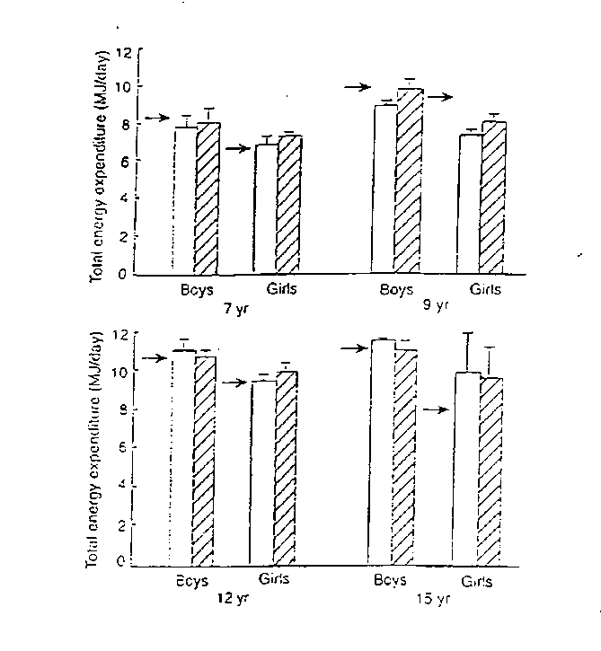
Heart rate monitoring denoted by open bars and doubly labelled water
by crossed bars.
Arrows depict World Health Organization estimates of energy intake
requirements.
Adapted from Livingstone et al, 1992.
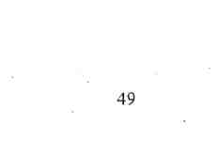
stable isotope dosing. The total energy expenditure is calculated from standard respiratory gas exchange equations [Coward, 1988]. The age related predicted normal values for total energy expenditure using heart rate monitors and the doubly labelled water method as well as the estimated daily energy intake requirements are shown in Figure 1.3.
1.5.3 Energy Expenditure in Cystic Fibrosis
The only two studies that have utilised doubly labelled water in patients with CF were
performed in children under the age of two years [Shepherd et al, 1988] and in children
between the ages of six and nine years [Tomeszko et al, 1994]. Shepherd et al [1988]
demonstrated that children with CF, under the age of two years, had 25% higher total
daily energy expenditure than healthy controls of the same age. The children with CF
were clinically well without significant lung disease or malnutrition. Tomeszko et al,
[1994] demonstrated that children with CF and mild lung disease, expended 12 % more
total daily energy than healthy controls. The resting energy expenditure was 9% greater
ill subjects with CF than healthy controls. In subgroup analysis using genotypes, children
with CF who had a genotype of delta F 508 homozygous, expended 23% more total daily
energy than healthy controls but, interestingly, had similar resting energy expenditure to
children with CF of other genotypes. Tomezsko et al, [1994] concluded that the increased
total energy expenditure in delta F508 homozygous children may be due to either
increased physical activity in these children or, an unidentified genotype related
mechanism.
50
Spicher et al, [1991] measured total energy expenditure using the heart rate method and demonstrated that adolescents with CF and mild lung disease had similar energy expenditure compared to healthy controls. Spicher et al, [1991] also demonstrated that the resting energy expenditure was significantly greater in children with CF compared to healthy controls and suggested that children with CF compensated for their increased resting energy expenditure by being less physically active during the day. This was not supported by Tomezsko's [1994] study where the "non resting" energy expenditure was increased. This difference in results may be due the intrinsic difficulties of converting heart rate to energy expenditure. Livingstone et al, [1992] demonstrated that when heart rates were used to predict energy expenditure, the results ranged from -16.9% to +18.8% of the true energy value as obtained by doubly labelled water. Assuming the heart rate to energy expenditure formulae was accurate, another explanation for the difference in energy expenditure between the Spicher [1991] and Tomezsko [1994] studies is that the energy cost of activity may have been greater for the children in Spicher's study. The concept of increased energy cost for the same physical activity for patients with CF was first suggested by Grunow et al, [1993]. However, recent personal communication from Shepherd's laboratory [1999] suggest that the increased energy cost of activity only occurs in patients with severe disease. As the subjects in Spicher's study had mild disease, it is unlikely that the difference between the studies can be explained by increased energy cost alone.
Several studies have been performed measuring the resting energy expenditure in patients with CF. Initially Vaisman et al [1987], and subsequently, Buchdahl et al [1988],
51
Girardet et al [1994], O'Rawe et al [1992] and Thomson et al 1996] have all used indirect calorimetry to measure resting energy expenditure. There is universal agreement that patients with CF have an increased resting energy expenditure compared to healthy controls. There is however controversy about the relationship between CF genotype and resting energy expenditure. O'Rawe et al [1992] demonstrated that subjects homozygous for delta F508 had a significantly greater resting energy expenditure than subjects who had a heterozygous genotype. Thomson et al [1996] demonstrated similar findings in clinically well children with CF under the age of 2 years. Fried et al, [1991] and Tomezsko et al [1994] however, found no significant difference between subjects who were homozygous and heterozygous for the delta F 508 gene.
The doubly labelled water method measures total energy expenditure (resting energy and physical activity) and has not been validated in patients with CF who may have different metabolic demands than healthy subjects. There are no published data on physical activity levels of children with CF. This information is necessary to ascertain both the impact of the disease on the child and to make nutritional recommendations.
52
1.5.4 Summary
- Measures of physical activity can provide important information about the impact of disease in patients with CF.
- Physical activity may be measured by

- Direct observation"
- Self report measures including diaries
- Mechanical devices such as pedometers or accelerometers
- Heart rate monitors
- Assessment of energy expenditure by doubly labelled water

- The currently available information on physical activity levels in patients with CF is based on studies extrapolating results from measurements of total energy expenditure and resting energy expenditure.
- Measures of physical activity, such as a seven day activity diary or an accelerometer, both of which have been validated against measures of total energy expenditure in healthy children have the potenial to be simpler tools for assessing activity levels in CF patients.
53
1.6 Exercise training programs in Cystic Fibrosis
1.6.1 Introduction
Lung function and exercise tolerance are maintained in patients with mild Cystic Fibrosis, but deteriorate as the disease progresses [Cropp et al, 1982]. Patients with high levels of aerobic fitness iiave a much better long term survival than those with lower levels of fitness [Nixon et al, 1992]. Exercise training programs aim to preserve and improve aerobic fitness and are recognised as essential components of pulmonary rehabilitation [Lacasse et al, 1996].
Exercise training programs have been studied extensively in adults with CF [O'Neill et al, 1987; Heyerman et al, 1991; De Jong et al, 1994]. There are, however, only a limited number of studies performed in children with CF and all were performed in the outpatient setting and had small sample sizes [Orenstein et al, 1981; Zach et al, 1982; Edlund et al, 1986; Andreasson et al, 1987; Gulmans et al, 1999]. A survey of CF referral centers by Kaplan et al [1991] demonstrated that only 21 % of the centers offer exercise programs for their patients although almost all the centers recommend exercise.
There are no previous studies on the effect of training programs in children admitted to hospital with an intercurrent pulmonary exacerbation. Neither are there are any previous studies, on the effect of resistance framing in children with cystic fibrosis.
54
1.6.2 Aerobic training programs
Oreastein et al [1981] compared the effect of a three month outpatient training program with no training in young adult patients with CF. The training program consisted of running for 30 rninutes per session, three sessions per week, at a speed that produced a heart rate of between 70 and 85% of peak maximal heart rate as determined by an initial exercise test. The results of the study demonstrated that after three months of training, the exercise group had a significant improvement in peak work capacity and maximal oxygen uptake when tested using a cycle ergometer. Respiratory muscle endurance also increased significantly in the exercise group. The control group had no significant changes with any of these parameters of assessment. Forced expiratory volume in one second was unchanged in the exercise group but decreased in the control group after the three month period of the study. The exercise group also had significantly lower heart rates for submaximal work loads than the control group. The investigators concluded that aerobic training programs are beneficial for patients with CF and Braggion et al, [1989] demonstrated similar benefits from providing aerobic (running) training for patients with CF.
Holzer et al [1984] studied the effect of an unsupervised home exercise training program in children with CF. The training program consisted of running and push ups for 30 rninutes per day for three months. There was a significant improvement in peak oxygen uptake after the training program. However, the improvements in peak work capacity, pulmonary function tests, and respiratory muscle strength were too modest to
55
reach statistical significance. Holzer et al [1984] suggested that poor compliance may have accounted for the equivocal benefit demonstrated.
Blau et al [1991] demonstrated that adult CF patients, who underwent a daily four hour mountain climb for a period of 4 weeks, had significant improvements in maximal oxygen uptake, peak work capacity, oxygen pulse and anaerobic threshold. However, there were no significant changes to the pulmonary function tests after the training program. Similar results were obtained by Stranghelle et al [1988] who assessed fee benefit of an eight week trampoline exercise program in children with CF. Notably, the pulmonary function tests were unchanged after the training program.
Andreasson et al [1987] enrolled patients with CF in a thirty month outpatient aerobic training program consisting of thirty minutes a day of trampolining, jogging and rope skipping. Although there was no significant change in peak work capacity when measured using a cycle ergometer, there were significant improvements in the functional residual capacity (FRC) and residual volume (RV) on pulmonary function testing.
Keens [1994] and De Jong et al [1994] demonstrated that a 12 week home bicycle «wise program in adult patients with moderately severe disease produced significant improvements in peak work capacity, maximal oxygen uptake, maximal mtate ventilation and peak heart Tate. As with other aerobic training programs, there were no changes in pulmonary function tests.
56
Heijerman et al [1991] evaluated the effects of an exercise training program in patients with advanced lung disease. All the patients in the study were hypoxic at rest and required supplemental oxygen therapy during the training program. The training program was performed under supervision and consisted of 20 minutes of bicycling per session at 75% of the individual's maximal power. The mean duration of the training program was 5.4 weeks. Exercise testing of the patients after the training program revealed improvement in peak work capacity, maximal oxygen uptake and oxygen pulse. FEVi had improved by 5 % when pulmonary function testing was performed. The benefits of the training program were still apparent when the patient® were followed up one year later [Heijerman et al, 1992].
A seven week swimming training program for patients with CF by Zach et al, [1981] resulted in significant improvements in FVC, FEVi, and mid maximal expiratory flow rate (MMEFR) but these improvements were not maintained when remeasured 10 weeks after the training program. Edlund et al [1986] compared children with CF who participated in a twelve- week swimming training program with children with CF who engaged in routine activities. After the training program, there was no significant improvement in pulmonary function, however, exercise endurance time, when assessed using a treadmill exercise test, improved significantly in the exercise group compared to the controls. The improvement in peak oxygen uptake in the exercise group was not significant when compared to the control group. Zach et al [1982] studied changes in pulmonary function after regular inhalation and chest physiotherapy was replaced by a swimming and running program over a 17-day period. The study demonstrated
57
significant improvements in pulmonary function that returned to the pre program levels after eight weeks. Zach et al [1982] concluded that regular physical exercise was an adequate replacement for conventional inhalation -chest physiotherapy routines.
1.6.3 Resistance training
Strauss et al [1987] demonstrated that residual volume and its ratio to total lung capacity decreased in adult patients with CF who participated in a six-month weight training program. There was no significant improvement in FEVi and MMEFR. The total body weight of the subjects as well as the muscle strength improved significantly. There are no previous studies on the effect of resistance training in children with CF.
Strength training has been demonstrated to promote muscle growth and strength in healthy subjects [Frontera et al, 1988]. In addition to improving peripheral muscle function [Lands et al, 1993], strength training may enhance exercise tolerance in patients with CF. Stronger quadriceps femoris muscles may reduce the perception of muscle fatigue which is a common limiting symptom in patients with chronic obstructive pulmonary disease (COPD) [Killian et al, 1992; Hamilton et al, 1995]. Patients with CF may likewise have similar benefit from stronger quadriceps femoris muscles.
Bernard et al [1999] demonstrated that the addition of strength training to aerobic training in patients with COPD was associated with significantly greater increases in muscle strength and mass than aerobic training alone. However, there was no additional improvement in exercise capacity. Likewise, strength training may represent a useful
58
addition to aerobic training in patients with CF, however, this patient group has not been studied. Skeletal muscle oxidative capacity, another potential factor involved in exercise intolerance,, has been demonstrated to increase significantly in patients with COPD with strength training [Frontera et al, 1990].
The effect of ventilatory muscle training programs is unclear with conflicting results obtained in previous studies. Keens et al [1977] demonstrated that the improvement in the ventilatory muscle capacity of patients with CF was twice that in control subjects after a four week ventilatory muscle training program. There was however, no significant improvement in pulmonary function. Asher et al [1982] demonstrated similar results after ventilatory muscle training. However, Sawyer and Clanton [1993] found that a ten week program resulted in significant improvements in FRC, TLC and exercise tolerance.
1.6.4 The effect of hospital therapy
Several studies have evaluated the effectiveness of Inpatient treatment of an acute pulmonary exacerbation on exercise tolerance. Patients treated with intravenous antibiotics and chest physiotherapy had significant improvements in pulmonary function, peak work capacity and maximal oxygen uptake [Cerny et al, 1984]. Alison et al [1994] demonstrated that patients with CF who were admitted to hospital with an acute pulmonary exacerbation for a 10 to 14 day period, had a 7% improvement in peak work capacity and a 7.1 minute improvement in peripheral-muscle endurance time. The
59
patients in this study received standard chest physiotherapy consisting of postural drainage, percussion and vibrations followed by forced expiratory technique. None of the subjects participated in an exercise training program. Alison et al [1994] and Michel et al, [1989] also demonstrated an improvement in lean body mass after hospital therapy.
Rachinsky et al [1990] demonstrated that adult patients with CF, admitted to hospital with an acute pulmonary exacerbation, benefit from an in-hospital exercise training program. However, as there was no control group, it was unclear if the improvements were due to the routine hospital therapy or to the training program. There are no reports of in hospital training programs during acute pulmonary exacerbation where patients who received a training program were compared with a control group. Furthermore, the effect of training programs on the quality of life in patients with CF has not been reported.
60
1.6.5 Summary
- The commonly used exercise training programs are aerobic training and resistance training.
- Although exercise training programs have been extensively studied in adult patients with CF, the only paediatric studies have been performed in the non supervised, outpatient setting and were limited by small sample sizes' and concerns about compliance.
- The results of these outpatient training programs have demonstrated variable benefit in terms of lung function.
- The effect of supervised training programs while in hospital during an acute pulmonary exacerbation has not previously been evaluated in comparison to routine in hospital therapy alone.
- There is also no published information on the effect of resistance training in children withCF.
61
CHAPTER 2 Aims
The overall aim of this thesis was to address deficiencies in the understanding of the role of exercise and exercise testing in the management of children with Cystic Fibrosis. It also examined how the disease may impact on the ability of the child to exercise. The specific aims of the studies may be grouped into three principal areas:
1. To assess the impact of Cystic Fibrosis on the ability of children to exercise. In order to accomplish this aim, four studies were performed with the specific aims of:
- Comparing physical activity levels in children with Cystic Fibrosis with those in healthy controls, and relating activity levels to aerobic capacity, lung function and quality of life in the children with CF.
- Assessing the relationship between fitness and genotype in children with Cystic Fibrosis.
- Investigating previously demonstrated gender differences in execrise ability in children with CF by,
i) Comparing resting energy expenditure and activity levels in girls
with mild Cystic Fibrosis and normal lung function with those in healthy, matched controls.
ii) Comparing muscle metabolism in girls with mild cystic fibrosis and normal lung function with that in healthy, matched controls.
62
2. To understand the role of exercise testing in the management of children with Cystic
Fibrosis by:
- Comparing changes in lung function with measures of fitness in hospitalised children with Cystic Fibrosis.
- Assessing the validity of a field test of peak aerobic capacity (shuttle test) in children with Cystic Fibrosis.
3. To determine the optimal exercise program for children admitted to hospital with an
intercurrent pulmonary exacerbation by performing a randomised controlled study
comparing aerobic training and resistance training and a non trained control group.
63
Chapter 3
Methods 3.1 Overview
This chapter provides a detailed examination of the various techniques used for studies
presented in the remainder of this thesis. The techniques were all selected on the basis of
their reliability and suitability for use in children. The peak aerobic capacity and
anaerobic power of subjects were measured in many of the studies in this thesis,
employing standard protocols which are presented in detail in this chapter. To assess the
subjective response to exercise, a rating of perceived exertion scale (Borg score) was
used. This is the only validated subjective index of exertion and details of this scale are
presented in this chapter. The gold standard of measuring energy expenditure is a method
Utilising double labeled water [Noland et al, 1990]. However, this method is expensive to
administer and is not readily available. In this thesis, physical activity was measured
using an activity diary, which has been demonstrated to have an excellent correlation
with doubly labeled water; an activity questionnaire; and activity accelerometers. These
methods of measuring physical activity are non- invasive, easy and inexpensive to
administer and have been demonstrated to be valid. To determine the optimal exercise
program to use in children admitted to hospital with a pulmonary exacerbation, a study
comparing aerobic Ixaining, resistance training, and a control group was performed.
Details of the exercise programmes are presented in mis chapter.
64
3.2 Measures of Fitness
The parameter most commonly assessed when gauging a child's fitness is aerobic fitness. Other measures of fitness, which are less frequently used in children, include anaerobic power and muscle strength. Aerobic fitness, anaerobic performance and muscle strength each measure different aspects of fitness.
3.2.1 Peak Aerobic Capacity
To assess peak aerobic capacity, subjects performed an incremental treadmill exercise test using the modified Bruce protocol [Bruce, 1971], which was chosen because unlike the other available protocols, the increments in intensity between the stages were gradual and therefore, appropriate for children with CF. Specific details of the modified Bruce protocol are presented in Table 3.1. Children recruited into the studies were instructed to wear appropriate foot wear and clothing. Short acting bronchodilators were withheld for 12 hours prior to testing. The studies were all performed in an air conditioned respiratory function laboratory maintained at 21 degrees Celsius. The treadmill used for the studies performed in this thesis was the Cardiovit 100 (Schiller, Switzerland). The treadmill had an in built polargraphic gas analyzer which performed breath by breath gas analysis. The gas analyzer was calibrated prior to each exercise test as recommended by the American Thoracic Society [Clausen et al, 1997]. Minute ventilation (Ve), oxygen uptake (VO2), carbon dioxide production (VCO2) and respiratory quotients (RQ) were recorded continuously during the exercise test. Pulse oximetry, via a finger probe (Biox 3700e, Ohmeda, Boulder, CO USA) and heart rate and electrocardiogram (12 lead) were also performed continuously during the exercise test. The exercise test was terminated when
65
the subject reached exhaustion, or if stage 9 of the modified Bruce protocol was completed. Measurements were completed when the heart rate and pulse oximetry of the subjects returned to the resting value (+/- 5 beats per minute and oxygen saturation +/- 1 %, respectively).
Table 3.1 The modified Bruce protocol

Stage | Duration (minutes) | Speed (km/h) | Grade (%)
1 | 3 | 1.9 | 0
2 | -> 3 | 1.9 | 5
3 | 3 | 2.7 | 10
4 | 3 | 4.0 | 12
5 | 3 | 5.5 | 14
6 | 3 | 6.8 | 16
7 | 3 | 8.0 | 18
8 | 3 | 8.8 | 20
9 | 3 | 9.7 | 22

3.2.2 Anaerobic power
Anaerobic power was measured by the Wingate test [Ayalon et al, 1974], using an
electronically braked cycle ergometer (Lode Ergometer, Pro Med, Canada). The
advantage the electronically braked cycle ergometer has over other mechanically braked
cycle ergometers is that the force exerted on the pedals is measured instantaneously. This
enables the cycle ergometer to be programmed to deliver either constant resistance, or, to
alter the resistance in response to the subject's exerted force to" maximise the power
output. All subjects who performed the Wingate test had a warm up period followed by
the formal test. The warm up period consisted of the cycle ergometer being programmed
to deliver a resistance of 0.6 or 0,7 watts per kilogram body weight for girls and boys,
respectively. The subjects were encouraged to keep the speed at 100 revolutions per
minute for 3 minutes. Pulse oximetry and heart rate, via a finger probe (Biox 3700e,
Ohmeda, Boulder, CO USA) was monitored during the test. The test consisted of the
subject pedaling as forcefully and fast as possible for 30 seconds. The electronic sensors
in the pedals, would alter the ergometer resistance during the course of the test to
maximise the subject's power output. At the completion of the study, the subject would
continue cycling until heart rate returned to within 5 beats per minute of the resting value.
The software provided by the manufacturer recorded the peak power output reached and
the mean power output over the 30 second test.
67
3.2.3 Muscle strength
Leg strength was measured using an isokinetic Cybex dynamometer (Lumex Inc, Ronkonkoma, NY). The strength tests were performed on the same day as the exercise tests. The muscles tested were the quadriceps femoris and the hamstrings of the n&Ur dominant leg. With the child comfortably seated, the limb to be tested was fixed securely to the dynamometer lever arm and the child was then instructed to exert maximum force against the lever arm. The same action was repeated after a three minute rest. The best of three repetitions was recorded as the strength of the tested muscle group. The maximal strength (measured in standard units, Newton meters) was recorded by the software provided by the manufacturer. The isokinetic dynamometer precisely matches the force applied by the subject and prohibits acceleration (hence the term isokinetic). This enables strength to be measured through a full range of motion at a constant velocity. The advantage of this method of strength testing is that short bursts of force, that are not maintained for the full range of motion of that muscle group, are not recorded and hence, cannot give a falsely high reading.
3.3 Field tests: 10m and 20 m shuttle tests
Shuttle tests require the child to walk (10m test) or, run (20m test), between two markers delineating the respective course, at a set incremental speed determined by a computer generated signal which was played by a standard audio cassette player. The test was terminated when the subject was unable to keep up with the paced signals.
68
The shuttle tests were performed with the subject wearing a firmly fitted facemask attached to the Cardiovit 100 Module (Schiller, Switzerland) which has an in-built gas analyzer allowing breath by breath gas analysis throughout the test. The gas analyzer was calibrated prior to each exercise test as recommended by the American Thoracic Society [Clausen et al, 1997]. Minute ventilation (Ve), oxygen uptake (V02), carbon dioxide production (VCO2) and respiratory quotients (RQ) were recorded continuously during the exercise test. The subject's heart rate was measured at rest and then continuously during testing using a heart rate monitor (Cardiosport, Australia). Pulse oximetry was measured via a finger probe (Biox 3700e, Ohmeda, Boulder, CO USA) throughout the test. The velocity for the 10m shuttle test is set at 1.8 km/hr for the first minute and increased by 0.61 km/hr for every minute thereafter. The velocity for the 20m shuttle test is set at 8km/h for the first minute and increased by 0.5km/h for every minute thereafter.
3.4 Responses to exercise
The methods used to assess the response to exercise by breath by breath gas analysis, oxygen saturation, and heart rate have been presented in the previous sections. In addition, a subjective measure of exertion, the validated Rating of Perceived Exertion scale, orBorg score [Borg, 1982] and the effects of exercise on muscle metabolism were also used to assess the response to exercise. These techniques are presented here.
3.4.1 Rating of Perceived Exertion scale (Borg score)
A psychophysical scale for measurement of the intensity of exercise has been developed by Borg [1982] and was used in these studies. The intensity of the exercise is linked to a
69
scale of numbers from zero (no sense of effort) to ten (maximal effort) and is presented in Table 3.2. Bie scale is visible to the subjects throughout exercise tests and the investigator records the subject's score at the conclusion of every minute of exercise.
Table 3.2: The Rating of Perceived Exertion (Borg score)
0 Nothing at all
0.5 Very, very slight
- Very slight
- Slight
- Moderate
- Somewhat severe
- Severe
- Between severe and very severe
- Very severe
- Between very severe and extremely severe
- Extremely severe
- Maximal
70
3.4.2 Magnetic Resonance Spectroscopy (31- Phosphorous)
Lean body mass was calculated using skinfold thickness and the equations provided by Durnin and Rahaman [1967] as shown below. Height was measured by a Harpenden stadiometer and weight by electronic scales. The subject then rested in a prone position for 10 minutes fi&the MR spectroscope, 31- Phosphorous (1.5 Tesla NMR Spectrometer, Philips SI5 HP) while resting data were obtained. The subjects' leg was secured at the waist, hips and two thirds of the distance from the anterior superior iliac crest and the medial condyle of the knee using straps. The subjects were then asked to exert maximal force for 2 seconds against a purpose- designed balloon by flexing the knee, followed by a 1 second rest period while lying prone in the MR spectroscope. The exercise was repeated until exhaustion, as determined by the Borg score [Borg, 1982]. A computerised audio-visual metronome, designed specifically for the study, guided the subject through each phase of the exercise. The force output exerted on the balloon for each contraction was measured using a calibrated pressure transducer (Vacumed, Ventura, CA) and total work (cumulative force output) was calculated for the complete exercise protocol in the spectroscope. The same exercise protocol was repeated three times for each subject but using a Cybex dynamometer (Lumex Inc, Ronkonkoma, NY) to assess the reproducibility of the total work output during the exercise protocol. Measurements of inorganic phosphorous (Pi), phosphocreatine (PCr) and intracellular pH were taken from the vastus lateralis muscle of the non dominant leg throughout the exercise. Comparison of the data from subjects with CF and healthy controls were made at rest, 25%, 50%, 75% and 100% of maximal work output.
71
3.5 Measures of physical activity
3.5.1 New South Wales Schools Physical Fitness Assessment (NSW SPFA)
This self reported fitness questionnaire estimates activity levels on the basis of the type, duration and frequency a child participates sport during the course of a school week and has been validated by Booth et al, [1998]. Both organised and informal sports are recorded. A compendium of the energy costs of several activities and sports, expressed in units of "mets" has previously been reported [Ainsworth et al, 1993]. A unit of met is defined as the oxygen consumption at rest and is equal to 3.5ml/ kg/ min. A sport with an energy cost of 5 mets will be of significantly greater intensity than a sport with an energy cost of 2 mets. The NSW SPFA uses the met value of the sports a child participates in to estimate the total weekly energy cost. As only the sports the child participates in are accounted for, activities of daily living are not included in the estimates of total energy utilistion. In the studies on activity levels performed in this thesis, subjects were requested to complete the NSW SPFA for the same days they completed the modified activity diary and wore the accelerometer.
3.5.2 Activity diary
The activity diary used in this thesi$ is a modification of the activity diary initially described by Bouchard et al [1983]. The modified activity diary has excellent correlation with the doubly labeled water method [Noland et al, 1990], which is the accepted gold standard in assessing total energy expenditure [Bratteby et al, 1997]. Subjects are asked to record the dominant activity of each fifteen minute period of the day and night on three week days and one weekend day in one week and the other two week days and the
72
alternative weekend day of the following week. Thus, a total of seven days over a two week period are recorded. The compendium of the energy costs of activities and sports, [Ainsworth et al, 1993] is used to estimate total energy utilisation for the seven days. In the studies on activity levels performed in this thesis, subjects were requested to complete the modified activity diary for the same days they completed the NSW SPFA and wore the accelerometer.
3.5.3 Accelerometer
The WAM 7164 brand accelerometer (Computer Science and Applications, Shalimar, Florida) is a small (5.1x 3.8x 1.5cm), light (45g) uniaxial accelerometer, worn on the hip. The accelerometer is designed to detect acceleration ranging in magnitude from 0.05 to 2.00 G with a frequency response from 0.25 to 2.5 Hz. Data can be collected over intervals of 1 second and the daily activity counts are recorded and downloaded when the device is returned for analysis. Trost et al, [1998] and Freedson et al, [1998] have demonstrated excellent correlation between activity counts as measured by the accelerometer and energy expenditure during exercise testing. In studies in this thesis, subjects wore WAM 7164 accelerometer on their hips continuously on the days the activity diary was completed. Therefore, they wore it for three week days and one weekend day in one week and the other two week days and the alternative weekend day of the following week. Data were collected over intervals of 1 second and the daily activity counts were recorded and downloaded when the device was returned. The activity counts were converted to energy expenditure by the software provided by
73
Computer Science and Applications (Shalimar, Florida) based on prediction equations presented by Freedson et a!, [1998].
3.6 Exercise training
3.6.1 Aerobic Training
Children randomised to the aerobic training group participated in aerobic activities for five sessions each of thirty minutes duration per week. The aerobic activities comprised running on a non-motorised treadmill, or cycling on a stationary cycle at a speed that maintained the heart rate at seventy percent of the peak heart rate for thirty minutes. Subsequent to the exercise test performed on admission where expired gas analysis was performed, each subject performed a maximal exercise test (non motorised treadmill or cycle, without gas analysis), every five days to determine the individual's peak heart rate. The peak heart rate from the most recent exercise test was used to determine the target heart rate (70% of peak heart rate) for the training program. A portable pulse oximeter, (Biox 3700, Ohmeda, CO, USA) with a finger probe was used during training. If necessary, supplemental oxygen was administered to maintain an oxygen saturation of at least 90% as has previously been recommended [Heyerman et al, 1991]. The training was terminated earlier than the mandatory thirty minutes if the modified Borg score reached seven. Each training session was supervised by physiotherapists.
3.6.2 Resistance Training
Resistance training consisted of both upper and lower limb exercises against a non-isokinetjte resistance machine which has an in-built graded incremental resistance dial
74
(Tidro-power_{s} Keylink, Adelaide, South Australia). The subjects would increase the resistance on the machine to the maximal subjective resistance at the commencement of each training session and a value of 70% of that value was then used for that training session. The subjects were blinded to the resistance dial of the machine. At the chosen level of resistance, the subject performed five sets often repetitions. The procedure was repeated for both arms and legs. Subjects attended five sessions per week and were supervised by physiotherapists.
3.7 Measures of CF disease status 3.7.1 Shwachman Score
This is a widely used clinico- radiological measure of disease severity in patients with CF [Shwachman and Kulczycki, 1958]. General activity, physical examination, nutritional status and chest radiograph are each assessed out of a 25 point scale and the final score is the sum of the four categories. A score of greater than 80 is consistent with a good clinical state whereas a score of less than 50 is consistent with severe disease. A summary of the Shwachman score is presented in Table 3.3.
75
Table 3.3 Shwachman score

Points | General activity | Physical examination | Nutrition | X ray findings
25 | Full normal ' activity | Normal; no cough; clear lungs | Weight and height above the 25th percentile | Clear tang fields
20 | Tires at end of day. Good school attendance. | Resting  respiration normal rare coughing. No clubbing. Clear lungs. | Weight and height 15 to 20th percentile | Minimal accentuation of bronchovascuiar markings. Early emphysema.
15 | May rest  voluntarily during day. Tires easily | Occasional cough. Respirations slightly elevated. Coarse breath sounds. Early clubbing. | Weight and height above 3rd  percentile. | Mild emphysema, patchy atelectasis.  Increased  bronchovascuiar  markings.
10 | Home teacher, Dyspnoeic after short walk. Rests a great deal. | Frequent cough.  Usually  productive.  Clubbing 2 to 3 +.  Moderate  emphysema.  Rales present. | Weight and height below 3rd percentile. | Moderate  emphysema.  Widespread  atelectasis with  minimal  bronchiectasis.
5 | Orthopneic. Confined to bed  or chair. | Severe coughing spells. May have right heart failure. Clubbing 3 to 4-h | Marked malnutrition. | Extensive changes, marked bronchiectasis, lobar atelectasis
76
3.7.2 Quality of well being assessment
To assess quality of life in the studies performed in this thesis, a quality of well being scale was used [Kaplan et al 1989]. The quality of well being scale has been validated in subjects with CF [Orenstein et al, 1989] and measures quality of life using four scales: mobility, physical activity, social activity and a symptom scale. Mobility and social activity are each divided into five graded levels and physical activity is divided into four graded levels (Table 3.4). Each of the twenty- three distinct symptom levels are assigned a score. The quality of well being scale is obtained by the formula:
Quality of well being scale =1+ (Symptom score) + (Mobility score) + (Physical
Activity score) + (Social activity score)
The scale ranges from 0.0 (dead) to 1.0 (optimal function). The quality of well being scale was administered to the patients themselves if they were older than 14 years, the patients and a parent if the patients were aged 10 to 14 years, and the parent if the patient was younger than 10 years of age. The administration of each assessment took about 15 minutes.
77

Table 3.4 Quality of well being Scale [Kaplan et al 1989]
Mobility Scale Score
TJ No limitations for health reasons -0.000
4 Did not drive a car, health related; did not ride in a car as usual for age -0.062
(younger than 15 years), health related; and/or did not use public transportation, health related; or had or would have used more help than usual for age to use public transportation, health related
2 fehospital, health related -0.090
Physical Activity Scale Score
~4 No limitations for health reasons -0.000
3 In wheelchair, moved or controlled movement of wheelchair without help -0.060
from someone else; or had trouble or did not try to lift, stoop, bend over,
or use stairs or inclines, health related; and/or limped, used a cane, crutches, or walker, health related; and/or had any other physical limitation in walking or did not try to walk as far or as fast as others the same age are able, health related
1 In wheelchair, did not move or control the movement of wheelchair -0.077
without help from someone else; or in bed, chair or couch for most or all
of the day, health related
Social Activity Scale Score
5 No limitations for health reasons -0.000
4 Limited in other {e.g. recreational) role activity, health related -0.061
3 Limited in major (primary) role activity, health related -0.061
2 Performed no major role activity, health related, but did perform self-care -0.061
activities
1 Performed no major role activity, health related, and did not perform or -0.106
had more help than usual in performance of one or more self-care activities, health related
Symptom/ problem scale Score
1 Death (not on respondent's card) -0.727
Loss of consciousness such as seizure (fits), fainting, or coma (out cold or -0.407
knocked out)
- Burn over large areas of face, body, arms, or legs -0.387
- Pain, bleeding, itching, or discharge (drainage) from sexual organs - does -0.349 not include normal menstrual (monthly) bleeding
- Trouble learning, remembering, or thinking clearly -0.340
- Any combination of one or more hands, feet, arms, or legs either missing, -0.333 deformed (crooked) paralysed (unable to move), or broken — includes
wearing artificial limbs or braces
Pain, stiffness, weakness, numbness, or other discomfort in chest, -0.299
stomach (including hernia or rupture), side, neck, back, hips, or any joints
or hands, feet arms, or legs
78
- Pain, burning, bleeding, itching, or other difficulty with rectum, bowel -0.292 movements, or urination (passing water)
- Sick or upset stomach, vomiting or loose bowel -0.290
- General tiredness, weakness* or weight loss -0.259
- Cough, wheezing, or shortness of breath with or without fever, chills, or -0.257 aching all over
- Spells of feeling upset, being depressed, or of crying -0.257
- Headache, or dizziness, or ringing in ears, or spells of feeling hot, or -0.244 nervous, or shaky
- Burning or itching rash on large areas of face? body, arms or legs -0.240
- Trouble talking, such as lisp, stuttering, hoarseness, or being unable to -0.237 speak
- Pain or discomfort in one or both eyes (such as burning or itching) or any -0.230 trouble seeing after correction
- Overweight for age and height or skin defect of face, body, arms, or legs, -0.188 such as scars, pimples, warts, bruises, or changes in colour
- Pain in ear, tooth, jaw, throat, lips, tongue; several missing or crooked -0.170 permanent teeth — includes wearing bridges or false teeth; stuffy, runny
nose; or any trouble hearing - includes wearing a hearing aid
- Taking medication or staying on a prescribed diet for health reasons -0.144
- Eyeglasses or contact lenses -0.101
- Breathing smog or unpleasant air -0.101
22 No symptoms or problem (not on respondent's card) -0.000
23 Standard symptom/problem -0.257
79
3.7.3 Nutritional Parameters
Anthropometry is considered the most useful tool for assessing the nutritional status of children. The most commonly used anthropometric measurements are weight and height. fjp heights of the subjects were obtained using a stadiometer. The subjects were requested to stand with their heels against the base of the stadiometer and to take a deep inspiration, followed by expiration. The height was then taken. The bare weight of the subjects was taken using electronic weight scales. The anthropometric data were related to standard growth charts [World Health Organisation, 1986]. The anthropometric data in the studies in this thesis were interpreted by relating it a) to its position within the percentile distribution of the reference values; b) to reference values as a standard deviation score (Z score); and/ or c) by deriving the body mass index (BMI) from the subjects' weight and height (Weight/ heighr). The lean body mass of subjects was estimated using skinfold thickness using Harpenden skinfold calipers (Hans Rudolph, Inc. Kansas City, USA). The sum of skinfold thickness from four sites (biceps, triceps, subscapuar and suprailiac) was used in prediction equations [Durnin and Rahaman, 1967] to estimate body fat. The relationship between skinfold thickness and percent body fat is presented in Table 3.5.
80
Table 3.5 Proportion of fat in children (based on sum of measurements of skinfold in 4 locations: biceps, triceps, subscapular, suprailiac). [Durnin and Rahaman,
1967]

Sum of skinfold thickness values | Boys | Girls
Sum of skinfold thickness values | Fat as a percent of total body mass
15mm | 9.0 | 12.5
20 mm | 12.5 | 16.0
25 mm | 153 | 19.0
30 mm | 17.5 | 21.5
35 mm | 19.5 | 23.5
40 mm | 21.5 | 25.0
45 mm | 23.0 | 27.0
50 mm | 24.0 | 28.5
55 mm | 25.5 | 29.5
60 mm | 26.5 | 30.5
65 mm | 27.5 | 32.0
70 mm | 28.5 | 33.0
75 mm | 29.5 | 34.0
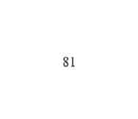
3.7-4 Pulmonary function tests
Pulmonary function measurements included forced expiratory volume in one second (FEVi) and forced vital capacity (FVC) using a spirometer (Sensormedics 2000, Yorba Linda, CA) and residual volume (RV) and total lung capacity (TLC) using a body plethysmograph (Sensormedics 2800 Autobox, Yorba Linda, CA). The calibration and performance of pulmonary function tests complied with American Thoracic Society Guidelines [1994]. The forced expiratory manoeuver was performed in the sitting posture with the head in a neutral position. Nose clips were worn by the subjects during the test. The test procedure was performed three times and the adequacy of performance was judged by monitoring the expiratory flow- volume relationship. If the three maximal expiratory flow volume curves appeared similar in configuration and matched within 5 per cent in terms of vital capacity (VC), the test was deemed to be reproducible and values analysed according to the reference range presented by Polgar [1971].
3.7.5 Resting energy expenditure
Resting energy expenditure was measured by open circuit, flow through ventilated hood indirect calorimeter with a computerized metabolic cart (Sensormedics 2900 Z, Yorba ■ Linda, CA). The metabolic cart has an inbuilt polargraphic gas analyser which measures oxygen and carbon dioxide production. The subjects all had their lean body mass calculated using skinfold thickness and the equations provided by Durnin and Rahaman [1967]. The subjects were requested to lie down on a bed with the ventilated hood placed over their head for 30 rninutes. If they so desired, the subjects could listen to music through headphones. All subjects fasted overnight for twelve hours before testing and medications were withheld during the twelve hour fast. The equations developed by
82

De Weir [1949] were used to calculate energy equivalency from oxygen consumption and carbon dioxide production.
83

CHAPTER 4
Activity levels in children with and without Cystic Fibrosis and the relationship to aerobic capacity, lung function and quality of life.
4.1 Introduction
Physical activity has been defined as "any bodily movement produced by the skeletal muscles that results in energy expenditure" [Casperson, 1989] and is an integral part of the growth and development of children. Chronic illnesses, such as Cystic Fibrosis (CF), may limit physical activity by either respiratory [Godfrey and Mearns 1971; Marcotte et al, 1986b] or nutritional compromise [Coates et al, 1980; Marcotte et al, 1986a]_{s} or due to other factors such as psychosocial stress [Blair et al, 1994]. When the inactivity results in deconditioning [Orenstein and Nixon, 1991] a negative feed back loop is formed thus making physical activity even more difficult.
Maintaining high levels of physical activity is an important objective in the management of CF. Nixon et al [1992] have demonstrated that aerobic fitness is an independent predictor of survival in CF and that CF patients who had active lifestyles had more slowly progressive disease. Furthermore, aerobic fitness has been shown to correlate with quality of life m CF [Orenstein et al, 1989]. Although clinicians have long encouraged children with CF to be active, there is little information on the daily activity levels in these children. Boucher et al [1997], using an activity questionnaire in thirty six children with CF, found that activity levels were not related to lung function. To date, there have been no comparisons of activity levels in healthy children and those with CF.
84
This study, therefore aimed to compare the activity levels of children with CF and healthy controls between the ages of 10 and 16 years, and to correlate activity levels in children with CF with aspects of their disease including quality of life, aerobic capacity, lung function, nutritional status, and the frequency of antibiotic usage.
4.2 Materials and methods
Subjects
One hundred and thirty eight patients with cystic fibrosis between the ages of 10 and 16 years, attending the CF clinic at the Royal Alexandra Hospital for Children, Sydney were eligible for the study. The children had a wide range of disease severity as measured by the Shwachrnan score [Shwachman and Kulczycki, 1958]. This is a widely used clinico- radiological measure of disease severity in patients with CF. The cohort included children with both pancreatic sufficiency and insufficiency (as measured by faecal fat testing). The control group consisted of 129 children without CF including friends and family of the children with CF (n=72) and participants in the New South Wales Schools Physical Fitness Assessment [Booth et al, 1998] (n=57). The study was approved by the Ethics Committee of the Royal Alexandra Hospital for Children and written consent was obtained from all participants and their parents where applicable.
Study Design
All children in the study completed a New South Wales School Physical Fitness Assessment (NSW SPFA) on the same days they completed an activity diary [Bouchard et al, 1983] and wore a uniaxial accelerometer on the hip. The activity diary comprised a
85
record of the dominant activity of each fifteen minute period of the day and night. Children were asked to complete the diaries on three week days and one weekend day in one week and the other two week days and the alternative weekend day of the following week. Thus, a total of seven days over a two week period were recorded. Each child also wore a validated accelerometer [Klesges et al 1990; Melanson et al, 1995; Trost et al, 1998], WAM 7164 (Computer Science and Applications, Shalimar, Florida) on the same day the activity diary was completed. Data were collected over intervals of 1 second and the daily activity counts were recorded and downloaded when the device was returned.
In addition, the children with CF and their parents were asked to complete a validated quality of well being assessment [Orenstein et al, 1989]. An assessment of peak cardiorespiratory capacity was made using the modified Bruce protocol [Stranghelle, 1998] on a treadmill (Cardiovit 100, Schiller, Switzerland). Pulmonary filiation tests were obtained using spirometry (Sensormedics 2000, Yorba Linda, CA), and the anthropometric details (weight in kilograms, height in meters, skinfold assessment from the triceps, biceps, subscapular and suprailiac sites [Durnin and Rahaman, 1967]) were recorded for each child. A prospective assessment of antibiotic frequency as the number of days of antibiotic administration (oral and/or intravenous) for the twelve months following testing was made. This information was obtained by scrutiny of the medical records and patient/ parent recall.
Data Analysis
Th& disease severity of children with CF, assessed by the Shwachman score, was
classified as mild (>70), moderate (50-70) and severe (<50). Measurements of lung
86
function were expressed as the percentage of normal predicted values. The measured aerobic capacity was expressed in terms of the lean body mass which was calculated using the skinfold assessment. The body mass index was expressed as a percent of the theoretical body mass index of a child of the same age and gender growing along the 50th percentile for weight and height. This value was termed the body mass percentile (BMP).
To analyse the information on the activity diary, the recorded activities were categorised into nine levels according to their average cost, representing multiples of Basal Metabolic Rates, from the lowest physical activity (level 1), representing rest or sleep, to the highest (level 9), representing high intensity, maximal work. The energy costs allotted to these activities in this study, were adopted from the validation study by Bratteby et al [1997]. In order to analyse daily energy expenditure, the children were divided into four groups depending on their gender (male, female) and age (<12years, > 12 years). This was necessary, as normative studies using doubly labelled water in children without CF, demonstrated that the mean total daily energy expenditure varied according to the age and sex of the child [Livingstone et al, 1992]. The age cut off was chosen as the most significant differences were previously found when comparing children under the age of 12 years with children 12 years and older [Stephens and Craig, 1988; Russell et ah 1992].
To analyse the data from the accelerometer, the activity counts were downloaded at fee end of the study period. The counts were converted to energy expenditure by the
software provided by Computer Science and Applications (Shalimar, Florida) based on
*
87
prediction equations presented by Freedson et al₉ [1998] and the compendium of the energy costs which has previously been reported [Ainsworth et al₉1993].
The differences between children with and without CF, were assessed by a two tailed paired Student's t test. The agreement between the Bouchard activity diary and the accelerometer was illustrated using a Bland and Altaian plot [Bland and Altaian, 1986]. Stepwise linear regression analysis was used to test for'any correlations between variables. Activity levels were divided into quartiles, with the 25% being the lowest activity level and 100% the highest activity. Duncan's Post Hoc test of analysis of variance (ANOVA), was then used to assess the relative effect of activity levels on aerobic capacity (VC^), nutrition (BMP), quality of life, disease severity (Shwachman score), and the use of antibiotics for intercurrent infections. Statistical significance was assigned for p values less than 0.05.
A subgroup analysis was carried out on the children with CF. Each child who was pancreatic sufficient (PS) was matched in terms of gender, age and disease severity (using the Shwachman score, [Shwachman and Kuczycki, 1958]) with two children who were pancreatic insufficient (PI). This was done to increase the power of the study. A matched sample comparison was made of the mean aerobic capacity, quality of life, BMP, activity levels and days on antibiotics.
4.3 Results
All 138 children with CF and 118 of the 129 control children who were recruited into the study, completed all aspects of the study. The mean age of the children with CF
88
(11-7, SD 2.7 years) and the control children (11.4, SD 2.7 years) was not significantly different. Although the gender ratio varied between the children with CF (63males, 75 females) and the control group (65 males, 53 females), this was also not significantly different.
Activity levels were assessed by the Bouchard activity diary, the NSW SPFA and the accelerometer. The Bouchard activity diary score cdrrelated best with the accelerometer counts (r = 0.83, pO.Ol; n=256). The agreement between the Bouchard activity diary and the accelerometer count is presented using a Bland and Altaian plot in Figure 4.1. The mean difference between the energy expenditure obtained using the activity diary and the accelerometer was 3.73 MJ/day with the limits of agreement set at 2.36 and 4.00 MJ/day. The NSW SPFA was less well correlated with accelerometer counts and Bouchard activity diary with a Pearsons correlation coefficient of r =0.44 (p<0.05) and r = 0.42 (p<0.05) respectively.
The energy expenditure based on the Bouchard activity diaries, according to age, gender and CF disease severity is presented in Table 4.1. Overall, children under the age of twelve years with CF were as physically active as children without CF with no significant differences in the gender combined mean of the Bouchard activity diary (11.49, SE 2.60 and 11.31, SE2.75 MJ/day), NSW SPFA (7.15, SE 1.8 and 7.02, SE 1.9 MJ/day) and activity levels using the accelerometer (11.65, SE 2.90 and 11.40, SE 2.77 MJ/day) between the CF and control groups respectively. However, children under 12 years with mild disease (Shwachman score >70) were significantly more active than controls for both boys (p<0.01) and girls (p<0.01).
89
Children twelve years and older with CF were also as physically active as children without CF with no significant differences in the gender combined means of the Bouchard activity diary (12.78, SE 2.65 and 12.75, SE 2.78MJ/day), NSW SPFA (9.13, SE 1.70 and 8.73, SE 1.93MJ/day) and activity levels using the accelerometer (12.97, SE 2.83 and 12.76, SE 2.77 MJ/day). Similar to children under 12 years of age, children between the ages of 12 and 16 with mild CF disease (Shwachman score > 70) were significantly more active than controls for both boys (p<0.01) and girls (pO.Ol). Children with CF in both age groups and with moderate disease (Shwachman score 50 to 70) were not significantly different to controls. Children with severe CF disease (Shwachman score less than 50) tended to have lower mean activity levels than controls but this difference did not reach statistical significance. Girls with mild and moderate CF disease had significantly lower activity levels than boys of the same age and disease severity (p<0.05). Activity levels in girls with severe CF disease was not significantly different to boys with the same degree of disease severity and age (Table 4.1).
There were significant differences between the three categories of disease severity with respect to BMP, aerobic capacity, quality of well being, lung function and antibiotics therapy for both boys (Table 4.2) and girls (Table 4.3). Activity levels in children with CF were also correlated with these aspects of their disease. Lung function (FEVi) correlated poorly with activity levels with r = 0.08 (Figure 4.2). Activity levels of children ^ith CF correlated well with aerobic capacity as measured by the treadmill exercise test (^=0.63, pO.Ol) (Figure 4.3), quality of well being (r² = 0.61, p<0.01), and inversely with the number of days on antibiotics (r² = 0.59, pO.Ol). ANOYA demonstrated that activity levels in children with CF, were most predictive of aerobic
90
capacity, followed by quality of well being and the number of days on antibiotics over a twelve month period. BMP and Shwachman scores correlated less well with activity levels with r² = 0.20 (p<0.05) and r² - 0.14 (p<0.05) respectively. In a subgroup of patients with severe disease (Shwachman score < 50; n— 14), the best correlates with activity levels were aerobic capacity (r = 0.74), quality of well being (r² = 0.65), BMP (r² = 0.58) and the number of days on antibiotics (r² =0.52).
Children with the highest activity levels (100% activity quartile) had significantly better nutritional status, aerobic capacity, quality of life and disease status than children with lower activity levels (Table 4.4). In addition, these variables were significantly less in children with the lowest activity level (25 % activity quartile) compared to children in the 50% and 75% activity quartile.
The effect of pancreatic function on activity level, aerobic capacity, quality of well being, BMP and days of antibiotics was assessed by comparing children who were PS with children who were PI and matched 1:2, in terms of age, gender and disease severity. The data are presented according to age in Tables 4.5 (ages 10 to 12 years) and 4.6 (ages 12 to 16 years). In children under 12 years of age (Table 4.5), there were no significant differences between the pancreatic sufficient (PS) and pancreatic insufficient (PI) children. In children between 12 and 16 years of age, PS girls were significantly better for all variables (p<0.05) while PS boys had significantly better quality of well being scores (p<0.05) and fewer days on antibiotics (p<0.05) when compared to PI girls and boys respectively (Table 4.6). In this age group, boys with PS had a significantly greater aerobic capacity than girls with PS. There were no other significant gender
91
differences in subjcets with PS. Similarly J& subjects with PI, the only statistically significant difference between the genders was in the aerobic capacity (Table 4.6).
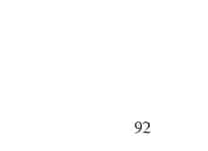
TABLE 4.1: Activity levels in children with and without Cystic Fibrosis according to age and gender

 | Activity levels (MJ/day)ª
 | Girls< 12 years | Boys < 12 years | Girls > 12 years | Boys > 12 years
Control | 10.80 + 1.75 (n = 24) | 11.80 ±1.64 (n = 25) | 11.31 ±2.20 (n = 29) | 13.81 ±2.70 (n = 40)
Total CF | 11.00 ±1.83 (n = 37) | 12.15 ±1.92 (n = 28) | 11.70 ±2.20 (n=38) | 13.94 ±2.56 (n = 35)
MildCF | 11.24 ±1.92* (n=19) | 13.65 ±2,50* (n=15) | 13.81 ±2.70* (n = 22) | 14.92 ±2.61*  (n=16)
Moderate CF | 10.87 ±1.80 (n=15) | 12.00 ±2.12 (n=10) | 11.60 ±2.15 (n=12) | 13.90 ±2.72 (n=15)
Severe CF | 10.40 + 2.17 (n=3) | 11.40 ±2.60 (n = 3) | 10.95 + 2.23 (n = 4) | 13.40 ±2.54 (n = 4)
ªmean ± standard error values are shown
* indicates significantly different from control value (p < 0.01)
n indicates the number of subjects studied in each group
Mild disease severity = Shwachman score >70
Moderate disease severity = Shwachman score 50-70
Severe disease severity = Shwachman score <50
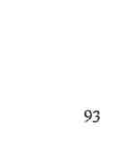
Table 4.2 BMP, aerobic capacity, quality of life, lung function and antibiotic usage of boys with Cystic Fibrosis according to age and disease severity.

 | Mild Disease Severity |  | Moderate Disease Severity |  | Severe Disease Severity
 | <12yrs | >12 yrs | <12yrs | >12yrs | <12yrs | >12 yrs
N | 15 | 16 | 10 | 15 | 3 | 4
BMP (%) | 98.56 (13.20) | 99.90 (11.60) | 85.40* ª (13.60) | 75.70* ^{b} (11.55) | 54.00"ª  (17.40) | 51.23"^{b} (17.22)
Aerobic capacity (ml/kg/min) | 48.00 (8.50) | 51.30 (7.90) | 41.35* ª (6.40) | 37.28* ^{b} (6.80) | 27.60"ª (9.69) | 21.61"^{b} (8.75)
Quality of well being score | 0.93 (0.07) | 0.94 (0.06) | 0.80* ª  (0.13) | 0.76* ^{b} (0.14) | 0.66"ª (0.17) | 0.62"^{b}  (0-15)
FEVl (% predicted) | 97.3 (4.5) | 95.4 (5.0) | 70.6*ª (4.2) | 66.1* ^{b} (7.2) | 4UT"  (9.8) | 35.2"^{b} (8.4)
Antibiotic therapy (days in year) | 6.20  (5.10) | 7.60 (4.10) | 12.20*ª (6.20) | 15.10* ^{b} (7.23) | 24.59"ª (11.20) | 29.90"^{b} (11.10)
All values shown are mean ± standard error BMP is body mass percentile Mild disease severity = Shwachman score >70 Moderate disease severi% = Shwachman score 50-70 Severe disease severity = Shwachman score <50
* ª Significant difference between mild and moderate disease severity for boys <12 years
(p<0.05, Students t test).
ª Significant difference between moderate and severe disease severity for boys < 12 years (p<0.05, Students t test).
* Significant difference between mild and moderate disease severity for boys >12 years
(p<0.05, Students t test).
Significant difference between moderate and severe disease severity for boys > 12 years (pO.05, Students t test).
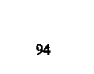
Table 4.3 BMP, aerobic capacity, quality of life, lung function and antibiotic usage of girls with Cystic Fibrosis according to age and disease severity.

 | Mild Disease Severity |  | Moderate Disease Severity |  | Severe Disease Severity
 | <12yrs | >12yrs | <12yrs | >12 yrs | <12yrs | >12 yrs
N | 19 | 22 | 15 | 12 | 3 | 4
BMP (%) | 97.56 (15.90) | 96.90 (13.20) | 84.00* ª (14.90) | 78.90* ^{b} \ (12.45) | 59.00" ª (16.28) | 52.18^{+b} (16.02)
Aerobic capacity (ml/kg/rnin) | 38.00 (7.60) | 41.30 (8.60) | 33.65* ª (6.90) | 36.18*° (5.99) | 26.90"ª (7.79) | 22.6r^{b} (7.65)
Quality of well being score | 0.92 (0.08) | 0.93 (0.07) | 0.81* ª (0.16) | 0.78* ^{b} (0.13) | 0.69" *  (0.10) | 0.65"^{b} (0.12)
FEV1 (%predicted) | 96.2 (4.0) | 92.4  (5.0) | 74.5* ª (7.2) | 68.1* ^{b} (6.7) | 46.0"ª (8.9) | 38.2"^{b} (9.4)
Antibiotic therapy (days in year) | 7.80 (4.20) | 8.70 (3.10) | 12.56* ª (5.90) | 14.20* ^{D} (6.23) | 22.90"ª (10.20) | 27.90"° (12.10)
AH values shown are mean ± standard error
BMP is body mass percentile
Mild disease severity = Shwachman score >70
Moderate disease severity = Shwachman score 50-70
Severe disease severity = Shwachman score <50 _{t}__
* ª Significant difference between mild and moderate disease severity for girls <12 years
(p<0.05₉ Students ttest).
ª Significant difference between moderate and severe disease severity for girls < 12 years (p<0.05, Students t test).
* Significant difference between mild and moderate disease severity for girls >12 years
(p<0.05, Students t test).
Significant difference between moderate and severe disease severity for girls > 12 years (p<0.05, Students t test).

Table 4.4 Nutritional status, aerobic capacity, quality of life and disease severity presented according to the level of activity.

 | Activity quartile
 | 25% | 50% | 75% | 100%
BMP (%) | 53.72(15.39) | 75.70 (12.76)* | 76.80 (14.20)* | 98.90 (14.72)
Aerobic capacity (ml/kg/min) | 22.87 (7.89) | 37.10(6.87)* | 40.21 (7.54)* | 50.32 (6.90)
Quality of well being score | 0.64(0.17) | 0.79(0.13)* | 0.83(0.14)* | 0.92 (0.08)
Shwachman score | 42.0 (12.0) | 57.0 (13.0)* | 65.0 (12.0)* | 88.0 (12.0)
Antibiotic therapy (days in year) | 27.80(12.10) | 15.20(8.23)* | 13.80(9.87)* | 7.80 (4.28)
* Significantly greater than 25% activity quartile and significantly less than 100% activity quartile (Duncans ANOVA, p <0.05). All values shown are mean ± standard error BMP is body mass percentile
96
TABLE 4-5: The effect of pancreatic insufficiency (PI) and pancreatic sufficiency (PS) on the activity levels, aerobic capacity, and quality of life of children with Cystic Fibrosis under 12 years of age.

 | BOYS |  | GIRLS
 | PI | PS | PI | PS
N | 14 | 7 | 12 | 6
BMP (%) | 98.05 + 18.10 | 98.45 + 16.90 | 97.25 ±16.90 | 98.02+18.10
Activity level (MJ/day) | 12.15 ±1.92 | 12.48 ±2.12 | 11.00±1.83 | 11.15 ±2.10
Aerobic capacity (ml/kg/min) | 41.61 ±7.45 | 43.20 ±9.22 | 37.72 ±8.10 | 39.20 ±8.10
Quality of well being score | 0.90 ±0.12 | 0.92 ±0.11 | 0.88 ±0.11 | 0.90 ±0.12
Antibiotic therapy (days in year) | 11.40 + 4.20 | 10.95 ±5.70 | 12.20 ±3.90 | 11.48 ±5.35
All values shown are mean ± standard error BMP is body mass percentile
97
TABLE 4.6: The effect of pancreatic insufficiency (PI) and pancreatic sufficiency (PS) on the activity levels, aerobic capacity, and quality of life of children with Cystic Fibrosis 12 years of age and older.

 | BOYS |  | GIRLS
 | PI | PS | PI | PS
N | 12 | 6 | 16 | 8
BMP (%) | 96.80 + 2.60 | 99.47 ±1.61 | 92.00 + 2.65 | 101.27 ±4.60*
Activity level (MJ/day) | 13.90 ±2.92 | 14.10 ±2.70 | 12.00 ± 0.64 | 13.12 ±0.59*
Aerobic capacity (ml/kg/min) | 43.78 ±8.33ª | 45.48 ±2.87° | 29.93 ±2.20ª | 34.60 ±2.12*^{b}
Quality of well being score | 0.70 ± 0.09 | 0.82 ±0.10* | 0.69 + 0.15 | 0.87 ±0.11*
Antibiotic therapy (days in year) | 15.70 + 5.09 | 6.40 ± 2.20* | 16.02 ±5.70 | 7.45 ± 7.09*
All values shown are mean ± standard error BMP is body mass percentile
* significant difference between pancreatic insufficient and pancreatic sufficient children of same gender (p < 0.05).
ª significant difference between genders in children with pancreatic insufficiency, significant difference between genders in children with pancreatic sufficiency.
98

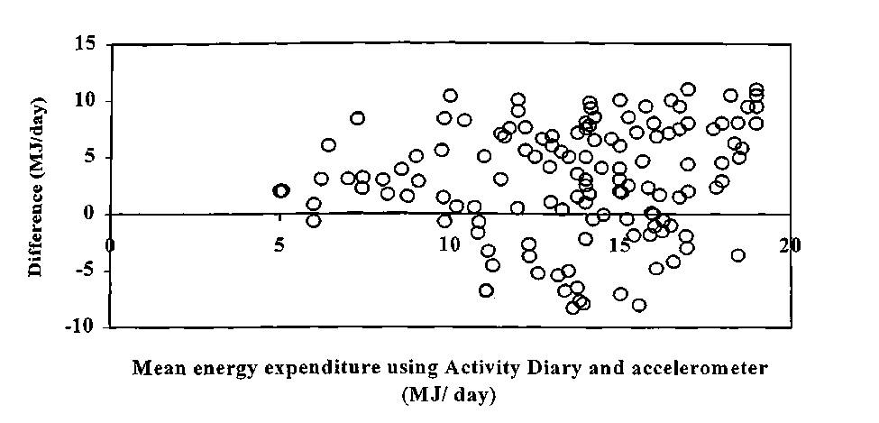
Figure 4.1 Bland and Altman plot comparing energy expenditure obtained using the Activity diary and Accelerometer.
Difference: Energy expenditure using activity diary - accelerometer (MJ/day)
99

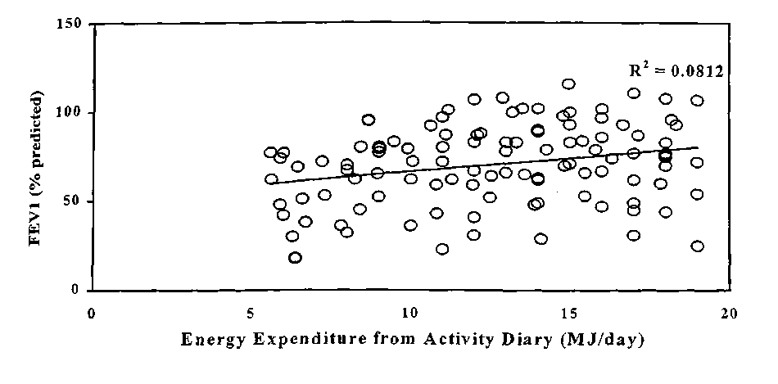
FIGURE 4.2: Relationship between lung function (FEVi) and activity levels in children with Cystic Fibrosis.
FEVi forced expiratory volume in one second
100

Figure 4-3: Relationship between peak aerobic capacity (V02) and activity levels in children with Cystic Fibosis.
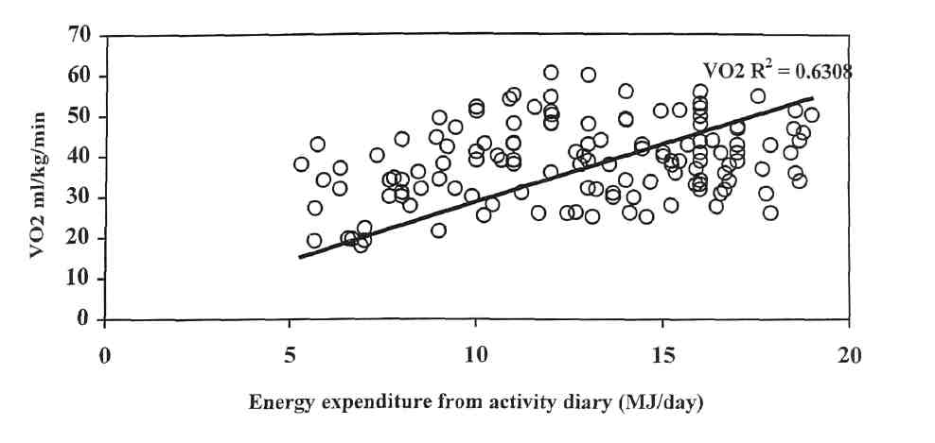
101
VO2 Peak aerobic capacity (ml/kg/min)
4.4 Discussion
This study has demonstrated that the activity levels of children with Cystic Fibrosis are not significantly different to activity levels in control children. In fact, children with "mild" Cystic Fibrosis were more active on a day to day basis than the control children. This difference may be due to the encouragement children with CF and their parents receive to be active. The mean activity levels of the control children in this study were not significantly different to the reported activity levels in 6890 school children as measured by the NSW SPFA [Booth et al, 1998]. This suggests that the control group in this study was an adequate representation of the larger population of children and is therefore a valid group for comparison with children with CF.
Physical activity can be measured from a physiological or behavioural perspective. Methods such as activity diaries [Seliger et al, 1974], observational studies [Klesges et al, 1990; McKenzie, 1991], frequency questionnaires [Simmons-Morton et al, 1990], proxy measures [Saris, 1985; Noland et al, 1990], heart rate monitors [Durant et al, 1992], portable accelerometers [Freedson, 1991], and doubly labelled water [Davies, 1992] have all been utilised to measure activity levels. Freedson [1991] and Trost et al [1998] have demonstrated excellent correlation between activity counts as measured by the accelerometer and energy expenditure and intraclass correlation coefficients during exercise testing. We also demonstrated a good agreement between the accelerometer and the seven day activity diary in this study, although its primary use was to provide objective comparative data on activity levels between CF and non CF (controls) children. We used a modification of the Bpuchard activity diary, a seven day activity diary that has been validated using doubly labelled water by Bratteby et al,
102
[1997]. The modification to the Bouchard activity diary in this study was the energy cost assigned to each activity. The newly assigned energy cost was based on more recently published data suggesting the need for this modification [Ainsworth et al, 1993].
Although doubly labelled water has become the gold standard for assessing energy expenditure in free living subjects [Davies, 1992], its cost and demanding methodology is prohibitive in population studies [Brattteby et al, 1997]. The only two studies that have incorporated doubly labelled water were in children with CF under the age of two years [Shepherd et al, 1988] and children between the ages of six and nine years [Tomezsko et al 1994]. The children in both study groups had mild disease, were pancreatic insufficient and demonstrated increased total daily energy expenditure. Tomezsko et al [1994] postulated that this may be due to the thermic effect of food, growth, increased daily voluntary activity or a cellular adaptive response resulting in an increased energy requirement for a given amount of physical activity. This study, using activity diaries, frequency questionnaires and portable accelerometers, has demonstrated increased levels of physical activity, as the likely explanation for the increased total daily energy expenditure in children with CF and mild disease.
Children with CF, who had high activity levels (top quartile for the respective gender and age group), had significantly better aerobic capacity, quality of life, nutrition and significantly lower disease severity and less days on antibiotics than children with low activity levels (lowest quartile). However, similar to the findings of Boucher et al, [1997], this study found that lung function was not related to activity levels. This would
103
suggest that high activity levels do not necessarily reflect the level of lung function and may independently improve outcome. Home based exercise programs have previously been studied and demonstrated varying degrees of benefit [Blomquist et al, 1984; Andreason et al, 1987; De Jong et al, 1994]. The reason for the variability was attributed to poor compliance rather than the severity of lung disease [Holzer et al, 1984]. The health benefits of increased activity levels demonstrated in this study should aid in improving compliance.
Although nutritional status correlated poorly with activity levels in the study group as a whole, in those with severe disease (Shwachman score <50), the association was much better. This may be explained by a decreased muscle mass, as a result of relative under nutrition [Russell et al, 1984] in severe disease, resulting in impaired functional ability and is consistent with the findings of Marcotte et al, [1986b] and Lands et al [1992]. The relationship between fat malabsorption and lung function has previously been reported [Kraemer et al, 1978; Gaskin et al, 1982b]. This study has also demonstrated for the first time that there were significantly lower levels of activity, aerobic capacity, and quality of life in girls between 12 and 16 years with pancreatic insufficiency compared with those who were pancreatic sufficient. These differences were not demonstrable in boys between 12 and 16 years and children under the age of 12 years. There are two possible explanations for the results of the present study. It is acknowledged that boys with pancreatic insufficiency are better able to maintain nutrition than girls [Kraemer et al, 1978]. Better nutrition facilitates muscle growth and greater activity and hence, a better aerobic capacity and quality of life. It may be that with the onset of puberty, the increased nutritional demands for muscle and bone growth
104
results in relative deficiencies of micronutrients required for activity. This may be exacerbated in pancreatic insufficient post pubertal girls because of poorer oral intake and/or hormonal changes which is supported by their lower BMP compared to those with pancreatic sufficiency. An alternative explanation would be that the older girls with pancreatic insufficiency may have more severe disease. This is less likely as there was no evidence that girls with severe disease had significantly reduced activity levels and there was no correlation between lung function and activity levels.
In conclusion, this study has demonstrated that children with mild CF were more active than children without CF, and, that those with moderate or severe CF had activity levels which were similar to control children. Activity levels in children with CF correlated with aerobic capacity, quality of life, nutritional status and inversely with days of antibiotics, but not with lung function. The effects of pancreatic insufficiency on activity level were most apparent in the cardiorespiratory status of girls after the age of 12 years. Further studies are required to investigate the possible cause of this gender difference and why the pancreatic status is of greater importance after the onset of puberty. The results of the present study however provide important information in regard to the relationship between aerobic capacity, activity level and quality of life, all of which have significant bearing upon the prognosis of children with CF.
105
CHAPTER 5 The relationship between genotype and fitness in children with Cystic Fibrosis
5.1 Introduction
Since the discovery of the genetic defect that causes Cystic Fibrosis (CF) by Riordan et al [1989], attempts have been made to correlate CF genotypes with clinical assessments [Kerem and Kerem, 1996]. To date, the correlations between genotype and prognosis, mortality and pulmonary function have been highly variable [Kerem et al, 1990; Mohon et al, 1993, Lester et al, 1994]. Kerem et al [1990], Santis et al [1990] and Campbell et al [1991] have demonstrated that patients homozygous for the delta F508 mutation have an earlier onset of disease, higher sweat chloride levels and a greater prevalence of pancreatic insufficiency. Despite this, patients with the delta F508 mutation have a wide range of severity of pulmonary disease and, severe pulmonary disease due to CF is not restricted to patients homozygous for the delta F508 genotype [Highsmith et al, 1994; MoulliereM/, 1994; Stern etal, 1995].
Tsui [1992] and Welsh and Smith [1993] proposed molecular mechanisms by which genetic mutations disrupt the function of cystic fibrosis transmembrane regulators (CFTR). By categorising these mechanisms into four different classes, it is not only possible to better understand' the pathophysiology of the disease process, but new therapies targetted at altering CFTR functioning are being developed according to the class of the mutation Penning et al, 1992b]. Tsui [1995] subsequently refined the classification to incorporate five different classes of mutations.
106
As several new therapies have been based on the CFTR mutation class, and exercise tolerance is a recommended outcome measure in interventional trials in CF [Ramsey and Boat, 1994], it is clearly important to assess the relationship between CFTR mutation class and exercise tolerance. There are no previously reported studies that have compared the exercise tolerance of patients on the basis of CFTR mutations.
5.2 Materials and Methods
Subjects
Children aged 8 to 17 years who attended the CF clinic at the Royal Alexandra Hospital for Children, Sydney were eligible for the study. The subjects were excluded if there was a history of pulmonary exacerbation in the month preceding the test.
Parameters of Assessment
Lean body mass was calculated using skinfold thickness and the equations provided by Duxnin and Rahaman [1967]. Height was measured by a Harpenden stadiometer and weight by electronic scales. The body mass index was recorded on each subject.
Subjects have the Shwachman score [Shwachman and Kulczycki, 1958], a clinico radiological measure of disease severity, recorded by their clinician at the yearly interval check of progress. This score was used to compare severity of the subjects both individually and collectively.
107
Pulmonary function tests consisted of measuring forced expiratory volume in one second (FEVi) and forced vital capacity (FVC) using a spirometer (Sensormedics 2000, Yorba Linda, CA) and the values presented by Polgar and Promadhat [1971] used as the reference range.
Peak aerobic capacity was assessed using a modified Bruce protocol on an electronic treadmill (Cardiovit 100, Schiller, Switzerland). Breath by breath gas analysis was used to determine peak oxygen uptake (VO2), minute ventilation (VE), and respiratory quotient (RQ). Anaerobic power was measured using the Wingate test [Ayalon et al, 1974]. Peak power and mean power were corrected for lean body mass for all subjects.
Children diagnosed with CF have their CFTR mutations recorded. This information was retrospectively obtained for the purposes of this study. The values for the peak aerobic capacity, anaerobic power, lung function, Shwachman score and body mass index for subjects with at least one copy of delta F508 mutation were compared according to the class of CFTR mutations (I-V) of the other mutation. Comparisons between subjects without one copy of delta F508 mutation were also made~according to the respective pah* of CFTR mutations they possessed.
The study was approved by the Ethics Committee of the Royal Alexandra Hospital for Children and informed written consent was obtained from all participants and their parents where applicable.
108
Data Analysis
The subjects were categorised into groups according to CFTR mutation. The five classes of CFTR mutations as described by Welsh and Smith [1993] and Tsui [1995] were adopted for mis study. Duncan's Post Hoc test of analysis of variance (ANOVA) was used to assess differences between the groups for each of the parameters of assessment. Statistical significance was assigned for p values less than 0.05.
Power calculations revealed that 60 subjects (10 subjects per group) would be required to detect a 0.5 standard deviation difference in peak aerobic capacity and anaerobic power between the groups with a significance of 0.05% and power of 80%. The SPSS-PC+ package (version 5.0) [Nie 1975] was used for statistical analysis.
5.3 Results
Seventy children with CF participated in the study. The mean age of the subjects was 14.1 (range 8.4 to 16.8) years and there was a wide range of disease severity as measured by the Shwachman score (mean 60.0; range 35 to 100). Only six of the subjects who participated in the study were pancreatic sufficient. The demographic details of the study population are displayed in Table 5.1.
In CF patients with at least one copy of the delta F508 mutation, subjects with a second mutation in class I had a mean peak aerobic capacity of 28.6 (SE 4.2) ml/kg/min which was not significantly different to subjects with class II second mutations [31.7 (SE 5.4) ml/kg/rnin] (Table 5.2). Subjects with a class III CFTR second mutation had a peak aerobic capacity 38.0% (p<0.05) greater than subjects with the class I CFTR
109
second mutation. Subjects with a class IV CFTR second mutation had a peak aerobic capacity 22.3% (p<0.05) greatcjf than those with class III CFTR second mutation. Duncan's Post Hoc ANOVA analysis demonstrated that while the mean peak aerobic capacity of subjects with class IV and class V CFTR second mutations was not significantly different from each other, it was significantly greater than subjects with class III CFTR second mutation which in turn was greater than those with class II and I CFTR second mutations.
Anaerobic power testing demonstrated that subjects with class III CFTR second mutations were 7.8% (p<0.05) stronger than subjects with class I and II CFTR second mutations, but were 10.9% (p<0.05) weaker than subjects with class IV and V CFTR second mutations. Duncan's Post Hoc analysis revealed three groups of strength with those with class I and II CFTR second mutations the weakest, individuals with class III mutations intermediate strength and class IV and V CFTR mutations the strongest.
Duncan's Post Hoc analysis revealed that BMI could be divided into two groups based on CFTR mutations, with those with second CFTR mutations belonging to class I and II having a significantly lower (17.6%, p<0.05) body mass index than those with class III, IV and V CFTR second mutations. The Shwachman score of disease severity followed the same trend as body mass index when analysed with Duncan's Post Hoc analysis. Subjects with class I and class II CFTR second mutations had significantly worse disease as measured by the Shwachman score than subjects with class III, IV and V CFTR second mutations.
no
Lung function, as indicated by forced expiratory volume in one second, was not significantly different between the groups and was thus unrelated to genotype.
The results from subjects without a copy of the delta F508 mutation are summarised in Table 5.3. Subjects with the rarer CFTR mutations tended to have highly variable aerobic capacity, anaerobic power, lung function, body mass index and Shwachman score, and analysis of the data did not reveal any statistically significant differences.
Ill

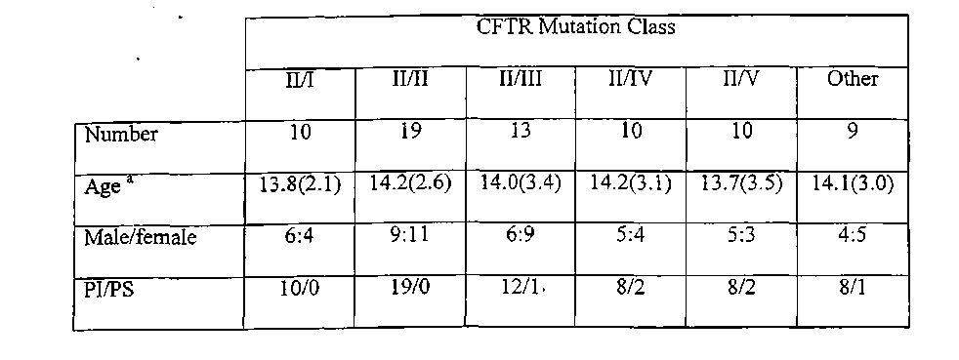
TABLE 5.1 Demographic details of subjects
ª age shown in years with standard deviation in brackets PS pancreatic sufficient PI pancreatic insufficient
112

TABLE 5.2- Aerobic and anaerobic performance and BMI in patients with at least one copy pf the delta F508 CFTR mutation

 | CFTR Second Mutation Class
 | I | II | in | IV | V
Aerobic capacity  ml/kg/rnin | 28.6(4.2) | 31.7(4.9) | 43.9(6.4)* | 53.0(7.2) | 53.7(6.8)
FEV_{I}  % predicted | 51.0(5.4) | 57.2(6.1) | 55.0(6.0) | .58.3(6.3) | 55.9(5.9)
Anaerobic power watts/ kg | 15.0(2.2) | 14.7(2.0) | 16.7(2.4)* | 17.7(2.1) | 17.8(2.0)
Body mass index | 17.0(1.8)" | 18.2(2.5) ^{T} | 20.0(2.3) | 20.1(2.4) | 20.4(2.0)
Shwachman score | 56.0(7.0)^{T} | 51.0(7.3)" | 65.0(6.5) | 64.0(6.0) | 60(5.9)
* Significantly greater than class I and II and signficantly lower than class IV and V
(Duncans ANOVA, p < 0.05).
+ Significantly lower than class III, IV and V (Duncans ANOVA, p<0.05)
FEVi Forced expiratory volume in one second
Mean values are shown with standard error of the mean in brackets
113
TABLE 5.3 Aerobic and anaerobic performance and BMI in patients without a copy of de!taF508 CFTR mutation

 |  | CFTR mutation class
 | III/I (n=2) | III/IV (n=4) | IV/IV (n=4)
Aerobic capacity ml/kg/min | 38.4 (7.9) | 44.2(8.1) | 53.9(7.2)
FEVi %predicted | 56.0 (6.2) | 60.0(7.5) | 57.9(6.2)
Anaerobic power watts/kg | 15.9(4.2) | 17.2(5.1) | 17.7(6.0)
Body mass index | 17.9(3.2) | 20.2(2.9) | 21.1(3.2)
Shwachman Score | 63.0(6.4) | 60.4(7.9) | 71.2(8.0)
FEVi Forced expiratory volume in one second
Mean values are shown with standard error of the mean in brackets
114
5.4 Discussion
This study has demonstrated that there is a significant relationship between the class of the second CFTR mutation and aerobic capacity, anaerobic power and body mass index in patients with CF with at least one copy of the delta F508 gene mutation. Those who possessed a second CFTR mutation belonging to either class I or II, were not significantly different from each other in terms of any of the exercise parameters measured. They had however, a significantly low$r peak aerobic capacity and anaerobic power than those with a second CFTR mutation belonging to class III. Patients who possessed a second CFTR mutation belonging to either class IV or V, were not significantly different from each other in terms of aerobic capacity and anaerobic power. They did however, have significantly higher values than those who had a second CFTR mutation belonging to class III. Patients with a second CFTR mutation belonging to class I and II had a significantly lower body mass index and Shwachman score than patients who had a second CFTR mutation belonging to class III, IV, or V. However, there were no statistically significant differences in the lung function of patients with the different classes of CFTR mutations, suggesting that this is a less sensitive indicator of disease severity. Despite these results being obtained from a single center, power analysis for the different classes of CFTR mutations, suggested that type Il^errors were niinimal.
Kaplan et al [1996] demonstrated no differences in terms of nutrition and exercisf tolerance between patients who were homozygous and heterozygous for the delta F508 grae mutation. The study was Hunted by the very small sample size. In addition, the study grouped all heterozygous patients together, failing to take into
115
account the vast spectrum of disease noted amongst heterozygous patients. By classifying the patients according to the cellular physiological function conferred by class of the CFTR mutation, this study has demonstrated significant differences in exercise tolerance, muscle power and nutrition.
Although CF genotype has been shown to be highly predictive of exocrine pancreatic function [Kristidis et al, 1992], to date there has been no proven association between genotype and pulmonary status [Hamosh and Corey, 1993]. Most recent approaches toward understanding the genotype-phenotype correlation in cystic fibrosis are centered on in-vitro studies of CFTR function. Sheppard et al [1994] studied the expression of normal and delta F508 CFTR in epithelial cells and demonstrated that the delta F508 CFTR produced only an immature core glycosylated type of protein due to defective processing. Tsui [1992] and Welsh and Smith [1993] suggested mechanisms by which the different classes of mutations disrupt CFTR function. The delta F508 gene belongs to class II mutations and results in defects in protein processing. Class I mutations result in defects in protein production, class III mutations result in defects in protein regulation and class IV mutations result in defects in protein conduction to the apical membrane. Class V mutations result in reduced level of ribonucleic acid (RNA). These classes of mutations were adopted for this study and the results indicate that the deficits conferred on epithelial function by the mutations may also affect processes involved in aerobic and anaerobic fitness.
This study has important implications in terms of long term prognosis as well as response to various therapies jb interventional studies. It may be that patients with class
116
Ill, IV or V CFTR mutations have a better overall prognosis, or, are more likely to respond to* therapies. Previous ambiguity about the relationship between genotype and phenotype in cystic fibrosis may now be clarified if interpreted in the light of the molecular mechanisms as proposed by Tsui [1992,1995] and Welsh and Smith [1993].
117
CHAPTER 6
A comparison of resting energy expenditure, activity levels in girls with mild Cystic
Fibrosis with healthy controls
6.1 Introduction
Life expectancy among patients with cystic fibrosis (CF) has dramatically improved over the past twenty years [Fitzsimrnons et al, 1993; Curtis et al, 1997]. However, there remains a significant gender difference in survival rates. This is most evident in females with CF under the age of 20 years, who are 60% more likely to die than males of the same age [Rosenfeld et al, 1997]. The aetiology of this gender difference is poorly understood. Rosenfeld et al [1997] demonstrated that while nutritional status, pulmonary function and airway microbiology were independent predictors of survival, none of these parameters could account for the gender difference in survival rates. Orenstein and Nixon [1991] have demonstrated that girls with CF had a lower peak aerobic capacity than boys with CF of the same age. As aerobic capacity is an important predictor of survival [Nixon et al, 1992], the aetiology of the gender difference in the survival of patients with CF may be related to differences in muscle function. Moreover, compared to reference values obtained in healthy girls, girls with moderate to sever&XF related lung disease have a significantly lower peak aerobic capacity, which has been attributed to reduced daily physical activity levels and nutritional status [Orenstein and Nixon, 1991]. On this basis, girls with mild CF disease without exercise limitation, should have similar peak aerobic capacity, activity levels and resting energy expenditure as healthy girls of the same age. The aim of this study was to investigate the validity of this premise by comparing aerobic and anaerobic capacity as well as resting energy
118
expenditure in girls with mild CF who, participated in organised sport at an eilt? level with that in healthy girls participating in the same sport.
6.2 Materials and Methods
Subjects
Girls with CF who were 13 years of age or older,'.who had "mild" CF disease and were participating in representative level (either at regional or state level), competitive sport were recruited for the study. "Mild CF" disease for the purposes of this study was defined by normal pulmonary function tests (forced expiratory volume in one second of greater than 80% predicted) and a Shwachman score of greater than 70 [Shwachman and Kulczycki, 1958]. The subjects were excluded if there was a history of pulmonary exacerbation in the three months preceding the test. The control population consisted of the female training partners of the girls with CF who were matched for age and pubertal stage [Tanner et al% 1966].
Parameters of Assessment
Lean body mass was calculated using skinfold thickness and the equations provided by Durnin and Rahaman [1967]. Height was measured by a Harpenden stadiometer and weight by electronic scales.
Peak aerobic capacity was assessed using a modified Bruce protocol on an electronic treadmill (Cardiovit 100, Schiller, Switzerland). Breath by breath gas analysis was used to determine peak oxygen uptake (VO2), minute ventilation (VE), and
119
respiratory quotient (RQ). The peak aerobic capacity was assessed twice in each subject. The anaerobic threshold was calculated using the method described by Beaver et al [1986]. In addition, the subjects were requested to estimate their level of exertion using the Borg's rating of perceived exertion score [Borg, 1982].
The dominant leg strength was assessed using a Cybex dynamometer (Lumex Inc, Ronkonkoma, NY). The muscles tested were the quadriceps femoris and the hamstrings. The best of three repetitions was recorded as the strength of the tested muscle group. The strength tests were performed on the same day as the exercise tests. Anaerobic power was measured using the Wingate test [Ayalon et al, 1974]. Peak power and mean power were corrected for lean body mass for both groups of girls.
Resting energy expenditure (REE) was measured by open circuit, flow through ventilated hood indirect calorimeter as described by Tomezsko et al [1994]. A computerized metabolic cart (Sensormedics 2900 Z, Yorba Linda, CA) was used to measure REE over a 30 minute interval. All subjects fasted overnight for twelve hours before testing and medications were withheld during the twelve hour fast. The modified equation developed by De Weir [1949] was used to calculate energy equivalency from oxygen consumption and carbon dioxide production.
Pulmonary function tests consisted of measuring forced expiratory volume in one second (FEVi) and forced vital capacity (FVC) using a spirometer (Sensormedics 2000, Yorba E|nda, CA) and the values presented by Polgar and Promadhat [1971] as the reference range.
120
Each subject was asked to complete a seven day activity diary to assess activity levels. These diaries have previously been validated by Bratteby et al [1997]. In addition, on the days on which the seven day activity diary was being completed, the subjects were asked to wear an activity accelerometer, WAM 7164 (Computer Science and Applications, Shalimar, Florida) which has been validated by Melanson etal [1995].
The study was approved by the Ethics Committee of the Royal Alexandra Hospital for Children and written consent was obtained from all participants and their parents where applicable.
Data Analysis
The group mean and standard error of the mean (SEM) was calculated for each parameter. Thez scores were calculated for each subject's height and weight using data from the National Center for Health Statistics [1979]. The lean body mass calculated from skinfold thickness was used to express the peak aerobic capacity.
Two tailed paired f tests were used to compare mean differences between the group with CF and healthy controls. To adjust for multiple comparisons, Duncan's Post Hoc test of analysis of variance was used. Values above the 95% confidence interval were considered statistically significant (p<0.05).
6.3 Results
Twelve girls with CF and their training partners took part in the study. All the subjects played representative sport and each girl with CF was paired with her training partner.
121
The sports each pair of subjects participated in were netball (n=4), basketball (n=2), swimming (n=3), hockey (n=l), gymnastics (n=l) and water polo (n=l).
The girls with CF had mild disease with a mean Shwachman score of 85.0 (SD 7,0), and a mean forced expiratory volume in one second of 88% (SD 9) predicted and were all pancreatic insufficient requiring daily pancreatic enzyme replacement. The mean age and pubertal stage [Tanner et al, 1966] of the girls with CF participating in the study was 15.0 years (range 13.2 - 17.3 years) and stage 4.3 (SD 0.6) respectively. This was not significantly different to the control subjects' mean age and pubertal stage of 14.9 years (range 13.4-17.5) and stage 4.4 (SD 0.7) respectively. The demographic details of the study population is demonstrated in Table 6.1. There were no significant differences between the girls with CF and their training partners in terms of the anthropometric details.
A comparison of the results in the girls with CF and their training partners is presented in Table 6.2. The resting energy expenditure was 7.6% (p<0.05) higher in the girls with CF which increased to 8.8% (p<0.05) when the resting energy expenditure was adjusted for body mass index. The girls with CF were also significantly more active both in terms of the activity diary (18.7%, p<0.01), as well as the activity counts obtained from the accelerometer (15.0%, p<0.01). The peak aerobic capacity in girls with CF was 21.7% (p<0.01) lower than their training partners. Both groups of study subjects exercised to exhaustion as demonstrated by the respiratory quotients being greater#an 1.10. The anaerobic threshold occurred at 46.8% and 59.9% of peak aerobic capacity for the girls with CF and controls respectively, which was also significantly
122
different (p<0.01). The dyspnoea index and Borg's rating of perceived exertion was not significantly different between the two groups.
Girls with CF were significantly weaker when strength was measured using the Cybex dynamometer (p<0.05). Similarly, the peak anaerobic power achieved in girls with CF was significantly lower compared to healthy controls (p<0.05).
TABLE 6.1: Demographic details of study population

 | Training partners | Cystic Fibrosis
Age in years | 14.9(1,2) | 15.0(1.3)
Weight z score | -0.10(0.85) | -0.15 (0.92)
Height z score | -0.06 (0.72) | -0.12(0.89)
Body fat(%) | 24.3 (2.35) | 23.2(2.78)
BMI | 18.91 (1.12) | 18.64(1.85)
Values shown are mean values with standard deviation values in brackets
TABLE 6.2: Aerobic capacity, anaerobic power and resting energy expenditure in adolescent female athletes with CF and their training partners

 | Training partners | Cystic Fibrosis
Peak aerobic capacity  ml/kg/min | 41.02(7.89)** | 32.10(6.90)
Respiratory quotient | 1.27(0.18) | 1.24(0.09)
Anaerobic threshold ml/kg/min | 24.60 (6.9)** | 15.05(7.20)
Dyspnoea Index (VE/MW) | 0.55 (0.08) | 0.60 (0.07)
Borg's Score | 8.90(1.01) | 9.10(1.12)
FEVl  % predicted | 92(7) | 88(9)
FVC  % predicted | 100(9) | 97(10)
Resting energy expenditure kJ/24hr | 5689 (363)* | 6159(952)
Resting energy expenditure kJ/BM/24hr | 301 (21)* | 330 (28)
Activity level activity diary MJ/24hr | 11.72(2.20)** | 13.91 (2.63)
Activity Count Units | 11282(490)** | 12974 (720)
Peak power watts/kg | 16.20* (2.70) | 12.60 (2.45)
Leg strength  Nm | 169 (32)* | 110(26)
*p<0.05, **p<0.001
FEVi Forced expiratory volume in one second
FVC Forced Vital Capacity
VE Minute ventilation
MW Maximal voluntary ventilation (= 35XFEV0
All values shown are mean values with standard error of the mean values in brackets
125
6.4 Discussion
This study, has shown that young athletes with mild CF have significantly lower peak aerobic capacity, anaerobic power and leg strength than their training partners. However, the resting energy expenditure and daily activity levels were significantly higher in the female athletes with CF than their training partners.
Although girls with CF had a significantly lower peak aerobic capacity compared to healthy controls, neither group had significant respiratory limitation as measured by the Dyspnoea Index [Wasserman et al, 1994] at the termination of the study. The effort expended in performing the test in both groups was similar as demonstrated by the respiratory quotient and the Borg's score of perceived exertion measured at the end of the exercise test. The girls with CF however, reached their anaerobic threshold at an earlier stage of the exercise test than healthy controls. This suggests that muscle conditioning was a more important limiting factor in girls with CF than healthy controls.
Girls with CF similarly had weaker lower limbs than their training partners as measured by the Cybex unit. The generated peak power assessed by the Wingate test was also significantly lower in girls with CF. While sedentary lifestyles may account for the reduced peak aerobic and anaerobic capacity in children with more severe CF disease [Lands et al, 1992], this is unlikely to be the explanation for these findings in this group with mild disease. The girls with CF in this study had more active lifestyles than their training partners as measured by the activity diary and the accelerometer. As all results were corrected for lean body mass, these differences cannot be explained by discrepancies in lean body mass as suggested by Gulmans et al [1996]. Other
126
explanations for the reduced exercise tolerance demonstrated in patients with CF have been based on the relative nutritional deficiency in patients compared to healthy controls [Coates et al, 1980; Marcotte et a\ 1986b]. The nutritional status, as measured by the body mass index of both the healthy controls and the girls with CF were however, good and not significantly different between the groups. In addition, normal nutritional status in the girls with CF was achieved despite all the patients being pancreatic insufficient.
Gulmans et al [1996] demonstrated that patients with CF had a greater oxygen consumption compared to healthy controls for a given quantity of submaximal work. De Meer et al [1995] demonstrated a lower efficiency of adenosine triphosphate (ATP) synthesis in patients with CF compared to controls. Differences in the efficiency of ATP synthesis between the groups were not investigated in this study, but are a possible explanation for our observed differences in aerobic and anaerobic capacity.
The resting energy expenditure of the girls with CF was significantly greater than their training partn». As all the patients were clinically stable, the resting energy expenditure values were likely to be repeatable [Bell et al, 1999]. All the subjects with CF were colonised with the microorganism Pseudomonas aeruginosa and as Pseudomonas colonisation has been shown to increase the metabolic demand [Vinton et al, 1999], this may explain the higher resting energy expenditure. It does however, seem implausible that colonisation alone in the absence of symptoms could account for the greater resting energy expenditure. This implausibility is supported by evidence that even acute pulmonary exacerbations are not associated with increased resting energy expenditure [Stallings et al, 1998]. "While our study demonstrated similar differences in
127
resting energy expenditure between patients with CF and controls as those found by Zemel et al, [1996], the difference was not of the same magnitude as that demonstrated by Shepherd [1997] and Girardet et al, [1994] in infants with and without CF. It is unclear why increases in resting energy expenditure compared to healthy controls are greater in infancy, where disease is usually milder than in older children with CF. Zemel et al [1996] performed longitudinal analyses over a 3 year study period in prepubertal children with CF and demonstrated that resting energy, expenditure increased significantly in the girls but not in the boys.
Selection bias may be a confounder in this study if female athletes with mild CF acquired their energy to perform exercise through a different mechanism to sedentary subjects with mild CF. However, there is currently no evidence that active subjects with CF acquire their energy through different metabolic mechanisms to sedentary subjects, and therefore this form of selection bias would seem unlikely. It could however form the basis of future research. Other biases could arise from the fact that the absence of a clinical history of diabetes and a negative glycosylated haemoglobin test does not exclude cystic fibrosis related diabetes which may potentially influence muscle metabolism. However, the current recommendations that are followed by our institution is to perform formal oral glucose tolerance tests if there is a history suggestive of diabete^ and unexplained deterioration in disease status and, or, if there is an abnormal glycosylated haemoglobin test [Moran et al, 1999]. Thus it is unlikely we have overlooked the presence of CF related diabetes in these patients although it is possible that peripheral insulin sensitivity may be a contributing factor to the inefficient muscle metabolism in these pancreatic insufficient patients [Moran et al, 1994]
128
These significant differences between girls with mild CF disease and healthy controls in aerobic capacity, anaerobic power and resting energy expenditure may have important implications. This study suggests that there is significant muscle impairment in girls with CF compared to healthy controls. If there is inefficiency in muscle function, a greater nutritional requirement would be needed to maintain activities of daily living. Muscle inefficiency may also limit the respiratory muscle capabilities of girls with CF who develop acute on chronic respiratory failure. Further studies of muscle metabolism in terms of substrate energy availability and, or utilisation are needed and may delineate a defect at the mitochondrial level, and these studies are presented in chapter 7.
129
CHAPTER 7
A comparison of oxidative capacity in active girls with mild Cystic Fibrosis and
healthy controls.
7.1 Introduction
The association between increased severity of pulmonary disease and reduced nutritional status with reduced exercise tolerance in patients wr& Cystic Fibrosis (CF) has previously been established [Coates et al, 1980]. The pathophysiology of reduced exercise tolerance in patients with cystic fibrosis is however, not completely understood. Although intrinsic abnormalities in the skeletal muscle cells of patients with CF have been identified, the clinical impact of these abnormalities is unclear. Abnormalities have been demonstrated in the mitochondria of fibroblasts and leucocytes and include increased calcium concentration [Shapiro, 1989], lower nicotinamide adenosine dehydrogenase activity (respiratory chain enzyme complex) [Dechecchi et al, 1988] and a higher pH optimum of nicotinamide adenosine dehydrogenase [Shapiro et al, 1979]. De Meer et al [1995] assessed in vivo mitochondrial performance in a small group of patients with moderate to severe cystic fibrosis during oxidative work and demonstrated increased intracellular pH. It was not clear if the intracellular differences were due to the primary defect conferred by the CFTR mutation on skeletal muscle, or, the secondary effects of severe CF disease, such as, poor nutrition, low physical activity levels and deconditioning. In order to attribute the cause of the intracellular differences to primary or secondary effects of CF disease, it is necessary to study patients with mild CF disease, who are physically active with good nutritional status.
130
Gender differences in life expectancy are most evident in females with CF under the age of 20 years, who are 60% more likely to die than males of the same age [Rosenfeld et al, 1997]. Orenstein and Nixoa [1991] have demonstrated that girls with CF had a lower peak aerobic capacity than boys with CF of the same age. As aerobic capacity is an important predictor of survival [Nixon et al, 1992], the aetiology of the gender difference in the survival of patients with CF may be related to differences in muscle function. This study therefore aimed to study intracellular differences in muscles of girls with mild CF compared to healthy matched controls.
7.2 Materials and Methods
Subjects
Girls with CF who were 13 years of age or older, who had participated in the previous study on resting energy expenditure and activity levels and who had "mild" CF disease were recruited for the study (chapter 6). Only subjects who were;§till participating in representative level (regional or state), competitive sport were eligible for the study. "Mild CF" disease for the purposes of this study was defined as normalpulmonary function tests (forced expiratory volume in one second of greater than 80% predicted) and a Shwachman score of greater than 70 [Shwachman and Kulczycki, 1958]. The subjects were excluded if there was a history of pulmonary exacerbation in the three months preceding the test. The control population consisted of the female training partners of the girls with CF who were matched for age and pubertal stage [Tanner et al, 1966].
131
Parameters of Assessment
Lean body mass was calculated using skinfold thickness and the equations provided by Durnin and Rahamaa [1967]. Height was measured by a Harpenden stadiometer and weight by electronic scales. The aerobic and anaerobic performances, and activity levels of each subject was assessed and reported in the previous chapter. The genotype of each subject with CF was recorded. The girls with CF were assessed for CF related diabetes (CFRD) by obtaining a history and checking their serum glycosylated haemoglobin (HbAlC).
Each subject exerted maximal force for 2 seconds against a purpose- designed balloon followed by a 1 second rest period while lying prone in the MR spectroscope (1.5 Tfila NMR Spectrometer, Philips SI5 HP). The exercise was repeated until exhaustion, as determined by the Borg score of dyspnoea [Borg, 1982]. A computerised audio-visual metronome, designed specifically for the study, guided the subject through each phase of the exercise. Measurements of inorganic phosphorous (Pi), phosphocreatine (PCr) and intracellular pH were taken from the vastus lateralis muscle of the non dominant leg. The force output was measured for each contraction and total work calculated for the complete exercise protocol in the spectroscope. The same exercise protocol was repeated three times for each subject using a Cybex dynamometer (Lumex Inc, Ronkonkoma, NY) to assess the reproducibility of the total work output during the exercise protocol.
132
The study was approved by the Ethics Committee of the Royal Alexandra Hospital for Children and written consent was obtained from all participants and their parents where applicable.
Data Analysis
The group mean and standard error of the mean (SEM) was calculated for each parameter. The z scores were calculated for each subject's height and weight using data from the National Center for Health Statistics [1979]. The lean body mass was calculated from skinfold thickness.
To assess the reproducibility of the exercise protocol, multiple comparisons were adjusted for, using ANOVA, to obtain the mean difference in total work output. Further, the correlation between the total work output during the Cybex dynamometer test and the same exercise protocol in the MR spectroscope was assessed using Pearson's correlation (r). A curve utilising non-linear least squares analysis, based on mixed Lorentzian and Gaussian line shapes, was used to calculate the areas under Pi, PCr and beta-ATP peaks. This method has previously been described by Zanconato et al, [1992]. The ratios Pi/ PCR and PCr/ beta ATP were then determined. Measurements were compared at rest, and at 25 %, 50%, and 75% of maximal work output, and when maximal work output was reached. To compare the results from the MR spectroscopy, two tailed paired Students /- tests were used to compare mean differences between the group with CF and healthy controls. Values above the 95% confidence interval were considered statistically significant (p<0.05).
133
7.3 Results
Eight girls with CF and their training partners took part in the study. All subjects played representative sports. The sports each pair of subjects (CF patient and training partner) participated in were netball (n= 4), basketball (n=2), hockey (n=l), and gymnastics (n=l).
The girls with CF had mild disease as demonstrated by a mean Shwachman score of 89.0 (SD 7.3), and a mean forced expiratory volume in one second of 88% (SD 9.0) predicted and were all pancreatic Insufficient requiring daily pancreatic enzyme replacements. Three girls with CF were homozygous for the delta F508 gene mutation. The other five subjects were heterozygous for the delta F508 gene mutation (second mutation G551D, n=3; G542X, n= 1; N1303K, n=l). None of the girls with CF had any evidence of CF related diabetes mellitus. The mean age and pubertal stage [Tanner et al 1966] of the girls with CF participating in the study was 15.8 years (range 14,6 - 17.1 years) and stage 4.6 (SD 0.7), respectively. This was not significantly different to the control subjects' mean age and pubertal stage of 15.9 years (range 14.7-17.0) and stage 4.8 (SD 0.6) [Tanner et al, 1966], respectively. The demographic details of the study population are presented in Table 7.1. There were no significant differences between the girls with CF and their training partners in terms of anthropometric details.
The exercise protocol was highly repeatable with a mean difference in total work output of 6.5 J (SD 3.19, 95% CI -2.46 ,8.18) between each repetition of the test. The mean total work output generated by girls with CF using this exercise protocol was 170 J
134
(SD 35) while the healthy controls produced 246 J (SD 41). This difference in total work output was statistically significant (paired sample t test, p<0.05). There were however, no significant differences between the two groups in the Borg's score at the termination of the test (9.5 SE 0.8 for CF m. 9.4 SE 0.7 for controls).
There were no significant differences in intracellular pH between the two groups at rest (7.02 SE 0.04 for girls with CF vs 7.04 SE 0.06 for controls). However, girls with CF had a significantly higher pH 6.99 (SE 0.06) than controls pH 6.90 (SE 0.05) (pO.Ol) when 25% of the total work output was reached. This difference was maintained until maximal work output was reached (pH 6.96 SE 0.06 vs 6.82 SE 0.05, pO.Ol) and is demonstrated graphically in Figure 7.1. When comparison was made of the muscle pH between girls with CF after maximal work output was reached and the matched controls after the same work output was achieved, significant differences were demonstrated (girls with CF pH 6,96 SE 0.06 vs healthy controls 6.86 SE 0.05, p<0.05).
At rest, girls with CF had an inorganic phosphate / phosphocreatine ratio of 0.24 (SE 0.08) compared with healthy controls who had a ratio of 0.23 (SE 0.07). The difference in the ratio was statistically significant when 25% of total work output was reached where the ratio was 0.34 (SE 0.07) and 0.41 (SE 0.08) for girls with CF and healthy controls respectively (p<0.05). At maximal work output, the inorganic phosphate / phosphocreatine ratio was 0.54 (SE 0.08) and 0.88 (SE 0.07) for girls with CF and healthy controls respectively (p<0.01). This is demonstrated graphically in Figure 7.2. When comparison was made of the inorganic phosphate/ phosphocreatine ratio between girls with CF after maximal work output was reached and the matched controls after the
135
same work output was achieved, significant differences were demonstrated (0.54 SE 0.08 in girls with CF vs 0.43 SE 0.06 in health controls, p<0.05).
There were no significant differences in the phosphocreatine/ beta ATP ratio at rest between girls with CF (2.85 SE 0.28) and healthy controls (2.90 SE 0.31). At 25% of maximal work the ratio was 2.58 (SE 0.25) for girls with CF and 2.37 (SE 0.29) for controls (pO.Ol). At maximal work output, the ratio of phosphocreatine/ beta ATP was 1.90 (SE 0.26) for girls with CF and 1.69(SE 0.28) for controls (pO.Ol). This is demonstrated graphically in Figure 7.3. When comparison was made of the phosphocreatine/ beta ATP ratio between girls with CF after maximal work output was reached and the matched controls after the same work output was achieved, significant differences were demonstrated (1.90 SE 0.26 for gg&i with CF vs 2.07 SE 0.28 for healthy controls, p<0.05).
The recovery rate after exercise measured in terms of the inorganic phosphate to phosphocreatine ratio was 0.24 /min for girls with CF and 0.42 /min for healthy controls. This difference was also statistically significant (p<0.01).
136
TABLE 7.1: Demographic details of study population
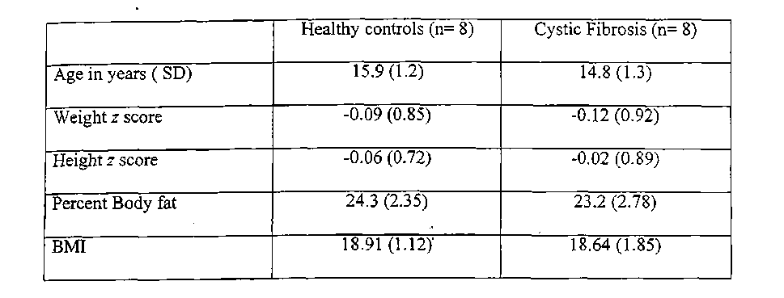
All values shown are the mean values with the standard deviation in brackets
FIGURE 7.1: Comparison of intracellular pH in girls with mild CF and healthy matched controls at maximal work output.
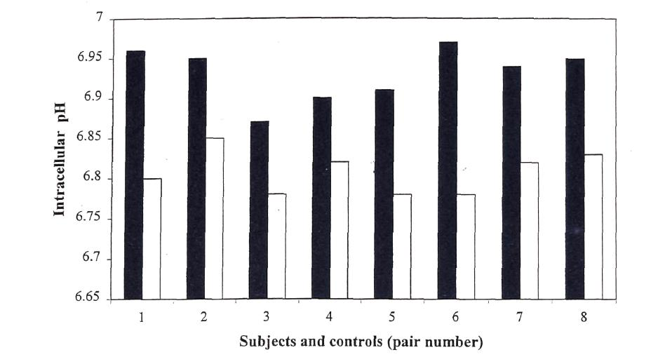
Solid bars indicate values from patients with CF while open bars indicate values from the matched controls
138
FIGURE 7.2: Comparison of Inorganic phosphate/ Phosphocreatine ratio in girls with mild CF and healthy matched controls at maximal work output
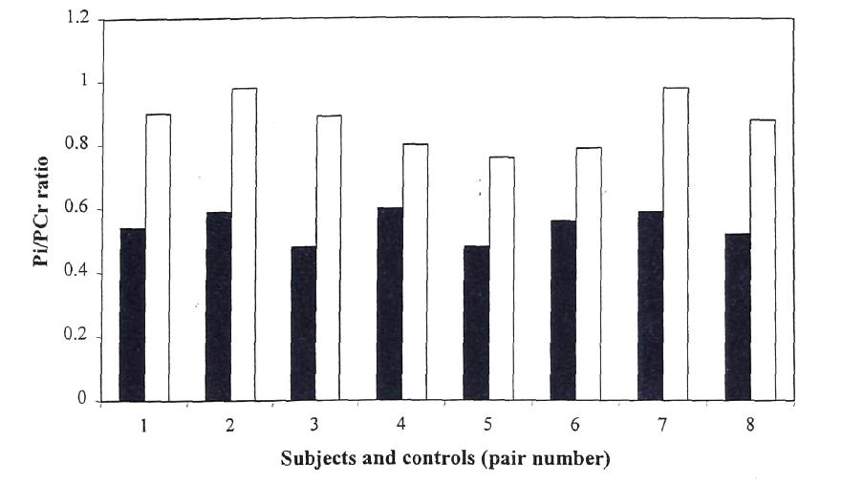
Solid bars indicate values from patients with CF while open bars indicate values from the matched controls
139
FIGURE 7.3: Comparison of Phosphocreatme/ beta ATP ratio in g\A with mild CF and healthy matched controls at maximal work output.
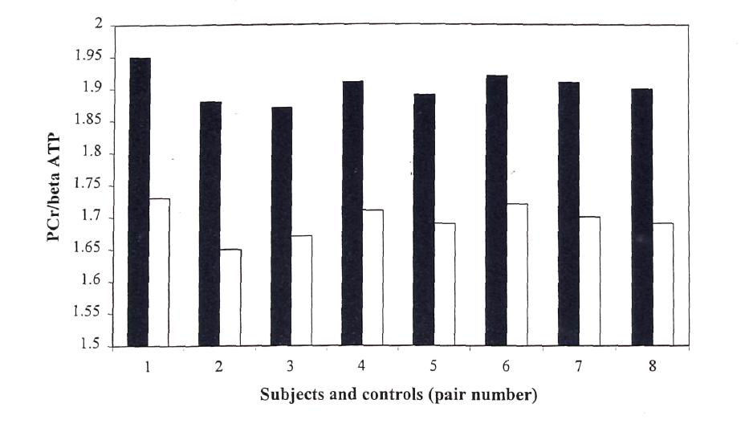
Solid bars indicate values from patients with CF while open bars indicate values from the matched controls
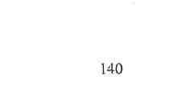
7.4 Discussion
The results of this study demonstrate that girls with mild CF had significant differences
in intracellular pH, inorganic phosphate / phosphocreatine ratio and phosphocreatine/ beta ATP ratio during high intensity exercise when compared to healthy matched training partners. These differences became increasingly apparent as the total work output increased. Girls with CF demonstrated significant deficiencies in anaerobic metabolism as well as inefficient and insufficient oxidative metabolism compared to healthy controls. As the subjects with CF were physically active with good nutritional status, the secondary effects of severe CF disease appear to be non contributory. The results provide support for Shapiro's hypothesis [1989] that that there is an intrinsic mitochondrial and cellular defect in the muscles of patients with Cystic Fibrosis.
The high intensity exercise protocol required the subjects to repeatedly exert maximal force. Thu^ although aerobic and anaerobic mechanisms for ATP production run concurrently, the anaerobic mechanism provided an increasing proportion of energy as the work output increased. As muscle work output increases, adenosine diphosphate (ADP) and inorganic phosphate (Pi) are released from the breakdown of ATP and phosphocreatine (PCr). The ratio of Pi/ PCr is thus directly proportional to the rate of mitochondrial oxidative metabolism [Chance et al, 1986]. As the rate of ATP hydrolysis approaches fee maximal rate of tissue oxidative phosphorylation, anaerobic glycolysis, activated by ADP and Pi₉ becomes the principle metabolic mechanism for energy production. Glycolysis results in the accummulation of lactic acid and hydrogen. By measuring hydrogen, the MR spectrsocope is able to quantify intracellular acidosis. This study demonstrated that despite high intdftity exercise, girls with CF did not develop
141
significant intracellular acidosis. This suggests that the rate of anaerobic glycolysis in girls with CF may be insufficient to meet the energy demands of the exercising muscle.
This is the first study to demonstrate deficiencies in anaerobic glycolysis in girls with CF. The Pi/ PCr ratio at maximal work output, which reflects mitochondrial oxidative metabolism, was significantly lower in girls with CF compared to healthy controls. This suggests that the maximal mitochondrial oxidative capacity is reduced in CF. When the same work output was performed, the Pi/ PCr ratio was however, significantly higher in girls with CF compared to healthy controls. This suggests that mitochondrial oxidative metabolism in girls with CF is inefficient, requiring utilization of greater phosphocreatine stores to perform the same amount of work as the healthy controls. The ratios of PCr/ beta ATP is similarly consistent with a reduced maximal mitochondrial oxidative capacity as well as inefficient mitochondrial oxidative metabolism compared to healthy controls. The inefficient oxidative metabolism demonstrated in this study is consistent with the results of De Meer et al [1995]. De Meer et al [1995] however, demonstrated these differences in adolescents with moderate to severe CF disease with impaired nutrition, whereas this study has demonstrated the differences are present in girls with mild CF, who are physically active and well nourished. It may be that the Cystic Fibrosis Transmembrane Regulator, which is involved in transmembrane chloride transport, and, is expressed in skeletal muscles [Denning et al, 1992a; Sheppard and Welsh, 1999], may be affecting both oxidative and anaerobic metabolism,.
142
Ramjeesingh et al [1999] demonstrated the catalytic and chloride channel gating properties of CFTR. Of importance to this study, CFTR has ATPase ac#ity which results in depletion of energy stores such as phosphocreatine. Gadsby et al [1998] demonstrated that CFTR causes ATP hydrolysis. This is a possible mechanism for the inefficient oxidative and anaerobic metabolism demonstrated in this study. Essential fatty acid deficiencies may be another mechanism of inefficient energy utilisation [Freedman et al, 1999]. The subjects in this stuSy did not however, demonstrate the clinical features of fatty acid deficiency. Quantitative or, qualitative abnormalities of insulin action in skeletal muscles may produce the observed effects on glycolysis but not oxidative phosphorylation [Majer et al, 1998]. Cystic fibrosis related diabetes mellitus was excluded in all the subjects with CF by obtaining a history and serum glycosylated haemoglobin. The results were not therefore confounded by this possibility.
Subjects with CF and who are pancreatic insufficient but without overt diabetes have been demonstrated to have significanly increased peripheral insulin sensitivity [Moran et al, 1994]. As insulin inhibits glycogenolysis [Boiteux and Hess, 1981] the acquisition of energy through skeletal muscle glycogenolysis may be reduced in this group of subjects. Skeletal muscle glycogenolysis is necessary for aerobic and anaerobic work and therefore, this may be a cause of exercise limitation in subjects with CF.
The exercise protocol used, consisting of 2 seconds squeezing and 1 second rest until exhaustion, was demonstrated to be highly reproducible using the Cybex dynamometer. Comparisons were made between the subject and control groups both at designated percentages of maximal work output as well as at the raw maximal work
143
output of the subject. This enabled conclusions to be drawn about the efficiency and maximum capacity of oxidative and anaerobic metabolism in girls with CF and healthy
controls.
Selection bias may be a confounder in this study if female athletes with mild CF acquired their energy to perform exercise through a different mechanism to sedentary subjects with mild CF. However, as there is no evidence that active subjects with CF acquire their energy through a different metabolic mechansisms to sedentary subjects, this form of selection bias would seem unlikely. It could form the basis of future research. Other biases could arise from the fact that the absence of a clinical history of diabetes and a negative glycosylated haemoglobin test does not exclude diabetes. However, the current recommendations that are followed by our institution is to perform formal oral glucose tolerance tests if there is a history suggestive of diabetes, unexplained deterioration in disease status and, or, if there is an abnormal glycosylated haemoglobin test [Moran et al, 1999]. Thus it is unlikely we have overlooked the presence of CF related diabetes la these patients although it is possible that peripheral insulin sensitivity may be a contributing factor to the inefficient muscle metabolism in these pancreatic insufficient patients [Moran et al, 1994]
In conclusion, this study has demonstrated that girls with mild CF had deficient anaerobic metabolism as well as inefficient and deficient oxidative metabolism compared to healthy controls during high intensity exercise. Further studies need to be performed to elucidate if sedentary patients with mild CF demonstrate a similar profile of muscle metabolism.
144
CHAPTER 8
Changes in lung function, peak aerobic capacity and quality of life in hospitalised
children with Cystic Fibrosis.
8.1 Introduction
Lung function tests are commonly used to assess both the severity of lung disease and the response to treatment for an acute pulmonary exacerbation in patients with CF. However, as there is a high degree of within patient variability-of lung function tests in patients with CF [Nickerson et al, 1980; Cooper et al, 1990], its usefulness has been questioned [Gozal et al, 1993]. Redding et al [1982] suggested that the minimum change in forced expiratory volume in one second (FEVi) and forced vital capacity (FVC) that was likely to be clinically significant in patients with CF was greater than 15 % of predicted values. Lung function tests in more severe disease may be even more unreliable due to variablity in flow at low lung volumes [Nickerson et al, 1980].
While lung function tests are often used to monitor clinical improvement, it is not known how they compare with maximal exercise tests in detecting change. The purpose of this study was to compare lung function tests and maximal exercise tests, and ascertain which test had a greater change from admission and which test correlated better with changes in quality of life, and weight gain.
8.2 Materials and Method
Subjects
Patients with CF, between the ages of 7 and 17 years, who were admitted to hospital
with a pulmonary exacerbation between January 1997 and June 1997 were eligible for
145
the study. A pulmonary exacerbation, for the purpose of this study, was defined as an increase in cough and sputum production. Patients were excluded if they were unable to reliably perform lung function tests.
Study Design
The severity of CF disease using the Shwachman score [Shwachman and Kulczycki, 1958] was recorded on all patients by their usual physician. All patients were treated with intravenous antibiotics according to the previous sputum cultures and modified, if necessary, after sputum cultures from admission became available. The patients also received regular intensive chest physiotherapy and participated in gym activities. They did not participate in a particular prescribed exercise program. Supplemental oxygen therapy and nutritional support was provided if clinically indicated.
Total body mass was measured on the day of admission and again on discharge from hospital. Lung function tests were performed within 24 hours of admission. The best forced vital capacity (FVC), and forced expiratory volume in one second (FEVi) were obtained and corrected for body temperature and atmospheric pressure. The functional residual capacity (FRC), residual volume (RV) and total lung capacity (TLC) were measured with a body plethymograph (Sensormedics 2800 Autobox, Yorba Linda, CA). The values presented by Polgar and Promadhat [1971] was used as the reference range.
The subjects performed an incremental treadmill (Cardiovit 100 Schiller, Switzerland), exorcise test using the modified Bruce protocol [Stranghelle, 1998],
146
During the test, breath by breath gas analysis was performed and minute ventilation (VE), oxygen uptake (V02), carbon dioxide production (VCO2) and respiratory quotients (RQ) were recorded. The exercise tests were performed within 36 hours of admission, and on the day of discharge from hospital.
An assessment of quality of life was made using the quality of well being scale as reported by Orenstein et al₉ [1989]. This was measured within 24 hours of admission to hospital and again within 1 week of discharge from hospital.
Data Analysis
The mean change from baseline for the parameters of assessment was calculated and a two- tailed paired Student's t test was used to assess the statistical significance of any changes from baseline. Significance was assigned when p<0.05. Group differences for the repeated measures were analysed using Duncan's test of multivariate analysis of variance. The SPSS-PC+ package (version 5.0) was used for statistical analysis. The correlation between changes in lung function and peak aerobic capacity after hospital therapy and changes in quality of life was assessed using Pearson's correlation.
8.3 Results
Thirty five children, comprising 16 boys and 19 girls, with a mean age of 13.3 (SD 3.2) years were enrolled in the study. The mean duration of admission was 18.4 (SD 4.0) days. The mean score for disease severity, using the Shwachman score was 66 (SD 19). Twenty patients had a score of > 70 and 15 had a score < 70. There were no major
147
complications such as haemoptysis or pneumothorax in any of the patients with CF. All, but two of the patients were pancreatic insufficient necessitating pancreatic enzyme replacement. Four patients received supplementary overnight nasogastric feeds. Thirty two patients isolated at least one strain of Pseudomonas aeruginosa in their sputum, two isolated Staphylococcus aureus and or© isolated Haemophilus influenzae.
As a group, patients demonstrated significant improvements in FEVi, FVC and RV from admission to discharge. There were also significant improvements in aerobic capacity, dyspnoea index, quality of life and body mass (Table 8.1). However, when the results were analysed according to the severity of CF disease, using Duncan's test of multivariate analysis of variance, patients with mild disease (Shwachman score > 70) had significantly greater improvements in FEVI than patients with moderate to severe disease (Shwachman score < 70). The change in FEVi from admission to discharge, was not statistically significant in patients with moderate to severe disease (Table 8.2). The changes in FVC and TLC from admission to discharge were not significantly different between those with mild and those with moderate to severe disease. RV was significantly reduced in both mild and severe disease on discharge and there was no significant difference in the magnitude of change between the two groups.
Peak aerobic capacity and breathing reserve (as measured by the dyspnoeic index) improved by almost fifteen percent from admission to discharge regardless of the severity of disease (Table 8.2). Quality of life also improved by a similar magnitude in both groups of disease severity. Body mass improved by about three percent in both groups. Changes in quality of life, as measured by the quality of well being scale,
148
correlated better with changes in peak aerobic capacity (Pearson's r = 0.57, p<0.05) than changes in FEVi (Pearson's r = 0.32).
Using the Duncan's Post Hoc test of multivariate analysis, peak aerobic capacity had the greatest magnitude of change from admission to discharge followed by dyspnoea index, quality of life and RV. FEVi and FVC, from admission to discharge, were poor predictors of change especially in the more severely affected patients with CF.
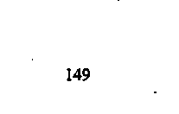
TABLE 8-1: Mean lung function and exercise test results at admission and discharge in 35 patients hospitalised with pulmonary exacerbation.
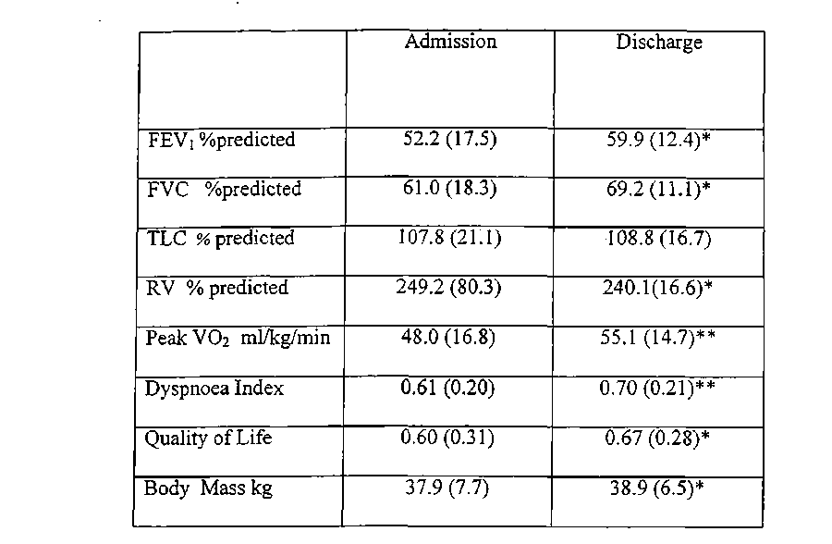
FEV| Forced expiratory volume in one second
FVC Forced vital capacity
TLC Total lung capacity
RV residual volume
V02 Aerobic capacity
Dyspnoea Index = Breathing reserve
* p<0.05 ** pO.Ol ( Students t test)
150
Values shown are the mean values with the standard error of the mean in brackets
TABLE 8.2 Percent changes in 20 patients with Shwachman score <70 compared to 15 patients with Shwachman score > 70
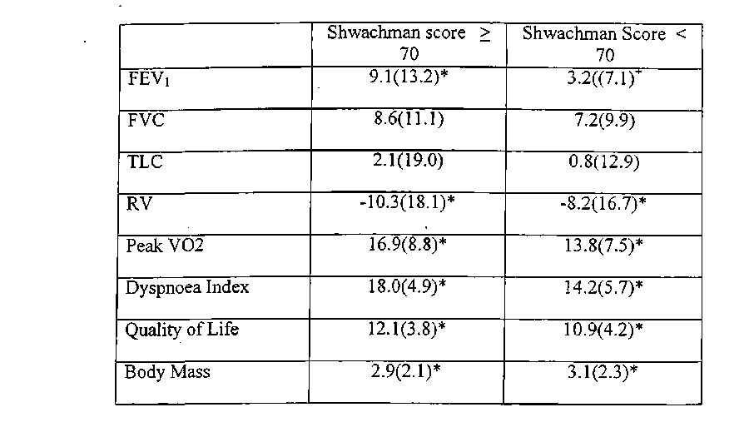
Values shown are the mean percentage changes from admission to discharge with standard error of the mean values in brackets.
* Statistically significant difference from admission to discharge (p < 0.05, Students t
test) + Statistically significant difference between improvement in groups with Shwachman scores above and below 70 (p<0.05, Students t test)
FEVj Forced expiratory volume in one second
FVC Forced vital capacity
TLC Total lung capacity
RV residual volume
' V02 Aerobic capacity
Dyspnoea Index = Breathing reserve ' •*
151
152
Figure 8.1: Changes in quality of life compared to percent changes in peak aerobic capacity (V02) and lung function (FEVl).
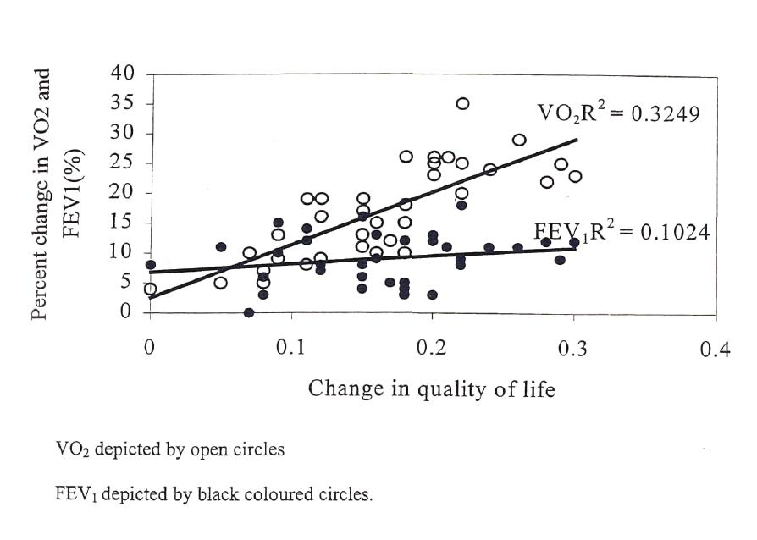
8.4 Discussion
This study has demonstrated that hospital therapy for acute pulmonary exacerbations produced improvements in peak aerobic capacity, dyspnoea index and quality of life. Lung function test parameters such as FEVi and FVC did not change as much as these other parameters, especially in patients with more severe CF disease. Furthermore, changes in quality of life correlated better with peak aerobic capacity than changes in lung function.
To date, a great deal of emphasis has been placed on lung function tests by physicians and patients when assessing response to hospital therapy for pulmonary exacerbations in CF. However, lung function tests have previously been demonstrated to have significant intra-individual variability [Nickerson et al, 1980; Cooper et al, 1990]. Although Redding et al, [1982] documented serial changes in lung function in children hospitalised with CF, the only study to date to analyse the changes according to severity of CF disease was by Gozal et al, [1993]. As in the present study, Gozal et al [1993] demonstrated that changes in lung function (FEVi, FVC) in patients with moderate to severe CF disease did not reach statistical significance. Gozal et al, [1993] also measured single breath nitrogen washout and concluded that changesnn nitrogen washout after hospital therapy, were better measures of change in patients with moderate to severe CF. It was postulated that this was because improved nitrogen washout reflected the improved pulmonary ventilation after hospital therapy. However, there was marked variability in the test, thought to be due to the effect of bronchodilators. Further, the equipment to measure nitrogen washout is not available in all lung function laboratories.
153
Exercise tests have obvious advantages over lung function tests and the nitrogen washout test in that while they also measure pulmonary ventilation, they are highly reproducible [Brown et al, 1985] and correlate significantly better with quality of life. As with the nitrogen washout test, exercise testing in this study detected significant changes in patients with moderate to severe disease which were not apparent with standard lung function tests. This is likely because exercise tests, and in particular aerobic capacity and dyspnoea index, are indirect measures of alveolar ventilation.
Quality of life was assessed uSing the quality of well being score [Orenstein et al, 1989]. This assessment has only been validated in the outpatient setting. In this study, the assessment was administered on the day of admission to hospital and again within 1 week of discharge. The emphasis of the admission assessment was on how the subject felt over the two weeks preceding admission, although the subjects' dislike of being admitted to hospital may have affected this assessment.
All the children who were admitted to hospital for therapy were encouraged to be as active as possible while in- patients. Thus, while a formal training program was not undertaken, all the children participated in thrice weekly activities such as basketball games and bicycle riding. Each session lasted 20 minutes and this may account for the lack of deconditioning in the children while in hospital.
In conclusion, this study has demonstrated that clinical improvement in children, with moderate to severe CF disease, after hospital therapy for pulmonary exacerbation
154
was not associated with significant spirometric changes but was associated with significant changes in aerobic capacity. Thus, exercise testing was a better indicator of change in children with moderate to severe CF than lung function testing which underestimates the degree of clinical improvement.
155
CHAPTER 9 " Validation of the shuttle tests in children with Cystic Fibrosis
9.1 Introduction
Exercise testing is a valuable tool for gauging the physiological impact of chronic lung diseases such as Cystic Fibrosis (CF). Exercise tolerance reduces as the patient's lung function deteriorates [Cropp et al, 1982] and there is a high correlation between exercise tolerance measured by aerobic fitness and long term survival [Nixon et al, 1992]. As exercise tolerance has become an important outcome measure of the effectiveness of interventional trials in patients with CF [Ramsey and Boat, 1994], there is clearly a need to validate a reliable, and sensitive test of maximal, aerobic fitness in children with CF. While a maximal test on a treadmill is considered the "gold standard" [Orenstein, 1998], it is expensive, not readily accessible and threatening to young children. To facilitate assessment in children, the test should be non-threatening, simple to perform, inexpensive and easy to adrninister [Orenstein, 1998].
Shuttle tests, in which a subject walks (10m test) or runs (20m test) between two markers, are potentially very useful in measuring the effectiveness¹ ~~of clinical interventions. The two shuttle tests commonly in use are the 10m shuttle walk which was developed by Singh et al [1992, 1994] and the 20m shuttle run which was developed by Leger et al [1988]. These tests are effective measures of the aerobic fitness as they measure the linear relationship between the rise in maximal oxygen uptake (V02) and changes in running or walking speed [Menier and Pugh, 1968]. Assessment of their validity has been made in healthy children [Van Mechelin et al, 1986; Leger et
156
al, 1988; Liu et al, 1992; McVeigh et al, 1995], athletes [Ramsbottom et al₉1988], and a sedentary adult population [Paliczka et al, 1987]. Neither of the shuttle tests have however been validated in children with lung disease. The aim of this study therefore was to assess the reproducibilty and validity of the shuttle tests, by comparing results obtained in these tests with those obtained from assessing treadmill peak aerobic capacity in children with Cystic Fibrosis.
9.2 Materials and Methods
Subjects
Children aged 6 to 16 years who attended the CF clinic at the Royal Alexandra Hospital for Children were invited to take part in the study. We excluded children with intercurrent infective exacerbation, those known to have pulmonary hypertension, and those who were oxygen dependent. Power calculations demonstrated that to detect a 0.5 standard deviation difference in peak aerobic capacity between the treadmill test and the shuttle test, with a significance of 0.05 and power of 80% a total of 30 subjects would be required. Approval for the study was obtained from the Royal Alexandra Hospital for Children Ethics Committee, and written informed consent was obtained from parents, or where appropriate from the study participant.
Study Design
Treadmill testing on all children was performed using the modified Bruce protocol [Orenstein, 1998]. Children performed either the 10m shuttle walk or the 20m shuttle run, or both tests. The 10m shuttle walk was used for all children who were 7 years of
157
age and younger, and those deemed too ill to perform the longer test. The 20m shuttle run was used in children older than 7 years. For the study, the children performed two identical shuttle tests and one treadmill test within a week. The order in which the shuttle tests and treadmill tests were undertaken was randomised. In those children doing both the 10m walk and the 20m run shuttle tests, the order of the testing was also randomised.
The 10m test was performed as previously described by Singh and coworkers [1992] and the 20m test was performed as described by Leger and colleagues [1988]. Shuttle tests required the child to walk (10m test) or, run (20m test), between two markers delineating the respective course, at a set incremental speed determined by a computer generated signal which is played by a standard audio cassette player. The test was terminated when the subject was unable to keep up with the paced signals. A validated Rating of Perceived Exertion scale, also known as the Borg score [Borg, 1982; Burdon et al₉ 1982; Wilson and Jones, 1989] was administered to quantify dyspnoea after the shuttle runs and treadmill tests.
The shuttle tests were performed with the subject wearing a firmly fitted facemask attached to the Cardiovit 100 CS Spirometry Module (Schiller, Switzerland) which has an in-built gas analyzer allowing measurement of breath by breath gas analysis throughout the test. The subject's heart rate was measured at rest and then continuously during testing using a heart rate monitor (Cardiosport, Australia). Pulse oximetry was measured via a finger probe (Biox 3700e, Ohmeda, Boulder, CO USA) throughout the test. The velocity for the 10m shuttle test is set at 1.8 km/hr for the first
158
minute and increased by 0.61 km/hr for every minute thereafter. The velocity (V) for the 20m shuttle test is set at 8km/h for the first minute and increased by 0.5km/h for every minute thereafter.
Prior to testing, each child's body weight, height and skinfold thickness were recorded. The skinfold assessment was made from four sites - the triceps, biceps, subscapular and suprailiac regions and was used to calculate the lean body mass [Durnin and Rahaman, 1967]. The aerobic capacity was recorded in terms of the lean body mass.
Data Analysis
In addition to the raw VO2 obtained by breath by breath gas analysis, the peak VO2 values were calculated for the 20m shuttle test using previously published regression equations [Leger et al, 1988] namely V0₂ peak = 31.025 + (3.238 x V_{max}) - (3.248 x A) where V_{max} is the maximal velocity attained in the last stage in km/h and A is the age in years. V_{max} was calculated as follows, V_{max} (km/h)= V + 0.5x n/60, where V is the velocity maintained during the next to last stage and n is the number of seconds the last stage was maintained.
Reproducibility between the first and second shuttle runs was measured by comparing the mean difference in peak aerobic capacity, heart rate, oxygen saturation, Borg score and distance cowed obtained in the two runs. Comparison of the results obtained for peak aerobic capacity, heart rate, oxygen saturation, Borg score and distant eovered for the shuttle test and treadmill tests were used to assess the validity of the shuttle test.
159
All data analysis was performed using the SPSS software package and differences in probability less than 5% (p<0.05) were considered significant. Mean differences were compared using paired Student's t-tests to assess reproducibility of the shuttle tests. The correlation between the peak aerobic capacity obtained by the shuttle test method and the treadmill method was measured using Pearson's correlation (r). Agreement between the shuttle test and the treadmill tests was demonstrated graphically using Bland-Altaian plots [Bland and Altman, 1986],
9.3 Results
The demographics of the children who participated in the study are shown in Table 9.1. The 10m shuttle test was completed by 35 children, the 20m shuttle test by 58 children and both the 10m and 20m comparison by 30 children. The shuttle tests were generally well tolerated by the children. Three children did not complete the initial 10m shuttle test due to coughing spasms. Another child withdrew due to joint pains. All four children did however, repeat the test without incident. Similarly, the treadmill tests were abandoned on four other children because of coughing spasms but, again, the tests were repeated without incident. Of the total of 108 subjects studied, 100 preferred the shuttle tests over the treadmill tests, 5 did not favour one type of testing over the other and 3 preferred the treadmill test.
10m shuttle test
The results indicate that the 10m shuttle walk is a very reproducible test (Table 9.2,
Figure 9.1 A). There were no significant differences between the first and second runs of
160
each shuttle test for maximal heart rate, distance walked, maximal saturato®, peak aerobic capacity and Borg score. For example, the mean difference in peak aerobic capacity measured in successive shuttle runs was 2.41ml/kg/min (SD 4.19, limits of agreement 3.46, -0.18).
The 10m shuttle test also correlated well with the treadmill test (Table 9.3, Figure 9.2A). For example, the peak aerobic capacity measured using the shuttle test and the treadmill test differed by a mean of 5.30 ml/kg/min (SD 4.63, limits of agreement 7.46, -1.18) and the Pearson's correlation was 0.76 (p<0.05). Although the values for the other measured parameters assessed were lower in the shuttle test compared to the treadmill test, these differences were not statistically significant.
The relationship between the distance walked and the peak measured aerobic capacity was strong (r = 0.91) and is represented by the regression equation: VO2 = [0.0289 x distance] + 17.46 where the distance that was walked is expressed in meters and the VO2 in ml/kg/min.
20m shuttle test
The 20m shuttle test was also very reproducible. There were no significant differences between the two shuttle runs in the measured heart rate, distance walked, saturation (oximetry), peak aerobic capacity and Borg score (Table 9.2, Figure 9.IB). As with the 10m test, the mean different in peak aerobic capacity was very low, 2.07 ml/kg/min (SD 2.51, limits of agreement 3.90, -0.60).
161
The 20m shuttle test also correlated well with the standard treadmill test (Table 9.3, Figure 9.2B). The peak aerobic capacity measured using the 20m shuttle test and the treadmill test differed by a mean of 3.50 rnl/kg/min (SD 3.20, limits of agreement 4.90, -1.60).
The Pearson's correlation between the peak aerobic capacity (measured by direct gas analysis) during the 20m shuttle test and the calculated aerobic capacity (using the formulae described above) was r = 0.71 (p<0.05). This correlation improved when weight age rather than the chronological age was used as the age variable (A). With this amendment, the Pearson's correlation between the raw and calculated value was r = 0.84 (p<0.01).The mean difference between the direct gas analysis and the calculated value was 2.23 ml/kg/min (SD 1.32, limits of agreement 2.60, -1.93). A Bland and Altman plot comparing the two methods of estimating aerobic capacity is presented in figure 9.3. The relationship between direct gas analysis and the calculated method is presented by the regression equation: V02peak (direct)= 0.8 x VO2 (calculated) + 8.53.
10m vs 20m shuttle test
There was a moderate correlation [r = 0.60 (p<0.05)] between the measured peak aerobic capacity obtained by the 10m and 20m shuttle tests. The peak aerobic capacity measured using the 20m shuttle test and the 10m shuttle test differed by a mean of 7.89 ml/kg/min (SD 3.67, limits of agreement -0.90, 9.90).However, when the peak aerobic capacity was corrected for the maximal heart rate attained during the test (oxygen pulse) the correlation was 0.83 (pO.Ol).
162
Eight subjects completed all the levels of the 10m shuttle test (mean age 13.6, range 12.0 to 16.5 years). The mean respiratory quotient (RQ) of these children was 0.99, which demonstrated that the test was submaximal. The measured aerobic capacity at the conclusion of the test was recorded and included in the analysis despite these children not reaching maximal effort.
The mean difference between the Borg Scpre after the two shuttle runs was -0.75 units (SD 0.32, p<0.05). When the eight subjects who completed all the stages of the 10m shuttle test were excluded from analysis, the mean difference was no longer statistically significant (0.42, SD 0.22).
163
TABLE 9-1: Demographic details of Subjects
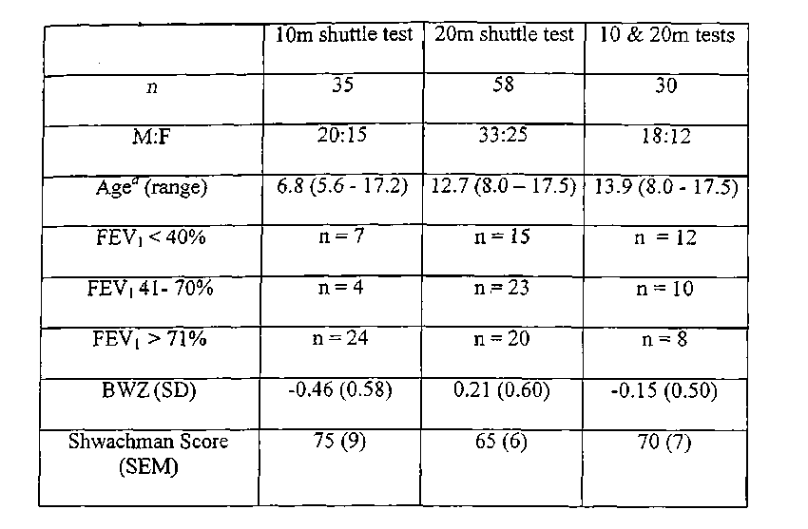
^{fl}mean age in years
BWZ mean body weight z score
FEVi Forced expiratory volume in one second
164
Table 9.2: Repeatability of the 10m and 20m shuttle tests
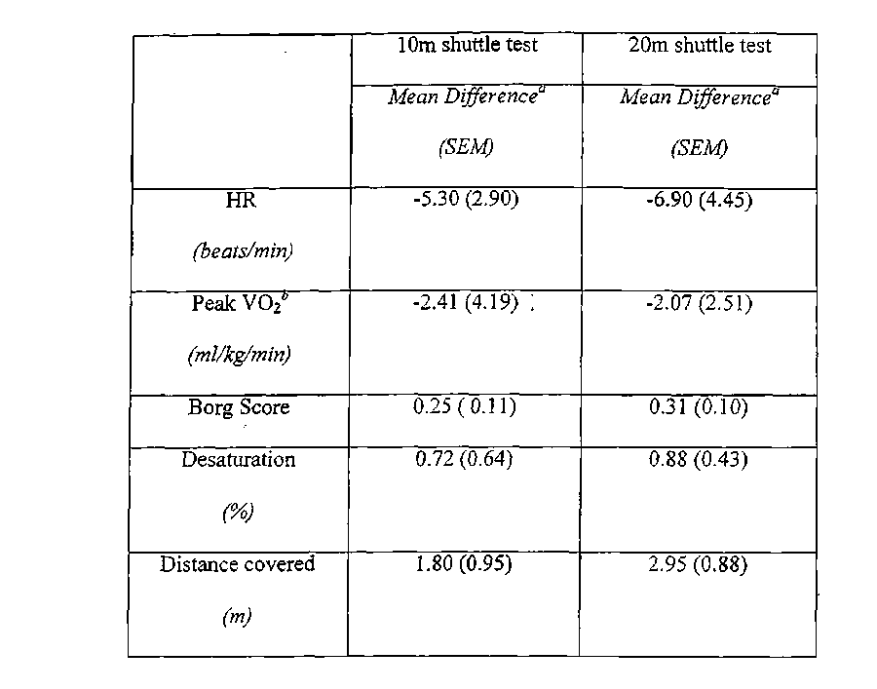
ª difference in parameters measured in the first and second shuttle tests value measured using the gas analyser VO2 peak aerobic capacity HR heart rate
165
TABLE 9.3: Comparison of the shuttle and treadmill tests
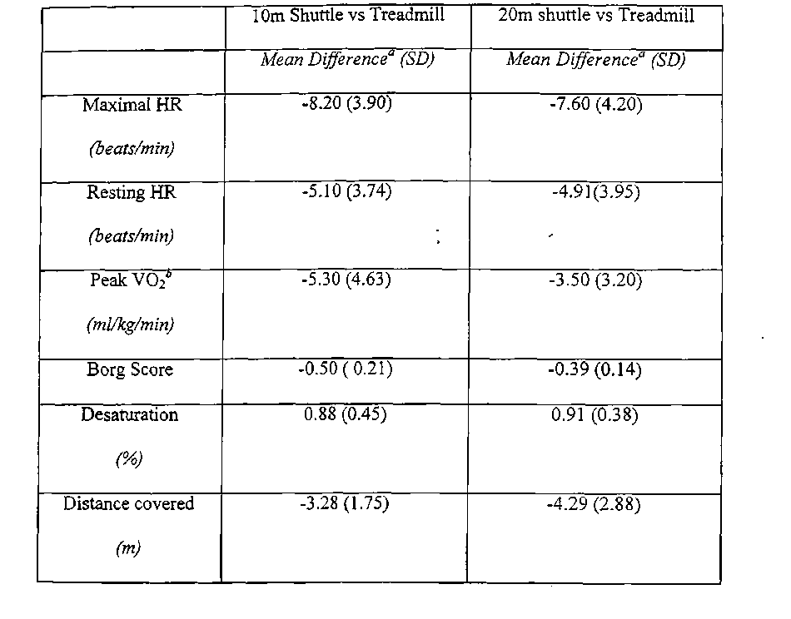
ª difference in parameters measured in the first and second shuttle tests
value measured using the gas analyser VO2 peak aerobic capacity HR heart rate

FIGURE 9.1: Reproducibility in measurement of aerobic capacity in successive shuttle tests (A) 10 m shuttle walk, (B) 20 m shuttle run
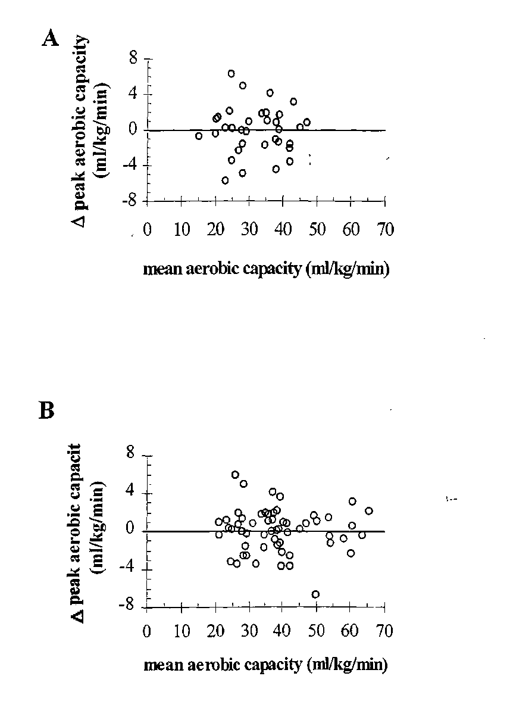
167
FIGURE 9.2: Comparison of aerobic capacity measured by the shuttle and treadmill tests (A) 10m shuttle walk, (B) 20m shuttle run
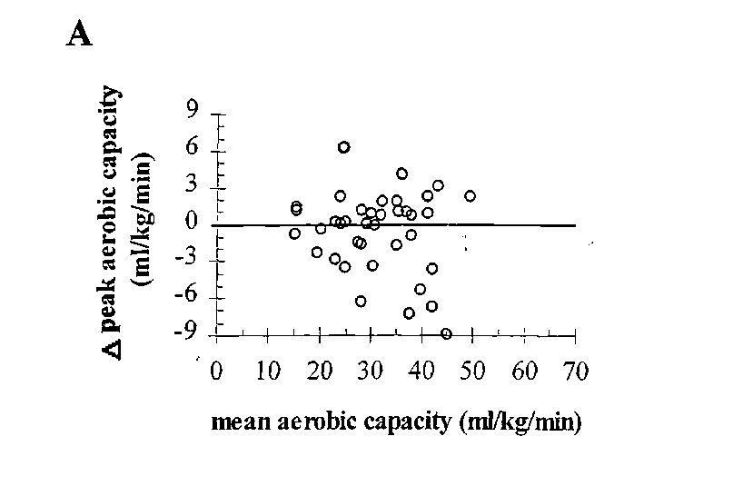
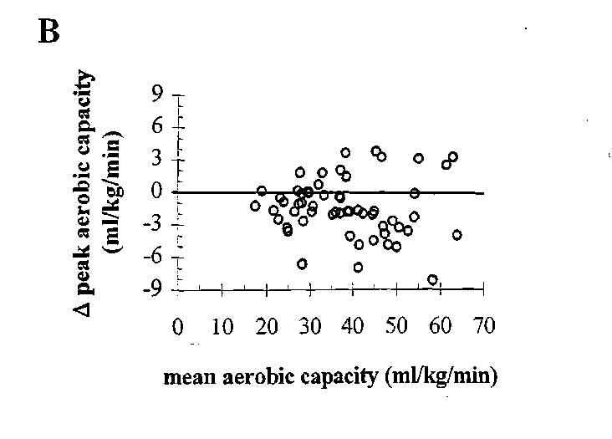
168
Figure 9.3: Comparison of the measured and calculated methods of estimating aerobic capacity for 20m shuttle test (Bland and Altman plot).
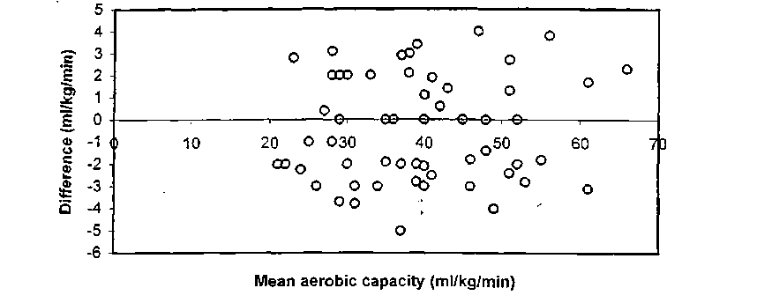
169
Difference (inl/kg/min) = measured aerobic capacity - calculated aerobic capacity
9.4 Discussion
The results of this study demonstrate that both the 10m and 20m shuttle tests are valid measures of aerobic capacity in children with Cystic Fibrosis. The tests are reproducible and correlate well with the treadmill tes| in terms of peak aerobic capacity, maximal heart rate, maximum desaturation and Borg's score of exertion.
The 10m arid the 20m shuttle tests correlated well with each other when the peak aerobic capacity was adjusted for heart rate. This was due to the fact that the fitter subjects were able to complete all the stages of the 10m shuttle walk without reaching peak aerobic capacity or maximal heart rate, but did reach these peaks with the 20m run test. To correct for this submaximal effort in the 10m shuttle test, the aerobic capacity was expressed in terms of the heart rate (known as the oxygen pulse). Similarly, while the Borg' score of exertion was significantly different between the two tests, the difference can be attributed to the eight children who completed the 10m shuttle test without reaching functional limitation. When the eight children were excluded from analysis, there was no longer a significant difference between the tests. These results suggest that while the 10m and 20m shuttle tests are independently valid tests, they can only be used interchangeably if the subject reaches maximal functional limitation in both. If this is not achieved, the oxygen pulse should be the parameter of choice. None of the children who completed all the stages of the 10m shuttle test were less than 7 years of age.
On the basis of our study, we suggest that 10m shuttle walk test should be used when studying either the young child (7 years of age or younger) or those with advanced
170
disease who are able to walk but not run. The 20m shuttle test should be used when studying children older than 7 years who are able to run.
Both the shuttle tests and the treadmill tests resulted in steady increments in heart rate with the increase in exercise intensity. Although, the peak heart rate did not reach statistical significance, that reached during the treadmill test was greater than that obtained during the shuttle tests. This may be due to either the relatively more threatening laboratory environment of the treadmill test, or, that the treadmill test was genuinely a more maximal test. The former explanation is more likely given that the resting heart rates were also greater with the treadmilll test, although, this difference was not statistically significant.
Given the excellent correlation between the measured VO2 and the calculated VO2, there is no necessity for direct gas analysis and hence, no requirement for expensive gas analysis machines and face masks. The peak VO2 can be calculated accurately from the subjects weight age and distance walked. This makes the shuttle test a very useful tool in clinical interventional trials. In our study, we modified the equation provided by Leger and colleague [1988] for calculating the peak aerobic capacity from the 20m shuttle test by substituting weight age for chronological age. The weight age is a commonly used parameter for assessing nutritional status in children. It is the age in years which corresponds to the point where the subject's weight meets the fiftieth percentile on a standard growth chart.
171
The validity of the 10m shuttle test has been assessed in adults with chronic airflow limitation and shown to be reproducible [Singh et al, 1992] and have good criterion validity with the treadmill VO2 [Singh et al, 1994]. The validity of the 20m shuttle test has been assessed in children without underlying cardiorespiratory disease and shown to be reproducible [Leger et al, 1988]. This study has added to these by validating Hie shuttle tests in children with cystic fibrosis.
To date, the six minute walk test [Gulmans et al, 1996] and the step test [Balfour- Lynn et al, 1998] have been validated in children. However, the limitation of the six minute walk test is that being self paced, is it subject to great variability and hence is not suited to clinical intervention trials. The step test does not measure a maximal functional capacity and the workload will vary according to the step height, and the weight and height of the subject and therefore, is not suited to longer-term clinical intervention trials. The shuttle tests overcome these limitations by being externally paced maximal tests which measure maximal aerobic capacity.
Unlike the treadmill or cycle ergometer test, the shuttle tests are non threatening. The subject can terminate the test at any point they choose. This was "particularly obvious in younger children and children with advanced disease who required persuasion to perform the treadmill test, but they were eager to perform the shuttle test. As the shuttle tests require tbe child to either wn or walk (depending on the test) between two markers, 4he tests do not necessitate acquisition of new skills to participate. This was reflected in our study by the overwhelming preference for the shuttle test over the treadmill test
172
Shuttle tests are frequently used in schools and by sporting teams, and therefore the children did not require extenrfve instructions on how to participate. The subject is accompanied for only the first minute of the test by the investigator. There was no significant "learning effect" seen in the study.
A portable pulse oximeter was used for the study. To improve the accuracy, the probe was taped to the index finger and the lead was strapped to the arm [Orenstein et al, 1993a]. Movement artifact was a problem encountered infrequently with the 10m shuttle walk and more commonly with the 20m shuttle run. A finger probe was preferred over the use of an ear lobe probe because of the improved accuracy as demonstrated by the studies performed by Gaskin and Thomas [1995].
In conclusion, the 10m shuttle walk and the 20m shuttle run tests are reproducible, valid assessments of maximal function limited aerobic capacity. Given the much greater patient preference over the treadmill test, the shuttle tests should be utilised in the assessment of aerobic capacity in the child with cystic fibrosis as well in interventional studies.
173
CHAPTER 10
A randomised controlled study of in-hospital exercise training programs in children with Cystic Fibrosis
10.1 Introduction
Lung function and exercise tolerance are maintained in patients with mild Cystic Fibrosis (CF), but deteriorate as the disease progresses [Cropp et al, 1982]. Patients with high levels of aerobic fitness have a much better long term survival than those with lower levels of fitness [Nixon et al, 1992], Exercise traimng programs aim to preserve and improve aerobic fitness and are recognised as essential components of pulmonary rehabilitation [Boyle et al, 1976; Lacasse et al, 1996, ACCP/AACVPR Guidelines 1997].
The two commonly used exercise training programs are aerobic training (at) and resistance or weight training (rt). The principal difference is that aerobic training is directed at improving cardiovascular conditioning and resistance training is aimed at improving muscle strength. Most studies on the effect of exercise training programs have been performed in adult CF patients [Orenstein et al, 1981; O'Neill et al, 1987; Heyerman et al_{t} 1991; De Jong et al, 1994]. There are a limited number "of aerobic training studies performed in children with CF, These were all performed in the outpatient setting and had small sample sizes [Zach et al, 1982; Edlund et al, 1986; Andreasson et al, 1987; Gulmans et al, 1996]. There have been no previous studies on the effect of training programs in children with CF admitted to hospital with an infective pulmonary exacerbation, or, on the effect of resistance training in children with CF.
174
The aim of this study was to compare groups performing aerobic and resistance training with a control group in children with Cystic Fibrosis admitted to hospital with an intercurrent pulmonary infection.
10.2 Materials and Methods
Subjects
Children with CF, between the ages of eight and sixteen years, who were admitted to the Royal Alexandra Hospital for Children for the treatment of an infective pulmonary exacerbation were eligible for the study. An infective pulmonary exacerbation was diagnosed if there were features of increased cough and purulent sputum. An abnormal chest X ray, weight loss and generalised malaise were frequently associated with the infective pulmonary exacerbation. Children with known pulmonary hypertension or, wi© required daytime oxygen prior to the infective exacerbation which lead to the hospital admission were excluded from the study.
Power calculations revealed that to a total of 60 subjects would be required to detect a 0.5 standard deviation difference in aerobic capacity and muscle strength between each of the training programs, with a significance of 0.05% and power of 80%.
Study Design
Each subject received the standard in hospital care which included intravenous antibiotics (chosen on the basis of the sensitivities of the pathogenic organism in the sputum or bronchoalveolar lavage), chest physiotherapy and nutritional
175
supplementation. The subjects were randomised into three training groups within the first day of admission. The randomisation was performed in blocks of six, using concealed information inside opaque envelopes. The three training groups were aerobic trainings resistance Wining and control group.
Parameter of Assessment Anthropometrics
All subjects had their weight measured using an electronic scale (Metier IDI multimap, Tiel, The Netherlands) between 9am and 10am. The height was also recorded at the same time (Holtain, Crymich, UK). The measurements were transformed into standard deviation scores [Hamill et al, 1979]. The fat free mass (FFM) was calculated using the skin fold thickness from four sites (biceps, triceps, subscapular and supra iliac crest) Purnin and Rahaman, 1967].
Pulmonary Function Tests
Pulmonary function tests were performed within 36 hours of admission and repeated on discharge from the hospital and again at one month after discharge. Measurements of forced expiratory volume in one second (FEVi) and forced vital capacity¹ (FVC) were obtained (Sensormedics 2800 Autobox, Yorba Linda, CA). The values presented by Polgar and Promodhat [1971] was used as the reference range.
Exercise Tests
All subjects performed an incremental treadmill (Cardiovit 100 Schiller, Switzerland).
exercise test using the modified Bruce protocol. During the test, gas analysis was
176
performed and minute ventilation (VE), oxygen uptake (V0₂), carbon dioxide production (VCO2) and respiratory quotients (RQ) were recorded. The exercise tests were performed within 36 hours of admission, on discharge and one month after discharge from hospital on all subjects. Lower limb strength was measured using a Cybex dynamometer (Lumex Inc, Ronkonkoma, NY). The muscles tested were the quadriceps femoris and the hamstrings of the non-dominant leg. The best of three repetitions were recorded as the strength of the tested muscle group. The strength tests were performed on the same day as the incremental exercise tests.
Quality of Life
An assessment of quality of life was made using the quality of well being scale as reported by Orenstein et al, [1989] and Kaplan et al, [1989], As this scale was previously validated only in the outpatient setting, it was administered on the day of admission and one month after discharge from hospital.
Levels of Activity
Subjects completed a seven day activity diary [Bouchard et al, 1983; Bratteby et al, 1997] as well as wearing an activity accelerometer [Freedson et al, 1998; Trost et al, 1998] for seven days prior to admission to hospital. These subjects repeated the seven-day activity diary as well as wearing the activity monitor for a week one month after discharge from hospital.
177
Study Design Aerobic Training
Children randomised to the aerobic training group participated in aerobic activities for five sessions (each of thirty minutes duration) a week. The aerobic activities comprised running on a non motorised treadmill, or cycling on a stationary bicycle at a speed which maintained the heart rate at seventy percent of the maximal heart rate for thirty minutes. Subsequent to the exercise test performed on admission where expired gas analysis was performed, each subject performed a maximal exercise test (non motorised treadmill or cycle, without gas analysis), every five days to determine the individual's peak heart rate. The peak heart rate from the most recent exercise test was used to determine the target heart rate (70% of peak heart rate) for the training program. The training was terminated earlier than the mandatory thirty minutes if a subjective index of dyspnoea, also known as the Borg score [Borg, 1982], reached seven.
Resistance Training
Subjects randomised to the resistance training group exercised both upper and lower limbs against a graded resistance machine (Tidro-power, Keylink, Adelaide, South Australia). At each visit, the subject would increase the resistance until a Borg score of WUa was reached. At this level of resistance, the subject would perform five sets often repetitions before exercising the same movement in the contralateral limb. The procedure was repeated for both arms and legs. As with the aerobic training group, subjects in the resistance-training group attended five sessions per week.
178
Control Group
Subjects in the control group received the standard chest physiotherapy as well as
intravenous antibiotics and nutritional supplementation.
Data Analysis
The parameters of assessment measured on admission, discharge and one month after discharge were lung function (FEVi, FVC), peak aerobic capacity, total body mass, fat free body mass, muscle strength and levels of activity. Quality of life, using the quality of well being scale, was compared at admission and one month after discharge from hospital. The peak aerobic capacity was expressed in terms of the fat free mass.
The mean change from baseline for each of the three groups for the parameters of assessment was calculated and a two tailed paired Student's t test was used to assess the statistical significance of any changes from baseline. Significance was assigned when p<0.05 [Airman 1991]. Group differences for the repeated measures were analysed using Duncan's test of multivariate analysis of variance. The SPSS-PC+ package (version 5.0) [Nie 1975] was used for statistical analysis. The correlation between changes in lung function and peak aerobic capacity after hospital therapy and~changes in quality of life was assessed using Pearson's correlation.
10.3 Results
Sixty six children participated in the study. Four children initially consented to the study ^{t}b®& subsequently were excluded prior to randomisation due to patient and, or parental concerns about the possibility of being randomised into the control group. The
179
demographic details of the children who participated in the study are presented in Table 10.1. There was a wide range of disease severity in the study sample and no significant differences between the groups for any of the assessed parameters. The male to female ratio was, likewise, not significantly different between the three groups. Although none of the children were withdrawn from the study, one subject in the control group developed haemoptysis on day 9 of admission and withdrew from the study for the subsequent 2 days. One subject in the aerobic training group injured her ankle while on a day pass and missed the subsequent 2 days of aerobic training. The mean duration of the hospital admission for the aerobic training, resistance training and control groups was not significantly different (18.6 (SD 3.9), 18.8 (SD 4.1) and 18.6 (SD 3.8) days respectively).
The changes from admission to discharge for each of the parameters of assessment (except for the quality of life score which was measured on admission and one month after discharge) are presented in Table 10.2. Aerobic training produced significant improvements in peak aerobic capacity (21.64%), FEVi (6.54%), quality of life (14.28%) and body mass (2.09%). Resistance training produced significant improvements in FEV! (10.09%), lower limb strength (18.32%) and body mass (7.25%). The control group had significant improvements in FEVi (4.51%) and body mass (2.69%). Although the peak aerobic capacity and lower limb muscle strength decreased in the control group, this reduction did not reach statistical significance.
There were no significant changes in any of the objective parameters from the time of discharge to one month post discharge (Table 10.2). However, subjects who
180
participated in aerobic training while in hospital continued to improve their aerobic fitness, irispite of the lack of a supervised training program. Subjects who received resistance training lost some muscle strength in the month after discharge but this did not reach statistical significance. Subjects in the control group improved their aerobic fitness as well as strength in the one month after discharge from hospital but, again, this improvement did not reach significance. The changes in each of the parameters of assessment according to each type of training is graphically presented in Figure 10.1.
Of the 49 subjects who were also part of a separate study on activity levels in children with CF, 15,18 and 16 were randomised to the aerobic training, resistance training, and control groups, respectively. These children had their activity levels measured when well, prior to their chest infection and again one month after discharge from hospital. The ^tivity levels in children who received aerobic training improved by 8.64 % from the pre pulmonary infection level. This improvement was significantly greater than the improvement obtained by resistance training (3.81 %). The control group had a reduction in activity level (-1.02 %). The results are reported in Table 10.3.
Duncan's test of ANOVA for multiple measures identified aerobic training as the best training program for improving peak aerobic capacity, and quality of life. Resistance training was identified as the best training program for improving FEVi, body mass, fat free mass, and leg strength. Changes in quality of life as measured by the quality of well being scale correlated better with changes in peak aerobic capacity (r = 0.57) than changes in FEVl (r = 0.32). The regression is graphically presented in Figures 10.2 and 10.3 respectively.
181
TABLE 10.1: Baseline results for the different training groups.
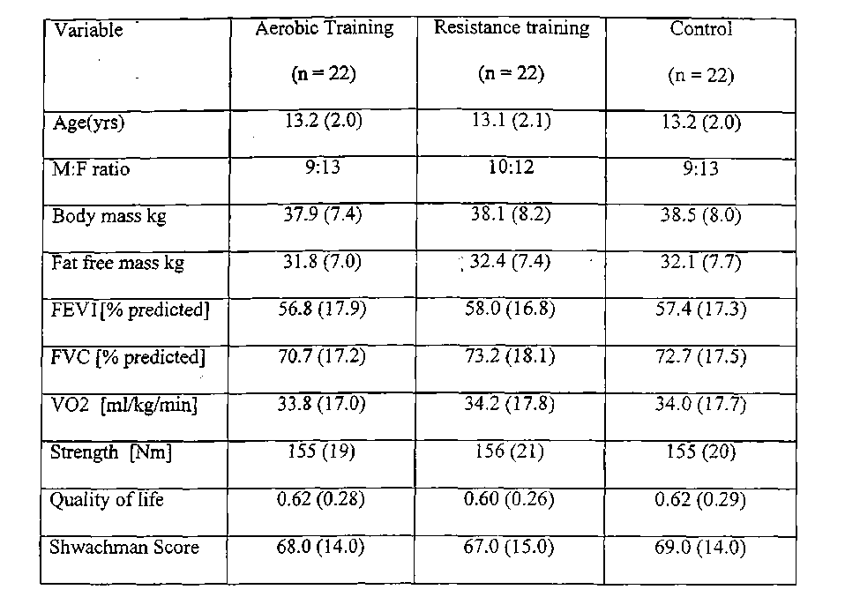
Values shown are the mean values with the standard error of the mean shown in brackets.
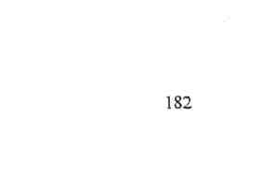
TABLE 10.2: Changes from admission for each training program
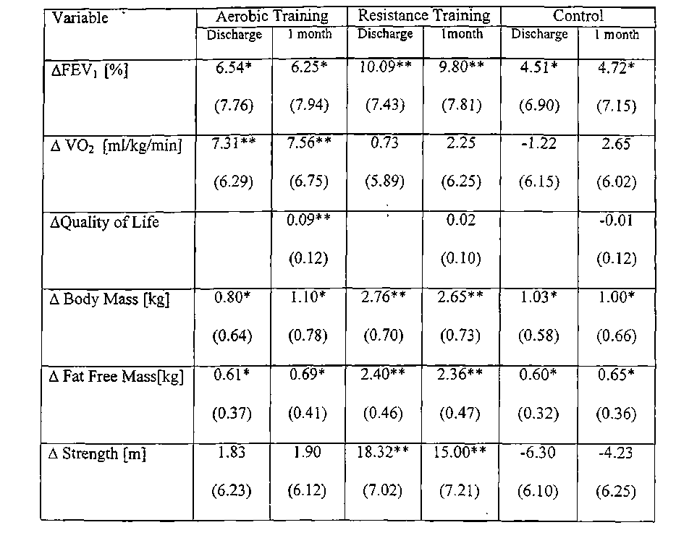
Student's t test ** p<0.01 *p<0.05
A Change from admission to one month after discharge
Values shown are the mean values with the standard error of the mean shown in
brackets.
183
TABLE 10.3: Changes in activity levels with training programs
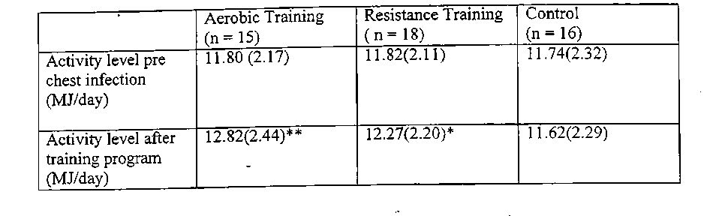
Students / test ** p<0.01 * p<0.05
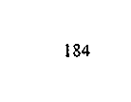
FIGURE 10.1: Change between admission and discharge for aerobic training, resistance training and control groups
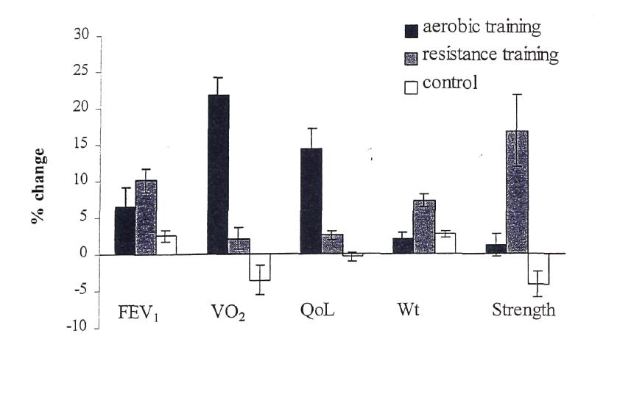
185
FEV] Forced expiratory volume in one second VO2 Peak aerobic capacity QoL Quality of life Error bars depict SEM
FIGURE 10.2: Relationship between changes in quality of life and changes in peak aerobic capacity..
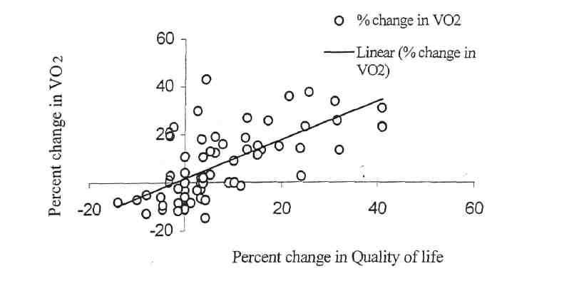
VO2 Peak aerobic capacity QoL Quality of life
186
FIGURE 10.3: Relationship between changes in quality of life and changes in lung function (FEVi).
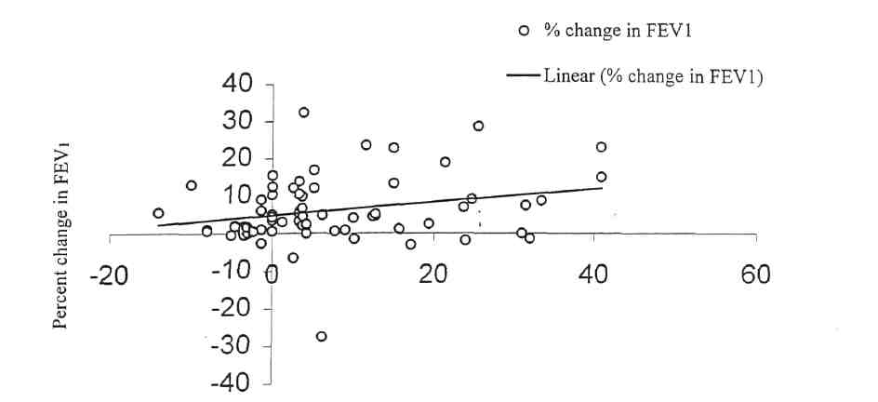
Percent change in quality of life
187
FEVi Forced expiratory volume in one second
1D.3 Discussion
This study has demonstrated that children with CF admitted to hospital with an infective pulmonary exacerbation, who participated in either aerobic or resistance training programs, were better in terms of the parameters of assessment than the control group which received no formal training program. Children who received aerobic training had significantly better peak aerobic capacity, activity levels and quality of life than children who received the resistance training program. Children who received resistance training had better weight gain (total mass, as well as fat free mass), lung function and leg strength than children who received aerobic training. The improvement in weight gain and lung function with resistance training is consistent with studies on adult patients with CF [Strauss et al, 1987] and adult patients with chronic obstructive pulmonary disease [Bernard et al, 1999]. This study is the first such study in children with CF.
Although, there was a significant improvement in lung function from baseline with aerobic training, it was not significantly different to the improvement obtained in the control group. Thus, the improvement in lung function is more likely due to the improvement in the chest infection from intravenous antibiotics and standard chest physiotherapy than any effect of the training program. This result is consistent with other studies, which also failed to detect any benefit in terms of lung function with aerobic training [Orenstein et al, 1981; Orentsein et al, 1983]. The deconditioning effect of hospitalisation is demonstrated in the control group by the reduction from baseline in leg strength, aerobic capacity and activity levels after discharge from hospital. With routine daily activities, the leg strength and peak aerobic capacity improved over the one month after discharge from hospital. While it has been previously reported that patients
188
with more severe disease, may have the potential to show greater improvement with training [Cerny et al, 1984], this study, by having a randomised control group, eliminated the chance of confounding bias for any given training group.
This study demonstrated that the improvements in the parameters of assessment were maintained for one month after discharge from hospital despite the lack of a formal exercise training program. Zach et al, [1986] found that the improvements in aerobic capacity from a swirnming program were maintained for eight weeks. In this study, a subgroup of children whose daily activity levels were recorded a month after discharge from hospital, demonstrated significant improvements, especially in those in the aerobic Ixaining group. The increased day to day activity levels may be the reason aerobic capacity was maintained one month after discharge in spite of the lack of a supervised training program. Improvements in quality of life, as measured by the quality of well being score, reached statistical significance only in the aerobic training group. This is consistent with the fact that changes in quality of life correlated better with changes in peak aerobic capacity than changes in lung function which has previously been reported by Orenstein et al [1989].
In summary, this study has demonstrated that aerobic training and resistance training improve different parameters of assessment in children with cystic fibrosis. These improvements were maintained for at least one month after discharge from hospital. Both programs were better than the control group in which children became deconditioned while in hospital. It may be that a combination of the aerobic and
189
resistance training may be the best training program and future studies on this are indicated.'
CHAPTER 11
Summary
In this thesis, the impact of Cystic Fibrosis (CF) on the ability of children to exercise was assessed, the role of exercise testing in the management of children with CF was further defined and the optimal exercise training program to use in children admitted to hospital with an intercurrent pulmonary exacerbation was determined.
Children with mild CF were demonstrated to be more physically active than healthy children without CF. Those with moderate to severe CF had activity levels which were similar to control children. The effects of pancreatic insufficiency on activity levels were most apparent in the cardiorespiratory status of girls after the onset of puberty. Prior to the onset of puberty, the physical activity levels in pancreatic sufficient and insufficient children were similar. Further studies are necessary to compare the energy costs of defined physical activities in children with CF with varying degrees of disease severity and healthy controls. It may be that a given physical activity may have different energy costs for different subjects depending on their disease severity. The effects of hormonal changes in subjects with CF on physical activity levels, and muscle function also need to be studied. This may provide information as to why pancreatic function is of greater importance after the onset of puberty.
Patients who were heterozygous for the delta F508 gene and possessed a second CFTR mutation belonging to either class I or II, had a significantly lower peak aerobic capacity and anaerobic power than those with a second CFTR mutation belonging to
191
class III. Patients, who possessed a second CFTR mutation belonging to either class IV or V, were' significantly fitter and stronger than those who had a second CFTR mutation belonging to class I, II or III. There were no statistically significant differences in the lung function of patients with different classes of CFTR mutations. Further studies need to be performed in children with combinations of CFTR mutations other than those with at least one Class II mutation. As these subjects are relatively uncommon, several CF centers would need to take part in the study, in order to get a sufficient sample size for meaningful comparisons.
Female athletes with mild CF, who are intrinsically active, were demonstrated to have a significantly lower peak aerobic capacity, anaerobic power and leg strength than their healthy training partners. The resting energy expenditure and daily activity levels were however, significantly higher in female athletes with CF than their healthy training partners. These results suggested that some process other than poor activity levels and, or, nutritional factors contributes to the comparatively poor ■ aerobic capacity and anaerobic power. Magnetic resonance spectroscopy using 31-Phosphorous was used to determine the efficiency of muscle metabolism in these subjects. Girls with mild CF were shown to have deficient anaerobic metabolism as well as inefficient iand deficient oxidative metabolism during high intensity exercise compared to healthy controls. Further studies should include male athletes with CF to determine if these findings are apparent in both genders and also non athletic CF patients to confirm that this defect is also seen in this group of CF patients.
192
Hospital therapy for acute pulmonary exacerbation was shown to produce significant* improvements in peak aerobic capacity, lung function, quality of life and weight. However, in the group of children with moderate to severe CF disease, the parameters measured in the exercise tests, quality of life and weight demonstrated the greatest magnitude of change. Changes in lung function tests (apart from residual volume) did not reach statistical significance in patients with moderate to severe CF disease. It was concluded that peak aerobic capacity is a better assessment of change in patients with moderate to severe CF admitted with a pulmonary exacerbation than standard lung function testing.
This thesis also assessed the validity of the 10m and 20m shuttle tests were assessed and it was concluded that the 10m shuttle walk and the 20m shuttle run tests are reproducible, valid assessments of maximal function limited aerobic capacity. Given the greater patient preference over the treadmill test, the shuttle tests should be utilised in the assessment of the child with CF as well as in interventional studies.
The optimal exercise program to use in children admitted to hospital with a pulmonary exacerbation was determined by performing a randomised controlled study. Aerobic training produced the greatest improvement in quality of life, whereas resistance training improved weight gain and lung function the most. These improvements were maintained for at least one month after discharge from hospital. Both programs were better than the control group in which children became deconditioned while in hospital. It is possible that a combination of aerobic and resistance training may produce the best outcome, but, this requires further study.
193
The studies presented in this thesis have accomplished the overall aim of addressing*deficiencies in the understanding of the role of exercise and exercise testing in the management of children with cystic fibrosis* In doing so, the studies have generated further research questions that will need to be addressed in future studies. Some of these studies have already commenced.
194
Bibliography
ACCP/AACVPR Pulmonary Rehabilitation Guidelines Panel 1997. Pulmonary rehabilitation: jlfet ACCP/AACVPR evidence based guidelines. Chest 1997; 112: 1363-1396.
Ainsworth BE, Haskell WL, Leon AS, Jacobs Jr DR, Montoye HJ, Sallis JF, Paffenberger Jr RS. Compendium of physical activities: classification of energy costs of human physical activities. Med Sci Sports Exerc 1993; 25: 71- 80.
Aitken ML, Franklin JL, Pierson DJ, Schoene RB. Influence of body size and gender on control of ventilation. J Appl Physiol 1986; 60: 1894-1899.
Alison JA, Donnelly PM, Lennon M, Parker S, Torzillo P, Mellis C, Bye PTP. The effect of a comprehensive intensive inpatient treatment program on lung function and exercise capacity in patients with cystic fibrosis. Phys Ther 1994;"74: 583-593.
Altman DG. Practical statistics for medical research. 1991. London, England: Chapman &HalL
American Thoracic Society: Standardization of spirometry — 1994 update. Am J Resp Crit Care Med 1995; 152: 1107-1136.
Andersen LB, Henckel P. Maximal voluntary isometric strength in Danish adolescents 16-19 years of age. Eur J Appl Physiol 1987; 56: 83-89.
195
Andreasson B, Jonson B, Kornfalt R, Nordmark E, Sandstrom S. Long term effects of physical exercise on working capacity and pulmonary function in cystic fibrosis Acta PaediatrScand 1987; 76: 70-75.
Armstrong N, Williams J, Balding J, Kirby B. The peak oxygen uptake of British children with reference to age, sex and sexual maturity. Eur J Appl Physiol 1991; 62: 369-375.
Asher MI, Pardy RL, Coates AL. The effects of inspiratory muscle training in patients with cystic fibrosis. Am Rev Respir Dis. 1982; 126: 855-859.
Astrand PO. Experimental studies of physical working capacity in relation to sex and age. 1952 (pp. 125-130). Copenhagen : Munksgaard.
Astrand PO, Ryhrning I. A normogram for calculation of aerobic capacity from pulse rate during submaximal work. J Appl Physiol 1954; 7: 218-221.
Ayalon A, Inbar O, Bar-Or O. Relationships among measurements of explosive strength and anaerobic power. In RC Nelson and CA Morehouse (Ed.) International series on sport sciences (Vol 1. Biomechanics IV) 1974 (pp572-577). Baltimore: University Park Press.
196
Balfour-Lynn IM, Prasad SA,- Laverty A, Whitehead BF, Dinwiddie R. A step in the right direction: Assessing exercise tolerance in Cystic Fibrosis. Pediatr Pulmonol 1998; 25:278-284.
Bar-Or O. Pediatric sports medicine for the practitioner. 1983 New York: Springer-Verlag.
Bar-Or O. The Wingate anaerobic test, an update on methodology, reliability and validity. Sports Med 1987; 4: 381-394.
Bar-Or O, Dotan R, Inbar A, Rotshtein A, Karlsson J, Tesch P. Anaerobic capacity and muscle fiber type distribution in man. Int J Sports Med 1980; 2: 89-92.
Beaver WL, Wasserman K, Whipp BJ. A new method for detecting anaerobic threshold by gas exchange. J Appl Physiol 1986; 60: 2020-2027.
Bell SC, Elborn JS, Nixon LE, Macdonald IA, Shale DJ. Repeatability and methodology of resting energy expenditure in patients with cystic fibrosis. Resp Physiol 1999; 115: 301-307.
Bell RD, MacDougall JD, Billeter R, Howald H. Muscle fiber types and morphometric analysis of skeletal muscle in 6 year old children. Med Sci Sports Exerc 1980; 12: 28-31.
197
Beilon G, Satta SO, Gilly R. Exercise testing in cystic fibrosis children. In: Lawson D, (Ed.). Cystic Fibrosis Horizons. Proceedings of the 9 International Cystic Fibrosis Congress, Brighton, England, 1984: 241.
Belman MJ, Epstein LJ, Doornbos Db, Elashoff JD, Koerner SK, Mohsenifar Z. Non invasive determinations of the anaerobic threshold. Reliability and validity in patients withCOPD. Chest 1992; 102:1028-1034.
Benson LN, Newth CJ, de Souza ME, Lobraico R, Kartodihardjo W, Corkey C, Gilday DL, Olley PM. Radionuclide assessment of right and left ventricular function during bicycle exercise in young patients with cystic fibrosis. Am Rev Respir Dis 1984; 130: 987-992.
Berenson GS (Ed.) Causation of cardiovascular risk factors in children. 1986. (pp 1-3) New York: Raven Press.
Bernard S, Whittom F, Leblanc P, Jobin J, Belleau R, Berube C, Carrier G, Maltais F. Aerobic and strength training in patients with chronic obstructive pulmonary disease. Am J Respir Crit Care Med 1999; 159: 896-901.
Berthoin S. Evaluation des apititudes aerobies a I'ecole: leur evolutions avec l'age le sexe et Fenlrainment. Unpublished doctoral dissertation. 1994. Universite de Lille II.
198
Bilton D, Dodd M, Webb AK. .Short term effects of exercise on airways resistance and air trapping in cystic fibrosis. Pediatr Pulmonol 1991; 6 (suppl): 281.
Blair C, Cull A, Freeman CP Psychosocial functioning of young adults with Cystic Fibrosis and their families. Thorax 1994; 49: 798-802.
Bland JM, Altman DG. Statistical methods for assessing agreement between two methods of clinical measurements. Lancet 1986; 8: 307-310.
Biro H, Fink G, Kav C. Effects of an intensive 4 week program on lung function and exercise tolerance in cystic fibrosis Pediatr Pulmonol 1991; 6 (suppl): 286.
Blimkie CJR, Ramsay J, Sale DG, Macdougall JD, Smith K, Garner S. Effects of 10 weeks of resistance Ixaining on strength development in prepubertal boys. In S.Obseid and KH Carlson (Eds), Children and Exercise XIII, International Series on Sport Science 1989. (ppl83-197), Champaign, IL.Human Kinetics.
Blimkie CJR, Roche P, Hay JT, Bar-Or 0. Anaerobic power of arms in teenage boys and girls: relationship to lean tissue. Eur J Appl Physiol 1988; 57: 677-683.
Blomquist M, Freyschuss U, Wiman LG, Strandvik. Physical activity and self treatment in Cystic Fibrosis. Arch Dis Child 1984; 140: 362 -367.
199
Boas SR, Joswiak ML, Nixon -PA, Fulton JA, Orenstein DM. Factors limiting anaerobic performance in adolescent males with cystic fibrosis. Med Sci Sports Exerc 1996; 28: 291-298.
Boiteux A, Hess B. Design of glycolysis. Phil Trans R Soc Lond. 1981; 293: 5-21.
Booth M, Macaskill P, Phongsavan P, McCellan C, Okely T. Methods of the NSW Schools Fitness and Physical Activity Survey. J Sci Med Sport 1998; 1: 111-124.
Borg GAV. Psychophysical bases of perceived exertion. Med Sci Sports Exerc 1982; 14: 377-381.
Bouchard C, Tremblay A, Leblanc C, Lortie G, Savard R, Theriault G. A method to assess energy expenditure in children and adults. Am J ClinNutr 1983; 37: 461-467.
Boucher GP, Lands LC, Hay JA, Hornby L. Activity levels and the relationship to lung function and nutritional status in children with Cystic Fibrosis. Am J Phys Med Rehabil 1997;76:311-315.
Boyle IR, Di Sant' Agneses PA, Sack S, Millican F, Kulczycki LL. Emotional adjustment of adolescent and young adults with Cystic Fibrosis. J Pediatr 1976; 88: 318-326.
200
Braggion C, CornacchiaM, Miano A. Exercise tolerance and effects of training in young patients with cystic fibrosis and mild airway obstruction. Pediatr Pulmonol 1989; 7: 145-152.
Bratteby L-E, Sandhagen B, Fan H, Samuelson G. A 7 day activity diary for assessment of daily energy expenditure validated by the doubly labelled water method in adolescents. Eur J ClinNutr 1997; 51: 585-591. ;
Brown GA, Halliday RB Turner PJ, Smalley CA. Faecal chymotrypsin concentrations in neonates with cystic fibrosis and healthy controls. Arch Dis Child 1988; 63: 1229-1233.
Brown SE, Fischer LE, Stanbury DW₅ Light RW. Reproducibilty of V02 max in patients with chronic airflow obstruction. Am Rev Respir Dis 1985; 131: 435-438.
Bruce RA. Exercise testing of patients with coronary heart disease: Principles and normal standards. Ann Clin Res 1971; 3: 323- 332.
Buchdahl R, Cox M, Fulleylove C, Marchant J, Tomkins A, Brueton M; Warner J. Increased resting energy expenditure in cystic fibrosis. J Appl Physiol 1988; 64: 1810-1816.
Buono MJ, Roby JQ^ .Micale FG, Sallis JF. Predicting maximal oxygen uptake in children: modification of the Astrand Ryhming test. Pediatr Exerc Sci 1989; 1: 278-283.
201
Burdon GW, Juniper EF, Killian KJ, Hargreave FE, Campbell EJM. The perception of breathlessriess in asthma. Am Rev Respir Dis 1982; 126: 825-828.
Burnie J, Brodie DA. Isokinetic measurement in preadolescent males. Int J Sports Med 1986;7:205-209.
Buskirk E, Longstreet Taylor H. Maximal oxygen intake and its relation to body composition with special reference to chronic physical activity and obesity. J Appl Physiol 1957; 2: 72-78.
CAHPER Fitness Performance Test. Canadian Association of Health, Physical Education and Recreation 1966. Human Kinetics. Toronto.
Campbell PW III, Phillips JA III, Krishnamani MR, Maness KJ, Hajinski TA. Cystic Fibrosis: Relationship between clinical status and F508 deletion. J Pediatr 1991; 118: 239-241.
Canny GJ, de Souza ME, Gilday DL, Newth CJ. Radionuclide assessmenfof cardiac performance in cystic fibrosis. Reproducibility and effect of theophylline on cardiac function. Am Rev Respir Dis 1984; 130: 822-826.
Casperson CJ. Physical activity epidemiology: Concepts, methods and applications to exercise science. Exerc Sport Sci Rev 1989; 17:423-473.
202
Cerny F. From Laboratory to the "Field". Pediatr Pulmonol 1996; 22: 80.
Cemy FJ, Cropp GJ, Bye MR. Hospital therapy improves exercise tolerance and lung function in cystic fibrosis. Am J Dis Child 1984; 138: 261-265.
Cerny FJ, Pullano TP, Crbpp GJ. Cardiorespiratory adaptations to exercise in cystic fibosis. Am Rev Respir Dis 1982; 126: 217-220. ;
Chance B, Leigh JS, Kent J, McCully K. Metabolic control principles and 3IP NMR. Federation Proc 1986; 45: 2915-2920.
Clarke HH.(Ed.) Muscular strength and endurance. 1966 Prentice Hall. Englewood Cliffs, N J.
Clausen JL, Coates AL, Quanjer PH. Measurement of lung volumes in humans: review and recommendations from an ATS/ ERS workshop. Eur Resp J 1997;10:1415-1427.
Coates AL, Boyce P, Muller D, Meams M, Godfrey S. The role of nutritional status, airway obstruction, hypoxia, and abnormalities in serum lipid composition in limiting exercise tolerance in children with cystia fibrosis. Acta Paediatr Scand 1980; 69: 353-358.
203
Coates AL, Canny G, Zimmerman R. The effects of chronic airflow limitation, increased dead space and the pattern of ventilation on gas exchange during maximal exercise in advanced cystic fibrosis. Am Rev Respir Dis 1988; 138:1524-1531.
Colling-Saltm AS. Skeletal muscle development in the human fetus and during childhood. In K. 1980. Berg & BO Eriksson(Eds.), Children and Exercise IX, (ppl93-207).Baltimore: University Park Press.
Concord F, Ferrari M, Ziglio PG, Droghetti P, CodercaL. Determination of the anerobic threshold by a noninvasive field test in runners. J Appl Physiol 1982; 52: 869-873.
Cooper D. Rethinking Exercise Testing in Children: A Challenge. Am J Respir Crit Care Med 1995; 152: 1154-57.
Cooper DM, Wasserman DH Vranic M, Wasserman K. Glucose turnover in response to exercise during high and low Fi02 breathing in man. Am J Physiol 1986; 251: 209-214.
Cooper PJ, Robertson CF, Hudson IL, Phelan PD. Variability of pulmonary function tests in cystic fibrosis. Pediatr Pulmonol 1990; 8:16-22.
Coward WA. The doubly labelled water method: Principles and practice. Proc Nutr Soc 1988;47:209-218.
204
Cropp GJ, Pullano TP, Cerny FJ, Nathanson IT. Exercise tolerance and cardiorespiratory adjustments at peak work capacity in cystic fibrosis. Am Rev Respir Dis. 1982; 126: 211-216.
Curnming GR, Everatt D, Hastman L. Bruce treadmill test in children: normal values in a clinic population. Am J Cardiol 1978; 41: 69-75.
Curtis R, Burke W, Kassner AW, Aitken ML. Absence of health insurance is associated with decreased life expectancy in patients with Cystic Fibrosis. Am J Respir Crit Care Med 1997; 155: 1921-1924.
Cystic Fibrosis Genetic Analysis Consortium. World wide survey of the delta F508 mutation: report from the Cystic Fibrosis Genetic Analysis Consortium. Am J Hum Gen 1990;47:354-359.
Daniels J, Daniels N. Running economy of elite male amd elite female runners. Med Sci Sports Exerc 1992; 24:483-489.
Dantzker DR, Patten GA, Bower JS. Gas exchange at rest and during exercise in adults with Cysti&Fibrosis. Am Rev Respir Dis 1982; 125: 400-405.
Darbee J, Watkins M. Isokinetic evaluation of muscle performance in individuals with cystic fibrosis. PediatrPulmonol 1987; 3:140-141.
205
Davies PSW. Developments in the assessment of physical activity. In N.G. Norgan (Ed.), Physical activity and health. 1992 (pp 45-56) Cambridge: Cambridge University Press.
Day G, Mearns MB. Bronchial lability in cystic fibrosis. Arch Dis Child 1973; 48: 355-
359.
> De Jong W, Grevink RG, Roorda RJ, Kaptein AA, van der Schans CP. Effect of a home
exercise training program in patients with cystic fibrosis. Chest 1994; 105: 463 - 468.
De Meer K₃ Gulmans VAM, van der Laag. Peripheral muscle weakness and exercise capacity in children with cystic fibrosis. Am J Respir Crit Care Med 1999; 159: 748-754.
De Meer K, Jeneson JAL, Gulmans VAM, van der Laag J, Berger R. Efficiency of oxidative work performance of skeletal muscle in patients with cystic fibrosis. Thorax 1995; 50: 980-983.
De Weir JB. New methods for calculating metabolic rate with special reference to protein metabolism. J Physiol 1949; 109:1-9.
Dechecchi MC, Girella E, Cabrini G, Berton G. The Km of NADH dehyrogenase is decreased in the mitochondria of cystic fibrosis cells. Enzyme 1988; 40: 45-50.
206
Denning GM, Ostedgaard LS, Cheng SH, Smith AE, Welsh MJ. Localization of cystic fibrosis transmembrane conductance regulator in chloride secretory epithelia. J Clin Invest 1992a; 89: 339-49.
Denning GM, Ostedgaard LS, Welsh MJ. Abnormal localization of cystic fibrosis transmembrane conductance regulator in primary cultures of cystic fibrosis airway epithelia. J Cell Biol. 1992b; 118: 551-559.
Di Prampero PE, Cerretelli P. Maximal muscular power (aerobic and anaerobic) in African natives. Ergonomics 1969; 12: 51-59.
Docherty D, Gaul CA. Relationship to body size, physique and composition to physical performance in young boys and girls. Int J Sports Med 1990; 12: 525-532.
Dotan R, Bar-Or O. Load optimization for the Wingate anaerobic test. Eur J Appl Physiol 1983; 51:409-417.
Duche P, Galgairette G, Bedu M, Fellman N, Lac G, Robert A, Coudert J, fcbngitudinal approach to bioenergetic profile in boys before and during puberty. In J.Coudert and E vanPraagh (Eds.) Pediatric work physiology 1992. (pp43-45).Paris: Masson.
Dunlevy CL, Douce FH, Hill E, Baez S, Clutter J. Physiological and psychological effects of low impact exercise on young adults with cystic fibrosis. J Cardio Rehabil. 1994;14:47-51.
207
Durant RH, Baranowski T, Davis H. Reliability and variability of heart rate monitoring in five or six year old children. Med Sci Sports Exerc 1992; 22: 698-703.
Durnin JVGA, Rahaman MM. The assessment of the amount of fat in the human body from measurements of skinfold thickness. Br J Nutr 1967; 21: 681-89.
Dux L, Dux E, Guba F. Further data on the androgenic dependency of the skeletal musculature. The effect of prepubertal castration on the structural development of skeltal muscle. Horm Metabol Res 1982; 14: 191-194.
Edlund ED, French RW₉ Herbst JJ, Ruttenberg HD, Ruhlmg RO, Adams AD. Effect of a swimming program on children with cystic fibrosis. AmJ Dis Child 1986; 140: 80-83.
Epstein L, McGowan C, Woodall K. A behavioural observation for free play activity in young overweight female children. Res Quart Exerc Sport 1984; 55: 180-183
Eriksson BO, Gollnick PD, Saltin B. Muscle metabolism and enzyme activities after training in boys 11-13 years. Acta Physiol Scand 1973; 87: 485-497.
Eriksson BO, Gollnick PD, Saltin B. The effect of physical training on muscle enzyme activities and fiber composition in 11 year old boys. Acta Paed Belgica 1974; 28: 245-252,
208
Essen B. Intramuscular substrate utilization. Ann NY Acad Sci 1977; 301: 30-44.
Falgairette G. Evolution de la puissance maximal aerobie de l'enfance a l'age adulte: influence de 1' activite physique et sportive. Revue des sciences et techniques en activites physiques et sportives 1989; 10: 43-58.
Fellman N,Bedu M, Spigelvogel H, Falgairette G,; Van Praagh E, Jarrige JF , Coudert J. Anaerobic metabolism during pubertal development at high altitude. J Appl Physiol 1988; 64: 1382-1386.
Fitzsimmons S. The changing epidemiology of cystic fibrosis. J. Pediatr 1993; 122: 1-9.
Forstner G, Durie PR. Cystic Fibrosis. In: Walker WA, Durie PR, Hamilton JR, Walker-Smith JA, Watkins JB. (Eds.) Pediatric Gastroenterology. Philadelphia: BC Decker 1991; 1179-1197.
Franks BD, Morrow JR, Plowman SA. Youth fitness testing: Validation, planning and politics. Quest 1988; 40:187-199.
Freedman SD, Katz MH, Parker EM, Caposata M, Urman MY, Alvarez JG. A membrane lipid imbalance plays a role in the phenotypics expression of cystic fibrosis in CFTR+/- mice. Proc National Acad Sci, USA 1999; 96: 3995-4000.
209
Freedson PS. Electronic motion sensors and heart rate as measures of physical activity in children. J'Sch. Health 1991; 61: 220-223.
Freedson and Goodman TL. Measurement of oxygen consumption. In TW Rowland (Ed.) Pediatric laboratory exercise testing 1993. (pp. 91-113). Champaign, IL: Human Kinetics.
Freedson PS, Melanson E, Sirard J. Calibration of the Computer Science and Applications , Inc. accelerometer. Med & Science in Sports & Exercise.1998; 30: 777-781.
Freeman W, Stableforth DE, Cayton RM. Endurance exercise capacity in adults with cystic fibrosis. Respir Med 1993; 87: 541-549.
Fried MD, Durie PR, Tsui LC, Corey M, Levison H, Pencharz PB.The cystic fibrosis gene and resting energy expenditure. JPediatr 1991; 119: 913-916.
Frontera WRC, Meredith CN, O'Reilly KP, Evans WJ. Strength training and detenninants of V0₂max in older men. J Appl Physiol 1990; 68: 329-333.
Frontera WRC, Meredith CN, O'Reilly KP, Knuttgen HG, Evans WJ. Strength conditioning in older men: skeletal muscle hypertrophy and improved function. J Appl Physiol 1988; 64:1038-1044.
210
Gadsby DC, Dousmanis AG, Nam AC. ATP hydrolysis cycles and the gating of CFTR CI Channels. Acta Physiol Scand 1998; 643: 247-256.
<ia$kin K, Durie P, Corey M, Wei P, Forstner GG. Evidence for primary defect of pancreatic bicarbonate secretion in cystic fibrosis. PedRes 1982a; 16: 554-557.
Gaskin K, Gurwitz D , Durie P, Corey M, Levison H, Forstner G. Improved respiratory prognosis in patients with normal fat absorption. J Pediatr 1982b; 100: 857-862.
Gaskin L, Thomas J. Pulse oximetry and exercise. Physio. 1995; 81: 254-261.
Gaul CA. Muscular strength and endurance. In D Docherty (Ed.), Measurement in pediatric exercise science 1996 (pp.225-258). Canada: Human Kinetics.
Germann K, Orenstein DM. Pulmonary adjustments to exercise -in cystic fibrosis. Med Sci Sports Exerc 1981:13: 120-124.
Gibson LE, Cooke RE. A test for concentration of electrolytes in sweat in cystic fibrosis of the pancreas utilising pilocarpine by iontophoresis. Pediatr 1959; 23: 545-549.
Gibbs CL, Gibson WR. Energy production of rat soleus muscle. Am J Physiol 1972; 22: 874-881.
211
Girardet JP, Tounian P, Sardet A_{s}Veinberg F, Grimfeld A, Tournier G, Fontaine JL. Resting energy expenditure in infants with cystic fibrosis. J Ped Gastro Nutr 1994; 18: 214-219.
Glencross DJ. The nature of the vertical jump test and the standing broad jump. Res Quart 1966; 37: 353-359.
Godfrey S, Mearns M. Pulmonary function and response to exercise in Cystic Fibrosis. ArchDis Child 1971; 46: 144-151.
Goldring RM, Fishman AP, Turino GM. Pulmonary hypertension and cor pulmonale in cystic fibrosis of the pancreas J Pediatr 1964; 65: 501-624.
Gozal D, Bailey SL, Keens TG. Evolution of pulmonary function during an acute exacerbation in hospitalized patients with Cystic Fibrosis. Pediatr Pulmonol 1993; 16: 347-353.
Grunow J, Azcue M, Berall G, Pencharz P. Energy expenditure in cystic fibrosis during activities of daily living. J Pediatr 1993; 122: 243-246.
Gulmans VAM, van Veldhoven NHMJ, de Meer K, Helders PJM. The six minute walking test in children with cystic fibrosis: reliability and validity. Pediatr Pulmonol 1996;22:85-89.
212
Gulmans VAM, de Meer K, Brackel HJL, Faber JAJ, Berger R, Helders PJM. Outpatient exercise training in children with cystic fibrosis: Physiological effects, perceived competence and acceptability. Pediatr Pulmonol 1999; 28: 39-46.
Guyatt GH, Pugsley SO, Sullivan MJ, Thompson PJ, Berman LB, Jones NL, Fallen EL, Taylor DW. Effect of encouragement of the walking test performance. Thorax 1984; 39: 818-822.
Hadorn B, Zoppi G, Shmerling DA. Quantitative assessment of exocrine pancreatic function in infants and children. J Pediatr 1968; 73: 39-50.
Haggarty P, Mcneil G, Abu Manneh MK, Davidson L, Milne E, Ashton J. The influence of exercise on the energy requirements of adult males in the UK. Br J Nutr 1994; 72: 799-813.
Hamill P, Drizd T, Johnson C Reed R, Roche A, Moore W. Physical growth: National Center for health statistics percentiles. Am J Clin Nutr 1979; 32: 607-627.
Hamilton AL, Killian KJ, Summers E, Jones NL. Muscle strength, symptom intensity and exercise capacity in patients with cardiorespiratory disorders. Am J Respir Crit Care Med 1995; 152: 2021-2031.
Hamosh A, Corey M. Correlations between genotype and phenotype in patients with cystic fibrosis. N Engl J Med 1993; 329:1308-1313.
213
Haralambie G. Enzyme activities in skeletal muscle of 13 to 15 year old adolescents. Eur Physio Respir 1982; 18: 65-74.
Haskell WL, Montoye HJ, Orenrf®in D. Physical activity and exercise to achieve health related fitness components. Pub Health Rep 1985; 100: 202-212.
Hebestreit H, Mimura K, Bar-Or O. Recovery of anaerobic muscle power following 30s supramaximal exercise. Comparison between boys and men, J App Physiol 1993; 74: 2875-2880
Heijerman HG, Bakker W, Sterk PJ. Oxygen assisted exercise training in adult cystic fibrosis patients with pulmonary limitation to exercise. Int J Rehabil Res 1991; 14: 101-105.
Heijerman HG, Bakker W, Sterk PJ. Long term effects of exercise training and hyperalimentation in adult cystic fibrosis patients with severe pulmonary dysfunction. Int J Rehab Res 1992; 15:252-257.
Henke KG, Orenstein DM. Oxygen saturation during exercise in cystic fibrosis. Am Rev Respir Dis 1984; 129: 708-711.
214
Heyerman HGM, Bakker W, Sterk PJ, Dffanan JH. Oxygen assisted exercise training in adult cystic fibrosis patients with pulmonary limitation to exercise. Int J Rehabil Res 1991;14:101-115.
Highsmith WE, Lauraneli H, Burch MS, Zhou Z, Olsen JC, Boat TE, Spock A, Gorvoy JD, Quittell L, Friedman KJ, Silverman LM, Boucher RC, Knowles MR. A novel mutation in the Cystic Fibrosis gene in patients- with pulmonary disease but normal sweat chloride concentrations. N Engl J Med 1994; 331: 974-980.
Hjeltnes N, Stranghelle JK, Skyberg D. Pulmonary function and oxygen uptake during exercise in 16 year old boys with cystic fibrosis. Acta Paediatr Scand 1984; 73: 548-553.
Holzer FJ, Schnall R, Landau LI. The effect of a home exercise program in children with Cystic Fibrosis and asthma. Aust Paediatr J 1984; 20: 297- 300.
Hovell M, Bursick J, Sharkey R, McClure J. An evaluation of elementary student's voluntary physical activity during recess. Res Quart Exerc Sport 1978; 49: 460-470.
Hubley C. Testing flexibility. In JD Macdougall, HA Wenger, HT Green (Eds). Physiological testing of the high performance athlete. 1991 (pp 309-360). Champaign, IL: Human Kinetics.
Inbar O. The Wingate anaerobic test- charcteristics, applications and norms. 1985 Natanya, Israel: Wingate Press.
215
Janz KF. Validation of the CSA accelerometer for assessing children's physical activity. Med Sci Sports Exercl995a; 26: 369-375.
Janz KF, Witt J, Mahoney LT. The stability of children's physical activity as measured by accelerometry and self report. Med Science Sports Exerc 1995b; 27: 1326-1332.
Jones A. Peak aerobic power in intensively trained young athletes related to puberty. J Sports Sci 1991; 9: 418-419.
Kaplan TA, Moccia-Loos G, Rabin M, McKey RM. Lack of effect of delta F508 mutation on aerobic capacity with patients with cystic fibrosis. Clin J Sport Med 1996; 6:226-231.
Kaplan TA, ZeBranek JD, Mckey RM Jr. Use of exercise in the management of cystic fibrosis: Short communication about a survey of cystic fibrosis referral centers. Pediatr Pulmonol 1991: 10:205-207.
Kaplan TA, Moccia G, Mckey RM. Unique pattern of pulmonary function after exercise inpatients with Cystic Fibrosis. Pediatr Exer Sci. 1994; 6: 275-286.
Kaplan RM, Anderson JP, Wu A, Mathews C, Kozin F, Orenstein D. The quality of well being Scale. Med Care 1989; 27: 27-42.
216
Katsardis CV\ Desmond KJ, Coates AL. Measuring the oxygen cost of breathing in normal adults and patients with Cystic Fibrosis. Respir Physiol 1986; 65: 257-266.
Keens TG. Home exercise training for cystic fibrosis patients. Chest 1994; 105: 334-353
Keens TG, Krastius IRB, Wannemaker EM. Ventilatory muscle endurance training in normal subjects and patients with cystic fibrosis. Am Rev Respir Dis 1977; 116: 853-860.
Kemper HCG. Longitudinal studies on the development of health and fitness and the interaction with physical activity of teenagers. Pediatr 1986; 13: 52-59.
Kerem B, Rommens M,Buchana J, Markiewicz D, Cox T, Chakravarti A, Buchwaid M, Tsui L. Identification of the cystic fibrosis gene: genetic analysis. Science 1989; 245: 1073-80.
Kerem E_{s} Corey M, Kerem B. The relation between genotype and phenotype in cystic fibrosis - analysis of the most common mutation (dF 508) N Engl J Med" 1990; 323: 1517-1522.
Kerem E, Kerem B. Genotype - Phenotype correlations in Cystic Fibrosis. Pediatr Pulmonol 1996; 22: 387-395.
217
KUlian K^ Leblance D, Martin DH, Summers E, Jones NL, Campbell EJM. Exercise capacity and ventilatory, circulatory and symptom limitation in patients with airflow limitation. Am Rev RespirDis 1992; 146: 935-940.
Kindermann VW, Huber G, Keul J. Anaerobe Kapazitat bei Kindern und Jugendlichen in Beziehung zum Erwachsenen. Sportartz und Sportmedizin.1975; 6:112-115.
Klesges R, Haddock CK, Eck LH. A multimethod approach to the measurement of childhood physical activity and its relationship to blood pressure and body weight. Journal of Pediatrics 1990; 116: 888-893.
Klesges LM, Klesges RC. The assessment of children's physical activity. A comparison of methods. Med Sci Sports Exerc. 1987; 19: 511-517.
Klesges RC, Klesges LM, Swenson AM, Phelley AM. A validation of two motion sensors in the prediction of child and adult physical activity levels. Am J Epidemiology 1985;122:400-410.
Klimt F, Voight ED. Investigations on the standardization of ergometry in children. Acta Pediatrica Scand 1971; 217: 35-36.
Koplernan H, Corey M, Gaskin K. Impaired chloride secretion as well as bicarbonate secretion underlies the fluid secretory defect in the cystic fibrosis pancreas. Gastro 1988; 95: 349-355.
218
Kraemer R, Rudeberg A, Hadom B, Rossi E. Relative underweight in cystic fibrosis and its prognostic value. Acta Paediatr Scand 1978; 67: 33-37.
Krahenbuhl GS , Williams TJ. Running economy: changes with age during childhood and adolescence. Med Sci Sports Exerc 1992; 24: 462-466.
Kraus H, Hirschland RP. Muscular fitness and health. J Health Phys Educ Rec 1953; 24:17-24.
Kraus H, Hrrschland RP. Minimum muscular fitness in school children. Res Quart 1954; 25:177-188.
Kristidis P, Bozon D, Corey M, Markiewicz D, Rommens J, Tsui LC, Durie P. Genetic determination of exocrine pancreatic function in cystic fibrosis. Am J Hum Genet 1992; 50:1178-1184.
Kruhlak RT, Jones RL, Brown NE. Regional air trapping before and after exercise m young adults with Cystic Fibrosis. West J Med 1986; 145: 196- 99.
Kuipers H. Verstappen FTJ, Keize HA, Guerten P, Van Kranenburg G. Variability of aerobic performance in the laboratory and its physiological correlates. Int J Sports Med 1985; 6: 197-201.
219
Kurowski TT. Anaerobic power of children from ages 9 through 15 years. Unpublished M.Sc thesis, Florida State University 1997. FL.
Kutsuzawa T₃ Sfaioya S, Kurita D, Haida M, Ohta Y, Yambayashi H. 31-P NMR study of skeletal muscle metabolism in patients with chronic respiratory impairment. Am Rev RespirDis 1992; 146: 1019-1024.
Lacasse Y, Goldstein RS, Wong E, Guyatt GH, King D, Cook DJ. Meta analysis of
respiratory rehabilitation in chronic obstructive pulmonary disease. Lancet 1996; 348:
1115-1119.
Lands LC, Heigenshauser GJ, Jones NO. Analysis of factors limiting exercise
performance in cystic fibrosis. Clin Sci 1992; 83: 391-397.
Lands LC, Heigenhauser GJ, Jones NO. Respiratory and peripheral muscle function in cystic fibrosis. Am Rev Respir Disease 1993; 147: 865-869.
Lebecque P, Lapierre JG, Lamarre A, Diffusion capacity and oxygen desaturation dB&gts on exercise in patients with Cystic Fibrosis. Chest 1987; 91: 693- 697;
Leger L. Aerobic performance. In D Docherty (Ed.), Measurement in pediatric exercise science 1996 (pp. 225-258). Canada: Human Kinetics.
220
Leger L, Cloutier J, Massicotte D. Energy cost of running, cycling and stepping during growth. In'T. Reilly, J Watkins and J Bonus (Eds.), Kinanthropometry III 1986 (pp. 138-145). London: E & FN Spon.
Leger L, Mercier D, Gadoury C, Lambert J. The multistage 20meter shuttle test for aerobic fitness. J Sports Sci 1988; 6: 93-101.
Lester LA, Kraut J, Lloyd-Still J. DF 508 genotype does not predict disease severity in ethnically diverse cystic fibrosis population. Pediatr 1994; 93: 114-118.
Levison H, Chemiack RM. Ventilatory cost of exercise in chronic obstructive pulmonary disease. J Appl Physiol 1968; 25: 21-27.
Livingtsone MBE, Coward WA, Prentice AM, Davies PSW, Strain JJ, Mckenna PG, Mahoney CA, White JA, Steward CM, Kerr MJ. Daily energy expenditure in free living children: Comparison of heart rate monitoring with doubly labelled water method. Am J ClinNutr 1992; 56: 343-352.
Liu NYS, Plowman SA, Looney MA. The reliability and validity of the 20rrrshuttle test in American students 12 to 15 years old. Res Quart Exerc Sport 1992; 63: 360- 365.
Luke A, Maki KC, Barkey N, Cooper R, McGee D. Simultaneous monitoring of heart rate and motion to assess energy expenditure. Med Sci Sports Exerc 1997; 29: 144-148.
MacDougall JD, Roche PD, .Bar-Or 0, Moroz JR. Maximal aerobic capacity of Canadian school children: prediction based on age related cost of running. Int J Sports Med 1983; 4: 194-198.
Macfarlane PI, Heaf D. Changes in airflow obstruction and oxygen saturation in response to exercise and bronchodilators in cystic fibrosis. Pediatr Pulmonol 1990; 8: 4-11.
Mahon AD, Vaccaro P. Can the point of deflection from linearity of heart rate determine ventilatory threshold in children? Ped Exerc Sci 1991; 3: 256-262.
Majer M, Popov KM, Harris RA, Bogardus K, Prochazka M. Insulin downregulates pyruvate dehyrogenase kinase mRNA; potential mechanism contributing to increased lipid oxidation in insulin resistant subjects. Molecular Genetic and Metabolism. 1998; 65:181-186.
Manitoba Education. Manitoba physical fitness manual and fitness objectives. Winnipeg, Manitoba 1980.
Manitoba Education. Manitoba schools fitness 1989. Winnipeg, Manitoba 1989.
Marcotte JE, Canny GJ, Grisdale R. Effects of nutritional status on exercise performance in advanced cystic fibrosis. Chest 1986a; 90: 375-379.
222
Marcotte JE₅ Grisdale R, Levison H, Coates AL, Canny G. Multiple factors limit exercise capacity in cystic fibrosis. Pediatr Pulmonol 1986b; 2:274-81.
Margaria R, Aghemo P, Rovelli E. Measurement of muscular power (anaerobic) in man. J Appl Physiol 1966; 21:1662-1664.
Massicotte D, Gauthier R, Markon P. Prediction of V02 max from running performance in children aged 10-17 years. J Sports Med 1985; 25: 10-17.
Matthay RA, Berger HJ, Loke J, Dolan TF, Fagenholz SA, Gottschalk A, Zaret BL. Right and left ventricular performance in ambulatory young adults with cystic fibrosis. British Heart Journal 1980; 43; 474-480.
McCool PL, Wagener JS, Accurso FJ. Gender differences during progressive incremental exercise in cystic fibrosis: assessment of oxygen uptake. Pediatr Pulmonol 1993; 9(suppl): 271.
Mckenzie TL. Observational measures of children's physical activity. J-Sch Health 1991;61:224-227.
McVeigh SK, Payne AC, Scott S. The reliability and validity of the 20 meter shuttle test as a predictor of peak oxygen uptake in Edinburgh school children aged 13 to 14 years. Pediatr Exerc Sci 1995; 7: 69 -79.
223
Melanson EL, freedson PS. Validity of the Computer Science and Application Inc (CSA) activity monitor. Med Sci Sports Exerc 1995; 27: 934 - 940.
Merrier DR, Pugh LG. The relation of oxygen intake and velocity of walking and running in competitive walkers. J Appl Physiol 1968; 197: 717-721.
Mercier B, Merrier J, Granier P, Le Gallais D, Prefaut C. Maximal anaerobic power: relationship to anthropometric characteristics during growth. Int J Sports Med 1992; 13: 21-26.
Michel SH, Darbee JC, Pequignot B. Exercise, body composition, and strength in cystic fibrosis. Pediatr Pulmonol 1989; 7: 142.
Mier A, Redington A, Brophy C. Respiratory muscle function in cystic fibrosis. Thorax 1990;45:750-752.
Mirwald RL, Bailey DA. Maximal aerobic power-a longitudinal analysis. 1986.(pp 121-139) London, ON: Sports Dynamics.
Mohon RT, Wagener JS, Abman SH. Relationship of genotype to early pulmonary function in infants with cystic fibrosis identified through neonatal screening. J Pediatr 1993; 122: 550-555.
224
Molnar GE, Alexander J. Quantitative muscle testing in children: a pilot study. Arch Phys Medkehabil 1973; 54: 224-228.
Molnar GE, Alexander J, Gutfield H. Reliability of quantitative strength measurements in children. Arch Phys Med Rehabil 1979; 60:218-221.
Moran A, Hardin D, Rodman D, Allen HF, Beall RJ₅ Borowitz D, Brunzell C, Campbell PW, Chesrown SE, Duchow C, Fink RJ, Fitzsimmons SC, Hamilton N, Hirsch I, Howenstine MS, Klein DJ, Madhun Z, Pencharz PB, Quittner AL, Robbins MK₉ Schindler T, Schissel K, Schwarzenberg SJ, Stallings VA, Zipf WB. Diagnosis, screening and management of cystic fibrosis related diabetes: a consensus conference report. Diabetes Res Clin Pract 1999; 45: 61- 73.
Moran A, Pyzdrowski K, Weinreb J, Kahn B, Smith S, Adams K, Seaquist E. Insulin sensitivity in cystic fibrosis. Diabetes 1994; 43: 1020-1026.
Moullier P, Jehanne M, Audrezet MP, Mercier B, Verlingue C, Quere I, Guillermit H, Raguenes O, Stomi V, Rault F, Ferec C. Association of 1078 delT Cystic Fibrosis mutation with severe disease. J Med Genet 1994; 31: 159-161.
Murphy JK, Alpert BS, Christman JV, Willey ESL. Physical fitness in children: a survey method based on parental report Am J Public Health 1988; 78: 708-710.
National Center for Health Statistics. United States of America, 1979.
225
Naughton tJ, Carlson J, Fairweather I. Determining the variability of performance on Wingate aerobic tests in children aged 6-12 years. Int J Sports Med 1992; 13: 512-517.
Nickerson BG, Lemen RJ, Gerdes CB, Wegmann MJ, Robertson G. Within subject variability and percent change for significance of spirometry in normal subjects and in patients with Cystic Fibrosis. Am Rev Respir Dis 1-980; 122: 859-866.
Nie NH. Statistical package for social sciences. New York: McGraw Hill:1975. (pp 153-158).
Nikolaizik WH, Knopfli B, Leister E, de Boer P, Sievers B, Schoni MH. The anaerobic threshold in cystic fibrosis: comparison of V- slope method, lactate turn points and the Conconitest. Pediatr Pulmonol 1998; 25:147-153.
Nixon P_{s} Joswiak M, Fricker F. A six minute walk test for assessing exercise tolerance in severely ill children. J Pediatr 1996; 129: 362-366.
Nixon P, Orenstein D, Kelsey S, Doershuk C. The prognostic value of exercise testing in patients with Cystic Fibrosis. N Engl J Med 1992; 327:1785-1788.
Noland M, Danner JE, Dewalt K, Mcfadden M, Kotchen JM. The measurement of physical activity m young children. Res Quart Exerc Sport 1990; 61:146-153,
226
O'Hara NM, Baranowski T, Simmons-Morton BG, Wilson BS, Parcel GS. Validity of observation of children's physical activity. Res Quart Exerc Sport 1989; 60: 42-47.
O'Neill PA, Dodd MA, Phillips B. Regular exercise and reduction in breathlessness in patients with cystic fibrosis. Br J Dis Chest 1987; 81: 62-69.
O'Rawe A, Mcintosh I, Dodge J, Brock D, Redmond A, Ward R, Macpherson A. Increased energy expenditure in cystic fibrosis is associated with specific mutations Clin Sci 1992; 82: 71-76.
Orenstein DM. Exercise testing in Cystic Fibrosis. Pediatr Pulmonology 1998; 25: 223-225.
Orenstein DM, Curtis SE, Nixon PA, Hartigan ER. Accuracy of three pulse oximeters during exercise and hypoxemia in patients with Cystic Fibrosis. Chest 1993 a; 104: 1187-1190.
Orenstein DM, Iftanklin BA, Doershuk CF, Hellerstein HK, Germann KJ, Horowitz JG. Exercise conditioning and cardiopulmonary fitness in Cystic Fibrosis. Chest 1981; 80: 392-398.
Orenstein DM, Henke KG, Cerny FJ. Exercise and cystic fibrosis. Phys Sports Med 1983;11:57-63.
227
Orenstein DM, Nixon PA. Exercise performance and breathing patterns in cystic fibrosis male- female differences and influence of resting pulmonary function. Pediatr Pulmonol 1991; 10:101-105.
Orenstein DM, Nixon PA, Ross EA, Kaplan RM. The quality of well being in Cystic Fibrosis. Chest 1989; 92: 344-347.
Orenstein DM, Nixon PA, Washburn RA, Kelsey SF. Measuring Phsyical activity in children with Cystic Fibrosis: A Comparison of four methods. Pediatr Exerc Science 1993b;5: 125-133.
Paliczka VJ, Nichols AK, Boreham CAG. A multistage shuttle run as a predictor of running performance and maximal oxygen uptake in adults. Br J Sports Med 1987; 21 163-64.
Paterson DH, Cunningham DA, Bumstead LA. Recovery oxygen and blood lactic acid: longitudinal analysis in boys aged 11 to 15 years. Eur J Appl Physiol 1986; 55: 93-99.
Pianosi P, Wolstein R. Carbon dioxide chemosensitivity and exercise ventilation in healthy children and in children with cystic fibrosis. Pediatr Res 1996; 40: 508-513.
228
Polgar G, Promadhat V. Standards in pulmonary function tests. In G Polgar (Ed.) Pulmonary function testing in children; techniques and standards. 1971 (pp 254-260). Philadelphia. WB Saunders Co.
Pradal U, Braggion C, Mastella G. Transcutaneous blood gas analysis during sleep and exercise in cystic fibrosis. Pediatr Pulmonol 1990; 8: 162-167.
Price JF, Weller PH, Harper SA. Response to bronchial provocation and exercise in children with cystic fibrosis. Clin Allergy 1979; 9: 563-570.
Puhl J, Greaves K, Hoyt M, Baranowski T. Children's activity rating scale (CARS): Description and evaluation. Res Quart Exerc Sport 1990; 61:26-36.
Rachinsky SV, Kapranow NI, Tatochenko VK. Submaximal physical loads in cystic fibrosis. Acta Univ Carol Med 1990; 36: 198-200.
Ramjeesingh M, Li C, Garam E, Huan CJ, Galley K, Wang Y, Bear C. Walker mutations reveal loose relationship between catalytic and channel gating activities of purified CFTR.Biochem 1999; 38:1463-68.
Ramsay JA, Blimkie CJR, Smith K, Garner S, Macdougall JD, Sale DG. Strength training effects in prepubescent boys. Med Sci Sports Exerc 1990; 22: 605- 614.
229
Ramsbottom R, Brewer J, Williams C. An estimation of the maximal multistage shuttle run test as"a predictor of V02 max in active female subjects. J Sports Sci 1988; 6: 165.
Ramsey B, Boat T, for the Consensus Group. Outcome measures for clinical trials in Cystic Fibrosis.Summary of Cystic Fibrosis Foundation Consensus Conference. J Pediatr 1994; 124:177-193.
> *■
Redding GJ, Restuccia R, Cotton EK, Brooks JG. Serial changes in pulmonary functions in children hospitalised for cystic fibrosis. Am Rev Respir Dis 1982; 126: 31-35.
Regnis JA, Alison JA, Henke KG, Donnelly PM, Bye PTP. Changes in end-expiratory lung volume during exercise in cystic fibrosis relate to severity of lung disease. Am Rev Respir Dis 1991: 144: 507-512.
Reilly JJ, Evans TJ, Wilkinson J, Paton JY. Adequacy of clinical formulae for estimation of energy requirements in children with cystic fibrosis. Arch Dis Child 1999(a); 81: 120-124.
Reilly JJ, Ralston JM, Paton JY, Edwatds CA, Weaver LT, Wilkinson J, Evans TJ. Energy balance during acute respiratory exacerbations in children with cystic fibrosis. EurResp J 1999(b); 13: 804-809.
230
Riordan J, Rommens J, Kerem B, Alon N, Rozmahel R, Grzelczak Z, Zielenski J, Lok S, Plavsic N, Chou J, Drumm M, Iannuzzi M, Collins F, Tsui L. Identification of the cystic fibrosis gene: cloning and characterization of complementary DNA. Science 1989; 245: 1066-1072.
Rogers DM, Olson BL, Wilmore JH. Scaling for the V02 to body size relationship among children and adults. J Appl Physiol 1995; 79: 958-967. ,
Rommens J, Iannuzi M, Kerem B, Drumm M, Melmer G, Dean M, Rozmahel R, Cole J, Kennedy D, Hidaka N, Zsiga M, Buchwald M, Riordan J, Tsui L₃ Collins F. Identification of the cystic fibrosis gene: chromosome walking and jumping. Science 1989;245:1059-1065.
Rosenfeld M, Davis R, FitzSimmons S, Pepe M, Ramsey B. Gender gap in cystic fibrosis mortallity. Am J Epidemiol. 1997; 145: 794-803.
Rosentein BJ, Cutting G. The diagnosis of cystic fibrosis: a consensus statement. J Ped 1998;132: 589-595.
Ross WD and Marfell-Jones MJ. Kinanthropometry. In JD Macdougall, HA Wenger, HT Green (Eds.). Physiological testing of the high performance athlete. 1991 (pp 223-308). Champaign, IL: Human Kinetics.
231
Rowland TW. Aerobic exercise testing protocols. In TW Rowland(Ed.) Pediatric laboratory exercise testing 1993 (ppl9-41). Champaign, IL: Human Kinetics.
Russell SJ, Hyndford C, Beaulieu A. Active living for Canadian children and youth: A statistical profile. 1992 (pp200-221) Ottawa: Canadian Fitness and Lifestyle Research Institute.
Russell DM, Walker PM, Leiter LA. Metabolic and structural changes in skeletal muscle during hypocaloric dieting . Am J ClinNutr 1984; 39: 503-513.
Sale DG. Testing strength and power. In JD Macdougall, HA Wenger, HT Green (Eds.). Physiological testing of the high performance athlete. 1991.(pp 21-106). Champaign, IL: Human Kinetics.
Sallis JF, Buono MJ, Freedson PS . Bias in estimating caloric expenditure from physical activity in children: implications for epidemiological studies. Sports Med 1991; 11: 203-209.
Sallis JF, Buono MJ, Roby JJ, Carlson D, Nelson JA. The Caltrac acceierometer as a physical activity monitor for school aged children. Med Sci Sports Exerc 1990; 22: 698-703.
232
Sallis JF, Patterson TL, Buono MI, Nader PR. Relation of cardiovascular fitness and physical activity to cardiovascular disease risk factors in children and adults. Am J Epidemiol 1988; 127: 933-941.
Saltin B, Gollnick PD. Skeletal muscles adaptability: significance for metabolism and performance. In Handbook of Physiology. Skeletal Muscle. LD Peachey (Ed.), 1983 (pp 555-556) Bethesda, MD, American Physiological Society.
Santis G, Osbome L, Knight RA₃ Hodson ME. Independent genetic determinants of pancreatic and pulmonary status in cystic fibrosis. Lancet 1990; 336; 1081-1084.
Sapega AA, Nicholas JA, Sokolow D, Saraniti A. The nature of torque overshoot in Cybex isokientic dynamometry. Med Sci Sports Exerc 1982; 14: 375-386.
Sargent DA. The physical test of a man. Am Phys Educ Review. 1921; 26: 18 8-194.
Sargeant AJ, Hoinville E, Young A. Maximum leg force and power output during short term dynamic exercise. J Appl Physiol 1981; 51: 1175-1182.
Saris WHM. The assessment and evaluation of daily physical activity in physical activity in children: a review. Acta Paediatr Scand. 1985; 318: 37-48.
233
Saris WHM, Blinkhorst RA. The use of a pedometer and actometer in studying daily physical activity in maa*l?art 1: Reliability of the pedometer and actometer. Eur J Appl Physiol 1977; 37: 219-228.
Sawyer EH, Clanton TL. Improved pulmonary function and exercise tolerance with inspiratory muscle conditioning in children with cystic fibrosis. Chest 1993; 104: 1490-1497.
Seliger V, Trefhy Z_{s} Bartunkova S, Pauer M. The habitual activity and physical fitness of 12 year old boys. Acta Paediatr Belgica 1974; 28: 54-59.
Shah AR, Gozal D, Keens TG. Determinants of aerobic and anaerobic exercise performance in Cystic Fibrosis. Am J Crit Care Med 1998; 157:1145-1150.
Shapiro BL. Evidence for a mitochondrial lesion in cystic fibrosis. Life Science 1989; 44:1327-1334.
Shapiro BL, Feigal RJ, Lam LFH. Mitochondrial NADH dehyrogenase in cystic fibrosis. Proc Natl Acad Sci USA 1979; 76: 2979-2983.
Shepherd R. Energy expenditure in infants in health and disease. Can J Gastro 1997; 11: 101-104.
234
Shepherd R Vasques-Velasquez LJPrentice A, Holt T, Coward W, Lucas A. Increased resting energy expenditure in young children with Cystic Fibrosis. Lancet 1988; 1: 1300-1303.
Shepherd RJ. Endurance Fitness. 1977 (pp 213-231). Toronto: University of Toronto Press.
Sheppard DN, Carson MR, Ostegaard LS, Denning GM, Welsh MJ. Expression of cystic fibrosis transmembrane conductance regulator in a model epithelium. Am J Physiol 1994; 266:405- 413.
Sheppard DN, Rich DP, Ostedgaard LS, Gregory RJ, Smith AE, Welsh MJ. Mutations in CFTR associated with mild disease form CI- channel with altered pores properties. Nature 1993; 362: 160-164.
Sheppard DN, Welsh MJ. Structure and function of the CFTR chloride channel. Physiol Rev 1999; 79:23-45.
Shuleva KM, Hunter GR, Hes1i£ DJ, Dunawaw DL. Exercise oxygen uptake in 3-through 6- years old children. Pediatr Exerc Sci 1990; 2: 130-139.
Shwachman E, Kulc2ycki M. Clinical evaluation and grading criteria for patients with Cystic Fibrosis. Am J Dis Child 1958; 6: 96-98.
235
Silverman M, Hobbs FDR, Gordon IRS. Cystic Fibrosis, atopy and airway lability. Arch Dis Child 1978; 53: 873-877.
Simmons - Morton BG, O'Hara NM, Parcel GS, Huang W, Baranowski T, Wilson B. Children's frequency of participation in moderate to vigorous physical activities. Res Quart Exerc Sport 1990; 61: 307 -314.
Singh SJ, Morgan MDL, Hardman AE, Rowe C, Bardsley PA. Comparison of oxygen uptake during a conventional treadmill test and the shuttle walking test in chronic airflow limitation. E»Respir J 1994; 7: 2016-2020.
Singh S, Morgan M, Scott S, Walter D, Hardman A. Development of a shuttle walking test of disability in patients with chronic airways obstruction. Thorax 1992; 47: 1019-1024.
Skorecki K, Levison H, Crozier DN. Bronchial lability in cystic fibrosis. Acta Paediatr Scan 1976; 65: 39-44.
Smith AE, Cheng SH, Marshall J. CFTR expression localization and function. Proc XI th International Cystic Fibrosis Congress, Dublin, August 1992:73.
Spicher V, Roulet M, Schutz Y. Assessment of total energy expenditure in free living patients with cystic fibrosis. J Pediatr 1991;118:865-872.
236
Stallings VA, Fung EB, Hofley PM, Scanlin TF. Acute pulmonary exacerbation is not associated" with increased energy expenditure in children with cystic fibrosis. J Pediatr 1998;132:493-499.
Stephens T, Craig CL. The well being of Canadians: Highlights of the 1988 Campbell's survey. Ottawa: Canadian Fitness and Lifestyle Research Institute. Human Kinetics.
Stern RC, Doershuk C, Drumm ML. 3849 + lOkb C- T mutation and disease severity in cystic fibrosis. Lancet 1995; 346: 274-276.
Stranghelle JK. Physical exercise for patients with cystic fibrosis: a review. Int. J. Sports Med 1998; 9: 6-18.
Stranghelle JK, Christensen CC, Haanaes OC. Arterial or transcutaneous measurements of oxygen saturation and blood gases? An evaluation of pulse oximetry and transcutaneous measurements of P02 and PCO during rest and exercise. Tidsskr Nor Laegoforen 1993; 113: 967-970.
Stranghelle JK, Hjeltnes N, Bangstad HJ. Effects of daily short bouts of trampoline exercise during 8 weeks on pulmonary function, and the maximal oxygen uptake of children with cystic fibrosis. Int J Sport Med 1988; 9: 32-36.
237
Stranghelle JK^eltnes N, Michalsen H. Pulmonary function and oxygen uptake during exercise in 11 year old patients with cystic fibrosis. Acta Paediatr Scand 1996; 75: 657-661.
Strauss GD, Osher A Wang CI, Goodrich E, Gold F, Colman W Stabile M, Dobrenchuk A, Keens TG. Variable wight training in Cystic Fibrosis. Chest 1987; 92: 273-276.
Sunnegardh J, Bratteby LE, Nordesjo LO, Nordgren B. Isometrics and isokinetic muscle strength , anthropometry and physical activity in 8 and 13 year old Swedish children. Eur J Appl Physiol 1988; 58: 291-297.
Swinbum CR, Wakefield JM, Jones PW. Performance, ventilation and oxygen consumption in three different types of exercise tests in patients with chronic obstructive lung disease. Thorax 1985; 40: 581-586.
Szeinberg A, England S, Mindorff C. Maximal inspiratory and expiratory pressures are reduced in hyperinflated, malnourished, young adult male patients with cystic fibrosis. Am Rev RespirDis 1985; 132:766-769.
Tanner JM, Whitehouse RH, Takaishi M. Standards from birth to maturity for height, weight, height velocity and weight velocity: British children, 1965. Arch Dis Child 1966;41:454-471.
238
Taylor NAS, Cotter JD, Stanley SN, Marshall RN. Functional torque velocity and power velocity characteristics in elite athletes. Eur J Appl Physiol 1991; 62: 116-121.
Thompson CH, Davies RJO, Kemp GJ, Taylor DJ, Radda GK, Rajagopalan B. Skeletal muscle metabolism during exercise and recovery in patients with respiratory failure. Thorax 1993; 48:486-490.
Thomson MA, Wilmott RW, Wainwright C, Masters B, Francis PJ₃ Shepherd RW. Resting energy expenditure, pulmonary inflammation and genotype in the early course of cystic fibrosis. J Pediatr 1996; 129: 367-373.
Tomezsko JL, Stallings VA, Kawchak DA, Goin JE, Diamond G, Scanlin TF. Energy expenditure and genotype of children with Cystic Fibrosis. Pediatr Res 1994; 35: 451-460.
Trost SG, Ward DS, Moorehead SM, Watson PD, Riner W, Burke JR. Validity of the computer science and applications (CSA) activity monitor in children. Med Sci Sports Exerc.1998; 30: 629-633.
Tsui L-C. The spectrum of cystic fibrosis mutations. TIG 1992; 8: 392-398.
Tsui L-C. The cystic fibrosis transmembrane conductance regulator gene. Am Rev Resp
Crit Care Med. 1995; 151: S47-53.
239
Vaccaro P_{s} Mahon A. Cardiorespiratory responses to endurance training in children. Sports Med 1987; 4: 352-363.
Vaisman N₅ Pencharz P, Corey M, Canny G, Hahn E. Energy expenditure of patients with cystic fibrosis J Pediatr 1987; 111: 496-500.
van Haren EH, Lammers JW, Festen J? van Herwaarden CL. Bronchial vagal tone and responsiveness to histamine, exercise and bronchodilators in adult patients with cystic fibrosis. Eur Respir 1992;5:1083-1088.
van Mechelin W,Hlobil H, Kemper HCG. Validation of two running tests as estimates of maximal aerobic power in children. Eur J Appl Physiol. 1986; 55: 503-506.
van Praagh E, Fellman N_{s}Bedu M, Falgairette G, Coudert J. Gender difference in the relationship of anaerobic power output to body composition in children. Pediatr Exerc Sci 1990; 2: 336-348.
Vanden Eynde B, Vienne D, Vuylsteke - Wauters M, Van Gerven D. Aerobic power and pubertal peak height velocity in Belgian boys. Eur J Appl. Physiol 1988; 57: 430-434.
Vandewalle H, Peres G, Heller J, Monod H. Standard anaerobic exercise tests. Sports Med.1987; 4: 268-289.
240
Versteegh FG, Neijens HJ, Bogaard JM. Relationship between pulmonary function, oxygen saturation during sleep and exercise and exercise responses in children with cystic fibrosis, Adv Cardiol 1986: 35: 151-155.
Vinton NE, Padman R, Davis M, Harcke HT. Effects of Pseudomonas colonization on body composition and resting energy expenditure in children with Cystic Fibrosis. J Par EntNutr 1999; 23: 233-236.
Wasserman K, Mcllroy MB. Detecting the threshold of anaerobic metabolism in cardiac patients during exercise. Am J Cardiol 1964; 14: 844-852.
Watkins J, Docherty D. Training loads for the development of upper limb muscular strength and endurance in preadolescents. In JA MacGregor and JA Moncur(Eds) Sport and Medicine. 1996 (pp 61-65). Proceeding of the VIII Commonwealth and international conference on Sport, Physical Education Dance recreartion and Health.London: F&N Spon.
Webb AK, Dodd ME. Exercise and training in adults with cystic fibrosisr5a: Hodson ME, Geddes DM (Eds) Cystic fibrosis. 1995(pp 397-409). New York: Chapman and Hall.
Welsh MJ, Smith AE. Molecular mechanisms of CFTR chloride channel dysfunction in cystic fibrosis. Cell 1993; 73: 1251-1254.
241
Wilcken B, Brown AR, Urwin.R, Brown DA. Cystic Fibrosis screening by dried spot trypsin ass'ayrresults in 75000 newborn infants. J Pediatr 1983; 102: 383-387.
Williams SG₃ Westaby D, Tanner MS, Mowat AD. Liver and biliary problems in cystic fibrost&Brit Med Bulletin 1993; 48: 877-892.
Wilson RC, Jones PW. A comparison of the visual analogue scale and modified Borg scale for the measurement of dyspnoea during exercise. Clin Sci 1989; 76: 277-282.
Winter DA, Wells RP, Orr GW. Errors in the use of isokinetic dynamometers. Eur J Appl Physiol 1981; 46:397-408.
World Health Organization. The growth chart. A tool for use in infant children care. Geneva, Switzerland, 1986.
Woynarowska B. The validity of indirect estimations pf maximal oxygen uptake in children 11-12 years of age. Eur J Appl Physiol 1980; 43: 19-23.
Zach M, Oberwaldner B. Influence of a swimming program on the lung function status of children with cystic fibrosis. Am J Dis Child 1986; 140: 855-857.
Zach M, Oberwaldner B, Hausler F. Cystic fibrosis: Physical exercise versus chest physiotherapy. Arch Dis Child 1982; 57: 587-589.
242
Zach M, Purrer B, Oberwaldner B. Effect of swimming on forced expiration and sputum clearance in cys||£"fibrosis. Lancet 1981; II: 1201-1203.
Zanconato S, Buchthal S, Barstow TJ, Cooper DM. 31-P magnetic resonance spectroscopy of leg muscle metabolism during exercise in children and adults. J App Physiol 1992; 72: 2214-221&
Zemel BS, Kawchak DA, Cnaan A, Huaqing Z, Scanlin TF, Stallings V. Propective evaluation of resting energy expenditure, nutritional status, pulmonary function and genotype in children with Cystic Fibrosis. Ped Res 1996; 40: 578-586.
243

