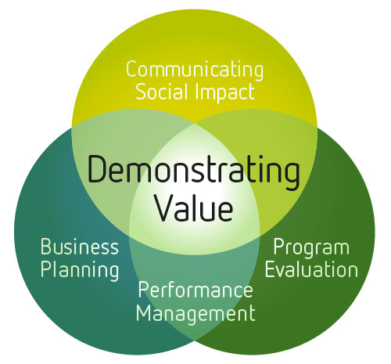

July 2011

The Demonstrating Value Workbook
An Activity Guide to Tracking and Expressing
Your Organization’s Success
www.demonstratingvalue.org
January 2014

Acknowledgments
This workbook was developed by Bryn Sadownik as part of the Demonstrating Value Initiative at Vancity Community Foundation. The workbook was originally developed in December 2010 by combining several earlier Demonstrating Value resources. The workbook is updated annually. Further copies can be downloaded at www.demonstratingvalue.org.
The Demonstrating Value Initiative is a collaboration of a community sector organizations, united by the common interest of developing more accessible performance measurement and impact assessment methodologies specifically geared to social enterprises. The initiative engaged 20 social enterprise investors and operators between 2007-2009 in a process to develop and pilot a measurement framework. This workbook and other tools on the Demonstrating Value website are based on this framework.
The Demonstrating Value Initiative is based at Vancity Community Foundation and has received financial and technical support from the following organizations: Coast Capital Savings, Community Economic Development Technical Assistance Program (CEDTAP), Enterprising Non-Profits (enp), Human Resources and Social Development Canada (HRSDC) and Renewal Partners, SAP Canada and Vancity Credit Union.

Contents
Introduction 1
Structure of this Activity Book 1
Demonstrating Value’s philosophy about measurement and guiding framework 2
Step 1 Define your Audiences and their Needs 4
Define the people who care about your organization and what they would like to know 4
Assess how you can better engage your stakeholders 5
Step 2: Develop a Vision of your Performance Snapshot 6
Review Snapshot examples. 7
Describe the purpose and look of your Snapshot. 7
Step 3 Map out your Information Needs 8
Describe why you exist and what you do. 8
Map out your information needs. 9
Step 4. Design your Snapshot 14
Review Snapshot Example 15
Define the broad sections 15
Review your data sources 16
Design your Snapshot 18
Step 6: Define Additional Data Development 19
Prioritize new data development 19
Develop a Data Development Plan 20
Monitoring Methods 21
Resources for Data Collection 22
Survey Research 22
Focus Group 22
Observation 22
Appendix A: Information Map Templates 23
Appendix B – Sample goals for different program areas 28

Introduction
Demonstrating Value can help you take control of the data you collect, how it is used and to communicate the performance and value of your organization, social enterprise or program. In this activity guide, you will work out what your data needs are, how they can be met, and design a ‘Performance Snapshot’ that will provide an engaging summary of the performance and value of your organization.
This process involves the following steps:

Structure of this Activity Book

The remainder of this activity book will guide you through these steps. The purpose of each step is first described, followed by specific activities for you to do. These activities are indicated with the following symbol:

In some cases you will be refered to other Demonstrating Value tools that can be found on the Tools and Resources page of www.demonstratingvalue.org. These additional tools are marked with the following symbol:
Because no single person has the full picture of what’s really going on, and the information that is needed for different purposes, we recommend working through this workbook with a cross-section of people in the organization. You can do this in a workshop, a series of meetings, or through targeted consultations.

Demonstrating Value’s philosophy about measurement and guiding framework
This guide (and all other Demonstrating Value tools) are based on the premise that the information you gather in your organization has to be directly relevant to the decisions you make and be compelling for others to learn about your value. To work out what information is most useful, always keep the following simple question in mind:
'What do we want to know and show?'
In essence, you need to think about the story you want to tell and the decisions that can be better supported by data.
The two lenses shown below can help focus the answer, and are reflected in the exercises in this workbook. The first asks: ‘What information is important?' and the second asks ‘How is information used?'
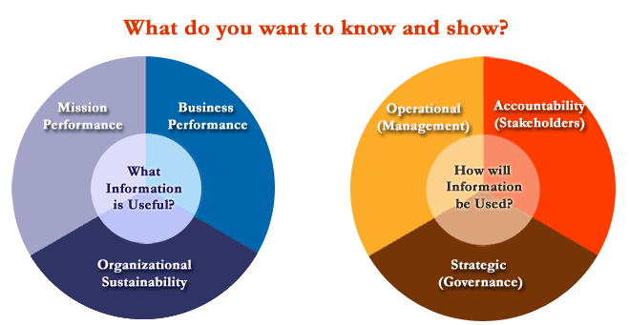
Determining what information is useful is a big task, but it can be simplified by looking at what you do from three different perspectives.
An Organizational Sustainability Perspective - What information can help you understand whether you are developing and maintaining resources to meet your purpose in the long run?
A Mission Perspective - What information can tell you about the ability of the organization to successfully contribute towards the social, cultural and environmental objectives set out in its mission?
A Business Performance Perspective - What information can tell you about the success of the organization from a financial or ‘business’ perspective?
It is also useful to consider carefully how information will be used, by considering three ‘audience’ perspectives:
An Operational Perspective - What information do you need to support day-to-day decisions by management and staff? For instance, what can help you stay on top of costs, quality, and delivery of your mission?
A Strategic Perspective - What information do you need to support strategic decisions that are often made by a governance body such as a board? This information needs to educate your audience about key trends and events that have occurred.
An Accountability Perspective - What information do you need to foster and maintain support of the organization? This includes support by investors, community members, employees and beneficiaries of your mission. This audience may have very limited knowledge of who you are and what you are trying to accomplish so your "story" needs to be very crisp.

Step 1 Define your Audiences and their Needs
Your organization is important for many different groups of people, and in different ways. These are your stakeholders. Understanding who these people are and what they care about is critical for developing effective monitoring and reporting capabilities. Common stakeholders include:
- Employees
- Volunteers
- Management
- A governance body (e.g. Board of Directors)
- A parent organization (for example in the case of a social enterprise that is associated with a broader non-profit organization)
- Constituent group – those in whose name you are working
- Customers
- Investors, funders, donors
- Peers and partners
- The community at large
In this step you will name the people and groups who care about your organization (your stakeholders), the information they need, and what you’d like to improve.

 Define the people who care about your organization and what they would like to know
In the table below identify your stakeholders and describe what information they need to have to do their job effectively. What does each stakeholder need to know about the organization in order to manage, plan or to provide support?
Don’t be too specific or name individual people. Rather think of the key groups of people that matter in and around the organization.
Add or delete rows as required.

Stakeholder | Information needs - what they need to know
e.g. Management | - Need to monitor operational issues and should be able to access additional information easily if needed to make decisions.
e.g. Advisory board | - Need to be clearly informed (in a succinct way) about what is happening with the enterprise so they can offer the best advice possible.

Assess how you can better engage your stakeholders
Look at the needs you’ve described. Where do you feel you can do a better job in meeting those needs? What's your biggest priority?
.

Step 2: Develop a Vision of your Performance Snapshot
A Performance Snapshot is a communication tool that you can develop to present the performance and value of your organization to boards, investors/funders and staff. It is tailored to your needs and the audiences you want to connect with.
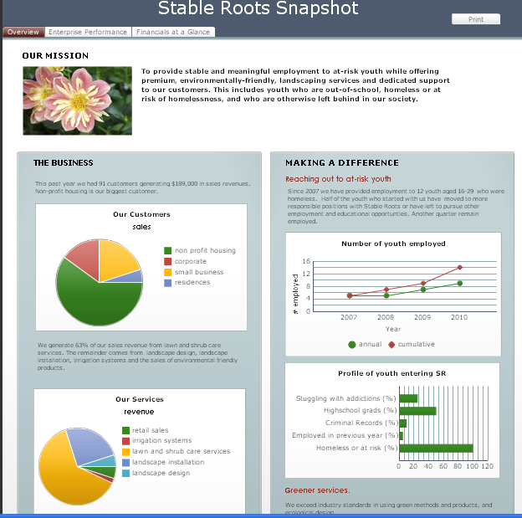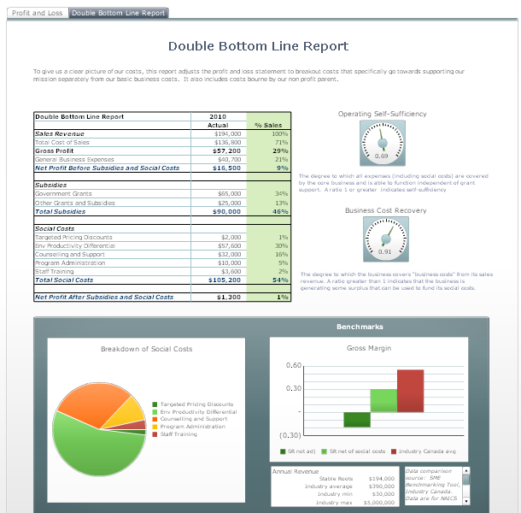
The snapshot can be a printed document or an electronic 'dashboard', which allows you to actively engage with the information. This tool will give you a clear picture of your organization to help you plan and manage your day-to-day activities, demonstrate your value to others, and ensure the long-term sustainability of your organization. Examples of performance snapshots can be found at:
www.demonstratingvalue.org/snapshots
Advantages of developing a snapshot include:
- Saving valuable time finding and pulling together data and other information for reports.
- Seeing key trends and relationships in data, so you can get the most from the data you collect.
- Combining different types of information effectively to engage your audience.
The exact content and format of the Snapshot depends on the audience you want to reach and the issues that are important. The design process includes thinking about who the audience is, what decisions they are making and the messages you want to convey, and the information that can be presented (numeric, narrative, pictures, quotes, video) to tell your story. This depends on your needs and audience. For example, the layout and content for a bi-monthly board presentation might be very different from a Snapshot designed to be part of your public website to engage volunteers and donors.
In this step, you will picture what your Snapshot will look like.

Review Snapshot examples.
To help envision the look of the snapshot you’d like to develop, look at the snapshot examples on www.demonstratingvalue.org/snapshots and select examples that make sense for what you want to develop..

Describe the purpose and look of your Snapshot.
In the table below describe the audience, purpose and format of your snapshot. Examples of audiences include a board of directors, your non-profit parent (if you have one), management, employees/volunteers, your investors, specific community members, and the public at large.
To help define an audience and purpose, look at the previous step. What did you define as the biggest area for improvement?
You may be able to connect with many audiences with your Snapshot but to guide the initial development, identify a primary audience.
Audience | Purpose | Format
 | e.g. to support on-going operational decisions, planning decisions; to develop and maintain support | i.e. What will you develop? When will it be used? What format will it be in? How often will it be updated?

In the future we’d also like to engage the following audiences:

Step 3 Map out your Information Needs
In this step you will develop the core content of your Performance Snapshot, based on your organization’s mission and objectives. This is done by mapping out what data and other information is most useful to you in managing, planning and communicating the value of your organization. The mapping starts with the big picture, by asking you why your organization exists and its mission and business. You will then identify what data you may currently be tracking, or could track in the future using one of two methods: An In-Depth Method or a Quick Method.

Describe why you exist and what you do.
In the boxes describe your vision, mission and business.

Your Vision Statement
A vision statement is a vivid, idealized description of how you want the community and world to change for the better as a result of your organization’s work.

Your Mission Statement
Your mission statement describes the overall purpose of your organization including your social, environmental and/or cultural objectives and how you are working to achieve them.

Your Business
Describe your business including what specifically you produce, sell or provide, and how your offering is unique.

Map out your information needs.

Choose the In-depth method or Short Method below to work out what you want to show in your Performance Snapshot. The in-depth method is helpful if you have a multi-faceted organization with many different objectives and activities. It is also helpful if you would like to review organizational goals and activities at the same time that you develop a Performance Snapshot.

In-depth Method: Create Information Maps
In the tables that follow, map out what information you need to know and show in your organization based on the goals you’re pursuing. Develop information maps using the following three steps:

- Write down your organization’s key goals. Base this on:
- Information in your strategic plans, business plans, grant applications, and in marketing and other communications materials.
- Examples of goals we’ve provided.

- Describe the activities you’re doing to achieve these goals and your desired impact.

- Determine what information you should be collecting to show that you are successful. Start by brainstorming around the question: ‘What do you want to know and show about this goal?’ Then write down specific indicators you’d include in your snapshot that would address what you want to know and show.
Don’t limit yourself to data and other information that you can provide right now, but describe what you’d ideally like.
Here is an example of a completed information map. Templates for your use can be found in Appendix A.
List up to 3 goals you have relating to your mission
- Provide employment in our landscaping to youth who are homeless or at risk of homelessness (Target: 80% of total # employees)
- Offer career advancement and nurture leadership potential
- Retain and sustain a stable workforce
Sample Activities:
- On-going recruitment
- Mentorship and training
- Support employees through flexible scheduling, resources, support with personal issues
Desired Impact:
- Youth develop skills and are more aware of their interests, skills and career development.
- Youth are more stable in their situation and access other community services (housing, medical, education)
What is useful to track and why? Think about what you want to ‘to know and show’ about the goals, activities and impacts you’ve described, and what you could then measure.
- We want to show how many youth have been employed and moved on to greater things. We can track:
  - # of target employees – annually and cumulatively, hours worked, income earned – to see how .
  - Training and employment progression. (e.g. # employees that expand hours or advance to more responsible roles, where they move onto after leaving Stable Roots)
- We want to know if we’re doing enough to support our employees at work: We can track:
  - % staff with wellness plans
  - Take up of supports offered
  - Issue areas supported (time, resources)
  - Retention rate; % of employees long term leave; Absenteeism rate
- We want to show how employee lives are being improved. We can track
  - Success profiles / stories
- Longer term employment outcomes -skill development, well-being, health, housing, change in risky behavior

Short Method: Question Brainstorming
This method is based on identifying your information needs more directly through brainstorming around two questions and then identifying the useful data that would meet your needs. The questions are:
1. What do you want to know?
Write down the top things that you want to know about in your organization that would assist your ability to manage and plan. Think about this in terms of your organization’s social or environmental mission, business performance and organizational sustainability. Also consider your operational decisions as well as your longer term strategies.
Examples: We want to know if we are…
improving public awareness of our program
enhancing the quality of our service
improving our cash-flow
retaining staff, etc.
Your turn: We want to know if we are…
2. What do you want to show?
Write down the key things that you want to show others about the value of your organization. Think about your organization’s strengths and how you make a difference, and be as specific as possible.
Examples. We want to show that we…
reach people that fall through the cracks of other programs
have highly qualified staff
provide flexible and individualized service
getting people out of their cars
are increasing wildlife habitat
Your turn: We want to show that we…:
3. Identify what is useful to track
In the previous section, you defined key information needs. In this section, come up with a list of data and other information that can address each of those needs. Don’t worry about being exhaustive and very detailed – we will refine this more in another exercise.

Information Need | What is Useful to Track?
e.g. We want to show that we reach people that aren’t serviced by other programs | Demographic information about who accesses our program (age, gender, ethnicity)

More on how to determine what is useful to track (‘indicators’).
Both methods require you to identify data and other information that would be useful to track to address the needs you identified. This data is often referred to as an ‘indicator’. In other words, something that helps you to understand where you are, where you are going and how far you are from the goal. It may be numerical data, but it can also be a graphic, a list, a narrative, and so on. It must be a clue, a symptom, a pointer to something that is changing. In other words, indictors are bits of information that highlight what is happening in a system, both within your organization and outside of it.
What Makes a Good Indicator?
Useful indicators are those that:
- Can be easily interpreted and communicated by others.
- Are reasonable to gather.
- Represent both qualities of the change (how well), in addition to the quantities (how much).
- Can give insights about where you want to go, not just current or past performance.
- Can be compared - such as a budget or last year’s figures and/or an industry benchmark
- Are precise.

The following resources may be useful to look at to identify potential indicators.
Information Source
Demonstrating Value  Resources | www.demonstratingvalue.org/tools-and-resources Search for specific resources on impact, business performance or organizational sustainability
SAP Network Wiki: | NetWeaver Business Intelligence www.sdn.sap.com/irj/scn/wiki /  (search for the Business KPI Link on This page)
Mr. Dashboard | www.mrdashboard.com/Business_Metrics.htm
KPI Library | Kpilibrary.com
Global Reporting Initiative, Indicator search | www.globalreporting.org/ReportingFramework/G3Online/PerformanceIndicators/
Prove and Improve, Sample Indicators Bank | www.proveandimprove.org/new/meaim/samplendicators.php
Impact Reporting and Investment Standards (IRIS) | iris.thegiin.org/iris-standards

More on measuring social, cultural and environmental impact in the community
The value you create through your mission can be multifaceted and complex. If you would like to do more to understand and measure this impact, consult the following demonstrating value resources:
Impact Mapping Worksheet (Impact Mapping Worksheet.xls)
This Excel workbook will help you brainstorm the ways that your organization create impact in the community by assessing if and how you create impact in different social and environmental areas. It also includes templates for commonly used impact mapping tools – Logic Model, Theory of Change & Outcome Mapping.
Short Resource Guides
The Demonstrating Value website includes short resource guides with specific measures and resource links that relate to the following mission areas:
Affordable Housing
Cultural Empowerment and Awareness
Neighbourhood Revitalization
Direct Income, Material and Food Support
Recycling and Waste Reduction
Green Building
This list represents short resource guides available as of December 2013. Check the website for any new mission areas.
In-depth Resource Guides
The Demonstrating Value website includes an detailed toolkit for Farmers’ markets.
Farmers Market Impact Toolkit
DV Blog
The Demonstrating Value blog on our website includes commentary and guidance for measuring impact. Subscribe to our blog, or check past blogs. Here are few examples that may be useful.

Is measuring impact possible?
How to build impact measurement into core business systems?
10 Ways to Show Your Impact: Part 1
10 Ways to Show Your Impact: Part 2
Expressing Your Organizational Value: Quantifying Value
Expressing Your Organizational Value: Monetizing Value
Expressing Your Organizational Value: Describing Value
Logic Models & the Outcome Indicators Project

Step 4. Design your Snapshot
In the previous step, you identified the information that is important for you to collect and potentially show in a snapshot, based on your organization’s goals. You will now design your snapshot with the information that you collect currently, or can easily develop.

Review Snapshot Example
Look at the snapshot example that you identified earlier as your model. You may want to follow it closely or make changes that fits better with your audience and purpose.
What do you like about this snapshot?
What do you dislike?
What would you change or add?

Define the broad sections
Sketch out roughly how you’d like to organize the information in a snapshot based on the snapshot examples, your information maps or other ideas. Make sure to define the sections in which you’d group information.

Review your data sources
In your information maps, you defined indicators you’d like to include in your snapshot. In this step, you will review your data needs against what you currently have available, or need to develop. Do this in the table below, or in the Excel worksheet: Indicator Record.xls, available in the Tools and Resources section of the Demonstrating Value website. (Using Indicator Record.xls will make it easier for you to sort and organize this information.) For each indicator, identify the snapshot section it relates to, how frequently it will be updated, any guidance on how it should be interpreted including any targets you may have, and finally its current availability and relevant data source.

Indicator Record
Snapshot Section | Indicator | Reporting Frequency | Interpretation  (e.g. why this would be collected, how it should be interpreted & targets where relevant) | Current Availability | Source
Business Performance | e.g. Customer retention (% of customer >3yrs) | Annually |  | Partially available – we collect some info, but it is not aggregated | Customer log.xls
Business Performance | e.g. Conversion rate (quote to contracts), ideally by market segment | Quarterly | After we learn what our conversion rate is, we should develop a target that improves on it. | Not available | N/A

Design your Snapshot
At this stage you are ready to design your snapshot. You may want to do this directly in the program you are using (Word, Excel, or a reporting software like SAP’s Crystal Dashboard Design), or sketch out content ideas first. Design it only with the indicators that are currently available or which you can develop easily. If you don’t have the data right away, make up data and adjust it later.
For each section, think carefully about what you want to convey. Beware of presenting data for the sake of presenting data! Rather group and relate information to make it meaningful. This means thinking about:
- Decisions that the snapshot’s audience will be making.
- Clear messages you want to convey about your value
It can be helpful to review your information maps to remind yourself of how the indicators relate to activities, objectives and impact.
You can use figures, numbers, text, stories, and even multimedia like videos and photo, to convey your message. Present it so that it can provide maximum insights to your audience. For instance, data and figures can be more powerful if you also provide some text to help your audience interpret them.
Snapshot Design Tips
1. Vary how you present information to keep it interesting.
2. Distinguish pages through changes in format and colour.
Use data, figures and graphics that:
• Accurately shows the facts
• Grabs the reader's attention
• Complements or demonstrates arguments
• Has a title , labels and units
• Is simple and uncluttered
• Clearly shows any trends or differences in the data
5. Present information in an engaging and appropriate way. Different types of graphs show different things (a line graph shows trends, a bar chart highlights comparisons, a pie chart shows shares, etc.). Helpful resources for portraying data include:
- Statistics Canada, “Using Graphs www.statcan.gc.ca/edu/power-pouvoir/ch9/using-utilisation/5214829-eng.htm
- Adobe Illustrator, “Put the Art in Charts” www.adobe.com/designcenter/illustrator/articles/illcs2at_chart_07.html

Step 6: Define Data Development
The snapshot which you’ve now developed is something that you can add to over time as your organization grows. In this step, you will plan out how you can develop additional indicators that you identified in your information maps for your snapshot.

Prioritize new data development
List up to 5 high priority indicators from your information maps that you’d like to develop in the next 2 years. (Refer to your Indicator Record).
If you have a hard time prioritizing, consider:
- What is of most benefit to gather? Consider this from the perspective of all stakeholders who defined the information. Are there things that are logical to do first? Are there things that would be nice to have, but are not critical?
- How much effort will it take to develop this data? Do you have a mechanism already in place, or can you develop one easily? What are the time and skills required collect, manage, and analyze the information? Will gathering these data be seen as intrusive by participants? Are there language or literacy challenges? Are you trained in the method, or will you need help from an outside consultant?
The following grid can help you prioritize.
 |  | Collection Challenge
Importance of Information |  | Easy | Feasible | Difficult
Importance of Information | High | 3  Definitely Collect | 2  Worth Collecting | 2  Consider an Alternative
Importance of Information | Medium | 2  Worth  Collecting | 1  Collect if have time | 1  Collect if have time
 | Low | 1  Collect if have time | 1  Collect if have time | 0  Ignore

Develop a Data Development Plan
For your priority indicators, develop a plan for how you will develop them in the tables that follow. First, list the indicator. Then propose a method for developing it. The resources described on page 13 may be helpful for researching methods for specific types of indicators. More general monitoring and research methods are also described in the next two pages. Once you’ve proposed a method, develop a concrete development timeline and designate somebody to lead its development.. A comments section is included for any additional comments. Copy and paste more tables to meet the number of indicators you plan to develop.
Indicator:
Method
Development Timeline
Responsibility
Comments

Indicator:
Method
Development timeline
Responsibility
Comments

Monitoring Methods
The following list describes common methods to collect information
Activity Log
Staff report of daily activities.
Anecdotal records
Stories and narratives about an event, an experience, or an individual, described by staff or participants.
Documentation
Administrative records of activities (e.g., inventory software, reports, minutes of meetings etc.).
Evaluation Form
A set of questions that determine the participants’ opinions, attitudes, and understanding once an activity is complete.
Focus Group
Group discussions with a relatively small number of selected people about certain questions.
Interview
A set of questions (could be predetermined or not) about certain topics that are posed to a target audience and followed by additional questions and conversations.
Journal Recording
Self report of daily activities by participants.
Knowledge/ Skill Tests
Survey
A set of predetermined questions about certain topics that are answered by a target audience.
A set of questions that determine the level of knowledge or skills in participants.
On-site visits
A combination of observation and interviews that occur in the participant’s environment.
Observation notes
Notes taken through direct observation of verbal and nonverbal behaviours that occur in activities.

This list is based on definitions in:
Zarinpoush, F. Project Evaluation Guide for Nonprofit Organizations: Fundamental Methods and Steps for Conducting Project Evaluation. Toronto, Ontario: Imagine Canada, 2006.

.

Resources for Data Collection

Survey Research
Downloadable Guides, University of Wisconsin-Extension
learningstore.uwex.edu
- Collecting Evaluation Data: Surveys (Ellen Taylor-Powell, Carol Hermann)
- Questionnaire Design: Asking Questions with a Purpose (Ellen Taylor-Powell)
- Sampling (Ellen Taylor-Powell)

What is a Survey. www.whatisasurvey.info/Initially published by the American Statistical Association

Research Methods Knowledge Base. www.socialresearchmethods.net/kb/survey.htmWilliam M.K. Trochim. Department of Policy Analysis and Management at Cornell University.

A Brief Guide to Questionnaire Development, Dr. Robert Frary, Virginia Tech www.testscoring.vt.edu/questionaire_dev.html

Survey Design Material, National Statistical Services, www.nss.gov.au/nss/home.NSF/sdm?OpenView

Developing On-line Surveys
The following are a few popular survey sites:
- Survey Monkey www.surveymonkey.com; SurveyZ www.surveyz.com; Inquisite www.inquisite.com; Hosted Survey ww.hostedsurvey.com
For a useful reference for evaluating these alternatives see: Rose M. Marra, Barbara Bogue, A Critical Assessment of Online Survey Tools, University of Missouri -- Columbia/ The Pennsylvania State University.

Focus Group
Focus Group Research Planning Guide, Wyoming Market Research Centre www.uwadmnweb.uwyo.edu\wmrc\Focus Group Research - Planning Guide - Revised.pdf/
Using Focus Groups, Health Communication Unit, Centre for Health Promotion, University of Toronto
www.thcu.ca/infoandresources/publications/Focus_Groups_Master_Wkbk_Complete_v2_content_06.30.00_format_aug03.pdf

Observation
Downloadable Guides University of Wisconsin-Extension
Collecting Evaluation Data: Direct Observation learningstore.uwex.edu

Appendix A: Information Map Templates
Maps are provided for three different perspectives: Mission, Business Performance and Organizational Sustainability.

Mission Perspective - What information can tell you about your success in contributing towards your social, cultural and environmental mission?

List up to 3 goals you have relating to your mission (your social, environmental and/or cultural objectives)

Examples of goals in this area:
- Improve awareness and engagement (around a specific issue)
- Shift people’s behavior and practices so they are more _________________
- Build community capacity to ________________
- Improve livelihoods and well-being
- More effectively engage different cultural groups, ages and genders
For examples of mission-related goals that relate to different program areas, see Appendix B.
Sample Activities:

Desired Impact:

What is useful to track and why? Think about what you want to ‘to know and show’ about the goals, activities and impacts you’ve described, and what you could then measure.

Business Performance Perspective - What information can tell you about the success of the organization from a ‘business’ perspective?

Market and Customers
List up to 3 goals you have relating to your market and customers

Examples of customer-related goals:
- Maintain existing customers - increase percentage of sales that comes from return customers
- Exceed customer expectations about products and/or service quality
- Diversify the customer base to be less reliant on a few key customers (or markets)
- Expand services into new geographic area.
- Develop more effective marketing promotions
- Renew your brand image; differentiate your image in the market

Sample Activities:

Desired Impact:

What is useful to track and why? Think about what you want to ‘to know and show’ about the goals, activities and impacts you’ve described, and what you could then measure.

Operations
List up to 3 goals you have relating to your operations

Examples of operational goals:
- Deliver products and services on time and on budget
- Improve information technology systems
- Improve internal and external communication
- Increase product/service quality
- Improve safety of operations
- Green operations; reduce waste
Sample Activities:

Desired Impact:

What is useful to track and why? Think about what you want to ‘to know and show’ about the goals, activities and impacts you’ve described, and what you could then measure.

Financial Performance
List up to 3 goals you have relating to your financial performance

Examples of goals in this area:
- Improve ability to pay expenses in a timely manner
- Increase the revenue obtained from each customer
- Obtain sufficient income
- Reduce dependence on short-term grants
- Reduce debt to a manageable level
- Control key costs that affect profitability
Sample Activities:

Desired Impact:

What is useful to track and why? Think about what you want to ‘to know and show’ about the goals, activities and impacts you’ve described, and what you could then measure.

An Organizational Sustainability Perspective - What information can help you understand how you are managing long-term risks to your organization?

List up to 3 goals you have relating to your organizational sustainability (e.g. building strong human resources, relationships, systems, financial capital, expertise and knowledge)

Examples of goals in this area:
- Retain and support staff and/or volunteers
- Provide training, skill development and other learning opportunities for employees and/or volunteers
- Improve financial sustainability
- Reduce dependence on short-term grants
- Create an inclusive environment where learning is shared
- Enhance profile and leadership in the community
- Build the capacity of the board of director
Sample Activities:

Desired Impact:

What is useful to track and why? Think about what you want to ‘to know and show’ about the goals, activities and impacts you’ve described, and what you could then measure.

Appendix B – Sample goals for different program areas
Sample social, environmental and cultural-related goals are provided for different program areas in the pages that follow. These are meant to help trigger ideas for your own goals, and is not an exhaustive list. If you’d like to see a goal added, contact us!
Recycling, Reducing, Reusing 29
Direct Habitat and/or Species Conservation and Protection 29
Green Building, Landscaping and Urban Design 29
Local and Organic Food/ Agriculture 29
Sustainable Energy Supply and Energy Use 30
Sustainable Fisheries 30
Sustainable Forestry 30
Sustainable Industrial Processes 31
Sustainable Transportation 31

Affordable Housing 31
Crime prevention and victim support 31
Income, material and food support 32
Disaster/emergency prevention and control 49
Health - treatment, rehabilitation, support, prevention 49
Education - basic, specialized, advanced 49
Community Revitalization and Economic Development 50
Advocacy and Legal Assistance 50
Life skills, Personal Development 50
Promotion/Preservation of History, Culture and/or Language 50
Performing and Visual Art 34
Supportive Employment/ Employment Training 51

Recycling, Reducing, Reusing
- Reduce the amount of solid waste diverted from landfill
- Shift society towards zero waste by redesigning resources systems so there is no waste and all resources are reused
- Reduce net greenhouse gas emissions produce by the community
- Reduce the overall amount of materials used in society
- Deliver program/products/ services in a way that responds to different cultures and genders
- Educate the public about how to reduce household waste
- Create incentives (i.e. tax breaks, subsidies etc.) to improve waste management

Direct Habitat and/or Species Conservation and Protection
- Identify and protect key habitats for at-risk species and key habitats within the terrestrial, fresh water, and marine ecosystems
- Promote more widespread use of strategic resource management plans, ecosystem management, land use planning, and habitat stewardship
- Measure and raise awareness of the effect of human activities on habitat and different species
- Encourage implementation of regulatory measures
- Promote networking initiatives between like-minded groups and individuals

Green Building, Landscaping and Urban Design
- Create awareness about environmental, social and economical advantages of green buildings, and provide practical information on how to do build green
- Educate the community about best practices
- Promote new urbanism approaches to reduce sprawl in suburban developments
- Develop pilot projects that showcase green building practices
- Provide incentives to retrofit existing buildings to be more energy and water efficient.
- Better integrate green spaces (parks, trails, etc.) with the built environment

Local and Organic Food/ Agriculture
- Increase our capacity to grow food close to home
- Enhance local food manufacturing, wholesaling and distribution
- Improve access to healthy, culturally diverse and affordable food for everyone
- Create a food system that is consistent with ecological health
- Establish closer relationships between food producers and consumers to encourage responsible consumerism

Sustainable Energy Supply and Energy Use
- Encourage and educate community to reduce its carbon footprint
- Develop pilot projects that showcase alternative energy practices
- Provide incentives to develop alternative energy projects.
- Invest in research and development to develop energy efficient, zero carbon and renewable energy technologies
- Educate public about energy alternatives and encourage them to become responsible consumers
- Advocate for regulations, carbon taxes and mandatory cap and trade systems to reducing Greenhouse Gas Emissions

Sustainable Fisheries
- Improve eco-system based management and sustainable exploitation of natural resources
- Reduce fishing capacity to sustainable levels and to allow over-exploited populations to recover
- Prevent overfishing, wasteful, destructive and illegal fishing to maintain a healthy dynamic population and sustainable practices in fisheries
- Educate public about destructive activities and how it impacts our economy and the environment
- Lobby for appropriate law and policy targeting unsustainable fisheries

Sustainable Forestry
- Adopt and encourage sustainable forest management practices
- Preserve wildlife, high-value conservation areas and the natural habitat while meeting our demand for natural products (i.e. pulp, paper, furniture)
- Empower communities to protect their forests and develop sustainable forestry initiatives (i.e. wildlife tours)
- Educate public to purchase sustainable forest certified goods to create incentives for unsustainable practices in forests to diminish
- Manage forests to reduce net greenhouse gas concentrations in the atmosphere through sequestration.

Sustainable Industrial Processes
- Encourage industry to adopt green practices including: energy efficiencies improvements, renewable energy development, efficient waste management and water efficiency.
- Support the growth of businesses that provide sustainable alternatives to standard products and services.
- Encourage eco-industrial parks in which the waste of some industries are inputs for others.
- Develop, pilot and commercialize sustainable industrial technologies

Sustainable Transportation
- Reduce travel demand (e.g. telecommuting, urban design, road pricing, etc.)
- Encourage alternatives to single occupancy automobile travel.
- Educate public about alternative options such as carpooling, vanpooling and / or rideshare
- Lobby for appropriate law and policy that foster sustainable transportation.
- Develop and operate alternatives to single use car travel
- Promote sustainable freight and delivery services

Affordable Housing
- Increase access to affordable housing to increase quality of life for low-income families
- Reach the people who would benefit the most from assistance
- Increase the number of low-cost affordable housing units in the community
- Better integrate housing with other support programs such as employment training, health and education.
- Increase quality of life for tenants through proximity to popular community destinations and public transit

Crime prevention and victim support
- Lower incidences of crime, create community resilience and improve the well-being of people affected by crime
- Effectively engage the community in defining and acting on community safety issues
- Reach the people who would benefit the most from assistance
- Educate victims about their rights and provide resources to support their needs
- Educate public about crime prevention and awareness

Income, material and food support
- Encourage low income earners, and others in poverty, to accumulate, develop, and preserve all types of assets and improve their self sufficiency
- Reach the people who would benefit the most from assistance
- Turn nobody away for emergency housing and care for people living with mental health, substance use and other challenges
- Better understand the needs of the community served.
- Connect people in need with available supports (e.g. direct income assistance, tax and other benefits they may qualify for)

Disaster/emergency prevention and control
- Educate the public to prepare for emergency situations: businesses, universities, individuals etc.
- Promote greater consideration of disaster prevention in buildings, cities and land-use design.
- Improve the capacity of the community to respond to emergency situations
- Capably respond to emergency situations 24 hours per day every day of the year.

Health - treatment, rehabilitation, support, prevention
- Educate public to take action to prevent highly infectious/contagious diseases and chronic disease
- Better connect people with available health supports
- Improve our understanding of the needs of the population we serve.
- Reach the people who would benefit the most from assistance
- Effectively engage the community in defining and acting on community health issues
- Provide no cost or affordable health services to those who are not currently accessing services.

Education - basic, specialized, advanced
- Effectively engage the community in defining and acting on education issues
- Reach the people who would benefit the most from assistance
- Improve our understanding of the needs of the population we serve
- Improve literacy rates in the community.
- Provide educational opportunities to marginalized individuals and families.
- Encourage employers to invest in their employees through advanced education opportunities at work

Community Revitalization and Economic Development
- Increase community inclusion and encourage establishment of mixed-income neighborhoods
- Generate supportive and collaborative action to ____________
- Diversify the local economy
- Develop sustainable jobs
- Revitalize shared community space and amenities

Advocacy and Legal Assistance
- Meet legal and advocacy needs of vulnerable populations
- Connect individuals with right resources
- Educate elders about their rights and defend their respected presence in the community

Life skills, Personal Development
- Improve people’s access to the resources, benefits and financial supports necessary to participate fully and with dignity in community activities.
- Enhance personal and work-related skills.
- Increase the financial resources of individuals necessary to participate fully and with dignity in community activities
- Help individuals develop healthy social networks that may include personal and family relationships, as well as community supports.
- Empower individuals to change patterns of behavior that result in harm to themselves or to other people.

Promotion/Preservation of History, Culture and/or Language
- Increase the cultural awareness of others outside of our cultural group
- Increase the strength and practice of our culture in our community
- Increase opportunities for community members to participate in cultural events
- Protect our heritage through landscape/urban conservation
- Raise the importance of historical values in the development and identity of our community

Performing and Visual Art
- Increase employment and income levels in arts and culture
- Empower community members to express themselves creatively.
- Stimulate interest and support by the public in arts and culture
- Recognize and award talent in arts and culture
- Enrich public and private spaces with art

Supportive Employment/ Employment Training
- Provide training and/or employment to individuals who face barriers to employment
- Offer career advancement and nurture leadership potential
- Provide adequate and effective supervision and support
- Retain and sustain a stable workforce
- Adequately accommodate employees’ preferences, skills and capabilities

