UNIVERSITY OF EL SALVADOR
SCHOOL OF ARTS AND SCIENCES
FOREIGN LANGUAGE DEPARTMENT


UNDERGRADUATE RESEARCH

THE TYPES OF SPEAKING ERRORS STUDENTS IN INTERMEDIATE INTENSIVE ENGLISH I COMMIT, THEIR CAUSES AND TECHNIQUES TO CORRECT THEM

IN ORDER TO OBTAIN THE DEGREE OF:
LICENCIATURA EN IDIOMA INGLES OPCION ENSEÑANZA

PRESENTED BY:

SUSAN EDITH ELIAS QUIJANO EQ04003
GLORIA MARISOL MARTINEZ CABRERA MC04136
FRANCO ALBERTO PEREZ ASCENCIO PA03032

ADVISOR
ANDRES ROBERTO ROSALES BALTES

San Salvador, El Salvador, Central America, JUNE 17th, 2011
AUTHORITIES OF THE UNIVERSITY OF EL SALVADOR

ING. RUFINO ANTONIO QUEZADA SANCHEZ
RECTOR

ARQ. MIGUEL ANGEL PEREZ RAMOS
ACADEMIC VICE RECTOR

MTRO. OSCAR NOE NAVARRETE ROMERO
ADMINISTRATIVE VICE RECTOR

LIC. DOUGLAS VLADIMIR ALFARO CHAVEZ
GENERAL SECRETARY

AUTHORITIES OF SCHOOL OF ARTS AND SCIENCES

LIC. JOSE RAYMUNDO CALDERON MORAN
DEAN

DR. CARLOS ROBERTO PAZ MANZANO
VICE-DEAN

MTRO. JULIO CESAR GRANDE RIVERA
SECRETARY

AUTHORITIES OF THE FOREIGN LANGUAGE DEPARTMENT

Mtl. EDGAR NICOLAS AYALA
HEAD OF THE DEPARTMENT

RICARDO GARAY SALINAS, Med
GENERAL COORDINATOR OF THE DEGREE PROCESSES

MtT. ANDRES ROBERTO ROSALES BALTES
ADVISOR

UNIVERSITY OF EL SALVADOR
SCHOOL OF ARTS AND SCIENCES
FOREIGN LANGUAGE DEPARTMENT

ACKNOWLEDGEMENTS

I would like to thank to:
God, for giving me life, health, strength and the patience to complete this important stage of my life. He thought me that everything can be done with dedication.

My parents Oscar Elías and Carmen de Elías, they have been my inspiration and motivation to go forward. Thank you for your unconditional love, sacrifice and support in my life. This effort is for you both.

My sister Cecilia and my brother Reynaldo for helping, encouraging me and give me your support. Thank you for always being at my side and have faith in me.

Susan Elias
ACKNOWLEDGEMENTS
I would sincerely like to express my special thanks to:
First of all I thank God, because he is the one who brings me the intellect and ability necessary to reach my goals but also for giving me enough strength without letting me give up.

I am also very grateful with my parents for being with me, giving me their hand when I felt times were hard to continue in my objective.

As well as I am grateful with my brother and sisters, Angel Gabriel Martinez, Claudia Martinez , Alba Martinez, for giving me their hand when I needed most. But also for their encouragement to fulfill my dream.

Gloria Marisol Martinez
ACKNOWLEDGEMENTS
I want to thanks to:
My Parents, Humberto Perez and Silvia Ascencio, who supported me with their endless love, patience and encouragement. They always cheered me up to reach the end of my career.

My Sister, Maritza Zeledon, who helped me to reach this goal by telling me I was capable of doing what I wanted to reach.

My Niece, Darlyn Perez, who made me happy with her smile.

My graduation partners who had patience with me when I could not fulfill with my duties due to other inconveniences.

Franco Perez
Chapter I
Statement of the Problem …………………………… 1

Delimitation …………………………… 1
Statement of the problem …………………………… 1
Objectives …………………………… 2
Rationale …………………………… 3

Chapter II
Theoretical Framework …………………………… 4

Background …………………………… 4
Framework …………………………… 5
Hypothesis and variables …………………………… 13

Chapter III
Methodology …………………………… 15

Class and level of research …………………………… 15
Research design …………………………… 15
Population and sample …………………………… 17
Research strategies …………………………… 17

Chapter IV
Analysis and Presentation of Results …………… 19

Chapter V
Conclusions …………………………… 30

Chapter VI
Recommendations …………………………… 31

Chapter VII
Bibliography …………………………… 32

Chapter VIII
Annexes …………………………… 33

ABSTRACT

Everyone commits errors when learning a second language. Even native speakers when they speak in their own language. Therefore, teachers and students in the teaching/learning process do not have to get surprised when they commit such errors. Everyday in the learning process learners are prone to make errors whenever they try to express new utterances. Teaching English to students in intermediate level is a challenge because everyone has different interests and needs so teachers should look for several ways of motivating them to get interested in the acquisition of the second language. Besides that, teachers have to take into account that in this level speaking errors are committed frequently since students have not had enough contact with the target language and some of them are still in the basic level. During the leaning process students commit different kinds of errors such as; omission, addition, ordering and selection. However, teachers have to be careful when correcting those errors without discouraging them. There are many correction techniques to correct those kinds of speaking errors, for instance; pointing, repeating, gesturing, cuing, and others that the teachers can use in an EFL classroom. On the other hand, teachers have to pay attention to the factors behind of speaking errors. These are causes why students in intermediate level commit speaking errors such as; interference with mother tongue, generalizing English grammar rules among others. Therefore, this research is presented with the purpose of giving readers some choices to be used while facing speaking errors in an EFL classroom made up of the intermediate English students.

Chapter I
Statement of the Problem

Delimitation

This research was ran with the idea of determining what types of speaking errors students from Intermediate Intensive English I in Foreign Language Department at University of El Salvador commit. After determining the types, it was necessary to determine the reasons why these students committed that kind of error in order to provide the suitable technique to correct that mistake.

Statement of the Problem

What are the types of speaking errors students from Intermediate Intensive English I at University of El Salvador commit, their causes and techniques to correct them?

Objectives

General Objective

To provide the types of speaking errors that students from Intermediate Intensive English commit, their causes and techniques to correct them.

Specific Objectives

- To describe what type of speaking errors the students commit.

- To explain the causes why students commit those speaking errors.

- To mention the suitable techniques to correct those speaking errors.

Rationale

Oral communication is the immediate mean that humans use to convey information, ideas, thoughts and knowledge. Oral communication becomes more important when learning a second language since practice makes perfection. It is mandatory to speak in order to improve that skill. Besides that, teachers of a second language have to help their students with practicing and correcting.

Many people are learning English whether for personal or for business reasons. Either way, these English language learners will share the same experience: committing some speaking errors. That is normal. It is part of the learning process, to commit some errors and overcome them by being corrected. The problem is that some teachers do not know how and when to correct the speaking errors since they are not aware of their origin.

It is necessary to correct students´ errors in order for them to get fluency and accuracy. Obviously, it is important to have an ample knowledge about the error types and origin in order to correct them with a suitable technique. This research pretends to describe the types of speaking errors students in Intermediate Intensive English I commit. Furthermore, this study will also find out the reasons why students commit those speaking errors.

Some benefits of knowing the types of speaking errors and their origin are that English teachers will have a better idea on how and when they have to correct their students when they commit an oral error. Besides that, a next benefit is that students from Foreign Language Department will be able to have this information available in order to know more about errors, their origin and how to deal with them in an EFL (English as a Foreign Language) classroom.

Chapter II
Theoretical Framework

Background

English language is a major international language for worldwide communication. In El Salvador, most people are aware of the necessity to speak English as a second language or at least to understand it. That is why many Salvadoran institutions offer English courses.

University of El Salvador has not been left behind. In the School of Arts and Sciences, there is a foreign language department. Its foundation was in 1956. At the beginning, there was not a clear understanding why teaching English was important. Since that year on, the curriculum underwent internal changes. One of the most important was in 1970 when some new careers were included to support the previous curriculum. In 1996, another internal change in the curriculum was approved. This time, the curriculum emphasized the development of the 4 macro skills: speaking, listening, reading and writing. Despite of developing the 4 macro skill, one objective was highlighted: develop the communicative approach.

That objective is still important. To help students to develop the speaking skill, teacher must play a very important role in the learning process. Among their responsibilities (duties) is the fact of correcting students’ errors. Through the years, they adopted some new correction techniques. Mostly to correct oral errors.

Framework

Through out the language learning process, it is natural that all students make mistakes and commit errors at various stages of this process. Trying to avoid any confusion, it is important to separate what both mistakes and errors mean. According to Harmer (2001) “A mistake can be thought of a slip of the tongue or the pen. The student is able to correct himself or herself, either complete unprompted or with the guidance of the teacher or other students” (p. 63). Whereas an error according to The Dictionary of Language Teaching and Applied Linguistics (1992) is the inappropriate use of a linguistic item due to an incomplete and poor learning or lack of competence on the learner’s part. More clearly, an error is beyond what they have learnt. Mistakes are what students can correct themselves and errors are what students cannot correct themselves since they need more explanation.

As it was mentioned before all students make errors at various stages of the learning process, the students of Intermediate Intensive English I are not the exception. Being in this course, the teacher faces a big challenge since he has to encourage students to participate actively during the class and pay attention to what they produce. So that speaking activities are the major source the teacher has in order to identify students’ errors; however it is important to take into account what the causes of why students keep on making the same error are even thought when such errors have been repeatedly pointed out to them. In order to correct the error, it is necessary to know their source, where they are made and their kind. According to Brown (2000) these causes are the following: Interlingual Transfer, Intralingual Transfer and Context of Learning.

Interlingual Transfer
It is one of the challenges that students of Intermediate Intensive English I have to face when learning a second language since these students have a wide knowledge of their mother tongue and when they come to learn English there is often confusion between L1 (mother tongue) and L2 (target language). So Interlingual Transfer can be defined as the process in which foreign learners (in this case Spanish- speakers) make a relationship between the mother tongue patterns (sounds, grammatical rules and structures) and the language which is being acquired (English). For instance, when students are asked to say a sentence; at the beginning of the process they might follow the pattern of their mother tongue and they produce a sentence as the following when they are studying the possessive forms of nouns: “The cat of my friend is black,” instead of saying “My friend’s cat is black.” The first sentence shows the grammatical pattern which is followed in Spanish, and even though the sentence is clearly understood by Spanish speakers, it does not follow the structure that is establish for showing the possession in English when using the Saxon genitive.

Intralingual Transfer
The second mentioned factor is Intralingual Transfer, also known as overgeneralization. They are “items produced by the learner which reflect not the structure of the mother tongue, but generalization based on partial exposure to the target language”. In other words, Intralingual Transfer or generalization refers to extending L2 (Target Language) rules to areas where they cannot be applied. In this case, the strategy the learners use is a false analogy. For instance, the creation of the plural form. Usually it is created by adding the letters “S” or “ES” at the end of a noun. As an example: “House – Houses; Horse – Horses”. When a student runs into the word “Mouse”, he can generalize the previous pattern and think that the plural form of that noun is: “Mouses” when the correct plural form is “Mice”.

The same case happens when creating the comparative form for the adjectives. The students can mix up the rules. Instead of saying “She is nicer that him”, students can say “She is more nicer that him”. This pitfall can disappear with the teacher or students’ own help. However, there should be special attention on this matter since it can become a major problem through the time. If this is not overcome and if it is repeated one time after another, this is called fossilization. This term was defined as widespread phenomenon in second language acquisition for linguistics and language learners have been aware that it is extremely rare for learners of L2 to achieve full native- like competence. That is, error fossilization is when somebody preserves and keeps on using given wrongs ways according to the given target language rules.

Context of Learning
This is a source of error that does not have to do with the mother tongue. Rather, it is closely related to human and material resources and their roles in the language learning. Here books, visual aids, audio and some other materials used in teaching a second language play an important role. If these materials are not adequate to students’ needs and interests, they are not going to cause any positive impact on the teaching-learning process, so that students may have a meaningful learning.
Teachers also take an important part in this source of error, since “They may provide incorrect information by way of a misleading definition, word, or grammatical generalization.” (Brown, 2000)
Teachers can also be one of the causes of students’ errors while explanations are not given clearly. It is mandatory to check learners’ comprehension by asking them and checking of what they are supposed to do after a topic. For example, if the teacher is explaining the use of “s” ending for the third person singular verbs in the simple present tense, (s)he is not going to know if learners have the idea by asking “Is it clear?” A possible way to know if pupils have gotten the idea about the topic would be to give them different sentences so that they may choose the correct one. The teacher could express the following sentences:
“Maria walk to school every day. Or Maria walks to school every day”.
After that, the teacher could ask students to say their own sentences by using “she” or “he” as subjects of a sentence.

Most common errors
Speaking is one of the most difficult skills to develop. Speaker tends to restrain himself from speaking because (s)he thinks that (s)he will not be able to speak clearly and fluently. Being afraid of that is a standard feeling in English-language learners. But there is damage on thinking that way. If learner does not practice, (s)he will never refuse his/her speaking errors and (s)he will make the same errors once and again.

Omission
In this category certain linguistic forms may be omitted by the learner because of the complexity in production. This can be reflected in morphology and syntax. In the first one, mistakes like the following can be seen: Mary eat a sandwich everyday and I watch T.V. yesterday. In the first sentence, the third person singular morpheme –s was omitted; in the second one, the past tense inflection –ed is left out. In the second one: syntax, learners may omit certain elements which are obligatory e.g. Must say also the names? Instead of Must we also say the names? Although this phenomenon is also exhibited by native speakers; it is in accordance with certain conventions since there are a number of fixed expressions or idioms in English characterized by omission of certain syntactic elements for instance; Beg your pardon? Long time no see, Had a nice day? Etc.
Based on what has been said previously, it is not suitable for the grammar and good communication to omit some important words which help to have the clear idea of the context.

Addition
Beside the first category (omission of some require elements) there is the second category which is like the opposite from the first one. In this one, learners add extra elements. In morphology learners often overuse the third person singular morpheme –s and the plural marker –s. A learner may say: “I thinks that the books is here” instead of “I think that the book is here”, respectively.
At the syntactic level the learner may produce a wrong combination, as for example, using the article with a place name; The London instead of London.
At the lexical level the learner may add an unnecessary word, e.g. “I stayed there during five years ago” instead of “I stayed there five years”.
Some unnecessary elements are added to this error (these elements are formed by students for the anxiety of talking or thinking in their mother tongue). This is when the learner says more than he or she has to express in a sentence.

Ordering
In every language, there is particular and exclusive way to express certain things. When learning a second language, some speakers translate the things from their mother tongue to the target language.
In this category, students cannot organized the words to make a coherent conversation in the target language and in the case of Spanish native speakers, it is a little confusing to form sentences without thinking in their mother tongue. E.g. “That is a dress beautiful”. Students sometimes confuse the order of the words in the target language specially speakers whose L1 is Spanish. It happens that they almost always change the position of noun and adjective.
Misordering can occur in pronunciation by shifting the position of certain phonemes, e.g, a speaker may say *fignisicant instead of significant. At the morphological level misordering of bound morphemes in English is perhaps less frequent, given their limited number, but in the example: “He’s get upping now”, the learner attaches the inflection –ing to the adverb in the phrasal verb, not to the verb itself: get.
Learners can also misorder words as in the sentence: “(S)He’s a dear to me friend”, where constituents of a single noun phrase are split.
At the lexical level the learner may reverse elements of a compound word. “Car key” may become “key car”, which may be regarded as a car carrying keys or the most important car in a caravan.

Selection
The error here is generalization. Generalization is when a student tends to use the same given rule for all the aspects of a given language point. For instance: “My father drinked a cup of hot milk yesterday night” instead of “My father drank a cup of hot milk yesterday night”. The incorrect element “drinked” for the past of “drink” is not appropriate because here it is presented as it all verbs are regular.

These errors can vary in dimension. They can conclude from a single word to a paragraph. For this reason according to Brown (2000), errors can be viewed as either global or local. Global ones, prevent the message from being understood, while in the local ones, there is a minor violation of a given sentence and it does not interfere with the message intended. An example of global errors might be “I liking play soccer.

Error Correction Techniques
In the teaching field, teachers need to consider some techniques in order to develop students’ confidence when speaking because the learning types vary from student to student and the learning situations they face every day are different. Those techniques are arranged in three categories, being these categories addressed to the performance students have in the classroom with themselves, the teacher, and classmates.
The first category is about
A. Self Correction with the Help of the Teacher. In these category teachers can use many techniques such as:
Pointing. The teacher localizes the error without providing the correct form by repeating the student’s response up to the point at which the error is made, hesitating and exaggerating the last word a little with a rising intonation:
Student: I need eat right now.
Teacher: I need...
Student: I need to eat right now.
When using this technique, students feel please to correct their errors by using the knowledge they already have.

Repeating. The teacher uses a question in order to have the student, repeat what (s)he said. “Could you repeat that again, please?” this can be a nice way to ask for repetition. This question must involve an implicit message not only to repeat but also to realize that there is a mistake:
Student: She watch TV.
Teacher: Again?
Student: She watches TV.

Gesturing. This technique is about using body language and gestures. There are certain errors that students make that are easy for them to correct if the teacher helps them by using any gesture or body language, for example the simple past:
Student: My sister and I do the dishes last night.
Teacher: ...
Student: Uh, My sister and I did the dishes last night.

Cuing. Instead of supplying the correct answer, the teacher provides some options for the incorrect or missing element, as in an oral multiple choice.
Teacher: What did you bring to the class?
Student: I...
Teacher: bring, brought
Student: I brought my books.

Providing original answer. In this technique, the teacher cues the student by providing his or her own answer to the question, supplying a model:
Teacher: What are you going to do this weekend?
Student: Oh, I go...
Teacher: I am going to watch TV.
Student: I am going to go to a restaurant.

Rephrasing the question. The teacher rephrases the question to a fewer number of words or a simpler format if the student fails to understand:
Teacher: What brought you here?
Student: (hesitation)
Teacher: Why are you here?
Student: I come here to study English.
Teacher: I...
Student: I came here to learn English.

Explaining a key word. The teacher may write a difficult word on the board or act it out if it seems to be the source of confusion or hesitation on the part of the students:
Teacher: Where do you come from?
Student: (no response)
Teacher: (writes “where” on the board)
Student: Oh! I came from El Salvador.
Teacher: Do you know how to drive a car?
Student: (no response)
Teacher: (gestures with hands on an imaginary steering wheel)
Students: Oh, yes! I know how to drive a car.

Questioning. If the student uses a word that the teacher does not understand, the teacher may want to ask further questions to elicit the meaning more clearly from further contextual support.
Student: I would like to study (incomprehensible word)
Teacher: Why would you like to study that?
Student: I like to help people.
Teacher: How do you think that will help them?
Student: If I help them, they can see better.
Teacher: Yes, being an optometrist is a good choice.

Rephrasing a question. After a formally correct, but inappropriate response to the original formulation:
Teacher: When are you leaving for vacation?
Student: I am going to Florida.
Teacher: Oh, that’s nice.
But when are you leaving? Monday, Tuesday…?
Student: I am leaving on Sunday.

B. Peer correction
There are not specific techniques for getting students to correct one another’s errors in class. The teacher can use any of the techniques for self-correction suggested previously simply by calling on another students who understood what he or she was trying to indicate to the first student.
Instead of the teacher’s providing possible answers, several students can do the same thing. The teacher can then return to the student who made the original error, and it will seem as if no correction had been made. Students can also be encouraged to correct one another when doing structured exercises and activities, using an answer key provided by the teacher.

C. Teacher correction
Teacher Correction is the third category and it is also known as Direct Correction. This technique is about correcting the error on - the – spot in order to avoid making the same error once again and again.
E.g.: Student: Sofia do not like jogging.
Teacher: Sofia DOES NOT like jogging. (The teacher emphasizes on the word that is not ok)
Student: Sofia does not like jogging.

Hypothesis and Variables

- Generalizing some English grammar rules pushes students from Intermediate Intensive English I to commit grammar speaking errors.

Independent Variable Dependent Variable

Generalizing of grammar rules Speaking grammar errors

Indicators Indicators
-Past inflection - wrong past tense of a verb
-Plural inflection - wrong plural of some nouns
-Comparative and superlative adjectives - wrong comparison and superlative

- Thinking too much in the mother tongue makes students from Intermediate Intensive English I commit speaking errors.

Independent Variable Dependent Variable
Thinking in the mother tongue Speaking errors

Indicators Indicators
Direct translation - Lack of coherence
Word order - Lack of cohesion
False cognate - Wrong meaning

- Techniques used to correct the speaking errors help students to overcome that type of error.

Independet Variable Dependent Variable
Type of error Techniques

Indicators Indicators
Omission - Pointing
Addition - Repeating
Ordering - Cuing
Selection - Gesturing

Chapter III
Methodology

A. Class and Level of Research
This research was a research field because this allowed the researchers to have an active and actual participation on the place where the facts to be investigated happened. Through this type of investigation, it is possible to establish a connection between the cause and effect of the facts. Besides that, this research used the qualitative method because the data that was to be obtained was mostly made up by ideas, opinions and thoughts.

The level of the research is explanatory. This focuses both on looking for the causes of a particular phenomenon and explaining why that phenomenon shows up, the variables that this can have and some characteristics in it. Explanatory research looks for a connection between cause and effect in order to have a deep knowledge about them.

B. Research Design
In order to reach the objectives of this research and answer the research question, these were the steps taken in order to gather the suitable information:

- To select the population
- To select the sample
- To design the observation sheet, questionnaire and interview
- To hand in the instruments
- To analyze and organized into categories the information obtained

1) To select the population
The population observed and submitted to the questionnaire was the students from Intermediate Intensive English I in the foreign Language Department at University of El Salvador. There were 9 groups of Intermediate Intensive English I. Each group had 40 students approximately.

2) To select the sample
To carry out the observation, 4 groups out of 9 were chosen for this purpose.
To carry out the questionnaire, 20 students for each group. That was a total amount of 80 students (Female = 49; Male = 31)

3) To design the observation sheet, questionnaire and interview
The observation sheet was used inside the classroom, during the class. It worked to write down some notes about students´ oral participation.

The questionnaire was a set of questions for the students in order to find out why students commit speaking errors.

The interview was made up by 5 questions that were answered by the instructor of each group that was observed. This provided information about what techniques (s)he used to correct his / her students.

4) To hand in the instruments
The observation sheet was used to observe the class when it was in motion. On the observation sheet some notes about a student’s oral participation were written. These notes were a written transcription of what a student spoke.

After choosing the sample, which was 80 students, these filled in the questionnaire after the class or in a time provided by the instructor in charge of the group.

5) To analyze and organized into categories the information obtained
The information gathered in the observation sheet, the questionnaire and the interview was qualitative information. This information could not be expressed in numbers or percentages. The qualitative information was organized into categories, groups or codes. The similar statements were grouped together.

C. Population
9 groups of Intermediate Intensive English I

D. Sample
4 groups of Intermediate Intensive English I was observed during the class.
80 students were submitted to the questionnaire outside the class hours

E. Research Strategies
The research was aimed to look for the types of errors that are committed by Intermediate Intensive English I students, some reasons why they commit those mistakes and the suitable techniques that can be used to correct those errors committed inside the classroom.

To collect the information that met the main objectives of this research, some instruments were designed to collect specific information:

1) Observation sheet
One strong point of the observation was that the observer went beyond seeing what was in front of him. The observer could interpret, contribute, analyze and make judgments. To capture all the events, the observer had an observation sheet. The objective of the observation sheet was to find out what types of speaking mistakes were committed the most. This contained two tables. The first table contained information that helped to name the information collected during the observation in class time.

The second table had four columns. From left to right, these were the titles of each column: type of activity, type of error, technique used and error transcription.

2) Questionnaire
This was a “self-completion questionnaire” because the respondents answered questions by completing the questionnaires themselves. The objective of the questionnaire was to find out the causes why Intermediate Intensive English I students committed speaking errors. This was made up by 10 questions regarding speaking mistakes. 4 questions were Yes-No questions. Besides answering Yes or No, an explanation was required to support his/her answer. The next 6 question were multiple choice structures.
3) Interview sheet
This instrument was designed to gather information about what type of speaking errors Intermediate Intensive English I teachers observed inside their classroom and the techniques that they used to correct those speaking mistakes. This interview sheet contained 5 questions: 4 of the questions provided options where teacher could pick up one option or some options s/he observed inside the classroom. Besides that, he could provide a further explanation describing why he had chosen that option or these options; 1 question was open since an opinion was required from the teachers.

F Methodological Process
Qualitative method provided a lot of data and this had to be sorted and arranged into categories in order to be useful for the project to be studied.

The observation sheet provided a lot of notes about students´oral participation. The questionnaire provided opinions and thoughts from the students. The Interview provided the specific techniques teachers used to correct speaking errors inside the classroom. All this data was taken as qualitative because could not be turned into numbers. To overcome this situation, the data went through two steps:
- Looking for patterns and categories in the data
- Considering where the findings are opposites or common in order to place them in the proper pattern or category.

To fulfill the two steps mention above there were three readings of the data. The first reading was to have a general sense of the data. While reading, some relevant information was highlighted for further consideration. On the second reading, some patterns and categories were set up in order to place the relevant information obtained on the first reading. The third reading was a proofreading. It was just to check if there was a flaw or everything had been placed in the right place.

Chapter IV
Analysis and Presentation of Results

Questionnaire
80 students took the questionnaire. In some cases, the total will not fit with the total quantity of the students who took the exam. The reason of this is due to: some answers were not taken into account because of lack of clarity when answering and there were some questions that had more than one option to choose and some students chose more than one.

The questionnaire sheet was made up by 10 questions addressed to Intermediate Intensive English I students. 4 out of 10 questions provided information about the way teacher corrects them, what type of errors need more correction and the reasons why students commit errors. The questions that provided necessary information were: 6, 7, 8 and 10.

6) How does the teacher correct errors in class?

Politely | Rudely | Sarcastically | Don’t know
75 | 3 | 1 | 1

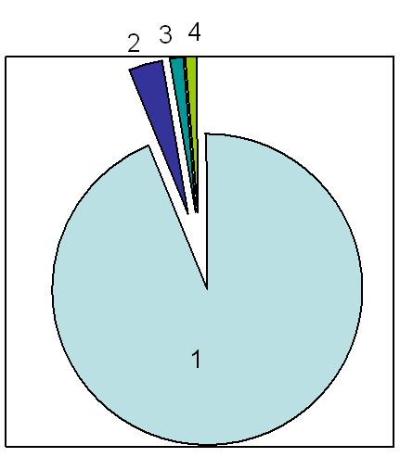
1 Politely
2 Rudely
3 Sarcastically
4 Don’t know

Most of the students that took the questionnaire think their teacher is polite when correcting the speaking errors.

7) When does the teacher correct the errors made in class?

Immediately | After oral participation | After class | Never
50 | 28 | 2 | 0

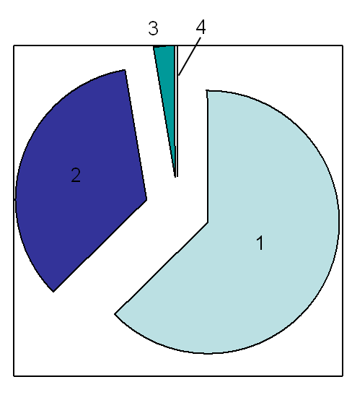
1 Immediately
2 After oral participation
3 After class
4 Never

Teachers prefer correcting the speaking errors right after these are committed. Some others decide to not interrupt student when this is speaking. Instead, they decide to correct the speaking errors after the student has finished his oral participation.

8) What kind of oral errors do you consider need more correction?

Grammar | Pronunciation | Intonation | Word order
41 | 44 | 4 | 8

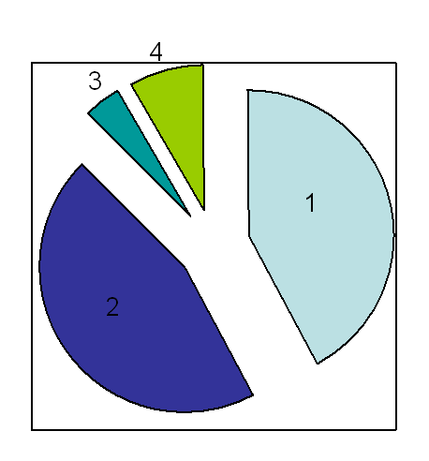
1 Grammar
2 Pronunciation
3 Intonation
4 Word order

Students consider that pronunciation needs more attention when correcting. Besides that, they also think that grammar speaking errors have to be taken into account when correcting the speaking errors.

10) Why do you think you commit errors?

Interference of mother tongue | Generalize English grammar rules | Lack of clarity in techer´s explanation | Lack of knowledge
36 | 35 | 8 | 2

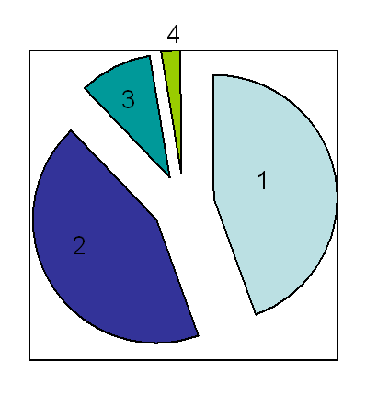
1 Interference of mother tongue
2 Generalize English grammar rules
3 Lack of clarity in Teacher explanation
4 Lack of knowledge
Students think that their mother tongue is the main reason why their classmates commit their speaking errors. Also, they think that generalizing – applying the same grammar rules on all the cases, compel them to commit the speaking errors.

Observation
The observation sheet provided information about the types of error that students commit inside the classroom when they participate in oral activity and the techniques that teachers use to correct those errors. These students that were observed are not the same that took the questionnaire. This is the mumber of cases that were observed inside the classroom while the class was in motion.

Types of Errors
Omission | Addition | Ordering | Selection
9 | 1 | 1 | 26

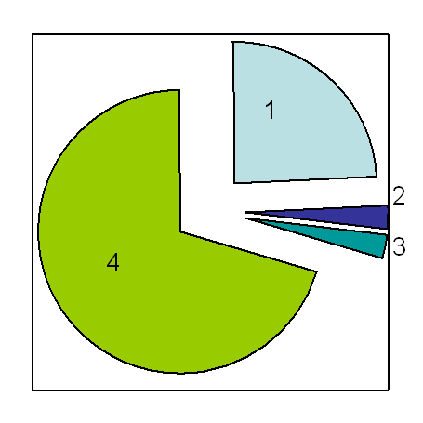
1 Omission
2 Addition
3 Ordering
4 Selection

Selection - picking up the wrong structure when speaking - is the most common type of error that occurs among students when they speak. After Selection, Omission, which is leaving out for example an inflection, is the next most common speaking error.

Technique Used
Self-correction with teacher´s help | Teacher correction | Peer correction
30 | 6 | 1

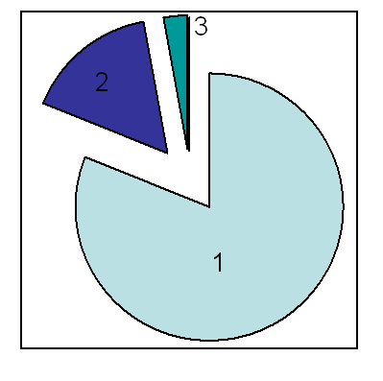
1 Self-correction with teacher´s help
2 Teacher correction
3 Peer correction

Instead of allowing students to correct themselves or providing directly the correct answers when a speaking error is committed, teachers prefer to help students to correct themselves. On this type of technique, teachers work as a guide.

Self - Correction with Teacher´s Help
The Self-Correction with Teacher’s Help technique is made by some sub-techniques. Here is the graphic that shows the most used sub-techniques that teachers use in the classroom.

Providing original answer | Repeating | Cuing | Explaining a key word | Pointing | Gesturing | Rephrasing the question
4 | 8 | 10 | 4 | 1 | 2 | 1

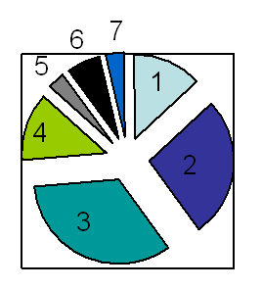
1 Providing original answer
2 Repeating
3 Cuing
4 Explaining a key word
5 Pointing
6 Gesturing
7 Rephrasing the question

Teachers from Intermediate Intensive English I use 7 techniques to correct speaking errors. The most used out of this 7 is: Cuing that is providing options when a student makes an error. The next one after cuing is: Repeating that is asking a student to repeat a sentence when an error is detected inside of it. The repetition is to make aware the student that there is an error and s/he has to correct it in the next attempt.

Interview
The interview was taken by 4 teacher from Intermediate Intensive English I. Interview was addressed to the teachers to find out what types of errors are committed in the classroom and the techniques they use to correct them. The interview was made up by 5 questions that provide different options from which the teachers could select as many as they considered appropiate but only 3 out of 5 provided information about matter.

- What kind of speaking errors do you usually correct?
Omission | Ordering | Addition | Global error | Selection
3 | 2 | 1 | 1 | 1


1 Omission
2 Ordering
3 Addition
4 Global Error
5 Selection
According to the teachers, they observe that the speaking error named Omission is the most common type of error that their students commit. Besides omitting some things in a sentence, students have a problem on ordering the words in organized way.

5) Which techniques do you use to correct speaking errors?

Self-correction with teacher´s help | Teacher correction | Peer correction
13 | 1 | 1

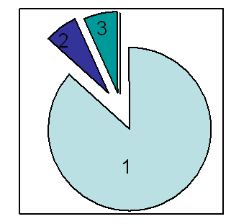
1 Self-correction with teacher´s help
2 Teacher correction
3 Peer correction

Since the students just left behind the Basic Level, Teachers consider that it is still necessary their participation when correcting their students. Peer correction and teacher correction technique is not the primary option to correct students.

These are the sub-techniques used by the teachers to correct errors.

Repeating | Cuing | Pointing | Gesturing | Rephrasing the question | Questioning
1 | 4 | 2 | 2 | 2 | 2

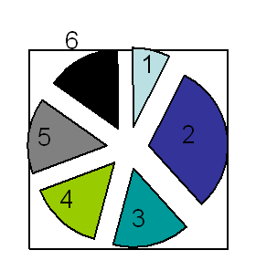
1 Repeating
2 Cuing
3 Pointing
4 Gesturing
5 Rephrasing the question
6 Questioning

When a student commits an error, teachers prefer providing options including the correct answer. Here is where student has to pick up the correct answer. With the Teacher´s help, students correct their errors when speaking.

Chapter V
Conclusions

- Intermediate Intensive English I teachers prefer correcting their students by using the self-correction with an important participation from the teacher. They feel inclined to use Cuing as a technique to correct their students´speaking errors. They have experienced that providing options to the students when making a speaking error is a technique that has happened to be useful to correct:

- As a conclusion, errors are part of the learning process of Intermediate Intensive English I students. In this level, it is very common that students think on their mother tongue since they have been speaking this target language during a short time. This is a challenge for Intermediate Intensive English I to help their students to overcome this issue.

- Throughout this investigation, the researchers found different kinds of speaking errors. The most frequent error committed by Intermediate Intensive English I students is Selection because they have not learnt to make a difference when choosing the right answer or option when speaking.

Chapter VI
Recommendations

- In order to help students to stop thinking on their mother tongue when speaking, it is necessary to engage them more frequently in native activities. For example: movies, songs, etc.

- Another way to help students to think on the mother is to encourage these students to speak only in English inside the clasroom by reminding them to express even the tiniest idea in English.

- During the class, students can record their teachers´voice to have a model so they can listen, repeat and practice.

- Since the most common type of erros is selection, teachers can assigned more speaking activities in order for teachers to realize on what grammar part they are failing.

Chapter VI
Bibliography

BOOKS
- Brown, D (2000). Principles of Language Learning and Teaching. (pp 217-229) Addison Wesley, Longman, 2000.

- Harmer, J (2001). How to teach English - An introduction to the practice of English. (pp 62–64). Addison Wesley Longman Limited 1998.

- Gower, R., Phillips, D., Walters S. (2000). Teaching practice: a handbook for teachers in training. Macmillan books for teachers 2000.

- Duckett, B (2011) Longman Dictionary of Language Teaching and Applied Linguistics. Emerald Group Publishing Limited.

WEB PAGES

- Ren, L., Zhang, D. (2007). Errors analysis and the EFL classroom teaching. Retrieved September, 2007, from http://www.teacher.org.cn

- Case, A. (2008). 15 ways to correct spoken errors. Retrieved October 2008, http://www.tefl.net

- Lengo, N. (1995) What is in a error?. Retrieved from http://www.exchanges.state.gov

ANNEXES


UNIVERSITY OF EL SALVADOR
SCHOOL OF ARTS AND SCIENCES
FOREIGN LANGUAGE DEPARTMENT

Objective: To find out the causes why students commit speaking errors.
General Instructions: Please answer these questions as sincerely as possible and choose one answer. F______ M ______

- Do you like English very much? Yes ________ No ________
- Do you feel comfortable when a teacher corrects you? Yes ___ No ____ Explain: __________________________________________________
- Besides the teacher, do you think your classmates can correct you properly? Yes _____ No_____ Explain: __________________________
- Do you limit your oral participation in class because of the fear of making errors? Yes _____ No______ Explain: _______________________
- How do you feel when you are corrected? Embarrassed ______ afraid________ happy ______ other_______
- How does the teacher correct errors in class?
Politely _______ rudely ______ sarcastically _______ other_______
- When does the teacher correct the errors made in class?
Immediately _____ after oral participation ____ after class _____ never ______
- What kind of oral errors do you consider need more correction?
Grammar ____ pronunciation ______intonation _____ word order_____
- What do you do when other students commit errors?
You correct him/ her immediately _____
You correct him/ her at the end of the class _____
Ignored the error committed _____
Tell the teacher to correct the error _____
- Why do you think you commit errors?
Interference for the mother tongue ______
Generalized English grammar rules ______
Lack of clarity in teacher explanation ______
Other (specify, please) ______
UNIVERSITY OF EL SALVADOR
SCHOOL OF ARTS AND SCIENCES
FOREIGN LANGUAGE DEPARTMENT

OBSERVATION SHEET

Type of activities | Individual, Pairs, Groups.
Types of errors | Omission, Addition, Ordering, Selection, Global errors, Local errors.
Error Correction Techniques | 1) Self Correction with Teacher’s help  Pointing, Repeating, Gesturing, Cuing, Providing original answer, Rephrasing the question, Explaining a key word, Questioning, Rephrasing a question.  2) Peer Correction  3) Teacher Correction

TYPE OF ACTIVITY | TYPE OF ERROR | TECHNIQUE USED | ERROR TRANSCRIPTION

UNIVERSITY OF EL SALVADOR
SCHOOL OF ARTS AND SCIENCES
FOREIGN LANGUAGE DEPARTMENT

Objective: To find out the corrective techniques that teachers used in English Intermediate I.

Teacher’s name: _________________________________________________

- What kind of speaking errors do you usually correct?

a) Omission b) Addition c) Ordering
d) Selection e) Global errors f) Local errors

- Do you correct every single error?

Yes _____ No _____ Why _____________________________________________________________________________________________________________________________________________________________________________________________

- When do you correct your students’ speaking errors?

a) Immediately b) After the activity c) Never d) Other

- How do students react when you correct them when they commit a speaking error?

a) Happy b) embarrassed c) doubtful d) complaining

- Which techniques do you use to correct speaking errors?

a) Pointing
b) Repeating
c) Gesturing
d) Cuing
e) Providing original answer
f) Rephrasing the question
g) Explaining a key word
h) Questioning

