Circuits logique
Corrigé exercices
Logique combinatoire:
Binaire.
Exexcice 2.1
a = (11010)2 | b = (1001101)2 | c = (110110)2
d = (110000)2 | e = (10110)2 | f = (101111)2
g = (1011110)2 | h = (101100)2 | i = (1010,001)2
j = (10011,000)2 | k = (11011,1)2 | l = (1001,01111)2
m = (1001)2 | n = (1101,101)2
Exercice 2.2
a = (100)2 | b = (1100)2 | c = (1000)2
d = (110010)2 | e = (10110)2 | f = (1101)2
g = (11000,100)2 | h = (1010,101)2 | i = (11,11)2
j = (101,01)2
Exercice 2.3
a = (11100)2 | b = (101010)2 | c = (100000)2
d = (1)2 | e = (10)2 | f = (11,100)2
g = (110001)2 | h = (100,1)2 | i = (11111)2
j = (11110,11)2

Exercice 2.4
a = 36 | b = 55 | c = 42
d = 60 | e = 65 | f = 5,625
g = 19,125 | h = 9,5625 | i = 31,75
j = 14,03125

Exercice 2.5
a = (1000011)2 | b = (10000000000)2 | c = (1100010001)2
d = (1000001)2 | e = (1000110111)2 | f = (111000101)2
g = (1010100)2 | h = (1100010010)2 | i = (1000000000)2
j = (1010100000)2

Octal
Exercice 3.1
a= 119 | b= 3386 | c= 860
d= 766 | e= 3583 | f= 3564
g=1650 | h= 668 | i= 8,015625
j= 12,033
Exercice 3.2
a= (247)8 | b= (1656)8 | c= (1557)8
d= (3025)8 | e= (2322)8 | f= (1425)8
g= (1067)8 | h= (23113)8 | i= (140,0314)8
j= (12,0121)8
Exercice 3.3
a= (23)8 | b= (27)8 | c= (12)8
d= (17)8 | e= (20)8 | f= (47)8
g= (73)8 | h= (43)8 | i= (770)8
j= (123)8

Exercice 3.4
a= 111101 | b= 1010101 | c= 11010110
d= 100111101 | e= 111111111 | f= 1010011
g= 10011110 | h= 10001 | i= 10111111
j= 100110001
Hexadécimal
Exercice 4.1
a= 6571 | b= 9469 | c= 9165
d= 22138 | e= 594173 | f= 297391
g= 41868 | h= 290363 | i= 113767
j= 8431
Exercice 4.2
a= (11E2)16 | b= (8705)16 | c= (22D8)16
d= (6EB9)16 | e= (7B)16 | f= (11CF)16
g= (16A0)16 | h= (AF63)16 | i= (3E8)16
j= (AF21)16
Exercice 4.3
a= (91)16 | b= (CC)16 | c= (3F3)16
d= (F0F)16 | e= (26A)16 | f= (939)16
g= (5FC)16 | h= (3A49)16 | i= (290C9)16
j= (3DDD)16
Exercice 4.4
a = (1010011001111001)2 | b = (1011110001001001)2 | c = (1010100100100001)2
d = (100110001001)2 | e = (10001110101)2 | f = (1011001100111001)2
g = (10000100101)2 | h = (10100010010)2 | i = (111100110111)2
j = (1101010000001100)2

Systèmes de codage

Exercice5.1
a = (0100010101111000)DCB | b = (001101100101)DCB | c = (100100100000)DCB
d = (001010000011)DCB | e = (000100100011)DCB | f = (010001011001)DCB
g = (011110010010)DCB | h = (010001001000)DCB | i = (000100000000)DCB
j = (010000110011)DCB
Exercice5-2
a = 37 | b = 122 | c = 234
d = 99 | e = 356 | f = 975
g = 777 | h = 456 | i = 1010
j = 375
Exercice5-3
a = (110101)Gray | b = (101101)Gray | c = (110100)Gray
d = (101101)Gray | e = (10101010)Gray | f = (11111111)Gray
g = (10010100)Gray | h = (110001)Gray | i = (101010011)Gray
j = (1101011011)Gray
Exercice5-4
a = (110110)2 | b = (1000101)2 | c = (1110110)2
d = (101001)2 | e = (110011)2 | f = (11101001)2
g = (1010001)2 | h = (10101010)2 | i = (1111000)2
j = (11111111)2

Lab1.1
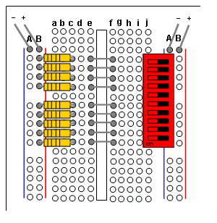

Karnaugh construction
Exercice 6.1
a = | b= | c =
  A | B | S
  0 | 0 | 0
  0 | 1 | 0
  1 | 0 | 1
  1 | 1 | 0
  A | B | C | S
  0 | 0 | 0 | 1
  0 | 0 | 1 | 0
  0 | 1 | 0 | 1
  0 | 1 | 1 | 0
  1 | 0 | 0 | 1
  1 | 0 | 1 | 0
  1 | 1 | 0 | 1
  1 | 1 | 1 | 1
  A | B | C | D | S
  0 | 0 | 0 | 0 | 0
  0 | 0 | 0 | 1 | 0
  0 | 0 | 1 | 0 | 1
  0 | 0 | 1 | 1 | 0
  0 | 1 | 0 | 0 | 0
  0 | 1 | 0 | 1 | 0
  0 | 1 | 1 | 0 | 1
  0 | 1 | 1 | 1 | 0
  1 | 0 | 0 | 0 | 0
  1 | 0 | 0 | 1 | 0
  1 | 0 | 1 | 0 | 1
  1 | 0 | 1 | 1 | 0
  1 | 1 | 0 | 0 | 1
  1 | 1 | 0 | 1 | 1
  1 | 1 | 1 | 0 | 1
  1 | 1 | 1 | 1 | 1
d = | e = | f =
  A | B | S
  0 | 0 | 0
  0 | 1 | 0
  1 | 0 | 1
  1 | 1 | 1
  A | B | C | D | S
  0 | 0 | 0 | 0 | 0
  0 | 0 | 0 | 1 | 0
  0 | 0 | 1 | 0 | 0
  0 | 0 | 1 | 1 | 0
  0 | 1 | 0 | 0 | 0
  0 | 1 | 0 | 1 | 0
  0 | 1 | 1 | 0 | 0
  0 | 1 | 1 | 1 | 0
  1 | 0 | 0 | 0 | 0
  1 | 0 | 0 | 1 | 0
  1 | 0 | 1 | 0 | 0
  1 | 0 | 1 | 1 | 0
  1 | 1 | 0 | 0 | 0
  1 | 1 | 0 | 1 | 0
  1 | 1 | 1 | 0 | 0
  1 | 1 | 1 | 1 | 1
  A | B | C | S
  0 | 0 | 0 | 0
  0 | 0 | 1 | 1
  0 | 1 | 0 | 1
  0 | 1 | 1 | 1
  1 | 0 | 0 | 1
  1 | 0 | 1 | 1
  1 | 1 | 0 | 1
  1 | 1 | 1 | 1
g = | h = | i =
  A | B | C | S
  0 | 0 | 0 | 1
  0 | 0 | 1 | 0
  0 | 1 | 0 | 0
  0 | 1 | 1 | 0
  1 | 0 | 0 | 1
  1 | 0 | 1 | 1
  1 | 1 | 0 | 1
  1 | 1 | 1 | 1
  A | B | C | D | S
  0 | 0 | 0 | 0 | 0
  0 | 0 | 0 | 1 | 0
  0 | 0 | 1 | 0 | 0
  0 | 0 | 1 | 1 | 1
  0 | 1 | 0 | 0 | 0
  0 | 1 | 0 | 1 | 0
  0 | 1 | 1 | 0 | 0
  0 | 1 | 1 | 1 | 1
  1 | 0 | 0 | 0 | 0
  1 | 0 | 0 | 1 | 0
  1 | 0 | 1 | 0 | 0
  1 | 0 | 1 | 1 | 1
  1 | 1 | 0 | 0 | 1
  1 | 1 | 0 | 1 | 1
  1 | 1 | 1 | 0 | 1
  1 | 1 | 1 | 1 | 1
  A | B | C | S
  0 | 0 | 0 | 0
  0 | 0 | 1 | 0
  0 | 1 | 0 | 1
  0 | 1 | 1 | 0
  1 | 0 | 0 | 0
  1 | 0 | 1 | 0
  1 | 1 | 0 | 0
  1 | 1 | 1 | 0
j =
A | B | C | D | S
0 | 0 | 0 | 0 | 0
0 | 0 | 0 | 1 | 0
0 | 0 | 1 | 0 | 1
0 | 0 | 1 | 1 | 0
0 | 1 | 0 | 0 | 0
0 | 1 | 0 | 1 | 0
0 | 1 | 1 | 0 | 1
0 | 1 | 1 | 1 | 0
1 | 0 | 0 | 0 | 0
1 | 0 | 0 | 1 | 0
1 | 0 | 1 | 0 | 1
1 | 0 | 1 | 1 | 0
1 | 1 | 0 | 0 | 0
1 | 1 | 0 | 1 | 0
1 | 1 | 1 | 0 | 1
1 | 1 | 1 | 1 | 1

Exercice 6.2

A)  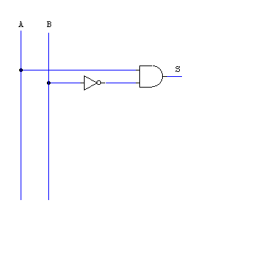 | B)  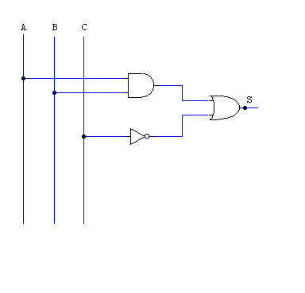
C)  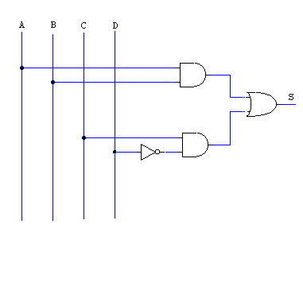 | D)  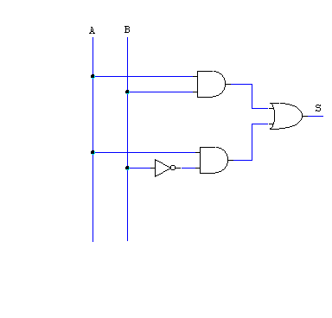
E)  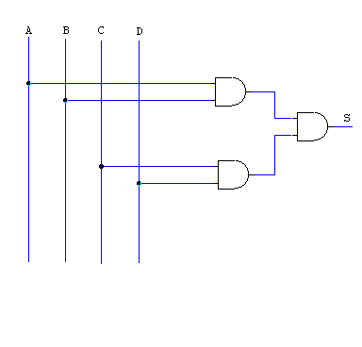 | F)  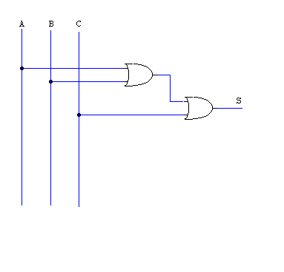
G)  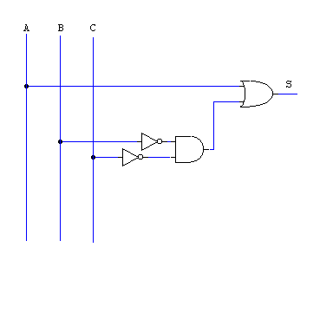 | H)  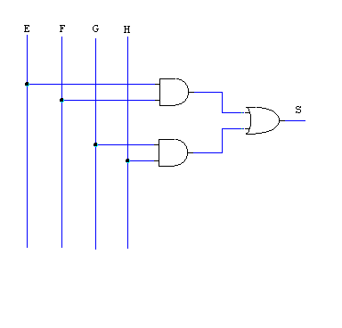
I)  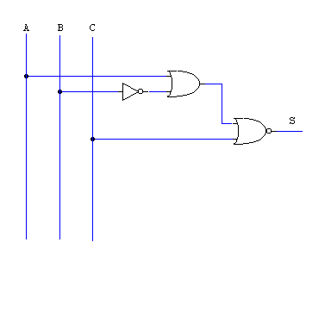 | J)  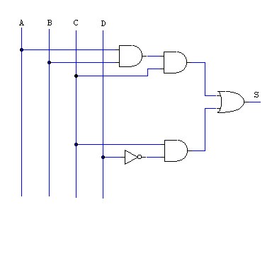

Exercice 6.3
a = /A/BC + A/BC
b = /A/B + /AB + A/B
c = /A/B/C/D+/AB/C/D+/ABCD+A/BCD+AB/C/D+ABCD
d = /A/B/C+/A/BC+/AB/C+/ABC+A/B/C+A/BC+AB/C
e = A/B+AB
Exercice 6.4
a=  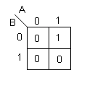 | b=  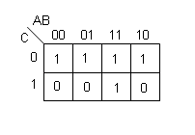
c=  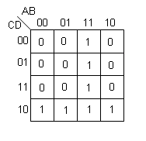 | d=  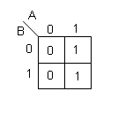
e=  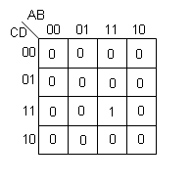 | f =  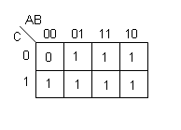
g =  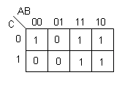 | h =  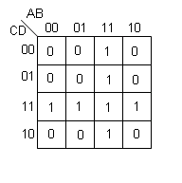
i =  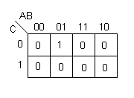 | j =  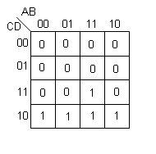

Karnaugh simplification
Exercice 7.1

a) S = AC + BC | b) S= AD + A/B + /B/C
c) S= A | d) S= /A + B + C
e) S= /A + C

Exercise 7.2
a | b | c | d | Mo | Mf | L
0 | 0 | 0 | 0 | X | X | X
0 | 0 | 0 | 1 | 0 | 1 | 1
0 | 0 | 1 | 0 | 0 | 0 | 1
0 | 0 | 1 | 1 | 0 | 1 | 0
0 | 1 | 0 | 0 | 0 | 0 | 1
0 | 1 | 0 | 1 | 0 | 0 | 1
0 | 1 | 1 | 0 | X | X | X
0 | 1 | 1 | 1 | X | X | X
1 | 0 | 0 | 0 | 1 | 0 | 0
1 | 0 | 0 | 1 | X | X | X
1 | 0 | 1 | 0 | 0 | 0 | 1
1 | 0 | 1 | 1 | X | X | X
1 | 1 | 0 | 0 | 1 | 0 | 0
1 | 1 | 0 | 1 | X | X | X
1 | 1 | 1 | 0 | X | X | X
1 | 1 | 1 | 1 | X | X | X

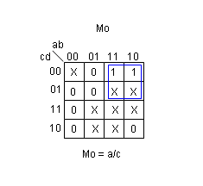 | 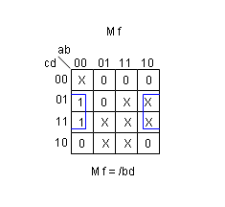
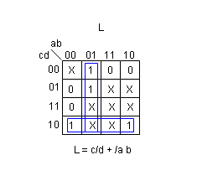
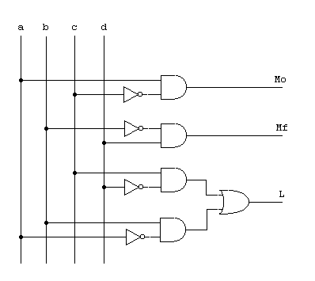

Exercise 7.3

c | v | p | t | T | C | P
0 | 0 | 0 | 0 | 0 | 0 | 0
0 | 0 | 0 | 1 | 0 | 0 | 0
0 | 0 | 1 | 0 | 0 | 0 | 0
0 | 0 | 1 | 1 | 0 | 0 | 0
0 | 1 | 0 | 0 | 0 | 0 | 0
0 | 1 | 0 | 1 | 0 | 0 | 0
0 | 1 | 1 | 0 | 0 | 0 | 0
0 | 1 | 1 | 1 | 0 | 0 | 0
1 | 0 | 0 | 0 | 0 | 0 | 0
1 | 0 | 0 | 1 | 0 | 1 | 0
1 | 0 | 1 | 0 | 1 | 0 | 1
1 | 0 | 1 | 1 | 0 | 1 | 0
1 | 1 | 0 | 0 | 0 | 1 | 0
1 | 1 | 0 | 1 | 0 | 1 | 0
1 | 1 | 1 | 0 | 0 | 1 | 0
1 | 1 | 1 | 1 | 0 | 1 | 0

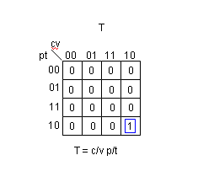 | 