SMPS & Digital Power Conversion Solutions from Microchip

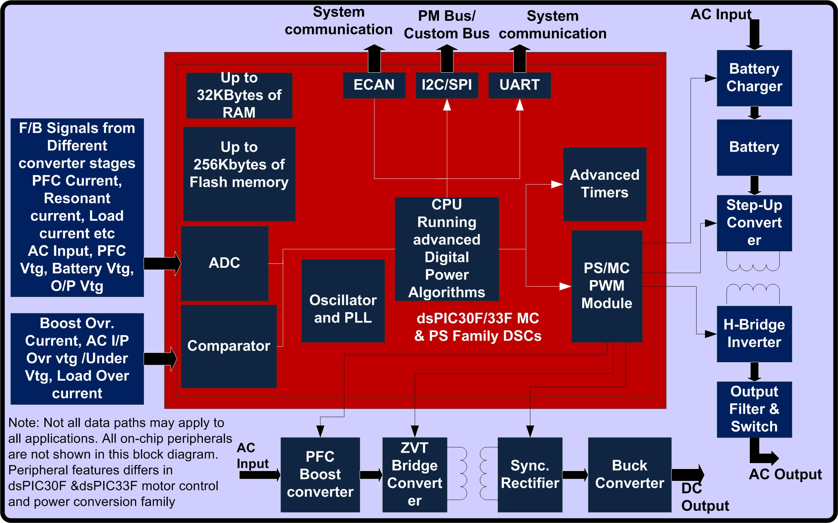 | 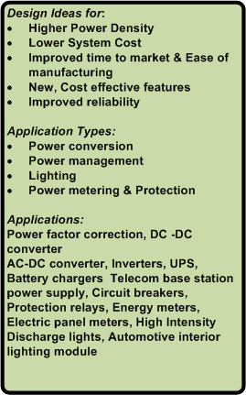

Find suitable Products, Software, Tools & Training for your Digital Power Conversion applications below

 |  | 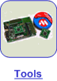 |  | 

Digital Power Design Ideas:
Are you considering moving to Digital Power, increasing power density, eliminating bigger magnetics and heat sinks or adding intelligent communication module to your power supply?
Let Microchip show you how to improve your power supply efficiency, reduce your form factor
and explore cost reduction options.
In this page you will discover Microchip’s comprehensive Digital Power Solutions, which feature 16-bit digital signal controllers, free software, development boards, technical training and more!

Looking for? | How….. | Microchip has Solution!
Higher Power Density | Increase Switching frequency  Reduce switching losses  Eliminate discrete components | High-speed and high resolution PWM  Innovative switching & control software loops –Free software  Adaptive compensation Implemented – Free software
Lower System Cost | Reduce the component counts & Over specified components  Smaller size transformers(less copper) & smaller heat sinks (less aluminum)  Reduce the board size | Software managed voltage transitions, compensations  High speed and high resolution PWM & power conversion efficiency
Improved time to market & Ease of manufacturing | Availability of design resources  Lesser the components  Self test capability, easy configuration for loads, no fine tuning of components | Many design examples, reference boards, Application notes, Code examples are available  High-speed and high resolution PWM, built-in ADC,  UART, CAN, I2C/SPI for system communication and configuration.
New, Cost effective features | High-speed PWM’s, integrated ADC, Analog comparators, IP Protection | dsPIC DSC family has all these peripherals integrated.
Improved reliability | Less components  Immune to component tolerance variance | Innovative switching & control software loops –Free software  Adaptive compensations
Back to Top

dsPIC DSC Digital Power Application Software

Category | Resource Type | Title & Link
Power Factor Correction | Application Note | AN1106 Implementing Power Factor Correction
SMPS | Application Note | AN1114 Switch Mode Power Supply (SMPS) Topologies (Part I)
SMPS | Application Note | AN1207 Switch Mode Power Supply (SMPS) Topologies (Part II)
GUI-based Design | Application Note | AN1085
SMPS Peripheral | Code Example | CE020 - Standard Mode PWM using dsPIC SMPS DSC
Buck Converter | Code Example | CE021 - dsPIC SMPS Buck Converter with PID Control
SMPS Peripheral | Code Example | CE022 - Staggered PWM with Individual Interrupts using SMPS DSC
SMPS Peripheral | Code Example | CE023 - PWM Frequency Dither using SMPS DSC
SMPS Peripheral | Code Example | CE024 - Push-Pull Mode PWM using SMPS DSC
SMPS Peripheral | Code Example | CE025 - dsPIC SMPS Negative Dead time Example
SMPS Peripheral | Code Example | CE026 - dsPIC SMPS ADC Early Interrupt
SMPS Peripheral | Code Example | CE028 - dsPIC SMPS Complementary PWM
SMPS Peripheral | Code Example | CE029 - PWM Shutdown using Analog Comparator
SMPS Peripheral | Code Example | CE030 - dsPIC SMPS ADC Triggered by Timer 1
SMPS Peripheral | Code Example | CE031 - dsPIC SMPS ADC Triggered by PWM
SMPS Peripheral | Code Example | CE032 - dsPIC SMPS ADC Interrupt Vectoring - Assembly
SMPS Peripheral | Code Example | CE033 - dsPIC SMPS ADC Interrupt Vectoring - C
Back to Top

dsPIC DSC Digital Power Training: Variety of learning options
GOING DIGITAL THE EASY WAY! In the technical aspects of digital power conversion and SMPS design with hands-on training and FREE web seminars from Microchip.
The Web Seminars listed below specifically focus on understanding and developing digital power SMPS and how the dsPIC DSC SMPS devices can be used to implement digital power conversion products.

Category | Training format | Seminar/Workshop Title
Introduction to SMPS | Web Seminar | Introduction to Switch Mode Power Supplies (SMPS)
SMPS Design : Choice of components | Web Seminar | SMPS Components and their effects on System Design
Buck DC –DC Converter | Web Seminar | SMPS Buck Converter Design Example
Digital Control techniques | Web Seminar | Introduction to SMPS Control Techniques
Reliability and Scalability of SMPS | Web Seminar | Advanced SMPS Topics
Features of dsPIC SMPS Family devices | Web Seminar | Introduction to the dsPIC® SMPS (part 1)
dsPIC SMPS Family devices PWM module, fault handling and synchronization | Web Seminar | Introduction to the dsPIC® SMPS (part 2)
Design Methods & issues : Digital SMPS | Web Seminar | Building a dsPIC® SMPS system
Digital Power conversion : Hands on Training | Hands-on Training | 312DPS: Digital Power Converter Design using dsPIC DSC SMPS Family

Back to Top

dsPIC DSC Digital Power Development Boards & SW Tools: Accelerate your development
Tools listed below targeting digital power. These development boards provides an easy and economical way to evaluate the dsPIC SMPS & Digital Power Conversion family of devices and provides an educational and prototyping platform to investigate digital power conversion and digital Switch Mode Power Supply (SMPS) design. Included with the development boards are software, documentation, and hands on exercises that can be used to get an in-depth hands-on on digital power conversion.

Selection Table: Development Boards
Digital Power Application Type | Target Device Family | Development Tools Required
Digital Power Application Type | Target Device Family | Dev Board(s) | Accessories | Plug-ins
Buck DC-DC Converter | dsPIC30F202x/1010 | SMPS Buck Development Board | None | None
Starter Board | dsPIC30F/33F | 16-Bit 28-Pin Starter Board | None | None
Development Board | dsPIC33F/30F | dsPICDEM 80-pin Starter Development Board | None | MA300016 - dsPICDEM 80-PIN TQFP PIM (dsPIC30F2023)
Development Board | dsPIC33F | Explorer16 Development Board | None | MA330013 -dsPIC33 MC 100P to 100P TQFP Plug-In Module  MA330014-dsPIC33 MC 28P QFN to 100P Plug-In Module  MA330017-dsPIC33 MC 44P QFN to 100P Plug-In Module

Development board Details:

Development/Starter Board | Features
Buck DC-DC Converter : SMPS Buck Development board  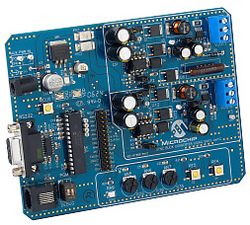  Click on the image to access complete details of this board  Click here to buy this development board | This development board provides an easy and economical way to evaluate the dsPIC30F202x/1010 SMPS & Digital Power Conversion family of components and provides an educational and prototyping platform to investigate digital power conversion and digital Switch Mode Power Supply (SMPS) design. The board includes a socketed dsPIC30F2020 device connected to power devices and circuitry for controlling dual independent low power DC to DC Synchronous Buck Converter circuits as well as support, debug, and communication circuitry.  Key Features:  - Socketed dsPIC30F2020 on board connected to power devices and circuitry for controlling dual independent low power DC to DC Synchronous Buck Converter circuits  - Buck converters can operate in Synchronous or Asynchronous modes  - Input voltage range 7V to 15V (nominal 9V)  - User can enable a dynamic output load to investigate transient response  - User potentiometers to simulate application features such as voltage trim, remote voltage sense, voltage tracking, current sharing, etc.  - MPLAB® ICD 2 or REAL ICE support ready  - RS-232 serial channel  - Example software for implementing digital dual synchronous buck converter
16- bit 28-Pin Starter Board  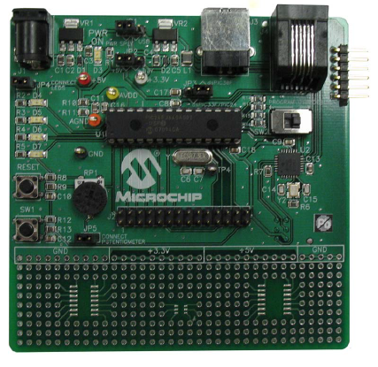  Click on the image to access complete details of this board  Click here to buy this development board | This low-cost, 16-bit, 28-pin Starter Development Board supports 28- dsPIC Digital Signal Controller (DSC) devices or pin PIC24 microcontrollers. This board is an ideal prototyping tool to help validate key design requirements using these DSCs & microcontrollers.  This board can be purchased with ICD2 (PN:DV164027 ) or without ICD2 (PN:DM300027 )  Key Features:  - Prototyping tool for all 28-pin, SDIP dsPIC30F, dsPIC33F & PIC24 devices  - On-board regulators for 3.3V or 5V operation  - Power input from 9V power supply or USB power source  - Single UART communication channel via USB bridge  - Connectors for MPLAB® ICD 2 In-circuit Debugger/Programmer and PICkit™ 2  - Header for access to all device I/O pins  - Circuit prototyping area including pads for SOIC and SOT-23 devices  - Includes a 28-pin PIC24FJ64GA002
dsPICDEM 80-Pin Starter Development Board  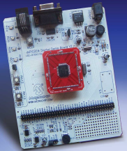  Click on the image to access complete details of this board  Click here to buy this development board | This development board offers a very economical way to evaluate both the dsPIC30F and dsPIC33F General Purpose and Motor Control Family devices. This board is an ideal prototyping tool to help you quickly develop and validate key design requirements.  Key features:  - Includes an 80-pin dsPIC30F6014A plug-in module (MA300014) and an 80-pin dsPIC33FJ256GP710 (MA330012)  - Power input from 9V supply  - Selectable voltage regulator outputs of 5V and 3.3V  - LEDs, switches, potentiometer, UART interface  - A/D input filter circuit for speech band signal input  - On-board DAC and filter for speech band signal output  - Circuit prototyping area  - Assembly language demonstration program and tutorial  - Can accommodate 80-pin dsPIC30F6010 plug-in module (MA300013) —sold separately
Explorer16 Development Board  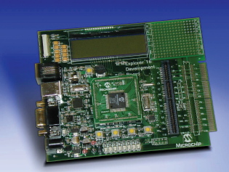  Click on the image to access complete details of this board  Click here to buy this development tool | The Explorer 16 is a low cost, efficient development board to evaluate the features and performance of Microchip's new PIC24 Microcontroller, the dsPIC33 Digital Signal Controller (DSC) families, and the new 32-bit PIC32MX devices. Coupled with the MPLAB ICD 2 In Circuit Debugger or MPLAB REAL ICE, real-time emulation and debug facilities speed evaluation and prototyping of application circuitry. The Explorer 16 100-pin features two interchangeable Plug-In Modules (PIMs), one each for the PIC24FJ128GA010 and the dsPIC33FJ256GP710 DSC. The Explorer 16 44-pin features a Plug-In Module (PIM) for the PIC24FJ64GA004  Key Features:  Includes PIC24FJ128GA010 and the dsPIC33FJ256GP710 DSC Digital Signal Controller PIMs (100-pin version)  Alpha-numeric 16 x 2 LCD display  Interfaces to MPLAB ICD 2, MPLAB REAL ICE, USB, and RS-232  Includes Microchip's TC1047A high accuracy, analog output temperature sensor  Expansion connector to access full devices pin-out and bread  Supports Plug-in modules for 28pin, 44pin & 100 pin dsPIC DSC Motor Control & Power Conversion family devices  Click here for the complete list of plug-in modules

Back to Top

Web-Based Circuit Designer and Simulator tool:
Microchip’s Mindi™ Simulator Tool aids in the design and analysis of various analog and digital circuits used in Power Management and Linear applications. This interactive simulator tool enables designers to quickly generate circuit diagrams, generate code, simulate circuits and specify passive components for a variety of power, battery-charger and linear applications. Circuits developed using the Mindi™ simulation tool can be downloaded to a personal computer (PC) or workstation and can often be ported directly into system diagrams.


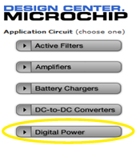 | 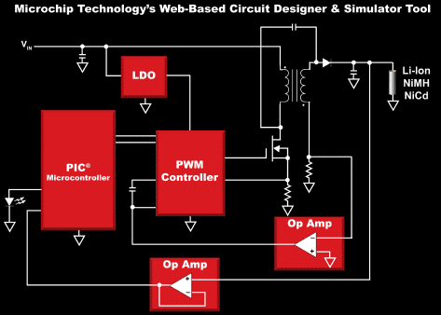 | 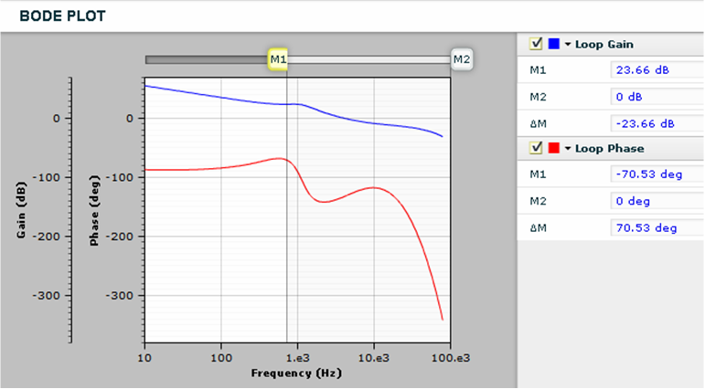

Click here for the complete list of Microchip’s and 3rd party Hardware and software development tools & Real Time operating systems for 16 bit microcontrollers

Back to Top

Getting Started with dsPIC Digital Power Products:

I want to know what digital Power is.

I am new to SMPS & digital power where should I start?

I have experience in designing SMPS but I am new to Microchip & would like to evaluate your dsPIC DSCs devices for my next generation of SMPS products.

I want to find the low cost tools & evaluation boards for digital power applications

Tell me the benefits of using dsPIC DSC’s in my power conversion applications

What are the features that dsPIC PWM Module will provide for SMPS applications
What are the important features that dsPIC ADC module provide for SMPS applications

Back to Top

Benefits of the dsPIC DSC SMPS & Digital Power Conversion Devices
(back to Getting Started)
Self contained SMPS solutions and rich peripherals of dsPIC – Digital Power devices enable the engineer to design solutions that do not require much in the way of external support chips. So when using the dsPIC DSC SMPS solution, developers can obtain a 20% reduction in component count over other solutions
In addition to the space and cost-saving features that are in the dsPIC DSC SMPS solution, it also has special features specifically enabling advanced power conversion. These include.. an Intelligent Power peripheral. The independent PWM, ADC and Analog Comparators peripherals form the Intelligent Power Peripheral via an internal configurable control fabric that enables them to interact directly with one another. The capability and benefits offered by the configurable control fabric are:
• Configurable Control Fabric
• Controls Coordination between Comparators, PWM, and ADC
• Set-up via Software / Operates Independently of Software
• Precisely Times ADC Conversions
• Controls PWM Response to Faults
• Benefits of Configurable Control Fabric
• Provides Real-Time Response without Firmware Intervention
• Expands Control Range of Options
• Adaptable for a Wide Variety of Control Methodologies
• Provides Fail-Safe Control

Back to Top

What Digital Power is
(back to Getting Started)

Digital power defined as “Digitally controlled power products that provide monitoring and supervisory functions and configuration and that extend to full-loop control using digital algorithms”
Digital circuits provide the functions of configuration, tracking, monitoring, protection, sequencing, and communications. The control feedback or feed-forward loop is controlled by the digital circuits
The control circuits combine A/D conversion, Pulse Width Modulation, and communication interfaces

Back to Top
I have experience in designing SMPS but I am new to Microchip & would like to evaluate your dsPIC DSCs devices for my next generation of SMPS products?

I want to find the low cost tools & evaluation boards for digital power applications?
(back to Getting Started)

Microchip provides you everything you will need to prototype your Digital power application including, development boards, debuggers and software libraries. Once you have installed the free MPLAB IDE and free student edition compiler MPLAB C30, just follow the easy directions below and purchase the components at microchipDIRECT.com. You can then begin your design! Remember that all of Microchip’s 16 & 32-bit MCUs and DSCs are supported by Explorer16 starter kit, so you can leverage this investment many times over the years.
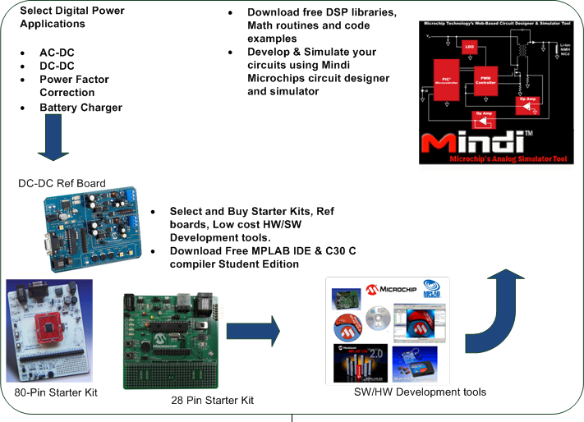
Back to Development boards section

Back to Top

I am new to SMPS & Digital power where should I start?
(back to Getting Started)
If you are new to SMPS & Digital Power, learning about Power conversion topologies is a great place to start. Click here for the SMPS Topologies application notes
We have several Application Notes, Web seminars and Hands on trainings (RTC) that may be very helpful.
You can also explore our Intelligent Power Supply Design Centre to learn more about SMPS & Digital power

Back to Top

What are the features that dsPIC PWM Module will provide for SMPS applications?
(back to Getting Started)

dsPIC SMPS family devices features the PWM module tailor made for SMPS applications which requires high-speed and high resolution PWM. Following are the main features of the PWM module. Please refer to individual datasheets, reference manuals for the detailed capabilities of PWM module

- High resolution PWM : 12 bits at 234 Khz
  - ns duty cycle resolution
- Dead-time resolution of 4.2 nsec @ 30 MIPS
- Frequency resolution of 8.4 nsec @ 30 MIPS

- 7 PWM Modes of operation
    - Standard PWM mode: Used for Buck, Boost & Flyback converters
    - Complementary PWM mode: Used in Buck Converters with Sync.
Rectification
    - Push-Pull PWM mode :Used in Series & Parallel Resonant Half Converters

    - Multi-Phase PWM mode: Used in Multi-Phase Converters

    - Variable Phase PWM mode: Used in ZVT Converters

    - PWM current reset mode: Used for Power Factor Correction

    - Current limit PWM mode: Used in many Topologies

- Individual deadtime values for each PWM
    - Positive and negative deadtime
    - 4.4 nsec resolution
- Extensive fault handing capability
- Extensive ADC triggering options
- Up to 4 Independent PWM generators
- There is one MASTER time-base:
    - All can share MASTER time base
    - All can share MASTER time base - with programmable phase shift

Back to Top

What are the important features that dsPIC ADC module provide for SMPS applications?
(back to Getting Started)

dsPIC SMPS Family devices come with a unique ADC features. Please refer to device datasheets for the complete details of ADC capabilities

- The SMPS dsPIC ADC can monitor voltages or currents at precise times.
- Asynchronous sampling is supported by the SMPS dsPIC via sophisticated ADC triggering. An ADC conversion can be triggered by the PWM Individual Trigger, PWM Special Event Trigger, Analog Comparator, General Purpose Timer or by Software.
- Multiple sample and hold circuits make simultaneous sampling possible.

- General Features of ADC include:
  - 10 /12 bit Resolution
  - 1/2 Million Samples / sec conversion rate
  - 6 to 24 input channels
  - Low latency improves control loop stability
  - Advanced Sampling Capability:
    - Individual triggers for each S&H
    - Samples may be simultaneous
    - Samples may be uniquely timed
    - Sample acquisitions are precisely timed

Back to Top

More about design ideas (Continued from top page….)

Higher Power Density:

dsPIC devices replace both MCU for power management and communications along with analog PWM controllers. A single dsPIC can support multiple control loops (PFC, multiple outputs, etc) thus eliminating multiple PWM controllers in a power supply. With the high speed and high resolution PWM it is possible to reduce the size of transformers and other associated inductors & capacitors. dsPIC PWM Module supports resonant conversion, by implementing the more efficient & innovative software control algorithms & switching techniques switching losses are reduced, many discrete components are eliminated thus increasing the power density per square inch of PCB.

Back to Design Ideas

Back to Top

Lower System Cost:

With dsPIC digital power & motor control family devices, it is possible to lower the system cost by reducing the size of inductors & heat sinks by implementing efficient & innovative switching technique using high speed and high resolution PWM. Complex compensation circuits replaced with software loops running on dsPIC

Leading edge blanking (LEB) will eliminate the RC delay circuits in the current measurements. Built-in comparators eliminate the external comparators. Built-in FRC eliminating the expensive high precision crystals/oscillators. Single supply voltage eliminates external power supply components.

dsPIC DSCs support resonance conversion thus eliminating external snubber circuits & managed voltage transitions eliminate “Over specified” Components thus reducing the overall system cost

Back to Design Ideas

Back to Top

Improved time to market & Ease of manufacturing:

DC-DC Buck converter reference design, starter kits are readily available from Microchip.
Mindi Power management simulator tool, application notes, Code examples can be used as a design resources and will help in coming out with the products quickly.
Easy software configuration helps in releasing the product variants quickly.

Changes / Tweaks quickly performed by changing software / parameters instead of hardware thus saving the manufacturing time. Component tolerance issues reduced thus giving more flexibility to manufacturing. Trimming and calibration performed by programming flash memory, eliminating trim pots, or laser trimming. Improved Self-Test Capability Simplifies/Speeds Product Testing

Back to Design Ideas

Back to Top

New, Cost effective features:

dsPIC devices replace both MCU for power management and communications along with analog PWM controllers. dsPIC devices are highly integrated and require few external support components

- Adapt to Changing Load (Capacitive, Inductive, Resistive, Current Demands)
  - Controller can anticipate load changes rather than react to the changes after the fact
- Better Transient Response Specifications – Not Limited to Linear Techniques
  - Non-linear, predictive, and adaptive control techniques can be implemented easily in software
- Managed Voltage Transitions Eliminate “Overspecified” Components
  - Advanced soft transition and ramping easily performed digitally

Back to Design Ideas

Back to Top

Improved reliability:

Designs with Fewer Components, “lesser the components better the reliability”
Component Tolerance/Drift Reduced thus improving the reliability
Control performed in software eliminating precision resistors, capacitors, etc
Adaptive compensation in software enables looser component tolerances
Design optimization/tuning faster

Back to Design Ideas

Back to Top

dsPIC DSC Power Conversion Families:
Microchip offers two device families of dsPIC DSCs for digital Power applications

- dsPIC DSC SMPS & Digital power conversion devices
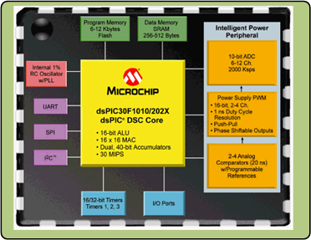 | 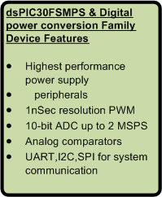

dsPIC30F operates from 2.5-5.5V and offers on-chip EEPROM.

- dsPIC DSC Motor Control & Power Conversion devices

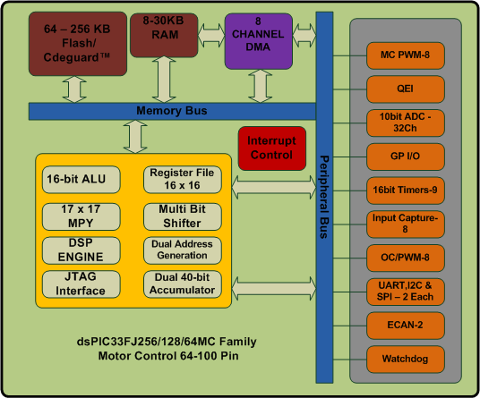 | 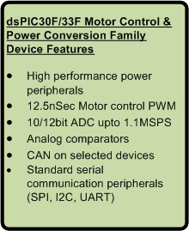

The dsPIC33F family operates3.3V and offers the lowest priced point, particularly for larger Flash memory sizes.
The devices in both families are listed in the two charts below:

Back to Top

