Chapter 18. Thermodynamics and Colloid and Surface Chemistry

Problem 1. The dispersion component of the surface tension of water using the Fowkes equation
Estimate the dispersive and specific components of the surface tension of water using the Fowkes equation and the experimental value for the liquid-liquid interfacial tension of water-cyclohexane (50.2 mN/m). The surface tension of water is 72.8 and of cyclohexane is 25.5, all values are in mN/m (or dyn/cm) at 20 ºC. Repeat the calculation for the water-n-hexane system (interfacial tension=51.1 mN/m; surface tension of hexane=18.4 mN/m). Compare the results obtained with the two mixtures.

Problem 2. Interfacial Tensions for liquid-liquid systems with the Fowkes equation
The interfacial tension of mercury with benzene is (at 20 ºC) $γ_{\text{HgB}}=\text{357}$mN/m. Using the values given in table 18.12 for the surface tensions of mercury (Hg), benzene (b) and water (w), estimate using the Fowkes equation for the liquid-liquid interfacial tension:
- The dispersion part of the surface tension of mercury at 20 ºC ($γ_{\text{Hg}}^{d}$).
- The interfacial tension of the mercury-water system ($γ_{\text{Hgw}}$). Compare the result to the experimental value, which is in the range 415-426 mN/m at 20 ºC.
- The interfacial tension of water/benzene and compare it to the experimental value (35 mN/m).
Explain the assumptions required and discuss briefly the results. If the results using the Fowkes equation are not satisfactory, which other method would you recommend using for estimating the interfacial tension ?

Table 18.12. Values for the surface tensions of mercury, benzene, water, n-pentane and n-octane.
Compound | Surface tension (at 20 ºC) in mN/m
Mercury | 485
Benzene | 28.9
Water | 72.8
n-pentane | 16.8
n-octane | 21.8

Problem 3. Liquid-liquid interfacial tensions with the Fowkes equation
- The structure of monoethylene glycol (MEG) is: OH-CH₂-CH₂-OH. MEG has a surface tension equal to 47.7 mN/m. Table 18.13 shows experimental data for the surface tension of two hydrocarbons and their liquid-liquid interfacial tensions with MEG. Based on these data, can you conclude whether Fowkes equation can be applied to glycol-alkane interfaces? Justify your answer with calculations.
- Perform the same exercise as part i. for the CHCl₃-water and CCl₄-water interfaces using the data of table 18.14. Use the well-accepted value for the dispersion surface tension of water (21.8 mN/m).
Table 18.13. Experimental data for the surface tension of two hydrocarbons and their liquid-liquid interfacial tensions with MEG.

Alkane | Surface Tension (mN/m) | Interfacial tension against MEG (mN/m)
cyclohexane | 25.5 | 14
n-hexane | 18.4 | 16

Table 18.14. Experimental data for the surface tension of two components and their liquid-liquid interfacial tensions with water.

Compound | Surface Tension (mN/m) | Interfacial tension against water (mN/m)
chloroform | 27.1 | 28
carbon tetrachloride | 26.9 | 45

Problem 4. Interfacial Tensions for hydrocarbon/water systems with the Hansen-Beerbower equation
Two sets of the Hansen dispersion, polar and hydrogen bonding solubility parameters have been reported for water: set 1 (7.6, 8.1, 20.6) and set 2 (10.8, 14.3, 15.6). All values are given in (cal/cm³)^{1/2}. The molar volume of water is 18.0 cm³/mol.
- Calculate, using the Hansen-Beerbower model, equation 18.6, the dispersion and specific (polar and hydrogen bonding) parts of the surface tension of water based on both sets of water solubility parameters. Which set of water solubility parameters results in values for the dispersion and specific surface tensions for water closer to those estimated from the Fowkes theory?
- Estimate, using the Hansen-Beerbower equation, the dispersion, polar and hydrogen bonding parts of the surface tension of pentane, octane and benzene. The experimental surface tensions of pure liquids are known (Table 18.12). Comment on the results.
- Estimate, using the Hansen-Beerbower equation for the interfacial tension, the interfacial tensions for water-octane and water-benzene. Which water solubility parameter set gives better results (closer to the experimental values)? The experimental interfacial tensions are 50.8 and 35.0 mN/m, respectively.

Data:
The Hansen solubility parameters (dispersion, polar, hydrogen bonding) and the volume of pentane are: 7.1, 0.0, 0.0 and 116.2, in (cal/cm³)^{1/2} and cm³/mol, respectively.
Similarly for octane: 7.6, 0.0, 0.0 and 163.5
And for benzene: 9.0, 0.0, 1.0 and 89.4

Problem 5. Work of adhesion and contact angles from the Hansen/Beerbower theory
The liquid (l)-solid (s) interfacial tension can be given by the Hansen/Beerbower expression:
$γ_{\text{sl}}={\left(\sqrt{γ_{s}^{d}}−\sqrt{γ_{l}^{d}}\right)}^{2}+{\left(\sqrt{γ_{s}^{p}}−\sqrt{γ_{l}^{p}}\right)}^{2}+{\left(\sqrt{γ_{s}^{h}}−\sqrt{γ_{l}^{h}}\right)}^{2}$ 18.61
- Show that, when the spreading pressure is zero, the contact angle for a solid-liquid interface based on equation 18.61, is given by the equation:
$\text{cos}ϑ=−1+2(\sqrt{γ_{l}^{d}γ_{s}^{d}}+\sqrt{γ_{l}^{p}γ_{s}^{p}}+\sqrt{γ_{l}^{h}γ_{s}^{h}})/{γ_{l}}$ 18.62
ii. A very simple theory for the interfacial tension which performs satisfactorily for some systems is a modified form of the Girifalco-Good equation (using a correction parameter equal to one):
$γ_{\text{sl}}={\left(\sqrt{γ_{s}}−\sqrt{γ_{l}}\right)}^{2}$ 18.63
Derive an expression for the work of adhesion as a function of the surface tensions of the solid and the liquid.
iii. Derive the expression for the solid-liquid work of adhesion from the Owens-Wendt theory.

Problem 6. Adhesion between paint layers based on epoxy and silicone
In a new fouling-release paint produced by a major paint company are included several layers of which two are based on epoxy and silicone. Various epoxies have been tried because adhesion problems have been observed in certain cases. In order to achieve a better understanding of the surfaces, contact angles have been measured for three liquids on the various epoxies and the results for three of the epoxies are shown in table 18.15.

Table 18.15. Measured contact angles for three liquids on various epoxies.

Epoxy type | Cos (contact angle)  of water | Cos (contact angle)  of ethylene glycol (EG) | Cos (contact angle)  of benzaldehyde
45742 | 0.511 | 0.846 | 0.972
45182 | 0.536 | 0.703 | 0.943
45143 | 0.442 | 0.742 | 0.943

The surface tension of the silicone layer (on top of the epoxy) is 29.5 mN/m. It is moreover expected that the epoxy with the highest surface tension may yield better adhesion with the silicon layer. Using the van Oss-Good approach:
i. Estimate the LW, acid/base and the total surface tension of all three epoxies. The surface tension components for the van Oss et al. Method are for water and EG (21.8, 25.5, 25.5) and (29, 1.92, 47.0), respectively. The order in parenthesis is LW, acid and base component. For benzaldehyde, it can be assumed that only LW contribution exists and the surface tension is 38.5 mN/m. Comment on the values obtained for the individual components of the surface tensions for the three epoxies.
ii. Which epoxy surface is expected to be better wetted by silicone and for which epoxy-silicon system is expected the highest adhesion?

Problem 7. Interfacial tension for 'complex' liquid-liquid interfaces with various models
Many theories have been proposed for the estimation of interfacial tensions. These theories can be tested against experimental data for liquid-liquid interfaces but testing is more difficult for solid-liquid interfaces (where the interfacial tension cannot be measured directly). In this problem we consider aqueous mixtures with organic compounds like aniline and alcohols and will select the best among a number of these theories. The first application is the water-aniline system. The surface tension of aniline is 42.9 mN/m and the ratio of dispersion to specific surface tension is, for the same liquid, 1.294.
- Calculate the water/aniline interfacial tension with the Fowkes equation and with the following two versions of the harmonic mean equation:
$γ_{\text{ij}}=γ_{i}+γ_{j}−\frac{4γ_{i}^{d}γ_{j}^{d}}{γ_{i}^{d}+γ_{j}^{d}}$ 18.64
$γ_{\text{ij}}=γ_{i}+γ_{j}−\frac{4γ_{i}^{d}γ_{j}^{d}}{γ_{i}^{d}+γ_{j}^{d}}−\frac{4γ_{i}^{\text{spec}}γ_{j}^{\text{spec}}}{γ_{i}^{\text{spec}}+γ_{j}^{\text{spec}}}$ 18.65
Compare the results to the experimental value which is 5.8 mN/m ? What do you observe?
- Calculate the water/aniline interfacial tension with the Owens-Wendt expression, which is similar to Fowkes but includes an extra term for the specific forces:
$γ_{\text{ij}}=γ_{i}+γ_{j}−2\sqrt{γ_{i}^{d}γ_{j}^{d}}−2\sqrt{γ_{i}^{\text{spec}}γ_{j}^{\text{spec}}}$ 18.66
How does the Girifalco-Good model perform for this system? Which of the four models compares best with the experimental data?
- The second application involves the immiscible water- heavy alcohols (i.e. heavier than propanol). The surface tensions of butanol, hexanol, heptanol and octanol are 24.6, 25.8, 25.8 and 27.5 mN/m, respectively. Which of the above models (considered in questions i and ii) would you employ for estimating the interfacial tensions of these alcohols with water? The experimental values are: 1.8 for butanol/water, 6.8 for hexanol/water, 7.7 for heptanol/water and 8.5 for octanol/water (all values in mN/m). How does the best model you have chosen perform compared to the experimental data?

Problem 8. Adsorption and Surface tension for aqueous solutions
In several cases, the adsorption from aqueous (and other type) solutions can be described by the Langmuir isotherm:

$Γ=\frac{Γ_{\text{max}}\text{kC}}{1+\text{kC}}$ 18.67
where C is the concentration and k a parameter characteristic of the system involved.
i. Show that, using the Langmuir isotherm, the surface tension depends on solute concentration as follows, via the so-called Szyszkowski equation:
$γ=γ_{o}−\text{RT}Γ_{\text{max}}\text{ln}(1+\text{kC})$ 18.68
where $γ_{{}_{o}}$is the surface tension of pure water.
- How does the surface tension depend on concentration, if the adsorption isotherm follows the so-called Henry's law (valid at very low concentrations)?
$Γ=Γ_{\text{max}}\text{kC}$ 18.69

Problem 9. The ideal gas law in the surface science
In some cases e.g. at low concentrations, the surface tension of aqueous surfactant solutions ($γ$) decreases linearly with concentration (c):
$γ=γ_{0}−\text{bc}$ 18.70
where $γ_{0}$is the surface tension of pure water and b is a constant depending on the system.
Show that, in this case, the surface pressure $π$ (=water surface tension-solution surface tension) is given by the so-called two-dimensional ideal gas law equation:
$πA=n_{i}^{σ}\text{RT}$ 18.71
where A is the surface area, R is the ideal gas law constant, T is the temperature and $n_{i}^{σ}$is the number of moles at the surface.

Problem 10. Adsorption from solution – the role of solvent
Figure 18.19 shows adsorption of three organic acids from solutions onto two different solids. The right part is adsorption on coal from aqueous solutions and the left one represents adsorption on silica gel from toluene solutions. Explain qualitatively the difference in the order of the adsorption of the three acids on the two solid surfaces. What is the role of the solvent in the two cases?

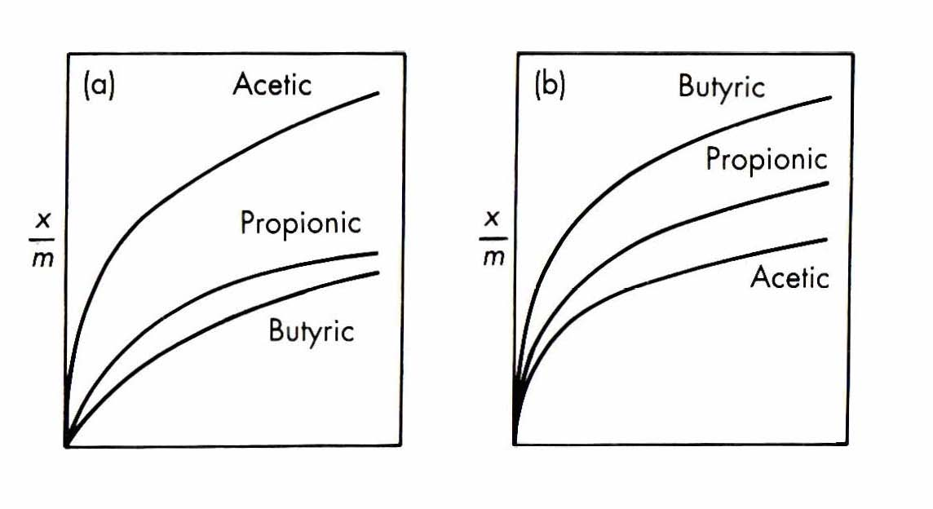
Figure 18.19. Adsorption isotherms for fatty acids: (a) from toluene solutions onto silica gel and (b) from aqueous solutions onto charcoal. From Shaw⁵. Reprinted with permission from Elsevier (1992).

Problem 11. Competitive adsorption of surfactants on solids
There are several measures of the balance between hydrophilic and lipophilic parts of an amphiphilic molecule like surfactants. Two of them are the well-known “structure-based” CPP (critical packing parameter) and the empirical HLB (hydrophilic-lipophilic balance). HLB is used mostly in emulsion studies (low values below 8 indicate poor water solubility and high values e.g. above 8 indicate good water solubility). HLB and CPP are often interrelated e.g. figure 18.10 for surfactants. We would like to study the competitive adsorption of an anionic surfactant (SDS), which is known to form spherical micelles and a non-ionic one (ethoxylated nonyl phenol with 10 ethylene oxide units) on a hydrophobic latex surface. The HLB of ethoxylated nonyl phenols can be estimated from equation 18.47. Two laboratories provide you with two completely different results for the relative concentrations of the two surfactants on the surface:
NPE₁₀/SDS : 90/10
NPE₁₀/SDS : 10/90
Which one of the two would you expect to be correct and why?

Problem 12. Characterization and wetting of Teflon surfaces
Measurements of contact angles for several liquids on a poly (tetra fluoro ethylene) surface (Teflon) at 20 ºC gave the results presented in table 18.16.

Table 18.16. Measurements of contact angles for several liquids on a poly (tetra fluoro ethylene) surface (Teflon) at 20 ºC.

Liquid | Contact angle ( º) | surface tension (mN/m)
Water | 107 | 72.8
propylene carbonate | 76 | 40.7
Hexachloro butadiene | 59 | 35.3
d(2-ethyl hexyl) adipate | 63 | 30.6
dibutyl ether | 35 | 22.8
n-octane | 33 | 21.8

- Estimate the critical surface tension of Teflon using the Zisman plot.
- Based on the answer to the previous question, is Teflon an easy material to wet?
- How can we improve the wetting of Teflon surfaces?
- Hansen/Beerbower have proposed equation 18.8 for estimating the surface tension using the Hansen solubility parameters. Using equation 18.8, and the Hansen solubility parameters for propylene carbonate (9.0, 9.6, 2.0; volume=85.0 cm³/mol), estimate the dispersion, the polar and the hydrogen bonding contributions of the surface tension of propylene carbonate ($γ_{d},γ_{p},γ_{h}$).
- The liquid (l)-solid (s) interfacial tension can be given by the Hansen/Beerbower expression, see equation 18.7. Show that, when the spreading (expanding) pressure is zero, the work of adhesion for a solid-liquid interface based on equation 18.7, is given by the equation:
$W_{\text{sl}}^{\text{adh}}=2(\sqrt{γ_{l}^{d}γ_{s}^{d}}+\sqrt{γ_{l}^{p}γ_{s}^{p}}+\sqrt{γ_{l}^{h}γ_{s}^{h}})$ 18.72
- Equation 18.72 also provides an expression for the contact angle as a function of the surface tension contributions (dispersion, polar, hydrogen bonding) of the liquids and of the solid. Using equation 18.72 (expressed for contact angle), the data of Table 18.16 and the dispersion, polar and hydrogen bonding surface tension contributions of propylene carbonate (answer to question 4), estimate the dispersion, polar and hydrogen bonding surface tension contributions ($γ_{d},γ_{p},γ_{h}$) of Teflon. You can assume that the polar and hydrogen bonding (surface tension) contributions of Teflon ($γ_{p},γ_{h}$) are equal to each other. Compare the overall value of the surface tension of Teflon to the critical surface tension, as obtained from Zisman plot (answer to question 1). What do you observe?

Hint: If one of the surface tension contributions (dispersion, polar, hydrogen bonding) is zero, then you can ignore, in equation 18.72, the square root term where this contribution is present.

Problem 13. Characterization of a PVC surface with the Owens-Wendt theory
The contact angles of water and methylene iodide have been measured on a PVC (polyvinyl chloride) surface to be equal to 87º and 36º, respectively. The surface tension of water is at 25 ºC equal to 72.8 with a dispersion part equal to 21.8. For methylene iodide, the surface tension is 50.8, and the dispersion part is 49.5. All surface tension values are in mN/m. Assuming the validity of the Owens-Wendt theory, calculate the surface tensions (total, dispersion and specific) of the solid PVC surface and comment briefly on the results.

Problem 14. Work of adhesion from the Zisman plot
The Zisman plot is sometimes expressed by the equation:

$\text{cos}ϑ=1−β\left(γ_{l}−γ_{\text{crit}}\right)$ 18.73

where $\text{cos}ϑ$ is the cosine of the contact angle, $γ_{l}$is the liquid-gas surface tension, $γ_{\text{crit}}$ is the critical surface tension and $β$ is a positive parameter that depends on the experimental data used. We can further assume that the spreading pressure is very low and can thus be ignored.
- Show that, under these assumptions, the work of adhesion goes through a maximum when the liquid-gas surface tension is:
$γ_{l}=\frac{2+{\text{βγ}}_{\text{crit}}}{2β}$ 18.74
- Show that, in this case, the maximum value of the work of adhesion is given by the equation:
$W_{\text{adh}}=\frac{1}{β}{\left(1+\frac{{\text{βγ}}_{\text{crit}}}{2}\right)}^{2}$ 18.75

Problem 15. Resistance of an adhesive joint in presence of liquids [From Owens, J. Appl. Polymer Sci., 1970, 14: 1725]
We are given a solid substrate, which is a flame-treated polypropylene (PP) film coated with a polymer, a vinylidene chloride/methyl acrylate co-polymer. The surface of two solids, coating-PP, is immersed in a solution of a surfactant, SDS (sodium dodecyl sulfate). Is there danger for separation of the two solids due to the surfactant? Use the data available in table 18.17 for the three materials and assume the validity of the Owens-Wendt theory.

Table 18.17. Surface tension and dispersion part of surface tension for different materials.

Compound | Surface tension (mN/m) | Dispersion part of the surface tension (mN/m)
Polypropylene (S1) | 37.6 | 33.5
Coating (S2) | 53.6 | 38.9
SDS (L) | 37.2 | 29.0

Problem 16. Characterization and wetting of Nylon surfaces
The following data is available for a specific nylon type [abbreviated as PA-6]:
Repeating unit: -[ (CH₂)₅-CO-NH] -
Critical surface tension: 43 mN/m
Density: 1.13 g/cm³
Solubility parameters (dispersion, polar, hydrogen bonding) = (9.5, 6.9, 7.1) (cal/cm³)^{1/2}

For formamide are available the surface tension components in the same order (dispersion, polar, hydrogen bonding): 16.5, 27.3 and 14.4 mN/m.
- Which of the following liquids can wet completely PA-6: water (72.8), acetone (23.3), hexachloro butadiene (35.5), diethyleneglycol (44.7) ? Explain briefly your answer. The values in parentheses are the surface tensions of the liquids, all in mN/m.
- Which of these three surfaces: PE (polyethylene), PA-6, Teflon is easiest to wet? Write these three surfaces in such an order starting from the one that is easiest to wet. Explain briefly your answer.
- Hansen/Beerbower have proposed equation 18.8 for estimating the surface tension using the Hansen solubility parameters (dispersion, polar and hydrogen bonding ones). Using equation 18.8 make an estimation of the dispersion, the polar and the hydrogen bonding contributions of the surface tension of PA-6 ($γ_{d},γ_{p},γ_{h}$).
- Estimate, based on the above, the contact angle of formamide with PA-6.

Problem 17. Critical and Solid Surface tensions - Are they the same?
It is often stated that Zisman's critical surface tension $γ_{\text{crit}}$ is numerically close to the surface tension of the solid $γ_{s}$. Prove that, under some simplifying assumptions:
- When the Girifalco-Good equation of the interfacial tension is used together with the Young equation, then:
$γ_{s}=\frac{γ_{\text{crit}}}{ϕ^{2}}$ 18.76
- When the Fowkes equation of the interfacial tension is used together with the Young equation, then:
$γ_{\text{crit}}=γ_{s}^{d}$ 18.77
Which assumption is made in both cases? Which is the additional assumption in the case of Fowkes equation?

Problem 18. Characterization and wetting of PET surfaces
Measurements of contact angles for several liquids on a poly (ethylene terephthalate) surface (PET) surface at room temperature are presented in table 18.18.

Table 18.18. Measurements of contact angles for several liquids on a poly (ethylene terephthalate) surface (PET).

Liquid | Contact angle ( º) | surface tension (mN/m)
Water | 83.8 | 71.99
Pyridazine | 34.8 | 49.51
Formamide | 51.4 | 57.03
Benzonitrile | 0.0 | 35.79
Adiponitrile | 12.3 | 45.45
Hydrazine | 75.2 | 66.39
Ethylene glycol | 30.1 | 47.99
Diethylene glycol | 9.7 | 44.77
1,2 dichloroethane | 0.0 | 39.55

All surface tension values provided below are at the same temperature as the values of the table (close to room temperature).
- Estimate the critical surface tension of PET using the Zisman plot.
- Can we use a paint with surface tension equal to 55 mN/m in order to paint a PET surface? Justify your answer.
- Calculate the work of adhesion of water and formamide with PET.
- Hansen/Beerbower have proposed equation 18.8 for estimating the surface tension using the Hansen solubility parameters. It is given that the surface tension of ethylacetate is equal to 23.9 mN/m and that the same parameter l could be used for all acetates. Can n-butylacetate wet the PET surface? Given: Hansen solubility parameters and volume for ethylacetate (7.7, 2.6, 3.5; 98.5) and for n-butylacetate (7.7, 1.8, 3.1; 132.5), both in (cal/cm³)^{1/2} and cm³/mol (volume).
- The surface tension of n-octanol is 27.5 mN/m. Estimate, with a method of your own choice, the interfacial tension of a water-n-octanol liquid-liquid interface and compare to the experimental value (=8.5 mN/m).

Problem 19. Characterization and wetting of Polystyrene (PS) surfaces
The following data is available for a polystyrene (PS) surface:
Repeating unit: -[CH₂-CH-(C₆H₅)]-
Critical surface tension: 33 mN/m
Density: 1.04 g/cm³
Solubility parameters (dispersion, polar, hydrogen bonding): (8.9, 2.7, 1.8) (cal/cm³)^{1/2}
The surface tension components of glycerol are available in the same order (dispersion polar, hydrogen bonding): 20.6, 6.3, 36.5, all in mN/m. The values of all properties in this problem are at room temperature.
- The critical surface tension of Polyvinylchloride (PVC) is 40 and that of Teflon (PTFE) is 18, both in mN/m. Which of the three polymers, PS, PVC and Teflon is easiest to wet and which one is the most difficult to wet ? Explain briefly your answer.
- Which of the following liquids can completely wet PS: n-hexadecane (27.6), formamide (58.2), acetone (23.3) and 1,1-diphenylethane (37.7) ? Explain briefly your answer. The values in parentheses are the surface tensions of the liquids, all in mN/m.
- Using equation 18.8 provide an estimation for the dispersion, the polar and the hydrogen bonding contributions of the surface tension of PS. Discuss briefly the result.
- Estimate, based on the above, the contact angle of glycerol with PS. Compare your result with the experimental value which is 82º. The Hansen solubility parameters (dispersion, polar, hydrogen bonding) and the volume of glycerol are: 8.5, 5.9, 14.3 and 73.3, in (cal/cm³)^{1/2} and cm³/mol, respectively.
- Provide an estimation of the theoretical work of adhesion of glycerol with PS.

Problem 20. Molecular Weight of Biomolecules from surface pressure data
The techniques used for studying spread monolayers of insoluble substances can be used in the study of protein films. Proteins adsorb and denaturate at high-energy air-water and oil-water interfaces because unfolding allows the polypeptide chains to be oriented with most of their hydrophilic groups in the water phase and most of the hydrophobic groups away from the water phase. Protein films tend to be gaseous at low concentrations, thus permitting relative molecular weight determination. Based on this assumption, estimate the molecular weight of the protein haemoglobin from the measurements of the surface pressure for various areas at 25 ºC (Table 18.19). Haemoglobin is regarded as amphiphilic. Compare your answer with a value of 68000 g/mol determined from sedimentation measurements.

Table 18.19. Measurements of the surface pressure for various areas at 25 ºC.
Surface pressure (mN/m) | 0.28 | 0.16 | 0.105 | 0.06 | 0.035
Area A (m²/mg) | 4.0 | 5.0 | 6.0 | 7.5 | 10.0

Problem 21. Wetting of PMMA surfaces
The following data are available for a polymethylmethacrylate (PMMA) surface:
Repeating unit: -[CH₂-C-(CH₃)-COOCH₃]-
Critical surface tension: 39 mN/m
Density: 1.18 g/cm³
Solubility parameters (dispersion, polar, hydrogen bonding): (8.6, 5.6, 2.1) (cal/cm³)^{1/2}
The surface tension components of formamide are available in the same order (dispersion polar, hydrogen bonding): 16.5, 27.3, 14.4, all in mN/m. The values of all properties in this problem are at room temperature. Table 18.20 shows the contact angle of several liquids on a PMMA surface.

Table 18.20. Contact angle of several liquids on a PMMA surface.

Liquid | Contact angle ( º) | surface tension (mN/m)
Water | 80 | 72.8
Glycerol | 69 | 63.3
Formamide | 57 | 58.3
diethyleneglycol | 30 | 44.7
nitromethane | 10 | 36.0
Acetone | 0 | 23.3

- Explain briefly the concept of 'the critical surface tension' and how it has been estimated for PMMA using the data of Table 18.20. Which of the following liquids will fully wet PMMA: diethylene glycol, formamide, and acetone?
2. Using equation 18.8, provide an estimation of the dispersion, the polar and the hydrogen bonding contributions of the surface tension of PMMA (). Discuss briefly the result.
- Estimate, based on the above, the contact angle between formamide and the PMMA surface. Compare your results with the experimental value (Table 18.20).
- The Hansen radius of solubility of PMMA is equal to 3.1 (cal/cm³)^{0.5}. Are benzene and methanol good solvents for PMMA? Discuss briefly the results.

Data:
The Hansen solubility parameters (dispersion, polar, hydrogen bonding) and the volume of formamide are: 8.4, 12.8, 9.3 and 39.8, in (cal/cm³)^{1/2} and cm³/mol, respectively.

Problem 22. Stability of Alumina particles in different solvents
Table 18.21 summarizes experiments of the settling behaviour of alumina particles in solvents of varying polarity which show that the dispersion stability displays a maximum (i.e. a minimum in the normalized settling rate, see figure 18.20). The maximum stability is observed in moderately polar solvents (with dielectric constants between 20 and 45). Can this order of stability be predicted using the theory of van der Waals forces and the Hamaker constant? (fill in Table 18.21 first). Comment on the results. How can you control the stability of alumina dispersions? It is given that the Hamaker constant of alumina (which has a dielectric constant of 9.3) and of the various liquid solvents can be given (as fraction of kT) by the following equation:
$\frac{A}{\text{kT}}=\text{113}\text{.}7\frac{{\left(ε−1\right)}^{2}}{{\left(ε+1\right)}^{3/2}{\left(ε+2\right)}^{1/2}}$ 18.78

Table 18.21. Experiments of the settling behaviour of alumina particles in solvents of varying polarity.

Solvent | Dielectric constant $ε$ | A_{L}/kT  (solvent) | A_{SLS}/kT  (alumina particles in the solvent) | Observed Stability Behaviour
Cyclohexane | 2.02 |  |  | Poor
Chloroform | 4.3 |  |  | Poor
2-butanol | 10.8 |  |  | Good
Isopropanol | 18.3 |  |  | Good
Ethanol | 24.3 |  |  | Good
Methanol | 32.4 |  |  | Good
Methanol/water (40%) | 66.7 |  |  | Intermediate
Water | 80 |  |  | Intermediate
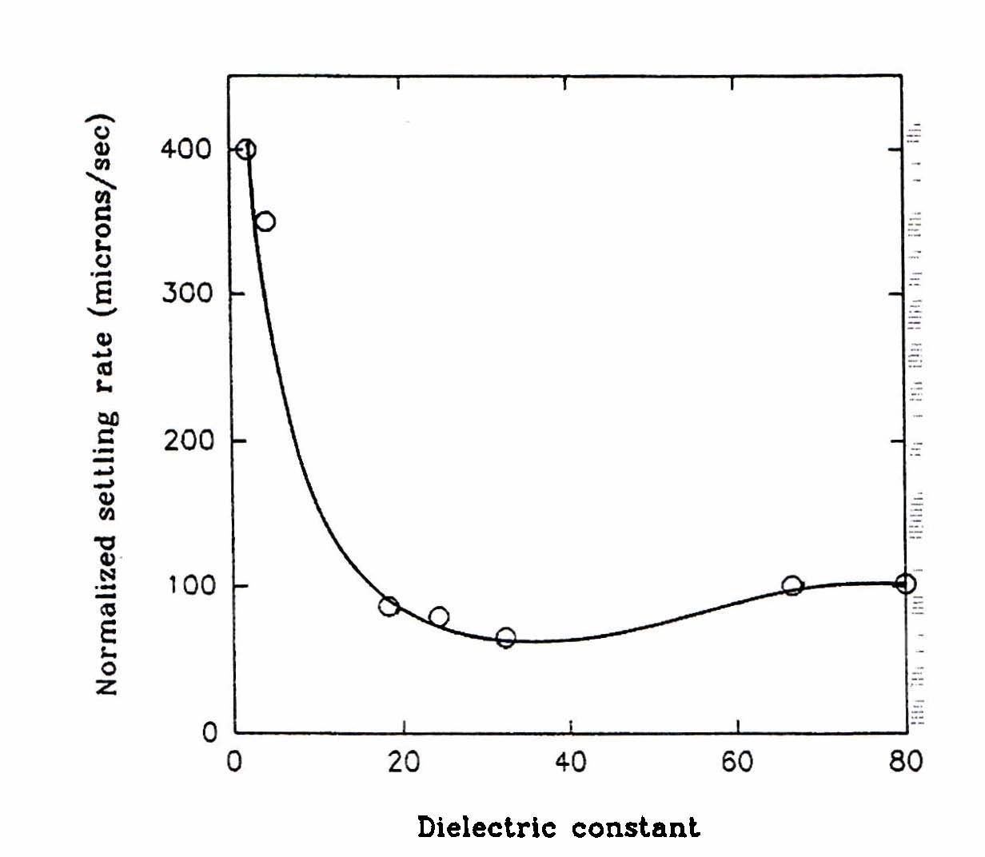
Figure 18.20. Settling behavior of alumina particles in solvents of varying polarity. It can be observed that with an increase in solvent polarity the dispersion stability displays a maximum, which corresponds to a minimum in the normalized settling rate. The normalized setting rate is the observed settling rate times the solvent viscosity/(particle density minus the solvent density). From Krishnakumar & Somasundaran, Colloids Surf., 1996, 117, 37.

Problem 23. Effective Hamaker constants
You are given the following 5 systems:
System 1: Fused quartz-air system in octane
System 2: CaF₂ – air in helium
System 3: Fused quartz particles in octane
System 4: Hexadecane particles in water
System 5: Teflon in water
The Hamaker constants of the pure materials/fluids are known (in 10⁻²⁰ J):
Fused quartz: 6.3, octane: 4.5, CaF₂: 7.2, Helium: 0.057, hexadecane: 5.2, water: 3.7, Teflon: 3.8
- Calculate using the combining relations the effective Hamaker constants for the five systems and compare them to the experimental (rigorously computed) Hamaker constant values, which are respectively: -0.71, -0.59, 0.13, 0.5 and 0.29 – all in 10⁻²⁰ J. Comment on the results.
- For which systems do you expect attractive and for which repulsive van der Waals forces. What is the physical meaning of the repulsive van der Waals forces?

Problem 24. Surface tensions and Hamaker constants
Hamaker constants are related to surface tensions.
- Using a Hamaker constant value for hexane equal to 4.1 x 10⁻²⁰ J and assuming a separation equal to 0.15 nm, provide an estimation of the surface tension of hexane. Compare it to the experimental value from direct measurements (18.4 mN/m).
- Repeat the previous questions for water. Assume a higher intermolecular separation say 0.33. What do you observe? Comment on the results.

Problem 25. Surface tensions and Hamaker constants
Table 18.22 presents Hamaker constants, surface tensions and liquid densities for seven normal alkanes.

Table 18.22. Hamaker constants, surface tensions and liquid densities for seven normal alkanes.

Alkane | 10²⁰ A(J) | 10³ surface tension (J m⁻²) -experimental | 10⁻³ density  (kg m⁻³) | H (nm) | 10³ surface tension (J m⁻²) - predicted
n-pentane | 3.75 | 16.05 | 0.6262
n-hexane | 4.07 | 18.40 | 0.6603
n-octane | 4.50 | 21.62 | 0.7025
n-decane | 4.82 | 23.83 | 0.7300
n-dodecane | 5.03 | 25.35 | 0.7487
n-tetradecane | 5.05 | 26.56 | 0.7628
n-hexadecane | 5.23 | 27.47 | 0.7733

- Calculate the distance H (critical length) which would reproduce these surface tension values using the theoretical relationship between Hamaker constant and surface tension. Fill in Table 18.22 and comment on the results.
- D.B. Hough and L.R. White (1980, Adv. Colloid Interface Sci., 14: 3-41) showed that the critical length is inversely proportional to the square root of the liquid density. This relationship can be used to predict the surface tensions with only one adjustable parameter, namely the “experimental” critical length for some reference hydrocarbon. Use the H-value for n-decane as reference and estimate the predicted critical lengths and predicted surface tensions. Fill in the last column of Table 18.22 and comment on the results.

Problem 26. Emulsions with hydrophilic and hydrophobic surfactants
A particular product is an o/w emulsion and is based on equal amounts (on weight percent) of two surfactants, which are both hydrophilic. The first surfactant has a HLB=13 and the second surfactant has a HLB=11. The company where you are currently working wishes, for some reasons, to change the formulation of the surfactants used for the stabilisation of this o/w emulsion product. Of course the product must have the same o/w emulsion characteristics. The company suggests using this time a mixture of hydrophobic and hydrophilic surfactants, both of which are non-ionic and belong to the family of polyoxyethylene alcohols (polyethylene oxides). The research director suggests using the surfactants C₁₂E₃₀ and C₁₆E₆ [C_{x}E_{y} indicates a polyoxyethylene surfactant with x carbons and y oxyethylene groups]. The formulation is, thus, based on both hydrophilic and hydrophobic surfactants. How much (weight) percentage of the new hydrophilic surfactant is needed for this specific o/w emulsion?

Problem 27. An industrial case (HLB with different methods)
An optimal HLB for an emulsion product is reported to be 10.3.
- What type of emulsion do we have?
- Suddenly one of the hydrophilic surfactants you are using in your company for this specific formulation is not available in the market any more (!). The hydrophobic surfactant (with HLB=2.1) is still available and it is very cheap (irrespectively of the amount employed). The researchers from the research department of your company suggest three possibilities: (i) a secret "in-house" (possibly anionic) surfactant X which has an oil-water partition coefficient equal to 2.10⁹ (they do not reveal the structure!), (ii) NPE₁₅ and NPE₃₀ (NPE = nonyl phenyl ethoxylates where the subscript is the number of ethylene oxide groups). The management department informs you that the cost of these three surfactants is almost the same. Which one of the three surfactants (X, NPE₁₅ or NPE₃₀) would you recommend to your manager for this specific product as a substitution of the surfactant that is out of the market?

Problem 28. Emulsions
A specific commercial emulsion (formulation) is stabilized with a mixture of 80% aromatic mineral oil (HLB=13) and 20% paraffin oil (HLB=10). The company you are working wants to change this emulsifier mixture and use a mixture of non-ionic (polyethylene oxides) surfactants C₁₂E₃₀ and C₁₆E₄, of which one is hydrophilic and the other is hydrophobic. How much (in weight fraction) would you need of the hydrophilic surfactant so that the new emulsion has the same characteristics as the original one? All concentrations are in weight fractions.

Problem 29. Double layer thickness
i. Calculate the “thickness” of the diffuse electric double layer for a solid surface in contact with the following aqueous solutions at 25 ºC:
- 0.1 mol/lt KCl
- 0.01 mol/lt KNO₃
- 0.001 mol/lt KCl
- 0.001 mol/lt ZnCl₂
- 0.001 mol/lt K₂SO₄, 0.001 mol/lt MgCl₂

In your opinion, which electrolyte system may result to the most stable colloidal system and which one will possible give the least stable colloidal system?

ii. Calculate the ionic strengths and corresponding values of the Debye length for the following solutions (aqueous at 25 ºC):

  - M Na₂SO₄
0.015 M LaCl₃
3x10⁻³ M Ca(NO₃)₂
A mixture of 10⁻⁴ M La₂(SO₄)₃ and 5x10⁻⁴ M NaNO₃

Which solution would you choose for stabilizing a colloidal system?

Problem 30. Colloid stability
i. In order to stabilize a latex solution, the polymer particles have been chemically modified so that each particle now carries a negative charge. The water solution is exchanged with an electrolyte water-based solution.
- Why is the latex solution more stable when the polymer particles are negatively charged, compared to being neutral (no charge)?
- You can choose between two electrolytes: (a) 0.01 M NaCl and (b) 0.01 M AlCl₃. Which electrolyte solution would you choose for the latex, in order to obtain the most stable suspension? Justify your answer with an estimate of the Debye thickness of the diffuse double layer in both cases.
ii. There are four different aqueous solutions at room temperature of the same negatively charged colloidal sol. e.g. As₂S₃ (CCC values are given in parenthesis in mmol/lt). The electrolytes and their concentrations are given in table 18.23.

Table 18.23. Four aqueous As₂S₃ colloid solutions using different electrolytes and/or concentrations. The values in parenthesis are the CCC in mmol/lt.

Sample 1 | KCl (49.5) | 0.100 mol/lt
Sample 2 | KCl (49.5) | 0.001 mol/lt
Sample 3 | CaCl₂ (0.65) | 0.001 mol/lt
Sample 4 | MgCl₂ (0.72) | 0.001 mol/lt

- Based on a comparison of the thickness of the electric double layer, identify the most stable and the least stable colloid from the four samples in table 18.23. Draw two schematic curves for the potential energy of interaction between two colloidal particles: one for a stable system and one for an unstable system.
- Which of the colloids of samples 1,2, and 4 are stable and which are not
- Which forces (attractive or repulsive) are dominant for the three samples 1,2 and 4 ?

Problem 31. The Schulze-Hardy rule and colloid stability
Overbeek (1952) provided the following measured values of the critical coagulation concentration (CCC) for a dispersion containing negatively charged gold (Au) particles:
24 mmol/L NaCl
23 mmol/L KNO₃
0.41 mmol/L CaCl₂
0.35 mmol/L BaCl₂

- Comment on these experimental results. Are they in agreement with the Schulze-Hardy rule?
- What would the CCC value be for the same dispersion of gold particles when the salt Ce(NO₃)₃ is used instead?
- For a dispersion containing positively charged Fe₂O₃ particles, the CCC value mmol/L when KNO₃ is used. A colloid scientist suggests to you to use for the same dispersion only 2 mmol/L MgSO₄ and claims that you will get a stable dispersion. Do you expect the dispersion suggested by the colloid scientist to be stable or not? Justify your answer.

Problem 32. The Schulze-Hardy rule and colloid stability
i. A dispersion of positively charged gold particles is experimentally found to coagulate with 36 x 10⁻³ mol/lt KCl and also with 0.57 x 10⁻³ mol/lt K₂SO₄. Are these data in agreement with the Schulze-Hardy rule?
ii. For a dispersion of positively charged Al₂O₃ particles, the following values of the critical coagulation concentration (CCC) have been measured: 43.5 mmol/lt NaCl and 0.63 mmol/lt K₂[Cr₂O₇]. Provide an estimation of the CCC for the same dispersion when the salt K₃[Fe(CN)₆] is used. Which of the three salts results in the most stable dispersion?
iii. Table 18.24 provides CCC (in mol/lt) for two different colloidal systems using two salts with counter-ion valency Z equal to 1 and 2.

Table 18.24. Critical coagulation concentrations (CCC) in mol/lt for PVC latex and AgBr colloid systems using salts with two different valancies.

Colloid | CCC using a salt having a counter-ion of valency Z=1 | CCC using a salt having a counter-ion of valency Z=2
PVC latex | 2.3 x 10⁻¹ | 1.2 x 10⁻²
AgBr | 1.6 x 10⁻² | 2.3 x 10⁻⁴

A colloid scientist tells you based on these data that “since the CCC for the AgBr system is less compared to the PVC latex, then the surface potential must be less for the AgBr colloidal system”. Do you agree with the scientist? Why/why not? Justify your answer using the Schulze-Hardy rule in combination with the DLVO theory.

