Solutions for exercises using Familias

Thore Egeland

There are also some videos available for some other exercises.

Exercise S1
Answers:
- We can write
Consider first the numerator. The only possible genotype for the child, given the mother and the AF, is A/B, and therefore the probability is 1. For the denominator, the father must have passed on the A allele, and therefore the probability is. Hence . The standard interpretation is
“The data is 20 times more likely assuming AF to be the father compared to the alternative that some unknown man is the father”.

- The buttons labeled 1, 2, 3 and 4 below will be used as explained under.

How to do it:
- General DNA data: Click Add to enter an allele system. In the new window, enter allele system name S1 and the two alleles A and B, both with frequencies 0,05. Enter the C allele with frequency 0,9. Press OK.
- Persons: Enter the persons: mother, AF and child and their gender.
- Case-Related DNA data: Double-click each person to enter his or her DNA data. In the new window, enter the appropriate allele system (use the pull-down menu) and the observed alleles for this person, then press Add and OK.
- Pedigrees: Click Add to enter the pedigree corresponding to hypothesis H₁. Enter H1 as Pedigree name. Enter the mother as the parent of the child in the pull-down menu and click Add. Enter the AF as the parent of the child in the pull-down menu and click Add. Click OK to finish the definition of the pedigree corresponding to hypothesis H1. Click Add in the pedigree window once more to add the pedigree corresponding to hypothesis H₂. Enter H2 as Pedigree name. Press LR. (Normally one would answer Yes when asked to save.) This gives relative values. It remains to specify the denominator, H₂ in this case, by marking the line corresponding to H₂. Press the button Relative or absolute values. The pedigree window should now appear as
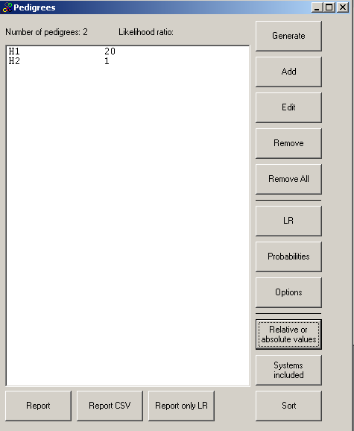

- Repeat step 1 above to define the marker S2 and step 3 to define the genotypes for all individuals. Steps 2 and 4 need not be repeated. The LR is then obtained as before and the answer is: LR=200.
- LR=(1+3*0.02)/(2*0.02+(1-0.02)*0.05)=11.91
- To be discussed in class. We note now, however, that Hardy-Weinberg equilibrium is required for the LR derivation for each marker. This assumption is not needed when we use theta-correction. Furthermore, linkage disequilibrium is needed. We have also assumed that there are no mutations or silent alleles.

Exercise S2

- The numerator, and therefore LR=0 as confirmed by Familias.
- The General DNA data is used to specify the mutation model and should be completed as below
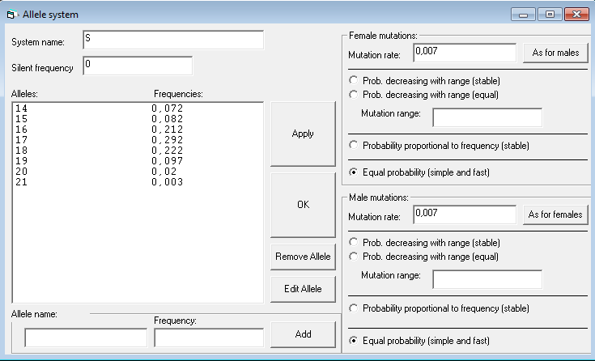

Answer LR=4.07E-03=0.00407

LR=0.01*(0.212+0.292)/(2*0.212*0.292)=0.00407

Exercise S3
The pedigree corresponding to H₁, Figure 3, is specified as follows
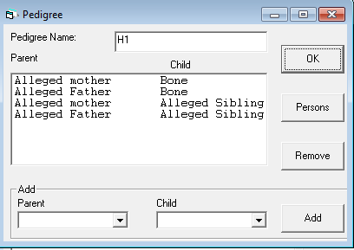

Most answers are given in the rightmost column of the below table from the report generated by Familias. “D7S820, gives a very large LR, namely 11189” since 11.1 is so rare. If this marker is omitted the new LR is 530437141/11189=47407.

Likelihood ratio versus H2: 530437140,978139

-------------------------------------------------------
| System: | Likelihood: | LR versus H2: |
-------------------------------------------------------
| D3S1358 | 0,002107356328 | 24,3295665373587 |
-------------------------------------------------------
| D21S11 | 0,00106135425 | 4,42583732057416 |
-------------------------------------------------------
| D18S51 | 0,0008102440125 | 26,7722473604827 |
-------------------------------------------------------
| D7S820 | 5,037122916E-07 | 11189,4499975311 |
-------------------------------------------------------
| D16S539 | 0,000811482 | 0,899280575539568 |
-------------------------------------------------------
| CSF1PO | 0,0130390037415 | 2,25229008488432 |
-------------------------------------------------------
| F13B | 0,001423488512 | 5,88485536018151 |
-------------------------------------------------------
| LPL | 0,0007365230775 | 1,37960642346607 |
-------------------------------------------------------

Exercise S4

- LR(grand father/unrelated) = 0.98 for D3S1358.
- LR(grand father/unrelated) = 0.0085 for all markers.
- Whether autosmal and haplotype markers can be combined and in case how is a big question and there appears to be no consenus

Exercise S5

- W=20/(1+20)=0.952
- W=200/(1+200)=0.995
- Same answers as above.
- This is a again a big question. Most recommendations are in favor of LR. The problem with W is to decide on the prior. W may be easier to interpret.

Exercise S6
- LR=10. Comment: The formula provided follows from
The same result is obtained in this particular case if inbreeding is ignored.
- LR (H1/H2)= 10, LR(H1/H3)=1.905. We are asked to verify that

Exercise S7
Most answers are given in problem.
Regarding question f. We can add the following: If a model is unstable, allele frequencies change with generations. This adds some intuition as to why introducing an extra person, say a grandparent, typically changes results slightly for an unstable model.

Regarding question g. Consider the first model listed in Familias Probability decreasing with range (stable) which gave LR=6.4E-03=0.0064. Remove alleles so that only 14,15, 16,17 and a ‘Rest allele’ remains. Then LR=7.8E-03=0.0078, a change. Again this effect does not have to with Familias; there are two different models, one with 8 alleles and one with alleles (which constrains mutations within those five alleles) and different models typically give different results.

Exercise S8
- The formula in Exercise S2 follows by setting and the numerical result LR=0.0029 follows.

Exercise S9
- LR(H1: father/H2:not father)=0 from Familias.
- LR=0 for PENTA_E as can be seen from report from Familias.
- LR= 4515433
- See Familias file ExS9Brother.txt which gives LR=1.4.
- To be discussed.

Exercise S10
- LR=0.791/0.209=3.8 Details on Familias implementation, including definition of pedigrees, can be seen from ExS10.txt.
- To be discussed.

Exercise S11

The LR is 1.36

How to do it:
Enter the allele system setting the silent allele frequency to 0.05. Enter the persons and their DNA data as usual. Construct the pedigrees manually. Use LR and Relative and Absolute values as previously

A theoretical argument, not requested, is given below: Let p_{A} = p_{B} = 0.1 and p_{S} = 0.05. According to http://dna-view.com/patform.htm,

which coincides with Familias.

Exercise S12
See pages 36-37 of the manual.

Exercise S13
LR=0.0068

Exercise S14
Explained in problem.

Thore Egeland, Sept 28, 2012 Norwegian University of Life Sciences P.O Box 5003 N-1432 Aas Norway Thore.Egeland@umb.no http://arken.umb.no/~theg/alcala

