LASER INTERFEROMETER GRAVITATIONAL WAVE OBSERVATORY
- LIGO –
CALIFORNIA INSTITUTE OF TECHNOLOGY
MASSACHUSETTS INSTITUTE OF TECHNOLOGY
Document Type  Management | LIGO-M060056-00M | 20 April 2006

Advanced LIGO Reference Design

David Shoemaker
for the Advanced LIGO Team

California Institute of Technology  LIGO Laboratory - MS 18-34  Pasadena CA 91125  Phone (626) 395-2129  Fax (626) 304-9834  E-mail: info@ligo.caltech.edu | Massachusetts Institute of Technology  LIGO Laboratory - NW17-161  Cambridge, MA 01239  Phone (617) 253-4824  Fax (617) 253-7014  E-mail: info@ligo.mit.edu

www: http://www.ligo.caltech.edu/

Advanced LIGO Reference Design

1. Overview

This document describes the technical approach for the first major upgrade to LIGO, consistent with the original LIGO design and program plan.

LIGO consists of conventional facilities and the interferometric detectors. The LIGO facilities (sites, buildings and building systems, masonry slabs, beam tubes and vacuum equipment) have been specified, designed and constructed to accommodate future advanced LIGO detectors. The initial LIGO detectors were designed with technologies available at the initiation of the construction project. This was done with the expectation that they would be replaced with improved systems capable of ultimately performing to the limits defined by the facilities.

In parallel with its support of the initial LIGO construction, the National Science Foundation (NSF) initiated support of a program of research and development focused on identifying the technical foundations of future LIGO detectors. At the same time, the LIGO Laboratory worked with the interested scientific community to create the LIGO Scientific Collaboration (LSC) that advocates and executes the scientific program with LIGO.

The LSC, which includes the scientific staff of the LIGO Laboratory, has worked to define the scientific objectives of upgrades to LIGO. It has developed a reference design and carried out an R&D program plan. This development has led to this Reference Design for construction of the Advanced LIGO upgrade following the initial LIGO scientific observing period.

The top-level performance requirements for the complete system are given in the Advanced LIGO Project Execution Plan (PEP), .

This document gives a summary of the principal subsystem requirements and high-level conceptual design of Advanced LIGO. The document is intended to be dynamic, and will be updated as our technical knowledge improves.

2. Reference Design Configuration and Sensitivity
The LIGO Scientific Collaboration, through its Working Groups, has worked with the LIGO Laboratory to identify a reference design for the Advanced LIGO detector upgrade. The reference design is planned to lead to a quantum noise limited interferometer array with considerably increased bandwidth and sensitivity.

The basic optical configuration is a power-recycled and signal-recycled Michelson interferometer with Fabry-Perot “transducers” in the arms; see Figure 1. Using the initial LIGO design as a point of departure, Advanced LIGO requires the addition of a signal-recycling mirror at the output “dark” port, and changes in the RF modulation and control systems. This additional mirror allows the gravitational wave induced sidebands to be stored in the arm cavities or extracted (depending upon the state of “resonance” of the signal recycling cavity), and allows one to tailor the interferometer response according to the character of a source (or specific frequency in the case of a fixed-frequency source). For wideband tuning, “quantum noise” dominates the instrument noise sensitivity at most frequencies (see Error: Reference source not found). Additional details may be found in Section 12. Interferometer Sensing and Controls Subsystem (ISC).

SILICA, 32 CM Φ, 40 KG
500kw

Figure 1 Schematic of an Advanced LIGO interferometer, with representative mirror reflectivities optimized for neutron star binary inspiral detection. Several new features compared to initial LIGO are shown: more massive test masses; 20× higher input laser power; signal recycling; active correction of thermal lensing; an output mode cleaner. (ETM = end test mass; ITM = input test mass; PRM = power recycling mirror; SRM = signal recycling mirror; BS = 50/50 beam splitter; PD = photodetector; MOD = phase modulation). Mode-matching and beam-coupling telescopes not shown.

The laser power is increased from 10 W to 180 W, adjustable to be optimized for the desired interferometer response, given the quantum limits and limits due to available optical materials. The resulting circulating power in the arms is roughly 500 kW, to be compared with the initial LIGO value of ~10 kW. The Nd:YAG pre-stabilized laser design resembles that of initial LIGO, but with the addition of a more powerful output stage; see Section 8. Prestabilized Laser Subsystem (PSL)). The conditioning of the laser light also follows initial LIGO closely, with a ring-cavity mode cleaner and reflective mode-matching telescope, although changes to the modulators and isolators must be made to accommodate the increase in power; see Section Overview).

Whereas initial LIGO uses 25-cm diameter, 11-kg, test masses, the fused-silica test mass optics for Advanced LIGO are larger in diameter (~32 cm) to reduce thermal noise contributions and more massive (~40 kg) to keep the radiation pressure noise to a level comparable to the suspension thermal noise. Polishing and coating are required to be somewhat better than the best results seen for initial LIGO; see Section 10. Core Optics Components (COC). In particular, the coating mechanical losses must be managed to limit the thermal noise. Compensation of the thermal lensing in the test mass optics (due to absorption in the substrate and coatings) is added to handle the much-increased circulating power; see Section 11. Auxiliary Optics Subsystem (AOS)

The test mass is suspended by fused silica ribbons (or tapered fibers as an alternate) attached with hydroxy-catalysis bonds, in contrast to the steel wire sling suspensions used in initial LIGO. Fused silica has much lower mechanical loss (higher Q) than steel, and the fiber geometry allows more of the energy of the pendulum to be stored in the earth’s gravitational field while maintaining the required strength, thereby reducing suspension thermal noise. The resulting suspension thermal noise is anticipated to be less than the radiation pressure noise and comparable to the Newtonian background (“gravity gradient noise“) at 10 Hz. The complete suspension has four pendulum stages, and is based on the suspension developed for the UK-German GEO-600 detector. The mechanical control system relies on a hierarchy of actuators distributed between the seismic and suspension systems to minimize required control authority on the test masses. The test mass magnetic actuators used in the initial LIGO suspensions can thus be eliminated (to reduce thermal noise and direct magnetic field coupling from the permanent magnet attachments) in favor of electrostatic forces for locking the interferometer. The much smaller forces on the test masses reduce the likelihood of compromises in the thermal noise performance and the risk of non-Gaussian noise. Local sensors and magnets/coils are used on the top suspension stage for damping, orientation, and control; see Section Overview.

The isolation system is built on the initial LIGO piers and support tubes but otherwise is a complete replacement, required to bring the seismic cutoff frequency from ~40 Hz (initial LIGO) to ~10 Hz. RMS motions (dominated by frequencies less than 10 Hz) are reduced by active servo techniques, and control inputs complement those in the suspensions in the gravitational-wave band. The attenuation offered by the combination of the suspension and seismic isolation system eliminates the seismic noise contribution to the performance of the instrument, and for the low-frequency operation of the interferometer, the Newtonian background noise dominates. See Section 6. Seismic Isolation Subsystem (SEI).

Reference Design Parameters

The Advanced LIGO reference design is summarized in Table 1.

Table 1 Principal parameters of the Advanced LIGO reference design with initial LIGO parameters provided for comparison
Subsystem and Parameters | Advanced LIGO  Reference Design | Initial LIGO Implementation
Comparison With initial LIGO Top Level Parameters
Observatory instrument lengths;  LHO = Hanford, LLO = Livingston | LHO: 4km, 4km;  LLO: 4km | LHO: 4km, 2km;  LLO; 2km
Strain Sensitivity [rms, 100 Hz band] | 10⁻²¹ | 10⁻²¹
Displacement Sensitivity [rms, 100 Hz band] | ????×10⁻²⁰ m | 4×10⁻¹⁸ m
Fabry-Perot Arm Length | 4000 m | 4000 m
Vacuum Level in Beam Tube, Vacuum Chambers | <10⁻⁷ torr | <10⁻⁷ torr
Laser Wavelength | 1064 nm | 1064 nm
Optical Power at Laser Output | 180 W | 10 W
Optical Power at Interferometer Input | 125 W | 6 W
Optical power on Test Masses | 800 kW | 30 kW
Input Mirror Transmission | 0.5% | 3%
End Mirror Transmission | 15 ppm | 15 ppm
Arm Cavity Power Beam size | 6 cm | 4 cm
Light Storage Time in Arms | 5.0 ms | 0.84 ms
Test Masses | Fused Silica, 40 kg | Fused Silica, 11 kg
Mirror Diameter | 32 cm | 25 cm
Suspension fibers | Fused Silica ribbons | Steel Wires
Seismic/Suspension Isolation System | 3 stage active,  4 stage passive | Passive, 5 stage
Seismic/Suspension System Horizontal Attenuation | ≥10⁻¹² (10 Hz) | ≥10⁻⁹ (100 Hz)

5. Facility Modifications and Preparation (FMP)

Overview

Advanced LIGO technical requirements will necessitate modifications and upgrades to the LIGO buildings, and vacuum equipment. In addition, the strategy for executing the Advanced LIGO construction will require some facility accommodations.

The principal impact on this WBS element is as follows:

- It is a program goal to minimize the period during which LIGO is not operating interferometers for science. For this reason, major subsystems such as the seismic isolation and suspension subsystems should be fully assembled and staged in locations on the LIGO sites ready for installation into the vacuum system as fully assembled and vacuum compatible units. This will require prepared assembly and staging space, materials handling equipment, and softwall clean rooms.
- Increasing the arm cavity length for the Hanford 2-kilometer interferometer to 4 kilometers will require removing and reinstalling the existing mid-station chambers and replacing them with spool pieces in the original locations.
- The larger optical beams in the input optics section (and possibly the output optics section) will necessitate changing out the input optics vacuum tube for a larger diameter tube.
- Two of the general-purpose (HAM) vacuum chambers will be moved for each interferometer to optimize the position of detection components.

Functional Requirements

Vacuum Equipment

All vacuum equipment functional requirements are the same as those in the initial LIGO design except that the vacuum level is required to be one order of magnitude lower (<10⁻⁷ torr; the present system operates at the Advanced LIGO level). Additional equipment (chambers, spool pieces, softwall clean rooms) is needed to accommodate additional arm cavity length for one interferometer and the desire for parallel assembly and installation in more chambers and staging areas. A larger diameter spool piece for the IO Mode Cleaner beam path (and possibly for a similar output mode cleaner) is required. The seismic isolation system requirements call for the Advanced LIGO subsystems to be compatible with the original LIGO vacuum envelope.
Other elements of this subsystem are the installation fixtures and hardware, equipment and materials for in-vacuum component and vacuum equipment cleaning/baking, and the installation planning (schedules, ES&H, logistics, SOP's, etc).

Beam Tube

The original end-pumped beam tube system requires no modifications or additions for Advanced LIGO. There is sufficient margin in the present vacuum performance to permit the operation of the more sensitive Advanced LIGO instrument with no changes.

Conventional Facilities

Preassembly of all large Advanced LIGO seismic isolation units prior to installation in the vacuum tanks requires clean onsite staging and assembly space. At both the Hanford and Livingston Observatories there exist suitable staging buildings with appropriate height and basic configuration; portable clean rooms and benches are required. Transporters for delivering fragile systems from the central buildings to the end stations are required.

Concept/Options

Vacuum Equipment

Approximately 1600 square feet of BSC type cleanroom will be installed in the Hanford and Livingston staging buildings. For each of the interferometers, additional clean rooms will be acquired to support parallel installation in additional chambers to facilitate reducing the duration of Advanced LIGO installation.

Four additional spool pieces will be acquired to replace the Hanford mid-station BSC chambers and to connect these chambers to the end-station BSC chambers once relocated. The chambers will be removed and reinstalled at the end stations.

The IO (and potentially the output) Mode Cleaner requires a larger diameter spool piece, ~15m in length, to accommodate the larger mirrors used.

The requirement of base pressure for Adv LIGO (<10⁻⁷ torr) is already met by the present system (which is operating at <10⁻⁸ torr).

Beam Tube

No action needed. The original installation meets requirements for Advanced LIGO.

Conventional Facilities

The existing staging buildings at both observatories will require additions of flow benches, fume hoods, vacuum bake ovens, and other minor equipment to support clean processing operations. In addition, at LHO some retrofit of the HVAC system will be necessary in the Staging Building to meet the cleanliness requirements. HEPA filters and a more powerful motor are needed.

R&D Status/Development Issues

There are no development issues or R&D associated with this WBS element.

6. Seismic Isolation Subsystem (SEI)

Overview

The seismic isolation subsystem serves to attenuate ground motion in the observation band (above 10 Hz) and also to reduce the motion in the “control band” (frequencies less than 10 Hz). It also provides the capability to align and position the load. Significantly improved seismic isolation will be required for Advanced LIGO to realize the benefit from the reduction in thermal noise due to improvements in the suspension system. The isolation system will be completely replaced, and this offers the opportunity to make a coordinated design including both the controls and the isolation aspects of the interferometer.

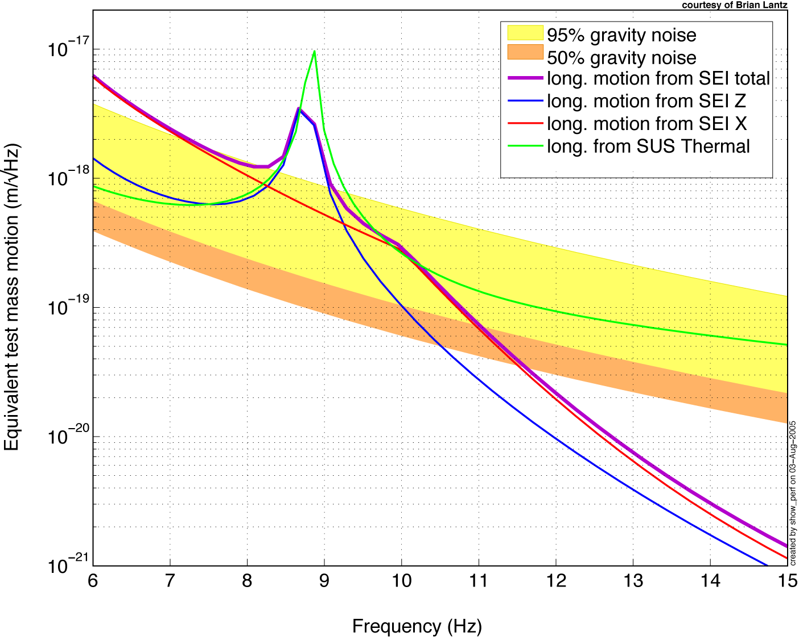
Figure 1 Predicted test mass displacement noise. The orange and yellow shaded regions are the expected longitudinal (beam direction) motion from direct gravity coupling, at 50th and 95th percentile ground motion measured at the LIGO sites; this dominates the noise above 11 Hz or so. The red, blue and purple lines are, respectively, the contributions to test mass motion from horizontal and vertical seismic isolation system motion and the total seismic contribution at about the 90th percentile level. The green curve is the expected suspension (pendulum) thermal noise; it exceeds the seismic noise above about 10.3 Hz. Courtesy of B. Lantz.

Functional Requirements for the BSC (Test Mass Chamber) payloads

The top-level constraints on the design of the isolation system can be summarized:

- Seismic attenuation: The amplitude of the seismic noise at the test mass must be equal to or less than the thermal noise of the system for the lowest frequencies where observation is planned, 10 Hz. At about that frequency and below, the competing noise sources (suspension thermal noise, radiation pressure, Newtonian background) conspire to establish a presently irreducible sensitivity level roughly a factor of 30 above the limits imposed by the LIGO facilities, and technical challenges in suspension design make a lower goal unrealistic. Figure 1 shows current estimates of some of these noise sources, based on 3-D dynamic models of the seismic platform and quadruple pendulum systems, 50th and 95th percentile ground motion statistics, and estimates of direct gravity coupling. At just above 10 Hz, the expected motion from seismic coupling equals that from suspension thermal noise, at about 2–3 x 10⁻¹⁹ m/√Hz, and then falls off rapidly. The visible ‘shoulder’ between 10 and 20 Hz is due to a large BSC vacuum chamber resonance; recent lab results have validated a HEPI feedforward technique to reduce this band even further, should it become a problem.
- The RMS differential motion of the test masses while the interferometer is locked must be held to a small value (less than 10⁻¹⁴ m) for many reasons: to limit light fluctuations at the antisymmetric port and to limit cross coupling from laser noise sources, as examples. Similarly, the RMS velocity of the test mass must be small enough and the test mass control robust enough that the interferometer can acquire lock. This establishes the requirement on the design of the seismic isolation system in the frequency band from 1 to 10 Hz of approximately 10⁻¹¹ m/√Hz, and a reduction in the microseism band to several tenths of a µm/√Hz.
- The isolation positioning system must have a large enough control range to allow the interferometer to remain locked for extended periods; our working value is 1 week.
- The system must interface with the rest of the LIGO system, including LIGO vacuum equipment, the adopted suspension design, and system demands on optical layout and control.

The requirements for the HAM (Auxiliary optics) payloads are less stringent at 1 Hz by a factor of approximately 30 and ~100 at 10 Hz, due to the reduced optic sensitivity for these chambers. Additional information on Advanced LIGO seismic isolation requirements is available.

Concept

The initial LIGO seismic isolation stack will be replaced with an Hydraulic External (to the vacuum) Pre-Isolator (HEPI) stage, and an In-vacuum two-stage active Seismic Isolation (ISI) platform (Figure 2 is a solid model of the currently under-construction prototype). The in-vacuum stages are mechanically connected with stiff springs, yielding typical passive resonances in the 2-8 Hz range. Sensing its motion in 6 degrees of freedom and applying forces in feedback loops to reduce the sensed motion attenuates vibration in each of the two-cascaded stages. Stage 1 derives its feedback signal by blending three real sensors for each degree of freedom: a long-period broadband seismometer, a short-period geophone, and a relative position sensor. The inertial sensors (seismometers and geophones) measure the platform's motion with respect to their internal suspended test masses. The position sensor measures displacement with respect to the adjacent stage. The resulting “super-sensor” has adequate signal-to-noise and a simple, resonance-free response from DC to several hundred hertz. Stage 2 uses the position sensor and high-sensitivity geophone, and some feed-forward from the outer stage 1 seismometer.

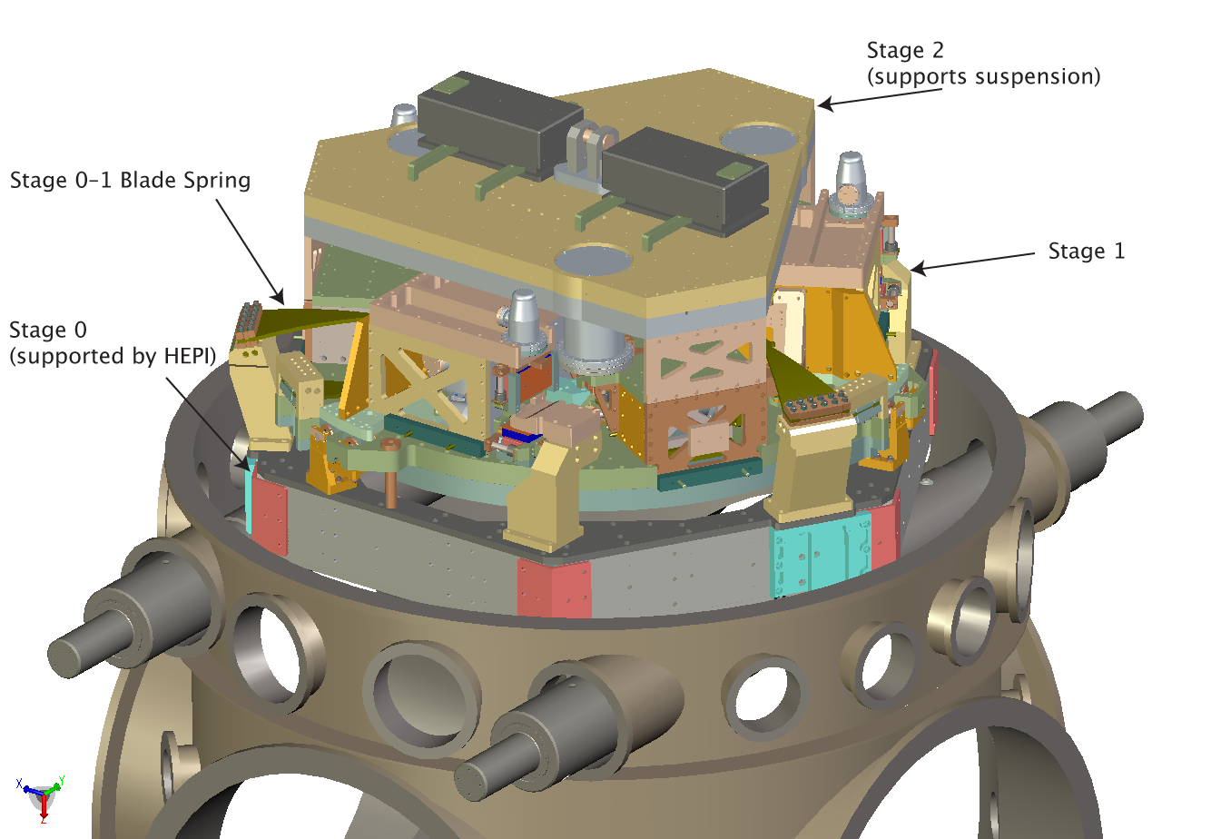
Figure 2 Computer rendering of the prototype two-stage in-vacuum active seismic isolation system (ISI) for the test-mass (BSC) vacuum chambers, which is under construction as of this writing. The outside frame (stage 0) supports the stage 1 from three trapezoidal blade springs and vertical flexure rods. Stage 2, which supports the payload, is likewise suspended from stage 1. The bottom of stage 2 is an optics table under which the test mass suspensions are mounted.

The outer frame of the isolation system is designed to interface to the existing in-vacuum seismic isolation support system, simplifying the effort required to exchange the present system for the new system. The outer stage is hung from the outer frame using trapezoidal leaf springs to obtain the 2-6 Hz resonances. The inner platform stage is built around a 1.5-m diameter optics table (BSC) or a larger polygonal table (HAM). The mechanical structures are carefully studied to bring the first flexible-body modes well above the ~50 Hz unity gain frequencies of the servo systems. For each suspended optic, the suspension and auxiliary optics (baffles, relay mirrors, etc.) are mounted on an optical table with a regular bolt-hole pattern for flexibility.

We will use commercial, off-the-shelf seismometers that are encapsulated in removable pods. This allows the sensors to be used as delivered, without concerns for vacuum contamination, and allows a simple exchange if difficulties arise. The actuators consist of permanent magnets and coils in a configuration that encloses the flux to reduce stray fields. These components must meet the stringent LIGO contamination requirements. The multiple-input multiple-output servo control system is realized using digital techniques; 16-bit accuracy with ~2 kHz digitization is sufficient.

The external pre-isolator is used to position the in-vacuum assembly, with a dynamic range of 1 mm, and with a bandwidth of 2 Hz or greater in all six degrees of freedom. This allows feedforward correction of low-frequency ground noise and sufficient dynamic range for Earth tides and thermal or seasonal drifts. We target approximately a factor of 10 reduction of the ~0.16 Hz microseismic motion from feedforward correction in this stage.

The performance of the ISI system is calculated with a model that includes all solid-body degrees of freedom, and measured or published sensitivity curves (noise and bandwidth) for sensors. It meets the Advanced LIGO requirements for both the test-mass (BSC) and auxiliary (HAM) chambers. Also, we are evaluating

The passive isolation of the suspension system provides the final filtering. A sketch of the system as applied to the test-mass vacuum chambers (BSC) is shown in Figure 3. A similar system is designed for the auxiliary optics chambers (HAM). Further details can be found in the subsystem Design Requirements and Conceptual Design documents.

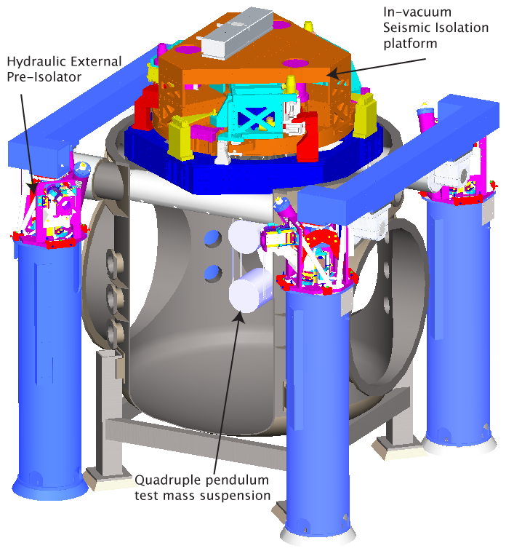
Figure 3 Rendering of the internal isolation system (ISI) installed in the BSC (test mass chambers), with a suspension system attached below. The external preisolator (HEPI) provides the interface between the vertical blue piers and the green horizontal support structure.

R&D Status/Development Issues

A first-generation prototype of the in-vacuum isolation system has shown performance at low- and high-frequencies comparable to the requirements. The HEPI system was installed in LIGO Livingston before LIGO’s S4 science run, specially configured to reduce transmitted ground noise up to 2–3 Hz, in order to allow daytime operation in the presence of noise from local forestry and other human activity. A second-generation “technology demonstrator” prototype of the in-vacuum isolation (HAM configuration) has been built and tested at the Stanford Engineering Test Facility. It has been used to demonstrate the required noise floor of the critical stage 2 geophones, as well as the 12 degrees-of-freedom active noise reduction. The exercise has validated a servo topology that avoids tilt-horizontal coupling and allows compensation for imperfections in the mechanical plant, and has allowed development of techniques for coping with mechanical resonances in payload structures.

7. Suspension Subsystem (SUS)

Overview

The test-mass suspension subsystem must preserve the low intrinsic mechanical losses (and thus the low thermal noise) in the fused silica suspension fibers and test mass. It must provide actuators for length and angular alignment, and attenuate seismic noise. The Advanced LIGO reference design suspension is an extension of the design of the GEO 600 multiple pendulum suspensions, with requirements to achieve a seismic wall, in conjunction with the seismic isolation (SEI) subsystem, at ~10 Hz. A variety of suspension designs are needed for the main interferometer and input conditioning optics.

Functional Requirements

The suspension forms the interface between the seismic isolation and the suspended optics. It provides seismic isolation and the means to control the orientation and position of the optic. These functions are served while minimally compromising the thermal noise contribution from the test mass mirrors and minimizing the amount of thermal noise from the suspension elements.

The optic (which in the case of the main arm cavity mirror serves also as the test mass) is attached to the suspension fiber during the suspension assembly process and becomes part of the suspension assembly. Features on the test mass will be required for attachment. The test mass suspension system is mounted (via bolts and/or clamps) to the seismic isolation system by attachment to the SEI optics table.

Local signals are generated and fed to actuators to damp solid body motions of the suspension components, and eddy current damping will be used to complement the active damping for some suspensions. In addition, control signals generated by the interferometer sensing/control (ISC) are received and turned into forces on the test mass and other masses in the multiple pendulum as required, to obtain and maintain the operational lengths and angular orientation. Such forces are applied by use of a reaction pendulum to reduce the reintroduction of noise through motion of the actuator. There are two variants of the test mass suspension: one for the End Test Mass (ETM) which carries potentially non-transmissive actuators behind the optic, and one for the Input Test Mass (ITM) which must leave the input beam free to couple into the Fabry-Perot arm cavity. There are also variants for the beamsplitter, folding mirror, and recycling mirrors; and for the mode cleaner, input matching telescope, and suspended steering mirrors.

Multiple simple pendulum stages improve the seismic isolation of the test mass for horizontal excitation of the pendulum support point; this is a valuable feature, but requires augmentation with vertical isolation to be effective. Vertical seismic noise can enter into the noise budget through a variety of cross-coupling mechanisms, most directly due to the curvature of the earth over the baseline of the interferometer. Simple pendulums have high natural frequencies for vertical motion. Thus, another key feature of the suspension is the presence of additional vertical compliance in the upper stages of the suspension to provide lower natural frequencies and consequently better isolation.

Further detail on requirements can be found in the Design Requirements Document.

Key parameters of the test-mass suspension design are listed in Table 2; other suspensions have requirements relaxed from these values.

Table 2 Test-mass suspension parameters: quadruple pendulum
Suspension Parameter | Value
Test mass | 40 kg, silica
Penultimate mass | 40 kg, silica (lower quality)
Top and upper intermediate masses | 22 kg each, stainless steel
Test mass suspension fiber | Fused silica ribbon
Upper mass suspension fibers | Steel
Approximate suspension lengths | 0.6 m test mass, 0.3, 0.3 m intermediate stages, 0.4 m top
Vertical compliance | Trapezoidal cantilever springs
Optic-axis transmission at 10 Hz | ~ 2 x 10⁻⁷
Test mass actuation | Electrostatic (acquisition and operation)
Upper stages of actuation; sensing | Magnets/coils; incoherent occultation sensors

Concept/Options

The test mass mirror is suspended as the lowest mass of a quadruple pendulum as shown in 20; the four stages are in series. Silica is the reference design mirror substrate material. However, the basic suspension design is such that sapphire masses could be incorporated with a modest level of redesign as a “fall-back” should further research favor its use. Both materials are amenable to low-loss bonding of the fiber to the test mass. The mass above the mirror— the penultimate mass— is made of lower-grade silica.

The top, upper intermediate and penultimate masses are each suspended from two cantilever-mounted, approximately trapezoidal, pre-curved, blade springs (inspired by and similar to the VIRGO blade springs), and four steel wires two attached to each blade. The blade springs are stressed to about half of the elastic limit. The upper suspension wires are not vertical and their lengths and angles gives some control over the mode frequencies and coupling factors.

Fused silica pieces form the break-off points for the silica ribbons at the penultimate and test masses. These pieces or ears are attached to the penultimate and test masses using hydroxy catalysis bonding, which is demonstrated to contribute negligible mechanical loss to the system. A CO₂ laser-based machine is being developed for pulling the ribbons and for welding them to the ears.

Tolerable noise levels at the penultimate mass are within the range of experience on prototype interferometers (10⁻¹⁷ m/√Hz) and many aspects of the technology have been tested in special-purpose setups and in the application of the approach to GEO-600. At the top-mass, the main concern is to avoid acoustic emission or creep (vibration due to slipping or deforming parts).

To meet the subsystem noise performance requirements when damping the solid-body modes of the suspension, sensors with sensitivity ~10⁻¹⁰ m/√Hz at 1 Hz and 0.6 mm peak-peak working range will be used in conjunction with suitable servo control algorithms with fast roll-off in gain, complemented by eddy current damping for some degrees of freedom.

Actuation will be applied to all masses in a hierarchy of lower force and higher frequency as the test mass is approached. Coils and magnets will be used on upper stages, and electrostatic actuation on the test mass itself (see figure 21) with switchable high- and low-force (and hence noise) modes for acquisition and operation respectively.

Other suspended optics will have noise requirements that are less demanding than those for the test masses, but still stricter than the initial LIGO requirements, especially in the 10-50 Hz range. Their suspensions will employ simpler suspensions than those for the test masses, such as the triple suspension design for the mode cleaner mirrors (see figure 22).

More design detail can be found in additional subsystem documentation.

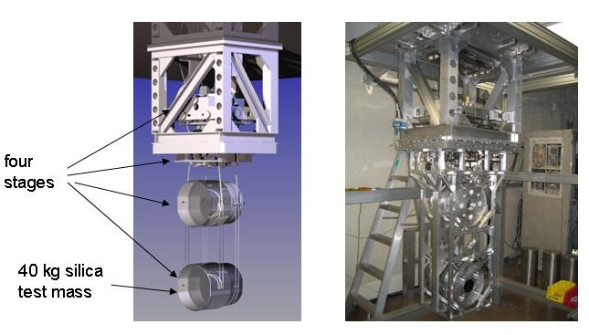
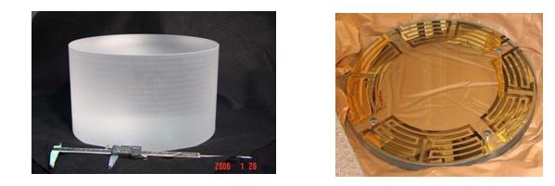
Figure 20. Left: schematic diagram of quadruple suspension showing main chain and parallel reaction chain for interferometer control actuation, with lower support structure removed for clarity. Right: all-metal controls prototype under test at Caltech

Figure 21 Left: full-size silica test mass (unpolished) procured with UK funding. Right: gold coated glass plate for testing electrostatic actuation in the controls prototype quadruple suspension
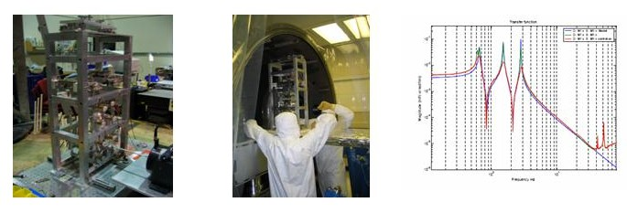

Figure 22 Left and middle : prototype modecleaner mirror triple suspension being bench tested and being installed for further test at the LASTI facility. Right:Longitudinal transfer function top mass drive to top mass position for modecleaner -green (damping off, red (damping on), blue: MATLAB model.

R&D Status/Development Issues

The SUS effort within the LSC is spread widely over several institutions including a major contribution from the UK. A consortium of the University of Glasgow, University of Birmingham, and Rutherford Appleton Laboratory was successful in securing UK funding of ~ $12M from PPARC to supply the test-mass suspensions for Advanced LIGO, and funding started in 2003, with delivery of 4 test mass blanks already completed (see figure 21). The GEO group at the University of Glasgow is the originator of GEO suspension design, and thus the UK team is very well positioned to carry through this effort, working in close collaboration with the US team. Other suspensions are the responsibility of the US members of SUS.

The primary role of the suspension is to realize the potential for low thermal noise, and much of the research into suspension development explores the understanding of the materials and defines processes to realize this mission. In addition, design efforts ensure that the seismic attenuation and the control properties of the suspension are optimized, and prototyping efforts ensure that the real performance is understood.

The GEO-600 suspensions utilizing the basic multiple-pendulum construction, fused-silica fibers, and hydroxy-catalysis attachments, have been in service since 2001. The systems have been reliable and the controls function essentially as modeled. Lessons learnt from the design, construction, installation and operation of the suspensions have been noted for application to the Advanced LIGO designs.

An all-metal prototype quadruple suspension for the test mass has been constructed in Caltech, and after preliminary assembly and testing has been shipped to the LASTI facility at MIT for full testing. This prototype is designed to allow investigation of mechanical design, control aspects and installation and alignment procedures. In parallel, design of a “noise” prototype with silica suspensions and silica mirror is underway in the UK, and this prototype is due to be shipped to LASTI at the end of 2006.

Two all-metal triple pendulum prototypes (figure 22) for modecleaner mirrors have been constructed and assembled at Caltech for initial tests, and subsequently sent to LASTI where full characterization of its behavior including comparison with computer models has been successfully completed.

Test mass thermal noise is one of the basic noise limits to performance of the Advanced LIGO design. To realize the reference design performance, the following lines of research are being pursued:

- Measurement of the dissipation levels (that determine the levels of thermal noise, according to the Fluctuation-Dissipation Theorem) of the various fused silica components and assembled systems, to guarantee that we can reach the levels limited by the best material properties.
- Qualification of production techniques to ensure that assembled suspensions meet all of the specifications, including those related to thermal noise. A separate measurement of the Q of components does not guarantee that the complete system will realize its potential.
- Verification that we do indeed achieve the expected thermal noise levels, without significant amounts of excess noise; both stationary (best characterized in the frequency domain) and non-stationary (studied in the time domain) performance are issues. Some can be studied with the planned prototype tests. Final performance tests require the full Advanced LIGO installation.

Development of the Advanced LIGO version of the suspension starts with the multiple pendulum scheme based on the GEO 600 suspension. Within that framework, there are a number of specific questions to address, including:

- choice of masses and dimensions for the masses for each stage,
- choice of wires or ribbons, dimensions, means of fabrication, and attachment,
- necessity of reaction masses, and designs of this system where required,
- sensing and actuation systems for the damping control
- establishment of the actuator hierarchy and development of electrostatic actuators

All of these questions have been addressed for the various types of suspensions required, and many of them are already resolved with others being worked on, often in collaboration with members of other subsystem groups with which subsystems the suspension interacts. As described above, full-scale controls and noise test prototypes are in development and will be used to test performance against requirements in laboratory-scale experiments.

The R&D program will include work on this subsystem through full-scale tests of all principal variants of the suspensions in the MIT LASTI testbed. By the completion of that test, the design will have been carried through the design requirements, preliminary design, and substantially through the final design review. A final LASTI test will serve to verify form, fit and conformance to functional requirements.

8. Prestabilized Laser Subsystem (PSL)

Overview

The Advanced LIGO PSL will be a conceptual extension of the initial LIGO subsystem, operating at the higher power level necessary to meet the required Advanced LIGO shot noise limited sensitivity. It will incorporate a frequency and amplitude stabilized 180 W laser. The Advanced R&D program related to this subsystem will develop rod optical gain stages that will be used in an injection-locked power oscillator.

Functional Requirements

The main requirements of the PSL subsystem are output power, and amplitude and frequency stability. Table 3 lists the reference values of these requirements. Changes in the readout system allow some requirements to be less stringent with respect to initial LIGO; the the higher power and extension to lower frequency provides the principal challenge.

Table 3 PSL Requirements
Requirement | Value
TEM₀₀ Power | 180 W
Non-TEM₀₀ Power | <5 W
Frequency Noise | 10 Hz/Hz^{1/2} (10 Hz)
Amplitude Noise | 2×10⁻⁹ /Hz^{1/2} (10 Hz)
Beam Jitter | 2×10⁻⁶ rad/Hz^{1/2} (100 Hz)
RF Intensity Noise | 0.5 dB Above Shot Noise at 25 MHz for 150 mW

TEM₀₀ Power: Assuming an optical throughput of 0.67 for the input optics subsystem, the requirement of 120 W at the interferometer input gives a requirement of 180 W PSL output.
Non-TEM₀₀ Power: Modal contamination of the PSL output light will mimic shot noise at the mode cleaner cavity, producing excess frequency noise. A level of 5 W non-TEM₀₀ power is consistent with the input optics frequency-noise requirements.
Frequency Noise: Frequency noise couples to an arm cavity reflectivity mismatch to produce strain noise at the interferometer signal port. The requirement is obtained based on a model with an additional factor of 10⁵ frequency noise suppression from mode cleaner and interferometer feedback, a 0.5% match in amplitude reflectivity between the arm cavities (a conservative estimate for the initial LIGO optics), and a signal recycling mirror of 10% transmissivity.
Amplitude Noise: Laser amplitude noise will cause strain noise in two main ways. The first is through coupling to a differential cavity length offset. The second and larger coupling is through unequal radiation pressure noise in the arm cavities. Assuming a beamsplitter of reflectivity 50±1%, the requirement is established.
Beam Jitter Noise: The coupling of beam jitter noise to the strain output is through the interferometer optics misalignment. Based on a model of a jitter attenuation factor of 1000 from the mode cleaner, a nominal optic alignment error of 10⁻⁹ rad rms imposes the requirement on higher order mode amplitude.
RF Intensity Noise: The presence of intensity noise at the RF modulation frequency directly produces strain noise. The noise is limited with the requirement above.

Concept/Options

The conceptual design of the Advanced LIGO PSL is similar to that developed for initial LIGO. It will involve the frequency stabilization of a commercially engineered laser with respect to a reference cavity. It will include actuation paths for coupling to interferometer control signals to further stabilize the beam in frequency and in intensity. Three options for the laser design were under consideration: a slab injection-locked stable-unstable resonator; a rod injection-locked stable resonator; and a multi-pass power amplifier.

At the March 2003 LIGO Scientific Collaboration meeting the laser down-select committee agreed that a technical decision could not be reached given the results achieved and that in order to minimize project delay and costs the rod injection-locked stable resonator approach would be pursued as the baseline laser design for the PSL. Because of the risks involved in developing a 180 W laser, it is important to maintain programs developing the other two laser technologies.

The front end for the Advanced LIGO Laser is based on the proven GEO600 laser. A medium power ring oscillator is injection-locked to the output of a monolithic non-planar ring oscillator. An alternative for the intermediate stage is a rod-based amplifier; both have been successfully employed, and the choice will be made with practical considerations. The high-power laser is based on a ring-resonator design with four end-pumped laser heads. Each laser head is pumped by ten 30 W fiber-coupled laser diodes. Each laser diode is individually temperature stabilized to minimize the linewidth of each fiber bundle. To improve the laser diode reliability and lifetime, the output power of each laser diode is de-rated by one-third. A fused silica rod homogenizes the transverse pump light distribution due to the spatial mixing of the rays emerging from the different fibers. This minimizes changes to the pump light distribution in the event of a pump diode failure or degradation. Thus failure of a pump diode can be compensated for by increasing the operating current for the remaining pump diodes. Three lenses then image the output of the homogenizer into the laser crystal. The Advanced LIGO laser is illustrated in Error: Reference source not found.

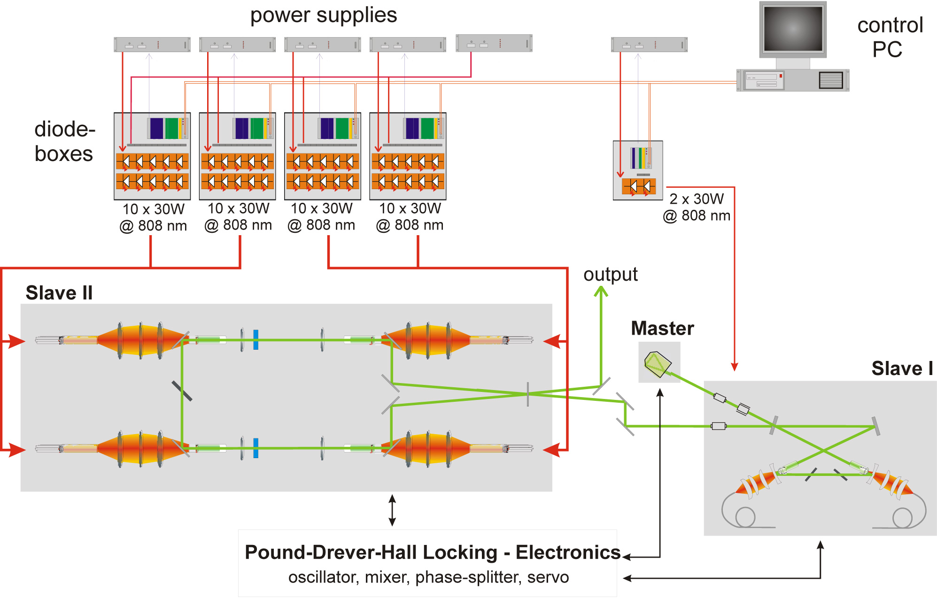
Figure 2 Schematic of the Advanced LIGO laser showing the single-frequency master laser, an injection-locked medium power stage (labeled Slave I) followed by the high power stage (labeled Slave II).
The optical layout of the PSL has four main components: the 180-W laser, a frequency stabilization path including a rigid reference cavity; an acousto-optic modulator as an actuator for the second frequency stabilization loop; a spatial filter cavity and a diagnostic path that permits investigation of the laser behavior without any disturbance to the output of the PSL. The PSL is illustrated in Figure 23. The output of the 180-W laser is spatially filtered by a small triangular ring cavity prior to being mode-matched into the suspended modecleaner.

A sample of the spatially filtered output is mode matched to the rigid reference cavity used for frequency stabilization. The scheme used is identical to that used in initial LIGO.

Two more beam samples, taken before and after the suspended modecleaner are used for the power stabilization. The baseline plan for power stabilization of the PSL is to actuate on the pump diode current to control the intensity of the laser by use of a current shunt.

Figure 23. Schematic of the Advanced LIGO PSL.

R&D Status/Development Issues

A successful Conceptual Design Review for the PSL was held at the March 2005 LIGO Scientific Collaboration meeting. The PSL is currently in the preliminary design phase.

At present work is continuing on improving and characterizing the design of the 180-W laser. Some minor problems have been encountered relating to cleanliness issues around the laser optics but these have been resolved. Issues concerning interfacing the 180-W laser with the Advanced LIGO CDS electronics, such as interfaces and sample rates, are being addressed.

An Innolight non-planar ring oscillator (NPRO) laser, similar to that used by Laser Zentrum Hannover, was acquired for testing of the planned digital control electronics. Experience gained with the initial LIGO PSL intensity stabilization suggests that a digital implementation of the servo design is desirable for maximum flexibility. A suitable digital signal processor (DSP) board from Xilinx has been identified and will be used in a technology demonstration testbed.

Progress has been made in further understanding the noise sources that limit the performance of the intensity stabilization at low frequencies. The results achieved at the Albert Einstein Institute to date are RIN=5x10⁻⁹/√Hz@10Hz and 3.5x10⁻⁹/√Hz [60Hz - 8kHz], both out-of-loop measurements, and so are close to meeting the Advanced LIGO requirement.

An effort with an industrial partner, the Laser Zentrum Hannover, similar to our practice in initial LIGO, is underway to engineer a reliable unit that will meet the LIGO availability goal. Tests of a complete full-power PSL will be made in the LASTI installation in late 2007. The PSL subsystem design work will proceed in parallel with the laser fabrication, so that the complete subsystem will be ready for installation in early 2009.

The Max Planck Institute for Gravitational Wave Research/Albert Einstein Institute and Laser Zentrum Hannover are proposing to supply the PSL systems for Advanced LIGO as a German contribution to the partnership in Advanced LIGO. The Max-Planck-Gesellschaft has approved funding for both the development and construction phase.

9. Input Optics Subsystem (IO)

Overview

The Advanced LIGO subsystem will be an extension of the initial LIGO Input Optics design, with the higher specified power and the lower noise level required by Advanced LIGO. The IO will consist primarily of beam conditioning optics including Faraday Isolators and phase modulators, a triangular input mode cleaner, and an interferometer mode-matching telescope.

Functional Requirements

The functions of the IO subsystem are to provide the necessary phase modulation of the input light, to filter spatially and temporally the light on transmission through the mode cleaner, to provide optical isolation as well as distribution of interferometer diagnostic signals, and to mode match the light to the interferometer with a beam-expanding telescope. Table 4 lists the requirements on the output light of the Advanced LIGO IO subsystem.

Table 4 Advanced initial LIGO requirements
Requirement | Value
Optical Throughput | 0.67 (net input to TEM₀₀ out)
Non-TEM₀₀ Power | <5%
Frequency Noise | 3×10⁻³ Hz/ Hz^{1/2} (at 10 Hz)
Beam Jitter | 1×10⁻⁹ rad RMS

The Input Optics has to deliver 120 W of conditioned power to the advanced LIGO interferometer. The optical throughput requirement ensures that the required TEM₀₀ power will be delivered. The cavities of the main interferometer will accept only TEM₀₀ light, so the IO mode cleaner must remove higher-order modes and its beam-expanding telescope must couple 95% of the light into the interferometer.

The IO reduces the frequency, and beam-jitter noise of the laser. The suspended mode cleaner serves as an intermediate frequency reference between the PSL and interferometer. Beam jitter (pointing fluctuation) appears as noise at the interferometer output signal through optical misalignments and imperfections. The nominal optic alignment error of 1×10⁻⁹ rad imposes the requirement in Table 4. Further details can be found in the IO Design Requirements document.

Concept/Options

The schematic layout of the IO is displayed in Figure 3, showing the major functional components. The development of the IO for Advanced LIGO will require a number of incremental improvements and modifications to the initial LIGO design. Among these are the needs for larger mode cleaner optics and suspensions to meet the Advanced LIGO frequency noise requirement, cross-product free modulation spectrum (with no sidebands-on-sidebands), increased power handling capability of the Faraday Isolator and phase modulators, and the ability to adaptively control the laser mode structure into the interferometer.

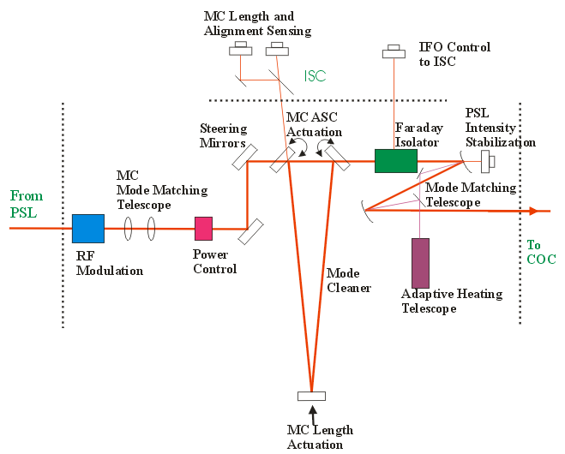
Figure 3 Schematic diagram of the Advanced LIGO Input Optics (IO) subsystem.
Phase modulation for use in the length and angle sensing systems is applied using electro-optic crystals. Faraday isolators are used to prevent parasitic optical interference paths to the laser and to obtain information for the sensing system.

The mode cleaner is an in-vacuum suspended triangular optical cavity. It filters the laser beam by suppressing directional and geometric fluctuations in the light entering the interferometer, and it provides frequency stabilization both passively above its pole frequency and actively through feedback to the PSL. Noise sources considered in design studies include sensor/actuator and electronic noise, thermal, photothermal, and Brownian motion in the mode cleaner mirrors, and radiation pressure noise. The mode cleaner will use 15-cm diameter, 7.5-cm thick fused silica mirrors. The cavity will be 16.7 m in length, with a finesse of 2000, maintaining a stored power of ~100 kW. A triple pendulum (part of the suspensions subsystem) will suspend the mode cleaner mirrors so that seismic and sensor/actuator noise does not compromise the required frequency stability.

Finally, the mode-matching telescope, which brings the beam to the final Gaussian beam parameters necessary for interferometer resonance, will be similar to the initial LIGO design using three spherical mirrors, but will use an auxiliary CO₂ laser to adjustably control the effect radius of curvature of the mirrors for in situ adjustment of mode matching without the need for vacuum excursions. This design allows for optimization of mode-matched power by having independent adjustment of two degrees of freedom, waist size and position, over a wide range of modal space.

Further documentation of the design can be found in the Input Optics Conceptual Design Document and references therein.

R&D Status/Development Issues

The IO subsystem completed its Design Requirements and Conceptual Review in May 2002 and is now completing the preliminary design phase. Major development efforts within the IO focus on optical components capable of handling high power (180 W level), including the development of the Faraday Isolators, phase modulators, as well as thermal modeling of the mode cleaner and mode-matching telescope.

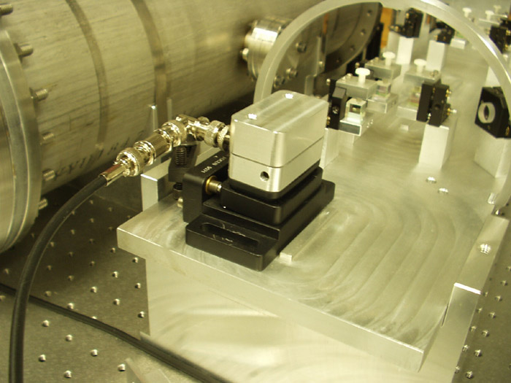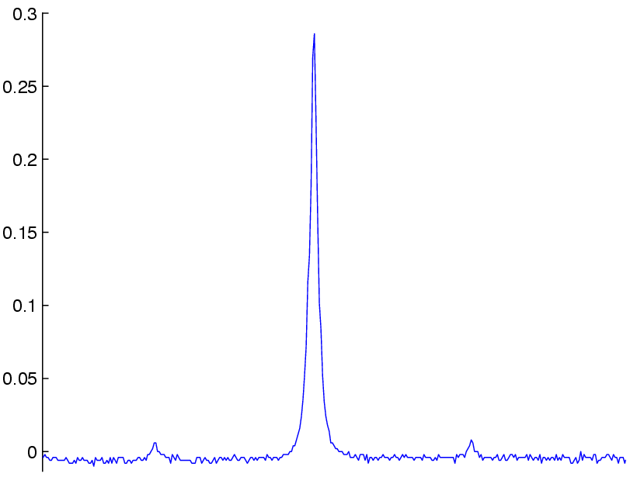
Fig. XX- The Advanced LIGO electro-optic modulators with modulated spectrum shown in the inset.
We have developed electro-optic modulators based on rubidium titanyl arsenate (RTA) and rubidium titanyl phosphate (RTP) electro-optically active crystals. We have characterized the thermo-optic and electro-optic performance of our modulators at powers up to 100 W and power densities exceeding Advanced LIGO conditions. Negligible absorption and thermal lensing as well as high electro-optic efficiency were observed, and we have operated these modulators at high powers for over 300 hours with no change in performance. In addition, we are investigating methods for synthesizing pure sideband modulation spectra based on both Mach-Zehnder and amplitude/phase modulation methods. Efforts to date have focused on defining requirements for MZ technical noise limits, fabrication and characterization of a prototype MZ (servo requirements), and developing serial AM/PM methods for synthesizing pure sideband spectra.

Fig. XX – Schematic drawing of the FI, showing from right (beam entrance) to left i) initial polarizer, ii) Faraday rotator, iii) 1/2 waveplate, iv) thermal lens compensator, and v) final polarizer.

For the mode cleaner, we have finished the optical design and analyzed its thermal performance using Melody combined with finite element modeling to better understand the effects of optical absorption on the mode quality of the interferometer. The coating absorption dominates the thermal effect due to high intracavity powers. Absorption levels 0.5 ppm or less preserve transmitted mode quality at 165 W input powers. The relatively compact design of the mode cleaner cavity produces small spot sizes on the mirrors with average intensities of approximately 700 kW/cm². This is below the quoted damage threshold for tantala/silica supermirrors (approximately 1 MW/cm²). However, the intensity is sufficiently high that we are investigating the long term effects of high intensity exposure.

For the Faraday Isolator, we have addressed both wavefront distortion (thermal lensing) and depolarization through a new design capable of providing compensation for polarization distortion and high isolation ratios up to the maximum test power of 160 W as shown in FIGURE XX. Using a negative dn/dT material (deutered potassium dihydrogen phosphate) to introduce negative lensing, we achieved significant compensation of the thermal lens in the Faraday isolator, with the system focal length increasing from ~ 7 m to > 40 m at 75 W power levels.
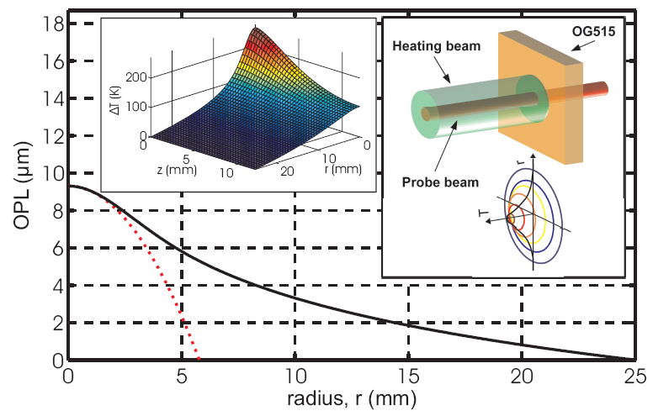
Fig. XX Calculated radial dependence of the optical path difference (OPD) assuming 4 W of heating power in a 7.2 mm diameter beam. The solid line results from an exact solution of the thermal diffusion equation; the dotted line displays the OPD assuming a parabolic lens. Right inset: schematic view of laser adaptive mode control. Left inset: the spatial dependence of the temperature profile ∆T(r,z).
To address control of the mode matching, we have developed and characterized an adaptive mode matching telescope for Advanced LIGO. It relies on controlled optical path deformation in a dichroic optical element heated with an auxiliary laser (FIGURE XX). An additional heating laser operating at a wavelength (10.6 μ) completely absorbed by a transmissive element creates a parabolic lens in that element. Provided that the heating beam mode is substantially larger than the transmitted beam mode, the lens is essentially aberration-free, has high dynamic range, and can be implemented to adjust the focus of high average power laser beams.

The IO subsystem lead role will remain with the University of Florida group who built the IO for initial LIGO. Fabrication of prototype high power Faraday Isolators and phase modulation methods has been proceeding under the University of Florida Advanced R&D program,. Advanced LIGO performance level modulators and isolators will be used for the initial LIGO enhancements to follow the S5 science run. Design of the adaptive telescope is underway, as well as the layout of the entire optical system. Tests of modulator phase and amplitude noise, completion of the adaptive mode matching telescope design, and damage studies of optical coatings in mirrors are currently underway. A complete end-to-end test of the IO will be performed at the MIT LASTI facility in conjunction with the mode cleaner suspension testing and the pre-stabilized laser testing.

10. Core Optics Components (COC)

Overview

The Advanced LIGO COC will involve a significant change from the initial LIGO COC to meet the higher power levels and improved shot-noise and thermal-noise limited sensitivity required of the Advanced LIGO interferometer. Many of the fabrication techniques developed for the fused silica initial LIGO COC will be directly applicable to the optics production. However, a much larger mass is needed to keep the radiation reaction noise to a level comparable to the suspension thermal noise. The optical coatings must also undergo development to achieve the combination of low mechanical loss (for thermal noise) while maintaining low optical loss. Reduction of mechanical loss in coatings has a direct impact on the Astrophysical reach of Advanced LIGO.

Functional Requirements

The COC subsystem consists of the following optics: power recycling mirror, signal recycling mirror, beam splitter, folding mirror, compensation plate, input test mass, and end test mass (see Figure 1). The following general requirements are placed on the optics:

- the radius of curvature and surface figure must maintain the TEM₀₀ spatial mode of the input light;
- the optics microroughness must be low enough to limit scatter to acceptable levels;
- the substrate and coating optical absorption must be low enough to limit the effects of thermal distortion on the interferometer performance;
- the optical homogeneity of the transmitting optics must be good enough to preserve the shape of the wavefront incident on the optic;
- the intrinsic mechanical losses, and the optical coating mechanical losses, must be low enough to deliver the required thermal noise performance

Table 5 lists the COC test mass requirements.

Table 5 COC test mass requirements
Mass | 40Kg
Dimensions | 340mm x 200mm
Surface figure  (deviation from sphere over central 12 cm) | 1 nm RMS
Micro-roughness | 0.1 nm RMS
Optical homogeneity  (in transmission through 15 cm thick substrate, over central 8 cm) | 20 nm rms, double pass
Bulk absorption | 1 ppm/cm
Bulk mechanical loss | 3 10⁻⁹
Optical coating absorption | 0.5 ppm (required)  0.2 ppm (goal)
Optical coating scatter | 2 ppm (required)  1 ppm (goal)
Optical coating mechanical loss | 2 10⁻⁴ (required)  3×10⁻⁵ (goal)

Requirements Documents

LIGO-T000127-01 COC Design Requirements Document
LIGO-T000128-02 COC Development Plan
LIGO-T000098-02 Conceptual Design Document
LIGO-C030187-01 Coating Development Plan
LIGO-T030233 Coating Test Plan

Concept

Advanced LIGO will draw on initial LIGO core optics design. Low optical absorption fused silica is the material chosen for the input and end test mass material. The initial LIGO optics far exceeded many of the specifications for Advanced LIGO; it is assumed that we will be able to meet the same specifications as LIGO1, but over a larger area and volume. A polishing demonstration program is planned to scale the LIGO1 approach to 40 kg sizes. Some work is required to ensure acceptable mechanical losses of fused silica in large substrates, although very low losses have been seen in smaller samples. The material properties of fused silica do imply reliance on the thermal compensation system (see 11. Auxiliary Optics Subsystem (AOS)).

The beam splitter requirements are met by the best presently available low absorption fused silica. Due to the large aspect ratio of the beamsplitter there is a coating demonstration program to ensure the stress of the coating can be compensated in order to preserve the flatness of the beamsplitter.

The very long lead time for production of substrates, for polishing, and for coating requires early acquisition in the Advanced LIGO schedule.

R&D Status/Development Issues
Four 40kg input test mass blanks have been received from the UK as part of their PPARC-funded contribution to Advanced LIGO. The blanks are Heraeus 311 material, a low absorption, ultra homogeneous fused silica. These blanks will be used in the development phase for the polishing pathfinder demonstration, and then subsequently processed as Advanced LIGO test masses in the Project phase.

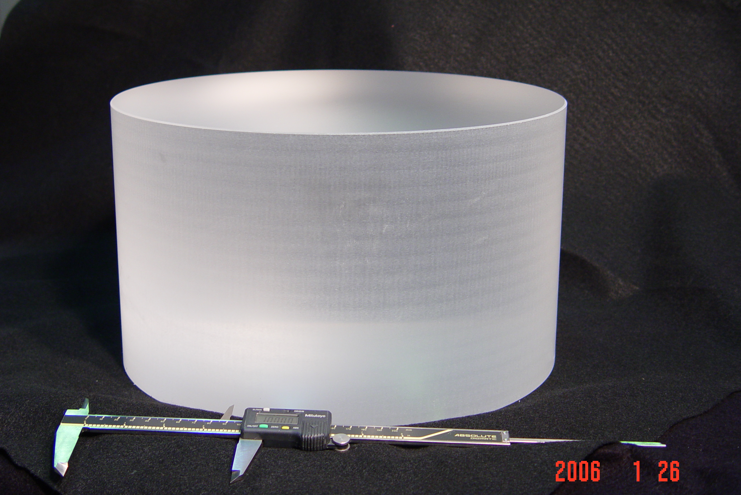
Figure 4 40kg Input test mass blank, supplied by University of Glasgow.

A very active program to characterize and reduce the mechanical loss in the coatings has made progress. The principal source of loss in conventional optical coatings has been determined by our research to be associated with the tantalum pentoxide, likely due to material. Doping of the tantala with titania is the most promising coating developed, with significantly lower thermal noise and optical properties near requirements. Silica doped titania is also a promising high index material. Further development of both of these materials along with research into new materials and processes is planned with multiple vendors. We have a goal of an approximate factor of ten reduction in the loss, as a coating mechanical loss at this level ensures the coating thermal noise does not significantly reduce the sensitivity of the instrument. We have seen reductions of 2.5 in selected samples of exploratory coatings.

The modeling of all tolerances of the core optics is to be completed in 2006, at which time the polishing pathfinder will commence. Polishing of high precision optics is currently limited only by metrology. There are at least three vendors with sufficient metrology in place to attempt an Advanced LIGO test mass polish. The polishing pathfinder will provide the opportunity for three vendors to polish a full size LIGO test mass. Performance on this task will be weighed alongside vendor proposals to determine qualified polishers for Advanced LIGO.

The purpose of the beamsplitter/fold mirror pathfinder is different from the polishing pathfinder. Optics of high aspect ratio are known to warp under the compressive stress of ion beam coatings. This change must be compensated in order to provide sufficiently flat optical surfaces. The compensation will be accomplished either by coating the back side of the optic with an equally stressful coating, by annealing, or by pre-figuring the optic slightly concave so that the resulting optic is flat.

The time scale for developing a satisfactory coating, with appropriate optical and mechanical losses, is associated with the commencement of coatings on the production optics about one year into the Project. Development of a titania doped tantala coating with satisfactory optical properties is a priority. Further development of silica doped titania and explorations of new materials will also be pursued.

11. Auxiliary Optics Subsystem (AOS)

Overview

The AOS for Advanced LIGO is an extension of this subsystem for initial LIGO, modified to accommodate the planned higher laser power and additional signal-recycling mirror. The AOS is responsible for transport of interferometer output beams and for stray light control. It includes beam reducing telescopes, and beam dumps and baffles. An additional element of this subsystem is active optics thermal compensation, where compensatory heating of an optic is used to cancel thermal distortion induced by absorbed laser power. It also includes the photon calibrator, which uses light pressure to apply precise calibration forces to the end test masses of the interferometer. AOS also covers the addition of an output mode cleaner.

Functional Requirements

The conventional subsystem requirements relate to control of interferometer ghost beams and scattered light, delivery of interferometer pickoff beams to the ISC subsystem, and maintenance of the surface figure of the core optics through active thermal compensation. While the requirements on these elements are somewhat more stringent than for the initial LIGO design, no significant research and development program is required to meet those requirements.

There are elements which are new to the Advanced LIGO design for which the requirements will be numerically determined as part of the systems flowdown:

- Active Thermal Distortion Compensation: The axisymmetric thermal lens must be corrected sufficiently to allow the interferometer to “cold start”; the compensation may also be required to correct for small (cm-) scale spatial variations in the substrate absorption.
- Output Mode Cleaner: The length sensing system requires that non-TEM₀₀ and RF sideband light power at the antisymmetric output port be reduced substantially to allow a small local-oscillator level to be optimal and thus to maintain the efficiency of the overall shot-noise-limited sensing.

Until recently we had planned to include a Photon Drive Actuator, which would apply forces to control the test mass position using radiation pressure. We now expect that electrostatic actuators can provide the desired actuation range with suitably low noise, and so the Photon Drive Actuator has been dropped from the baseline design. However, should the low noise requirements of the electrostatic actuator not be realized, the Photon Drive Actuator can then be developed and installed, and optical clearance around the end test masses is being maintained for this contingency.

Concept/Options

The AOS conventional elements consist of low-aberration reflective telescopes that are placed in the vacuum system to reduce and relay the output interferometer beams out to the detectors, and baffles of absorptive black glass placed to catch stray and “ghost” (products of reflections from the residual reflectivity of anti-reflection coatings) beams in the vacuum system. The elements must be contamination-free and not introduce problematic mechanical resonances. Because of the increased interferometer stored power, the AOS for Advanced LIGO will involve careful attention to control of scattered light, and will require greater baffling and more beam dumps than for initial LIGO.

The thermal compensation approach involves adding heat, which is complementary to that deposited by the laser beam, using two complementary techniques: a ring heater that deals with circularly symmetric distortions, and a directed laser that allows uneven absorption to be corrected.

The frequency-dependent transmission and filtering properties required of the output mode cleaner depend on the DC readout scheme chosen by ISC and will be determined with respect to this readout scheme. ACIGAError: Reference source not found, with their expertise in sensing systems, will aid in the design of the output mode cleaner, and ACIGA is proposing to contribute materially in the fabrication and installation of an output mode cleaner. This complements their efforts to study variable transmission signal recycling mirrors and to develop phase-front sensors for thermal compensation measurements.

R&D Status/Development Issues

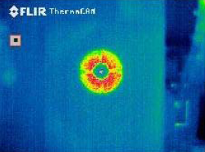
Development of active optic thermal compensation is proceeding under the LIGO advanced R&D program. A model of the thermal response of the interferometer in a modal basis has been developed and used extensively to make predictions for the deformations and of the possible compensation. A prototype has successfully demonstrated thermal compensation, in excellent agreement with the model, using both the ring heater and directed laser techniques. This will be complemented with a physical optics model using FFT beam propagation techniques, using these phase maps as input. LIGO is currently using CO₂ laser projectors on the input test masses of all three interferometers for thermal compensation both of the interferometers’ self-heating and of their static mirror curvature errors. This experience is teaching us a great deal about servo control methods for thermal compensation and allowed us to measure compensator noise injection mechanisms (see figs. 1 and 2).
Figure 5: an initial LIGO thermal compensation pattern.

The photon calibrator will be redesigned to employ Nd:YAG lasers, which are more reliable than the Nd:YLF lasers currently in use. This will require the photon calibrator laser to be offset-locked from the main carrier laser to prevent scattered light coherence, but this is not difficult to implement.

Given the DC readout scheme, the output mode cleaner will be a short, rigid cavity, mounted in one of the output HAM chambers. Both the VIRGO Project and GEO-600 use output mode cleaners in their initial design. We plan to start with a study of their approach and the experience with those systems. The principal design challenges lie in the interface to the Interferometer Sensing and Control. The cavity must be aligned with the nominal TEM00 axis of the interferometer, but the bulk (by several orders of magnitude) of the output power will be in higher-order modes; determining the correct alignment is thus non-trivial. The length control, in particular the lock acquisition sequence, also adds complexity.

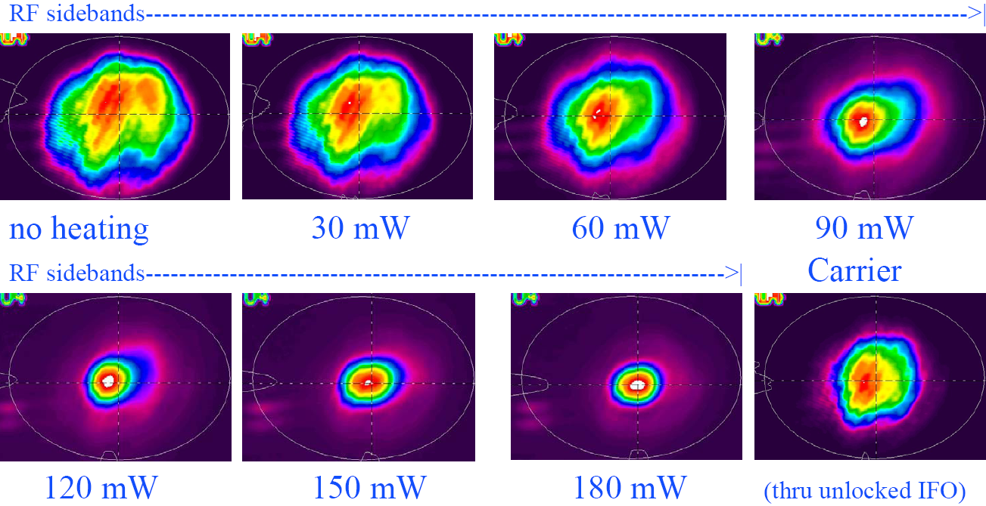Figure 6: RF sideband mode shape control using thermal compensation. Note the optimum overlap between RF sideband and carrier mode at 90 mW heating power.

Work on the active optics thermal compensation is proceeding under the advanced R&D program. A testbed thermal compensation system is under test in the ACIGA Gingin facility in 2005; while their compensator design is not adaptable to Advanced LIGO, they use a Hartmann sensor to detect thermal aberrations, which is being studied as potential component for Advanced LIGO, and they are gaining valuable experience in thermal sensing and compensation of high-power suspended cavities. A prototype thermal aberration sensor based upon a white-light Fizeau interferometer has been developed at the Institute for Advanced Physics in Nizhny Novgorod, Russia, and is also under evaluation for Advanced LIGO. And, thermal compensation studies continue in initial LIGO. Photon calibrators have been used on the LIGO interferometers for a few years, and adaptation to Advanced LIGO either as photon calibrators or photon drive actuators is not expected to pose any difficulty. The output mode cleaner will be studied using the modeling tools developed for the Mode Cleaner cavity as well as overall interferometer controls models. We also have built a prototype output mode cleaner, to be tested on the Caltech 40-meter prototype interferometer (see figure 3). The design process for the beam dumps, baffles, reducing telescopes will resemble that for enhancements to the initial LIGO design with a planned installation starting in 2007.
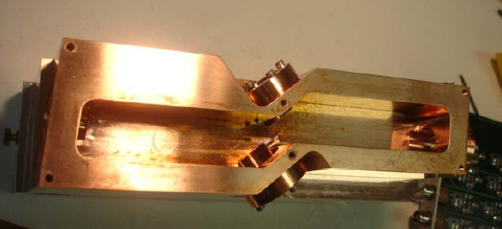Figure 7: the 4-mirror output mode cleaner prototype at the Caltech 40-meter prototype interferometer.

12. Interferometer Sensing and Controls Subsystem (ISC)

Overview

This subsystem comprises the length sensing and control, the alignment sensing and control, and the overall controls infrastructure modifications for the Advanced LIGO interferometer design. The infrastructure elements will be modified to accommodate the additional control loops in the reference design. The single most significant difference in the Advanced LIGO subsystem is the addition of the signal recycling mirror and the resulting requirements on the controls.

Functional Requirements

Table 6 lists significant reference design parameters for the interferometer length controls.

Table 6 Significant Controls Parameters
Configuration | Signal and power recycled Fabry-Perot Michelson interferometer
Controlled lengths | - differential arm length (GW signal)  - near-mirror Michelson differential length  - common-mode arm length (frequency control)  - power recycling cavity resonance  - signal recycling mirror control
Controlled angles | 2 per DOF above, 12 in total
Main differential control requirement | 10⁻¹⁴ m rms
Shot noise limited displacement sensitivity | 4×10⁻²¹ m/√Hz
Angular alignment requirement | 10⁻⁹ rad rms

The requirements for the readout system are in general more stringent than those for initial LIGO. The differential control requirement is a factor of 10 smaller, as is the angle requirement, and the additional degrees of freedom add complexity. Integration with the thermal compensation system and the gradual transition from a “cold” to a “hot” system will be needed.

In spite of the increased performance requirements for Advanced LIGO, significant simplification in the controls system is foreseen because of the large reduction in optic residual motion afforded by the active seismic isolation and suspension systems. Reduced core optic seismic motion can be leveraged in two ways. First, the control servo loop gain and bandwidth required to maintain a given RMS residual error can be much smaller. Second, the reduced control bandwidths permit aggressive filtering to block leakage of noisy control signals from imperfect sensor channels into the measurement band above 10 Hz. While control modeling is just getting started, this latter benefit is expected to significantly relieve the signal-to-noise constraints on sensing of auxiliary length and alignment degrees of freedom.

Concept/Options

The signal-recycled configuration is chosen to allow tunability in the response of the interferometer. This is useful for the broadband tuning to control the balance of excitation of the mirrors by the photon pressure, and the improvement in the readout resolution at 100-200 Hz. A narrow-band instrument (to search for a narrow-band source, or to complement a broad-band instrument) can also be created via a change in the signal recycling mirror transmission. An example of possible response curves for a single signal recycling mirror transmission is shown in .

Another important advantage of the signal recycled configuration is that the power at the beamsplitter for a given peak sensitivity can be much lower; this helps to manage the thermal distortion of the beam in the beamsplitter, which is more difficult to compensate due to the elliptical form of the beam and the significant angles in the substrate.

Figure 8 Strain sensitivity curves for a narrowband interferometer. By changing from a signal recycling mirror optimized for broadband operation to one chosen to give optimum performance around 800 Hz, good performance at a selected frequency between ~400–2000 Hz can be achieved by tuning the signal mirror position microscopically; the set of curves shown span a mirror motion of about 0.1 wavelength. At the lower end of the range, coating thermal noise limits the performance; at higher frequencies, above ~500 Hz, the quantum noise limits the best performance (modeled using Bench)

Most length sensing degrees-of-freedom will be sensed using RF sidebands in a manner similar to that in initial LIGO. However, for the gravitational-wave output, a baseband (‘DC’) rather than synchronous modulation/demodulation (‘RF’) approach will be used. The output of the interferometer is shifted slightly away from the dark fringe and deviations from the setpoint become the measure of the strain. This approach considerably relaxes the requirements on the laser frequency; the requirement onbaseband intensity fluctuations is not different from the case of RF detection. A complete quantum-mechanical analysis of the two readout schemes has been undertaken to determine which delivers the best sensitivity, and the requirements imposed on the laser and modulation sources due to coupling of technical noise have been followed through, both indicating the preference for this DC readout scheme.

In Advanced LIGO, all of the detection will be performed in vacuum with photodetectors and auxiliary optics mounted on seismic isolation systems. This will avoid the influence of air currents and dust on the beam, and minimize the motion of the beam with respect to the photodiode.

Alignment sensing and control will be accomplished by wavefront sensing techniques similar to those employed in initial LIGO. They will play an important role in managing the potential instability in angle brought about by photon pressure if exerted away from the center of mass of the optic.

The greater demands placed by optical powers and sensitivity are complemented by the improved seismic isolation in Advanced LIGO, leading to similar demands on the control loop gains. In general, the active isolation system and the multiple actuation points for the suspension provide an opportunity to optimize actuator authority in a way not possible with initial LIGO.

R&D Status/Development Issues

The signal-recycled optical configuration chosen for Advanced LIGO (see Figure 1) challenges us to design a sensing and control system that includes the additional positional and angular degrees of freedom introduced by the signal-recycling mirror. Several straightforward extensions of the sensing system for initial LIGO have been considered. Mason, Delker and Shaddock have demonstrated locking of signal-recycled tabletop interferometers using variants of the initial LIGO asymmetry method, adapted in more or less radical ways to accommodate the additional signal recycling cavity degrees of freedom.

These tabletop experiments and their associated simulations have shown that it is not difficult to arrive at non-singular sensing schemes by adding an additional RF modulation which, through selection of resonant internal lengths, preferentially probes the new cavity coordinates. However there is a great deal of subtlety in choosing parameters to decouple the coordinate readouts adequately to establish a simple, robust control design while realizing the high strain signal-to-noise required. A detailed prototype test of the control system was undertaken in GEO (Glasgow), with results leading to a baseline readout scheme. An engineering control demonstration is well underway in the LIGO 40 Meter Interferometer (Caltech); it has made a complete emulation of the control system using the target control hardware and software. Locking and operation of the system have been studied for one readout scheme. Others will be pursued, and a demonstration of the DC readout scheme is being prepared.

We are studying the advantages and difficulties associated with making stable the optical modes of the signal and power recycling cavities. In initial LIGO, the effective recycling optical cavity is nearly flat-flat, leading to mode degeneracy and a high sensitivity to mirror defects. By including focusing elements in the cavity, it can be made stable, and there are strong advantages for both the power and signal recycling cavities in this. There are some layout challenges, as it puts more interferometrically sensed optics into the HAM chambers. Some more modeling of the impact on the optical modes is also being pursued.

A possible auxiliary sensing of the seismic optical tables is being pursued in a systems-level study which is closely linked to the sensing and control system and the locking of the interferometer. The objective is to allow the relative velocity of the test masses to be reduced before the interferometer is locked, to aid in (and to accelerate) the locking process. The system may also be used in the operational mode. Several implementations are being considered, with a low-finesse interferometer formed between mirrors rigidly mounted to the seismic tables as one straightforward possibility.

To accommodate the needs for wideband multi-frequency auxiliary length readouts, the DC strain readout, and high-frequency wavefront sensing, characterization of photodiodes will be undertaken. As for initial LIGO detectors, the first steps will be surveys of commercial devices and those developed by colleagues in other projects. This phase will likely be followed in one or more cases by development work to customize or to improve performance and to optimize the electronic amplifiers that mate to these detectors.

Though not necessarily required, lower noise analog-to-digital and digital-to-analog converters would be of great benefit in the design of the sensing and control signal chain. We will prototype board circuitry and software to integrate these converters into our digital control environment. We also will experiment with new topologies and circuits for the critical analog signal conditioning filters that match the dynamic range of the converters to that of the physical signals they deal with.

13. Data Acquisition, Diagnostics, Network & Supervisory Control (DAQ)

Overview

The differences between the initial LIGO and Advanced LIGO Data Acquisition, Network & Supervisory Control (DAQ) requirements derive from the increased number of channels in the Advanced LIGO interferometers, due to the greater number of active control systems.

Functional Requirements

The principal Advanced LIGO reference design parameters that will drive the data acquisition subsystem requirements are summarized in Table 7.

Table 7 Principal impacts of the Advanced LIGO Reference Design on Data Acquisition and Data Analysis Systems. The number of Degrees of Freedom (DOF) is indicated for the main interferometer to give a sense of the scaling.
Parameterization | Advanced LIGO  Reference Design | Initial LIGO Implementation | Comment
Acquisition System Maximum Sample Rate, s/s | 16384 | 16384 | Effective shot noise frequency cutoff is well below f_{Nyquistt}  (8192 Hz)
Active cavity mirrors, per interferometer | 7 | 6 | Signal Recycling Mirror will be added.
Active seismic isolation system servos | 11 chambers per interferometer; 18 DOF per chamber; total, 198 DOF | 2 end chambers per interferometer, total, 12 DOF | Iinitial LIGO uses passive isolation with an external 6 DOF pre-isolator on end test masses;  Advanced LIGO uses active multistage 6 DOF stabilization of each seismic isolation platform.
Axial and angular alignment & control, per interferometer | SUS DOF : 42  $L$ DOF: 5  ($q,f$) DOF:12 | SUS DOF: 36  $L$ DOF: 4  ($q,f$) DOF: 10 | Advanced LIGO has one additional cavity. Each actively controlled mirror requires 6 DOF control of suspension point plus ($q,f,L$) control of the bottom mirror.
Total Controlled DOFs | 257 | 62 | Relative comparison of servo loop number for maintaining resonance in the main cavities  (PSL and IO not included)

Advanced LIGO will require monitoring and control of many more degrees of freedom (DOF) than exist in the initial LIGO design. The additional DOFs arise primarily from the active seismic isolation, with a smaller contribution from the move to multiple pendulum suspensions and the additional suspended mirror. Table 7 summarizes these modifications. Both the suspension and the seismic isolation systems will be realized digitally (except for the sensors and actuators) and the DAQ will need to capture a suitable number of the internal test points for diagnostics and state control (as is presently done for the initial LIGO digital suspension controllers).

Referring to Table 7, the number of loops per interferometer that are required for Advanced LIGO is seen to be ~ 250. This is to be compared to ~ 60 for initial LIGO. The number of channels that the DAQ will accommodate from the interferometer channels for Advanced LIGO will reflect this 4X increase in channel number.

Table 8 presents approximate channel counts classified by sample bandwidth for Advanced LIGO and compares these to initial LIGO values. These represent the total volume of data that is generated by the data acquisition (DAQS) and the global diagnostics system (GDS); a significant fraction of these data are not permanently acquired. Nonetheless, the ability to acquire all available channels must be provided.

Table 8 DAQ Acquisition Data Channel Count and Rates (You should check the numbers below with Rolf and Albert. E.g., I think they recently came up with 10 MB/s per ifo (30 MB/s total) for the archived data rate, versus 20.6 below)
System | Advanced LIGO Reference Design | Initial LIGO | Comments
Channels, LHO + LLO  Total  (Total: 3 x IFO + 2 x PEM) | 5464 + 3092  8556 | 1224 + 714  1938 | Adv. LIGO will have ~4.5X greater number of channels.
Acquisition Rates, MB/s  LHO + LLO  Total | 29.7 + 16.3  46 | 11.3 + 6.1  17.4 | DAQS has ~3X total data acquisition.
Recorded Framed Data Rates, MB/s  LHO + LLO  Total | 12.9 + 7.7  20.6 | 6.3 + 3.5  9.8 | DAQS has ~2X total framed data recording rate.

Concept/Options

The driving features of the Advanced LIGO hardware design are the increase in channel count and the resulting increase in data rate, in terms of both the rate that must be available on-line, and the rate that is permanently archived..

The additional data channels required for the newer seismic isolation and compound suspension systems will require additional ADCs distributed throughout the experimental hall Control and Data Systems (CDS) racks. Additional racks will be required and can be placed alongside the present CDS racks within the experimental halls. In those cases where there is interference with existing hardware, racks will need to be located further away, at places previously set aside for LIGO expansion. Additional cable harnesses for new channels will be accommodated within the existing cable trays.

The initial LIGO data acquisition processors do not have excess capacity sufficient to accommodate the increase in acquisition rate and will need to be upgraded. The upgrade will be a combination of updating the hardware technology and using a greater number of processors. The existing fiber optic infrastructure will accommodate the Advanced LIGO DAQS changes without requiring an upgrade. (not sure that this statement about the fiber optic infrastructure is true; either ask Rolf or delete) The DAQ framebuilder and on-line mass storage systems will be upgraded to accommodate the greater data and frame size. The Global Diagnostic System (GDS) will be upgraded to handle ~3X as much real time data as the initial LIGO GDS.

R&D Status/Development Issues

There are two technology changes from initial LIGO that are currently being : A change from VME to PCIx, and a distributed network change from Reflective Memory to Myrinet, the latter having higher capacity and being more flexible (star-configuration versus ring). We are also exploring a move from VxWorks to real-time Linux as the software basis.

Acquisition systems have been designed and prototyped to determine performance of candidate hardware solutions. Tests are currently underway at the 40 Meter Interferometer at Caltech, and the LASTI testbed at MIT.

The Global Diagnostics System (GDS) hardware will need to be scaled for the greater processing and throughput requirements. Parallelization techniques that are being used in the initial LIGO design (e.g., passing messages across Beowulf clusters) can be introduced to solve compute-bound (but not I/O bound) data processing problems.

It is plausible that hardware technology trends will continue over the coming years. Thus, it is likely that the solutions required to support the ~3X increased acquisition rates and data volumes would become commercially available by the time they are needed. We have taken as the point of departure that “Moore’s law” will be a reasonable predictor of the growth in available performance.

14. Support Equipment (SUP)
DOES THIS STILL EXIST????

15. Advanced LIGO Construction Project Research and Development (R&D)
DOES THIS STILL EXIST????

16. LIGO Data and Computing Subsystem (LDCS)

Overview

The computational load is increased over that for initial LIGO due to the broader frequency range of detector sensitivity. The enhanced frequency band in Advanced LIGO means that sources whose characteristic frequency of emission varies with time will be observable in the detection band for longer periods. Most of the search algorithms are based on frequency-domain matched filtering and thus the pipelines are compute-bound using the Fast Fourier Transform. Since the computational cost of the FFT grows as ~N logN with the number of data samples, longer duration waveforms require computational power that grows non-linearly with the length of the dataset. Data volume is also increased over that for initial LIGO because the interferometers are more complex and have a greater number of data acquisition channels that must be accommodated.

The impact on data analysis strategies of exploiting the increased instrumental sensitivity depends on the source type being considered and will be discussed below for those classes of search that drive the computational needs. Most presently envisioned search and analysis strategies involve spectral-domain analysis and optimal filtering using template filter banks calculated either from physics principles or parametric representations of phenomenological models. The interferometer strain output is the primary channel of interest for astrophysics. The other thousands of channels in Advanced LIGO are used to validate instrumental behavior. It is expected that relatively few channels (< 50) will also prove useful in producing improved estimates of GW strain. This would be done by removing instrumental cross-channel couplings, etc. either with linear regression techniques in the time domain (Kalman filtering) or in the spectral domain (cross-spectrum correlation). Based on Initial LIGO experience, signal conditioning is not expected to be a driver for LIGO Data and Computing System (LDCS) upgrades.

The Advanced LIGO Data and Computing Subsystem is a scaled up version of current systems with an important point of departure. By the time LDCS will be needed for Advanced LIGO science observations, disk-based mass storage technology is expected to have outpaced tape storage. Therefore, the current plan is to convert to a disk-based archival system that can grow and is sustainable throughout the period of Advanced LIGO science operations.

Functional Requirements

LIGO Laboratory and the LSC are active participants in a number of NSF-sponsored initiatives, and have already implemented a large-scale production data analysis grid, termed the LIGO Data Grid (LDG). The LDG scope includes not only LIGO Laboratory resources, but also LIGO Scientific Collaboration. Its goal has been to adopt and make widely available grid computing methods for the analysis of LIGO data. A significant portion of LIGO Laboratory’s operations activities in software development has been dedicated to grid-enabling legacy software and pipelines primarily designed to run on targeted cluster resources.

The construction of Advanced LIGO offers an opportunity to start by integrating the latest grid middleware technology available at the time Advanced LIGO science operations begin. This proposal addresses the LIGO Laboratory Tier 1 components of LIGO data analysis and computing. At appropriate times in the future, the Laboratory and the LSC will respond to opportunities for funding that will be needed in order to also enhance the Tier 2 facilities at the collaboration universities. Such enhancements will include an increase in the number of Tier 2 university centers serving the LIGO data analysis community.

LIGO Laboratory Computational Resources for Advanced LIGO

For the classes of sources considered (transient “bursts”, compact object inspirals, stochastic backgrounds, and continuous-wave sources), the continuous-wave and binary inspirals place the greatest demands on the computational requirements. Optimal searches for periodic sources with unknown EM counterparts (the so-called blind all-sky search) represent computational challenges that require O[10¹⁵ or more FLOPS] and will likely remain beyond the capacity of the collaboration to analyze using LIGO Tier 1 and Tier 2 resources. Alternative techniques have been developed that lend themselves to a distributed grid-based deployment. Research in this area has been ongoing during initial LIGO and will continue. For example, during the 2005 Einstein World Year of Physics, the LIGO Scientific Collaboration, the University of California’s BOINC Project, and the American Physical Society (APS) developed a project called Einstein@home to develop a screensaver based on SETI@home technology to analyze LIGO data to look for continuous gravitational waves. By 1Q2006 Einstein@home had been downloaded onto over 200,000 home computers of all types. A recent posting by the BOINC Project indicated that Einstein@home had been used by over 100,000 users during the last 24 hour period, contributing an astounding 40 TFLOPS of computational effort to the search for continuous gravitational waves.

The Tier 1 center installation for Advanced LIGO will not be specifically targeted to this class of search, since it is one that will need to be addressed on a much larger scale within the national Grid infrastructure.

Advanced LIGO will search for compact object binary inspiral events using the same general technique that will be employed in initial LIGO: a massive filter bank processing in parallel the same data stream using optimal filtering techniques in the frequency domain. The extension to lower frequencies of observation allowed by Advanced LIGO means that the duration of observation of the inspiral is significantly longer, leading to a concomitant increase in the computing power required. Counterbalancing this trend, however, are emergent theoretical improvements in techniques applying hierarchical divide-and-conquer methods to the search algorithms. Improvements in search efficiency as high as 100X should be possible by optimal implementation of these techniques. While not yet demonstrated with actual data, it is reasonable to expect that algorithmic improvements will become available by the time of Advanced LIGO turn-on.

The number of distinct templates required in a search depends on many factors, but is dominated by the low-frequency cutoff of the instrument sensitivity (since compact binaries spend more orbital cycles at low frequencies) and the low-mass cutoff of the desired astrophysical search space (since low-mass systems inspiral more slowly, and hence spend more cycles in the LIGO band). Approximate scaling laws can be used, but in practice the precise number of templates depends on the specifics of the LIGO noise curve and the template-placement algorithm.

Table 9 provides a comparison between relative computational costs for inspiral searches down to 1M_{O/}1M_{O}binary systems between initial LIGO and Advanced LIGO. The length of the chirp sets the scale of fast-Fourier transforms (FFTs) that are required for optimal filtering. FFT computational cost scales as ~N log₂N. On the other hand, the greater duration of the chirp provides more time to perform the longer calculation. Considered together, a ~7X increase in signal duration corresponds to a ~2X increase in computational cost. In addition, the lower frequency sensitivity of Advanced LIGO requires an additional ~2X greater number of templates. A detailed model of the computational cost indicates that ~10X greater capacity will be required to keep up with the data stream for LHO with two interferometers. If one were to go to lower mass systems, the computational costs will scale as (M_{min})^{-8/3}. However, current stellar evolution models predict that the minimum mass of a neutron star remnant is around 1M_{O}. Extending the template bank below this limit may be of interest in order to cover all plausible sources, with a margin to allow for discoveries not predicted by current theories.

When one or both of the binary components are spinning black holes, spin-orbit couplings can significantly modulate the waveform. Exact theoretical templates for these waveforms do not yet exist, but would involve several additional search parameters, increasing the size of the template bank significantly. Buonanno, Chen, and Vallisneri have proposed adopting instead a bank of approximate templates that uses heuristic waveform parameters (not explicitly tied to the astrophysical properties of the system) to achieve reasonable overlaps with various competing theoretical models. A two-parameter template family would be only slightly larger (perhaps by a factor of 2) than the spinless parameter space, and would have an effective fitting factor (overlap) of better than 90% with almost all proposed double black hole binary signals. However, it would match black hole/neutron star signals only at about the 80% level (i.e. 20% loss in signal-to-noise, or about 50% reduction in event rate). Increasing the fitting factor to above 90% would require adding a third parameter to the template family, at a significant increase (10X – 100X) in computational cost compared to non-spinning systems.

At the same time, however, there is much room to improve computational methods to increase signal-to-noise for fixed computational cost. An 80% fitting factor would be enough for the first stage of a hierarchical search, which would go on to apply a restricted set of more accurate templates to candidate events in order to achieve a near-optimal signal-to-noise ratio. As a rough estimate, we assess a computational cost based on a flat search of a template bank twice as large as is required for the spinless case, or ~ 200,000 templates.

Table 9 Initial LIGO and Advanced LIGO Analysis System Requirements for compact object binary inspiral detection using Wiener filtering techniques. M=1M_{O}provides a reference to indicate how quantities change with M_{min}. Quantities were calculated using a spreadsheet model of the data flow for the inspiral detection analysis pipeline, and assume a 20 Hz start frequency for observation.
Parameter | Advanced LIGO (LHO, 2 IFOs)  1M_{O/}1M_{O} | Initial LIGO (LHO, 2 IFOs)  1M_{O/}1M
Maximum template length, seconds | 280 s | 44 s
Maximum template length, Bytes | 128 MB | 16 MB
Number of templates | 2.5 x 10⁵ | 1.3 x 10⁵
Calculation of templates, FLOPS | ~ 4 GFLOPS | ~ 2 GFLOPS
Wiener filtering analysis, FLOPS  (flat search) | ~ 5 TFLOPS | ~ 0.4 TFLOPS

We began with an initial LIGO configuration having 2X the computational and archive capacity at Hanford with respect to Livingston which reflects the presence of two interferometers at one site and one interferometer at the other. However experience since the start of initial LIGO scientific operation has indicated that it is advantageous to implement essentially identical configuration at both observatories. The reasons for this are several. In practice, users and local scientists have wanted “all the data everywhere”; in addition, network-based analyses can be performed at both sites if both sites have comparable capacity. This dilutes the load on individual sites; last, existing personnel at both sites can be relied upon to manage comparable facilities, thereby balancing the workload according to the LIGO Laboratory staffing profile. This complement is reflected in the characteristics shown in Table 10. Further details are shown for the Observatory facilities in Table 11, which compares the S5 initial LIGO and Advanced LIGO configurations.

Table 10: Projected LIGO Laboratory Computational Facilities for an early Advanced LIGO Science Run
LIGO Laboratory Site | CPUs | Cluster-based  IDE RAID
CIT | 512 nodes  16x Multicore  >2.2 MHz per core | 10 TB per node  5.1 PB total
MIT | 192 nodes  16x Multicore  >2.2 MHz per core | 10 TB per node  1.9 PB total
LHO | 256 nodes  16x Multicore  >2.2 MHz per core | 10 TB per node  2.6 PB total
LLO | 256 nodes  16x Multicore  >2.2 MHz per core | 10 TB per node  2.6 PB total
Aggregated | 19,456 CPUs  > 42.8 THz | 12.2 PB

Table 11 Initial LIGO and Advanced LIGO Analysis System Specification for compact object binary inspiral detection using Wiener filtering techniques.
Parameter | Advanced LIGO | Initial LIGO (1Q2006)
Beowulf Cluster Size (# nodes @ LHO, LLO) | 256 x 16 CPU cores/node | 210 x 2 CPUs
Memory per CPU, MB | 1024 | 1024
Disk per node, GB | 10 TB | 0.400 TB
GHz per node | 2-3 GHZ per CPU | 2.7 GHz per CPU
Total Computational Power, GHz | 9 THz | 1.1 THz

The off-site computing facilities at Caltech support network analysis for follow-up analyses requiring data from all three interferometers. In addition the computational facility will support Tier 1 functions of data storage and retrieval functions. The parallel Beowulf cluster at Caltech will also be upgraded to provide expanded search and analysis capacity. The Caltech Beowulf cluster has been sized at 512 multi-core nodes. Similar scaling of the smaller computational facility at MIT will be made.

Data Archival/Storage Upgrades

Advanced LIGO data rates are ~3X the initial LIGO rates. These are summarized in Table 12. Based on already demonstrated data compressibility, the volume of data that will be generated is ~600 TB per year. Allowing for 300% copies, Adv. LIGO archives will grow at the rate of 1.8 PB per year.

Table 12: Data volumes generated by the Advanced LIGO Reference Design
Data rate, per interferometer | 10 MB/s | Annual Data Volume
Uncompressed rate for 3 interferometers | 30 MB/s | 947 TB
Rate for 3 interferometers, with 1.6X lossless compression | 19 MB/s | 592 TB  (single copy)
300% archive | 57 MB/s | 1.8 PB  (3 copies)

At the present time it is not clear the degree to which the additional data associated with monitoring functions of instrumental performance needs to be accessed by the collaboration for science and detector characterization functions. However, experience to date with LIGO I has shown that any data that are acquired are required to be archived indefinitely. We will use this same data model as a conservative estimate for Advanced LIGO requirements. In this model, all data are acquired and stored for several weeks on-line in a disk cache at the observatories that is shared with the CDS LAN to permit real-time data access from the control rooms. The data are also ingested into the RAID cluster data array capable of storing ~ 2.5 PB on the cluster disk array. This is sufficient to accommodate more than 1 year of on-site data at each observatory (for all interferometers). Data will be streamed over the WAN to the main archive at Caltech, where multiple copies will be made for backup. Reduced Data Sets (RDSs) in this tapeless model can be produced wherever it is convenient (for initial LIGO the full raw data are initially only accessible at the sites, where all RDSs are created). The experience in initial LIGO is that several stages of RDSs are desirable, each reducing the volume of data via channel selection and data downsampling by a factor ~10X. As shown in the table, accounting for a 300% backup of archived frame data, Advanced LIGO will require a ~ 1.8 PB/yr archive capacity.

Handling Greater DAQ Data Rates – Frame Data Archive Growth

The greater data rate is accommodated in the model described above.

Handling Greater Event Rates – Meta-database Growth

As described earlier, the LIGO meta-database serves to provide a catalog of all frame data published on the LIGO Data Grid. The volume of metadata is tied to the number of files, and not to their specific content. Thus, metadata requirements are comparable to initial LIGO. The computing facilities are planned to include an enterprise-class SMP server for metadata. The data volume can be accommodated in the disk arrays that are planned.

Wide Area and Local Area Network Upgrades

As discussed earlier, the LIGO WAN for the initial LIGO S5 run is gigabit Ethernet-over-fiber to both observatories. Both ESnet, which provides WAN access at LHO, and LSU which provides the access at LLO, are already planning major upgrades to 10 gigabit Ethernet-over-fiber. The increased volume of data generated can be expected to be accommodated by the time of Advanced LIGO scientific operations.

Software Upgrades

Unified Authentication and Access

The importance of computer security and access control to computer resources is an evolving technology, continuing to provide greater protection to valuable computer resources as risk assessment dictates. Having the GLOBUS GSI infrastructure in common to all these tools assures that as the GLOBUS developers make security related changes such as bug fixes, and enhancements, they will become available to all of LIGO’s data analysis environments in lock-step. The LDACS group will continue to track the evolution of access and authentication technologies, making the necessary changes and upgrades to the infrastructure to assure secure and reliable utilization of the computational resources available to the LIGO Laboratory and the LIGO Scientific Collaboration (LSC).

Reduced Data Sets (RDS) Frames

Archival RDS Frames

With Advanced LIGO, the preliminary estimates are that the number of channels will increase by more that a factor of four and that the recorded frame data rates will be ~3X relative to Initial LIGO. This implies that larger frame files will be needed if the time interval chunk size for each file is remain the same. The longer waveforms in Advanced LIGO suggests that there will be a benefit to moving to longer time intervals for the RDS frames used for analysis. To efficiently manage these larger data volumes, the underlying software used to generate the RDS frames will need to be improved upon in two areas to be able to keep up with data rates during science runs; larger processor address space in memory; better throughput from I/O through better processor speed and software efficiencies. It is also likely that the data sets associated with the raw frames and RDS will see the same gradual increase in size over time as the new Advanced LIGO interferometers are being tuned through improved understanding of their properties.

Larger, more complex frame files for Advanced LIGO will increase the importance of having thorough tools available for validating both raw and RDS frames as they are generated at the observatories and after being transferred over the internet or copied from tapes.

Custom User Frames

As user signal processing needs evolve, these and other more advanced algorithms may become important enhancements. In addition, the larger data sets typical of Advanced LIGO will require extending the address space of the processes associated with producing these custom user frames to support 64 bits to be able to work with larger files and datasets.

Data Location

Ongoing development of the data discovery, data location and data replication tools has identified these areas as candidates for integration into a more cohesive environment. To achieve this unification the extremely efficient algorithms for data discovery found in the LDAS diskCacheAPI have been made available as shared object libraries either for inclusion into existing scripts or as a basis for a new service. Grid Security Infrastructure is critical to this environment so the GLOBUS Toolkit will be an important component. With the newly wrapped GLOBUS for TCL/TK applications the option to provide this new service using TCL/TK has been proposed as a possible integration path for Advanced LIGO.

Maintenance

Continued maintenance and upgrading is necessary for any long term software project. This is to assure compatibility with new hardware as old hardware is replaced, assure compatibility with third-party software dependencies as these are forced onto new hardware and operating system, and to keep up with bug fixes and security patches as they become available and relevant to the underlying infrastructure. The majority of software systems in used for Initial LIGO are already in a maintenance phase, primarily seeing code base changes to keep up with changes to the underlying hardware and operating systems. This includes migration effort onto the emerging 64 bit architectures becoming popularized by new 64 bit processors for the commodity PC market.

The majority of the software tools being maintained under the LDACS make use of web browser friendly problem tracking systems to track and monitor progress on issues and requests for enhancements to software projects. All have seen a steady stream of upgrade and enhancement requests during all phases of Initial LIGO. These problem tracking systems will continue to be used during Advanced LIGO and will provide an interface between the user community’s needs and issues and the development teams, giving guidance to the leadership teams on how best to prioritize maintenance and upgrade issues associated with the supported software provided by the LDACS.

Concept/Options

The implementation of Advanced LIGO computational facilities (LDCS) is an expansion of initial LIGO LDAS. Large multi-core processor PC clusters will replace existing clusters. LAN network infrastructure in place for initial LIGO will be capable of expansion to accommodate 10 gigabit. The latest generation of Initial LIGO cluster technology supports very large volumes of hot-swappable RAID-configured disk arrays resident within the compute clusters, thereby providing data where they are needed – on the nodes. This has been shown to work successfully and we plan to capitalize on this paradigm, expanding it to accommodate a tapeless archive system for Advanced LIGO. The disk systems will support growth of both meta-databases and framed databases. Data servers will be upgraded to the enterprise class servers available at the time. Multiple servers may be clustered to provide greater throughput where this is required.

Existing tape libraries will be kept for large-scale backups, but will not be needed for providing deep look back production level science data access.

WAN access to LIGO data will be provided from each observatory and Caltech at 10 gigabit-over-Ethernet or greater bandwidth.

R&D Status/Development Issues

Most of the improvements in hardware performance that are discussed and identified above should become naturally available through the advance in technology that comes from market forces. LIGO will continue to meet its needs using commercial or commodity components.

Software evolution towards a grid-based paradigm will occur through continued participation by the Laboratory and the LSC in NSF-funded grid computing initiatives and in concert with the LSC Data Analysis Software Working Group.

Procurement of hardware for Advanced LIGO Data and Computing Systems will follow the model successfully implemented during the initial LIGO commissioning and science runs. Namely, procurement will be deferred until Advanced LIGO integration and test has sufficiently progressed to the point that Advanced LIGO science operations will be expected within 18 months of the start of the procurement process.

Up to this point, LIGO Laboratory will rely on its initial LIGO computing resources to support early Advanced LIGO engineering runs, integration, and test. Unlike the experience with initial LIGO, when four green-field computing facilities had to be implemented, for the Advanced LIGO construction phase, the Laboratory will be able to continue to provide to the collaboration the existing resources that will continue to be maintained and upgraded as needed as part of LIGO Laboratory operations.

An initial procurement plan will be developed by LIGO Laboratory in coordination with the LIGO Scientific Collaboration’s Data Analysis Working Group (DASWG) and the LSC Computing Committee which is comprised of representatives from all the Tier 1 and Tier 2 LSC computing facilities. The plan will be provided to NSF for comment and approval, typically as part of the regular Advanced LIGO Construction review cycle. Once LIGO has received approval for the plan, the procurement will proceed in a coordinated, phased manner to ensure that each LIGO Laboratory site is prepared to receive the hardware. This was executed several times during initial LIGO successfully.

The software development model has undergone a major change since the beginning of initial LIGO science operations. The creation of the collaboration-wide Data Analysis Software Working Group (DASWG) has consolidated most major software projects across the collaboration. The coordination of these activities takes place in the forum of DASWG weekly meetings. The tasks outlined above relating to upgrades to existing infrastructure in preparation for Advanced LIGO science operations will be formulated and presented for review within this working group. The activities will be organized, including as appropriate software experts from the broader collaboration. These activities will be carried out as part of the ongoing LIGO Laboratory operations program throughout the construction of Advanced LIGO.

17. Installation, integration, and test Task (INS)

Overview DHS

The installation, integration, and test of the Advanced LIGO detector systems is planned to be as rapid as possible in order to minimize the observatory downtime. It requires the installation of all detector elements in all three LIGO interferometers in a phased approach to best utilize the infrastructure and manpower in the Laboratory and LSC. The subsystem teams are expected to have pre-assembled and pre-tested components available for installation when needed (some assembly and test can take place at the observatory sites in advance).

Functional Requirements

At the end of the installation, integration, and test period Advanced LIGO shall be locking reliably. The installation, integration, and test effort must be done simultaneously with continued observatory site and LIGO Laboratory operations, though much of the staff will be diverted to installation, integration, and test tasks.

Concept/Options

The basic conceptual plan for the installation is as follows:

- The installation, integration, and test phase is under the direction and responsibility of the LIGO Laboratory. LSC members may contribute and assist. We assume that developers of technology in the LSC will participate in installation, integration, and test of their respective components, though our planning assumes much of the labor required will come from the Laboratory staff or contractors.
- Full-scale subsystem testing is performed to prove out the design and fabrication of components, assemblies and subsystems and their interfaces wherever possible.
- System level testing of the full configuration (power and signal recycled Michelson with Fabry-Perot arm cavities) with as much of the full-scale hardware as possible (active seismic system, suspension system, etc.) is performed on the Caltech 40 Meter Interferometer and MIT LASTI testbeds.
- Installation exercises will be carried out for the major mechanical subsystems at the MIT LASTI testbed, training the subsystem and observatory staff who will then carry our the installation at the observatories.
- Pre-assembly, pre-alignment and pre-testing (to the extent possible) is carried out for all subsystems prior to installation into the system. For example, the seismic systems will be fully preassembled and sealed for transport from onsite staging buildings into the vacuum equipment areas. Suspensions will be preassembled onsite up to attachment of the final silica fibers and test masses. These will be installed at the time the vacuum system is ready to receive the subsystems.
- In order to minimize observatory downtime, installation will not begin until all required fabrication is complete and all required assembly and unit level testing is complete.
- Two shifts of installation are planned only for labor-intensive activities on the critical path and held in reserve for contingency for non-critical tasks.
- The integration and test teams, as in initial LIGO, require expertise from multiple disciplines and subsystems. Staffing for the design and development phases of the Advanced LIGO effort are planned with the intent of providing (and developing) this expertise.

One possible option in the overall program, which has significant impact on the installation, integration, and test phase, is whether the initial LIGO 2 km interferometer is converted to a 4-km interferometer or operated in the initial LIGO configuration. The baseline for this proposal is that the 2km interferometer will be upgraded and the arm length will be extended to 4 km.

R&D Status/Development Issues

A rapid and predictable installation schedule requires well thought out and tested installation procedures and fixtures. LASTI will provide an opportunity to test these installation procedures in full-scale chambers and to train team leaders. This development is essential for successful installation of the interferometers. Work on the seismic isolation system and suspension systems at LASTI has confirmed the utility, and necessity, of this approach.

System R&D and testing of the signal and power recycled configuration on the 40 Meter testbed is essential for the integration and test team to gain the experience and expertise that will be required.

A stock of equipment will be built up at the two observatories; a satisfactory end will be reached for the final Science Run for initial LIGO. These events will trigger the start of installation activities. For many months prior to this point, the subsystem components will have been pre-positioned at the sites, assembled and tested, and the limiting pace should be set by the available skilled manpower. The decommissioning, and installation, will start with the Livingston site. Once the seismic isolation installation is completed at Livingston, that installation team will migrate to Hanford for the commencement of installation there. This staggered pattern will continue with the suspensions, optics, and the other subsystems.

This is the baseline plan. The status of the global observing networks, agreements between projects, and scientific and technical developments may motivate altering the order of upgraded interferometers or the interval between installations of the successive interferometers.

The plan is to perform the physical installation as rapidly as possible to maximize the time for debugging, characterization, integration, and test. This is enabled by the pre-deployment of all materials to the sites and by the full-scale testing which minimizes the risk of rework.

18. Project Management (PM)

Overview DHS

The Advanced LIGO Project Management will carry out the Project. All equipment, and all on-task labor, is directed by the Advanced LIGO management. A limited number of business and infrastructure functions will be supported by the LIGO Laboratory operations budget (WBS 2.0).

Functional Requirements

Advanced LIGO Project Management must provide a means of managing project performance with an earned value system, and maintaining control of the Advanced LIGO configuration and baseline. It must provide project reporting, manage project procurements, safety, quality assurance, and risk management. It will provide definition and support of the technical system configuration and interfaces, and manage interfaces with the general computing, document control and information systems operated by the Laboratory. It is responsible for the delivery of the Advanced LIGO Project. The Advanced LIGO management reports to the LIGO Laboratory Directorate, which in turn reports to the NSF.

Concept/Options

The management concept is described in the Project Execution Plan and related documents. It is informed by the initial LIGO experience, but also accommodates the significant differences from initial LIGO: There is no civil construction, and the site infrastructure and staff are well developed; there is a parallel effort to operate and observe with the initial LIGO interferometers; there is significant participation from the LIGO Scientific Collaboration; and there are contributions of equipment from international partners.

R&D Status/Development Issues

There are no development issues or R&D for this WBS element.

The Advanced LIGO Project Office is in place and is managing the presently ongoing pre-construction R&D as well as planning the fabrication and construction phase of Advanced LIGO.

LIGO Project Management Plan, LIGO M950001-C-M (http://www.ligo.caltech.edu/LIGO_web/ligolab/m950001-c.pdf); LIGO Lab documents can be accessed through the LIGO Document Control Center (http://admdbsrv.ligo.caltech.edu/dcc/)
LIGO Laboratory Charter, LIGO http://www.ligo.caltech.edu/docs/M/M010213-01/ (http://www.ligo.caltech.edu/LIGO_web/ligolab/charter.html)
http://www.ligo.org/charter.pdf
Please see http://www.ligo.caltech.edu/LIGO_web/docs/acronyms.html for a dictionary of acronyms
Status of the GEO600 Detector H Lück et al (GEO600 collaboration) Class. Quantum Grav. 23, S71-S78, 2006; Damping and tuning of the fibre violin modes in monolithic silica suspensions S Gossler, G Cagnoli, D R M Crooks, H Lück, S Rowan, J R smith, K A Strin, J Hough and K Danzmann Class. Quant. Grav, 21, S923 - S933 , 2004
Advanced LIGO Seismic Isolation Design Requirements Document, LIGO-E990303-03-D
Classical and Quantum Gravity 21(9): 2255-2273.
Phys. Rev. D 58, 122002
Advanced LIGO Seismic Isolation Design Requirements Document, LIGO-E990303-03-D; HAM Seismic Isolation Requirements (update), http://www.ligo.caltech.edu/docs/T/T060075-00.pdf
Advanced LIGO Seismic Isolation System Conceptual Design, E010016-00
R. Abbott, R. Adhikari, G. Allen, S. Cowley, E. Daw, D. DeBra, J. Giaime, G. Hammond, M. Hammond, C. Hardham, J. How, W. Hua, W. Johnson, B. Lantz, K. Mason, R. Mittleman, J. Nichol, S. Richman, J. Rollins, D. Shoemaker, G. Stapfer, and R. Stebbins. Seismic isolation for advanced LIGO. Classical and Quantum Gravity 19(7):1591, 2002. P010027-01-R
Test Mass Suspension Subsystem Design Requirements Document, T010007-00-R
Advanced LIGO Suspension System Conceptual Design, T010103-05; N. A. Robertson, G. Cagnoli, D. R. M. Crooks, E. Elliffe, J. Faller, P. Fritschel, S. Gossler, A. Grant, A. Heptonstall, J. Hough, H. L\"uck, R. Mittleman, M. Perreur-Lloyd, M. V. Plissi, S. Rowan, D. H. Shoemaker, P. Sneddon, K. A. Strain, C. I. Torrie, H. Ward, P. Willems: Quadruple Suspension Design for Advanced LIGO, N A Robertson et al Class. Quantum Grav. Vol. 19 (2002) 4043-4058; P020001-A-R
Advanced LIGO Input Optics Design Requirements Document, T020020-00
Advanced LIGO Input Optics Subsystem Conceptual Design Document, T020027-00
“Upgrading the Input Optics for High Power Operation”, LIGO-E060003-00-D
R. G. Beausoleil, E. K. Gustafson, M. M. Fejer, E. D'Ambrosio, W. Kells, and J. Camp, "Model of thermal wave-front distortion in interferometric gravitational-wave detectors. I. Thermal focusing”, J. Opt. Soc. B 20 1247-1268 (2003).
E. Khazanov, N. Andreev, A. Babin, A. Kiselev, O. Palashov, and D. H. Reitze, “Suppression of Self-Induced Depolarization of High-Power Laser Radiation in Glass-Based Faraday Isolators”, J. Opt. Soc. Am B. 17, 99-102 (2000); E. Khazanov, N. Andreev, A. Mal’shakov, O. Palashov, A. Poteomkin, A. M. Sergeev, A. Shaykin, V. Zelenogorsky, Igor Ivanov, Rupal Amin, Guido Mueller, D. B. Tanner, and D. H. Reitze, “Compensation of thermally induced modal distortions in Faraday isolators”, IEEE J. Quant. Electron. 40, 1500-1510 (2004).
V. Quetschke, J. Gleason, M. Rakhmanov, J. Lee, L. Zhang, K. Yoshiki Franzen, C. Leidel, G. Mueller, R. Amin, D. B. Tanner, and D. H. Reitze, Adaptive control of laser modal properties”, Opt. Lett. 31, 217-219 (2006).
R.G.Beausoleil, E. D'Ambrosio, W. Kells, J. Camp, E K.Gustafson, M.M.Fejer: Model of Thermal Wavefront Distortion in Interferometric Gravitational-Wave Detectors I: Thermal Focusing, JOSA B 20 (2003)
Adaptive thermal compensation of test masses in Advanced LIGO, R. Lawrence, M. Zucker, P. Fritschel, P. Marfuta, D. Shoemaker, Class. Quant. Gravity 19 (2002)
LIGO document LIGO-G040071-00.
http://www.ligo.mit.edu/bench/bench.html
J. Mason, “Length Sensing and Noise Issues for a Advanced LIGO RSE Interferometer,” PAC Meeting, 1 May 2000 (http://www.ligo.caltech.edu/docs/G/G000119-00.pdf)
T. Delker, G. Mueller, D. Tanner, and D. Reitze, “Status of Prototype Dual Recycled-Cavity Enhanced Michelson Interferometer,” LSC Meeting, 15 Aug 2000 (http://www.ligo.caltech.edu/docs/G/G000275-00.pdf)
M. Gray, D. Shaddock, C. Mow-Lowry, and D. McClelland, “Tunable Power-Recycled RSE Michelson Interferometer for Advanced LIGO.” LSC Meeting, 15 Aug 2000 (http://www.ligo.caltech.edu/docs/G/G000227-00.pdf)
These rates include are derived from LIGO I rates with scaling as indicated in the table. Data rates quoted include a number of diagnostics channels and this rate is greater than the framed data rate which eventually is recorded for long term storage.
LIGO I channel counts differ by site and interferometer; representative values are indicated.
c.f., Brady et al., PRD 57 (1998) 2101-2116 and PRD 61 (2000) 082001
http://www.einsteinathome.org/
http://www.boincstats.com/
Dhurandhar et al., gr-qc/030101025, PRD 64 (2001) 042004
Phys. Rev. D67 (2003) 104025
Phys.Rev. D67 (2003) 082004 Class.Quant.Grav. 19 (2002) 1507-1512
This factor represents actually achieved compressions for initial LIGO data.

