Student Laboratory Manual
Biology 1407 Austin Community College

Introduction

This manual is intended to be primarily an electronic document available on-line. It should be viewed and printed as needed by individual students

Our approach in this manual is different from most traditional manuals. We assume that students will work in small groups (“teams”) rather than individually. We expect sharing and pooling of data both within a group and among groups, not individual reports of measurements. Tasks are not presented as techniques to be demonstrated (like recipes to be followed) but rather as group projects to be executed and communicated (like banquets to be served and eaten).

Since Biology 1407 has an extremely challenging prerequisite (Biology 1406), we want this course to reinforce, expand and practice skills already present in students’ intellectual toolboxes. Students are expected to “bring to the table” all these skills: basic use of light microscope including quantitative measurements, micro-liter scale volumetric measurements, preparation of chemical solutions and quantitative dilution techniques, usage of electronic spreadsheets, basic graphing and data analysis (including linear regression). Various places in this manual refer students to their Biology 1406 laboratory manual for review. (That manual, like this one, is available on-line.)

We also assume that (modest) modern computer-based tools will be available in labs. These tools include: computers with word processing and spreadsheet software, live internet connections at high speed, microscopes with digital photo microscopy. Our students should learn to think of these as fundamental tools in biological research.

Each exercise is presented in four parts: first is a very general introduction to the exercise; second is a series of exercises to be completed on line before class meeting (pre-lab); each third part presents a project or challenge to be accomplished by team effort; each part four suggests techniques, references, cautions, approaches, constraints, etc, but does not give specific directions.

An absence of detailed instruction is extremely intentional: our student teams should learn to determine their own directions—and then execute them—and then communicate their work. Students are expected to develop intellectual independence of their instructor and instructors are urged to wean students from “hand holding” with regard to directions. Students should learn to “make it happen” not simply to follow step-by-step instructions. Of course, procedures involved in making it happen must be subject to scrutiny (preferably of colleagues) and reported accurately.

We have attempted to provide, when appropriate, local relevance for these labs by choosing example organisms that occur in Texas and that, in some cases, have economic importance in our state.

We include some projects that require multiple weeks to complete. In doing this, we hope to expose students to time frames for data acquisition that are longer than a few hours and to illustrate biological phenomena that unfold more slowly than typical lab exercises permit.

Another inclusion in this manual is phenomena of populations. While traditional lab manuals for such courses focus on individuals, we attempt here to direct students’ descriptions and examinations to populations of individuals.

We hope that ACC students will use this biology class as a vehicle for bringing multiple technological abilities (photography, calculations, information acquisition, cell phone use, etc) to bear on biological challenges. We want society’s convergence of technologies to accelerate in our classroom and we expect our students to lead society in this endeavor.

Laboratory Projects for Biol 1407—sequenced for Bostic’s sections
(Sequence subject to change)

Week 1 Aug 24--28, 2009
Lecture topics: Intro to course; some general principles of biology
Lab: Protocols, Safety ... Electronic Information Searches

Week 2 Aug 31—Sept 4, 2009
Lecture topics: some general principles of biology, plant biology
Lab: Meet Some Organisms

Week 3 Sept 7--11, 2009
Lecture topics: plant biology
Lab: Making Scientific Observations (inc set-up Tenebrio population)

Week 4 Sept 14--18, 2009
Lecture topics: plant biology
Lab: Life History of Mosses, Lycopods, Ferns

Week 5 Sept 21--25, 2009
Lecture topics: plant biology
Lab: Life History of Conifers

Week 6 Sept 28—Oct 2, 2009
Lecture topics: plant biology
Lab: Life History of Angiosperms

Week 7 Oct 5--9, 2009
Lecture topics: plant biology, exam
Lab: To be determined

Week 8 Oct 8--16, 2009
Lecture topics: animal biology
Lab: Osmotic Effects
Week 9 Oct 19--23, 2009
Lecture topics: animal biology
Lab: Concepts of Relatedness

Week 10 Oct 26--30, 2009
Lecture topics: animal biology
Lab: Life History of Cnidarians, Platyhelminthes, Annelids

Week 11 Nov 2--6, 2009
Lecture topics: animal biology
Lab: Arthropoda--Lobster Dissection

Week 12 Nov 9--13, 2009
Lecture topics; animal biology
Lab: Chordata--Rat Dissection

Week 13 Nov 16--20, 2009
Lecture topics: animal biology, exam
Lab: Euglena population assay;

Week 14 Nov 23--27, 2009 (inc Thanksgiving)
Lecture topics: microbiology
Lab: Life History of Fungal Groups

Week 15 Nov 30—Dec 4, 2009
Lecture topics: microbiology
Lab: “Protists” and Prokaryotes

Week 16 Dec 7--11, 2009
Lecture topics: microbiology
Lab: final exam

Biol 1407 Appendices for Laboratory Projects

Appendix 1 Using our Spectrophotometers

Appendix 2 Using our Digital Cameras

Appendix 3 Using our Mechanical Stages for Measurements

Appendix 4 Illustrating Biological Material

Appendix 5 Maintaining Laboratory Notebooks and Related Records

Appendix 6 Using “Prepared” Slides

Appendix 7 Reading a Vernier Scale

Appendix 8 Constructing Graphic Displays of Data

Appendix 9 Using ACC’s “Blackboard” program

Appendix 10: Interpreting Absorbance Spectra

Appendix 11: Using Oil Immersion Lenses

Appendix 12: Measuring an Area of Irregular Shape

Establish General Laboratory Protocols for this Course: Safety Training, Equipment Orientation, Lab Partners, And Electronic Information Searches
“Establish…Protocols” and “Meet…Organisms” labs can overlap and some parts can be done out of class as homework.

Brief Background

Modern biological research almost always requires teams of scientists to work together while sharing both facilities and information. Without delay, you need to form a lab “team”, learn our school’s standard practices (protocols) and establish effective communications.

II. Pre-lab assignment

1. Review the following materials from Biol 1406 labs:
Use of light microscope—including calibration of reticles (http://www.austincc.edu/biology/labmanuals/140612th/12th1406lab03.pdf) and
(http://www.austincc.edu/biology/labmanuals/140612th/12th1406lab04.pdf).

Use of spectrophotometer—including establishment of a material’s absorbance spectrum (http://www.austincc.edu/biology/labmanuals/140612th/12th1406lab02.pdf)

Dilution techniques—including both serial and parallel dilutions (http://www.austincc.edu/biology/labmanuals/140612th/12th1406lab02.pdf)

2. Review the following appendices to this lab manual:

Appendix 1 Using our Spectrophotometers
Appendix 2 Using our Digital Cameras
Appendix 3 Using our Mechanical Stages for Measurements
Appendix 4 Illustrating Biological Material
Appendix 5 Maintaining Laboratory Notebooks and Related Records
Appendix 6 Using “Prepared” Slides
Appendix 7 Reading a Vernier Scale
Appendix 8 Constructing Graphic Displays of Data
Appendix 9 Using ACC’s “Blackboard” program
Appendix 10: Interpreting Absorbance Spectra
Appendix 11: Using Oil Immersion Lenses

3. After studying relevant material in your textbook and other information sources, visit the “Blackboard” site for your class and complete this lab’s pre-lab quiz according to your instructor’s general directions. Check your answers when you finish, of course.

Student Team Assignment

1. Participate in ACC safety training and sign official roster of persons allowed to perform laboratory work in your lab room.
2. Assemble your lab “team”; your instructor may have some suggestions for doing this, but, in general, it will be useful to have team members with differing sets of skills.
3. All team members should demonstrate to their entire team that they have competence in every piece of equipment and every technique listed below (part IV). Most students will be more comfortable with some techniques than others, but mutual instruction and coaching is expected until all have competence in every technique.
4. Using in-lab computers, assemble information and links to further information about these two organisms: Tenebrio, Trypanosoma.
You must utilize at least four widely different search engines/data bases:
- google (http://www.google.com )
- ACC library search engine that utilizes data bases not visible to the world wide web (http://library.austincc.edu )—use link that says “find articles and research information”,
- youtube (http://www.youtube.com ),
- Genome databases co-coordinated by National Center for Biotechnology Information (http://www.ncbi.nlm.nih.gov).
Create a table that lists each of these databases, describes the nature of material searched by each mechanism, and at least three URL’s from each search. An Excel spreadsheet would be a very good mechanism for making your table and probably will be essential for your future manipulations of this table. (Note: you likely will want to format all cells to “wrap text”.)
Your table should be something like this (you are responsible for its exact form):

- Also using in-lab computers, assemble a spreadsheet with names and non-private contact information for your lab team. Get a copy of this spreadsheet to every team member.

You should look ahead at lab 2 to see if parts of it can be considered and started while you are working on lab 1.
As with most labs in this course, students are expected to work in teams and to utilize standard laboratory equipment. Team members are expected to communicate with each other and also with other teams.
Students are expected and encouraged to refer to a variety of references in developing this project. These sources include any of the following: laboratory manuals and records from previous courses, discussions with classmates, and literature available on internet sites.
Written report of this project should be made according to your instructor’s directions--with sources of data and other information clearly indicated.

Recommended Equipment, Supplies, Preparation, General Directions, Clean-up, etc.

Today’s exercise should be a review of most these materials, but some parts are likely to be unfamiliar. Lab teams need to work together to establish confidence in all team members’ competences. During this course, all students are expected to utilize all the following equipment, techniques and software.
1. General use of standard bright-field microscope, including preparation of a slide of “fresh” material, proper focus, control of lighting, use of mechanical stage, control of magnification
2. General use of dissecting microscope including control of lighting, degree of magnification, proper focus
3. General use of excel spreadsheets
4. General use of digital camera
5. General use of student-grade spectrophotometer
6. General use of top-loading electronic balance
7. General use of micropipettes
8. General use of desktop computer with internet connection
9. General use and access to blackboard classroom software
- General use of dilution techniques, both serial and parallel

Clean up procedures for this exercise: these materials are generally non-hazardous; disposable glass and broken glass go in broken glass container, other materials in ordinary trash. Reusable glass is washed and returned to proper location.

Meet Some Organisms—Literature Search, Introduction, and Documentation Project: Artemia, Brassica, Capra, Euglena, Helix, Lycopodium, Nostoc, Paramecium, Polypodium, Physarum, Pleurotus, Sphagnum, Tenebrio, Trypanosoma
“Establish…Protocols” and “Meet…Organisms” labs can overlap and some parts can be done out of class as homework.

Brief Background

An important goal of this course is to familiarize students with a wide diversity of living things. This list is a starting point; major groups of organisms will be covered in various ways during this course but in this exercise you put a sampling of life’s diversity in front of you at once.

Pre-lab assignment

1. Read this entire lab project and discuss it with your teammates, making initial assignments of tasks and responsibilities.

2. Review the following materials from Biol 1406 labs:
Use of light microscope—including calibration of reticles (http://www.austincc.edu/biology/labmanuals/140612th/12th1406lab03.pdf) and
(http://www.austincc.edu/biology/labmanuals/140612th/12th1406lab04.pdf).

3. After studying relevant material in your textbook and other information sources, visit the “Blackboard” site for your class and complete this lab’s pre-lab quiz according to your instructor’s general directions. Check your answers when you finish, of course.

4. Before arriving at lab, review all equipment listed under “IV. Recommended Equipment…” and make sure someone in your team is familiar with all items listed.

Student Team Assignments

1. Create a grid of electronic references for all these organisms using a similar format to the one you used in previously for Tenebrio and Trypanosoma. Include an encyclopedia article in each list and read that article carefully so that you have some general knowledge of each organism. Expand your table to include the name of each organism’s phylum, each organism’s kingdom, and a brief comment on each organism’s relevance to human affairs and whether or not the organism occurs in Texas. Also leave a place for miscellaneous comments and make some comments. (Here are two links to insert—and read—into your miscellaneous comments section: for Trypanosoma insert http://en.wikipedia.org/wiki/Parasite and for Clostridium insert http://en.wikipedia.org/wiki/Nosocomial.) Most of these organisms will be discussed in lecture throughout this semester. (If you retain, modify and add to this grid throughout this semester, you may find it useful when you are called upon to compare and contrast phyla.) Rearrange your table so that organisms from the same kingdom are clustered.
2. Carefully examine all microscopes at your team’s work area. Make a written record describing each microscope (brand, number and types of objective lenses, type(s) of ocular lenses, lighting system). Calibrate (and record) all reticles (at all magnifications) in your work area. You probably will want to use the same microscope repeatedly during the semester, so calibrations now will be useful in later labs.
3. Examine material available in lab and produce at least one sketch of each organism listed, and several photographs of each organism. Be sure to label every illustration (review appendix on biological illustration) and include sizes.

As with most labs in this course, students are expected to work in teams and to utilize standard laboratory equipment. Team members are expected to communicate with each other and also with other teams.
Students are expected and encouraged to refer to a variety of references in developing this project. These sources include any of the following: laboratory manuals and records from previous courses, discussions with classmates, and literature available on internet sites.
Written report of this project should be made according to your instructor’s directions--with sources of data and other information clearly indicated.

Recommended Equipment, Supplies, Preparation, General Directions, Clean-up, etc.

Tables of information made on paper are fine, but Excel is probably necessary as a way of generating and manipulating this large table.
A few of the organisms are worth searching under additional terms, especially in the non-technical literature (like Youtube). For Brassica, consider searching for “canola”; for Pleurotus consider searching “oyster mushroom”; for Sphagnum consider “peat moss”; for Artemia consider “sea monkey”; for Nostoc consider “Cyanobacteria”; for Trypanosoma, consider “sleeping sickness” and “Chagas’ disease”.

Microscopes, slides, cameras will all be needed for this project.

Clean up procedures for this exercise: these materials are generally non-hazardous; disposable glass and broken glass go in broken glass container, other materials in ordinary trash. Reusable glass is washed and returned to proper location.

Practice Making Scientific Observations: Archival Specimens and Living Populations

Brief Background

Making observations is an essential part of a scientist's work. Some branches of science rely heavily, if not exclusively, on observation. Just think about astronomy, for example. For experiments and experimental work, observations play a role in the background work that leads to research questions, developing hypotheses, and designing experiments. Data collection relies on good observations. An important goal in this lab is learning to how to make good observations, to consider characteristics of populations (not only individuals), and to use simple descriptive statistics in summarizing observational data.

II. Pre-lab assignment

1. Review descriptions of scientific inquiry in a standard textbook.

2. Review the following materials from BIOL 1406 labs:

Collection and Analysis of Data
http://www.austincc.edu/biology/labmanuals/140612th/12th1406lab01.pdf

Use of Excel
http://www.austincc.edu/~emeyerth/exceltutor1.htm
http://www.austincc.edu/~emeyerth/exceltutor2a.htm
http://www.austincc.edu/~emeyerth/excel3.htm

Mean and Standard Deviation
http://www.austincc.edu/biology/labmanuals/140612th/12th1406labappB.pdf

Graphing Data
http://www.austincc.edu/biology/labmanuals/140612th/12th1406labappE.pdf

3. Review the following appendices to this lab manual:
Appendix 1 Illustrating Biological Material
Appendix 2 Maintaining Laboratory Notebooks and Related Records
Appendix 4 Reading a Vernier Scale
Appendix 5 Constructing Graphic Displays of Data
Appendix 6 Using ACC’s “Blackboard” program

4. After studying relevant material in your textbook and other information sources, visit the “Blackboard” site for your class and complete this lab’s pre-lab quiz according to your instructor’s directions.

Student Team Assignment

First project for day: Set up Tenebrio Culture
Your group will set up a Tenebrio culture that you will observe for several weeks. After set-up, you should collect data each week for the rest of the semester.

You need the following materials:
Population culture container
Oats and/or wheat bran
Cut up potatoes and/or apples
20 Tenebrio individuals, including some from all three major stages
Calipers
Balance
Weigh boats
Sketching materials
Digital camera and accessories

Your group should complete these tasks:
1. Set up culture containers.

2. Collect starting population from master culture.

3. For each starter individual, collect the following data:
length, using calipers gently
weight, using the electronic balance and weigh boats
stage of development
written observations

4. Document with photographs.

5. Record data in an Excel spreadsheet. Set up your spreadsheet so you can continue to add data each week. Keep in mind that you will not be able to keep track of each individual from week to week. Larva #1 from this week will not be the same individual as Larva #1 next week. A recommended data table is attached

You will need a separate data table for each observation. You can either keep adding sheets to your spreadsheet, using a different sheet for each week. Or, you can construct a separate data table for each week within the same sheet.

By the end of this project, you will have descriptive statistics for each week. Then, you can put descriptive statistics for each week into one data table and graph changes in your variables over time.

Second Project for today: Practice Making Observations
Your group will be examining shells from two different genera of mollusks and will need:
A package of each type of shell
Calipers
Balance
Weigh boats
Sketching materials
Laptop computer
Digital camera and accessories

Your group should complete these tasks:

1. For each shell type, sketch a representative specimen. Sketches should artist’s name, date of sketch, and size scale of subject.

2. Take a representative specimen of each shell and examine it with a dissecting microscope. Make sketches and photographs of each shell type using a dissecting microscope. (Note: be sure to record size scale for all photographs and sketches made with microscopes.)

3. For each shell type, line up all shells and take a group picture. Make written observations of each population of shells. Summarize variation within each type of shell. Compare the two species (shell types) by looking at similarities and differences.

4. Set up an Excel spreadsheet for each shell type to record this data:
shell length
shell width
shell weight
include three calculated values that are ratios of these three measurements

5. For each type of shell, take a photo of one shell and show with labels how you measured length and width. You can use your own Photoshop software, drawing tools in any Microsoft Office product (such as Word or Powerpoint), Paint or any other software that you can access
6. Collect all data for each shell in your two packages and record in Excel data table that your group has designed.

7. For each shell type, calculate descriptive statistics for each measurement:
• average (mean)
• standard deviation
• range

8. For each shell type, make these graphs in Excel:
scatter plot of length vs. width (Note: use length for x axis)
scatter plot of length vs. weight
scatter plot of length vs. weight/length
histogram of shell length (Note: continuous variables; bars touch)
histogram of shell width
histogram of shell weight

9. Write-up your work according to your instructor’s directions.

Clean up procedures for this lab: Put shells back into their respective bags. Put all materials and equipment back where you found them.

Document Moss, Fern, and Lycopod Life Histories and Anatomy (Polytrichum, Cyrtomium, and Selaginella or substitutes)

Brief Background
Polytrichum (or Funaria or Mnium or Sphagnum) is used here as a representative of the phylum Bryophyta. Students should know general characteristics of this phylum and additional examples of organisms in it.
Students should understand plants’ “alternation of generations” and understand this phylum’s manifestation of it: which tissues are haploid? Which are diploid? What roles are played by mitosis, meiosis, syngamy?

Cyrtomium (or Polypodium or Thelypteris or Ceratopteris) is used here as a representative of the phylum Pteridophyta. Students should know general characteristics of this phylum and additional examples of organisms in it.
Students should understand plants’ “alternation of generations” and understand this phylum’s manifestation of it: Which tissues are haploid? Which are diploid? What roles are played by mitosis, meiosis, syngamy? Furthermore, students should note fundamental anatomical features encountered here for the first time and carried over into later-appearing phyla.

Selaginella is used here as a representative of the phylum Lycophyta. Students should know general characteristics of this phylum and additional examples of organisms in it.
Students should understand plants’ “alternation of generations” and understand this phylum’s manifestation of it: Which tissues are haploid? Which are diploid? What roles are played by mitosis, meiosis, and syngamy? Furthermore, students should note fundamental anatomical features encountered here for the first time and carried over into later-appearing phyla.

Use this search engine to locate natural occurrences of these organisms in Texas (positive search results usually include a link to distribution maps):
http://plants.usda.gov/checklist.html

- Pre-lab assignment

1. Read this entire lab project and discuss it with your teammates, making initial assignments of tasks and responsibilities.

2. After studying relevant material in your textbook and other information sources, visit the “Blackboard” site for your class and complete this lab’s pre-lab quiz according to your instructor’s general directions. Check your answers when you finish, of course.

3. Review all equipment listed under “IV. Recommended Equipment…” and make sure someone in your team is familiar with all items listed.

Student Team Assignment—documentation of representative organisms for Bryophyta, Pterophyta, and Lycophyta

After consulting various references and resources (including textbook, college web site, general internet information searches, etc.) students should have expectations of the general anatomy of these organisms. By sketching, using various photographic equipment, dissecting equipment, and microscopes, document moss anatomy.

For your moss, include all the following features (not necessarily in this order) and indicate each structure’s level of ploidy:

Gametophyte generation
Spore
Protonema
Phyllids (= prophylls)
Caulid (= axis)
Rhizoids
Gametangium (gametangia)
Antheridium (antheridia)
Archegonium (archegonia)
Calyptra (old archegonium)

Sporophyte generation
Embryo
Stalk (seta)
Capsule (sporangium)
Peristome

For your fern, Include all the following features (not necessarily in this order) and indicate each structure’s level of ploidy:

Sporophyte generation
Embryo
Vascular tissue
Stem
Roots
Leaves (simple or compound? Vascular tissue)
Fiddlehead
Sporophylls and vegetative leaves
Sorus (sori)
Sporangium (sporangia) with stalk and annulus
Gametophyte generation
Spores
Young prothallus (prothallia)
Mature prothallus
Gametangium (gametangia)
Antheridium (antheridia)
Archegonium (archegonia)

For your lycopod, Include all the following features (not necessarily in this order) and indicate each structure’s level of ploidy:

Sporophyte generation
Vascular tissue
Stem
Roots
Leaves (simple or compound? Vascular tissue)
Strobilus (strobili) (= cones)
Sporophylls (two types: microsporophylls and
megasporophylls)
Vegetative leaves
Sporangia (two types: microsporangia and megasporangia)
Gametophyte generation
Spores (microspores and megaspores)
Male gametophyte (= microgametophyte) may not be
available
Female gametophyte (= megagametophyte) may not be
available

As with most labs in this course, students are expected to work in teams and to utilize standard laboratory equipment. Team members are expected to communicate with each other and also with other teams.

Students are expected and encouraged to refer to a variety of references in developing this project. These sources include any of the following: laboratory manuals and records from previous courses, discussions with classmates, and literature available on internet sites.

Written report of this project should be made according to your instructor’s directions--with sources of data and other information clearly indicated.

Recommended Equipment, Supplies, Preparation, General Directions, Clean-up, etc.

General dissecting equipment includes: sharp probe, dull probe, sharp blade, forceps, scissors, water with dropper, paper towels, blank microscope slides, cover slips, dishes to hold organisms and materials under dissecting microscope, ruler, pins.

Biologists sometimes use stains on material being examined. Sometimes stains are highly specific for substrate and other stains are broad in the kinds of substances to which they attach. Stains often are hazardous and biologists should wear gloves when handling them. Slides and materials containing hazardous stains need to be treated as hazardous waste; the volume of this material is generally quite small.

Clean up procedures for this exercise: these materials are generally non-hazardous; disposable glass goes into broken glass container; excess solutions go down sink; other materials go in ordinary trash. Equipment should be returned to storage settings and returned to storage location. Any saved materials must be clearly labeled with group name, date, and content description. Unlabeled materials may be discarded by lab assistant or instructor.

All equipment must be washed and dried before stowing.

Document Conifer Life History and Anatomy (Pinus or substitute)

Brief Background
Pinus is used here as a representative of the phylum Pinophyta (Coniferophyta). Students should know general characteristics of this phylum and additional examples of organisms in it.
Students should understand plants’ “alternation of generations” and understand this phylum’s manifestation of it: Which tissues are haploid? Which are diploid? What roles are played by mitosis, meiosis, and syngamy? Furthermore, students should note fundamental anatomical features encountered here for the first time and carried over into later-appearing phyla.

Use this search engine to locate natural occurrences of this organism in Texas (positive search results usually include a link to distribution maps):
http://plants.usda.gov/checklist.html
http://www.fs.fed.us/pnw/pubs/pnw_rp389.pdf

- Pre-lab assignment

1. Read this entire lab project and discuss it with your teammates, making initial assignments of tasks and responsibilities.

2. After studying relevant material in your textbook and other information sources, visit the “Blackboard” site for your class and complete this lab’s pre-lab quiz according to your instructor’s general directions. Check your answers when you finish, of course.

3. Review all equipment listed under “IV. Recommended Equipment…” and make sure someone in your team is familiar with all items listed.

Student Team Assignment—documentation of representative organism

After consulting various references and resources (including textbook, college web site, general internet information searches, etc.) students should have expectations of the general anatomy of these organisms. By sketching, using various photographic equipment, dissecting equipment, and microscopes, document Pinus anatomy. Include all the following features (not necessarily in this order) and indicate each structure’s level of ploidy:
Sporophyte generation
Stem
Roots
Leaves
Strobili (= cones)
Microspore-producing cone (= pollen cone)
Megaspore-producing cone (= ovulate cone = seed
cone)
Sporophylls
Microsporophylls
Megasporophylls
Sporangia
Microsporangia
Megasporangia (= ovules ≠ eggs)
with integuments and micropyle
Gametophyte generation
Spores (microspores and megaspores)
Male gametophyte (= pollen = microgametophyte)
Female gametophyte (= megagametophyte) inside ovule
Archegonium
Seed structures (note genetic status of each: old sporophyte,
female gametophyte, new sporophyte)
Megagametophyte
Embryo
Cotyledons (how many?)
Hypocotyl
Radicle
Seed coat

As with most labs in this course, students are expected to work in teams and to utilize standard laboratory equipment. Team members are expected to communicate with each other and also with other teams.

Students are expected and encouraged to refer to a variety of references in developing this project. These sources include any of the following: laboratory manuals and records from previous courses, discussions with classmates, and literature available on internet sites.

Written report of this project should be made according to your instructor’s directions--with sources of data and other information clearly indicated.

Recommended Equipment, Supplies, Preparation, General Directions, Clean-up, etc.

General dissecting equipment includes: sharp probe, dull probe, sharp blade, forceps, scissors, water with dropper, paper towels, blank microscope slides, cover slips, dishes to hold organisms and materials under dissecting microscope, ruler, pins.

Biologists sometimes use stains on material being examined. Sometimes stains are highly specific for substrate and other stains are broad in the kinds of substances to which they attach. Stains often are hazardous and biologists should wear gloves when handling them. Slides and materials containing hazardous stains need to be treated as hazardous waste; the volume of this material is generally quite small.

Clean up procedures for this exercise: these materials are generally non-hazardous; disposable glass goes into broken glass container; excess solutions go down sink; other materials go in ordinary trash. Equipment should be returned to storage settings and returned to storage location. Any saved materials must be clearly labeled with group name, date, and content description. Unlabeled materials will be discarded by lab assistant or instructor.

All equipment must be washed and dried before stowing.

Document Flowering Plant Life History and Anatomy (Lillium or Brassica or substitute)

Brief Background

Lillium (or Brassica or Glycine) is used here as a representative of the phylum Magnoliophyta (Anthophyta). Students should know general characteristics of this phylum and additional examples of organisms in it.

Students should understand plants’ “alternation of generations” and understand this phylum’s manifestation of it: Which tissues are haploid? Which are diploid? What roles are played by mitosis, meiosis, and syngamy? Furthermore, students should note fundamental anatomical features encountered here for the first time.

- Pre-lab assignment

1. Read this entire lab project and discuss it with your teammates, making initial assignments of tasks and responsibilities.

2. After studying relevant material in your textbook and other information sources, visit the “Blackboard” site for your class and complete this lab’s pre-lab quiz according to your instructor’s general directions. Check your answers when you finish, of course.

3. Review all equipment listed under “IV. Recommended Equipment…” and make sure someone in your team is familiar with all items listed.

Student Team Assignment—documentation of representative organism

After consulting various references and resources (including textbook, college web site, general internet information searches, etc.) students should have expectations of the general anatomy of these organisms. By sketching, using various photographic equipment, dissecting equipment, and microscopes, document Lillium (or Brassica or Glycine) anatomy. Where indicated, students should provide quantitative data from both their own specimens and other specimens in the room. Address all the following features (not necessarily in this order):

Sporophyte generation
Stem—see section below
Roots—see section below
Leaves –see section below
Strobili (flowers) – see section below
Sporophylls
Microsporophylls (= stamens)
Megasporophylls (= carpels)
Sporangia
Microsporangia (= anthers)
Megasporangia (= ovules)
integuments and micropyle

Gametophyte generation
Spores (microspores and megaspores)
Male gametophyte (= microgametophyte = pollen)
Female gametophyte (= megagametophyte) inside ovule
7 cells, 8 nuclei including egg and endosperm mother cell

Seed and associated structures (note genetic composition of each,
particularly endosperm)
Embryo
Endosperm
Cotyledons (how many?)
Hypocotyl
Radicle
Seed coat
Fruit

Details of flower parts (all are sporophytic)
Sepals (quantify)
Petals (quantify)
Microsporophylls = stamens (collectively, the androecium) (quantify)
Anther (= microsporangium)
Filament
Megasporophylls = carpels (collectively, the gynoecium)—may be
fused to each other; (a single structure consisting of one
unfused carpel or multiple fused carpels is called a pistil)
Ovules (= megasporangia ≠ eggs) with integuments and micropyle (quantify)
While examining Lillium ovaries, develop (and report) a technique (and its result) for estimating total number of ovules per ovary. Gather similar reports from at least 5 other students and report their numbers with a comparison to your numbers.

Details of Root, Stem and Leaf structures in typical configurations:
Apical meristem of stem
Apical meristem of root
Structures in stem cross section:
Epidermis
Cortex
Vascular bundle (xylem and phloem)
Pith
Structures in root cross section
Epidermis
Root hairs
Cortex
Endodermis
Pericycle
Vascular bundle (xylem and phloem)
Structures in leaf cross section
Cuticle
Upper epidermis
Palisade parenchyma
Spongy parenchyma
Mesophyll
Air spaces
Vascular bundle (xylem and phloem)
Lower epidermis
Stomata
Guard cells

As with most labs in this course, students are expected to work in teams and to utilize standard laboratory equipment. Team members are expected to communicate with each other and also with other teams.

Students are expected and encouraged to refer to a variety of references in developing this project. These sources include any of the following: laboratory manuals and records from previous courses, discussions with classmates, and literature available on internet sites.

Written report of this project should be made according to your instructor’s directions--with sources of data and other information clearly indicated.

Recommended Equipment, Supplies, Preparation, General Directions, Clean-up, etc.

General dissecting equipment includes: sharp probe, dull probe, sharp blade, forceps, scissors, water with dropper, paper towels, blank microscope slides, cover slips, dishes to hold organisms and materials under dissecting microscope, ruler, pins.

Biologists sometimes use stains on material being examined. Sometimes stains are highly specific for substrate and other stains are broad in the kinds of substances to which they attach. Stains often are hazardous and biologists should wear gloves when handling them. Slides and materials containing hazardous stains need to be treated as hazardous waste; the volume of this material is generally quite small.

Clean up procedures for this exercise: these materials are generally non-hazardous; disposable glass goes into broken glass container; excess solutions go down sink; other materials go in ordinary trash. Equipment should be returned to storage settings and returned to storage location. Any saved materials must be clearly labeled with group name, date, and content description. Unlabeled materials will be discarded by lab assistant or instructor.

All equipment must be washed and dried before stowing.

Design and Execute Tests of Osmotic Effects on Several Biological Processes: Seed Germination of Brassica, Dormancy Break in Artemia, and Cell Morphology in Euglena

Brief Background

Seed germination generally requires imbibing large amounts of water. It is reasonable to expect that concentration of available water would impact germination. Brassica is a well-known, fast germinating member of the mustard family.

Artemia embryos (often referred to as “eggs”) withstand long, extreme desiccation and resume development when water is available. It is reasonable to expect that water concentration impacts dormancy break.

Euglena is a frequent inhabitant of aquatic environments and it is reasonable to expect it has limits of osmotic tolerance.

Students should have already located some information sources relevant to these organisms during their “Meet Some Organisms” laboratory exercise.

Briefly consider these “Texas connections” for these organisms.

http://www.pubmedcentral.nih.gov/articlerender.fcgi?blobtype=html&artid=1280988
http://aggie-horticulture.tamu.edu/extension/Texascrops/brassicacolecrops/index.html

http://www.tpwd.state.tx.us/landwater/water/environconcerns/hab/otherhab/

Pre lab assignment

1. Read this entire lab project and discuss it with your teammates, making initial assignments of tasks and responsibilities.

2. Review the following materials from Biol 1406 labs:
Use of light microscope—including calibration of reticles (http://www.austincc.edu/biology/labmanuals/140612th/12th1406lab03.pdf) and
(http://www.austincc.edu/biology/labmanuals/140612th/12th1406lab04.pdf).

Dilution techniques—including both serial and parallel dilutions (http://www.austincc.edu/biology/labmanuals/140612th/12th1406lab02.pdf )

Osmotic properties of solutions (http://www.austincc.edu/biology/labmanuals/140612th/12th1406lab05.pdf )

3. After studying relevant material in your textbook and other information sources, visit the “Blackboard” site for your class and complete this lab’s pre-lab quiz according to your instructor’s general directions. Check your answers when you finish, of course.

4. Before arriving at lab, review all equipment listed under “IV. Recommended Equipment…” and make sure someone in your team is familiar with all items listed.

Student Team Assignment

Using sodium chloride, prepare solutions of various osmotic properties and examine their effects on germination of Brassica seeds, dormancy break in Artemia, and cell morphology in Euglena. Express tonicity as compared to seawater for example: 2x[sea salts] or .5x[sea salts].

Students are expected to work in teams and to utilize standard laboratory equipment. Team members are expected to communicate with each other and also with other teams.

Observations and reported results should include both qualitative and quantitative observations. Quantitative results should be treated with appropriate statistical methods.

As with most labs in this course, students are expected to work in teams and to utilize standard laboratory equipment. Team members are expected to communicate with each other and also with other teams.

Students are expected and encouraged to refer to a variety of references in developing this project. These sources include any of the following: laboratory manuals and records from previous courses, discussions with classmates, and literature available on internet sites.

Written report of this project should be made according to your instructor’s directions--with sources of data and other information clearly indicated.

Recommended Equipment, Supplies, Preparation, General Directions, Clean-up, etc.

Available equipment and supplies should include: NaCl, Artemia cysts, Brassica seeds, Euglena culture, standard measuring and mixing equipment, Para film, balances, weigh boats, micropipettes and tips, flasks, labeling materials, photographic equipment, rulers and/or calipers.

Artemia culture for longer than 2 days can be tricky; check web for culture advice.

Brassica seeds germinating in Petri dishes can dry out; at least 4 mL on an appropriate amount of filter paper is probably needed for one week of observation.

When adding salt water to Euglena for observation, measure the volumes and report the resulting [salt] – don’t simply add some Euglena to some salt water. It might be useful to prepare several test tubes using calculated volumes of water, salt-water stock, and Euglena culture and then to draw samples from them for observation.

Clean up procedures for this exercise: these materials are generally non-hazardous; disposable glass goes into broken glass container; excess salt solutions (remember to retain some stocks) go down sink; other materials go in ordinary trash. Equipment should be returned to storage settings and returned to storage location. Any saved materials must be clearly labeled with group name, date, and content description. Unlabeled materials will be discarded by lab assistant or instructor.

Compare Some Concepts of Relatedness

Brief Background

To say that organisms or groups of organisms are “related” has meant different things in the history of biology and still can mean different things in different contexts today. In this exercise, students are to explore what “being related” means in two different contexts: anatomical similarity and protein amino acid sequence similarity. (What obvious potential point of comparison are we ignoring here?)

Pre-lab assignment

1. Read this entire lab project and discuss it with your teammates, making initial assignments of tasks and responsibilities.

2. Students need to be aware of “FASTA” format for amino acid and nucleotide sequences. Visit an online encyclopedia for a brief introduction. (Some ACC students have discovered that, in FASTA format, the first line of identifying description can be edited for convenience. The align software ignores the identifying description line of FASTA.)

3. Students need to be aware of the ExPASy (Expert Protein Analysis System) proteomics server of the Swiss Institute of Bioinformatics (SIB). Visit http://ca.expasy.org/ and note its search engine near the top of its homepage. One can enter both protein names and generic epithets to search for a protein’s report within a genus. Complete protein names and binomials sometimes score a hit, too.

4. Students need to be aware of software that compares sequences of amino acids and/or nucleotides. Visit http://align.genome.jp/ and notice the box that accepts FASTA sequences for comparison. (Multiple sequences should be entered at once, but all must be entirely in FASTA.) To actually execute the comparison, scroll to bottom of the page and “Execute Multiple Alignment”. The first line that is identification should be entered along with its accompanying sequence.

5. After studying relevant material in your textbook and other information sources, visit the “Blackboard” site for your class and complete this lab’s pre-lab quiz according to your instructor’s general directions. Check your answers when you finish, of course.

6. Before arriving at lab, review all equipment listed under “IV. Recommended Equipment…” and make sure someone in your team is familiar with all items listed.

Student Team Assignment

For this exercise we need some organisms to compare and some features to be compared. While many anatomical features and proteins are worthy of comparison, your assignment is
(1) compare forelimb skeletal anatomy and
(2) compare cytochrome c in the following animals:
frog (Rana or Bufo)
rat (Rattus)
cat (Felis)
human (Homo),
domestic dog (Canis familiaris)
coyote (Canis latrans)
crocodile (Crocodylus)
chicken (Gallus)
bat (Tadarida or Myotis)
pigeon (Columba)
turtle (Trachemys)
mole (Scalopus)
salamander (Siren),
lizard (Sceloporus or Anolis)
snake (Pantherophis)
duck (Anas).
(Not all these organisms will have both protein data and skeletons available.) After these comparisons (1 and 2),
(3) build on your cytochrome c data by adding more organisms from other “kingdoms” and enter a larger data set into alignment analysis.

As with most labs in this course, students are expected to work in teams and to utilize standard laboratory equipment. Team members are expected to communicate with each other and also with other teams.

Students are expected and encouraged to refer to a variety of references in developing this project. These sources include any of the following: laboratory manuals and records from previous courses, discussions with classmates, and literature available on internet sites.

Written report of this project should be made according to your instructor’s directions--with sources of data and other information clearly indicated.

Recommended Equipment, Supplies, Preparation, General Directions, Clean-up, etc.

For assignment 1, photograph and/or sketch forelimb skeleton for animals available in lab. Create a table comparing these skeletal structures and assess overall similarities suggesting closeness or distance of relationship. (An ambitious project would be to use digital photography to create a table of illustrations along the lines of a famous drawing of feet skeletons by Haeckel shown in Appendix 4 of this manual.)

In assignment 2, cytochrome c comparisons, use the ExPASy search engine to find protein amino acid sequences (search the top-listed data base; use the phrase “cytochrome c oxidase subunit 1” followed by the generic epithet; then choose carefully from among the hits), get them in FASTA (scroll to bottom of page), save them in a word processing document, then enter them all at once into alignment software at http://align.genome.jp/ . After alignment results are reported, scroll to the bottom of results page and have a “Dendrogram with branch length” drawn for you. (You will need to print your dendrogram as well as your FASTA document in order to label dendrogram with confidence.)

For assignment 3, here is a suggested list of additional organisms with a checklist of cautions. It is, of course, an enlargement on assignment 2.

Genus (common name) verify entry matches name | Verify protein name matches  Cytochrome c oxidase subunit 1 (Watch for and exclude subunit 2, subunit II, fragment, etc.) | Verify this is not a report of a fragment | # of amino acids in protein (unprocessed)

Anabaena
Anas (duck)

Anolis (anole lizard)

Arabidopsis

Artemia

Bos taurus (cow)
Brassica
Bufo (bull frog)
Canis familiaris (dog)
Canis latrans (coyote)
Crocodylus (crocodile)
Drosophila (fruit fly)
Euglena
Felis (cat)
Gallus (chicken)
Glycine (soybean)
Homo (human)
Leptotyphlops (Texas blind snake)
Macropus (Wallaroo)
Nostoc
Ornithorynchus (duckbilled platypus)
Oryza (rice)
Pantherophis (corn snake)
Paramecium
Penicillium
Phascolarctos (Koala)
Physarum
Pleurotus (oyster mushroom)
Rana (frog)
Rattus (rat)
Scalopus (mole)
Sceloporus (western fence lizard)
Siren (salamander)
Solanum lycopersicon (tomato)
Tadaria (free tailed bat)
Trachemys (slider turtle)
Triticum (wheat)
Trypanosoma
Xenopus (African frog)
Zea (corn)

Clean up procedures for this exercise: these materials are generally non-hazardous; disposable glass goes into broken glass container; excess solutions go down sink; other materials go in ordinary trash. Equipment should be returned to storage settings and returned to storage location. Any saved materials must be clearly labeled with group name, date, and content description. Unlabeled materials will be discarded by lab assistant or instructor.

Document Cnidarian, Platyhelminth and Annelid Life History and Anatomy (Hydra, Dugesia and Lumbricus or substitutes)

Brief Background

Hydra is used here as a representative of the phylum Cnidaria. Students should know general characteristics of this phylum and additional examples of organisms in it. Hydra lives in fresh water while most cnidarians are marine.

Briefly visit these sites for some Texas cnidarians.
http://www.tmc.edu/health_briefs/05_01_98-sting.html

http://en.wikipedia.org/wiki/Craspedacusta_sowerbyi (Craspedacusta occurs in Travis county.)

http://flowergarden.noaa.gov/image_library/images_maps_figures/gulf_map.jpg
http://www.gulfbase.org/reef/view.php?rid=fgb1
http://www.tpwd.state.tx.us/learning/webcasts/gulf/jellyfish.phtml

Dugesia is used here as a representative of phylum Platyhelminthes. Students should know general characteristics of this phylum and additional examples of organisms in it.
Many free-living members of Platyhelminthes are known by the common name “planarians”. Many other Platyhelminthes are parasitic, tapeworms and flukes for example, and have significant impact on humans and our agricultural animals. Most platyhelminths are aquatic, but a few are terrestrial.
Briefly consider these “Texas connections” for platyhelminths:
http://creatures.ifas.ufl.edu/misc/land_planarians.htm (Bipalium is fairly common in Austin) and http://www.dshs.state.tx.us/idcu/disease/taeniasis/faqs/.

Lumbricus is used here as a representative of the phylum Annelida. Students should know general characteristics of this phylum and additional examples of organisms in it. It is a well-known annelid, familiar to gardeners and fishermen; it is inexpensive and easily reared or procured at bait stores. It is atypical of its phylum in that it is terrestrial --most annelids are aquatic. Earthworms provide a good introduction to metamerism.

Briefly consider these “Texas connections” for this organism.
Some Texas researchers have utilized earthworm nervous systems in neurobiological research: http://www3.interscience.wiley.com/journal/69503357/abstract?CRETRY=1&SRETRY=0

http://digital.library.unt.edu/permalink/meta-dc-5476 (proteomics is a important developing area in biology)

View some aquatic annelids off Texas’ coast.
http://flowergarden.noaa.gov/image_library/video/christmastreespawning.mov

- Pre-lab assignment

1. Read this entire lab project and discuss it with your teammates, making initial assignments of tasks and responsibilities.

2. After studying relevant material in your textbook and other information sources, visit the “Blackboard” site for your class and complete this lab’s pre-lab quiz according to your instructor’s general directions. Check your answers when you finish, of course.

3. Review all equipment listed under “IV. Recommended Equipment…” and make sure someone in your team is familiar with all items listed.

Student Team Assignment—documentation of representative organism

After consulting various references and resources (including textbook, college web site, general internet information searches, etc.) students should have expectations of the general anatomy of these organisms.

1. By sketching, using various photographic equipment, dissecting equipment, and microscopes, document Hydra anatomy. Include all the following features (not necessarily in this order):

Type of symmetry
Gastrovascular cavity
Mouth
Hypostome

Tentacles
Basal disc (“pedal disc”)
Bud
Gonads
Cnidocytes (nematocyst and cnidocil)

Epidermis

Gastrodermis

Mesoglea
Nutritive-muscular cells
neurons
Gland cells
Interstitial cells

After examining several individuals (at least six), students should report these quantitative data (at a minimum) for each individual examined:
Number of tentacles
Maximum extended length of individuals
Minimum contracted length of individuals
(Spreadsheet use and data pooling are encouraged.)

Students should place a healthy individual in a depression slide with some food. After adding a cover slip, animal and food should be observed under a standard microscope with careful attention paid to structures on tentacles. Observations should be recorded, of course.

Students also should, under a dissecting microscope, gently touch a healthy individual with a delicate probe and determine and record if a consistent touch response can be observed.

2. By sketching, using various photographic equipment, dissecting equipment, and microscopes, document Dugesia anatomy. Include all the following features (not necessarily in this order):

Type of symmetry
Dorsal surface
Ventral surface
Anterior end
Posterior end
Left side
Right side
Cephalization

Epidermis
Gastrodermis
Mesenchyme

Gastrovascular cavity

Cerebral ganglia (brain) and nervous system

Auricles
Eyespots (eyecups)

Mouth
Pharynx
Protonephridia

After examining several individuals (at least six), students should report these quantitative data (at a minimum) for each individual examined:
Length (maximum)
Width at auricles
(Spreadsheet use and data pooling are encouraged.)

Utilizing a dissecting microscope, students should place several individuals in an observation dish with some food and attempt to observe feeding behavior. Behavior should be recorded, of course.

Working with a dissecting microscope, students should take a vigorously moving, large individual and cut it in half (cross section) with a sharp blade. Students should observe animal for a few minutes and record behavior.

3. By sketching, using various photographic equipment, dissecting equipment, and microscopes, document Lumbricus anatomy. Include all the following features (not necessarily in this order):
Type of symmetry
Anterior end
Posterior end
Dorsal surface
Ventral surface
Annulus (Annuli)
Septum (Septa)
Segment
Clitellum
Prostomium
Mouth
Esophagus
Pharynx
Crop
Gizzard
Intestine
Anus
Seminal vesicles
Seminal receptacles
Dorsal blood vessel
Ventral blood vessel
Aortic arches (hearts)
Metanephridia (Nephridia)
Setae
Coelomic cavity (coelom)
Lumen of intestine
Typhlosole
Ventral nerve cord
Cerebral ganglia (brain)

After examining several individuals (at least six), students should report these quantitative data (at a minimum) for each individual examined:
Total length
Total weight
Diameter (away from Clitellum and ends)
Lengths of several segments (and their mean)
Estimated total number of segments
Estimated volume of animal (treat as if a cylinder)
Estimated density of animal (compare to water)
(Spreadsheet use and data pooling are encouraged.)

As with most labs in this course, students are expected to work in teams and to utilize standard laboratory equipment. Team members are expected to communicate with each other and also with other teams.

Students are expected and encouraged to refer to a variety of references in developing this project. These sources include any of the following: laboratory manuals and records from previous courses, discussions with classmates, and literature available on internet sites.

Written report of this project should be made according to your instructor’s directions--with sources of data and other information clearly indicated.

Recommended Equipment, Supplies, Preparation, General Directions, Clean-up, etc.

Recommended food for Hydra is living Daphnia, but they must be small. Many Hydra will not feed under these depression slide conditions and feeding response can be slow—so patience is required. Whether feeding or not, tentacles should be examined under high magnification and dim light.

Depression slides are not disposable. They should be cleaned, dried and saved for future use.

Delicate probes can be made by heating a disposable glass pipettes’ narrow region in a tea candle (cool flame is necessary) and stretching it with forceps as it softens.

Dugesia can be offered food (if any is available) and, sometimes feeding behavior can be observed.
Earthworms are to be anesthetized and “sacrificed” by immersion for 30 minutes in 40% ethyl alcohol (not denatured). Live animals can be stored in refrigerator for several days, but serve best if brought to room temperature for 24 hours before use so that they ingest soil and their guts are full.

Students should open their earthworms starting from posterior, dorsal surface. Dorsal blood vessel provides a guiding line. Students should try both sharp blades and sharp scissors as instruments. Target of cut is to go through body wall and into coelom without entering intestine. After cutting about 1cm, break septa so that body wall can be neatly laid away from gut; this will require several minutes of practice. The rear half of the animal is for learning and practicing this skill, but the anterior half must be properly opened if structures are to be seen.

Lumbricus should be dissected in dissecting pans, but should be positioned in such a way that the pan can be placed under a dissecting microscope. Viewing under dissecting microscope is essential for proper observation of most structures.

Biologists sometimes use stains on material being examined. Sometimes stains are highly specific for substrate and other stains are broad in the kinds of substances to which they attach. Stains often are hazardous and biologists should wear gloves when handling them. Slides and materials containing hazardous stains need to be treated as hazardous waste; the volume of this material is generally quite small.

Clean up procedures for this exercise: these materials are generally non-hazardous; disposable glass goes into broken glass container; excess solutions go down sink; other materials go in ordinary trash. Equipment should be returned to storage settings and returned to storage location. Any saved materials must be clearly labeled with group name, date, and content description. Unlabeled materials may be discarded by lab assistant or instructor. All equipment—including pins—must be washed and dried before stowing.

Document Arthropod Life History and Anatomy (Homarus or substitute)

Brief Background

Homarus is used here as a representative of the phylum Arthropoda. Students should know general characteristics of this phylum and additional examples of organisms in it. Homarus is a well-known arthropod, famous as a food for humans. It is useful as a representative of Arthropoda for beginners because it is large and easy to examine. (Crayfish can be substituted, but are much smaller.) This is also an excellent example for illustrating biological homology (lobster appendages are mutually homologous) and metamerism.
Considering the enormous ecological role of arthropods, it might be appropriate for students pursuing wildlife biology to take leading roles in dissection.
Briefly consider these sites for lobster relatives in Texas.
http://www.tpwd.state.tx.us/publications/annual/fish/crabreg/
http://www.tpwd.state.tx.us/learning/webcasts/gulf/coastal_bays.phtml

- Pre-lab assignment

1. Read this entire lab project and discuss it with your teammates, making initial assignments of tasks and responsibilities.

2. After studying relevant material in your textbook and other information sources, visit the “Blackboard” site for your class and complete this lab’s pre-lab quiz according to your instructor’s general directions. Check your answers when you finish, of course.

3. Review all equipment listed under “IV. Recommended Equipment…” and make sure someone in your team is familiar with all items listed.

Student Team Assignment—documentation of representative organism

After consulting various references and resources (including textbook, college web site, general internet information searches, etc.) students should have expectations of the general anatomy of these organisms. By sketching, using various photographic equipment, dissecting equipment, and microscopes, document Homarus anatomy. Include all the following features (not necessarily in this order):

Type of symmetry

Cephalothorax

Abdomen

Antennules (= First Antennae)

Compound Eye
Antenna (Antennae)

Maxilla

Maxilliped

Cheliped (chela, chelae)

Walking legs

Swimmerets

Uropod
Telson
Carapace

Rostrum

Anus

Gills

Heart

Stomach

Ovaries, testes
Antennal gland (= green gland)
Nerve cord
Brain

Homology of various appendages
Functions of various appendages

After examining several individuals (at least six), students should report these quantitative data (at a minimum) for each individual examined:

Sex and size of all available individuals (define size carefully and make measurements of several dimensions)

Weights of various body parts; students should decide which body parts, but at a minimum, total weight of appendages and total body weight need to be calculable. Groups should exchange data so that data are available for several individual lobsters.

Proportions of total body weight accounted for by various body parts including: abdomen, cephalothorax, chelae, walking legs, swimmerets

(Spreadsheet use and data pooling are encouraged.)

Students should also determine 4 qualitative sex-related differences. Be sure to examine multiple individuals of each sex.

As with most labs in this course, students are expected to work in teams and to utilize standard laboratory equipment. Team members are expected to communicate with each other and also with other teams.
Students are expected and encouraged to refer to a variety of references in developing this project. These sources include any of the following: laboratory manuals and records from previous courses, discussions with classmates, and literature available on internet sites.
Written report of this project should be made according to your instructor’s directions--with sources of data and other information clearly indicated.
A recommended data sheet is included and pooling data from all groups is highly recommended.

Recommended Equipment, Supplies, Preparation, General Directions, Clean-up, etc.

Lobsters should be purchased from grocery with attention to having examples of both sexes. Animals should be frozen for at least 3 days (shorter times result in animals reviving!) and prepared for use by submerging in warm water in lab sink immediately prior to dissection. Animals then can be rinsed in 20% ethyl alcohol as a final cleaning and odor control measure.

After an initial examination to establish sex and verify general body regions, dissection should proceed in two broad parts: external anatomy (emphasis on appendages) and internal anatomy.

External anatomy examination should begin at the posterior end from a ventral view. From ONE SIDE ONLY, remove appendages one at a time (be sure to take entire appendage), discuss their functions, set them aside for photography and sketching. When you reach the rear-most walking leg a fresh challenge arises; important portions of appendages are hidden under the carapace. These hidden structures (are they internal or external?) need to be removed along with the “leg” to which they are attached.
When you reach the large pincers you are only a little more than half finished with appendages. Continue careful appendage removal until you reveal the mouth (surprisingly difficult to perceive, although it is quite visible). You will return to the mouth when you are engaged in internal anatomy examination.

For internal anatomy, turn your animal with its dorsal side up and work to remove one side of its carapace (same side as appendages were removed). This should be sort of like shelling a hard-boiled egg—there is a distinct membrane below exoskeleton. Leave it intact if you can—it will need to be removed, but if it remains intact while removing half the carapace, you will be assured that the delicate heart will be intact. (The heart, like the mouth, can be difficult to perceive, even though it is large. Look for its ostia as a visual cue.)

Students often confuse the following structures: gonads, digestive gland, antennal gland (green gland). Here are some pointers: digestive gland is usually largest, most conspicuous internal structure and is usually a yellowish green; antennal gland (green gland) is entirely different—it is at base of antenna and it is a dark green; gonads, both ovaries and testes, also are often green (ranging from blackish to yellowish) green—they are highly variable in appearance depending upon reproductive status of animal—but generally parallel the intestine for much of its length. (Students should already have determined the sex of their animal from external examination.)

While examining digestive system, be sure to put a dull probe into the mouth and discern the mouth’s relationship to the stomach. Open the stomach and carefully examine its interior; you will likely see its last “meal” but you also should see some complex structures comprising the stomach’s walls. What can you hypothesize about their function? Of what material do they appear to be composed?

Abdominal segments are largely muscle, but be sure to examine the easily visible intestine (locating anus will help) and nerve (visible through exoskeleton). Make special note of spatial relationship between nerve and intestine.

General dissecting equipment includes: sharp probe, dull probe, sharp blade, forceps, scissors, water with dropper, paper towels, blank microscope slides, cover slips, dishes to hold organisms and materials under dissecting microscope, ruler, pins.

Clean up procedures for this exercise: these materials are generally non-hazardous; disposable glass goes into broken glass container; excess solutions go down sink; most other materials, except animal parts, go in ordinary trash. Equipment should be returned to storage settings and returned to storage location. Any saved materials must be clearly labeled with group name, date, and content description. Unlabeled materials will be discarded by lab assistant or instructor.

All equipment—including pins—must be washed and dried before stowing. Animal bodies and paper towels should be placed into a single trashcan.

Document Chordate Life History and Anatomy (Rattus or substitute)

Brief Background

Rattus is used here as a representative of the phylum Chordata. Students should know general characteristics of this phylum and additional examples of organisms in it. Furthermore, biologists working in research areas associated with human health care (including pharmacy) can expect extensive use of rats in professional research. In this exercise, it might be considerate to allow team members planning careers in health care to take leading roles in dissection.

Wild rats are traditionally viewed as a nuisance. For example:
http://www.plano.gov/Departments/Health/rat_control.htm
There is good reason: http://www.cdc.gov/mmwr/preview/mmwrhtml/00001270.htm

- Pre-lab assignment

1. Read this entire lab project and discuss it with your teammates, making initial assignments of tasks and responsibilities.

2. After studying relevant material in your textbook and other information sources, visit the “Blackboard” site for your class and complete this lab’s pre-lab quiz according to your instructor’s general directions. Check your answers when you finish, of course.

3. Review all equipment listed under “IV. Recommended Equipment…” and make sure someone in your team is familiar with all items listed.

Student Team Assignment—documentation of representative organism

After consulting various references and resources (including textbook, college web site, general internet information searches, etc.) students should have expectations of the general anatomy of these organisms. By sketching, using various photographic equipment, dissecting equipment, and microscopes, document Rattus anatomy. Include all the following features (not necessarily in this order):

Integumentary system

Skeletal system

Axial division

Appendicular division

Muscular system

Diaphragm

Digestive system

Mouth

Hard palate

Soft palate

Salivary glands

Pharynx

Esophagus

Stomach

Small intestine (duodenum), mesentery

Caecum

Large intestine

Rectum

Anus

Liver*

Pancreas*

Circulatory system

Heart

Spleen

Gas exchange (“respiratory”) system

Pharynx

Lungs

Trachea

Larynx

Urinary system

Kidney

Ureter

Urinary bladder

Urethra

Nervous system

Brain

Spinal cord

Eye

Endocrine system

Adrenal gland

Thymus

Pancreas*

Reproductive system

Testes*

Scrotum

Vas deferens

Ovaries*

Uterus

Oviduct (cp. Fallopian tube)
*Indicates that structure can be considered part of more than one system

After examining several individuals (at least six), students should report these quantitative data (at a minimum) for each individual examined:
(Groups are expected to pool data.)
Identification of individual
Sex
Total weight
Weight of each removable organ listed above and its proportion of total weight
Weight of each system listed above and its proportion of total weight
Skull length and width
Tail length
Total body length to tip of tail,
Length of hind foot (distance from tip of longest claw to heel)
(Spreadsheet use and data pooling are encouraged.)

As with most labs in this course, students are expected to work in teams and to utilize standard laboratory equipment. Team members are expected to communicate with each other and also with other teams.

Students are expected and encouraged to refer to a variety of references in developing this project. These sources include any of the following: laboratory manuals and records from previous courses, discussions with classmates, and literature available on internet sites.

Written report of this project should be made according to your instructor’s directions--with sources of data and other information clearly indicated.

Recommended Equipment, Supplies, Preparation, General Directions, Clean-up, etc.

Rats should be research grade animals; they provide students with hands-on experience with animals they are likely to use in future research; they are docile; they are parasite-free. (Feeder rats from pet stores are vicious and laden with parasites.) If a health certificate is available, examine and save it.

Rats are sacrificed by placing them in an airtight container (like a Styrofoam ice chest) with a block of dry ice; animal and carbon dioxide are separated by a divider to prevent animal from freezing. These animals’ brains die quickly, but are kept in container for half an hour. This carbon dioxide poisoning will not kill all muscle tissue, and some muscles may still respond to stimulus.

General approach to dissection should be as follows (students are encouraged to locate more specific directions before class if they want them):
Working from a ventral view, open a sort of window in integumentary system with a mid-ventral cut from lower abdomen to upper thoracic region. Follow with three cuts at right angles to the first—one cut in lower abdomen another cut in at bottom of rib cage and another above the heart region. Skin should lie away from intact musculature below. (Later all skin is to be removed and weighed.)
Open abdominal cavity and examine it thoroughly. Early on, identify the caecum and avoid opening it. Later in abdominal examination it will be necessary to remove the liver in order to examine structures behind it. This results in bleeding—be prepared to blot with paper towels so that blood does not interfere with rest of dissection.
Examine diaphragm and esophagus’ connection to stomach before opening thorax. Cutting through ribs will now open the thoracic cavity. Examine it thoroughly. (Removing the heart, like removing the liver, will result in bleeding; be prepared with paper towels to blot this blood.) Avoid damaging lungs and develop a safe way to inflate them.
Proceed to neck and head. It will be necessary to make a difficult cut through the hinge of jaw in order to lay open the pharynx.
Remove skin from head and expose skull. Remove skull and expose brain. When cutting and breaking bone, take particular care to protect hands and eyes.

Place all waste, including paper towels, in a single receptacle. Wash and dry all equipment before stowing.

General dissecting equipment includes: sharp probe, dull probe, sharp blade, forceps, scissors, water with dropper, paper towels, blank microscope slides, cover slips, dishes to hold organisms and materials under dissecting microscope, ruler, pins.

Clean up procedures for this exercise: these materials are generally non-hazardous; disposable glass goes into broken glass container; excess solutions go down sink; most other materials, except animal parts, go in ordinary trash. Equipment should be returned to storage settings and returned to storage location. Any saved materials must be clearly labeled with group name, date, and content description. Unlabeled materials will be discarded by lab assistant or instructor.

All equipment—including pins—must be washed and dried before stowing. Animal bodies and paper towels should be placed into a single trashcan.

Develop Technique Utilizing Skills from Cellular Biology: Euglena Population Assay

Brief Background

Euglena, a well-known photosynthetic protist, grows easily in laboratory culture. As cultures age, their color darkens and it is reasonable to assume that intensity of cultures’ color is related to population density of Euglena cells.
Microbial life generally is studied by biologists in populations, not as individuals. We often speak of “population density” or “cell density”; this, of course, is number of cells per unit of volume.

Students should have already located some information sources relevant to this organism during their “Meet Some Organisms” laboratory exercise.

- Pre-lab assignment

1. Read this entire lab project and discuss it with your teammates, making initial assignments of tasks and responsibilities.

2. Review these materials from Biol 1406 labs
http://www.austincc.edu/biology/labmanuals/140612th/12th1406lab02.pdf
http://www.austincc.edu/biocr/1406/labv/spectrophotometer/index.html
http://www.austincc.edu/biocr/1406/labv/micropipettor/index.html

Review these materials from this manual
Appendix 1 Using our Spectrophotometers
Appendix 10: Interpreting Absorbance Spectra

3. After studying relevant material in your textbook and other information sources, visit the “Blackboard” site for your class and complete this lab’s pre-lab quiz according to your instructor’s general directions. Check your answers when you finish, of course.

4. Before arriving at lab, review all equipment listed under “IV. Recommended Equipment…” and make sure someone in your team is familiar with all items listed.

Student Team Assignment

Using a spectrophotometer and a standard curve, develop a technique to determine population density in Euglena cultures by taking a simple absorbance reading. (You will be provided a “mother culture” of unknown concentration as a working population.)

After developing your technique, write a (group) report in which you:
describe its development,
provide data to support your development,
generate a set of instructions that a competent technician could follow to determine cell density in a Euglena population,
demonstrate your instructions using the unknowns provided in lab.
compare your assessments of unknowns to other groups
comment on likely limitations of your technique

Be sure to address the following issues in your report, including data and graphs as appropriate:
What wavelength of light is appropriate for such an assay?
How should “concentration” of Euglena be expressed (i.e., what will your units be)?
Is your relationship between absorbance and concentration linear? Can you determine the limits of its linearity? Do the limits matter in this case?
How can a valid “count” of cells be established in your work?

As with most labs in this course, students are expected to work in teams and to utilize standard laboratory equipment. Team members are expected to communicate with each other and also with other teams.
Students are expected and encouraged to refer to a variety of references in developing this project. These sources include any of the following: laboratory manuals and records from previous courses, discussions with classmates, and literature available on internet sites.
Written report of this project should be made according to your instructor’s directions--with sources of data and other information clearly indicated.

Recommended Equipment, Supplies, Preparation, General Directions, Clean-up, etc.

Available equipment should include: established Euglena cultures, micropipettes with tips, ordinary 5mL glass pipettes, culture medium for Euglena, spectrophotometers with cuvettes, microscopes with microscope slides, glassware, vortex mixers, test tubes.

Euglena do not “like” distilled water. Use spring water or aquarium water instead of distilled water, if you want water for dilutions.

If a culture of Euglena stands for more than 5 minutes, cells move to an area of their container where light conditions are best. Any sample taken for quantitative assessment MUST be freshly agitated to distribute cells evenly.

Clean up procedures for this exercise: these materials are generally non-hazardous; disposable glass goes into broken glass container; excess solutions go down sink; other materials go in ordinary trash. Equipment should be returned to storage settings and returned to storage location. Any saved materials must be clearly labeled with group name, date, and content description. Unlabeled materials will be discarded by lab assistant or instructor.
Remember that test tubes and cuvettes look similar, but they are radically different in cost. Test tubes are disposable (cheapest quality glass) while cuvettes are carefully cleaned and reused. They should be rinsed with distilled water, wiped with soft chem-wipes (not paper) and saved.

Compare Some Fungal Groups

Brief Background
Fungi are an ancient monophyletic group of enormous ecological and social importance. All good biologists are keenly aware of them.

Some Texas connections:
http://www.texasmushroomfestival.com/

http://cahe.nmsu.edu/news/1997/052997_sorghum_ergot.html (See also wikipedia article on ergotism: http://en.wikipedia.org/wiki/Ergotism)

Pre-lab assignment

1. Read this entire lab project and discuss it with your teammates, making initial assignments of tasks and responsibilities.

2. After studying relevant material in your textbook and other information sources, visit the “Blackboard” site for your class and complete this lab’s pre-lab quiz according to your instructor’s general directions. Check your answers when you finish, of course.

3. Review all equipment listed under “IV. Recommended Equipment…” and make sure someone in your team is familiar with all items listed.

Student Team Assignment
Using sketches and photography, document life histories and anatomical features of these organisms. Be sure to record phylum names as well as those genera serving as examples. Comments about level of ploidy, location of meiosis, location of syngamy and other life history events should also be included as annotations to your illustrations.

Phylum Basidiomycota Pleurotus or Coprinus or other
Phylum Zygomycota Rhizopus or other
Phylum Ascomycota Penicillium or Peziza or other

Anatomical features to be documented should include (as available):
For Basidiomycota:
Hypha (hyphae)
Basidiocarp (= tertiary mycelium)
Pileus
Stipe
Gills
Basidium (basidia)
Basidiospores
Secondary mycelium
For Zygomycota (as available):
Hypha (hyphae)
Sporangiophore
Sporangium (sporangia)
Asexual spores
Gametangia
Zygosporangium (= zygospore)

For Ascomycota
Hypha (hyphae)
Ascus
Ascocarp
Ascospores
Conidia
Conidiophores

Biologists are generally expected to recognize certain types of microbial life under a microscope and students should acquire sight recognition ability of all major groups covered in this lab manual. Many students find it helpful to have several microbes prepared for observation at once so that comparisons are easier.

As with most labs in this course, students are expected to work in teams and to utilize standard laboratory equipment. Team members are expected to communicate with each other and also with other teams.

Students are expected and encouraged to refer to a variety of references in developing this project. These sources include any of the following: laboratory manuals and records from previous courses, discussions with classmates, and literature available on internet sites.

Written report of this project should be made according to your instructor’s directions--with sources of data and other information clearly indicated.

Recommended Equipment, Supplies, Preparation, General Directions, Clean-up, etc.

Instructors and campuses will vary in the exact material used to illustrate these taxa. Generally there will be a mixture of prepared slides, living cultures, and other materials. Most observations will require microscopy for examination at appropriate level.

If living Rhizopus is available, it is probably the best place for a beginner to start. Hyphae and spores are easily seen so that frustration in finding structures is minimal.

Biologists sometimes use stains on material being examined. Sometimes stains are highly specific for substrate and other stains are broad in the kinds of substances to which they attach. Stains often are hazardous and biologists should wear gloves when handling them. Slides and materials containing hazardous stains need to be treated as hazardous waste; the volume of this material is generally quite small.

Clean up procedures for this exercise: these materials are generally non-hazardous; disposable glass and broken glass go in broken glass container, other materials in ordinary trash. Reusable glass is washed and returned to proper location.

Compare Some “Protists” and Some Prokaryotes

Brief Background

“Protista” is falling from use as a kingdom name; nonetheless, it is a useful term for a very large group of organisms. This polyphyletic assemblage can be divided (for beginners) into autotrophs and heterotrophs. This lab introduces students to some famous autotrophic and heterotrophic “Protists”.

Briefly examine these links to some of Texas’ autotrophic “Protists”.
http://www.tpwd.state.tx.us/landwater/water/environconcerns/hab/redtide/
http://www.tpwd.state.tx.us/landwater/water/environconcerns/hab/otherhab/
http://www.sargassum.org/
http://www.physorg.com/news100350969.html (note wavelengths)
http://www.baysfoundation.org/archives_07_10_Sargassum.php

Briefly examine these sites for some Texas relevance for these heterotrophic “Protists”.
http://www.dshs.state.tx.us/idcu/disease/amebiasis/faqs/
http://www.dshs.state.tx.us/idcu/disease/malaria/faqs/
http://www.cdc.gov/mmwr/preview/mmwrhtml/00036836.htm
. http://www.dnr.state.mn.us/volunteer/janfeb03/slimemolds.html
http://handsontheland.org/monitoring/projects/slimemolds/slimemolds.cfm

Prokaryotes were the original living things. Prokaryotes shaped our planet’s chemistry. Prokaryotes served as the actual building blocks for eukaryotes. Prokaryotes may be tough enough to survive blasts into space. Prokaryotes exhibit dazzling variety in their nutritional patterns. A few prokaryotes generate much human misery, but without prokaryotes humans would not exist to experience misery (or other conditions).

Briefly consider some connections between these organisms and Texas.

http://www.utexas.edu/news/2008/04/23/biofuel_microbe/
http://repositories.tdl.org/tdl/handle/1969.1/2235

http://www.utmbhealthcare.org/Health/Content.asp?PageID=P02201
http://www.cdc.gov/mmwr/preview/mmwrhtml/mm56d730a1.htm
http://texashelp.tamu.edu/004-natural/disease-and-epidemic.php

- Pre-lab assignment

1. Read this entire lab project and discuss it with your teammates, making initial assignments of tasks and responsibilities.

2. After studying relevant material in your textbook and other information sources, visit the “Blackboard” site for your class and complete this lab’s pre-lab quiz according to your instructor’s general directions. Check your answers when you finish, of course.

3. Review all equipment listed under “IV. Recommended Equipment…” and make sure someone in your team is familiar with all items listed.

Student Team Assignment

Using sketches and photography, document life histories and anatomical features of these organisms. Be sure to record phylum names as well as those genera serving as examples. Comments about level of ploidy, location (or absence) of meiosis, location (or absence) of syngamy and other life history events should also be included as annotations to your illustrations.

Phylum Bacillariophyta Thalassiosira or mixed diatoms or other
Phylum Dinoflagellata Peridinium or Ceratium or other
Phylum Euglenida Euglena and Trypanosoma
Phylum Chlorophyta Volvox or other colonial green alga
Phylum Phaeophyta Sargassum or Fucus or other

Phylum Ciliophora Paramecium or other
Phylum Apicomplexa Plasmodium or other
Phylum Rhizopoda Amoeba or other
Phylum Myxomycota Physarum or other

Lactobacillus (and others) from commercial yogurt culture
Nostoc from limestone cliffs around Austin
Clostridium prepared slides of the infamous disease agent

Biologists are generally expected to recognize certain types of microbial life under a microscope and students should acquire sight recognition ability of all major groups covered in this lab manual. Many students find it helpful to have several microbes prepared for observation at once so that comparisons are easier.

As with most labs in this course, students are expected to work in teams and to utilize standard laboratory equipment. Team members are expected to communicate with each other and also with other teams.

Students are expected and encouraged to refer to a variety of references in developing this project. These sources include any of the following: laboratory manuals and records from previous courses, discussions with classmates, and literature available on internet sites.

Written report of this project should be made according to your instructor’s directions--with sources of data and other information clearly indicated.

Recommended Equipment, Supplies, Preparation, General Directions, Clean-up, etc.

Instructors and campuses will vary in the exact material used to illustrate these taxa. Generally there will be a mixture of prepared slides, living cultures, and other materials. Most observations will require microscopy for examination at appropriate level.

Biologists sometimes use stains on material being examined. Sometimes stains are highly specific for substrate and other stains are broad in the kinds of substances to which they attach. Stains often are hazardous and biologists should wear gloves when handling them. Slides and materials containing hazardous stains need to be treated as hazardous waste; the volume of this material is generally quite small.

Clean up procedures for this exercise: these materials are generally non-hazardous; disposable glass and broken glass go in broken glass container, other materials in ordinary trash. Reusable glass is washed and returned to proper location.

Appendix 1 Using our Spectrophotometers

See also: (http://www.austincc.edu/biology/labmanuals/140612th/12th1406lab02.pdf )

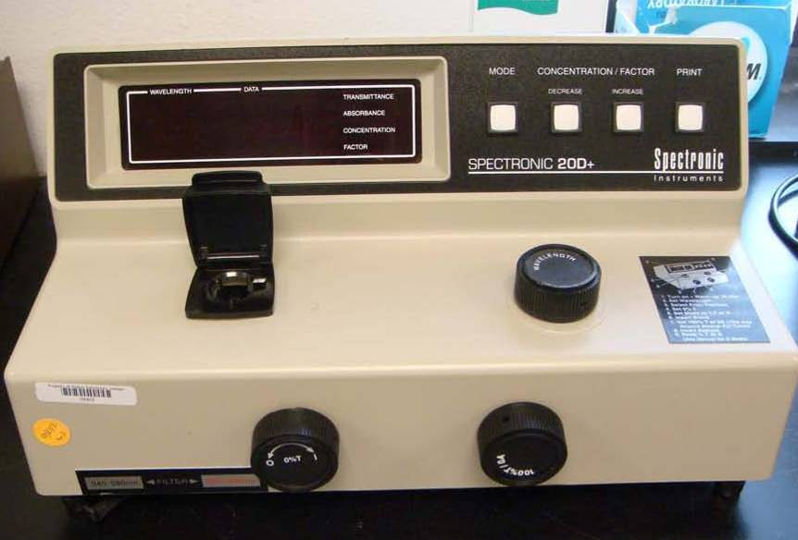

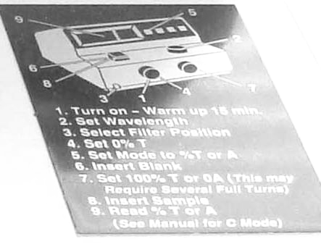
Steps 1—5 require chamber to be empty and closed. Step’s numbers refer to illustration of machine.
- clockwise turns on, counterclockwise turns off
- every time this setting is changed, machine must be re-zeroed
- often overlooked
- switch 5 toggles among various functions, verify transmittance
- set the mode you plan to use—usually absorbance
- understand what a blank is—verify that you are using cuvettes, not test tubes
- set according to function you plan to use (usually A)—NOT knob 4
- hash mark forward, no smudges, bottom third of cuvette all that needs to be filled, CLOSE CHAMBER LID
- readings should not be taken during the first 3 seconds while machine is settling on reading; as soon as reading is taken, remove sample and close chamber lid.

Appendix 2 Using our Digital Cameras

Instructions will be provided in lab.

Appendix 3 Using Mechanical Stages for Measurements

Think of a microscope’s stage as a Cartesian plane with an x-axis and a y-axis. Mechanical stages generally have markings on each axis that are millimeter marks and a Vernier scale that allows for measurements to tenths (or better) of a millimeter. (See Appendix 7 for reading Vernier scales.)
Thus, any point of reference (like tip of pointer), or series of points, can be assigned x,y co-ordinates that are real values in millimeters. Student can make a sketch of a structure, determine co-ordinates of critical points, and then use geometry to determine distances between points.

For example, if two points on this structure were found to have the co-ordinates indicated (and their units are millimeters),

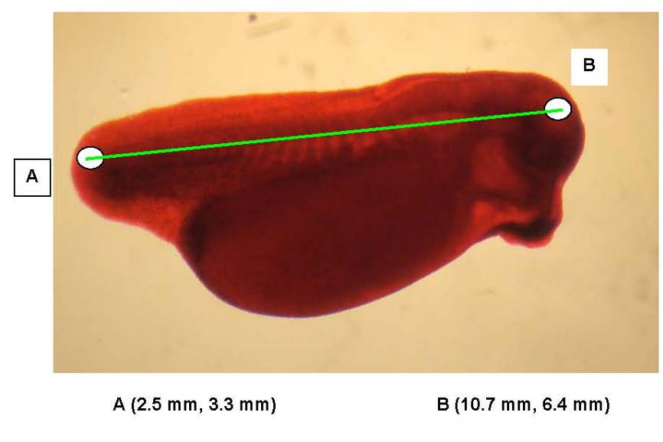

then the distance between them (AB) can be calculated thus:

consider a point C with these co-ordinates:

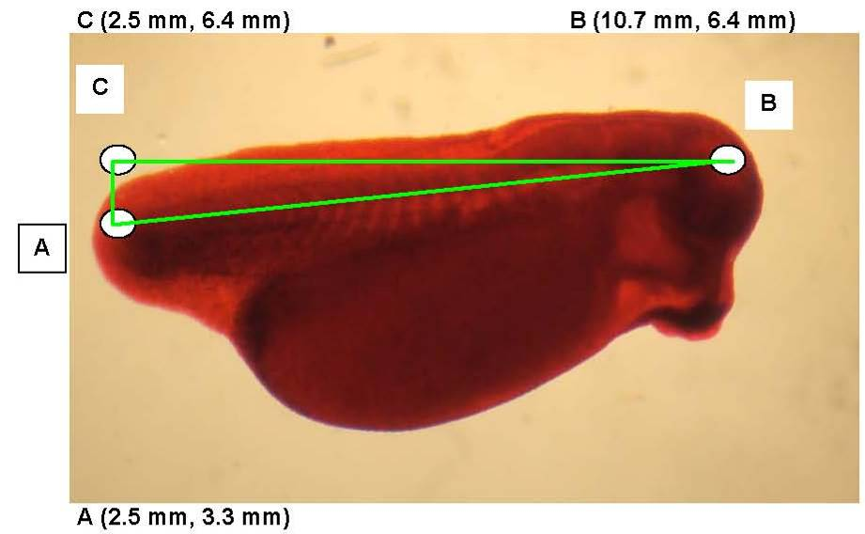

Then, AC = 6.4mm – 3.3mm = 3.1mm and CB = 10.7mm – 2.5mm = 8.2mm

Now, AC² + CB² = AB²
(3.1mm)² +(8.2mm)² = AB²
AB = 8.8mm

Co-ordinates for a point also can be used to return a slide to a previously notated location (if slide’s previous orientation can be re-established).

Appendix 4 Illustrating Biological Material

Biologists make frequent use of both sketches and photographs. In this course you should develop competence at both.

Sketches have the following advantages: They show features that photos do not show—for example, structures’ three dimensional features revealed by repeatedly using fine focus, or subtle differences in color. They can reflect examination of multiple individuals and thus be a sort of composite. They force biologists to look carefully at material, deciding what is important and what is trivial-- thus they document what the biologist perceives at the time of the observation.

Photographs have the following advantages: They are quickly and easily made. They accurately portray shapes, sizes and positions of photographable structures (although only in two dimensions). They record information that is present in the view but not considered important at the time of photo.

All illustrations in this course must include all the following information: identity of material as best it is known, source of material, date illustration was made, person responsible for making illustration, indication of size of material and conditions under which it was viewed.

Sketches are usually made in pencil and are the one place in laboratory records where erasures are not viewed as attempts to hide information. General appearance of sketches is improved if they are enclosed in a circle (for material viewed through a microscope) or a rectangle (for material viewed with naked eye or simple magnifying glass). Leader lines for labels should be at ninety or 45-degree angles and labels should be outside illustration and square with page.

Here is a highly recommended discussion of an unfortunate side of biological illustrations: http://www.nature.com/ncb/journal/v8/n2/full/ncb0206-101.html.

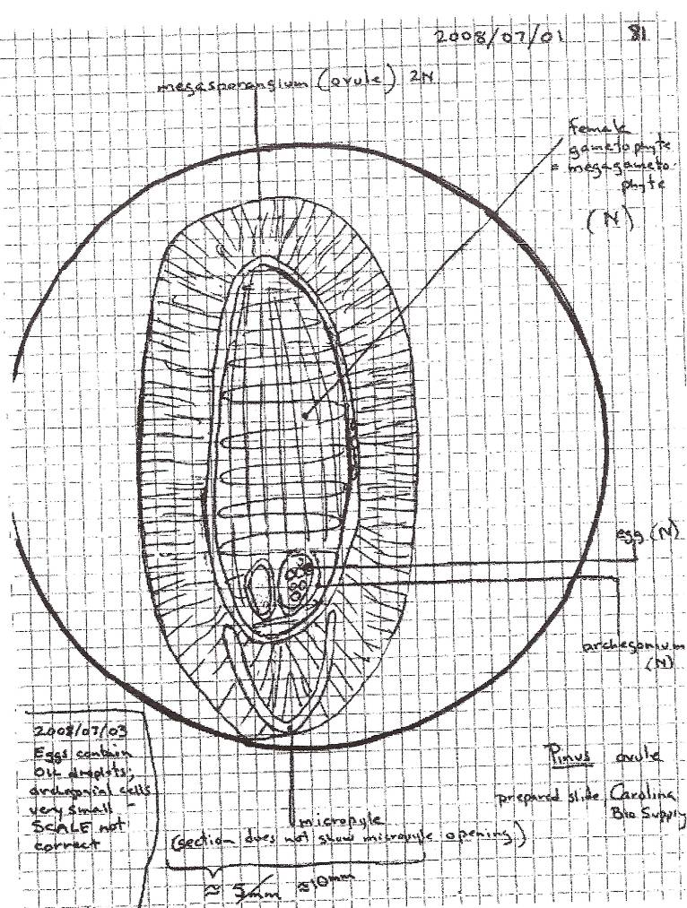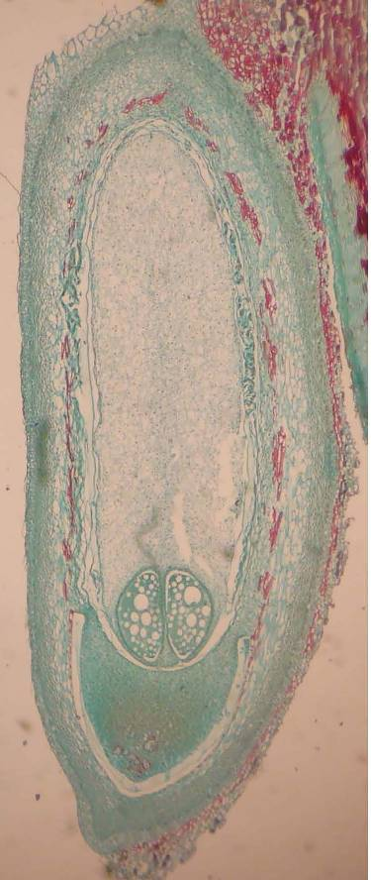

Here is an example of a mediocre sketch and a mediocre photograph of the same material. Sketches reveal what a biologist deems important at the time of drawing (notice red-stained structures are ignored in sketch) and include interpretations of material (note indications of haploid and diploid and reference to missing structure). Photos, on the other hand, show everything equally—crucial cells are equal to dust on the slide as far as a photo is concerned.

Drawings and photographs are data, not works in progress. Changes made later (label change, inversion of photo, etc) should be treated as corrections to data—as you would treat a correction in a table of quantitative data.

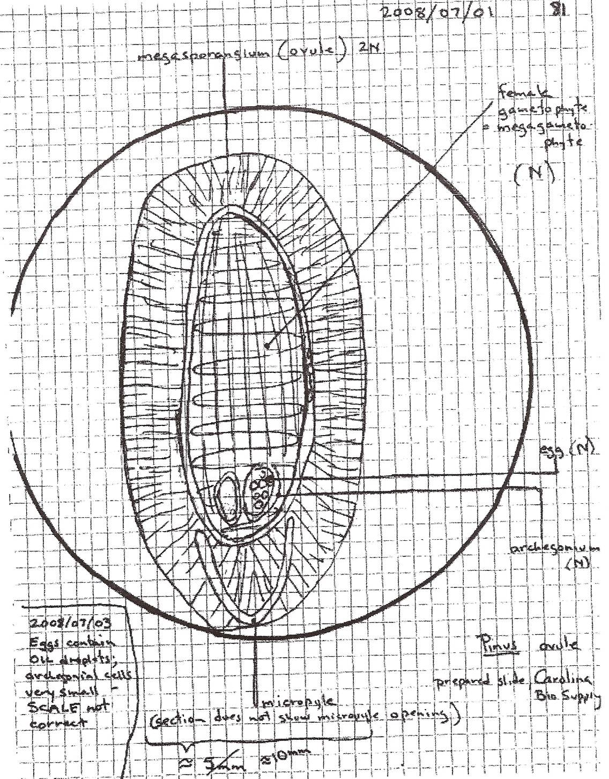

Note here that changes have been made and notated in lower left corner.

Carefully prepared biological drawings (as for publications) often contain large amounts of implied information. They illustrate the way things are “supposed” to look—and thus the way we are “supposed” to perceive them; they often imply relationships among juxtaposed drawings; they often summarize, in visual terms, theoretical predispositions of the artist. This famous illustration by Ernst Haeckel shows some hard-to-see bones as they are supposed to look and implies homology among them.

(Haeckel is famous for contributing to our notion of biological homology. Students might be interested in investigating “Haeckel’s Law”. One site for it: http://www.bookrags.com/research/haeckels-law-of-recapitulation-ansc-03/)

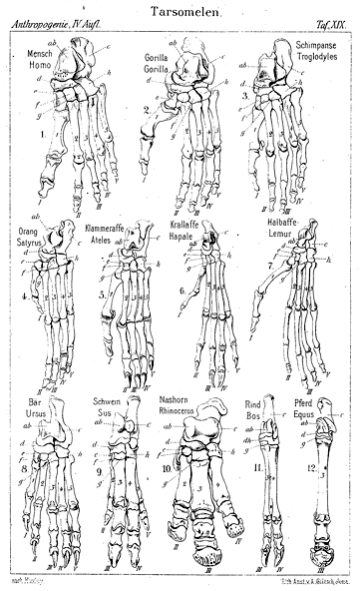
Appendix 5 Maintaining Laboratory Notebooks and Related Records

Doing science, like performing art, is often a self-conscious activity drawing on personal discipline and cultivated practice. Consciously “doing science” requires an important habitual discipline of creating records. This habit usually must be learned (rarely does it come naturally), but scientists value it greatly; it is a large component of our intellectual strength and one of civilization’s greatest benefits.

Our records include, foremost, our observations—“facts” that are not much subject to argument. But our records also include a sort of window on our thoughts—calculations and predictions and labels—that often are subject to reconsideration. All these things are recorded in expectation that they will be examined again in the future, at a time when the immediacy of the present is forgotten or unknown.

How much information should be recorded? Well certainly one should record everything that seems pertinent, but one never knows what seemingly trivial fact will be important in future considerations. While filtering, it might seem completely adequate to say “solution was filtered” but some day it might be useful to know what brand of filter paper was used. When scientists are repeatedly using equipment, microscopes for example, they should record equipment particulars in a separate place in their notebooks (near front or near back).

Biologists have long established practices of “vouchers”—actual specimens of living things—that are preserved as records. These can be pressed and dried plants, frozen samples of blood, pelts of animals, etc. This practice (dating from at least the 18th century) has served us well especially now that protein and DNA analysis can add new dimensions to our observations. As much as is practical, students should retain actual samples of their studied organisms. Obvious exceptions exist: items that are likely to decay and stink, items that are large, items that are hazardous, etc.

Our current age of electronic records and communication gives scientists new opportunities for collection, manipulation, dispersal and examination of records. In this course, students are expected to utilize both traditional written-on-paper records and electronic ones.

Appendix 6: Using “Prepared” Slides

Take one slide at a time; they must be shared and we don’t have one for each student. Share these slides.

Slides are not equally good. Have some idea about what you need to see before grabbing the first available slide; read the label on the slide (not just the label on the box); boxes often have several different subjects housed inside; often slides are filed in a wrong box. Some companies produce consistently better slides than others. With your illustration, name the company that produced the slide. Generally you should seek slides that show typical features of your subject. It usually is a waste of time to concentrate on aspects of a slide that are accidents of its preparation (artifacts, we call them) or that are not illustrating the purpose of the slide.

Take care to replace slides in their correct box when you finish. Never leave slides on the microscope.

Slides get very dirty. Wipe with lens paper or chem wipe.

Here are some standard abbreviations:
cs = cross section
ls = longitudinal (long) section
wm = whole mount

Preparation of “prepared” slides can be quite complex. Often materials have been fixed, dehydrated, embedded, sectioned, stained, and mounted.

Fixation of tissue is rapid killing and preserving against change. Fixatives are often extremely hazardous and are among the greatest hazards faced by beginning laboratory workers.

Dehydration of tissue is gradual replacement of water in tissue by alcohol—this is needed in order to accomplish the next typical step.

Embedding of tissue is replacement of alcohol (which replaced water) with paraffin (or substitute) which, when hardened, will allow for very thin slicing or sectioning.

Sectioning of tissue is cutting into suitable thin slices (thin enough to transmit light). It usually involves a specialized machine called a microtome.

Staining of tissue usually involves adding coloring agents with some specificity for components of the tissue. Sometimes multiple stains are employed. Almost all color in prepared slides results from these stains—prior processing removes most natural color.

Mounting of sections involves careful placement of sections on slides and “gluing” cover slips.

Appendix 7: Reading a Vernier Scale

(see also http://physicspmb.ukzn.ac.za/OnlineExercises/IntroVernier/intro2.html )
Main scale--here reading between 6.2 and 6.3, but closer to 6.2.

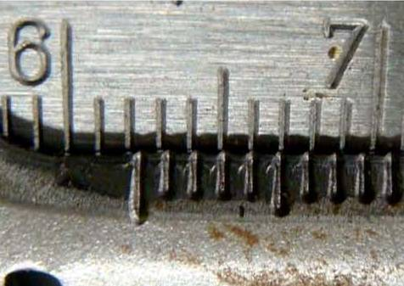

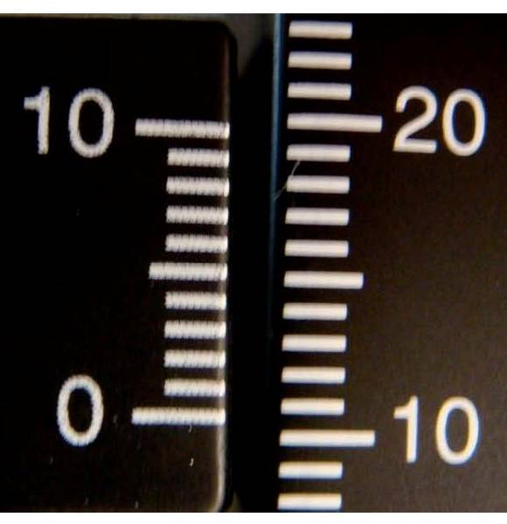
Main scale--here reading between 10 and 11, about halfway between them.
Vernier scale--here its 6 mark is most closely aligned with a mark on the main scale. This scale is reading 10.6 units.

Appendix 8: Constructing Graphical Displays of Data

Students should already be aware that numerical data often are presented graphically. They should cultivate skills at graphic presentation (especially using excel) but they should also develop discernment regarding appropriate and inappropriate graphic display.

Graph Example 1: Data (these are not real data) presented in a table—at almost every hour, on the hour, the number of birds at a bird feeder was recorded. A few hours were missed.

Hour of Day | Number of birds at Station
1 | 0
2 | 0
3 | No count made
4 | No count made
5 | 0
6 | 3
7 | 6
8 | 11
9 | 21
10 | 1
11 | 1
12 | 0
13 | 0
14 | 2
15 | 0
16 | 0
17 | 0
18 | 3
19 | 5
20 | 4
21 | 1
22 | 0
23 | 0
24 | 0

A data table is almost always a good first presentation of data. It is the starting point for almost all other graphic presentations. Sometimes it is enough.

Graph Example 2: Same (fake) data presented in a simple scatter plot—a scatter plot usually contains no information other than that in its table, but may suggest patterns.

Scales must, of course be appropriate to the subject and regular in their intervals. ( For example, here we have “number of birds” not “log number of birds” and “Hour of Day” not “Year of Century”; also every marked interval on the y-axis is 5 birds and every marked interval on the x-axis is 2 hours.)

Scientific data often have a distinct independent (x) variable and a distinct dependent (y) variable. If time is one of the axes, it usually is the independent variable.

A good graph title says something other than re-stating the axes. Axes must always be labeled and usually have units indicated.

A scatter plot is almost always a good second presentation of data.

Graph Example 3: Same (fake) Data presented in an appropriate bar graph

Bar graphs contain no more information than scatter plots and are subject to the same requirements.

Graph Example 4: Same (fake) data presented in an inappropriate bar graph

This graph is an example of a practice that students should AVOID. It is displaying three dimensions of “data” when only two exist. That third dimension (easily added by graph drawing programs) should be used only if there is a third dimension of data to show—for example if temperature had been recorded at each hour, we might have an interesting and valid third dimension to graph. But we don’t; this “fluff” is distasteful and actually impedes good interpretation of data.

Graph Example 5: Same (fake) data with an inappropriate line drawn

Inserting a line into a set of data points should be done thoughtfully. To insert a line implies continuity of variables—here it implies that at hour 7.25, there were (or could have been) 11.3 birds present. This is not reasonable since “number of birds” is a discrete variable—it only exists in whole numbers. (Time, by contrast is a continuous variable—there is such a thing as hour 7.25.)

Furthermore, it is not reasonable to expect this relationship to be linear, even though parts of it may be extremely linear (linear regression can be used to determine what line most nearly is described by a set of points).

Some biological relationships are regular, but not linear. For example, this data set suggests (but does not directly address) a hypothesis that this feeding station experiences two episodes of feeding per day.

Graph Example 6: Same (fake) data with many inappropriate lines drawn

This graph has the same problems as the previous, except that there are several lines instead of only one.

Appendix 9: Using “Blackboard”

BIOL 1407 students at Austin Community College are required to utilize “Blackboard” to access most materials for this course.

Students must establish their electronic identification with ACC. This is called an “ACCeID”

From ACC’s homepage (http://www.austincc.edu/) go to lower right corner and select “Blackboard Login”.

Select student guide and login. Explore and see how much you can figure out.

Blackboard is complex and only a few of its features will be utilized in BIOL 1407, so don’t try to comprehend it all at once. Your familiarity will increase with usage.

Appendix 10: Interpreting Absorbance Spectra

An absorbance spectrum is a pattern, usually presented as a graph that shows a compound’s relative absorbance of various wavelengths of light. This pattern is almost never a simple geometric curve or line, but rather a series of “peaks and valleys”. Wavelengths that coincide with peaks and valleys are unique for every compound. Height of peak is proportional to concentration of compound.

absorbance
Wavelength (nm)
Absorbance Spectrum Compound A

absorbance
Wavelength (nm)
Absorbance Spectrum Compound B
absorbance
Wavelength (nm)
Absorbance Spectrum Compound A at lower concentration than previous graph

Appendix 11: Using Oil Immersion Lenses

Instructors often dread students’ use of oil immersion lenses because, almost always, messes are made and ordinary lenses become filthy. However, to push a light microscope to its limits of magnification and resolution, it is necessary to use “oil immersion”. The technique is essential for sufficiently viewing most prokaryotes.

A slide (with a cover slip, of course) is brought into focus and position using ordinary dry technique and then carried to its highest non-oil-immersion magnification. Then, without changing the slide’s location on the stage, the stage is moved away from the lens (use focus knob). Then, the ordinary objective lens in place is rotated away, a single drop of optical oil is placed on the cover slip, and the oil immersion lens is rotated into position so that it contacts the oil. Now, all focusing must keep the lens within the oil drop so that light does not have an air/glass interface between specimen and objective lens.

Slide
Cover-slip
Oil drop
Oil
immersion
lens

THE MESS TO AVOID: students forget they are using special technique and move their slide around on the stage, then switch to lower magnification (image is not sharp) and then move to still lower magnification. Now oil is all over the slide and worse, on several objective lenses. Even a conscientious student trying to clean up all this mess cannot get the lenses clean and the microscope now is “messed up” until a repairperson comes.

Always clean oil immersion lens and slide immediately after use.

Appendix 12: Measuring Area of an Irregular Shape

Biologists frequently need to know an irregular shape’s area. Some variation of the following method often will suffice.

If the object is sufficiently flat, the object or its photograph or a tracing of its outline, is placed under a transparent grid (often graph paper). The number of squares within the outline is then counted or, better, the number of line intersections is counted. This provides a direct measurement of the number of grid units² that comprise the area of the image. If object is a photograph, grid units² are then converted to “real world” units²; thus, the real world area of the object is measured.

Smaller spaces on grid result in more accurate measurements of area.

Example: this shape on the left is placed under a grid and the number of intersections counted (for an intersection that falls on the line, count it as a half). In this example, the area of the shape is 209 square grid units.

If we have determined that, in this situation: 9 linear grid units = 25 mm, then (9 linear grid units) ² = (25 mm) ² or 81 grid units² = 625 mm²

The real world area of our shape is: 209 grid unit² x (625 mm² / 81 grid units²) = 1613 mm²

(Software now exists that does this automatically, if images are digital.)

