CHAPTER 7

Laboratory Experiments

7.1 Introduction
This chapter contains several useful laboratory experiments for an instrumental methods of analysis class. These start with a statistics assignment and then go on to more complicated lab experiments. Sample student results are provided for most experiments.

7.2 Computer Laboratory I: Linear Least Squares Analysis
Computer Laboratory II: Student’s t test
Equipment needed: A lab-top computer equipped with Excel®
A basic knowledge of spreadsheets

Purpose of this Exercise:
One of the first lessons that you need to learn in Instrumental Analysis is that few, if any, instruments report direct measurement of concentration or activity without calibration. Even our balances need periodic calibration. More complicated instruments need even more involved calibration. Instruments respond to calibration standards in either a linear or exponential manner, and exponential responses can easily be converted to a linear plot by the log or natural log transformation. The goals of the first computer exercise is to create a linear least squares (LLS) spreadsheet for analyzing calibration data and learn to interpret the results of your spreadsheet. The goal of the second computer exercise is to create a spreadsheet for conducting the student’s t test for (1) comparing your analysis results to a known reference standard, and (2) comparing two group’s results to each other. The student’s t test allows you to tell if the results are within an acceptable range and if the results are acceptable.

Programming Hints:
First, here are a few hints on using Microsoft Excel®:
-calculations must start with a “=”
-the “$” locks a cell address, you can lock rows, columns, or both
-mathematical symbols are as you expect except “^” is used to raise a
number to a power
-text is normally entered as text, but sometimes you may have to start the
line with a single quote symbol, ‘

Introduction:
Linear Least Squares Equations:
The first step in analyzing unknown samples is to have something to reference the instrument signal to (instrument do not directly read concentration). To do this we create a standard curve (line) relating signal response to concentration.

All of our calibration curves will be some form of linear relationship (line) of the form y = mx + b. Sensitivity refers to the equation

S = mc + S
where S is the signal (abs, pk ht) response,
m is the slope of the straight line,
c is the concentration of the analyte, and
S_{blank} is the instrumental signal (abs, etc.) for the blank.

This is the calibration equation for a plot of S on the y-axis and C on the x-axis. The slope is m and the y-intercept is S_{blank}. The detection limit will be Sm = S_{blank} + kstandard deviation _{blank} (where k = 3).

We will usually collect a set of data correlating S to c. Examples of S include light absorbance in spectroscopy,
peak height in chromatography, or
peak area in chromatography.

We will plot our data set on linear graph paper and develop an equation for the line connecting the data points. We will define the difference between the point on the line and the measured data point as the residual (in the x and y direction).

For calculation purposes we will use the following equations (S’s are sum of squared error or residuals)
$\begin{aligned}S_{\text{xx}}=\sum{(x_{i}\text{ - }\overline{x})^{2}=\sum{(x_{i^{2}})}}\text{ -}\frac{{\left(\sum{x_{i}}\right)}^{2}}{N} \\ S_{\text{yy}}=\sum{(y_{i}\text{ - }\overline{y})^{2}=}\sum{(y_{i^{2}})}\text{ - }\frac{{\left(\sum{y_{i}}\right)}^{2}}{N} \\ S_{\text{xy}}=\sum{(x_{i}\text{ - }\overline{x})(y_{i}\text{ - }\overline{y})=}\sum{x_{i}y_{i}\text{ - }\frac{\sum{x_{i}}\sum{y_{i}}}{N}}\end{aligned}$

where xi and yi are individual observations, N is the number of data pairs, and x-bar and y-bar are the average values of the observations. Six useful quantities can be computed from these.

The slope of the line (m) is m = Sxy/Sxx

The y-intercept (b) is b = y-bar - (m) (x-bar)

The standard deviation sy of the residuals, which is given by
$s_{y}=\sqrt{\frac{S_{\text{yy}}{\text{ - m}}^{2}S_{\text{xx}}}{\text{N-2}}}$

The standard deviation of the slope sm:
$s_{m}={\text{ s}}_{y}\text{ / }\sqrt{S_{\text{xx}}}$

The standard deviation sb of the intercept:

$s_{b}={\text{ s}}_{y}\sqrt{\frac{\sum{(x_{i^{2}}})}{N\sum{(x_{i^{2}})\text{ - }{\left(\sum{x_{i}}\right)}^{2}}}}={\text{ s}}_{y}\sqrt{\frac{1}{\text{N - }\frac{{\left(\sum{x_{i}}\right)}^{2}}{\sum{(x_{i^{2}})}}}}$

$s_{c}=\frac{s_{y}}{m}\sqrt{\frac{1}{L}+\frac{1}{N}+\frac{({\bar{y}}_{c}\text{ - }\overline{y})^{2}}{m^{2}{\text{ S}}_{\text{xx}}}}$The standard deviation s_{c} for analytical results obtained with the calibration curve:

where y_{c}-bar is the mean signal value for the unknown sample, L is the number of times the sample is analyzed, N is the number of standards in your calibration curve, and y-bar is the mean signal value of the y calibration observations (from standards). So, you will have a reported value of plus or minus a value.

It is important to note what s_{c} refers to—it is the error of your sample concentration results from the linear least squares analysis. Since the equation for sc (above) does not account for any error or deviation in your sample replicates (due to either sample preparation error such as pipeting or concentration variations in your sampling technique), s_{c} does not account for all sources of error in precision. To account for these latter errors you will need to make a standard deviation calculation on your sample replicates.
Most of your calculators have an r or r² key and you probably know that the closer this value is to 1.00 the better. Where does this number comes from
$\text{r }=\frac{\sum{x_{i}y_{i}}}{\sqrt{\sum{(x_{i^{2}}}) \sum{(y_{i^{2}})}}}$

r (and r²) are called the coefficient of regression or regression coefficient.

Student’s t Test Equations

After you obtain a mean value for a sample, you will want to know if this is in an acceptable range of the true value, or you may want to compare mean values obtained from two different techniques. We can do this with a statistical technique called the student’s t test. To perform this test, we simply rearrange the equation for the confidence limits to
$\overline{x}\text{ - }μ=±\frac{\text{t s}\text{.}d\text{.}}{\sqrt{N}}$

where x-bar is the mean of your measurements,
❍ is the known or true value of the sample,
t is the value from the t table,
s.d. is the standard deviation, and
N is the number of replicates that you analyzed.

Basically, we are looking at the acceptable difference between the measured value and the true value. The basis for comparison is dependent on a t value, the standard deviation, and the number of observations. “t” values are taken from tables such as the one given out in your quantitative analysis or instrumental analysis textbook and you must pick a confidence interval and the degrees of freedom (this will be N-1 for this test). If the experimental value of (x-) is larger than the value of (x-) calculated from the equation above, the presence of bias in the method is suggested. If, on the other hand, the value calculated by the equation is larger, no bias has been demonstrated.

A more useful, but difficult procedure can be performed to compare the mean results from two experiments or techniques. This uses the following equation
${\overline{x}}_{1}\text{ - }{\overline{x}}_{2}=±\frac{\text{t s}\text{.}d{\text{.}}_{\text{pooled}}}{\sqrt{\frac{n_{1}n_{2}}{n_{1}+{\text{ n}}_{2}}}}$
$s_{\text{pooled}}=\sqrt{\frac{s_{1}^{2}(n_{1}\text{-1})+{\text{ s}}_{2}^{2}(n_{2}\text{-1})}{n_{1}+{\text{ n}}_{2}\text{ -2}}}$

where s1 and s2 are the respective standard deviation of each mean, and n1 and n2 are the number of observations in each mean.

In this case the degrees of freedom in the table “t” value will be (N-2) (2 because you are using two s-squared values). As in the procedure above, if the experimental (observed) value of (x1-x2) is larger than the value of (x1-x2) calculated from the equation above, there is a basis for saying that the two techniques are different. If, on the other hand, the value calculated by the equation is larger, no basis is present for saying that the two techniques are different. (i.e. the value from the equation gives your tolerance (or level of acceptable error). Also, note that by using the 95% CI, you will be right 95 times out of 100 and wrong 5 times out of 100.

Assignment:
Your task is to create a spreadsheet that looks identical to the ones available from this chapter’s web page. During the first laboratory period you will create a linear least squares analysis sheet. For the second laboratory period you will create a spreadsheet for conducting a student’s t test. The cells contains bold numbers are the only numbers that should be entered when you actually use the spreadsheet for calibrating an instrument. All other cells should contain equations that will not be changed (and can be locked to insure that these cells do not change).

What do you turn in?
A one-page print out (print to fit on one page) of each spreadsheet.
Before you turn in your spreadsheets, change the format of all column data so that they only show 3 or 4 significant figures (which ever is correct).
Explain your LLS analysis and student’s t test results (approximately 1 page each, typed).

Here are some things to include in your write-up.
Give: the equation of the line,
the signal to noise ratios for your analysis, and
the minimum detection limit.
Was bias indicated in your analysis of the unknown (the 5 ppm sample)
and the true value?
Were the results from the two groups comparable?
How do the numbers compare to the results from your calculator?
What shortcomings does your calculator have (if any)?
The complete spreadsheet is available from this chapter’s web page as a downloadable file.

7.3 Solutions, Weights, and Lab Technique

OBJECTIVES: Develop and refine student’s calculation and laboratory skills
Introduce students to analytical equipment (and see what you
learned in Quantitative Methods of Analysis)

The scientific method requires the collection of experimental data and the data must be collected in a manner that insures precision and accuracy. No matter what field of science that you work in, you will eventually have to make solutions of specified concentrations. There are two main goals of this lab exercise: (1) to test your ability to determine how to make a solution of specified concentration, and (2) to test your accuracy and precision in making these solutions. You will complete this experiment using gravimetric and volumetric techniques.

EXPERIMENTAL / SOLUTIONS NEEDED:
An FAAS equipped with a Ca lamp
Each pair of students will be supplied with:
1 or 2, 5, 10, 25 mL Class A pipets,
25, 50, 100, 250, and 500 mL Class A volumetric flasks,
99.6 % pure CaCO₃ (CAS number 471-34-1) (dried at 104 C overnight),
1% by volume nitric acid for dilution purposes,
and your knowledge of general chemistry and quant lab.
NOTE that you may need to use a piece of glassware more than once.
Also NOTE that the fewer dilutions you make, the more precise your solutions will be.

Weighing and Dilution Skills

This lab will test your knowledge of converting from grams to molar units, weighing skills, and dilution skills. The latter two skills will require a high degree of accuracy and precision at each step in the procedure. You should have obtained each of these skills in the pipetting labs earlier in Quantitative Analysis. Your assignment is to make up a 2.18 x10⁻⁴ M Ca²⁺ solution (depending on the sensitivity of your instrument) from known purity CaCO₃ salt (This changes every year, so ask me what the purity of our bottle is this year before conducting calculations). You must figure out how to accurately do this given the available equipment (listed above). As you make decisions on how to make this solution (how much to weigh out and what dilutions to make), consider the accuracy and precision of each step. Your ability to complete this task will be tested using a flame atomic absorbance spectrophotometer (FAAS) and your accuracy and precision will be reflected in your lab grade!

You will immediately note that you cannot accurately weigh out the small amount that you need to make the solution. So, you must first make a more concentrated solution and then dilute it. The question that you must figure out is “what is the concentration of the initial solution that you must make?”, and then, “how should you dilute it to achieve the desired concentration (2.18 x10⁻⁴ M Ca²⁺) (depending on the sensitivity of your instrument)?”.

Strict Guidelines for making your solutions:
(1) Carefully clean all glassware to remove any Ca²⁺⁻ that may be present (1%
Nitric acid works well for this).
(2) Weigh at least 0.100 grams on the balance in order to reduce your error from weighing. Note weight to three significant figures.
(3) Sonicate your first aqueous solution to ensure the dissolving of your salt.
- Your final volume should be at least 10 mL, but 100 mL are better. You may also want to conserve the volume of distilled water used.
- (5) All solutions must be made in 1% HNO₃. You do not have to make the 1%
- very accurate. (HNO₃ is needed to dissolve the salt in the first solution and
- keep it dissolved in your dilution.)
- (6) Bring a FULL volumetric flask to the instrument room for measurement. MIX WELL.

“The order in which you are to do things”

Step 1: First you will each prepare a procedure for making your dilution. You will do this using the guidelines given above and without the help of anyone else. Once you have come up with a plan you will present it to your instructor. If they concur you can proceed to step 2. (This lab is worth 25 points. 2.55 points will be deducted for each incorrect calculation or dilution, i.e. check your guidelines!)
Step 2: Make your solution and bring it to the FAAS.
Step 3: If your solution is incorrect, remake your solutions paying particular attention to your lab technique. If your solution is the correct concentration, clean up and you’re finished. 2.5 points will be deducted from your grade for each incorrect solution.

CLEARLY show all calculations for making of the solution in your lab notebook using the guidelines given in class.

-Work in pairs, each person will make at least one correct solution
-Dilute the stock to make your 2.18 x 10⁻⁴ M soln (depending on the sensitivity of your FAAS)
-Bring your data sheet to the AA with our samples

After you finish at the AA: What is your conc in ppm to three sign figs?

Results of this experiment have been published in Dunnivant, et al., The making of a solution: A simple but poorly understood concept in general chemistry, The Chemical Educator, Vol. 7(4), 2002.
Solutions Data Sheet; BRING THIS SHEET TO THE AA WITH YOUR SAMPLE

Name: ____________________________

Calculations: Attempt #1 _________
Attempt #2 _________
Attempt #3 _________

FAAS Results: Measurement #1 _________
Measurement #2 _________
Measurement #3 _________
Measurement #4 _________
Measurement #5 _________
Measurement #6 _________

Calc. conc. of Ca as mg/L to three sign figs = _______

7.4 The Determination of a Surrogate Toxic Metal (Ca) in a Simulated Hazardous Waste Sample (Carbonated Beverages)

This experiment uses a variety of FAAS methods in a multi-lab experience to analyze the concentration of Ca in a complex matrix. These experiments are published in Dunnivant, F.M. 2004. Environmental Laboratory Exercises for Instrumental Analysis and Environmental Chemistry, Chapter 14, Wiley InterScience, NY. Basically the experiment allows students to compare the result of two or more techniques and forces them to defend one result as the best procedure. The options of procedures are:
Procedure 1: Determination of Ca using FAAS and external standards
Procedure 2: Determination of Ca using FAAS, external standards, and a releasing agent
Procedure 3: Determination of Ca using FAAS, standard addition, and a releasing agent
Procedure 4: Determination of Ca using FAAS, standard addition, without a releasing agent
Procedure 5: Determination of Ca using the EDTA titration
Procedure 6: Determination of Ca using ion-specific electrodes

Several years of results are shown below.

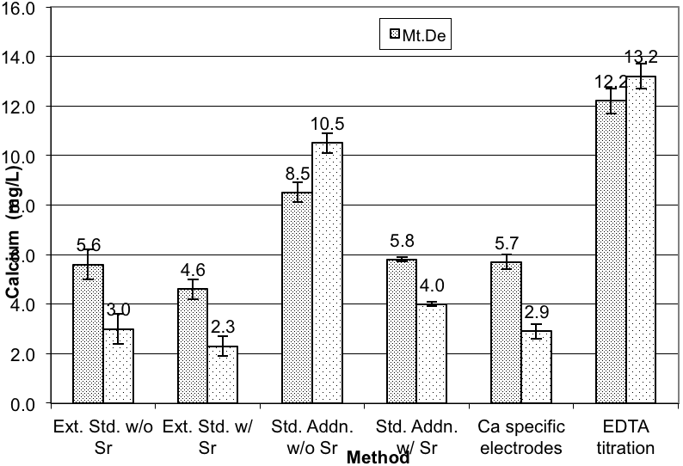

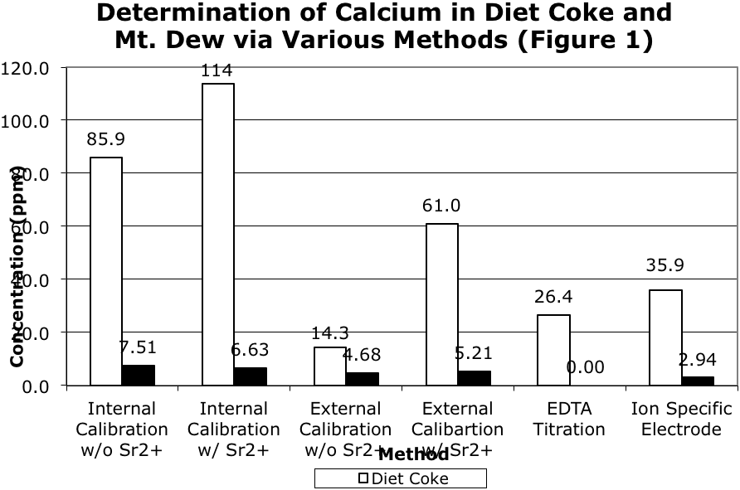
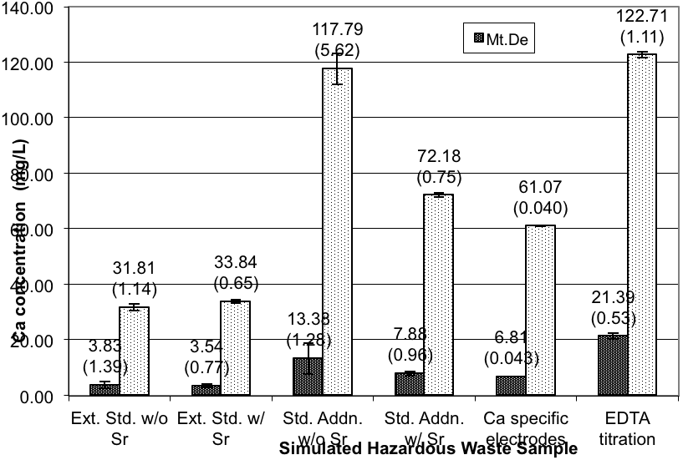

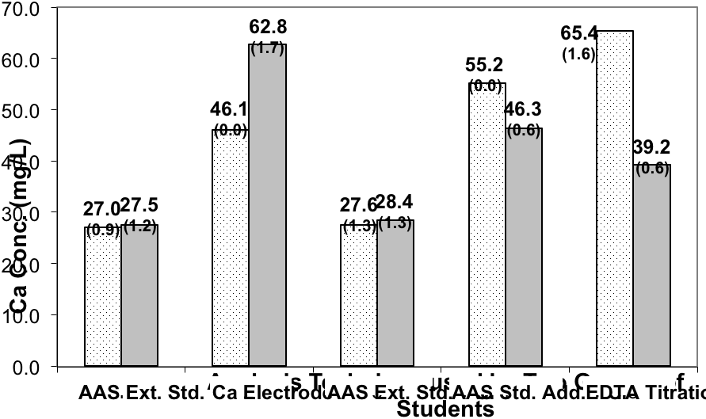

An example student “mock” peer-reviewed journal article is shown below.
Cover Letter:

October 22, 2015
Editorial Board
Journal of the American Chemical Society: Analytical Chemistry
Dear Editor:
Please find enclosed our manuscript, titled “Assessment of Techniques for Measuring Barium in Waste Samples” which we have submitted for consideration as a journal article in Analytical Chemistry. This study focuses on a comparison of three methods for measuring barium (Ba) concentration within standardized waste samples using a flame atomic absorption spectrometer (FAAS). These methods are external standard calibration, external standard with a strontium (Sr) releasing agent and standard addition. The toxicity of Ba and its impact upon the environment are the primary reasons for its role as the focal point of this study. Ba is used as a manufacturing ingredient in the production of fireworks, industrial dyes and a number of other products. Given these risks, it is vital to have an efficient method of measuring samples that could exceed the health limits established by health organizations like the EPA and WHO. The three aforementioned techniques were used to measure known concentrations of calcium (Ca), which is a Ba surrogate, within standardized samples. These techniques were compared using the following criteria: accuracy, precision, and time efficiency. Based on these criteria, the best method is established for analyzing a workload of 50+ samples per day.
Beyond the implications for Ba concentrations, this study provides valuable information about measuring metal concentrations within complex matrices. The toxicity of most metals when present in high concentrations requires an effective and efficient method of analysis. These methods also need to account for the complex matrices in which metals may be present. We confirm that this manuscript (3,558 words, 2 tables, 3 figures) and the abstract (174 words) have not been submitted to any other journals, nor have they been published previously. All of the authors have given their approval of the following documents and have agreed with its submission to Analytical Chemistry. We suggest Serife Tokalioglu*, John C. Latino#, S. B. Erdemoglu† and J. Zieba-Palus⁺ as reviewers of this article due to their expertise in the field of measuring heavy metals in complex matrices using absorbance spectroscopy.

We thank you for your time and look forward to your response.
Sincerely,
David Burtt Jacob O’Connor Ruth Thirkill
280 Boyer Ave 280 Boyer Ave 280 Boyer Ave
Walla Walla, WA Walla Walla, WA Walla Walla, WA
99362 99362 99362

Division of Labor:
-Cover = David
-Intro = David
-References = David
-Abstract = Ruth
-Methods = Ruth
-Results/Discussion = Jacob
-Conclusion = Ruth
-Figure/Tables = Ruth + Jacob

*Erciyes University, Department of Chemistry, Faculty of Arts and Sciences, TR-38039, Kayseri, Turkey
#Perkin Elmer Co., 761 Main Avenue, Norwalk, CT 06859-0324 USA
⁺Institute of Forensic Research, Westerplatte 9, 31-033 Cracow, Poland
† Department of Chemistry, Faculty of Science and Arts, Inonu University, Malatya, Turkey,

Abstract:
A statistical analysis of three techniques for the determination of barium (Ba) concentrations in industrial waste water by Flame Atomic Absorbance Spectrometry (FAAS) is presented. The techniques under investigation were external standard calibration, external standard calibration with a strontium (Sr) releasing agent and standard addition. Each technique was primarily assessed on its ability to consistently and precisely determine analyte concentration. Additional assessments were made based off of cost-benefit and time investment associated with each technique. External standard calibration with a releasing agent and standard addition were included as possible techniques to overcome the possibility of signal suppressing effects caused by a complex matrix. External standard calibration with a releasing agent was discovered to be more cost efficient than standard addition and gave better data than standard addition and external standard calibration. It is therefore suggested that external standard calibration with a releasing agent is the most promising candidate for high throughput analysis based on the fact that it gave more consistent and precise numbers for analyte recovery without an excessive time or cost requirement.

Introduction:
Trace metal contamination within the environment presents a serious issue to many cities around the world^{1, 2, 3}. These toxic elements can infiltrate the groundwater and subsequently affect potable water supplies as well as crops and agriculture. One particular group of interest is Ba compounds. A variety of products such as fireworks, electronics, industrial dyes and rat poison involve the use of Ba compounds^{1, 2, 4}. Barium sulfate can also be used in radiological procedures to test stomach and intestinal health^{4, 5}. However, like other metals, Ba is toxic to humans and metal resistant animals in high concentrations^{1, 2, 4, 6}. Factories that use Ba can put nearby communities and habitats at risk if they fail to follow the proper procedures for waste disposal. At concentrations above 100 ppm, these compounds must be labelled as hazardous waste and disposed of according to the EPA procedure D005^{7, 8}. To ensure the safety of these communities and environments, it is essential to have a standard protocol for an efficient and cost-effective measurement of Ba concentrations. The primary focus of this experiment is to compare methods of measuring Ba concentration and determine the most effective method. To test these methods, this procedure uses a round-robin sequence whereby standard waste samples are sent to five labs around the world. Due to international shipping laws, however, these samples do not contain Ba. Instead of measuring Ba, the procedures will measure calcium (Ca), another divalent element. Both elements are known to ionize when exposed to an air-acetylene flame, making them ideal for flame atomic absorbance spectroscopy (FAAS) ^{9, 10}. Since they have the same charge and similar properties, Ca can be used as a surrogate for Ba. The samples being measured, waste sample and rinse sample, contain 0.77 ppm Ca and 8.14 ppm Ca respectively.
These concentration values are significant because of the health risks they pose to humans. The health risks of Ba are dependent upon the solubility of the compound^{2, 3}. Compounds like barium nitrate and barium hydroxide are relatively soluble and can cause serious damage to humans^{2, 3}. Barium sulfate, on the other hand, is less soluble and is therefore less likely to cause damage^{2, 3}. According to the Environmental Protection Agency (EPA), the maximum amount of soluble Ba a human can consume is 2 mg/kg per day or 2 ppm per day¹. Consumption of Ba beyond this point can lead to adverse health effects including nausea, vomiting, diarrhea, and even death^{2, 3}. Similarly, the World Health Organization (WHO) established 0.7 mg/L as the safe limit for Ba within drinking water^{2, 3}. Given that samples waste and rinse sit above and below the health limits respectively, any method that can measure the waste samples will be able to determine if a water sample is hazardous.
These samples will often contain more than just Ba and water and therefore matrix effects are an important focus of this study. Matrix effects in inorganic solutions are often related to extra ligands that complex the analyte and create a false signal. These effects must be taken into account when assessing the techniques being tested, which include external standard calibration, external standard with a Sr releasing agent and standard addition on a FAAS. The external standard with Sr releasing agent and standard addition both specifically address matrix effects that would affect the signal of any divalent elements⁵. Sr works as a releasing agent for Ca because it shares the same divalent charge and its electrons are less tightly bound. By placing 1000 ppm Sr in the samples, any extra ligands like phosphorus will complex with the Sr, thus releasing the Ca to be measured by the FAAS. As such, these techniques are expected to give more accurate values than the external standard calibration. The FAAS was chosen based on its reputation for providing relatively cheap Ba analyses, even within complex matrices¹¹ such as lake water¹², orange juice¹³, motor oil¹⁴, human milk¹⁵ and Turkish herbs¹⁶. These analyses successfully reached the ppm range, which makes the FAAS suitable for this study^{17, 18}.
The overall aim of this study is to determine an efficient and cost-effective manner of measuring Ba concentrations within a variety of samples. The study will involve the use of the following three techniques on an FAAS: external standard calibration, external standard with a strontium nitrate releasing agent and standard addition. The releasing agent will contain 1000 ppm Sr, which is concentrated enough to significantly reduce the matrix effects of the solutions. These techniques will ultimately be assessed based on their cost in terms of time and money as well as the accuracy and precision of the data they produce.

Materials & Methods:
Instrumentation: A Flame Atomic Absorption Spectrometer (Perkin-Elmer, AAnalyst 400) with an air-acetylene flame was used in all three techniques. Absorbance was measured at 422.7nm. The source was a calcium hollow cathode lamp. Only 50 mL and 100 mL volumetric flasks were used for the calibration standards.
Reagents and Solutions: All chemicals used were of analytical grade. 1% (v/v) nitric acid in deionized water was used for all three techniques as a solvent. Calcium carbonate came from Sigma-Aldrich as a white powder with a purity of 99.6%. A 1000 ppm calcium solution was prepared by adding 1.2533g CaCO₃ to 1L of 1% nitric acid. This solution was then stored in a polyethylene bottle.
Standard solutions were prepared from the stored solution using appropriate dilutions in ~1% nitric acid. All chemicals used throughout experiment were: calcium carbonate (Baker Analyzed, 99.6% pure), and strontium nitrate (Mallinckrodt, ACS grade).
The simulated waste solutions were prepared to a set calcium concentration of 8.14 ppm for the process waste and 0.77 ppm for the rinse waste. Additionally, a 10,000 ppm strontium stock solution was also made in 1% nitric acid. These three solutions were prepared by an outside source¹⁹. To reduce the chance of contamination, all glassware was rinsed at least three times with 1% nitric acid.
Safety: Though the calcium carbonate is considered nontoxic, measures were taken to avoid any contact with the sample waste and rinse solutions. This was done because the techniques under analysis were investigated to determine their usefulness for potentially very toxic industrial waste solutions.
Method: For all techniques investigated, refer to the standard operating procedure¹⁹.
FAAS with External Standard Calibration: Measurements were taken with external standards of calcium solutions between 0.1 ppm and 10 ppm. 1% nitric acid was used as a blank for the instrument. Both the simulated waste and simulated rinse were measured five times and introduced to the instrument with no additional manipulation.
FAAS with External Standard Calibration and a Strontium Releasing Agent: Measurements were taken with external standard of calcium solutions between 0.1 ppm and 10 ppm. Each standard solution 1000 ppm Sr. 10 mL of strontium was added to 90 mL each of both the simulated waste and simulated rinse, resulting in a dilution of the sample to 90%. 1% nitric acid was used as a blank for the instrument.
Standard Addition: Standard solutions were prepared separately for the simulated rinse and waste solutions using standard addition. All standard were made to a uniform total volume and were prepared with a 50% dilution of the sample. Standards ranging from 0.01 ppm to 2 ppm were made with the rinse and standards ranging from 0.5 ppm to 15 ppm were made with the waste.

Results and Discussion
Each of the five labs in the investigation were given the waste and rinse samples, used the same standard operating procedures to evaluate the samples using three different methods, processed their data and then reported their final values as well as their raw data. In order to ensure the validity of the final reported data, our group performed its own analysis of the reported raw data and found large differences between the reported and calculated results in a few cases (Table 1). These differences are troubling as it indicated an important source of error that is arising between the groups’ analyses. In order to make sure calculation methods were consistent across datasets, we performed the final data analysis using our own calculations rather than the reported values.
Additionally, during analysis of the data, it was found that several groups had data points that were significantly different from the others, as determined by a Grubb’s test (n=4, significance level = 0.05). This likely indicates procedural error within some of the group’s methods. For example, given that Monaco’s waste concentrations were consistently close to double those of the other groups, it seems likely the Monaco lab incorrectly prepared its calibration standards for the waste analysis. These values that were found to be outliers were not included in the final results outlined in Table 2.
The first method investigated was the use of simple external standards, the results of which are displayed in Figure 1. This method was the least time-consuming as samples could easily be made by dilution from a stock solution. The simplicity of this method would at first seem to promise better results, as there were fewer opportunities for measurement error and uncertainty arising from glassware to confound the results. However, this method gave the worst precision and very poor accuracy. This likely is due to matrix effects within the standards. It is well-documented that calcium will bind to phosphate groups in the air-acetylene flame, resulting in inorganic salts that will not absorb at the monitored wavelength. This results in the underestimation of calcium concentrations. Interestingly, this explanation does not satisfactorily explain the deviation observed in the rinse sample, which was actually higher than the known value. This deviation could be due to procedural error between the groups, or perhaps arises from a different source. The phosphate explanation also accounts for the extremely poor precision of the method. As phosphate concentrations were not controlled between the standards and the samples, the amount of calcium binding to phosphate also varied, resulting in very poor precision. This severely limits the use of external standards as a method for calcium measurement, as a simple correction factor will not be useful unless phosphate concentrations are accounted for. This limitation will also likely extend to the measurement of barium concentrations, as barium is in the same group and will likely bind to phosphate in a similar manner.
The second method attempted to correct for the problems with simple external standards by including a SrNO₃ releasing agent, the results of which are shown in Figure 2. This method took advantage of the fact that strontium is in the same group as calcium and so will bind the phosphate groups. In fact, strontium will bind preferentially to these groups. As long as there is a relatively high level of strontium relative to phosphate, the strontium theoretically would outcompete the calcium, rendering the matrix effects negligible. This technique increased the time and complexity of the procedure and the calculations, resulting from the addition of the same amount of strontium to each standard and sample. A common error that seemed to occur in other groups’ calculations was forgetting to account for the dilution of their concentrations this creates. Additionally, if the sample already had a low concentration, the dilution could potentially result in the concentration falling below the detection limit. Nevertheless, these potential drawbacks were clearly outweighed by the benefit of the releasing agent, as the final measured concentrations were far more accurate and precise than those found using external standards. Even though the final value failed a student t test comparing it to the actual value, indicating the presence of bias, the high precision means that the technique can still be used as long as a correction factor is determined and applied.
The final method investigated was the use of standard addition with the inclusion of a releasing agent. Standard addition is theoretically one of the best methods for dealing with matrix effects because the standards contain the matrix of interest. Unfortunately, standard addition required more complex sample prep than external standards, which introduced new potential sources of error. Two sets of standards, one for the wash and one for the rinse, were required to account for the differences in the matrixes between the two samples. This made standard addition far more time-intensive and therefore expensive than the other two methods. This may be worthwhile if it is the only way to account for matrix effects, or if it resulted in a large increase in accuracy or precision. However the results of the analysis, shown in Figure 3, suggest that standard addition actually resulted in poorer accuracy, and only minor improvements in precision when compared to external standard calibration with a releasing agent. Standard addition also required a 50% dilution, which may have pushed the concentration of the standard below the WHO No Observed Adverse Effect limit is set at 0.7mg/L, given that the method detection limit of 0.49mg/L. Additionally, the dilution correction appeared to be forgotten in some of the group’s calculations just as the dilution correction in the strontium solution was. The increase in precision does mean that it would be a slightly better technique if a conversion factor is used and the detection limit is not exceeded. However, for the purposes of the company, the potential gains are modest and not worth the significant increase in time or manpower the method would require, especially for labs concerned with high-throughput analysis.

Conclusion:
Methods for analyzing complex matrix samples for Ba concentration are urgently needed. Our group assessed three techniques: external standard calibration, external standard calibration with a Sr releasing agent, and standard addition. These three methods were evaluated based on their accuracy, precision and reproducibility as well as time and financial cost. Despite its efficiency in terms of cost and time, calibration by external standards yielded results that had poor accuracy and precision. Although it was the most precise method, standard addition faced similar accuracy issues and took more time and money to perform. Calibration by external standards with a Sr releasing agent gave the best accuracy and precision, with only a little increase in time and financial cost. Additionally, this method provided results that were fairly consistent and reproducible. Therefore, it is our recommendation that labs analyzing upwards of 50 samples per day with complex matrices and unknown concentration of Ba adopt this technique as a standard operating procedure for the analysis of Ba in industrial wastewater. It is also suggested that corporations develop a standardized procedure to ensure that there is reproducibility across the statistical analysis performed by different labs. This technique is also applicable to the determination of other divalent metals. Future work will focus on other methods for addressing complex matrices such as using different instrumentation, novel releasing agents, and extending the methods to alternate analytes.

References:
- EPA: Basic Information About Barium in Drinking Water. http://water.epa.gov/drink/contaminants/basicinformation/barium.cfm (accessed on October 19, 2015).
- Fawell, J. K.; Mascarenhas, R. World Heal. Organ. 2004, 1–13.
- Menzie, C. A.; Southworth, B.; Stephenson, G.; Feisthauer, N. Hum. Ecol. Risk Assess. Int. J. 2008, 14, 974–991.
- ATSDR: Toxic Substances Portal – Barium. http://www.atsdr.cdc.gov/PHS/PHS.asp?id=325&tid=57 (accessed on October 19, 2015).
- USAPHC: Management Guidance for Barium Sulfate – Fact Sheet 37-008-1210. Accessed on October 23, 2015.
- Lira, V. F.; Santos, G. A. P.; Derycke, S.; Larrazabal, M. E. L.; Fonsêca-Genevois, V. G.; Moens, T. Mar. Environ. Res. 2011, 72 (4), 151–159.
- New Hampshire Department of Environmental Services: Frequently Asked Questions. http://des.nh.gov/organization/commissioner/p2au/pps/hs/pphfp/categories/faq.ht m (accessed on October 23, 2015).
- EHSO: Hazardous Waste Fact Sheet – Toxicity Characteristic Leaching Procedure and Characteristic Hazardous Wastes. www.ehso.com/cssepa/TCLP%20fact%20sheet%20from%20EHSO.pdf (accessed on October 23, 2015).
- Dinnin, J. I. Anal. Chem. 1960, 32, 1475–1480.
- Chughtai, A. R.; Marshall, R.; Nancollas, G. H. J. Phys. Chem. 1968, 72, 208–211.
- Smeyers-verbeke, J.; Michotte, Y.; Winkel, P. Van Den; Massart, D. L. 1976, 48 (1), 125–130.
- Tokalioglu, S.; Kartal, S.; Elci, L. Anal. Sci. 2000, 16 (November), 1169–1174.
- McHard, J. a.; Foulk, S. J.; Nikdel, S.; Ullman, a. H.; Pollard, B. D.; Winefordner, J. D. Anal. Chem. 1979, 51 (11), 1613–1616.
- J.Zieba-Palus. Forensic Sci. Int. 1998, 91, 171–179.
- Pozzi, C. M. C.; Braga, C. P.; Vieira, J. C. S.; Cavecci, B.; Vitor de Queiroz, J.; de Souza Barbosa, H.; Arruda, M. A. Z.; Gozzo, F. C.; Padilha, P. D. M. Food Chem. 2015, 166 (JANUARY), 492–497.
- Başgel, S.; Erdemoğlu, S. B. Sci. Total Environ. 2006, 359 (1-3), 82–89.
- Latino, J. C.; Grosser, Z. a. At. Spectrosc. 1996, 17 (6), 215–217.
- Stetzenbach, K.; Amano, M. Groundwater. 1994, pp 976–9985.
- Dunnivant, F. M. Environmental laboratory exercises for instrumental analysis and environmental chemistry; Wiley-Interscience: Hoboken, N.J, 2004.

Acknowledgements:

We would like to thank Frank Dunnivant for his assistance and advice during the experiments, as well as Whitman College for providing the lab space and reagents used.

Figures:

 |  |  | Reported |  |  | Calculated
Technique |  | Group | Waste (ppm) | Rinse  (ppm) |  | Waste (ppm) | Rinse (ppm)
External |  | The Vatican | 4.2 ± 0.1 | 0.9 ± 0.1 |  | 4.2 ± 0.1 | 0.9 ± 0.1
Standards |  | Puerto Rico | 5.1 ±0.3 | 0.62 ± 0.08 |  | 5.1 ± 0.2 | 0.61 ± 0.2
 |  | Concentrate | 7.2 ± 0.2 | 1.1 ± 0.2 |  | 7.9 ± 0.2 | 1.1 ± 0.2
 |  | New Mexico | 4.7 ±0.2 | 0.8 ± 0.2 |  | 4.7 ± 0.2 | 0.8 ± 0.2
 |  | Monaco | 6.9 ± 0.6 | 1.46 ± 0.05 |  | 6.91 ± 0.09 | 1.50 ± 0.08*
External |  | The Vatican | 8.9 ± 0.6 | 0.86 ± 0.07 |  | 8.27 ± 0.09 | 0.86 ± 0.07
Standards |  | Puerto Rico | 7.81 ± 0.09 | 0.81 ± 0.02 |  | 8.66 ± 0.1 | 0.9 ± 0.1
with Strontium |  | Concentrate | 7.6 ± 0.1 | 0.69 ± 0.09 |  | 8.4 ± 0.1 | 0.79 ± 0.09
Releasing |  | New Mexico | 8.5 ± 0.1 | 0.71 ± 0.09 |  | 9.5 ± 0.1 | 0.79 ± 0.09
Agent |  | Monaco | 16.6 ± 0.3 | 1.5 ± 0.1 |  | 18.4 ± 0.2* | 16.9 ± 0.08*
Standard |  | The Vatican | 11.2 ± 0.6 | 1.08 ± 0.04 |  | 11.2 ± 0.6 | 1.08 ± 0.04
Addition |  | Puerto Rico | 11.8 ± 0.2 | 1.06 ± 0.05 |  | 11.8 ± 0.4 | 1.1 ± 0.1
 |  | Concentrate | 11.1 ± 0.6 | 0.99 ± 0.08 |  | 11.07 ± 0.4 | 0.98 ± 0.05*
 |  | New Mexico | 10.1 ± 0.7 | 1.06 ± 0.04 |  | 10.1 ± 0.2 | 1.06 ± 0.05
 |  | Monaco | 9.07 ± 0.01 | 1.119 ± 0.002 |  | 18.3 ± 0.2 | 1.119 ± 0.002

Table 1. Summary of reported data of each lab for each method and the results our lab calculated from the reported raw data. * indicates values identified as outliers by the Grubb’s test which were not use in the final calculations displayed in Table 2.

Technique | Waste (ppm)  Actual = 8.14 | Rinse (ppm)  Actual = 0.77
External Standards | 5 ± 1.6 | 0.9 ± 0.2
External Standards with Strontium Releasing Agent | 8.7 ± 0.5 | 0.84 ± 0.06
Standard Addition | 12.5 ± 0.2 | 1.08 ± 0.02

Table 2: Comparison of Calcium concentrations determined by each technique. These values were determined by taking the average and standard deviations of the values found by each group, with the exception of those that did not pass the Grubb’s test.
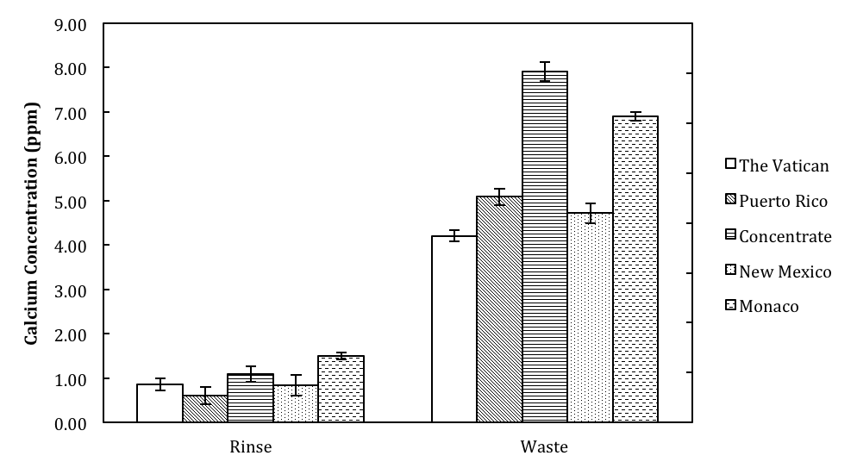
Figure 1. Calcium concentrations of samples as determined by FAAS using an external standard calibration method.

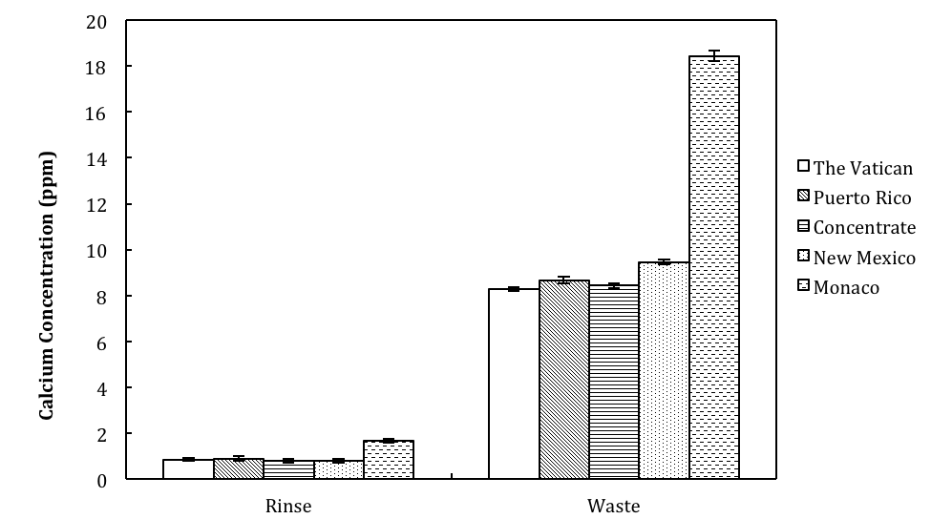
Figure 2. Calcium concentrations of samples as determined by FAAS using an external standard with a strontium releasing agent calibration method.

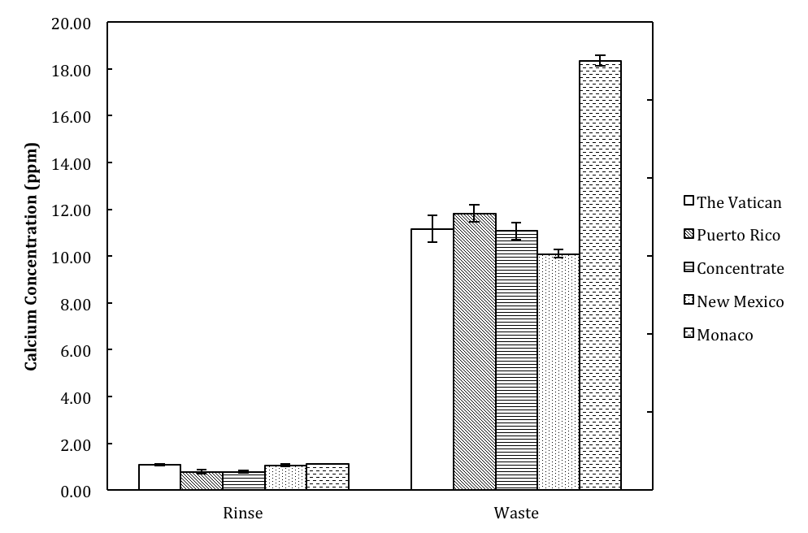
Figure 3. Calcium concentrations of samples as determined by FAAS using a standard addition and strontium releasing agent calibration method.

