89-850 Exercises – Network Calculus, DiffServ, IntServ and 802.11
Comment: I hope to provide solutions to most (but not these from [BT])
- All problems from chapter 4 of [KMK]
- Problems 8.4-8.12 of [KMK]
- Exercises from [Boudec and Thiran]: 1.1-1.5, 1.12, 1.14, 1.17-19, 1.22,1.25,1.27, 1.30, 1.34, 1.36, 2.4
- [wireless, 802.11, simple optimization] Help design a new wireless network using the 802.11 MAC protocol. The hardware supports transmission rate of 5Mbit/sec and maximal distance of 1KM from sender to recipient. Assume independent bit errors: each bit flips with probability 10⁻⁶.
  - Ignoring collisions and size of headers and ACK, compute optimal packet length. Note: check and indicate if the use of RTS/CTS is desirable or not.
  - Explain the expected impact of possible collisions on the optimal packet length (no need to compute it analytically).
  - Assume that the time to process an in coming packet is 5 micro seconds. What is a good choice of DIFS? Justify.
- [wireless, 802.11] Write pseudo-code for 802.11 MAC sender and receiver. The code should cover all the aspects we studied, including RTS/CTS, except PCF.
- [QoS, Tspec, simple analysis] Let a token bucket Tspec be defined by bucket size of B bytes, token arrival rate of R bytes/second, and maximum (peak) output rate of p bytes/second.
  - Derive a formula for the length S of the maximum-rate burst, i.e. the longest sequence of bytes sent using the maximum (peak) rate p.
  - Consider a router receiving packets from three inputs flows, all conforming to the same Tspec with parameters as above, and all going to the same destination. Assume that S is the maximal packet length. and minimal packet length of 64 bytes. Compute the token-bucket Tspec parameters for the output of the router, for FIFO, GPS, and WFQ queuing?
- [DiffServ] The AF PHB utilizes four classes and three drop precedence levels, or a total of 12 differential services code points (DSCP's). The EF PHB uses a single DSCP, 101110. Motivate this difference.
  - Explain why a single DSCP is sufficient for EF. Namely, show that every EF-compliant scheduling mechanism using multiple DSCP, can be replaced by using a single DSCP with same results. Notice: you may (and should) make a reasonable assumption, regarding the packet arrival process.
  - Demonstrate that a single DSCP does not suffice for AF.
- [ECN/RED] Suggest how routers supporting RED should be extended to support ECN and Diff Serv. Specifically:
  - The two last bits of the DS field are for ECN, specifically: an `ECN capable` bit, which is `on` iff the sender supports ECN; and an `ECN (congestion experienced)` bit, turned on (in `ECN capable` packet) by ECN-capable routers, to warn of congestion. What, if any, changes in the RED algorithm are desirable, to support ECN? Explain.
  - The first 6 bits of the DS field are the DS codepoint, identifying the PHB to be applied to the packet. What changes are required, if we want to support EF PHB and `best effort` PHB? (Ignore any other PHBs, e.g. AF PHB).
  - Extend the pseudo-code for RED presented in the lecture as you explained in the previous parts of this question (to support ECN and EF PHB). Present your extension by a marking your changes on the code presented in class.
- Consider the simple network in the figure below. Sources A,B,C may need high-quality video flow to destination D, with maximal delay of 100msec, for video messages of (compressed) length up to 10Kbit, sent once every 20msec (or more). Assume such messages can fit within a single packet. All packets pass thru local routers R_{A}, R_{B} and R_{C}, which can enforce QoS policy, in particular block or mark packets (DS field) as necessary. Then, these routers pass the packets to the `outgoing router` R, which sends them to the destination router R_{D}. Ignore delays between sources A,B, C, respective routers R_{A} , R_{B} and R_{C} and router R, and between destination D and router R_{D}. However, do not ignore the inter-router link R-R_{D} whose length is 2500km and transmission rate is 1Mb/sec (each way, full duplex). Ignore the overhead (headers etc.). Assume strict priorities: A > B > C. The sources (A, B, C) do not communicate all the time, so we should provide best possible service to the lower priority sources when possible. Assume propagation speed of 250,000Km/sec.
  - The goal is to provide the best possible service to the lower priority sources (B,C), as long as the service to higher priority sources (A, B) are kept within the allowed parameters. Router R_{A} , R_{B} and R_{C} are allowed to regulate the traffic and discard or mark packets. Show why WFQ cannot satisfy these requirements.
  - Present a simple non-preemptive queuing algorithm for R, satisfying the same requirements.
  - What is the (minimal) size of buffer required at router R and at the destination, to satisfy the above goal and ensure continuous play, using the algorithm you presented in (b)?
  - Can you satisfy EF PHB for any or all of the sources (which?)? If so, what is the best per-packet error E^{P} (for each source)?
  - Assume all three routers R_{A}, R_{B} and R_{C}, enforce token-bucket on the inputs, with the same Tspec parameters. Show that, with appropriate 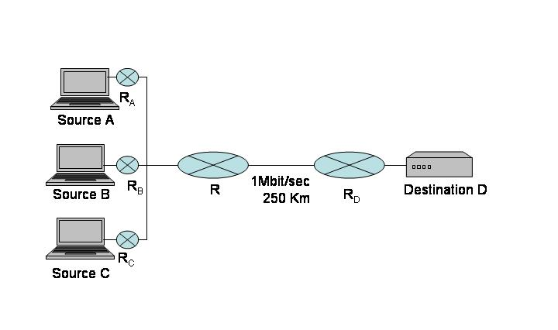
- Consider a router using RED, which carries (only) TCP traffic. Assume that the average number of bytes in the queue of the router converges to N, the average output rate converges to λ (bytes/sec), and the average delay converges to T.
  - Explain why you cannot simply apply Little's theorem (as stated in class).
  - Prove or disprove: N= λ T [or: N≤ λ T, N≥ λ T].
- Consider the enclosed state-transition diagram for a (simple, discrete-value) Discrete-Time Markov Chain.
0
2
1
  - Present transition probabilities P_{ij} s.t. the chain is periodic (prove).
  - Present transition probabilities P_{ij} s.t. the chain is a-periodic (prove).
  - Express the stationary probability πj=Σi πiPij as a function of P₁₀. In particular compute for P₁₀={0,0.5,1}.
- Consider the two leaky-bucket shapers in tandem, with parameters (σ₁ , ρ₁) and (σ₁ , ρ₁).
  - Obtain the overall envelope.
  - Suppose A(t) has envelope E(t). What is the envelope of D₂(t)?
- Consider a router with one output port, rate C, that handles two flows: one `best-effort` flow and one Expedited Forwarding PHB flow with traffic spec (σ , ρ), i.e. arrivals enveloped by σ+ρt. Can you bound the (best) competitive ration for the et departures process (for both flows), denoted D(t) ?

