Activity 7.4.2: Challenge DHCP and NAT Configuration

Topology Diagram
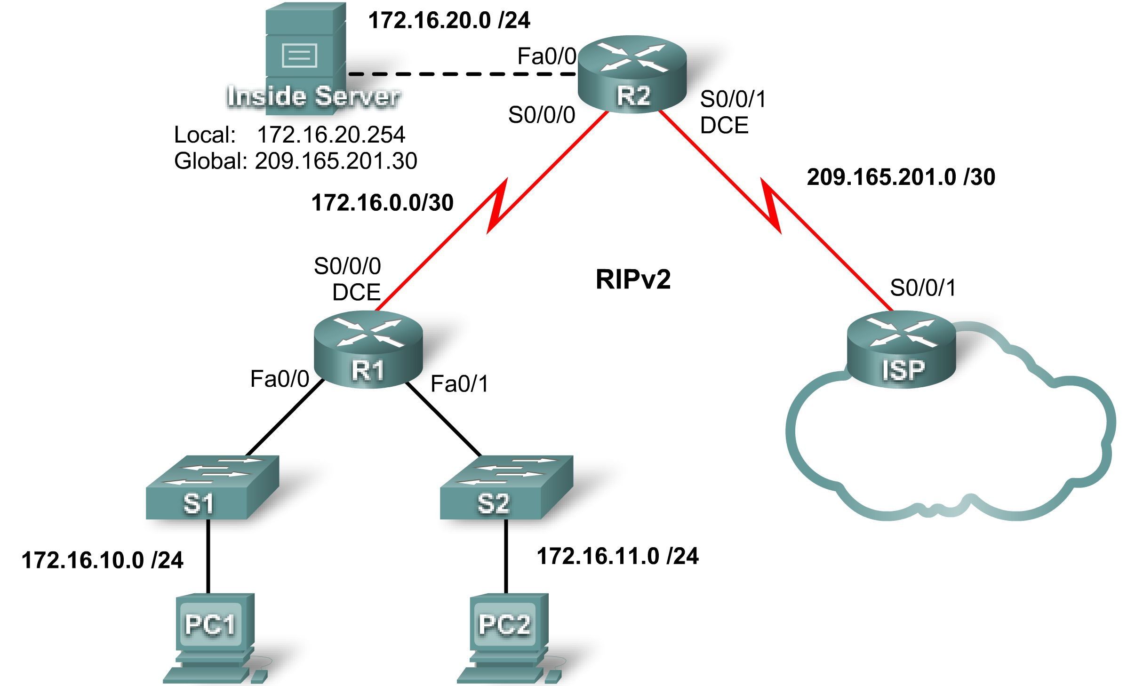

Addressing Table
Device | Interface | IP Address | Subnet Mask
R1 | S0/0/0 | 172.16.0.1 | 255.255.255.252
R1 | Fa0/0 | 172.16.10.1 | 255.255.255.0
R1 | Fa0/1 | 172.16.11.1 | 255.255.255.0
R2 | S0/0/0 | 172.16.0.2 | 255.255.255.252
R2 | S0/0/1 | 209.165.201.1 | 255.255.255.252
R2 | Fa0/0 | 172.16.20.1 | 255.255.255.0
ISP | S0/0/1 | 209.165.201.2 | 255.255.255.252

Learning Objectives
Upon completion of this lab, you will be able to:
- Prepare the network
- Perform basic router configurations
- Configure a Cisco IOS DHCP server
- Configure static and default routing
- Configure static NAT
- Configure dynamic NAT with a pool of addresses
- Configure NAT overload

Scenario
In this lab, configure the IP address services using the network shown in the topology diagram. If you need assistance, refer back to the basic DHCP and NAT configuration lab. However, try to do as much on your own as possible.
Task 1: Perform Basic Router Configurations
Configure the R1, R2, and ISP routers according to the following guidelines:
- Configure the device hostname.
- Disable DNS lookup.
- Configure a privileged EXEC mode password.
- Configure a message-of-the-day banner.
- Configure a password for the console connections.
- Configure a password for all vty connections.
- Configure IP addresses on all routers. The PCs receive IP addressing from DHCP later in the lab.
- Enable RIPv2 on R1 and R2. Do not advertise the 209.165.200.224/27 network.
For all devices:
enable
conf t
no ip domain-lookup
enable secret class
banner motd $Authorized Access Only!$
!
line con 0
logging synchronous
password cisco
login
!
line vty 0 4
password cisco
login
end
copy run start

R1:
hostname R1
int fa0/0
ip address 172.16.10.1 255.255.255.0
no shut
int fa0/1
ip address 172.16.11.1 255.255.255.0
no shut
int s0/0/0
ip address 172.16.0.1 255.255.255.252
clock rate 125000
no shut
!
router rip
version 2
network 172.16.0.0
no auto-summary

R2:
hostname R2
int fa0/0
ip address 172.16.20.1 255.255.255.0
no shut
int s0/0/0
ip address 172.16.0.2 255.255.255.252
no shut
int s0/0/1
ip address 209.165.201.1 255.255.255.252
clock rate 125000
no shut
!
router rip
version 2
network 172.16.0.0
no auto-summary

ISP:
hostname ISP
int s0/0/1
ip address 209.165.201.2 255.255.255.252
no shut
!
Task 2: Configure a Cisco IOS DHCP Server
Configure R1 as the DHCP server for the two directly attached LANs.
Step 1. Exclude statically assigned addresses.
Exclude the first three addresses from each pool.
R1(config)#ip dhcp excluded-address 172.16.10.1 172.16.10.3
R1(config)#ip dhcp excluded-address 172.16.11.1 172.16.11.3
Step 2. Configure the DHCP pool.
- Create two DHCP pools. Name one of them R1_LAN10 for the 172.16.10.0/24 network, and name the other R1_LAN11 for the 172.16.11.0/24 network.
- Configure each pool with a default gateway and a simulated DNS at 172.16.20.254.
R1(config)#ip dhcp pool R1_LAN10
R1(dhcp-config)#network 172.16.10.0 255.255.255.0
R1(dhcp-config)#default-router 172.16.10.1
R1(dhcp-config)#dns-server 172.16.20.254
R1(dhcp-config)#ip dhcp pool R1_LAN11
R1(dhcp-config)#network 172.16.11.0 255.255.255.0
R1(dhcp-config)#default-router 172.16.11.1
R1(dhcp-config)#dns-server 172.16.20.254
Step 3. Verify the DHCP configuration.
R1#show ip dhcp binding
IP address Client-ID/ Lease expiration Type
Hardware address
172.16.10.4 00E0.F70C.7E1E -- Automatic
172.16.11.4 0009.7CB0.39E6 -- Automatic
Task 3: Configure Static and Default Routing
- Configure ISP with a static route for the 209.165.201.0/27 network. Use the exit interface as an argument.
ISP(config)#ip route 209.165.201.0 255.255.255.224 serial 0/0/1
- Configure a default route on R2 and propagate the route in OSPF. Use the next-hop IP address as an argument.
R2(config)#ip route 0.0.0.0 0.0.0.0 209.165.201.2
R2(config)#router rip
R2(config-router)#default-information originate
Task 4: Configure Static NAT
Step 1. Statically map a public IP address to a private IP address.
Statically map the inside server IP address to the public address 209.165.201.30.
R2(config)#ip nat inside source static 172.16.20.254 209.165.201.30
Step 2. Specify inside and outside NAT interfaces.
R2(config)#interface serial 0/0/1
R2(config-if)#ip nat outside
R2(config-if)#interface fa0/0
R2(config-if)#ip nat inside
Step 3. Verify the static NAT configuration.
R2#show ip nat translations
Pro Inside global Inside local Outside local Outside global
--- 209.165.201.30 172.16.20.254 --- ---
Task 5: Configure Dynamic NAT with a Pool of Addresses
Step 1. Define a pool of global addresses.
Create a pool named NAT_POOL for the IP addresses 209.165.201.9 through 209.165.201.14 using a /29 subnet mask.
R2(config)#ip nat pool NAT_POOL 209.165.201.9 209.165.201.14 netmask 255.255.255.248
Step 2. Create a standard named access control list to identify which inside addresses are translated.
Use the name NAT_ACL and allow all hosts attached to the two LANs on R1.
Note: The .10 LAN must be configured first, then the .11 LAN. Otherwise, Packet Tracer will not grade the ACL as correct.
R2(config)#ip access-list standard NAT_ACL
R2(config-std-nacl)#permit 172.16.10.0 0.0.0.255
R2(config-std-nacl)#permit 172.16.11.0 0.0.0.255
Step 3. Establish dynamic source translation.
Bind the NAT pool to the ACL and allow NAT overloading.
R2(config)#ip nat inside source list NAT_ACL pool NAT_POOL overload
Step 4. Specify the inside and outside NAT interfaces.
Verify that the inside and outside interfaces are all correctly specified.
R2(config)#interface serial 0/0/0
R2(config-if)#ip nat inside
Step 5. Verify the dynamic NAT configuration by pinging from PC1 and PC2 to ISP.
R2#show ip nat translations
Pro Inside global Inside local Outside local Outside global
icmp 209.165.201.9:2 172.16.10.4:2 209.165.201.2:2 209.165.201.2:2
icmp 209.165.201.9:1024172.16.11.4:2 209.165.201.2:2 209.165.201.2:1024
--- 209.165.201.30 172.16.20.254 --- ---
Task 6: Document the Network
On each router, issue the show run command and capture the configurations.

