Exercices sur les 2 preterits

- Supprime deux elements dans chaque liste pour former une phrase cohérente

- they were visited their cousins in Canada next last summer
- mary we was jogging in the park when it starts started raining
- you did you catch caught any fish in this river ?
- hurry up ! they wait are waited waiting for us !

- Dis en anglais

  - qu’il regardait la télévision quand tu as téléphoné
  - que tu étais fatigué hier soir quand tes amis sont arrivés
  - que ta mère a rencontré ton professeur au supermarché

- Les phrases suivantes sont incompletes : quelles questions faut-il poser chaque fois pour trouver l’élement manquant ?

  - I saw a very nice … at Marks & Spencer’s this morning
  - She didn’t buy that tee-shirt because…
  - I went to China …years ago
  - After the cinema, we went to …
  - I met my boss to …

- Corrige les erreurs dans les phrases suivantes

  - how much did you payed for that guitar ?
  - were you playing tennis when it starts raining ?
  - who did phone you at 10 o’clock this morning ?
  - did John passed his exam ?
  - what was you doing when the lights went out ?

- Conjugue les verbes entre parenthèses au preterit simple ou preterit BE + V-ING

  - the ghost (disappear) when the lights (go on)
  - the children (dance) when their parents (come back)
  - the burglars (break) into the house while (pendant que) we (sleep)
  - she (make) the bed when she (hear) a funny noise
  - the people (wait) for the bus when they (see) an accident

- Traduis
  - John Lennon était un célèbre chanteur, n’est ce pas ?
  - Elvis est mort très jeune. Quel dommage !
  - Où es tu né ? –je suis né à New York, il y a 25 ans, en 1980. Mais j’ai grandi à Chicago.
  - Quand est-ce que tes parents se sont mariés ?
  - Combien ce jean t’a-t-il couté ?
  - Qu’est ce que tu lisais lorsque je suis entrée ?
  - A quelle heure ton amie est-elle partie de chez toi hier soir ?
  - Je promenais le chien dans le parc quand j’ai vu ta sœur courir
  - Le professeur ecrivait au tableau quand quelqu’un frappa a la porte

EXERCICE - PRETERIT SIMPLE VS PRETERIT BE + V-ING
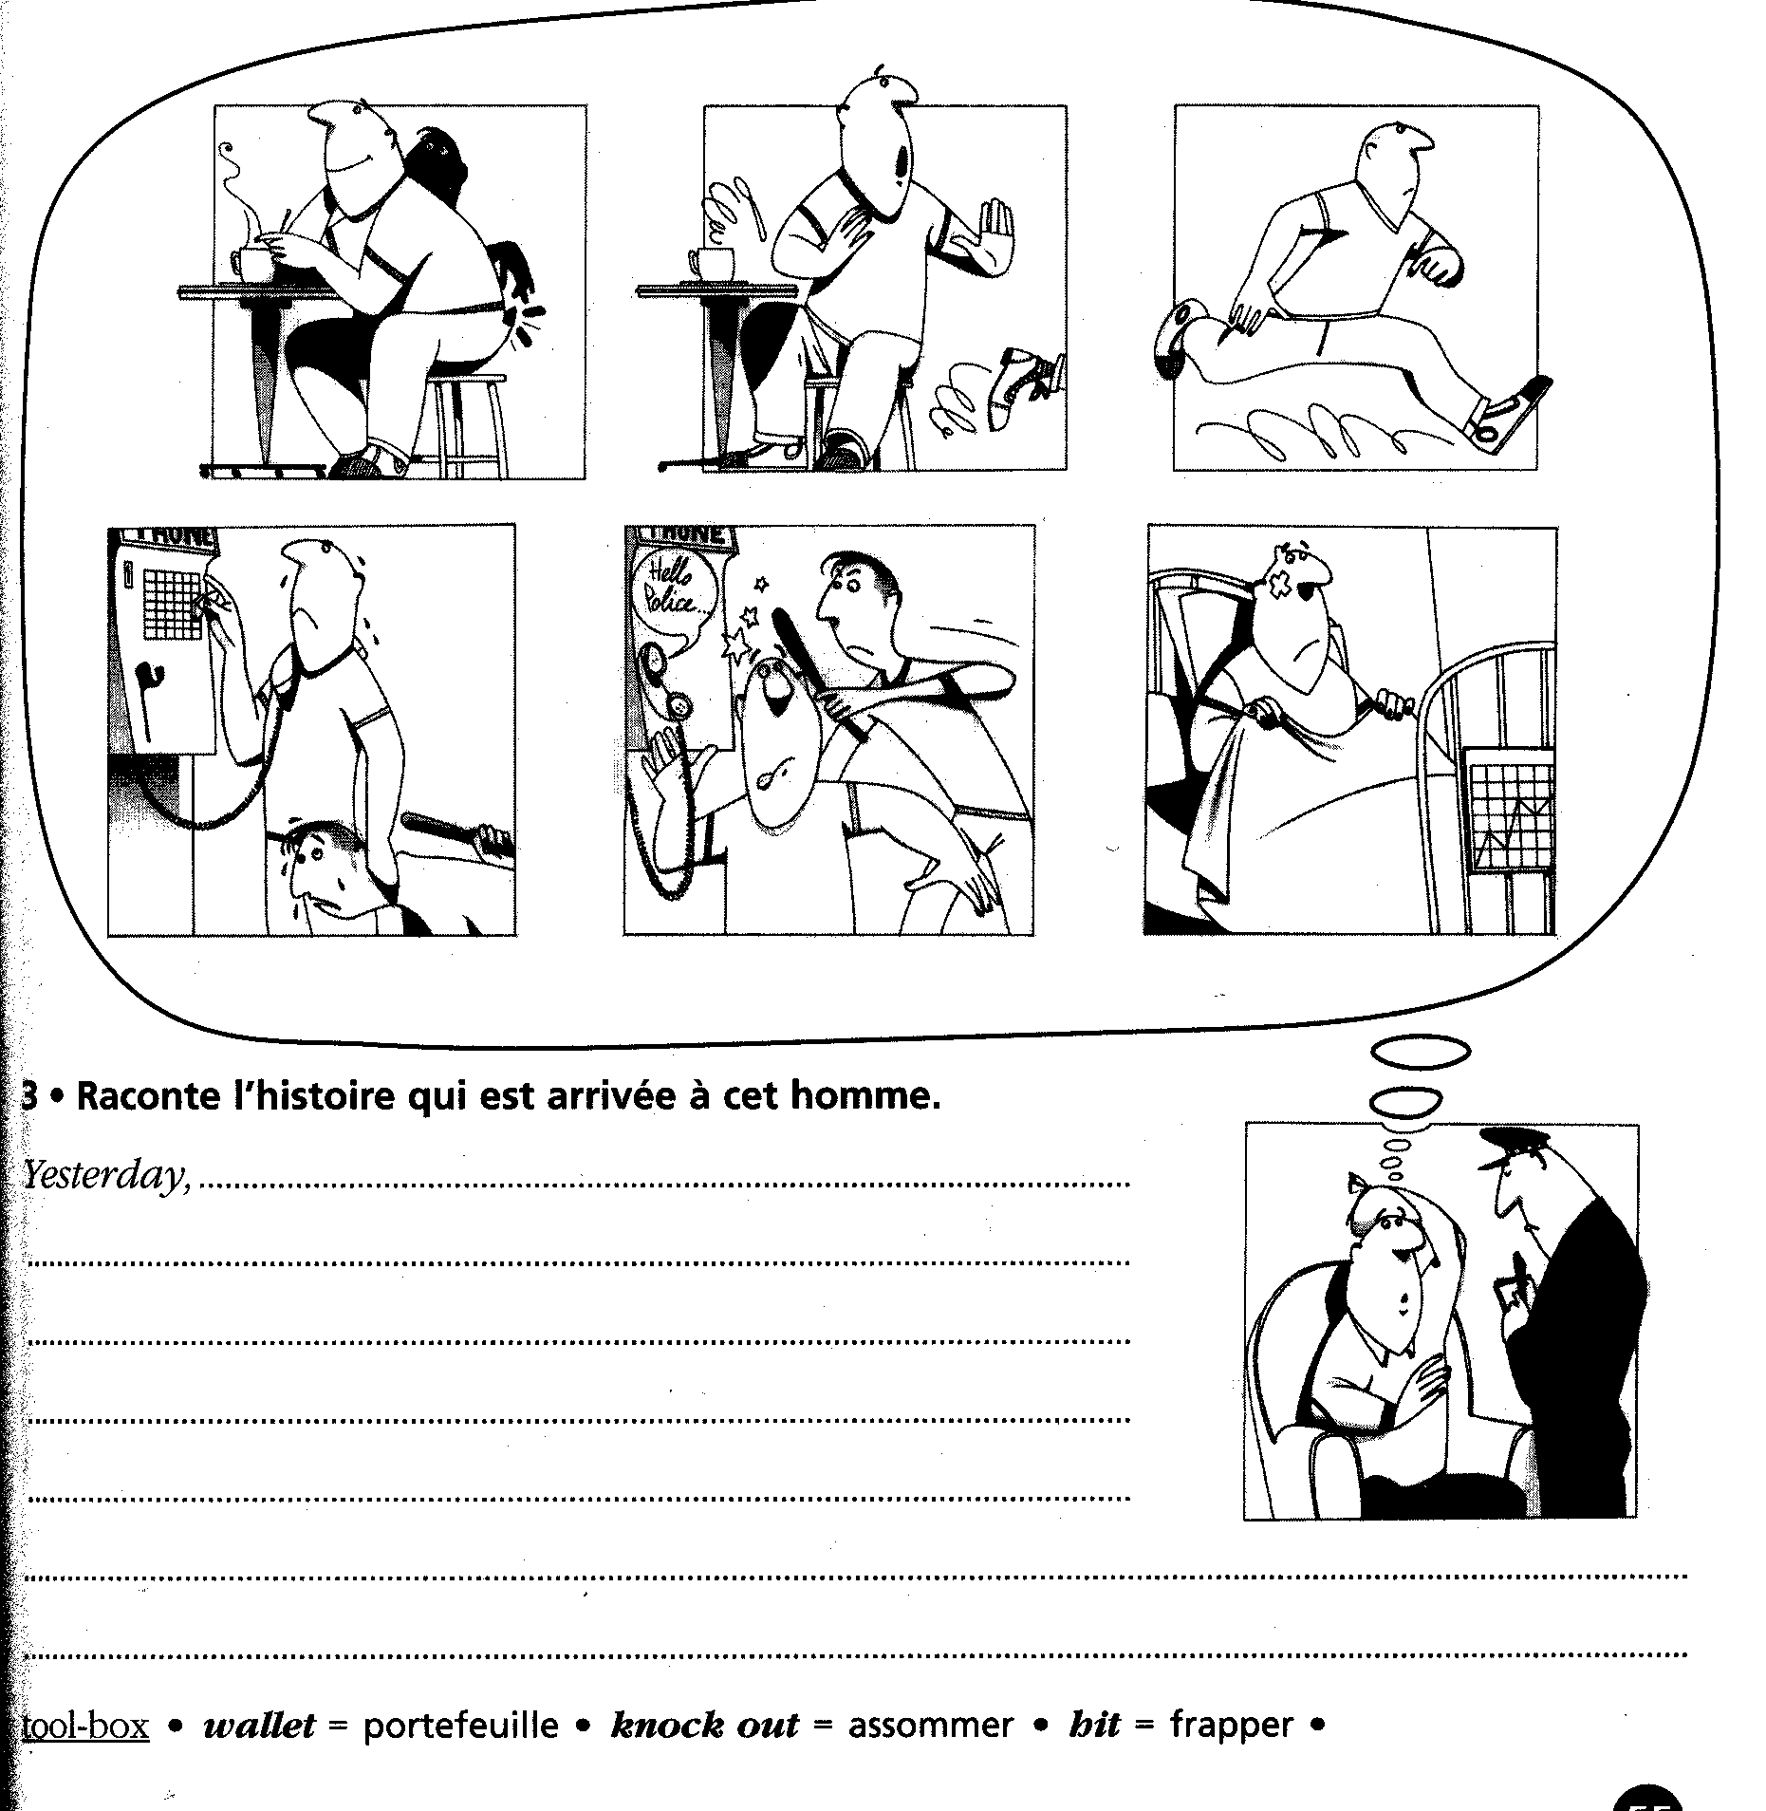

Complète les phrases avec le verbe conjugué au preterit simple ou preterit BE + -ING selon ce qui correspond le mieux.

The other day, I ………………………………………………….(walk) in the street when I ……………………………………….(find) a kitten (=un chaton), near a bin (= une poubelle). It ……………………………………….(be) a white and black one. It seemed to be abandoned. So I …………………………………………(take) him at home with me and …………………………………….(decide) to give him some milk and food. While he ……………………………………………..(have) milk, my dog ……………………………………(enter) the kitchen and ……………………………….(frighten) him. The kitten …………………………………..(run) to hide (=se cacher) under the bed. While the kitten …………………………………………(hide), the dog ……………………………………..(bark) (= aboyer), and it ……………………………………..(make) a gigantic noise, so much noise that my neighbours ……………………………………(come) to ask me stop it and we …………………………………..(get) angry !

EXERCICES SUR LES DEUX PRETERITS

Conjugue les verbes entre parenthèses au temps qui convient.

Yesterday, I ………………………………………………………………(study) in my room when my brother Tom ……………………………………………………………… (put) his radio on at full blast. I ……………………………………………………………… (get) mad at him ! I ……………………………………………………………… (be) very angry because he often ……………………………………………………………… (do) so and it’s impossible for me to work with so much noise. Mum ……………………………………………………………… (be) furious too because she ……………………………………………………………… (watch) TV downstairs and couldn’t hear anything about her television show “who wants to be a millionaire” ! She always ……………………………………………………………… (watch) this program at 7 in the evening , she’s fond of it. So she ……………………………………………………………… (get) really angry : she ……………………………………………………………… (go) to Tom’s room and ……………………………………………………………… (bang) on the door. Tom ……………………………………………………………… (not / answer). In fact, he ……………………………………………………………… (lie) quietly on his bed, he ……………………………………………………………… (sing) along with the music, his eyes closed, and he ……………………………………………………………… (smile) ! She ……………………………………………………………… (have) to shout because he ……………………………………………………………… (not / hear) her come into his room !

Conjugue les verbes au temps qui correspond. Ce temps peut être le present simple ou BE + ING, ou encore le preterit simple ou BE + ING. Raccroche-toi aux INDICES dans les phrases !

Last night, I .................................................................(read) a book in my bedroom, when I..............................(hear) someone knock at the door. I ......................................................(go) downstairs to see who was there, but when I .......................................................(open) the door, there .............................................(be / not) anyone. This..................................................(happen) very often, and I am really worried about it. It's really scary, do you know?
Anyway , what .......................I.............................(go) to do ? I ......................................(have) no idea who can be responsible for that stupid joke !
The point is now, I always .............................................(get) nervous at night, when I am alone in my bedroom, and I really .............................................................(know / not) how to relax !

Retrouve les questions correspondant aux éléments soulignés dans la réponse donnée.
-..................................................................................................................................................................................?
-She won a trip to China !
-..................................................................................................................................................................................?
-She was having breakfast (when she heard some noise upstairs).
-..................................................................................................................................................................................?
-no, I didn't. (tu peux inventer ce que tu veux pour la question)
-..................................................................................................................................................................................?
-I go to the market twice a day. As a cook, I must buy fresh fruit and vegetables every day.
-..................................................................................................................................................................................?
-We went to London, and we really enjoyed it !

