Worksheets

BEFORE Reading:

- Look through the pictures in the book. Guess what kind of people the characters are. Try to find one word to describe each character.
- Oliver – Mr Bumble – Jack Dawkins – Fagin – Sikes – Nancy
- Who has already read the book?
- What do you already know about Oliver Twist?
- Try to find and to describe some situations in which a poor boy like Oliver Twist could get involved.
- Search the internet: find out some more about Charles Dickens (other books, life, situate him in place and time, …)

WHILE Reading:

If there are words in the book you don’t understand while reading, write them down!

Answer the questions with the information given in the chapters.

Chapter 1: Oliver asks for more

- Define a workhouse.

- Which word do we use to describe a child who has neither a father nor a mother?

- On which day do the workhouse-boys receive a small piece of bread?

- The bowls that the boys used to put in their soup never needed cleaning. Why was that?

- Which instrument did the master use to hit Oliver with? What was the reward of taking in Oliver Twist?

- Try to find some indications in the first chapter that prove that Oliver’s mother was really poor. Use the sentence/phrase the author uses.

- What is Mr Sowerberry’s profession? What does he make?

Chapter 2: He goes out to work

- Who took Oliver to Mr Sowerberry’s shop?

- What was Mrs Sowerberry like?

- What did Oliver eat on the first evening?

- Where did Oliver sleep?

- Who knocked on the door in the morning?

- What did Noah call Oliver?

- Why was Noah rude to Oliver?

Chapter 3: He runs away

- Why did Oliver attack Noah?

- How did Noah react?

- What was Mr Bumble’s advice to Mrs Sowerberry on how to handle Oliver?

Who said each of these things in Chapter 3? Who was she/he talking to?

- Don’t say anything about her to me.

- We all pity you, Workhouse, but your mother was a bad woman.

- He might murder us all in our beds.

- He must be mad. Nobody speaks to you like that!

Chapter 4: London

- What happened when Oliver ran away that he would never forget?

- Oliver came along a stone where he rested for a moment. What was written on that stone?

- Barnet is ....?

- What was the name of Oliver’s new friend?

- Describe Fangin.

- In Fangin’s room there were four or five boys, what were they doing?

Chapter 5: Fagin

- What did Jack Dawkins bring home with him?

- Look up the word “handkerchief” in you dictionary.

Match each adjective with a noun to make a phrase from Chapter 5.

A. long I. box
B. half-closed II. boy
C. secret III. bread
D. expensive gold IV. eyes
E. beautiful V. gentleman
F. silent VI. handkerchiefs
G. pretty VII. hole
H. hot VIII. interest
I. marked IX. ladies
J. silver X. pocket
K. coat XI. rings
L. old XII. sleep
M. shop XIII. things
N. funny XIV. watch
O. young XV. way
P. good XVI. window

Chapter 6: Oliver among the thieves

- Give another word for “constable” which has a similar meaning.

Put these events from Chapter 6 in the right chronological order.

  - A police constable pushed through the crowd and seized Oliver by the neck.
  - Dawkins and Charley went back to Fagin’s house and told him about Oliver.
  - Dawkins gave the handkerchief to Charley and they both ran away.
  - Dawkins took the old man’s handkerchief.
  - Everybody started shouting ‘Stop, thief,’ even Dawkins and Charley.
  - Fagin said someone must go and find Oliver.
  - Fagin told Charley to watch the bookshop every day.
  - Nancy went and found out that a gentleman had got him but that the police didn’t know where he lived.
  - Oliver suddenly understood about the handkerchiefs and ran away too.
  - Oliver, Charley and Dawkins saw an old man outside a bookshop.
  - Somebody hit Oliver and he fell to the ground.
  - The bookshop owner said that Oliver didn’t steal the handkerchief.
  - The old gentleman missed his handkerchief and shouted ‘Stop, thief.’
  - The old gentleman took Oliver to his house in a carriage.
  - The police constable let Oliver go and he fainted.

Chapter 7: A Better home

- What was the task Mr Grimwig suggested for Oliver?

- Is Mr Grimwig pessimistic or optimistic about Oliver’s intentions?

One word is wrong in each of the sentences about the information in chapter 7. Correct the word.

  - Oliver stayed in bed for several years at Mr Brownlow’s house.
  - He was quite well.
  - One day he was thrown downstairs to Mrs Bedwin’s rooms.
  - He saw a lady on the wall and stared.
  - Mr Brownlow noticed that Oliver’s eyes and head and mouth were the same as the lady in the room.
  - One day Oliver went to Mr Brownlow’s room, which was full of boots.

Chapter 8: Back among the thieves

Are these sentences about the information in Chapter 8 true or false and explain why.

  - Oliver is Nancy’s brother.
  - Oliver’s mother is waiting at home.
  - Sikes and Nancy took Oliver back to the house he had stayed in before.
  - Sikes got the five pound note that Mr Brownlow gave Oliver.
  - Oliver escaped from the room.
  - Sike’s dog attacked Oliver.
  - Fagin hit Oliver twice.
  - Another boy who ran away from Fagin had been hanged.
  - Sikes and Fagin planned to steal silver from a house in Chertsey.
  - They needed Oliver to climb through a small window into the house.

Chapter 9: Bill Sikes

- What did Sikes press to Oliver’s head to scare him?

- What does the story tell us about Toby Crackit’s appearance?

- Did Sikes, Toby and Oliver succeed in robbing the silverware in Chertsey’s house?

- What happened with Oliver?

Chapter 10: Oliver is safe again

- Which injuries had Oliver sustained during his failed attempt to break into Chertsy’s house?

- Who played piano in the evening and sang in her sweet, gentle voice at house Chertsey?

- What else did Oliver learn during this period of happiness?

Chapter 11: The mysterious stranger

- Why did Oliver go to the old church and started praying outside on the grass?

- What happened after Oliver delivered the letter for Dr Losberne and came out of the inn?

- One night when he was reading a book when Oliver saw ..... and started calling for help?

Chapter 12: Mr Bumble and the stranger

- What is Mr Bumble’s position in the workhouse? And compare it with his position in the beginning of the story.

- What is the name of the mysterious stranger?

- What did Monks throw into the river after meeting with Mr Bumble and the old woman

Chapter 13: Nancy learns a secret

- Nancy was eavesdropping when Fagin talked with Monks. Explain the meaning of this new word in bold, using the text as a help.

Complete each sentence about the information in chapter 13 with a preposition or particle from the box. You can use the same word more than once

About – at – away – back – beside – from – into – near – of – off – on – to – with

  - Bill Sikes lay __________ his bed.

  - He had been ill __________ a fever for several weeks.

  - The dog lay __________ the bed.

  - Nancy sat __________ the window.

  - When she helped him __________ his chair, he cursed her and hit her.

  - She turned __________ and tried to laugh but she was crying.

  - The door opened and Fagin came __________ the room.

  - He said that they had to get Oliver___________.

  - He was worth a lot of money _____________ Fagin.

  - He said that Oliver was staying ______________ Miss Maylie and her aunt.

  - They had come ___________ London –

  - – and they were staying ____________ a hotel near Hyde Park.

Chapter 14: A visit to Rose Maylie

- Where is Rose staying with Oliver in London?

- Why does Nancy want to see Rose?

Who says each of these sentences from Chapter 14? Who is he/she talking to?

  - I must go now or I may be too late.

  - I want to see a lady who is staying here.

  - Come! You must leave now.

  - I am the person you wanted to see.

  - If there were more people like you in the world, there would be fewer like me.

  - If you are in trouble, I will be glad to help you.

  - I took little Oliver back to Fagin’s on the night when he left that gentleman’s house.

  - He said that he had the young boy’s money now.

  - That will be the end of my young brother, Oliver.

Chapter 15: Old friends meet

- What does Mr Grimwig always say when he expresses a statement?

- Why was Rose standing in shock during her visit to Mr Brownlow?

Who or what does each word in italics refer to?

  - Tell him to let me go.

  - I must have her followed.

  - On his orders, he was hiding in the shadows.

  - Why have you brought us to this dark place?

  - I can never do that.

  - He is young – about 28.

  - Do you know him?

  - It may help you.

Chapter 16: Midnight on London Bridge

- Who was spying on Nancy, Rose and Mr Brownlow when they met?

- Where is Monks supposed to have a red, burnlike mark?

Chapter 17: Nancy is murdered

- Who murdered Nancy?

In what way are these things important in the last part of the story?

    - a bag

    - a pistol

    - a heavy stick

Chapter 18: Sikes escapes

- Did Sikes flee alone?

In what way are these things important in the last part of the story?

    - blood

    - a dog

    - kidnap

Chapter 19: Monks is caught

- What is the relationship between Oliver and Monks that is disclosured by Mr Brownlow?

- What happens to Mr Bumble?

In what way are these things important in the last part of the story?

    - a beautiful daughter

    - a will

    - reward

Chapter 20: The death of Sikes

- Where did Sikes want to hide from the police?

Chapter 21: The end of the story
1 = Charley Bates

2 = Monks

3= Noah Claypole

4= Mr Bumble
A. Who went to America and squandered all his money?

B. Who became an informant for the police?

C. Who gave up the life of crime and began working for a farmer?

D. Who lost his job as master of the workhouse?

In what way are these things important in the last part of the story?

  - a dog

ii. the roof

AFTER Reading:

The first 6 exercises are compulsary. You must do them.

Exercise 1: Plot overview: fill in the missing words.

Oliver (1)................. is born in a workhouse in 1830s England. His mother, whose name no one knows, is found on the street and dies just after Oliver’s birth. Oliver spends the first nine years of his life in a badly run home for young orphans and then is transferred to a (2)............................... for adults. After the other boys bully Oliver into asking for more gruel at the end of a meal, Mr Bumble, the parish beadle, offers (3).......................... to anyone who will take the boy away from the workhouse. Oliver is apprenticed to a local undertaker, Mr Sowerberry. When the [undertaker’s] other apprentice, (4).........................................., makes [disparaging] comments about Oliver’s mother, Oliver attacks him and [incurs] the Sowerberrys’ [wrath]. Desperate, Oliver runs away at dawn and travels toward (5)......................................

Outside London, Oliver, starved and exhausted, meets Jack Dawkins, a boy his own age. Jack offers him shelter in the London house of his [benefactor], Fagin. It turns out that Fagin is a career criminal who trains orphan boys to pick pockets for him. After a few days of training, Oliver is sent on a pickpocketing mission with two other boys. When he sees them swipe a (6)................................. from an elderly gentleman, Oliver is horrified and runs off. He is caught but narrowly escapes being convicted of the theft. Mr Brownlow, the man whose [handkerchief] was stolen, takes the feverish Oliver to his home and nurses him back to health. Mr Brownlow is struck by Oliver’s resemblance to a (7) ............................... of a young woman that hangs in his house. Oliver [thrives] in Mr Brownlow’s home, but two young adults in Fagin’s gang, Bill Sikes and his lover (8) ............................... , capture Oliver and return him to Fagin.

Fagin sends Oliver to assist Sikes in a burglary. Oliver is (9).............................. by a servant of the house and, after Sikes escapes, is taken in by the women who live there, Mrs Maylie and her beautiful niece Rose. They grow fond of Oliver, and he spends an idyllic summer with them in the [countryside]. But Fagin and a mysterious man named Monks are set on recapturing Oliver. Meanwhile, it is revealed that Oliver’s mother left behind a gold locket when she died. Monks obtains and destroys that locket. When the Maylies come to London, Nancy meets (10)........................ with Rose and informs her of Fagin’s designs, but a member of Fagin’s gang overhears the conversation. When word of Nancy’s [disclosure] reaches Sikes, he brutally (11) ............................... Nancy and flees London. [Pursued] by his guilty conscience and an angry [mob], he [inadvertently] hangs himself while trying to escape.

Mr Brownlow, with whom the Maylies have reunited Oliver, confronts Monks and wrings the truth about Oliver’s parentage from him. It is revealed that Monks is Oliver’s half brother. Their father, Mr Leeford, was unhappily married to a wealthy woman and had an affair with Oliver’s mother, (12) ........................ Fleming. Monks has been pursuing Oliver all along in the hopes of ensuring that his half-brother is [deprived] of his share of the family [inheritance]. Mr Brownlow forces Monks to sign over Oliver’s share to Oliver. Fagin is hung for his crimes. Finally, Mr Brownlow adopts Oliver, and they and the Maylies retire to a blissful existence in the countryside.

- EXPLAIN THE WORDS BETWEEN BRACKETS in the text above: (you can use a dictionnary if necessary, but first try to derive the meaning from the context.)

  - undertaker:....................................................................................................
  - disparaging:..............................................................................................
  - incur: ...................................................................................................
  - wrath: ................................................................................................
  - benefactor:......................................................................................................
  - handkerchief: .................................................................................................
  - to thrife:........................................................................................
  - countryside: ...................................................................................................
  - disclosure: ...................................................................................................
  - to pursue:......................................................................................................
  - mob:...............................................................................................................
  - inadvertently:.................................................................................................
  - to deprive: ...................................................................................................
  - inheritance: ..........................................................................................

Exercise 2: Compare the book to the film
Visit : http://www.sonypictures.com/movies/olivertwist/
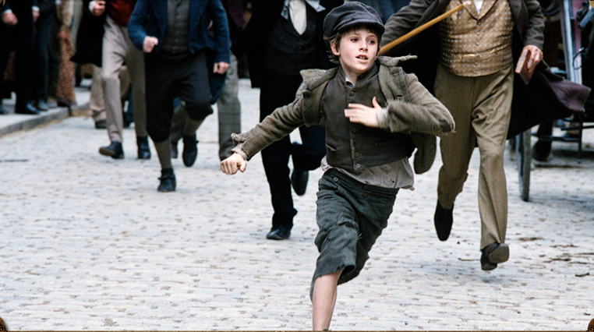

- Take a quick, first look. What are your first thoughts, impressions?

2. Go to ‘CHARACTERS’
- Which character(s) you know from the book, are missing in the film?

- Character relations: Pick one character and describe his/relation to another character. Why did you choose them? In what way does the relationship between those two fascinate you.

- When Oliver first comes to London he’s taken to ‘Fagin’ by ‘a boy his age behaving like a man’ says the book. In the film this boy has a different name. What do they call him in the film?

Exercise 3: Compare the book to the film.
You are going to write a film review. Answer these questions to help you plan your review.

- Name of the film: _______________________________________________________________
- Film stars: ______________________________________________________________________________________________________________________________________________________________________
- Film director and producer: ___________________________________________________________________________________
- Name of the book: _________________________________________________________________
- Author of the book:________________________________________________________________
- What is this film about? Describe the story in three or four sentences.

- What did you especially like or dislike about the film?

- Is the film a good version of the book? Is it similar or very different?
- What are your opinions of the actors?

- Would you recommend the film? If so? What sort of people will like it?

- Can you give the film an age rating?

- And a star rating

Exercise 4: Choose 5 characters from the film/book and try to fill in the ‘star’. Information that is not given can be left out of the star.

CHARACTER 1
Sex:
Age:
Appearance:
Some characteristics:

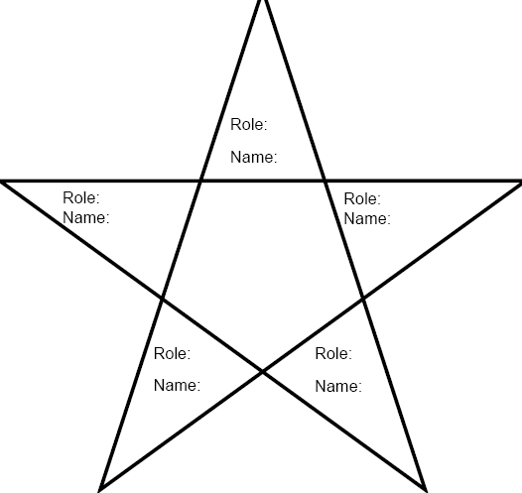

CHARACTER 2
Sex:
Age:
Appearance:
Some characteristics:

CHARACTER 5
Sex:
Age:
Appearance:
Some characteristics:

CHARACTER 3
Sex:
Age:
Appearance:
Some characteristics:

CHARACTER 4
Sex:
Age:
Appearance:
Some characteristics:

Exercise 5: Creative writing assignment + put in the right order

- Give the right order of the events pictured.
- Write in a few sentences what happens in the pictures using your knowledge of the book.

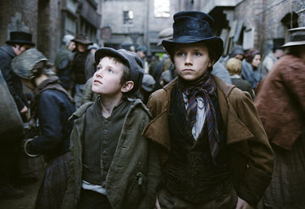 A
………………………………………………………………………………………………………………………………………………………………………………………………………………………………………………………………………………………………………

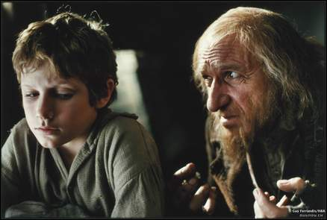 B
……………………………………………………………………………………………………………………………………………………………………………………………………………………………………………………………………………………………………...

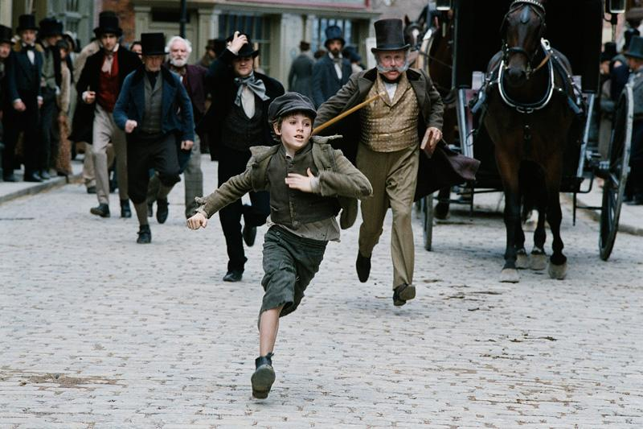 C
……………………………………………………………………………………………………………………………………………………………………………………………………………………………………………………………………………………………………....

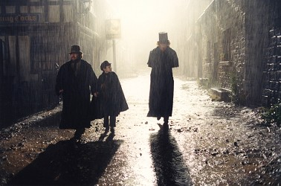 D
………………………………………………………………………………………………………………………………………………………………………………………………………………………………………………………………………………………………………

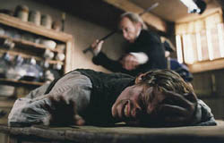 E
………………………………………………………………………………………………………………………………………………………………………………………………….............................................................................................................................................................
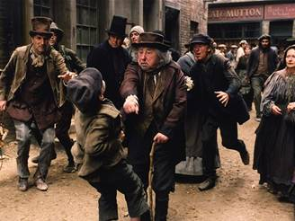 F
………………………………………………………………………………………………………………………………………………………………………………………………………………………………………………………………………………………………………..

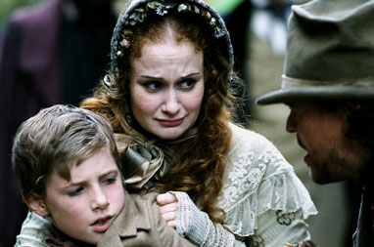 G
……………………………………………………………………………………………………………………………………………………………………………………………………………………………………………………………………………………………………….
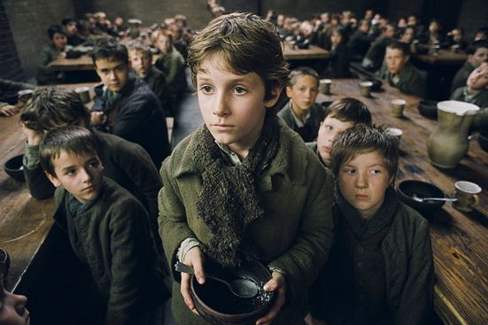 H
……………………………………………………………………………………………………………………………………………………………………………………………………………………………………………………………………………………………………….

Exercise 6: Point out these places of interest, mentioned in the book, in the map.

- London Bridge
- Jacob’s Island
- Hyde Park
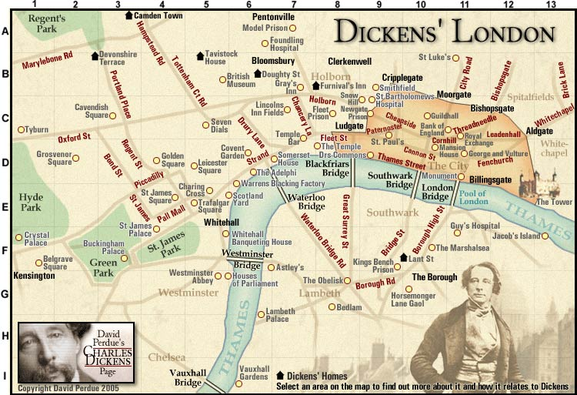

Explain why these places were mentioned in the book, what happened there?

Finished? Now, choose one of the following exercises and finish it at home. You can either choose to work individually or in pairs/groups.

- Try to design a creative, inspiring and original book cover. (individual)
- Be Oliver Twist (or choose another character) for 15 days and write a diary! (individual)
- Choose a chapter or part out of the book that you like and play it with some fellow pupils. (group) Maybe…go and see the musical to get some inspiration
- Prepare a quiz for the rest of the class… How well have they read Oliver Twist and how well do they know the boy and his story? (group)

- Use the internet for this part.

  - Look up the Victorian age on the internet, and make a sort of collage + essay about London during the Victorian age.
  - Compare London in the Victorian age with London today. / Compare the situation of the orphans in those days and at present.

Quiz

1. How does Oliver violate the rules of the workhouse?
(A) By asking for more gruel
(B) By taking the Lord’s name in vain
(C) By running a pickpocketing ring
(D) By spreading revolutionary ideology among the paupers

2. What is Mr. Sowerberry’s profession?
(A) Undertaker
(B) Chef
(C) Butler
(D) Chimney sweep

3. How does Noah Claypole incur Oliver’s wrath?
(A) By mistreating Charlotte
(B) By insulting his clothes
(C) By insulting his mother
(D) By stealing food from the larder

4. Mr. Brownlow notices that Oliver bears a close resemblance to whom?
(A) Mrs. Bedwin
(B) The woman in the portrait on his wall
(C) Queen Victoria
(D) The Christ child

5. What does Nancy pretend to be in order to drag Oliver back to Fagin?
(A) A truant officer
(B) Oliver’s sister
(C) A workhouse official
(D) Oliver’s mother

6. Who comes to Oliver’s defense after Fagin recaptures him?
(A) Jack Dawkins
(B) Charley Bates
(C) Nancy
(D) Mr. Brownlow

7. Who is shot in the attempted burglary of the Maylie house?
(A) Oliver
(B) Bill Sikes
(C) Bull’s-eye
(D) Toby Crackit

8. Which character falls deadly ill in the countryside?
(A) Oliver
(B) Mrs. Maylie
(C) Mr. Bumble
(D) Rose Maylie

9. What did Old Sally get from Agnes Fleming?
(A) A will
(B) A marriage certificate
(C) An engraved watch
(D) A gold locket

10. To whom does the dog belong?
(A) Bill Sikes
(B) Oliver
(C) Monks
(D) Mr. Brownlow

11. Where does Nancy meet Rose and Brownlow?
(A) London Bridge
(B) The Three Cripples
(C) The Old Victoria Theater
(D) A blacking factory

12. What image haunts Bill Sikes after he commits murder?
(A) Oliver’s face
(B) A bloody club
(D) Nancy’s eyes
(C) The gallows

13. Where does Oliver last see Fagin?
(A) In a courtroom
(B) In the West Indies
(C) Underneath London Bridge
(D) In a jail cell

14. Which character’s real name is Edward Leeford?
(A) Jack Dawkins
(B) Monks
(C) Oliver
(D) Noah Claypole

15. Dr Losberne was?
(A) The master of the workhouse
(B) Oliver’s father
(C) A doctor
(D) The bookshopowner

Oliver Twist – Test 2 (Peguin Readers)
/90

- When does Oliver meet these Characters? Put them in the correct order (1-5)

  - _____ Fagin
  - _____ Mr Brownlow
  - _____ Rose Maylie
  - _____ Bill Sikes
  - _____ Mr Bumble
/10

- Choose a phrase (1-5) to describe each character.

- Warns his friend about Oliver
- Insults Oliver’s mother
- Is Oliver’s half-brother
- Is poor but kind-hearted
- Introduces Oliver to Fagin

  - Nancy _____
  - Noah Claypole _____
  - Jack Dawkins _____
  - Mr Grimwig _____
  - Monks _____
/10

- Underline the correct word(s) in these sentences.

  - Oliver’s name is chosen by his mother/Mr Bumble
  - Mr Sowerberry makes coffins/furniture
  - Mr Bumble advises the Sowerberrys not to give Oliver meat/vegetables
  - Fagin teaches Oliver how to steal/fight
  - Oliver is blamed for stealing Mr Brownlow’s wallet/handkerchief
  - Mr Brownlow has a picture of Monks’s aunt/Oliver’s mother on the wall
  - Before she dies, Oliver’s mother leaves her son a locket and a gold watch/ring
  - Nancy refuses to leave Bill Sikes because she is afraid of/in love with him
  - Sikes kills Nancy because she tried to poison him/help Oliver
  - Bill Sikes kills himself accidentally with a rope/knife

/20

- Look at the words in bold. Who or what are they?

  - ‘Please, sir,’ repeated Oliver, ‘I want some more.’

  - He was a boy but he wore a man’s clothes.

  - Fagin kept it in a secret hole in the floor.

  - After breakfast Fagin and the boys played a strange game.

  - Fagin said, ‘They cause a lot of trouble, but we need them for our work.’

  - Oliver stared at the madman for a moment an then ran into the inn for help.

  - Oliver saw his face in the window and was frightened.

  - Monks threw it into the river.

  - Sikes wanted to throw it into the river.

  - Fagin kept them in a secret hole a little way up the chimney.

/20

- Join these sentences together. Use the words from the box. One word is not used.

although – if – whose – which – while – when

  - Noah Claypole’s father was a soldier. Noah was rude to Oliver.

  - He wore a man’s coat. It nearly reached his feet.

  - Fagin was an evil old man. Nancy didn’t want him to go to prison.

  - Fagin waited for his death. He thought about his past.

  - Monks’ mother died. He promised her that he would find Oliver.

/10

- Do these people have a happy (H) or a sad (S) ending? Write DK if we don’t know.

A. Oliver ____ F. Monks ____
B. Mr Bumble ____ G. Jack Dawkins ____
C. Mr. Brownlow ____ H. Noah Claypole ____
D. Nancy ____ I. Charley Bates ____
E. Rose Maylie ____ J. Mr Sowerberry ____

/20

Teacher’s Notes

Introduction:

In order to make these worksheets, tests,… we used a lot of internet materials. Some of the exercises we made ourselves but there are a lot of nice exercises on the net.
Interesting links are:

- http://www.penguinreaders.com/ → There are splendid exercises, test and teacher’s notes!
- http://www.macmillanenglish.com/DEFAULT.aspx?id=514 → these worksheets and test are not made, based on the penguin readers but they are interesting. Have a look and maybe you get some really crazy ideas.
- http://www.edhelper.com/ReadingComprehension_33_222.html → here you can create a worksheet yourself (about Charles Dickens). You have to create an account with a password.
- http://www.sonypictures.com/movies/olivertwist/ → As to us, a fantastic site to use, also for the pupils.

Formation objectives

Language

- The pupils learn new vocabulary by reading a foreign novel.
- The pupils learn how to describe different characters
- Pupils learn to express themselves creatively by making up scenes of a play and acting it out.
- Pupils learn to write creatively by describing what they see in certain pictures.

Learning strategies

- Pupils learn to derive the meaning of new words from the context.
- Pupils are able to look things up on the internet.

Personality formation

- The pupils learn to be critical of social problems (such as poverty).
- The pupils learn to be critical of television.
- The pupils can emerge themselves in the world of fantasy.
- The pupils can differentiate the world of fantasy from the real world.
- Pupils are able to speak in front of each other and act out a play.
- Pupils are willing to watch and listen to their fellow students.

World view

- The pupils learn more about poverty in the world.
- Pupils learn to create a critical view against poverty today and in the past.
Before reading

- Look through the pictures in the book. Guess what kind of people the characters are. Try to find one word to describe each character.
Oliver – Mr Bumble – Jack Dawkins – Fagin – Sikes – Nancy
- Who has already read the book?
- What do you already know about Oliver Twist?
- Search the internet: find out some more about Charles Dickens (other books, life, situate him in place and time, …)

These are some ‘starters’ to get warmed up. There are no specific directives you should use, just pick the ones you like.

While reading

These are just some exercises pupils have to do. There are correction keys. It’s up to the teacher to decide whether she/he corrects the worksheets or not. The pupils can easily correct them themselves if they have the correction keys. Peer assessment is also possible.

It’s useful to encourage the pupils to write down the words they don’t understand while they are reading. Some of the difficult words will appear in the exercises.
After reading you can make groups and maybe they can help each other to find out the translations/explanations of the difficult words. If not they can use a dictionary.

After reading

In the worksheets we suggest that the first 6 exercises are compulsory exercises (again there are correction keys). After those, there are some examples of creative, optional exercises. Pupils can choose one of the assignments and do them either individually or in groups (if possible). Afterwards the pupils can show their work to the rest of the class. Maybe it’s possible to do some peer assessment. Ask the pupils what they think of what they see. The teacher can give a score, evaluating speaking/writing skills, content,… but the pupils can also easily evaluate content, originality, …

Pupils can use an evaluation sheet. You can find an example in the attachments.

Correction keys

Worksheets While Reading

Chapter 1: Oliver asks for more

- A house for poor people who had no money and nowhere to live.
- an orphan
- On Sundays
- The boys cleaned the bowls with their spoons until they shone.
- His spoon
- Five pounds
- He makes coffins

Chapter 2: He goes out to work

- Mr Bumble
- Short and thin with a narrow face. She wasn’t a very nice person.
- Some meat which they saved for the dog.
- In the shop, between the coffins.
- Noah Claypole
- Workhouse – because that’s where he came from
- Because other boys were rude to him

Chapter 3: He runs away

- Noah insulted his mother. He said bad things about her.
- He started to cry, and started to scream for help.
- Leave Oliver in the dark room for two more days and only give him soup.

Who said each of these things in Chapter 3? Who was she/he talking to?

- Oliver to Noah

- Noah to Oliver

- Mrs Sowerberry to Noah

- Mrs Sowerberry to Mr Bumble

Chapter 4: London

- He passed an old friend, called Dick, who blessed him.
- Seventy miles to London
- a little town, a few miles from London
- Jack Dawkins
- He was an old man, dressed in strange clothes with most of his evil-looking face hidden by his red hair.
- They were smoking long pipes.

Chapter 5: Fagin

- He came in with another boy called Charley Bates and he had brought hot bread and meat.
- Een zakdoek

Match each adjective with a noun to make a phrase from Chapter 5.

A. XII
B. IV
C. VII
D. XIV
E. XI
F. VIII
G. XIII
H. III
I. VI
J. I
K. X
L. V
M. XVI
N. XV
O. IX
P. II

Chapter 6: Oliver among the thieves

- A policeman

Put these events from Chapter 6 in order.

J – D – C – I – M – E – K – A – L – O – N – B – F – H – G

Chapter 7: A Better home

- He had to return some books to the bookshop for Mr Brownlow.
- Pessimistic, he doesn’t believe Oliver is coming back.

One word is wrong in each of the sentences about the information in chapter 7. Correct the word.

  - Years – weeks
  - Well – Ill
  - Thrown – carried
  - Lady – picture of a lady
  - Room – picture
  - Boots – books

Chapter 8: Back among the thieves

Are these sentences about the information in Chapter 8 true or false.

  - False – She only says this to have a reason to capture him.
  - False – Sikes only says this to have a reason to capture him.
  - False – he didn’t know where he was.
  - True – Fagin took it but Sikes took it back.
  - True – but not from the house.
  - False – Nancy was afraid of that though.
  - False – Nancy stopped the second blow.
  - True
  - True
  - True

Chapter 9: Bill Sikes

- a pistol
- He had red hair and big boots and some large rings on his dirty fingers.
- No they didn’t.
- Oliver got shot and was left in the field while Sikes and Toby ran away.

Chapter 10: Oliver is safe again

- He had a broken arm and the rain and cold had given him a fever.
- Rose
- He learned to read (better) and to write.

Chapter 11: The mysterious stranger

- Rose was fallen very ill.
- He almost fell against a tall man in a black coat.
- Fagin

Chapter 12: Mr Bumble and the stranger

- He is now the master of the workhouse, so he got promoted.
- Monks
- A small bag containing a small gold locket, two pieces of hair and a plain wedding ring.

Chapter 13: Nancy learns a secret

- Eavesdropping (= luistervinken) When you listen to a conversation of other people secretly. Most commonly used when you are standing at a door and listening to what is being said on the other side of the door in the other room.

Complete each sentence about the information in chapter 13 with a preposition or particle from the box. You can use the same word more than once

About – at – away – back – beside – from – into – near – of – off – on – to – with

  - on
  - with
  - beside
  - near
  - from
  - away
  - into
  - back
  - to
  - with
  - to
  - at
Chapter 14: A visit to Rose Maylie

1.In a quiet family hotel near Hyde Park.
- Nancy tells Rose the secret she knows after eavesdropping on Fagin and Monks.

Who says each of these sentences from Chapter 14? Who is he/she talking to?

  - Nancy to herself
  - Nancy to a servant at the hotel
  - The servant to Nancy
  - Rose to Nancy
  - Nancy to Rose
  - Rose to Nancy
  - Nancy to Rose
  - Nancy to Rose
  - Monks to Fagin

Chapter 15: Old friends meet

1. “ I’ll eat my hat if ...”
2. Mr Grimwig suddenly kissed her.

Who or what does each word in italics refer to?

  - him = Sikes / me = Nancy
  - I = Fagin / her = Nancy
  - His = Fagin / he = Noah Claypole
  - You = Nancy / us = Brownlow and Rose / dark place = under the bridge
  - I = Nancy / that = tell the police about Fagin
  - He = Monks
  - You = Brownlow / him = Monks
  - It = money / you = Nancy

Chapter 16: Midnight on London Bridge

- Noah Claypole
- On his neck

Chapter 17: Nancy is murdered

- Sikes

In what way are these things important in the last part of the story?

Open answers

Chapter 18: Sikes escapes

- No, he took his dog with him

In what way are these things important in the last part of the story?

Open answers

Chapter 19: Monks is caught

- Oliver is Monk’s half-brother.
- He loses his postion as master of the workhouse.

In what way are these things important in the last part of the story?

Open answers

Chapter 20: The death of Sikes

  - In an old, empty house on Jacob’s Island in the river Thames.

Chapter 21: The end of the story

A = 2
B = 3
C = 1
D = 4

In what way are these things important in the last part of the story?

Open answers

Worksheets After Reading

Exercise 1:

(1) Twist (2) workhouse
(3) five pounds (4) Noah Claypole
(5) London (6) handkerchief
(7) portrait (8) Nancy
(9) shot (10) secretly
(11) murders (12) Agnes

- (begrafenisondernemer) Someone who makes coffins for dead people.
- (kleinerende) Sort of remarks that are ment to hurt a person’s feelings.
- (zich op de hals halen) When you get yourself into something.
- (toorn, woede) Someone’s anger.
- (weldoener) Someone who is good to certain people.
- (zakdoek) You use it to wipe your nose.
- (platteland(streek) the landscape away from the city.
- (bekend maken) To reveal, announce, make public of a secret.
- (achtervolgen)
- (gespuis, menigte, bende) large group of people with a low social status
- (onopzettelijk)
- (beroven) When you take something unlawfully from someone.
- (erfenis)

Exercise 2:

Open answers

Exercise 3:

Open answers

Exercise 4:

Open answers

Correction key Test 2 : Oliver Twist (Penguin Readers)

1.
- 2
- 3
- 5
- 4
- 1

2.
- 4
- 2
- 5
- 1
- 3

3.
- Mr Bumble
- Coffins
- Meat
- Steal
- Handkerchief
- Oliver’s mother
- Ring
- In love with
- Help Oliver
- rope

4.
- soup
- Jack Dawkins
- box of watches and rings
- stealing things from Fagin’s pockets
- women
- Monks/the mysterious stranger
- Fagin
- Bag (with the gold ring and locket)
- His (white) dog
- The papers (that prove who Oliver’s father is)

6.
- Noah Claypole, whose father was a soldier, was rude to Oliver.
- He wore a man’s coat, which nearly reached his feet.
- Although Fagin was an evil man, Nancy didn’t want him to go to prison.
- While Fagin waited for his death, he thought about his past.
- When Monks’ mother died, he promised her that he would find Oliver.

7.
- H
- S
- H
- S
- H
- S
- DK
- H
- H
- DK

