Liquified Gas Handling Principles

Definitions
The definitions listed in this section relate to their usage within this book. Other publications may use similar terms with different interpretations.

Absolute Pressure
The absolute pressure is the total of the gauge pressure plus the pressure of the surrounding atmosphere .

Absolute Temperature
The fundamental temperature scale with its zero at absolute zero and expressed in degrees Kelvin. One degree Kelvin is equal to one degree Celsius or one degree Centigrade. For the purpose of practical calculations in order to convert Celsius to Kelvin add 273. It is normal for the degree Kelvin to be abbreviated in mathematical formulae to ‘K’ with the degree symbol being omitted.

Absolute Zero
The temperature at which the volume of a gas theoretically becomes zero and all thermal motion ceases. It is generally accepted as being -273.16°C.

Activated Alumina
A desiccant (or drying) medium, which operates by adsorption of water molecules (see 4.7.1).

Adiabatic
Describes an ideal process undergone by a gas in which no gain or loss of heat occurs (see 2.1).

Aerating
Aerating means the introduction of fresh air into a tank with the object of removing toxic, flammable and inert gases and increasing the oxygen content to 21 per cent by volume (see 7.9.4).

Airlock
A separation area used to maintain adjacent areas at a pressure differential. For example, the airlock to an electric motor room on a gas carrier is used to maintain pressure segregation between a gas-dangerous zone on the open deck and the gas-safe motor room which is pressurised.

Approved Equipment
Equipment of a design that has been type-tested and approved by an appropriate authority such as a governmental agency or classification society. Such an authority will have certified the particular equipment as safe for use in a specified hazardous atmosphere.

Auto-ignition Temperature
The lowest temperature to which a liquid or gas requires to be raised to cause self-sustained spontaneous combustion without ignition by a spark or flame (see 2.20).

Avogadro’s Law
Avogadro’s Hypothesis states that equal volumes of all gases contain equal numbers of molecules under the same conditions of temperature and pressure.

BLEVE
This is the abbreviation for a Boiling Liquid Expanding Vapour Explosion. It is associated with the rupture, under fire conditions, of a pressure vessel containing liquefied gas (see 2.20).

Boil-off
Boil-off is the vapour produced above the surface of a boiling cargo due to evaporation. It is caused by heat ingress or a drop in pressure (see 4.5).

Boiling Point
The temperature at which the vapour pressure of a liquid is equal to the pressure on its surface (the boiling point varies with pressure) (see 1.1).

Booster Pump
A pump used to increase the discharge pressure from another pump (such as a cargo pump) (see 4.2).

Bulk Cargo
Cargo carried as a liquid in cargo tanks and not shipped in drums, containers or packages.

Canister Filter Respirator
A respirator consisting of mask and replaceable canister filter through which air mixed with toxic vapour is drawn by the breathing of the wearer and in which the toxic elements are absorbed by activated charcoal or other material. A filter dedicated to the specific toxic gas must be used. Sometimes this equipment may be referred to as cartridge respirator. It should be noted that a canister filter respirator is not suitable for use in an oxygen deficient atmosphere (see 9.9.1).

Carbamates
A white powdery substance produced by the reaction of ammonia with carbon dioxide (see 7.2).

Carcinogen
A substance capable of causing cancer.

Cargo Area
That part of the ship which contains the cargo containment system, cargo pumps and compressor rooms, and includes the deck area above the cargo containment system. Where fitted, cofferdams, ballast tanks and void spaces at the after end of the aftermost hold space or the forward end of the forwardmost hold space are excluded from the cargo area. (Refer to the Gas Codes for a more detailed definition).

Cargo Containment Systems
The arrangement for containment of cargo including, where fitted, primary and secondary barriers, associated insulations, interbarrier spaces and the structure required for the support of these elements. (Refer to the Gas Codes for a more detailed definition) (see 3.2).

Cascade Reliquefaction Cycle
A process in which vapour boil-off from cargo tanks is condensed in a cargo condenser in which the coolant is a refrigerant gas such as R22 or equivalent. The refrigerant gas is then compressed and passed through a conventional sea water-cooled condenser (see 4.5.2).

Cavitation
A process occurring within the impeller of a centrifugal pump when pressure at the inlet to the impeller falls below that of the vapour pressure of the liquid being pumped. The bubbles of vapour which are formed collapse with impulsive force in the higher pressure regions of the impeller. This effect can cause significant damage to the impeller surfaces and, furthermore, pumps may loose suction (see 4.2).

Certificate of Fitness
A certificate issued by a flag administration confirming that the structure, equipment, fittings, arrangements and materials used in the construction of a gas carrier are in compliance with the relevant Gas Code. Such certification may be issued on behalf of the administration by an approved classification society (see 3.7.1).

Certified Gas Free
A tank or compartment is certified to be gas-free when Its atmosphere has been tested with an approved Instrument and found in a suitable condition by an Independent chemist. This means it is not deficient in oxygen and sufficiently free of toxic or flammable gas for a specified purpose.

Cofferdam
The isolating space on a ship between two adjacent steel bulkheads or decks. This space may be a void space or ballast space.
Condensate
Reliquefied gases which collect in the condenser and which are then returned to the cargo tanks.
Compression Ratio
The ratio of the absolute pressure at the discharge from a compressor divided by the absolute pressure at the suction.

Critical Pressure
The pressure at which a substance exists in the liquid state at its critical temperature. (In other words it is the saturation pressure at the critical temperature) (see 2.12).

Critical Temperature
The temperature above which a gas cannot be liquefied by pressure alone (see 2.12).

Cryogenics
The study of the behavior of matter at very low temperatures.

Dalton’s Law of Partial Pressures
This states that the pressure exerted by a mixture of gases is equal to the sum of the separate pressures which each gas would exert if it alone occupied the whole volume (see 2.17).

Dangerous Cargo Endorsement
Endorsement issued by a flag state administration to a certificate of competency of a ship’s officer allowing service on dangerous cargo carriers such as oil tankers, chemical carriers, or gas carriers.

Deepwell Pump
A type of centrifugal cargo pump commonly found on gas carriers. The prime mover is usually an electric or hydraulic motor. The motor is usually mounted on top of the cargo tank and drives, via a long transmission shaft, through a double seal arrangement, the pump assembly located in the bottom of the tank. The cargo discharge pipeline surrounds the drive shaft and the shaft bearings are cooled and lubricated by the liquid being pumped (see 4.2).

Density
The mass per unit volume of a substance at specified conditions of temperature and pressure (see 2.16).

Dew point
The temperature at which condensation will take place within a gas if further cooling occurs (see 2.18).

Endothermic
A process, which is accompanied by the absorption of heat.

Enthalpy
Enthalpy is a thermodynamic measure of the total heat content of a liquid or vapour at a given temperature and is expressed in energy per unit mass (k Joules per 1 kg) from absolute zero. Therefore, for a liquid/vapour mixture, it will be seen that it is the sum of the enthalpy of the liquid plus the latent heat of vaporisation (see 2.19.1).

Entropy
Entropy of a liquid/gas system remains constant if no heat enters or leaves while it alters its volume or does work but increases or decreases should a small amount of heat enter or leave. Its value is determined by dividing the intrinsic energy of the material by its absolute temperature. The intrinsic energy is the product of specific heat at constant volume multiplied by a change in temperature. Entropy is expressed in heat content per mass per unit of temperature. In the SI system its units are therefore Joule/kg/K.
It should be noted that in a reversible process in which there is no heat rejection or absorption, the change of entropy is zero.
Entropy is the measure of a system’s thermal energy which is not available for conversion into mechanical work.
Many calculations using enthalpy or entropy require only a knowledge of the difference in enthalpy or entropy at normal operating temperatures. Accordingly, to simplify calculations, many different enthalpy or entropy tables have been produced which have different baselines. Care should be taken when using such tables as they do not provide absolute values (see 2.19.2).

Explosion-Proof/Flameproof Enclosure
An enclosure which will withstand an internal ignition of a flammable gas and which will prevent the transmission of any flame able to ignite a flammable gas which may be present in the surrounding atmosphere (see 4.8).

Flame Arrestor
A device fitted in gas vent pipelines to arrest the passage of flame into enclosed spaces.

Flame Screen
A device incorporating corrosion-resistant wire meshes. It is used for preventing the inward passage of sparks (or, for a short period of time, the passage of flame), yet permitting the outward passage of gas.

Flammable
Capable of being ignited.

Flammable Range
The range of gas concentrations in air between which the mixture is flammable. This describes the range of concentrations between the LFL (Lower Flammable Limit) and the UFL (Upper Flammable Limit). Mixtures within this range are capable of being ignited (see 2.20).

Flash Point
The lowest temperature at which a liquid gives off sufficient vapour to form a flammable mixture with air near the surface of the liquid. The flash point temperature is determined by laboratory testing in a prescribed apparatus (see 2.20).

Frost Heave
The pressure exerted by the earth when expanding as a result of ice formations. It is a situation which can arise as a result of the low temperature effects from a storage tank being transmitted to the ground beneath.

Gas Codes
The Gas Codes are the Codes of construction and equipment of ships carrying liquefied gases in bulk. These standards are published by IMQ (see Appendix 1 — References 1.1, 1.2 and 1.3).

Gas-Dangerous Space or Zone
A space or zone (defined by the Gas Codes) within a ship’s cargo area which is designated as likely to contain flammable vapour and which is not equipped with approved arrangements to ensure that its atmosphere is maintained in a safe condition at all times. (Refer to the Gas Codes for a more detailed definition) (see 3.5).

Gas-free Certificate
A gas-free certificate is most often issued by an independent chemist to show that a tank has been tested, using approved testing instruments, and is certified to contain 21 per cent oxygen by volume and sufficiently free from toxic, chemical and hydrocarbon gases for a specified purpose such as tank entry and hot work. (In particular circumstances, such a certificate may be issued when a tank has been suitably inerted and is considered safe for surrounding hot work.)

Gas-free Condition
Gas-free condition describes the full gas-freeing process carried out in order to achieve a safe atmosphere. It therefore includes two distinct operations: Inerting and Aeration.
(Note: — In some gas trades the expression ‘Gas-free’ is used to denote a tank which is just Inerted. Some gas carrier operations can stop at this stage; for example prior to special dry dockings or cargo grade changes. However, in this book this condition is described as an ‘Inert condition’ and the expression Gas-free is reserved for the condition suited to tank entry or for hot work, as described on the Gas-free certificate).

Gas-Freeing
The removal of toxic, and/or flammable gas from a tank or enclosed space with inert gas followed by the introduction of fresh air (see 7.9.3).

Gassing-up
Gassing-up means replacing an inert atmosphere in a tank with the vapour from the next cargo to a suitable level to allow cooling down and loading (see 7.3).

Gas-Safe Space
A space on a ship not designated as a gas-dangerous space.

Hard Arm
An articulated metal arm used at terminal jetties to connect shore pipelines to the ship’s manifold (see 5.1).

Heel
The amount of liquid cargo retained in a cargo tank at the end of discharge. It is used to maintain the cargo tanks cooled down during ballast voyages by re-circulating through the sprayers. On LPG ships such cooling down is carried out through the reliquefaction plant and on LNG ships by using the spray pumps (see 7.8).

Hold Space
The space enclosed by the ship’s structure in which a cargo containment system is situated.

Hydrates
The compounds formed by the interaction of water and hydrocarbons at certain pressures and temperatures. They are crystalline substances (see 2.7).

Hydrate Inhibitors
An additive to certain liquefied gases capable of reducing the temperature at which hydrates begin to form. Typical hydrate inhibitors are methanol, ethanol and isopropyl alcohol (see 2.7).

IACS
International Association of Classification Societies.

IAPH
International Association of Ports and Harbors.

ICS
International Chamber of Shipping.

IMO
International Maritime Organization. This is the United Nations specialised agency dealing with maritime affairs.

Incendive Spark
A spark of sufficient temperature and energy to ignite a flammable gas mixed with the right proportion of air.

Inert Gas
A gas, such as nitrogen, or a mixture of non-flammable gases containing insufficient oxygen to support combustion (see 2.5).

Inerting
Inerting means:
(i) the introduction of inert gas into an aerated tank with the object of attaining an inert condition
suited to a safe gassing-up operation.
(ii) the introduction of inert gas into a tank after cargo discharge and warming-up with the object of:—
(a) reducing existing vapour content to a level below which combustion cannot be supported if aeration takes place
(b) reducing existing vapour content to a level suited to gassing-up prior to the next cargo
(c) reducing existing vapour content to a level stipulated by local authorities if a special gas-free certificate for hot work is required — see the note under gas-free condition (see 7.2.3/7.9.3).

Insulation Flange
An insulating device inserted between metallic flanges, bolts and washers to prevent electrical continuity between pipelines, sections of pipelines, hose strings and loading arms or other equipment Oee5.1.4).

Interbarrier Space
The space between a primary and a secondary barrier of a cargo containment system, whether or not completely or partially occupied by insulation or other material.

Intrinsically Safe
Equipment, instrumentation or wiring is deemed to be intrinsically safe if it is incapable of releasing sufficient electrical or thermal energy under normal conditions or specified fault conditions to cause ignition of a specific hazardous atmosphere in its most easily ignited concentration (see 4.8).

ISGOTT
International Safety Guide for Oil Tankers and Terminals (see Appendix 1 — Reference 2.4).

Isothermal
Descriptive of a process undergone by an ideal gas when it passes through pressure or volume variations without a change of temperature.

Latent Heat
The heat required to cause a change in state of a substance from solid to liquid (latent heat of fusion) or from liquid to vapour (latent heat of vaporisation). These phase changes occur without change of temperature at the melting point and boiling point, respectively (see 2.10.1).

Latent Heat of Vaporisation
Quantity of heat to change the state of a substance from liquid to vapour (or vice versa) without change of temperature (see 2.10.1).

Liquefied Gas
A liquid, which has a saturated vapour pressure exceeding 2.8 bar absolute at 37.8°C and certain other substances specified in the Gas Codes (see 1.1).

LNG
This is the abbreviation for Liquefied Natural Gas, the principal constituent of which is methane (see 1.2.4).

Lower Flammable Limit (LFL)
The concentration of a hydrocarbon gas in air below which there is insufficient hydrocarbon to support combustion (see 2.20).

LPG
This is the abbreviation for Liquefied Petroleum Gas. This group of products includes propane and butane which can be shipped separately or as a mixture. LPGs may be refinery by-products or may be produced in conjunction with crude oil or natural gas (see 1.2.4).

MARVS
This is the abbreviation for the Maximum Allowable Relief Valve Setting on a ship’s cargo tank — as stated on the ship’s Certificate of Fitness (see 4.1.2).
mlc
This is the abbreviation for metres liquid column and is a unit of pressure used in some cargo pumping operations (see 4.2).

Molar Volume
The volume occupied by one molecular mass in grams (g mole) under specific conditions. For an ideal gas at standard temperature and pressure it is 0.0224 m³/g mole (see 2.17).

Mole
The mass that is numerically equal to the molecular mass. It is most frequently expressed as the gram molecular mass (g mole) but may also be expressed in other mass units, such as the kg mole. At the same pressure and temperature the volume of one mole is the same for all ideal gases. It is practical to assume that petroleum gases are ideal gases (see 2.1).

Mole Fraction
The number of moles of any component in a mixture divided by the total number of moles in the mixture (see 2.17).

Mollier Diagram
A graphic method of representing the heat quantities contained in, and the conditions of, a liquefied gas (or refrigerant) at different temperatures (see 2.19).

NGLs
This is the abbreviation for Natural Gas Liquids. These are the liquid components found in association with natural gas. Ethane, propane, butane, pentane and pentanes-plus are typical NGLs. (See 1.2.4)

NPSH
This is the abbreviation for Net Positive Suction Head. This is an expression used in cargo pumping calculations. It is the pressure at the pump inlet and is the combination of the liquid head plus the pressure in the vapour space (see 4.2).

OCIMF
Oil Companies International Marine Forum.

Oxygen Analyser
Instrument used to measure oxygen concentrations in percentage by volume (see 9.7.2).

Oxygen-Deficient Atmosphere
An atmosphere containing less than 21 per cent oxygen by volume (see 9.3.2).

Partial Pressure
The individual pressure exerted by a gaseous constituent in a vapour mixture as if the other constituents were not present. This pressure cannot be measured directly but is obtained firstly by analysis of the vapour and then by calculation using Dalton’s Law (see 2.17).

Peroxide
A compound formed by the chemical combination of cargo liquid or vapour with atmospheric oxygen or oxygen from another source. In some cases these compounds may be highly reactive or unstable and a potential hazard.

Polymerization
The chemical union of two or more molecules of the same compound to form a larger molecule of 1 new compound called a polymer. By this mechanism the reaction can become self-propagating causing liquids to become more viscous and the end result may even be a solid substance. Such chemical reactions usually give off a great deal of heat (see 2.6).

Primary Barrier
This is the inner surface designed to contain the cargo when the cargo containment system includes a secondary barrier. (Refer to the Gas Codes for a more detailed definition) (see 3.2.1).

R22
R22 is a refrigerant gas whose full chemical name is monochlorodifluoromethane and whose chemical formula is CHCIF₂. It is colorless, odorless and non-flammable. It is virtually non-toxic with a TLV of 1,000 ppm. Its relatively low toxicity and flammability levels render it suitable for use on gas carriers and is approved for such use under the IGC Code (see 4.5).
Other refrigerant gases listed in the IGC Code are shown in Appendix 2 although many are now controlled with a view to being phased out under the Montreal Protocol (1987).

Relative Liquid Density
The mass of a liquid at a given temperature compared with the mass of an equal volume of fresh water at the same temperature or at a different given temperature (see 2.16 and 8.3.2).

Relative Vapour Density
The mass of a vapour compared with the mass of an equal volume of air, both at standard conditions of temperature and pressure (see 2.16).

Restricted Gauging
A system employing a device, which penetrates the tank and which, when in use, permits a small quantity of cargo vapour or liquid to be expelled to the atmosphere. When not in use, the device is kept completely closed (see 4.9.1).

Rollover
The phenomenon where the stability of two stratified layers of liquid of differing relative density is disturbed resulting in a spontaneous rapid mixing of the layers accompanied in the case of liquefied gases, by violent vapour evolution (see 2.16.1).

Saturated Vapour Pressure
The pressure at which a vapour is in equilibrium with its liquid at a specified temperature (see 2.15).

Secondary Barrier
The liquid-resisting outer element of a cargo containment system designed to provide temporary containment of a leakage of liquid cargo through the primary barrier and to prevent the lowering of the temperature of the ship’s structure to an unsafe level (see 3.2.2).

Sensible Heat
Heat energy given to or taken from a substance which raises or lowers its temperature.

Shell and Tube Condenser
A heat exchanger where one fluid circulates through tubes enclosed between two end-plates in a cylindrical shell and where the other fluid circulates inside the shell.

Silica Gel
A chemical used in driers to absorb moisture (see 4.7.1).

SI (Systeme International) Units
An internationally accepted system of units modeled on the metric system consisting of units of length (metre), mass (kilogram), time (second), electric current (ampere), temperature (degrees Kelvin), and amount of substance (mole).

SIGTTO
Society of International Gas Tanker and Terminal Operators Limited.

Slip Tube
A device used to determine the liquid-vapour interface during the ullaging of semi and fully pressurised tanks. See also Restricted Gauging (see 4.9.1).

SOLAS
International Convention for the Safety of Life at Sea, 1974; as amended.

Span Gas
A vapour sample of known composition and concentration used to calibrate gas detection equipment (see 9.7.3).

Specific Gravity
The ratio of the density of a liquid at a given temperature to the density of fresh water at a standard temperature (see 8.3.2).
Temperature will affect volume and the comparison temperature must therefore be stated; e.g. specific gravity 60/60°F — substance and water at 60°F; specific gravity 15/4°C — substance at 15°C, water at 4°C. (The use of this term is being superseded — see Relative Liquid Density.)

Specific Heat
This is the quantity of energy in kilojoules required to change the temperature of 1 kg mass of the substance by 1 °C. For a gas the specific heat at constant pressure is greater than that at constant volume.

Spontaneous Combustion
The ignition of material brought about by a heat-producing chemical reaction within the material itself without exposure to an external source of ignition (see 2.20).

Static Electricity
Static electricity is the electrical charge produced on dissimilar materials caused by relative motion between each when in contact (see 2.22).

Submerged Pump
A type of centrifugal cargo pump commonly installed on gas carriers and in terminals in the bottom of a cargo tank. It comprises a drive motor, impeller and bearings totally submerged by the cargo when the tank contains bulk liquid (see 4.2).

Superheated Vapour
Vapour removed from contact with its liquid and heated beyond its boiling temperature.

Surge Pressure
A phenomenon generated in a pipeline system when there is a change in the rate of flow of liquid from the line. Surge pressures can be dangerously high if the change of flow rate is too rapid and the resultant shock waves can damage pumping equipment and cause rupture of pipelines and associated equipment (see 4.1.3).

Toxicity Detector
An instrument used for the detection of gases or vapours. It works on the principle of a reaction occurring between the gas being sampled and a chemical agent in the apparatus (see 9.7.4).

TLV
This is the abbreviation for Threshold Limit Value. It is the concentration of gases in air to which personnel may be exposed 8 hours per day or 40 hours per week throughout their working life without adverse effects. The basic TLV is a Time-Weighted Average (TWA). This may be supplemented by a TLV-STEL (Short-Term Exposure Limit) or TLV-C (Ceiling exposure limit) which should not be exceeded even instantaneously (see 9.3.1).

Upper Flammable Limit (UFL)
The concentration of a hydrocarbon gas in air above which there is insufficient air to support combustion (see 2.20).

Vapour Density
The density of a gas or vapour under specified conditions of temperature and pressure (see 2.16). ^{f}

Void Space
An enclosed space in the cargo area external to a cargo containment system, other than a hold space, ballast space, fuel oil tank, cargo pump or compressor room or any space in normal use by personnel.

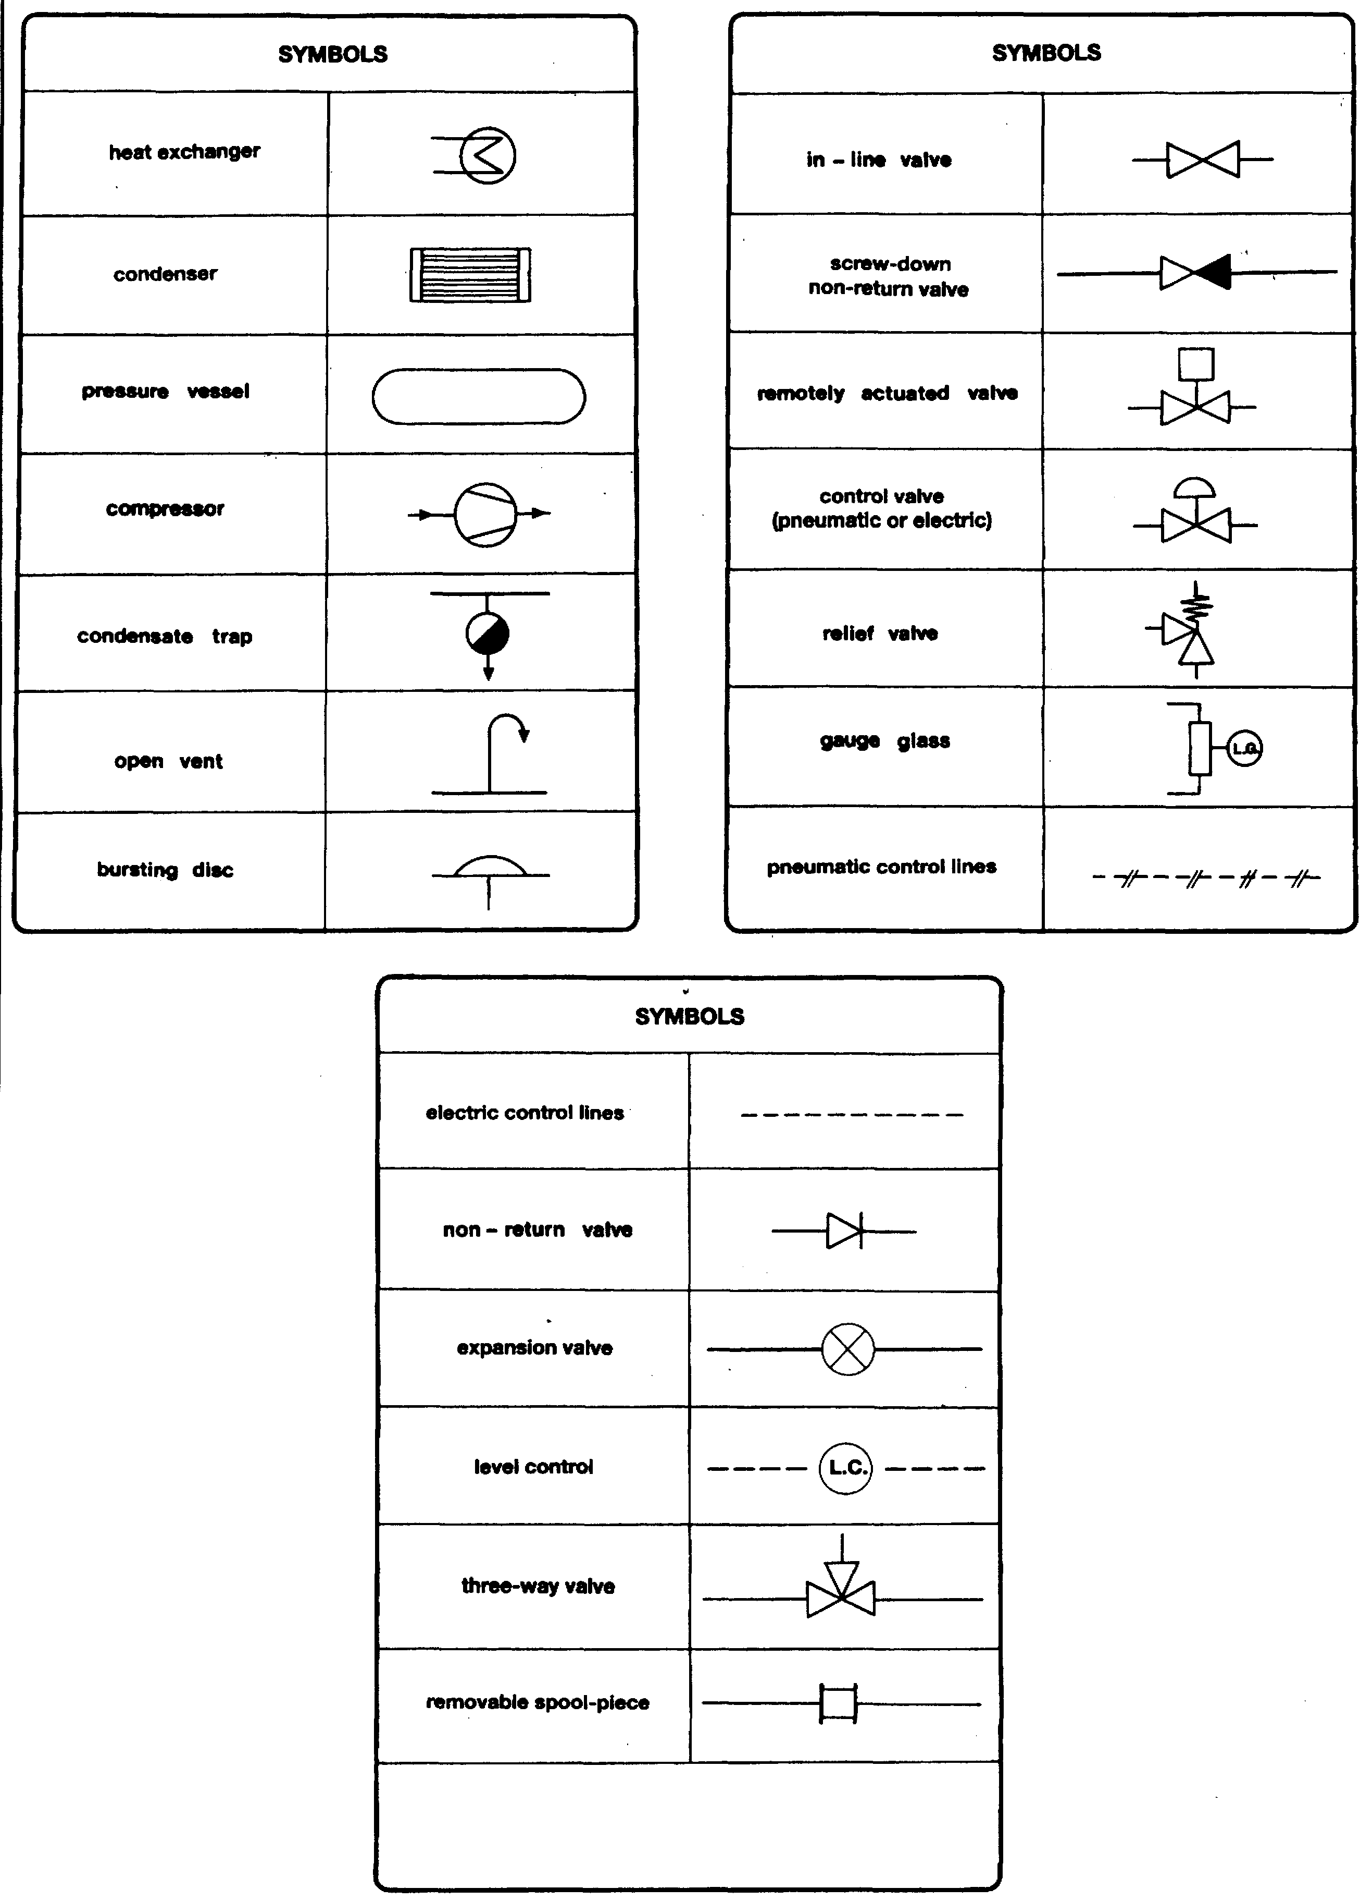
Explanation of symbols
Chapter 1
Introduction
This chapter provides an overview of the liquefied gases carried by sea and it concludes with some advice on the safety issues involving the ship, the terminal and the ship/shore interface. The latter point is of the utmost importance as this is where ship and shore personnel meet to plan safe operations. Subsequent chapters provide much greater detail about gas carrier cargoes and the equipment utilized on the ship and at the terminal jetty. They also cover operational and emergency procedures. Questions of health and safety are also covered and Chapter Six is devoted exclusively to ship/shore interface matters.
A thorough understanding of the basic principles outlined in this book is recommended as such knowledge will help ensure safer operations, better cargo planning and the efficient use of equipment found on gas carriers and on jetties.

1.1 LIQUEFIED GASES
A liquefied gas is the liquid form of a substance, which, at ambient temperature and at atmospheric pressure, would be a gas.
Most liquefied gases are hydrocarbons and the key property that makes hydrocarbons the world’s primary energy source — combustibility — also makes them inherently hazardous. Because these gases are handled in large quantities it is imperative that all practical steps are taken to minimize leakage and to limit all sources of ignition.
The most important property of a liquefied gas, in relation to pumping and storage, is its saturated vapor pressure. This is the absolute pressure (see 2.15) exerted when the liquid is in equilibrium with its own vapor at a given temperature. The International Maritime Organization (IMO), for the purposes of its Gas Carrier Codes (see Chapter Three), relates saturated vapor pressure to temperature and has adopted the following definition for the liquefied gases carried by sea:

Liquids with a vapor pressure exceeding 2.8 bar absolute at a temperature of 37.8°C
An alternative way of describing a liquefied gas is to give the temperature at which the saturated vapor pressure is equal to atmospheric pressure — in other words the liquid’s atmospheric boiling point.
In Table 1.1 some liquefied gases carried at sea are compared in terms of their vapor pressure at 37.8°C — the IMO definition — and in terms of their atmospheric boiling points.

Table 1.1 Physical properties of some liquefied gases
Liquefied gas | Vapor pressure at 37.8°C (bars absolute) | Boiling point at atmospheric pressure (°C)
Methane | Gas* | -161.5
Propane | 12.9 | -42.3
n-Butane | 3.6 | -0.5
Ammonia | 14.7 | -33.4
Vinyl chloride | 5.7 | -13.8
Butadiene | 4.0 | -5
Ethylene oxide | 2.7 | +10.7
*The critical temperature of methane is –87.5°C, while the critical pressure is 44.7 bars. Therefore at the 37.8°C it can only exist as a gas and not as a liquid.
On the basis of the above IMO definition, ethylene oxide (see Table 1.1) would not qualify as a liquefied gas. However, it is included in the International Code for the Construction and Equipment of Ships Carrying Liquefied Gases in Bulk (the IGC Code) because its boiling point at atmospheric pressure is so low that it would be difficult to carry the cargo by any method other than those prescribed for liquefied gases.
Likewise, chemicals such as diethyl ether, propylene oxide and isoprene are not strictly liquefied gases but they have high vapor pressures coupled with health and flammability hazards. As a result of such dangers these chemicals, and several similar compounds, have been listed jointly in both the IGC Code and the Bulk Chemical Codes. Indeed, when transported on chemical tankers, under the terms of the Bulk Chemical Codes, such-products are often required to be stowed in independent tanks rather than in tanks built into the ship’s structure.
The listing of liquefied and chemical gases given in the IGC Code is shown in Appendix 2.

1.2 LIQUEFIED GAS PRODUCTION
To assist in understanding the various terms used in the gas trade, this section discusses the manufacture of liquefied gases and describes the main gas carrier cargoes transported by sea. It is first of all necessary to differentiate between some of the raw materials and their constituents and in this regard the relationships between natural gas, natural gas liquids (NGLs) and Liquefied Petroleum Gases (LPGs) is shown in Figure 1.1.

Methane (C₁)

Water, carbon dioxide, nitrogen and non-hydrocarbon contaminants
NATURAL GAS

Ethane (C₂)

Pentane (C5) and
other heavier fractions
NGL

Propane (C₃)
Butane (C₄)

LPG

1.2.1 LNG PRODUCTION
Natural gas may be found in:
- Underground wells, which are mainly gas bearing (non-associated gas)
- Condensate reservoirs (pentanes and heavier hydrocarbons)
- Large oil fields (associated gas)
In the case of oil wells, natural gas may be either in solution with the crude oil or as a gas-cap above it.
Natural gas contains smaller quantities of heavier hydrocarbons (collectively known as natural gas liquids — NGLs). This is in addition to varying amounts of water, carbon dioxide, nitrogen and other non-hydrocarbon substances. These relationships are shown in Figure 1.1.
The proportion of NGL contained in raw natural gas varies from one location to another. However, NGL percentages are generally smaller in gas wells when compared with those found in condensate reservoirs or that associated with crude oil. Regardless of origin, natural gas requires treatment to remove heavier hydrocarbons and non-hydrocarbon constituents. This ensures that the product is in an acceptable condition for liquefaction or for use as a gaseous fuel.
Figure 1.2 is a typical flow diagram for a liquefaction plant used to produce liquefied natural gas (LNG). The raw feed gas is first stripped of condensates. This is followed by the removal of acid gases (carbon dioxide and hydrogen sulphide). Carbon dioxide must be removed as it freezes at a temperature above the atmospheric boiling point of LNG and the toxic compound hydrogen sulphide is removed as it causes atmospheric pollution when being burnt in a fuel. Acid gas removal saturates the gas stream with water vapor and this is then removed by the dehydration unit.

Figure 1.2 Typical flow diagram for LNG liquefaction.
The gas then passes to a fractionating unit where the NGLs are removed and further split into propane and butane. Finally, the main gas flow, now mostly methane, is liquefied into the end product, liquefied natural gas (LNG).
To lower the temperature of the methane gas to about -162°C (its atmospheric boiling point) there are three basic liquefaction processes in current use. These are outlined below:—
- Pure refrigerant cascade process — this is similar in principle to the cascade reliquefaction cycle described in 4.5 but in order to reach the low temperature required, three stages are involved, each having its own refrigerant, compressor and heat exchangers. The first cooling stage utilizes propane, the second is a condensation stage utilizing ethylene and, finally, a sub-cooling stage utilizing methane is involved. The cascade process is used in plants commissioned before 1970.
- Mixed refrigerant process — whereas with pure refrigerant process (as described above) a series of separate cycles are involved, with the mixed refrigerant process (usually methane, ethane, propane and nitrogen), the entire process is achieved in one cycle. The equipment is less complex than the pure refrigerant cascade process but power consumption is substantially greater and for this reason its use is not widespread.
- Pre-cooled mixed refrigerant process — this process is generally known as the MCR process (Multi-Component Refrigerant) and is a combination of the pure refrigerant cascade and mixed refrigerant cycles. It is by far the most common process in use today.
Fuel for the plant is provided mainly by flash-off gas from the reliquefaction process but boil-off from LNG storage tanks can also be used. If necessary, additional fuel may be taken from raw feed gas or from extracted condensates. Depending upon the characteristics of the LNG to be produced and the requirements of the trade, some of the extracted NGLs may be re-injected into the LNG stream.
1.2.2 LPG production
Liquefied petroleum gas (LPG) is the general name given for propane, butane and mixtures of the two. These products can be obtained from the refining of crude oil. When produced in this way they are usually manufactured in pressurized form.
However, the main production of LPG is found within petroleum producing countries. At these locations, LPG is extracted from natural gas or crude oil streams coming from underground reservoirs. In the case of a natural gas well, the raw product consists mainly of methane. However, as shown in Figure 1.2, in this process it is normal for NGLs to be produced and LPG may be extracted from them as a by-product.
A simple flow diagram, which illustrates the production of propane and butane from oil and gas reservoirs, is shown in Figure 1.3. In this example the methane and ethane, which have been removed, are used by the terminal’s power station, and the LPGs, after fractionation and chill-down, are pumped to terminal storage tanks prior to shipment for export.
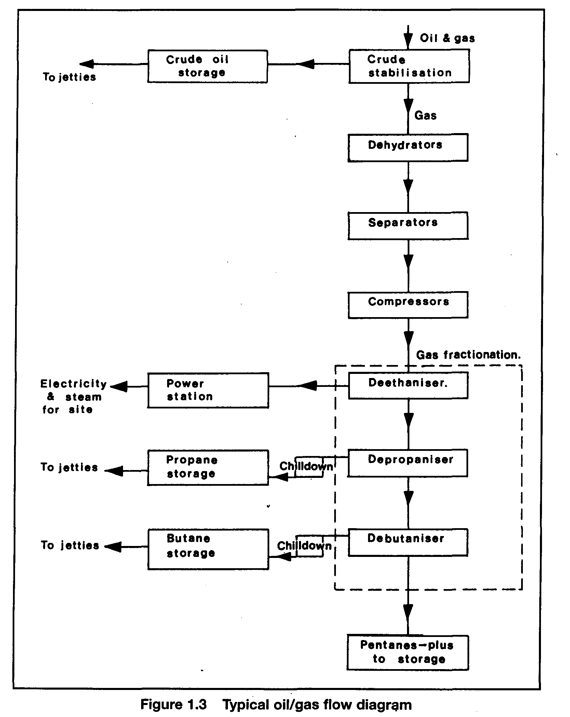
1.2.3 Production of chemical gases
A simplified diagram for the production of the chemical gases, vinyl chloride, ethylene and ammonia is shown in Figure 1.4. These three chemical gases can be produced indirectly from propane. The propane is first cracked catalytically into methane and ethylene. The ethylene stream can then be synthesized with chlorine to manufacture vinyl chloride. In the case of the methane stream, this is first reformed with steam into hydrogen. By combining this with nitrogen under high pressure and temperature, in the presence of a catalyst, ammonia is produced.

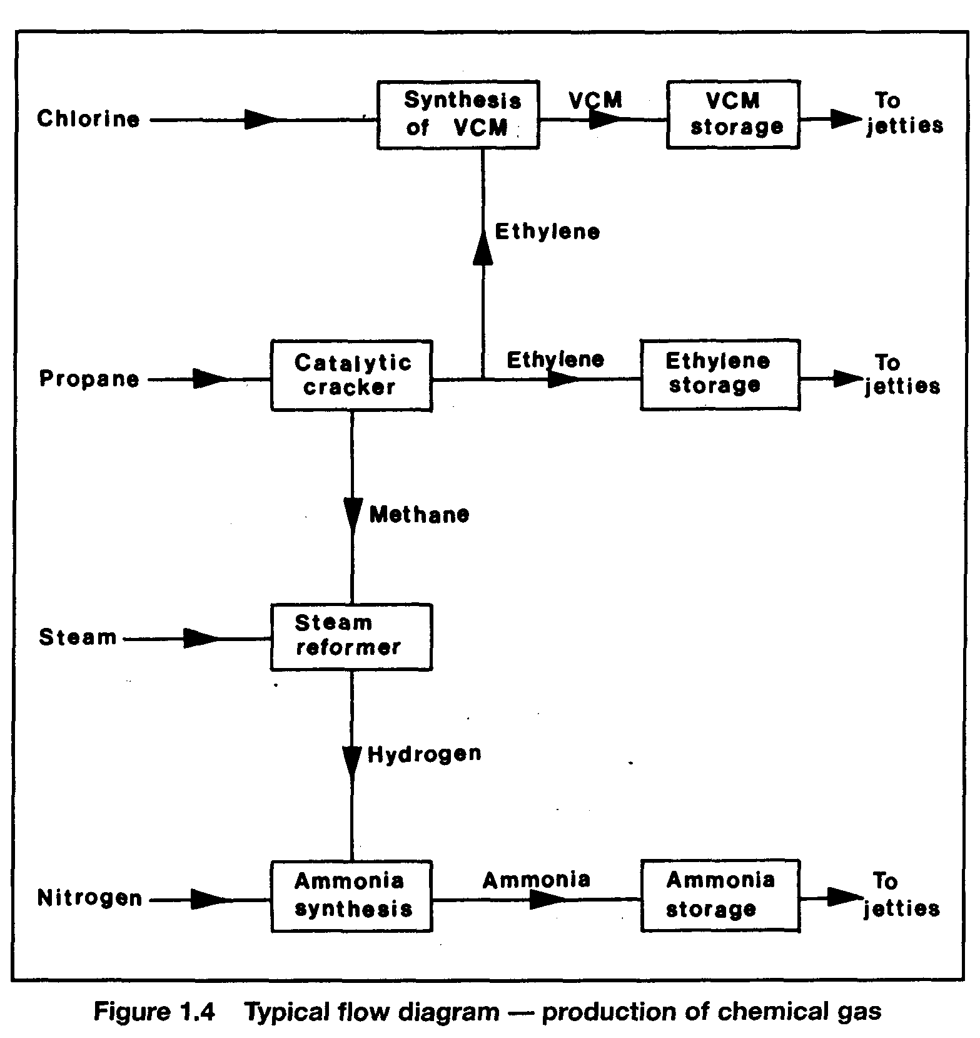
1.2.4 The principal products
Whilst the hydrocarbon gases methane, ethane, propane and butane may be regarded principally as fuels, the LPGs are also important as feedstocks in the production of the chemical gases.

Liquefied Natural Gas (LNG)
Natural gas is transported either by pipeline as a gas or by sea in its liquefied form as LNG.
Natural gas comes from underground deposits as described in 1.2.1. Its composition varies according to where it is found but methane is by far the predominant constituent, ranging from 70 per cent to 99 per cent. Natural gas is now a major commodity in the world energy market and approximately 73 million tonnes are carried by sea each year. This is expected to increase to 100 million tonnes per year by the end of the millennium.

Natural Gas Liquids (NGLs)
Associated gas, found in combination with crude oil, comprises mainly methane and NGLs. As shown in Figure 1.1, the NGLs are made up of ethane, LPGs and gasoline. A small number of terminals, including several facilities in Europe, have the ability to strip methane from the gas stream and to load raw NGLs onto semi-pressurized gas carriers. These ships are modified with additional compressor capacity for shipment to customers able to accept such ethane-rich cargoes. These NGLs are carried at -80°C at atmospheric pressure or at -45°C at a vapor pressure of 5 bar.

The Liquefied Petroleum Gases (LPG)
The liquefied petroleum gases comprise propane, butane and mixtures of the two. Butane stored in cylinders and thus known as bottled gas, has widespread use as a fuel for heating and cooking in remote locations. However, it is also an important octane enhancer for motor gasoline and a key petrochemical feedstock. Propane, too, is utilized as a bottled gas, especially in cold climates (to which its vapor pressure is more suited). However, LPG is mainly used in power generation, for industrial purposes such as metal cutting and as a petrochemical feedstock. About 169 million tonnes of LPG are produced each year worldwide and, of this, about 43.7 million tonnes are transported by sea.
Ammonia
With increased pressure on the world’s food resources, the demand for nitrogen-containing fertilizers, based on ammonia, expanded strongly during the 1970s and 1980s. Large-scale ammonia plants continue to be built in locations rich in natural gas, which is the raw material most commonly, used to make this product. Ammonia is also used as an on-shore industrial refrigerant, in the production of explosives and for numerous industrial chemicals such as urea. Worldwide consumption of this major inorganic base chemical in 1996 was 120 million tonnes. About 12 million tonnes of ammonia are shipped by sea each year in large parcels on fully refrigerated carriers and this accounts for the third largest sea borne trade in liquefied gases — after LNG and LPG.

Ethylene
Ethylene is one of the primary petrochemical building blocks. It is used in the manufacture of polyethylene plastics, ethyl alcohol, polyvinyl chloride (PVC), antifreeze, polystyrene and polyester fibers. It is obtained by cracking either naphtha, ethane or LPG. About 85 million tonnes of ethylene is produced worldwide each year but, because most of this output is utilized close to the point of manufacture, only some 2.5 million tonnes is moved long distances by sea on semi-pressurized carriers.

Propylene
Propylene is a petrochemical intermediate used to make polypropylene and poly-urethane plastics, acrylic fibers and industrial solvents. As of mid-1996, annual worldwide production of propylene was 42 million tonnes, with about 1.5 million tonnes of this total being carried by semi-pressurized ships on deep-sea routes.

Butadiene
Butadiene is a highly reactive petrochemical intermediate. It is used to produce styrene, acrylonitrile and polybutadiene synthetic rubbers. Butadiene is also used in paints and binders for non-woven fabrics and, as an intermediate, in plastic and nylon production. Most butadiene output stems from the cracking of naphtha to produce ethylene. Worldwide total production of Butadiene in 1996 was 6.9 million tonnes. About 800,000 tonnes of butadiene is traded by sea each year.

Vinyl chloride
Vinyl chloride is an easily liquefiable, chlorinated gas used in the manufacture of PVC, the second most important thermoplastic in the world in terms of output. Vinyl chloride not only has a relatively high boiling point, at -14°C, but is also, with a specific gravity of 0.97, much denser than the other common gas carrier cargoes. Worldwide production of vinyl chloride in 1996 was 22.3 million tonnes. Some 2 million tonnes of vinyl chloride is carried by sea each year.

1.3 TYPES OF GAS CARRIERS
Gas carriers range in capacity from the small pressurized ships of between 500 and 6,000 m³ for the shipment of propane, butane and the chemical gases at ambient temperature up to the fully insulated or refrigerated ships of over 100,000 m³ capacity for the transport of LNG and LPG. Between these two distinct types is a third ship type — the semi-pressurized gas carrier. These very flexible ships are able to carry many cargoes in a fully refrigerated condition at atmospheric pressure or at temperatures corresponding to carriage pressures of between five and nine bar.
The movement of liquefied gases by sea is now a mature industry, served by a fleet of over 1,000 ships, a worldwide network of export and import terminals and a wealth of knowledge and experience on the part of the various people involved. In 1996 this fleet transported about 62.5 million tonnes of LPG and chemical gases and 73 million tonnes of LNG. In the same year the ship numbers in each fleet were approximately as follows: —
- LNG carriers 105
- Fully refrigerated ships 183
- Ethylene carriers 100
- Semi-pressurized ships 276
- Pressurized ships 437

Gas carriers have certain design features in common with other ships used for the carriage of bulk liquids such as oil and chemical tankers. Chemical tankers carry their most hazardous cargoes in center tanks, whilst cargoes of lesser danger can be shipped in the wing tanks. New oil tankers are required to have wing and double bottom ballast tanks located to give protection to the cargo. The objective in both these cases is to protect against the spillage of hazardous cargo in the event of a grounding or collision. This same principle is applied to gas carriers.
A feature almost unique to the gas carrier is that the cargo tanks are kept under positive pressure to prevent air entering the cargo system. This means that only cargo liquid and cargo vapor are present in the cargo tank and flammable atmospheres cannot develop. Furthermore all gas carriers utilise closed cargo systems when loading or discharging, with no venting of vapors being allowed to the atmosphere. In the LNG trade, provision is always made for the use of a vapor return line between ship and shore to pass vapor displaced by the cargo transfer. In the LPG trade this is not always the case as, under normal circumstances during loading, reliquefaction is used to retain vapor on board. By these means cargo release to the atmosphere is virtually eliminated and the risk of vapor ignition is minimized.
Gas carriers must comply with the standards set by the International Maritime Organization in the Gas Codes (see Chapter Three), and with all safety and pollution requirements common to other ships. The Gas Codes are a major pro-active feature in IMO’s legislative programme. The safety features inherent in the Gas Codes’ ship design requirements have helped considerably in the safety of these ships. Equipment requirements for gas carriers include temperature and pressure monitoring, gas detection and cargo tank liquid level indicators, all of which are provided with alarms and ancillary instrumentation. The variation of equipment as fitted can make the gas carrier one of the most sophisticated ships afloat today.
There is much variation in the design, construction and operation of gas carriers due to the variety of cargoes carried and the number of cargo containment systems utilized. Cargo containment systems may be of the independent tanks (pressurized, semi-pressurized or fully refrigerated) or of the membrane type (see 3.2.2). Some of the principal features of these design variations and short histories of each trade are described below.

Fully pressurized ships
The seaborne transport of liquefied gases began in 1934 when a major international company put two combined oil/LPG tankers into operation. The ships, basically oil tankers, had been converted by fitting small, riveted, pressure vessels for the carriage of LPG into cargo tank spaces. This enabled transport over long distances of substantial volumes of an oil refinery by-product that had distinct advantages as a domestic and commercial fuel. LPG is not only odorless and non-toxic, it also has a high calorific value and a low sulphur content, making it very clean and efficient when being burnt.
Today, most fully pressurized LPG carriers are fitted with two or three horizontal, cylindrical or spherical cargo tanks and have capacities up to 6,000 m³. However, in recent years a number of larger capacity fully-pressurized ships have been built with spherical tanks, most notably a pair of 10,000 m³ ships, each incorporating five spheres, built by a Japanese shipyard in 1987. Fully pressurized ships are still being built in numbers and represent a cost-effective, simple way of moving LPG to and from smaller gas terminals.

Semi-pressurized ships
Despite the early breakthrough with the transport of pressurized LPG, ocean movements of liquefied gases did not really begin to grow until the early 1960s with the development of metals suitable for the containment of liquefied gases at low temperatures. By installing a reliquefaction plant, insulating the cargo tanks and making use of special steels, the shell thickness of the pressure vessels, and hence their weight, could be reduced.
The first ships to use this new technology appeared in 1961. They carried gases in a semi-pressurized/semi-refrigerated (SP/SR) state but further advances were quickly made and by the late 1960s semi-pressurized/fully refrigerated (SP/FR) gas carriers had become the shipowners’ choice by providing high flexibility in cargo handling. Throughout this book the SP/FR ships are referred to as semi-pressurized ships. These carriers, incorporating tanks either cylindrical, spherical or bi-lobe in shape, are able to load or discharge gas cargoes at both refrigerated and pressurized storage facilities. The existing fleet of semi-pressurized ships comprises carriers in the 3,000-15,000 m³ size range, although there is a notable exception — a ship of 30,000 m³ delivered in 1985.

Ethylene and gas/chemical carriers
Ethylene carriers are the most sophisticated of the semi-pressurized tankers and have the ability to carry not only most other liquefied gas cargoes but also ethylene at its atmospheric boiling point of -104°C. The first ethylene carrier was built in 1966 and, as of 1995, there were about 100 such ships in service ranging in capacity from 1,000 to 12,000m³.
Of this ethylene carrier fleet, about one dozen form a special sub-group of ships able to handle a wide range of liquid chemicals and liquefied gases simultaneously. These ships feature cylindrical, insulated, stainless steel cargo tanks able to accommodate cargoes up to a maximum specific gravity of 1.8 at temperatures ranging from a minimum of -104°C to a maximum of +80°C and at a maximum tank pressure of 4 bar. The ships can load or discharge at virtually all pressurized and refrigerated terminals, making them the most versatile gas carriers in terms of cargo-handling ability.

Fully refrigerated ships
The 1960s also saw another major development in gas carrier evolution — the appearance of the first fully refrigerated ship, built to carry liquefied gases at low temperature and atmospheric pressure between terminals equipped with fully refrigerated storage tanks. A Japanese shipyard, to a United States design, constructed the first purpose-built, fully refrigerated LPG carrier in 1962. The ship had four prismatic-shaped (box-like) cargo tanks fabricated from 3% per cent nickel steel, allowing the carriage of cargoes at temperatures as low as -48°C, marginally below the atmospheric boiling point of pure propane. Prismatic tanks enabled the ship’s cargo carrying capacity to be maximized, thus making fully refrigerated ships highly suitable for carrying large volumes of cargo such as LPG, ammonia and vinyl chloride over long distances. Today, fully refrigerated ships range in capacity from 20,000 to 100,000m³.
The main types of cargo containment system utilized on board modern fully refrigerated ships are independent tanks having rigid foam insulation. Older ships can have independent tanks with loosely filled perlite insulation. In the past, there have been a few fully refrigerated ships built with semi-membrane or integral tanks and internal insulation tanks, but these systems have only maintained minimal interest.

Liquefied natural gas (LNG) carriers
At about the same time as the development of fully refrigerated LPG carriers was taking place, naval architects were facing their most demanding gas carrier challenge. This was the transport of LNG. Natural gas, another clean, non-toxic fuel, is now the third most important energy source in the world, after oil and coal, but is often produced far from the centers of consumption. Because a gas in its liquefied form occupies much less space, and because of the critical temperature of liquefied methane, the ocean transport of LNG only makes sense from a commercial viewpoint if it is carried in a liquefied state at atmospheric pressure; as such, it represents greater engineering challenge than shipping LPG, mainly because it has to be carried at a much lower temperature; its boiling point being -162°C.
The pioneering cargo of LNG was carried across the Atlantic Ocean in 1958 and by 1964 the first purpose-built LNG carriers were in service under a long-term gas purchase agreement. LNG containment system technology has developed considerably since those early days: now about one-half of the LNG carriers in service are fitted with independent cargo tanks and one-half with membrane tanks. The majority of LNG carriers are between 125,000 and 135,000 m³ in capacity. In the modern fleet of LNG carriers, there is an interesting exception concerning ship size. This is the introduction of several smaller ships of between 18,000 and 19,000 m³ having been built in 1994 and later to service the needs of importers of smaller volumes.

1.4 THE SHIP/SHORE INTERFACE AND JETTY STANDARDS
In comparison to most other ship types, gas carriers have a better safety record. However, casualty statistics involving gas carriers demonstrate that the risk of a serious accident is potentially greater when the ship is in port than when at sea. For this reason it is appropriate that attention should concentrate on the port facilities and the activities of ship and shore personnel involved in cargo operations.
1.4.1 Safe jetty designs
The ship/shore interface is a vital area for consideration in the safety of the liquefied gas trade. Considering jetty design (and the equipment which may be needed), safety in this area requires a good understanding of ship parameters before construction begins. In this context the following points are often addressed by terminal designers: —
- The berth’s safe position regarding other marine traffic
- The berth’s safe position in relation to adjacent industry
- Elimination of nearby ignition sources
- Safety distances between adjacent ships
- The range of acceptable ship sizes
- Ships’ parallel body length — for breasting dolphin positioning
- Suitable jetty fender designs
- Properly positioned shore mooring points of suitable strength
- Tension-monitoring equipment for mooring line loads
- Suitable water depths at the jetty
- Indicators for ship’s speed of approach to the jetty
- The use of hard arms and their safe operating envelopes
- Emergency shut-down systems — including interlinked ship/shore control
- Suitable plugs and sockets for the ship/shore link
- A powered emergency release coupling on the hard arm
- Vapor return facilities
- Nitrogen supply to the jetty
- Systems for gas-leak detection
- A safe position for ship/shore gangway
- Design to limit surge pressures in cargo pipelines
- Verbal communication systems
- The development of Jetty Information and Regulations
- Jetty life saving and fire-fighting equipment
- Systems for the warning of the onset of bad weather
- The development of Emergency Procedures
Further issues have to be considered in the port approach. These may include the suitability of Vessel Traffic Management Systems, and the sizing of fairways and turning basins. However, these latter points fall outside of the scope of this publication.

1.4.2 Jetty operations
The ship/shore interface is the area where activities of personnel on the ship and shore overlap during cargo handling. Actions on one side of the interface will affect the other party and responsibility for safe operations does not stop at the cargo manifold for either ship or shore personnel. The responsibility for cargo handling operations is shared between the ship and the terminal and rests jointly with the shipmaster and responsible terminal representative. The manner in which the responsibility is shared should, therefore, be agreed between them so as to ensure that all aspects of the operations are covered.
From an operational viewpoint it should be appreciated that at the ship/shore interface two differing cultures co-exist. To ensure safe operations, a proper understanding of the working practices of both ship and shore personnel is necessary. Equally, before and during operations, procedures of practical relevance have to be in place and jointly understood by ship and shore personnel. Most often this is best achieved by properly addressing the Ship/Shore Safety Check List (see Appendix 3) and a suitable terminal operating manual, containing Jetty Information and Regulations, which should be passed to the ship, should supplement this.
There is much variation in the design and operation of terminals and jetties and not all are dedicated solely to the handling of liquefied gases. Sometimes the combined nature of the products handled can complicate operations. Equally, however, variations in gas carrier and jetty construction can heighten the importance of safety issues at the interface, making them an important area requiring proper controls and good operational procedures.
LPG berths may have to handle ships of varying size and having a range of different cargo handling equipment. Jetties may be relatively new, and fitted with modern cargo facilities. Conversely, they may be relatively old using flexible hoses for cargo transfer. Of course, many jetties fall between these two extremes. At LPG berths, local design variation at the ship/shore connection may result in the need to use either hoses or all-metal hard arms. The hard arm may be hydraulically operated: it may be fitted with emergency release couplings and an emergency release system.
LNG terminals are an exception to the foregoing — they are primarily dedicated to this single product, although some LNG jetties also handle LPGs and condensates. In most cases such berths have been specially built for a particular export/import project. LNG jetties only use hard arms for cargo transfer. The hard arm is invariably hydraulically operated. Almost certainly, it will be fitted with emergency release couplings and an emergency release system.
Liquefied gas cargo handling procedures can be complex and the cargo itself is potentially hazardous. For these reasons, the persons operating gas carriers and gas berths require a thorough understanding of ship and shore equipment and cargo properties. They need to have available good operating procedures so as to avoid accident and emergency plans should be in place in case an accident does occur.
For ships’ personnel, much of this information is made available by means of approved courses to obtain dangerous cargo endorsements for sea-going certificates. For terminal personnel, such background may be available at national institutions; alternatively, terminal managements may find References 2.19 and 2.32 of benefit.

Chapter 2
Properties of Liquefied Gases
This chapter deals with the basic physics and chemistry of liquefied gases. The text then discusses the theory of ideal gases and continues into a description of refrigeration and its application at sea. Certain sections explain particular problems encountered such as hydrate formation, polymerization and stress corrosion cracking. Many of these particular issues are more fully appraised in other publications and reference can be made to Appendix 1 for further details.

2.1 CHEMICAL STRUCTURE OF GASES
Chemical compounds with the same chemical structure are often known by different names. An alternative name given to the same compound is called a synonym. Table 2.1 gives a list of the synonyms of the main liquefied gases against each common name and its simple formula. The more complex compounds tend to have a larger number of synonyms than the simple compounds.
The simple chemical formula, as shown in Table 2.1, gives the ratio of atoms of each element in the compound. Since a molecule is the smallest part of the compound, which exhibits all the chemical properties of that specific material, this formula is often referred to as the molecular formula.
Hydrocarbons are substances whose molecules contain only hydrogen and carbon atoms. The molecules can be in various arrangements and the products may be gases, liquids or solids at ambient temperatures and pressures, depending upon the number of the carbon atoms in the molecular structure. Generally, those hydrocarbons with up to four carbon atoms are gaseous at ambient conditions and comprise the hydrocarbon liquefied gases. Hydrocarbons with five up to about twenty carbon atoms are liquid at ambient conditions and those with more carbon atoms are solid. The carbon atom has four bonds, which can unite with other carbon atoms or with atoms of other elements. A hydrogen atom, however, has only one bond and can unite with only one other atom. Where the relative numbers of carbon and hydrogen atoms in a hydrocarbon molecule permit the carbon atoms to use their bonds singly to other carbon atoms, the molecule is said to be saturated. Figure 2.1 illustrates the saturated molecular structure of iso-butane (i-butane) and normal butane (n-butane). Examination of these examples shows that, for saturated hydrocarbons, the proportion of carbon and hydrogen atoms in the molecule is in accordance with the formula C₄H_{2n+2}. Thus, methane (CH₄), ethane (C₂H₆), and propane (C₃H₈) are all saturated hydrocarbons.
Where there is less than the full complement of hydrogen atoms, as given by the above formula, two or more carbon atoms become inter-linked by double or triple bonds. For
Table 2.1 Synonyms for the main liquefied gases
Common Name | Simple Formula | Synonyms
Methane | CH₄ | Fine damp; marsh gas; natural gas; LNG
Ethane | C₂H₆ | Bimethyl; dimethyl; methyl methane
Propane | C₃H₈ | -
n-Butane | C₄H₁₀ | Normal-butane
i-Butane | C₄H₁₀ | Iso-butane; 2-methlypropane
Ethylene | C₂H₄ | Ethene
Propylene | C₃H₆ | Propene
α-Butylene | C₄H₈ | But-1-ene; ethyl ethylene
β-Butylene | C₄H₈ | But-2-ene; dimethyl ethylene; pseudo butylene
γ-Butylene | C₄H₈ | Isobutene; 2-methylprop-2-ene
Butadiene | C₄H₆ | b.d.; bivinyl; 1,3 butadiene; butadiene 1-3; divinyl; biethylene; erythrene; vinyl ethylene
Isoprene | C₅H₈ | 3-methyl -1,3 butadiene; 2-methyl -1,3 butadiene; 2-methylbutadiene-1,3
Vinyl chloride | C₂H₃Cl | Chloroethene; chloroethylene; VCM; Vinyl chloride monomer
Ethylene oxide | C₂H₄O | Dimethylene oxide; EO; 1,2 epoxyethane; oxirane
Propylene oxide | C₃H₆O | 1,2 epoxy propane; methyl oxirane; propene oxide
Ammonia | NH₃ | Anhydrous ammonia; ammonia gas; liquefied ammonia; liquid ammonia

Note: Commercial propane contains some butane; similarly, commercial butane contains some propane. Both may contain impurities such as ethane and pentane, depending on their permitted commercial specification. Some further data on mixtures is given in 2.17 and 2.18.
This reason they are called unsaturated. These links between carbon atoms are weaker than single bonds, with the result that such compounds are chemically more reactive than the single-bonded compounds.
Figure 2.2 illustrates the molecular structure of two such unsaturated hydrocarbons, propylene (C₃H₆), and butadiene (C₄H₆). Ethylene (C₂H₄) is a further example of an unsaturated hydrocarbon.
The third group of liquefied gases consists of the chemical gases. These are characterized by additional atoms other than carbon and hydrogen. Figure 2.3 illustrates the molecular structure of two such compounds, propylene oxide (C₃H₆O) and vinyl chloride (C₂H₃Cl). Most compounds in this grouping are chemically reactive.

2.2 SATURATED AND UNSATURATED HYDROCARBONS

Saturated hydrocarbons
The saturated hydrocarbons, methane, ethane, propane and butane are all colorless and odorless liquids.
They are all flammable gases and will burn in air or oxygen to produce carbon dioxide and water vapor. They do not present chemical compatibility problems when in contact with the construction materials commonly encountered in gas handling. In the presence of moisture, however, the saturated hydrocarbons may form hydrates (see 2.7).

Unsaturated hydrocarbons
The unsaturated hydrocarbons, ethylene, propylene, butylene, butadiene and isoprene are colorless liquids with a faint, sweetish odor. Like the saturated hydrocarbons they are all flammable in air or oxygen, producing carbon dioxide and water vapor. They are more reactive, from a chemical viewpoint, than the saturated hydrocarbons and may react dangerously with chlorine. Ethylene, propylene and butylene do not present chemical compatibility problems with materials of construction, whereas butadiene and isoprene, each having two pairs of double bonds, are by far the most reactive within this family. They may react with air to form unstable peroxides, which tend to induce polymerization (see 2.6). Butadiene is incompatible in the chemical sense with copper, silver, mercury, magnesium, aluminum and monel. During production, butadiene streams often contain traces of acetylene, which can react with brass and copper to form explosive acetylides.
Water is soluble in butadiene, particularly at high temperatures and Figure 2.4 illustrates this effect. In this diagram the figures quoted are for the purpose of illustration only. As can be seen, on cooling water-saturated butadiene, the solubility of the water decreases and water will separate out as droplets, which settle as a layer in the bottom of the tank. For instance, on cooling water-saturated butadiene from +15°C to +5°C approximately 100 parts per million of free water separates out. On this basis, for a 1,000 m³ tank, 0.1 m³ of free water would require to be drained from the bottom of the tank. On further cooling to below zero, this layer of water would increase in depth and freeze.
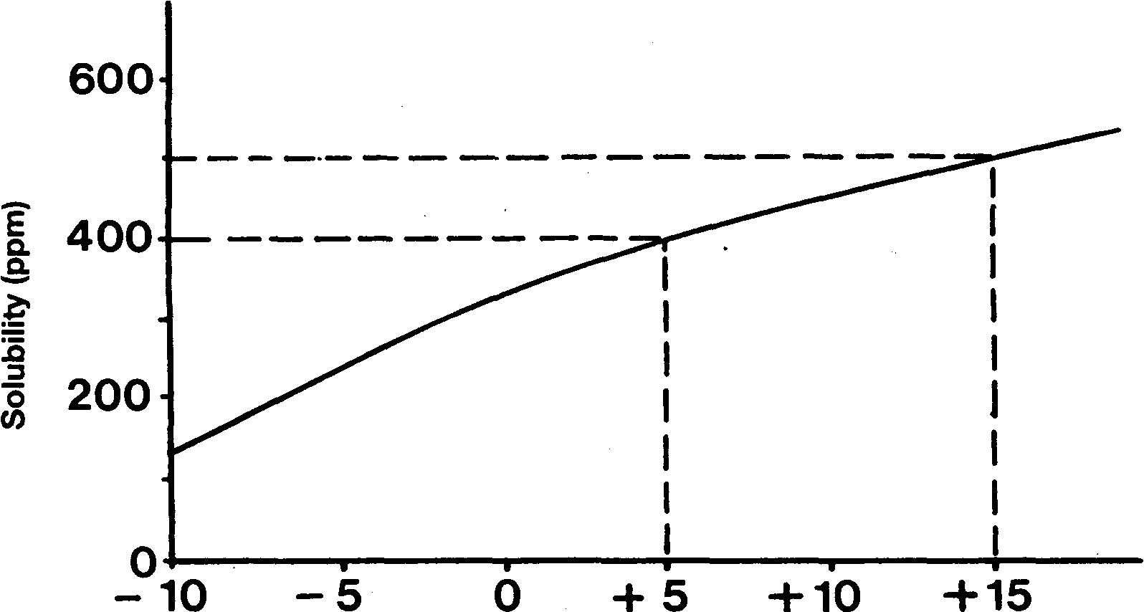
Figure 2.4 Solubility of water in butadiene

THE CHEMICAL GASES
The chemical gases commonly transported in liquefied gas carriers are ammonia, vinyl chloride, ethylene oxide and propylene oxide. Apart from the latter two examples, since these gases do not belong to one particular family, their chemical properties vary considerably.
Ammonia is a colorless alkaline liquid with a pungent odor. The vapors of ammonia are flammable and burn with a yellow flame, forming water vapor and nitrogen. However, ammonia vapor in air requires a high concentration (14-28 per cent) to be flammable, has a high ignition energy requirement (600 times that for propane) and burns with low combustion energy. For these reasons, the Gas Codes, while requiring full attention to the avoidance of ignition sources, do not require flammable gas detection in the hold or interbarrier spaces. Nevertheless, ammonia must always be regarded as a flammable cargo.
Ammonia is toxic and highly reactive. It can form explosive compounds with mercury, chlorine, iodine, bromine, calcium, silver oxide and silver hypochlorite. Ammonia vapor is extremely soluble in water and will be absorbed rapidly and exothermically to produce a strong alkaline solution of ammonium hydroxide. One volume of water will absorb approximately 200 volumes of ammonia vapor. For this reason it is unsafe to introduce water into a tank containing ammonia vapor, as this can result in a vacuum condition rapidly developing within the tank. (See also 7.9.5)
Since ammonia is alkaline, ammonia vapor/air mixtures may cause stress corrosion on cargo tank shells. The factors contributing to stress corrosion cracking are the material of construction, residual stress within structures (from tank fabrication) and the nature of the cargo (including its temperature, pressure and impurities). Stress corrosion cracking occurs as a result of a chemical reaction and thus will happen faster at higher temperatures.
Stress corrosion cracking is identified as cracking in a containment vessel where (typically) fine cracks may be formed in many directions. Cracks caused by stress corrosion cracking are usually fine and brittle in nature (see Reference 2.30).
The risk of stress corrosion cracking occurring can be reduced by the following measures:
- The provision of refrigerated storage at a temperature of below -30°C
- During construction, by using steels having a low yield strength
- During construction, by having tank welds stress-relieved by thermal methods
- Adding 0.2 per cent water to the ammonia
- Developing procedures to minimize the ammonia being contaminated with air
Because of ammonia’s highly reactive nature, copper alloys, aluminum alloys, galvanized surfaces, phenolic resins, polyvinyl chloride, polyesters and viton rubbers are unsuitable for ammonia service. Mild steel, stainless steel, neoprene rubber and polythene are, however, suitable.
Vinyl chloride is a colorless liquid with a characteristic sweet odor. It is highly reactive, though not with water, and may polymerize in the presence of oxygen, heat and light. Its vapors are highly toxic and flammable. Aluminum alloys, copper, silver, mercury and magnesium are unsuitable for vinyl chloride service. Steels are, however, chemically compatible.
Ethylene oxide and propylene oxide are colorless liquids with an ether-like odor. They are flammable, toxic and highly reactive. Both polymerize; ethylene oxide does so more readily than propylene oxide, particularly in the presence of air or impurities. Both gases may react dangerously with ammonia. Cast iron, mercury, aluminum alloys, copper and alloys of copper, silver and its alloys, magnesium and some stainless steels are unsuitable for the handling of ethylene oxide. Mild steel and certain other stainless steels are suitable as tank shell construction materials for both ethylene and propylene oxides.
Chlorine is a much less frequently carried cargo and restricted to special ships. It is a yellow liquid, which evolves a green vapor. It has a pungent and irritating odor and is highly toxic. It is non-flammable but it can support combustion of other flammable materials in much the same way as oxygen. It is soluble in water forming a highly corrosive acidic solution and can form dangerous reactions with all the other liquefied gases. In the moist condition, because of its corrosivity, it is difficult to contain. Dry chlorine is compatible with mild steel, stainless steel, monel and copper. Chlorine is very soluble in caustic soda solution, which can be used to absorb chlorine vapor.

2.4 CHEMICAL PROPERTIES
The chemical properties and compatibilities of many liquefied gases are summarized in Tables 2.2, 2.3(a) and 2.3(b). For details of chemical reactivity and of suitable materials of construction for the various liquefied gases, reference should be made to the data sheets contained in Reference 1.1 and Reference 2.1 in Appendix 1.

Table 2.2 Chemical properties of liquefied gases
 | Methane | Ethane | Propane | Butane | Ethylene | Propylene | Butylene | Butadiene | Isoprene | Ammonia | Vinyl Chloride | Ethylene Oxide | Propylene Oxide | Chlorine
Flammable | X | X | X | X | X | X | X | X | X | X | X | X | X
Toxic |  |  |  |  |  |  |  | X |  | X | X | X | X | X
Polymerisable |  |  |  |  |  |  |  | X | X |  | X | X
REACTIVE WITH
Magnesium |  |  |  |  |  |  |  | X | X |  |  | X | X
Mercury |  |  |  |  |  |  |  | X | X | X |  | X | X | X
Zinc |  |  |  |  |  |  |  |  |  | X |  |  |  | X
Copper |  |  |  |  |  |  |  | X | X | X |  | X | X
Aluminum |  |  |  |  |  |  |  | X | X | X | X | X | X | X
Mild carbon steel | X3 |  |  |  | X1
Stainless steel |  |  |  |  |  |  |  |  |  |  |  | X2
Iron |  |  |  |  |  |  |  |  |  |  |  | X | X
PTFE* |  |  |  |  |  |  |  |  |  | X
PVC+ |  |  |  |  |  |  |  |  |  | X
Polyethylene | X3 | X | X | X |  |  | X
Ethanol |  |  |  |  |  |  |  |  |  |  |  |  |  | X
Methanol |  |  |  |  |  |  |  |  |  |  |  |  |  | X

Notes:’ Study can be made to the data sheets in the Reference 2.1 or to the IGC Code for further details on chemical reactivity.
1 Stainless steel containing 9 per cent nickel is the usual containment material for ethylene.
2 Refer to IGC Code - Section 17.16.3
3 Not suitable with liquid methane due to brittle fracture.
*PTFE- polytetrafluoroethylene (jointing material)
†PVC:- polyvinyl chloride (electric cable insulation)

Table 2.3(a) Chemical compatibilities of chemical gases X=incompatible
Carbon dioxide |  |  |  |  |  |  |  |  |  | x
Oxygen or Air |  |  |  |  |  |  |  | x | x |  | x | x
Water vapor |  |  |  |  |  |  |  | x | x |  |  |  |  | x
Chlorine | X | x | X | x | x | x | x | x | x | x | x |  |  |  | x
Propylene oxide |  |  |  |  |  |  |  |  |  | x
Ethylene oxide |  |  |  |  |  |  |  |  |  | x |  |  |  |  |  | x
Vinyl chloride |  |  |  |  |  |  |  |  |  |  |  |  |  | x |  | x
Ammonia |  |  |  |  |  |  |  |  |  |  |  | x | x | x |  |  | x
Isoprene |  |  |  |  |  |  |  |  |  |  |  |  |  | x | x | x
Butadiene |  |  |  |  |  |  |  |  |  |  |  |  |  | x | x | x
Butylene |  |  |  |  |  | ‘ |  |  |  |  |  |  |  | x
Propylene |  |  |  |  |  |  |  |  |  |  |  |  |  | x
Ethylene |  |  |  |  |  |  |  |  |  |  |  |  |  | x
Butane |  |  |  |  |  |  |  |  |  |  |  |  |  | x
Propane |  |  |  |  |  |  |  |  |  |  |  |  |  | x
Ethane |  |  |  |  |  |  |  |  |  |  |  |  |  | x
Methane |  |  |  |  |  |  |  |  |  |  |  |  |  | x
 | Methane | Ethane | Propane | Butane | Ethylene | Propylene | Butylene | Butadiene | Isoprene | Ammonia | Vinyl Chloride | Ethylene oxide | Propylene Oxide | Chlorine | Oxygen or Air | Carbon Dioxide

Table 2.3(b) Previous cargo compatibilities of liquefied gases
TANK CLEANING TABLE

NEXT CARGO

 | Butane | Butadiene | Butylene | C4-Raff | Ethylene | Propane | Propylene | Propylene Oxide | Propane Propylene mix | Vinyl Chloride | C4-Crude’
O₂ Content | <0.5% | <0.2% | <0.3% | <0.3% | <0.3% | <0.5% | <0.3% | <0.1% | <0.3% | <0.1% | <0.3%
Dew-point | <-10ºC | <-10º’C | <-10ºC | <-10º’C | <-50ºC | <-40ºC | <-25ºC | <-40ºC | <-40ºC | <-20ºC | <-10ºC
LAST CARGO

Ammonia | Loading cargo after ammonia is often subject to specific terminal requirements  Loadin  g cargoes after a  mmonia is often subject to specific terminal requ  irements
Butane |  | N₂  <5% | N₂I  <5% | ET | V,N₂ | S | V,N₂ | V,N₂ | ET | V,N₂ | ET
Butadiene | ET |  | N₂I  <25%  N,I  <25% | N₂I  <25% | V,N₂ | ET | V,N₂ | V,N₂ | V,N₂ | V,N₂ | ET
Butylene | ET | N₂  <5% |  | ET | V,N₂ | ET | V,N₂ | V,N₂ | V,N₂ | V,N₂ | ET
C4-Raff* | ET | N₂  <5% | S |  | V,N₂ | ET | V,N₂ | V,N₂ | V,N₂ | V,N₂ | ET
Ethylene | S  Heat | N₂  <5% | N₂I  <5% | S |  | S | N₂ <3000ppm | V,N₂ | ET  Heat | N₂ <1000ppm | S  Heat
Propane | ET | N₂  <5% | N₂I  <5% | ET | N₂ <1000ppm |  | ET | V,N₂ | ET | N₂ <1000ppm | S
Propylene | ET | N₂  <5% | N₂I  <5% | ET | N₂ <1000ppm | ET |  | V,N₂ | ET | N₂ <1000ppm | S
Propylene Oxide | W,V,N₂I | W,V,N₂ | W,V,N₂I | W,V,N₂I | W,V,N₂ | W,V,N₂I | W,V,N₂ |  | W,V,N₂ | W,V,N₂ | W,V,N₂
Propane Propylene mix | ET | N₂  <5% | N₂I  <5% | ET | V,N₂ | S | N₂  <25% | V,N₂ |  | N₂ <1000ppm | S
Vinyl Chloride | V,N₂I | V,N₂ | V,N₂I | V,N₂I | V,N₂ | V,N₂I | V,N₂ | V,N₂ | V,N₂ |  | V,N₂
Butane & Propane wet | S | N₂  <5% | N₂I  <5% | ET | V,N₂ | ET | V,N₂ | V,N₂ | S | V,N₂
C3/C4* | ET | N₂ | N₂I | ET | V,N₂ | S | V,N₂ | V,N₂ | V,N₂ | V,N₂

*These cargoes are mixtures of various liquefied gases and are not listed in the IGC Code.
CODE | DESCRIPTION
w | Water wash
v | Visual Inspection
N₂ | Inert with Nitrogen only
N₂I | Inert with Nitrogen or Inert Gas
ET | Empty Tank: which means as far as the pumps can go
S | Standard Requirements; cargo tanks and cargo piping to be liquid free and 0.5 bar overpressure (ship-type dependant) prior to loading, but based on terminal or independent cargo surveyor’s advice.

Note: Before any inerting starts the tank bottom temperature should be healed to about 0ºC Note: A cargo tank should not be opened for inspection until the lank temperature is close to ambient conditions.

2.5 INERT GAS AND NITROGEN
Inert gas is used on gas carriers to inert cargo tanks and to maintain positive pressures in hold and interbarrier spaces (see 4.7, 7.2.3, 7.9.3). This is carried out in order to prevent the formation of flammable mixtures. For cargo tanks the inerting operation is a necessary preliminary prior to aerating for inspection or drydock but it can be time-consuming. Inerting is also required before moving from a gas-free condition into the loaded condition. Regarding inerting levels, prior to gassing-up, a tank should have an oxygen content of less than 5 per cent but sometimes a lower figure is required by loading terminals. Prior to aeration, the inerting process should have achieved a hydrocarbon content of below 2 per cent.
In addition to oxygen, another essential element regarding inert gas quality is its dryness. Any moisture contained within the gas can condense at the cold cargo temperatures encountered. Therefore, in order to prevent hydrate formation in the products loaded and to prevent serious condensation and corrosion in tanks and hold spaces, inert gas is thoroughly dried as it leaves the generator.
For inerting holds and interbarrier spaces the shipboard generation (or storage) of inert gas is a requirement of the Gas Codes. This applies to ships fitted with full secondary barriers and for ships having Type ‘C’ tanks suited to refrigerated products. Of course, this is a lower capacity requirement than that described for cargo tank inertion.
For cargo tank purposes, the shipboard production of inert gas is not a requirement of the Gas Codes. The Gas Codes recognize that when inerting is needed, it should be possible to operate ships by taking an inert gas from the shore. Generally, this is true for ports where trade-switching occurs, but if in-tank maintenance is considered in remote ports supply from ashore can be problematic. Nevertheless, most of the larger gas carriers (and many smaller ships) are fitted with inert gas generators for cargo tank purposes. Gas carriers do not use the ship’s main boilers for generating inert gas — it is produced by means of fuel combustion in purpose-built plant. In this regard, the most relevant documentation for the design of inert gas plant are the Gas Codes. However, the content of these Codes is limited and it should be noted that, in practice, the inert gas quality specification is also largely dependant on the unique trades in which these ships are employed.
Accordingly, for all but the smallest of LPG ships, combustion inert gas plant is usually fitted on board and has the primary purpose as described above. Due to great progress made with plants producing nitrogen by the air separating process (see 4.7.2) in recent years, such plants can now produce up to 15,000 m³/h of nitrogen and although the production rate might depend much of the oxygen content required, they will probably replace the conventional inert gas combustion plants for ships of small to medium size in the near future. For LNG ships, combustion-type inert gas is often fitted and this is usually in addition to plant able to produce small quantities of nitrogen for inerting holds and interbarrier spaces. (For the older LNG ships nitrogen was often carried in liquid nitrogen tanks). On either LNG or LPG ships, when larger quantities of nitrogen are needed for inerting cargo tanks, it has to be taken from the shore.
As mentioned above, inert gas produced on gas carriers takes two forms. It may be produced by means of a combustion inert gas generator and, in this case, typical components of the gas are shown in Table 2.4. Furthermore, gaseous nitrogen can be produced on board and here again some data is included in the same table. For the shipboard production of nitrogen, this table shows that some oxygen is usually found in the final nitrogen mix. High purity can be obtained but this drastically reduces the production level.
Each type of inert gas (fuel burning, shipboard nitrogen production, or pure nitrogen from the shore) has its own particular use. Throughout this book the term inert gas is used before a gas produced by a combustion inert gas generator. The use of the word

Table 2.4 Inert gas compositions
Component | Inert Gas by combustion | Nitrogen Membrane Separating Process
Nitrogen | 85 to 89% | up to 99.5%
Carbon dioxide | 14% | —
Carbon monoxide | 0.1% (max) | —
Oxygen | 1 to 3% | >0.5%
Sulphur oxides | 0.1% | —
Oxides of Nitrogen | traces | —
Dew point | -45°C | -65°C
Ash & Soot | present | —
Density (Air =1.00) | 1.035 | 0.9672

nitrogen can mean inert gas without carbon dioxide but with some oxygen present (as for shipboard production systems) or it can relate to the pure nitrogen used for special inerting prior to loading an oxygen critical cargo.-
As mentioned above, in the past LNG ships were fitted with storage tanks for liquid nitrogen. Where the production of nitrogen is an on board feature using a membrane-type system, (see 4.7.2) storage tanks are fitted to cope with the large demand during cooling down periods. Alternatively, nitrogen can be generated on board ships by the fractional distillation of air or by pressure swing adsorption but these methods are rare.
Only nitrogen of high purity is fully compatible, in the chemical sense, with all the liquefied gases. Many components of combustion-generated inert gas can put the liquefied chemical gases off specification. In particular, as far as personal safety and chemical reactivity are concerned, the following points regarding the constituents of inert gas should be noted:
Carbon particles in the form of ash and soot can put many chemical gases off specification.
Carbon dioxide will freeze at temperatures below -55°C thus contaminating thef¹ cargo if carriage temperatures are particularly low, such as in the case of ethylene or LNG. Carbon dioxide will also contaminate ammonia cargoes by reacting to produce carbamates. Both solid carbon dioxide and carbamate formation result in cargo contamination and operational difficulties, such as clogging of pumps, filters and valves. Carbon dioxide can also act as a catalyst in complicated chemical reactions with sulphur compounds in some LPG cargoes.
Carbon monoxide, if generated in sufficient quantities, can cause difficulties during any subsequent aeration operation. When aeration is thought complete, the levels of toxic carbon monoxide may still be unacceptable from the aspect of personal safety. (It should be noted that carbon monoxide has a TLV-TWA of 50 parts per million.)
Moisture in inert gas can condense and in so doing hydrates can form in cargoes and inerted spaces can suffer from severe corrosion. When cold cargo is to be loaded, it is therefore important that the inert gas in cargo tanks has a sufficiently low dew point to avoid any water vapor freezing out and other operational difficulties. Furthermore, moisture can create difficulties particularly with butadiene, isoprene, ammonia and chlorine cargoes.
Oxygen even in the small percentages found in shipboard produced inert gas is incompatible with butadiene, isoprene, vinyl chloride and ethylene oxide. In contact with oxygen, these cargoes may combine to form peroxides and polymers.
For the foregoing reasons, only pure nitrogen taken from the shore can be considered to be fully inert, in the chemical sense, for all the liquefied gases. Nevertheless, for the inerting of hold spaces and cargo tanks on ships carrying LPG, cargoes at temperatures down to about -48°C, inert gas generation by good quality fuel burning under carefully controlled combustion or by the air separation process can provide an inert gas of acceptable quality.

2.6 POLYMERISATION
While many of the liquefied gases are polymerisable (as indicated by a double bond in their molecular structure), cargo polymerization difficulties only arise in practice in the case of butadiene, isoprene, ethylene oxide and vinyl chloride. Polymerization may be dangerous under some circumstances, but can be delayed or controlled by the addition of inhibitors.
Polymerization takes place when a single molecule (a monomer) reacts with another molecule of the same substance to form a dimer. This process can continue until a long-chain molecule is formed, possibly having many thousands of individual molecules (a polymer). The mechanism is illustrated for vinyl chloride in Figure 2.5. The process can be very rapid and involves the generation of a great deal of heat. It may be initiated spontaneously or may be catalyzed by the presence of oxygen (or other impurities) or by heat transfer during cargo operations (see also 7.6). During polymerization, the cargo becomes more viscous until, finally, a solid and unpumpable polymer may be formed.
Polymerization may be prevented, or at least the rate of polymerization may be reduced, by adding a suitable inhibitor to the cargo. However, if polymerization starts, the inhibitor will be consumed gradually until a point is reached when polymerization may continue unchecked. In the case of butadiene, tertiary butyl catechol (TBC) is added primarily as an anti-oxidant but, in the absence of oxygen, it can also act, to a limited extent, as an inhibitor.

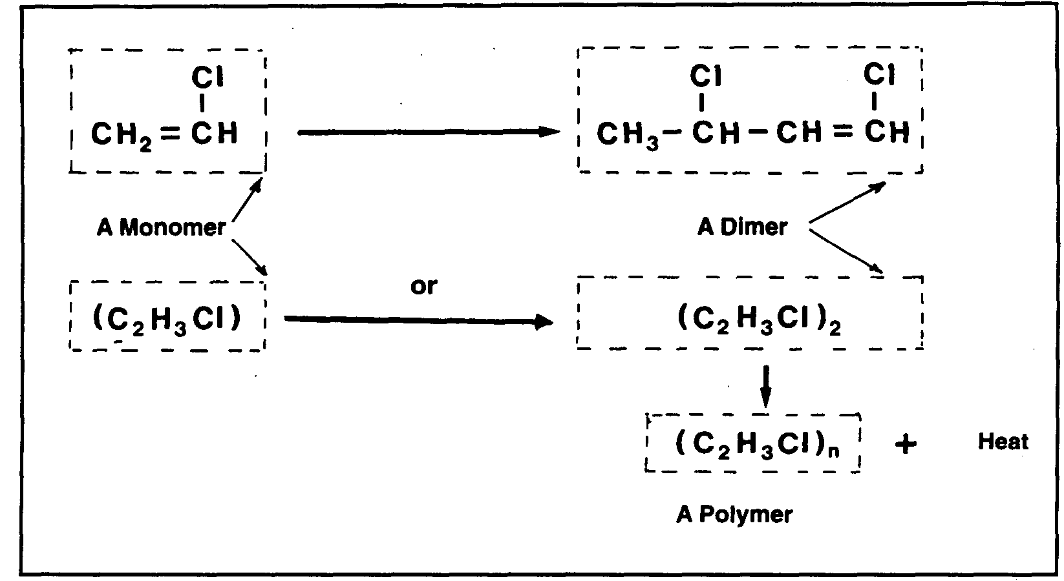
Figure 2.5 The polymerization of vinyl chloride
The difference between the vapor pressure of an inhibitor and its cargo has an important bearing on the effectiveness of the inhibitor. Generally, inhibitors have a vapor pressure lower than the cargo in which they sit. Accordingly, the greatest protection is provided in the liquid. This leaves the gases in the vapor space relatively unprotected. It follows therefore that condensation in the vapor space can suffer from increased rates of polymerization and problems have been known to occur in these areas.
Inhibitors can be toxic. Those most commonly used are hydroquinone (HQ) and TBC. Health and safety data for these products is included in 9.1. As will be noted, care should be taken when handling inhibitors and cargoes with inhibitor added.
Ships’ personnel should ensure that an Inhibitor Information Form is received from the cargo shipper before departure from the loading port. This certificate should provide the information shown in the figure below:—

LIQUEFIED GAS—INHIBITOR INFORMATION FORM
To be completed before loading an inhibited cargo
SHIP ............................................... DATE ...........................

PORT & BERTH ...........................….. TIME ............................

1. CORRECT TECHNICAL NAME OF CARGO ……………………………………………………

2. CORRECT TECHNICAL NAME OF INHIBITOR …………………………………………..….

3. AMOUNT OF INHIBITOR ADDED ……………………………………………………………...

4. DATE ADDED ...................................................................................................

5. EXPECTED LIFETIME OF INHIBITOR ..... ….........................................................

6. ANY TEMPERATURE, LIMITATIONS AFFECTING INHIBITOR ……………………………..

7. ACTION TO BE TAKEN IF VOYAGE EXCEEDS EFFECTIVE LIFETIME OF INHIBITOR
........................................................................................................

IF THE ABOVE INFORMATION IS NOT SUPPLIED, THE CARGO SHOULD BE REFUSED (IGC Coda, Section 18.1.2)
FOR SHIP ......................................... FOR SHORE ........................................
(signed) (signed)

Liquefied gas—inhibitor Information form

Figure 2.5(a) Inhibitor information form
In addition, the quantity of inhibitor required for effective inhibition and the toxic properties of the inhibitor should be advised.
A similar but more difficult reaction to control is known as dimidiation. This cannot be stopped by inhibitors or any other means. The only way to avoid or slow down dimidiation is to keep the cargo as cool as possible and such cooling is recommended, especially during longer voyages.

2.7 HYDRATE FORMATION
Propane and butane may form hydrates under certain conditions of temperature and pressure in the presence of free water (see Reference 2.14). This water may be present in LPG as an impurity or may be extracted from cargo tank bulkheads if rust is present. Rust which has been dehydrated in this way by LPG loses its powers of adhesion to tank surfaces and may settle to the tank bottom as a fine powder.
LPG hydrates are white crystalline solids which may block filters and reliquefaction regulating valves. Furthermore they may damage cargo pumps.
Hydrate inhibitors such as methanol or ethanol may be added at suitable points in the system but nothing whatsoever should be added without the consent of the shipper and ship operator. It should be noted that in some countries the use of methanol is banned. In addition, some chemical gases may be put off specification by the addition of methanol. Care must be taken if a hydrate inhibitor is added to a polymerisable cargo as the polymer inhibition mechanism may be negated.
Since methanol is toxic, care should be taken regarding its safe handling.

2.8 LUBRICATION
The property of a fluid, which restricts one layer of the fluid moving over an adjacent layer, is called viscosity. Viscosity is important in determining the lubricating properties of liquid. The majority of liquefied gases have poor lubricating properties by comparison with lubricating oils or even water and this is shown in Table 2.4(a).

Table 2.4(a) Factors affecting lubrication
Liquid (temperature) | Lub oil  (at +70ºC) | Water  (at +100°C) | Propane  (at -45°C)
Viscosity (centipoise) | 28.2 | 0.282 | 0.216
Specific Heat (k cal/kg °C) | 0.7 | 1.0 | 0.5
Latent Heat of Vaporization (k cal/kg) | 35 | 539 | 101

Liquefied hydrocarbon gases can dissolve in lubricating oil and, for certain applications, such admixture can result in inadequate lubrication of pump seals and compressors. The solvent action of liquefied gases on grease can cause the degreasing of mechanical parts with similar loss of lubrication in fittings such as valves.
In addition to low viscosity, liquefied gas has relatively poor cooling properties and liquids are not able to carry heat away from a shaft bearing very effectively. Any excessive heat will result in a relatively rapid rise in temperature of the bearing. (Specific heat of propane is about half that of water). Under these circumstances, the liquid will vaporize when its vapor pressure exceeds the product pressure in the bearing. The vapor will expel liquid from the bearing and result in bearing failure due to overheating. This is the cause of compressor lubricating problems referred to in 4.6.1. It should also be noted that the lubricating oil used in a compressor must be compatible with the grade of cargo being carried (see 7.6.1).

2.9 PHYSICAL PROPERTIES
The physical properties of a liquefied gas depend on its molecular structure. Some compounds have the same molecular formula, but the ways in which the atoms are arranged within the molecule may be different. These different compounds of the same basic substance are called isomers. They have the same molecular mass but differing physical and chemical properties. Examples are n-butane and iso-butane, shown in Figure 2.1. The principal physical properties of the main liquefied gases are listed in Table 2.5. From this data the different physical properties of the isomers of butane and butylene should be noted.
The most important physical property of a liquefied gas is its saturated vapor pressure/temperature relationship. This property, which will be studied in detail later, governs the design of the tank containment system best suited to each cargo and has a strong influence on economic considerations.

2.10 STATES OF MATTER
2.10.1 Solids, liquids and gases
Most substances can exist in either the solid, liquid or vapor state. In changing from solid to liquid (fusion) or from liquid to vapor (vaporization), heat must be given to the substance. Similarly, in changing from vapor to liquid (condensation) or from liquid to solid (solidification), the substance must give up heat. The heat given to or given up by the substance in changing state is called latent heat. For a given mass of the substance the latent heats of fusion and solidification are the same. Similarly, the latent heats of vaporization and of condensation are the same, although of different values from the latent heat of fusion or solidification.
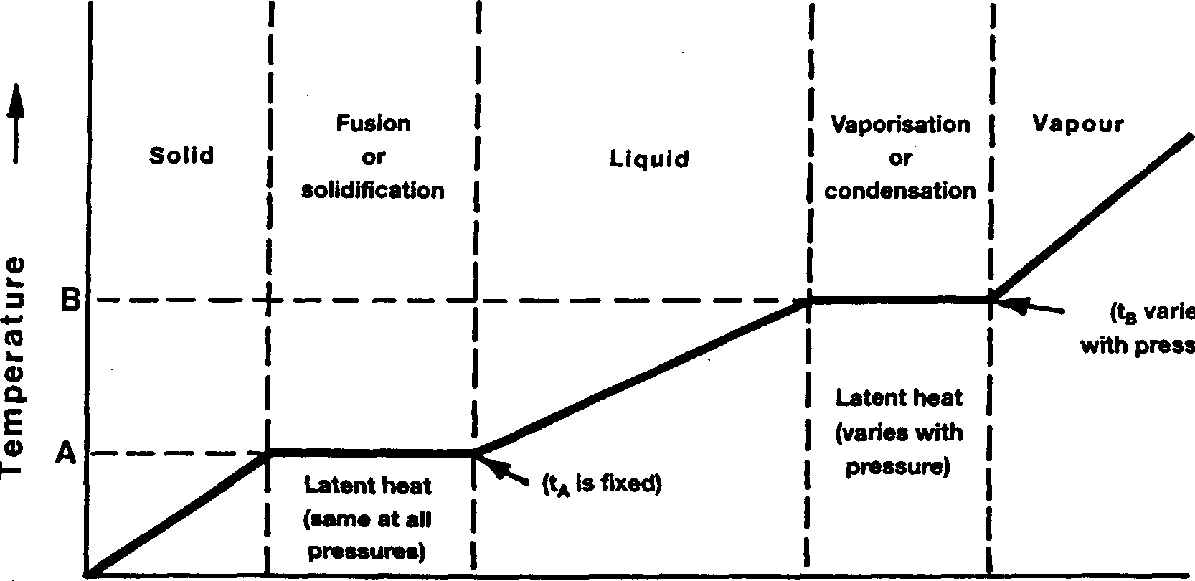

Figure 2.6 Temperature/heat diagram for varying states of matter

Table 2.5 Physical properties of gases
Gas | Atmospheric boiling point  (ºC) | Critical temperature  (ºC) | Critical pressure  (bars, absolute) | Condensing ratio  dm³ liquid  1 m³ gas | Liquid relative density at Atm Boiling Pt.  (Water=1) | Vapor relative density  (Air=1)
Methane | -161.5 | -82.5 | 44.7 | 0.804 | 0.427 | 0.554
Ethane | -88.6 | 32.1 | 48.9 | 2.453 | 0.540 | 1.048
Propane | -42.3 | 96.8 | 42.6 | 3.380 | 0.583 | 1.55
n-Butane | -0.5 | 153 | 38.1 | 4.32 | 0.600 | 2.09
i-Butane | -11.7 | 133.7 | 38.2 | 4.36 | 0.596 | 2.07
Ethylene | -103.9 | 9.9 | 50.5 | 2.20 | 0.570 | 0.975
Propylene | -47.7 | 92.1 | 45.6 | 3.08 | 0.613 | 1.48
α-Butylene | -6.1 | 146.4 | 38.9 | 4.01 | 0.624 | 1.94
γ-Butylene | -6.9 | 144.7 | 38.7 | 4.00 | 0.627 | 1.94
Butadiene | -5.0 | 161.8 | 43.2 | 3.81 | 0.653 | 1.88
Isoprene | 34 | 211.0 | 38.5 |  | 0.67 | 2.3
Vinyl chloride | -13.8 | 158.4 | 52.9 | 2.87 | 0.965 | 2.15
Ethylene oxide | 10.7 | 195.7 | 74.4 | 2.13 | 0.896 | 1.52
Propylene oxide | 34.2 | 209.1 | 47.7 |  | 0.830 | 2.00
Ammonia | -33.4 | 132.4 | 113.0 | 1.12 | 0.683 | 0.597
Chlorine | -34 | 144 | 77.1 | 2.03 | 1.56 | 2.49

Fusion or solidification occurs at a specific temperature for each substance and this temperature is virtually independent of the pressure. However, vaporization or condensation of a pure substance occurs at a temperature, which varies widely depending upon the pressure exerted. It should also be noted that the latent heat of vaporization varies with pressure. Figure 2.6 illustrates these temperature/heat relationships as a substance is heated or cooled through its three states: here the temperatures of fusion or solidification (A) and of vaporization or condensation (B) are shown.
For liquefied gases, the solid state is not of concern since this can only occur at temperatures well below those at which such gases are carried. However, temperatures, pressures and latent heats of vaporization are of fundamental importance. This data may be presented in graphical form such as Figure 2.7, which gives data for methane covering absolute vapor pressure (P), liquid density (γ’), saturated vapor
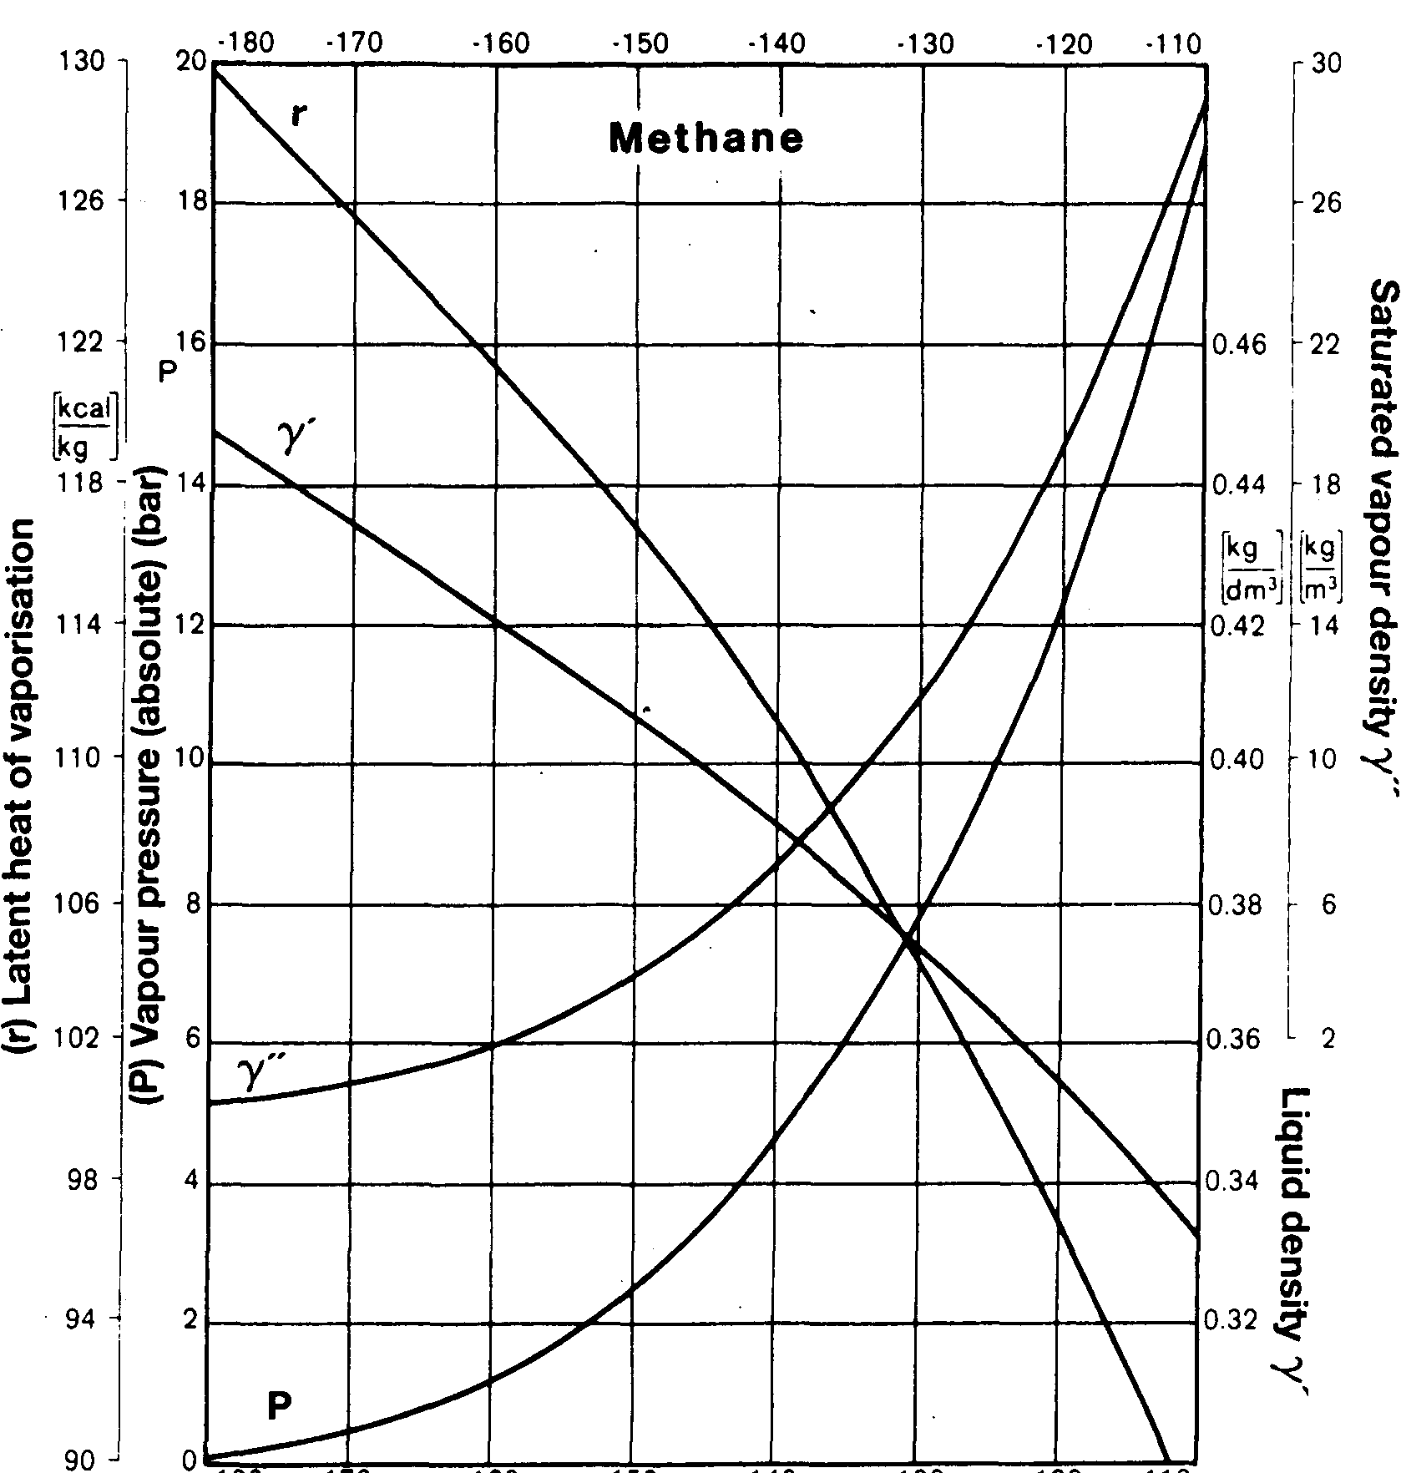

Figure 2.7 Characteristics of methane
density (γ’’) and latent heat of vaporization ® against temperature. Similar graphical presentations of these properties are available elsewhere for all liquefied gases carried by sea.
2.10.2 Spillage of liquefied gas
It is convenient here, against the background of the preceding paragraphs, to consider what happens when a liquefied gas is spilled. Firstly, consider the escape from its containment of a fully refrigerated liquid. Here the liquid is already at or near atmospheric pressure but, on escape, it is brought immediately into contact with the ground or sea at ambient temperature. The temperature difference between the cold liquid and the material it contacts provides an immediate heat transfer into the liquid, resulting in the rapid evolution of vapor. If the spill is lying in a pool on the ground, the removal of heat from the ground beneath narrows the temperature difference. Eventually, temperature differences stabilize and the rate of evaporation continues at a lower level. Under these conditions, the liquid will continue to boil until completely evaporated. For spills on the sea, the strong convection currents in the water may maintain the initial temperature difference and evaporation will probably continue at the higher initial rate. In this case, the large quantities of cold vapor produced from the liquid will diffuse into the atmosphere and cause condensation of the water vapor in the air. By this process, a visible vapor cloud is formed which is white in color.
Initial spillage of a liquefied gas from a pressure vessel behaves differently to that described above. In this case the liquid, on escape, is at a temperature close to ambient. However, the high pressure at release, quickly falls to ambient and this results in extremely rapid vaporization, the necessary heat being taken primarily from the liquid itself. This is called flash evaporation and, depending upon the change in pressure, much of the liquid may flash-off in this way. By this means any remaining liquid is cooled rapidly to its refrigerated temperature (and even lower) at atmospheric pressure. High-pressure liquids escaping in this way cause much of it to spray into the atmosphere as small droplets. These droplets take heat from the atmosphere and condense the water vapor in the air to form a white visible cloud. The liquid droplets soon vaporize to gas and in the process causes further cooling, so maintaining the white cloud formation for longer. Thereafter, any remaining liquid pools attain an equilibrium temperature and evaporate, as described in the preceding paragraph, until wholly vaporized.
The hazard introduced by the escape of vapor into the atmosphere is that, on mixing with the air, it becomes flammable. The white vapor cloud so formed can give warning of the presence of a hazardous condition but it should be noted that the flammable extent of the gas cloud will not necessarily coincide with the visible cloud.
Apart from the hazards introduced by vapor-in-air mixtures, the cold liquid can cause frostbite on human tissue and may convert metals to a brittle state. Furthermore, on exposure to air it is likely that a liquefied gas will become sub-cooled to a temperature below its atmospheric boiling point (see also Chapter Ten).

2.11 PRINCIPLES OF REFRIGERATION
The principles of heat transfer, evaporation and condensation are applied in refrigeration. Figure 2.8 illustrates the basic components and operating cycle of a simple refrigerator. Cold liquid refrigerant is vaporized in an evaporator which, being colder than its surroundings, draws in heat to provide the latent heat of vaporization. The cool vapor is drawn off by a compressor which raises both the pressure and the temperature of the vapor and passes it to the condenser. Here, the vapor is condensed to a high-pressure liquid and the sensible heat from desuperheating, together with latent heat of condensation, is removed by means of the condenser coolant, which is warmed in the process. The high-pressure liquid then passes through an expansion valve to the low-pressure side of the refrigerator and, in doing so, flash evaporates to a two-phase mixture of cold liquid and vapor. This mixture then passes to the evaporator (cargo tank) to complete the cycle.
In considering Figure 2.8, if:
Q₁ is the heat flow rate from the surroundings into the evaporator
Q₂ is the heat-rate equivalent of work done on the vapor by the compressor, and
Q₃ is the heat-rate rejected by the condenser

then, if the system were 100 per cent efficient:— Q₁ + Q₂ = Q₃
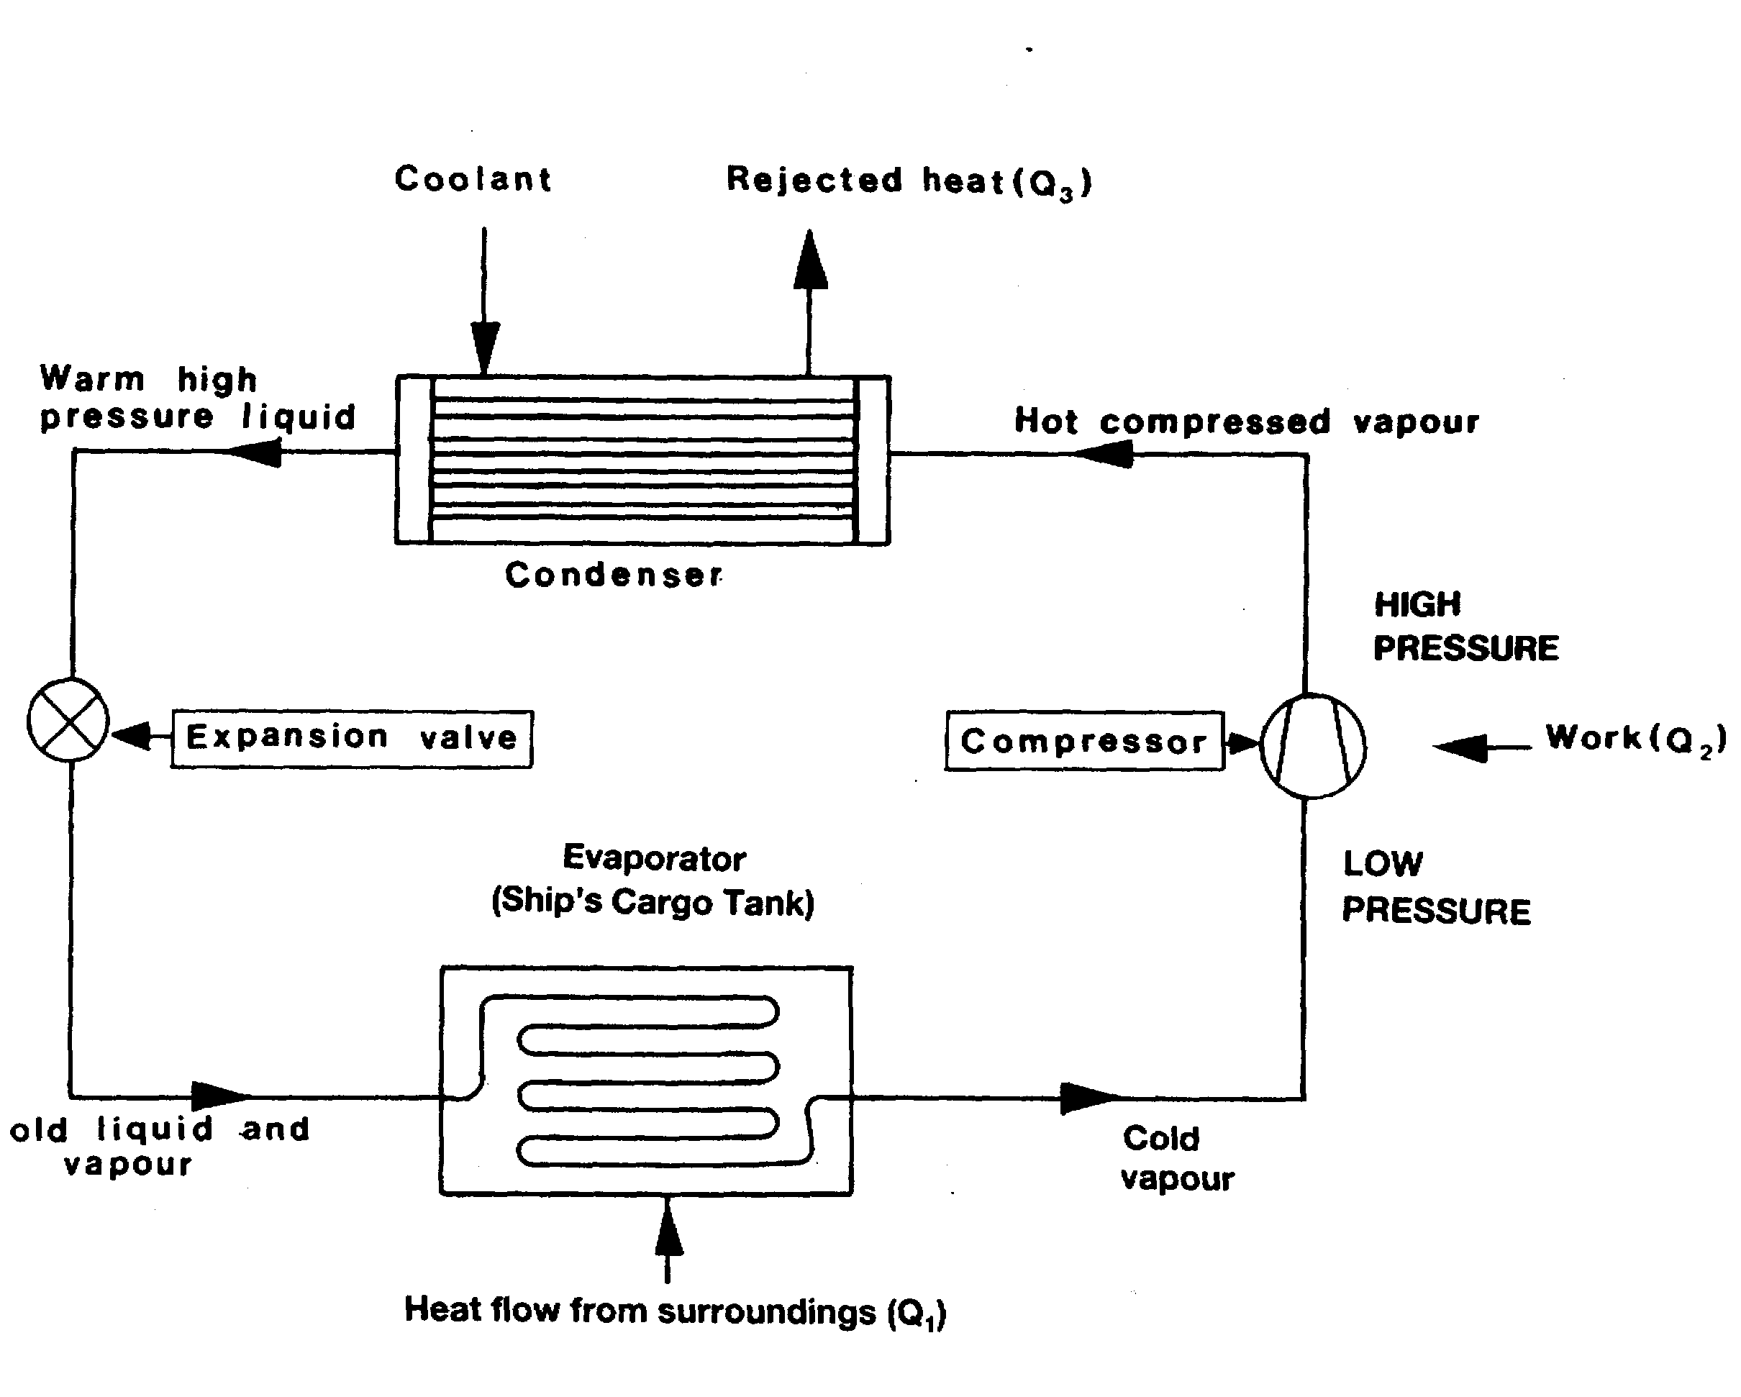
Figure 2.8 Simple refrigeration — evaporation/condensation cycle
In the case of refrigeration at sea, a non-flammable and non-toxic fluid (such as R22) can be used as a refrigerant in the condenser. These refrigerants have similar vapor pressure/temperature characteristics to LPG.
The principles as shown in Figure 2.8 also apply to the reliquefaction cycle of liquefied gas cargo vapors. Here the cargo tank and its boil-off vapors replace the evaporator as shown in Figure 2.8. Practical cargo reliquefaction is discussed in more detail in 2.19 and 4.5.

2.12 CRITICAL TEMPERATURES AND PRESSURES
The critical temperature of a gas is the temperature above which it cannot be liquefied no matter how great the pressure. The critical pressure of a gas is the pressure required to compress it to a liquid state at its critical temperature. Critical temperatures and pressures for the principal gases are listed in Table 2.5. As will be seen, all the gases, with the exception of methane (at times also ethane and ethylene), can be liquefied by pressure alone at temperatures within the normal ambient range. Accordingly, for the carriage or storage of ethane or ethylene as a liquid, a reliquefaction process is required. In the case of LNG carriers, reliquefaction is seldom an option and boil-off from the pre-refrigerated cargo is restricted by the efficiency of tank insulation. In this case the remaining boil-off is used in the ship’s boilers as fuel.

2.13 LIQUID/VAPOR VOLUME RELATIONSHIPS
As a guide to the relative sizing of equipment to handle a vapor compared with that to handle its liquid condensate, it is useful to note the condensing ratio of the various liquefied gases. This ratio gives that quantity of liquid (in dm³) at its atmospheric boiling point which will condense from one cubic meter of its vapor at the standard conditions of one bar absolute and 0°C. If at 0°C the gas is at a higher temperature than its critical temperature (such as for methane), the ratio is given for the vapor at the atmospheric boiling point of the liquid. Condensing ratios are listed in Table 2.5.

2.14 IDEAL GAS LAWS
The ideal gas laws are appropriate just to vapors; indeed, they are most appropriately applied to non-saturated vapors. Liquid/vapor mixtures and liquids possess characteristics different from those described below. Relating what follows to the principles of refrigeration (as described in 2.11) that portion of the cycle involving vapor compression is most relevant.
An ideal gas is one, which obeys the gas laws by virtue of its molecules being so far apart that they exert no force on one another. In fact, no such gas exists, but at room temperature and at moderate pressures many non-saturated gases approach the concept for most practical purposes. The ideal gas laws govern the relationships between absolute pressure, volume and absolute temperature for a fixed mass of gas. The relationship between two of these variables is commonly investigated by keeping the third variable constant.
For a gas to perform according to these principles, it must be in its unsaturated form and removed from its own liquid.
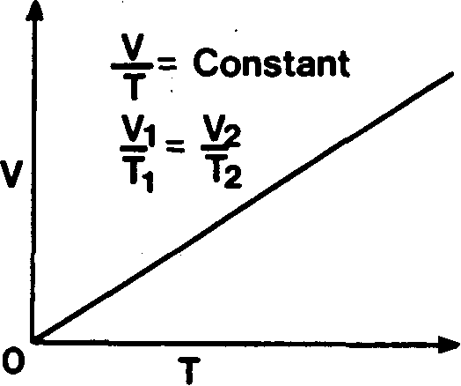
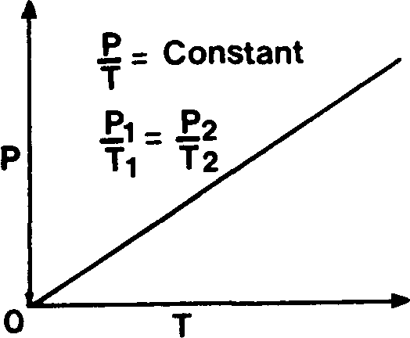
Fig 2.9(a) Boyle’s law for gases (constant temperature)
Fig 2.9(b) Charles’ law for gases (constant pressure)
Fig 2.9(c) Pressure Law for gases (constant volume)
Boyle’s Law states that, at constant temperature, the volume of a fixed mass of gas varies inversely with the absolute pressure. This relationship is illustrated in Figure 2.9(a) and can be written:—
PV = constant, or
P₁V₁=P₂V₂
Charles’ Law states that, at constant pressure, the volume of a fixed mass of gas increases by 1/273 of its volume at 0°C for each degree Centigrade rise in temperature. An alternative definition is that the volume of a fixed mass of gas at constant pressure varies directly with its absolute temperature. This law is illustrated in Figure 2.9(b) and can be written: —
$\frac{V}{T}=$constant, or
$$\frac{V_{1}}{T_{1}}=\frac{V_{2}}{T_{2}}$$
The Pressure Law states that, at constant volume, the pressure of a fixed mass of gas increases by 1/273 of its pressure at 0°C for each degree Centigrade rise in temperature. Alternatively, it can be stated that the pressure of a fixed mass of gas at constant volume, varies directly with its absolute temperature. The pressure law is illustrated graphically in Figure 2.9© and can be written: —
$\frac{P}{T}=$constant, or
$$\frac{P_{1}}{T_{1}}=\frac{P_{2}}{T_{2}}$$

These three laws may be combined into
$\frac{P_{1}V_{1}}{T_{1}}=\frac{P_{2}V_{2}}{T_{2}}=$constant
or, more generally, for an ideal gas, using the Universal Ideal Gas Constant

$$\frac{\text{PV}}{T}=\frac{M}{m}R$$
where all the quantities are in consistent units, e.g.
where P is absolute pressure in pascals (N/m²)
V is in cubic meters
T is in degrees Kelvin
M is the mass of the gas in kilograms m is the molecular weight (dimensionless), and
R is the Universal Gas Constant = 8.314 kJ/kg mol.K.
Figure 2.9 outlines the three basic gas laws. They cover changes at constant temperature (isothermal); changes at constant pressure (isobaric); and changes at constant volume (isovolumetric).
However, a fourth process involving the ideal gas is also of relevance to refrigeration. This is called the adiabatic compression and may be reversible or irreversible. A reversible process is one involving constant entropy (see definitions). Changes in pressure, involving constant entropy (isentropic), are shown on the Mollier diagram in Figure 2.16.
A reversible adiabatic (or isentropic) expansion is one where the heat flow to or from an external source is zero. In the compressor of a refrigeration plant, work is done on the gas as it passes through the compressor, although no heat is assumed to be transmitted to or from the outside. The work is converted into internal energy and, hence, the temperature of the gas is increased. By this means, temperatures at the compressor discharge are raised (a) by increased pressure and (b) by increases in internal energy.
In practice, to approximate to an adiabatic compression, work on the gas must be carried out very quickly. By this means, little time is allowed for heat to escape from the system. The adiabatic curve is shown by the curve A/B in Figure 2.10. On the other hand, and by way of comparison, an isothermal compression, as shown by the curve A/C, must be carried out very slowly otherwise temperature changes will become obvious.
It follows, therefore, that the actual changes taking place, say in a compressor (with respect to pressure, volume and temperature), follow a curve somewhere between the adiabatic and the isothermal. This could approximate to the curve A/D shown in Figure 2.10.
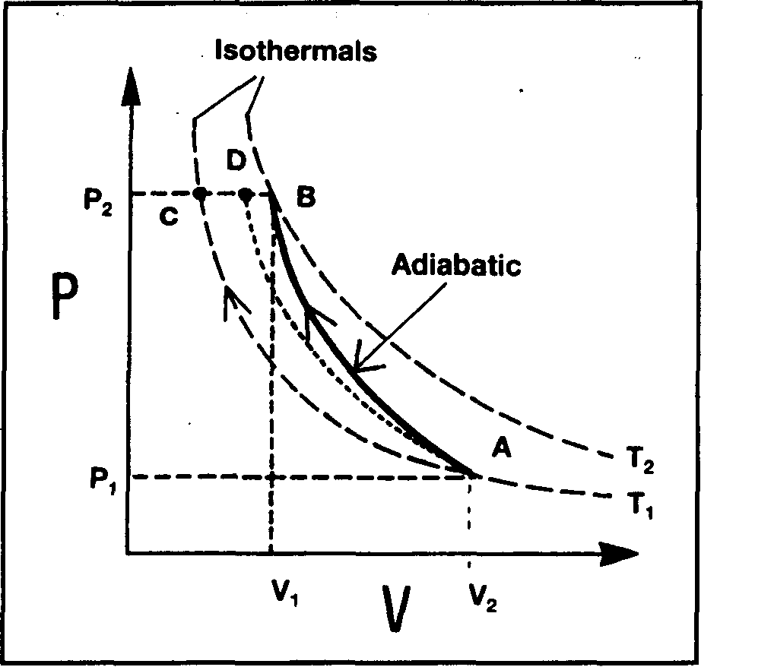
Figure 2.10 Relationship between adiabatic and isothermal compression
Figure 2.10 is produced on similar axes as Figure 2.9(a). However, Figure 2.10 includes two isothermal lines — one for a low temperature (T1) and one for a higher temperature (T2). For a compressor, as the changes lie closer to the adiabatic line than the isothermal line, it is usual to assume an adiabatic change in such cases.
As covered at the beginning of this section under the discussion on Boyle’s Law, the equation for an isothermal compression is:—

PV = constant
It may be of interest to note that the equation for the adiabatic compression is:

PV^{k} = constant
where ‘k’ is the ratio of principal specific heats for the substance. This is the ratio of specific heat of the liquid divided by the specific heat of the vapor.

2.15 SATURATED VAPOR PRESSURE

In 2.14, discussion centered on pure gases isolated from their liquids. In this section, attention is given to gases in contact with their own liquids. It is in this respect that the concept of saturated vapor pressure (SVP) becomes important.
Vapor in the space above a liquid is in constant motion. Molecules near the liquid surface are constantly leaving to enter the vapor-phase and molecules in the vapor are returning to the liquid-phase. The vapor space is said to be unsaturated if it can accept more vapor from the liquid at its current temperature. A saturated vapor is a vapor in equilibrium with its liquid at that temperature. In that condition, the vapor space cannot accept any further ingress from the liquid without a continuous exchange of molecules taking place between vapor and liquid.
The pressure exerted by a saturated vapor at a particular temperature is called the saturated vapor pressure of that substance at that temperature. Various methods exist for the measurement of saturated vapor pressures and one is illustrated in Figure 2.11. This apparatus consists of a barometric tube © which is filled with mercury, inverted and immersed in a mercury reservoir (A). The space above the f mercury is a virtual vacuum (B). The height of mercury (X) is a measure of atmospheric pressure. A small amount of the liquid under test is introduced into the mercury barometer and this rises to the vacuum space. Here it partially vaporizes and exerts its saturated vapor pressure. This vapor pressure pushes the mercury down the barometer tube to a new level (Y). The saturated vapor pressure exerted by the test liquid is shown by the difference between the heights of the mercury column X and Y and, in this case, is usually expressed in millimeters of mercury.
If the mercury column containing the liquid under test is heated, then the mercury level will fall further, indicating that the saturated vapor pressure has increased with increasing temperature. It is possible by this means to determine the saturated vapor pressure for the liquid under test at various temperatures.
Evaporation is a phenomenon where the faster-moving molecules escape from the surface of a liquid. However, when boiling occurs, it takes place in the body of the liquid. This happens when the external vapor pressure is equal to the pressure of the liquid. By varying the pressure above the liquid the liquid boils at different
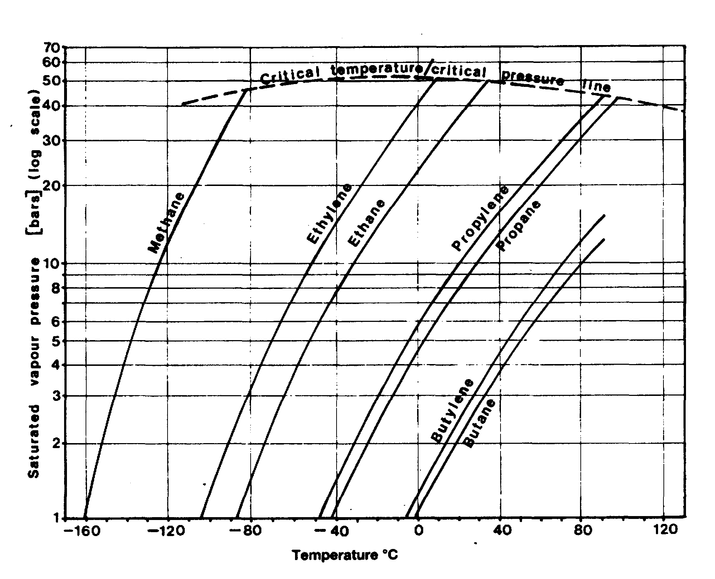
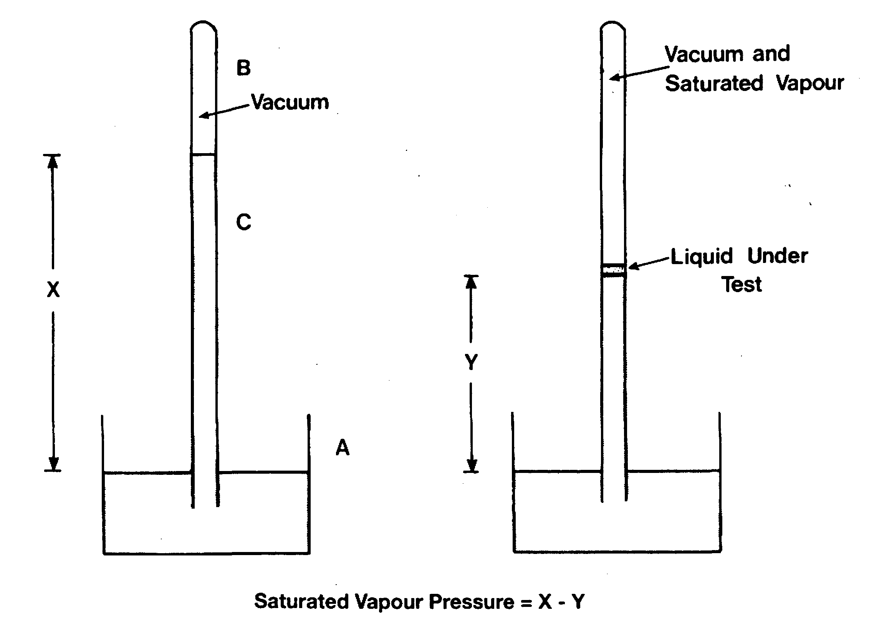
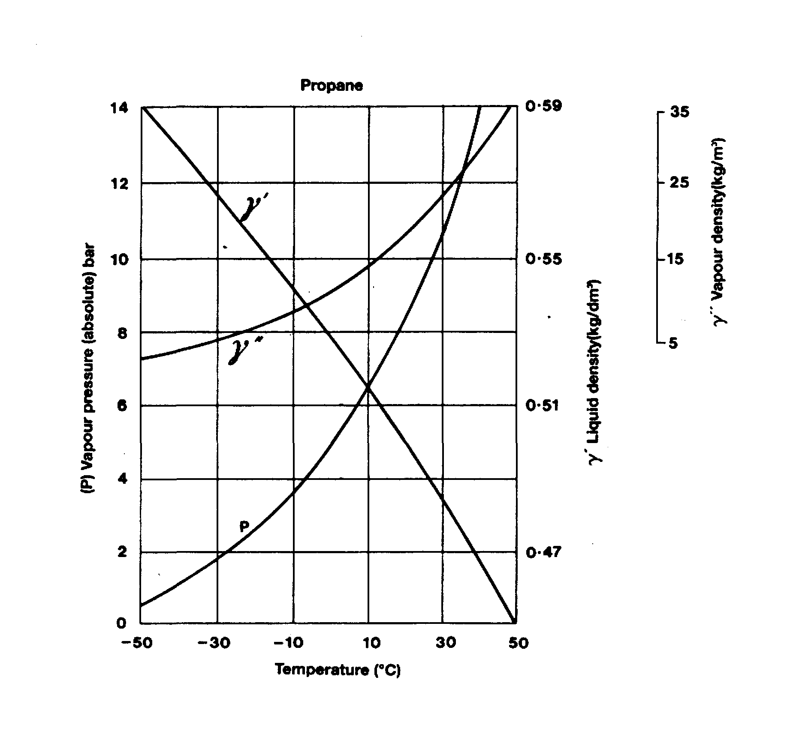

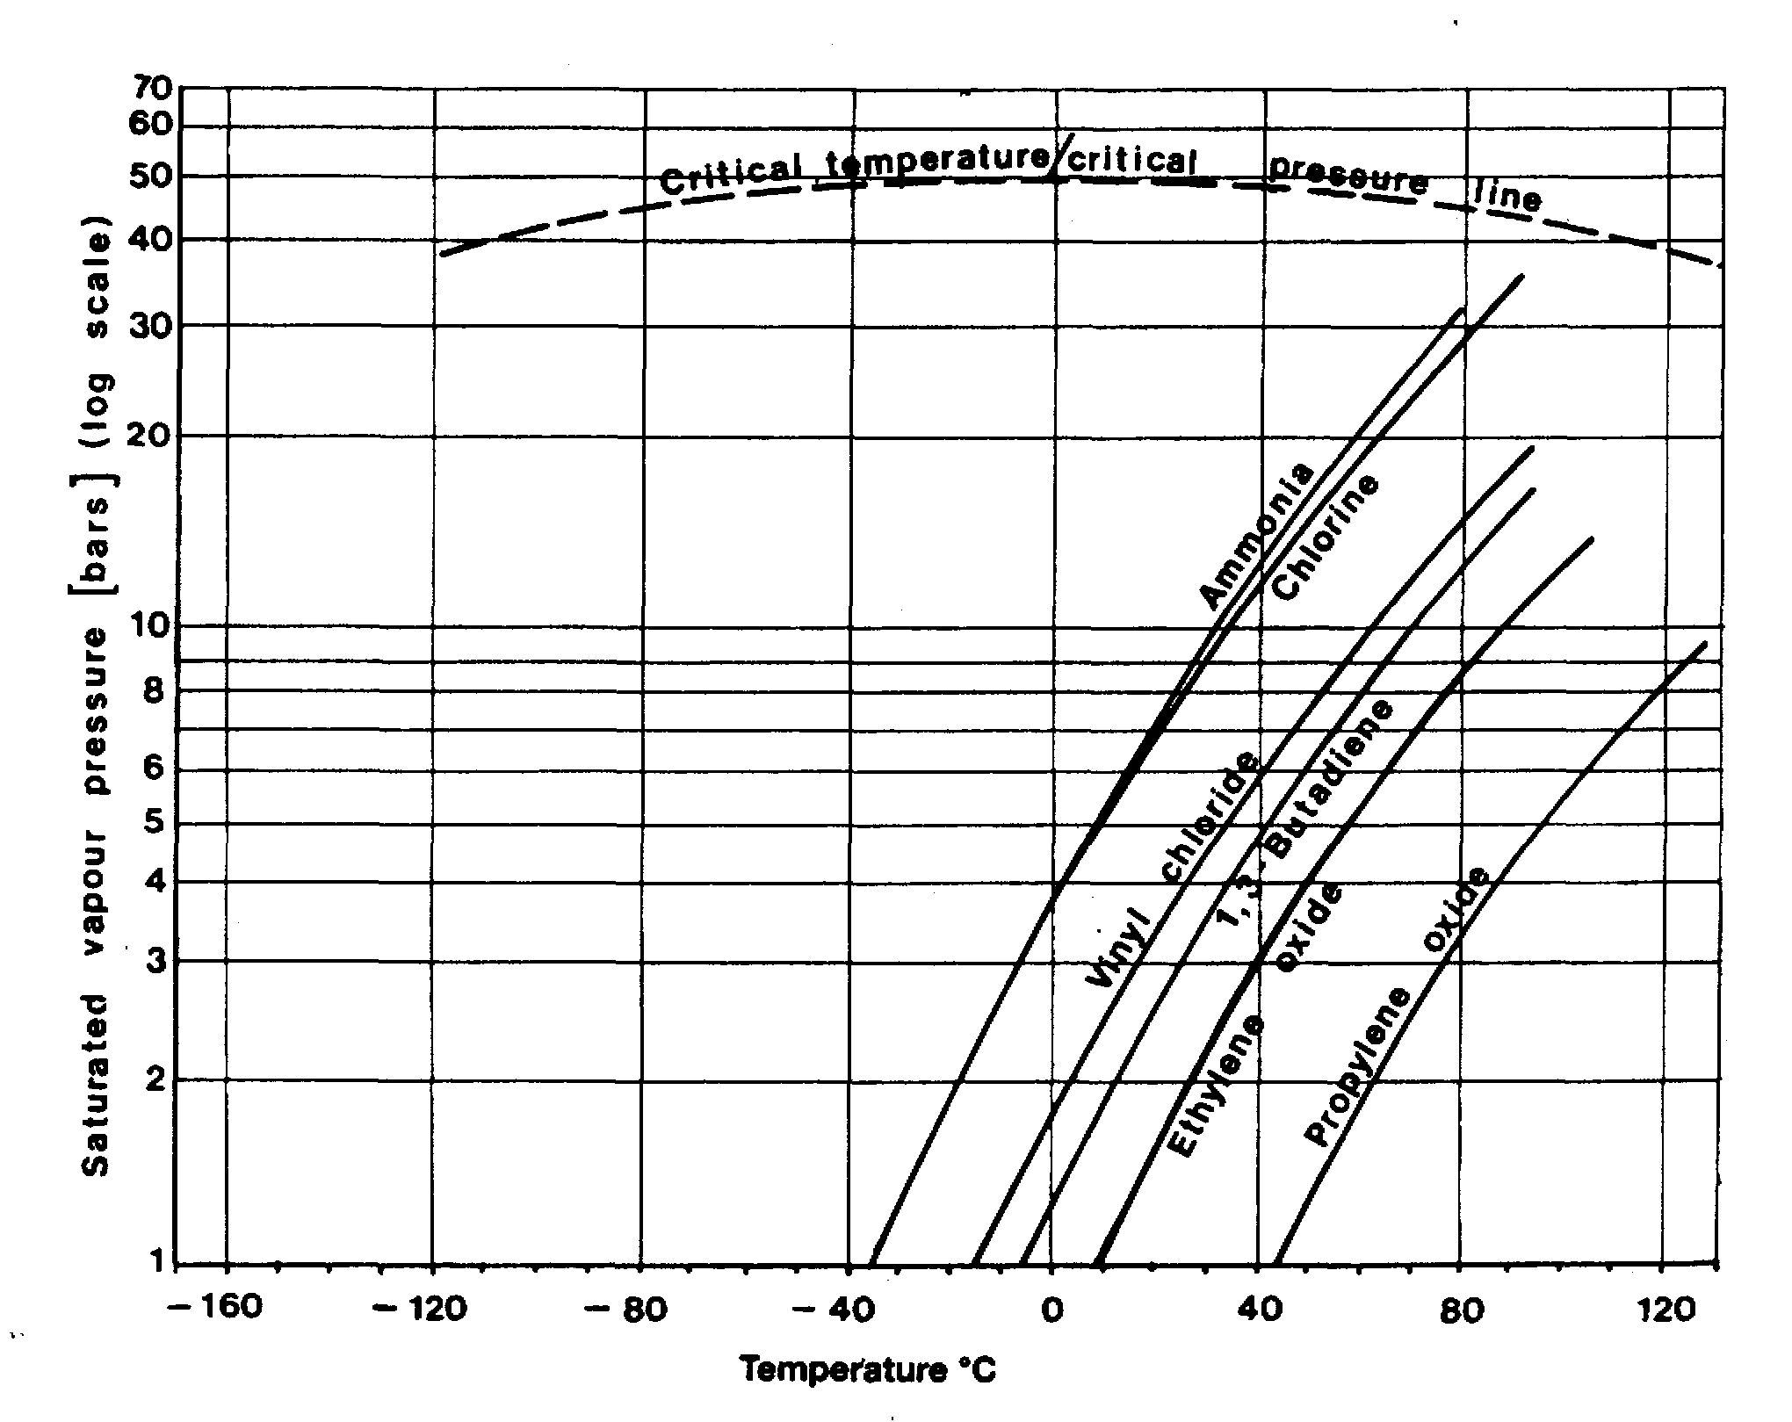

Table 2.6 Conversion factors for units of pressure
 | Kpa | Bar | Std Atm | kg.f/cm² | lb.f/inch²  (p.s.i.) | lb.ft/ft²  (p.s.i.) | mm  (mercury) | inches  (mercury) | inches  (water) | feet  (water) | meters  (water)
Kpa | 1 | 0.01 | 0.0099 | 0.0102 | 0.1450 | 20.88 | 7.50 | 0.2953 | 4.015 | 0.3346 | 0.1020
Bar | 100 | 1 | 0.9869 | 1.020 | 14.50 | 2,089 | 750.1 | 29.53 | 402.2 | 33.52 | 10.22
Std Atm | 101.325 | 1.013 | 1 | 1.033 | 14.70 | 2,116 | 760 | 29.92 | 407.5 | 33.96 | 10.35
kg.f/cm² | 98.039 | 0.9807 | 0.9678 | 1 | 14.22 | 2,048 | 735.6 | 28.96 | 394.4 | 32.87 | 10.02
lb.f/inch²  (p.s.i.) | 6.8966 | 0.06895 | 0.06805 | 0.07031 | 1 | 144 | 51.72 | 2.036 | 27.73 | 2.311 | 0.7044
lb.ft/ft²  (p.s.i.) | 0.0479 | 4.788x10⁻⁴ | 4.725x10⁻⁴ | 4.882x10⁻⁴ | 0.006944 | 1 | 0.3591 | 0.01414 | 0.1926 | 0.01605 | 0.004891
mm  (mercury) | 0.1333 | 0.001330 | 0.001316 | 0.001360 | 0.01934 | 2.785 | 1 | 0.03937 | 0.5362 | 0.04469 | 0.01362
inches  (mercury) | 3.3864 | 0.03386 | 0.03342 | 0.03453 | 0.4912 | 70.73 | 25.4 | 1 | 13.62 | 1.135 | 0.3459
inches  (water) | 0.2491 | 0.002486 | 0.002454 | 0.002535 | 0.03606 | 5.193 | 1.865 | 0.07342 | 1 | 0.0833 | 0.02450
feet  (water) | 2.9886 | 0.02984 | 0.02944 | 0.03042 | 0.4327 | 62.31 | 22.38 | 0.8810 | 12 | 1 | 0.3048
meters  (water) | 9.8039 | 0.09789 | 0.09660 | 0.0998 | 1.420 | 204.4 | 73.42 | 2.891 | 39.37 | 3.281 | 1
temperatures. Decreasing the pressure above the liquid lowers the boiling point and increasing the pressure raises the boiling point. The curve marked ‘P’ in Figure 2.12,. illustrates the variation in saturated vapor pressure with temperature for propane, r will be noticed that an increase in liquid temperature causes a non-linear increase in the saturated vapor pressure. The non-linear shape of the curve shows also that the saturated gas does not behave exactly in accordance with the Gas Laws (see also Figure 2.9©). Also shown on Figure 2.12 are the variations of propane liquid density (7’) and saturated vapor density (7”) with temperature.
Different liquefied gases exert different vapor pressures. This can be seen from Figures 2.13 and 2.14. The vertical axis in these two figures gives the saturated vapor pressure on a logarithmic scale. (The use of the logarithmic scale changes the shape of the curves from that shown for ‘P’ in Figures 2.7 and 2.12). Figure 2.13 shows information for the hydrocarbon gases. A comparison of the graphs shows that smaller molecules exert greater vapor pressures than larger ones. In general the chemical gases shown in Figure 2.14 exert much lower saturated vapor pressures than the small hydrocarbon molecules such as methane. The point of intersection of these curves with the horizontal axis indicates the atmospheric boiling point of the liquid (the temperature at which the saturated vapor pressure is equal to atmospheric pressure). This is the temperature at which these cargoes would be transported in fully refrigerated or fully insulated containment systems.
Whereas the bar is now the most frequently used pressure unit in the gas industry, other units such as kgf/cm² (kilogram’s force per square centimeter), atmospheres or millimeters of mercury are frequently encountered. However, the only legal units are the SI units with kilopascal as the usual pressure unit. The conversion factors for these units of pressure are given in Table 2.6.
All gauges used for the measurement of pressure measure pressure difference. Gauge pressure is therefore the pressure difference between the pressure to which the gauge is connected and the pressure surrounding the gauge. The absolute pressure is obtained by adding the external pressure (such as atmospheric pressure) to the gauge pressure.
Vapor pressures, though they may be found by means of a pressure gauge, are a fundamental characteristic of the product. Accordingly, they are essentially absolute pressures. Tank design pressures and relief valve settings, however, like pressure gauge indications, are tuned to the physical difference between internal and external pressure and thus are gauge pressures. For consistency throughout this book, most pressures are given in bars but, to avoid confusion, the unit is denoted as barg where a gauge pressure is intended.
It is appropriate to re-emphasize here the information from Chapter One that a liquefied gas is defined in terms of its vapor pressure as a substance having a vapor pressure at 37.8°C equal to or greater than 2.8 bar absolute.

2.16 LIQUID AND VAPOUR DENSITIES
2.16.1 Liquid density
The density of a liquid is defined as its mass per unit volume and is commonly measured in kilogram’s per cubic decimeter (kg/dm³). Alternatively, liquid density may be quoted in kg/liter or in kg/m³. The variation with temperature of the liquid density of a liquefied gas (in equilibrium with its vapor) is shown for propane in curve γ’ in Figure 2.12. As can be seen, the liquid density decreases with increasing temperature. The large changes seen are due to the comparatively large coefficient of volumetric expansion of liquefied gases. Values for liquid density (relative to water) of liquefied gases at their atmospheric boiling points are quoted in Table 2.5. All the liquefied gases, with the exception of chlorine, have liquid relative densities lower than one. This means that in the event of a spillage onto water, these liquids would float prior to evaporation.

Rollover
A danger associated with cargo density is the phenomenon of rollover. The conditions for rollover are set when a tank’s liquid contents stratify so that a heavier layer forms above a less-dense lower layer (see Reference 2.35). Rollover is the spontaneous mixing, which takes place to reverse this instability. Rollover, in either a ship or shore tank, can result in boil-off rates ten times greater than normal, causing over-pressurization, the lifting of relief valves and the release to atmosphere of considerable quantities of vapors or even two-phase mixtures.
When liquids of differing density are loaded — without mixing — into the same tank, there is a possibility that layering will take place. For LNG tanks, this may be as a result of the older contents becoming weathered between cargo imports because of genuine density differences or by a high concentration of nitrogen in the feed gas. In the case of LPGs, it may be due to cargo mixing (see below). Instability will occur between the layers if the lower layer becomes less dense than the upper. This can happen due to heat input to the lower portion while (in the case of LNG) evaporation of methane is taking place in the upper layer, leaving a higher percentage of the heavier ends (weathering).
The phenomenon is largely limited to LNG storage tanks, although it is known to have occurred on LNG carriers. Furthermore, a number of recorded rollover incidents involving the shore storage of ammonia are known. For most other liquefied gases, being pure products, the risk of rollover is less severe as the process of weathering will be limited. However, if two different cargoes, such as butane and propane, are loaded into the same tank, layering can become acute. Loading a ship’s tank by this means is not recommended unless a thorough thermodynamic analysis of the process is carried out and the loading takes place under strictly controlled conditions.
The following are measures, which can help prevent rollover:
- Store liquids of differing density in different shore tanks
- Load shore tanks through nozzles or jets to promote mixing
- Use filling pipework at an appropriate level in the shore tank
- Do not allow prolonged stoppages when loading ships
- Monitor cargo conditions and boil-off rates for unusual data
- Transfer cargo to other tanks or recirculate within the affected shore tank
2.16.2 Vapor density
The density/temperature relationship of the saturated vapor of propane is given by curve γ’ in Figure 2.12. The density of vapor is commonly quoted in units of kilograms per cubic meter (kg/m³). The density of the saturated vapor increases with increasing temperature. This is because the vapor is in contact with its liquid and, as the temperature rises, more liquid transfers into the vapor-phase in order to achieve the higher vapor pressure. This results in a considerable increase in mass per unit volume of the vapor space. The densities of various vapors (relative to air) at standard temperature and pressure are given in Table 2.5. Most of the liquefied gases produce vapors which are heavier than air. The exceptions are methane (at temperatures greater than -113°C), ethylene and ammonia (see also 10.1.2). Vapors released to the atmosphere, which are denser than air, tend to seek lower ground and do not disperse readily.

2.17 PHYSICAL PROPERTIES OF GAS MIXTURES
If the components of a gas mixture are known, it is possible to perform a variety of calculations using the following relationships.

Molecular mass
Molecular mass of gas mixture = m_{i}v_{i}/100
where M_{i} = component molecular mass
V_{i}= percentage component volume

Percentage mass
Percentage mass of component = V_{i}M_{i}/M_{mix}
where M_{mix} = molecular mass of gas mixture

Relative vapor density
Relative vapor density of gas mixture (at 0°C and 1 bar) = M_{mix}/M_{a}
where M_{a} = molecular mass of air = 29
For example, given the percentage by volume of the components in a gas mixture, Table 2.7 shows how the molecular mass of the mixture can be determined. The example taken considers the composition of a typical natural gas.

Table 2.7 Calculation for molecular mass of a gas mixture
Gas Component | Percentage by Volume  (v_{i}) | Component Molecular Mass (M_{i}) | M_{i}V_{i}  100 | Percentage by Mass
Methane | 83.2 | 16.04 | 13.35 | 67.6
Ethane | 8.5 | 30.07 | 2.56 | 13.0
Propane | 4.4 | 44.09 | 1.94 | 9.8
Butane | 2.7 | 58.12 | 1.57 | 7.9
Nitrogen | 1.2 | 28.02 | 0.34 | 1.7
 | 100.00 |  | 19.76 | 100.00
 |  | M_{mix}= 19.76
Relative density of mixture = $\frac{\text{19}\text{.}\text{76}}{\text{29}}=$0.681

Vapor pressure of liquid mixtures
Dalton’s Law of Partial Pressure states that when several gases occupy a common space, each behaves as though it occupies the space alone. The pressure which each gas exerts is called its partial pressure and the total pressure exerted within the enclosing space is the sum of the partial pressures of the components.
Using Dalton’s Law, it is possible to calculate the saturated vapor pressure of a mixture of liquids at a given temperature. The partial pressure exerted by the vapor of a liquid component, is equal to the product of the saturated vapor pressure of that component, if it existed alone at that temperature, multiplied by the mole fraction of the component in the liquid mixture. The total saturated vapor pressure of the mixture will be the sum of the partial pressures of each component.
Thus, P_{mt}=Σ(P_{nt}XF_{n})
Where P_{mt} is saturated vapor pressure of liquid mixture (m) at temperature (t)
P_{nt} is saturated vapor pressure of component (n) at temperature (t)
F_{n} is mole fraction of component (n) in liquid mixture. This is the mass of that component divided by the mass of the whole mixture. For example, in Table 2.7 the mole fraction of the gas mixture is given by:—
$$\frac{M_{i}V_{i}}{M_{\text{mix}}x\text{100}}$$
For example, for an LPG of the following composition at -40°C: —
Component (n) | Mole Fraction in mixture (Fn) | SVP of component at 40°C  (P_{nt}) (bar) | Partial Pressure of component at -40°C (P.xF,,)  (bar) | Composition of vapor (Partial Pressure/SVP of mixture x 100)  (% by volume)
Ethane | 0.002 | 7.748 | 0.0155 | 1.4
Propane | 0.956 | 1.13 | 1.0803 | 97.8
n-Butane | 0.030 | 0.17 | 0.0051 | 0.5
i-Butane | 0.012 | 0.284 | 0.0034 | 0.3
 | 1.000 |  | 1.1043 | 100.0
Saturated Vapor Pressure of mixture =1.1043 bar.

It is clear from the above example how the presence of a small amount of a very volatile component in the liquid mixture can add significantly to the vapor pressure. Because the components of the liquid mixture are in solution with each other, a low boiling component, such as the ethane in the above example, can remain in the liquid phase at temperatures well above the boiling point of the pure substance. However, the vapor phase will contain a higher proportion of such low boiling point material than does the liquid mixture.

2.18 BUBBLE POINTS AND DEW POINTS FOR MIXTURES
As outlined in 2.10 and illustrated in Figure 2.6, a pure liquid will commence to boil at a temperature depending upon the pressure above it. The liquid will continue to boil at
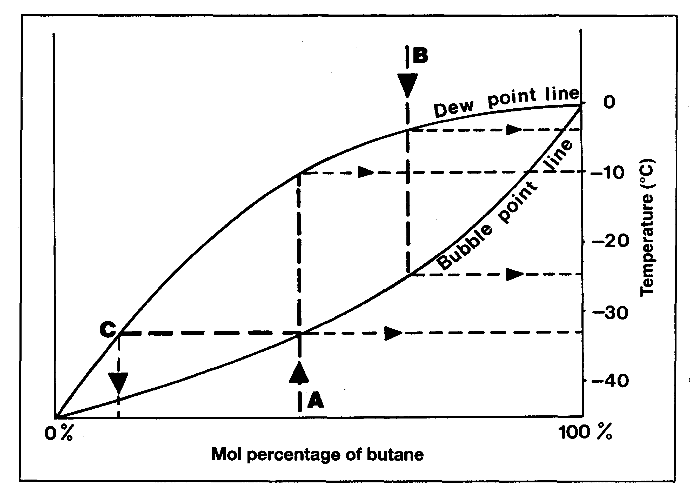
Figure 2.15 Equilibrium diagram for propane/butane mixtures
that temperature, provided the pressure is kept constant. On cooling superheated vapor to that same pressure, the vapor will become saturated at the same fixed temperature and will condense to liquid at that temperature. However, because of the differing volatilities of its components, a mixture of liquefied gases will behave differently. The bubble point of a liquid mixture, at a given pressure, is defined as that temperature at which the liquid will begin to boil as the temperature rises. The dew point of a vapor mixture, at a given pressure, is defined as the temperature at which the vapor begins to condense as the temperature decreases. For a liquid mixture in equilibrium with its vapor, the bubble point and the dew point are at different temperatures.
This behavior can be represented on an equilibrium diagram. A typical example for propane/butane mixtures is shown in Figure 2.15. The diagram here gives vapor/ liquid equilibrium data for mixtures in terms of the mol percentage content in the liquid of the less-volatile component (butane). Equilibrium data must be related to a unique pressure and in this case the data is given for atmospheric pressure.
The two curves of Figure 2.15 show the bubble points and dew points of the mixture over a range from pure propane (zero percentage butane) to pure butane (100 per cent). It will be noted that at the two extremes, denoting either pure butane or pure propane, the bubble points and dew points become coincident. Interpreting the diagram, it can be seen that a liquid mixture of composition (A) will start to boil at its bubble point of-32.5°C but can only completely vaporize in equilibrium with its vapor provided the temperature rises to -10°C.
Similarly, a vapor mixture of composition (B) will start to condense at its dew point of -3°C but can only condense completely with a fall in temperature to -25°C.
A further use of such diagrams is the estimation of the differing proportions of the components in a liquid mixture and in its equilibrium vapor mixture. Taking again a liquid of composition (A), and assuming it is carried on a fully refrigerated ship at its initial bubble point of -32.5°C, at this temperature the vapor composition that will be in equilibrium with the liquid is given by (C).

2.19 RELIQUEFACTON AND ENTHALPY
2.19.1 Enthalpy
The enthalpy of a mass of a substance is a measure of its thermodynamic heat (or energy) content, whether the substance is liquid or vapor or a combination of the two. Within the SI system it is measured in kilojoules per kilogram. Enthalpy (H) is defined as: —
$$H=U+\frac{\text{PV}}{M}$$
where H = enthalpy (kJ/kg) „
U = internal energy (kJ/kg)
P = absolute pressure (kN/m²)
V = total volume of the system — liquid plus vapor (m³)
and M = mass in the system (kg)
[Note: Newtons = kg m/sec2; Joules = kg mVsec2]
The total internal energy of a fluid is the thermodynamic energy attributable to its physical state. It includes sensible heat, latent heat, kinetic energy and potential energy. The PV term in the foregoing formula represents the energy available within a fluid due to pressure and volume.
Absolute values of enthalpy are not normally of practical interest — it is the changes of enthalpy, which are important in the thermodynamic analysis of a process. Accordingly, the enthalpy of a system is usually expressed from an arbitrarily chosen zero. Since a change in enthalpy expresses the total energy change in a fluid as it passes through any thermodynamic process, it is a useful unit for the analysis of energy changes. This is particularly so in cyclic processes involving compression, expansion, evaporation or condensation such as those encountered in the reliquefaction of boil-off vapors. In such processes, changes in kinetic energy and potential energy are negligible and thus enthalpy changes are calculable from well-established thermodynamic data. Tabular presentation of enthalpy changes for some liquefied gases are available but for many applications, the most widely used presentation is that found in Mollier diagrams. On one comprehensive chart, the Mollier diagram plots many different factors against absolute pressure (log scale) and enthalpy (linear scale). Mollier diagrams are available for a wide range of fluids, including all the liquefied gases, and should be available on board every LPG ship for the cargoes transported.
2.19.2 Refrigeration
Figure 2.16 depicts the principal features of the Mollier diagram for propane. In this diagram, the heat unit used is the kilojoules. (The enthalpy scale is based upon the assumption of 419 kJ/kg at 0°C in the liquid phase.) The predominant feature of the diagram is the rounded conic shape of the liquid/vapor mixture area. This is enclosed
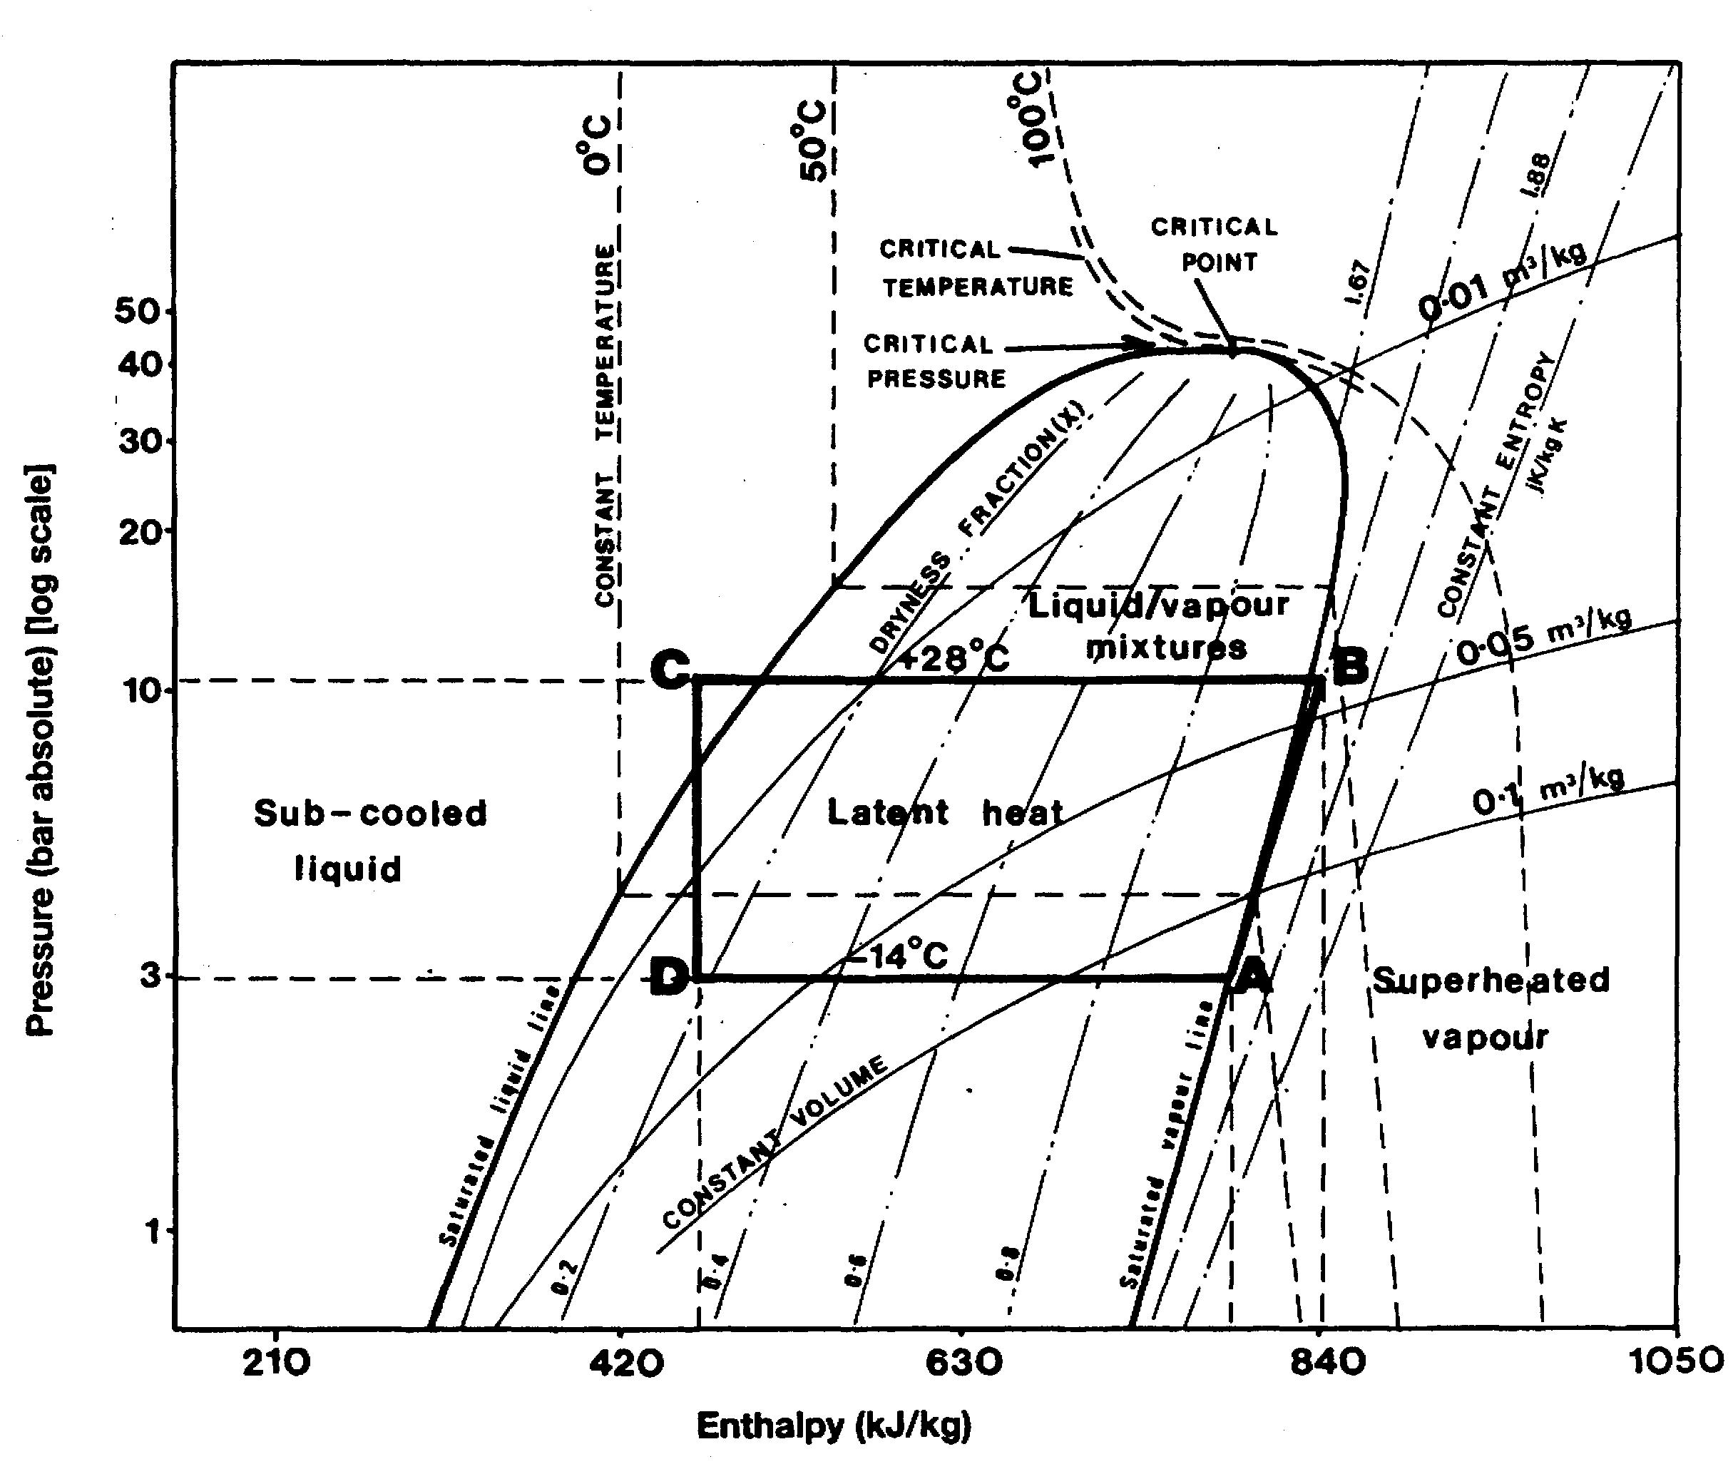

Figure 2.16 Mollier diagram for propane
by the saturated liquid line and the saturated vapor line which meet at the apex which is the critical point. As will be seen, the diagram also contains lines of constant temperature, constant volume, constant entropy and dryness fraction.

Reliquefaction
Superimposed on the Mollier diagram is an example of the pressure and enthalpy changes taking place in a simple shipboard reliquefaction cycle. This covers the boil-off from a semi-pressurized cargo of propane being carried at 3 bars and -14°C. (In following this example reference can also be made to 2.11 and Figure 2.8.) At A on the diagram, the boil-off vapor is drawn off from the cargo tank and compressed to 10 bars at B. It is generally assumed that the compression is adiabatic; that is with no heat lost from the vapor during the compression (see also 2.14). For such an ideal adiabatic process, the change in entropy is zero and the line AB follows a line of constant entropy. The difference in enthalpy between B and A (approximately 840 — 790 = 50 kJ/kg) represents the work input to the vapor by the compressor. It will also be noticed that the line AB crosses lines of constant volume; this indicates decreasing volume due to compression.
From B to C, the vapor has heat taken from it and is condensed to liquid. The position of C in this example shows that the condenser has achieved some degree of sub-cooling of the liquid. The enthalpy change from B to C (approximately 840 — 470 = 370 kJ/kg) represents the heat removed by the condenser.
The liquid condensate is then expanded through a regulating valve (expansion valve) and returned to the ship’s tank at a pressure of 3 bars. In this procedure, the condensate neither gives up nor receives heat and thus there is no change in enthalpy. In the expansion process, the change in sensible heat (cooling) exactly matches the ingress of latent heat required for flash evaporation. The line CD is, therefore, vertical and the position of D indicates a dryness fraction of 0.2 for the returned condensate: that is 20 per cent mass of vapor and 80 per cent mass of liquid.
The total refrigeration effect of the cycle is given by the difference in enthalpy of the vapor drawn to the compressor at A and that of the condensate return at D (approximately 790 — 470 = 320 kJ/kg).

2.20 FLAMMABILITY

Combustion
Combustion is a chemical reaction, initiated by a source of ignition, in which a flammable vapor combines with oxygen to produce carbon dioxide, water vapor and heat. Under ideal conditions the reaction for propane can be written as follows: —
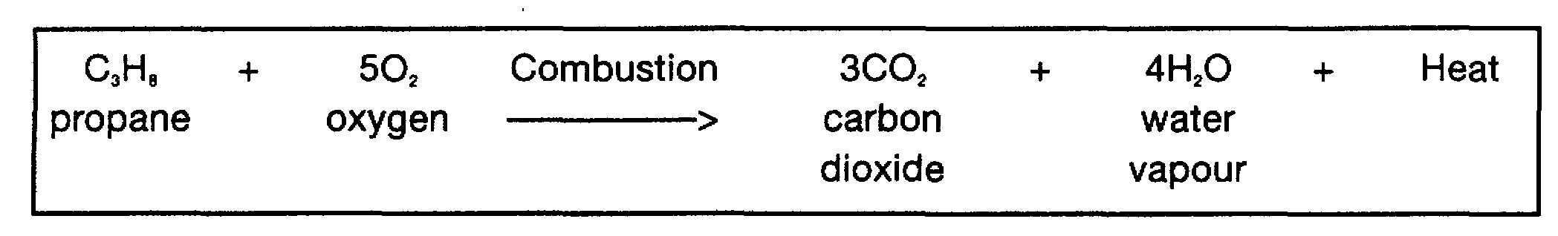
Under certain circumstances when, for example, oxygen supply to the fuel is restricted, carbon monoxide or carbon can also be produced.
The three requirements for combustion to take place are fuel, oxygen and ignition. Furthermore, for ignition to occur, the proportions of vapor to oxygen (or to air) must be within the product’s flammable limits.
The gases produced by combustion are heated by the reaction’. In open spaces, gas expansion is unrestricted and combustion may proceed without undue over-pressures developing. If the expansion of the hot gases is restricted in any way, pressures will rise and the speed of flame travel will increase. This depends upon the degree of confinement encountered. Increased flame speed gives rise to a more rapid increase in pressure with the result that damaging over-pressures may be produced. Even in the open, if the confinement resulting from surrounding pipework, plant and buildings is sufficient, the combustion can take on the nature of an explosion. In severely confined conditions, such as within a building or ship’s tank, where the expanding gases cannot escape, the internal pressure and its rate of increase may be sufficient to burst the containment. Here, the explosion is not due to high combustion rates and flame speed: it results more from the surge of high pressure upon containment rupture.

The BLEVE
A BLEVE (Boiling-Liquid/Expanding-Vapor Explosion) is an explosion resulting from the catastrophic failure of a vessel containing a liquid significantly above its boiling point at normal atmospheric pressure. The container may fail for any of the following reasons: mechanical damage, corrosion, excessive internal pressure, flame impingement or metallurgical failure. The most common cause of a BLEVE is probably when a fire increases the internal tank pressure of the vessel’s contents and flame impingement reduces its mechanical strength; particularly at that part of the vessel not cooled by internal liquid. As a result, the tank suddenly splits and pieces of the vessel’s shell can be thrown a considerable distance with concave sections, such as end caps, being propelled like rockets if they contain liquid. Upon rupture, the sudden decompression produces a blast and the pressure immediately drops. At this time the liquid temperature is well above its atmospheric boiling point and, accordingly, it spontaneously boils off, creating large quantities of vapor, which are thrown upwards along with liquid droplets.
Where the gas/air mixture is within its flammable limits, it will ignite from the rending metal or the surrounding fire to create a fireball reaching gigantic proportions and the sudden release of gas provides further fuel for the rising fireball. The rapidly expanding vapor produces a further blast and intense heat radiation.
Such BLEVE incidents have occurred with rail tank cars, road vehicles and in a number of terminal incidents. There have been no instances of this kind on liquefied gas carriers. Under the Gas Codes, pressure relief valves are sized to cope with surrounding fire and, as for shore tanks, this helps to limit this risk. It must be said that the chance of a fire occurring in the enclosed space beneath a pressurized ship’s tank is much smaller than on an equivalent tank situated on shore. This minimizes the possibility of a surrounding fire occurring on a ship and almost excludes the possibility of a BLEVE occurring on a gas carrier.

Flammable Range
The concept of a flammable range gives a measure of the proportions of flammable vapor to air for combustion to occur. The flammable range is the range between the minimum and maximum concentrations of vapor (per cent by volume) in air which form a flammable mixture. The lower and upper limits are usually abbreviated to LFL (lower flammable limit) and UFL (upper flammable limit). This concept is illustrated for propane in Figure 2.17.
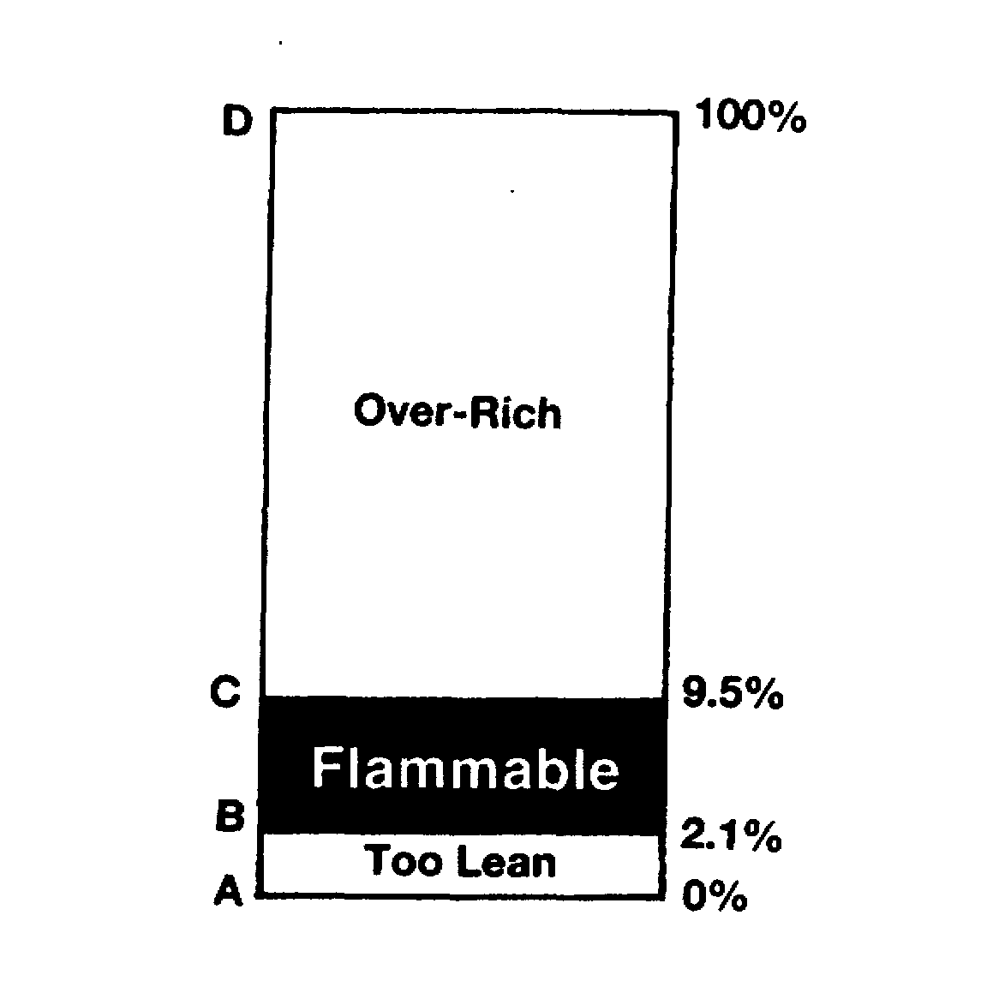

Figure 2.17 Flammable range for propane
All the liquefied gases, with the exception of chlorine, are flammable but the limits of the flammable range vary depending on the particular vapor. These are listed in Table 2.8. The flammable range of a vapor is broadened in the presence of oxygen in excess of that normally found in air. In such cases the lower flammable limit is

Table 2.8 Ignition properties for liquefied gases
Liquefied Gas | Flash Point  (Cº) | Flammable range  (% by vol. in air) | Auto-ignition temperature (Cº)
Methane | -175 | 5.3-14 | 595
Ethane | -125 | 3.0-12.5 | 510
Propane | -105 | 2.1-9.5 | 468
n-Butane | - 60 | 1.5-9.0 | 365
i-Butane | - 76 | 1.5-9.0 | 500
Ethylene | -150 | 3.0-34.0 | 453
Propylene | -108 | 2.0-11.1 | 453
α-Butylene | - 80 | 1.6-10 | 440
β-Butylene | - 72 | 1.6-10 | 465
Butadiene | - 60 | 1.1-12.5 | 418
Isoprene | - 50 | 1.5-9.7 | 220
Vinyl Chloride | - 78 | 4.0-33.0 | 472
Ethylene oxide | - 18 | 3.0-100 | 429
Propylene oxide | - 37 | 2.1-38.5 | 465
Ammonia | - 57 | 14-28 | 615
Chlorine | Non-flammable

Table 2.9 Flammability range in air and oxygen for some liquefied gases
 | Flammable range (% by volume)
 | (in air) | (in oxygen)
Propane | 2.1-9.5 | 2.1-55.0
n-Butane | 1.5-9.0 | 1.8-49.0
Vinyl Chloride | 4.0-33.0 | 4.0-70.0

changed little but the upper flammable limit is considerably raised. Comparative flammable ranges in air and in oxygen are quoted in Table 2.9 for propane, n-butane and vinyl chloride. All flammable vapors exhibit this property and, as a result, oxygen should not normally be introduced into an atmosphere where flammable vapors exist.

Flash Point
The flash point of a liquid is the lowest temperature at which that liquid will evolve sufficient vapor to form a flammable mixture with air. High vapor pressure liquids such as liquefied gases have extremely low flash points, as seen from Table 2.8. However, although liquefied gases are never carried at temperatures below their flash point, the vapor spaces above such cargoes are non-flammable since they are filled entirely with cargo vapor and are thus safely above the upper flammable limit.

Auto-ignition Temperature
The auto-ignition temperature of a substance is the temperature to which its vapor-in-air mixture must be heated to ignite spontaneously. The auto-ignition temperature is not related to the vapor pressure or to the flash point of the substance and, since the most likely ignition sources are external flames or sparks, it is the flash point rather than the auto-ignition temperature which is used for the flammability classification of hazardous materials. Nevertheless, when vapor escapes are considered in relation to adjacent steam pipes or other hot surfaces, the auto-ignition temperature is worthy of note. Accordingly, they are listed in Table 2.8.

Energy Required for Ignition
Accidental sources of ignition of a flammable vapor can be flames, thermal sparks (due to metal-to-metal impact) and electric arcs or sparks. The minimum ignition energy necessary to set fire to hydrocarbon vapors is very low, particularly when the vapor concentration is in the middle of the flammable range. Minimum ignition energies for flammable vapors in air are typically-less than one milliJoule. This is an energy level substantially exceeded by any visible flame, by most electric circuit sparks or by electrostatic discharges down to the lowest level detectable by human contact. The presence of oxygen in excess of its normal proportion in air further lowers the minimum ignition energy.
Only the flammable mixtures of ammonia have minimum ignition energies lying outside this typical range. Ammonia requires energies some 600 times higher than the other gases for ignition. Nevertheless, the possibility of ignition of ammonia vapors cannot be completely discounted.

Flammability within Vapor Clouds
Should a liquefied gas be spilled in an open space, the liquid will rapidly evaporate to produce a vapor cloud (see also 2.10.2) which will gradually disperse downwind. The vapor cloud or plume is flammable only over part of its area. The situation is illustrated in Figure 2.18.
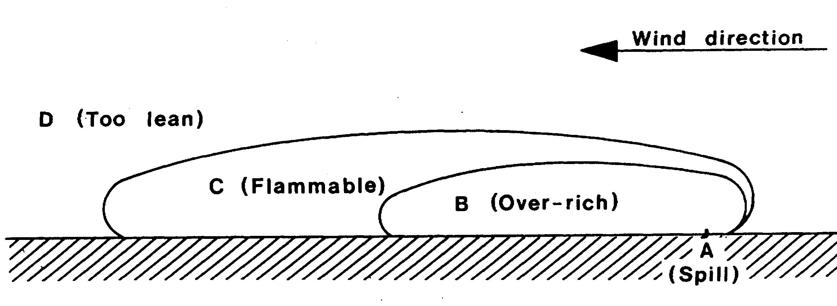

Figure 2.18 Flammable vapor zones — a liquefied gas spill
The region (B) immediately adjacent to the spill area (A) is non-flammable because it is over-rich. It contains too low a percentage of oxygen to be flammable. Region (D) is also non-flammable because it is too lean; containing too little vapor to be flammable. The flammable zone lies between these two regions as indicated by (C).

2.21 SUPPRESSION OF FLAMMABILITY BY INERT GAS
Whereas increasing the oxygen concentration in a flammable mixture causes a broadening of the flammable range and a lowering of the energy necessary for ignition, decreasing the oxygen causes the flammable range to be narrowed and the minimum ignition energy to be increased. If the oxygen availability is reduced to a sufficient extent, the mixture will become non-flammable no matter what the combustible vapor content may be. Figure 2.19 illustrates this concept for typical hydrocarbon gas mixtures with air and nitrogen. The mixtures are represented on the horizontal axis by the percentage oxygen content in the total mixture. The diagram provides much useful information. The narrowing of the flammable range as the oxygen is reduced
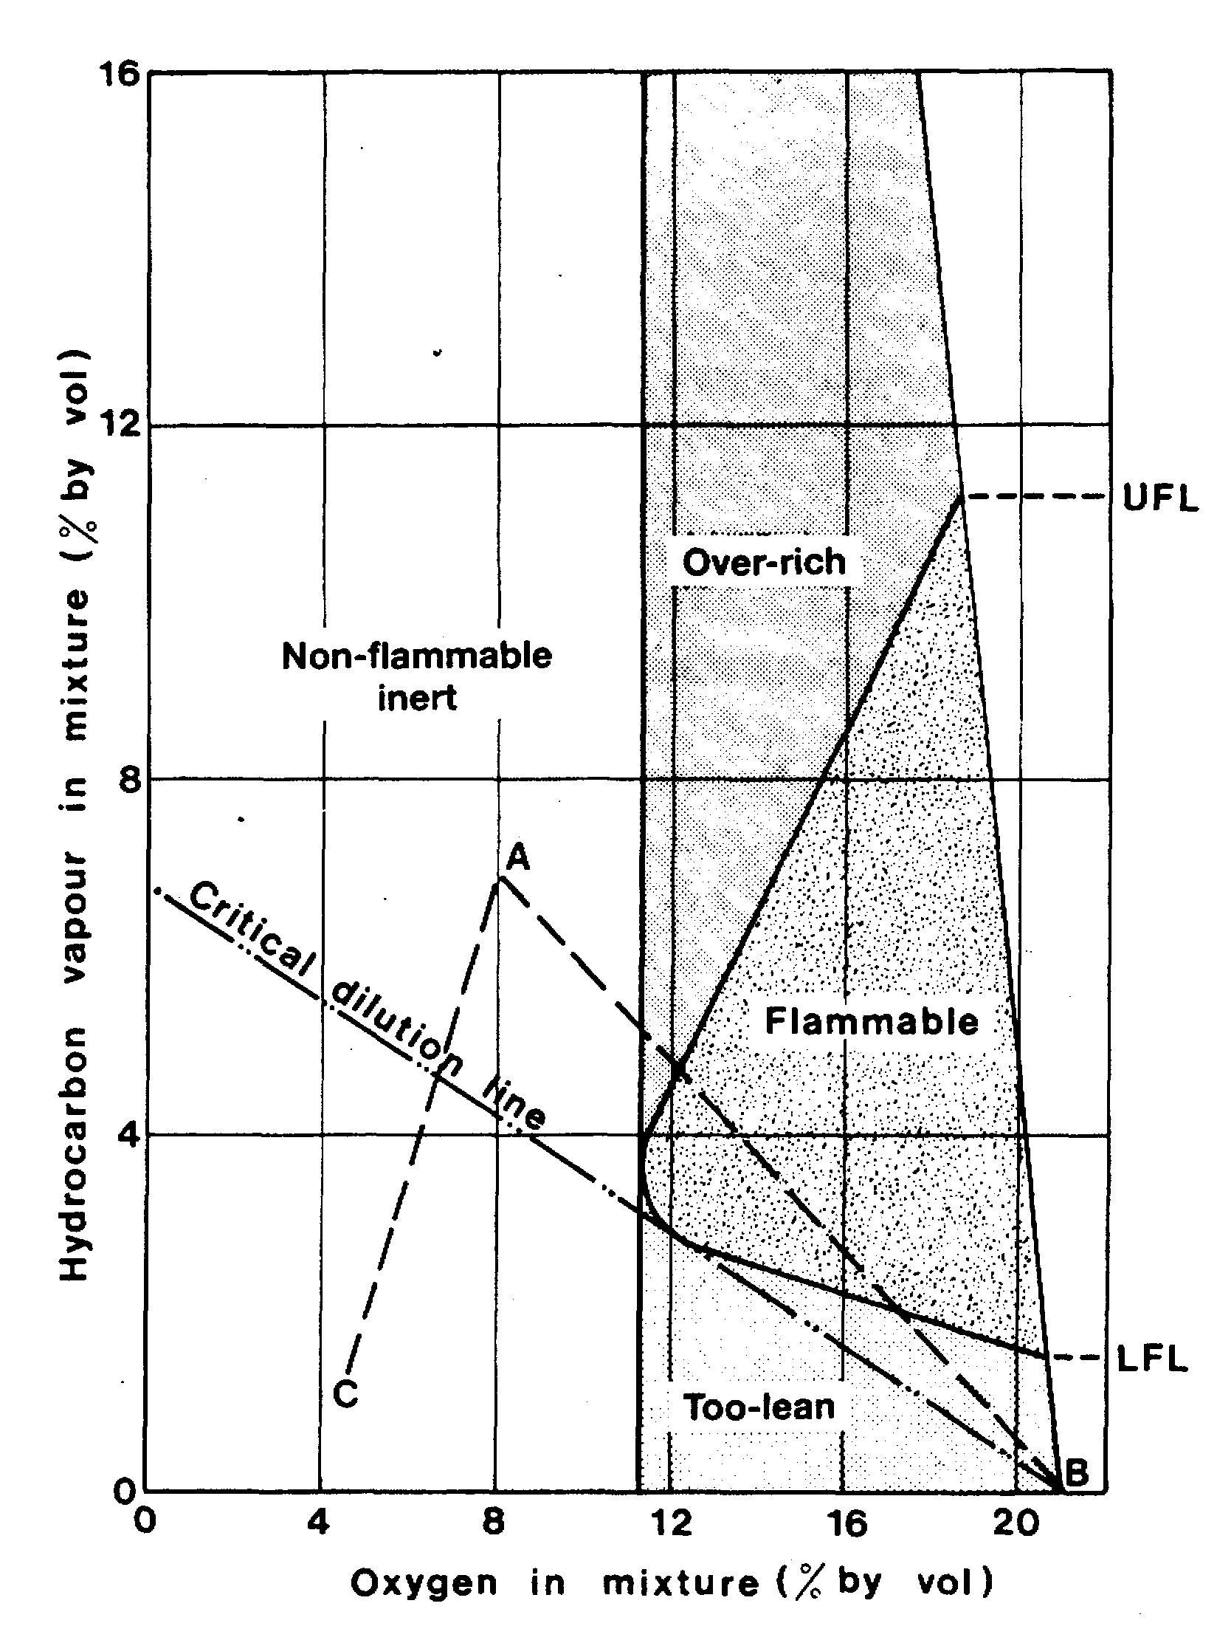

Figure 2.19 Flammable limits of gas mixtures in air and nitrogen
can be seen from the shape of the area labeled flammable. It is also clear that oxygen content of less than that at the left hand extremity of the flammable envelope renders the mixture non-flammable. This value, for most hydrocarbon vapors, is around 10 to 12 per cent by volume. However, on a gas carrier for an atmosphere to be adequately non-flammable, less than 5 per cent (sometimes 2 per cent) by volume oxygen is needed. This allows for a degree of poor mixing and pockets of gas remaining in some areas of the tank.
The diagram is also useful in illustrating proper inerting and gas-freeing procedures. For example, assume that a tank atmosphere is determined to be at point A. If the tank is then gas-freed directly with air, the composition of the tank atmosphere will move along the line AB to the fully gas-free condition at point B. In so doing, the atmosphere passes through the flammable envelope. This can be avoided by first inerting the tank along, say, the line AC to a point below the critical dilution line. Aerating to point B may then be undertaken without the tank atmosphere passing through the flammable envelope. This result can only be safely achieved if regular measurements are taken, using properly calibrated instruments to evaluate the atmosphere throughout the tank at the various stages. In this process, it is important to use reasonable margins of safety since the shape of the flammable envelope is ill-defined for mixtures and any non-homogeneity of the tank atmosphere must be allowed for. Also, the varying range of flammable limits for the different gases must be considered (see Table 2.8). The flammable envelope data, as given in Reference 2.1, can also be helpful on a grade-by-grade basis.

2.22 SOURCES OF IGNITION
The principal method of protection against fire and explosion on gas carriers and on jetties is achieved through design and operational procedures. These should be planned to control atmospheres and to avoid spills or leakages. However, added protection is essential and can be provided by means of controlling sources of ignition. Sources of ignition can also result from human error. Some of the principal sources of ignition are outlined below.

Smoking
Illicit smoking can be a source of ignition in hazardous areas; therefore smoking must always be restricted to approved locations. These regulations must be enforced during cargo-handling operations, particularly when visitors are present who may not appreciate the nature of the cargo being handled. Smoking regulations should also ban the carriage of matches and lighters within hazardous areas.

Hot Work and Cold Work
Hot and cold work should only be permitted under conditions of strict control. This can best be achieved by the use of appropriate work permits. Atmospheres in areas, which could become hazardous, should be continuously monitored during hot and cold work operations. This should preferably be carried out with instruments, which are capable of alarming automatically on the detection of flammable vapor.

Safety Tools
The use of safety tools designed for spark-free use in hazardous areas can create a false sense of security. Made from soft copper alloys, these tools are often referred to as non-sparking but it should be appreciated that fragments of steel and grit can easily become imbedded in the heads of these tools. The use of such tools is, therefore, not recommended.

Static Electricity
As is the case with many other hydrocarbon liquids, a static electrical charge can be built up within a liquefied gas as it is being pumped. It has been found that the charge will increase as pumping velocity rises. This phenomenon occurs due to charge-separation between layers within the fluid. The charge is then retained for some time within the liquid mass by its non-conducting property. The danger of such charges is that they can attain sufficient potential to create incendive sparks and, particularly in cargo tanks, electrical arcing is possible. It is, therefore, vital that the handling of gas cargoes only takes place in spaces having atmospheres outside the flammable range. On gas carriers, such atmospheres are always maintained in the over-rich condition.
Problems with static electricity can also arise within vapor flows but only when the gas is contaminated with debris, dust particles or when a condensed mist is present. In such cases it is the debris (or the mist which forms as it exits to atmosphere), which attains a static charge. Vapors, which can attain a static charge in this way, include carbon dioxide (as a fire extinguishing agent) and steam.
Liquid hydrocarbons, which are most prone to static build-up, are called static accumulators. For a physical description of this phenomenon see Reference 2.4.

Electrical Power and Instrumentation
Electrical instruments used in hazardous areas should be of flameproof or intrinsically safe design (see 4.8). The use of wandering electric power leads should be disallowed.

Aluminum
Portable aluminum alloy equipment, such as ladders and “Zip-Up” scaffolding should not be used in hazardous areas; as a smear of aluminum on rusty steel can cause an incendive spark if subsequently struck. Thus the potential for ignition can remain after the equipment has been removed from the area. Alloys containing more than 6% magnesium are potentially more dangerous than those with a lower magnesium content.

Mobile Telephones
The use of mobile telephones and pagers on deck or in terminals should be strictly limited to those certified as intrinsically safe.

Insulation Flanges and Ship/Shore Bonding Cables
Electrical arcs may occur when connecting or disconnecting cargo connections between ship and shore if the hose or hard arm provides an electrical path between ship and jetty structures. Electrical current will flow through this path due to differences in potential between the ship and the jetty. Such differences may be increased by imbalance between the cathodic protection applied to each structure. Although the resultant potential difference between ship and jetty is small, the electrolytic cell is large. Accordingly, and given that the electrical resistances in the cargo connection is small, a heavy current of many amperes may flow through the cargo connection. This current, on being interrupted, can produce arcs of incendive energy at the manifold.
The original intention of the ship/shore bonding cable was to provide an alternative path for this current but, in practical terms, such cables have been shown to be ineffective. Since it is ineffective and presents a hazard by virtue of the current it carries, the use of the bonding cable is no longer recommended. The introduction of an electrical discontinuity in the cargo hose or hard arm by means of an insulating flange or a length of electrically discontinuous hose, as appropriate, is effective in eliminating the current and any sparking.
For reasons of accessibility, insulating flanges are usually located at the lower end of the outer arm of the hard arm (see also 5.1.4).
Although the potential dangers of using a ship/shore bonding cable are widely recognized, attention is drawn to the fact that some national and local regulations may still require a bonding cable to be connected. If a bonding cable is insisted upon, it should first be visually inspected to make sure it is mechanically sound. The connection point on board ship for the cable should be well clear of the manifold area. There should always be a switch on the jetty, in series with the bonding cable, and of a type suitable for use in a hazardous area. It is important to ensure that the switch is always in the off position before connecting or disconnecting the cable. Only when the cable is properly attached and in good contact with the ship should the switch be closed. The cable should be attached before the cargo hoses or hard arms are connected and removed only after they have been disconnected.
Where national authorities require a ship/shore bonding cable to be used it is still recommended that insulation flanges be fitted.

Chapter 3
Principles of Gas Carrier Design
This chapter provides an overview of the written standards covering gas carrier construction. It starts with an outline of the various Gas Codes agreed by the international Maritime Organization. Later sections discuss the essential elements of design such as cargo containment systems and Ship Types.
In reading this chapter it is important to realize that apart from written standards there are some aspects of gas carrier construction, which are covered by the additional requirements of experienced shipowners.
  - DESIGN STANDARDS AND SHIP TYPES
3.1.1 The Gas Carrier Codes
The overall layout of a gas carrier is similar to that of the conventional oil tanker from which it evolved. The cargo containment system and its incorporation into the hull is, however, very different .due to the need to carry cargo under pressurized, or refrigerated conditions; or under a combination of pressure and refrigeration.
Gas carriers designed for pressurized cargoes can usually be identified by cylindrical or spherical tanks, which may project through the deck. Similarly the LNG carrier with spherical tanks protruding above the main deck can be easily recognised by its distinctive profile and much larger size. Gas carriers designed to carry their cargo at atmospheric pressure in prismatic tanks are not easily distinguishable from oil tankers except by their freeboard, which is significantly greater. This greater buoyancy results from cargoes of a much lower density than most oils and the requirement to have totally segregated tanks for ballast.
To examine the design of these ships in greater detail, readers should consult the Gas Codes and the rules of the major ship classification societies which give guidance on the requirements of the Gas Codes.
The Gas Codes, developed by IMO, apply to all gas carriers regardless of size. There are three Gas Codes and these are described below.

Gas carriers built after June 1986 (the IGC Code)
The Code which applies to new gas carriers (built after 30th June 1986) is the International Code for the Construction and Equipment of Ships Carrying Liquefied Gases in Bulk. In brief, this Code is known as the /GC Code. The /GC Code, under amendments to Safety of Life at Sea Convention (SOLAS), is mandatory for all new ships. As proof that a ship complies with the Code, an International Certificate of Fitness for the Carriage of Liquefied Gases in Bulk should be on board.
In 1993, the IGC Code was amended and the new rules came into effect on 1st July 1994. Ships on which construction started on or after 1st October 1994 should apply the amended version of the Code but ships built earlier may comply with previous editions of the IGC Code.

Gas carriers built between 1976 and 1986 (the GC Code)
The regulations covering gas carriers built after 1976 but before July 1986 are included in the Code for the Construction and Equipment of Ships Carrying Liquefied Gases in Bulk. It is known as the Gas Carrier Code or GC Code in short.
Since 1975, IMO has approved four sets of amendments to the GC Code. The latest was adopted in June 1993. It should be noted that all amendments are not necessarily agreed by every government. Although this Code is not mandatory, many countries have implemented it into national law. Accordingly, most charterers will expect such ships to meet with Code standards and, as proof of this, to have on board a Certificate of Fitness for the Carnage of Liquefied Gases in Bulk.

Gas carriers built before 1977 (the Existing Ship Code)
The regulations covering gas carriers built before 1977 are contained in the Code for Existing Ships Carrying Liquefied Gases in Bulk. Its content is similar to the GC Code, though less extensive.
The Existing Ship Code was completed in 1976 after the GC Code had been written. It therefore summarizes current shipbuilding practice at that time. It remains as an IMO recommendation for all gas carriers in this older fleet of ships. The Code is not mandatory but is applied by some countries for ship registration and in other countries as a necessary fulfillment prior to port entry. Accordingly, many ships of this age are required by charterers to meet with Code standards and to have on board a Certificate of Fitness for the Carnage of Liquefied Gases in Bulk.
Some of the factors to be taken into consideration which affect the design of gas ships are: —
- Types of cargo to -be carried
- Condition of carriage (fully pressurised, semi-pressurised, fully refrigerated)
- Type of trade and cargo handling flexibility required by the ship
- Terminal facilities available when loading or discharging the ship
Perhaps more than any other single ship type, the gas tanker encompasses many different design philosophies. Nowhere is this more apparent than in considering the different types of cargo containment system, which have been adopted.
3.2 CARGO CONTAINMENT SYSTEMS
A cargo containment system is the total arrangement for containing cargo including, where fitted:
- A primary barrier (the cargo tank),
- Secondary barrier (if fitted),
- Associated thermal insulation,
- Any intervening spaces, and
- Adjacent structure, if necessary, for the support of these elements.

For cargoes carried at temperatures between -10°C and -55°C the ship’s hull may act as the secondary barrier and in such cases it may be a boundary of the hold space.
The basic cargo tank types utilized on board gas carriers are in accordance with the list below:—
Some other types such as:
- Independent Type ‘A’ • Internal insulation Type ‘1’
- Independent Type ‘B’ • Internal insulation Type ‘2’
- Independent Type ‘C’ • Integral
- Membrane
have been fully designed and approved but have not been commercially used yet.
3.2.1 Independent tanks
Independent tanks are completely self-supporting and do not form part of the ship’s hull structure. Moreover, they do not contribute to the hull strength of a ship. As defined in the IGC Code. and depending mainly on the design pressure, there are three different types of independent tanks for gas carriers: these are known as Types ‘A’, ‘B’ and ‘C’.

Type ‘A’ tanks
Type ‘A’ tanks are constructed primarily of flat surfaces. The maximum allowable tank design pressure in the vapour space for this type of system is 0.7 barg; this means cargoes must be carried in a fully refrigerated condition at or near atmospheric pressure (normally below 0.25 barg). Figure 3.1 shows a section through this type of
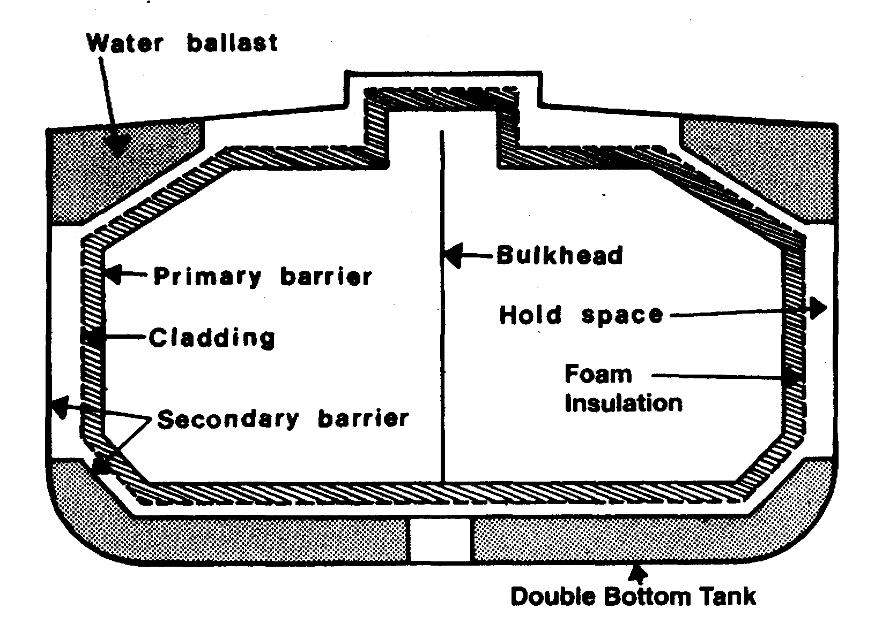
Figure 3.1 Prismatic self-supporting Type ‘A’ tank — fully refrigerated LPG carrier
tank as found on a fully refrigerated LPG carrier. This is a self-supporting prismatic tank, which requires conventional internal stiffening. In this example the tank is surrounded by a skin of foam insulation. Where perlite insulation is used, it would be found filling the whole of the hold space.
The material used for Type ‘A’ tanks is not crack propagation resistant. Therefore, in order to ensure safety, in the unlikely event of cargo tank leakage, a secondary containment system is required. This secondary containment system is known as a secondary barrier and is a feature of all ships with Type ‘A’ tanks capable of carrying cargoes below -10°C.
For a fully refrigerated LPG carrier (which will not carry cargoes below -55°C) the secondary barrier must be a complete barrier capable of containing the whole tank volume at a defined angle of heel and may form part of the ship’s hull, as shown in the figure. In general, it is this design approach, which is adopted. By this means appropriate parts of the ship’s hull are constructed of special steel capable of withstanding low temperatures. The alternative is to build a separate secondary barrier around each cargo tank.
The IGC Code stipulates that a secondary barrier must be able to contain tank leakage for a period of 15 days.
On such ships,, the space between the cargo tank (sometimes referred to as the primary barrier) and the secondary barrier is known as the hold space. When flammable cargoes are being carried, these spaces must be filled with inert gas to prevent a flammable atmosphere being created in the event of primary barrier leakage.

Type ‘B’ tanks
Type ‘B’ tanks can be constructed of flat surfaces or they may be of the spherical type. This type of containment system is the subject of much more detailed stress analysis compared to Type ‘A’ systems. These controls must include an investigation of fatigue life and a crack propagation analysis.
The most common arrangement of Type ‘B’ tank is a spherical tank as illustrated in Figure 3.2(a). This tank is of the Kvaerner Moss design. Because of the enhanced design factors, a Type ‘B’ tank requires only a partial secondary barrier in the form of a drip tray. The hold space in this design is normally filled with dry inert gas. However, when adopting modern practice, it may be filled with dry air provided that inerting of the space can be achieved if the vapour detection system shows cargo leakage. A protective steel dome covers the primary barrier above deck level and insulation is applied to the outside of the tank. The Type ‘B’ spherical tank is almost exclusively applied to LNG ships; seldom featuring in the LPG trade.
A Type ‘B’ tank, however, need not be spherical. There are Type ‘B’ tanks of prismatic shape in LNG service. The prismatic Type ‘B’ tank has the benefit of maximizing ship-hull volumetric efficiency and having the entire cargo tank placed beneath the main deck. Where the prismatic shape is used, the maximum design vapour space pressure is, as for Type ‘A’ tanks, limited to 0.7 barg. A drawing of a self-supporting prismatic Type ‘B’ tank is shown in Figure 3.2(b).
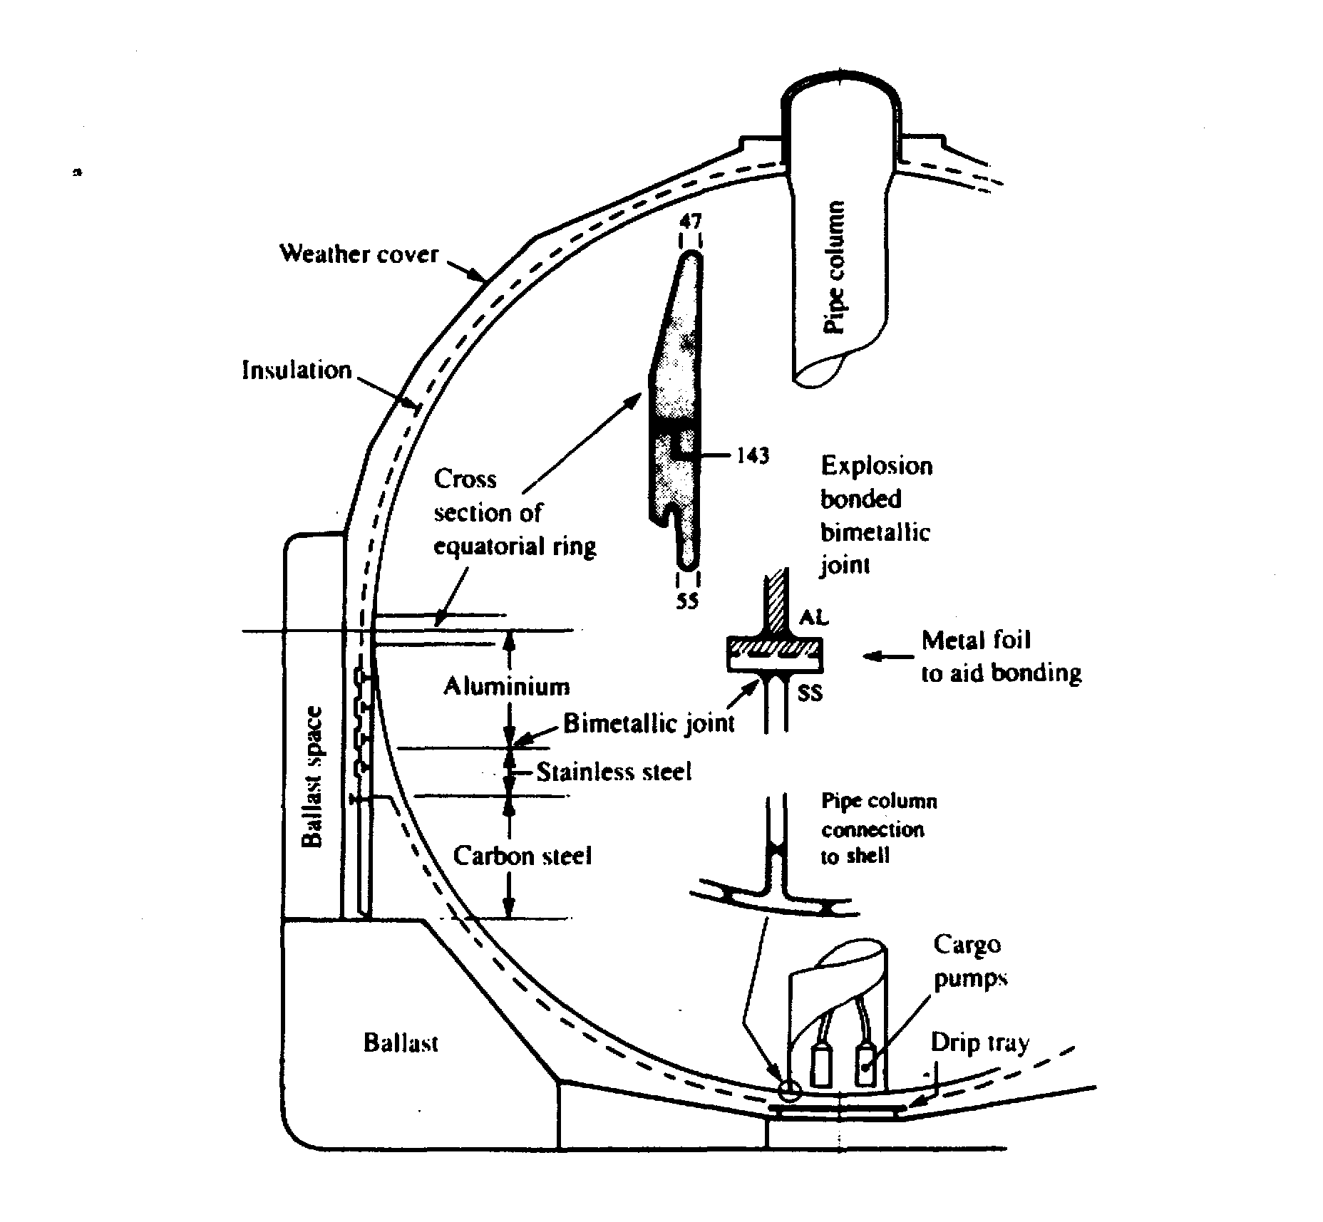
Figure 3.2(a) Self-supporting spherical Type ‘B’ tank
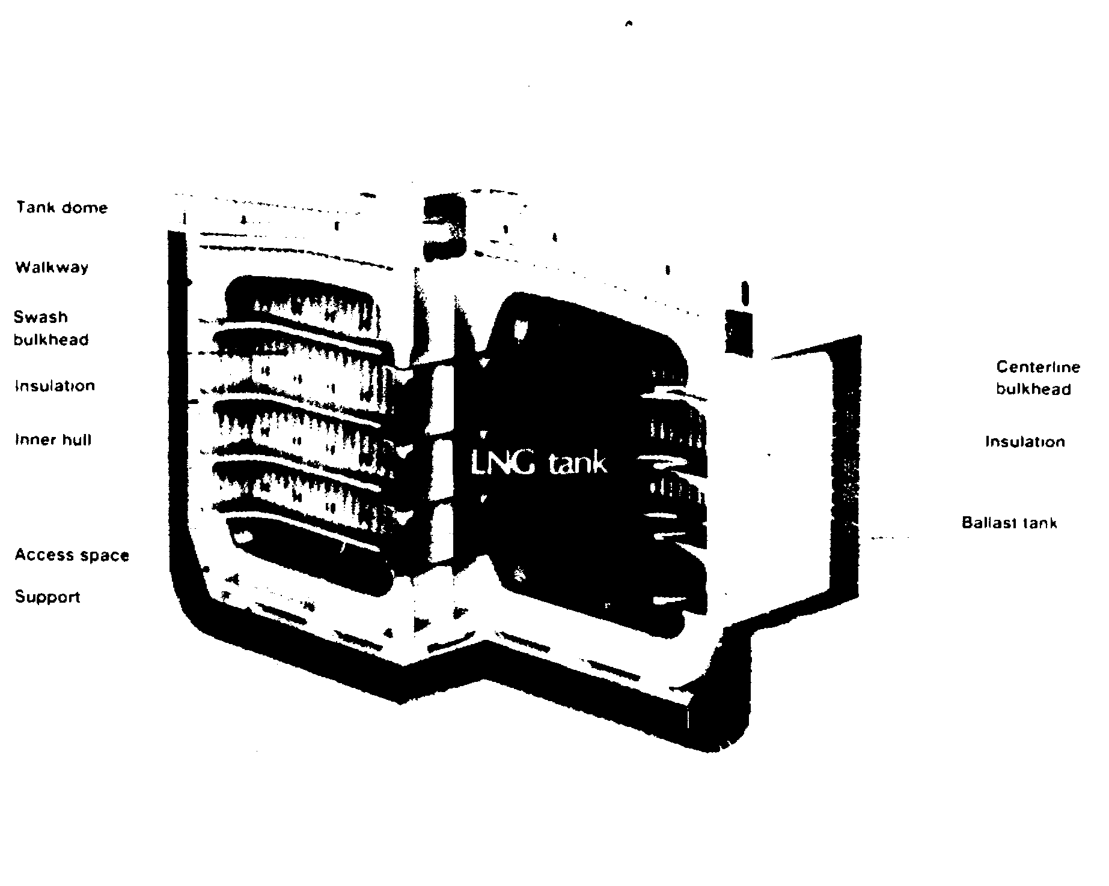
Figure 3.2(b) Self-supporting prismatic Type ‘B’ tank

Type ‘C’ tanks
Type ‘C’ tanks are normally spherical or cylindrical pressure vessels having design pressures higher than 2 barg. The cylindrical vessels may be vertically or horizontally mounted. This type of containment system is always used for semi-pressurised and fully pressurised gas carriers. In the case of the semi-pressurised ships it can also be used for fully refrigerated carriage, provided appropriate low temperature steels are used in tank construction. Type ‘C’ tanks are designed and built to conventional pressure vessel codes and, as a result, can be subjected to accurate stress analysis. Furthermore, design stresses are kept low. Accordingly, no secondary barrier is required for Type ‘C’ tanks and the hold space can be filled with either inert gas or dry air.
In the case of a typical fully pressurised ship (where the cargo is carried at ambient temperature), the tanks may be designed for a maximum working pressure of about 18 barg. For a semi-pressurised ship the cargo tanks and associated equipment are designed for a working pressure of approximately 5 to 7 barg and a vacuum of 0.5 barg. Typically, the tank steels for the semi-pressurised ships are capable of withstanding carriage temperatures of -48°C for LPG or -104°C for ethylene. (Of course, an ethylene carrier may also be used to transport LPG.)
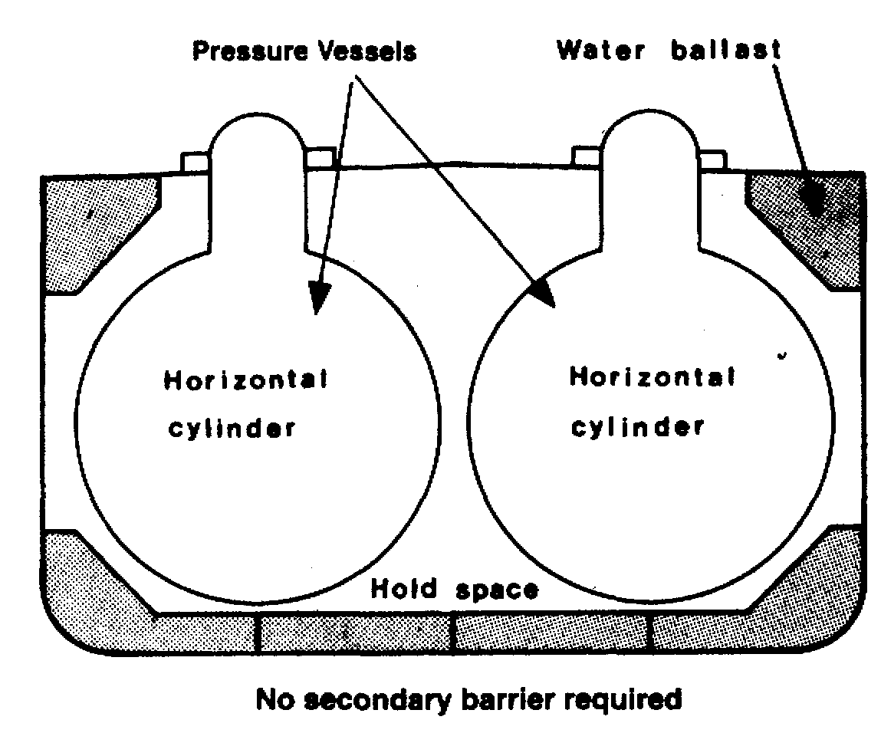
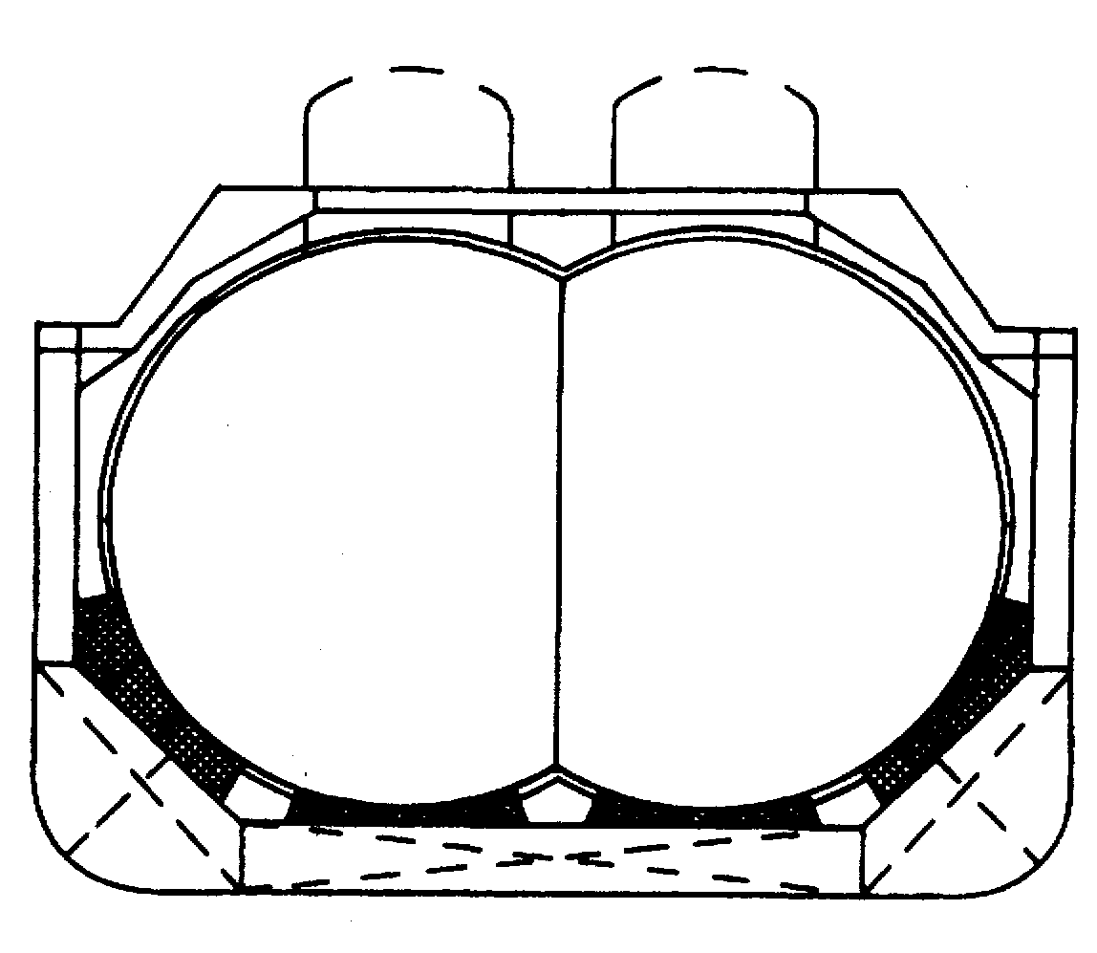

Figure 3.3 shows Type ‘C’ tanks as fitted in a typical fully pressurised gas carrier. With such an arrangement there is comparatively poor utilization of the hull volume; however, this can be improved by using intersecting pressure vessels or bi-lobe type tanks which may be designed with a taper at the forward end of the ship. This is a common arrangement in semi-pressurised ships as shown in Figure 3.4.
3.2.2 Membrane tanks (membrane - 0.7 to 1.5 mm thick)
The concept of the membrane containment system is based on a very thin primary barrier (membrane - 0.7 to 1.5 mm thick), which is supported through the insulation. Such tanks are not self-supporting like the independent tanks outlined in 3.2.1; an inner hull forms the load bearing structure. Membrane containment systems must always be provided with a secondary barrier to ensure the integrity of the total system in the event of primary barrier leakage. The membrane is designed in such a way that thermal expansion or contraction is compensated without over-stressing the membrane itself. There are two principal types of membrane system in common use — both named after the companies who developed them and both designed primarily for the carriage of LNG.
These two companies have now combined into one and future developments can be expected.

Gaz Transport membrane system
Figures 3.5(a) and 3.5(b) show the Gaz Transport system comprising a thin Invar primary barrier. Invar is a stainless steel alloy containing about 36 per cent nickel and 0.2 per cent carbon. This is attached to the inner (cold) surface of perlite-filled plywood boxes used as primary insulation. These boxes have thickness of between 200 and 300 millimeters. These, in turn, are attached to an identical inner layer of Invar (the secondary barrier) and, finally, a further set of similar perlite-filled boxes is used
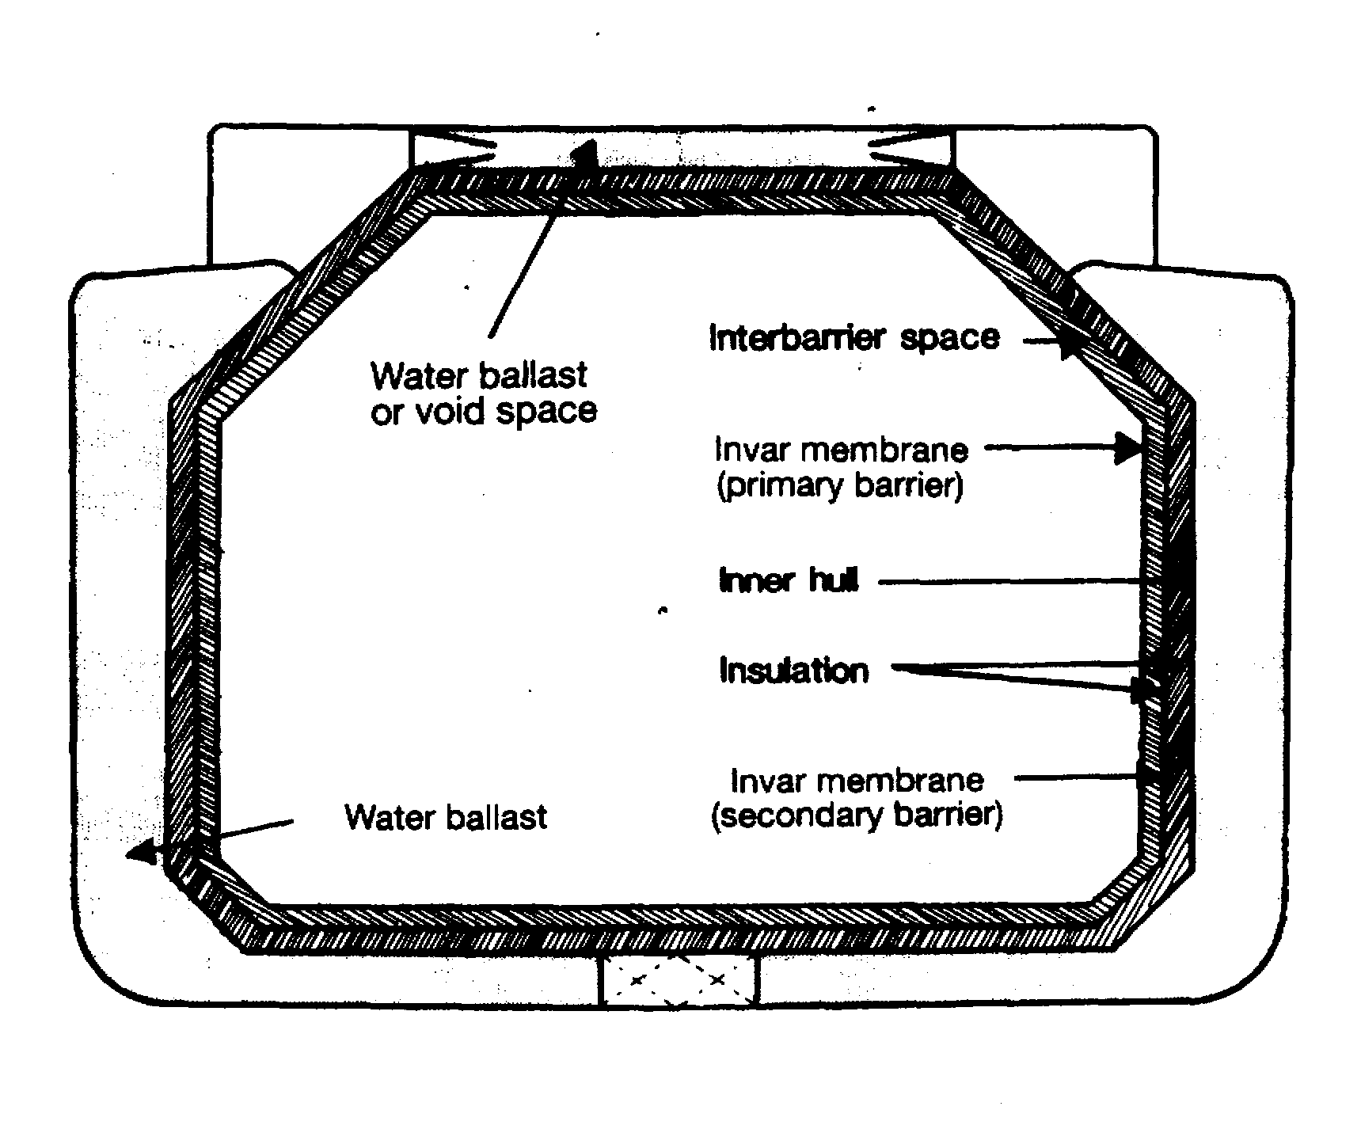

Figure 3.5(a) Gaz Transport membrane containment system — larger LNG carriers
for secondary insulation. Invar is chosen for the membranes because of its very low coefficient of thermal expansion, thus making expansion joints, or corrugation, in the barriers unnecessary. Newer designs of the Gaz Transport system utilize Invar membranes of 0.7 millimetres thickness in strakes of 0.5 meters width and strengthened plywood boxes to hold the perlite insulation. The perlite is processed with silicon to make it impervious to water or moisture. The thickness of the insulation boxes can be adjusted to obtain the required amount of boil-off.
Figure 3.5(b) shows a section through the basic Gas Transport containment system.
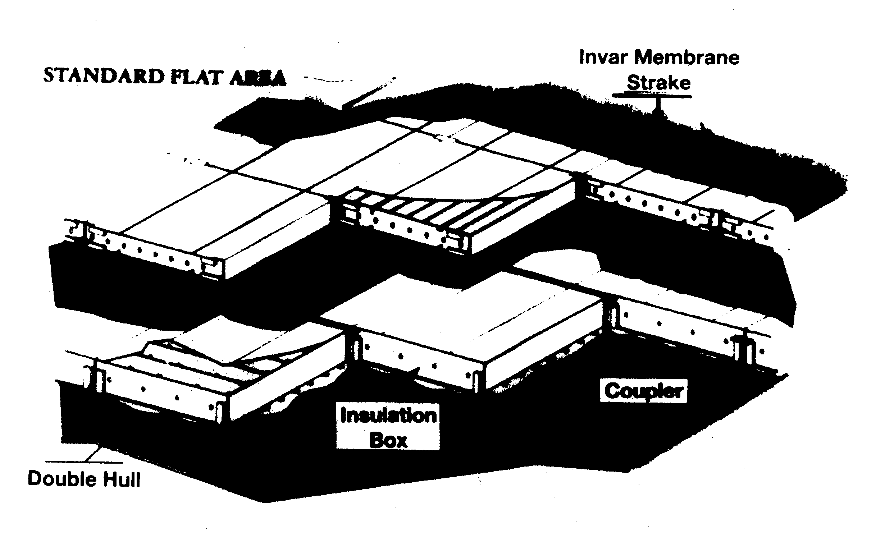

Figure 3.5(b) Construction of the Gaz Transport membrane system

Technigaz membrane system
The Technigaz system, shown in Figure 3.6(a), features a primary barrier of stainless steel (1.2 millimetres in thickness) having raised corrugations, or waffles, to allow for expansion and contraction. In the original Mark I design, the insulation that supports
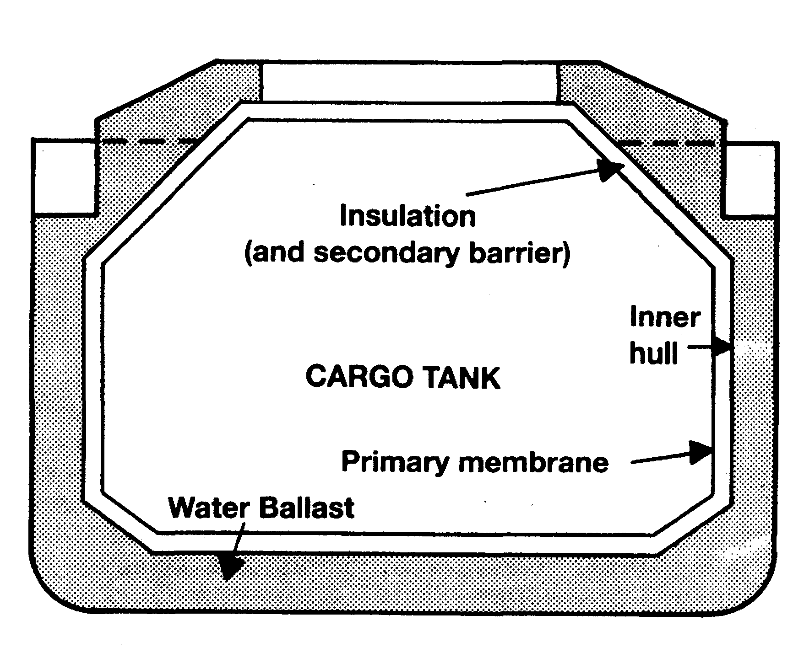
Figure 3.6(a) Technigaz membrane containment system — larger LNG carriers
the primary membrane consisted of laminated balsa wood panels held between two plywood layers; the face plywood formed the secondary barrier. The balsa wood panels were interconnected with specially designed joints comprising PVC foam wedges and plywood scabs and were supported on the inner hull of the ship by wooden grounds.
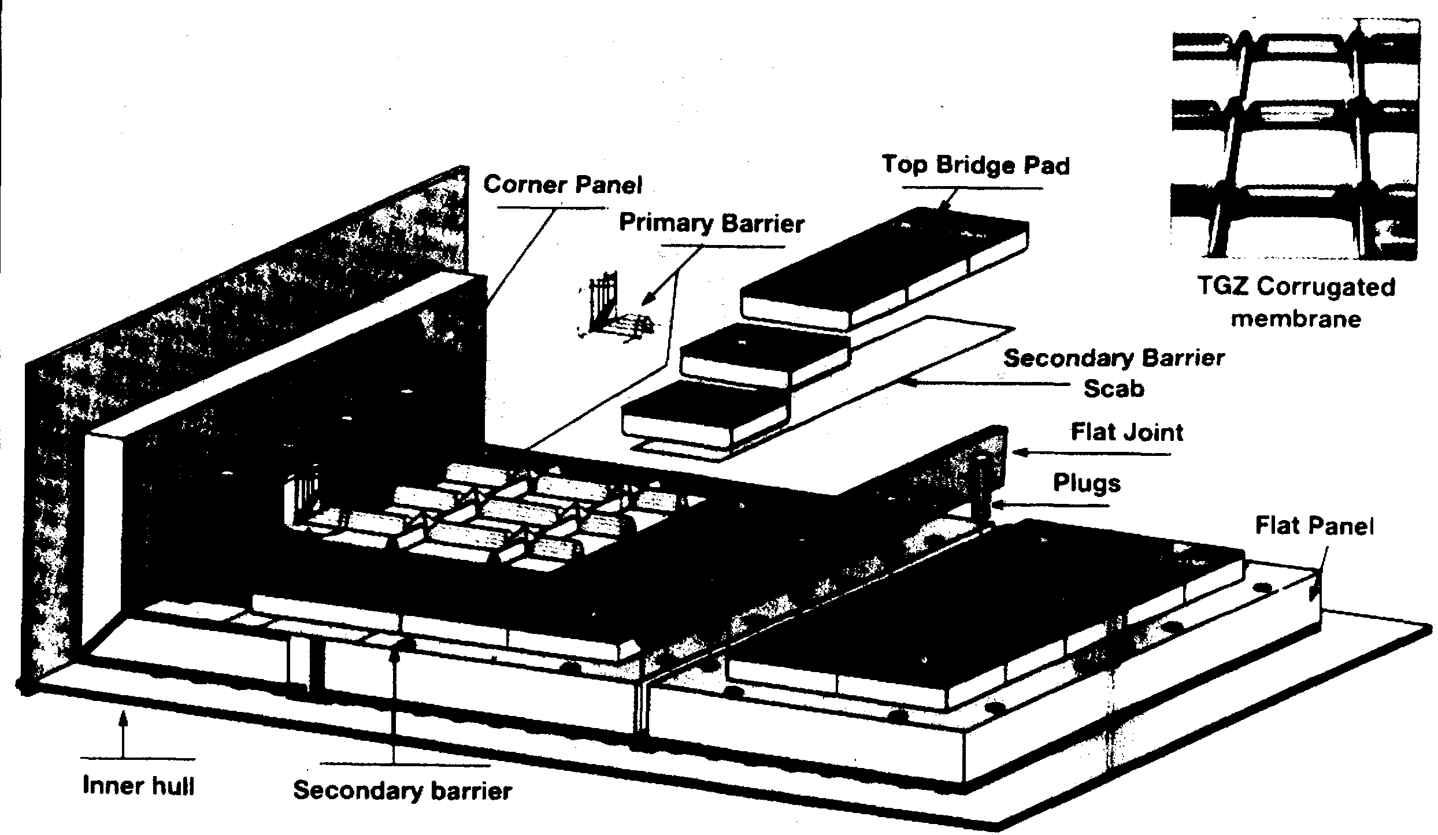

Figure 3.6(b) Construction of the Technigaz membrane — Mark
In the latest design (Mark III) the balsa wood insulation is replaced by reinforced cellular foam. Within the foam there is a fiberglass cloth/aluminum laminate acting as secondary barrier. Figure 3.6(b) shows a cutaway section through the Mark III Technigaz containment system.
3.2.3 Semi-membrane tanks
The semi-membrane concept is a variation of the membrane tank system. The primary barrier is much thicker than that in the membrane system, having flat sides and large radiused corners. The tank is self-supporting when empty but not in the loaded condition. In this condition the liquid (hydrostatic) and vapour pressures acting on the primary barrier are transmitted through the insulation to the inner hull as is the case with the membrane system. The corners and edges are designed to accommodate expansion and contraction.
Although semi-membrane tanks were originally developed for the carriage of LNG no commercial-size LNG carrier has yet been built to this design. The system has however, been adopted for use in LPG ships and several Japanese-built fully refrigerated LPG carriers have been delivered to this design.
3.2.4 Integral tanks
Integral tanks form a structural part of the ship’s hull and are influenced by the same loads which stress the hull structure. Integral tanks are not normally allowed for the carriage of liquefied gas if the cargo temperature is below -10°C. Certain tanks on a limited number of Japanese-built LPG carriers are of the integral type for the dedicated carriage of fully refrigerated butane.
3.2.5 Internal insulation tanks
Internally insulated cargo tanks are similar to integral tanks (see 3.2.4). They utilize insulation materials to contain the cargo. The insulation is fixed inside ship’s inner hull or to an independent load-bearing surface. The non-self-supporting system obviates the need for an independent tank and permits the carriage of fully refrigerated cargoes at carriage temperatures as low as -55°C.
Internal insulation systems have been incorporated in a very limited number of fully refrigerated LPG carriers but, to date, the concept has not proved satisfactory in service.
3.3 MATERIALS OF CONSTRUCTION AND INSULATION
3.3.1 Construction materials
The choice of cargo tank materials is dictated by the minimum service temperature and, to a lesser degree, by compatibility with the cargoes carried. The most important property to consider in the selection of cargo tank materials is the low-temperature toughness. This consideration is vital as most metals and alloys (except aluminum) become brittle below a certain temperature.
Treatment of structural carbon steels can be used to achieve low-temperature characteristics and the Gas Codes specify low-temperature limits for varying grades of steel down to -55°C. Reference should be made to the Gas Codes and classification society rules for details on the various grades of steel.
According to the Gas Codes, ships carrying fully refrigerated LPG cargoes may have tanks capable of withstanding temperatures down to -55°C. Usually, the final temperature is chosen by the shipowner, depending on the cargoes expected to be carried. This is often determined by the boiling point of liquid propane at atmospheric pressure and, hence, cargo tank temperature limitations are frequently set at about -46°C. To achieve this service temperature, steels such as fully killed, fine-grain, carbon-manganese steel, sometimes alloyed with 0.5 per cent nickel, are used.
Where a ship has been designed specifically to carry fully refrigerated ethylene (with a boiling point at atmospheric pressure of -104°C) or LNG (atmospheric boiling point -162°C), nickel-alloyed steels, stainless steels (such as Invar) or aluminum must be used for the material of tank construction.
3.3.2 Tank insulation
Thermal insulation must be fitted to refrigerated cargo tanks for the following reasons:
- To minimize heat flow into cargo tanks, thus reducing boil-off.
- To protect the ship structure around the cargo tanks from the effects of low temperature.

Insulation materials for use on gas carriers should possess the following main characteristics:
- Low thermal conductivity
- Ability to bear loads
- Ability to withstand mechanical damage
- Light weight
- Unaffected by cargo liquid or vapour
The vapour-sealing property of the insulation system, to prevent ingress of water or water vapour, is important. Not only can ingress of moisture result in loss of insulation efficiency but progressive condensation and freezing can cause extensive damage to the insulation. Humidity conditions must, therefore, be kept as low as possible in hold spaces. One method to protect the insulation is to provide a foil skin acting as a vapour barrier to surround the system.

Table 3.1 Typical insulation materials
MATERIAL | APPLICATION | THERMAL CONDUCTIVITY watts/metre °K
Balsa Wood | A load-bearing insulant | 0.05
Mineral Wool | Normally supplied in slabs or rolls | 0.03
Perlite | Granular silicon/aluminium oxide used as bulk in-fill for hold spaces or in modular boxes | 0.04
Polystyrene | Pre-formed, sprayed or foamed | 0.036
Polyurethane | Pre-formed, sprayed or foamed | 0.025

Table 3.1 provides information on the insulation materials normally used in gas carrier construction, together with approximate values for their thermal conductivities at 10°C.
Thermal insulation may be applied to various surfaces, depending on the design of the containment system. For Type ‘B’ and ‘C’ containment systems, insulation is applied directly to the cargo tank’s outer surfaces. For Type ‘A’ cargo tanks insulation can be applied either directly to the cargo tank or to the inner hull (if fitted) although its application to the cargo tank is more common.
As most insulation materials are flammable, great care is required at times of construction or refit to ensure that fires are avoided.
3.4 GAS CARRIER TYPES
Gas carriers can be grouped into five different categories according to the cargo carried and the carriage condition. These are as follows:
- Fully pressurised ships
- Semi-pressurised ships
- Ethylene ships
- Fully refrigerated LPG ships
- LNG ships
The first three ship types listed are most suitable for the shipment of smaller-size cargoes of LPG and chemical gases. This is normally accomplished on short-sea and regional routes. Fully refrigerated ships are used extensively for the carriage of large-size cargoes of LPG and ammonia on the deep-sea routes.
3.4.1 Fully pressurised ships
Fully pressurised ships are the simplest of all gas carriers. Their containment systems and cargo handling equipment have been established for many years. They carry their cargoes at ambient temperature. They are fitted with Type ‘C’ tanks (pressure vessels) fabricated in carbon steel having a typical design pressure of about 18 barg. Ships with higher design pressures are in service and a few ships can accept cargoes at pressures of up to 20 barg. No thermal insulation or reliquefaction plant is necessary for these ships and cargo can be discharged using either pumps or compressors.
Because of their design pressure, the cargo tanks are extremely heavy. As a result, fully pressurised ships tend to be small having cargo capacities of about 4.000 to 6,000 m³, and are primarily used to carry LPG and ammonia. Ballast is carried in double bottoms and in top wing tanks. Because these ships are fitted with Type ‘C’ containment systems, no secondary barrier is required and the hold space may be ventilated with air.
Figure 3.3 shows a section through a typical fully pressurised ship. These ships carry cargo at ambient conditions and, as such, cargo temperatures may be different at each end of the voyage. Allowance must be made for this and certain rules apply (see 7.5.5).
When equipped with a loading heater these ships can load from a fully refrigerated terminal.
3.4.2 Semi-pressurised ships
Semi-pressurised ships are similar to fully pressurised ships in that they have Type ‘C’ tanks — in this case pressure vessels designed typically for a maximum working pressure of from 5 to 7 barg. Compared to fully pressurised ships, a reduction in tank thickness is possible due to the reduced pressure but this is at the cost of refrigeration plant and tank insulation. This type of gas carrier has evolved as the optimum means of transporting a wide variety of gases such as LPG, vinyl chloride, propylene, and butadiene. They are most frequently found in the busy coastal trades around the Mediterranean and Northern Europe. Today, this type of ship is the most popular amongst operators of smaller-size gas carriers due to its cargo handling flexibility. Semi-pressurised ships use Type ‘C’ tanks and, therefore, do not require a secondary barrier (cargo capacities can vary from 3,000 to 20,000 m³). The tanks are usually made from low temperature steels to provide for carriage temperatures of -48°C which temperature is suitable for most LPG and chemical gas cargoes. Alternatively, they can be made from special alloyed steels or aluminium to allow for the carriage of ethylene at -104°C (see also ethylene ships). The ship’s flexible cargo handling system is designed to load from (or discharge to) both pressurised and refrigerated storage facilities. A typical ship section is shown in Figure 3.4.
3.4.3 Ethylene ships
Ethylene ships are often built for specific trades but will also operate carrying LPGs or Chemical Gases. They normally have capacities ranging from 1,000 to 12,000 m³. Ethylene is normally carried in its fully refrigerated condition at its atmospheric boiling point of -104°C. Normally Type ‘C’ pressure vessel tanks are used and no secondary barrier is required. Thermal insulation and a high-capacity reliquefaction is fitted on this type of ship.
Ballast is carried in the double bottom and wing ballast tanks.
A complete double hull is required for all cargoes carried below -55°C, whether the cargo tanks are of Type ‘A’, ‘B’ or ‘C’.
3.4.4 Fully refrigerated ships
Fully refrigerated ships carry their cargoes at approximately atmospheric pressure and are designed to transport large quantities of LPG and ammonia. Four different cargo containment systems have been used for these ships. They are as follows:—
- Independent tanks with single hull but double bottom and hopper tanks
- Independent tanks with double hull
- Integral tanks (incorporating a double hull), and
- Semi-membrane tanks (incorporating a double hull)
For this class of ships the most widely used arrangement is the first listed above. (The other systems have not found general favor with ship operators). Here, the tank itself is a Type ‘A’ prismatic free-standing unit capable of a maximum working pressure of 0.7 barg (Figure 3.1). The tanks are constructed of low-temperature steels to permit carriage temperatures of about -48°C. Fully refrigerated ships range in size from about 20,000 to 100,000m³.
There are relatively few fully refrigerated ships between 55,000 m³ and 70,000 m³. Trading patterns in the 1990s show that ships smaller than 55,000 m³ tend to be used in general tramping routes where cargo changes are frequent. Such ships may switch into the ammonia trade from time to time and in exceptional circumstances, if properly certificated as an oil tanker, they have been known to carry petroleum products. On the other hand ships of 70,000 m³ and above tend to be on long-haul bulk trades carrying similar grades between a limited number of regular ports.
A typical fully refrigerated ship has up to six cargo tanks. Each tank is fitted with transverse wash plates, while a longitudinal bulkhead on the center line is provided to reduce free surface so improving ship stability. The tanks are usually supported on wooden chocks and are keyed to the hull to allow for expansion and contraction as well as to prevent tank movement under static and dynamic loads. The tanks are also provided with anti-flotation chocks to avoid lifting in case of ballast tank leakage. Because of the low-temperature carriage conditions, thermal insulation and reliquefaction equipment must be fitted.
To improve a fully refrigerated ship’s operational flexibility, cargo heaters and booster pumps are often fitted to allow discharge into pressurised storage facilities. This will normally be accomplished at reduced discharge rates.
Where Type ‘A’ tanks are fitted, a complete secondary barrier is required (see 3.2.1). The hold spaces must be inerted when carrying flammable cargoes. Ballast is carried in double bottoms and in top side (saddle) tanks or, when fitted, in side ballast tanks.
3.4.5 LNG ships
LNG carriers are specialized types of gas carriers built to transport large volumes of LNG at its atmospheric boiling point of about -162° C. These ships are now typically of between 125,000 and 135,000 m³ capacity and are normally dedicated to a specific project. Here they often remain for their entire contract life, which may be between 20-25 years or more. Apart from a few notable exceptions during the early years of LNG transport, the containment systems on these ships are mainly of four types:
- Gaz Transport membrane (Figures 3.5(a) and 3.5(b))
- Technigaz membrane (Figures 3.6(a) and 3.6(b))
- Kvaerner Moss spherical — independent Type ‘B’ (Figure 3.2(a)), and
- IHI SPB Tank — prismatic (Figure 3.2(b))
These systems have already been described in 3.2. The newest containment system is the self-supporting, prismatic Type ‘B’ (SPB) design developed by the Japanese shipbuilder IHI and this is based on the earlier Conch system. This design incorporates an aluminium tank.
All LNG ships have double hulls throughout their cargo length which provide adequate space for ballast. Ships fitted with the membrane systems have a full secondary barrier and tanks of the Type ‘B’ design have drip-pan type protection. A characteristic common to all LNG ships is that they burn cargo boil-off as fuel.
Hold spaces around the cargo tanks are continuously inerted, except in the case of spherical Type ‘B’ containment where hold spaces may be filled with dry air provided that there is an adequate means for inerting such spaces in the event of cargo leakage. Continuous gas-monitoring of all hold spaces is required.
In general, reliquefaction plants have been little used on LNG ships but it should be noted that a very small number of LNG ships have been fitted with reliquefaction plant suited to cater for limited boil-off. However these were never successfully operated. Being much colder than LPG, the necessary equipment is much more costly and it is currently more economic to burn the boil-off gas in the ship’s main boilers (see 7.6.2). Most LNG carriers have steam turbine propulsion plants. Two medium size ships are equipped with low speed, low injection pressure, dual fuel diesel engines. Although technology exists to introduce gas-burning diesel engines the perceived greater reliability of the steam turbine has so far prevented any serious development in this direction.
3.5 GAS CARRIER LAYOUT
Gas carriers have many features which are not found on other types of tanker. Chapter Four deals specifically with cargo handling systems and highlights some of these basic differences. Other unique features can be identified from the general arrangement of gas carriers. Some specific features are outlined below.
It is not permitted for a cargo pumproom to be placed below the upper deck, nor may cargo pipelines be run beneath deck level; therefore, deepwell or submersible pumps must be used for cargo discharge. Pipelines to cargo tanks must be taken through a cargo tank dome, which penetrates the deck.
Where ships are fitted with a reliquefaction plant, this is located in a compressor house on deck. Adjacent to the compressor house is an electric motor room, which contains the machinery for driving the reliquefaction compressors. The electric motor room and compressor room must be separated by a gastight bulkhead (see Figure 3.7).
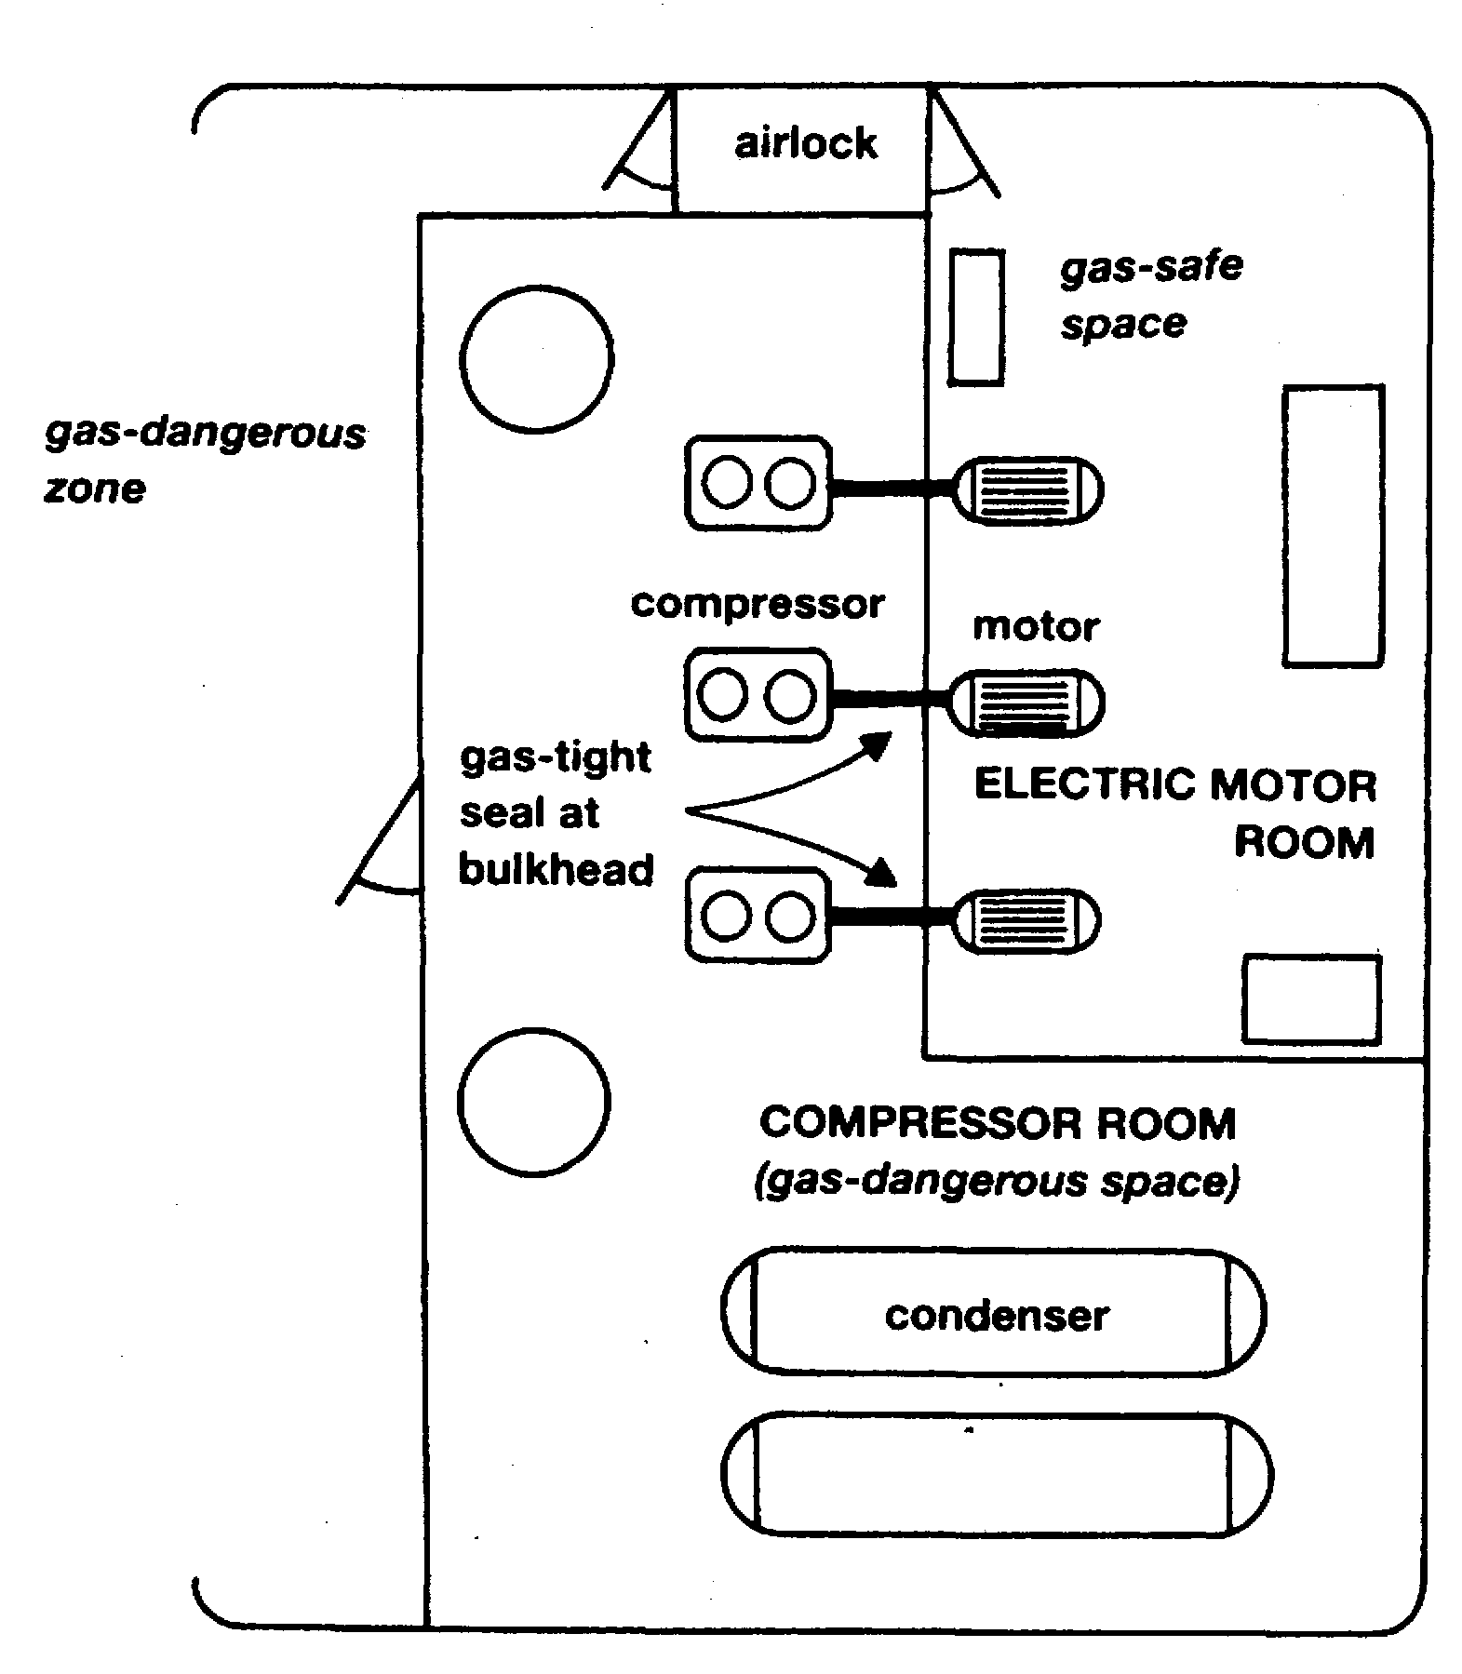
Figure 3.7 Compressor room/electric motor room on a gas carrier
The Gas Codes detail the requirements for mechanical ventilation of these rooms. Positive pressure ventilation must be provided for the electric motor room and negative pressure ventilation for the cargo compressor area. This ensures an appropriate pressure differential between the rooms. An airlock entrance to the electric motor room from the ship’s deck, with two gastight doors at least 1.5 metres apart, prevents loss of air pressure on entry. To ensure that both doors are not opened simultaneously they must be self-closing with audible and visual alarms on both sides of the airlock. (However an airlock is required only where access to the motor room is within 2.4 metres of the ship’s main deck). In addition, loss of over-pressure in the motor room should trip the electric motors within.
Another safety feature associated with the compressor room area concerns the sealing of the drive-shafts penetrating the gas-tight bulkhead between the compressor and motor room and this is discussed further in Chapter Four.
The cargo containment and handling systems must be completely separate from the accommodation and machinery spaces. A cofferdam, or other means of gas-tight segregation, is required between the cargo area and the engine room and fuel tanks. The Gas Codes also give specific advice for positioning doors leading from accommodation spaces into cargo areas. In addition, air intakes for accommodation and engine spaces must be sited away from cargo vent risers. All air intakes into accommodation and service spaces should be fitted with closing devices.
Gas tankers are fitted with a fixed water spray system for fire protection purposes. This covers areas such as:
- Cargo tank domes
- Cargo tank areas above deck
- Cargo manifold areas
- The front of the accommodation including lifeboat boarding areas, and
- Control room bulkheads facing the cargo-deck
Minimum water flow rates of 10 litre/m² per minute for horizontal surfaces and 4 litre/m² per minute for vertical surfaces must be achieved. In addition to the fixed water spray systems, all gas tankers must be fitted with a fixed dry powder installation capable of fighting fires in the cargo area. At least two hand-held hoses and a minimum of one fixed monitor must be provided to cover the deck area. The dry powder installation is activated by nitrogen pressure which is stored in cylinders adjacent to the powder containers.
Finally, cargo tanks cannot be used for ballast purposes and separate ballast tanks are required.
3.6 SURVIVAL CAPABILITY
The Gas Codes divide gas carriers into four categories; Ship Types 1G, 2G, 2PG and 3G, according to the hazard rating of the cargoes for the carriage of which the ship is certified. This categorization can be seen in Appendix 2. For example, Type 1G ships (where the cargo tanks are located at the greatest distance from the side shell and which may also be restricted in capacity) must be used for cargoes representing the greatest hazard, such as chlorine. Ship Types 2G/2PG and 3G can carry cargoes which represent progressively decreasing environmental hazards and, therefore, progressively less stringent structural requirements in respect of damage survival capability in the event of collision or grounding.
A fully refrigerated ship, say with Type ‘A’ tanks, designed for LPG, must comply with the requirements for tank location and survival capability of a category 2G ship whereas a semi-pressurised ship, with Type ‘C’ tanks carrying LPG can comply with the requirements either of a 2G or a 2PG ship. For the latter case, the Type ‘C’ pressure vessels must have a design pressure of at least 7 barg, and a design temperature not lower than -55°C. The 2PG category takes into account the fact that the pressure vessel design provides increased survival capability when the ship is damaged by collision or-grounding.
The Gas Codes and classification society rules should be referred to for the detailed construction requirements for each category of ship.
  - SURVEYS AND CERTIFICATION
3.7.1 Certificate of Fitness
A ship complying with an older IMO Gas Code (Existing Ship or GC Code) should be surveyed and issued with a Certificate of Fitness for the Carnage of Liquefied Gases in Bulk. This certificate remains valid, dependant on the results of intervening surveys, for a period of five years assuming the ship has not changed flag. (Where the ship is designed in accordance with the new IGC Code, then the certificate is called the International Certificate of Fitness for the Carriage of Liquefied Gases in Bulk). Such certificates signify that a minimum standard of constructional safety has been achieved and list the cargo grades, which the ship is certified to carry.
To comply with the relevant Gas Code, throughout the period of validity of the certificate, a gas carrier must be re-surveyed periodically. Such surveys ensure the continuing validity of the Certificate of Fitness.
Surveys required to maintain the validity of the Certificate of Fitness are listed below:—
- An Initial Survey before the ship is put into service
- A Periodical Survey before the end of a period not exceeding five years (a new Certificate of Fitness is issued)
- An Intermediate Survey half way between each Periodical Survey
- An Annual Survey
- An Additional Survey after serious accident or important renewals
3.7.2 Other certification
The surveys as outlined in 3.7.1 are, of course, additional to usual cargo-ship certification as required under various IMO conventions, where the surveys are carried out by the individual flag state administration.
This certification will include:
- International Tonnage Certificate International Load Line Certificate
- International Oil Pollution Prevention Certificate
- Cargo Ship Safety Construction Certificate
- Cargo Ship Safety Equipment Certificate
- Cargo Ship Safety Radio Certificate

Chapter 4
The Ship - Equipment and Instrumentation
This chapter covers gas carrier cargo handling equipment and related instrumentation. ft reviews pipeline and valve design issues and considers cargo pumps and ancillary equipment. The plant associated with cargo reliquefaction is also described along with some of the special operational and maintenance issues. The design of inert gas generation equipment is also covered.
  - CARGO PIPELINES AND VALVES
4.1.1 Cargo pipelines
Gas carriers are normally fitted with liquid and vapour manifolds situated amidships. These are connected to liquid and vapour headers — or pipelines — (see Figure 7.2) with branches leading into each cargo tank. The liquid loading line is led through the tank dome to the bottom of each cargo tank; the vapour connection is taken from the top of each cargo tank. On semi-pressurised and fully refrigerated LPG ships a vapour connection is taken from the vapour header to the cargo compressor room where reliquefaction of the boil-off takes place. After reliquefaction the cargo is piped, via a condensate return line, to each cargo tank. In the case of LNG ships the boil-off vapors are usually fed to the ship’s boilers, via a compressor and heater, for use as main propulsion fuel.
As stated in Chapter Three, cargo pipelines are not allowed beneath deck level on gas carriers; therefore, all pipe connections to tanks must be taken through the cargo tank domes, which penetrate the main deck. Vapour relief valves are also fitted on the tank domes; these are piped, via a vent header, to the vent riser. The vent risers are fitted at a safe height and safe distances from accommodation spaces and other such gas-safe zones as specified in the Gas Codes.
Provision must be made in the design and fitting of cargo pipelines to allow for thermal expansion and contraction. This is best achieved by the fitting of expansion loops or, by using the natural geometry of the pipework, as appropriate. In a few specific cases, expansion bellows may be fitted and, where this is planned, corrosion resistant materials should be used and Section 5.3.2.2 of the IGC Code should be considered. Where expansion bellows are fitted in vapour lines, it should be ensured that their pressure rating at least meets the liquid pipeline design criteria. Furthermore, expansion bellows are often subject to a considerable amount of wear and tear while a ship is in service — in particular, sea-water corrosion must be carefully avoided otherwise pin hole leaks are liable to develop.
It is also important not to alter or adjust adjacent pipeline supports once the ship has entered service since they form an integral part of the expansion arrangements.
Furthermore it should also be noted that parts of pipeline systems are fitted with strong anchor points to resist lateral or vertical displacement from surge pressures. Similarly, when replacing parts such as bolts and restraining rods, care must be taken, to ensure that the new parts are of the correct material for the service. ‘
Removable spool pieces are taken in or out of pipelines to interconnect sections of line for special operational reasons such as using the inert gas plant or ensuring segregation of incompatible cargoes. These spool pieces should not be left in position after use but should be removed and pipelines blanked to ensure positive segregation.
4.1.2 Cargo valves and strainers
Isolating valves for cargo tanks must be provided in accordance with Gas Codes. Where cargo tanks have a MARVS greater than 0.7 barg (Type ‘C’ tanks), the principal liquid and vapour connections on the tank dome (except relief valve connections) should be fitted with a double valve arrangement. This should comprise one manually operated globe valve and a remotely operated isolation valve fitted in series. For Types ‘A’ and ‘B’ cargo tanks (with the MARVS less than 0.7 barg) the Gas Codes allow single shut-off valves for liquid and vapour connections. These valves can be remotely actuated but must also be capable of local manual operation.
Remotely operated emergency shut-down valves are provided at the liquid and vapor manifolds for all gas carriers.
Figure 4.1 shows the piping system on a cargo tank dome including the valving arrangement. This particular drawing is typical for a semi-pressurised ship.
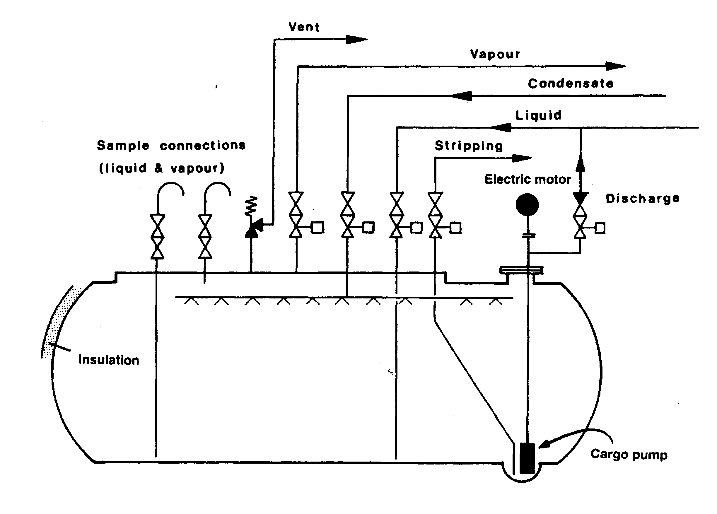
Figure 4.1 Cargo tank dome piping arrangement — Type ‘C’ tank
The types of isolation valve normally found on gas tankers are ball, globe, gate or butterfly valves. These valves are usually fitted with pneumatic or hydraulic actuators. Ball valves for liquefied gas service are provided with a means of internal pressure relief. This is usually a hole drilled between the ball cavity and the downstream side of the valve. Valves must be of the fail-safe type.
In the LNG trade, strainers are commonly provided at the manifold connections for loading and discharging. It is important not to bypass these strainers. Furthermore, they should be frequently checked and cleaned. The strainers are installed to protect cargo-handling equipment from damage by foreign objects. Many strainers are designed for one-way flow only (see also Reference 2.33).
4.1.3 Emergency shut-down (ESD) systems
At a number of locations around the ship (bridge front, gangway, compressor room and cargo control room, emergency control station), pneumatic valves or electric push buttons are provided. When operated, these controls close remotely actuated valves and stop cargo pumps and compressors (where appropriate). This provides an emergency-stop facility for cargo handling. Such emergency shut-down (ESD) is also required to be automatic upon loss of electric control or valve actuator power. Furthermore, if a fire should occur at tank domes or cargo manifolds (where fusible elements are situated), the ESD system is automatically actuated. Individual tank filling valves are required to close automatically upon the actuation of an overfill sensor in the tank to which they are connected. ESD valves may be either pneumatically or hydraulically operated but in either case they must be fail-safe; in other words they must close automatically upon loss of actuating power.
A vital consideration, particularly during loading, is the possibility of surge pressure generation when the ship’s ESD system is actuated. The situation varies from terminal to terminal and is a function of the loading rate. the length of the terminal pipeline, the rate of valve closure and the valve characteristic itself. The phenomenon of surge pressure generation is complex and its effects can be extreme, such as the rupture of hoses or hard arm joints. Precautions are, therefore, necessary to avoid damage and sometimes, loading jetties are fitted with surge pressure drums (see 5.3.2). Terminals should confirm ship’s ESD valve closure times and adjust loading rates accordingly or place on board a means to allow the ship to actuate the terminal ESD system and so halt the flow of cargo before the ship’s ESD valves start to close (see also 10.5). In this respect consultation between the ship and shore must always take place, to establish the parameters relevant to surge pressure generation and to agree upon a safe loading rate (see also 6.4).
4.1.4 Relief valves for cargo tanks and pipelines
The Gas Codes require at least two pressure relief valves of equal capacity to be fitted to any cargo tank of greater than 20 cubic metres capacity. Below this capacity, one valve is sufficient. The types of valves normally fitted are either spring-loaded or pilot-operated. Pilot-operated relief valves may be found on all tank-types while spring-loaded relief valves are usually only used on Type ‘C’ tanks. The use of pilot-operated relief valves on fully refrigerated tanks ensures accurate operation at the low-pressure conditions prevailing; their use on Type ‘C’ tanks allows variable relief settings to be achieved using the same valve. This may be done by changing the pilot-spring. Figure 4.2 shows a typical pilot-operated relief valve. Other types of pilot valve are available for adjustment of set pressure and blowdown pressure.
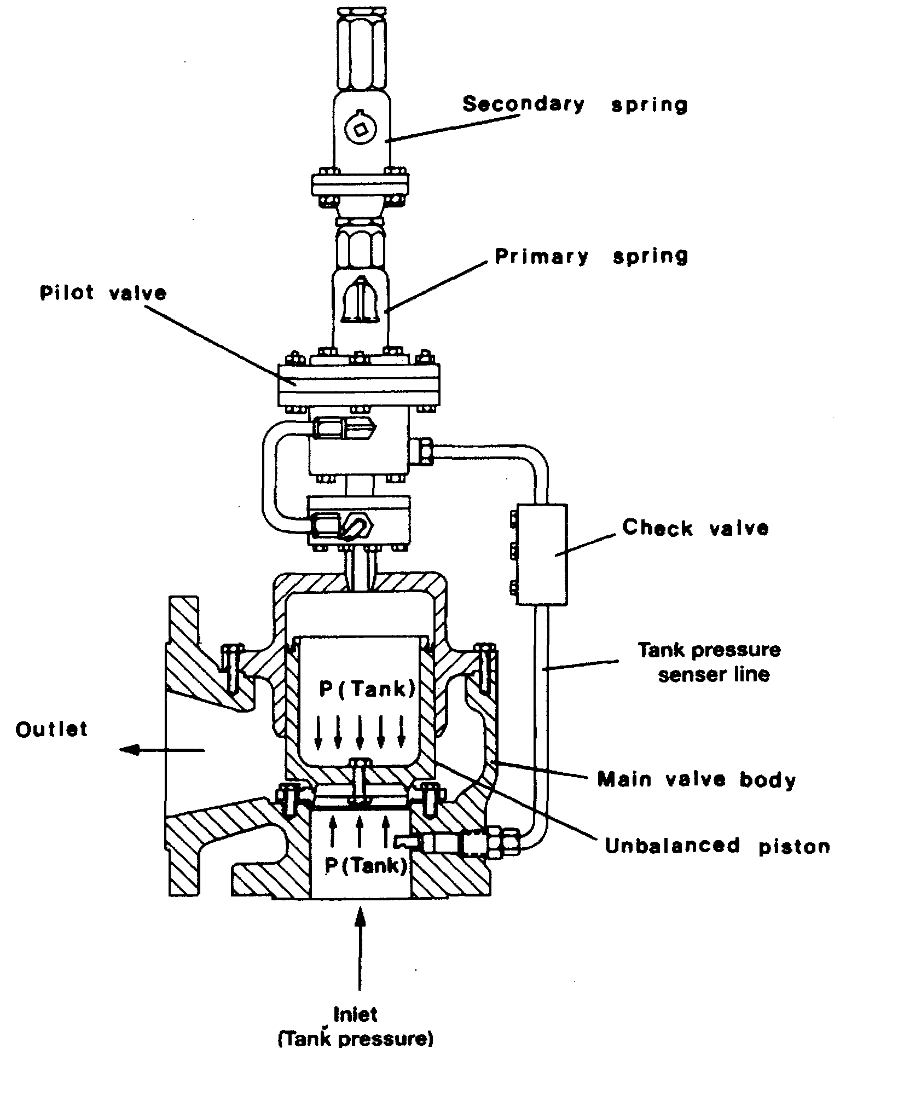

Figure 4.2 Pilot-operated relief valve
Adjustable settings for pilot-operated relief valves are used mainly in two different roles. Firstly, they may be used to provide a set pressure (not exceeding the MARVS) but higher than normal. This is known as the harbor setting. Secondly, on Type *C’ tanks, they can be adjusted to permit a means of reducing the MARVS to comply with United States Coast Guard (USCG) regulations. These regulations impose more stringent safety factors for pressure vessel design than do the Gas Code requirements.
Whenever such valves are used for more than one pressure setting, a proper record must be kept of changes to the pilot valve springs. The pilot assembly cap must always be resealed after such changes (see also 7.5) and this will ensure that no unauthorized adjustments can be made. When relief valve settings are changed, the high-pressure alarm should be adjusted accordingly.
Cargo tank relief valves exhaust via the vent header. From there, the vapour is led to atmosphere via one or more vent risers. Vent riser drains should be provided. These drains should be checked regularly, to ensure no accumulation of rainwater in the riser. Any accumulation of water has the effect of altering the relief valve operation due to increased back pressure.
Pressure relief valves on tanks require routine maintenance and for further information on this subject Reference 2.26 is recommended.
The Gas Codes require all pipelines which may be isolated, when full of liquid, to be provided with relief valves to allow for thermal expansion of the liquid. These valves usually exhaust back into cargo tanks. Alternatively, the exhaust may be taken to a vent riser via liquid collecting pots, in which case, means for detecting and disposing of liquid in the vent system must be provided.
4.2 CARGO PUMPS
Cargo pumps fitted on board refrigerated gas carriers are normally of centrifugal design and may be either of the deepwell or submerged type. They may operate alone or in parallel with one another. They may also operate in series with a deck-mounted booster pump and a cargo heater: this would happen during discharge of LPG to pressurised storage (see 4.3).
Some fully pressurised ships discharge cargo by pressurizing tanks with vapour and booster pumps are fitted to speed the cargo transfer.

Pump performance curves
An understanding of pump performance is important when considering the work done by cargo pumps. Figure 4.3 shows a typical set of performance curves for a multistage deepwell pump (see also Figure 4.6).

The flow-head curve (Curve A)
Curve A shows the pump capacity, given in terms of flow rate (m³/hr), as a function of the head developed by the pump, given in terms of metres liquid column (mic).
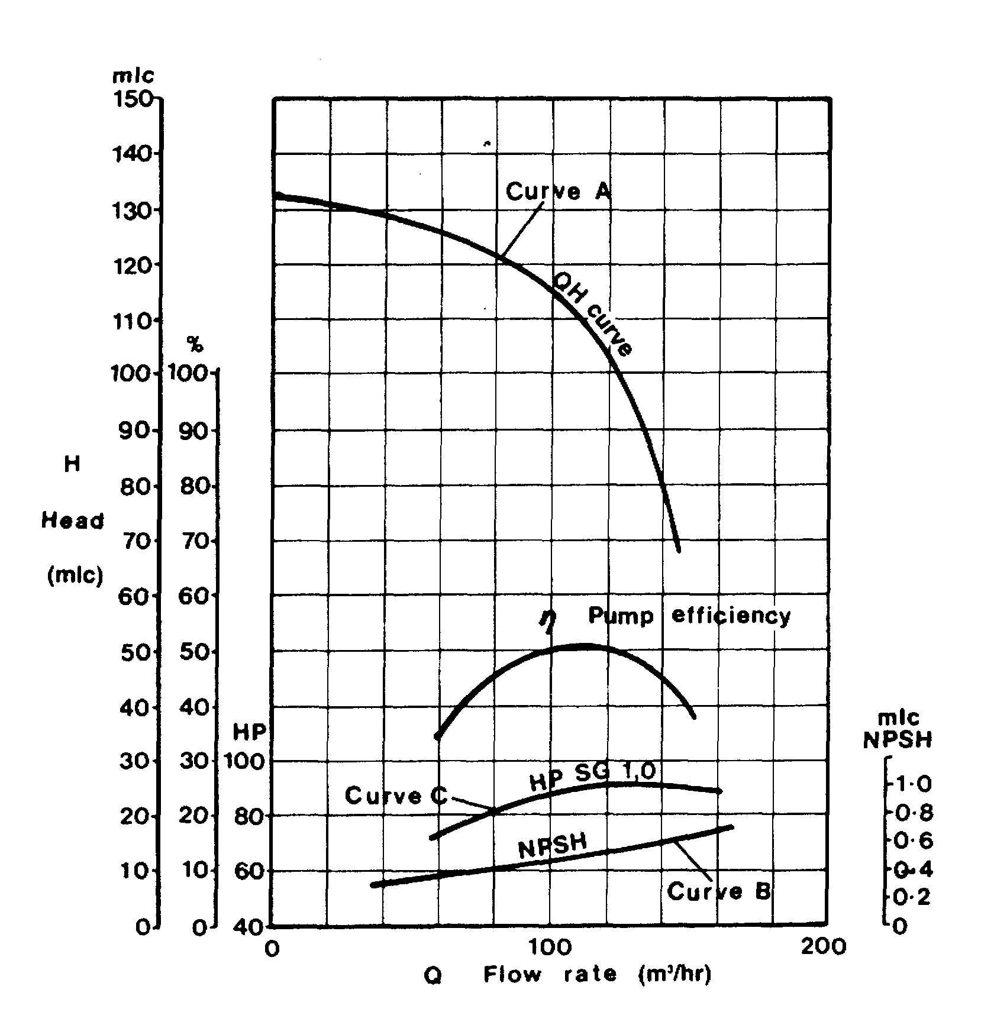

Figure 4.3 Pump performance curves — a deepwell pump
This curve is called the pump characteristic. By adopting metres liquid column and flow as the main criteria, the pump characteristic is the same, irrespective of the fluid being pumped. Taking curve A, shown in Figure 4.3; the pump will deliver 100 m³/hr, against a head difference of 115 mic between ship and shore tanks. To convert this head into pressure, the specific gravity of the cargo being pumped must be known.
For example, at a head of 105 mic, the increase in pressure across the pump when pumping ammonia at -33°C with a specific gravity of 0.68 would be:
105 x 0.68 = 71.4 mic (water) = 71.4/10.2 = 7 barg.
(Note: — the factor 10.2 in the foregoing equation denotes the height, in metres, of a water column maintained solely by atmospheric pressure — see Table 2.6.)

The net positive suction head curve (Curve B)
Curve B shows the Net Positive Suction Head (NPSH) requirement for the pump as a function of flow-rate. The NPSH requirement at any flow rate is the positive head of fluid required at the pump suction over and above the cargo’s vapour pressure to prevent cavitation at the impeller. For example, at a capacity of 100 m³/hr the NPSH requirement for the pump is 0.5 mic. This means that with a flow rate of 100 m³/hr a minimum head of cargo equivalent to 0.5 metres is required at the pump suction to prevent cavitation. An over-pressure of 0.03 bar in the cargo tank is equivalent to 0.5 metres head when pumping ammonia at -33°C.
NPSH considerations are particularly significant when pumping liquefied gases because the fluid being pumped is always at its boiling point. It must be remembered that if cavitation is allowed to occur within a pump, not only will damage occur to the impeller but also the shaft bearings themselves will be starved of cargo. This will restrict cooling and lubrication at the bearings and damage will quickly result.

The power consumption curve (Curve C)
Curve C shows the power absorbed as a function of pump capacity. This curve is normally given for a specific liquid density and can be converted for any liquid by multiplying by the ratio of specific gravities. In this respect, of the cargoes normally transported in gas carriers, vinyl chloride has the highest specific gravity. This is about 0.97 at its atmospheric boiling point. Table 2.5 gives details for other liquefied gases). In cases where cargo pump motors have been sized on the basis of LPG and ammonia cargoes, it will therefore be necessary to reduce discharge rates when pumping vinyl chloride in order to avoid overloading the motor.

Running pumps in parallel and in series
During a gas carrier discharge, cargo pumps are usually run in parallel but, when a refrigerated ship discharges to pressurised storage, cargo tank pumps are run in series with a booster pump, as explained in 7.7.3.
When pumps are run in parallel, their individual pump characteristics can be combined to give, for example, a flow/head curve for two, three or four pumps when running together. Taking the pump characteristic as given in Figure 4.3. the flow/head curve for running two pumps in parallel can be easily plotted by doubling the flow rate at the appropriate head for a single pump. This is shown in Figure 4.4. Similarly, when running three pumps in parallel, the flow rate at the appropriate head can be obtained by multiplying the single pump flow rate, at the same head, by three. Thus, a series of curves can be built up from the pump characteristic curve of a single pump.

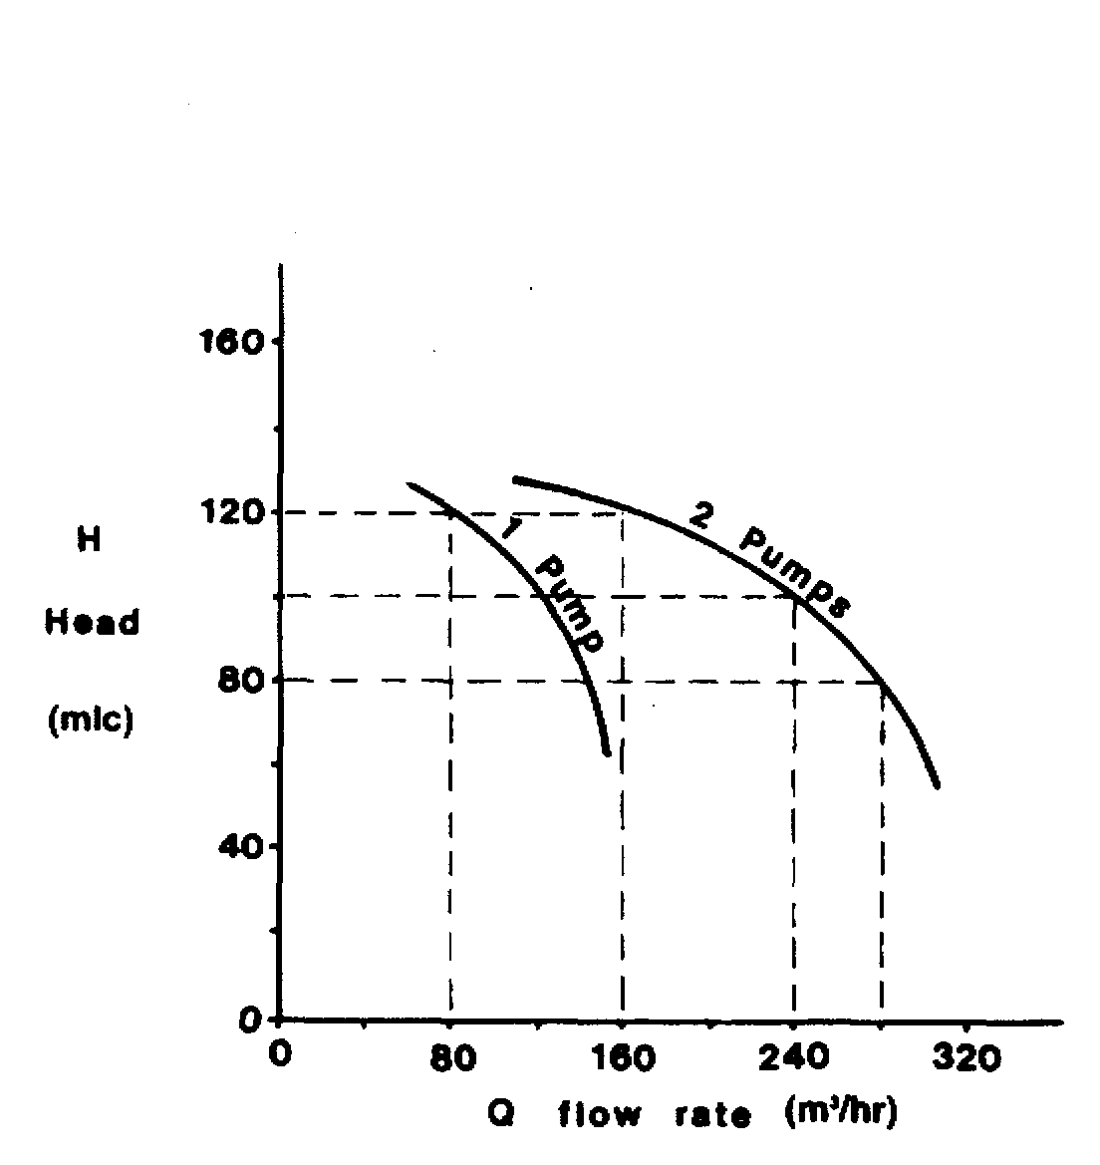
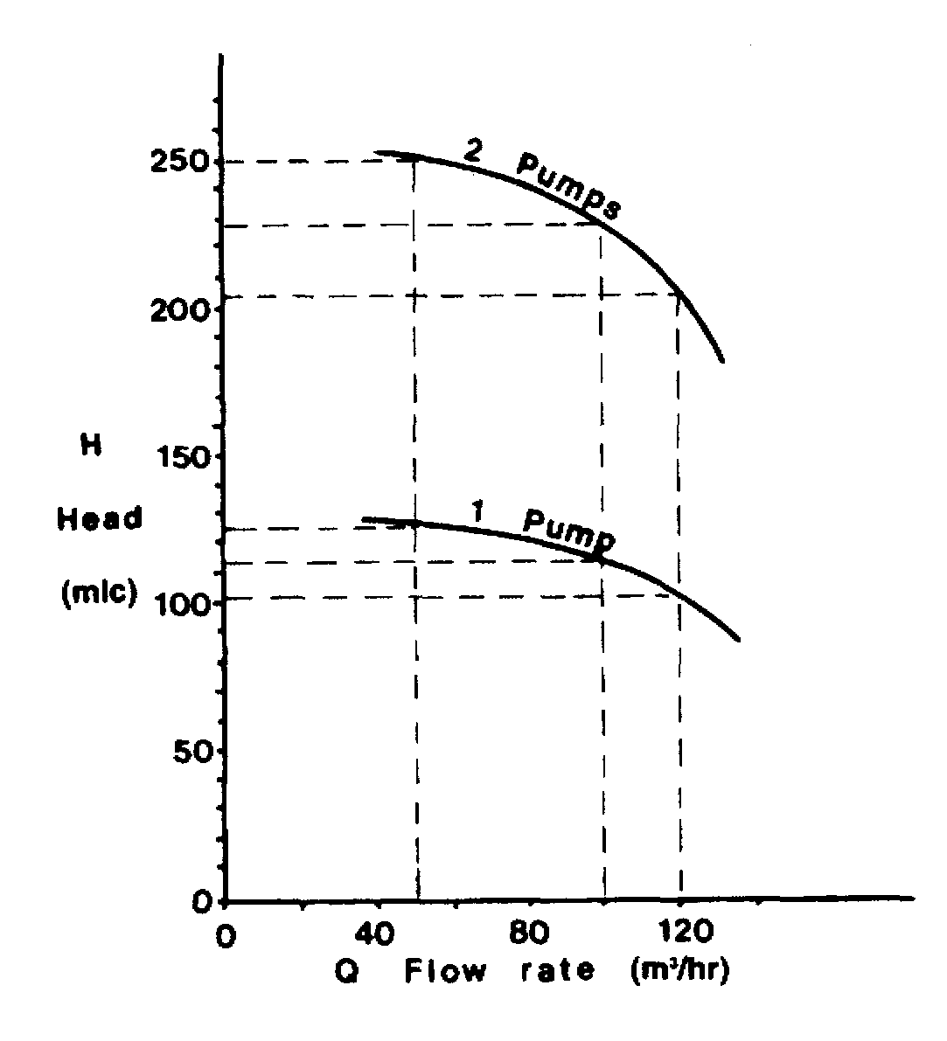

Figure 4.4 Centrifugal pumps in parallel — combined characteristics
Figure 4.5 Centrifugal pumps in series — combined characteristics

When pumps are run in series, again the individual pump characteristics curves can be combined to give the appropriate curve for the series configuration. Figure 4.5 shows how this can be done using, for example, two similar pumps in series (see again Figure 4.3). This time, for each value of flow rate, the appropriate head developed by a single pump is doubled to give the resultant head.
The foregoing arguments relate only to pump performance. For a full assessment of a ship’s discharge performance the effect of head difference from the cargo tank to the manifold and of pipeline resistance between cargo pump and manifold should be subtracted from pump performance.
The cargo flow rates achieved by any pump or combination of pumps will depend upon the back pressure encountered due to static head (difference in liquid levels of receiving tank and tank being discharged) and the resistance to flow in the pipe-line. To determine the flow rate for a particular pipeline set-up, the shore pipeline flow characteristic must be superimposed upon the ship’s pumping characteristic. This is dealt with in 7.7 but it should be noted that the system resistance may be steep enough to restrict the flow shown in Figures 4.4 and 4.5.
The minimum necessary pumping power should be used in order to reduce heat input to the cargo and to limit the rise in saturated vapour pressure of the delivered cargo (see 7.7.2).

Deepwell pumps
Deepwell pumps are the most common type of cargo pump for LPG carriers. Figure 4.6 shows a typical deepwell pump assembly. The pump is driven electrically or hydraulically (through a sealing arrangement) by a motor, which is mounted outside the tank. The drive shaft is held in carbon bearings inside the cargo discharge tube and these bearings are lubricated and cooled by the cargo flow.
The centrifugal impeller is mounted at the bottom of the cargo tank and frequently comprises two or three stages together with a first stage inducer: this latter is used to minimize the NPSH requirement of the pump. Shaft sealing at the cargo tank dome

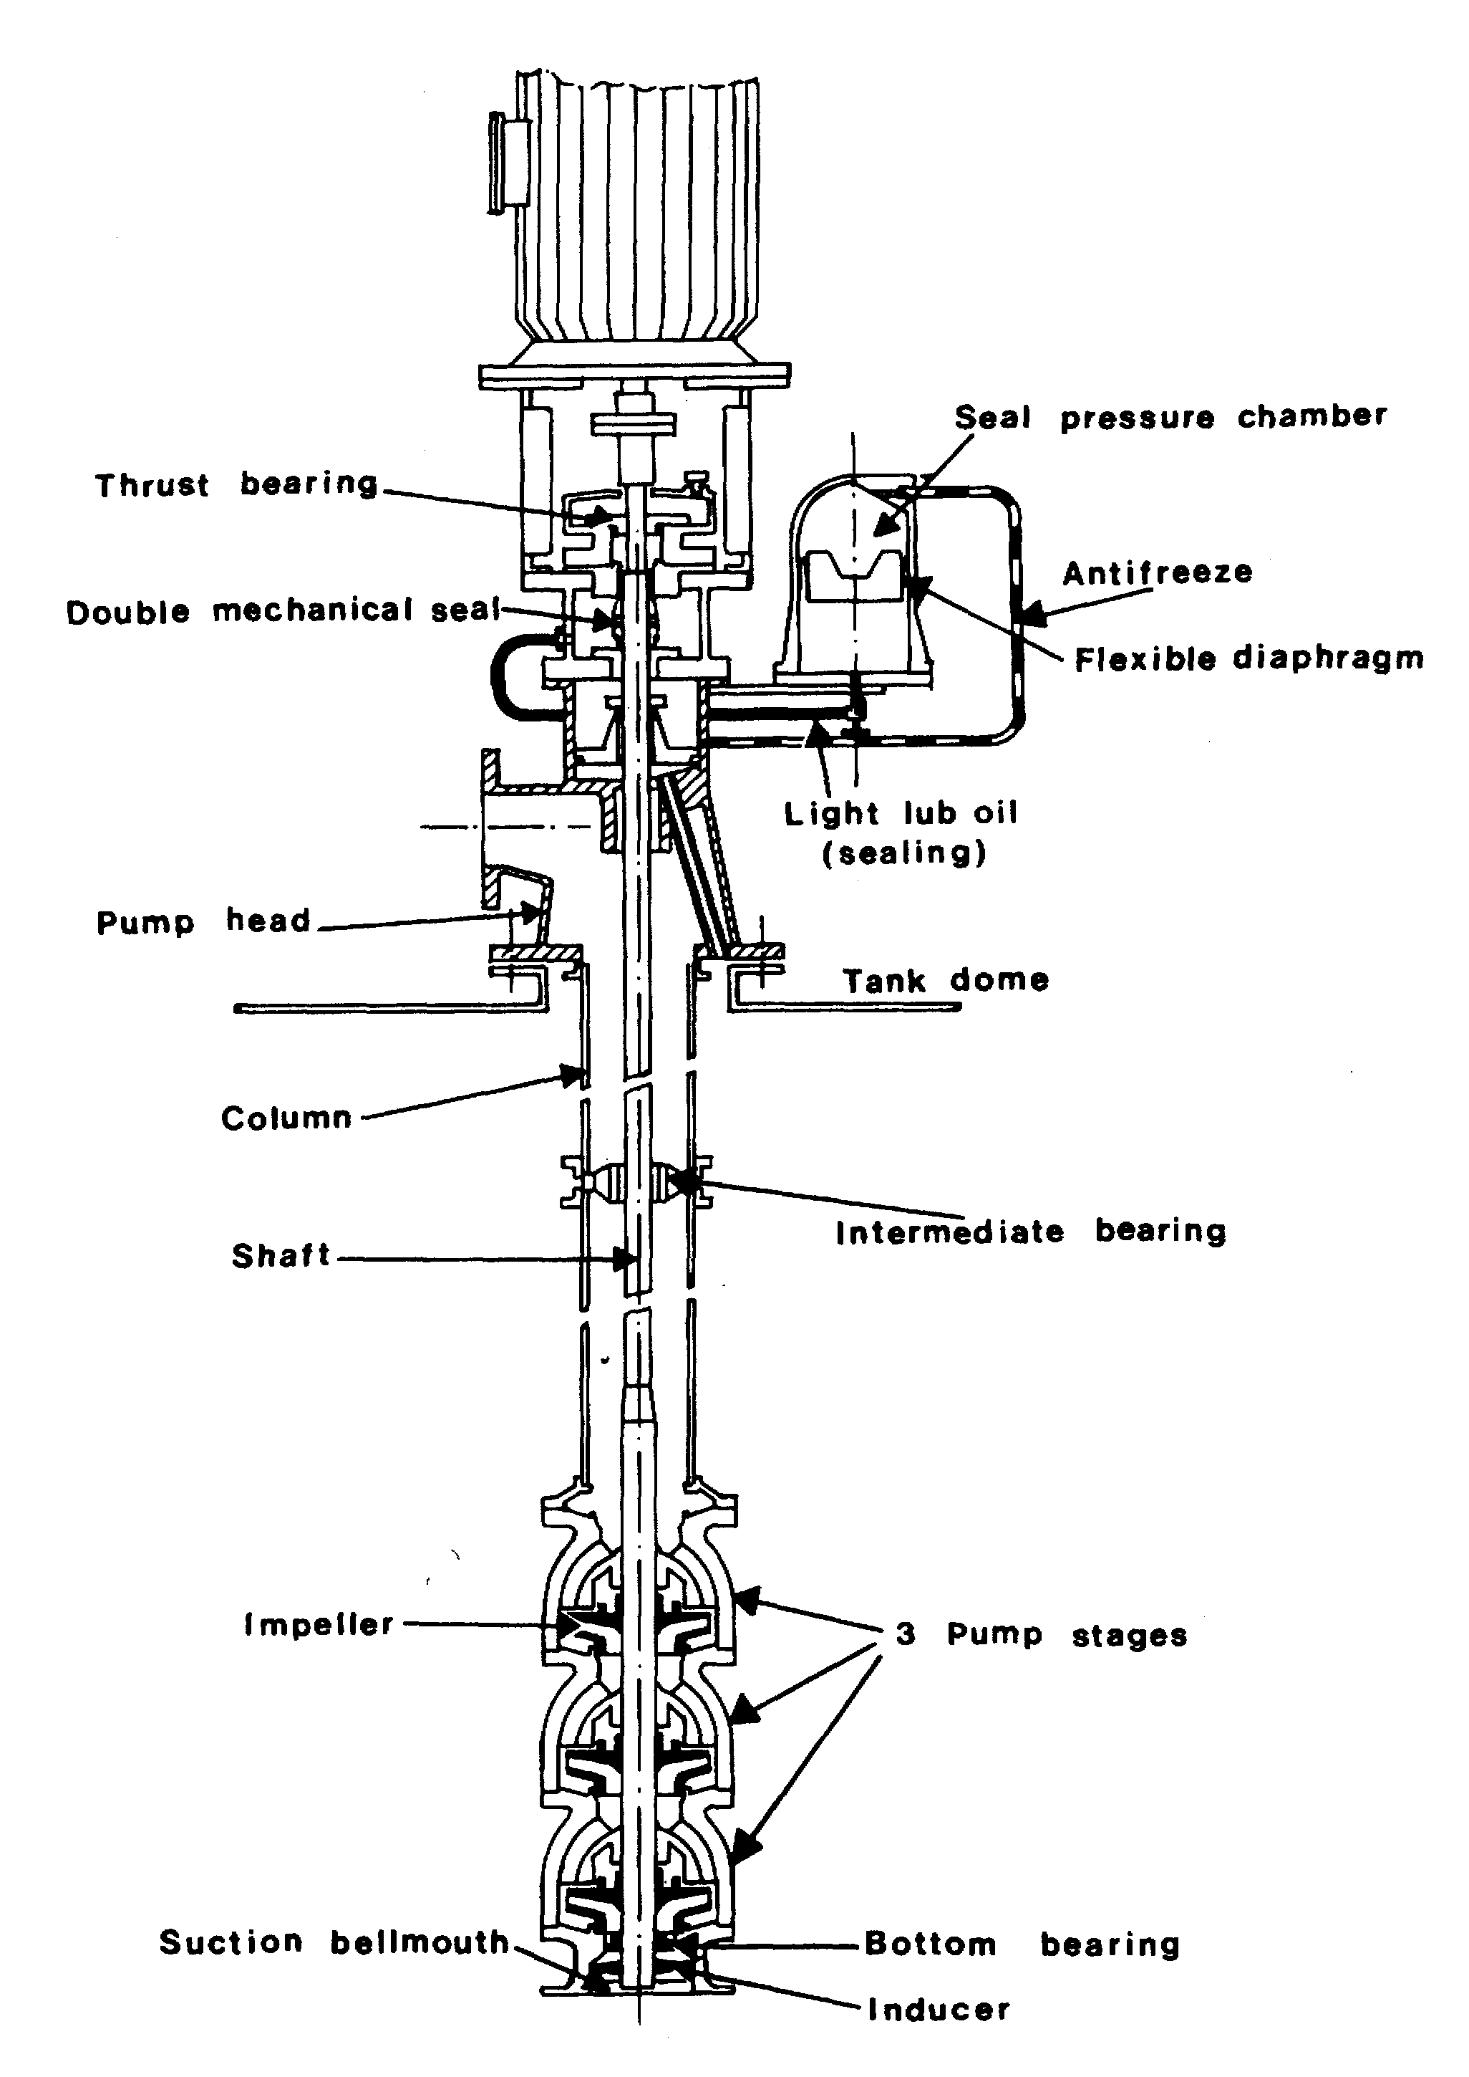

Figure 4.6 Typical deepwell pump
consists of a double mechanical seal flushed with lubricating oil. This stops cargo leakages to atmosphere. The accurate alignment of the motor coupling, thrust bearing and mechanical oil seal is important.
Furthermore, the length of the drive shaft can be a problem and the longer it becomes the more support is needed. Accordingly, it is often found that the largest types of ships are fitted with submerged pumps.

Submerged motor pumps
Submerged motor pumps are installed at the bottom of cargo tanks and enable very low pump-down levels to be achieved. They are fitted on all LNG carriers and on some of the larger LPG carriers.
The pump and electric motor are integrally mounted on the same shaft so eliminating the need for a mechanical seal or coupling. Power is supplied to the motor through specially sheathed cables. Electrical cabling is passed through a hazardous area junction box in the tank dome and then, by flexible cables to the motor terminals. The older mineral insulated copper sheathed cable used inside cargo tanks has been superseded in modern ships by flexible stainless steel armored insulated power cables.
These pumps are cooled and lubricated by cargo flow and are, therefore, prone to damage due to loss of flow. Accordingly, the pump is protected from dry running by safety devices such as an under-current relay, a low discharge pressure switch, or a low tank level switch. Figure 4.7(a) shows a typical submerged pump/motor assembly for an LPG carrier and Figure 4.7(b) shows a similar pump but in this case designed for LNG.
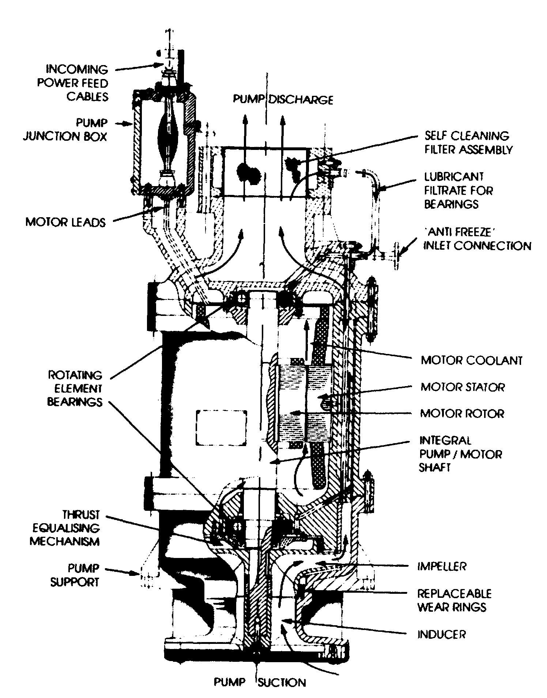

Figure 4.7(a) Submerged motor pump for LPG
Submerged pumps need to be designed for the particular grades of cargo found on the ship’s Certificate of Fitness. For example contrary to the hydrocarbon gases, ammonia is an electric conductor and can also be a particularly corrosive cargo for
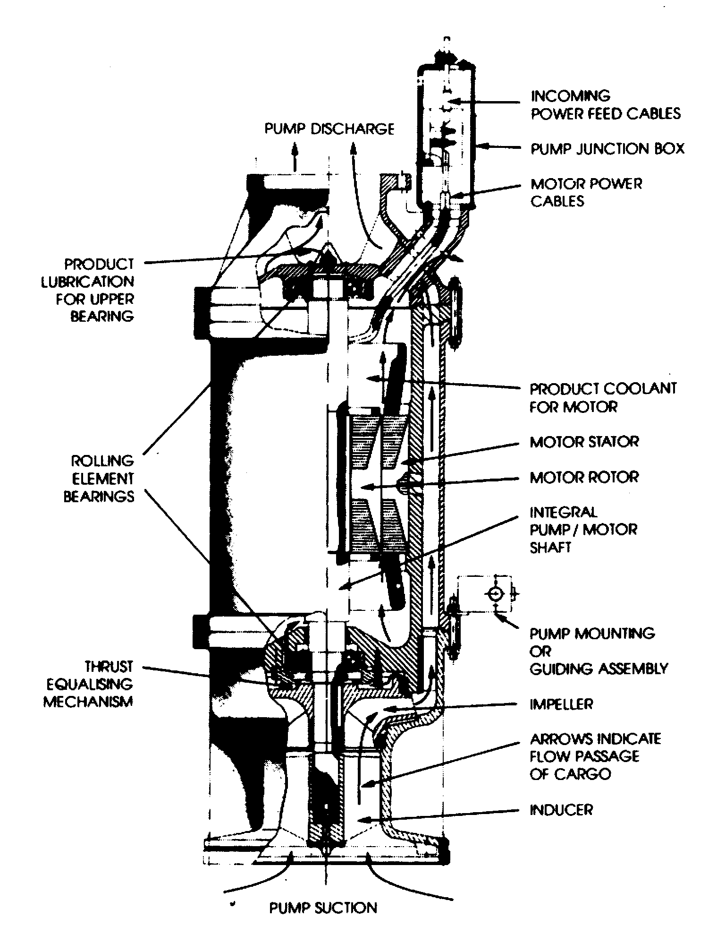

Figure 4.7(b) Typical LNG submerged motor pump assembly
some materials such as copper wires and electrical insulation. Pump design must take this into account. To preserve the electric motor, pumps used for ammonia have the electric stator enclosed in a ‘can’.

Booster pumps
Booster pumps are usually of the centrifugal type. They may be vertically or horizontally mounted on deck in the appropriate discharge line. In these positions, they will be driven by an increased safety (E Exe) (see 4.8) electric motor. Alternatively, they may be in the cargo compressor room. When fitted in the compressor room, they are driven through a gas-tight bulkhead by an electric motor installed in the electric motor room. Figures 4.8 and 4.9 show examples of these types of pump. The particular pumps shown are fitted with double mechanical seals. The seal flushing system should be well maintained to ensure continuing reliability.

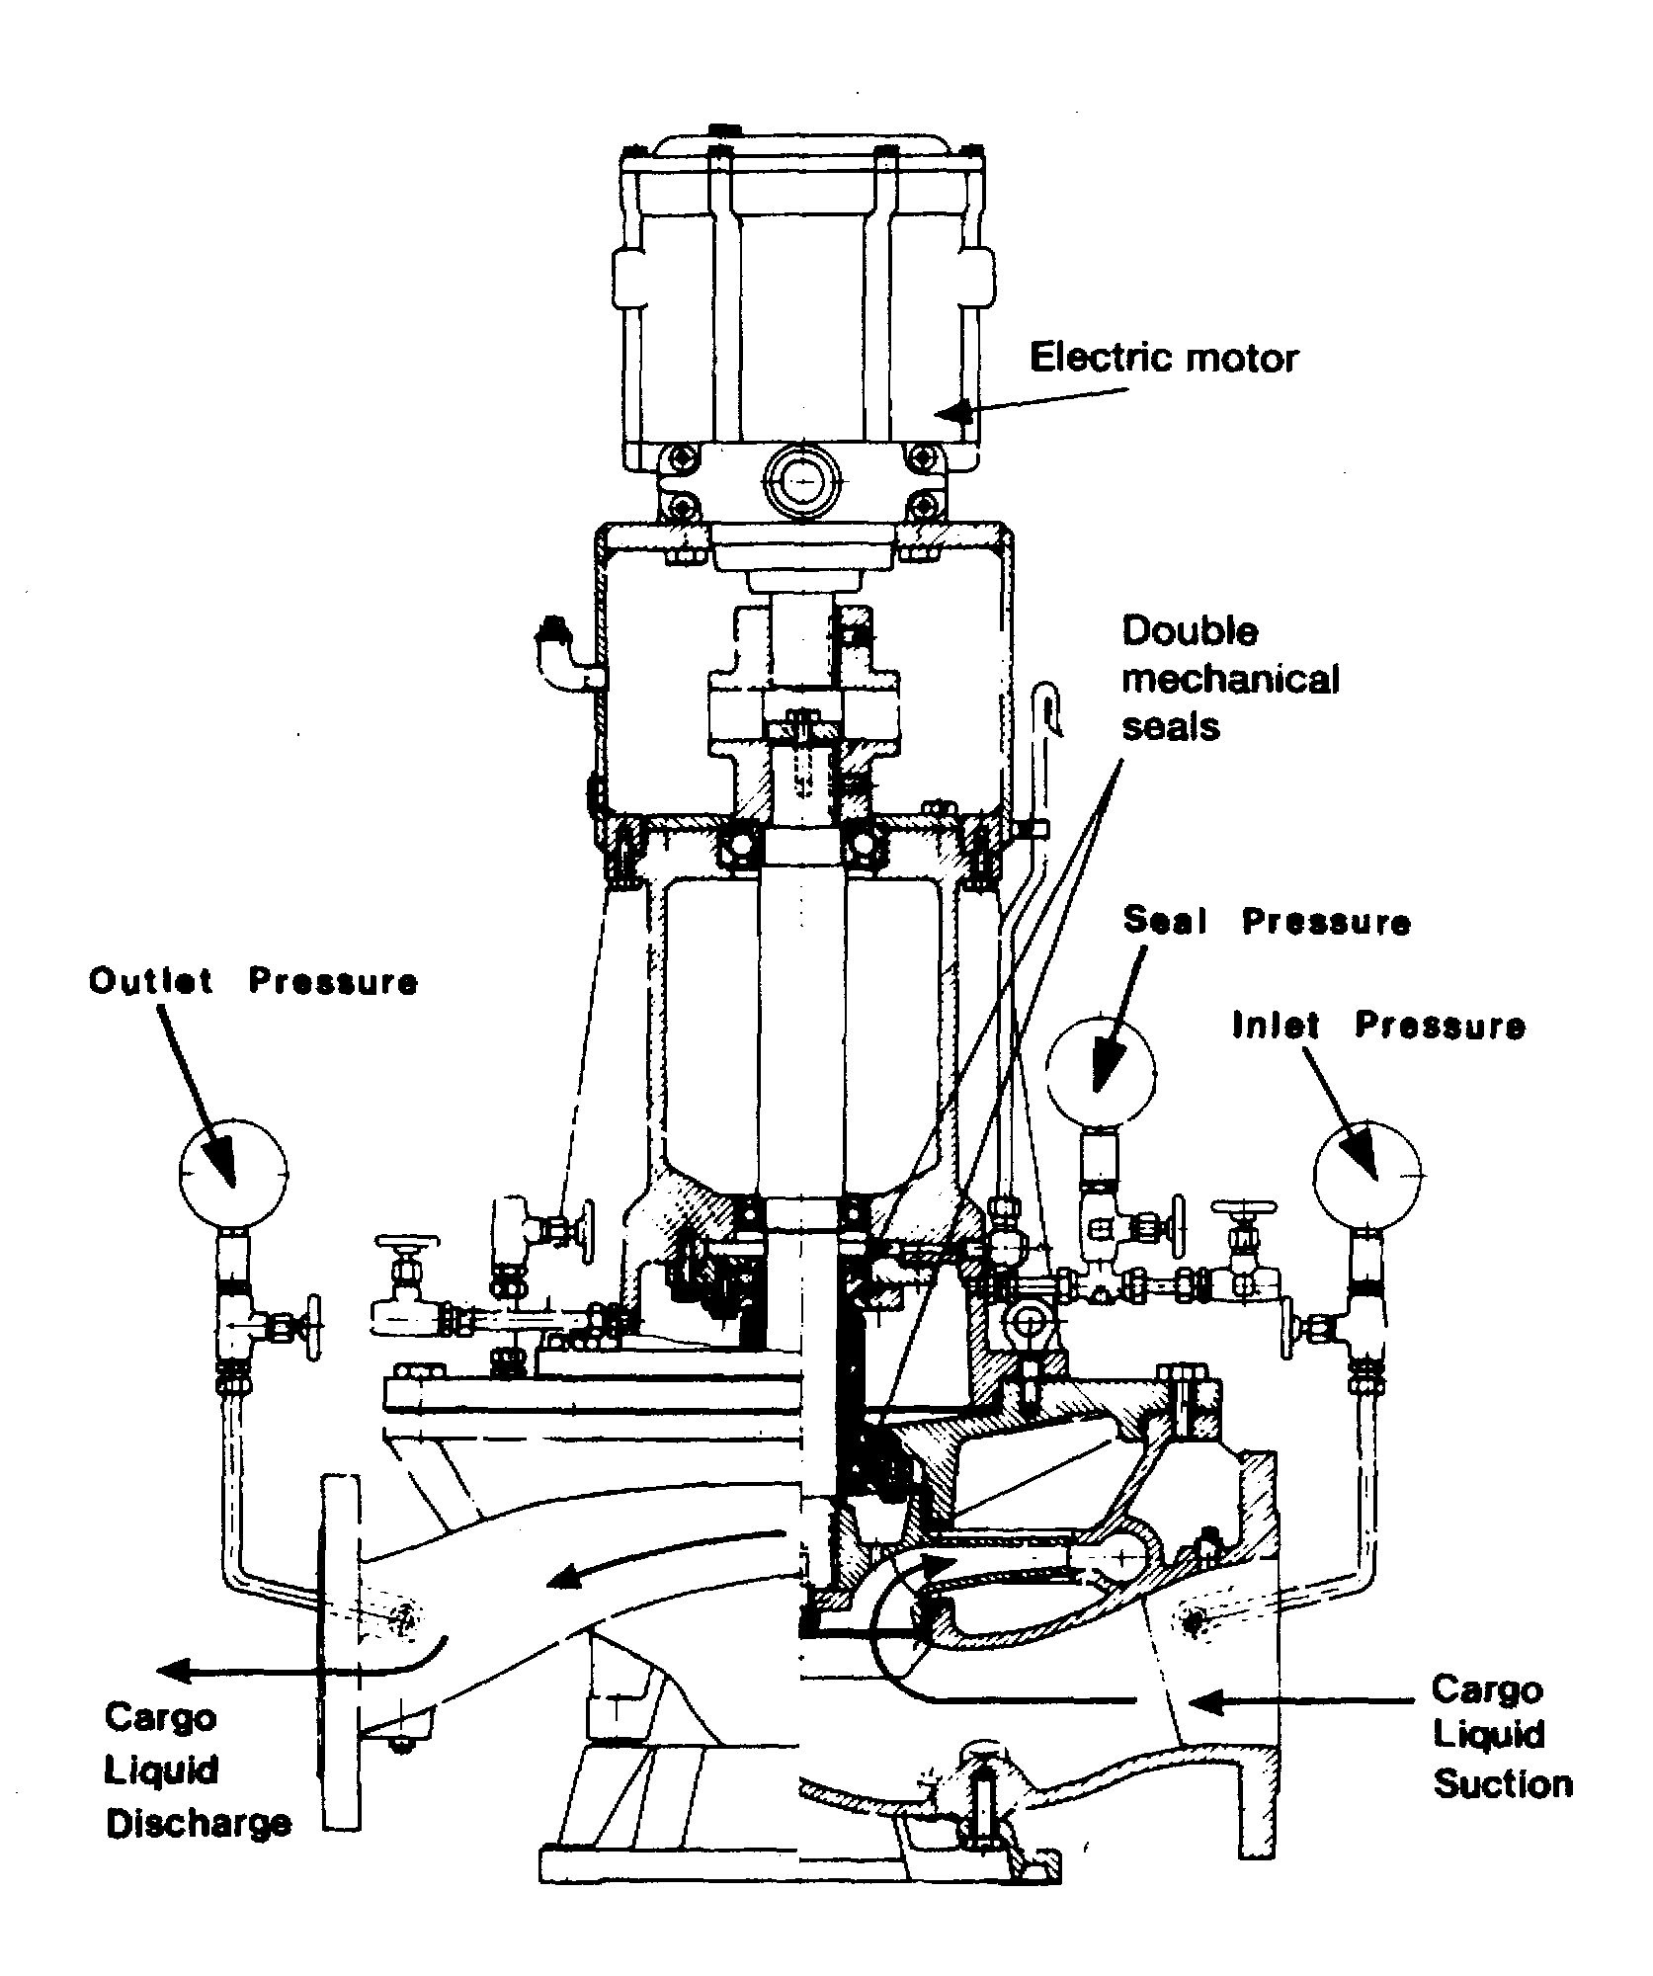

Figure 4.8 Vertical booster pump
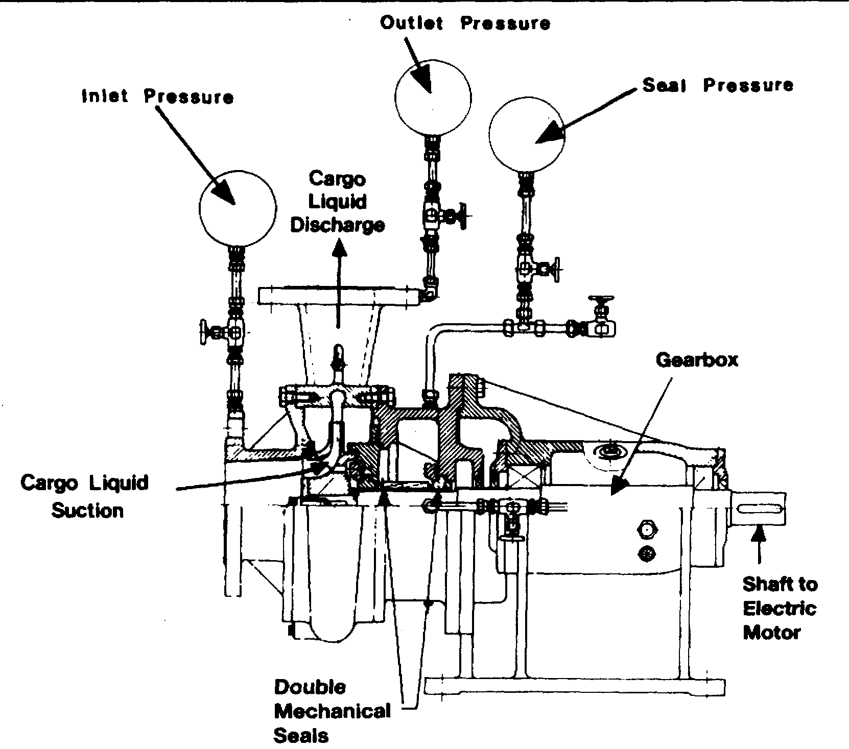

Figure 4.9 Horizontal booster pump

Ice prevention at cargo pumps
The formation of ice or hydrates (see 2.7) may occur in ships carrying refrigerated or semi-pressurised LPG. Furthermore, hydrates may be transferred from the terminal during loading operations. Hydrates from the shore can be removed by cargo filter in the terminal loading lines.
Hydrate formations may enter cargo pumps, block lubricating passages, unbalance impellers and seize bearings. To prevent such damage it is common practice to inject a small quantity of freezing-point depressant into the cargo pump, especially submerged pumps, to facilitate de-icing. Because of the danger of methanol contamination to certain LPG cargoes, injection of this product should not normally be allowed without cargo receivers agreement.
When deepwell pumps are not in operation, it is recommended that manual rotation of the shafts be carried out during cool-down and loading to prevent freezing of the impellers.
4.3 CARGO HEATERS
When discharging refrigerated cargoes into pressurised shore storage, it is usually necessary to heat the cargo so as to avoid low-temperature embrittlement of the shore tanks and pipelines.
Cargo heaters are normally of the conventional horizontal shell and tube type exchanger. Most often, they are mounted in the open air on the ship’s deck. Sea water is commonly used as the heating medium and this passes inside the tubes with the cargo passing around the tubes.
The heaters are typically designed to raise the temperature of fully refrigerated propane from -45°C to -5°C; however, it should be noted that the cargo flow rate at
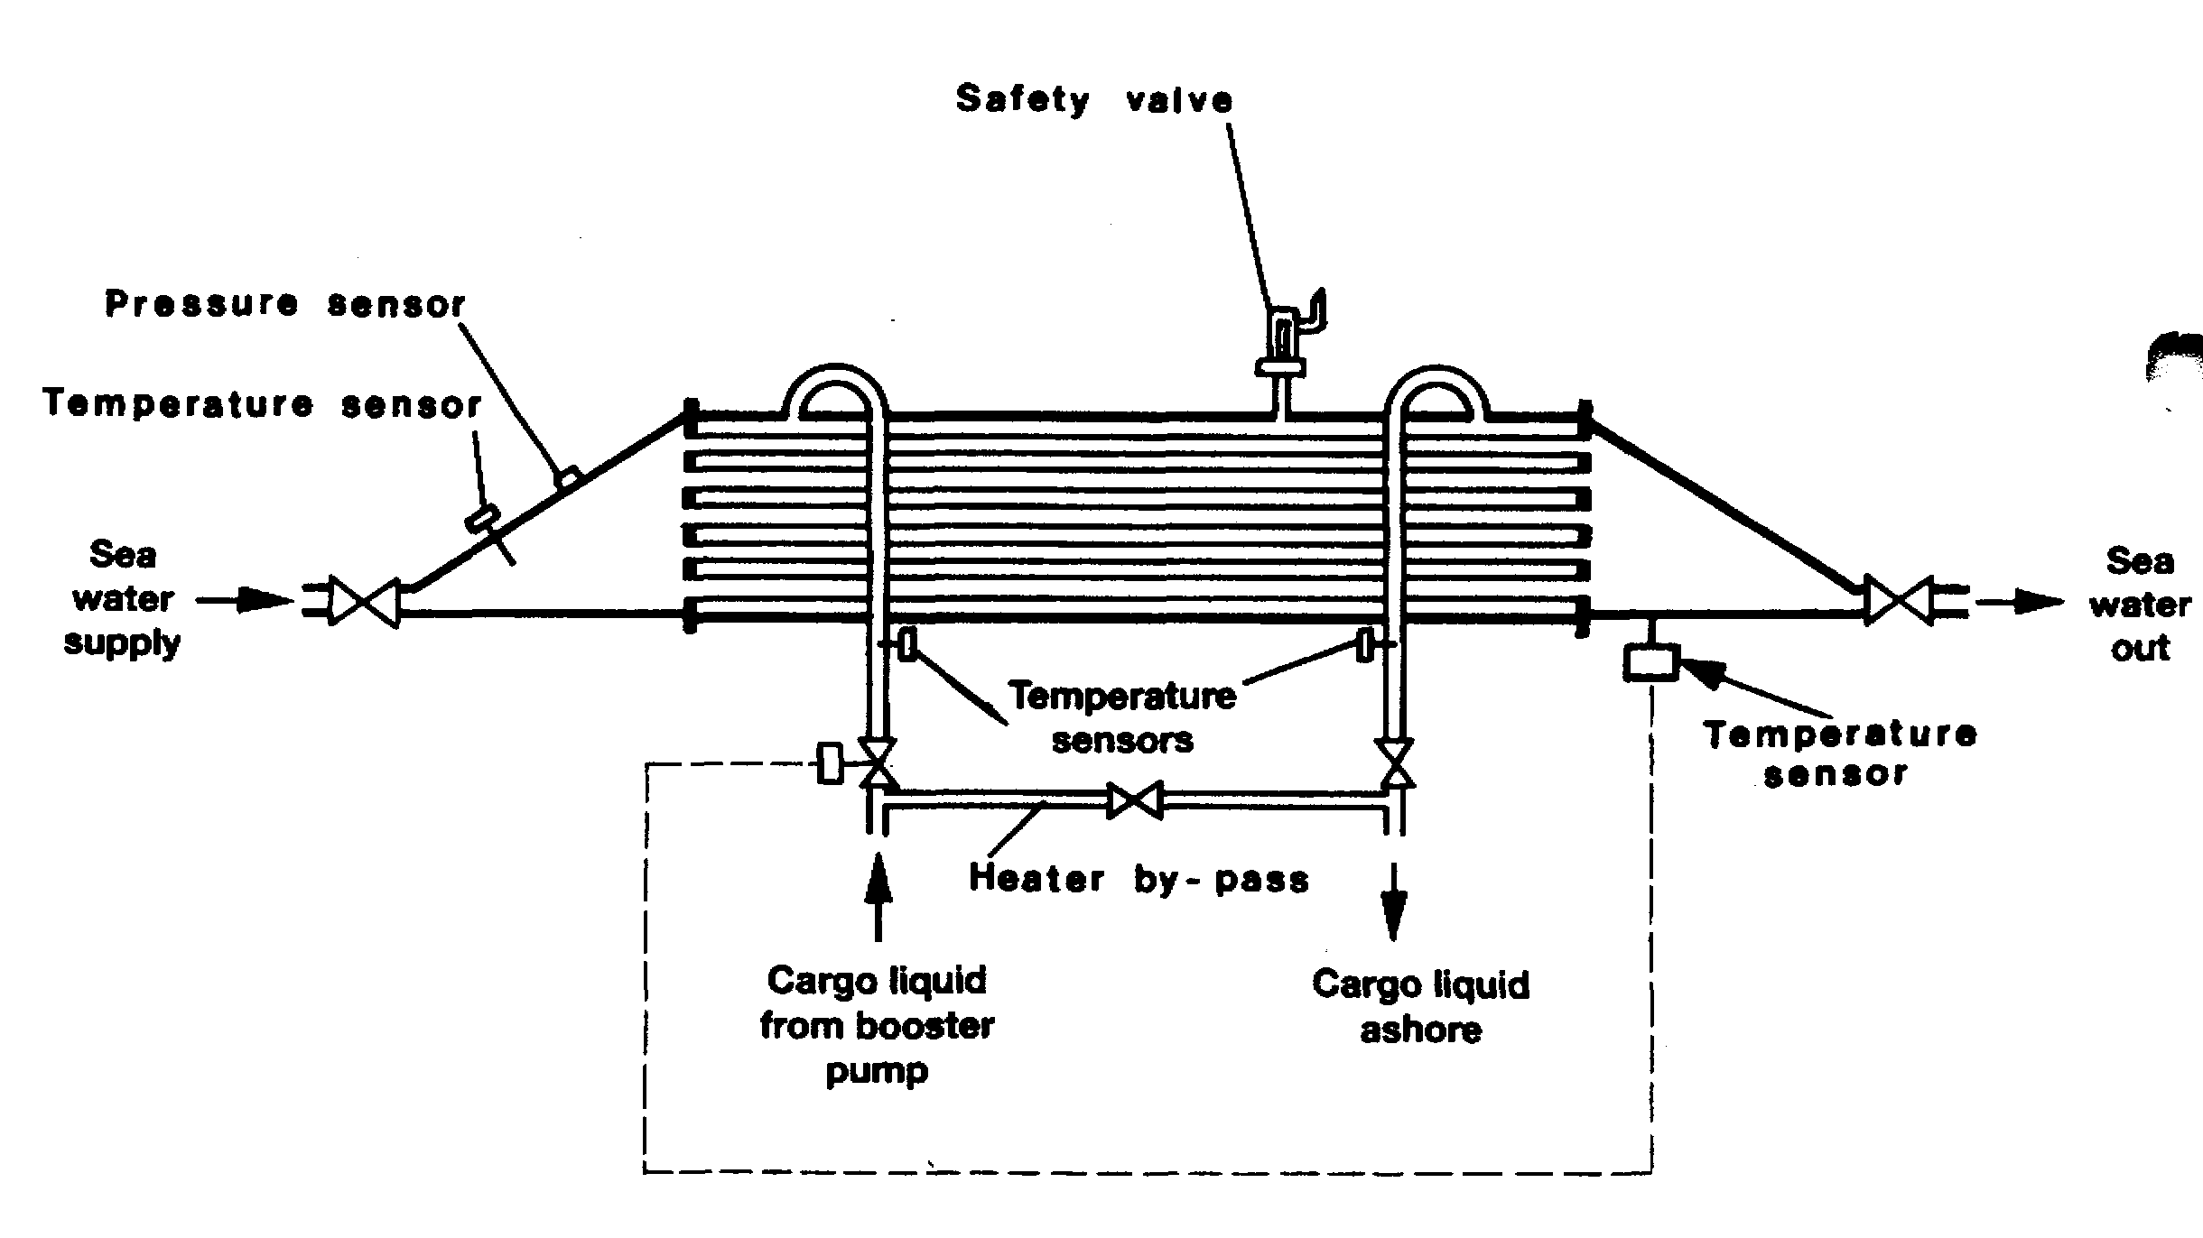

Figure 4.10 Cargo heater

which this temperature rise may be achieved can be significantly reduced in cold sea water areas. Under such circumstances only very slow discharge rates may be possible and when sea water temperatures fall below 5°C it becomes increasingly difficult to use sea water as a heating medium.
Figure 4.10 shows a typical heater arrangement; note the requirement for temperature controls and alarms to avoid freezing. This is a very real risk, which always has to be guarded against.
4.4 CARGO VAPORISERS
A means of producing cargo vapour from liquid is often required on gas carriers. For example, vapour may be needed to gas-up cargo tanks or to maintain cargo tank pressure during discharge. This latter need will be more obvious in the absence of a vapour return line from shore. Accordingly, a vaporiser is usually installed on board for these purposes.
Cargo vaporisers may be either vertical or horizontal shell and tube heat exchangers. They are used with either steam or sea water as the heating source.
4.5 RELIQUEFACTION PLANTS AND BOIL-OFF CONTROL
With the exception of fully pressurised gas carriers, means must be provided to control cargo vapour pressure in cargo tanks during cargo loading and on passage. In the case of LPG and chemical gas carriers, a reliquefaction plant is fitted for this purpose. This equipment is designed to perform the following essential functions:
- To cool down the cargo tanks and associated pipelines before loading;
- To reliquefy the cargo vapour generated by flash evaporation, liquid displacement and boil-off during loading; and
- To maintain cargo temperature and pressure within prescribed limits while at sea by reliquefying the boil-off vapour.
There are two main types of reliquefaction plant and these are described in the following sections.
4.5.1 Indirect cycles
Indirect cycle is descriptive of a system where an external refrigeration plant is employed to condense the cargo vapour without it being compressed. This cycle is relatively uncommon as its use is limited to a small numbers of cargoes. It requires, for efficiency, very cold refrigerant and large surfaces for heat exchange.
This type of reliquefaction plant is, however, required by the Gas Codes when carrying any of the following cargoes
- Chlorine
- Ethylene oxide
- Ethylene oxide — propylene oxide mix
- Propylene oxide

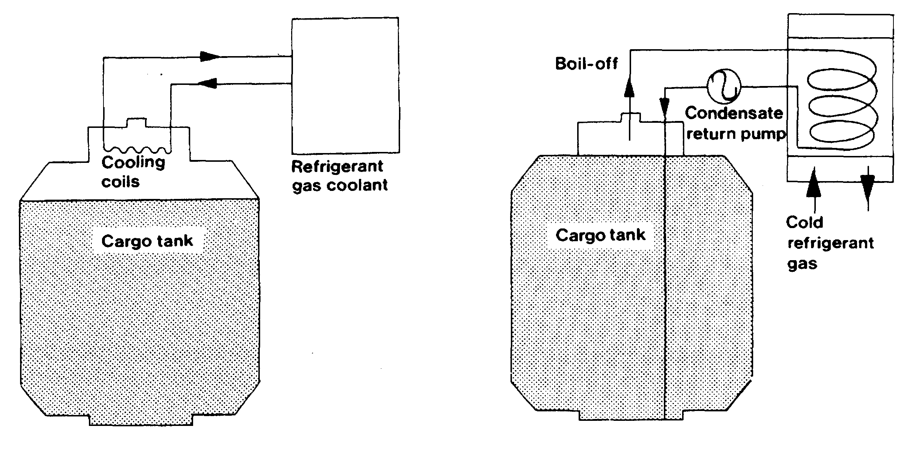

Figure 4.10(a) Examples of indirect cooling cycles
Reference to Table 2.5 shows that with respect to propylene oxide it is unlikely, but dependent on ambient conditions, that refrigeration will be required on voyage.
Two indirect cycle systems are shown diagramatically in Figure 4.10(a).
4.5.2 Direct cycles
Direct cycle is descriptive of a system where the boil-off is compressed, condensed and returned to the tank. This is the most common system, but may not be employed for certain gases (see IGC Code, Chapter 17 and 4.5.1 above).
There are three main types of direct cycle reliquefaction plant and these are described in the following sections.

Single-stage direct cycle
The single-stage direct cycle system is particularly suited to the semi-pressurised carrier.
A simplified diagram of single-compression reliquefaction is shown in Figures 4.11 (a) and (b). This cycle is suitable where suction pressures are relatively high, as in the carriage of semi-pressurised products. Boil-off vapors from the cargo tank are drawn off by the compressor — (a) in the diagrams. Compression increases the pressure and temperature of the vapour — to (b) in the diagrams. The high temperature allows it to be condensed against sea water in the condenser — at (c) in the diagrams. The condensed liquid is then flashed back to the tank via a float controlled expansion valve — at (d) in the diagrams. The liquid/vapour mixture being returned the cargo tank may be either distributed by a spray rail at the top of the cargo tank or taken to the bottom of the tank to discourage re-vaporisation. The spray rail is normally used when the tank is empty and bottom discharge when the tank is full (see also 2 19 and Figure 2.16).

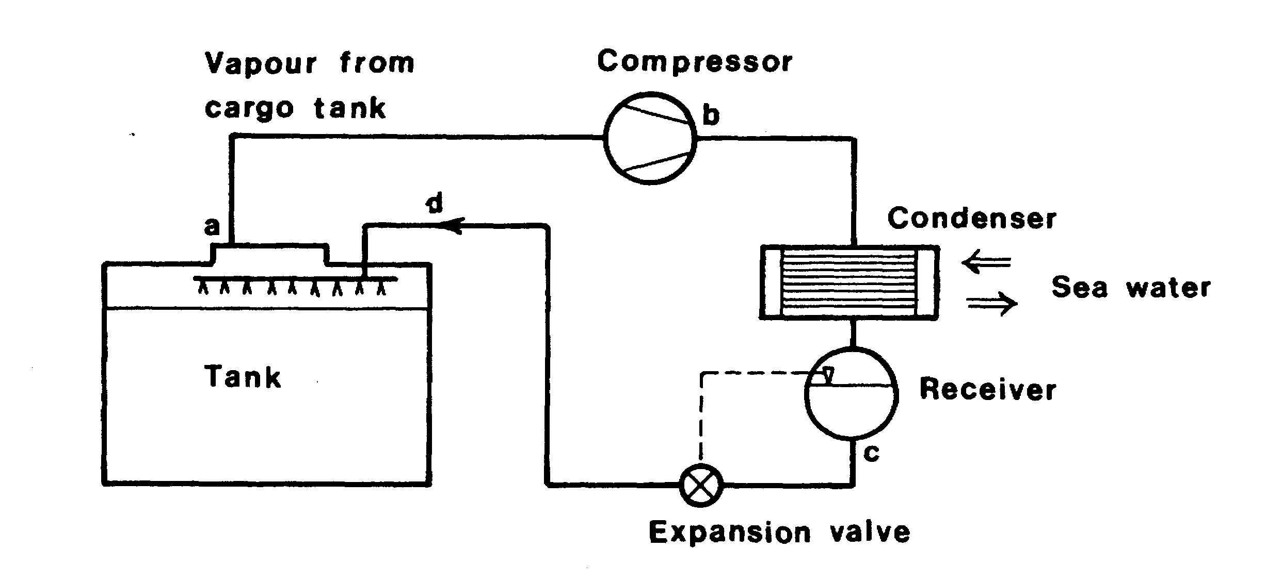

Figure 4.11 (a) Single-stage direct reliquefaction cycle
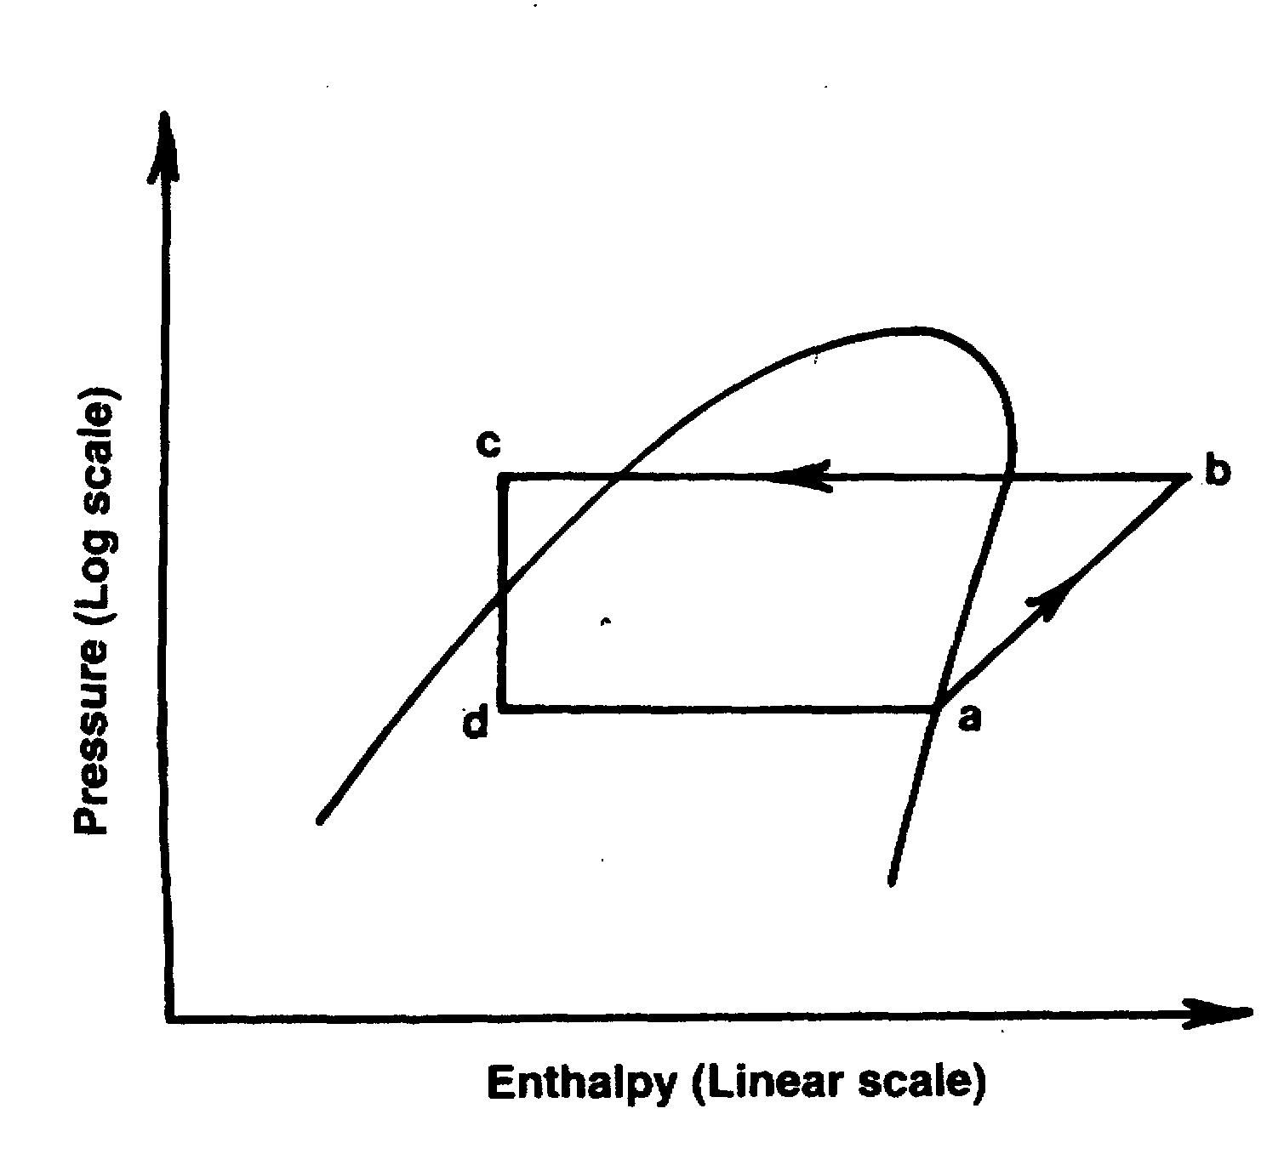

Figure 4.11 (b) Mollier diagram — single-stage direct reliquefaction cycle

Two-stage direct cycle
Although two-stage direct cycle equipment is relatively uncommon, it is used for those liquefied gas carriers handling a wide range of products. For grades such as butadiene and vinyl chloride its fitting is essential.
A simplified diagram showing two-stage reliquefaction is given in Figures 4.12(a) and (b). The two-stage cycle with inter-stage cooling is used where suction pressures are low and. as a result, compression ratios high (assuming sea water condensing) compared to the single-stage cycle. Two-stage compression (with inter-stage cooling) is necessary to limit the compressor discharge temperature, which increases significantly with the higher compression ratio. This is particularly important for cargoes such as butadiene and vinyl chloride (see also 7.6).

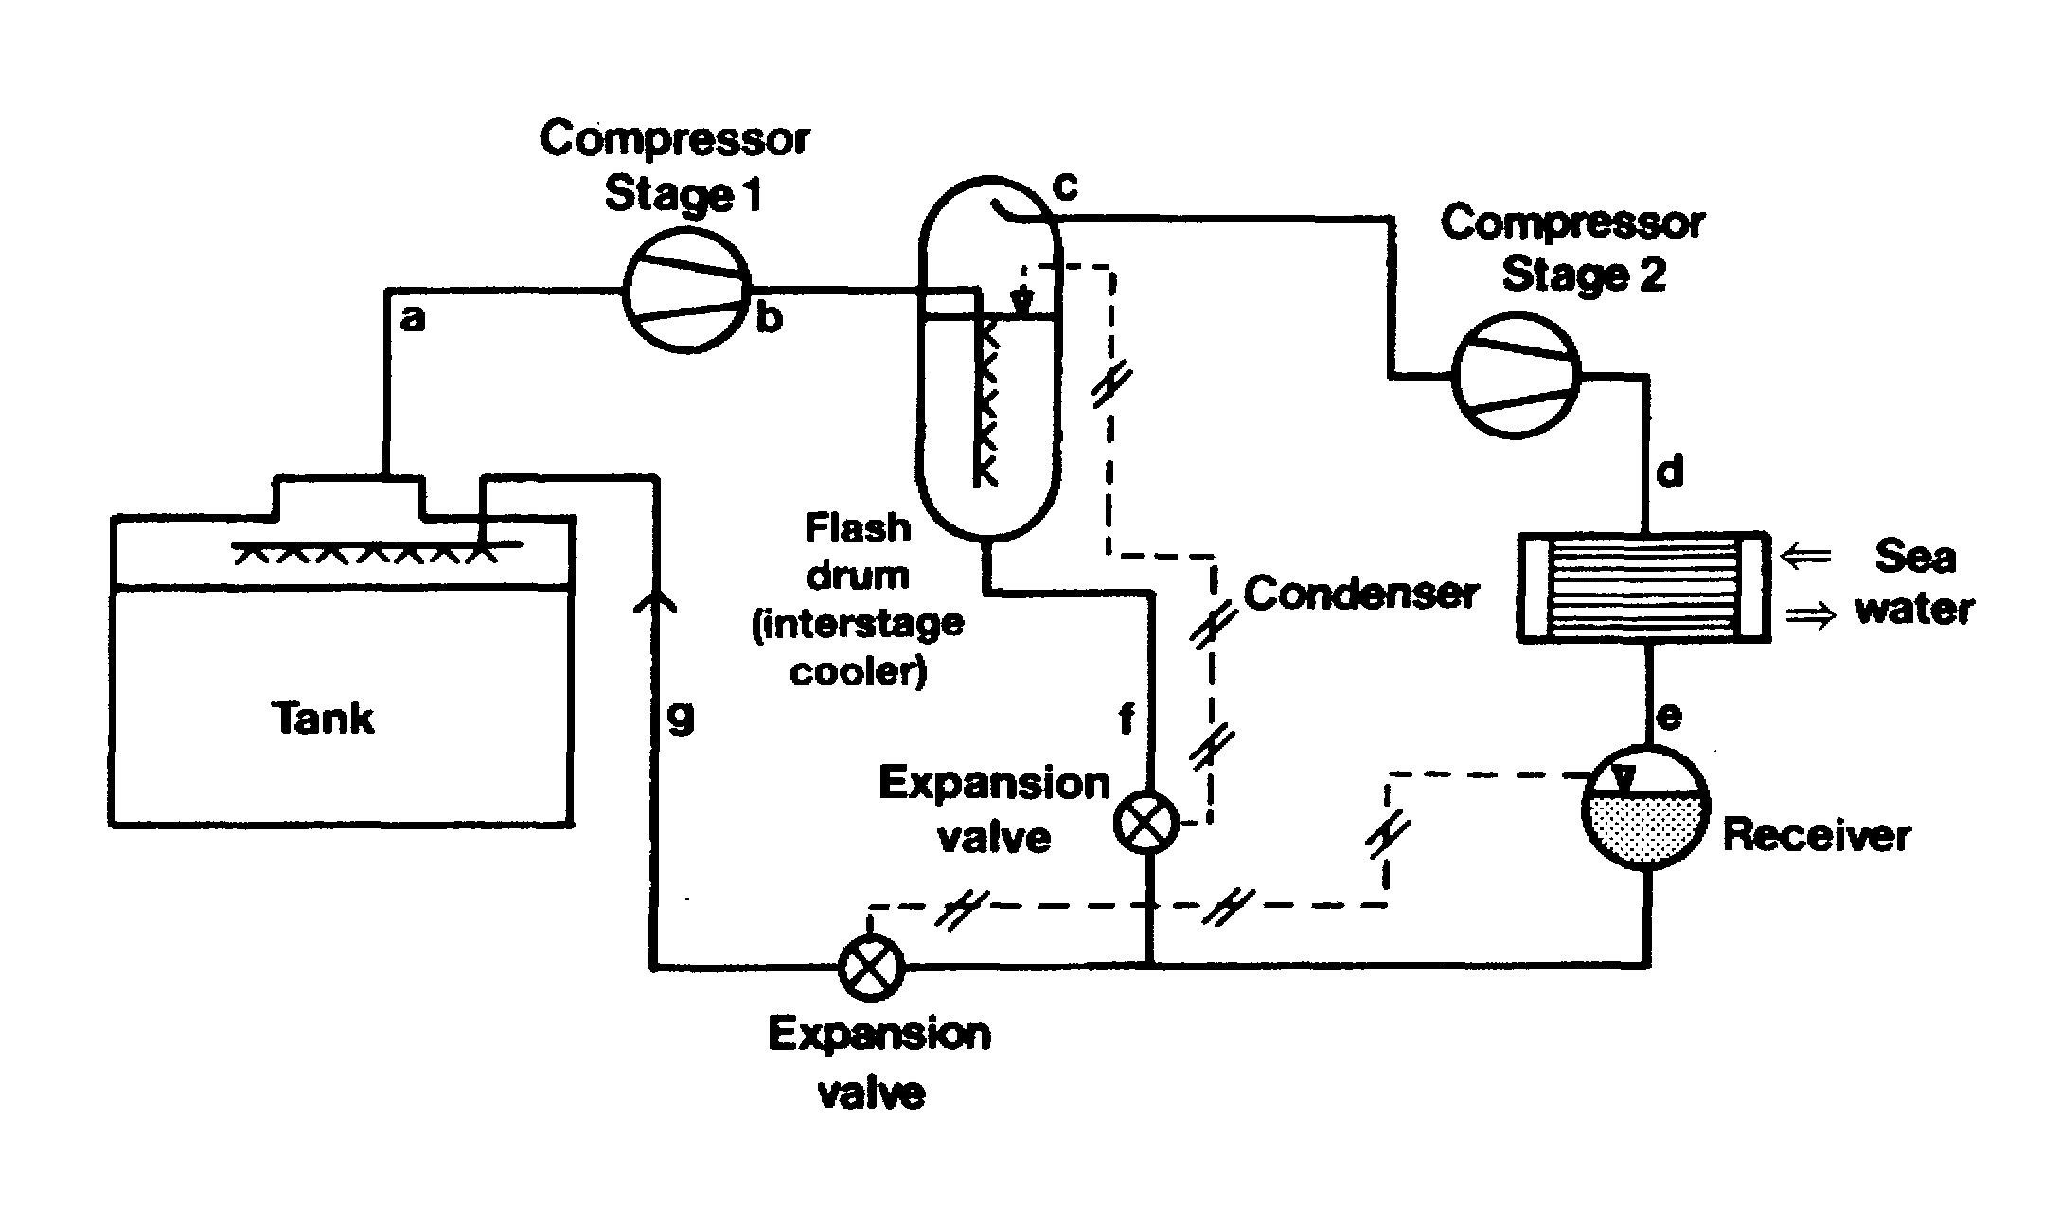

Figure 4.12(a) Two-stage direct reliquefaction cycle with inter-stage cooling
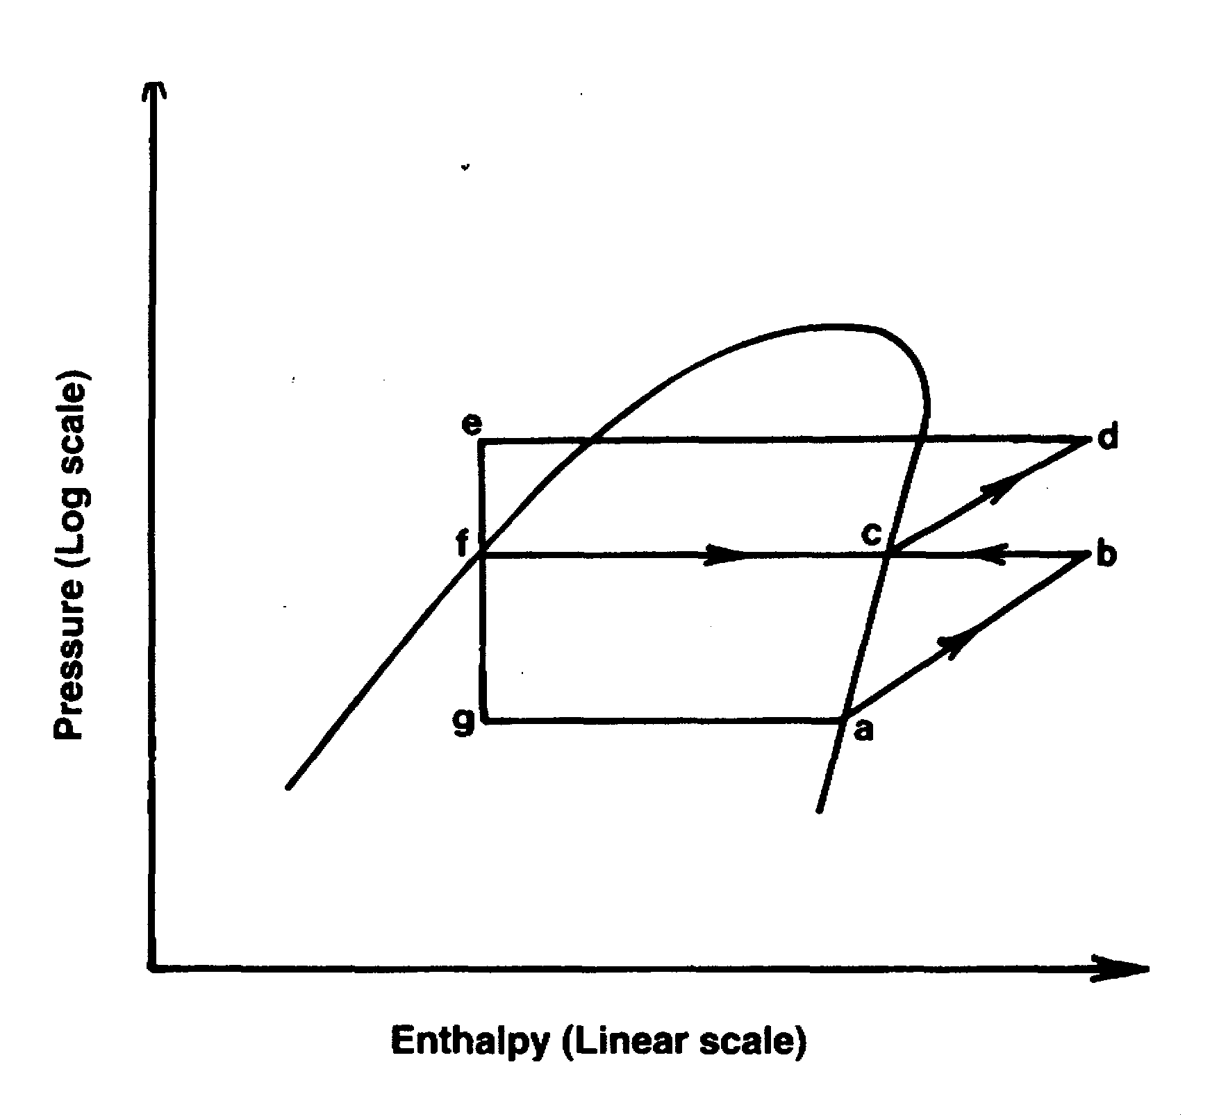

Figure 4.12(b) Mollier diagram — two-stage direct reliquefaction cycle
The vapour from the first stage discharge — (b) in the diagrams — is taken to an interstage cooler where its superheat is reduced — (c) in the diagrams. The cooling medium is cargo liquid flashed down to intercooler pressure from the sea water-cooled condenser. The remaining parts of the cycle are similar to the single-stage cycle.

Cascade direct cycle
The cascade cycle is used for fully refrigerated cargoes where a special refrigerant such as R22* (see below) is used to obtain the lower carriage temperatures. Furthermore in these systems, refrigeration plant capacities are not so affected by sea water temperature changes compared with other reliquefaction cycles. For the carriage of ethylene this type of equipment is essential.
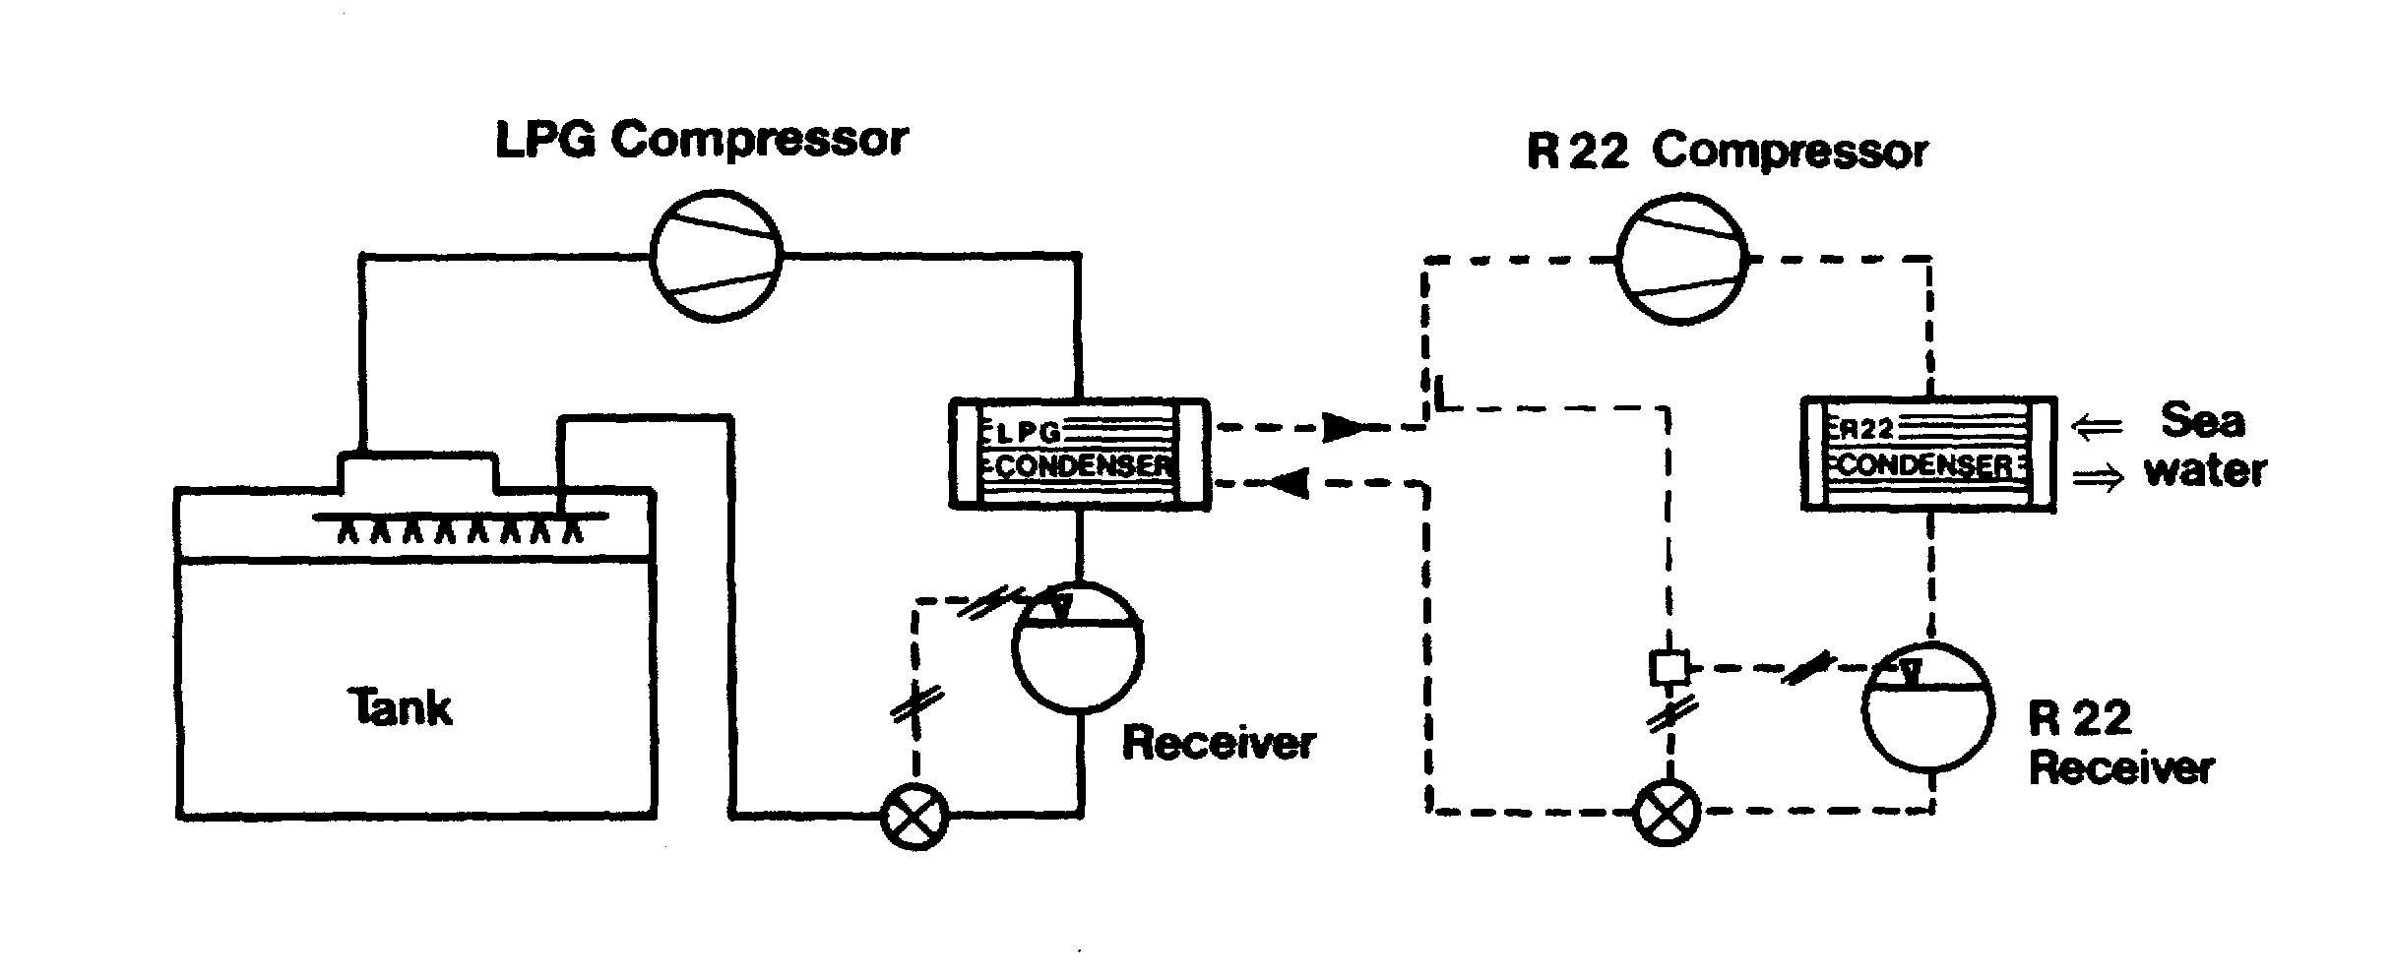
Figure 4.13 Simplified cascade reliquefaction cycle
The cascade system uses a refrigerant such as R22 to condense cargo vapors; a simplified diagram for this system is shown in Figure 4.13. The single-stage compression of cargo vapour is identical to the single-stage direct cycle, but the cargo condenser is cooled using R22 instead of seawater. The cargo, in condensing, evaporates the liquid R22 and the R22 vapour is then taken through a conventional R22 closed refrigeration cycle, condensing against sea water — hence the term cascade.

*Refrigerant gas - R22
As appropriate the indirect and direct cascade reliquefaction systems discussed in this book are assumed to use the refrigerant monochlorodifluoromethane which is more normally referred to by its refrigerant number R22. This material is an halogenated chloro fluoro carbon (HCFC).
It is well suited for use in reliquefaction plants, particularly in reciprocating type compressors. This refrigerant is not specifically listed in the Montreal protocol to be phased out but a separate agreement, indicating that its eventual phasing out by the year 2020 is desirable, has been reached by all signatories to the Montreal protocol. Research into suitable replacements is under way with major chemical companies involved.
R22 has a very low toxicity; however, in the presence of a naked flame it breaks down into a toxic gas, which has a very strong smell.
As per the Montreal Protocol, R22 will eventually be phased out in the not too distant future.
4.6 CARGO COMPRESSORS AND ASSOCIATED EQUIPMENT
The compressor is the heart of the reliquefaction plant. As far as LPG ships are concerned there are two main types of compressor: these are the reciprocating type and the screw type.
4.6.1 Reciprocating compressors
Older compressors were sometimes not of the oil-free type. This attracted the problems discussed in 2.8 and 7.6.1 because many liquefied gases can adversely’ affect the quality of the lubricating oil used in the machines. In using these older compressors, very careful control is required. In particular, sump heating systems are often fitted in order to evaporate any dissolved gases. In addition, the changing of lubricating oil between cargoes is usually necessary. Full data on the operation of these compressors should be available from manufacturers’ handbooks.
For these reasons, the vast majority of reciprocating cargo compressors now found on board gas carriers are of the so-called oil-free type.

1 The piston’s surface is machined with labyrinth grooves, forming a succession of throttling points for gas blow-by.

2 The cylinder is water-cooled or heated and is similarly provided with grooves in the bore.

3 The gland consists of a system of graphite rings forming a labyrinth seal. Gas leakage at this gland is usually returned to the intake side of the compressor.

4 The distance piece gives clear segregation between the compression space and crank gear and prevents the part of the piston rod (with a molecular oil film) from entering the gland.

5 The oil wiper prevents oil creeping up the piston rod into the neutral space and thence into the gland.

6 The piston rod is guided very accurately by a guide bearing and crosshead.

7 The guide bearing is lubricated and water-cooled.

8 The crosshead is lubricated and water-cooled.

9 The crankshaft is lubricated.

Figure 4.14 Sulzer oil-free compressor

In the Sulzer oil-free compressor shown in Figure 4.14, sealing between the piston and cylinder wall, and between the piston rod and gland, is achieved by the use of machined labyrinths. Consequently, no lubrication is needed for those spaces in the compressor swept by cargo vapors. The absence of any contact at the seals limits wear and lubricating oil consumption is minimal. The oil-free side of the compressor and the lubricated crank are separated by oil scraper rings mounted on the piston rod. The rod also carries a ring which prevents any residual oil film from creeping up the rod. The distance between the crank and gland is such that the oily part of the piston rod cannot enter the oil-free gland. Should any gas leak through the gland, it is returned to the suction side. The crankcase and separation space are kept under suction pressure. Where the crankshaft leaves the case, it is fitted with a shaft seal operating in oil.
Although the Sulzer compressor is oil-free in the compression chamber, it is common practice to change the lubricating oil with each change of cargo. This is to cover the question of compatibility of the lubricating oil grade with the next cargo (see 7.6.1).
Capacity control of the compressor is achieved by lifting suction valves during the compression stroke. The plate lifters are normally hydraulically operated with the fluid pressure being provided by the lubricating oil pump. When the compressor is shut down, the cargo vapour in the crankcase can condense, giving rise to lubricating problems. To avoid this, provision must be made for crankcase heating when the compressor is idle. When the compressor is running, cooling must be provided for the crankcase, for the crossheads and for the guide bearings. Normally, a closed cycle glycol water system provides for the heating — when the compressor is shut down — and for cooling, when the compressor is running.


Figure 4.15 Linde oil-free compressor

Another common type of reciprocating oil-free compressor is shown in Figure 4.15. This machine is manufactured by Linde. Such a compressor has PTFE piston rings instead of the labyrinth piston in the Sulzer machines. Volumetric efficiencies tend to be higher with the PTFE ring design.
4.6.2 Screw compressors
Screw compressors for use with liquefied gas cargoes can be either dry oil-free or oil-flooded machines. In the dry machines, the screw rotors do not make physical contact but are held in-mesh and driven by external gearing. Due to leakage through the clearances between the rotors, high speeds are necessary to maintain good efficiency (typically 12,000 rpm). Figure 4.16 is a diagram of a typical rotor set with the common combination of four and six lobes. The lobes inter-mesh and gas is compressed in the chambers numbered 1, 2, 3, in the diagram which are reduced in size as the rotors turn. The compressor casing carries the suction and discharge ports.
The oil-flooded machine relies on oil injection into the rotors and this eliminates the need for timing gears. Drive power is transmitted from one rotor to the other by the injected oil. This also acts as a lubricant and coolant. Because the rotors are sealed with oil, gas leakage is much less and, therefore, oil-flooded machines can run at lower speeds (3,000 rpm). An oil separator on the discharge side of the machine removes oil¹ from the compressed gas.
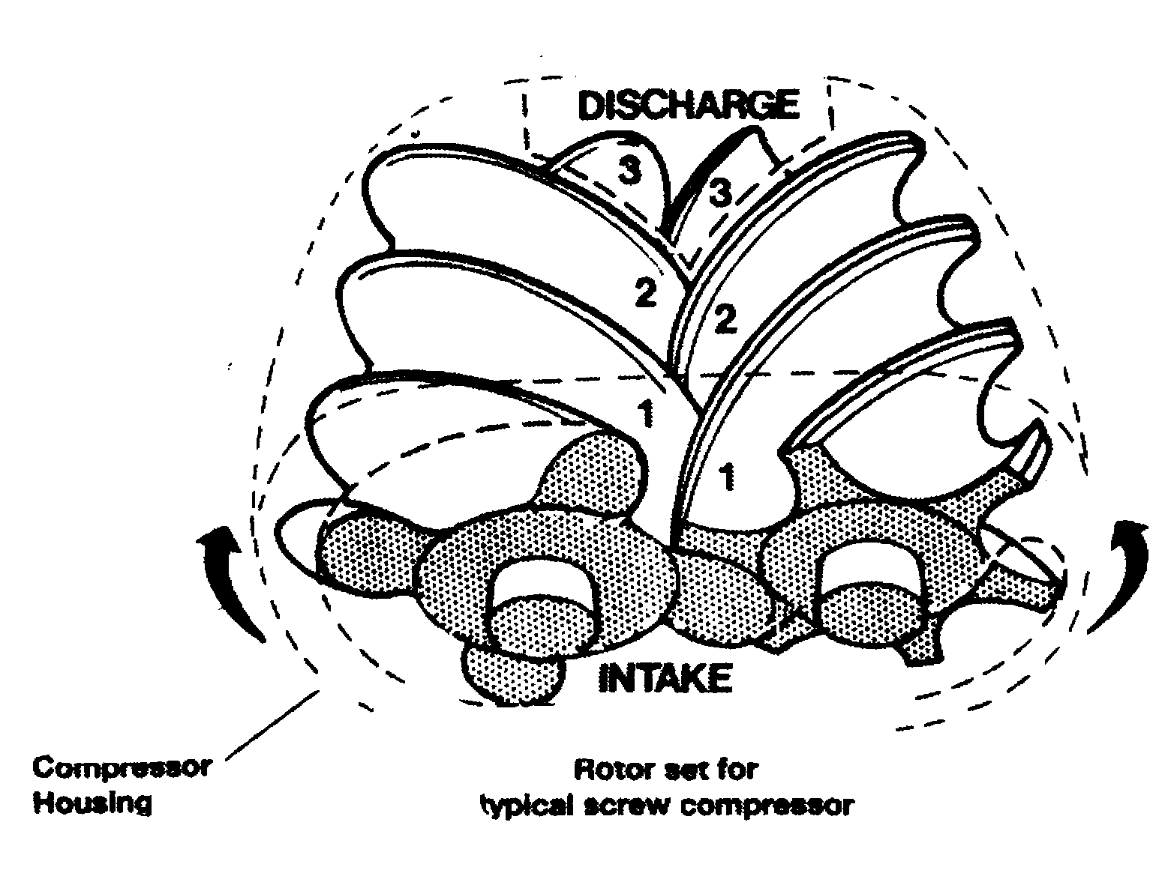

Figure 4.16 Typical rotor for an oil-free screw compressor
Capacity control of screw compressors can be achieved in a number of ways. The most common is the use of a sliding valve, which effectively reduces the working length of the rotors. This is more efficient than suction throttling. Screw compressors consume more power than reciprocating compressors.
4.6.3 Compressor suction liquid separator

It is necessary to protect cargo vapour compressors against the possibility of liquid being drawn in. Such a situation can seriously damage compressors since liquid is incompressible. It is normal practice, therefore, to install a liquid separator on the compressor suction line coming in from the cargo tanks. The purpose of this vessel is to reduce vapour velocity and, as a result, to allow any entrained liquid to be easily removed from the vapour stream. In case of over-filling, the separator is fitted with high-level sensors, which set off an alarm and trip the compressor.
4.6.4 Purge gas condenser
Many reliquefaction plants are fitted with a heat exchanger mounted above the cargo condenser. These units are of the shell and tube types. The purpose of this heat exchanger is to condense any cargo vapours which remain mixed with incondensable gases (such as nitrogen). These cargo vapours may have failed to condense in the main condenser. For example, commercial propane which may have two per cent ethane in the liquid will have perhaps 14 per cent ethane in the vapour; ethane being the more volatile component. On a semi-pressurised LPG carrier, the presence of ethane can cause difficulties in a conventional sea water-cooled condenser.
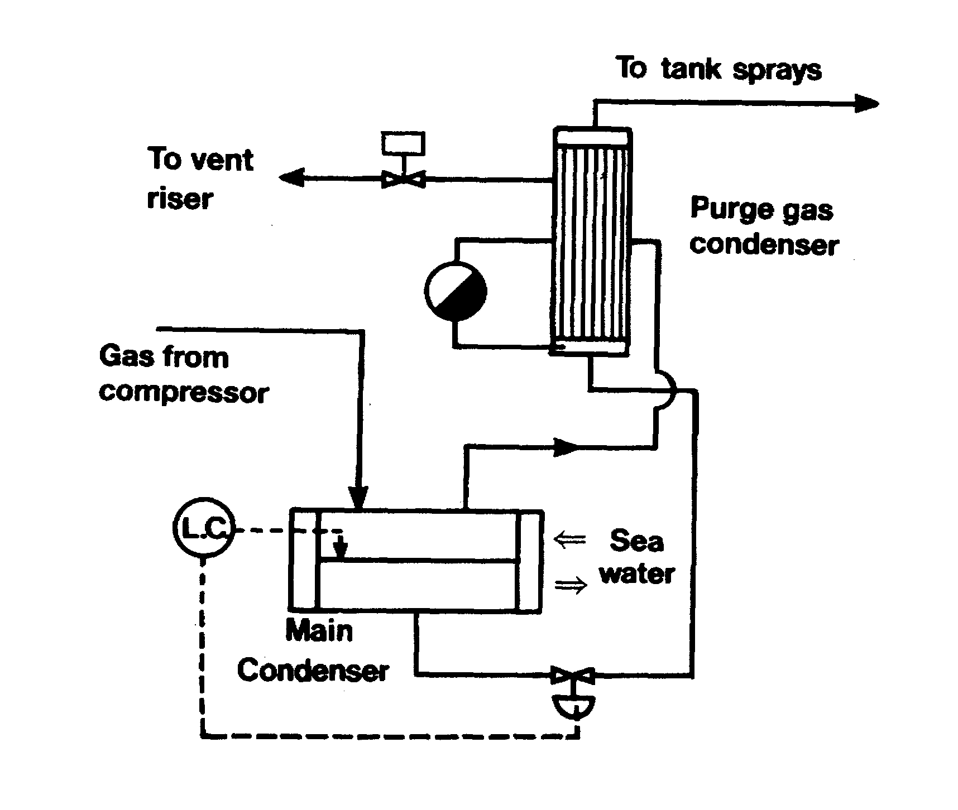

Figure 4.17 Typical purge gas condenser system
Figure 4.17 shows a typical purge gas condenser system. The uncondensed gases in the main condenser are displaced into the shell of the purge condenser. Here they are subjected to the same pressure that exists in the main condenser but to a lower condensing temperature. This is equivalent to the outlet temperature from the expansion valve, since the whole or part of this liquid passes through the tube side of the purge condenser. This lower condensing temperature allows cargo vapours to be condensed and incondensable gases are purged from the top of the purge gas condenser by a pressure control system.
4.6.5 LNG boil-off and vapour-handling systems
The older LNG ships use steam turbine-driven compressors to handle boil-off vapours. Newer designs incorporate electrically driven equipment. Boil-off vapours are/ produced during cool-down, loading and during the loaded and ballast voyages. Normally, a low-duty compressor handles the boil-off whilst on passage: a high-duty compressor handles cargo vapours produced during cool-down and loading, returning these vapours to shore.
When a ship is at sea, the low-duty compressor collects the boil-off gas from a header connected to each cargo tank. It then passes the boil-off through a steam heater and into the engine room (see 7.6.2). The pipeline is jacketed from the point at which it enters the engine room or the accommodation up to the boiler front. The annular space (between the gas pipeline and its jacket) is either pressurised with nitrogen or exhaust-ventilated with air giving at least 30 changes per hour. The gas pipeline must be purged with inert gas before and after gas-burning operations.
There are a number of automatic protective devices built into the system to ensure safe operation and these must be regularly inspected and maintained. Protective systems include continuous monitoring for leakage and automatic shut-down in the event of system malfunction or leak detection. These systems are described in some detail in the IGC Code.
The compressors are provided with surge controls and other protective devices.
LNG is the only liquefied gas product allowed by the Gas Codes to be burnt in the ship’s boilers. The other gases, having densities heavier than air, are considered to be hazardous for this purpose.
4.7 INERT GAS AND NITROGEN SYSTEMS
As covered in 2.5, gas carriers use various forms of inert gas and these are listed below:
- Inert gas from combustion-type generators
- Nitrogen from shipboard production systems, and
- Pure nitrogen taken from the shore (either by road tanker or barge)
Unlike oil tanker inert gas systems, which have their design and operation established by extensive regulations and guidelines, the fitting of inert gas systems to gas carriers is subject to limited advice in the Gas Codes, special consideration by administrations and the particular demands of the trade. In general, for gas carriers, the production of combustion-generated inert gas will be covered in new building specifications at about one per cent oxygen
LNG ships were once provided with storage facilities for liquid nitrogen but newer designs include a nitrogen generation plant. However, up to now, the quantity of nitrogen produced on board has not been of sufficient volume for tank-inerting operations. It is fitted mainly for interbarrier space inerting. Where cargo tank inerting is required on LNG ships, nitrogen from the shore, or combustion-generated inert gas is used.
As can be seen from the foregoing, most ships, barring only the smallest pressurised gas carriers, have the capability of generating their own inert gas. Furthermore, all LNG ships have the capability of producing nitrogen for hold space and interbarrier space inertion — this is a necessary specification, as the carbon dioxide in inert gas would freeze when in close proximity to the cargo. The methods of producing the inert gases, as listed at the beginning of this section, are covered below.
4.7.1 Inert gas generators
The Gas Codes require continuous oxygen monitoring in the inert gas stream and the oxygen content should normally be no more than about one per cent. High oxygen content can trigger an alarm; however, the generator is not normally shut down on this alarm but the gas is diverted to atmosphere via a vent riser.
The main advantages of the on board inert gas generator are as follows:
- The cost of inert gas is less than the purchase of liquid nitrogen
- The inert gas plant capacity is available either at sea or in port
The disadvantages of the combustion-type generator center on the quality of gas produced. Combustion must always be carefully adjusted to avoid the production of toxic carbon monoxide and soot. Also, even under good operating conditions, the volume of oxygen in the inert gas may be unsuitable for use with the chemical gases, as detailed in Chapter Two. Accordingly, given that an oxygen-critical gas is to be loaded, as a preliminary operation, pure nitrogen must be taken from the shore.
Inert gas produced by the careful combustion of diesel or gas oil, results in a reduced oxygen content in the products of combustion. In the inert gas generator, the resulting gases are further treated to give an inert gas of acceptable standard. Apart from plant operation, the final quality of the inert gas also depends on the fuel used and generally fuel of low sulphur content is preferred. In this regard, experience often dictates that gas oil should be used in preference to marine diesel oil but bunker prices also have a bearing on the final choice.
A typical analysis of inert gas from a modern generator is shown in Table 2.4. The quality of the inert gas produced, however, is very dependent on the conditions under which the generator is operated and, in this respect, the manufacturer’s guidance
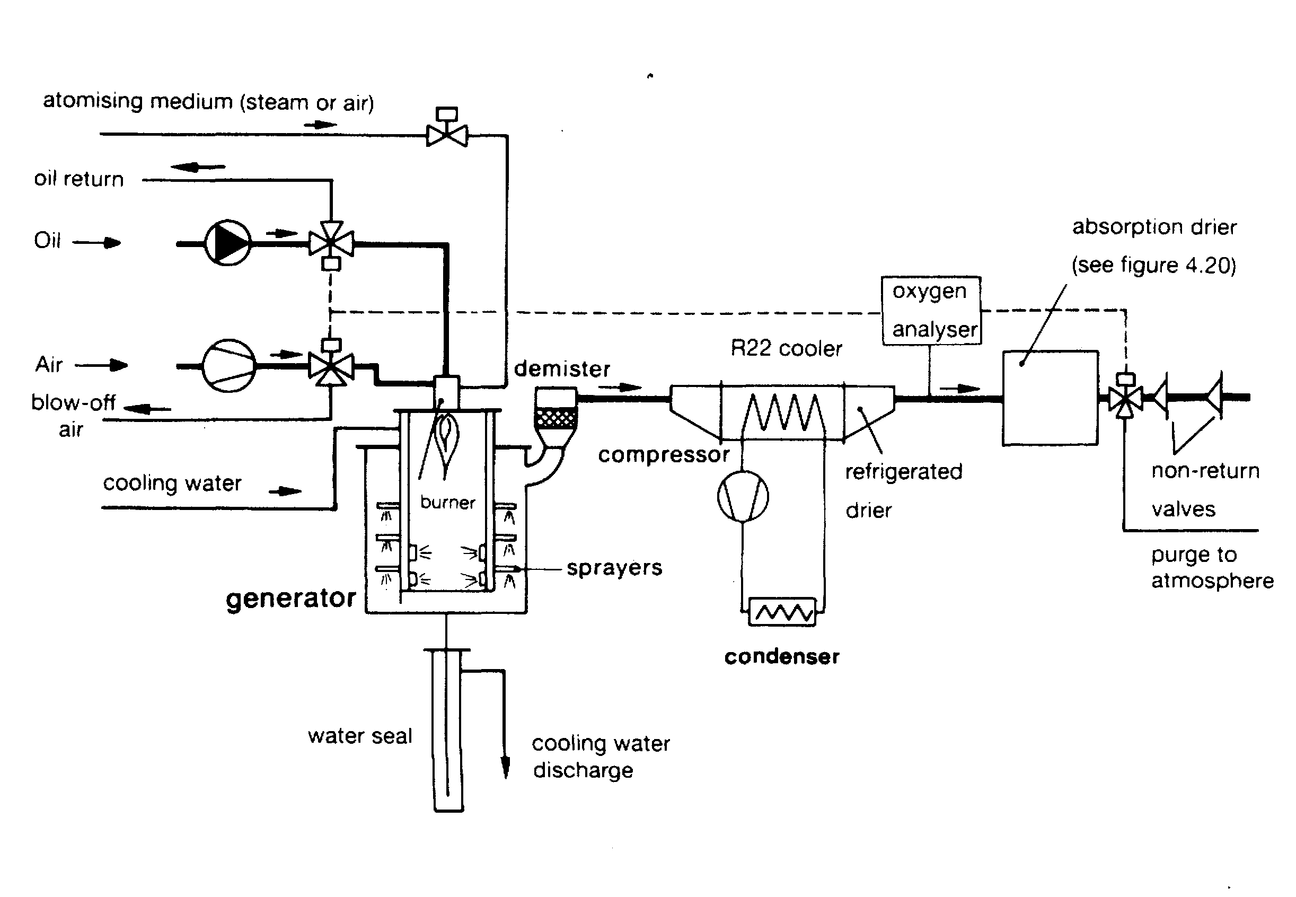

Figure 4.18 Flow diagram of an inert gas generator
should be closely followed. A particular point to watch is that poorly maintained plant can produce significant quantities of carbon monoxide or soot such that, even after aerating, carbon monoxide levels in a tank may be unacceptable.
The mode of operation is shown in Figure 4.18. Here it will be seen that the inert gas generator has three main parts. These are as follows:
- A combustion chamber with scrubbing and cooling (the generator)
- A refrigerated drier — cooled normally by R22, and
- An absorption drier

Combustion chamber
Combustion-type generators must be located outside the cargo area and are usually installed in the ship’s engine room. It is usual to find the inert gas main permanently piped into the cargo holds and temporary connections are provided between the inert gas main and the cargo system for tank inerting operations. When not in use, these must be disconnected and blanks fitted. Two non-return valves (or equivalent) are fitted in the inert gas main to prevent any back-flow of cargo vapours. When not being used for high capacity tank inerting operations the inert gas plant is used from time to time to top up hold and interbarrier spaces.
Within the combustion chamber, the burner is designed to ensure good combustion so producing a minimum of oxygen residue in the inert gas. Operationally, however, there is a fine balance to be achieved in generator adjustment as minimizing oxygen output tends to increase the production of carbon monoxide: and further adjustment can result in the overproduction of soot. The combustion chamber itself is water-jacketed. After combustion, the inert gas enters the washing section of the generator at a very high temperature and is “cooled and scrubbed by spraying with sea water. This is also carried out for the removal of soluble acid gases such as sulphur dioxide and the oxides of nitrogen. The inert gas is then filtered to remove solid particles. The gas leaves the generator at approximately five degrees Centigrade above sea water temperature and by this time it should be essentially free from sulphur oxides formed by burning the sulphur present in the fuel — but it is saturated with water vapour. Accordingly, it is then further cooled and dried (as covered below) and delivered to the cargo tanks.

The refrigerated drier
In the refrigerated drier, the inert gas is cooled to approximately four degrees Centi-grade, resulting in the condensation of much of the water vapour. Figure 4.19 shows the content of water vapour in saturated inert gas as a function of temperature. From this diagram, the reduction in water vapour content can be seen as the temperature is reduced.
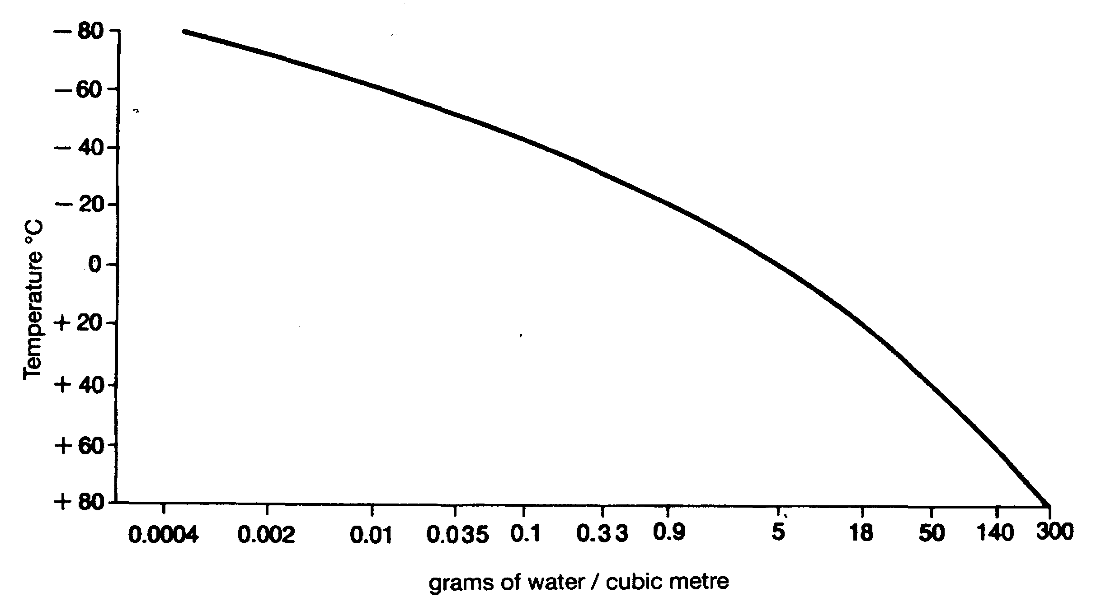

Figure 4.19 Saturated water content of inert gas

The absorption drier
The absorption drier consists of two vessels filled with activated alumina or silica gel. One vessel is on drying duty while the other is being regenerated. Typically, the cycle time is six hours.
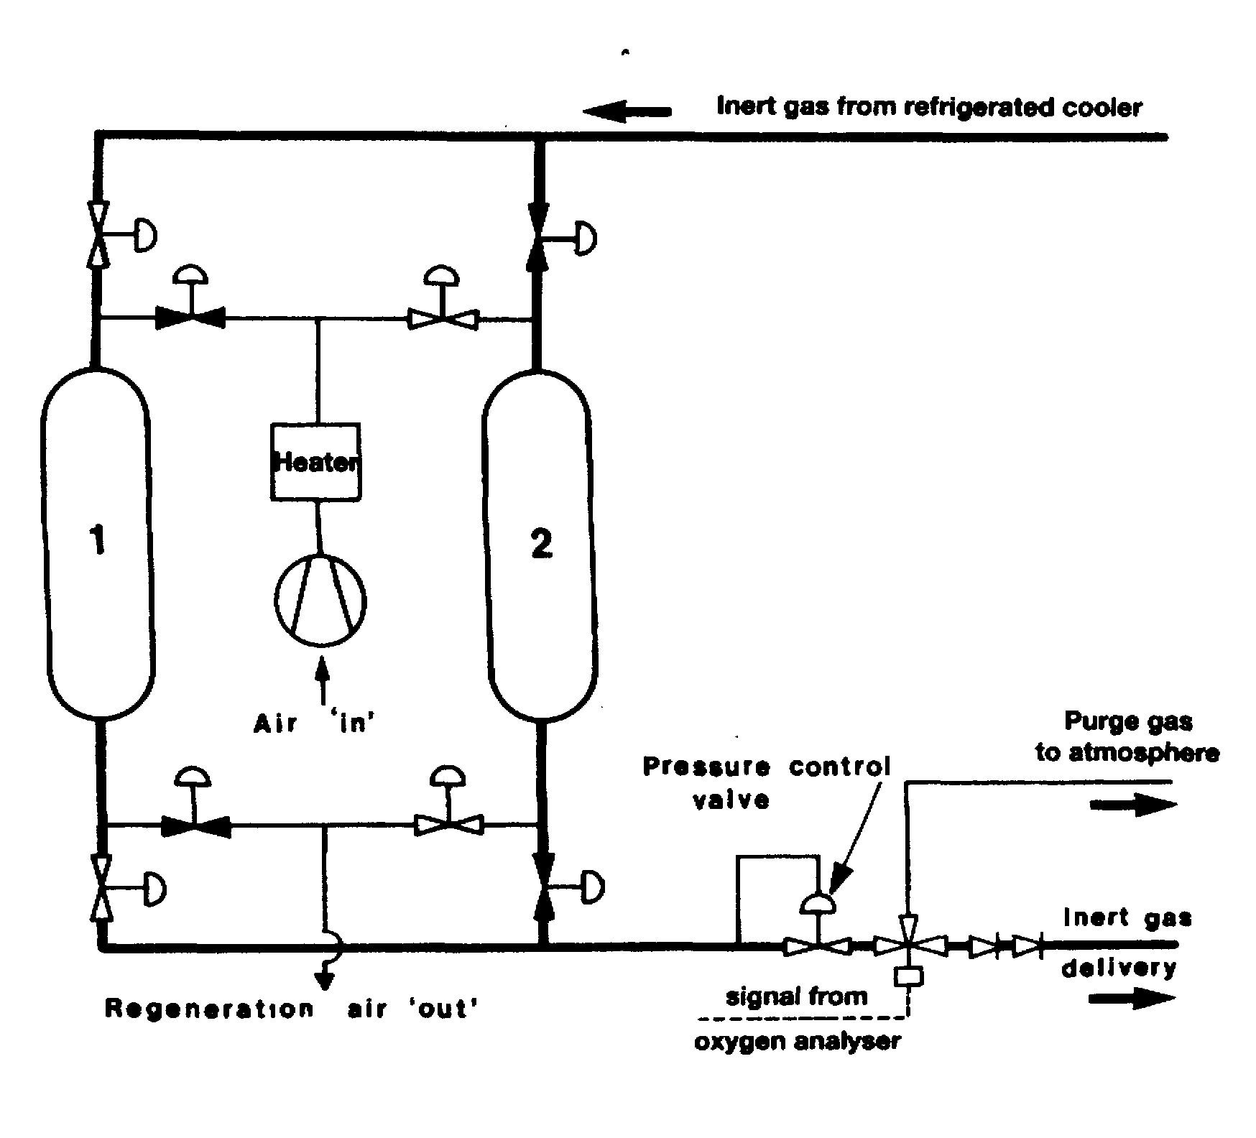

Figure 4.20 Drying of inert gas

Drying in the absorption drier reduces the dew point of the inert gas to -40°C or below. A layer of molecular sieves can be added to the bottom of the drying tower to improve the dew point. In order to ensure stable combustion in the generator, the pressure in the drying system must be kept constant and this is achieved by means of a pressure control valve as shown in Figure 4.20.
4.7.2 Nitrogen production on ships
The most common system utilised for the production of nitrogen on ships is an air separation process. This system works by separating air into its component gases by passing compressed air over hollow fibre membranes. The membranes divide the air into two streams — one is essentially nitrogen and the other contains oxygen, carbon dioxide plus some trace gases. This system can produce nitrogen of about 95 to 97 per cent purity. The capacity of these systems depends on the number of membrane modules fitted and is dependant on inlet air pressure, temperature and the required nitrogen purity. Figure 4.21 shows one such system.
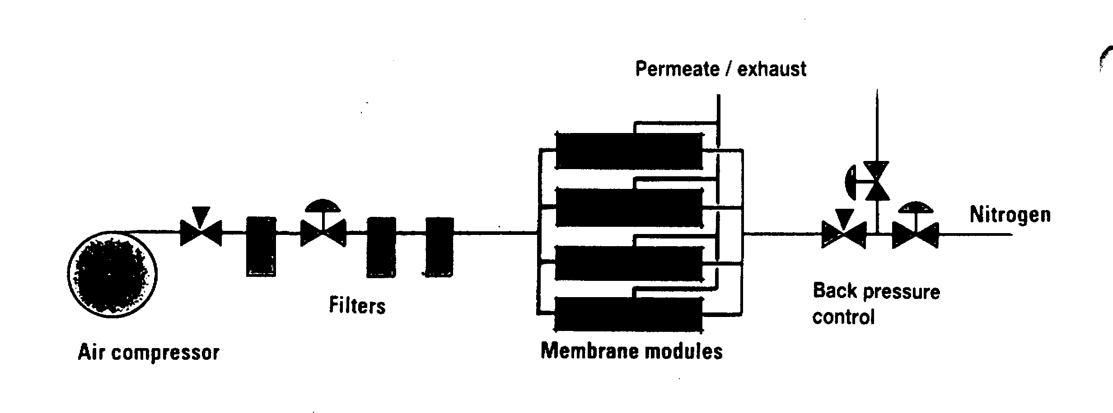

Figure 4.21 The membrane system for producing nitrogen
4.7.3 Pure nitrogen from the shore ^
The quality of inert gas produced by shipboard systems is usually inadequate for oxygen-critical cargoes — see strict in-tank oxygen requirements in Table 2.3(b). Bearing in mind the components in the inert gas, this may create restrictions on use if tanks have been previously gas-freed for inspection; and this is often necessary when a change in grades is involved. Under these circumstances, and prior to loading, it is normal for shipmasters to arrange for cargo tanks to be inerted with pure nitrogen, taken from the shore. This is usually delivered by road tanker or barge. As deliveries are in liquid form, where immediate inerting is required, a nitrogen vaporiser is needed.
4.8 ELECTRICAL EQUIPMENT IN GAS DANGEROUS SPACES

A common definition of area safety classification for electrical equipment in shore installations is as follows:
Zone 0: An area with a flammable mixture continuously present
Zone 1: An area where flammable mixtures are likely during normal operations
Zone 2: An area where flammable mixtures are unlikely during normal operations
Electrical installations on gas carriers are subject to the requirements of the classification society and the Gas Codes. Zones and spaces on ships are classified as either gas-safe or gas-dangerous, depending on the risk of cargo vapour being present. For example, accommodation and machinery spaces are gas-safe, while compressor rooms, cargo tank areas and holds are gas-dangerous. In gas-dangerous spaces, only electrical equipment of an approved standard may be used; this applies to both fixed and portable electrical equipment. There are several types of electrical equipment certified as being safe for use on gas carriers and these are described in the following sections.

Intrinsically safe equipment
Intrinsically safe equipment can be defined as an electrical circuit in which a spark or thermal effect (under normal operation or specified fault conditions) is incapable of causing the ignition of a given explosive mixture.
Limitation of such energy may be achieved by placing a barrier, as shown in Figure 4.22, in the electrical supply. This must be positioned in a safe area. Zener barriers are frequently used for this purpose and, in the circuit shown, the voltage is limited by the Zener diodes so that the maximum current flow to the hazardous area is restricted by the resistors. The uses of such intrinsically safe systems are normally limited to instrumentation and control circuitry in hazardous areas. Because of the very low energy levels to which they are restricted, intrinsically safe systems cannot be used in high-power circuits.
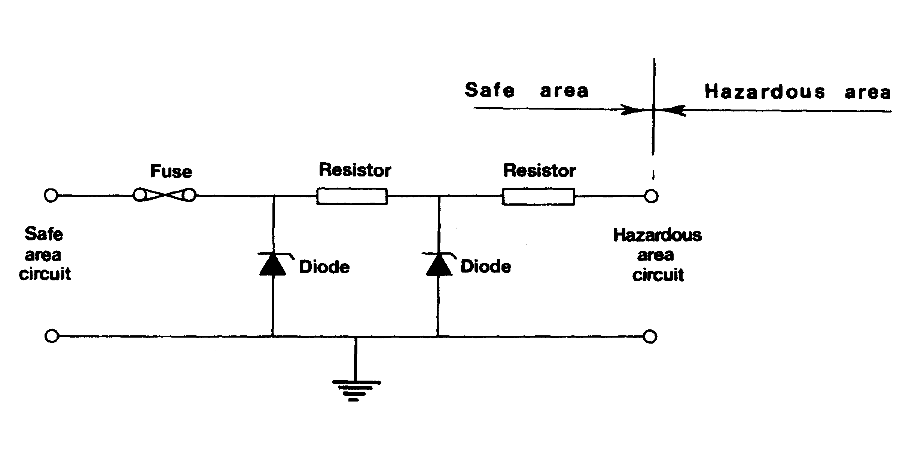

Figure 4.22 Intrinsic safety using Zener barriers

Flameproof equipment
A flameproof enclosure is one, which can withstand the pressure developed during an internal ignition of a flammable mixture. Furthermore, the design is such that any flames, occurring within the enclosure, are cooled to below ignition temperature before reaching the surrounding atmosphere.
Therefore, the gap through which hot gases are allowed to escape is critical and great care must be taken in assembly and maintenance of flameproof equipment to ensure that these gaps are well maintained. No bolts must be omitted or tightened incorrectly, while the gap must not be reduced by painting, corrosion or other obstructions.

Pressurised or purged equipment
The pressurization or purging of equipment is a technique used to ensure that an enclosure remains gas-free. In the case of pressurisation, an over-pressure of about 0.5 bar, relative to the surrounding atmosphere, must be maintained. In the case of a purged enclosure, a continuous supply of purging gas must be provided to the enclosure. Air or inert gas can be used.

Increased safety equipment
The use of Increased Safety Equipment is appropriate for electrically powered light fittings and motors. This equipment has a greater than normal separation between electrical conductors and between electric terminals. Starters are designed to minimise both arcing at contactors and to limit the temperature of components. Increased safety motors, with flameproof enclosures, are frequently used on deck on gas carriers. Here they may be found- driving deepwell pumps or booster pumps. In such cases they must be protected by a suitable weatherproof covering.
4.9 INSTRUMENTATION
Instrumentation is an important part of gas tanker equipment and is required for the measurement of cargo level, pressure and temperature. It is also used for gas detection. Instrumentation must be carefully selected and well maintained.
4.9.1 Liquid level instrumentation
The Gas Codes and classification society rules require every cargo tank to be fitted with at least one liquid level gauge. Specific types of gauging system are required for certain cargoes as defined in Chapter 19 of the IGC Code. This information is summarised in Appendix 2.
The IMO classification for gauging systems is as follows:
- Indirect systems — these may be either weighing methods or flow meters
- Closed devices, which do not penetrate the cargo tank — here ultrasonic devices or radio isotope sources may be used
- Closed devices, which penetrate the cargo tank — such as, float gauges and bubble tube indicators
- Restricted devices which penetrate the tank but which release small volumes of liquid or vapor to atmosphere when in use, such as fixed or slip-tube gauges. When not in use, the restricted device should be kept completely closed
In the LPG trade the most common types of level gauging are the last two described, while in the LNG trade, the closed devices are more usual.

Float gauges
The float gauge is widely used on all gas carriers. It consists of a float attached by a tape to an indicating device, which can be arranged for local and remote readout. Figure 4.23 shows a typical float gauge installed in a tubular well. Alternatively guide wires may be fitted. Float gauges have gate valves for isolation so that the float can be serviced in a safe atmosphere.
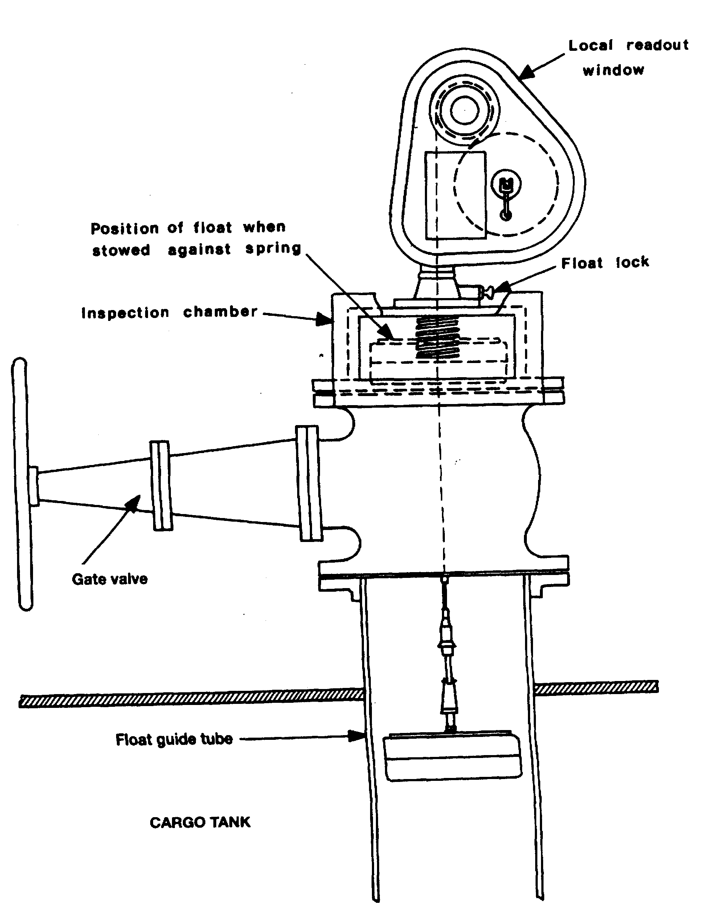

Figure 4.23 Float level gauge

The float must be lifted from the liquid level when not in use; if left down, liquid sloshing, while at sea, will damage the tape-tensioning device. Float gauges cannot normally register a liquid level of less than ten centimeters from the tank bottom.

Nitrogen bubbler gauges
Nitrogen bubbler gauges measure the pressure necessary to displace liquid cargo from a small bore tube mounted vertically in a tank. A sufficient pressure of nitrogen is introduced into the tube to displace the liquid and to commence bubbling at the bottom. The pressure necessary to do this is measured and is a function of the liquid level and the liquid density. For cargoes of known density the level readout is obtained directly. By installing two such tubes, one alongside the other, and with their lower extremities a known vertical distance apart, the density of the cargo can also be determined. Figure 4.24 shows the principle of the bubbler gauge.
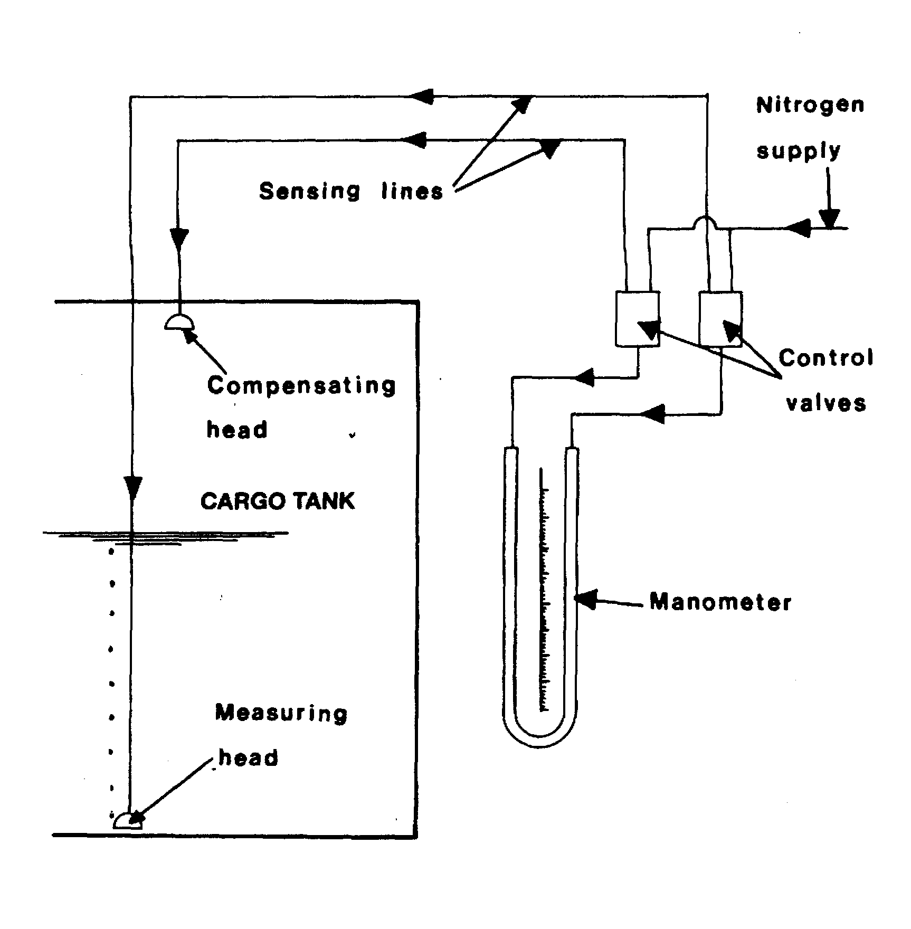

Figure 4.24 Nitrogen bubbler level gauge
The use of such instruments in connection with the carriage of ethylene is not recommended. Ethylene has a strict specification for nitrogen contamination and the use of such equipment could damage the cargo.

Differential pressure gauges
Differential pressure gauges operate on pressure differences between liquid and vapour. The signal lines for the instrument are normally purged with inert gas. This type of gauge can only be used on ships when the cargo tank is situated completely above deck, thus such measuring equipment is more generally found in use on shore in terminal tanks. Figure 4.25 shows the principle of the differential pressure gauge.

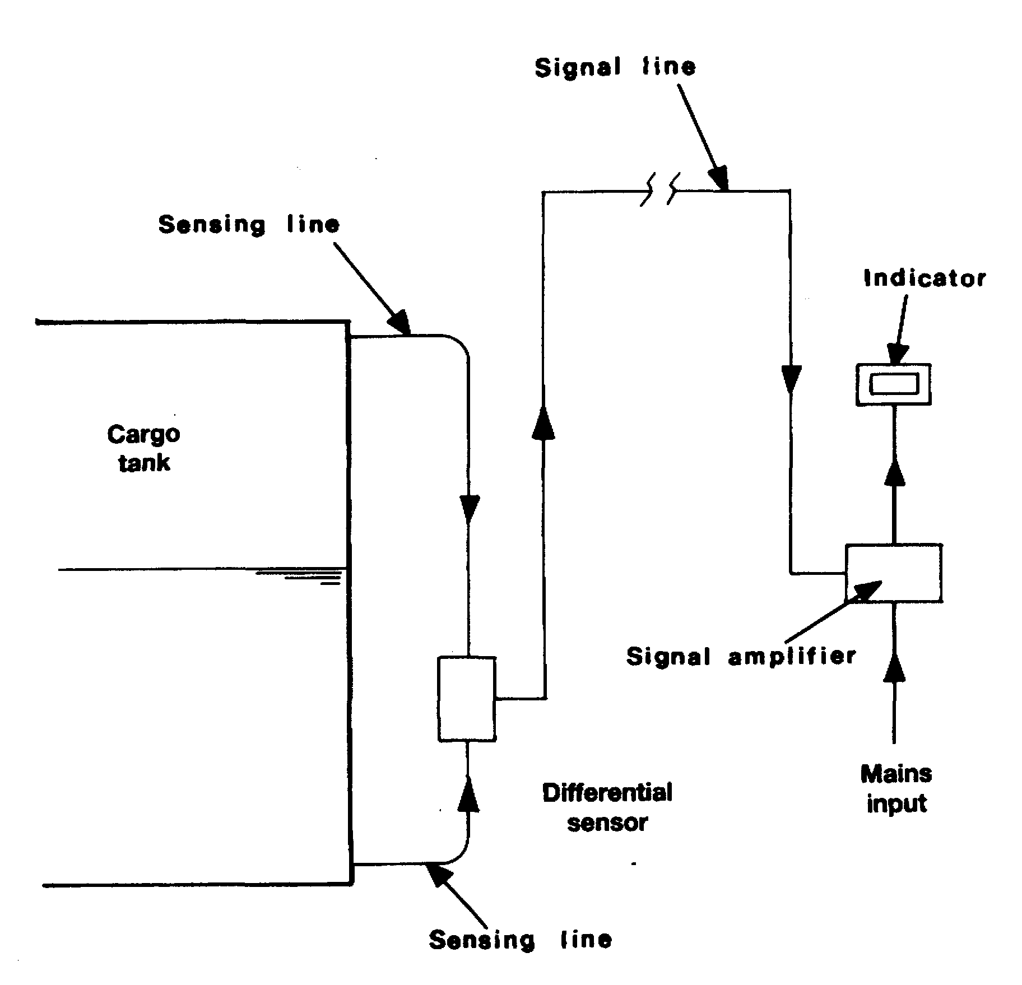

Figure 4.25 Differential pressure level gauge

Capacitance gauges
Capacitance gauges measure the change in electrical capacitance between two probes as cargo liquid, rather than vapour, takes up the space between them. Figure 4.26 illustrates just such a device in which the two probes are enclosed within an open protective tube. This tube extends throughout the depth of the tank and provides a continuous indication of liquid content at all levels.
For single preset level indication, as for a high-level alarm or overfill shut-off, a short probe sensor may be fitted at the precise level required. The electrical circuits are, of course, intrinsically safe. The devices, having no moving parts, are usually reliable but must be kept free from dirt, rust, water and ice since such contaminants can cause inaccuracy.

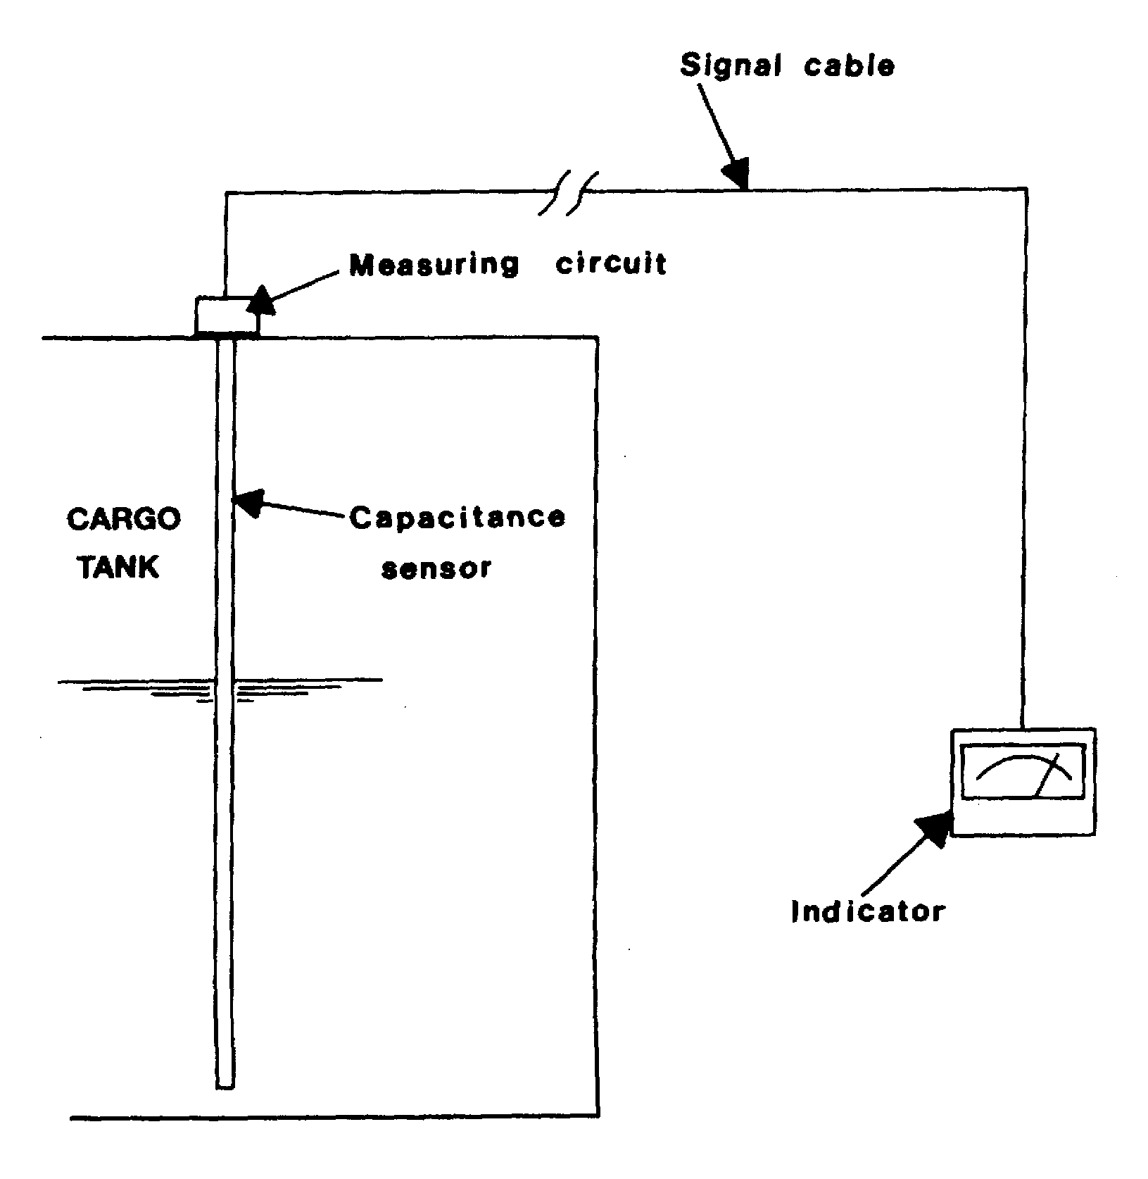

Figure 4.26 Electrical capacitance level gauge

Ultrasonic gauges
Ultrasonic gauges operate on a similar principle to echo sounders. They measure either the ullage or the liquid depth by reflecting sound waves from the liquid surface. The transceiver may be mounted either in the tank dome or at the tank bottom, depending on whether the ullage depth or liquid dip is to be measured.
Ultrasonic gauges fitted on gas carriers can be unreliable. There can be problems obtaining satisfactory readings when loading tanks by the spray line. Other points of inaccuracy can develop as cargoes of differing types are loaded. Furthermore, readings can vary, depending on temperature and pressure changes.

Radar gauges
Another type of tank gauging equipment is that designed to operate on the principle of radar. Such equipment works at very high frequencies — approximately 11 gigahertz (11 x 10⁹). Radar type liquid level gauges have now been specially developed for liquefied gases and their usage on gas tankers. The equipment provides measurements adequate to meet industry requirements .
All the above devices are classed as closed devices (see Appendix 2). This means that, when in use, no cargo liquids or vapours are released to the atmosphere during level measurement. The slip-tubes, which are described in the following paragraph, are classed as restricted devices and have some disadvantages over the equipment described previously.

Slip-tubes
As defined in the Gas Codes, slip-tubes constitute a restricted type of gauging device — so named because a small amount of cargo vapour or liquid is released to atmosphere during level measurement. Some terminals disallow the use of this type of equipment — depending on cargo type — because released gases can have harmful effects on personnel working nearby. These dangers are discussed in Chapter Nine and relate mostly to product toxicity.
Slip-tubes have an orifice at their upper end through which liquid or vapour can be released. The Gas Codes limit the size of this orifice to 1.5 millimetres in diameter, unless an excess flow valve is fitted. The lower end of the slip-tube is open to the cargo tank environment. The device slides up and down through a gland fitted in the tank dome. The observed differences between either liquid or vapour venting from the orifice gives an indication of when the liquid level has been reached and, by reading from the markings on the tube itself, the actual liquid level is read-off. Because of the considerable depth of many tanks, it is usual to find that a number of slip-tubes are fitted, with each individual unit covering a certain range of tank level measurements.
Slip-tubes represent a simple and direct method of measurement but, because of a certain amount of high-pressure spray released to the atmosphere, special precautions must be taken. These include the wearing of protective clothing. Furthermore, operational procedures should be established to direct the spray away from personnel. As described earlier in this section, the use of slip-tubes is limited to backup of the closed devices (described above) and to Type ‘C’ tanks only.
4.9.2 Level alarm and automatic shut-down systems
With the exception of Type ‘C’ tanks having a capacity of less than 200 cubic metres, every cargo tank must be fitted with an independent high level sensor giving audible and visual alarms. The float, capacitance or ultrasonic sensors (as covered in 4.9.1) may be used for this purpose. The high-level alarm — or other independent sensor — is required to automatically stop the flow of cargo to the tank.
During cargo loading, there is a danger of generating a significant surge pressure if the valve stopping the flow closes too quickly against a high loading rate. (For further information on surge pressure see 4.1.3 and 10.5).
4.9.3 Pressure and temperature monitoring
The Gas Codes call for pressure monitoring throughout the cargo system. Appropriate positions include cargo tanks, pump and compressor discharge lines, liquid crossovers and vapour crossovers. In addition, pressure switches are fitted to various systems to protect personnel and equipment by operating alarms and shut-down systems.
The Gas Codes also require at least two devices for indicating cargo tank temperatures. One is placed at the bottom of the tank and the second near the tank top, but below the highest allowable liquid level. Ships’ officers should be aware of the lowest temperatures to which the cargo tanks can be exposed and these values should be marked on the temperature gauges — especially those at the cargo manifold.
Where cargo is carried in tanks requiring a secondary barrier at a temperature of below -55° C, the Gas Codes call for temperature-indicating devices within the insulation or on the hull structure adjacent to the containment system. The thermo-couples should be set to provide adequate warning prior to the lowest temperature for the hull steel being approached.
The Gas Codes also recommends more thermometers to be fitted to at least one tank in order to monitor the cargo system during cool-down and warm-up operations. This is to avoid undue thermal stress.
4.9.4 Gas detection systems
The provision of gas detection systems on board gas carriers is of importance. The Gas Codes require gas carriers to have a fixed gas detection system with audible and visual alarms. These must be fitted in the wheelhouse, in the cargo control room and at the gas detector readout location. Detector heads are normally provided in the following spaces: —
- Cargo compressor room
- Electric motor room
- Cargo control room (unless classified as gas-safe)
- Enclosed spaces such as hold spaces and interbarrier spaces (excepting hold spaces containing Type ‘C’ cargo tanks)
- Airlocks
- Burner platform vent hoods and engine room gas supply pipelines (LNG ships only)
The detector heads should be sited having regard to the density of cargo vapours. This means that for heavier-than-air vapour, the detector heads should be sited at a low level and for lighter-than-air vapours, at high level — see Table 2.5. The sensing unit for the gas detection system is normally located in the cargo control room or the wheelhouse. Provision should be made for regular testing of the equipment: span gas of a certified mixture for calibration purposes should be readily available and permanently piped, if possible.
Sampling and analyzing from each detector head is done sequentially. The Gas Codes call for sampling intervals from any one space generally not exceeding 30 minutes. Alarms should be activated when the vapour concentration reaches 30 per cent of the lower flammable limit.
In addition to the fixed gas detection system, every ship must have at least two sets of portable gas detection equipment adapted to the cargoes listed in the Fitness Certificate. Means for measuring oxygen levels in inert atmospheres are also required.
Gas carrier crews should be familiar with gas detection equipment and its operating principles. Manufacturer’s instructions should always be followed. Chapter Nine deals with the principles and uses of gas detection equipment.
4.9.5 LNG custody transfer systems
LNG ships are generally fitted with custody transfer equipment which comprises a calibrated package of cargo measurement equipment. To meet the requirements for custody transfer, the cargo tanks are calibrated by an independent-measurer and high accuracy level, temperature and vapour pressure measuring equipment is installed. This is often supported by data logging and cargo calculation facilities. Such systems are usually approved by local customs authorities.
The need for such equipment has developed from a practice in the LNG trade of relying on shipboard measurement of cargo to determine the quantity of product transferred between seller and buyer. Accuracy is important in these circumstances since the quantities determined are also used as a basis for import duties and fiscal accounting.
Such a system normally includes the following equipment: —
- Level gauges — either float, ultrasonic or capacitance, all with remote readout
- Temperature sensors — frequently of the platinum resistance type, and
- Pressure gauges or sensors
Typical accuracies for LNG measurement equipment are as follows: —
- Level — ±7.5 millimetres at a specified temperature over the full tank height
- Temperature — in the range -150°C to -170°C, ± 0.2°C in the range -10°C to -150°C, ± 0.3°C in the range +80°C to -20u°C. ±1.0°C
- Pressure — ±0.0015 bar (which will apply within the MARVS of the tank)
Some LNG ships are fitted with a means of determining cargo density. However, more usually its value is derived from the analysis of samples carried out in the terminal.
4.9.6 Integrated systems
Some gas carriers relay read-outs from cargo instrumentation to an on-line computing system. This allows the ship immediate access to cargo quantities and cargo tank conditions at any stage of loading or discharging. To permit this system to function a shipboard method of density determination is required, but such determinations should not be confused with density values which may be noted on the Bill of Lading used for custody transfer.
4.9.7 Calibration
Instrumentation, as sophisticated as it can be, is only accurate if properly calibrated. Calibration can be done on board by the crew, using calibration instruments, or it can be done by service engineers carrying their own calibration instruments. Calibration instruments must be calibrated at regular intervals in specialized facilities and carry a calibration certificate.
The ISM Code, in Chapter 9 of SOLAS (Reference 1.4), recommends that each ship carries a calibration procedure and that confirmation of compliance with that procedure is available on board.

Chapter 5
The Terminal-Equipment and Instrumentation
Terminal equipment is more difficult to describe than ship’s equipment due to the lack of international design standards. However, this chapter describes some of me essential aspects, including the primary piece of cargo transfer equipment — the jetty based marine loading arm or hard arm. Furthermore, the fitting of Emergency shutdown systems and Emergency Release Couplings is recommended in the text. This recommendation is in addition to a suitable means of closing down ship and shore operations in unison — most often best achieved by an interlinked system.
The chapter also describes various types of shore storage tanks and provides some advice on jetty fire-fighting equipment.
5.1 CARGO TRANSFER SYSTEMS
Cargo transfer systems vary widely between the different liquefied gas trades. For example in the LNG trade there are relatively few terminals — numbering close to fifty. At LNG loading terminals some condensate cargoes may also be handed. Here also gas-processing plant can be found and large scale liquefaction equipment is fitted. LNG receiving terminals are usually connected to public utilities such as gas distribution companies or electrical generating companies but sometimes large gas customers such as steelworks are included. In addition to storage tanks. LNG receiving ports will also be outfitted with large-scale vaporising equipment.
In contrast, w/hen dealing with the LPGs and chemical gases there are many hundreds of terminals worldwide. Loading Terminals can range from on refineries to chemical or fertilizer plants and for discharge purposes the variety of ports are too numerous to cover.
Design standards vary considerably from country to country and from company to company and this variation can also be apparent at the jetty. Here it will be found that cargo transfer is usually accomplished by the use of loading arms (hard arms and noses, in recent years, mere has been a steady increase in the use of nard arms to;
the transfer of LPGs, however, since the beginning of the LNG trade, nard arms have been used universally.
5.1.1 Hoses
All noses should be purchased for the purpose intended and specified against a suitable national standard (for example’ the rubber hoses used for cargo transfer often comply with British Standard BS 4089 — Hoses and Hose Assemblies for LPG and composite hoses are often manufactured to British Standard 5842). Accordingly, at the point of purchase, important specifications to be relayed to manufacturers are the minimum and maximum operating temperatures and pressures. The compatibility of the hose material with the cargo must also be addressed.
During operations, the proper handling of hoses is particularly important and hoses of all types should be correctly supported in a hose cradle. This will help to ensure that manufacturers’ recommendations on minimum bending radius are met. Care should also be exercised when rigging or moving hoses to ensure that they are not damaged or laid against sharp edges, which could weaken the hose.
Hoses should be inspected frequently (before each transfer operation) and tested at specified intervals (generally, not exceeding six months). Where appropriate, pressure testing should be supplemented with measurements for elongation under pressure and for electrical continuity. It is good practice for terminals to provide hoses with breakaway couplings (see 10.5.2).
There are three types of cargo hose suitable for liquefied gases. These can be of composite, rubber or stainless steel construction.
For LNG, they can be of composite construction or of corrugated stainless steel, but in general the composite type is preferred. For LPG, hoses may be of similar construction to those used for LNG but hoses of synthetic rubber manufacture may also be used.
Hoses of composite design have been used for LNG transfer, but this has only ever been necessary in emergency situations. Normally, all LNG cargo transfers are carried out through hard arms with the ship alongside a jetty. These hoses are normally manufactured from special polypropylene films and fabrics supported by inner and outer wire helixes,
Further information on the subject of cargo hoses is to be found in Reference 2.12 and 2.38).
For hoses carried on board ship, the Gas Codes should be consulted, where additional specifications will be found.
5.1.2 Hard arms (loading arms)
A typical marine loading arm used for the transfer of liquefied gas is shown in Figure 5.1. The arm is fitted with swivel joints to provide the required movement between the ship and the shore connections. A counter-balance is provided to reduce the deadweight of the arm on the ship’s manifold connection and to reduce the power required to manoeuvre the arms into position.
The range or operating envelope of the hard arm is determined by the tidal variation and changes of ship’s freeboard whilst loading or discharging. In addition, an allowance is provided in case the ship ranges fore and aft along the jetty or drifts away from the berth. Figure 5.2 shows a typical operating envelope.
Maximum allowable angular limits in the arms are typically 150° at the apex angle; 15° on the arm tuckback from vertical; 10° for arm elevation above the horizontal; and about 45° for slew or luff.
For further information on hard arm specifications Reference 2.22 and 2.43 are recommended.

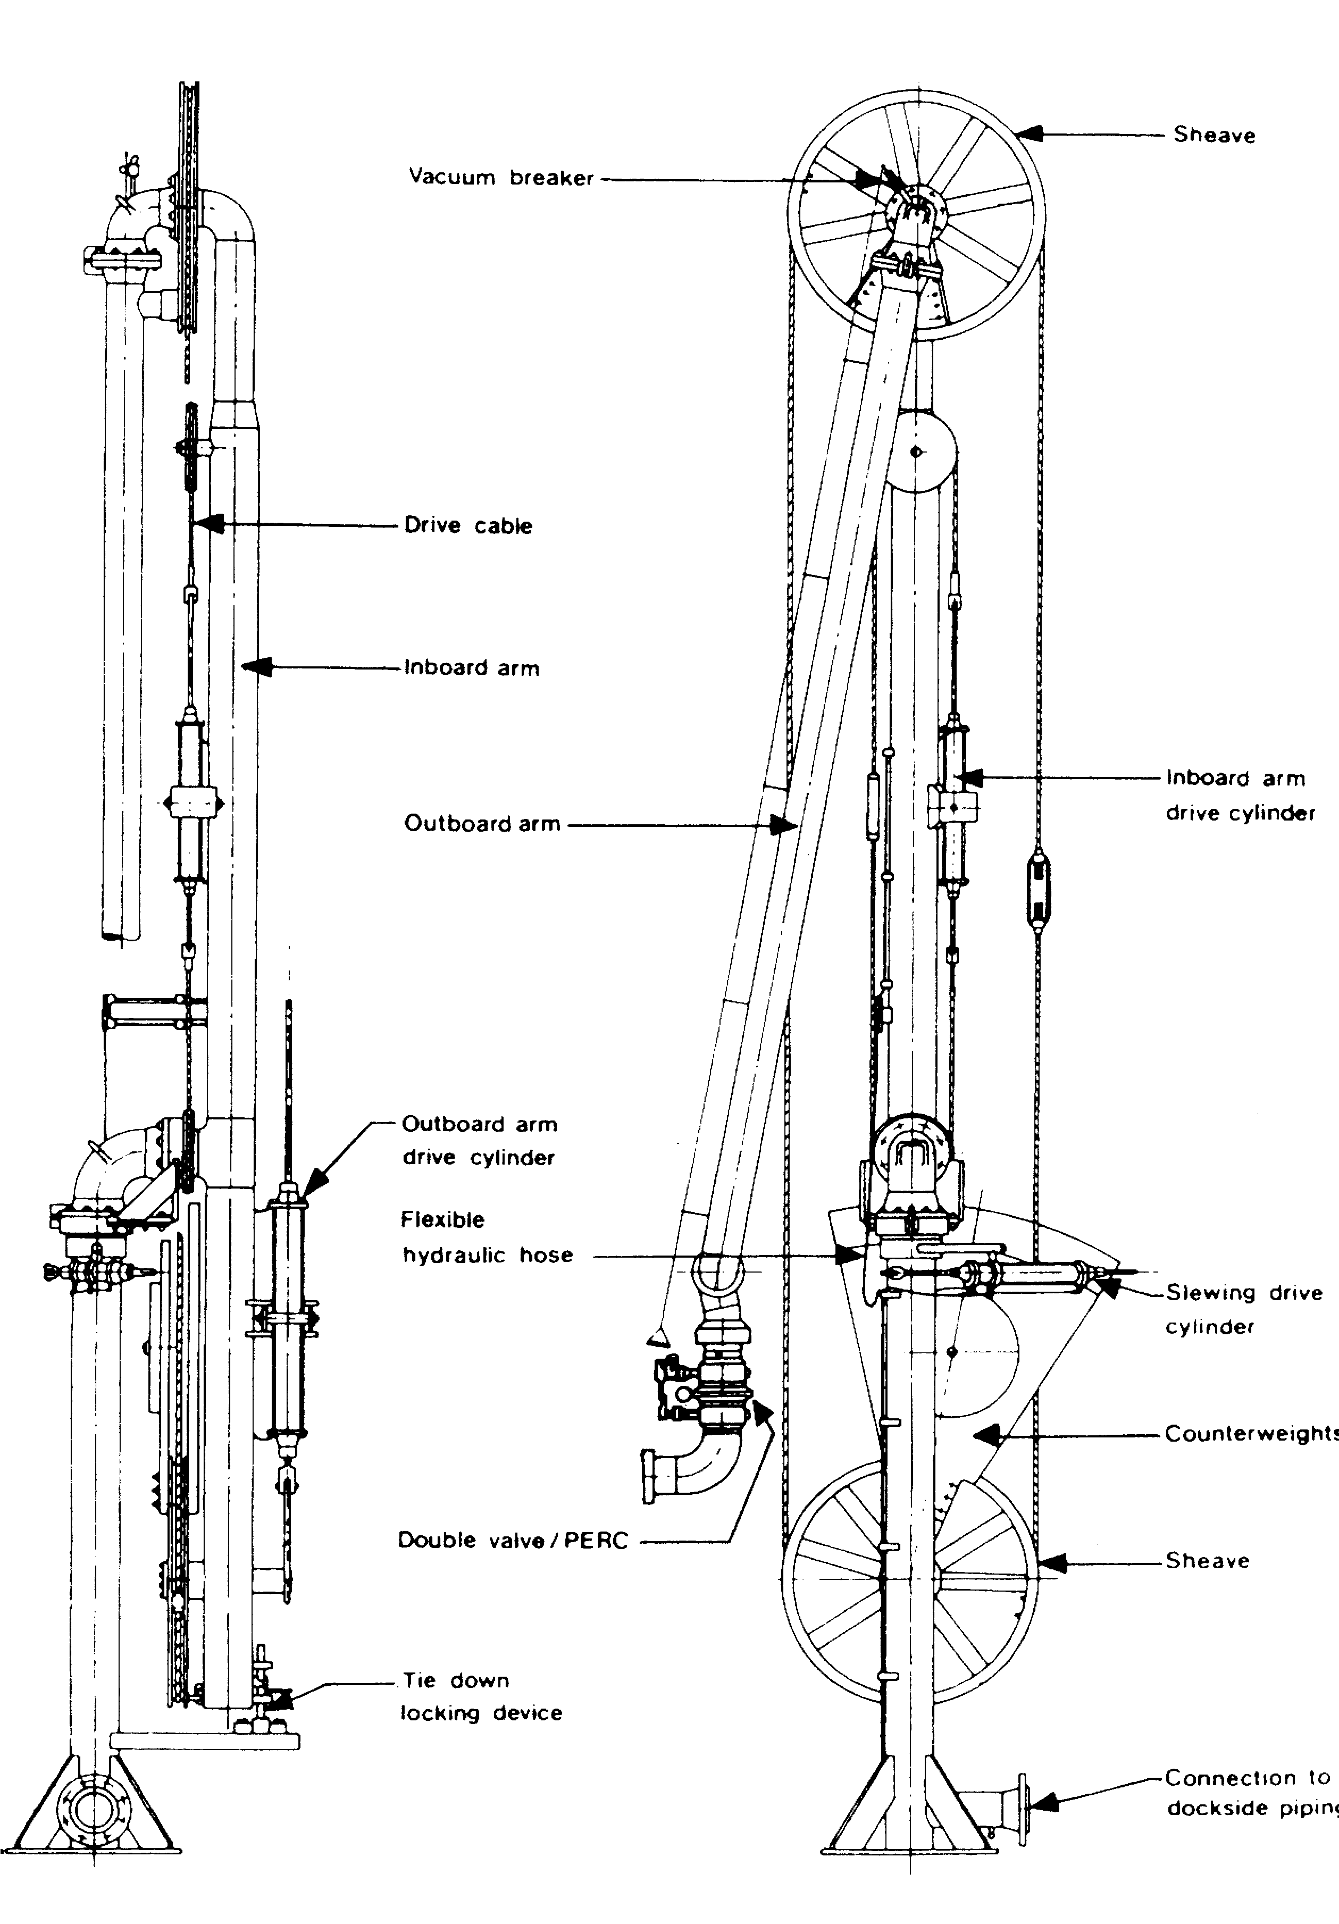
Figure 5.1 Typical gas carrier loading arm

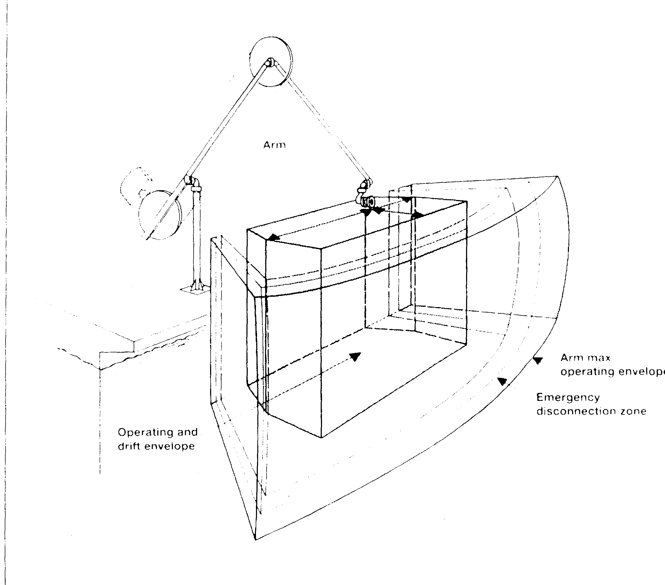

Figure 5.2 Loading arm operating envelope
Connecting systems between hard arms and ships are of two types:
- Bolted flanges — these are basic bolted flange connections.
- Quick connect/disconnect coupling (QCDC) — QCDCs are used to speed up the connection and disconnection operation. The coupling is under full manual control but most often has hydraulic operation of the clamping/unclamping jaws (see Figure 5.3). During cargo pumping, the ship/shore joint is maintained by a positive mechanical lock, independent of the hydraulic power supply. In certain applications, the QCDC can benefit the safety of personnel. Such areas can include offshore ports where ship movement is a problem.

Emergency release system
An important development in hard arm design has been the introduction of emergency disconnects arrangements for use in the event that the limits of the design operating envelope are approached or if some other emergency occurs. This special connection is fitted in addition to the normal means of connection (bolted flange or a QCDC as described above).

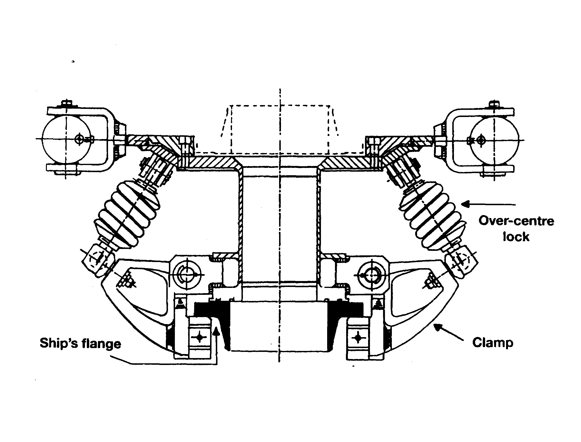

Figure 5.3 Quick connect/disconnect coupling
The emergency release system (ERS) forms a second stage emergency shutdown system in addition to the first stage emergency shutdown system described in 6.8. Its purpose is to provide a means to quickly uncouple the hard arms with minimal spillage in an emergency. The system incorporates instrumentation to monitor the ship’s position; it also includes alarm and control systems. The physical disconnection is achieved by means of a Powered Emergency Release Coupler (PERC) installed in each hard arm, as shown in Figure 5.1.
A typical PERC is illustrated in Figure 5.4 and consists of a clamped flange interposed between two ball or butterfly valves. Two hydraulic actuators are mounted on the upper part of the coupler: one for the clamp ring; the other operating both valves via special linkage. In emergency operation, the two valves close first: this is followed by the release of the clamped coupling. On release, the lower part of the PERC and its attendant valve remain attached to the ship’s manifold whilst the arm with the upper part of the PERC and its valve is free to rise clear of the ship. Mechanical and hydraulic interlocks prevent the coupling from releasing before the valves are closed. The space between the two valves is kept as small as possible to minimise liquid spillage.
The ERS acts in conjunction with the shore ESD system and firstly, will initiate shutdown of the transfer operation via the ship/shore link, before acting on the PERCs. The valves adjacent to the PERC close rapidly and this is typically achieved within five seconds. In the cargo-loading situation such rapid closure could give rise to excessive pressure surges. This must be catered for in some way and it is common to find shore-

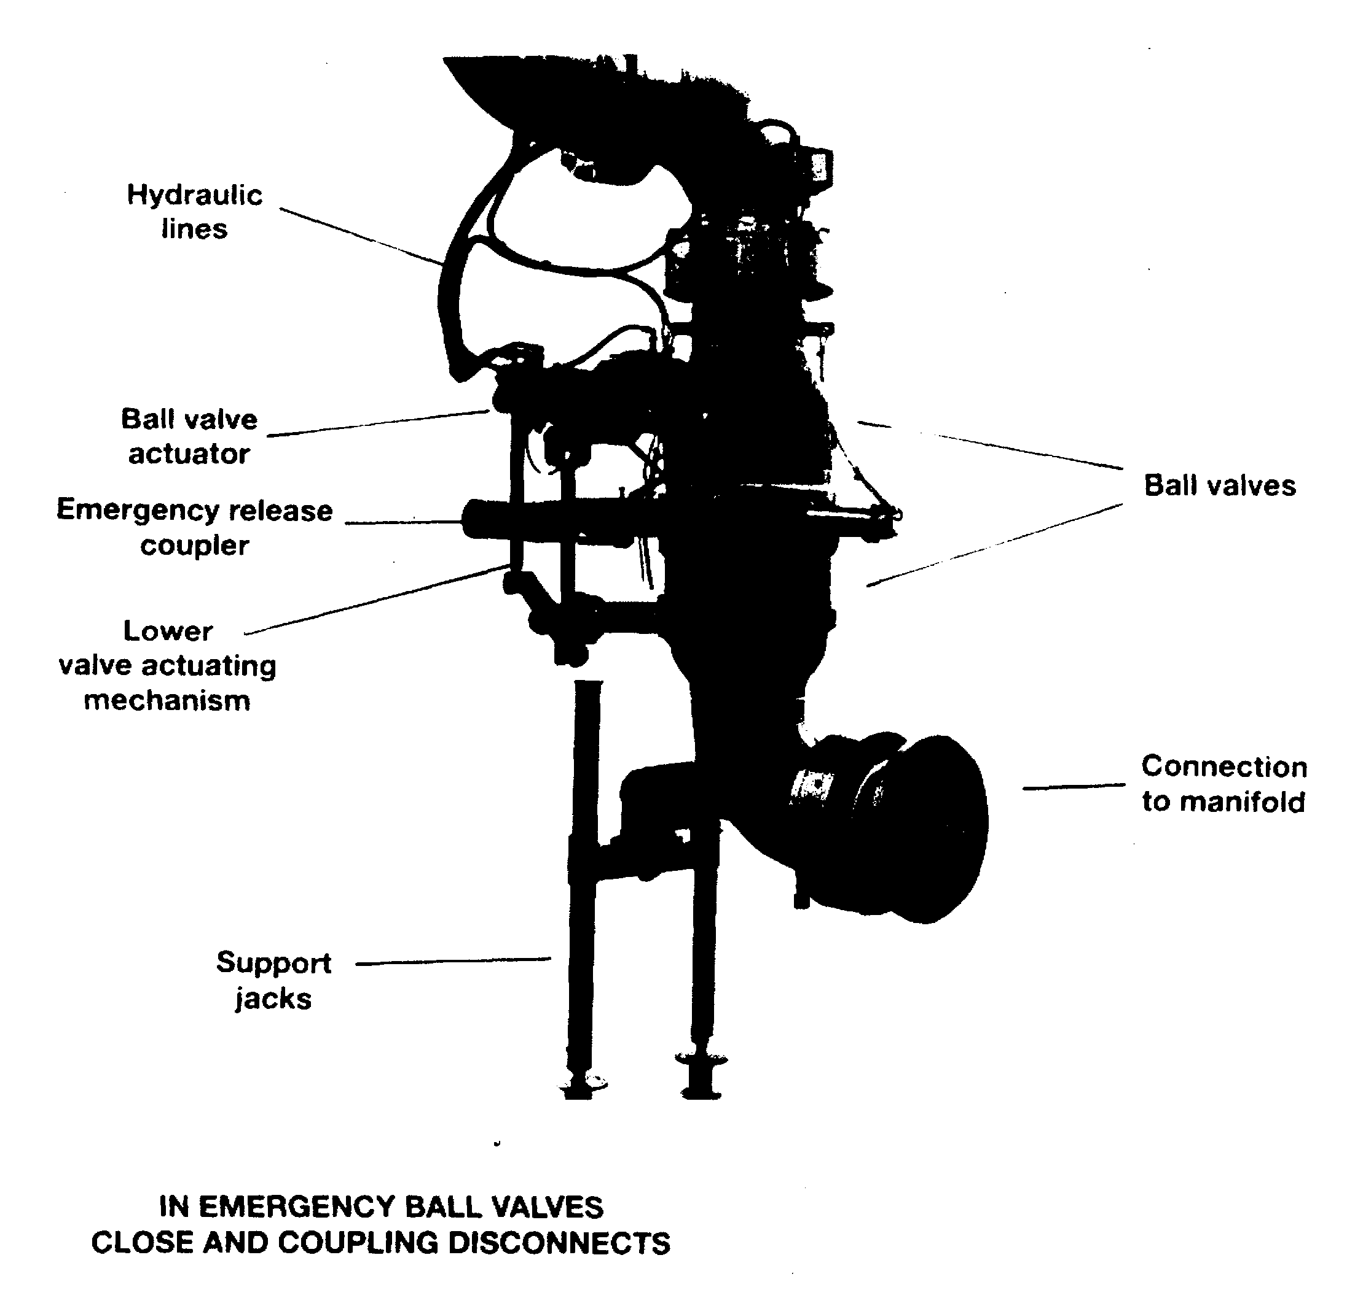

Figure 5.4 Powered emergency release coupling (PERC)
based surge control facilities fitted for this purpose. As an alternative, increased pipeline scantlings may be considered or special operating procedures may be followed. (For further information see also 10.5.2).

5.1.3 Vapour return
The provision of a vapour return facility between ship and shore at both loading and discharging terminals depends on a number of factors such as, economics, cargo transfer rates, distance of jetty from storage tanks, product pressures and cargo temperatures. In the LNG trade, vapour returns are always fitted. In the LPG trade they are becoming more common but are usually connected to the ship for safety reasons and might only be operated if high shipboard pressures become difficult to contain.
Where a vapour return facility is available, the vapours generated during loading may be transferred to the shore by a ship’s compressor or vapour blower. Alternatively, a terminal vapour blower or compressor may be used. In the latter case, loading rates are independent of the ship’s vapour return capacity, although they may be limited by the shore reliquefaction plant capacity.

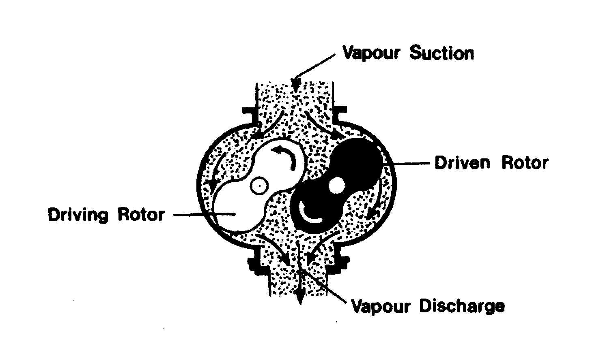
Figure 5.5 Roots blower typically used for vapour return Vapour is transferred from low-pressure suction to high-pressure discharge as rotor lobes rotate.
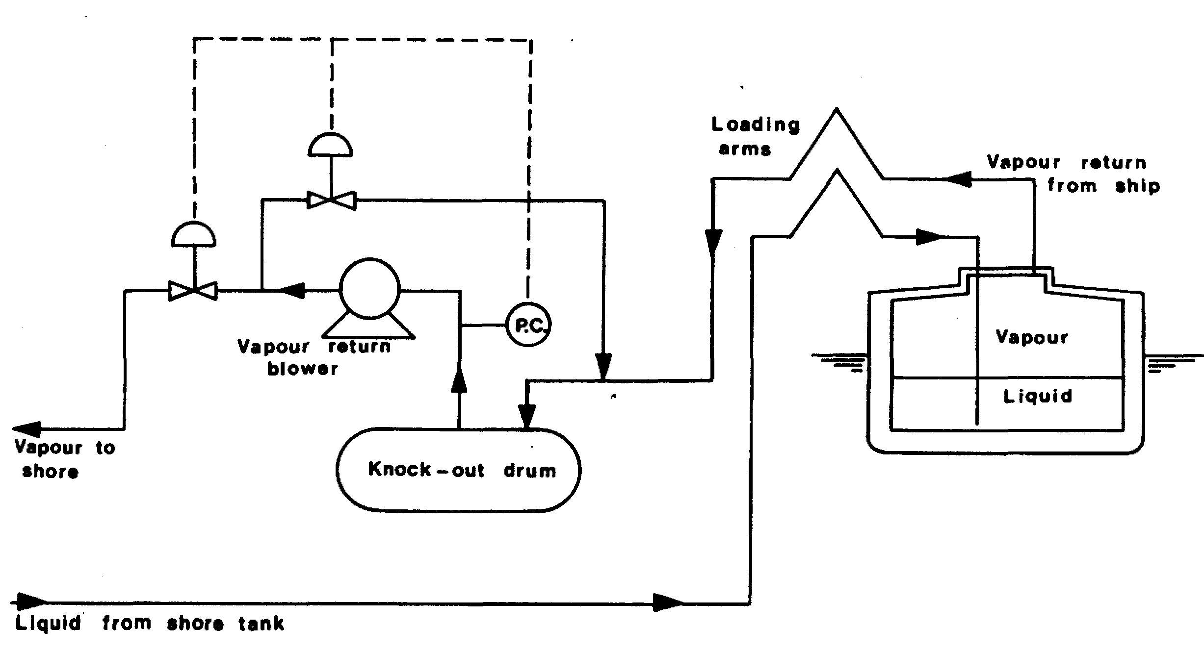

Figure 5.6 LPG loading terminal — vapour return using a shore based blower
A typical shore-based blower for removing LPG vapours from ships’ tanks and returning them to shore is shown in Figure 5.5. A pipeline drawing showing a typical terminal arrangement, with an in-line blower, is shown in Figure 5.6. Liquid is prevented from entering the blower by a knock-out drum. The knock-out drum is provided with a high-level switch. In order to protect against low pressures being created in the ship’s tank, a low suction pressure control is provided for in blower design. This opens a bypass valve between the discharge and the suction sides of the machine.
Certain loading terminals, although providing vapour return facilities, restrict their use due to the risk of receiving contaminated vapour ashore. At such terminals, vapour returns are usually fitted in case of unacceptable pressures developing in the ship’s tanks. Similarly, some loading terminals require that a vapour return line be connected for reasons of safety. Receiving terminals may also require vapour return facilities as an integral part of the cargo handling system. In such circumstances the ship will be so advised prior to cargo transfer.
5.1.4 Insulating flanges
Discussion in 2.22 centers on the need to prevent electrical flow through a hard arm or hose. Such currents can be generated by electrolytic differences between ship and shore. It describes the recommended practice of inserting an insulating flange in the lower end of the outer hard arm to achieve this aim.
Cargo hoses are normally insulated by a similar flange but this is usually fitted onshore close to the shore presentation flange. Its position in the pipework should ensure that no supports to the jetty deck exist between the insulation flange and the point of hose connection.
The external surfaces of insulating flanges should be kept clean and unpainted and its insulating properties should be regularly tested by a 500 volt insulation resistance tester (such as a megger) and recorded in terminal maintenance documents.
5.2 SHORE STORAGE
In the same way that gas cargoes are transported by sea through control of their pressure and temperature, liquefied gases are stored on shore in either a pressurised, semi-pressurised or refrigerated condition. The most common methods utilised for storing liquefied gases can be itemised as follows:
1. As a liquid at ambient temperature under pressure in:
- Spherical tanks above-ground
- Mounded horizontal cylindrical tanks
- Underground storage caverns
2. As a semi-pressurised liquid at a temperature above the product’s atmospheric boiling point
3. As a fully refrigerated liquid at atmospheric pressure and at low temperature equal to the cargo’s boiling point in:
- Single-wall tanks (LPG)
- Double-wall tanks (LNG. LPG, chemical gases)
- Double-containment tanks (LNG, LPG)
- In-ground tanks (LNG)
It should be noted that methods 1 and 2 above do not apply to LNG storage.
5.2.1 Pressurised storage at ambient temperature
Pressurised storage of liquefied gases is undertaken at refineries, chemical plants, import and export terminals, filling/bulk distribution centres, retail sales outlets and large industrial premises. Individually, pressure tanks are small compared to fully refrigerated gas storage tanks. For example, the largest spheres have a capacity of about 5,000 m³, but many distribution terminals have large numbers of cylindrical tanks or spheres to provide total capacities equivalent to the average-sized refrigerated terminal. In Spain, for example, there are several gas storage terminals in ports with total capacities in excess of 50,000 m³ in 30 or more pressure tanks.
Pressure vessels should be designed, fabricated, inspected and tested in accordance with a recognised pressure vessel code, such as British Standard BS 5500 (Specification for Unfired Fusion Welded Pressure Vessels) and the American Standard ASME Boiler and Pressure Vessel Code; Section VIII. The layout of a storage installation should be such that if product leaked, and if that leakage ignited, the effect on other parts of the complex or on people or property located outside the terminal is minimised.
The storage of quantities of liquefied gases is recognised by regulators as a hazardous industrial activity and has been subject to stricter controls in recent years. For example, the recent amendments to the European Union’s Seveso Directive, covering major hazard sites, calls for greater distances, not only between gas storage vessels within the plant but also between the industrial installation itself and adjacent public facilities, than has previously been the case.

Storage in above-ground spheres or cylinders
When considering pressure storage in above-ground tanks, the storage terminal layout requirements effectively mean that pressure storage vessels, pump bays and loading and discharge facilities must be at a sufficient distance from sources of ignition. Furthermore, they must be accessible for fire-fighting and be laid out in such a way that spillage from one tank or work area does not flow under any other tank or to any other important work area. In addition, each pressure vessel must be provided with at least one pressure relief system connected directly to the vapour space, a level gauge, pressure and temperature indicators and a maximum level device such as a high level alarm.
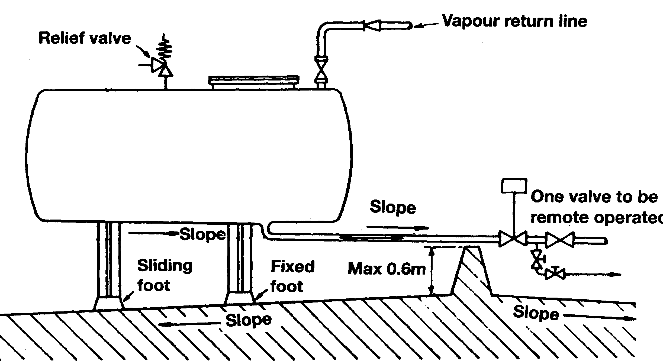

Figure 5.7 Fully pressurised storage in horizontal cylindrical tanks
If liquid should leak from a pressurised tank, vapour evolves due to rapid flashing. Therefore, maximum ventilation is essential to ensure dispersion; this is facilitated by laying out the ground under a tank in such a way that any leak drains to a catchments area where spill vaporisation can be more closely controlled. Retaining walls around a catchments area should not be more than 0.6 metres high and should not totally surround the area to allow for air circulation.
Figure 5.7 shows a typical horizontal, cylindrical pressure vessel tank and associated pipework.
Each gas storage vessel and each bulk loading or discharge facility must be provided with a fire protection system which will ensure the tank’s structural integrity under fire conditions. Fire protection may be achieved by the use of spacing, location, insulation or similar systems and by the use of cooling water. All above-ground pressure storage should be provided with fixed spray systems to ensure that all tank surfaces and product pipelines in the immediate vicinity exposed to thermal radiation are protected by a film of cooling water.

Storage in mounded horizontal cylinders
In recent years increasing concern about the safety of areas surrounding gas storage depots in case of a major containment failure has prompted greater interest in mounded horizontal cylindrical storage tanks. Some countries have even gone so far as to specify the use of mounded tanks in certain circumstances. In Germany, for example, planning approval is conditional on burying all pressurised gas storage tanks over 1,000 m³ in capacity under an earth cover while existing larger capacity above-ground pressure vessels will have to be replaced by mounded pressure tanks in time. In the early 1990s France announced that it was to prohibit the construction of LPG spheres greater than 500 m³ in capacity.
The first mounded gas storage tanks were installed in Germany in 1959 and today such units can not only be found throughout Europe but also on most continents. The largest mounded cylinders are 4.000 m³ in size but several countries utilise small mounded, semi-underground and fully buried tanks in the size range 10 to 100 m³ to support marketing operations such as automotive LPG retailing and networked LPG supply systems.
The earth covering mounded tanks protects them from fire engulfment and radiation from close-proximity fires-so that extensive water deluge systems are unnecessary and the BLEVE form of catastrophic tank failure is impossible. Furthermore, the amount of space required between mounded tanks is much less than that specified for above-ground tanks so that less land area is required. In practice, mounded vessels are usually installed in batches of up to six units with the spacing between individual tanks as little as 0.8 to 2.0 metres. Other groups of up to six tanks are then situated a safe distance away.
The question of appropriate landscaping can also be an important factor in terminal layout and design. For example, at a recent LPG storage development in Europe, immediately adjacent to an area designated as one of outstanding natural beauty, the company’s choice of mounded cylindrical tanks was heavily influenced by the need to ensure that no part of the facility could be seen above the tree-line.
Another advantage of mounded tanks relates to the sun impingement factor. Because direct sunlight does not fall upon such units, the design pressure of a tank for the storage of LPG can be set at about 12 barg, in contrast to a figure of 16 to 18 barg for an above-ground tank. Thus, the shell thickness of the mounded vessel does not have to be so great. The use of internal ring stiffeners along the length of the tank also helps avoid the need for uneconomically thick shells.
Most mounded tanks are placed on beds of sand, a type of foundation which provides uniform support over the length of the vessel. The number of connections and nozzles fitted to mounded tanks is kept to a minimum; experience has shown that the optimum arrangement is to have a top outlet only. in conjunction with a submersible pump.
One of the alleged drawbacks of earth-covered pressure tanks is the difficulty in providing adequate protection against corrosion although the service records of these units have shown that this is not a problem. After the finished tank is shot blasted, it is then primed prior to being wrapped with a heavy anti-corrosion coating. Polyester glass-flake coatings have proved to be suitable in this respect. A compatible cathodic protection system, usually of the impressed current type, completes the corrosion protection package.
Underground storage
Pressurised LPG may also be stored in underground caverns either leached from salt deposits or mined from rock formations.
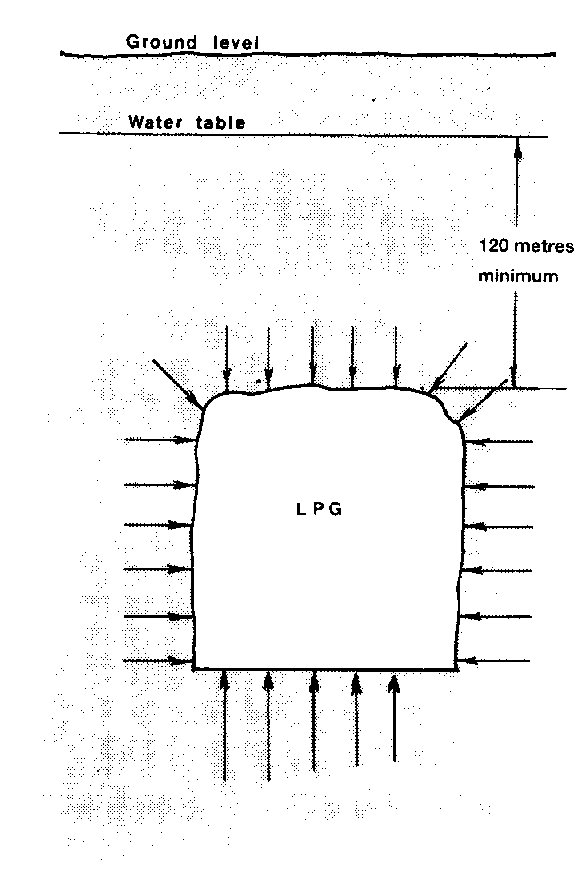

Figure 5.8 Rock cavern LPG storage
The principle of mined rock cavern storage is that the caverns are set at such a depth below ground level that the static head of the water-table is greater than the pressure of the stored product. There is, therefore, a pressure gradient towards the inside of the cavern and leakage of product to the rock strata is thereby avoided.
Ground water inflow is collected in a water pit on the cavern floor and then pumped to the surface. The LPG is discharged from the cavern by means of submerged pumps. Figure 5.8 shows a mined cavern suitable for LPG.
In the case of a cavern leached from salt deposits the product is stored above a brine solution. On filling, LPG is pumped into the upper part of the cavern and displaces the brine. After passing through a degassing process, the brine is stored in a pit. The LPG is normally retained in the cavern by brine pressure. For delivery to ship or pipeline, LPG may be discharged either by brine displacement or by means of submerged pumps. Figure 5.9 shows the basic layout of a salt cavern.
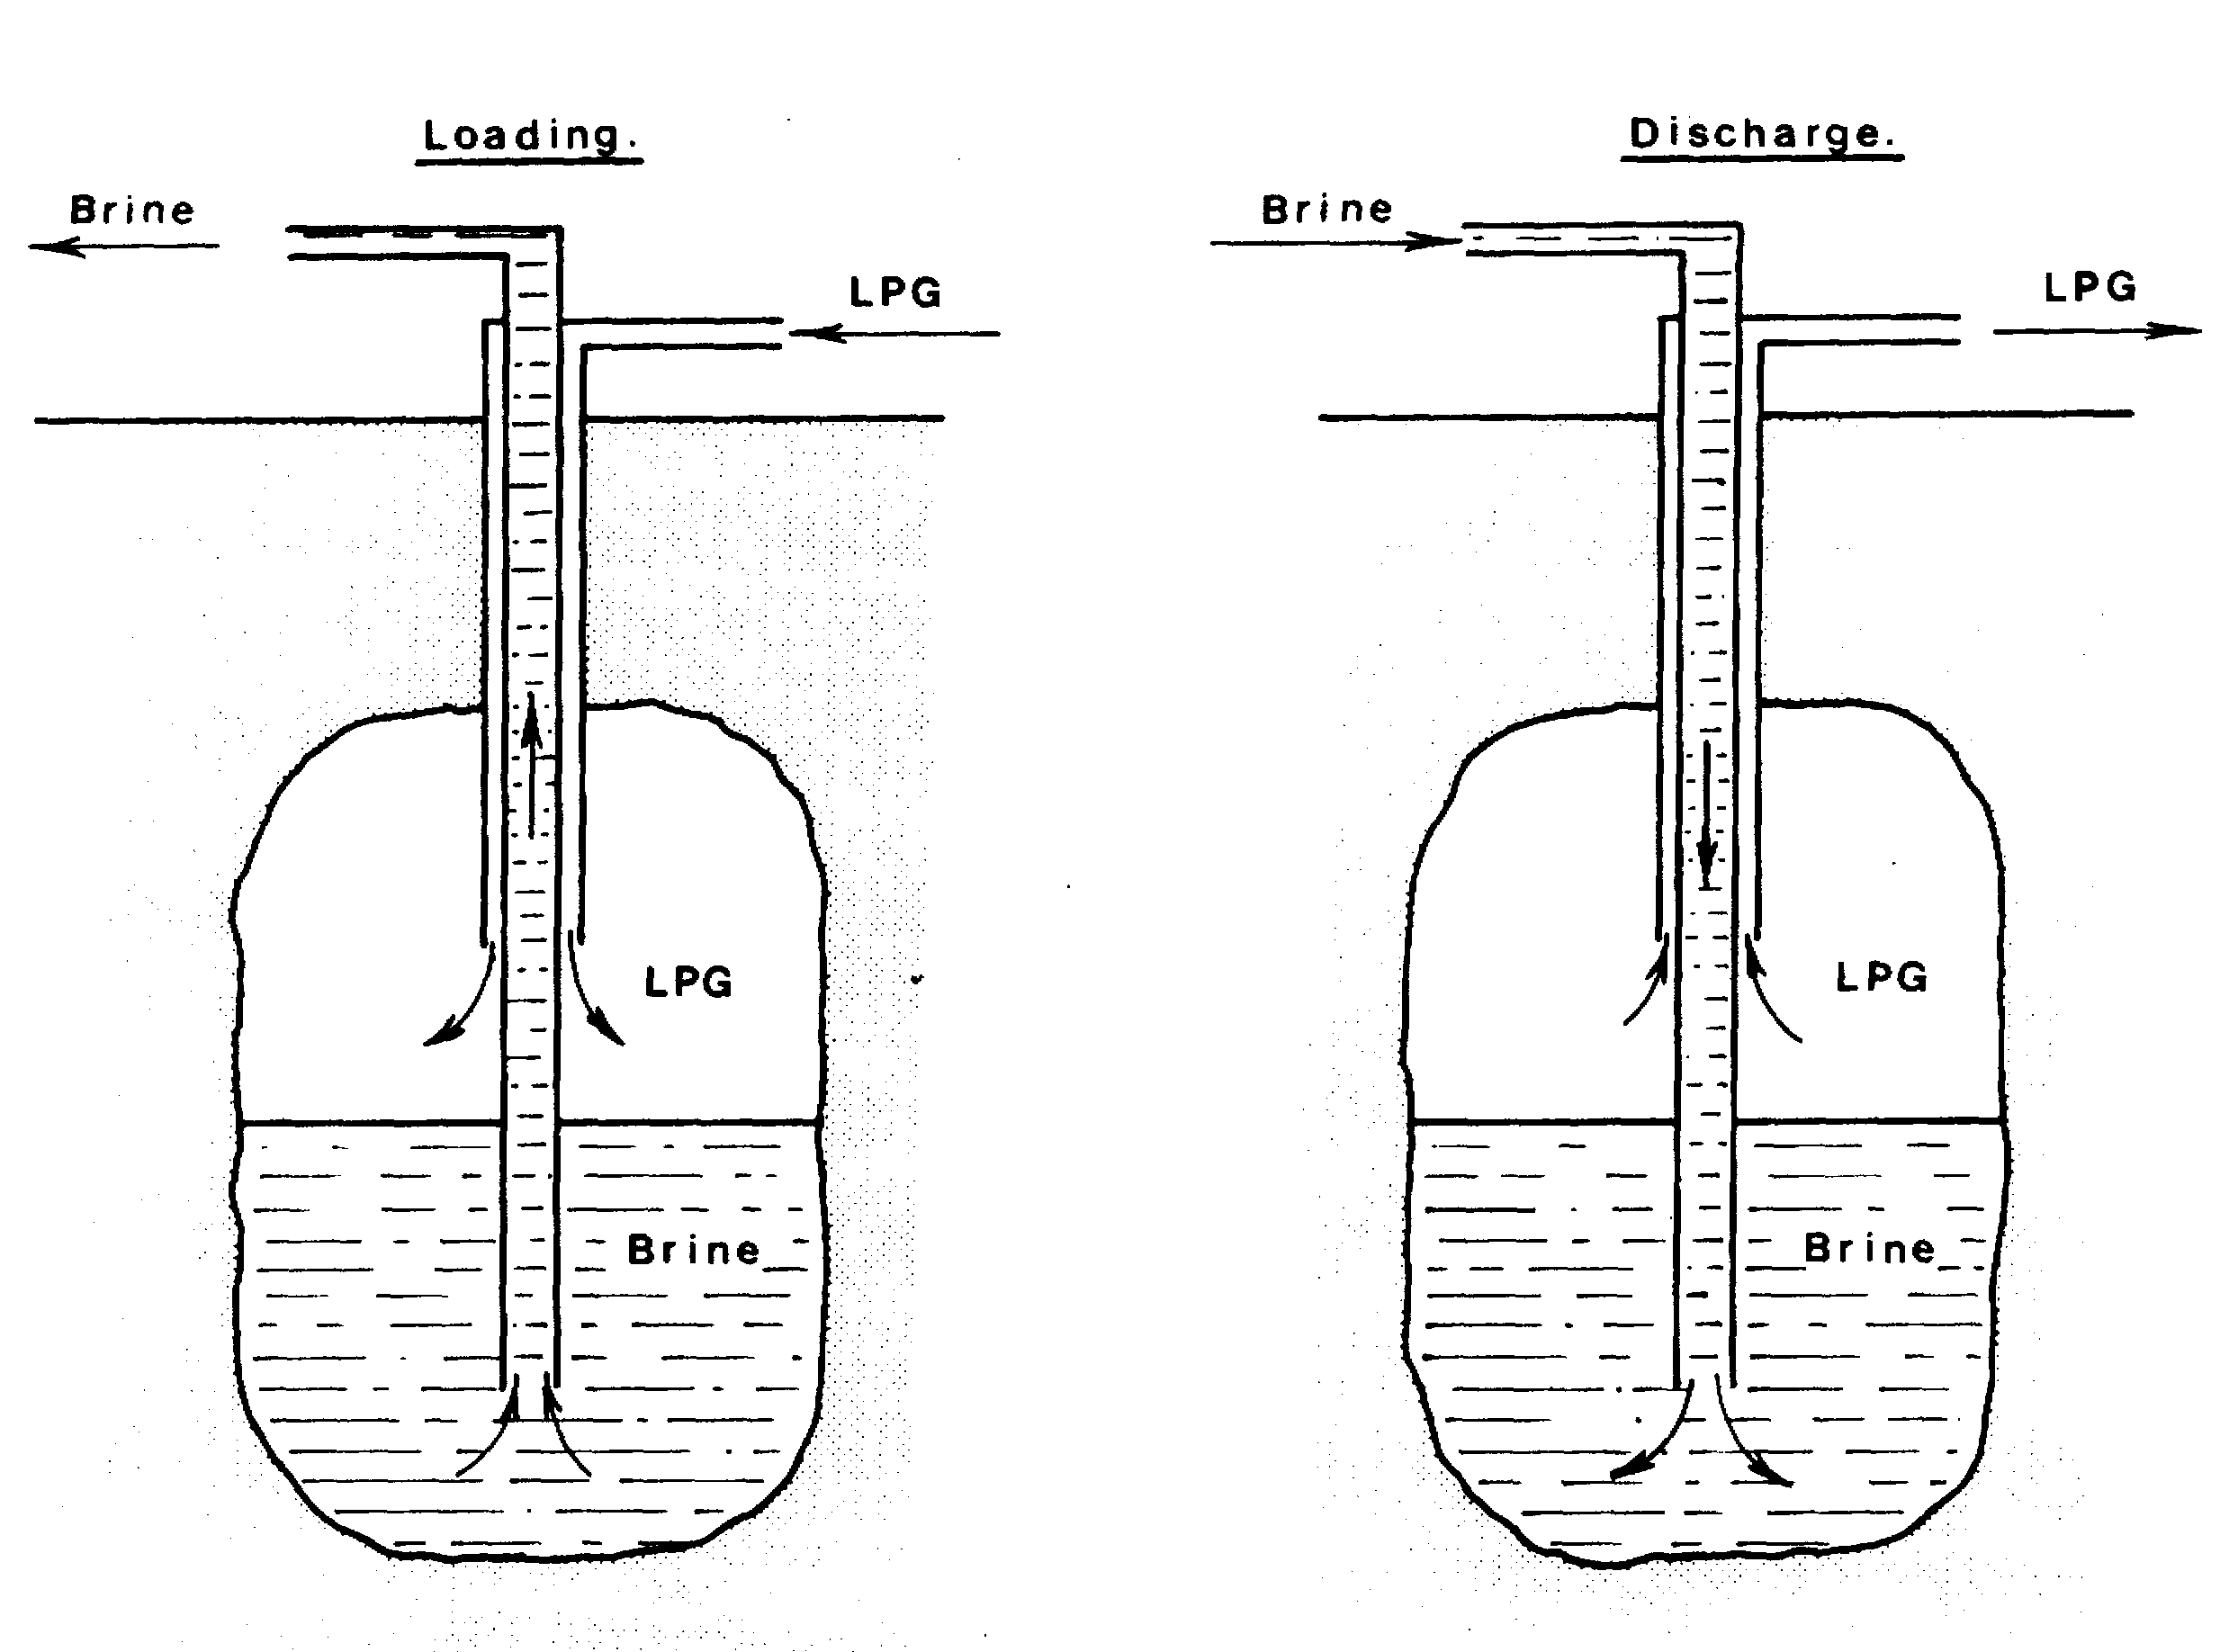

Figure 5.9 Salt cavern LPG storage
5.2.2 Storage in semi-pressurised spheres
Spheres for the semi-pressurised storage of liquefied gases can be fabricated on site. Each may provide up to 5,000 tonnes of storage capacity. Normally, this type of storage requires vapour pressure control by means of a reliquefaction plant (see Figure 5.10).

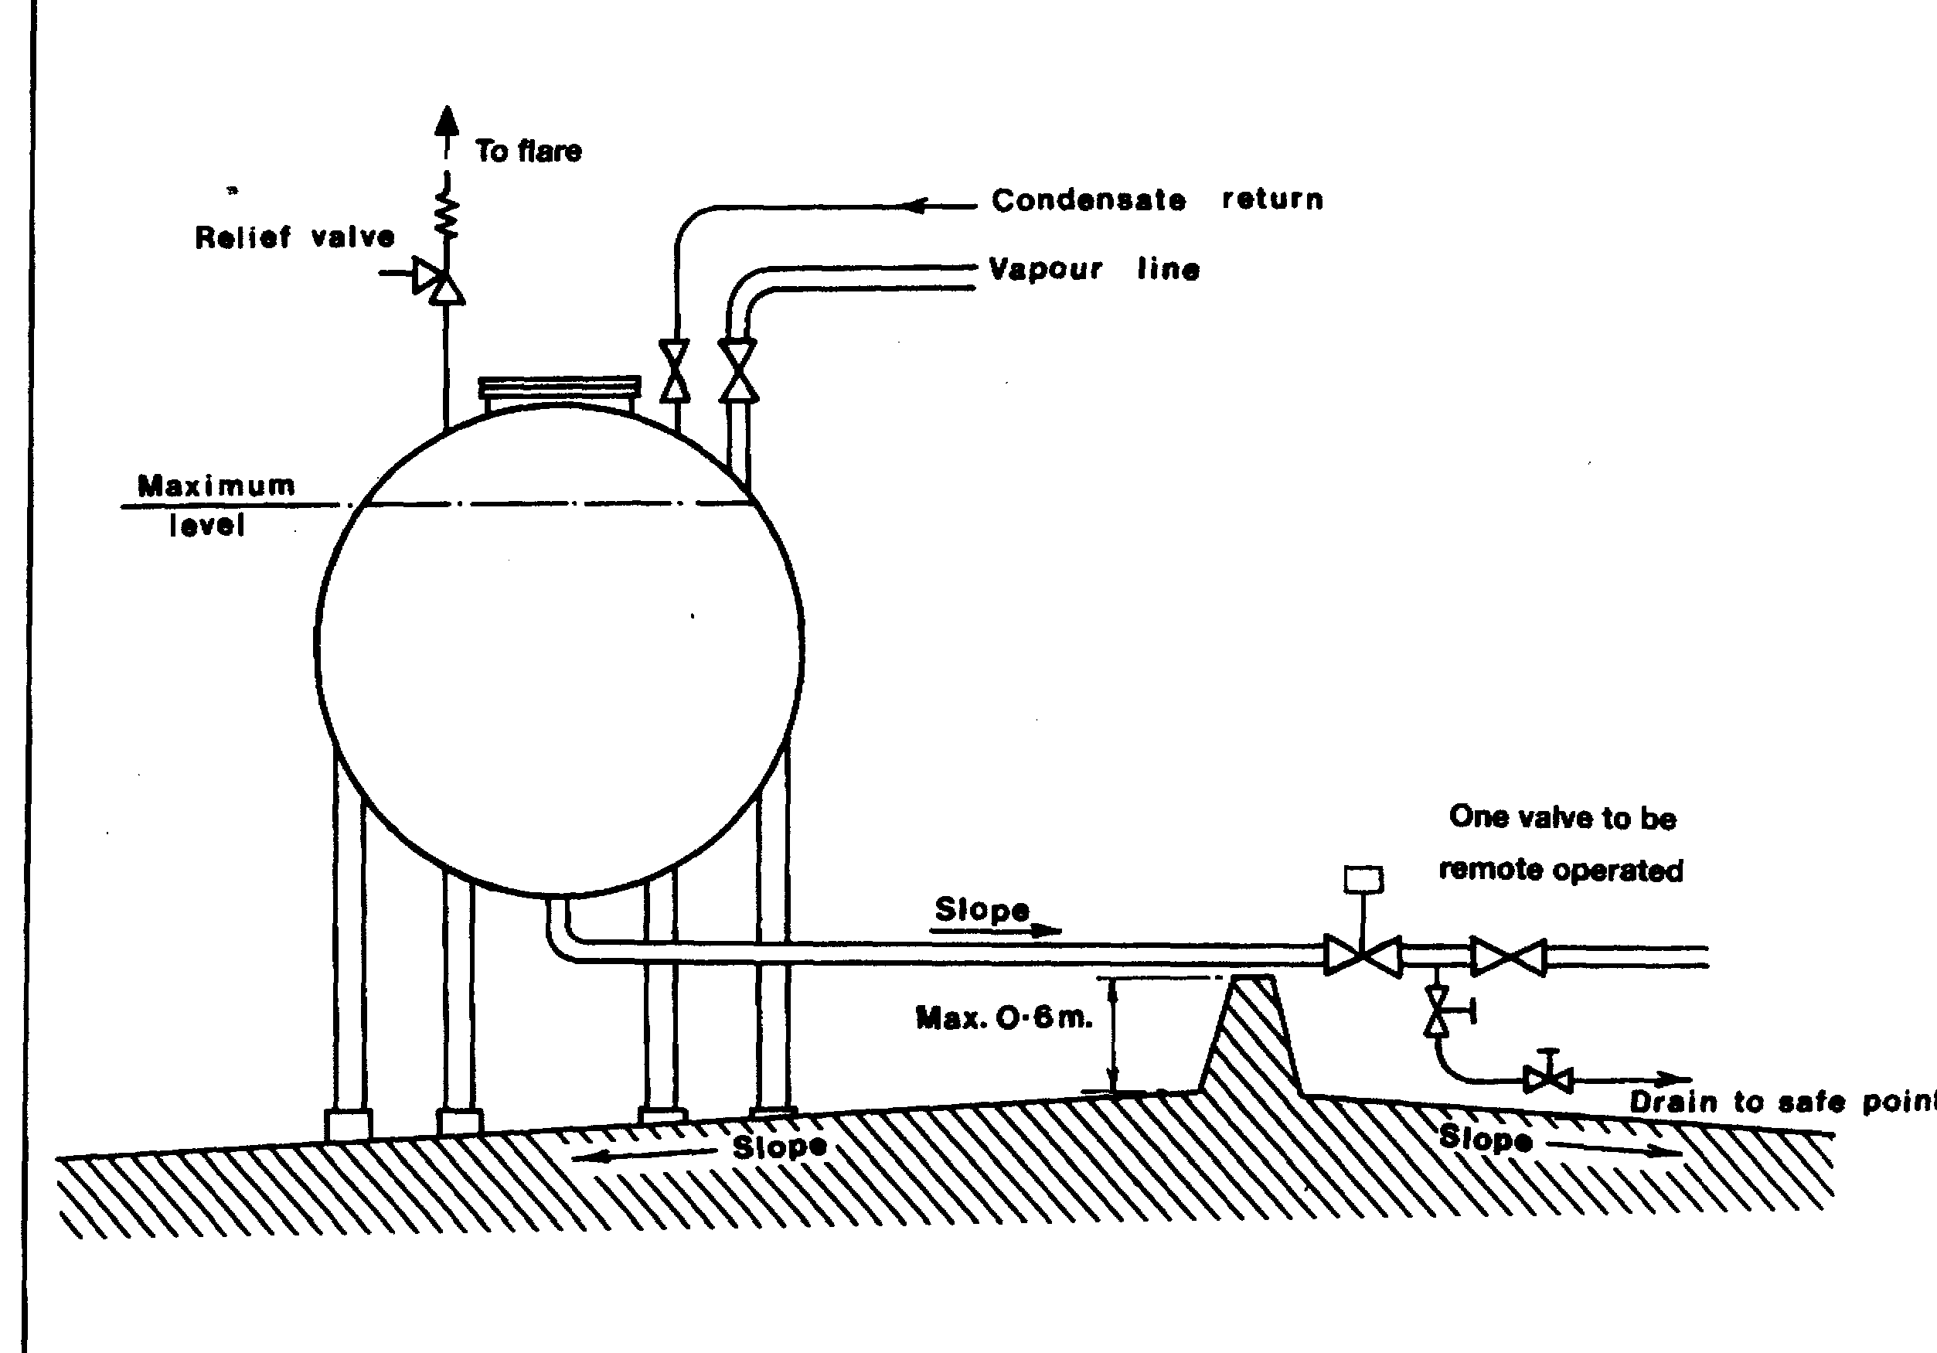

Figure 5.10 Semi-pressurised storage in spheres
5.2.3 Refrigerated storage at atmospheric pressure
Refrigerated storage is considered economical when storing liquefied gas in quantities of more than 5,000 tonnes.
Because cargo leaking from a refrigerated storage tank is already close to atmospheric pressure, it would boil rather than flash-off. Therefore, any liquid release which takes place requires heat inflow for evaporation. The source of heat is the ground on which the liquid has fallen. The larger the surface area the greater the heat inflow and hence the greater the vapour generation rate. The use of a walled bund area around a refrigerated tank, therefore, reduces the potential vapour cloud and prevents the spread of a spilled liquid.
The tanks commonly used to store gases in a fully refrigerated state are of the following types:

Single containment — single-wall tanks (for LPG)
Traditionally, refrigerated LPG has been stored in single-wall tanks. One such is shown in Figure 5.11. There are large numbers of this tank type throughout the world. Specific details of construction vary from tank to tank but the main features are those of a low-temperature steel shell surrounded by insulation. The insulation is held in place by an outer cladding which should be waterproof.
For some varieties of this tank type, additional insulation can be provided above the liquid level in the form of a suspended ceiling. Within the tank base, heating coils, or sometimes an air gap, are fitted to avoid freezing the ground and damaging the foundations by frost heave.

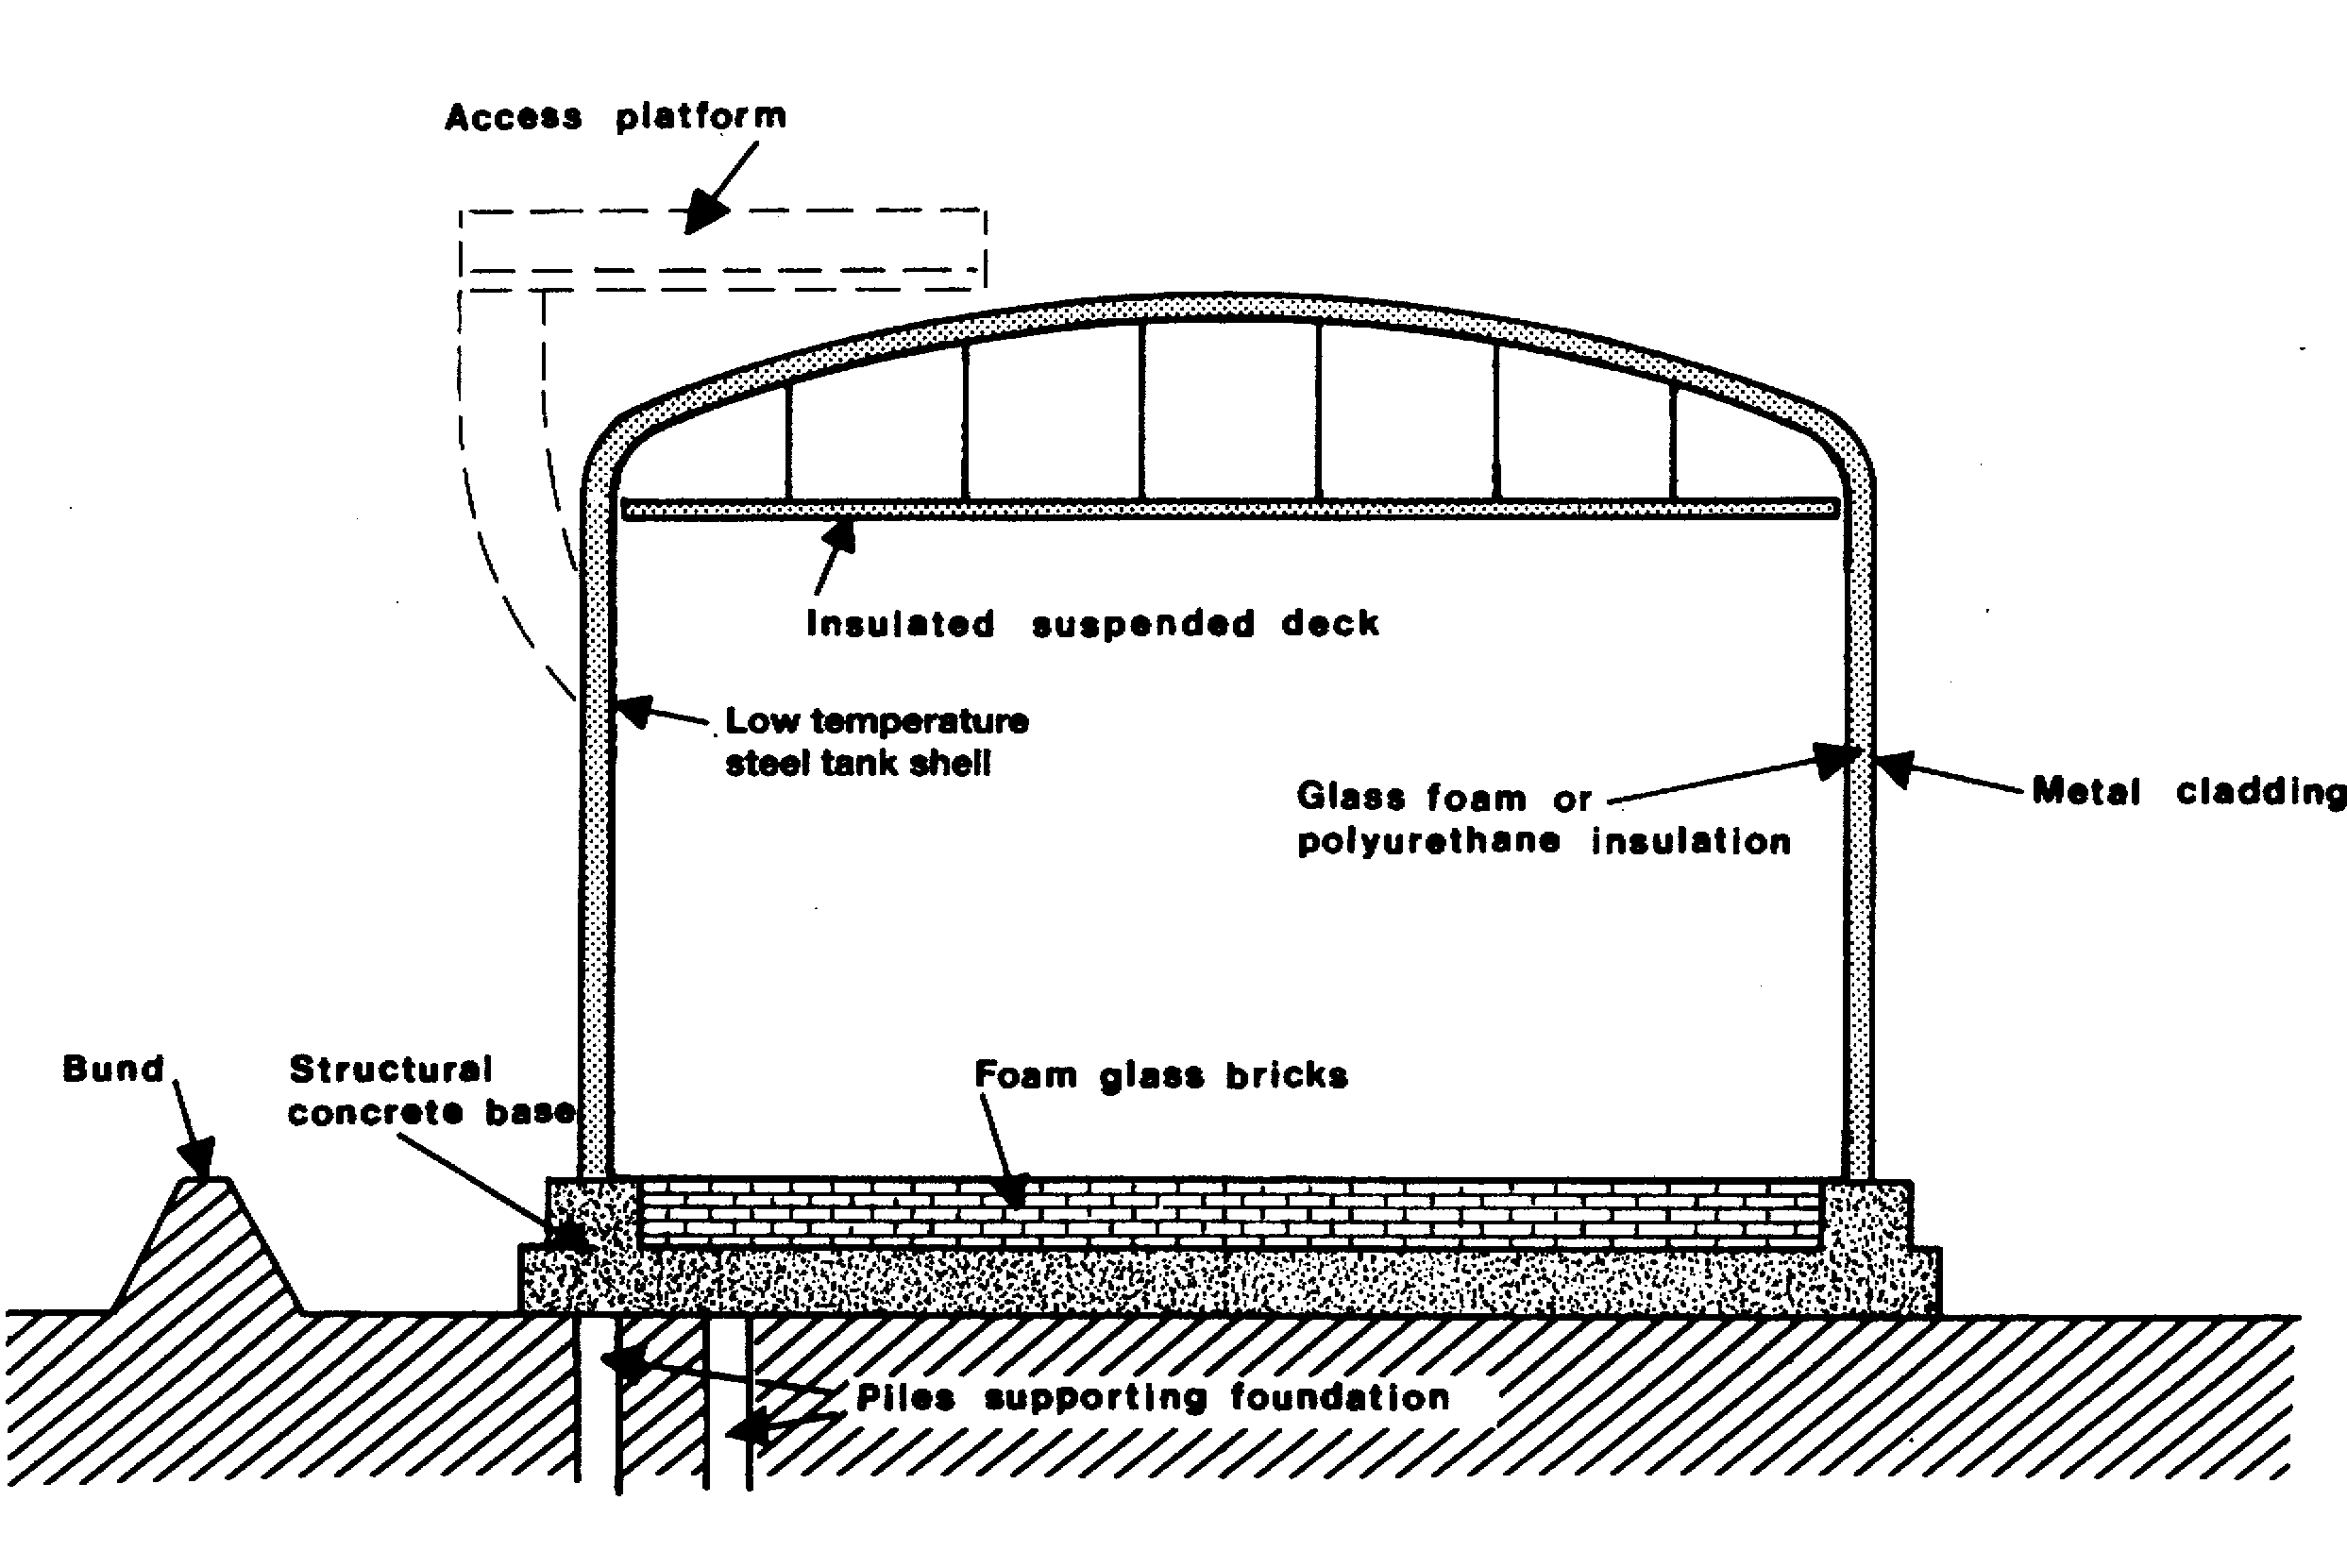

Figure 5.11 Typical single-wall tank — LPG storage
Tank filling is through a top entry spray ring; tank discharge is taken from the bottom via submerged pumps.
Any leakage of liquid from such tanks is contained in a bunded area around the tank. Tanks of this type will normally be designed to an appropriate code, which requires a bund to contain a spillage equal to the tank contents in the unlikely event of tank failure.
Such tanks are classified as a single containment storage system.

Single containment — double-wall tanks (for LPG and LNG)
Single containment tanks are most usually provided with an outer shell surrounding the primary tank. They are constructed so that only the primary containment is required to meet the low-temperature requirements for product storage.
The outer shell is primarily for the retention and protection of loosely filled insulation and to contain nitrogen purge-gas pressure. The outer shell is not designed to contain refrigerated liquid in the event of leakage from the primary container.
Figure 5.12 shows a typical double-wall tank for LNG. This example shows two complete tanks with an annular gap of about 0.5 metres in between. The annular space may be filled with granular insulation such as perlite (see Table 3.1) and a nitrogen breather system is provided to accommodate volume changes in the inter-space, resulting from atmospheric pressure changes and inner tank expansion or contraction. A suspended roof, inside the outer tank dome, fits inside the inner tank. Here, the insulating space is filled with cargo vapour flowing freely from the main vapour space.

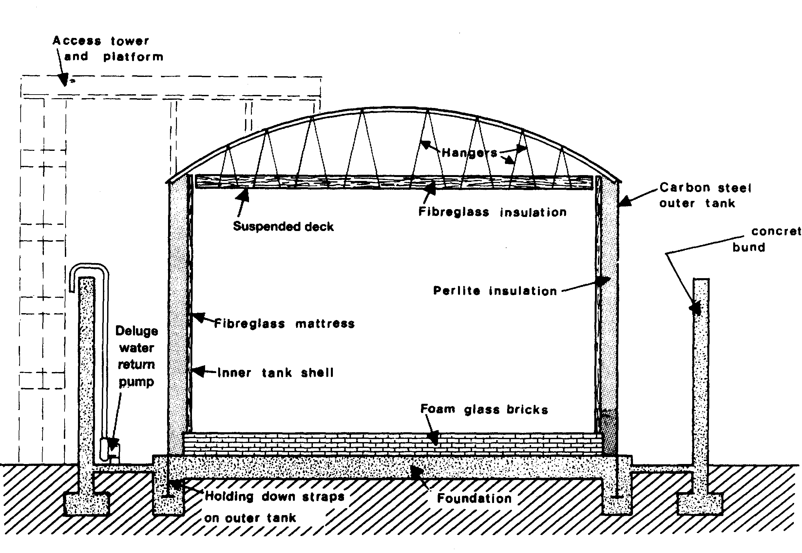

Figure 5.12 LNG tank — concrete bund
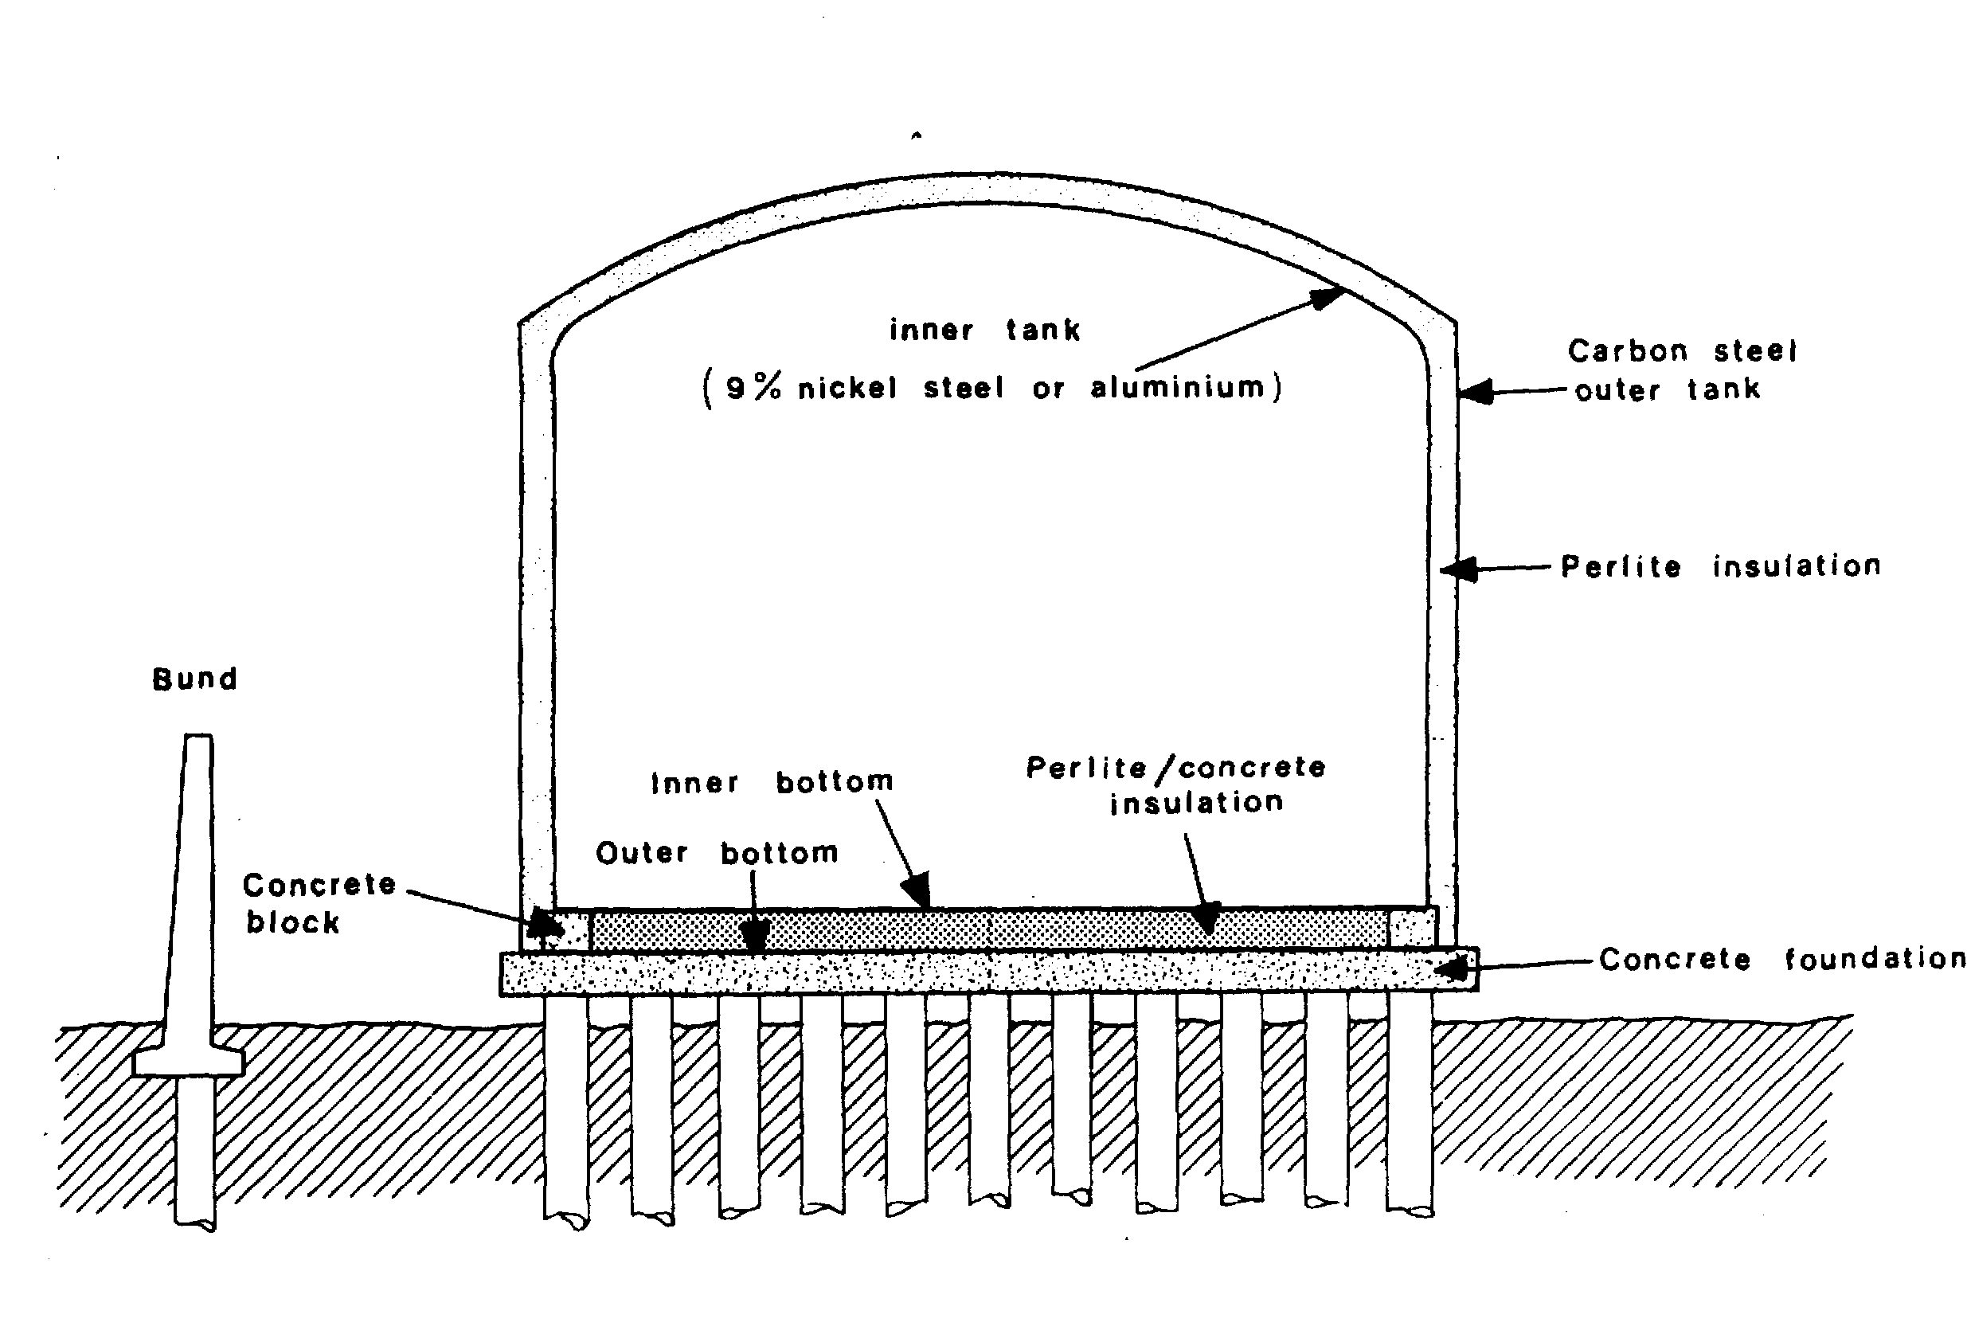

Figure 5.13 LNG tank — double-wall

Such a tank is also classified as a single containment storage system. More recent versions of this design are provided with a full-height concrete bund wall. This is constructed close to the tank, usually within one or two metres from the outer shell.
Figure 5.13 shows another typical double-wall tank. In this case an elevated foundation, to eliminate frost heave problems, is used. Furthermore, there is a complete dome cover on the inner tank to enable inner tank leakage to be detected in the nitrogen gas in the insulation space.
The bund wall contains any liquid leakage. Also, its position minimises boil-off rate from any leakage by preventing liquid from spreading over a large area of warm ground. Another advantage is that any leaked vapour within the bunded area is released at a high level, which assists with dispersion of the gas cloud.

Double containment storage tank (for LPG and LNG)
Double containment storage tanks are a development of the single-wall tank. They provide increased safety margins against tank leakage by introducing an extra inner tank.
Figure 5.14 illustrates this design. Here the liquid is contained in an inner shell, which is surrounded by an outer shell, also of low-temperature steel.
The outer shell acts in the same way as a bund and contains any liquid leakage from the inner shell — but in this case it also avoids vapour release to atmosphere.
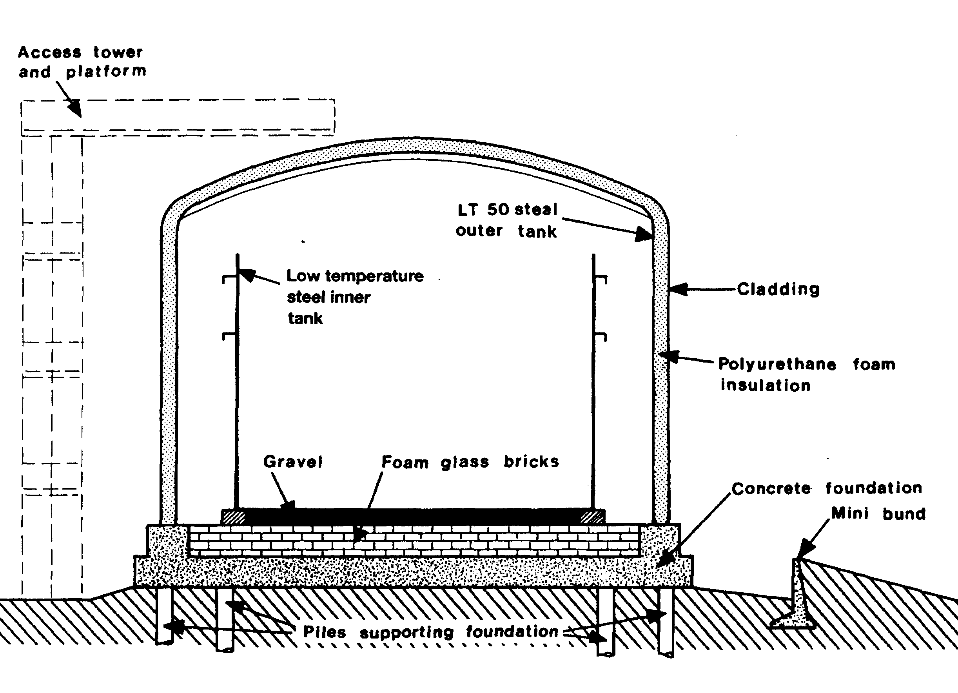

Figure 5.14 Double containment steel tank for LPG

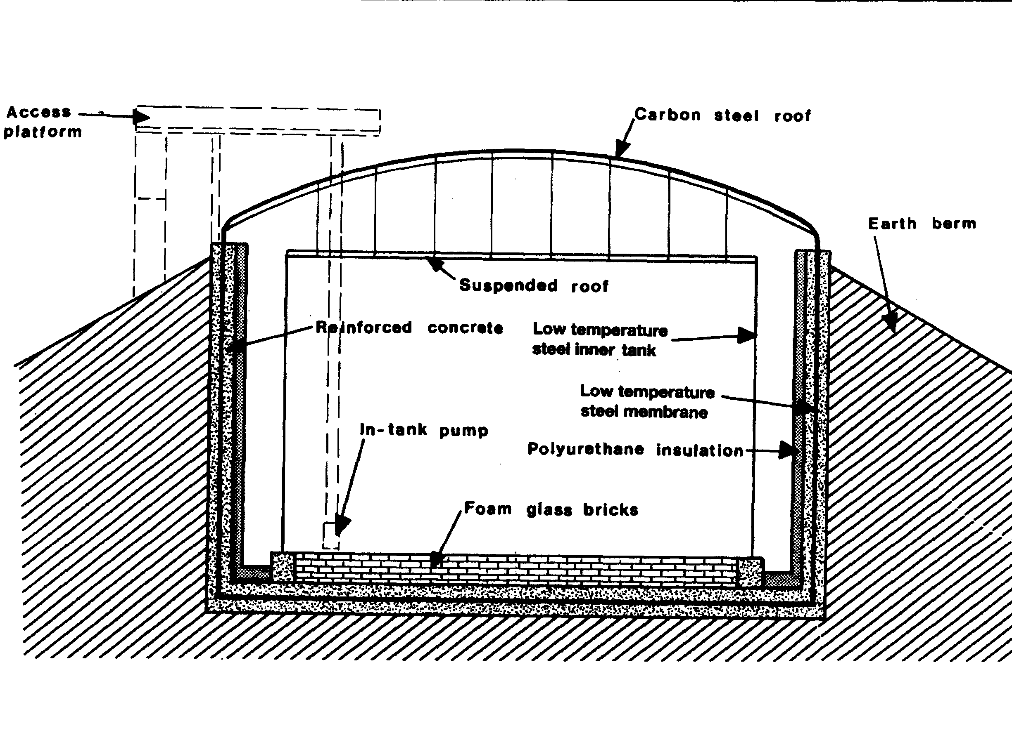

Figure 5.15 LPG tank — earth berm
The mini-bund, as shown in the figure, is provided to contain minor leaks from pipelines, valves and flanges.
A further variation of double containment is shown in Figure 5.15. Here the inner tank is surrounded by a low-temperature steel membrane tank supported by a reinforced concrete wall. This, in turn, is backed with an earth berm to provide further assurance against both internal and external loads. This tank has a steel roof in preference to concrete. These concepts may also be applied to LNG storage tanks.

In-ground storage tanks for LNG
In-ground tanks are a popular option for storing LNG, which provide: —
- High-integrity storage with virtually no risk of spillage
- High seismic protection against earthquakes, and
- Minimal visual impact on the environment
The main features of one such in-ground LNG storage tank are illustrated in Figure 5.16. Primary containment is by a stainless steel membrane, supported (as in ships’ membrane-type tanks) by rigid polyurethane foam insulation. This, in turn, is supported within a reinforced concrete caisson. The roof is a dome-shaped carbon steel structure supporting a suspended deck with glass wool insulation (see Reference 2.27).

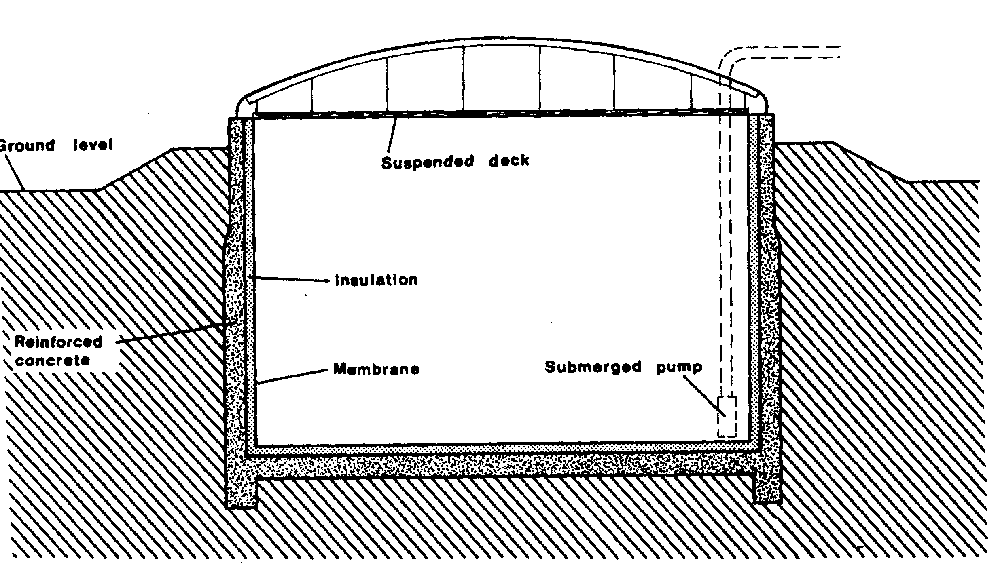

Figure 5.16 In-ground tank for LMG
5.2.4 Construction materials and design
The material of construction for refrigerated tanks depends on the storage temperature. Carbon steels, or in some cases nickel alloy steels, are utilised for LPG tanks but, for lower temperatures, alternative materials such as nine per cent nickel steel, austenitic stainless steel, Invar or aluminium alloy must be used.
The foundations for all refrigerated tanks, particularly for LNG, require specialised design. This should allow for thermal movements of the tank, anchorage against uplift, insulation of the base and foundation settlement. A further need is to prevent ground freezing and frost heave conditions that may lift and damage the tank. This may be achieved by the provision of an air space under the tank, as in Fig. 5.13. or by the installation of a heating and temperature monitoring system in the foundation and also in the vertical wall of in-ground tanks and tanks with an earth berm.
In all cases, therefore, the involvement of foundation specialists is essential to establish the safe bearing pressures, to design heating systems, to predict anticipated settlements and to oversee soil investigations, including laboratory tests of the foundation material.
With increasing concern for safety and the widespread use of double containment tanks for liquefied gas storage, the use of reinforced or prestressed concrete has grown. Such material is frequently used in the construction of the outer skin of double-wall tanks. In one recently constructed LNG tank, both the inner and outer walls are of prestressed concrete.
Where refrigerated tanks are insulated externally, sealing of the insulation is necessary to prevent moisture ingress (such as rain) and subsequent freezing. A lack of maintenance, in this respect, has been known to result in insulation collapse.
5.3 ANCILLARY EQUIPMENT
5.3.1 Pressure relief venting
Liquefied gas tanks must be fitted with pressure relief valves. In certain designs, for example in the case of refrigerated tanks, vacuum breakers are also fitted. These protect the tank against pressure excursions due to process malfunction or fire conditions. Both conventional spring-loaded and pilot-operated pressure relief valves are used, as described in Chapter Four. Relief can take place either to atmosphere or to a flare. This will depend on storage quantities, site layout and products handled. Flame arresters in vent lines are a potential cause of blockage (with consequent tank failure) and, accordingly, they must be regularly inspected and maintained.
Tankage is usually provided with a water deluge system to give additional protection in the event of fire. Alternatively, thick tumescent coatings, which char in fire conditions giving substantial heat absorption and insulation, are being increasingly used.
5.3.2 Pipelines and valves
Pipelines and valves used in liquefied gas service are designed, installed and maintained in accordance with the appropriate standards and codes of practice. This means, for example, provision for positive isolation at inlet and outlet of all storage vessels, adequate allowance for thermal expansion and contraction in pipelines and pressure relief for liquid trapped between isolation valves. Sample points are normally provided with double shut-off valves. It is customary to open the primary isolation valve fully and throttle on the second valve. In this way any blockage due to hydrate formation will occur at the second valve, leaving the primary valve free to isolate again while the blockage is cleared. This is of particular importance for drainage connections of pressure vessels.

Description of shore pipeline engineering standards
Pipeline design and engineering in terminals is most often covered by standards developed jointly by the American Standards for Testing and Materials (ASTM) and the American Society of Mechanical Engineers (ASME). Another similar organization is the American National Standards Institute (ANSI). Of course, national codes are also consulted. According to the American standards, depending on the product being handled, differing design factors prevail. In this regard petroleum’s have been divided into four classes: A, B, C, and D, respectively. LPG and ammonia, for example, fall into Class D which is the category carrying the highest risk.
Pipelines, which run outside terminal compounds, are normally designed in accordance with ASTM/ASME standards B31.4 and B31.8. In the area of the ship/shore interface these standards may only need to be addressed by terminals when considering pipework to- jetties and on the jetty itself. These standards consider population densities and provide guidance for extra precautions as pipelines traverse areas of differing population levels. Also considered in the standards are practical difficulties such as the design requirements at road crossings.
External damage is a major cause of pipeline failures and specific precautions against this should be addressed. In particular, pipelines on jetties should be suitably protected against damage by vehicles.
Most pipelines within terminals are designed and engineered to the ANSI/ASME B31.3. In addition to the general engineering aspects, as covered in B31.3, design limits such as temperature and pressure for a particular pipeline are specified in ANSI B16.5. The standards also address maximum working conditions and provide design characteristics for pipes, flanges, fittings, reducers, gaskets and bolting. It is this latter standard, which identifies flange pressure/temperature ratings such as Class 150, and Class 300 either of which may be found in terminals depending on the working pressure of the system.

Surge pressures
When a terminal is being designed, the proposed pipeline system for liquefied gases should be subject to hydraulic analysis. At this time the question of surge pressure
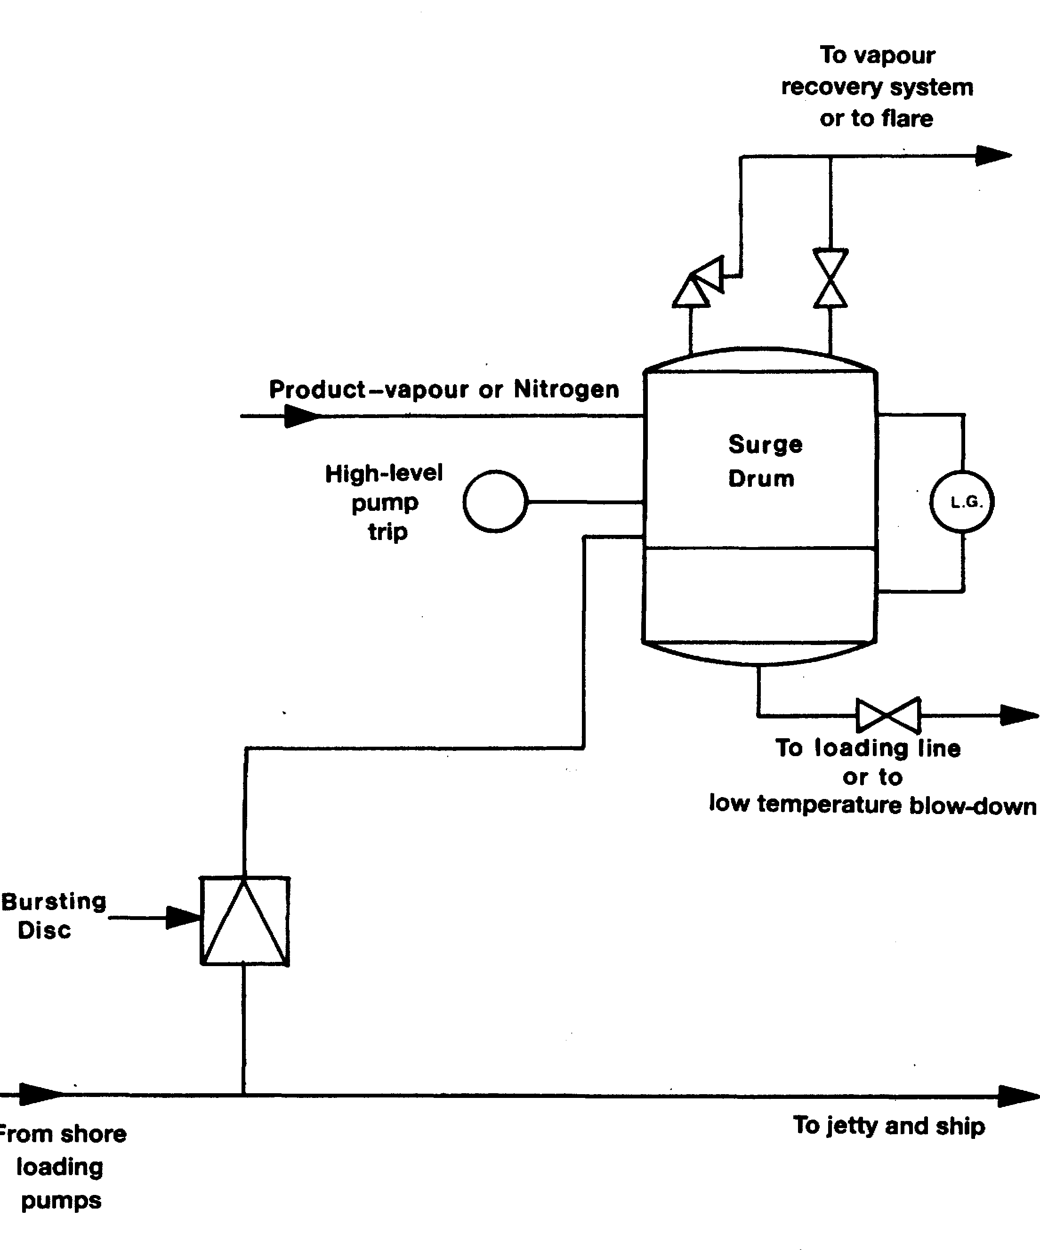

Figure 5.17 Bursting disc for surge pressure relief
ought to be covered by the establishment of the MAIP (Maximum Allowable Incidental Pressure). Pressure surges in pipelines are created by changes in the momentum of the moving stream. An example of an event causing a surge is sudden valve closure.
Surge pressures are particularly critical for pipelines transporting liquids. This is because of the density of liquid, and its low compressibility as compared to vapour. Pressure surges are additional to the maximum working pressure. They can be very high. They travel at the speed of sound in the liquid and reverberate from one end of the closed section to the other.
On this subject, it is worthy of note that surge pressures can be more severe when pumping liquefied gas cargoes as compared to other products. This is because gas cargoes are only ever in association with their own gas. Products such as oil cargoes may mix with air or inert gas and, even in very small admixed quantities, this effect can produce significant buffering.
To cater for surge pressures, the standard used should allow for a maximum short-term over-pressure. This short-term limited pressure rating is to cover anticipated surges and other variations.
Methods of limiting high surge pressures include adjusting valve closing times and special fast-response pressure relief systems. In addition, mountings for pipelines on the jetty should be properly engineered to protect the jetty structure from shock loads. For further reading on this subject Reference 2.25 is recommended.
The danger of surge pressure generation may be greatly minimised by providing surge pressure relief of the loading pump and loading line. There are various means of achieving this relief. One such is by means of a kick-back pipeline to a storage tank at the pump discharge; another system is that outlined in Figure 5.17. Here, surge protection is provided by bursting discs. Liquid released is collected in a surge drum, which is held under a nitrogen or a product vapour blanket. Liquid collected is normally returned to the loading line or drained to blow-down and vapours are normally vented to the vapour recovery system or to a flare (see also 4.1.3, 4.9.2, 6.6.4 and 10.5).
5.3.3 Pumps, compressors and heat exchangers
Within terminals, centrifugal pumps are normally used for pumping operations when loading ships. These pumps may be inside or outside of the tank and are usually of the following types: —
- Deepwell pumps
- Vertical in-line pumps
- Horizontal foot-mounted pumps, or
- Submerged pumps within the tank
The type of pump used depends on the installation and type of storage.
Product flow can normally be controlled by a flow control valve. Where refrigerated tanks are situated at some distance from the jetty, it is normal to provide a re-circulation facility for maintaining the product pipeline at a low temperature between cargo transfers. This minimises vapour generation in the ship or shore tank during early stages of cargo transfer.
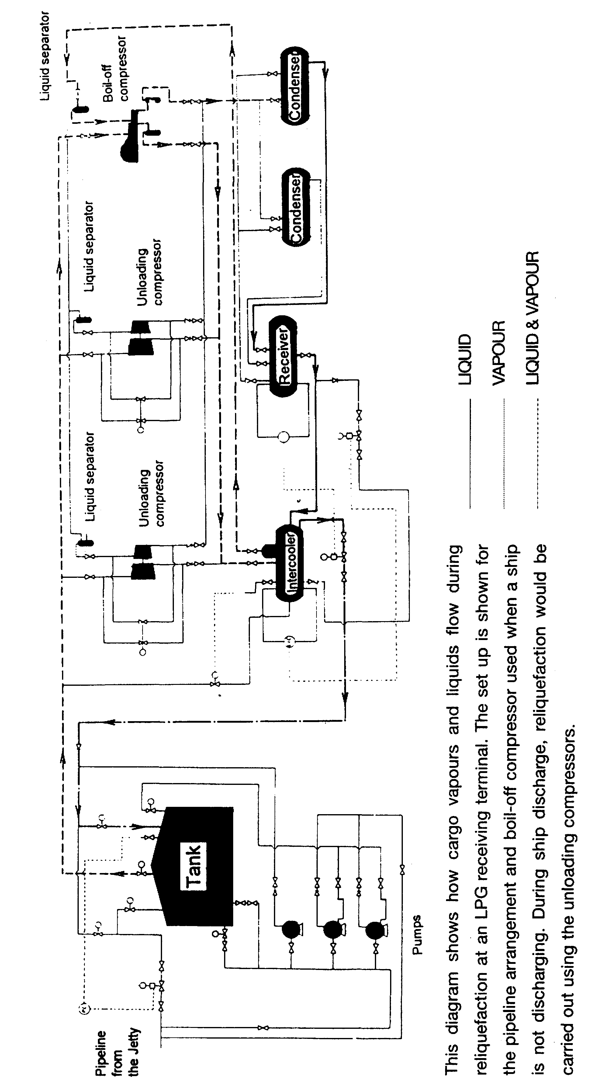

Figure 5.18 Flow diagram for reliquefaction within an LPG terminal
Compressors for LPG terminal refrigeration are of a similar design to those outlined in 4.6 for LPG ships reliquefaction systems but, generally, they have considerably greater capacity so that they can handle ship discharge or production run-down rates. A separate smaller capacity compressor is provided to handle boil-off vapors from within the shore tanks between loadings. Such boil-off may be generated as a consequence of heat input through the tank insulation.
Product condensers are either air-cooled or water-cooled, depending on economics and environmental aspects. Other heat exchangers may include units for warming refrigerated cargoes in order to load fully pressurised ships. Such equipment is often heated with glycol/water systems.
At some refrigerated terminals, it is common practice to receive refrigerated cargoes and subsequently to back-load fully pressurised ships. To facilitate loading operations, cargo heaters are often fitted in the terminal loading lines. These heaters are of the normal shell and tube design sea water can be used as the heating medium. To carry out such operations, without terminal heat exchangers requires the ship to be fitted with his own cargo heater of similar design.
Figure 5.18 shows a typical LPG terminal pipeline terminal pipeline diagram. It includes tankage, reliquefaction plant and export pumps.
Figure 5.19 shows a typical LNG receiving terminal. This terminal utilizes the gas in two ways.
- Gas is sent out to domestic and business consumers via the distribution main.
- There is a direct connections to an adjacent electric power station.
Gas vaporisation is achieved by: —
- Natural boil-off.
- Two types of vaporiser (open rack-type heated by sea water and submerged combustion-type heated by gas flame).
- Utilization of cold energy in an adjacent air separation plant.
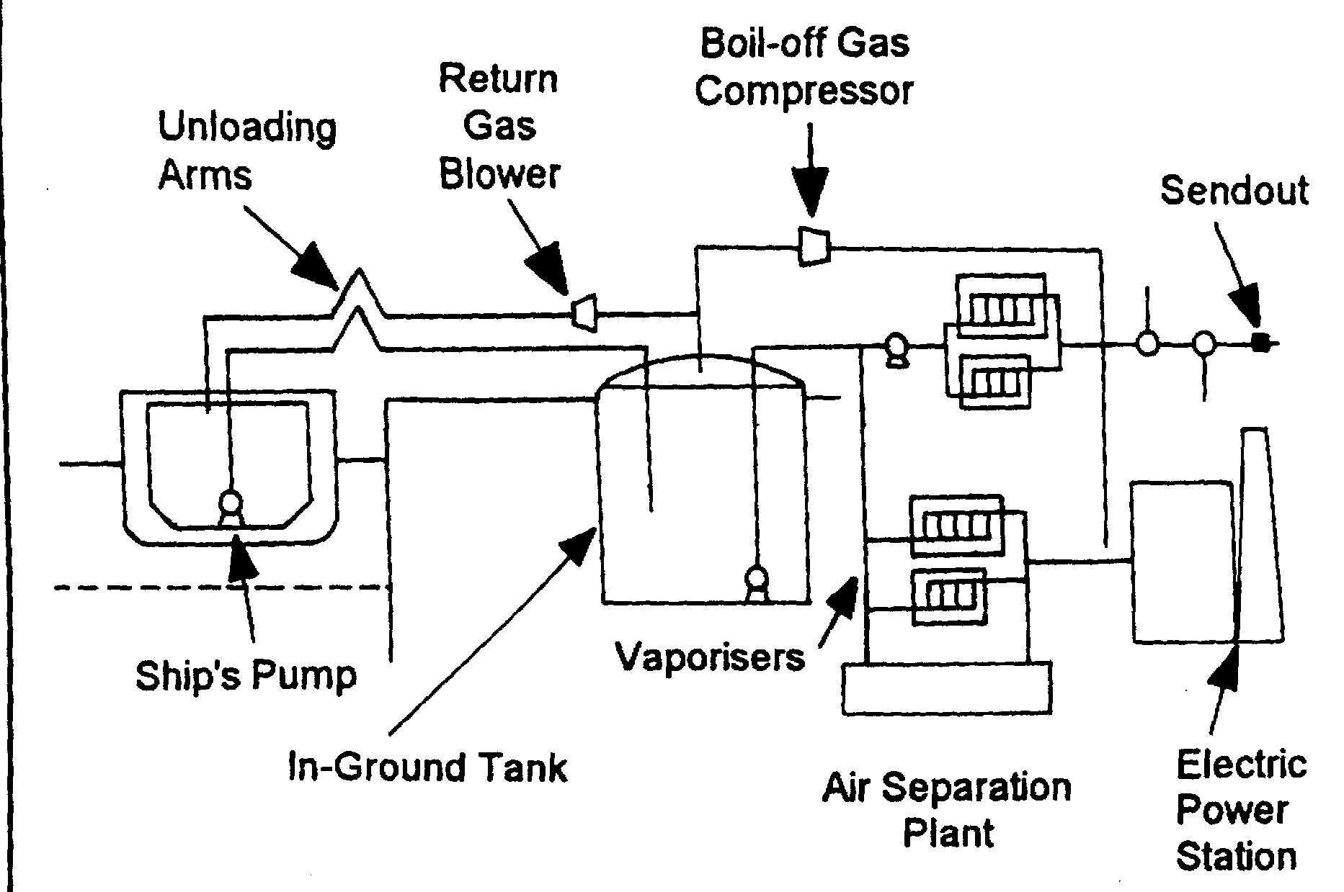

Figure 5.19 LNG receiving terminal — vaporiser/sendout

Other features are:—
- LNG is pumped from the in-ground storage tanks using submerged pumps.
- The pressure is raised to send-out pressure by a booster pump which is positioned before the vaporisers.
- Send-out gas is odorized and its calorific value is adjusted by injection of nitrogen or propane before leaving the plant.
Such terminals utilise the energy released by vaporisation in other ways. For example, to operate food freezer plants or to operate a direct expansion cryogenic generator to produce electricity.
5.4 INSTRUMENTATION
5.4.1 Product metering
The quantity of liquefied gas loaded onto a gas carrier can be determined by conventional tank gauging (ship and shore where appropriate) in the usual manner.
Alternatively, the volumes transferred can be monitored by flow meter. It should be noted, however, that where vapours are returned to the tank being discharged, the quantity of such vapours must also be taken into account in the calculation.
There are seven types of metering systems in regular use at liquefied gas terminals. These are listed below: —
- Positive displacement meters operating in a similar manner to positive displacement pumps.
- Turbine meters where the rotation of the blades is proportional to the flow.
- Coriolis metering where the fluid is passed through a vibrating U-tube, the mass gas flow being determined from the twisting of the U-tube caused by the Coriolis effect.
- Ultrasonic metering whereby the volumetric flow rate can be determined.

These meters are normally used for the measurement of vapour quantity.
- Vortex meter may be thought as an obstruction within the pipe which causes vortices to be generated on each side of the obstruction.
While the two former units require equipment to be fitted within pipelines, it is interesting to note that the others are non-intrusive.
The positive displacement, turbine, vortex, ultrasonic and coriolis types are covered in more detail below.


Figure 5.20 A positive displacement meter

Positive displacement meter
Figure 5.20 shows a typical positive displacement meter. The meter operates on the same principle as a positive displacement pump, the number of revolutions of the meter being proportional to the volume of fluid passed.

Turbine meter
Figure 5.21 shows a typical turbine meter. Here, the speed of rotation of the turbine is proportional to the flow.


Figure 5.21 A turbine meter
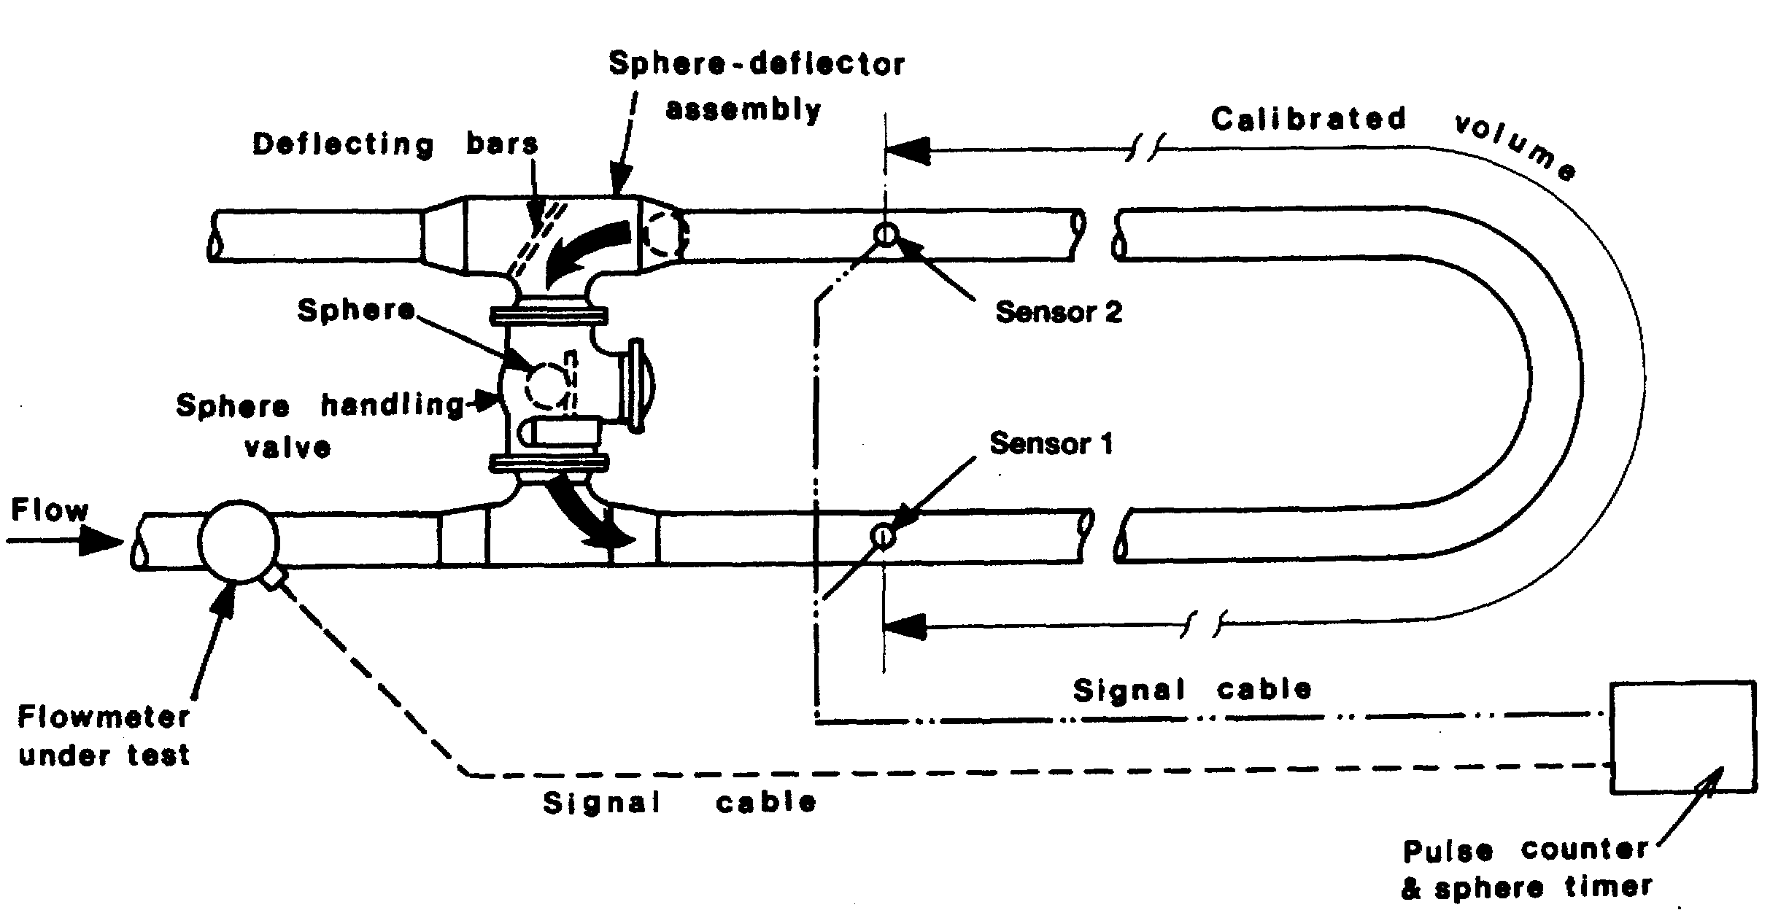

Figure 5.22 A prover loop
When using meters, it is necessary to be able to calibrate the installation. The most usual way to calibrate a flow meter for liquefied gas is to pass a quantity of liquid through a prover loop. The common arrangement for terminal metering is to have a prover loop of accurately known volume within which there is a sphere. Figure 5.22 shows a typical prover loop arrangement. The sphere in the prover is designed to have a very close fit and is moved through the system by the flowing liquid. Sensors installed at the inlet and the outlet of the prover give a signal as the sphere passes. In the time taken for the sphere to pass from inlet to outlet sensor, the volume measured by the flow meter is electronically recorded. By this means, because the volume of the prover loop is accurately known, a direct calibration of the meter is possible.
This type of prover cannot be used under refrigerated conditions because the sphere becomes hard at low temperatures. For refrigerated products, a piston prover must be used, with a metal piston with low temperature seal materials replacing the sphere.
In order to correctly use the flowmeter, the relationship between the K factor, defined as number of pulses per unit volume, and flow rate should be programmed into the flow computer servicing the meter. This calibration is continuously applied to the meter during cargo loading.

Vortex meter
The vortex meter is starting to be used for some liquid loading lines. The principle of this meter is exactly that which causes a flag to flap on a flagpole as it moves from side to side with the wind generated vortices.
By counting the vortices, the fluid flow rate may be determined quite accurately. This meter has two advantages over the turbine meter. Firstly, it contains no moving parts and therefore needs no prover; secondly, it is significantly cheaper. Although the use of this meter is still in its infancy, it promises to be of great value in LPG service. Evidence exists that uncertainties as low as those of turbine meters on LPG can be achieved with vortex meters, that is of the order of 0.3% on volume.

Ultrasonic meter
The measurement of vapour quantity should not be ignored. If the liquid is metered during ship loading, the vapour return - if used - must also be metered. Ultrasonic meters offer the best possibility here, mainly because they can cope with the wide range of flow rates typically found in vapour return lines. The ultrasonic meter measures the time of flight of a sound signal passing diagonally across the pipe. Both times, in the direction of the fluid flow and against, are required in order to determine flow rate. These meters also require no prover and give no obstruction to the flow. These are often not calibrated since their performance can be determined from their installation - admittedly with a worse uncertainty than could be expected with liquid metering. However, this does not have a major effect on the overall measurement uncertainty since the liquid mass is always much greater than the vapour mass.

Coriolis mass flow meter
The Coriolis mass flow meter has the advantages of a high accuracy and of a direct mass flow metering. The measurement principal is based on the controlled generation of Coriolis forces. These forces are always present in systems when both transitional (straight line) and rotational (revolving) movements occur simultaneously. This principal has been adapted so an oscillation replaces the rotational movements. Two parallel measuring pipes with fluid flowing through them, are made to oscillate in antiphase so they act like a tuning fork. When mass is flowing through, there is a phase shift between the inlet and the outlet. As the mass flow increases, the phase difference also increases. This phase shift is determined using electro-dynamic sensors at the inlet and outlet. The measurement principle operates independently of temperature, pressure, viscosity, conductivity or flow profile.
5.4.2 Pressure, temperature and level instrumentation
The same types of primary measurement devices as described in Chapter Four, ship-board instrumentation are found in terminals.
5.4.3 Gas detection systems
Automatic gas detection systems for monitoring possible leakage of flammable anc toxic vapours are installed in terminals and at jetties. The principle of operation o1 these systems is similar to the ship systems already described.
The number and location of detector heads will depend on the prevailing wind velocity and direction. Their positioning will also depend on the density of the gas being monitored and on the more likely sources of release.

5.5 FIRE-FIGHTING

Fire-fighting facilities installed in terminals and on jetties depend on such factors as location of the terminal, type and size of storage, sizes of ships and types of products handled.
The most important function of a fire-fighting system is the protection of personnel. Secondary, but nonetheless important considerations, are to minimise loss of equipment and product.
The fire-fighting equipment and the fire-fighting strategy employed at a terminal will vary with the type of fire considered. Fires may be broadly categorized as follows;
- Minor fires at pump glands, pipe flanges and relief valves
- Fires from confined liquid pools
- Fires from unconfined spillages
- Fires in confined spaces
The guiding principle for fire control is that effective attack should be carried out as early as possible. In certain circumstances, however, an appropriate strategy might be to stop the spillage and protect the surroundings while allowing the fire to burn itself out.
In understanding how best to control a liquefied gas fire, the behaviour of gas spills, their characteristics and potential hazards must be understood — this subject is described in Chapter Two (2.10, 2.20 and Figure 2.19) and Chapter Ten (10.1 and 10.2).
The following fire-fighting mediums may be found in a terminal’s fire control system: water, foam, dry chemical powder, smothering gas (carbon dioxide) and vaporising liquids (such as halon). A brief discussion on each follows and in each case the reader is referred to the corresponding section of the ship’s fire-fighting procedures (see 10.3) since many observations are similar.
5.5.1 Water
Although inappropriate for direct application to a liquid gas fire, water is an essential element in a terminal’s firefighting system. Water is readily available in unlimited quantities and may be used in a variety of ways.
Water is an excellent cooling medium. It is widely used to protect exposed plant and storage from fire and heat radiation. It may be used in the form of jets, sprays, fixed deluge systems or water-curtain radiation screens. Water is, however, a heat source for refrigerated product spills, promoting evaporation of spilled product (see 10.3.2).
Fixed deluge systems, designed to provide a layer of water over exposed surfaces, are customary for storage tanks and plant in potential fire areas. This provides a screen against fire radiation. Application rates vary from two to ten or more litres per minute per square metre.
Sprays from fixed monitors or hand-held hoses can provide essential radiation protection for personnel in their approach to shut valves. Such spray shields are also beneficial in an approach to a jet fire where an attack using dry chemicals to extinguish the flame is envisaged.
Of course, water is effective in cases where other combustible materials such as wood, insulation and paint have been ignited.
A special application of a water spray is to induce air movement into a vapour cloud and thereby deflect it from a source of ignition or to encourage its dilution (see also 10.3.2 and Reference 2.21 and 2.29).
5.5.2 Foam
Medium and high-expansion foam applied in large quantities to the surface of a confined, liquid pool fire will largely suppress radiation beaming its way from the flame into the liquid below. This will reduce vaporisation and, thus, the intensity of the fire will decrease. The rate of foam application should be sufficient to maintain a foam depth of one to two metres. High-expansion foams of 500:1 expansion ratio are the most effective for this purpose, but such foam blankets are very likely to be affected by high wind conditions (see also 10.3.2).
Application of such foam to unignited LNG pools can reduce the distance traveled by flammable vapour. This is achieved by using the foam to warm the generated vapour so increasing its buoyancy.
When used for the abovementioned application, foam is normally applied by fixed monitors controlled by remote means and suitably located around tank bund areas.
5.5.3 Dry chemical powders
Dry chemical powders such as sodium bicarbonate, potassium bicarbonate and urea potassium bicarbonate are effective in extinguishing small LNG and LPG fires. They attack the flame by absorbing the free radicals in the combustion process. Just a few seconds application are required for mixing with the flame before the chemical begins to affect the fire. The time taken to extinguish the fire is a function of the burning rate and the application rate of the chemical.

Dry chemicals may be applied from fixed, mobile or portable equipment. A well-trained operator using a hand line or monitor nozzle discharging at the rate of 23 kg/sec can extinguish a fire of about 100 square metres in area — greater areas require more operators or a number of fixed systems. Required application rates for successful extinguishment are very dependent upon wind speed and direction.
The presence of objects such as steel supports may cause problems by shielding parts of the fire from the chemical. Because powders have a negligible cooling effect, they can leave hot spots which, subsequently, are able to produce re-ignition after the initial extinguishment. For this latter reason, special attention should be given to eliminating the source of spillage when using dry chemical powders. Dry chemicals are particularly effective in dealing with fires at sumps, tank vents and leaking flanges. Fixed and portable dry chemical extinguisher systems provide an important defence against liquefied gas fires on many jetties.
5.5.4 Carbon dioxide (CO₂) systems
CO₂ injection systems act by reducing the oxygen content of the atmosphere to a level at which combustion cannot continue. They are thus only effective in enclosed spaces. It should be appreciated that such equipment should only be used for fire-fighting and not for inerting: this is due to the risk that static electricity may be generated.
Although substantial quantities of CO₂ may be required to extinguish a fire, its action can be rapid and effective. It is essential that all personnel are evacuated from the space before CO₂ is introduced because of the rapidity with which an asphyxiating atmosphere develops.
C0₂ extinguishers are of little value on open jetties, except for the local extinguishment of electrical fires in junction boxes and similar equipment.
5.5.5 Halon replacements
Halon is stored in bottle banks as a liquefied gas under pressure. When released in the presence of a fire, the gas reacts with the combustion process and extinguishes the flames. For many years fixed total flooding systems using halon have been used for this purpose but halon can now no longer be designed into new projects and is to be ⁽ phased-out from existing installations under the provisions of an international treaty. This is because it has a high Ozone Depletion Potential and is, thus, a danger to the environment. There has been considerable research into halon substitutes and there are now replacement becoming commercially available.
It may be possible for existing halon installations to be maintained in use for several years to come as a total ban on this CFC is not expected to be in place until the year 2005. At present, rules may vary from country to country but ships so fitted may experience difficulty in refilling a halon system after use, or when in need of maintenance or topping-up.
Halon (as for CO₂) is generally only suitable for fire-fighting in enclosed spaces. It has an advantage over COs inasmuch as its action is more rapid. Additionally, because only low concentrations are required, the necessary storage can be of smaller size. A further advantage over CO₂ is that halon may be injected into a space before all personnel have evacuated. Generally, at the concentrations normally used for fire-fighting, from a toxicity viewpoint, personnel have some ten minutes in which to evacuate in an orderly manner.
5.5.6 Inspection, maintenance and training
Fires at liquefied gas terminals occur only rarely but can have severe consequences. Accordingly, and with respect to emergency situations, the interest of operations personnel must be kept high by suitable drills including the use of equipment. This should help to ensure that fire-fighting equipment is effective when needed. The following considerations are relevant:
- Before commencing any ship/shore cargo operation, check all fire-fighting equipment and ensure that monitors are aligned to cover appropriate areas.
- Inspect fire-fighting equipment monthly. This should include the weighing of containers where necessary and the actuation of fire monitors.
- The rotation of portable extinguishers between the terminal and the training area is also encouraged. This will help to ensure the equipment is operated and returned to the terminal with a new charge.
- The immediate reporting (and suitable maintenance) of any faulty fire-fighting equipment in the shortest possible time should be a responsibility of all concerned.
- The provision of clear plans showing the fire-fighting equipment provided and its proper location is recommended.
- The correct marking of all fire-fighting equipment showing its intended function and proper operation should be established.
- The training (and refresher training) of all personnel who may be involved in fire-fighting should be addressed. Training should be done at an adjacent training area where realistic fires can be arranged under controlled conditions.
- The provision of adequate emergency plans and procedures covering terminal personnel and local authorities is an increasingly important aspect. Particular reference should be made to Reference 2.6.

Chapter 6
The Ship/Shore Interface
This chapter discusses a central theme contained within this book. This is the safety of both ship and terminal during cargo transfer operations. The methods developed and the check-lists used to achieve this objective are fully described.
All operations when a ship is alongside must be pre-planned and jointly managed in such a way that both the ship and the shore are aware of their respective responsibilities, capabilities and limitations. Throughout the cargo transfer operation both ship and shore should work together according to mutually agreed procedures and responsibilities.
For those requiring further background on this subject a listing of additional sources can be found in References 2.32 and 2.39.

6.1 SUPERVISION AND CONTROL
Within the gas trade, the ship/shore interface plays a vital part in operations. It is an area where differing standards and safety cultures may coexist. A central theme of this book is to close gaps in design standards and operational practices, which may exist on either side of the interface. In so doing, this book, by explanation and training content, hopes to achieve a better understanding of the principles involved so that ship and shore personnel can order their procedures to suit the requirements of each party and, by so doing, achieve better reliability and safety.
With respect to the equipment fitted on jetties, the ship/shore interface covers:—
- Moorings
- Fenders
- Breasting dolphins
- Hard arms and hoses
- Ship/shore gangways
- Emergency shut-down arrangements
- Ship/shore links, and
- Fire-fighting equipment capability
Liquefied gases are loaded and discharged at many terminals around the world by a wide variety of ship types and sizes. Operations range from the very large self-contained LNG projects to smaller LPG terminals handling many different products.
In the case of large LNG projects, dedicated ships trade continuously between purpose-built terminals for contract periods of up to 25 years. Each link of the chain — the loading terminal, the gas carriers and the receiving terminal — is designed as part of an integrated whole. In this trade the ships are designed to be compatible with the terminal and ship and shore personnel should be familiar with each other’s equipment and responsibilities. Similar observations apply also to some LPG projects, particularly those which involve long-term contractual arrangements and, inevitably, the use of large ships and dedicated terminals.
In contrast, however, there are many LPG terminals, which handle many ‘spot’ cargoes delivered by a very wide variety of ships and shipowners. Here, different gases are handled under a variety of conditions and ships are frequently required to load more than one product simultaneously. Furthermore, in such trades, the ships may need to change cargoes on successive voyages, with the extension of operations sometimes requiring very careful control.
In all gas trades it is essential that ship and terminal operators are:—
- Familiar with the basic characteristics of each other’s facilities,
- Aware of the division of responsibilities, and
- Able to communicate effectively during the port call.
It is only in this way that safe, efficient and reliable operations can be assured.
These issues are re-emphasized in the International Safety Guide for Oil Tankers and Terminals (see Section 7.1 in Reference 2.4) and in this respect information of value can also be found in References 2.8 and 2.31.
The International Safety Guide for Oil Tankers and Terminals under the heading of ‘Supervision and Control’, states that: —
General
The responsibility for safe cargo handling operations is shared between the ship and the terminal and rests jointly with the shipmaster and the responsible terminal representative. The manner in which the responsibility is shared should, therefore, be agreed between them so as to ensure that all aspects of the operations are covered.

Joint agreement on readiness to load or discharge
Before starting to load or discharge cargo or ballast, the responsible ship’s officer and the terminal representative must formally agree that both the ship and the terminal are ready to do so safely.

Supervision
The following safeguards must be maintained throughout loading and discharging: —
A responsible officer must be on duty and sufficient crew on board to deal with the operation and security of the ship. A continuous watch of the tank deck must be maintained. If a ship’s cargo control room, from which all operations can be controlled, does not have an overall view of the tank deck, then a competent member of the ship’s crew must be continuously on watch on the tank deck.
A senior terminal representative must be on duty and communications between him and the responsible ship’s officer continuously available.
A competent member of the terminal organization should be on continuous duty in the vicinity of the cargo connections. Supervision should be aimed at preventing the development of hazardous situations. If, however, such a situation arises, the controlling personnel should have adequate means available to take corrective action. Supervision by systems incorporating television should only be used where they give effective control over the cargo operations and these systems cannot be regarded as satisfactory when cargo operations are at a critical phase or during adverse weather conditions.
The agreed ship-to-shore communications system must be maintained in good working order.
At the commencement of loading or discharging, and at each change of watch or shift, the responsible ship’s officer and the terminal representative must each confirm that the communications system for the control of loading and discharging is understood by them and by other personnel on duty.
The stand-by requirements for the normal stopping of shore pumps on completion of loading and the emergency stop system for both the ship and terminal must be fully understood by all personnel concerned.

Checks during cargo handling
At the start of and during cargo handling, frequent checks should be made by the responsible officer to confirm that cargo is only entering or leaving the designated cargo tanks and that there is no escape of cargo.

6.2 DESIGN CONSIDERATIONS
6.2.1 The terminal
During the design of a new marine terminal, minimum and maximum ship size is established. Furthermore, the jetty and its equipment are designed accordingly. Farther offshore, the port approaches and river channel are surveyed. Once a terminal is ready for service, the relevant information needed by visiting ships should be advised to the port authority, ships’ agents, pilots and shipowners’ associations. (Reference 2.41).
In the case of a change to an existing facility it may be necessary to either amend the original design parameters or accept a new class of ship having different characteristics from those originally envisaged. If, as a consequence, modifications are made to the jetty facilities, the appropriate details should be advised to the same group of organizations.
It is good practice for terminals to audit their marine facilities from time to time and in this respect, Marine Terminal Survey Guidelines (References 2.15) can be of benefit. Reference 2.18 may also be consulted with advantage.

6.2.2 The ship
Gas carriers are normally built in such a way that there is maximum compatibility with a range of terminals. Compatibility of any particular ship and terminal should always be confirmed from a technical viewpoint by terminal personnel prior to acceptance of any nomination. Confirmation should include items such as mooring studies, manifold configurations and ESD link compatibility (see 6.3.1).
6.3 COMMUNICATIONS
Communications should start before the intended voyage and continue until the arrival of the ship alongside: they must also include the period of cargo operations and continue until the ship departs. All communications should be carried out in a common language so that misunderstanding cannot develop. Usually, apart from some coastal trades, this will be English. (Reference 2.31).
6.3.1 Prior to charter
Prior to chartering a ship, in order to ensure a suitable match of ship and jetty, it is necessary for the parties concerned to exchange information. From a terminal’s viewpoint, it is important for operations personnel to have a clear understanding of the restrictions within the port and at the jetty which influences the maximum or minimum size of ship they are able to receive. This information should be documented and made available to their commercial departments so that only ships having suitable dimensions are received. Apart from the more obvious criteria, such as ship’s length and height of manifold above the water line, other issues such as the suitability of the ship’s mooring equipment and its deck layout, are often relevant. Furthermore, in the gas trades, the provision of a compatible ship/shore link can be vital.
To assist in determining the suitable matching of ship and jetty mooring equipment, on receipt of appropriate information such as the ship’s mooring plan, it is often advantageous to prepare a ship/shore mooring plan showing the direction of all mooring line leads and to ensure that these provide maximum restraint for all weather conditions. Guidance on this matter is to be found in Mooring Equipment Guidelines (see Reference 2.17).
Such information exchange can be simplified where data has been completed in accordance with the Ship Information Questionnaire for Gas Carriers (see Reference 2.16). This referenced data is often required by a ship’s time charterer and reproductions of the publication are sometimes referred to as Gas Form ‘C’.
The use of Reference 2.16 as a pro-forma also expedites information exchange on other matters such as cargo manifold arrangements, reliquefaction capabilities, cargo pumping characteristics, cargo tank capacities and cargo segregation possibilities.
6.3.2 Prior to arrival
As a ship approaches a port, direct contact should be established between ship and shore as soon as possible. Modern communications will readily allow the terminal to update the ship on its requirements for the envisaged transfer operation. Additionally, port requirements, berthing arrangements and the facilities available can also be advised. Similarly, the shipmaster may inform the terminal of the cargo arrival temperatures and pressures, stores and bunker requirements and personnel joining or leaving.
For the planning of ship cargo operations, the shipmaster should be advised by the terminal of all port and terminal requirements relevant to gas carriers.-(Reference 2.42).
6.3.3 Alongside the jetty
As for the earlier parts of a ship’s voyage described in the foregoing paragraphs, reliable and effective communications are a necessity once the ship is alongside.
While alongside and transferring cargo, various means of communication need to be agreed. Decisions must be made on the use of portable radios or telephones. These tools usually form the basis of good communications under normal operating conditions. However, emergency means of communication must also be developed and this will normally take the form of an established terminal operating procedure (see Reference 2.31).
In many terminals, the actuation of emergency shut-down (ESD) valves is interlinked between ship and shore. This communication channel requires a suitable system having plugs and sockets fitted on ship and jetty. Both ship and shore need to be properly outfitted. Such methods of communication are recommended so that a controlled emergency shut-down can always be accomplished. This will always ensure that either the ship or shore emergency shut-down valve, whichever is nearest to the operational cargo pump, is closed first. (Reference 2.34).

6.4 DISCUSSIONS PRIOR TO CARGO TRANSFER
Before the start of any cargo transfer operation, the intended cargo handling procedures must be thoroughly discussed at a meeting held between the responsible personnel from the ship and the terminal.
The purpose of the meeting is primarily to draw up a suitable cargo plan and to check on safety issues. Furthermore, the meeting has the benefit of making both sides familiar with the essential characteristics of ship and shore cargo handling systems. At the meeting, the envisaged operational and safety procedures and requirements should be covered. Finally, any limitations to be observed during the transfer should be noted in writing. Written agreements should include a cargo handling plan (including transfer rates), communication procedures, emergency signals, emergency shut-down procedure and the tank venting system to be used.
The content of the meeting will depend on a wide variety of circumstances but the following broad outline forms the normal basis for such meetings.
(i) The names and roles of terminal and ship personnel who will be responsible for cargo transfer operations should be noted.
(ii) The terminal representative should check that pre-arrival instructions to the ship on cargo, cargo disposition and cargo arrival temperature have been carried out. They also check that all necessary ship equipment inspections and tests have been performed.
(iii) Similarly, the ship’s officers should satisfy themselves that the relevant terminal equipment is satisfactory and that appropriate inspection checks have been carried out.
(iv) The terminal representatives and, where necessary, customs and independent surveyors should be informed of the cargo tank data, such as:—
- Temperatures
- Liquid heel or arrival dip
- Pressures
- Composition of tank vapour, and
- Cargo tank quantities
- Total quantity of cargo on board

(v) The ship and terminal should then discuss and agree in writing the quantity and types of cargo to be loaded or discharged and in what order. The anticipated transfer rates and, for discharge, the receiving tank allocations should also be agreed.
The cargo transfer operation should be planned and confirmed in writing in order to assure full mutual understanding. The items to be addressed should include:—
      - The order of loading or discharging
      - The total quantities of cargo to be transferred
      - The sequence of discharging and receiving tanks
      - The intended transfer rates
      - The transfer temperatures and pressures to be expected, and
      - The use of vapour return line
Simultaneous cargo and ballast handling, for stress and ship stability purposes, should also be noted on the cargo plan.
(vi) To reconfirm earlier pre-charter advice, the previous three cargoes carried by the ship and the relevant dates should be noted in order to identify and assess any possible cargo contamination problems, particularly after ammonia.
(vii) The appropriate Cargo Information Data Sheets should be provided (see Reference 2.1) and should be posted in prominent places on board the ship and within the terminal.
Similar detail for cargo inhibitors should be provided by the terminal.
(viii) A review of port and jetty regulations should be made with particular attention being paid to berth operating limits, fire-fighting capabilities and other emergency procedures. Similarly, ship regulations and emergency procedures should be communicated to terminal personnel. Particular importance should be paid to emergency shut-down valve closure times and to the agreed emergency shut-down procedures (see 6.6.4).
Equipment and procedures for normal and emergency communications between ship and terminal should be defined and understood. Where portable radios are provided, adequate spare battery capacity should be made available. A common language should be established.
(ix) Any further information or procedures relevant to the operation should be discussed.

6.5 SHIP/SHORE SAFETY CHECK LIST
When a ship is alongside, no cargo operations or inerting should commence until the international Ship/Shore Safety Check List has been completed by the ship and the terminal and it has been confirmed that such operations can be safely carried out. It is normal practice that this check list be presented to the ship by the terminal.
Recommendations on the Safe Transport of Dangerous Cargoes and Related Activities in Port Areas were revised by IMO in 1995. They refer to a comprehensive Ship/Shore Safety Check List covering the handling of bulk liquid dangerous substances with a special section for liquefied gases. It also includes guidelines for its completion. This has since been updated (see Reference 2.4) and the current version is reproduced in Appendix 3.
The Ship/Shore Safety Check List consists of Part A (Bulk Liquids — General), Part B (Additional Checks — Bulk Liquid Chemicals) — not included in this volume — and Part C (Additional Checks — Bulk Liquefied Gases). For gas carriers, Parts A and C should be fully completed.
A ship presenting itself to a loading or receiving terminal needs to check its own preparations and fitness for the safety of the intended operations. Additionally, the shipmaster has a responsibility to assure himself that the terminal operator has also made proper preparations for the safe operation of the terminal. Similarly, the terminal needs to check its own preparations and to be assured that the ship has carried out its checks and has made appropriate arrangements. The Ship/Shore Safety Check List, by its questions and its requirements for the exchange of various written agreements, is a minimum basis for performing such a mutual examination.
Some of the questions in the Ship/Shore Safety Check List are directed to considerations for which the gas carrier has prime responsibility. Others apply to both ship and terminal and the remainder to the terminal alone.
All items lying within the responsibility of the gas carrier should be personally checked by the ship’s representative and, similarly, all items under the terminal’s responsibility personally checked by the terminal representative. In carrying out their full responsibilities, however, both representatives, by questioning the other, by sighting of records and, by joint visual inspection, should assure themselves that the safety standards on both sides of the operation are fully acceptable. The joint declaration at the end of the Ship/Shore Safety Check List should not be signed until such mutual assurance is achieved.
The conditions under which the operation takes place may change during the process and the changes may be such that safety can no longer be guaranteed. A party noticing or causing any unsafe condition is required to take all necessary actions, which may include stopping the operation, to re-establish safe conditions. The presence of the unsafe condition should be reported to the other party and, where necessary, cooperation with the other party should be sought.
During cargo transfer operations, it is essential that the items shown on Ship/Shore Safety Check List be revisited by joint inspection at suitable intervals to ensure continued compliance. In this regard, re-inspection should be considered at intervals not exceeding six hours. Whenever such inspections take place, the check list should be endorsed by ship and shore personnel.
Guidelines for the completion of the Ship/Shore Safety Check List have been produced jointly by the oil, chemical and gas industries. As appropriate, these guidelines are annexed to Appendix 3 and contain detailed advice on each item of the check list. They are made widely available to ships and terminals through industry publications.

6.6 OPERATIONAL CONSIDERATIONS

6.6.1 Berthing and mooring

Berthing
Port and terminal authorities should establish berthing and unberthing criteria for safe operations, including limiting wind, wave, current and tide conditions. Requirements for the number and size of tugs must also be set.
Mooring
Mooring line configurations should be agreed as suitable. The initial mooring of the ship to the terminal and the subsequent tending of moorings is most important if the ship is to be safely held alongside and damage to transfer facilities and jetty prevented.
Comprehensive guidance on jetty and ship mooring design and on operational mooring management is given in Prediction of Wind Loads on Large Liquefied Gas Carriers (see Reference 2.13), and Mooring Equipment Guidelines (see Reference 2.17). For design and operational reasons, both terminal and ship staff should be familiar with the content of these books.

6.6.2 Connection and disconnection of cargo hoses and hard arms
Terminal equipment, such as hoses and hard arms, designed to connect with the ship’s manifold are described elsewhere in this book (see 5.1) but, irrespective of the type of equipment being used, there are certain operational procedures to be considered (Reference 2.40).
- No flanges should be disconnected or blanks removed until it is confirmed that line connections are liquid-free and de-pressurised and, where possible, inerted with nitrogen or other suitable inert gas.
- Care must be taken to avoid air or contaminants entering cargo pipelines.
- The manifold area of a gas carrier is a zone where flammable vapours may be present. Therefore, care must be taken to ensure that ignition sources are eliminated from this area.”
At some terminals, problems can be encountered with gas carriers due to mismatching (in positioning or layout) of hard arms in relation to the ship’s cargo manifold. As a result it may be necessary to restrict the number of connections used and, thereby, the overall cargo transfer rates. An alternative solution involving the use of short lengths of hard piping to bridge the mismatch, unless properly engineered, should be disallowed as these systems can induce unacceptable loads onto the ship’s manifold piping and supports. The use of flexible cargo hoses for this purpose should also be disallowed as this procedure degrades the design parameters and security of the hard arm concept. Hose bridging should be restricted to vapour service connections only where permanent systems have been purpose designed. This is sometimes seen on hard arms where vapour return connections are provided by means of piggy-back systems. International standards for cargo connections for liquefied gases have been published in two booklets, one for LNG and the other for liquefied gas cargoes (see References 2.10 and 2.11). The recognition of these standards in the design of new ships and terminals will greatly increase ship and shore compatibility.

6.6.3 Cargo tank atmospheres
Prior to any cargo transfer, the oxygen content in the ship’s cargo tank vapours should be carefully checked. As stated elsewhere in this book, at these times the oxygen content should never exceed five per cent and is commonly required to be not more than two per cent by volume in tanks containing vapour only. Lower oxygen contents may be required for cargo quality purposes and some guidance on this subject is given in Table 2.3(b).
For example, products such as butadiene and vinyl chloride, which can react with oxygen to form unstable compounds, require maximum oxygen concentrations of 0.2 per cent by volume and 0.1 per cent by volume, respectively.

6.6.4 Cargo handling procedures
Cargo handling is described in Chapter Seven but procedural aspects of these operations, directly relevant to the ship/shore interface, are considered here.
All operations carried out alongside should be under the continuous supervision of experienced ship and shore personnel. These personnel should be familiar with the details, hazards and characteristics of the cargoes being handled and capable of ensuring that such operations can be safely and efficiently completed. Facilities for instant and reliable communications (such as separate telephone, portable radio or VHF) between the ship and the shore control should be provided at all times during cargo operations.
Before commencing operations, maximum cargo transfer rates have to be agreed. This should be done in accordance with vapour return specification, ship or shore reliquefaction capacity and emergency shut-down requirements. Inevitably, some of these considerations may be based on best practical estimates. Accordingly, during operations, a strict watch should be maintained on flow rates, tank pressures and temperatures. By means of ship/shore communications, adjustments to initial agreements can be made as appropriate.
If cargo transfer operations need to be stopped, this should be carried out under previously agreed controlled conditions with proper communication. If the situation demands an emergency shut-down, the agreed procedure should be followed, bearing in mind the dangers of excessive surge pressures. It is particularly important to maintain appropriate communication in emergency conditions and, if the responsible person becomes over-occupied in controlling operations, the communication task should be delegated to another officer.

LPG ships and the Gas Codes
The Gas Codes specify a minimum design pressure of 10 barg for ship’s pipelines and some fully refrigerated ships and LNG carriers are built to this specification. The Gas Codes do not take into account an over-pressure allowance for pressure surges and this is less secure than terminal standards (as detailed in 5.3.2). This mismatch between ship and shore is technically acceptable provided a high integrity ship/shore link and emergency shut-down system is in use.

Problems with ship/shore compatibility
As described above, there can be incompatibility between terminal and ship pipeline systems. In practice the lowest allowable standard for pipelines and hard arms for many refrigerated terminal installations is the ANSI Class 150 pressure rating. This will normally provide for a 19 bar working pressure plus 33 per cent surge allowance. Ship pipework sometimes has lower ratings as described above.

6.6.5 Cargo surveyors
Independent cargo surveyors are often employed by cargo buyers or sellers and the survey companies provide personnel to check cargo operations and cargo quantities both on board ship and within terminals. Such activities can include cargo measuring and cargo sampling (Reference 2.20).
During cargo operations, it is important to maintain a log of events. Ship’s officers and shore personnel should ensure that their time records are in agreement and that, when independent cargo surveyors are used, similar times are recorded in the Surveyor’s Time Sheet.

6.6.6 Gangways and ship security
It is the duty of both the ship and the terminal to ensure that adequate and safe ship/shore access is provided. Where possible, the manifold areas should be roped off to limit the access of personnel to that area. The gangway should be located away from the immediate vicinity of the manifold and, ideally, should be positioned about mid-way between the cargo manifold and the accommodation. As appropriate, it should be rigged with a strong safety net beneath. Both on the terminal and on board ship it is good practice to provide a lifebuoy at the gangway entrances. Proper illumination of the gangway and its approaches should be provided during darkness (see Reference 2.23).
A notice warning against unauthorized personnel should be posted at the gangway and provision should be made for all ship visitors to be met and escorted to the accommodation .
Ideally, a jetty should provide a secondary means of escape from the ship in case the normal access is unusable in an emergency. If the jetty configuration renders such secondary escape by gangway impossible, other means should be considered such
as:—
- Preparing the ship’s free-fall lifeboat for immediate lowering, or
- Rigging of the ship’s accommodation ladder on the side away from the jetty.
The terminal, in liaison with the ship, should control the persons and vehicles entering the jetty area to ensure that only authorized persons with legitimate business are permitted access. In controlling this access, any local regulations concerning smoking, carriage of matches or lighters, the use of mobile telephones and pagers, and the use of cameras should be enforced. Similarly the ship’s deck-watch should ^ check on the side away from the jetty and report the approach of unauthorized waterborne craft coming into the restricted area.

6.6.7 Bunkering
In general, on gas carriers, bunkering operations by barge will not take place during cargo operations as this is usually disallowed by terminal regulations. This avoids a bunker craft with possible ignition sources being allowed alongside the gas carrier.
Bunkering from the shore can be carried out during cargo operations so long as ship-side scuppers can be closed quickly. In case of cargo leakage open scuppers on gas carriers are an important feature to allow cold liquids to escape quickly so reducing the risk of metal embrittlement and the possibility of small pool-fires on a ship’s deck.
Oil tanker practice is to operate with scuppers closed and, in general, this standard is also applied to bunkering operations. It is therefore essential for gas carrier port operations to be properly considered in this respect and either suitable operational procedures must be in place or bunker tank openings and air pipes should be well bunded so, that bunkering from ashore can take place during liquid cargo handling.

6.6.8 Work permits
While a ship is alongside, only under exceptional and well-controlled circumstances should any hot work (including the use of power tools) be undertaken, either on board or within the vicinity of the ship. In the unlikely event that such work must be carried out, the most stringent safety precautions and procedures should be drawn up and rigidly adhered to.
To cover these and similar circumstances, a Permit to Work system should be in place. In the event that hot or cold work becomes necessary when a ship is alongside, a Work Permit should be agreed between the ship, the terminal and, where necessary, the port authority. The Work Permit should cover a limited period and the terms and conditions for which it is issued should be rigidly enforced.

6.7 FIRE-FIGHTING AND SAFETY
When a ship is alongside a terminal jetty, it is important that a joint emergency plan be available. The preparation of such a plan is the responsibility of each terminal. The details of the plan should consider the appropriate actions to be taken in all envisaged emergencies. This should include communication with local emergency services and the port authority. A summary of the essential elements within the plan should be made available to ships’ personnel and an appropriate method of providing this information is by inclusion of suitable data in the Terminal Information and Regulation booklet (see Reference 2.5).
Whilst a ship is alongside the terminal, fire-fighting equipment, both on board and on shore, should be correctly positioned and ready for immediate use. Although the requirements of a particular emergency situation will vary, fixed and portable fire fighting equipment should always be stationed to cover the ship and jetty manifold area. As described in the Ship/Shore Safety Check List Guidelines (see Appendix 3), fire hoses should be laid out with nozzles attached; hoses from fixed dry powder units should be laid out; and portable fire extinguishers readied for immediate action. The international ship/shore fire connection (see Appendix E of Reference 2.4) should also be made available for use at short notice.
Water spray systems should be tested on a regular basis. Where water sprays are designed to operate automatically, in the event of fire, the functioning of the automatic devices should be included in the test.
The ship’s fire-fighting and safety plan should be placed in a container near the gangway. This plan should provide the most up-to-date information. It is good practice to include a copy of the ship’s Crew List in the container.

6.8 LINKED EMERGENCY SHUT-DOWN SYSTEMS
As described elsewhere in this book, ESD systems are fitted at terminals and to ships. At the ship/shore interface, in order to enhance safety, it is recommended that these systems are compatible and that they be interlinked. This is usually accomplished by electrical connections although, in the LNG trade, fibre-optics are commonly used. For this arrangement to be appropriately assembled, both ship and shore need compatible systems; this also means that suitable plugs and sockets must be provided.
The main purpose of a linked ESD system is to have safe ship and shore control over the entire ESD system. This is in order to ensure a safe shut-down in line with appropriate valve closure times.
The Guiding rules for limiting pressure surge on loading or discharging are:—
(1) To stop the cargo pump
(2) First close the ESD valve nearest to the pump
(3) Finally, close other ESD valves
This surge pressure control recognizes the greater vulnerability of hoses or hard arms in comparison to the rest of the pipeline system.
As will be noted, the guiding rules are standard but the sequence of operations depends on whether the ship is loading or discharging. It will also be seen that to follow the procedure in a satisfactory manner, good coordination is required between the ship and jetty. It is accepted that without a linked system, in an emergency situation, such control is difficult and for this reason ship and shore ESD system should be interconnected.
The system logic engineered into a linked system must be designed to ensure an appropriate procedure is followed no matter which party initiates an ESD. (Details of such a system suited to LPG terminals is available from Reference 2.34. The particular system described in the reference has the advantage of being quite easily retro-fitted to existing plant and ships and is well suited to the many berths not so fitted in the LPG trade.)
The following tables outline the manual and automatic means by which an ESD should be activated: furthermore, the tables outline the signals, which should be transmitted.

ESD should be initiated by the following EMERGENCIES:-

SHIP | TERMINAL
Manual Trip | Manual Trip
Operation of manual trip | Operation of manual trip
Automatic Trip | Automatic Trip
Shut-down signal from ashore | Shut-down signal from ship
Overfilling of any cargo tank | Overfilling of receiving tank
Power loss to valve controls | Power loss to arm maneuvering
Loss of control air pressure | Power loss to ERS
ESD valve moving from full-open | ESD logic failure
ESD logic failure | Fire in terminal area
Fire in cargo area | Loss of electric power
Loss of electric power | Ship movement — pre-ERS
 | Activation of the PERC
 | High level in surge drum

ESD should initiate the following IMMEDIATE ACTIONS: -

ON SHIP | ON TERMINAL (LOADING)
Send shut-down signal to the shore  Trip ship’s cargo and spray pumps  Trip booster pump (LPG)  Trip vapor return compressor  Start a close ship’s ESO valve | Send shut-down signal to the ship via the ship/shore link  Trip loading pump  Open spill-back valves  Start a close shore ESD valve
 | ON TERMINAL (RECEIVING)
Send shut-down signal to the ship
Start a close shore ESD valve

ESD Links are already well established at LNG ports. In the early LNG projects, ship and shore were coupled with pneumatic systems. These could be slow in operation and suffered from problems with dirt and moisture. These drawbacks led to the development of electric or electronic and optical links. Accordingly, there are now four main types in operation: —
- Pneumatic types
- The electrical type (either intrinsically safe or of increased safety)
- The fibre optic type, or
- Those operated by radio telemetry
Regardless of the cargo to be handled, it is vital, prior to receiving a new ship at a terminal, to communicate on the question of the compatible systems being fitted at the terminal and on the ship.

6.9 TERMINAL BOOKLET — INFORMATION AND REGULATION
This chapter has outlined a number of terminal-based procedures, which should apply to any well-run ship/shore operation. For the purposes of clear and unambiguous operations many terminals produce a Terminal Information and Regulation booklet.
Such guidelines can be helpful for defining the responsibilities of each party and can be used for introducing local procedures. A booklet of this type can be subdivided as follows: —

Information
- Port geographical position
- Restrictions on port entry
- Ship restrictions at the berth
- Weather and tidal data
- Preferred mooring plan
- Diagram of jetty fire-fighting and life-saving appliances
- Procedures for limiting surge pressures
- Terminal pipeline and tankage plan
- Description, of ESD arrangements
- Communication methods
- Requirements for a ship/shore ESD Link
- Cargo pumping limitations
- Safety requirements
- Emergency procedures

Regulations
Regulations may include, national and port authority requirements. They can also include many of the safety issues described in Chapter Six of this book.
Documentation
- Letter to shipmasters (see Appendix 3)
- The ship/shore safety checklist (see Appendix 3)
- A cargo planning form
- A cargo calculation form
For further information on this subject terminal managements can turn to Reference 2.31 and 2.42.

6. 10 TRAINING
The training of seagoing personnel is covered by international regulation under course syllabuses prepared under the auspices of IMO (see References 1.5, 1.8 and 1.9). Further more, basic training is provided for seafaring ratings in Reference 2.2. For terminal personnel, similar training is recommended and in this respect Reference 2.19 has been published by SIGTTO for the benefit of marine terminal managers and training personnel in the gas industry.

Chapter 7
Cargo Handling Operations
This chapter takes the reader through a complete cycle of ship loading and discharging operations, from a gas-free condition until a change of cargo is planned. In addition, recommendations for ship-to-ship transfer operations are provided. The text ties together much of what has been written in earlier chapters so that personnel can appreciate how the various equipment and procedures fit within operational practices.
When a gas carrier first comes alongside a berth to carry out cargo handling operations, it is essential that the preliminary procedures as outlined in Chapter Six be properly completed. In particular, the questions given in the Ship/Shore Safety Check List should always be addressed. In line with check list questions, cargo handling plans should be developed and agreed jointly. Furthermore, written procedures should be established for controlling ship/shore cargo flow rates and for procedures covering general emergencies. It is in accordance with these plans that safe operations, as outlined in this chapter, can be ensured.

7.1 SEQUENCE OF OPERATIONS
Assuming a gas carrier comes directly from a shipbuilder or drydock, the general sequence of cargo handling operations is as follows.
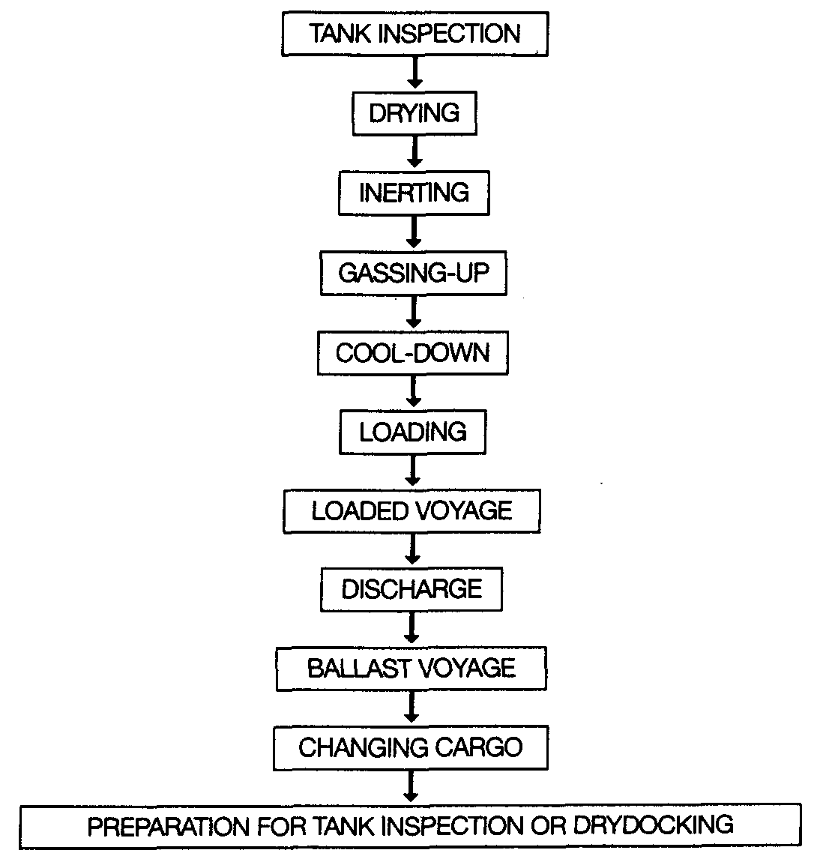

7.2 TANK INSPECTIONS, DRYING AND INERTING
7.2.1 Tank inspection
Before any cargo operations are carried out it is essential that cargo tanks are thoroughly inspected for cleanliness; that all loose objects are removed; and that all fittings are properly secured. In addition, any free water must be removed. Once this inspection has been completed, the cargo tank should be securely closed and air-drying operations may start.
7.2.2 Drying
Drying the cargo handling system in any refrigerated ship is a necessary precursor to loading. This means that water vapour and free water must all be removed from the system. If this is not done, the residual moisture can cause problems with icing and hydrate formation within the cargo system. (The reasons are clear when it is appreciated that the quantity of water condensed when cooling down a 1000m³ tank containing air at atmospheric pressure, 30°C and 100% humidity to 0°C would be 25 litres.)
Whatever method is adopted for drying, care must be taken to achieve the correct dew point temperature — see Table 2.3(b). Malfunction of valves and pumps due to ice or hydrate formation can often result from an inadequately dried system. While the addition of antifreeze may be possible to allow freezing point depression at deep-well pump suctions, such a procedure must not substitute for thorough drying. (Antifreeze is only used on cargoes down to -48°C; propanol is used as a deicer down to -108°C but below this temperature, for cargoes such as LNG, no deicer is effective.)
Tank atmosphere drying can be accomplished in several ways. These are described below.

Drying using inert gas from the shore
Drying may be carried out as part of the inerting procedure when taking inert gas from the shore (see 7.2) and this is now commonly done. This method has the advantage of providing the dual functions of lowering the moisture content in tank atmospheres to the required dew point and, at the same time, lowering the oxygen content. A disadvantage of this and the following method is that more inert gas is used than if it is simply a question of reducing the oxygen content to a particular value.

Drying using inert gas from ship’s plant
Drying can also be accomplished at the same time as the inerting operation when using the ship’s inert gas generator but satisfactory water vapour removal is dependent on the specification of the inert gas system. Here, the generator must be of suitable capacity and the inert gas of suitable quality — but the necessary specifications are not always a design feature of this equipment. The ship’s inert gas generator is sometimes provided with both a refrigerated dryer and an adsorption drier (see 4.7) which, taken together, can reduce dew points at atmospheric pressure to -45°C or below.

On board air-drying systems
An alternative to drying with inert gas is by means of an air-drier fitted on board. The principle of operation is shown in Figure 7.1. In this method, air is drawn from

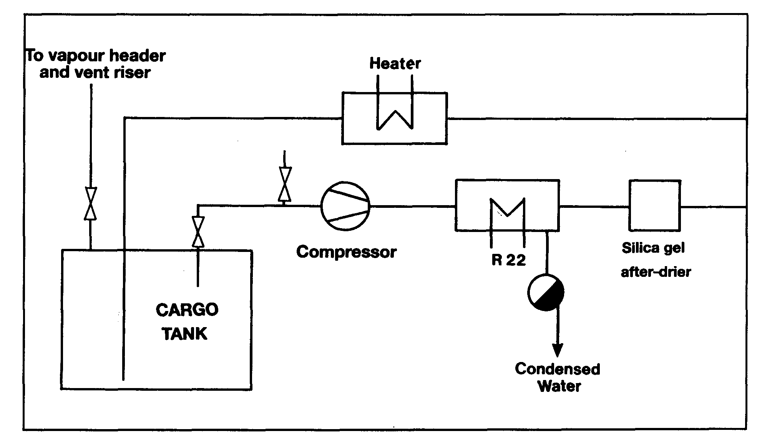
Figure 7.1 Air Drying — operational cycle
the cargo tank by a compressor or provided by the on board inert gas blower (without combustion) and passed through a refrigerated drier. The drier is normally cooled by R22 refrigerant. Here the air is cooled and the water vapour is condensed out and drained off. The air leaving the drier is, therefore, saturated at a lower dew point. Further reduction of the dew point can be achieved by a silica gel after-drier fitted downstream. Thereafter, the air may be warmed back to ambient conditions by means of an air heater and returned to the cargo tank. This process is continued for all ship tanks (and pipelines) until the dew point of the in-tank atmosphere is appropriate to carriage conditions.
7.2.3 Inerting — before loading
Inerting cargo tanks, cargo machinery and pipelines is undertaken primarily to ensure a non-flammable condition during subsequent gassing-up with cargo. For this purpose, oxygen concentration must be reduced from 21 per cent to a maximum of five per cent by volume although lower values are often preferred — see Table 2.3(b).
However, another reason for inerting is that for some of the more reactive chemical gases, such as vinyl chloride or butadiene, levels of oxygen as low as 0.1 per cent may be required to avoid a chemical reaction with the incoming vapour. Such low oxygen levels can usually only be achieved by nitrogen inerting provided from the shore (see 2.5 and 4.7.3).
There are two procedures, which can be used for inerting cargo tanks: displacement or dilution. These procedures are discussed below.

Inerting by displacement
Inerting by displacement, also known as piston purge, relies on stratification of the cargo tank atmosphere based on the difference in vapour densities between the gas
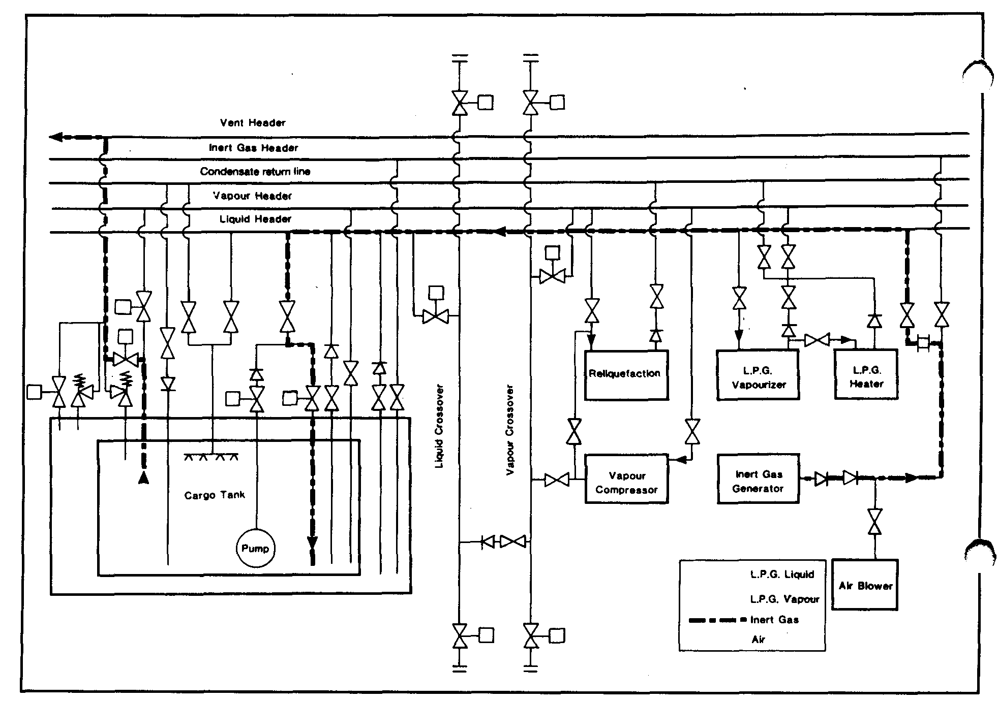
Figure 7.2 Inerting cargo tanks by the displacement method
entering the tank and the gas already in the tank. The heavier gas (see Table 2.5) is introduced beneath the lighter gas at a low velocity to minimise turbulence. If good stratification can be achieved, with little mixing at the interface, then just one tank volume of the incoming inert gas is sufficient to change the atmosphere. In practice mixing occurs and it is necessary to use more than one tank-volume of inert gas. This amount may vary by up to four times the tank volume, depending on the relative densities of the gases together with tank and pipeline configurations. There is little density difference between air and inert gas (see Table 2.4); inert gas from a combustion generator is slightly heavier than air while nitrogen is slightly lighter. Theses small density differences make inerting by displacement difficult to achieve and usually the process becomes part displacement and part dilution (discussed below). Combustion-generated inert gas is usually introduced through the liquid loading line with the effluent being exhausted through the vapour line into the vent header. Figure 7.2 shows the inerting of a cargo tank by the displacement method. The symbols used in this and the cargo handling diagrams, which follow, are identified at the beginning of this book.
Inerting by displacement is an economical procedure as it uses the least amount of inert gas and takes the shortest time. However, it is only practical when mixing with the initial tank vapour can be limited. If the tank shape and the position pipe-entries are suitable for the displacement method, then results will be improved by inerting more than one tank at a time. This should be done with the tanks aligned in parallel. The sharing of the inert gas generator output between tanks reduces gas inlet speeds, so limiting vapour mixing at the interface. At the same time the total inert gas flow increases due to the lower overall flow resistance. Tanks being inerted in this way should be monitored to ensure equal sharing of the inert gas flow.

Inerting by dilution
When inerting a tank by the dilution method, the incoming inert gas mixes, through turbulence, with the gas already in the tank. The dilution method can be carried out in several different ways and these are described below: —

Dilution by repeated pressurisation
In the case of Type ‘C’ tanks, inerting by dilution can be achieved through a process of repeated pressurisation. In this case, inert gas is pressurised into the tank using a cargo compressor. This is followed by release of the compressed gases to atmosphere. Each repetition brings the tank nearer and nearer-to the oxygen concentration of the inert gas. Thus, for example, to bring the tank contents to a level of five per cent oxygen within a reasonable number of repetitions, inert gas quality of better than five per cent oxygen is required.
It has been found that quicker results will be achieved by more numerous repetitions, each at low pressurisation, than by fewer repetitions at higher pressurisation.

Dilution by repeated vacuum
Type ‘C’ tanks are usually capable of operating under considerable vacuum and, depending on tank design, vacuum-breaking valves are set to permit vacuums in the range from 30 per cent up to 70 per cent. Inerting by successive dilutions may be carried out by repeatedly drawing a vacuum on the tank. This is achieved by using the cargo compressor and then, breaking the vacuum with inert gas. If, for instance, a 50 per cent vacuum can be drawn, then, on each vacuum cycle, half the oxygen content of the tank is removed. Of course, some of the withdrawn oxygen will be replaced by the oxygen content of the inert gas.
Of all the dilution processes, this method can be the most economical as only the minimum quantity of inert gas is used to achieve the desired inerting level. The overall time taken, however, may be longer than with the pressurisation method because of reduced compressor capacity when working on vacuum and a slow rate of vacuum-breaking due to limited output of the inert gas generator.

Continuous dilution
Inerting by dilution can be carried out as a continuous process. Indeed, this is the only diluting process available for Type ‘A’ tanks, which have very small, over-pressure or vacuum capabilities. For a true dilution process, (as opposed to one aiming at displacement) it is relatively unimportant where the inert gas inlet or the tank efflux are located, provided that good mixing is achieved. Accordingly, it is usually found satisfactory to introduce the inert gas at high speed through the vapour connections and to discharge the gas mixture via the bottom loading lines.
When using the continuous dilution method on ships with Type ‘C’ tanks, increased inert gas flow (and thereby better mixing and reduced overall time) may be achieved by maintaining the tank under vacuum. This is accomplished by drawing the vented gas through the cargo vapour compressor. Under these circumstances care should be taken to ensure good quality inert gas under the increased flow conditions.
Where a number of tanks are to be inerted, it may be possible to achieve a reduction in the total volume of inert gas used, and the overall time taken, by inerting tanks one after the other in series. This procedure also inerts pipelines and equipment at the same time. (On some ships, cargo and vapour pipeline arrangements may prevent more than two tanks being linked in series.) The extra flow resistance of a series arrangement will decrease the inert gas flow rate below that achievable when inerting tanks singly.

As can be seen from the foregoing discussion, the optimum arrangement for inerting by dilution will differ from ship to ship and may be a matter of experience.

Inert gas — general considerations
It can be seen from the preceding paragraphs that inert gas can be used in different ways to achieve inerted cargo tanks. No one method can be identified as the best since the choice will vary with ship design and gas density differences. Generally, each individual ship should establish its favored procedure from experience. As already indicated, the displacement method of inerting is the best but its efficiency depends upon good stratification between the inert gas and the air or vapours to be expelled. Unless the inert gas entry arrangements and the gas density differences are appropriate to stratification, it may be better to opt for a dilution method. This requires fast and turbulent entry of the inert gas, upon which the efficiency of dilution depends.
Whichever method is used, it is important to monitor the oxygen concentration in each tank from time to time, from suitable locations, using the vapour sampling connections provided. In this way, the progress of inerting can be assessed and, eventually, assurance can be given that the whole cargo system is adequately inerted.
While the above discussion on inerting has centered on using an inert gas generator, the same principles apply to the use of nitrogen. The use of nitrogen may be required when preparing tanks for the carriage of chemical gases such as vinyl chloride, ethylene or butadiene. Because of the high cost of nitrogen, the chosen inerting method should be consistent with minimum nitrogen consumption.

Inerting prior to loading ammonia
Modern practice demands that ships’ tanks be inerted with nitrogen prior to loading ammonia. This is so, even though ammonia vapour is not readily ignited.
Inert gas from a combustion-type generator must never be used when preparing tanks for ammonia. This is because ammonia reacts with the carbon dioxide in inert gas to produce carbamates. Accordingly, it is necessary for nitrogen to be taken from the shore as shipboard nitrogen generators are of small capacity.
The need for inerting a ship’s tanks prior to loading ammonia is further underscored by a particular hazard associated with spray loading. Liquid ammonia should never be sprayed into a tank containing air as there is a risk of creating a static charge which could cause ignition. (Mixtures of ammonia in air also introduce an additional risk and they can accelerate stress corrosion cracking — see 2.3.)

7.3 GASSING-UP
Neither nitrogen nor carbon dioxide, the main constituents of inert gas, can be condensed by a ship’s reliquefaction plant. This is because, at cargo temperatures, each is above its critical temperature and is, therefore, incondensable. Accordingly, removal of inert gas from the cargo tank is necessary. This is achieved by gassing-up, using vapour from the cargo to be loaded at ambient temperature and venting the incondensable to atmosphere so that subsequently the reliquefaction plant can operate efficiently.
Similarly, on changing grade, without any intervening inerting, it may first be necessary to remove the vapour of the previous cargo with vapour of the cargo to be loaded. The basic principles discussed previously in respect of inerting methods apply equally to this type of gassing-up. However, when gassing-up, there is usually a greater density difference between cargo vapours — see Table 2.5 — than is the case when inerting from air. (See 9.7.3 and 9.7.4 for measuring progress in this operation).
7.3.1 Gassing-up at sea using liquid from deck storage tanks
Gassing-up at sea is a procedure normally only available to fully refrigerated, or semi-pressurised ships. Such carriers are often equipped with deck tanks, which may have a compatible cargo in storage. In this case, either vapour or liquid can be taken from the deck tanks into the cargo tanks.
Liquid can be taken directly from deck storage through the tank sprays (with the exception of ammonia). This is done at a carefully controlled rate to avoid cold liquid striking warm tank surfaces. In this case, vapour mixing occurs in the cargo tanks and the mixed vapours can be taken into other tanks (when purging in series) or exhausted to the vent riser.
Alternatively, liquid from the deck storage tanks can be vaporized in the cargo vaporiser and introduced gradually into the top or bottom of the cargo tank, depending on vapour density, to displace the existing inert gas or vapour to other tanks or to the vent riser.
Only when the concentration of cargo vapour in the tanks has reached approximately 90 per cent (or as specified by the compressor manufacturer) should the compressor be started and cool-down of the system begin.
7.3.2 Gassing-up alongside
Gassing-up operations, which take place alongside, are undertaken using cargo supplied from the shore. At certain terminals, facilities exist to allow the operation to be carried out alongside but these terminals are in a minority. This is because the venting of hydrocarbon vapours alongside a jetty may present a hazard and is, therefore, prohibited by most terminals and port authorities.
Thus, well before a ship arrives in port with tanks inerted, the following points must be considered by the shipmaster:—
- Is venting allowed alongside? If so, what is permissible?
- Is a vapour return facility to a flare available?
- Is liquid or is vapour provided from the terminal for gassing-up?
- Will only one tank be gassed-up and cooled down initially from the shore?
- How much liquid must be taken on board to gas-up and cool-down the remaining tanks?
- Where can the full gassing-up operation be carried out?
Before commencing gassing-up operations alongside, the terminal will normally sample tank atmospheres to check that the oxygen is less than five per cent for LPG cargoes (some terminals require as low as 0.5 per cent) or the much lower concentrations required for chemical gases such as vinyl chloride — see Table 2.3(b).
Where no venting to atmosphere is permitted, a vapour return facility must be provided and used throughout the gassing-up operation. In this case, either the ship’s

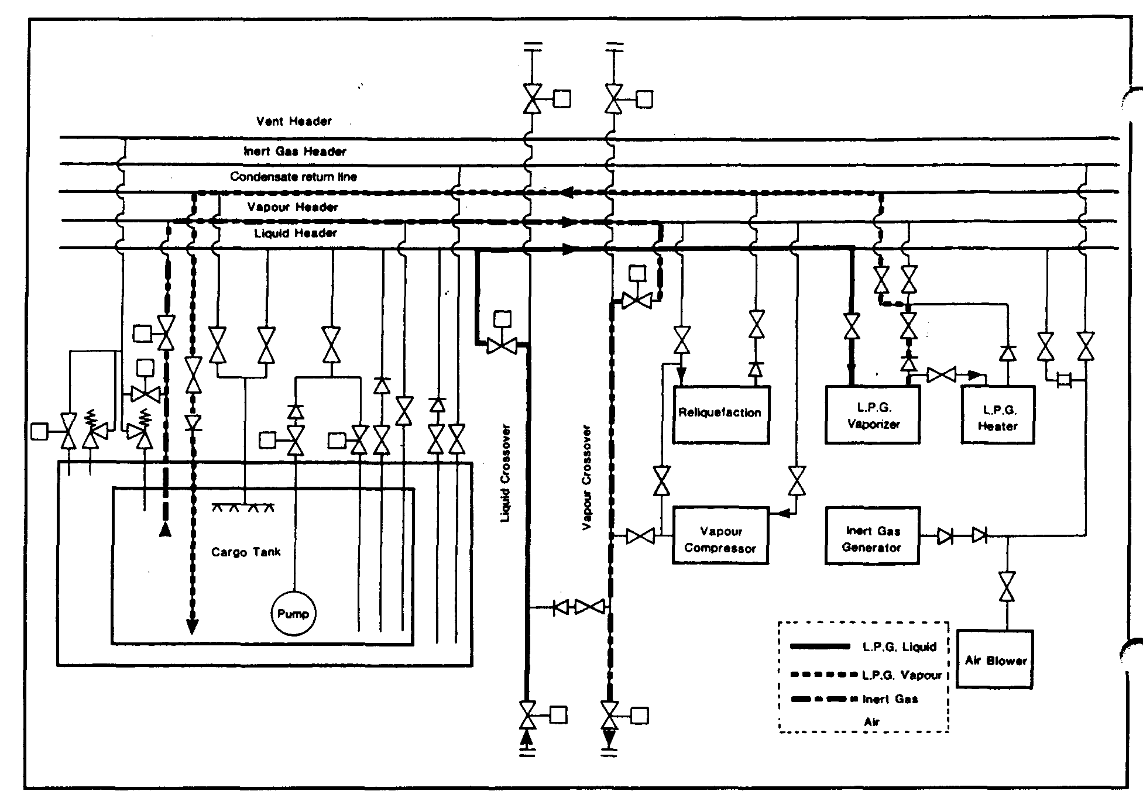

Figure 7.3(a) Gassing-up cargo tanks using liquid from shore
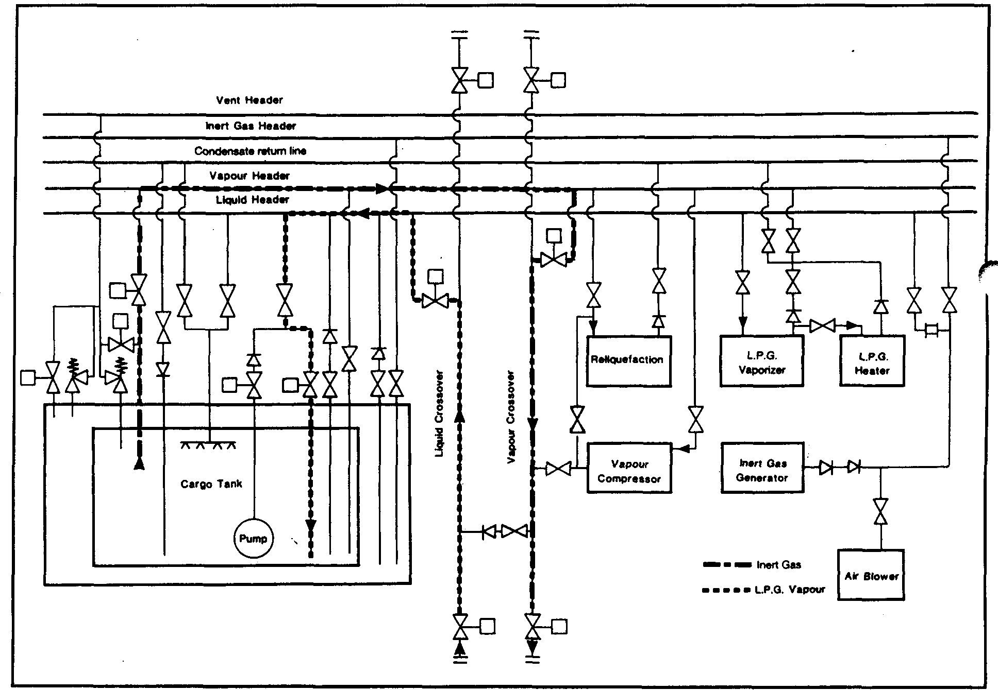
Figure 7.3(b) Gassing-up cargo tanks using vapour from shore

cargo compressors or a jetty vapour blower can be used to handle the efflux. Some terminals, while prohibiting the venting of cargo vapours, permit the efflux to atmosphere of inert gas. Thus, if a displacement method of gassing-up is used — see 7.2.3 — the need for vapour return to shore may be postponed until cargo vapours are detected at the vent riser. This point may be considerably postponed if tanks are gassed-up one after the other in series.
Where a terminal supplies a liquid for gassing-up, it should be loaded at a carefully controlled rate. It is then passed through the ship’s vaporiser. Alternatively, the liquid may be allowed to vaporise in the ship’s tanks. If vapour is supplied, this can be introduced into the tank at the top or bottom depending on the vapour density (see Table 2.5). Figures 7.3(a) and 7.3(b) show typical gassing-up operations using liquid from shore and vapour from shore, respectively.
When a ship arrives alongside with tanks containing a cargo vapour, which requires to be replaced with the vapour of a different grade, then the terminal will normally provide a vapour return line. The vapours taken to the shore will be flared until the desired vapour quality is achieved in the tanks. At this point cool-down can begin.
If facilities, such as a vapour return line, are not available for the ship to gas-up alongside, it is common practice for the ship to prepare one cargo tank and to take sufficient liquid to complete the operation elsewhere. The ship then leaves the berth for a designated anchorage or proceeds to sea. The ship returns to the berth after having gassed-up and cooled-down all cargo tanks.
Recent developments have been made in LPG vapour recovery systems. Such systems are using the energy obtained from vaporising liquid nitrogen to reliquefy the cargo vapour returned from the ship, either during gassing-up operations or during inerting operations, (see 7.9.3) thus avoiding any venting of hydro carbon gases. The skid mounted unit would receive liquid nitrogen from a truck, vaporise it for delivery to the ship and at the same time reliquefy the return cargo vapour for storage and further usage.

7.4 COOL-DOWN

Cool-down — refrigerated ship
Cooling down is necessary to avoid excessive tank pressures (due to flash evaporation) during bulk loading. Cool-down consists of spraying cargo liquid into a tank at a slow rate. The lower the cargo carriage temperature, the more important the cool down procedure becomes.
Before loading a refrigerated cargo, ship’s tanks must be cooled down slowly in order to minimise thermal stresses. The rate at which a cargo tank can be cooled, without creating high thermal stress, depends on the design of the containment system and is typically 10°C per hour. Reference should always be made to the ship’s operating manual to determine the allowable cool-down rate.
The normal cool-down procedure takes the following form. Cargo liquid from shore (or from deck storage) is gradually introduced into the tanks either through spray lines, if fitted for this, purpose, or via the cargo loading lines. The vapours produced by rapid evaporation may be taken ashore or handled in the ship’s reliquefaction plant. Additional liquid is then introduced at a rate depending upon tank pressures and temperatures. If the vapour boil-off is being handled in the ship’s reliquefaction plant, difficulties may be experienced with incondensibles, such as nitrogen, remaining from the inert gas. A close watch should be kept on compressor discharge temperatures

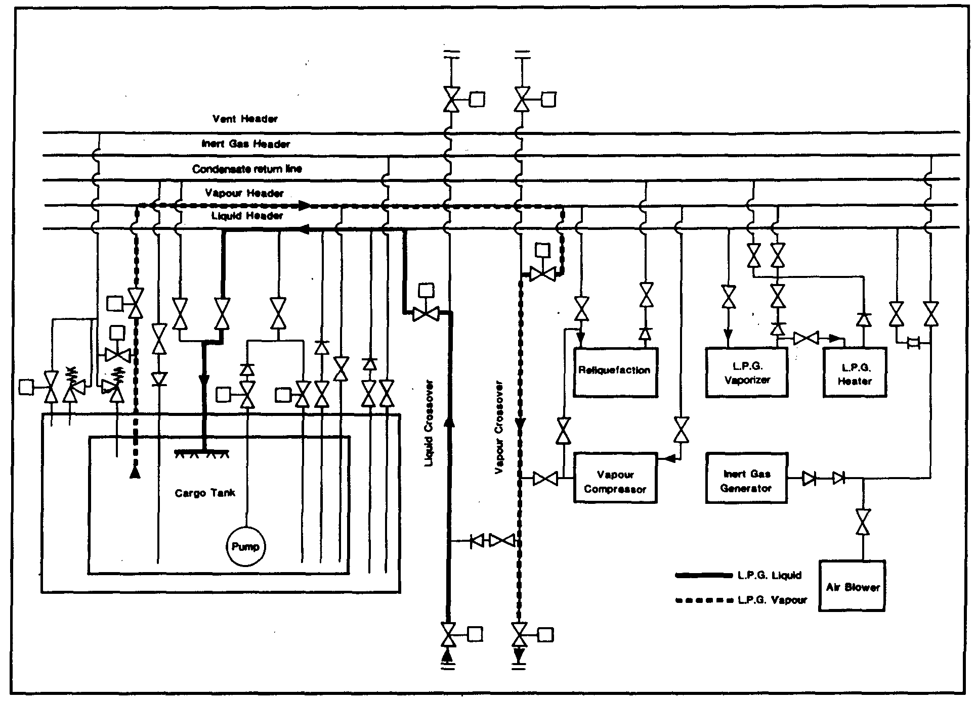
Figure 7.4 Cargo tank cool-down using liquid from shore: vapour returned to shore
and the incondensible gases should be vented from the top of the condenser as required (see 7.6).
As the cargo containment system cools down, the thermal contraction of the tank combined with the drop in temperature around it tend to cause a pressure drop in the hold and interbarrier spaces. Normally, pressure control systems supplying air or inert gas will maintain these spaces at suitable pressures but a watch should be kept on appropriate instruments as the cool-down proceeds.
Cool-down should continue until boil-off eases and liquid begins to form in the bottom of the cargo tanks. This can be seen from temperature sensors. At this stage, for fully refrigerated ammonia for example, the pool of liquid formed will be at approximately -34°C while the top of the tank may still be at -14°C. This gives a temperature difference of 20°C. The actual temperature difference depends on the size of the cargo tank and the spray nozzles positions.
Difficulties that may occur during cool-down can result from inadequate gassing-up (too much inert gas remaining) or from inadequate drying. In this latter case, ice or hydrates may form and ice-up valves and pump shafts. In such cases, antifreeze can be added, provided the cargo is not put off specification, or the addition will not damage the electrical insulation of a submerged cargo pump. Throughout the cool-down, deepwell pump shafts should be turned frequently by hand to prevent the pumps from freezing up.
Once the cargo tanks have been cooled down, cargo pipelines and equipment should be cooled down. Figure 7.4 shows the pipeline arrangement for tank cool-down using liquid supplied from the shore.

Cool-down — semi-pressurised ships
Most semi-pressurised ships have cargo tanks constructed of steels suitable for the minimum temperature of fully refrigerated cargoes. However, care must be taken to avoid subjecting the steel to lower temperatures. It is necessary to maintain a pressure within the cargo tank at least equal to the saturated vapour pressure corresponding to the minimum allowable steel temperature. This can be done by passing the liquid through the cargo vaporiser and introducing vapour into the tank with the cargo compressor. Alternatively, vapour can be provided from the shore.

7.5 LOADING

7.5.1 Loading — preliminary procedures
Before loading operations begin, the pre-operational ship/shore procedures must be thoroughly discussed and carried out. Appropriate information exchange is required and the relevant parts of the Ship/Shore Safety Check List should be completed (see also 5.3.2, 6.4, 6.5 and 10.5). Particular attention should be paid to:
- The setting of cargo tank relief valves and high alarm pressures
- Remotely operated valves
- Reliquefaction equipment
- Gas detection systems
- Alarms and controls, and
- The maximum loading rate
This should all be carried out taking into account restrictions in ship/shore systems.
The terminal should provide the necessary information on the cargo, including inhibitor certificates where inhibited cargoes are loaded (see 2.6). Any other special precautions for specific cargoes should be made known to ship personnel. This may include the lower compressor discharge temperatures required for some chemical gas cargoes (see 7.6). Where fitted, variable setting pressure relief valves, high tank pressure alarms and gas detection sample valves should be correctly set.
The ballast system for gas carriers is totally independent of the cargo system, as outlined in 3.5. Deballasting can, therefore, take place simultaneously with loading, subject to local regulations. Ship stability and stress are of primary importance during loading. Procedures for these matters are in accordance with normal tanker practice.

The ship’s seagoing safety

Trim, stability and stress
The cargo plan should allow for distribution within the ship in order to achieve acceptable structural stress and the required ship trim to meet safe stability conditions when at sea. For these purposes, the weight of the cargo in each tank will need to be known. For ship stability purposes, the weight in question is the true weight-in-air.
As will be seen from the procedures discussed in Chapter Eight, the weight-in-air of liquefied gases, calculated for cargo custody purposes, is not exact in that the cargo vapour in these calculations is assumed to be liquid of the same mass as the vapour.

Thus, the air buoyancy of the cargo vapour spaces has been neglected. However, for practical purposes concerning a ship’s stability calculation, this may be ignored.
All gas carriers, as part of the statutory requirements, are provided with stability date.,’ including worked examples showing cargo loaded in a variety of ways. In conjunction with consumables such as fresh water, spare parts and bunkers on board, these conditions provide cargo storage guidelines to ship’s officers in order to maintain the ship in a safe and stable condition. Additionally, as part of the requirements to obtain a Certificate of Fitness in compliance with the Gas Codes, the stability conditions must be such that, in specified damaged conditions, the ship will meet certain survival requirements. It is, therefore, essential that all relevant guidance concerning the filling of cargo tanks be observed.

Sloshing
A further point to be noted in respect of tank filling levels is that, large prismatic cargo tanks, due to their width and shape, may suffer from substantial sloshing of cargo in heavy pitching or rolling conditions. Such tanks, and particularly membrane-type tanks which have no centre line wash bulkheads, may have prohibited filling levels in order to avoid damage to tank structures or internal fittings. Typical controls on such tanks are a prohibition on all filling levels in the 10 to 80 per cent range.
n
If an unusual cargo distribution is requested and if this involves cargo tanks only bein^ part-filled, then it is usual for the shipmaster to seek further guidance from shipowners. In such cases it is sometimes necessary for the owner to seek confirmation from the ship’s classification society before loading can start.
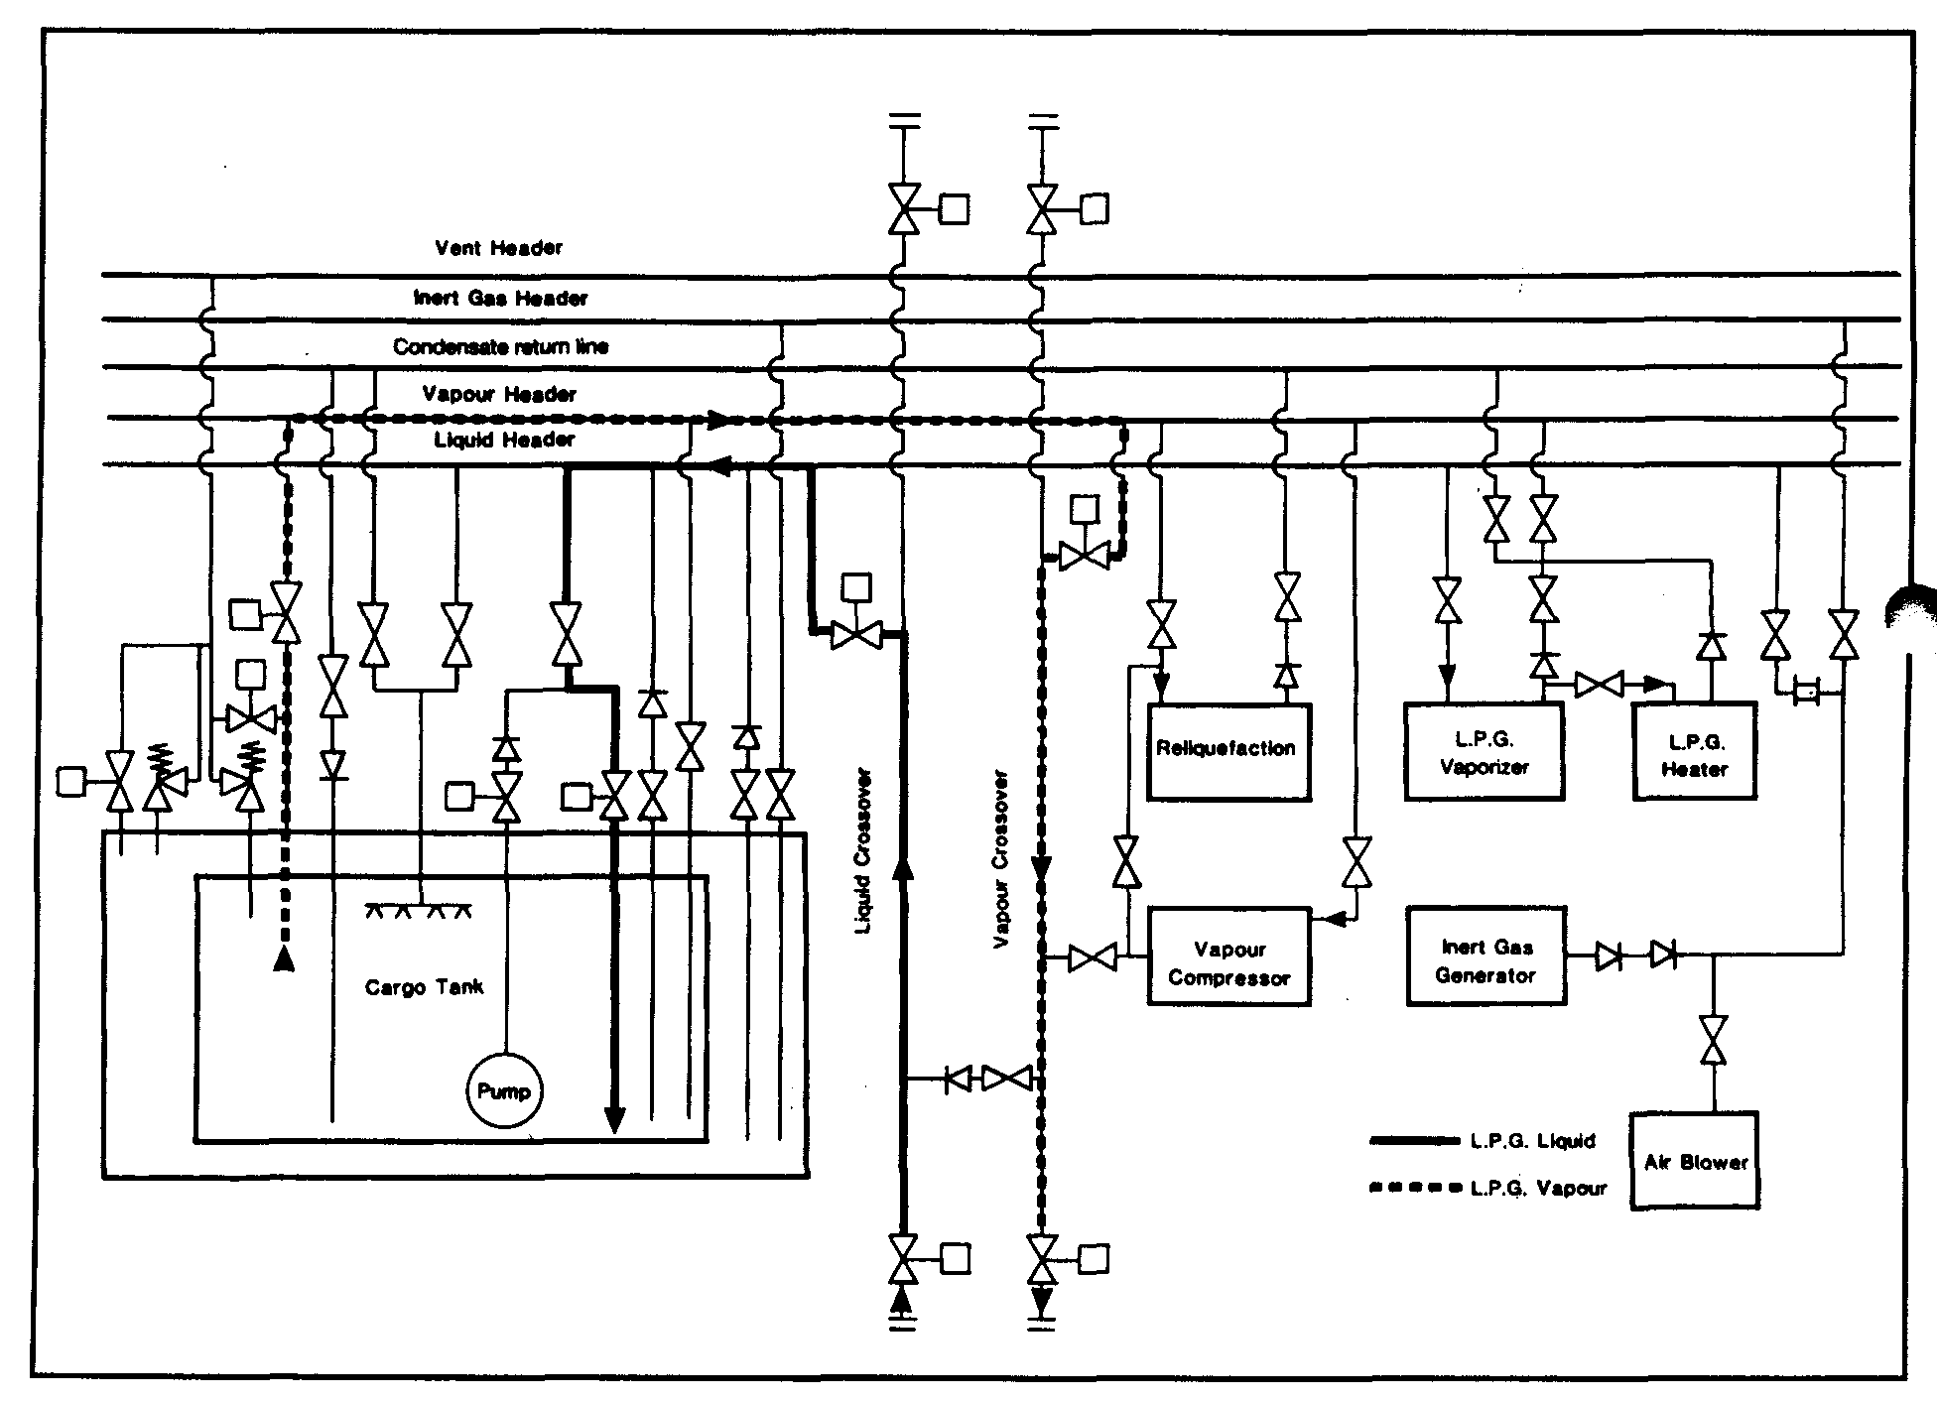

Figure 7.5 Loading with vapour return

Cargo tank loading limits
Apart from the sloshing requirement outlined above, the question of cargo tank loading limits — as discussed in 7.5.5 should also be addressed. (Reference 2.37).

7.5.2 Control of vapours during loading
The control of cargo vapours during loading can be carried out by using: —
- A vapour return line to the shore coupled to a gas compressor
- The ship’s reliquefaction plant for liquid return to the ship’s tanks, or
- Both of the above.
For LNG ships, as depicted in Figure 7.5, gas-return to the shore, using a vapour return system, is normal. This is because there are no reliquefaction plants fitted on board. For such ships, the liquid cargo is loaded via the liquid header and piped to the appropriate tanks. Gas generated in the vapour space is returned to the shore using a cargo vapour compressor. This equipment is usually mounted on board ship but may be mounted ashore; the choice is dependant on project specifications.
When loading with a vapour return line in use, the loading rate is independent of the capacity of the ship’s reliquefaction plant and is governed by:
- The flow rate acceptable to the ship and terminal, and
- The capacity of the cargo vapour compressor
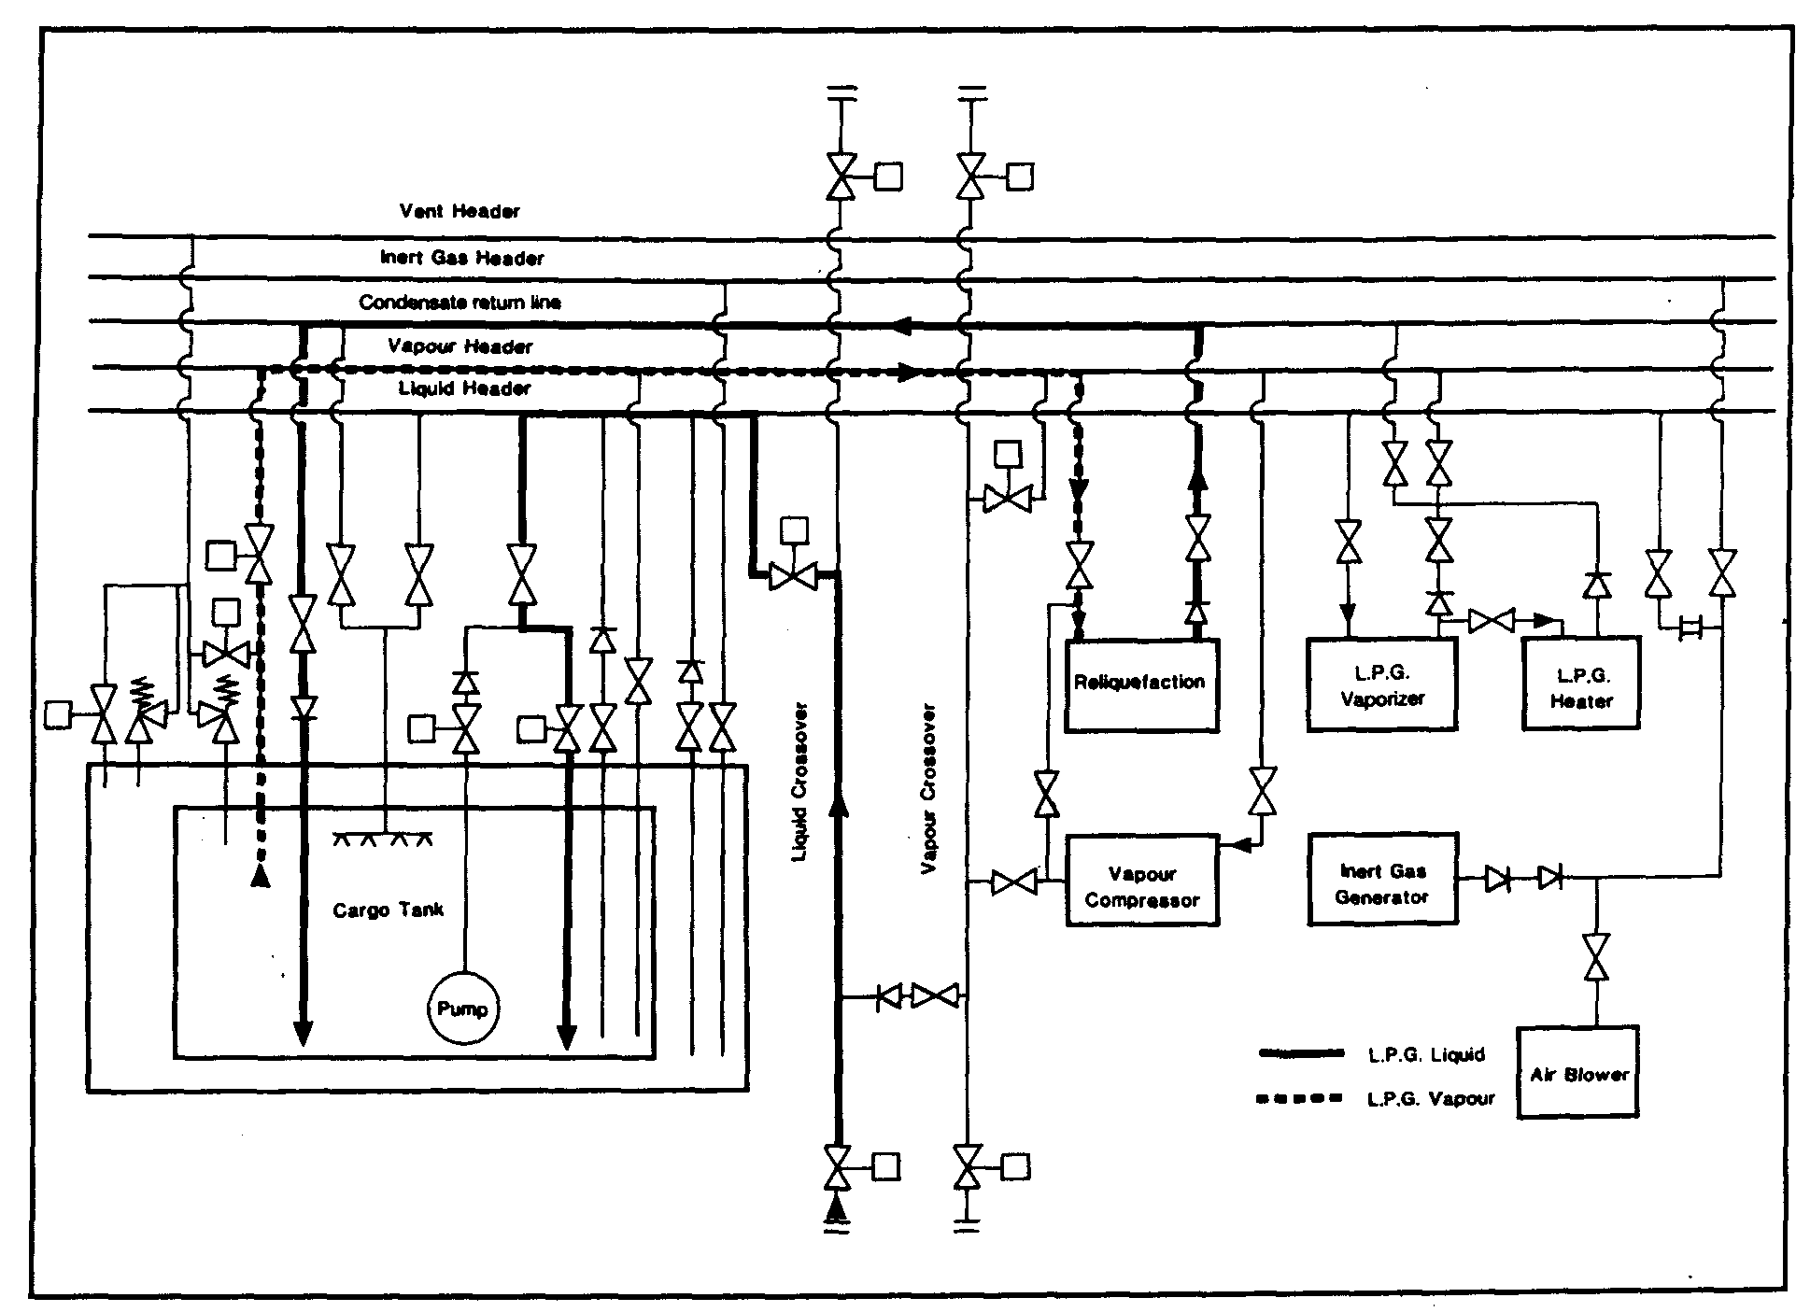

Figure 7.6 Loading without vapour return

For fully refrigerated or semi-pressurised LPG ships, a vapour return line is normally connected to the ship’s vapour manifold but this is most often put in place for safety relief purposes. Normal loading practice on such ships is to load through the liquid header, to draw off excess vapour via the vapour header, to operate the reliquefaction plant and to return the liquid to the ship’s tank via the condensate return line. This operation controls cargo boil-off and ensures that tank pressure limits are not exceeded. The pipeline arrangement is shown in Figure 7.6. The introduction of a reliquefaction plant in the system can mean that loading rates are restricted by the capacity of the machinery. It is in this sense that the vapour return line acts as a safety device; should tank pressures become excessive, the ship’s vapour manifold valve can be opened to relieve the situation. (For pressurised LPG carriers, the system should be similar to that described in this paragraph, and a vapour return should be fitted for safety relief purposes. However, a reliquefaction system is not fitted to such ships and loading is normally achieved by shore pumps creating sufficient pressure to allow cargo tank vapour to continuously condense into the bulk liquid.)
Where refrigerated storage is found in a terminal, the terminal’s reliquefaction capacity is usually greater than that provided on board ship. As a result, where an LPG vapour return is used, in a similar way to that described for LNG ships, loading rates can be higher than those described in the previous paragraph. However, while advantageous, such systems for LPG are relatively rare.
A problem experienced when using vapour returns in the LPG trades is that terminals can be concerned about the vapour quality to be returned to the shore. This is especially so at the early stages of loading. Terminal personnel can be concerned about residual nitrogen, which acts as an incondensible during reliquefaction. They may also be concerned about contamination with vapours from previous ship-cargoes. It is also difficult to account for the vapour returned to shore, especially if it is flared. This can lead to an overstatement of the Bill of Lading quantity, unless credit is given for the returned vapour. For these reasons it is unusual to find LPG terminals accepting return gas other than for safety reasons and then only to a flare (see also 8.1.6).

7.5.3 Loading — early stages

Loading refrigerated ships
When liquefied gas is being loaded, it is necessary to consider the location, pressure, temperature and volume of the shore tanks as well as the terminal’s pumping procedures. Fully refrigerated ships usually load from fully refrigerated storage where tanks typically operate at a pressure of approximately 60 millibars.
This pressure will allow the cargo at the bottom of a full shore tank to sustain a temperature perhaps one degree Centigrade warmer than its atmospheric boiling point.
When this cargo is pumped to the jetty, the pumping energy required for transfer is dissipated in the liquid as heat, to which must be added the heat flow into the liquid through the pipelines. The cargo may, therefore, arrive on the ship at an even warmer temperature. When loading without a vapour return line being used, the vapour, which is displaced by the incoming liquid, must be reliquefied on board. The power required for this, and to compensate for the pumping energy and the heat flux through the insulation, may leave little capacity for cooling the cargo during loading.
Therefore, as can be seen from the foregoing paragraphs, the early stages of loading can be critical, particularly where significant distances exist between the storage tank and jetty. The ship’s tank pressures must be regularly checked and on no account should relief valves be allowed to lift. Loading rates should be reduced, and if necessary stopped, when difficulties are experienced in maintaining acceptable tank pressures. In some ports in hot countries, where the terminal has long pipelines, this feature can be difficult to overcome. Under these circumstances, cargo stoppage would allow the pipeline contents once again to rise in temperature. Accordingly, in such ports, cargo flow should be maintained as long as it is safe to do so until cold product can be received on board at which time tank pressures will fall.
A rise in ship’s tank pressure in the early stages of loading can also be controlled to some extent by loading limited quantities of liquid into the cargo tank via the top sprays, if fitted. This will help to condense some of the cargo vapours.

Loading pressurised ships
Pressurised ships normally arrive at a loading terminal having cargo tanks at atmospheric pressure. Firstly, the ship requests vapours from the shore to purge any remaining nitrogen or contaminants from the tanks. This also allows the equalization of ship and shore pressures. Thereafter, the method used is to start loading at a very slow flow, giving time for the incoming liquid to expand safely at the first valves in the ship’s system.
In this case, as the liquid is allowed through, local flash cooling can occur and it is important to ensure that at no time, tank or pipeline temperatures are allowed to fall below design limitations.

Loading pressurised ships from refrigerated storage
The cargo tanks on fully pressurised ships are made from carbon steel which is only suitable for a minimum temperature of between 0°C and -5°C. In contrast, LPG when stored in the fully refrigerated condition are maintained at the temperatures given in Table 2.5. Consequently, some refrigerated cargoes require considerable heating prior to loading on such ships. Given that fully pressurised ships may not have cargo heaters fitted on board, all heat input must be provided by pumping through heaters fitted on shore.
Of course, on a pressurised ship, having loaded a cargo at close to 0°C, the cargo may warm up further during the voyage in accordance with ambient conditions. The Gas Codes only allow cargo to be loaded to such a level that the tank-filling limit will never be more than 98 per cent at the highest temperature reached during the voyage. This means that, during pre-loading discussions, tank topping-off levels must be established to allow sufficient room for liquid expansion into the vapour space while on voyage.

Loading semi-pressurised ships from refrigerated storage
The cargo tanks on semi-pressurised ships are usually constructed of low temperature sheets able to accommodate fully refrigerated propane at temperatures of between -40°C and -50°C — or even for ethylene carriers at -104°C. Refrigerated cargoes can therefore be loaded directly to such ships without heating. In addition, these ships can usually maintain fully refrigerated temperatures on voyage and this is often done to gain more space so that a greater weight of cargo can be carried. The tank pressure must however always be maintained slightly above atmospheric. Temperatures of sub-cooled products under vacuum conditions can reach levels much lower than what is acceptable for the tank material. However, when discharge to pressurised storage is planned, this is conditional on the ship having suitable equipment to warm the cargo. On semi-pressurised ships, the cargo is occasionally allowed to warm up during the loaded voyage and in this case, a similar procedure to that described for fully pressurised ships applies.

Terminal pipeline system and operation
Where a terminal can expect to load fully pressurised ships not fitted with their own heaters, in-line equipment fitted to terminal pipeline systems is needed. This usually comprises the following:—
- Shore tank
- Cargo pump
- Booster pump
- Cargo heater
- Suitably sized loading arm
When considering a refrigerated terminal loading a fully pressurised ship, given that loading temperatures on these ships are limited to about 0°C, loadings can normally be managed by pumping through the refrigerated pipelines rated at 19 bar.
Operation of the system takes the following form: Firstly, until back pressure starts to build up from the ship, loading is carried out by pumping only through the cargo heater then, as the back pressure increases, the booster pump is also brought into operation.
At the start of loading, the pressure in a ship’s tank should be at least 3 bar. This pressure will limit flashing-off and sub-cooling as the first liquid enters the tank. At this time, in-tank cargo temperatures should be carefully watched. Practical observation also of value, with the sighting of ice formation on pipelines acting as a warning that temperatures on board the ship are falling below safe levels. In such cases, loading must be stopped until temperatures increase and the problem is resolved.

Small ship problems at large berths
A primary concern for the loading of small ships is that refrigerated storage is most often designed for large ship/shore operations. At the jetty, this means that mooring plans must be properly adapted to accommodate the very different mooring patterns from small ships and that loading arms or hoses are of a size suited to the operation.
Large loading arms can introduce difficulties on small ships. If the berth is in an exposed area, a small ship (being more sensitive, than a larger ship, to the sea state) may roll and pitch at the berth. The loading arm has to keep pace with these fast movements and this is quite a different question from any slow changes (say tidal) which may be accommodated under normal design considerations. Here, the inertia of the loading arm has to be taken into account. At present, such dynamic forces are not considered in loading arm design and manufacturers leave this for terminal managers to address in operational procedures. In such cases, a possible solution ^{r}^ the use of cargo hose.

7.5.4 Bulk loading
Depending on the efficiency of the earlier gassing-up operation, significant quantities of incondensible gases may be present in tank atmospheres and, without vapour return to shore, these incondensibles will have to be vented via the ship’s purge-gas condenser (where fitted) or, alternatively, from the top of the cargo condenser. Figure 4.17 shows a purge-gas condenser arrangement. Care must be taken when venting incondensibles to minimise venting of cargo vapours to the atmosphere. As the incondensibles are vented, the condenser pressure will drop and the vent valve should be throttled and eventually closed.
A close watch should be kept on the ship’s cargo tank pressures, temperatures, liquid levels and interbarrier space pressures, throughout the loading operation. Monitoring of liquid levels may present difficulties when the reliquefaction plant is in operation. This is because the liquid in the tank is boiling heavily at these times and, as a result, vapour bubbles within the liquid increase its volume, thus giving false readings when using float-type ullage gauges. Accurate level monitoring can be achieved by suppressing boiling and this can be done by temporarily closing the vapour suction from the tank.
Towards the end of loading, transfer rates should be reduced as previously agreed with shore personnel in order to accurately top-off tanks. On completion of loading, ship’s pipelines should be drained back to the cargo tanks. Remaining liquid residue can be cleared by blowing ashore with vapour, using the ship’s compressor. Alternatively, this residue may be cleared by nitrogen injected into the loading arm to blow the liquid into the ship’s tanks. Once liquid has been cleared and pipelines have been depressurized, manifold valves should be closed and the hose or loading arm disconnected from the manifold flange.
In many ports it is a requirement, before disconnection takes place, for the hard arm, hose and pipelines at the manifold to be purged free from flammable vapour.
The relief valves of some ships have dual settings to allow higher tank pressures during the loading operation. This is permissible in the absence of dynamic forces, which occur only when the vessel is at sea. If relief valve settings are altered by changing the pilot spring, then the procedure must be properly documented and logged and the current MARVS must be prominently displayed. Relief valves must be reset to the seagoing position before the ship departs. When relief valve pressure settings are changed, high pressure alarms have to be readjusted accordingly.

7.5.5 Cargo tank loading limits
Chapter 15 of the IGC Code recognizes the large thermal coefficient of expansion of liquefied gas and gives requirements for maximum allowable loading limits for cargo tanks. This is to avoid tanks becoming liquid-full under conditions of surrounding fire.
The maximum volume to which any tank may be filled is governed by the following formula: —
$$\text{LL}=\text{FL}\frac{ρR}{ρL}$$
where:
LL = loading limit expressed in per cent which means the maximum liquid volume relative to the tank volume to which the tank may be loaded.
FL = filling limit = 98 per cent unless certain exceptions apply.
ρR = relative density of cargo at the reference temperature.
ρL = relative density of the cargo at the loading temperature and pressure.
The reference temperature (in the expression ρR above) is defined as the temperature corresponding to the vapour pressure of the cargo at the set pressure of the relief valves. Some pressurised ships with Type ‘C’ tanks have a pressure capability of up to about 18 bars with relief valves being designed for this pressure. These loading limits impose a substantial cargo shut-out for fully pressurised ships loading cargo when operating in ambient conditions, well below 45°C which is the maximum operating temperature for which the pressure capabilities of such tanks are designed.
In the case of cargo tanks on fully refrigerated ships, the Gas Codes envisage relief valves set to open only marginally above the vapour pressure of the cargo at the maximum temperature it will reach over the whole cycle of loading, transportation and discharge. Even so, the loading limit must be such that, if a surrounding fire occurs, the tank will not become liquid-full before the relief valve opens. Thus, the amount o& cargo shut-out required, over and above the normal operational considerations cargo expansion, depends upon the margin between the relief valve setting and maximum envisaged vapour pressure on the voyage.
There are good safety reasons for minimizing cargo shut-out. The concept is very simple. The fuller the tank, the longer the tank structure will be able to withstand fire conditions. The tank contents, when exposed to a fire, will boil at a constant temperature until the bulk of the liquid has been vented through the relief valve system. After this, the upper regions of the tank become exceedingly hot and eventually fail. However, the greater the mass of liquid inside the tank, the longer the tank can withstand unacceptable external temperatures.
Cargo quantities can be maximized by adjustable settings on relief valves. This brings its own problems — particularly for Type ‘C’ pressurised ships — where the pressure differential between saturation temperature at the maximum allowable pressure is considerable. Relief valves designed for, say, 18 barg do not perform well at the reduced pressures required to minimise shut-out. When operated at such settings, gases are ejected at velocities well below those associated with design pressures, and as a consequence, the effluent is not propelled clear of hazardous areas.
The Gas Codes permit a further alternative solution which obviates any cargo shut-oni on loading beyond that of normal operational considerations of cargo temperature change. This solution requires the provision of an additional pressure relieving system with relief valves set to open at the maximum operational vapour pressure of the cargo. The system is brought into operation by the melting of fusible elements suitably located to detect surrounding fire conditions. It is not a popular or very practical solution.

Examples

Case 1
A fully pressurised ship loading propane at 20°C with relief valves set at 16 barg.
$$\text{LL}=\text{FL}\frac{ρR}{ρL}$$
Reference temperature +49°C (corresponding to SVP of 16+1 = 17 bar for propane.
Density of liquid propane at 49°C = 452 kg/m³.
Loading temperature +20°C Density of liquid propane at 20°C = 502 kg/m³
$$\text{LL}=\text{98}×\frac{\text{452}}{\text{502}}=\text{88}\text{.}2$$
Therefore, the tank can be filled to 88.2 per cent of tank volume.

Case 2
A semi-pressurised ship loading propane at -42°C with relief valves set at 5 barg and having no additional pressure relieving facility fitted.
Here, since no additional pressure relief is fitted in accordance with the Gas Codes, the reference temperature must be taken as the temperature corresponding to vapour pressure at set pressure of relief valves, i.e. a temperature corresponding to an SVP of 5+1=6 bar. Reference temperature = +8°C
Density of liquid propane at 8°C= 519 kg/m³
Loading temperature= -42°C
Density of liquid propane at -42°C = 582 kg/m³
$$\text{LL}=\text{98}×\frac{\text{519}}{\text{582}}=\text{87}\text{.}4$$
Thus, the tank can be filled to 87.4 per cent of tank volume.

Case 3
A fully refrigerated ship loading propane at -42°C with relief valves set at 0.25 barg.
Reference temperature -37.5°C
Density of liquid propane at -37.5°C = 577 kg/m³
Loading temperature -42°C
Density of liquid propane at -42°C = 582 kg/m³
Thus, the tank can be filled to 97.1 per cent of tank volume.

New developments
In recent years IMO recognised that the problem of cargo shut-out on ships with pressurised tanks (Type ‘C’ tanks) had not been properly solved under the original Gas Code formulae. Either the fire protection afforded by full tanks or the ability of relief valves to project vented gases away from decks and structure is sacrificed.
Amendments to the Gas Codes in 1995 produced a solution, which allows additional cargo to be loaded in Type ‘C’ tank ships. This concession can be granted to all Type ‘C’ carriers, except those designated by Chapter 19 of the IGC Codes as being 1G ships. These are specialised carriers transporting chlorine, ethylene oxide, methyl bromide and sulphur dioxide — see Appendix 2.
When the Gas Codes were first produced, it was recognised that tank relief valves were sized using empirical formulae based on experimental data from valve manufacturers. This data was based exclusively upon vapour flow. Although manufacturers had made allowances for liquid pick-up in vented gases, IMO decided tank relief inlets should never be exposed to liquid and, to this end, they required that tanks should never be more that 98 per cent full. This decision leads to the cargo shut-out illustrated by the worked examples.
Since the Gas Codes were first introduced, much work has been done on relief valve operation. It became apparent that, with a tank at 98 per cent full, relief valve operation would inevitably involve both liquid and vapour in the vented stream. Such two-phase flow occurs even when tank levels are as low as 80 per cent. This implied that existing relief valves sized using valve manufacturers’ methods can cope with all conditions of two-phase flow and still provide protection against over-pressure.
A further concern was dispelled when it was demonstrated that even with a tank 100 per cent full, when relief valves open, no jetting of liquid will occur at the vent riser. Much of this work was based on theoretical analysis made possible by an increased knowledge of the physics of two-phase flow. Theoretical work was backed by practical tests.
With this knowledge, IMO decided to amend the Gas Codes as they relate to Type ‘C’ tanks. In Chapter 15, they added a change in the definition of the relative cargo density for this particular category of tank.
ρR = relative density of cargo at the highest temperature which the cargo may reach upon termination of loading, during transport or at unloading, under the ambient design temperature conditions.
In the above definition the expression Ambient design temperature conditions is linked to the performance specification for temperature control of cargoes which states that the upper ambient design temperatures should be a sea temperature of 32°C and air temperature of 45°C.
The Gas Codes further state that for service in especially hot or cold zones, these design temperatures should be increased or reduced, as appropriate, by the national administration.
This allows the shipowner to demonstrate to the relevant national administration the rationale for the selection of the highest temperature.
In these new developments, IMO has retained the requirement for 2 per cent of tank volume to be a vapour space. The tank volume-filling limit thus remains at 98 per cent.
Although accepting that pressure relief valves can cope with all aspects of two-phase flow, IMO recognizes that relief valve performance can be affected by the piping system within which it is installed. To this end, administrations will now require shipowners to demonstrate that ships taking advantage of increased loading have tank venting systems which are adequate to deal with all aspects of two-phase flow.
Guidelines which provide a method whereby the adequacy of the vent system can be assessed are now available as an IMO publication. New ships should use the Guidelines as design criteria and, for existing ships, they will demonstrate if modification to the vent system is required.
The advantages of these concessions are easily demonstrated. Considering Case 1 of the worked examples, should the ship concerned be on a long voyage and likely to encounter seas at 32°C and air temperatures of 45°C for prolonged periods the prediction of the highest cargo temperature then becomes, say, 38°C. Under these circumstances, the Loading Limit becomes 92 per cent of tank volume. If however, it can be shown that the ship will operate in temperate waters and that the highest cargo temperature is 25°C, then, the Loading Limit becomes 96 per cent. If in Case 1, the highest cargo temperature anticipated is 20°C, then, the density ratio is unity and the Loading Limit 98 per cent. Furthermore, for cases 2 and 3 of the worked examples, the Loading Limit normally becomes 98 per cent.
For shipowners to take proper advantage of these rules, they should have performance details such that national administrations can understand how quickly a fully pressurised ship’s cargo may warm up during the voyage. Additionally, a clear indication of the route, which the ship will take, and the ambient conditions existing along that route, will further justify the selected highest temperature.
This selection process deserves a more detailed appraisal than is possible in the book. Accordingly, IACS and SIGTTO have produced a joint publication entitled:
Application of the Gas Carrier Code Amendments to Type ‘C’ Cargo Tank Loading Limits (see Reference 2.27).

7.6 THE LOADED VOYAGE

Cargo temperature control
For all refrigerated and semi-pressurised gas carriers, it is necessary to maintain strict control of cargo temperature and pressure throughout the loaded voyage. This is achieved by reliquefying cargo boil-off and returning it to the tanks (see also 7.5 and 4.5). During these operations, incondensibles must be vented as necessary to minimise compressor discharge pressures and temperatures. In LNG ships, the boil-off is burned as fuel in the ship’s main boilers (see also 4.6.5).
Frequently, there are occasions when it is required to reduce the temperature of an LPG cargo on voyage. This is necessary so that the ship can arrive at the discharge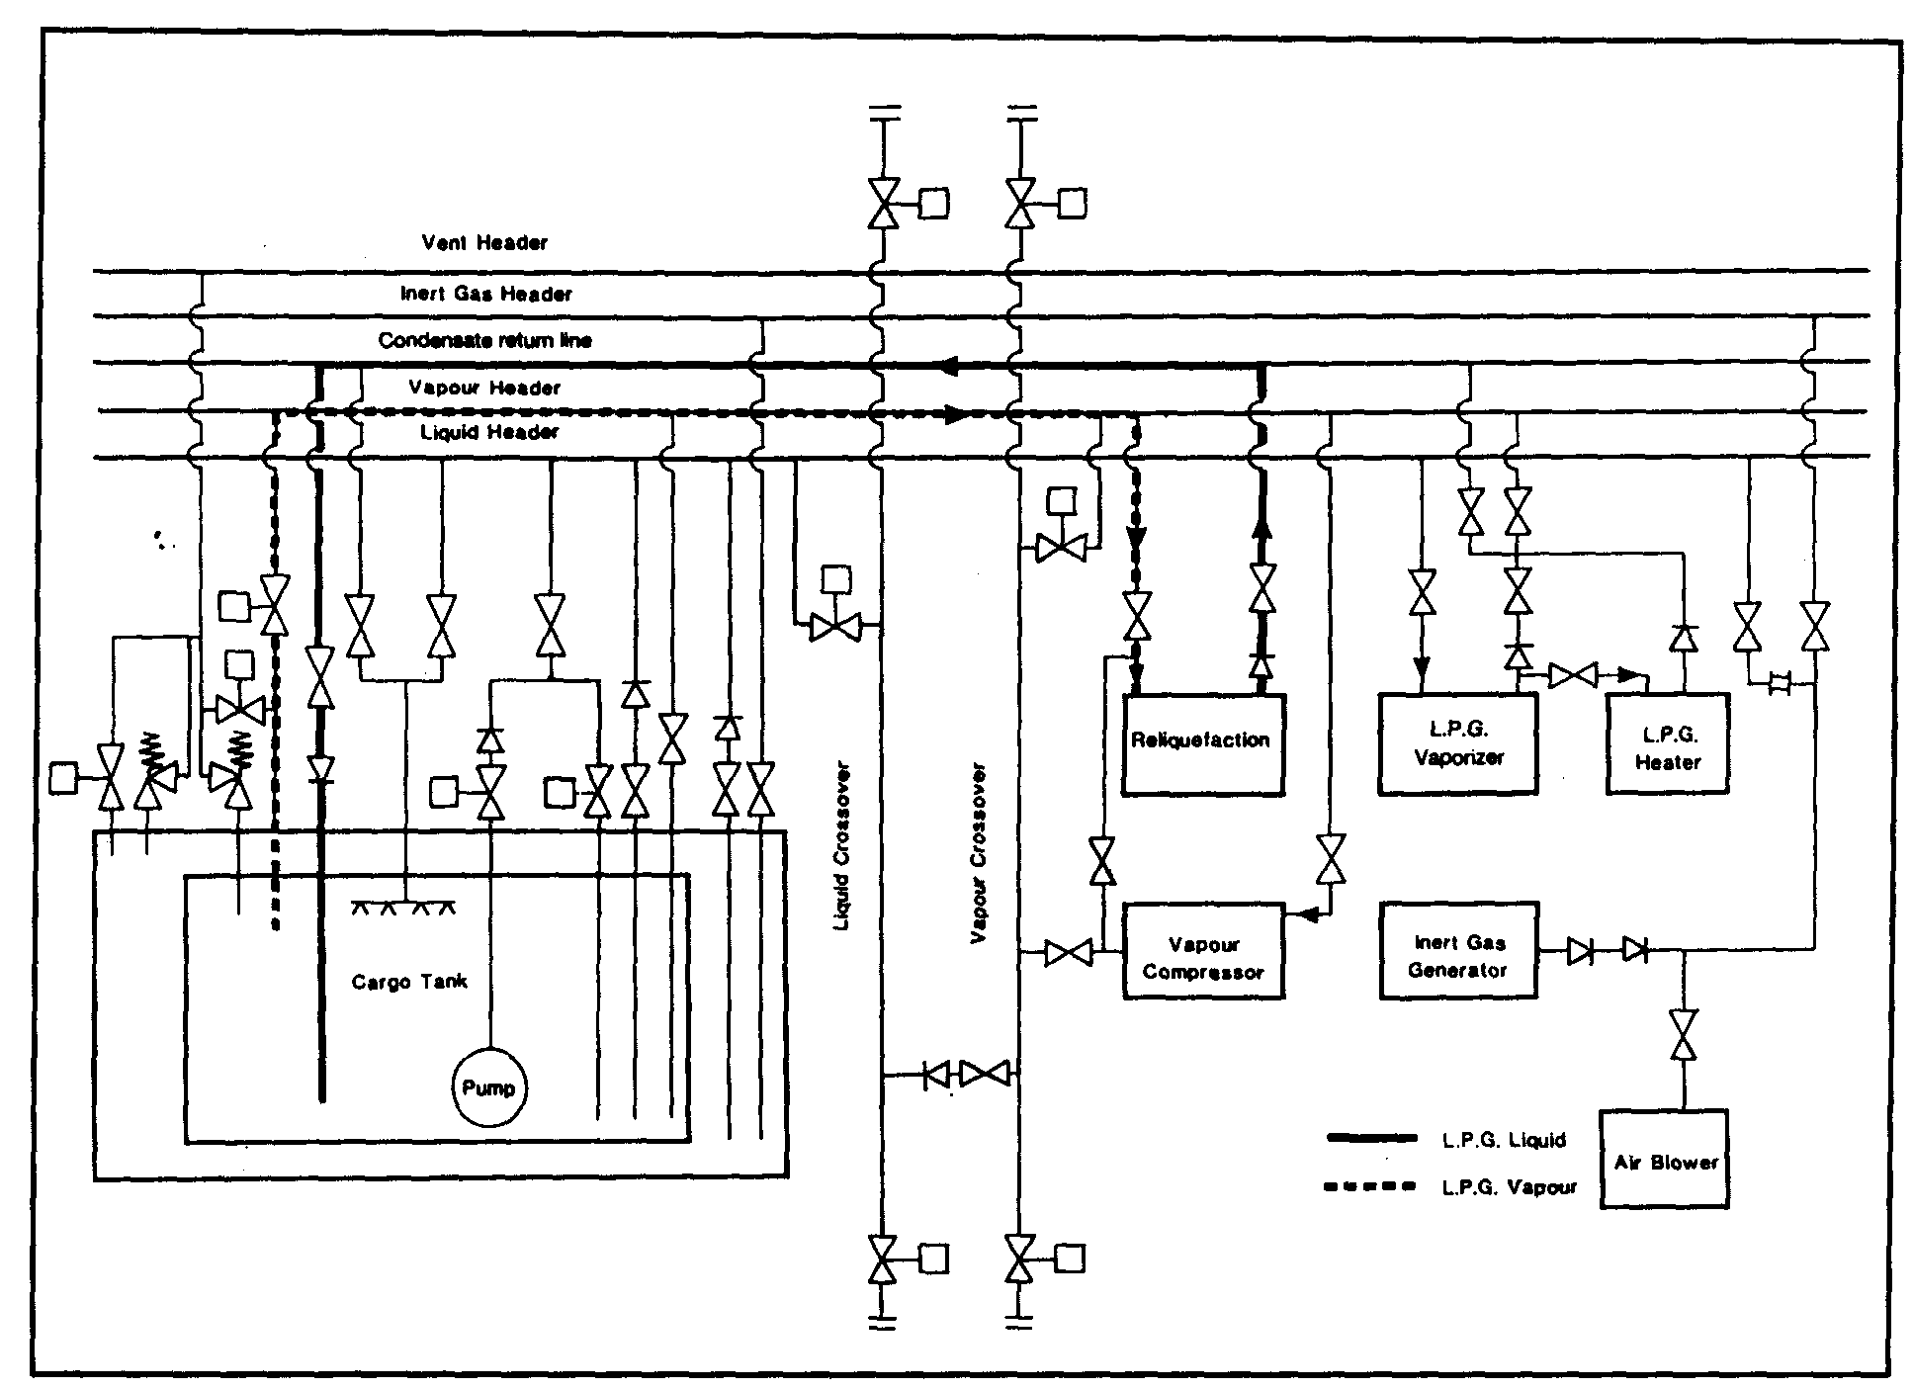

Figure 7.7 Cargo refrigeration at sea
port with cargo temperatures below that of the shore tanks, thus minimizing the amount of flash gas. Depending on the cargo and reliquefaction plant capacity, it can often take several days to cool the cargo by one or two degrees centigrade, but this may be sufficient. The need for this will often depend on the contractual terms in the charter party.
In this respect, poor weather conditions can sometimes present problems. Although most reliquefaction plants have a suction knock-out drum to remove liquid, there is a risk, in gale conditions, that entrained liquid can be carried over into the compressor. For this reason, it is preferable not to run compressors when the ship is rolling heavily, if there is risk of damage.
In calm weather conditions, if the condensate returns are passed through the top sprays, because of the small vapour space and poor circulation in the tank, it is possible that a cold layer can form on the liquid surface. This enables the compressors to reduce the vapour pressure after only a few hours running, when in fact the bulk of the liquid has not been cooled at all. To achieve proper cooling of the bulk liquid, the reliquefaction plant should be run on each tank separately and the condensate should be returned through a bottom connection to ensure proper circulation of the tank contents. After the cargo has been cooled, reliquefaction capacity can be reduced to a level sufficient to balance the heat flow through the tank insulation. Figure 7.7 shows the arrangement for cooling down cargoes on a loaded voyage.
If the reliquefaction plant is being run on more than one tank simultaneously, it is important to ensure that the condensate returns are carefully controlled in order to avoid the overfilling of any one tank.

Prevention of polymerization
Where butadiene cargoes are being carried, the compressor discharge temperature must not exceed 60°C and the appropriate high discharge temperature switch must be, selected. Similarly, in the case of vinyl chloride, compressor discharge temperatures should be limited to 90°C to prevent polymerization (see also 2.6).

Condition inspections
Throughout the loaded voyage, regular checks should be made to ensure there are no defects in cargo equipment and no leaks in nitrogen or air supply lines. On LNG ships, it may be necessary to carry out visual cold-spot inspections of cargo tank surrounds even when the ships are fitted with temperature monitoring of the inner hull surfaces. Such inspections must comply with all relevant safety procedures for entry into enclosed spaces and due regard must be given to hazardous atmospheres in adjacent spaces.

7.6.1 Operation of the reliquefaction plant
As already mentioned in 4.5, the reliquefaction plant is used during cargo loading to handle the vapours formed by evaporation and displacement. At this time, it is likely ^ that the maximum compressor capacity will be required.
On the loaded voyage, and depending on cargo temperature, ambient temperature, and the design of tank insulation, the plant may be operated continuously or intermittently. If it is necessary to reduce the temperature of the cargo before reaching the discharge port, for example, to comply with the receiving terminal requirements or charter party stipulations, the plant will again be operating continuously.
Before starting the reliquefaction plant, it is necessary to ensure that oil levels in the compressors are correct and that the glycol/water cooling system is ready for operation (see 4.6.1). This will require a check to make sure the header tank is full and that the cooling fluid is circulating.
The lubricating oil in compressors must be compatible with the cargo being handled and must be changed if necessary. (When changing from butane/propane mixtures to other grades, it will be necessary to change the oil.) Before starting a cargo compressor, the condenser cooling system must be operating with seawater circulating or the R22 system running. Compressors should always be started and stopped in accordance with the manufacturer’s instructions. Compressor discharge valves should be opened and suction valves opened slowly to minimise damage from liquid carry-over (see 4.6.3). The cooling water outlet temperature should be adjusted in accordance with the manufacturer’s instructions. The following details should be checked regularly:
- Suction, inter-stage (see 4.5) and discharge pressures
- Lubricating oil pressures
- Gas temperatures on the suction and delivery side of compressor (high discharge temperature switches protect the compressor). Here, inspection of the appropriate Mollier diagram will assist in gaining maximum benefit from the compressor by ensuring that it operates along the appropriate line of constant entropy (see 2.19)
- Current drawn by electric motor
- Oil leakage from shaft seal, and
- Cooling water temperature

Stopping the cargo compressor should always be carried out in accordance with the manufacturer’s instructions. Generally, the first action is to stop the compressor. This is followed by closure of the suction and discharge valves. The glycol/water system (see 4.6.1) is left running to provide crankcase heating or, alternatively, the lubricating oil heater should be left switched on.

7.6.2 LNG boil-off as fuel
Although it is feasible to reliquefy LNG boil-off vapours, the equipment required is complex and expensive and, to date, full-scale equipment has not been installed on board ships. As methane vapours, at ambient temperature, are lighter than air (see 3.4.5/4.6.5), boil-off is used as fuel for the ship’s main propulsion during sea passages. LNG is the only cargo, which is permitted to be used as fuel in this manner. The equipment and safety devices used for this operation are described in 4.6.5.
Daily boil-off rates during the loaded voyage vary with changes in barometric pressure (unless absolute pressure control is adopted), ambient temperature and sea conditions. For this reason, a close watch must be kept on tank pressures and inter-barrier space pressures. On no account should cargo tank pressures be allowed to fall below atmospheric. Typical figures for LNG carrier boil-off rates are from 0.10 to 0.15 per cent of the cargo volume per day during the loaded voyage and 0.10 per cent per day for the ballast voyage. It should be noted that LNG often contains a small percentage of nitrogen, which will boil-off preferentially, thus reducing the calorific value of the boil-off gas at the beginning of the loaded voyage.
Normally, the compressors used on LNG ships have shaft seals pressurised with nitrogen. Thus, an adequate nitrogen supply must be available at all times when the compressor is running. Furthermore, as with LPG compressors, care must be taken to avoid liquid from being carried into the compressor via the vapour suction line.
Receiving terminals often require cargo tank pressures on arrival to be below a certain value and this must be provided for by regular disposal of the boil-off through the voyage.

7.7 DISCHARGING
When a ship arrives at the discharge terminal, cargo tank pressures and temperatures should be in accordance with terminal requirements. This will help maximum discharge rates to be achieved.
Before the discharge operation begins, the pre-operational ship/shore procedures should be carried out along similar lines to the loading operation previously outlined, (see 6.3, 6.4 and 7.5).
The method of discharging the ship will depend on the type of ship, cargo specification and terminal storage. Three basic methods may be used:—
- Discharge by pressurizing the vapour space
- Discharge with or without booster pumps
- Discharge via booster pump and cargo heater
These methods are discussed in 7.7.1, 7.7.2 and 7.7.3 below.

7.7.1 Discharge by pressurizing the vapour space
Discharge by pressure using either a shore vapour supply or a vaporiser and compressor on board is only possible where Type ‘C’ tanks are fitted. It is an inefficient and slow method of discharge and is restricted to small ships of this type. Using this system, the pressure above the liquid is increased and the liquid is transferred to the terminal. An alternative method is to pressurize the cargo into a small deck tank from which it is pumped to the shore.

7.7.2 Discharge by pumps

Starting cargo pumps
A centrifugal pump should always be started against a closed, or partially open, valve in order to minimise the starting load. Thereafter, the discharge valve should be gradually opened until the pump load is within safe design parameters and liquid is being transferred ashore.
As the discharge proceeds, the liquid level in the cargo tanks should be monitored. Discharge and ballasting operations should be carefully controlled, bearing in mind ship stability and hull stress.
Removal of liquid from the cargo tank may cause changes in interbarrier space pressures and these should be monitored throughout the discharge.
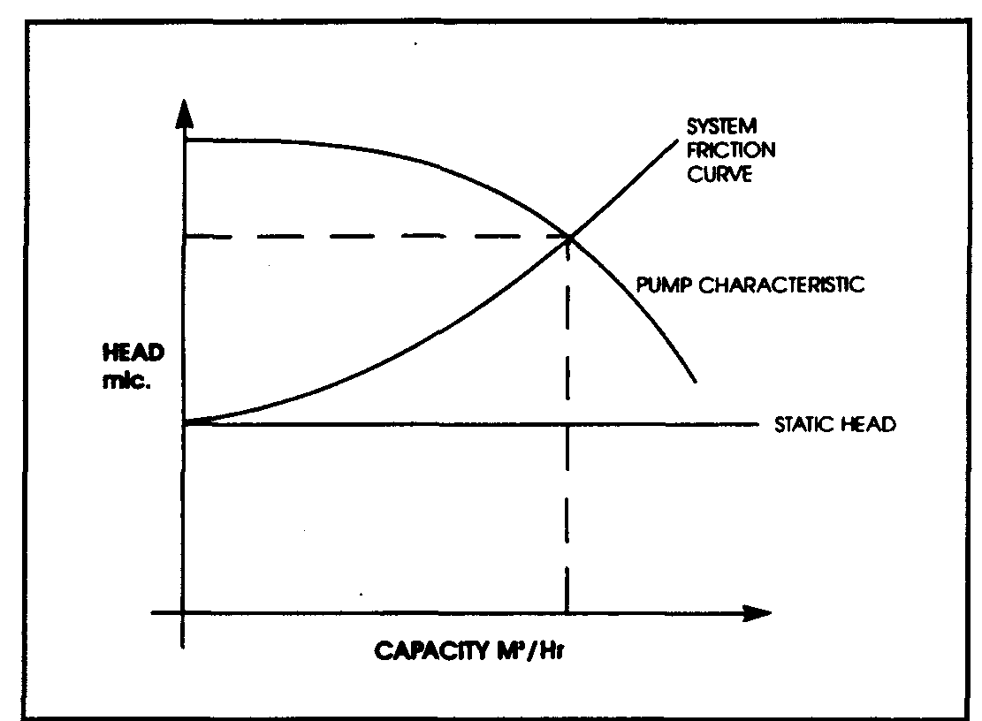

Figure 7.8 Combined ship and shore cargo pumping characteristics — single pump
Discharging by centrifugal cargo pumps, either alone or in series with booster pumps, is the method adopted by most ships and an understanding of the centrifugal pump characteristic (as outlined in 4.2) is essential for efficient cargo discharge. Figure 7.8 shows a cargo pump Q/H curve (flow against head) superimposed on a system resistance curve (or system characteristic). The graph shows the head or back pressure in mic (metres liquid column) in the terminal pipeline system against flow rate measured in cubic metres per hour. Increasing the flow rate increases the backpressure. This varies approximately as the square of the flow rate, giving the shape of system characteristic curve as shown. The point where the two curves intersect is the flow rate and head at which the pump will operate. Some of the above points are further demonstrated by inspection of Figure 7.9. This diagram shows a gas carrier alongside a jetty discharging to shore storage set at some elevation. The elevation of the tank introduces the concept of static head — this being the backpressure exerted at the pump even when pumps are not running. It can be seen that the static head changes as the ship moves up and down with the tide and as the level in the shore tank alters. The diagram also indicates that the friction head loss is largely dependant on the length of the pipeline system.
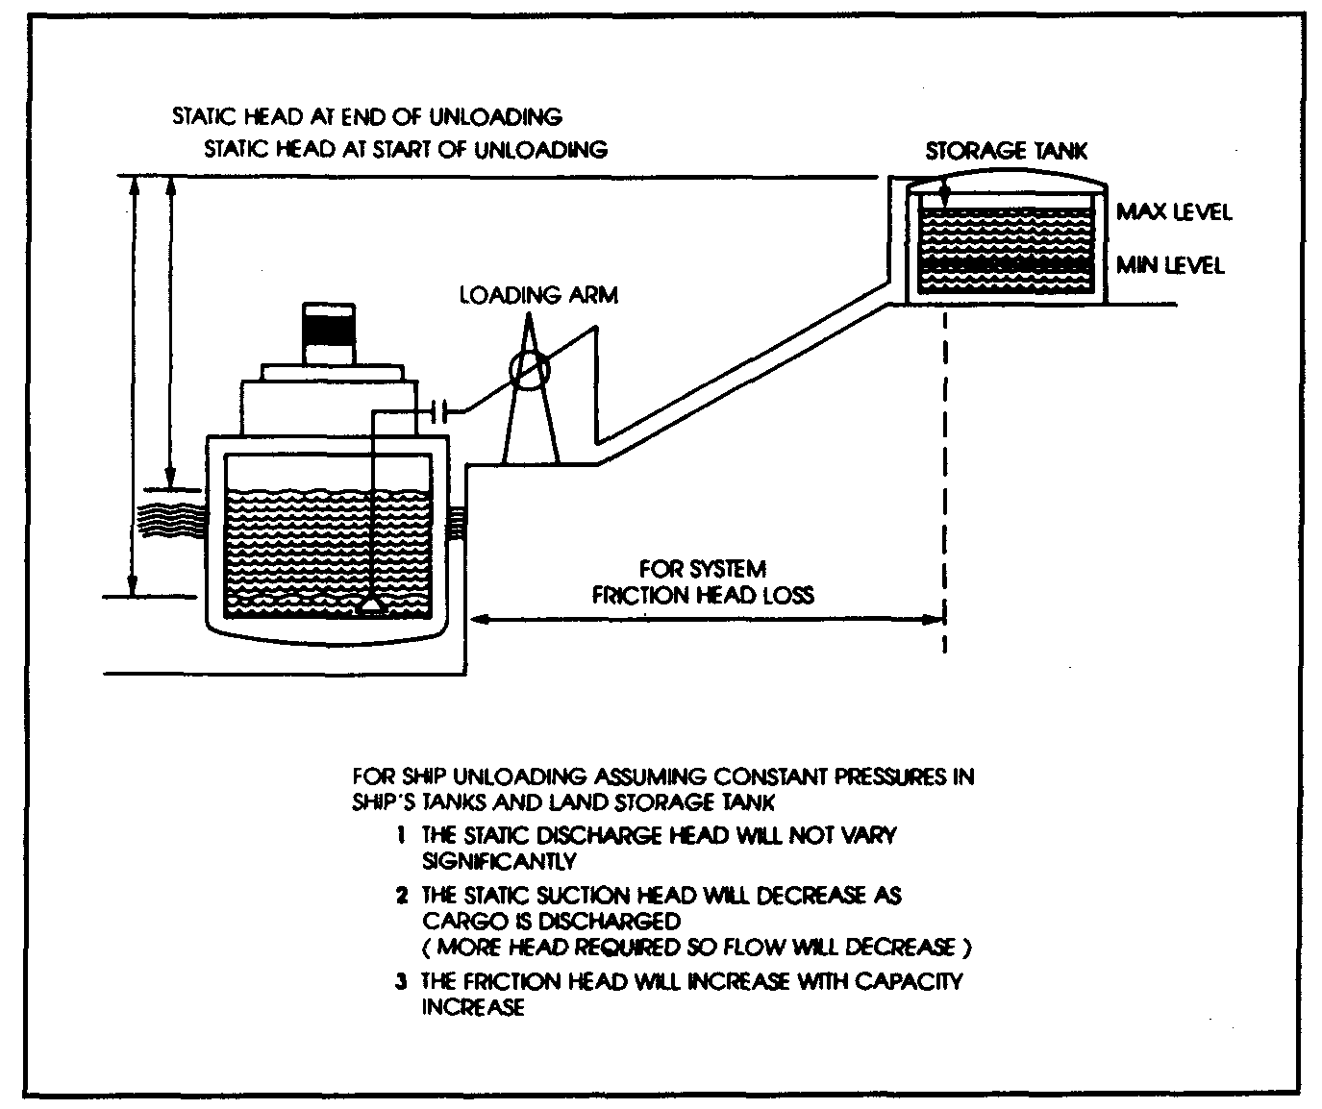

Figure 7.9 Illustrations of static head and friction head
Consider now the situation where pumps are run in parallel, as would be the normal case for a gas carrier discharge. Figure 7.10 shows the pump characteristics using one pump and when using two, three or four similar pumps in parallel. (This family of curves is derived from the principles discussed in 4.2).
Superimposed on the pump characteristics are a number of system characteristics labeled ‘A’, ‘B’ and ‘C’. System characteristic ‘A’ indicates a small diameter shore pipeline, ‘B’ a larger diameter pipeline and ‘C’ a very large diameter pipeline with shore tanks situated nearby. The latter provides the least resistance to cargo flow.
The actual system characteristic applicable at any terminal should be known to shore personnel and they should have such curves available. In preparing such graphs, personnel should note, as mentioned above, that the system characteristic can vary with the size of the chosen pipeline and with variation in the pipe-lengths from the jetty when alternative shore tanks are used. If a range of pipelines and tanks are available at any one terminal, then, it may be appropriate for terminal personnel to have a number of system characteristics, already pre-calculated and available, for use during pre-transfer discussions.
In any case, during the pre-transfer discussions (see 6.4), such matters should be covered and the optimum transfer rate should be agreed.

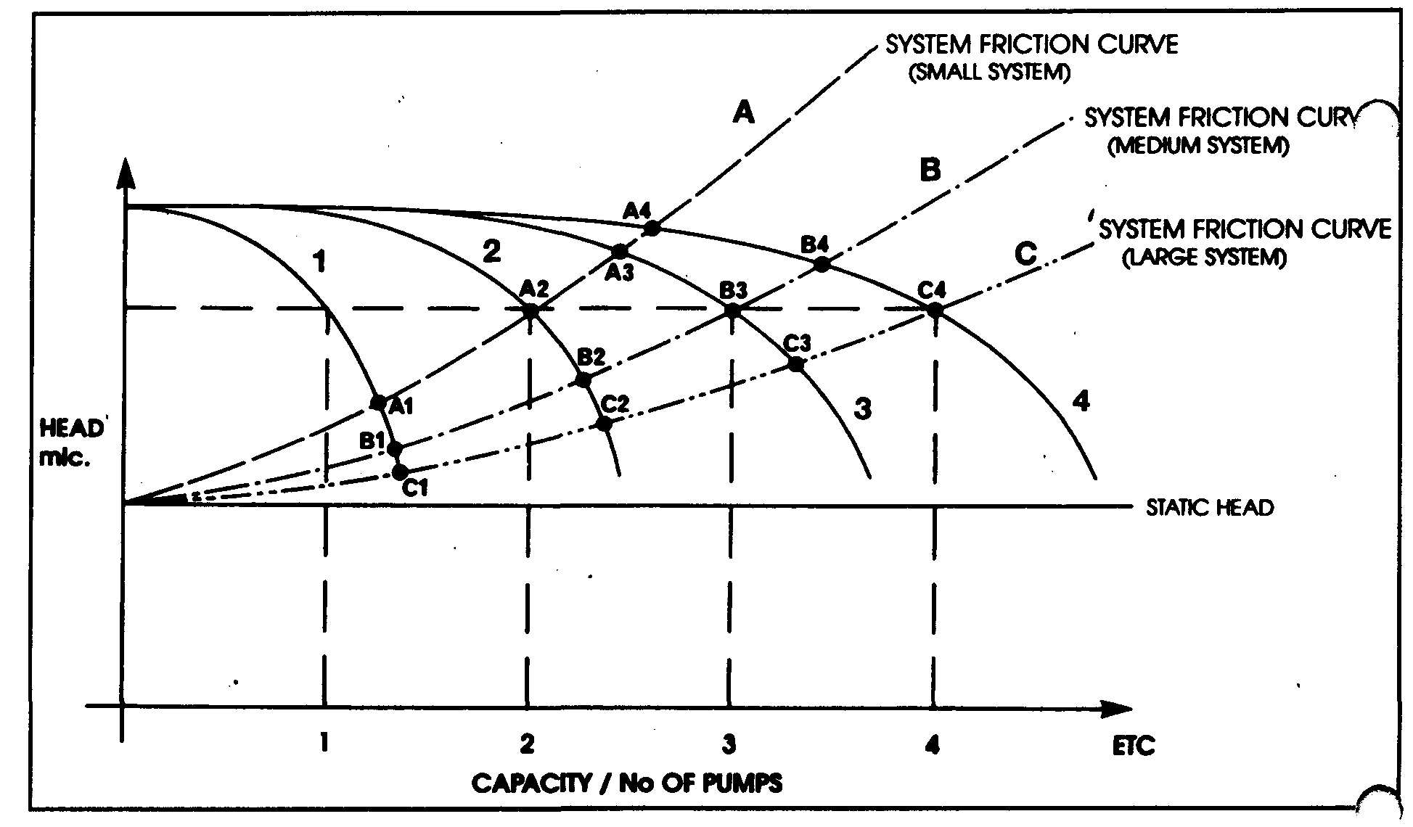

Figure 7.10 Combined ship and shore cargo pumping characteristics — parallel pumps
To clarify some of these issues, two of the system characteristics, as shown in Figure 7.10, are covered in detail below.
If a ship, having the pumping characteristics as shown in Figure 7.10 (numbered 1, 2, 3, and 4), is discharging to a terminal presenting only minor restrictions to flow, then the shore system characteristic may be equivalent to ‘C’. The operating point of the ship/shore system moves from points C, through to 64 as the number of cargo pumps in operation is increased from one to four. Under such conditions, the total flow achieved (when using four pumps) is only marginally less than the total theoretical flow (assuming no resistance). With such a shore pipeline system, it is therefore probable that all four pumps (and maybe more) can be run to good effect.
In the case of system characteristic ‘A’, where flow restrictions are high, it can be seen how little extra flow is achieved by running more than two pumps. By running three pumps the operating point moves from A₂ to A₃, achieving some extra throughput. When running four pumps the operating point moves from A, to A4, achieving an increasing flow of virtually zero. In such cases, much of the energy created in the additional pumps is imparted to the cargo. This is converted to heat in the liquid and results in an increase in cargo temperature. This increases flash-gas boil-off as the liquid discharges into shore storage and this excess must be handled by the shore compressors. If the shore compressors are unable to handle the additional flash-gas, the terminal will require a reduction in flow rate to avoid lifting the shore relief valves. Therefore, the net effect, in restricted circumstances, of running an unnecessary number of pumps can be to decrease rather than to increase the overall discharge rate.
Observing pressure gauges at the manifold will give a good indication if it is worthwhile running, say, four pumps or six pumps. The discharge rate should not be reduced by throttling valves at the ship’s cargo manifold if the shore cannot accept the discharge rate. Throttling in this manner further heats up the cargo. However, those gas carriers with only limited recirculation control may have to use manifold valves to throttle pumps.

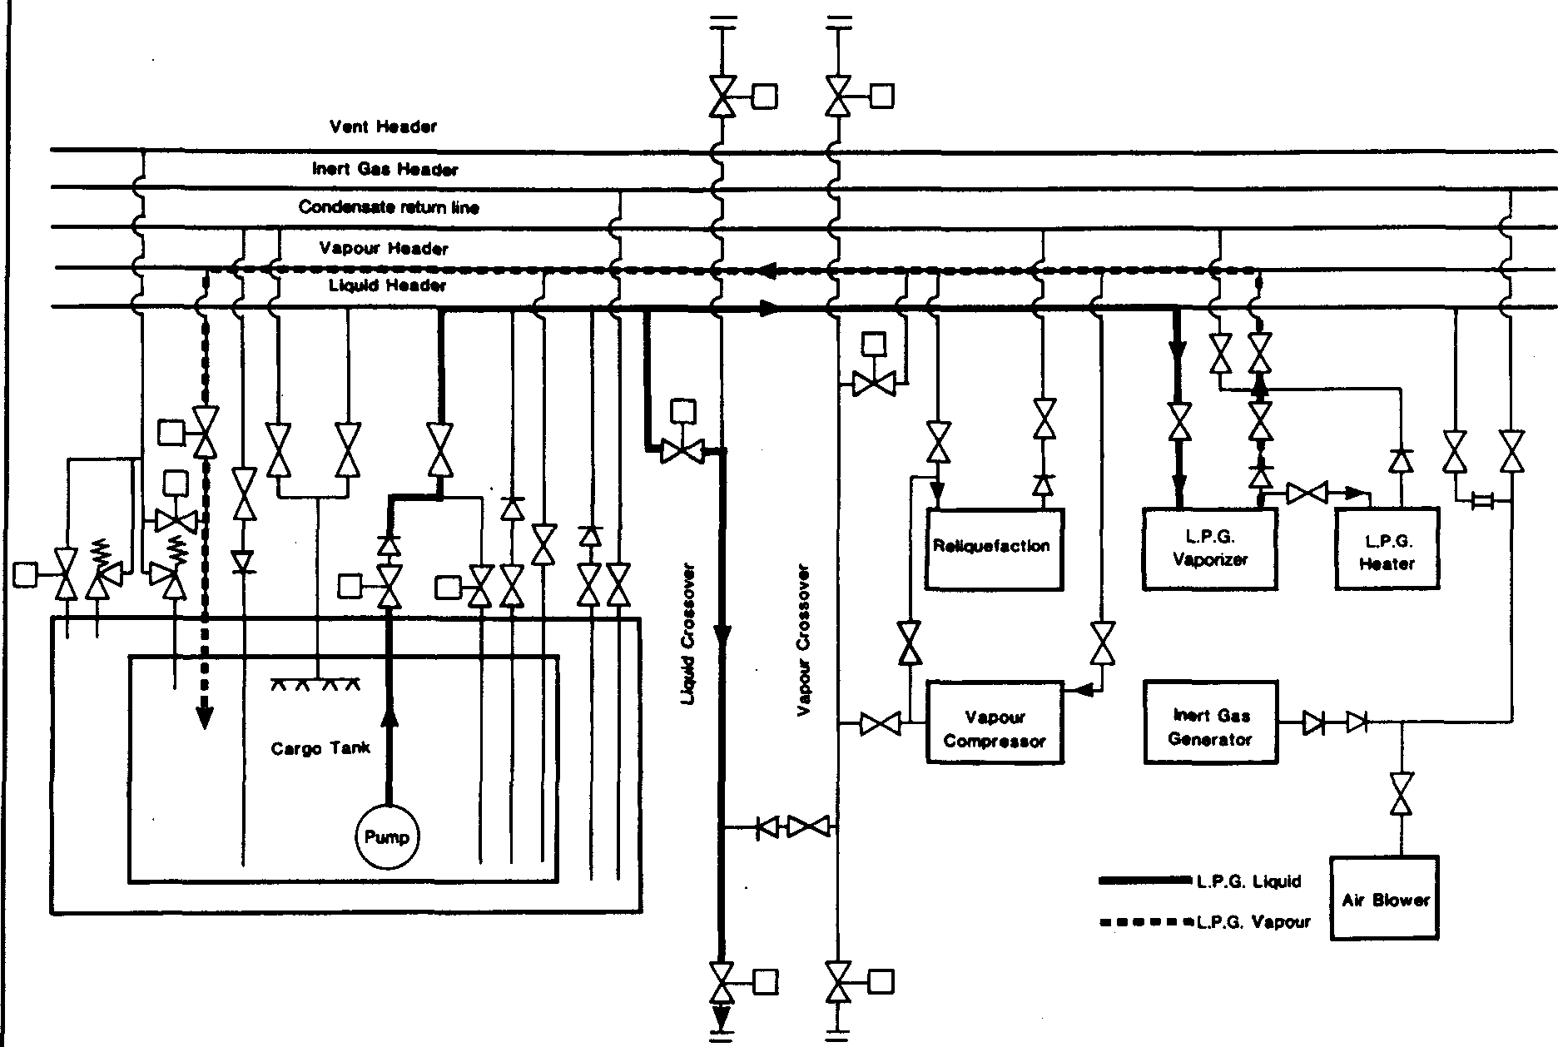
Figure 7.11 Discharge without vapour return
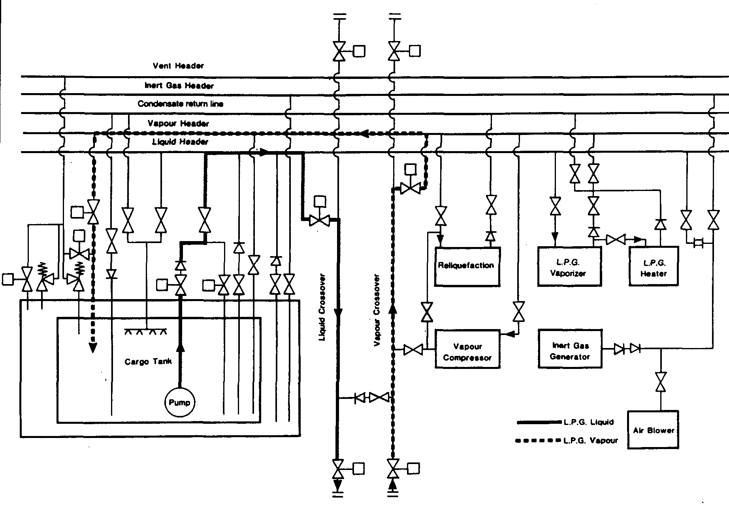

Figure 7.12 Discharge with vapour return

It also may be desirable to throttle a cargo pump discharge when it is used in conjunction with a booster pump. This may be done in order to reduce the pressure in the booster module. Any additional control of flow, however, should be carried out by throttling the booster pump discharge, by opening the main pump recirculation or by a combination of the two. It should be noted that control of flow solely by throttling the main pump discharge may cause loss of booster pump suction.
As liquid is being pumped from the ship, tank pressures tend to fall. Boil-off due to heat flow through the tank insulation takes place continuously and this generates vapour within the tank. The boil-off is usually insufficient to maintain cargo tank pressures at acceptable levels but this ultimately depends upon discharge rate, cargo temperature and ambient temperature. Where vapours produced internally are insufficient to balance the liquid removal rate, it is necessary to add vapour to the tank if discharge is to continue at a constant rate. This vapour may be provided, either by using the ship’s cargo vaporiser (see 4.4), or from the terminal (via a vapour return line). When using the cargo vaporiser, the liquid is normally taken from the discharge line and diverted through the vaporiser. Figure 7.11 shows a discharge operation without the vapour return facility; Figure 7.12 depicts a similar operation but with a vapour return in use.

7.7.3 Discharge via booster pump and cargo heater
Where cargo is being discharged from a refrigerated ship into pressurised storage, it is necessary to warm the cargo (usually to at least 0°C). This means running the cargo booster pump and cargo heater in series with the cargo pump. To operate the booster
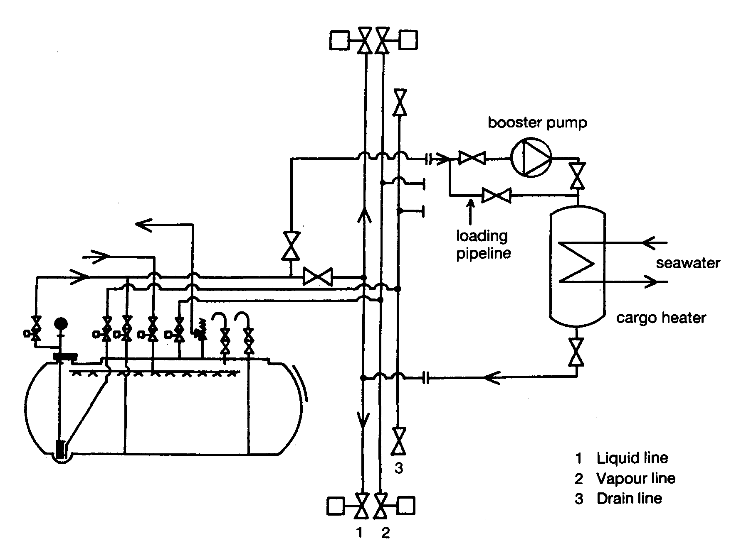
Figure 7.13 Pipeline diagram of a cargo booster pump and heater
It also may be desirable to throttle a cargo pump discharge when it is used in conjunction with a booster pump. This may be done in order to reduce the pressure in the booster module. Any additional control of flow, however, should be carried out by throttling the booster pump discharge, by opening the main pump recirculation or by a combination of the two. It should be noted that control of flow solely by throttling the main pump discharge may cause loss of booster pump suction.
As liquid is being pumped from the ship, tank pressures tend to fall. Boil-off due to heat flow through the tank insulation takes place continuously and this generates vapour within the tank. The boil-off is usually insufficient to maintain cargo tank pressures at acceptable levels but this ultimately depends upon discharge rate, cargo temperature and ambient temperature. Where vapours produced internally are insufficient to balance the liquid removal rate, it is necessary to add vapour to the tank if discharge is to continue at a constant rate. This vapour may be provided, either by using the ship’s cargo vaporiser (see 4.4), or from the terminal (via a vapour return line). When using the cargo vaporiser, the liquid is normally taken from the discharge line and diverted through the vaporiser. Figure 7.11 shows a discharge operation without the vapour return facility; Figure 7.12 depicts a similar operation but with a vapour return in use.

7.7.3 Discharge via booster pump and cargo heater
Where cargo is being discharged from a refrigerated ship into pressurised storage, it is necessary to warm the cargo (usually to at least 0°C). This means running the cargo booster pump and cargo heater in series with the cargo pump. To operate the booster
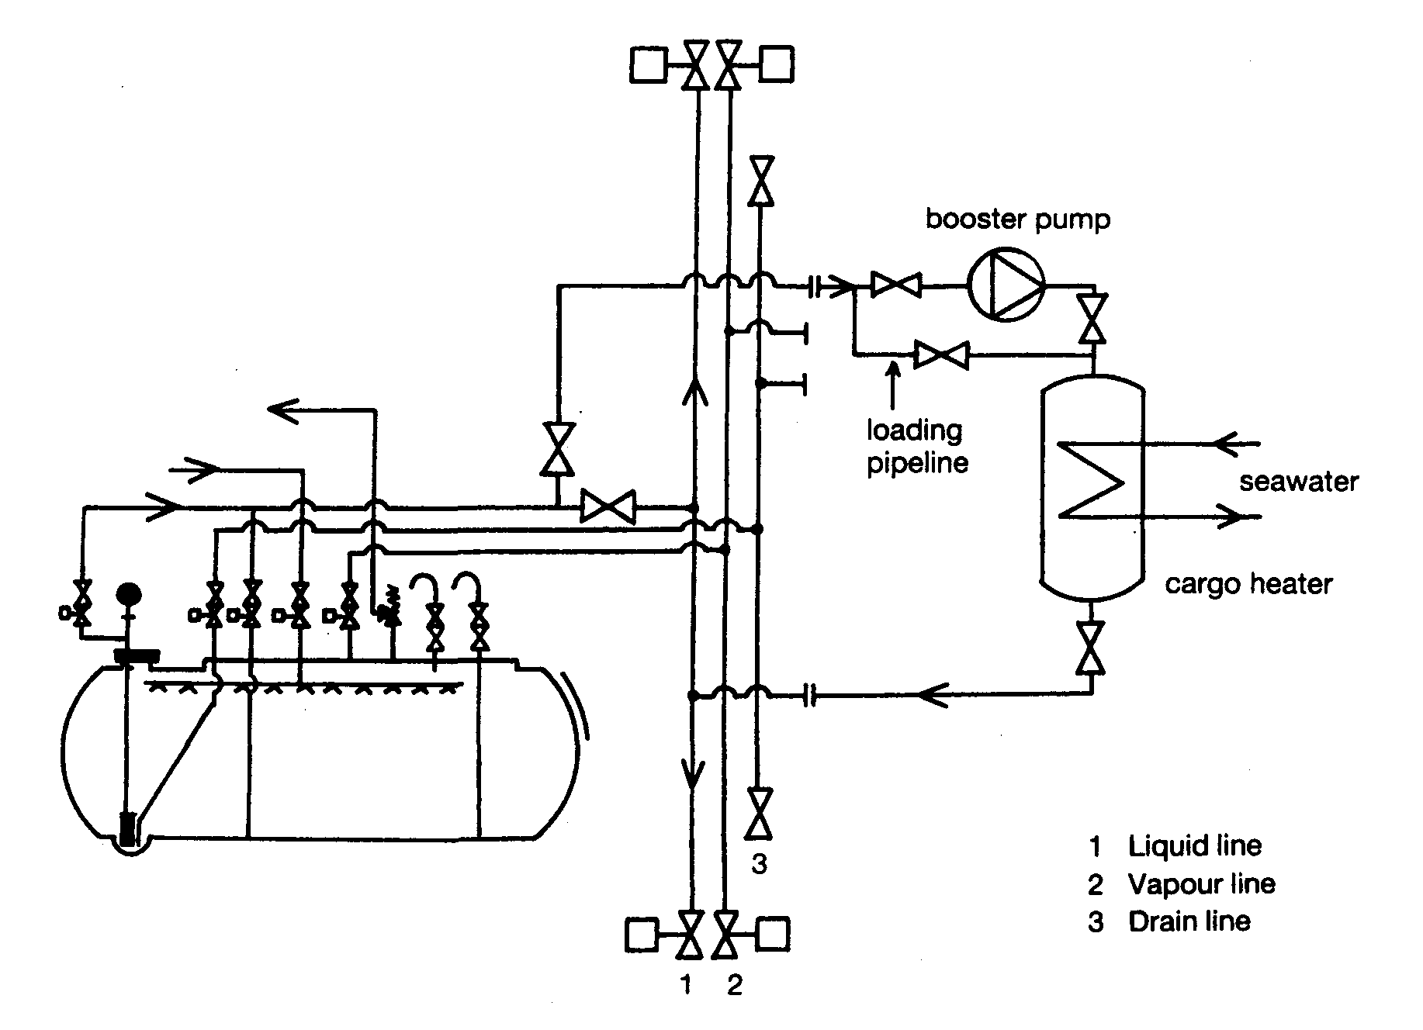
Figure 7.13 Pipeline diagram of a cargo booster pump and heater
pump and heater, it is necessary to first establish sea water flow through the heater. Thereafter, the booster pump and heater may be slowly cooled down (prior to full operation) by very slow throughput of liquid from the cargo pump discharge. Once cooled down, the discharge valve can be opened until the desired outlet temperature is reached. It is important to ensure that the cargo pumps maintain adequate flow to the booster pump at all times. Figure 7.13 shows the usual layout.
Heating cargo during discharge always entails a risk of freezing the circulating water in the heater. In addition to checking the cargo outlet temperature and the booster pump suction during operation, attention should also be paid to the sea water inlet and outlet temperatures and pressures. The seawater outlet temperature must not be allowed to fall below the manufacturer’s recommended limit. A low temperature switch should stop cargo flow through the heater in case of low seawater discharge temperature.
As will be noted, this method of cargo heating depends on a suitable seawater temperature. In cold sea water areas, the efficiency of the system can be seriously affected and slow discharge rates can result and if sea water temperatures are below 5°C the risk of freezing becomes much greater. To cover such possibilities, sometimes thermal oil heaters are fitted to ships.

7.7.4 Draining tanks and pipelines
It has already been noted in 4.2 and illustrated in Figure 4.3 that in order to avoid cavitation of a centrifugal pump, the pressure of the liquid at the pump suction needs to exceed the saturated vapour pressure (SVP) by an amount termed the minimum Net Positive Suction Head (NPSH). The required minimum NPSH, expressed as an equivalent head of liquid above the pump suction, may vary from one metre (at maximum pump capacity) to 200 millimetres (at reduced flow). If the vapour space pressure can be increased above the SVP by the supply of extra vapour from the shipboard vaporiser, the onset of cavitation, as the liquid level approaches the bottom of the tank, can be delayed. Such augmentation of vapour space pressure is usual practice on fully pressurised and semi-pressurised ships and may also be carefully applied to fully refrigerated cargoes, particularly where maximum cargo out-turn is required in preparation for gas freeing. Whether this extra vapour pressurisation is used or not, there will be a liquid level at which the pump becomes erratic. Gradual reduction of the flow rate at this point, by careful throttling of the discharge valve, reduces the NPSH requirement and permits continued discharge to a lower level. It should be remembered, however, that a pump discharge valve should not be used for flow control if the pump is operating with a booster pump since the booster pump might cavitate, resulting in damage (see 7.7.2).
On completion of discharge, liquid cargo must be drained from all deck lines and cargo hoses or hard arms. Such draining can be done from ship to shore using a cargo compressor. Alternatively, it may be carried out from shore to ship, normally by blowing the liquid into the ship’s tanks using nitrogen injected at the base or apex of the hard arm. Only after depressurizing all deck lines and purging with nitrogen should the ship/shore connection be broken (see Reference 2.40).

7.8 THE BALLAST VOYAGE
It is frequent practice in some refrigerated trades to retain a small quantity of cargo on board after discharge and the amount retained is known as the heel. This product is used to maintain the tanks at reduced temperature during the ballast voyage but this procedure only applies when the same grade of cargo is to be loaded at the next loading terminal.
In general, the quantity retained on board as a heel depends on: —
- Commercial agreements
- The type of gas carrier
- The duration of the ballast voyage
- The next loading terminal’s requirements, and
- The next cargo grade
In the case of a large LNG carrier, as much as 2,000 to 3,000 cubic metres of liquid may be retained in the tanks on departure from the discharge port; the actual volume, depending on the size and type of cargo containment, the length of the voyage and fuel policy. These ships are normally fitted with spray cool-down pumps in each cargo tank to provide liquid to spray lines fitted in the upper part of each tank. This system is used from time to time on the ballast voyage to minimise tank thermal gradients. The frequency of this operation will depend on ship size and type and the duration of the ballast voyage.
With LPG cargoes, the small amount of liquid remaining after discharge should be sufficient to provide the necessary cooling effect during the ballast voyage. This is carried out by intermittent use of the reliquefaction plant, returning the condensate to the tanks to ensure arrival at the loading port with tanks and product suitably cooled.
If the ship is proceeding to a loading terminal to load an incompatible product, none of the previous cargo should be retained on board but if small amounts exist they may be stored in the deck-mounted pressure vessels. This avoids contamination of the following cargo and allows the maximum quantity of the new cargo to be loaded (see 7.9).

7.9 CHANGING CARGO (AND PREPARATION FOR DRYDOCK)
Of all the operations undertaken by a gas carrier, the preparation for a change of cargo is the most time consuming. If the next cargo is not compatible with the previous cargo, it is often necessary for the tanks to be gas-freed to allow a visual inspection — see Table 2.3(b). This is commonly the case when loading chemical gases such as vinyl chloride, ethylene or butadiene.
When a ship receives voyage orders, a careful check must be made on the compatibility of the next cargo. (It is also necessary to check compatibilities and the ship’s natural ability to segregate, if more than one cargo grade is to be carried. On such occasions, special attention must be given to the ship’s reliquefaction system.) There may also be a need, when changing cargoes, to replace the lubricating oil in compressors for certain cargoes — this is discussed in 7.6.1 and 4.6.1.
Tables 2.3(a) and 2.3(b) provide a guide to the compatibility of gases. The tables also cover cargo compatibility with respect to the construction materials commonly used in cargo handling systems. For a more detailed exposition of these points, reference should be made to the IGC Code and Reference 2.1.
In order to obtain a gas-free condition, the full process is as shown below. However, depending on the grade switch, it may not be necessary to include all these steps:
- First, make the tank liquid free
- Then, warm the tank with hot cargo vapours (if necessary)
- Next, inert the tank, and
- Finally, ventilate with air
These procedures are preliminary to tank entry for inspection or when gas freeing the ship for drydock.

7.9.1 Removal of remaining liquid
Depending upon cargo tank design, residual liquid can be removed by pressurisation, normal stripping or, in the case of fully refrigerated ships with Type ‘A’ tanks, by using the puddle heating coils fitted for this purpose. (An older method of warming Type ‘A’ tanks with hot vapours from the compressor — but without puddle heating — is now generally out of favor due to the extended time taken, although on some ships, and particularly those in LNG trades, there may be no other choice).
The first operation to be carried out is the removal of all cargo liquid remaining in the tanks or in any other part of the cargo system. Due to enhanced evaporation in a non-saturated atmosphere, residual liquid can become super-cooled to a temperature, which could result in brittle fracture of the tank. Furthermore, any liquid retention will frustrate the future inerting operation.
As an aid to liquid removal, many general-purpose LPG ships are provided with special pressure vessels mounted on deck. These tanks can be used for the recovery of liquid and vapour from the cargo tanks. The contents of the deck tanks may also be used, at some future time, to provide vapour for gassing-up purposes when changing grades.
When all cargo tank liquid has been removed, the tanks can be inerted either with inert gas from the ship’s supply or from the shore, as required by the next cargo. Alternatively, gassing-up using vapour from the next cargo may be carried out — but this is increasingly unusual (see 7.2.3 and 7.3 for more detail of the procedure).

Liquid stripping for Type ‘C’ tanks
For ships having Type ‘C’ cargo tanks a cargo stripping line is often provided (see Figure 4.1).
By pressurizing the cargo tanks on these ships, (using the cargo compressor) residual liquid can be lifted from the tank sump into the stripping line and thence to deck level. It may then be stored temporarily in a chosen cargo tank for returning to the shore. Alternatively, it may be stored in a deck-mounted pressure vessel provided for the purpose. This draining should continue until all liquid cargo is removed from the cargo tanks, as checked through the bottom sampling line. The compressor pressure necessary to remove residual liquid will depend on the specific gravity of the cargo and the depth of the tank (see Figure 7.14).
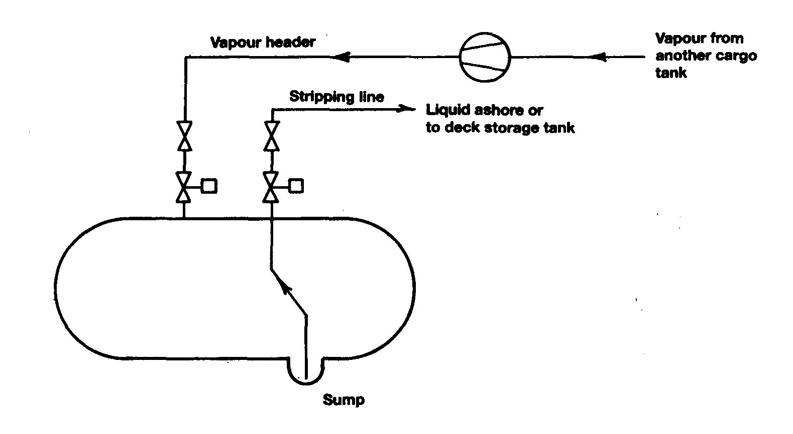
Figure 7.14 Removal of cargo liquid residue by pressurisation

Liquid freeing for other tank types
For ships with Type ‘A’ or ‘B’ tanks the removal of all cargo liquid residues is not possible by pressurisation. Instead, cargo liquid residues must be vaporized. This is normally achieved using puddle-heating coils.
When puddle-heating coils are used, the heat source in the coils is hot gas discharged from the cargo compressor. Vapour is drawn from the cargo tank atmosphere and passed through the compressor where the heat of compression causes increased vapour temperatures. By by-passing the condenser, hot vapour can be led directly to the heating coil system and heat is transferred to the liquid cargo residue. In this way remaining liquid is evaporated and an effect of the heat transfer is to turn the hot vapour in the coils into liquid which is then normally piped to a deck-mounted tank.
An alternative to the use of puddle heating coils is to supply hot cargo vapours (from the compressor) directly to tank bottoms. However, as already covered earlier in this section, this results in much slower evaporation of remaining liquids than the method described above as the hot gas only flows over the surface of the liquid pool rather than causing boiling within it. This method is used, however, on LNG carriers not fitted with puddle heating and on some smaller ships where increasing temperature 0^1 special cargo grades could be problematic.
When a ship is at sea, in order to finalize either type of operation, cargo tank vapour is normally sent to the vent riser. Alternatively, it may be condensed and pumped into deck storage or overboard. If the ship is in port, as venting to atmosphere is seldom allowed, the condensate is usually pumped to the shore or put into deck storage. (See 7.3)
When all tanks have been satisfactorily liquid-freed, pipework and other in-line equipment must be blown free from liquid and drained through the appropriate drain valves.

7.9.2 Warming-up
When cargo tanks have to be fully ventilated with fresh air, it is often necessary, depending on tank temperatures and design considerations, to warm-up the tanks prior to inerting. This is achieved by controlled circulation of warm cargo vapours through the tanks and is done before inerting takes place.
As for the cool-down (see 7.4), the rate of warm-up should be carefully controlled in accordance with the shipbuilder’s guidance.
Warming up is vital where cargo tanks are at very low temperatures, for example on board LNG ships. On such ships, compressors and heaters are operated to circulate warm gas. First, this evaporates any residual liquid and, thereafter, the whole tank structure is warmed to ambient conditions.
If warming up to ambient temperature is not carried out, freezing of carbon dioxide from within the inert gas can result. (Moreover, greater volumes of inert gas will be required at low temperatures.)

7.9.3 Inerting — after discharge
Removal of cargo vapours with inert gas is carried out to reduce gas concentrations to a level where aeration can take place without the tank atmosphere passing through the flammable envelope (see Figure 2.19). The level to which the hydrocarbon vapour must be reduced varies according to the product and details of the varying flammable envelopes for each product are given in Reference 2.1. In general, when inerting in this way, it is necessary to reduce the hydrocarbon content in the inert atmosphere to about 2 per cent before air blowing can begin. (Although this is conservative for methane, it is in accord with common practice).
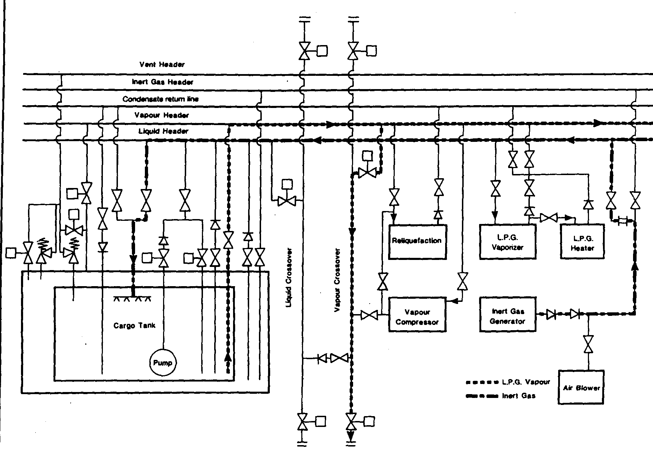
Figure 7.15 Inerting of cargo tanks

In the past, some grade-changing operations involved the replacement of existing tank vapours with the vapours of the next cargo to be loaded. However, this is now seldom carried out. As shown in Table 2.3(b), this method can only ever be appropriate when switching to compatible grades and when air is not to be introduced into the tank.
Once the cargo system has been satisfactorily freed of liquid and warmed up, inerting operations may start. This involves the replacement of the vapour atmosphere with inert gas or nitrogen. The need of inerting will depend on: —
- A desire to gain tank entry for inspection
- Last cargo
- Next cargo
- Charter party terms
- Requirements of the loading terminal
- Requirements of the receiving terminal, and
- Permissible cargo admixture
Where tanks must be opened for internal inspection, inerting is always necessary. This is to reduce the hydrocarbon content within tank atmospheres to the safe level required before blowing through with fresh air. This safe level will correspond to a point below the critical dilution line (see Figure 2.19) as found on a graph for the product in question. The procedure for inerting after cargo discharge is similar to that described in 7.2.3. During inerting operations, when venting to atmosphere, care must be taken to safeguard personnel and to ensure the absence of any source of ignition.
Figure 7.15 shows how a cargo pipeline system may be set for inerting cargo tanks when using an inert gas generator on board. This diagram shows hydrocarbon gas being returned to the shore but during the operation it is often the case that the gases to be exhausted are directed to the forward vent riser.

7.9.4 Aerating
After the foregoing procedures have been addressed, the cargo tanks can be ventilated with air. The air is supplied using compressors or air blowers and air dryers in the inert gas plant. This should continue until the oxygen content of the whole tank is at 21 per cent and hydrocarbon levels are at the zero percentage of the Lower Flammable Limit. In order to ensure uniformity in the tank atmosphere, various levels and positions in the tank should be monitored prior to tank entry. Figure 7.16 shows a pipeline set up for aerating tanks.
It is important to note that ventilation with air should only take place once the ship’s tanks are warmed to ambient conditions. If the tank is still cold when air is allowed inside, any moisture in the air will condense on tank surfaces. This can cause serious problems when preparing the tank for new cargoes. If condensation is allowed to form, its removal can be a protracted and costly operation.
As covered in 2.5, aeration should continue not only until oxygen levels are satisfactory but also until safe levels of carbon monoxide are established.

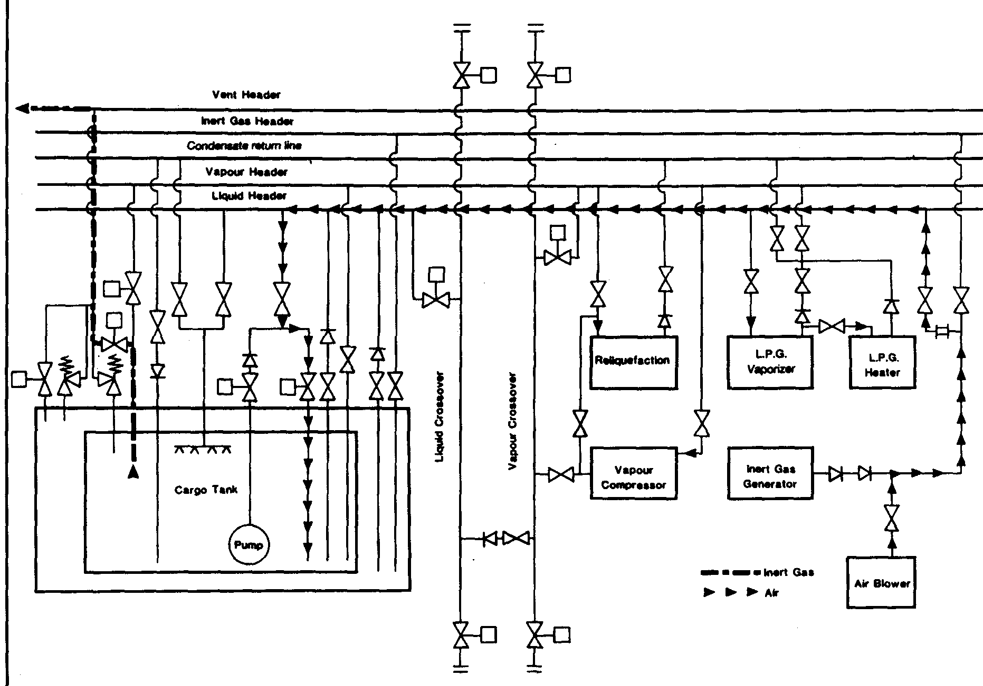
Figure 7.16 Aeration of cargo tanks

7.9.5 Ammonia — special procedures
Certain cargoes present particular difficulties when trying to remove all traces of the product. Ammonia is one such case. When a ship is switching from ammonia to LPG, virtually all traces of vapours must be removed from the system. Prior to loading the next cargo, an allowable concentration of ammonia vapour in a tank atmosphere is usually quoted at less than 20 parts per million by volume. This results in a time consuming operation, which is covered in more detail below.
The first operation when switching from ammonia is to remove all liquid ammonia from the system. This is important as ammonia, when evaporating to air, is particularly likely to reach super-cooled conditions. Therefore, unless all liquid is removed, dangerously low liquid temperatures can result and tank fractures could ensue. Confirmation that all liquid has been removed can be established, during warming-up, by carefully observing tank temperature read-outs.
Once cargo tank temperatures have been warmed to substantially above the dew point of the air, the ammonia vapours are usually dispersed by blowing warm fresh air through the system. (For ammonia the inert gas plant must not be used due to the formation, of ammonia carbamates when ammonia is in contact with carbon dioxide.) The continued use of warm dry air should avoid water vapour condensation, thus limiting the seepage of ammonia into porous tank surfaces. The ventilation of tanks and the cargo system at the highest practical temperature is advantageous as this encourages release of ammonia from rusty surfaces. (Ammonia is released ten times faster at 45°C than at 0°C).
Washing with fresh water to remove ammonia is sometimes carried out. This can be most effective as ammonia is highly water-soluble. However, the following points should be noted: ^
- The benefit of water washing is limited to certain types of tank. (This technique is not always practical for large fully refrigerated ships with prismatic tanks.)
- When switching from ammonia to LPG, water can hold ammonia in solution and this can be a contaminant for future cargoes. Accordingly, water washing is only recommended for cargo tanks, which are completely clean, rust-free and have minimum internal structure, so allowing full and effective drainage.
- All traces of water must be removed at the end of washing to stop the formation of ice or hydrates.
- The high solubility of ammonia in water (300:1) can lead to dangerous vacuum conditions being created within a tank. It is, therefore, essential to ensure adequate air entry into the cargo tank during the water washing process.
After water washing, it is essential that all water residues are removed using either fixed or portable pumps. Subsequently, tanks and pipelines must be thoroughly dried before further preparations for cargo loading are made. In order to maintain maximum dryness, it is important to continue ventilation of the tanks using air with a dew point lower than the tank atmosphere for the reasons discussed above.

7.10 SHIP-TO-SHIP TRANSFER
In recent years the transfer of LPG cargoes from one ship to another has become a common practice in many areas where there is insufficient terminal infrastructure. Detailed recommendations for the safe conduct of such operations are given in the Ship-to-Ship Transfer Guide (Liquefied Gases) (see Reference 2.3). Before any such operations are arranged, it is recommended that this publication be consulted and its procedures be adopted.
Most ship-to-ship transfer operations involve LPG, but there have been a few instances where LNG has been transferred from ship to ship with complete success. However, these instances have been casualty operations occasioned by the disablement of one of the ships. For these transfers of LNG hoses of a composite type were used (see 5.1.1).
Despite a number of studies being carried out, no attempt has yet been made to^-N proceed with projects based on routine LNG ship-to-ship transfer. Due to the special ‘ risks inherent to the low temperature of LNG and to the large size of ships involved, such an operation would require extensive detailed preparation. This should include comprehensive studies of the proposed location, the prevailing weather, the ship’s movements and the special transfer and mooring equipment to be installed.

7.11 CONCLUSION
This completes the cycle of gas carrier operations. It is important for every ship to have its own detailed operational procedures clearly listed. What can be done on one ship may not be possible or even desirable on another. However, the basic principles of cargo handling for liquefied gas remain the same for all gas carriers. A safe operation is invariably also an efficient operation and, if in doubt about the safety of any operation, ship’s personnel and terminal staff are recommended to seek further advice.

Chapter 8
Cargo Measurement and Calculation
This chapter discusses the methods of calculating shipped quantities of liquefied gas cargoes. It clarifies the two main points of difference between calculations for liquefied gas and other petroleum cargoes. In the case of gas cargoes, it is first necessary to quantify both liquids and vapours and, secondly, because gas cargoes are carried in closed containers, special procedures must be adopted to derive weight-in-air.
For further reading on this subject a study of Reference 2.20 is recommended.
  - PRINCIPLES FOR LIQUEFIED GASES
8.1.1 Special practices for gas cargoes
The quantity of liquefied gas cargoes loaded to, or discharged from, ships is measured and calculated in a similar manner to other bulk liquid cargoes such as crude oils and petroleum products. This is done by finding cargo volume and cargo density and, after correcting both to the same temperature, by multiplying the two to obtain the cargo quantity. However, unlike most other bulk liquids carried by sea, liquefied gases are carried as boiling liquids in equilibrium with their vapours. Furthermore, they are contained within closed systems. This method of carriage involves the following considerations, which lead to more complicated measurement and calculation procedures than is the case for other bulk liquids.

The inclusion of vapour in cargo calculations
At all times when cargo is in the tank, vapour spaces contain the saturated vapour of the cargo liquid. The vapour evaporates from, or condenses back into, the liquid during cargo handling and no vapour is lost to atmosphere. The vapour is, therefore, an intrinsic part of the cargo and must be accounted for in cargo quantification.

The difference between before and after quantities
On discharge, it is common practice in some trades to retain on board a significant quantity of liquid (heel) and its associated vapour to keep cargo tanks cool on the ballast voyage and to provide suitable cargo quantities for cool-down before loading the next cargo. On loading, the new cargo is added to the heel. Alternatively, if the ship has arrived with warm tanks, bulk cargo is added to the product put on board for tank cool-down purposes. Thus, at both discharge and loading, it is necessary to measure the vapour and liquid content both before and after handling, in order to find the cargo discharged or loaded.

Temperature and liquid level measurement
Cargo loaded in a ship’s tank may vary in temperature over the loading period. This may be due to cargo coming from different shore tanks or to initial cooling of shore pipelines. Liquefied gases have comparatively large thermal coefficients of volumetric expansion. These are some three to four times those of petroleum products. Accordingly, the resultant variation in density of the cargo may give rise to stratification in a ship’s tank after loading. A number of temperature sensors are usually provided at different tank levels and it is important that all these temperature readings are taken into account to assess accurate averages for the liquid and vapour. It is from these average temperatures that the appropriate temperature corrections may be applied.
Either by boil-off or by condensation, a tank’s liquid and vapour content will adjust to saturated equilibrium. However, this equilibrium may not be achieved immediately after loading. It is, therefore, desirable to delay cargo measurement and sampling for as long as possible, subject to the constraints of the ship’s departure time.
8.1.2 General - Density in Air and Density in Vacuo
Liquefied gas cargo quantities are commonly expressed in terms of “weight in air” — often as a result of Customs regulations. But no air is physically displaced from closed liquefied gas systems, and we include both vapour and liquid in our quantification. So, the expression “weight in air” can be confusing and we must clarify the fundamental concept.
The terms “weight” and “mass” are often used interchangeably. This is not correct. The “mass” is the amount of matter in any given object, whereas its “weight” is the force exerted by gravity on the object. The mass is a characteristic of an object — it would be the same in space (i.e. zero gravity) as on earth, while the weight is dependent on the force of gravity where the object is placed.
Mass is the only SI unit not based upon fundamental atomic properties or the speed of light. The reference standard is a small platinum cylinder with a mass of exactly 1 kilogram made in the late 1880’s; it is kept under inert conditions at the Bureaus International des Poids et Mesures near Paris. Copies are kept in various laboratories ‘ around the world as a comparison standard.
Everyday commodities are sold by weight, for example fruit or cement. This means their weight-in-air. Consider a simple beam balance. Weighing is carried out by balancing the force of gravity acting on the commodity against the force of gravity acting on a known mass — for example a brass weight. Since the gravitational force is the same on both sides of the balance, then this weighing process is balancing mass against mass.
However, the commodity and the brass weight are immersed in air during this process and — by Archimedes principle — there will be a small upthrust. The upthrust is equal to the force of gravity acting on the mass of air displaced. So, if the commodity and the weight occupied the same volume, then the buoyancy upthrust would be the same — so the result would be a mass-to-mass balance. The same would apply if the weighing was carried out in a perfect vacuum; so, the term weight-in-vacuum is synonymous with mass.
It is most usual for the volume of the commodity being weighed on the beam balance to be different to the volume of the brass weights. So, there is an imbalance in the buoyancy forces on either side of the balance. This is usually ignored as it is so small, but the result is that the weight of a commodity determined by this method is slightly different to its actual mass. To minimise the effect of buoyancy variations, the balance weights are standardized against brass, which has a density of 8,000 kg/m³. So, the use of balance weights made of a different material does not matter as all balance weights are calibrated against a brass standard, which thereby compensates for the different buoyancy.
The type of weighing machine does not matter since all devices are calibrated in accordance with the standards described. Variation in the gravitational field have no effect on the result as the variation affects both sides of the balance equally. So, the result is independent of the type of machine used in its location. Of course, if a machine is calibrated under one gravitational field and is then relocated to an area with a different gravitational field, then the results will be incorrect unless it is recalibrated.
The above description of quantification applies to any weighing, whether it be apples or crude oil. However, it is clearly impractical to place a ship on a beam balance, so the cargo is quantified indirectly by taking a small sample of the cargo and determining its density — which is its mass per unit volume. If this density is multiplied by the cargo volume, then the quantity of the whole cargo can be obtained.
8.1.3 True Density - Apparent Density
There are two important points to note when applying this indirect method. Density should be quoted in the fundamental units of mass per unit volume; this is also called “true density”. It is the weight per unit volume in a vacuum. So, an adjustment for the buoyancy of air is necessary to obtain the weight-in-air. Conversely, the “apparent density” of a substance is the weight per unit volume in air. Both densities are quoted in the same units (e.g. kilograms per litre) but, as the cargoes are traded by quantity-in-air or quantity-in-vacuum, it is essential to specify density units clearly.
8.1.4 Relative Density (Specific Gravity)
The density of a substance relative to that of pure water is also an important unit in our industry. This is called the “relative density” or “specific gravity”. Again we must account for buoyancy and also for the fact that the water may be at a different temperature to the substance under consideration.
The “relative density” or “specific gravity” of a liquid is the ratio of the weight in vacuo of a given, volume of that liquid at a specified temperature to the weight in vacuo of an equal volume of pure water at a specified temperature. When this ratio is reported, the reference temperatures must also be stated. For example, relative density 15°C/20°C means the ratio of the true density of the liquid at 15°C to the true density of water at 20°C.
8.1.5 Apparent Relative Density (Apparent Specific Gravity)
The “apparent relative density” or “apparent specific gravity” of a liquid is the ratio of the weight in air of a given volume of that liquid at a specified temperature to the weight in air of an equal volume of pure water at a specified temperature. When this ratio is reported, the reference temperatures must also be stated. For example, apparent relative density 15°C/20°C means the ratio of the apparent density of the liquid at 15°C to the apparent density of water at 20°C.
It is obvious that the volume of the cargo is very important, and this is in turn dependent on its temperature. So, it is necessary to specify the conditions of the cargo at which it is to be quantified. The condition most commonly chosen is to evaluate the cargo as though it was at 15°C; it is further assumed that the entire cargo is a liquid at its boiling point.
It is now clear why it is essential to state clearly the standard condition assumed for the cargo quantification. Although the mass of two cargoes may be identical, if their volumes are not equal, the upthrust caused by air displacement will be different and hence their weight will be different. An extreme case could be conceived in which two cargoes of equal mass were weighed, one entirely as a liquid, and the other entirely as a vapour. The former would have a weight not greatly different in magnitude from its mass; whilst the latter would have very little weight due to its very large air displacement. The use of a precise standard avoids this ambiguity.
The derivation of cargo weight may be carried out in practice by two methods. The mass may be calculated and this converted to weight by use of a conversion factor, with the liquid density at 15°C. The conversion factor used in this method is given by the short table at the introduction to Table 56 of the ASTM/IP Petroleum Measurement Tables.
The second practical method of determining the weight of a cargo is from its volume at 15°C using a volume to weight conversion factor. This weight conversion factor is the weight per unit volume of the saturated liquid at 15°C. This factor should not be confused with density, although it is closely related. The factor has a unit of weight per unit volume, whilst true density has a unit of mass per unit volume. The main Table 56 gives the relationship between density at 15°C and this volume to weight conversion factor.
Liquefied gases are always handled in closed containers from which air is totally excluded. Consequently, air has no influence on either the liquid phase or the vapour phase of the stored product.
Although from a purely scientific point of view, it is not correct to use apparent densities in quantity calculations, they are applied in the commercial trade of liquefied gases. An apparent density of a liquefied gas should be considered as a theoretical density. It may be obtained from a True Density, converted to Apparent Density by applying ASTM Table 56. Densities of the most common liquefied gases at their boiling point vary from 0.5680 Kg/Litre (Ethylene) to 0.9714 Kg/Litre (Vinyl Chloride Monomer). When converting this true density to density in air (Apparent density), always a difference of 0.0011 Kg/Litre appears. Note that conversion from density in air to density in vacuo has to be done by introducing the conversion factors from ASTM Table 56 with a density at 15°C. This conversion is not always possible considering the critical temperature of some products such as Ethylene, Methane, which are completely gaseous at 15°C.

Table 8.1 ASTM 56 (short table)
*  Density at 15°C  (Kg/L) | Factor for  converting  Weight in  Vacuo to  Weight in Air | Density at 15°C  (Kg/L) | Factor for  converting  Weight in Air  to Weight in  Vacuo
0.5000 to 0.5191 | 0.99775 | 0.5000 to 0.5201 | 1.00225
0.5192 to 0.5421 | 0.99785 | 0.5205 to 0.5432 | 1.00215
0.5422 to 0.5673 | 0.99795 | 0.5433 to 0.5684 | 1.00205
0.5674 to 0.5950 | 0.99805 | 0.5685 to 0.5960 | 1.00195
0.5951 to 0.6255 | 0.99815 | 0.5961 to 0.6265 | 1.00185
0.6256 to 0.6593 | 0.99825 | 0.6266 to 0.6603 | 1.00175
0.6594 to 0.6970 | 0.99835 | 0.6604 to 0.6980 | 1.00165
0.6971 to 0.7392 | 0.99845 | 0.6981 to 0.7402 | 1.00155
0.7393 to 0.7869 | 0.99855 | 0.7403 to 0.7879 | 1.00145
0.7870 to 0.8411 | 0.99865 | 0.7880 to 0.8421 | 1.00135
0.8412 to 0.9034 | 0.99875 | 0.8422 to 0.9044 | 1.00125
0.9035 to 0.9756 | 0.99885 | 0.9045 to 0.9766 | 1.00115
0.9757 to 1.0604 | 0.99895 | 0.9767 to 1.0614 | 1.00105
1.0605 to 1.1000 | 0.99905 | 1.0615 to 1.1000 | 1.00095

8.1.6 LNG quantification
The foregoing discussion has been general in nature and applies to all liquefied gases. LNG trading, however, differs from other liquefied gas trading in two respects affecting cargo quantification. Firstly, LNG is traded within long-term projects with dedicated production, transportation and reception facilities. Secondly, cargo boil-off during loaded and ballast voyages is used as ship’s fuel. Accordingly, commercial cargo quantification is tailored to the particular project and contract and this is usually on the basis of calorific value of cargo delivered. Calorific value is derived from a knowledge of cargo composition and the mass of the liquid transferred, with an adjustment made for the calorific content of the volume of the vapour displaced. Thus, weight-in-air is not involved in the quantification of LNG cargoes and mass is invariably calculated from liquid volume and density at tank conditions.
8.1.7 Shore measurement versus ship measurement
Terminals usually require storage tanks to be measured for day-to-day internal accounting. However, shore tank measurements for cargo loaded or received are not always as accurate as ship measurements.
Firstly, shore storage tanks usually have greater cross-sections than the ship’s tanks. Therefore, there can be greater inaccuracies associated with on-shore liquid level measurement, particularly in the transfer of small cargoes.
More important is the question of vapour flow to and from a shore tank during cargo handling. When loading a ship, in order to maintain shore tank pressure within pressure limits, vapour flow may be from other shore storage tanks, from liquid vaporisers or from the ship-to-shore vapour return line. Similarly, during ship discharge, vapour flow may be from the shore tank to other shore tanks, to the shore reliquefaction plant or to the ship by the shore-to-ship vapour return line. In cases where there is only one shore tank, the liquid input to the tank from production run-down must also be considered. These factors add to uncertainty in shore tank measurement. It is, therefore, common practice to use the ship’s figures to determine cargo volumes for custody transfer at both loading and receiving terminals. Because of this, some customs authorities require the ship’s tank calibration tables to be certified by an approved classification society or by suitable independent cargo surveyors.
On loading, it is important to take account of the density of the liquid heel in each ship’s tank. If this is appreciably different from the density of the cargo to be loaded, then, the density of the liquid in the ship’s tanks after loading may be significantly affected.
It is usual for cargo interests to appoint an independent cargo surveyor as an unbiased third party to verify the ship and shore volume measurements, the use of appropriate density values and the cargo calculations.
8.2 MEASUREMENT OF CARGO TANK VOLUMES
All ships are provided with a calibration table for each cargo tank. The calibration table enables liquid and vapour volumes to be found from a measurement of the liquid level. A calibration table is obtained from careful measurements taken at ambient temperature and pressure after the ship is built. The volumes given in the tables normally assume the ship to be upright and with no trim. The calibration table therefore, contain correction factors with which to adjust the liquid level measurements in accordance with the actual conditions of the ship’s list and trim and with the cargo tank temperatures at the time of cargo measurement.
The principal corrections are described below.
8.2.1 Trim correction
Figure 8.1 shows a prismatic tank on a ship, which is trimmed by the stern. In other words the ship’s aft draft is greater than the forward draft. As can be seen, with the ship in the trimmed position, the liquid level in the tank remains horizontal and the liquid level rises by the amount a/a’ at the aft bulkhead. However, if the ship was on an even keel (or zero trim), the liquid level would be as shown by the dashed line on the diagram.
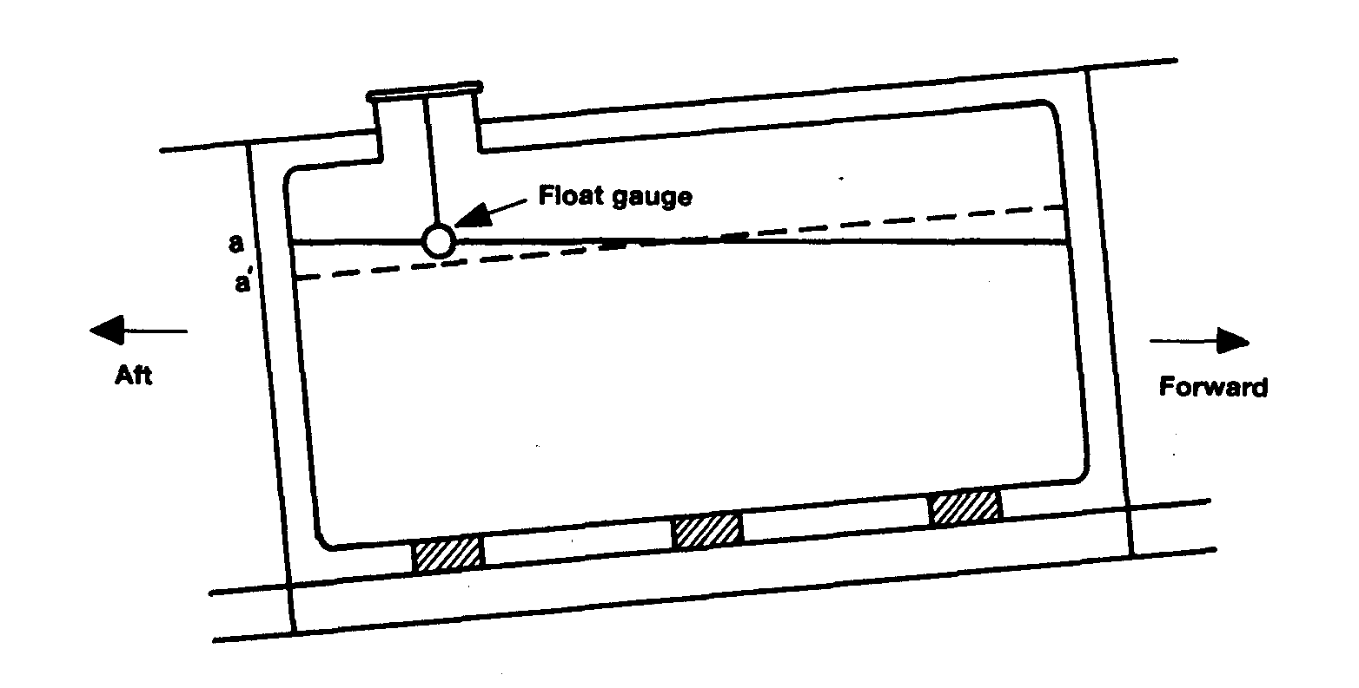
Figure 8.1 Cargo calculations — correction for trim

It is usual for tank calibration tables to be presented assuming that the ship is on an ^ even keel. Accordingly, where the tank gauge is not situated at the tank’s geometric centre and if the ship is trimmed, a correction to the measured liquid level is necessary in order to enter the calibration table to get the correct liquid volume. This deviation from the correct liquid level is indicated on the diagram by the distance between the gauge-float and the even-keel liquid level.
8.2.2 List correction
Figure 8.2 shows a prismatic tank on a ship, which is listed to port. In other words the ship’s port side draft is greater than the starboard side draft. As can be seen, with the ship in the listed condition, the liquid level in the tank remains parallel to the waterline. Accordingly, and taking the port side tank as an example, at the outer bulkhead the liquid level rises by the amount a/a’. However, if the ship was upright, the liquid level would be as shown by the dashed line on the diagram.
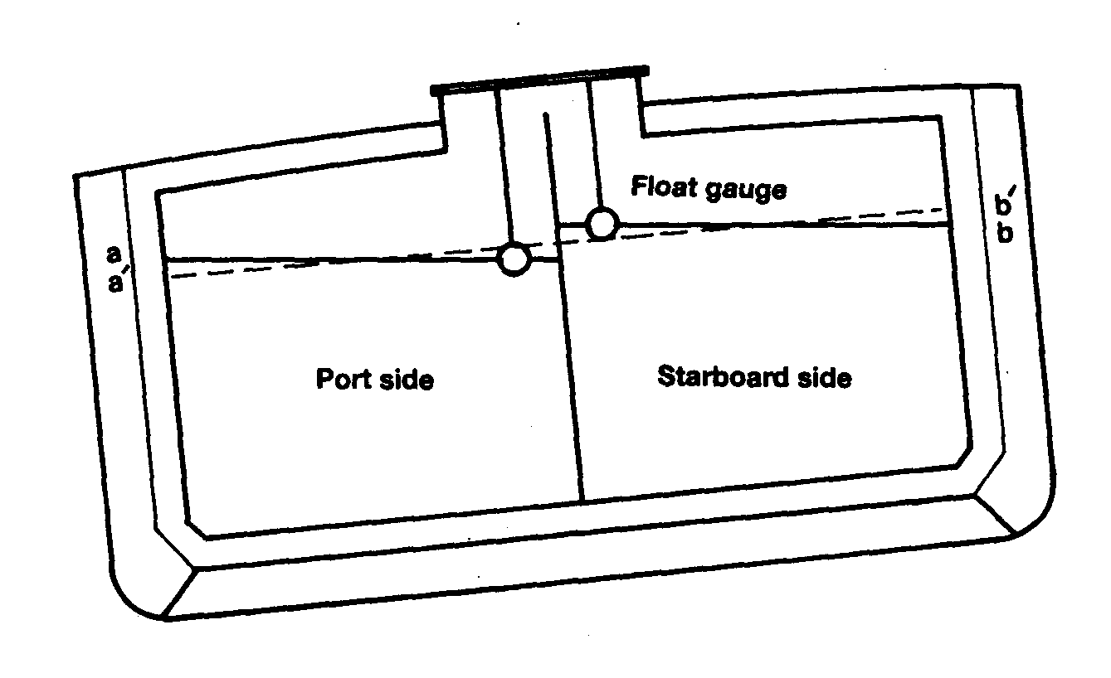

Figure 8.2 Cargo calculations — correction for list
It is usual for tank calibration tables to be established assuming the ship to be upright (having a zero list). Accordingly, where the tank gauge is not situated centrally and if the ship is listed, a correction to the measured liquid level is necessary in order to enter the calibration table to get the correct liquid volume. This deviation from the correct liquid level is indicated on the diagram by the distance between the gauge-float and liquid level shown for the ship in the upright position.
8.2.3 Tape correction
Float gauge tapes pass through cold vapour spaces and, depending on temperature, will contract and indicate a greater ullage in the vapour space — so leading to a lesser indication of liquid level. This correction, therefore, adds to the indicated liquid level.
8.2.4 Float correction
The zero reading of a float gauge is determined by the manufacturer but is normally at ^ 50 per cent float immersion. If the cargo liquid has a temperature and density different ‘ from that assumed for the manufacturer’s zero determination, a small correction for float immersion will be required.
8.2.5 Tank shell contraction and expansion
The cargo tank, having been calibrated at an ambient temperature, has a smaller volume at a cold cargo temperature due to contraction of the tank material. If the liquid temperature is different from the vapour space temperature, it is usual to apply separate correction factors to the liquid and vapour space tank volumes.
8.3 MEASUREMENT OF DENSITY

8.3.1 Density measurement methods
Since liquefied gases are boiling liquids, the measurement of density requires laboratory equipment not available on ships. Cargo liquid density is measured on shore and the results are provided to the ship for its cargo calculations.
There are four principal methods of liquid density measurement. These are described below.
By calculation from an analysis of liquid composition
Liquid composition analysis is the most accurate method of density measurement and is increasingly used in modern terminals. The liquid composition is usually obtained by a gas liquid chromatograph, which is an instrument requiring expert operation. The density is calculated from this analysis by means of one of two formulae: the Francis Formula or the Costald Equation. The Francis Formula is the simpler but is applicable only to LPG temperature ranges and loses some accuracy in the case of LPG mixtures and chemical gases. The Costald Equation is more complicated but provides accurate results when calculating the density of LNG, chemical gas and mixed gas cargoes. Calculations using these formulae are usually carried out by a programmed hand calculator or small computer. Apart from the greater accuracy obtainable by these formulae, the methods also have the virtue of providing a density at any required temperature without introducing the inaccuracy of generalized conversion tables.

By density meters
Shore tank density may be measured by density meters which operate using various physical principles. The differing types are listed below.
- Differential pressure across the height of a known vertical liquid column
- Resonant frequency of a vibrating element immersed in the liquid
- Buoyancy of a body immersed in the liquid
- Variation of electrical capacitance of an immersed probe, or
- The variation of the speed of ultrasonic signals within the liquid In such cases the density is measured at shore tank temperature and requires conversion to a standard temperature, usually 15°C, or to the ship’s tank temperature, depending on the calculation procedure used.

By in-line densitometer
The use of a densitometer involves diverting a portion of the product flow in a pipeline through the instrument. The instrument contains a vibrating element and, as in the static density meter using this principle, the resonant frequency of the vibrating element is related to the density of the liquid. Each densitometer requires careful initial calibration. Corrections need to be applied to its correlations between frequency and density for pressures, temperatures and for products differing from the calibration values. The overall accuracy is considered to be ±0.2 per cent and is similar to that achieved from compositional analysis. The instrument is particularly appropriate for use with liquid cargo flow measurement since the corrected output of the densitometer may be combined with the output of the volume flow measurement to give mass flow. This can then be integrated over the whole transfer period to give directly the total liquid mass transferred.

By pressure hydrometer — ASTM D 1657
The measurement of density by hydrometer has been the standard method for many years. It is a simple procedure but is probably the least accurate of all. In this method, the hydrometer, containing a thermometer, is floated in a sample of the liquid within a transparent pressure container. The procedure involves warming to a standard temperature, usually 15°C, and the density is read directly from the immersed hydrometer.

8.3.2 Units of density
The density of LPG cargoes is usually expressed in terms of kilogrammes per cubic metre (kg/m³), kilogrammes per cubic deci-metre (kg/dm³) (equivalent to tonne/m³) or kilogrammes/litre (for all practical purposes equal to kg/dm³, 1 litre = 1.000028 dm³).
However, units of relative density, formerly called specific gravity, are still used at some terminals. Relative density is defined as the mass of a given volume of product at a given temperature divided by the mass of the same volume of water at a given temperature which may be different from the temperature given for the product. This wide definition of relative density requires a knowledge of the density of pure water at the given water temperature in order to determine the density of the product. Thus, the relative density 60°/60°F of a product denotes both product and water to be at the same given temperature of 60°F and may be converted to density at 60°F by multiplying by the density of water at 60°F (999.035 kg/m³). Similarly, a product specific gravity 15°/4°C may be converted to density at 15°C by multiplying by the density of water at 4°C (1,000.0 kg/m³).
8.4 SHIP/SHORE CALCULATION PROCEDURES
8.4.1 Outline of weight-in-air calculation
Procedures to calculate the weight-in-air of a cargo can vary in detail between ship and shore. It is not possible in this book to deal with every variation. There is, unfortunately, no internationally agreed standard but all calculation procedures should meet the following basic requirements.
- Account must be taken of liquid product on board before loading or left on board after discharge.
- Account must be taken of the vapour quantity. In determining the contribution of the vapour quantity to the total, the vapour is converted to a liquid equivalent.
- The mass of liquid or vapour is determined by multiplying the volume at a stated temperature by the density at the same temperature. If volume and density are not physically measured or calculated at the same temperature, they must be converted to the same temperature before multiplication.
- The result of the foregoing multiplication is mass and may be converted to weight-in-air by an appropriate conversion factor found in published tables.
8.4.2 Procedures using standard temperature
The following is a widely practised procedure using SI units when considering a standard temperature of 15°C.
(i) Find the average liquid and average vapour space temperatures (°C) and the vapour space pressure (barg or mbarg).
(ii) Read the liquid level and calculate the liquid volume (V,) at tank conditions (t°C) using the ship’s calibration tables and making corrections for temperature and the ship’s list and trim (V, in m³). (iii) Obtain the liquid density noting the temperature at which it is determined and, by ASTM-IP Table 53, convert this to liquid density at 15°C (expressed in kg/m³). Note that in Table 53 density is given in kg/litre. For all practical purposes the values are equal to tonne/m³ and should be multiplied by 1,000 to obtain kg/m³.
(iv) Using the liquid density at 15°C (expressed in kg/litre) and the average liquid temperature, enter ASTM-IP Table 54 to derive the appropriate volume correction factor to convert V, to the volume at 15°C (V₁₅ in m³).
(v) Calculate the liquid mass as M_{liq} (kg) = V₁₅ x D₁₅
(vi) Calculate the vapour volume at tank conditions (V_{t}) in m³ by subtracting the apparent liquid volume at calibration temperature from the tank total volume at calibration temperature and applying to the difference the necessary vapour space contraction factor.
(vii) Determine the vapour density at vapour space conditions (D_{vt}) by the following calculation based upon the ideal gas laws.
$$D_{\text{vt}}=\frac{T_{s}}{T_{v}}×\frac{P_{v}}{P_{s}}×\frac{M_{m}}{l}{\text{kg}}/{m^{3}}$$
where:— T_{s} standard temperature of 288 K (15°C)
T_{v} is average temperature of vapour in degrees Kelvin
P_{v} is absolute pressure of vapour space in bar
P_{s} is standard pressure of 1.013 bar
M_{m} is molecular mass of vapour mixture in kg/kmol (provided from industry tables or from shore)
l is ideal gaseous molar volume at standard temperature (288 K) and standard pressure (1.013 bar) = 23.645 m³/kmol.
[Note: An accurate knowledge of the vapour composition in deriving M_{m} is not necessary and the deviation of saturated liquid gas vapours from the ideal gas laws is usually ignored.]
(viii) Calculate the vapour mass (m) as the product of vapour volume and vapor density: m = V_{t} x D_{vt} (kg).
(ix) Add the liquid mass, M_{liq}, and the vapour mass, m, to give the total mass, M_{T} ; M_{T}=M_{liq} + m (kg).
(x) Convert the total mass to weight-in-air by means of the appropriate conversion factor found by entering the left hand side of the short table in the introduction of ASTM-IP Table 56 with the liquid density at 15°C.
The above is the procedure for the static measurement of tanks when the calculation is based on the standard temperature of 15°C. It can apply either to shore tanks or the ship’s tanks before and after cargo transfer, the net cargo transfer being the difference. In the case of ship tank measurement and shipboard calculations, the liquid density is supplied by the shore.
As already mentioned in 8.1.6, one of the difficulties in shore measurement is accounting accurately for the various vapour flows within the terminal. Some terminals, therefore, use a simplified approach in assessing the vapour quantity associated with the cargo transfer of refrigerated propane or butane. In this procedure the weight-in-air of the liquid change in the shore tank is evaluated from measurements before and after transfer and 0.43 per cent of the weight-in-air of the liquid transferred is subtracted to account for the vapour which replaces the liquid in the case of a tank being discharged or for the vapour displaced in the case of a tank being filled. Despite its simplicity, the procedure is a good approximation, although it is not recommended for custody transfer purposes. It assumes that the vapour is at the same temperature and pressure before and after transfer and that the difference in vapour volume before and after is the same as the difference in liquid volume. On this basis, the vapour mass to be accounted for will be related to the liquid mass transferred by the ratio of the density of vapour to that of liquid at the tank conditions. The vapour/liquid density ratio at atmospheric boiling point for pure propane is about 0.0040 and for n-butane, 0.0046. Thus, vapour weight-in-air = 0.43 per cent of liquid weight-in-air can be taken as a generalized figure for fully refrigerated propane, butane or their mixtures. This figure should not be used for other cargoes or for propane and butane at other than fully refrigerated condition, where substantially different vapour/liquid density relationships apply.
8.4.3 Procedure using dynamic flow measurement
As a means of overcoming the uncertainties associated with static measurement of cargo on shore, which were discussed in 8.1.6, some modern terminals are being equipped with sophisticated liquid and vapour flow metering with associated in-line sampling. The equipment presently is expensive and requires complicated proving arrangements. However, this method allows flow rate and density to be continuously recorded at the flow temperature and, by combining these outputs electronically, mass flow rate can be provided and integrated to give total mass transferred. Nevertheless, it is likely that, until such systems have been proved reliable and have been widely accepted, shipboard static measurement will continue to be the basis of cargo quantification for cargo custody transfer purposes.
8.5 EXAMPLE — CARGO CALCULATION
The following example demonstrates the typical procedure outlined in 8.4.2 using/fae standard temperature of 15°C as applied to cargo in a ship’s tank.

Measurement data — Tank No.3 port
Product — Propane
Gauge reading of liquid depth............................................................... 10.020 metres
Ship’s trim .......................................................................................... 2.0 metres by stern
Ship’s list............................................................................................ 0.5° to port
Mean temperature of liquid.................................................................. - 43°C
Mean temperature of vapour................................................................ - 38°C
Vapour space pressure........................................................................ 59 mbarg ,
Molecular weight of liquid.................................................................... 44.097 given by
Density of liquid at 15°C ..................................................................… 511 kg/m³ shore

From ship’s calibration tables for Tank No.3 port
Correction for trim............................................................................... - 127 mm (Figure 8.1)
Correction for list................................................................................. + 46 mm (Figure 8.2)
Level gauge correction......................................................................... + 1 mm
Float immersion correction................................................................... + 0 mm
Corrected liquid depth = (10020 - 127 + 46 + 1 + 0)/1000.................… = 9.940 metres
Volume of liquid at calibration temperature........................................... = 5441.88 m³
100 per cent tank volume at calibration temperature..........................… 9893.63 m³
Volume of vapour space at calibration temperature............................… = 4451.75 m³
Factor for tank contraction from calibration temperature to -43°C.....….. 0.99773
Factor for tank contraction from calibration temperature to -38°C.....….. 0.99791

Liquid calculation
Volume of liquid at calibration temperature........................................... 5441.88 m³
Tank thermal correction factor (-43°C)................................................. (x)0.99773
Volume of liquid at -43°C.................................................................... = 5429.52 m³
Volume reduction factor from -43°C to 15°C from ASTM-IP Table 54 ….. (x)1.145
Volume of liquid at 15°C...................................................................... = 6216.8 m³
Density of liquid at 15°C (from shore).................................................. (x)511 kg/m³
Mass of liquid..............................................................................…….. 3176785 kg

Vapour calculation
Volume of vapour at tank calibration temperature................................ 4451.75 m³
Tank thermal correction factor (-38°C)................................................ (x)0.99791
Volume of vapour at -38°C ................................................................ 4442.45 m³
Density of vapour at -38°C =
$\frac{T_{s}}{T_{v}}×\frac{P_{v}}{P_{s}}×\frac{M_{m}}{l}=\frac{\text{288}}{(\text{273}−\text{38})}×\frac{1\text{.}\text{059}}{1\text{.}\text{013}}×\frac{\text{44}\text{.}\text{097}}{\text{23}\text{.}\text{645}}$ ……………………………. (x)2.389 kg/m³
Mass of vapour..................................................................................... = 10613 kg

Total mass
Mass of liquid........................................................................................ = 3176785 kg
Mass of vapour..................................................................................... = 10613 kg
Total mass............................................................................................. = 3187398 kg

Weight-in-air
Factor for converting mass (weight-in-vacuo) to weight-in-air for liquid of 511 kg/m³ density at 15°C from short table of ASTM-IP Table 56...……………………… (x)0.99775
Total weight-in-air.................................................................................. = 3180226 kg
3180.23 metric tonnes
The above procedure and calculation requires to be duplicated before and after cargo transfer in order to obtain the weight of cargo transferred.
8.6 OTHER CALCULATION PROCEDURES AND MEASUREMENT UNITS
The above discussion and calculation uses SI units. These are often used in liquefied gas quantification. It is still possible, however, to find ships with tank calibrations and instruments working on Imperial units. In this case, the basic calculations remain the same but the user must ensure that all data conforms to the same system. For the Imperial system, this requires temperatures in degrees Fahrenheit, relative density (or specific gravity) in 60/60°F form, volumes in cubic feet and weight in long tons. In some countries, cargo determination may be made in US barrels and in yet others, densities may be quoted at +20°C.
Even in the metric systems of calculation, procedures can vary and some of these variations have been identified above. It is possible in one cargo shipment to find that units and calculation procedures differ at the loading terminal, on the ship and at the receiving terminal. In order to resolve this difficulty, it is normal, in many gas trades, to standardize on the ship’s volume measurement and calculation procedure and to apply this at both ends of the voyage. Provided, therefore, that the units and procedure used are fully documented by the ship and are understood by both loading and receiving terminals, discrepancy problems of a mathematical nature can be avoided.
In most gas trades it is usual for the liquid density to be provided by the loading terminal and this is then used in the calculations both at loading and discharge. However, in all cases, it is important that the terms of this density (applicable temperature, true-density or so-called density-in-air) are understood and indicated in the calculation records.
Independent cargo surveyors often use computerized methods for calculating cargo quantities. This is often carried out on small portable instruments. This method of working is fast, efficient and is suitable for cargoes where a full analysis is available. Calculators or computers of this type can be connected to printers so that a record of the workings is permanently available.
8.7 CARGO DOCUMENTATION
The transport of liquefied gas is subject to similar commercial documentation as found for oil cargoes. The documents accompanying cargoes of liquefied gas normally include those described in this section.
Considering the documents covered below, the Bill of Lading is the most important and is the basis against which the cargo receiver can assess if the proper quantity has been discharged. The shipmaster, before departure from the loading terminal, should ensure that the Bill of Lading quantities accurately represent the cargo loaded. The shipmaster should also be sure that cargo calculation records made at loading and discharge are properly prepared.

Bill of Lading
A Bill of Lading is a document signed by the shipmaster at the port of loading. It details the type and quantity of cargo loaded, the name of the ship and the name of the cargo receiver. The cargo quantity written on the Bill of Lading can be the shore tank figure or the quantity as given by shore-based custody transfer” meters. However, in many gas trades it is commonly found that the ship’s figure is used and this is calculated after completion of loading, usually with verification from an independent cargo surveyor.
The Bill of Lading has three functions. It is:
- The shipmaster’s receipt for cargo loaded
- A document of title for the cargo described in it
- Evidence that a Contract of Carriage (such as a voyage charter party) exists
As such, the Bill of Lading is a vital document in the trade. By signing the document, the shipmaster attests to the apparent good order and condition of the cargo loaded.
By signing the Bill of Lading, the shipmaster agrees to the quantity of cargo loaded and any subsequent claim for cargo loss will hinge on the quantity stated on the document. In some circumstances, where the Bill of Lading quantities do not match the ship’s figure, the shipmaster may be expected to issue a Letter of Protest at the loading port.
The most important function of a Bill of Lading is as a document of title. Whoever possesses the Bill of Lading rightfully owns the cargo and can demand a shipmaster to discharge that cargo to him. Therefore, unless a Bill of Lading’s whereabouts is carefully controlled, it may fall into the wrong hands. For this reason, the old practice of issuing three original Bills of Lading has been largely superseded and now it is common to find only one being issued. On completion of loading, the original Bill is then mailed from the loading port to the rightful cargo receiver.
Should a cargo be sold on the water — that is before it reaches its destination — the Bill of Lading must be endorsed by the original cargo buyer to show the new cargo owner. A new cargo owner requiring a shipmaster to discharge against presentation of an endorsed Bill of Lading is normal practice. However, due to delays in banking or trading chains, an endorsed original is not always to hand at the discharge port. Accordingly, as an alternative to presenting the original Bill of Lading to the ship master, a receiver may issue a Letter of Indemnity (LOI) to the ship. The terms of the Letter of Indemnity should be agreed between the ship charterer and the ship owner. As the name suggests, such a letter indemnifies the shipowner against any subsequent claims to the cargo and against wrongful discharge.

Certificate of Quantity
A Certificate of Quantity is issued by the loading terminal as, or on behalf of, the shipper and the cargo quantities declared as loaded may be verified by an independent cargo surveyor. The certificate is of assistance to the shipmaster in determining the quantities to be inserted in the Bill of Lading. However, the quantities as stated on the Bill of Lading remain the official record of the cargo as loaded.

Certificate of Quality
A Certificate of Quality provides the product specification and quality in terms of physical characteristics (such as vapour pressure and density) and component constituents. It is issued by the loading terminal as, or on behalf of, the shipper or may be issued by an independent cargo inspection service. Again, the data contained in the document assists the shipmaster in signing the Bill of Lading.

Certificate of Origin
A Certificate of Origin is a document issued by the manufacturer or shipper, countersigned by the customs authorities, which attests to the country in which the cargo was produced. It may be required by financial authorities in the importing country so that they may assess import taxes or grants. Unlike the previous two certificates, it is not complementary to or supportive of the Bill of Lading but its distribution to shipper, carrier and cargo receiver is similar.

Time Sheet
The Time Sheet records all salient port-times, from a ship’s port entry until final departure. The Time Sheet is usually prepared by an independent cargo surveyor or the ship’s agent and is checked and countersigned by the shipmaster and the shore terminal. Its purpose is to provide an agreed statement of facts relating to the timing of events and delays during the ship’s port call and is used to facilitate demurrage claims.

Cargo Manifest
A Cargo Manifest is usually prepared by the ship’s agent at the loading port or by the shipmaster and lists all cargoes according to the Bills of Lading. Its purpose is to provide readily available data for customs authorities and ships’ agents in the discharge port. The appropriate preparation of the Cargo Manifest is controlled by the SOLAS convention.

Certificate of Tank Fitness
A Certificate of Tank Fitness is usually issued by a specialist chemist from a cargo surveying company and is issued where particular tank cleanliness conditions are required prior to loading.

Certificate of Inhibitor Addition
An Inhibitor Information Form is issued by the loading terminal or by the cargo manufacturer. Such a document is shown in 2.6.

Chapter 9
Personal Health and Safety
This chapter mainly concentrates on the quality of the atmosphere to which personnel can be exposed. An issue of major, importance; the entry into enclosed spaces, is covered in detail. In addition to the risk to personnel encountering hydrocarbon vapours of a toxic nature, the question of oxygen deficiency is also covered. Methods of checking atmospheres are described.

9.1 CARGO HAZARDS
All gas carriers are designed so that, in normal operation, personnel should never be exposed to the hazards posed by the products being carried. This assumes, of course, that the ship and its equipment are maintained properly and that operating instructions are followed.
In the event of accidental leakage, emergency inspections or maintenance tasks, personnel may be exposed to liquid or gaseous product. It is the purpose of this chapter to review the hazards to health and safety, which such circumstances present, and to outline means of hazard avoidance.
The overall approach in the avoidance of hazards to personnel should always be, in order of preference:
- Hazard removal
- Hazard control, and then only on,
- Reliance on personal protection.
This listing suggests that reliance of personal protection should only be used in cases where hazard removal or hazard control are found impossible to accomplish.
An essential requirement is the thorough training of all personnel. Effective supervision of all tasks where hazards may be present is also vital. Training should go beyond basic instruction on the use of equipment or the execution of procedures, and should include the nature of the hazards, including those which are sometimes not immediately obvious.
Broadly, the hazards of liquefied gases or their vapours may be five-fold. These hazards are discussed more fully later in this chapter. However, the essential components are listed below: —
- Flammability — see 9.2
- Toxicity (poisoning) — see 9.3.1
- Asphyxia (suffocation) — see 9.3.2
- Low temperature (frostbite) — see 9.4
- Chemical burns — see 9.5
In Chapter Two, a description is given of the properties of the liquefied gas cargoes normally carried. In addition, the Cargo Information Data Sheets in Reference 2.1 and the Medical First Aid Guide (see Reference 1.7) published by IMO provide detailed health and safety data for products. The risks of flammability, low temperature and asphyxia apply to nearly all liquefied gas cargoes. However, the hazard of toxicity and chemical burns apply to only some of them.
Table 9.1 lists the main liquefied gases together with their flammable and toxic hazards. Where appropriate, asphyxiant hazards are also noted in the column headed ‘TLV. However, this applies only when the gas has asphyxiant hazards and is not recorded as having any toxic effects or where the toxic effects are limited.

Table 9.1 Health data — cargo vapour
Cargo vapour in air |  |  |  | Toxic effects of vapour or liquid
Substance | Flammable | Toxic | Typical TLV-TWA (ppm) | Corrosive/ Irritant | Effects on Nervous System
Methane | Yes | — | A | No | —
Ethane | Yes | — | A | No | Yes
Propane | Yes | — | A | No | Yes
Butane | Yes | — | 600 | No | Yes
Ethylene | Yes | — | A | No | Yes
Propylene | Yes | — | A | No | Yes
Butylene | Yes | — | 800 | No | Yes
Isoprene | Yes | — | No Data | — | Yes
Butadiene | Yes | Yes | 10 | Yes | Yes
Ammonia | Limited | Yes | 25 | Very | —
Vinyl chloride | Yes | Yes | 5 | Yes | Yes
Ethylene oxide | Yes | Yes | 10 | Very | Yes
Propylene oxide | Yes | Yes | 50 | Very | Yes
Chlorine | No | Yes | 25 | Very | Very
Gases shown with an ‘A’ marked in the ‘TLV column do not have recorded TLVs. These gases are relatively non-toxic in character. They are known as Asphyxiant Gases and will kill when their concentration in air is sufficient to displace the oxygen needed to sustain life (see 9.3.2).

The table is subdivided horizontally by a double line. The products above this line are mainly the hydrocarbon liquefied gases and those below the line are mainly chemical gases. It should be noted that the chemical gases tend to have stronger toxic effects.
The last two columns of the table show how a liquefied gas may affect a person. Broadly, the initial toxic effects on the human body can be corrosive or narcotic (effects on the nervous system). In certain cases, both may apply. In the case of a corrosive compound, depending on exposure and toxicity, its effects may be minor or major. In the case of minor effects, only limited irritation of the skin, eyes or mucous membranes may be felt. An example of a more serious case may be that debilitating effects on the lungs are experienced. In the case of exposure to a narcotic gas, the major initial effect is on the body’s nervous system. In such cases, severe dis-orientation and mental confusion can result. The corrosive and narcotic effects are worthy of note. They are of help in identifying the gas to which a person has been exposed and, additionally, they help in identifying proper medical treatment (see 9.3.3).

Table 9.1 (a) Health data — cargo inhibitors
Cargo Inhibitors |  |  |  | Toxic effects
Substance | Flammable | Toxic | Typical TLV-TWA (ppm) | Corrosive/ Irritant | Effects on Nervous System
Hydroquinone | Limited | Yes | 1 | Very | Yes
Tertiary butyl catechol | Limited | Yes | — | Very | —

Table 9.1 (a) provides similar information to that shown in Table 9.1 but covers the potential hazards of cargo inhibitors. Information on the type of inhibitor used in particular cargoes is given in 2.6.

Table 9.2 Additional health data — cargo liquid (effects on the human body)
Substance | Frostbite | Chemical burn
Methane | Yes | —
Ethane | Yes | —
Propane | Yes | —
Butane | Yes | —
Ethylene | Yes | —
Propylene | Yes | —
Butylene | Yes | —
Isoprene | Yes | —
Butadiene | Yes | —
Ammonia | Yes | Yes
Vinyl chloride | Yes | —
Ethylene oxide | Yes | Yes
Propylene oxide | No | Yes
Chlorine | Yes | Yes

This information is discussed further in 9.4 and 9.5.

9.2 FLAMMABILITY
9.2.1 Operational aspects
The single most hazardous aspect of liquefied gases is the flammable nature of their vapours. Much effort is put into ship design to ensure effective cargo containment so as to limit vapours escaping to atmosphere. In addition, ships and terminals have design specifications for electrical equipment so as to ensure that, within well-defined operating zones, such sources of ignition are eliminated. Furthermore, in the ship and terminal working environments, operational procedures should apply that limit other possible sources of ignition, such as those described in 2.22, to areas outside established safe distances (see also 9.2.2).
All liquefied gases transported in bulk by sea, with the exception of chlorine, are flammable. The vapours of other liquefied gases are easily ignited. The exception to this is ammonia, which requires much higher ignition energy than the other flammable vapours. Accordingly, fires following ammonia leakage are less likely than with the other cargoes. However, in practice, it is usual to consider the possibility of ammonia ignition and to act accordingly.
9.2.2 Emergency aspects
Because of the very rapid vaporisation of spilled liquefied gases, the spread of flammable vapour will be far more extensive than in the case of a similar spillage of oil. The chances of ignition following a spill of liquefied gas is, therefore, much greater. For this reason, many terminals establish ignition-free zones round jetties. The extent of these zones is based on a hazard analysis, taking into account local conditions and involving the dimensions of the gas cloud which could be so formed. To establish the size of such a cloud, it is necessary first to estimate the size of the maximum credible spillage. Such an estimation may be carried out in various ways and numerous methods are available. One simplified method is published in Guidelines for Hazard Analysis (see Reference 2.18). Results of such estimations at jetties, often show the need for safety distances in the order of several hundred metres.
The hazards to personnel in fighting oil cargo fires are well known and apply generally to liquefied gas fires. There are, however, some points of difference to note (see 2.20, 2.21 and 2.22). Radiation from liquefied gas fires, because of the rapidity of vapour production, can be intense and fire fighting should only be attempted when personnel are wearing protective clothing suited for purpose.
9.3 AIR DEFICIENCY
9.3.1 Toxicity
General
Toxicity is the ability of a substance to cause damage to living tissue, including impairment of the nervous system. Illness or, in extreme cases, death may occur when a dangerous gas or liquid is breathed, taken orally or absorbed through the skin. (In general, the terms ‘toxic’ and ‘poisonous’ can be considered synonymous.)
Many substances can act as poisons and a person can be exposed to their effects by various routes. As a result, toxicology has branched into several specialised areas, one of which is industrial toxicology. In this area, the effects of chemicals in the air or on the body are evaluated.
Toxic substances are often ranked according to a system of toxicity ratings. One such scale is shown below:
Unknown, for products with insufficient toxicity data available;
No toxicity, for products causing no harm (under conditions of normal use) or for those that produce toxic effects only because of overwhelming dosages;
Slight toxicity, for products producing only slight effects on the skin or mucous membranes or other body organs;
Moderate toxicity, for products producing moderate effects on the skin or mucous membranes or other body organs from either acute or chronic exposure;
and,
Severe toxicity, for products that threaten life or cause permanent physical impairment or disfigurement from either acute or chronic exposure.
In summary, toxic substances may result in one or more of the following effects:
1 Permanent damage to the body: With a few chemicals, such serious ill effects may occur. Vinyl chloride is a known human carcinogen and butadiene is suspected of having similar effects.
2 Narcotics: A patient suffering from exposure to a narcotic product can be oblivious to the dangers around him. Narcosis results in ill effects to the nervous system. The sensations are blunted, clumsy body movements are noticeable and distorted reasoning occurs. Prolonged exposure to a narcotic may result in loss of consciousness.
3 Corrosion/Irritation of the skin, lungs, throat and eyes.

Threshold Limit Values (TLV)
Research into toxicity considers such factors as: —
- The length of exposure
- Whether contact is by inhalation, ingestion or through the skin
- The stress of the person, and
- The toxicity of the product
As a guide to permissible vapour concentrations in air, such as might occur in terminal operation, various government authorities publish systems of Threshold Limit Values (TLVs). These systems cover many of the toxic substances handled by the gas industry. The TLVs, as published, are usually quoted in ppm (parts per million of vapour-in-air by volume) but may be quoted in mg/m³ (milligrams of substance per cubic metre of air).
TLVs-TWA (see definitions below) for the main liquefied gases are given in Table 9.1. These are provided for purposes of illustration and help to identify the relative toxicity of vapours. However, it must be appreciated that the application of a specific TLV to the workplace is a specialist matter. It is not just the safe level which must be known;
it is also the resultant effect on the body which must be-understood.
The most widely quoted TLV system is that of the American Conference of Governmental Industrial Hygienists (ACGIH). TLV systems promulgated by advisory bodies in other countries are generally similar in structure. The TLVs-in most systems are republished annually and updated in light of new knowledge. The latest revision of these values should be made known to operating personnel by their management.
The ACGIH system contains the following three categories of TLVs, which describe the concentration in air to which it is believed personnel, may be exposed, under certain specific circumstances, without adverse effects:
(1) TLV-TWA. This is known as the Time Weighted Average. It is the concentration of vapour-in-air which may be experienced for an eight-hour day or 40-hour week throughout a person’s working life. It is the most commonly quoted TLV. It shows the smallest concentration (in comparison to (2) and (3) below) and is the value reproduced in Table 9.1.
(2) TLV-STEL. This is known as the Short Term Exposure Limit. It is the maximum concentration of vapour-in-air allowable for a period of up to 15 minutes provided there are no more than four exposures per day and at least one hour between each. It is always greater than (1) above but is not given for all vapours.
(3) TLV-C. This is what is known as the Ceiling concentration of the vapour-in-air, which should never be exceeded. Only those substances which are predominantly fast acting are given a TLV-C. Of the main liquefied gases only the more toxic products, such as ammonia and chlorine, have been ascribed such a figure.
The IGC Code (Chapter 19) gives a list of the more hazardous products. This is indicated for some cargoes where a toxic alarm (as well as a flammable alarm) required to be fitted on ships (see also Appendix 2).
As explained earlier in this section, TLVs should not be regarded as absolute dividing lines between safe and hazardous conditions. It is always good operating practice to keep all vapour concentrations to an absolute minimum so limiting personal exposure.
9.3.2 Asphyxia (suffocation)
For survival, the human body requires air having a normal content of about 21 per cent oxygen. However, a gas-free atmosphere with somewhat less oxygen can support life for a period without ill-effects being noticed. The susceptibility of persons to reduced oxygen levels vary but at levels below about 19 per cent, impaired mobility and mental confusion rapidly occur. This mental confusion is particularly dangerous as the victim may be unable to appreciate his predicament. Accordingly, self-assisted escape from a hazardous location may be impossible. At levels below 16 per cent, unconsciousness takes place rapidly and, if the victim is not removed quickly, permanent brain damage and death will result.
In general, such a problem is limited to enclosed spaces. Oxygen deficiency in an enclosed space can occur with any of the following conditions:—
- When large quantities of cargo vapour are present
- When large quantities of inert gas or nitrogen are present, and
- Where rusting of internal tank surfaces has taken place
For the above reasons, it is essential to prohibit entry to any space until an oxygen content of 21 per cent is established. This can be assured by using an oxygen analyzer (see 9.7.2) and sampling the atmosphere from a number of points. These should be at different levels and widely dispersed within the space. As appropriate for the space being entered, tests for hydrocarbon gas and carbon monoxide may also be required (see 9.8).
With regard to Table 9.1, it will be seen from the footnote that some gases are known as asphyxiant gases. This is because they have limited toxic side effects but can be dangerous if present in sufficient quantities so as to exclude oxygen. Accordingly, a casualty having been exposed to these products is likely to be suffering from suffocation. Immediate action is necessary in such cases as outlined in 9.3.3.
If tank entry is absolutely necessary and the above gas-free condition cannot be ensured, personnel entering the space must be protected by breathing apparatus and should follow the advice given in the Maritime Safety Card (see Figure 9.6).
9.3.3 Medical treatment
The symptoms and medical treatment for casualties of asphyxia or from the effects of toxic materials are summarised in this section.
Medical treatment for exposure to gas first involves the removal of the casualty to a safe area. Where necessary it may also involve artificial respiration, external cardiac massage and the administration of oxygen. Professional medical treatment should always be sought in cases where casualties have been overcome by gas.
Further advice on these issues is available from the data sheets in Reference 2.1 and in the Medical First Aid Guide (MFAG) published by IMO (see Reference 1.7). The latter publication has a number of Chemical Tables associated with it. These tables categorize the main liquefied gases into groups as shown in Table 9.3.

Table 9.3 Liquefied Gas groups — for medical first aid purposes
MFAG TABLE | 310 Hydrocarbons | 340 Chlorinated hydrocarbons | 365 Aliphatic oxides | 620 Liquefied gases | 725 Ammonia | 740 Chlorine
P R 0 D U C  T | Butadiene | Vinyl chloride | Ethylene oxide | Methane | Ammonia | Chlorine
P R 0 D U C  T | Butane |  | Propylene oxide
P R 0 D U C  T | Butylene
P R 0 D U C  T | Ethane
P R 0 D U C  T | Ethylene
P R 0 D U C  T | Propane
P R 0 D U C  T | Propylene

In the MFAG, each of the main categorizations (as listed along the top row of Table 9.3) has medical first-aid advice attached to it. This is divided into general advice, signs & symptoms and treatment. If a person is affected by any of the gases listed, it is the tables in the MFAG, which should be consulted. With regard to medical treatment, the MFAG has recommended advice for: —
- Inhalation
- Skin contact
- Eye contact, and
- Ingestion
The main points to be remembered in treating patients for gas poisoning or asphyxiation are outlined below (other points are covered later):

Treatment for asphyxia and inhalation of toxic fumes
Remove the casualty at once from the dangerous atmosphere — ensure that rescuers are equipped with self-contained breathing apparatus so that they do not become the next casualty.
To check that the patient is breathing tilt the head firmly backwards as far as it will go to relieve obstructions and listen .for breathing with the rescuer’s ear over the patient’s nose and mouth.
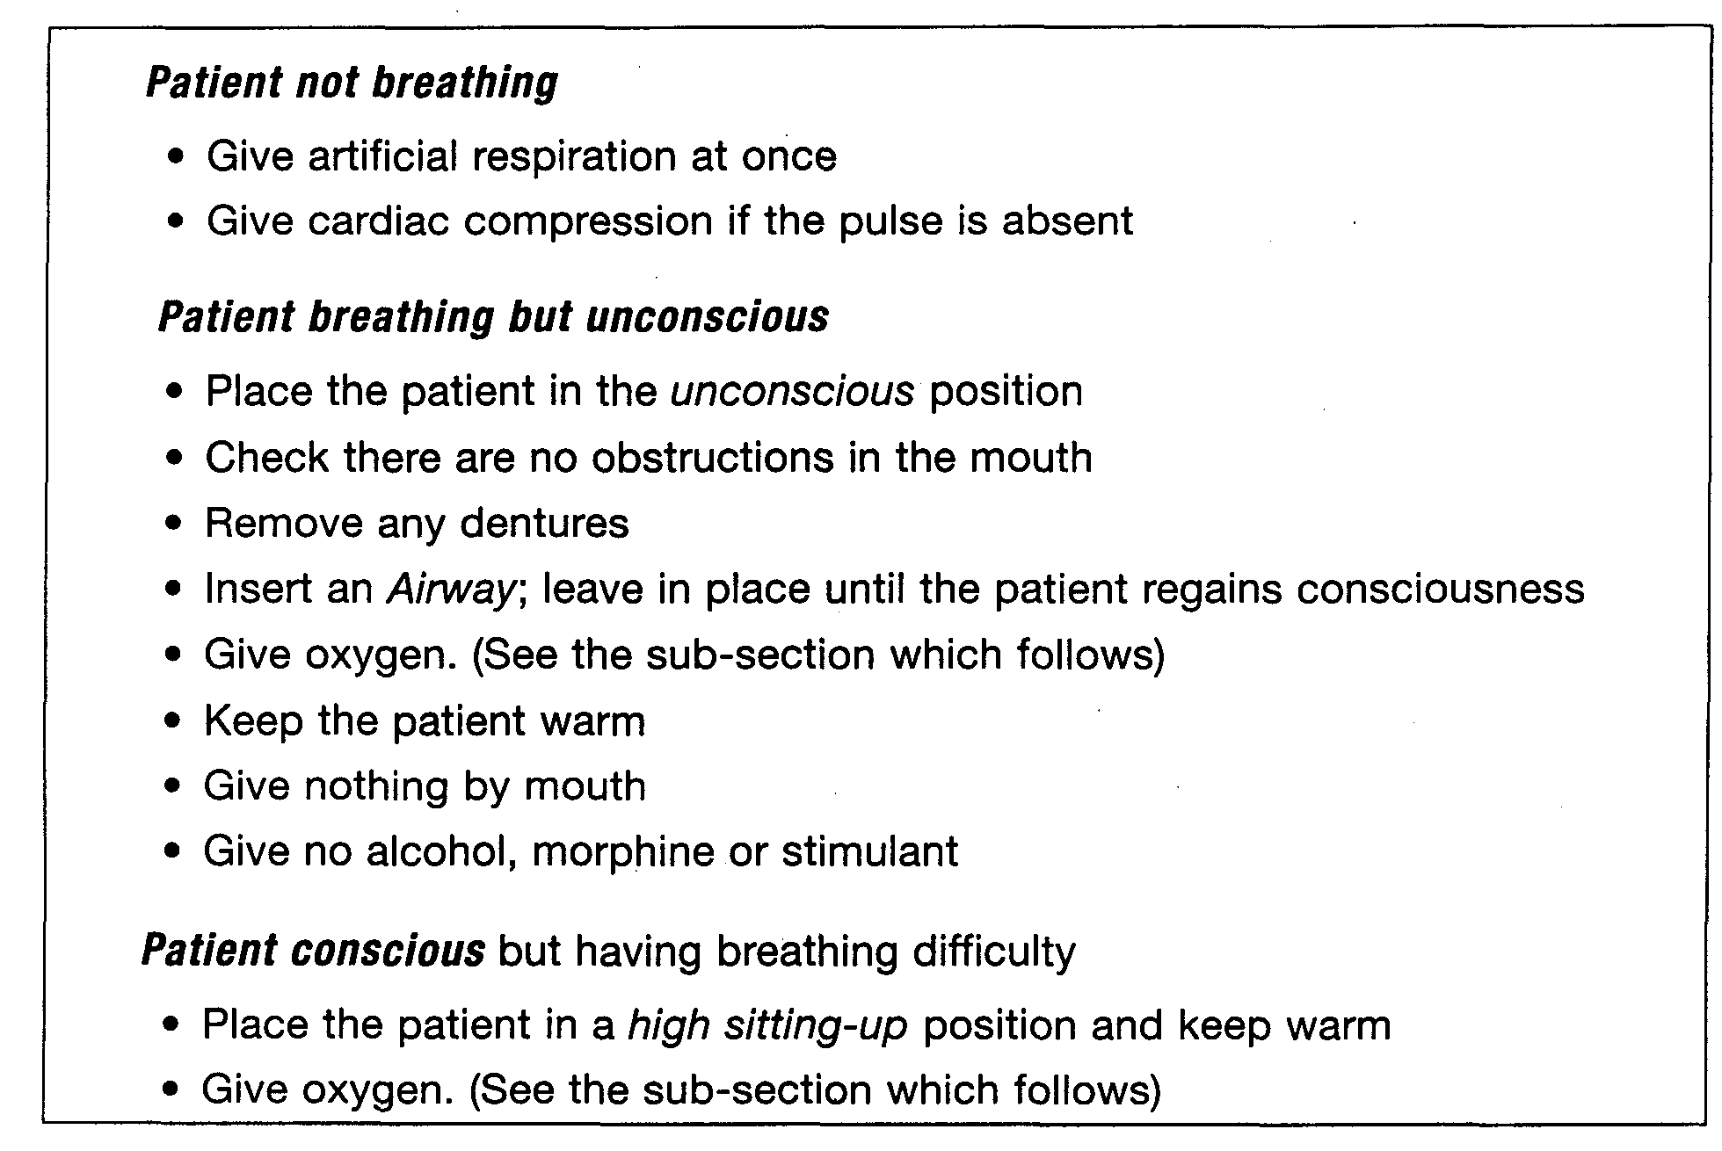
If breathing does not improve despite these measures, then asphyxia or other lung problems may have occurred. In such circumstances, or if the patient’s condition deteriorates rapidly, obtain medical advice.
9.3.4 Oxygen therapy

Oxygen resuscitators
Oxygen resuscitators are used to provide oxygen-enriched respiration to assist in the recovery of victims overcome by oxygen deficiency or toxic gas. The equipment can be taken into enclosed spaces to give immediate treatment to a casualty. Oxygen resuscitators consist of facemask, pressurised oxygen cylinder and automatic controls to avoid damage to the victim and give audible warning in the event of airway obstructions. The equipment is provided with a standard eight-metre long extension hose so that the carrying case (with cylinder and controls) may be securely placed and the mask taken to the victim if he is lying in a confined location. Some ships provide a further 15-metre extension hose. If the equipment is taken into a contaminated atmosphere, it must be remembered that, if adjustable, the instrument must be set to supply only pure oxygen. Caution with its use in a flammable atmosphere is necessary. If the instrument is used when the victim has been removed from the contaminated space, there are means to vary the air/oxygen mix.
It should be noted that the couplings on oxygen resuscitators should not be greased.
Warning: Smoking, naked light or fires must not be allowed in the same room during the administration of oxygen because of the risk of fire.
Oxygen must be given with care since it can be dangerous to patients who have had breathing difficulties such as bronchitis.
An accident in which a patient may require oxygen can be divided into two stages:

Stage 1 — During rescue
During rescue the patient should be connected to the portable oxygen resuscitation apparatus and oxygen administered until transferred to safety.

Stage 2 — When the patient is in a safe room

The unconscious patient
1. Ensure there is a clear passage to the lungs and that an Airway is in place
2. Place mask over the nose and mouth and give 35 per cent oxygen
3. Connect the mask to the flowmeter and set it at 4 litres per minute

The conscious patient
1. Ask if the patient suffers with breathing difficulty. If the patient has severe bronchitis, then give only 24 per cent oxygen. All others should be given 35 per cent oxygen
2. The mask is secured over the patient’s mouth and nose
3. The patient should be placed in the high sitting-up position
4. Turn on the oxygen flowmeter to 4 litres per minute
Oxygen therapy should be continued until the patient no longer has difficulty in breathing and has a healthy color. If the patient has difficulty in breathing, or if the face, hands and lips remain blue for longer than 20 minutes, seek urgent medical assistance.
Additional measures necessary where exposure to toxic vapours has been experienced include: —
- The removal of affected clothing
- Eye washing, and
- Skin washing
9.4 FROSTBITE
The extreme coldness of some liquefied gases is, in itself, a significant hazard. If the skin is exposed to severe cold, the tissue becomes frozen. This danger is ever-present in gas terminals and on a ship handling fully refrigerated cargoes. For fully pressurised gases, while containment systems will normally be at or near ambient temperature, liquid leaks will quickly flash to the fully refrigerated temperature. Such areas should never be approached without proper protective clothing.
The symptoms of frostbite are extreme pain in the affected area (after thawing), confusion, agitation and possibly fainting. If the affected area is large, severe shock will develop.

Initial symptoms
- The skin initially becomes red, but then turns white
- The affected area is usually painless, and
- The affected area is hard to the touch
If the area is left untreated, the tissue will die and gangrene may occur.

Treatment
- Warm the area quickly by placing it in water at 42°C until it has thawed*
- Keep the patient in a warm room
- Do not massage the affected area
- Severe pain may occur on thawing: give pain killer or morphine if serious
- Blisters should never be cut, nor clothing removed if it is adhering firmly
- Dress the area with sterile dry gauze
- If the area does not regain normal color and sensation, obtain medical advice
- As immediate action is necessary, and without the warm water close to hand, in the first instance the affected, part can be warmed with body heat or woolen material. If the finger or hand has been affected, the casualty should hold his hand under his armpit. Blood circulation should be allowed to re-establish itself naturally. If appropriate, the casualty should be encouraged to exercise the affected part while it is being warmed.
9.5 CHEMICAL BURNS
As shown in Table 9.2, chemical burns can be caused by ammonia, chlorine, ethylene oxide and propylene oxide. The symptoms are similar to burns by fire, except that the product may be absorbed through the skin causing toxic side-effects. Chemical burning is particularly damaging to the eyes.

Symptoms
- A burning pain with redness of the skin
- An irritating rash
- Blistering or loss of skin
- Toxic poisoning

Treatment
- Attend first to the eyes and skin
- Wash the eyes thoroughly for ten minutes with copious amounts of fresh wate
- Wash the skin thoroughly for ten minutes with copious amounts of fresh wate
- Cover with a sterile dressing
Otherwise, the treatment is as for burns, details of which are contained in the IMC Medical First Aid Guide (see Reference 1.7).
On gas carriers authorized to transport these products, deck showers and eye baths are provided for water dousing; their locations should be clearly indicated.
9.6 TRANSPORT TO HOSPITAL
It is extremely important to label the patient adequately before removal from the ship or terminal and a specimen patient-label is shown in Figure 9.1.
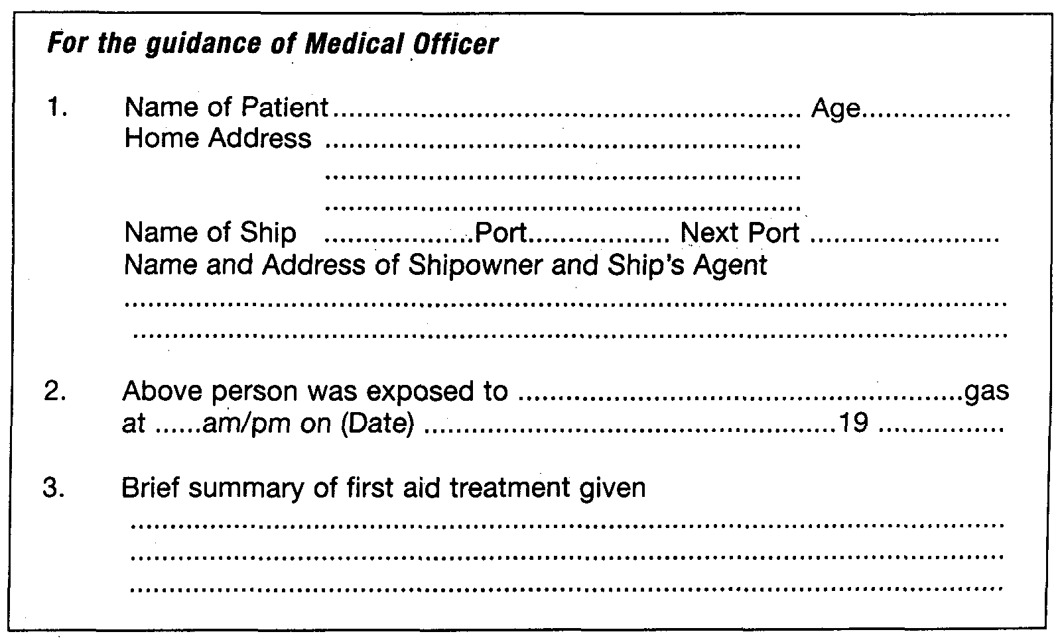
Figure 9.1 Patient label
  - HAZARDOUS ATMOSPHERES
9.7.1 The need for gas testing
The atmosphere in enclosed spaces must be tested for oxygen and hydrocarbon content in the following circumstances:
- Prior to entry by personnel (with or without protective equipment)
- During gas-freeing, inerting and gassing-up operations
- As a quality control before changing cargoes, and
- To establish a gas-free condition prior to drydock or ship repair yard
The atmosphere in a cargo tank is rarely, if ever, homogeneous. With the exception of ammonia and methane, most cargo vapours at ambient temperatures are denser than air. This can result in layering within the cargo tank. In addition, internal structures can hold local pockets of gas. Thus, whenever possible, samples should be drawn from several positions within the tank.
Atmospheres, which are inert or deficient in oxygen, cannot be checked for flammable vapours with a combustible gas indicator. Therefore, oxygen concentrations should be checked first, followed by checks for flammable and then toxic substances. All electrical instruments used should be approved as intrinsically safe.
9.7.2 Oxygen analyzers
Several different types of oxygen analyser are available. A common type of analyser is illustrated in Figures 9.2(a) and (b). In this example, oxygen diffuses through the teflon membrane into a potassium chloride solution and activates the chemical cell. When the switch is closed, current flows round the circuit and deflects the ammeter needle. The more oxygen absorbed by the solution, the greater the current and the needle deflection indicates the percentage of oxygen in the atmosphere being sampled.
The instrument described above operates without batteries and is relatively insensitive. Other types of analysers include the polarographic and paramagnetic-type instruments. These are much more sensitive and require batteries.
It should be noted that batteries should never be changed in a gas dangerous zone. Such instruments have dual scales, each having a separate function. For example:—
- Scale 1 — oxygen deficiency in air — zero to 25 per cent oxygen by volume;
- Scale 2 — oxygen in nitrogen —zero to 1 per cent oxygen by volume.
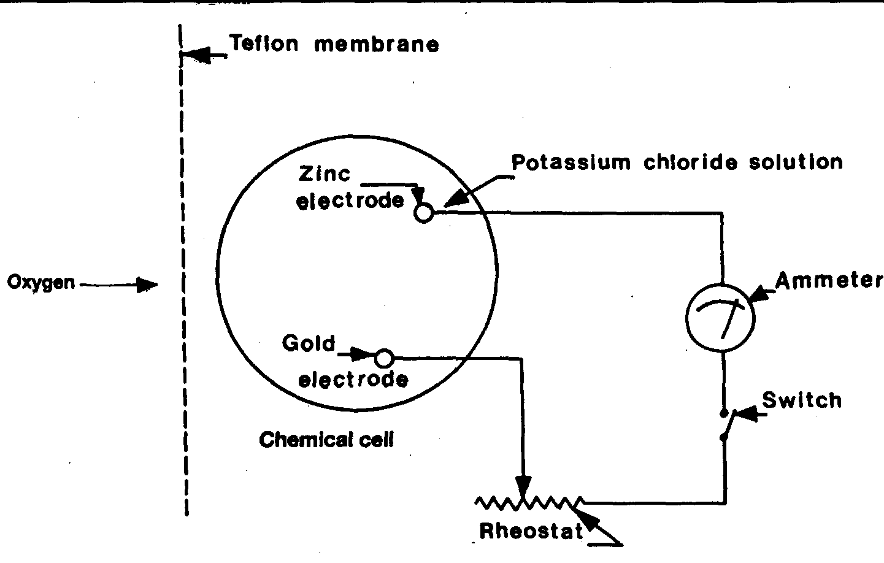
Figure 9.2(a) Oxygen indicator — circuit diagram
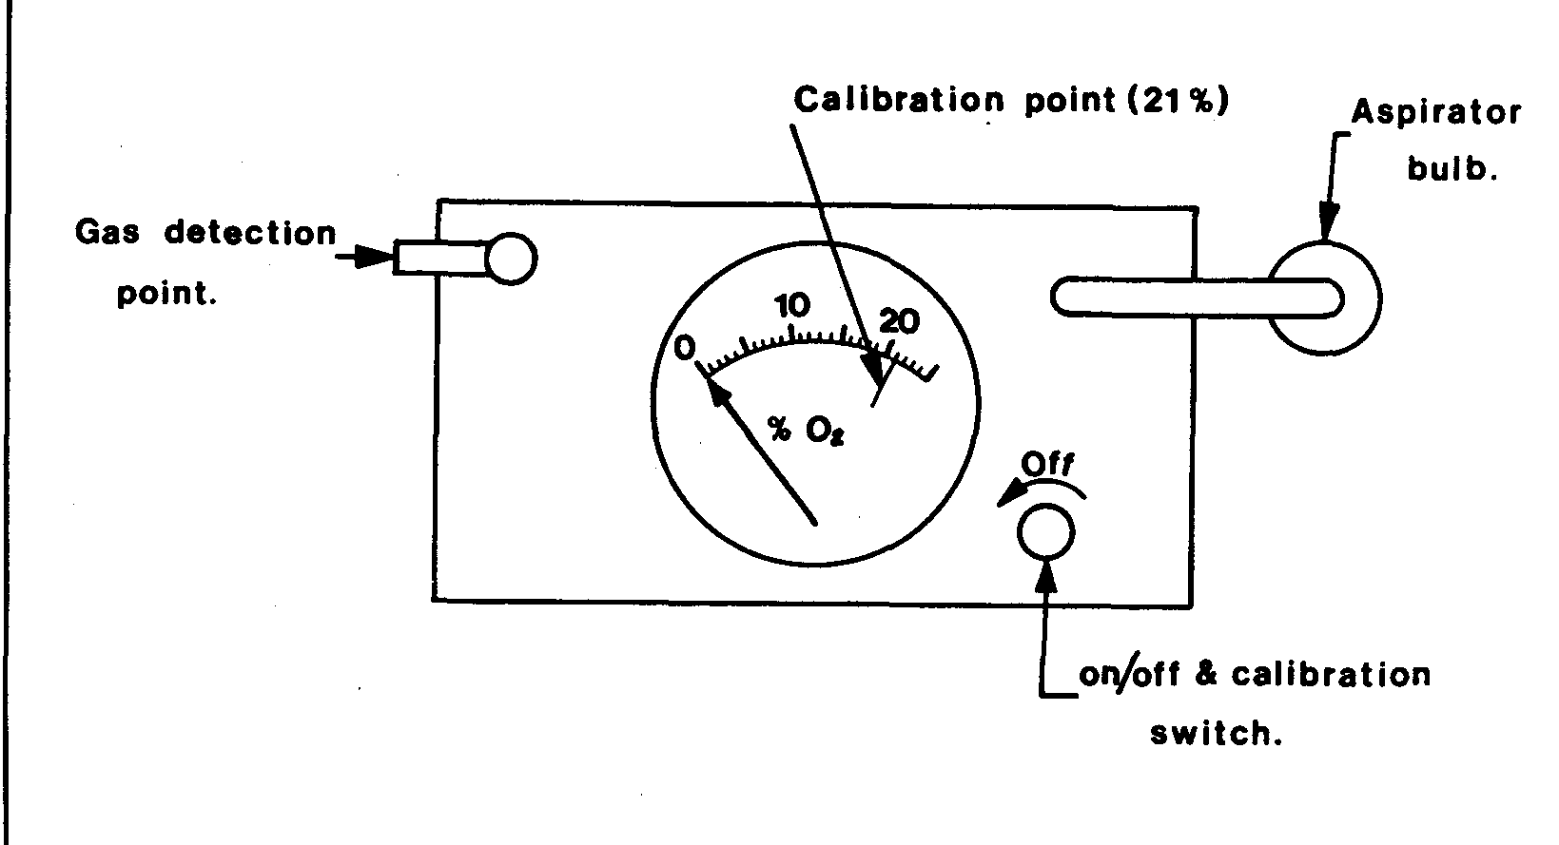
Figure 9.2(b) Oxygen indicator — plan view
A schematic diagram of the polarographic cell used in some oxygen analysers is shown in Figure 9.2©. In this cell, the current is controlled by the electrochemical reaction of oxygen at the cathode (the permeable membrane). The life of the cell is approximately six months when continuously operated in air.
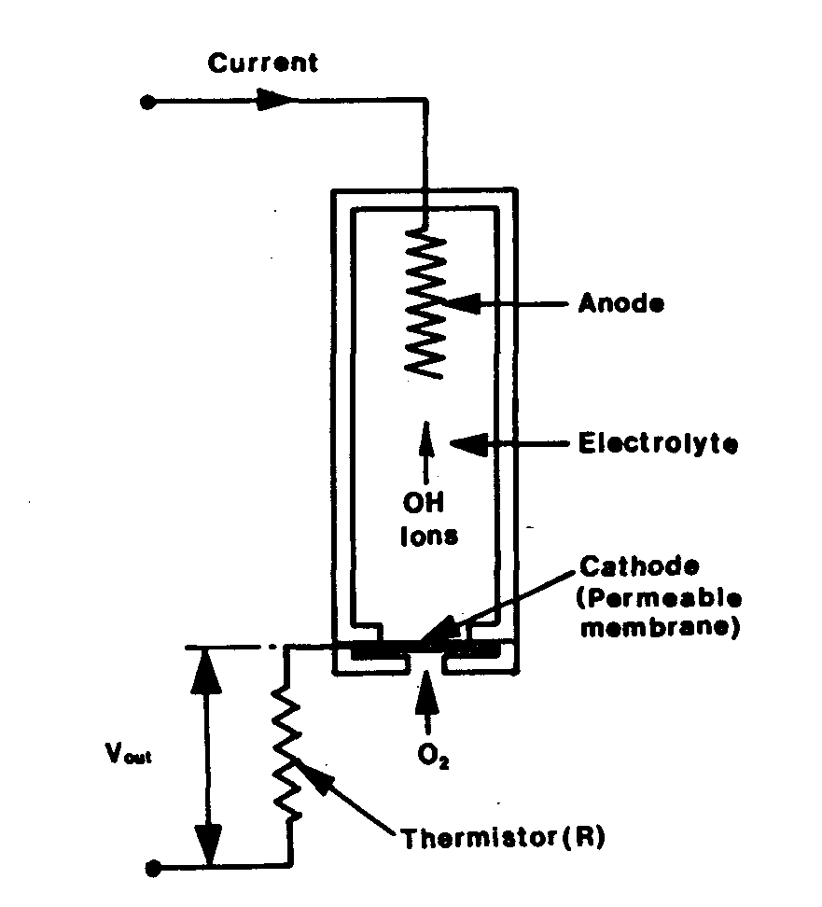

Figure 9.2© A polarographic cell
These instruments should be regularly spanned (calibrated) with fresh air (21 per cent oxygen) and test-nitrogen (a virtual zero per cent oxygen content). Liquid contamination, pressure or temperature effects may result in drifting of instrument response.
9.7.3 Combustible gas indicators

Catalytic instruments
The basic electric circuit (Wheatstone Bridge) of the combustible gas indicator is shown in Figure 9.3(a). The gas to be measured is aspirated over the sensor filament, which is heated by the bridge current. Even though the gas sample may be below the lower flammable limit, it will burn catalytically on the filament surface. In so doing, it will raise the temperature of the filament, increase its electrical resistance and unbalance the bridge. The resultant imbalance registers on the meter, which indicates the hydrocarbon content in the air.
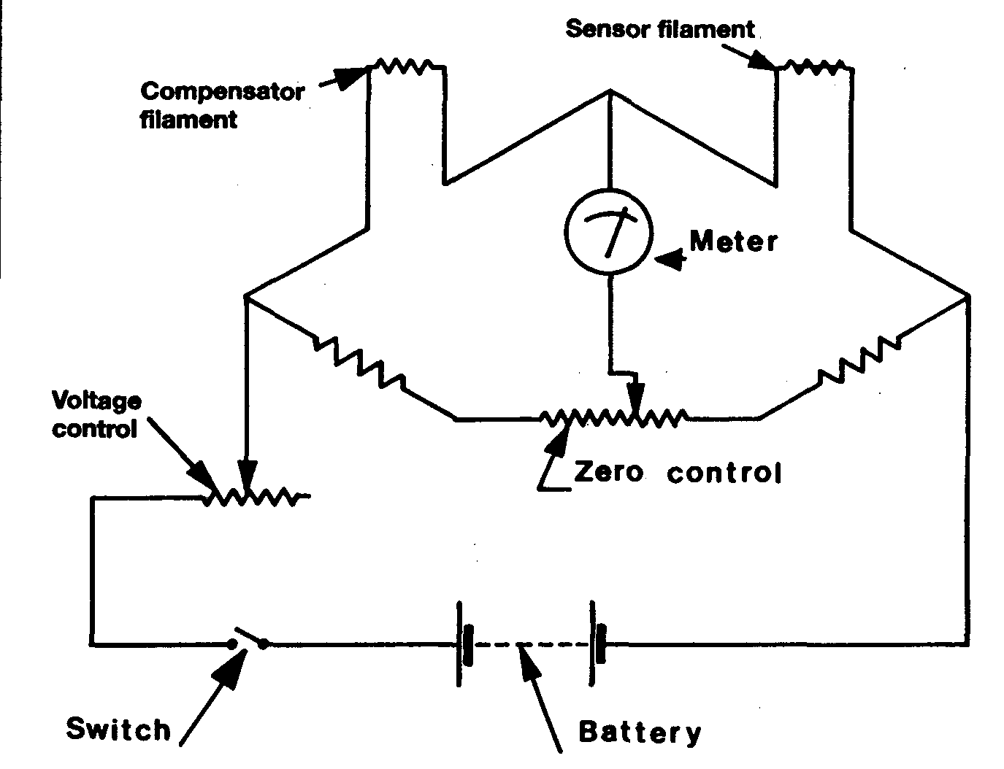
Figure 9.3(a) Combustible gas indicator — circuit diagram
Such instruments are designed principally to indicate flammability but are also used to detect the presence of small concentrations of gases in air.
The meter scale commonly reads from zero percent to 100 per cent of the lower flammable limit (LFL). On instruments having a dual range, a second scale indicates zero to 10 per cent of the LFL. Instruments of this type contain batteries, which must be checked prior to use, and it is a recommended practice to check the instrument using a calibration gas at frequent intervals. When calibrating the instrument, the meter reading should fall within the range indicated on the calibration graph which is provided by the manufacturers — see Figure 9.3(b).
In the example shown in Figure 9.3(b), a meter reading of between 68 and 92 per cent of LFL for a calibration gas containing three per cent methane in air indicates that the detector filament is in good order. These values are only given for illustration and reference must always be made to the graphs, which accompany each calibration kit.
Tank spaces being sampled, which have an atmosphere above the flammable range, will produce a low or even zero reading on this type of meter. However, as the sample is initially drawn into the meter, the meter needle will give a momentary strong deflection before returning to its steady low or zero reading. This momentary deflection must always be watched for, since it gives warning that the following steady
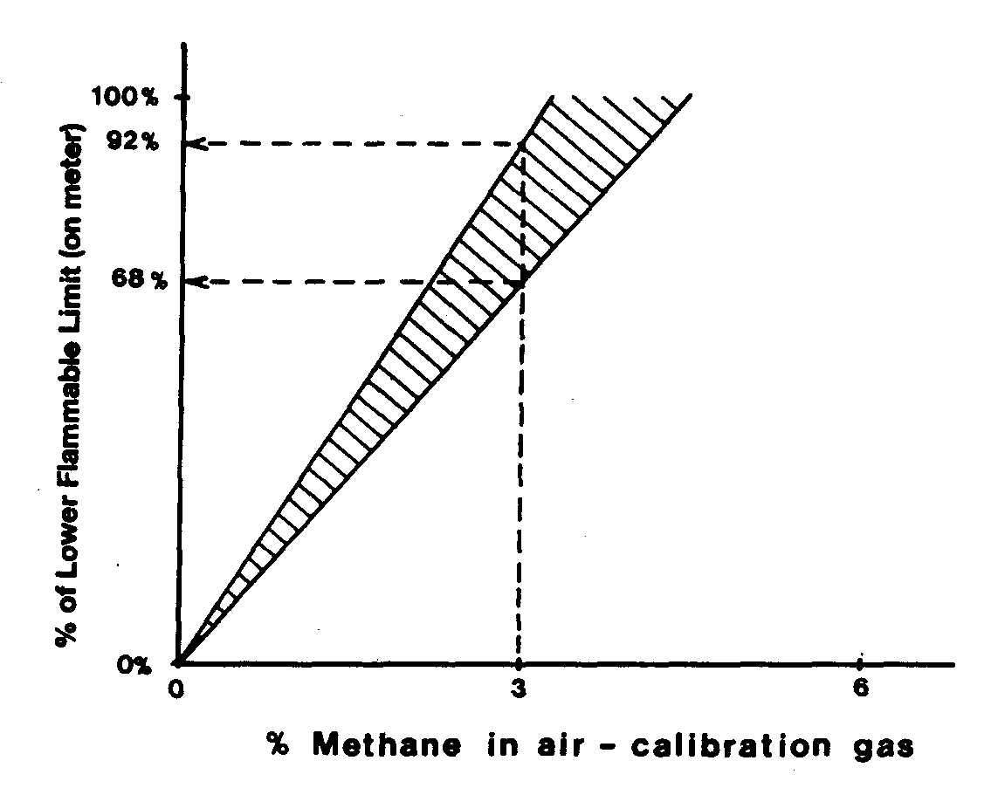

Figure 9.3(b) Combustible gas indicator — calibration
reading will be misleading and that the gas being sampled is above the lower flammable limit.
Some instruments may have sensor filaments whose catalytic action may be spoilt by the presence of other gases such as halogenated hydrocarbons (halon) sometimes used for fire extinguishing. Whenever opportunity arises, instruments should be checked against each other and any doubt resolved by a calibration kit. It should be noted that the batteries fitted within such instruments should only be changed in gas-safe areas.

Non-catalytic heated filament gas indicators
Since the action of the catalytic gas indicator depends upon combustion with air, it cannot be used for inerted atmospheres because of oxygen deficiency. Instruments suitable for such use, while operating on a similar Wheatstone Bridge principle, contain a filament sensitive to variations in heat conductivity of the sample which varies with its hydrocarbon content. Such meters usually register over the range 0 to 25 per cent hydrocarbon vapour by volume and are useful for monitoring inerting operations.

Multipoint flammable gas monitors
The catalytic and heated filament flammable gas indicators are widely used as portable, hand-aspirated instruments. They are intrinsically safe. Their main purpose is for testing cargo tanks, void spaces and other enclosed spaces and this is most often carried out during gas freeing operations and before entry by personnel.
The catalytic instrument is also used in multi-point form for continuous monitoring of air-filled or air-ventilated spaces such as compressor rooms, motor rooms, machinery spaces and cargo holds. In multi-point form, the indicator is installed on ships’ bridges or in cargo control rooms. These instruments draw samples sequentially from points in the various spaces monitored. The indications may be automatically recorded and individual alarms are provided when a low percentage of the Lower Flammable Limit is detected.
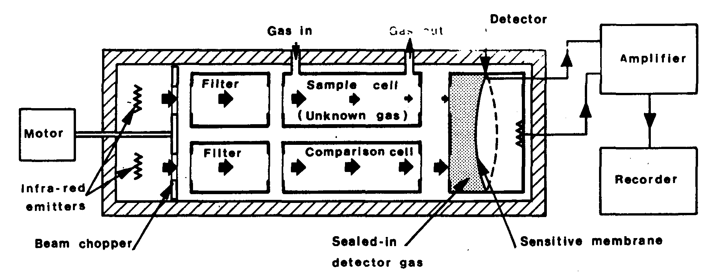

Figure 9.4 Infra-red gas analyser
Where void spaces are inerted continuously with nitrogen, the catalytic type will not function and an infra-red analyser is often provided as the central multi-point instrument. Figure 9.4 illustrates the principle of a typical infra-red analyser. This instrument employs the property of hydrocarbon gas to absorb infra-red radiation. Two similar nickel/chrome emitters within the instrument beam provide infrared radiation to two separate channels, one through the sample cell and one through a reference cell free of hydrocarbon. The two channels are alternately blocked by a semi-circular beam chopper driven by an electric motor. The transmitted radiation from both channels passes to a detector cell in which the gas is heated by the received radiation. The resultant rise in pressure is detected by the sensitive membrane of a condenser microphone. As a result of the chopping of the two beams and the absorptive effect of any hydrocarbon in the sample cell, the output of the microphone is an alternating current signal, directly related to the hydrocarbon content of the sample. This signal is amplified and recorded and, when gas is detected, actuates the alarm for the point being sampled.
9.7.4 Toxicity detectors
Toxic gas detectors usually operate on the principle of absorption of the toxic gas in a chemical tube which results in a colour change. A common type of toxic gas detector is illustrated in Figure 9.5. Immediately prior to use, the ends are broken from a sealed glass tube. This is inserted into the bellows unit and a sample aspirated through it. The reaction between the gas being sampled and the chemical contained in the tube causes a colour change. Usually, readings are taken from the length of the colour stain against an indicator scale marked on the tube. These are most often
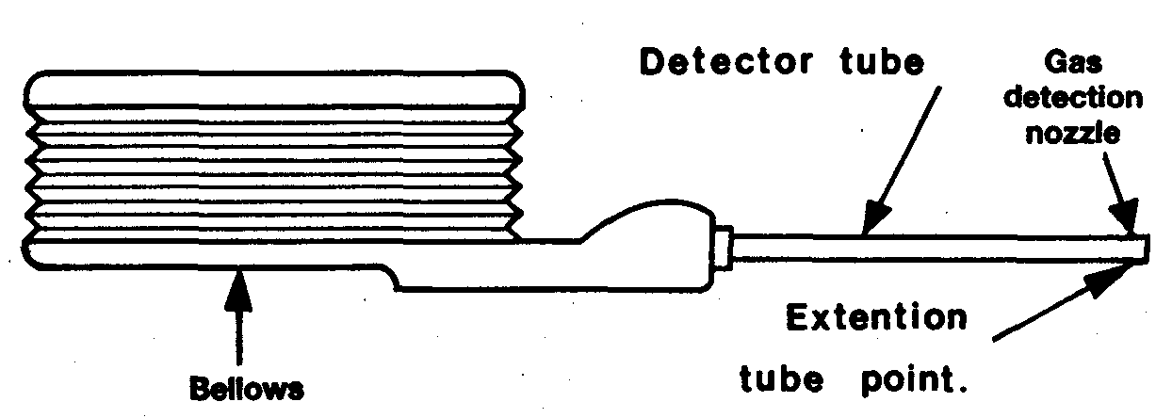

Figure 9.5 Toxic gas indicator

expressed in parts per million (ppm). Some tubes, however, require the colour change to be matched against a control provided with the instruction manual. As tubes may have a specific shelf life, they are date-stamped and are accompanied by an instruction leaflet, which lists any different gases which may interfere with the accuracy of the indication.
When using this type of instrument, it is important to aspirate the bulb correctly if reliable results are to be obtained. Normally, the bellows are compressed and the unbroken tube inserted. By this means the instrument is checked for leaks prior to breaking the tube. If found to be faulty, it should be replaced.
This type of instrument can also be used to good effect during gassing-up operations when changing from one cargo to another. By using tubes suitable to detect trace amounts of the previous cargo, a careful estimation can be made regarding a suitable cut-off point for the operation.
9.8 ENTRY INTO ENCLOSED SPACES

9.8.1 Precautions for tank entry
Because of the danger of hazardous atmospheres, an enclosed space should only be entered when it is essential to do so. At such times a permit to work should be issued and this should be specific as to date, time and space concerned and list the precautions to be taken. Alternatively, for ship tank entry purposes, the Maritime Safety Card should be completed. An example of this card, from IMO’s International Maritime Dangerous Goods Code (Supplement) (see Reference 1.7), is reproduced in Figure 9.6.
The Maritime Safety Card gives an appropriate procedure for entering enclosed spaces on ships.
Particular hazards atmospheres can include: —
- Amounts of hydrocarbon gas
- Trace amounts of toxic gas
- The intrusion of inert gas, and
- Oxygen deficiency (often caused by the rusting process in unventilated tanks)
The table below lists those spaces on a gas carrier which are either enclosed or which may be considered gas-dangerous for entry.

Table 9.4 Enclosed spaces on gas carriers
enclosed spaces ON gas carriers INCLUDE:—

Enclosed Spaces in Cargo Area | Enclosed Spaces Elsewhere | Encloses Spaces Entered Routinely
cargo tanks | void spaces | compressor rooms
hold spaces | bunker tanks
interbarrier spaces | cofferdams
•duct keels | ballast tanks
spaces containing cargo pipes | spaces adjacent to cargo spaces having unsafe atmospheres
Note:— Even if a space is already considered gas-free and fit for entry, where it is immediately adjacent to a tank having a dangerous and pressurised atmosphere, the space should always be entered with caution and only after suitable checks have been made.

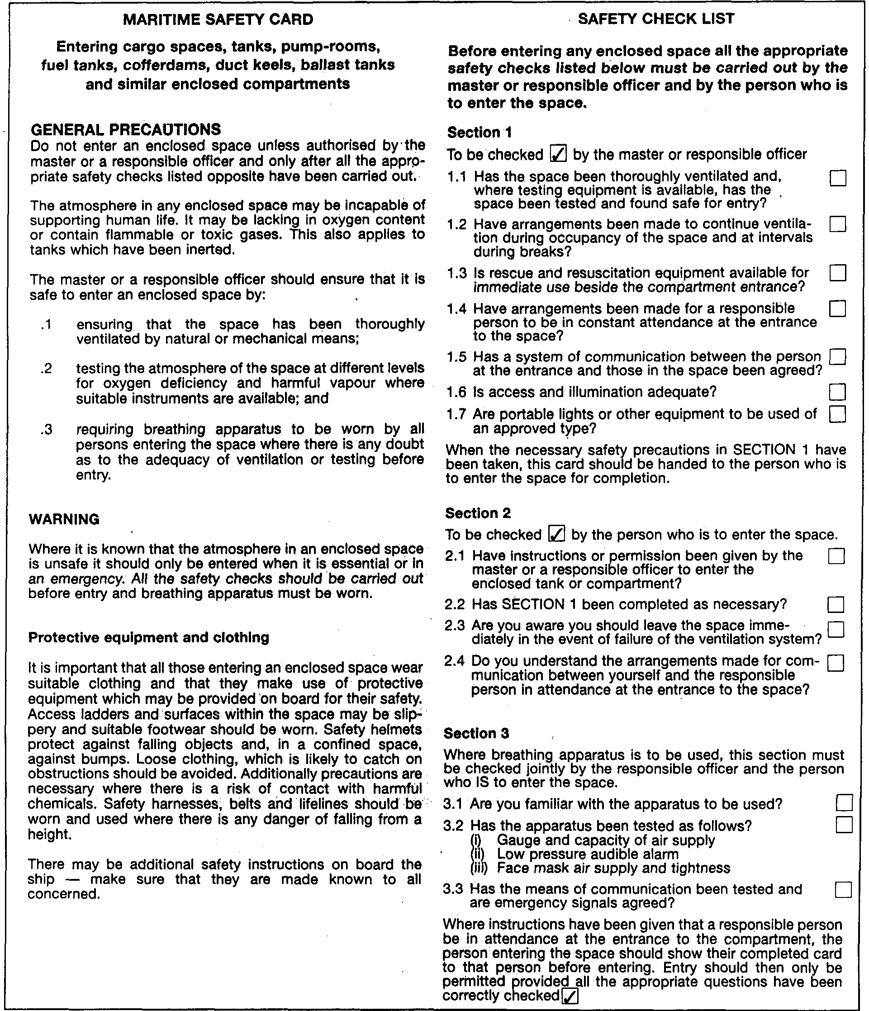
Figure 9.6 Maritime Safety Card with Safety Check List

9.8.2 Procedures
For those special cases where tank entry is required, every ship and terminal should have procedures for safe entry and these should be written into operating manuals. Manuals should be clear on questions of area responsibility; shore tanks should not be entered without the terminal manager’s permission and the ship’s tanks should not be entered without the shipmaster’s permission. As far as the terminal operating manual is concerned, such procedures should¹ give advice on terminal operations and the requirements expected from their own, or contracted, personnel when they are visiting or inspecting ships. This matter should be taken most seriously by terminal managers as accidents to shore personnel when entering enclosed spaces on ships are not uncommon.
Generally, entry into enclosed spaces should only be permitted when the atmosphere has been declared gas-free and fit for entry by a responsible officer. Only in very exceptional circumstances should tank entry be allowed when the tank atmosphere is unsafe — and then, only with full protective equipment and breathing apparatus. Further information covering entry into enclosed spaces can be found in Reference 2.1.

9.8.3 Rescue from enclosed spaces
Experience has shown that the rescue of persons from within an enclosed space can be extremely hazardous and especially so in cases of oxygen deficiency. These risks are heightened where access to a compartment can only be achieved with difficulty. In such circumstances, it is vital that rescuers always pay strict attention to the correct procedures and the use of proper equipment and do not rush into ill-considered action. Many fatalities have resulted from failure to comply with these basic rules.
For training purposes, full-scale exercises in non-hazardous atmospheres have been found extremely beneficial. Exercises involving weighted dummies, with rescuers wearing protective equipment and breathing apparatus, are essential if rescue teams are to be properly prepared for a real emergency. Such simulations are often conducted by ship’s personnel. They can also involve terminal employees and shore-based emergency services such as the fire brigade.
9.9 PERSONAL PROTECTION
9.9.1 Breathing apparatus
As previously indicated, it is always preferable to achieve a gas-free condition in a tank or enclosed space prior to entry by personnel. Where this is not possible, entry into tanks should only be permitted in exceptional circumstances and when there is no practical alternative, in which case, breathing apparatus (and if necessary, protective clothing) must be worn. There are four types of respiratory protection: —
- Short duration breathing apparatus
- Fresh air respirators
- Compressed air breathing apparatus
- Canister filter respirators
- Each type is described in the following sections:

Short-duration breathing apparatus
Short-duration breathing apparatus consists of a small compressed air cylinder and a polythene hood, which may be rapidly placed over the head. Their duration is limited to about 15 minutes of comparatively non-exertive effort and-the sets must be used only for emergency escape purposes. Depending on the cargoes specified on the ship’s Certificate of Fitness, short-duration breathing apparatus may be provided in accommodation spaces for each crew member. Such equipment may also be supplied for inspections of gas-free enclosed spaces, as an aid in case a hazardous atmosphere is encountered, although, in cases of known danger, it is recommended that compressed air breathing apparatus be worn.

Fresh air respirators
Fresh air respirators consist of a helmet or facemask linked by a flexible hose (maximum length 40 metres) through which air is supplied by a manual bellows or rotary blower. The equipment is simple to operate and maintain and its operational duration is limited only by the stamina of the bellows or blower operators. However, movement of the user is limited by the weight and length of hose and great care must be taken to ensure that the hose does not become trapped or kinked.
Users of such equipment should always wear a safety line for communication and rescue.
While this respirator has been largely superseded by the self-contained or airline compressed air breathing apparatus, it will be found on many ships as a backup to that equipment.

Compressed air breathing apparatus
Compressed air breathing apparatus may be adapted into two forms. It may be the self contained type (SCBA) or the air-line version (ALBA).
In the self-contained (SCBA) version, the wearer carries air for breathing in a compressed air cylinder at an initial pressure of up to 300 bars. The pressure is reduced at the outlet to about 5 bars and fed to the face mask through a demand valve. This provides a slight positive pressure within the mask. The working duration of the equipment depends upon the capacity of the air cylinder and respiratory demand. A pressure gauge and an alarm are provided to warn of low air supply pressure.
A typical set, providing approximately 30 minutes operation with physical exertion, may weigh about 13 kg and the bulk of the cylinder on the back of the wearer imposes some restriction on maneuverability in confined spaces. When properly adjusted, the SCBA is simple and automatic in operation. However, maintenance requires care and skill. To ensure serviceability, all such breathing sets should be checked monthly and used during exercises. This should be done using special exercise air cylinders in order to keep the operational cylinders always fully charged or, alternatively, an air compressor may be used for immediate refilling.
Although demand valves are designed to maintain a slight positive pressure within the facemask, it should not be assumed that this feature will prevent a contaminated atmosphere leaking into an ill-fitting mask. It is essential that, before entry into a dangerous space, the air tightness of the mask on the wearer’s face be thoroughly checked in accordance with the manufacturer’s instructions. Tests have shown that it is virtually impossible to ensure continued leak tightness in operational conditions on a bearded face.
Most compressed air breathing sets may be used in the airline version (ALBA) whereby the compressed air cylinder and a pressure reducing valve are placed outside the contaminated atmosphere and connected to the face mask and demand valve by a trailed air hose. At the expense of decreased range and the need for extra care in guiding the trailing air hose, the wearer is relieved of the bulk of the air cylinder. Also, operational duration may be extended by the use of larger air cylinders or special cylinder changeover arrangements.

Canister filter respirators versus SCBA
Canister filter respirators consist of a mask which has a replaceable canister filter attached. In this type of equipment, contaminated air is drawn in by the normal breathing of the wearer and toxic elements are filtered out. They are simple to operate and maintain, can be put on quickly and are used as personal protection for emergency escape purposes on ships certified for carrying toxic cargoes. They are, however, only suitable for relatively low concentrations of toxic gas. Once used, there is no simple means of assessing the remaining capacity of the filter. Filter materials are specific to a limited range of gases and, of course, the respirator gives no protection in atmospheres of reduced oxygen content. For these reasons, the requirements of the Gas Codes for emergency escape protection is now almost exclusively met by lightweight self-contained breathing apparatus.
Canister filter respirators are not suitable for use in atmospheres where the oxygen content is insufficient to support life.

Training
Good training is essential in the use of this life-saving appliance. Specially marked cylinders should be used for training to ensure that in an emergency, only fully charged units are used. Cylinder pressures should be regularly checked and low-pressure cylinders should be recharged promptly.
9.9.2 Protective clothing
In addition to breathing apparatus, full protective clothing should be worn when entering an area where contact with cargo is a possibility. Types of protective clothing vary from those providing protection against liquid splashes to a full positive pressure gas-tight suit, which will normally incorporate helmet, gloves and boots. Such clothing should also be resistant to low temperatures and solvents.
It is particularly important to wear full protective clothing when entering an enclosed space, which has contained toxic gas such as ammonia, chlorine, ethylene oxide, propylene oxide, vinyl chloride or butadiene.
For certain cargoes, the Gas Codes require the use of suitable eye protection.

Chapter 10
Emergency Procedures
This chapter discusses events, which may follow cargo spillage and the procedures, which can be adopted to protect life and property in such circumstances. While this chapter concerns both ship and terminal, reference should also be made to Chapter Six, which discusses emergency precautions particularly applicable to the ship/shore interface. For more background on these matters the reader is referred to References 2.5, 2.6, 2.7 and 2.9.
10.1 THE PRINCIPAL HAZARDS
The gases with which this book is concerned are either flammable or toxic or both. Most are stored and handled at sub-zero temperatures, or under pressure or by means of a combination of the two. The main hazards are, therefore, vapour release, flammability, toxicity and the effects of sub-zero temperatures on personnel and structures.

10.1.1 Flammability
As already described in 2.20, when a gas is released to atmosphere, if within its flammable range and if exposed to a source of ignition, it will burn. Depending upon the conditions under which combustion takes place, some degree of over-pressure will occur due to the rapid expansion of the heated gas.
A liquid spill or vapour cloud burning over open water will develop little over-pressure due to the unconfined nature of the surroundings. At the other extreme, the ignition of vapour within an enclosed space will rapidly create an over-pressure sufficient to burst the boundaries. Between these two extremes, that is in cases of partial confinement such as might occur among shore plant and equipment, ignition may produce overpressures sufficient to cause substantial damage, so escalating the hazard and its consequences.
A leakage of liquid or vapour from a pipeline under pressure will burn, if ignited, as a jet which will continue as long as fuel is supplied.
A particularly destructive form of vapour burn, associated with the storage of liquefied gas in pressurised containers, is the BLEVE (Boiling Liquid Expanding Vapour (*Explosion). This is described in 2.20.
10.1.2 Vaporisation of spilled liquid
When a gas is stored as a liquid, whether under pressure or refrigerated, it will vaporise on being released to the atmosphere, taking heat from the surroundings. Depending upon the liquid spilled, the spill size and whether the spill is on land or water, the rate of vaporisation and the temperature and density of the ensuing vapour cloud will vary. Almost certainly the cloud will be low-lying (only methane, when warmer than -100°C, ethylene and ammonia are lighter than air — see Table 2.5). Initially, the cloud will be cold and will drift downwind. In general, it will be visible as a white cloud, which is condensed atmospheric water vapour. The characteristic of this cloud in terms of its flammability and oxygen content are discussed in 2.20 and 9.2.2.

10.1.3 Toxicity and toxic products of combustion
Some liquefied gases present toxic hazards, principally if the vapours are inhaled. Ammonia, chlorine, ethylene oxide and propylene oxide, are also very corrosive to the skin. Vinyl chloride is known to cause cancer and butadiene is suspected as having similar harmful effects.
Incomplete combustion of hydrocarbon vapours may produce the toxic gas carbon monoxide which is found in inert gas in quantities which can vary with the quantity of combustion in the generator. Combustion of vinyl chloride may produce toxic carbonyl chloride.
10.1.4 Frostbite
Cold liquefied gas spilled onto a person freezes the skin. This effect can cause extensive frostbite to exposed parts of the body (see 9.4).

10.1.5 Brittle fracture
Liquefied gas spilled onto ships’ decks, not designed for low temperatures, may chill the steel to temperatures where it becomes brittle. Stress already within the steel, together with that resulting from differential contraction, can cause fractures in the cooled areas. The resultant fractures are unlikely to propagate beyond the cooled areas. Spills can have serious consequences and ships have been taken out of service for extensive periods for this reason. Care should be taken and appropriate drip-trays should be provided as a protection against such spillage on ships carrying the particularly cold liquids (LNG and ethylene). The area around the manifold may be sheathed in wood or glass-fibre and all refrigerated gas carriers are provided with a stainless steel, wooden or equivalent drip tray under the manifold connections.
10.2 LIQUEFIED GAS FIRES
It is not proposed in this book to deal with fires that can occur in terminal buildings, store rooms, the ship’s accommodation or machinery spaces. The characteristics and methods of fighting such fires are covered elsewhere. Provided cargo containment is not ruptured, it is rare for such fires to spread to the cargo. Accordingly, this section deals only with cargo liquid or vapour fires.

10.2.1 Fire detection
On ships, the only mandatory requirement for fire detection equipment in the cargo area is the fusible elements specified in the Gas Codes. These have to be fitted in the vicinity of tank domes and at cargo manifolds. The fusible elements provide for the automatic cargo shut-down in the event of fire. However, many modern ships have fire detectors installed in motor rooms and compressor rooms.
In terminals, where storage tank and miscellaneous plant are diversely located, fire detection equipment is extensively provided. Typical locations are electrical control rooms, boil-off gas compressor houses and at cargo pumps.
Cargo-related fires may be broadly categorized as follows:—
- Jet fires from leaks at pumps or pipelines
- Fires from confined liquid pools
- Fire, from unconfined spillages, and
- Fires in enclosed spaces, such as compressor rooms
10.2.2 Jet fires
Small leaks from pump glands, pipe flanges or from vent risers will initially produce vapour. This vapour will not ignite spontaneously but, if the escape is large, there may be a risk of the vapour cloud spreading to a source of ignition. Should a gas cloud occur, ignition should be prevented by closing all openings to hazardous areas. Furthermore, the vapour cloud should be directed or dispersed away from ignition sources by means of fixed or mobile water sprays (see 10.3.2). If ignition does occur, it will almost certainly flash back to the leak. Leaks from pipelines are likely to be under pressure and, if ignited, will give rise to a jet flame. Emergency shut-down of pumping systems and closure of ESD valves should have already occurred but, even so, pressure may persist in a closed pipeline until the liquid trapped within has been expelled through the leak. In such a case the best course of action is often to allow the fire to burn out. The alternative of extinguishing the fire has a high risk of further vapour cloud production and flash-back causing re-ignition. While the fire is being allowed to burn itself out, the surroundings should be protected with cooling water.

10.2.3 Liquid (pool) fires
Significant pool fires are not likely on the ships’ decks because the amount of liquid, which can be spilled in such a location, is limited. The arrangement of the ship’s deck, with its camber and open scuppers, will allow liquid spillage to flow quickly and freely away over the ship’s side (see also 6.6.7). Prompt initiation of ESD procedures further limits the availability of liquid cargo.
Furthermore, on LNG ships, a water curtain is fitted to provide a warming flow down the ship’s side adjacent to the cargo manifold. This is to limit the possibility of brittle fractures.
A liquid spillage on shore, from tank or pipeline ruptures, may involve large quantities but should be contained in bunded areas or culverts. Any -ignition of the ensuing vapour cloud would then result in a pool fire. The flame height from such a fire, in the absence of wind, is as illustrated in Figure 10.1. Figure 10.1 also illustrates the effect
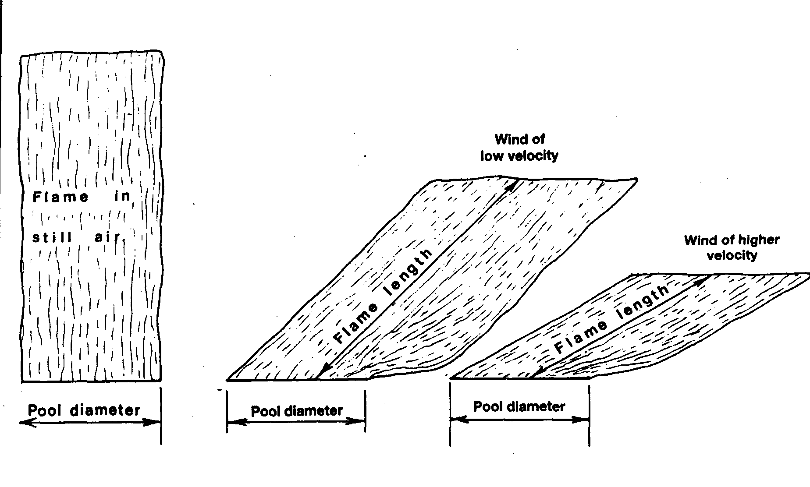
Figure 10.1 Pool fire configurations
of wind in deflecting the axis of the flame and in shortening flame-length. The emissive power of a flame surface increases with pool diameter. LNG vapours burn in the initial stages with a comparatively clear flame; LPG, however, burns with a greater production of soot and, as a result, maximum surface emissive powers are lower than for LNG. Heat radiation levels from both LNG and LPG pool fires dictate that unprotected personnel must escape from the immediate vicinity as quickly as possible.
Heat radiation from a fire falls away approximately as the inverse square of the distance between the object and the flame. The human body will feel extreme pain on bare skin after only 10 seconds of incident radiation of 6 kW/m² and will suffer severe blistering after 10 seconds exposure to 10 kW/m². Incident radiation greater than 10 kW/m² will quickly vaporise PVC cables and will seriously affect fiberglass lifeboats. The estimation of safe distances from a pool fire involves complex factors but, for a large pool fire, such safe distances are likely to be some tens of metres.
Because of the damage which radiation can inflict on surrounding tanks and plant, such equipment is always protected (often by insulation or by remotely operated water deluge systems). Also, the bunds and culverts where pool fires may occur are often provided with remotely operated dry powder installations. Alternatively, they may be fitted with a high expansion foam system for rapidly building up and maintaining a depth of foam to control the rate of burning.

10.2.4 Fires in compressor rooms
Enclosed spaces containing cargo plant such as compressors, heat exchangers or pumps will normally be provided with a fixed and remotely activated fire extinguishing system such as carbon dioxide. Provided no major disruption to the enclosure has occurred, these systems should be immediately effective.

10.3 LIQUEFIED GAS FIRE-FIGHTING

10.3.1 Alarm procedures
Each gas ship and terminal should have fire-fighting plans and muster lists prominently displayed. These should be carefully read and understood by all personnel. As a general guide, when a liquid gas fire occurs, the correct procedure to adopt is as follows: —
- Raise the alarm
- Assess the fire’s source and extent, and if personnel are at risk
- Implement the emergency plan
- Stop the spread of the fire by isolating the source of fuel
- Cool surfaces under radiation or flame impingement with water, and
- Extinguish the fire with appropriate equipment or, if this is not possible or desirable, control the spread of the fire as above

Raising the alarm and initial action
Fundamental to emergency procedures is how to report and how the alarm should be given to all concerned. These procedures should be developed independently for the terminal, the ship and the ship/shore system.
Procedures should warn that a seemingly minor incident may quickly escalate to one of a more serious nature. Much is gained by immediately reporting any abnormal occurrence, thereby permitting early consideration of whether a general alarm is desirable.
In the case of incidents on a ship or on a jetty while a ship is alongside, the manpower and facilities immediately available on the ship will generally make it appropriate that the ship takes first autonomous action by initiating cargo transfer ESD by the agreed safe means, alerting the terminal to provide assistance as quickly as possible and immediately putting into action the ship’s own emergency procedure.

10.3.2 Extinguishing mediums
There are a number of established and proven methods for dealing with gas fires but, to be effective, the appropriate extinguishing medium must be used.

Water
Water should never be applied to a burning liquefied gas pool. This would provide a heat source for more rapid vaporisation of the liquid and increase the rate of burning. Nevertheless, water remains a prime fire-extinguishing medium for liquefied gas fire-fighting. Being abundantly available, water is an excellent cooling agent for surfaces exposed to radiation or direct fire impingement. Also, it may be used in spray form as a radiation screen to protect fire-fighters. In some circumstances, water can be used to extinguish a jet of burning gas but this is not always desirable.
Fixed water deluge systems are customary for surfaces -such as ships’ structures, deck tanks and piping, shore storage tanks, plant and jetties, all of which can be exposed to liquefied gas fires. Such systems are designed to supply a layer of water over the exposed surfaces and thus to provide a useful cooling effect. Provided a water layer of some thickness can be maintained, the surface temperature cannot exceed 100°C. Application rates vary with the distance of the structure to be protected from the envisaged fire source and range from two to ten or more litres of water per square metre of protected surface.
Water spray from fixed monitors or from hand-held hose nozzles can provide radiation protection for personnel in their approach to shut-off valves. Additionally, they can provide protection when approaching jet fires in order to deliver more effectively an attack by dry chemicals to extinguish the flame.
A special application of water sprayed from hoses is to deflect an unignited vapour cloud away from ignition sources (see Reference 2.29).

Dry chemical powders
Dry chemical powders such as sodium bicarbonate, potassium bicarbonate and urea potassium bicarbonate can be very effective in extinguishing small LNG or LPG fires. Gas carriers are required by the Gas Codes to be fitted with fixed dry powder systems capable of delivering powder to any part of the cargo area by means of fixed monitors and hand held hoses.
It is also usual for jetty manifold areas to be protected by substantial portable or fixed dry powder systems. Dry chemical powders are effective in dealing with gas fires on deck or in extinguishing jet fires from a holed pipeline and have been used successfully in extinguishing fires at vent risers.
Dry chemicals attack the flame by the absorption of free radicals in the combustion process but have a negligible cooling effect. Reignition from adjacent hot surfaces, therefore, should be guarded against by cooling any hot areas with water before extinguishing the flame with dry powder.
Dry chemicals should never be used in combination with sprayed water.

Foam
High expansion foam, adequately applied to the surface of a burning liquid pool (when confined within a bunded area), suppresses the radiation from the flame into the liquid beneath and reduces the vaporisation rate. Consequently, the intensity of the pool fire is limited. Continuous application is required in order to maintain a foam depth of at least one to two metres. High expansion foam of about five-hundred to one expansion ratio has been found to be the most effective for this purpose.
Foam applied to unignited LNG pools can reduce the horizontal extent of gas clouds because the heat input from the foam to the evolving vapour increases the vapour’s buoyancy. The foam, as it breaks down into the liquid beneath, may increase the vaporisation rate. However, if the foam is stable, it can freeze at the interface and thereby reduce vaporisation rates.
Foam, however, will not extinguish a liquefied gas fire and, while effective for the above purposes, requires to be applied to a substantial depth. For liquefied gases, therefore, foam is only appropriate for use in bunded areas and for this reason is only found at terminals and is not provided on gas carriers.

Inert gas and carbon dioxide
Inert gas or nitrogen is commonly used on gas carriers and in terminals for the permanent inerting of interbarrier spaces or for protective inerting of cargo-related spaces. These spaces can include ships’ hold spaces or enclosed plant spaces on shore which are normally air-filled but in which flammable gas may be detected.
Because of the comparatively low rate at which such gas can be delivered, it is not normally used for the rapid inerting of an enclosed space in which a fire has already begun. For this, high-pressure bottled carbon dioxide gas or halon is injected through multiple nozzles, the mechanical ventilation system to the space having been first shut off. While carbon dioxide injection systems are effective in enclosed spaces, they have two disadvantages. Their fire extinguishing action is achieved by displacing oxygen in the space to a level, which will not support combustion, and it is, therefore, essential that all personnel evacuate the space before injection begins. Secondly, the injection of CO₂ produces electrostatic charging which can be an ignition hazard if CO₂ is injected inadvertently or as a precautionary measure into a flammable atmosphere.
CO₂ or nitrogen injected into safety relief valve outlets may be used as an effective means of extinguishing vapour fires at the vent risers. This is particularly valuable once the initial pressure flow has subsided.
After COg has been injected into an enclosed space, the boundaries of the space should be kept cool — usually with water sprayed from a hose. The space should remain sealed until it is established that the fire is extinguished and has sufficiently cooled so that it will not reignite with the introduction of oxygen.
10.3.3 Training
For effective use of any of these systems, a thorough knowledge of the capabilities of each is essential. Speed in correctly tackling a fire is vital if escalation is to be minimised and life and property safeguarded. This knowledge can only be achieved by a serious approach to training by management and operating personnel alike. Training of ship and shore personnel who may have to lead a fire party should be given in shore-based fire schools where fire-extinguishing techniques can be demonstrated and practiced. The training should be consolidated by frequent exercises on board ship and in terminals and these should be realistically staged.
Proper maintenance of fire-fighting equipment is also of importance. Inspection and maintenance should be incorporated into on board and on-site training programmes and these aspects should help to familiarize personnel with the equipment and to provide them with a fuller understanding of its operation.
For further information on fire-fighting training for liquefied gas cargoes, Reference 2.21 is recommended.

10.4 EMERGENCY PROCEDURES
10.4.1 The emergency plan
An emergency can occur at any time and in any situation. Effective action is only possible if pre-planned and practical procedures have been developed and are frequently exercised.
When cargo is being transferred, the ship and shore become a combined operational unit and it is during this operation that the greatest overall risk arises. In this respect, the cargo connection is probably the most vulnerable area.

The objective of an emergency plan to cover cargo transfer operations should be to make maximum use of the resources of the ship, the terminal and local authority services. The plan should be directed at achieving the following aims: —
- Rescuing and treating casualties
- Safeguarding others
- Minimising damage to property and the environment, and
- Bringing the incident under control
Attention is drawn to References 2.5, 2.6, and 2.7 where these aspects are discussed fully from both the ship and terminal perspectives.

10.4.2 Ship emergency procedures

Organizational structure
Effective emergency response requires an emergency organization round which detailed procedures may be developed. The international character of ocean shipping and its universally similar command structures lend themselves to the development of a standard approach in ships’ emergency planning. For gas carriers this broad uniformity can be extended further to the development of incident planning. Such standardization is of advantage since ships’ personnel generally do not continuously serve on the same ship. It is also of advantage in the handling of incidents in port in that terminal emergency planning can be more effective if there is knowledge of the procedures a ship is likely to follow.
Outlined below is a suggested emergency organizational structure for gas carriers in port which has received wide acceptance. As shown, the basic structure consists of four elements:
(i) Emergency Command Centre. In port the Emergency Command Centre should be established in the Cargo Control Room. It should be manned by the senior officer in control of the emergency, supported by another officer and a crewmember acting as a messenger. Communication should be maintained with the three other elements (see below) and with the terminal emergency control room by portable radio or telephone.
(ii) Emergency Party. The Emergency Party is a pre-designated group. It is the first team sent to the scene and reports to the Emergency Command Centre on the extent of the incident. The Party recommends the action to be taken and the assistance required. The Party is under the control of a senior officer and comprises officers and other suitable personnel trained to deal with rescue or fire-fighting.
(iii) Back-up Emergency Party. The Back-up Emergency Party stands by to assist the Emergency Party at the direction of the Emergency Command Centre. The Back-up Party should be led by an officer and comprises selected personnel.
(iv) Engineers Group. Some engineering personnel may form part of either emergency party. However, the Engineers Group is normally under the leadership of the chief engineer and has prime responsibility for dealing with an emergency in the main machinery spaces. Additionally, the Group provides emergency engineering assistance as directed by the Emergency Command Centre.

Incident plans
In developing plans for dealing with incidents, the following scenarios should be considered:
- Checks for missing or trapped personnel
- Collision
- Grounding
- Water leakage into a hold or interbarrier space
- Cargo containment leakage
- Cargo connection rupture, pipeline fracture or cargo spillage.
- Lifting of a cargo system relief valve
- Fire in non-cargo areas
- Fire following leakage of cargo
- Fire in a compressor or motor room
10.4.3 Terminal emergency procedures

Organizational structure
When viewed from an international perspective, it is found that terminal emergency organizational structure and incident planning are less standardized than on ships. Terminal plans depend upon the size and nature of the terminal and how it is located in relation to other harbor facilities and neighboring industry.
Whatever the nature and location of a terminal, it will require a fast-acting emergency structure under the command of a site incident controller. The incident controller should operate from a designated emergency control room. The organization will need to be fully responsive at any time of day or night and under shift working conditions.
While always responsible for initiation and direction of immediate action in case of a major incident, the emergency organisation at a marine terminal may come under the direction of the port authority. In such cases, the port authority should have a fast-acting structure within its own emergency control centre available at all times. Here, the port authority should have means of coordinating assistance from other public services. They should also have procedures for issuing warnings to, and evacuation of, surrounding industry and population. The terminal’s emergency planning, and similar port planning, should be developed together and should be exercised jointly at suitable intervals.
It is of importance, when developing procedures, to give guidance to the site incident controller on the scaling of incident severity to provide a check on when to call upon port authority emergency response personnel and services.

Incident plans
In the development of a terminal’s incident plan, the following aspects are appropriate for consideration:—
- Cargo spillage or fire on board a ship alongside the jetty
- Cargo spillage or fire
- Cargo spillage or fire while loading or receiving cargo
- Cargo spillage or fire not associated with loading or receiving cargo

10.5 EMERGENCY RELEASE AND EMERGENCY SHUTDOWN
10.5.1 Emergency shut-down (ESD) — ship/shore link
In any serious incident associated with cargo transfer, on shore or on ship, it is essential to shut-down cargo flow by stopping pumps and to close ESD valves. All gas carriers and all large terminals have a system for the rapid emergency shutdown of cargo transfer.
Where gas carriers and terminals are dedicated to each other, as in most LNG projects, terminal and ship ESD systems are linked during cargo transfer and act in combination.
In general trading of other liquefied gases, the ship and shore ESD systems are not always linked and consideration must be given to avoiding escalation of an incident by creating disruptive surge pressures at the ship/shore cargo connection by the over-rapid closure of ESD valves against cargo flow. It is preferable that in loading a ship, the terminal ESD is actuated and completes its shut-down before the ship’s ESD valves close. Similarly, it is preferable during a ship discharge that the ship completes its ESD before the terminal’s ESD valves close.
It is a growing practice for loading terminals to present the ship with a pendant by means of which the ship may actuate the terminal’s ESD. Similarly, some receiving terminals encourage discharging ships to provide the jetty with a pendant by means of which the ship’s ESD may be actuated from the shore. In any case it is desirable that the maximum cargo flow rate be limited to that which will not cause excessive surge pressure should ESD valves downstream of the cargo connection be closed, at their known rate of closure, against the cargo flow.
While the above procedures and pendant-controls may be suitable in some circumstances, they cannot always be relied upon, especially in an emergency when personnel may activate the system incorrectly. To overcome this difficulty, it is recommended that ship and shore systems be fitted with a linked system. This must be engineered to ensure the appropriate procedure is followed, no matter which party initiates the shut-down. Details of such a system, suited to LPG, are to be found in Reference 2.34.
10.5.2 Emergency release systems (ERS)

Hard arms
Hard arms for liquefied gases are normally provided with an over-travel alarm system. In most cases this is a two-zone system. An alarm is actuated when the arm approaches predetermined limits (based upon movements of the ship at the berth). At this stage the alarm may also automatically cause a safe shut-down of cargo transfer. If the arm continues its movement (in excess of the predetermined limits), a second alarm may be sounded and, if an emergency release system is provided, the arm will automatically disconnect from the ship with insignificant spillage of cargo. Such an emergency release system is fitted wholly within the lower extremity of the arm and consists of a release coupling flanked by two closely adjacent ball or butterfly valves (see Figure 5.4). On actuation of the ERS, the two valves are closed within about five seconds and, only when the valves are closed, is the release coupling tripped. The arm then swings by counter-balance, or is automatically driven, clear of the ship, leaving the outer valve attached to the ship’s manifold flange. Experience shows that when a ship, due to an excessive wind or due to wave surges, moves beyond the arm’s predetermined limits, it does so rapidly. It is for this reason that the total actuation time for the ERS, including valve closure, is deliberately designed to be short. Where ERS is arranged to be fully automatic, actuation of cargo transfer ESD will occur before valve closure and arm disconnection. Where ERS is not fully automatic, or where ERS is manually initiated, procedures should ensure that cargo flow is halted before the ERS valves commence their rapid closure. Otherwise, excessive surge pressure could result (see 5.1.2).

Breakaway couplings for hoses
For smaller terminals which do not have hard arms and which operate with hoses, it is often found that a break-away coupling is fitted in the hose string. Such equipment is installed to minimise cargo release in the event of a sudden ship break-out from the berth. This can be due to strong winds overstraining mooring lines.
10.6 REMOVAL OF SHIP FROM BERTH
A burning ship moored alongside, usually cannot be safely removed from the berth. Experience shows that a ship with a serious incident aboard, such as a fire, is less of a hazard to the port if kept alongside where assistance from shore services can be brought to bear.
In the case of an internal emergency within the terminal, it is often good practice to remove ships from the berths in order to avoid their possible involvement in the situation.
In any case, the ship’s removal should be a matter for consultation between the shipmaster, the terminal and the port authority.

10.7 SHIP-TO-SHIP CARGO TRANSFER
A spillage or fire during ship-to-ship cargo transfer operations presents aspects of emergency action, which need special consideration. The various contingencies and emergency procedures should be fully discussed between the two shipmasters before operations commence. An incident on one ship may call for substantial assistance from the emergency resources of the other and to the mutual benefit of both. There may be circumstances, however, when it would be preferable for the ships to separate in order to minimise the overall risk and perhaps to allow unobstructed access to the stricken ship by fire tugs and salvage services. These matters are more fully discussed in Reference 2.3.

Appendix 1
References
Sources of information used during the compilation of this book, and referenced throughout the text, are given below. Where possible, an International Standard Book Number (ISBN) is given.
These references are recommended to be available on gas carriers, in marine terminals and at educational establishments.

1 International Maritime Organization (IMO)
In this section the IMO publication reference numbers apply to English-language versions but versions other official languages (French and Spanish) are available.
1.1 International Code for the Construction and Equipment of Ships Carrying Liquefied Gases in Bulk (IGC Code), 1993. IMO Ref: 104 E. ISBN 92 801 1277 5.
1.2 Code for the Construction and Equipment of Ships Carrying Liquefied Gases in Bulk, 1983. Incorporating Amendments 1-4, IMO Ref: 782 E. ISBN 92 801 1165 5.
1.3 Code for Existing Ships Carrying Liquefied Gases in Bulk, 1976. Plus Supplement 1980. IMO Ref: 788 E/731 E. ISBN 92 801 1101 9 and Supplement 1980. ISBN 92 801 1274 0.
1.4 International Convention for the Safety of Life at Sea, 1974,1992. Plus all amendments up to 1995-1997 Consolidated edition. IMO Ref: HOE. ISBN 92 801 1294 5.
1.5 International Convention on Standards of Training, Certification and Watchkeeping for Seafarers, 1978. As amended by the 1995 Convention. IMO Ref: 938 E. ISBN 92 801 1085 3. (revised 1995).
1.6 Recommendations on the Safe Transport of Dangerous Cargoes and Related Activities in Port Areas, 1995. IMO Ref: 290 E. ISBN 92 801 1329 1.
1.7 Medical First Aid Guide for Use in Accidents involving Dangerous Goods (MFAG), 1991. IMO Ref: 251 E. ISBN 92 801 1189 2.
See also supplement to the International Maritime Dangerous Goods Code (IMDG Code). Consolidated 1992. IMO Ref: 229 E. ISBN 92 801 1248 1.
1.8 Model Course 1.05 — Liquefied Gas Tanker Familiarization, 1991.
1.9 Model Course 1.06 — Advanced Training Programme on Liquefied Gas Tanker Operations, 1991.
The publications listed above are available from International Maritime Organization, 4 Albert Embankment, London SE1 7SR, UK. Tel: (0171)-735-7611, Fax: (0171)-587-3210.

2 Other Sources
  - Tanker Safety Guide (Liquefied Gas), (ICS) 1996. ISBN 0 906270 03 0.
  - Safety in Liquefied Gas Tankers, (ICS) 1991. ISBN 0 85493 026 4.
2.3 Ship to Ship Transfer Guide (Liquefied Gases), (SIGTTO/ICS/OCIMF) 1995. ISBN 1 85609 082 5.
2.4 International Safety Guide for Oil Tankers and Terminals, (ICS/OCIMF/IAPH) 1996. ISBN 1 85609 081 7.
2.5 A Guide to Contingency Planning for the Gas Carrier Alongside and Within Port Limits, (ICS/OCIMF/SIGTTO) 1998. ISBN 0 948691 27 1.
2.6 A Guide to Contingency Planning for Marine Terminals Handling Liquefied Gases in Bulk, (ICS/OCIMF/SIGTTO) 1999. ISBN 0 948691 81 6.
2.7 Contingency Planning and Crew Response Guide for Gas Carrier Damage at Sea and in Port Approaches, (ICS/OCIMF/SIGTTO) 1998. ISBN 0 948691 89 1.
2.8 Safety Guide for Terminals Handling Ships Carrying Liquefied Gases in Bulk, (OCIMF) 1993. ISBN 1 85609 057 4.
2.9 Safe Havens for Disabled Gas Carriers. A Consultative Document in the Seeking and Granting of a Safe Haven, (SIGTTO) 1982.
2.10 Recommendations for Manifolds for Refrigerated Liquefied Gas Carriers for Cargoes from 0°C to -104°C, (OCIMF) 1987. ISBN 0 948691 36 0.
2.11 Recommendations for Manifolds for Refrigerated Liquefied Natural Gas Carriers (LNG), SIGTTO/OCIMF) 1994. ISBN 1 85609 066 3.
2.12 Guide to Purchasing, Manufacturing and Testing of Loading and Discharge Hoses for Offshore Moorings, (OCIMF) 1991. ISBN 1 85609 038 8.
2.13 Prediction of Wind Loads on Large Liquefied Gas Carriers, (OCIMF/SIGTTO) 1985. ISBN 0 900886 97 8.
2.14 Hydrates in LPG Cargoes — A Technological Review, (SIGTTO) 1984. ISBN 0 900886 94 3.
2.15 Marine Terminal Survey Guidelines — Chemical, Gas and Oil Terminals, (OCIMF) 1995. ISBN 1 85609 062 0.
2.16 Ship Information Questionnaire for Gas Carriers, (OCIMF/SIGTTO) 1998. ISBN 1 85609 1384. Mooring Equipment Guidelines, (OCIMF) 1997. ISBN 1 85609 088 4.
2.17 Guidelines for Hazard Analysis as an Aid to Management of Safe Operations, (SIGTTO) 1992. ISBN 1 85609 054 X.
2.18 Training of Terminal Staff Involved in Loading and Discharging Gas Carriers, (SIGTTO) 1996. ISBN 1 85609 092 2.
2.19 Quantity Calculations - LPG and Chemical Gases, (SIGTTO) 1997. ISBN 1 845609 144 9.
2.20 Cargo Firefighting on Liquefied Gas Carriers — Study Notes, (SIGTTO) 1986. ISBN 0 948691 01 8.
2.21 Design and Construction Specification for Marine Loading Arms, (OCIMF) 1999. ISBN 1 85609 071 X.
2.22 Guidelines for Ship to Shore Access for Gas Carriers, (SIGTTO) 1993.
2.23 Guidelines for Preparing and Co-coordinating a Major Ship/Shore Emergency Exercise, (SIGTTO) 1994.
2.25 Guidelines for the Alleviation of Excessive Surge Pressures on ESD, (SIGTTO) 1987.ISBN 0 948691 40 9.
2.26 An Introduction to the Design and Maintenance of Cargo System Pressure Relief Valves on Board Gas Carriers, (SIGTTO) 1998. ISBN 1 85609 163 5.
2.27 Information Paper No. 12: In-Ground LNG Storage Tanks: Their Design, Construction, Operation and Maintenance, (SIGTTO) 1993.
2.28 Information Paper No. 6: Report of a Working Group on Liquefied Gas Sampling Procedures, (SIGTTO) 1988.
2.29 Information Paper No. 3: The Controlled Dispersion of Liquid Spill and Vapour Emission Incidents by Water Spray, (SIGTTO) 1987.
2.30 Information Paper No. 2: Avoidance of Stress Corrosion Cracking in Cargo Tanks, Reliquefaction Condensers and Condensate Return Pipework with Liquefied Ammonia Cargoes, (SIGTTO) 1987.
2.31 Information Paper No. 5: The Ship/Shore Interface - Communications Necessary for Matching Ship to Berth, (SIGTTO) 1997. ISBN 85609 128 7.
2.32 Information Paper No. 13: A List of Publication References applicable to Gas Carriers during Loading and Discharging Operations Alongside, (SIGTTO) 1997.
2.33 Recommendations for the Installation of Cargo Strainers on LNG Carriers, (SIGTTO) 1984.
2.34 Recommendations and Guidelines for Linked Ship/Shore Emergency Shut-Down of Liquefied Gas Cargo Transfer, (SIGTTO) 1987. ISBN 0 948691 39 5.
2.35 Rollover Prevention — A Review of Causes, Methods for Prevention and Damage Limitation Measures, (SIGTTO) 1993.
2.36 Guidelines for Automatic Cargo Tank Overfill Protection Aboard Gas Carriers, (SIGTTO) 1993.
2.37 Applicaton of Amendments to Gas Carriers Codes Concerning Type C Tank Loading Limits, (SIGTTO/IACS) 1997. ISBN 185609 125 2.
2.38 Accident Prevention. The Use of Hoses and Hard Arms at Marine Terminals Handling Liquefied Gas. Information Paper No. 4. (SIGTTO) 1996. ISBN 1 85609 1147.
2.39 Information Paper No. 15. A Listing of Design Guidelines for Liquefied Gas Terminals (Referencing Ports and Jetties), (SIGTTO) 1997. ISBN 1 85609 1406.
2.40 Information Paper No. 16. Ship/Shore Interface. Safe Working Practice for LPG and Liquefied Chemical Gas Cargoes, (SIGTTO) 1998. ISBN 1 85609 1430.
2.41 Site Selection and Design for LNG Port and Jetties, (SIGTTO) 1997. ISBN 1 85609 129 5.
2.42 Port Information Questionnaire for Liquefied Gas Terminals, (SIGTTO) 1998. ISBN 1 85609 161 9.
The publications listed in this section are available from Witherby & Co Ltd (Marine Publishing) Book Dept., 2nd Floor, 32-26 Aylesbury Street, London EC1R OET, UK. Tel: (0171)-251-5341 Fax:(0171)-251-1296.

Appendix 2
Liquefied and Chemical Gases covered by the IGG Code

Summary of minimum requirements
a | b | c | d | e | f | g | h | i
Product name | UN Number | Ship type | Independent tank type C required | Control of vapor space within cargo tabks | Vapor detection | Gauging type | MFAG table no | Special requirements (See IGC Code)
Acetaldehyde | 1089 | 2G/ 2PG | — | Inert | F+T | C | 300 | 14.4.3, 14.4.4, 17.4.1, 17.6.1
Amonia, anhydrous | 1005 | 2G/ 2PG | — | — | T | C | 725 | 14.4.2, 14.4.3, 14.4.4, 17.2.1, 17.13
Butadiene | 1010 | 2G/ 2PG | — | — | F | R | 310 | 17.2.2, 17.4.2, 17.4.3, 17.6, 17.8
Butane | 1011 | 2G/ 2PG | — | — | F | R | 310
Butane-propane mixtures | 1011/ 1978 | 2G/ 2PG | — | — | F | R | 310
Butylenes | 1012 | 2G/ 2PG | — | — | p | R | 310
Chlorine | 1017 | 1G | Yes | Dry | T | 1 | 740 | 14,4,17.3.2, 17.4.1, 17.5, 17.7, 17.9, 17.14
Diethyl ether” | 1155 | 2Q/ 2PG | — | Inert | F+T | C | 330 | 14.4.2, 14.4.3, 17.2.6, 17.3.1, 17.61, 17.10, 17.11, 17.15
Dimethylamine | 1032 | 2G/ 2PG | — | — | F+T | C | 320 | 14.4.2, 14.4.3, 14.4.4, 17.2.1
Ethane | 1961 | 2G | — | — | F | R | 310
Ethyl chloride | 1037 | 2G/ 2PG | — | — | F+T | R | 340
Ethylene | 1038 | 2G | — | — | F | R | 310
Ethylene oxide | 1040 | 1G | Yes | Inert | F+T | C | 365 | 14.4.2, 14.4.3, 14.4.4, 14.4.6, 17.2.2, 17.3.2, 17.4.1, 17.5, 17.6.1, 17.16
Ethylene oxide-propylene oxide mixtures with ethylene oxide content of not more than 30% by weight- | 2983 | 2G/ 2PG | — | Inert | F+T | C | 365 | 4.4.3, 17.3.1, 17.4.1, 17.6.1, 17.10, 17.11, 17.20
Isoprene * | 1218 | 2G/ 2PG | — | — | p | R | 310 | 4.4.3, 17.8, 17.10,17.12
Isopropylamine * | 1221 | 2G/ 2PG | — | — | F+T | C | 320 | 4.4.2, 14.4.3, 17.2.4, 17.10, 17.11, 17.12, 17.17
Methane (LNG) | 1972 | 2G | — | — | F | C | 620
Methyl acetylene-propadiene mixtures | 1060 | 2G/ 2PG | — | — | F | R | 310 | 7.18
Methyl bromide | 1062 | 1G | Yes | — | F+T | C. | 345 | 4.4, 17.2.3, 17.3.2, 17.4.1, 17.5, 17.9
Methyl chloride | 1063 | 2G/ 2PG | — |  | F+T | C | 340 | 7.2.3
Monoethylamine * | 1036 | 2G/  2PG |  |  | F+T | C | 320 | 14.4.2, 14.4.3, 14.4.4, 17.2.1, 17.3.1, 17.10, 17.11, 17.12, 17.17
Nitrogen | 2040 | 3G | — | — | 0 | C | 620 | 17.19
Pentanes (all Isomers)* | 1265 | 2PG/  2PG | — |  | F | R | 310 | 14.4.4, 17.10, 17.12
Pentene (all isomers) * | 1265 | 2G/  2PG |  |  | F | R | 310 | 14.4.4, 17.10, 17.12
Propane | 1978 | 2G/  2PG |  |  | F | R | 310
Propylene | 1077 | 2G/  2PG |  |  | F | R | 310
Propylene oxide* | 1280 | 2G/ 2PG | — | Inert | F+T | C | 365 | 14.4.3, 17.3.1, 17.4.1, 17.6.1, 17.10, 17.11, 17.20 f
Refrigerant gases  (see notes) |  | 3G |  |  |  | R | 350
Sulphur dioxide | 1079 | 1G | Yes, | Dry | T | C | 635 | 14.4, 17,3.2, 17.4.1, 17.5, 17.7, 17.9
Vinyl chloride | 1086 | 2G/  2PG |  |  | F+T | C | 340 | 14.4.2, 14.4.3, 17.2.2, 17.2.3, 17.3.1, 17.6, 17.21
Vinyle ethyl ether* | 1302 | 2G/ 2PG | — | Inert | F+T | C | 330 | 14.4.2, 14.4.3, 17.2.2, 17.3.1, 17.6.1, 17.8, 17.10, 17.11, 17.15
Vinylidene chloride* | 1303 | 2G/  2PG |  |  | F+T | R | 340 | 14.4.2, 14.4.3, 17.2.5,17.6.1, 17.8, 17.10,17.11
*This cargo is covered also by the IBC code.

Explanatory notes to the summary of minimum requirements
UN Numbers The UN numbers as listed in the table of chapter 19 of the IGC Code are intended for information only.
Vapour detection F — Flammable vapour detection required (column f)
T — Toxic vapour detection
- — Oxygen analyser
F+T — Flammable and toxic vapour detection
Gauging — types I — Indirect or closed, as described in 13.2.2.1 and .2 of the IGC Code
C — Indirect, or closed, as described in 13.2.2.1, .2 and .3 of the IGC Code
R — Indirect, closed or restricted, as described in 13.2.2.1, .2, .3, and .4 of the IGC Code
Refrigerant gases Non toxic and non-flammable gases such as:-
dichlorodifluoromethane(1028)........................ R12
dichloromonofluoromethane (1029)................. R21
dichlorotetrafluoroethane (1958)..................... R114
monochlorodifluoromethane (1018)................. R22
monochlorotetrafluoroethane (1021)................ R124a
monochlorotrifluoromethane (1022)................. R13
Unless otherwise specified, gas mixtures containing less than 5 per cent total acetylenes may be transported with no further requirements than those provided for the major components.
MFAG (Medical First Aid Guide) numbers are provided for information on the emergency procedures to be applied in the event of an incident involving the products covered by the IGC Code. Where any of the products listed are carried at low temperature from which frostbite may occur, MFAG no. 620 is also applicable.

