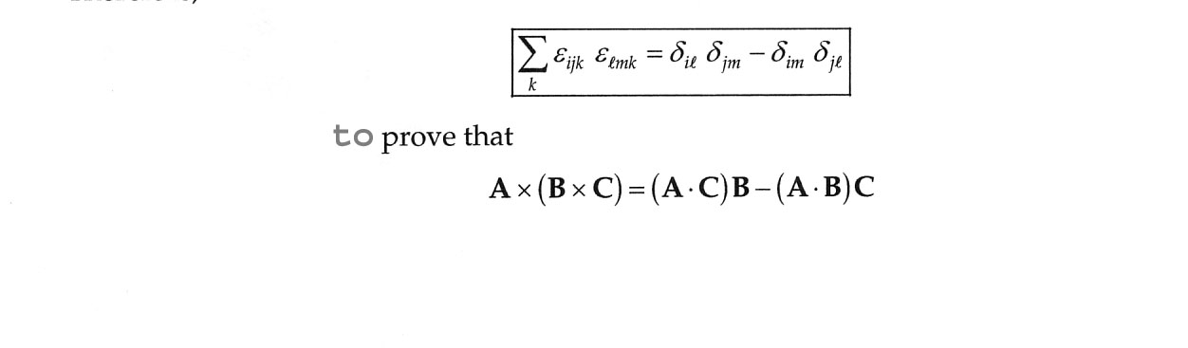
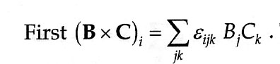
Use of the Levi-Civita tensor (‘permutation symbol’) result

Call the above equation “eq. 1”. This is just eq. 1.66 from the text, but with (AxB)_{i} now (BxC)_{i}.

Then eq. 2 below is

This, as we discussed in class, is just from eq. 1.66 in the text, but instead of (AxB)_{i}, it’s A cross product with a second vector that is not just simply B, but instead is BxC. Also, instead of the i’th component as in eq. 1.66, it’s the l’th component. So this last equation above (eq. 2) sums over m,n, instead of j,k like in the book. So ‘i’ (eq. 1.66) is now ‘l’, and j,k are m,n. A_{j} (subscript here is ‘j’ – hope it’s readable) from eq. 1.66 in the book is A_{m}, and B_{j} (subscript ‘j’ again) is just (BxC)_{n}. In the right side of the above equation (eq. 2), substitute from eq. 1, with the appropriate subscript renaming. (since eq. 2 involves (BxC)_{n}, the subscripts for the sum involving ε involves n,j,k and not i,j,k as in eq. 1.

Now, collect the sum over j,k together with the sum over m,n and permute n,j,k twice (‘even’ permutation) to get j,k,n and rewrite:

Then, collect the factors containing ‘n’ separate out the sum over ‘n’ to get:
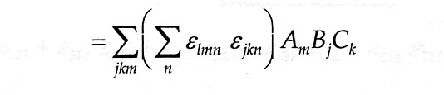
The sum over ‘n’ in the parentheses is just (from the starting equation above) the product of delta functions (have to rename indices since here we have the sum over ‘n’ above is a sum over ‘k’):

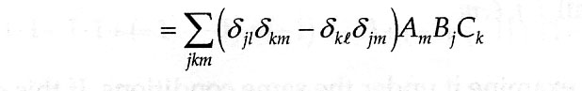

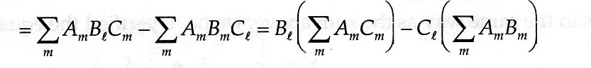
For the first product of delta functions times A_{m}B_{j}C_{k}, j becomes l (so B_{j} becomes B_{l}) and k becomes m (so C_{k} becomes C_{m}); for the second product of delta functions times A_{m}B_{j}C_{k} k becomes l (so C_{k} becomes C_{l}) and j becomes m, so B_{j} becomes B_{m} . Thus
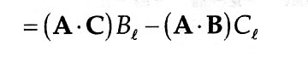
But we recognize that the two sums over m are just the dot products between vectors A and C, and A and B, respectively. Thus we have the l’th component (the left hand side) of AxBxC equal to:

Thus, AxBxC = (A dot C)B – (A dot B)C

