
f3rd Year of ESO
Unit 3 “This is the best...! (Money, money, money)”
- The Project: An advertisment
- Pair work or groups of three.
- Think of something you would like to sell.jjfdfvv
- Look up this information: description, utility. Use adjectives to oversell it.
- Choose a slogan.
- Use comparatives and superlatives.
- Presentation in a video.
http://www.thinkslogans.com/slogans/
Some examples of previous years…
- Warm up. SB p. 31. Small groups. Correction in the big group.
  - Are you a saver or a spender? Go to page 36 and do 1,3,4.
  - The debate: Should teenagers work while the study? Go to the WB page 127 and read the two opinions. Write your opinion in three lines to give in to Pili.
Diary
- Speaking. Make up a dialogue commenting the results of the quiz, if you agree with the conclusion or not and why.
Add some exclamations What a...! How...! Criterion 2.
http://study.com/academy/lesson/the-concept-of-how-in-spanish-adding-que-to-adjectives-nouns.html

http://www.tolearnenglish.com/exercises/exercise-english-2/exercise-english-55422.php
- The Project
- Listening: SB p. 35. Criterion 1.
- Pronunciation: The sound /ə/ (photocopy).
- Vocabulary: Go to the SB p. 40 or use the glossary of the WB p. 152 or the dictionary.
4.2. SB p. 32: 1,2, 3,4,5. Correction in the big group.
4.3. SB p. 32: Recycle + photocopy (adjectives).
4.4. WB p. 26: Recycle, 1,2,3,4.
- Some grammar. Comparatives and superlatives.
  - In your group, answer the questions at the back of the sheet. Criterion 6.
  - Some practise on comparatives and superlatives (slides).
  - Choose one brand on the following products on the market and write one sentence with a comparison and one using a superlative to show to the class: perfumes, chocolate bars, trainers, soft drinks, mobile phones, football teams, and clothes shops. Criterion 5.
- Too.../ ... enough. Copy all this in your notebook.
6.1. Write the meaning in Spanish:
It’s too hot to walk:
It isn’t cold enough to wear gloves:
6.2. SB p. 34: 5 + power point http://www.authorstream.com/Presentation/zeynepkaradeniz- 178181-enough-grammar-enjoyable-activities-exercises-education-ppt-powerpoint/
6.3. SB p. 34: 6 + WB: 27: 5, 34: 4.
- The Project
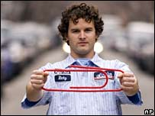
- Reading: SB pp. 32-33 “One red paper clip”
  - SB p. 32: 6.
  - Close your books and listen.
  - SB p. 32: 7.
  - Open your books, let’s read all together and do 8,9,10
  - Speaking: activity 11.
  - Shall we swap something?
Diary

Do you think swapping is a good idea? Why?

9. Vocabulary: False Friends, SB p. 35.
9.1 Homework WB p. 28.
Criterion 5.
10. Some more grammar: revision of quantity.
Let’s fill in the photocopy of quantity and do the exercises of the SB p.37: 1,2 and WB p.29: 1,2,3,4. Criterion 5.
- The Project: Present the add.
Criteria 2,6,8.



COMPARATIVES

- Write some comparative sentences in Spanish: (Go to page 41 of the SB, to page 102 of the WB and to the internet https://prezi.com/fcdoepbskvi9/comparatives-equality-superiority-and-inferiority/
a. an superiority comparison:
b. an equality (also called positive) comparison:
c. an inferiority comparison:
- Write the three examples in English
- How many elements take place in a comparison? _____________

- Look at these four examples:
A car is cheaper than a house. An elephant is bigger than an ant
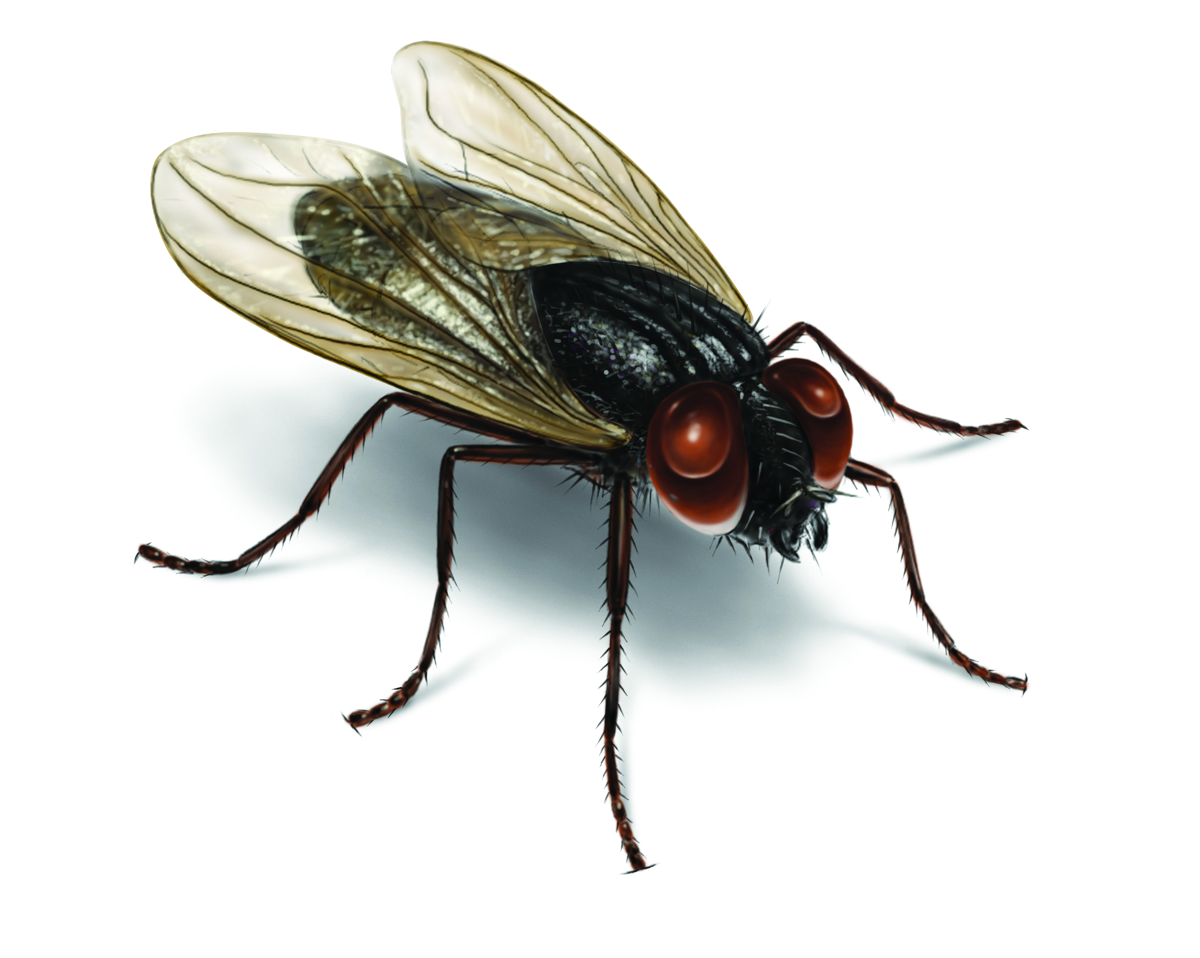
A butterfly is more beautiful than a fly Las Huesas is more popular than Bascamao (in Guía)
4.1. Translate the examples into Spanish.
4.2. Why is the use of the comparatives different in English?
4.3. Make up (invent) one example of each use in English.
SB p. 34:3 + WB p. 27:2
SUPERLATIVES
- Write a superlative in Spanish:
- Translate it into English:
- How many elements take place in a comparison? _____________
- Write sentences using superlatives with these adjectives:
- young:
- nice:
- boring:
- difficult:
SB p. 34:4 + WB p. 27:3
- Summarize the spelling rules and write five examples of each rule.
SB p. 34:2 + WB p. 27: 1,4 + SLOW STUDENTS -> WB p. 103: 1,2,3 + Teacher’s Resource Pack pp. 12,13

